ABSN-13746 - D_UBS_2795 For future PLPC, for inactive customer with Lost business option, delete also linked records from RentalQtyAdjustment
Environment | Prerequisites
Version: 9.07.00.UNF21  DBServerName= abs-srv20.internal.abslbs.com  DBSID=CUST24  DBUser=UNFDEV  Environment=Test | - Module:  - System setting

Contents
Reproducing before fix 1
Steps to reproduce 1
Current Behavior 4
Expected behavior 5
Retest after fix 5

Reproducing before fix

Steps to reproduce
- Make sure the ss INACTIVATECUSTOMER is 1
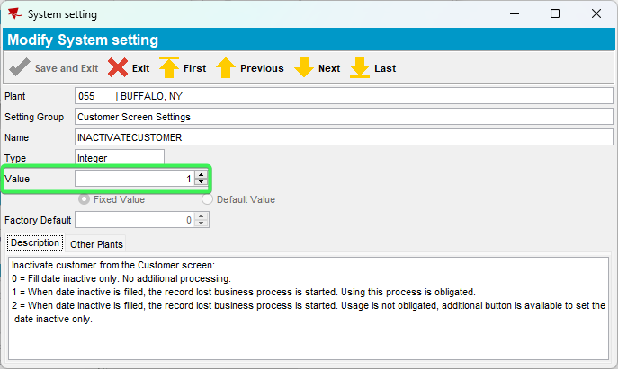
- Before ending a customer, make sure there is a PLPC with a start date and an end date greater than the date you want to use to end the customer. If there is none, add it from the contract.
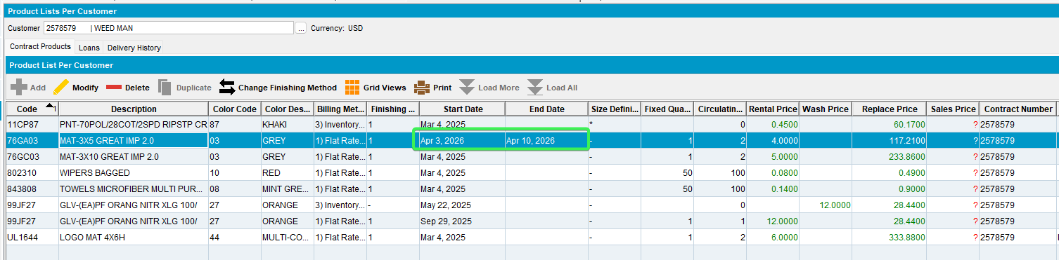
- For PLPC, make sure you have a delivery line and a rental quantity adjustment:
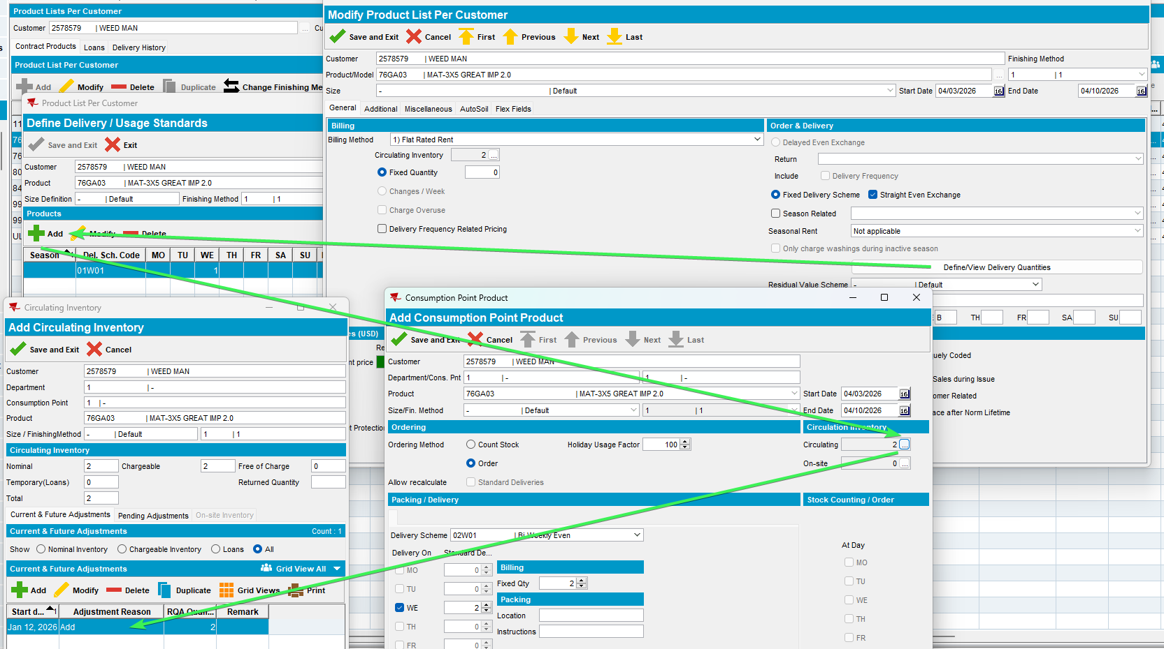
- Check PLSQL for entries in the Rental Quantity Adjustments table
select RQA.*
from PRODUCTLISTPERCUSTOMER PLPC
join CUSTOMER C
on C.CUSTOMER_ID = PLPC.CUSTOMER_ID
join DEPARTMENT D
on C.CUSTOMER_ID = D.CUSTOMER_ID
join DISTRIBUTIONPOINT DP
on D.DEPARTMENT_ID = DP.DEPARTMENT_ID
join PRODUCTLISTPERDISTRIBPOINT PLPD
on PLPD.PRODUCT_ID = PLPC.PRODUCT_ID
and PLPD.SIZEDEFINITION_ID = PLPC.SIZEDEFINITION_ID
and PLPD.FINISHINGMETHOD_ID = PLPC.FINISHINGMETHOD_ID
and PLPD.DISTRIBUTIONPOINT_ID = DP.DISTRIBUTIONPOINT_ID
join RENTALQTYADJUSTMENT RQA
on RQA.PRODUCTLISTPERDISTRIBPOINT_ID =
PLPD.PRODUCTLISTPERDISTRIBPOINT_ID
join PRODUCT P
on P.PRODUCT_ID = PLPC.PRODUCT_ID
where C.CUSTOMERNUMBER = 2578579
and P.CODE = '76GA03'
- End the customer by setting a date inactive
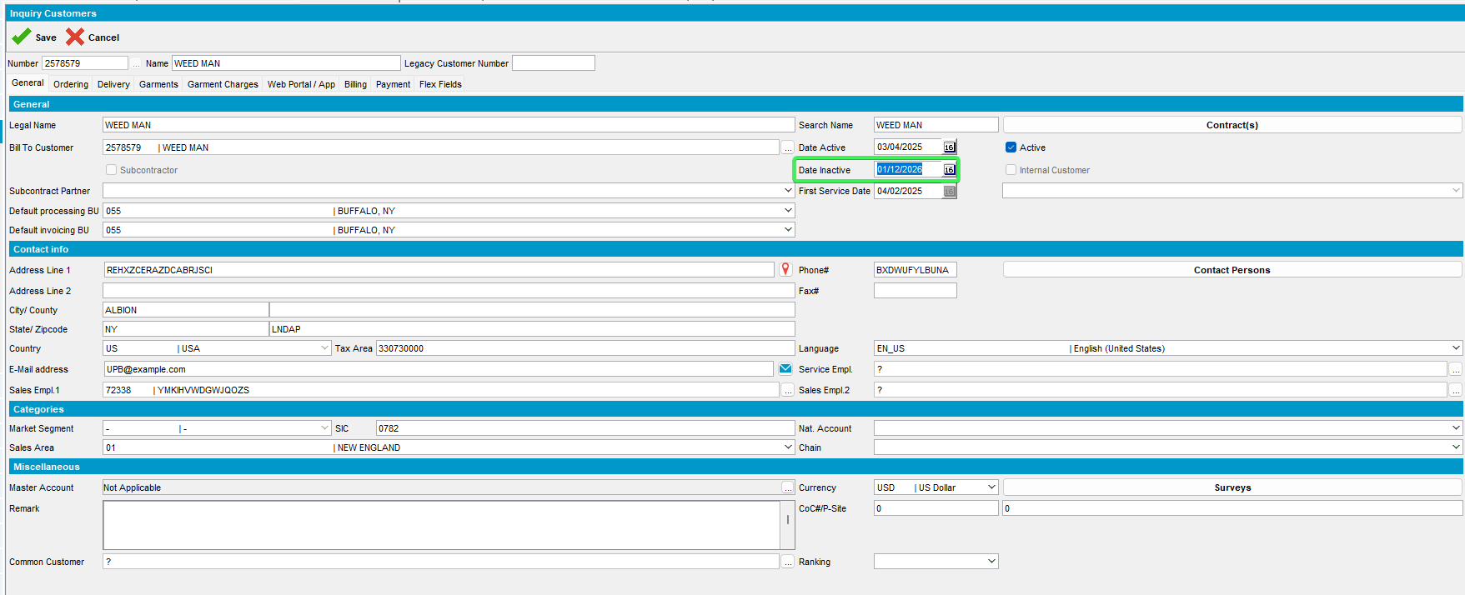
- The pop-up for Lost business is displayed when you save the customer
- Fill in a lost reason and a competitor and press OK
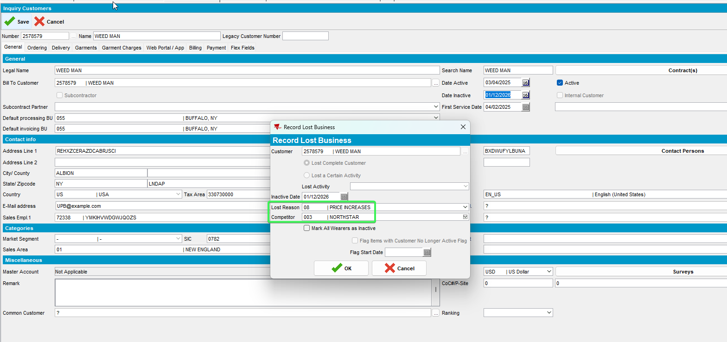
- Press OK to add a flag.
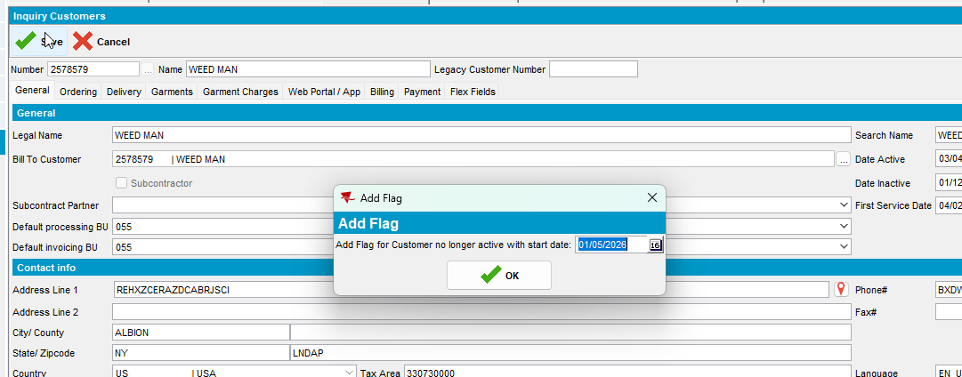

REPRODUCED OK.

Current Behavior
There is no longer a delivery line for the future PLPC, but in the table, there is the RQA record:
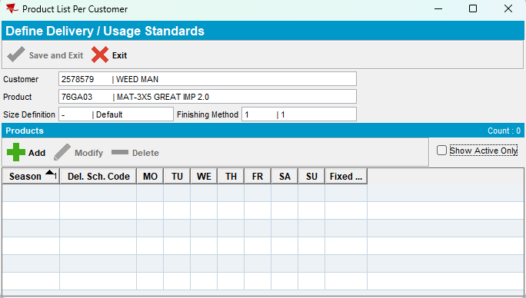
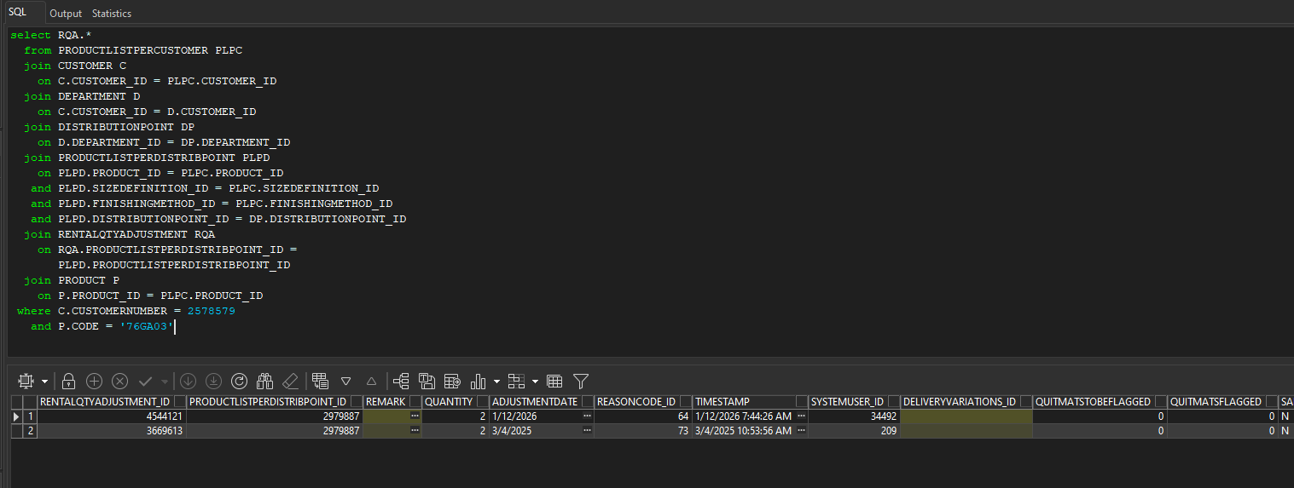

Expected behavior

Retest after fix
Hash: 47600e3f3f97
- Make sure the ss INACTIVATECUSTOMER is 1
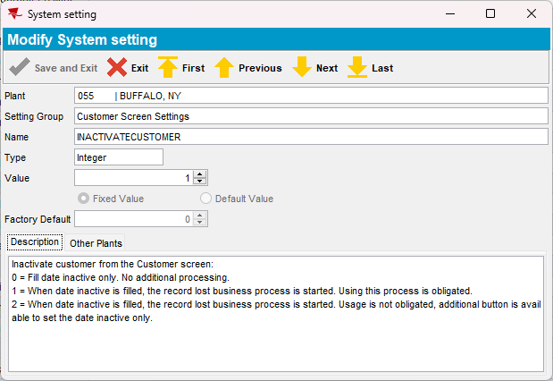
- Before ending a customer, make sure there is a PLPC with a start date and an end date greater than the date you want to use to end the customer. If there is none, add it from the contract.
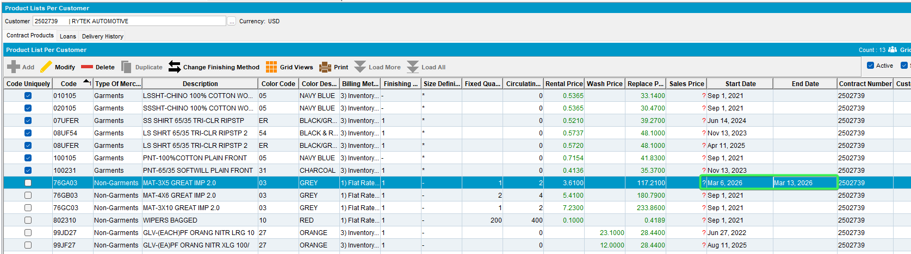
- For PLPC, make sure you have a delivery line and a rental quantity adjustment:
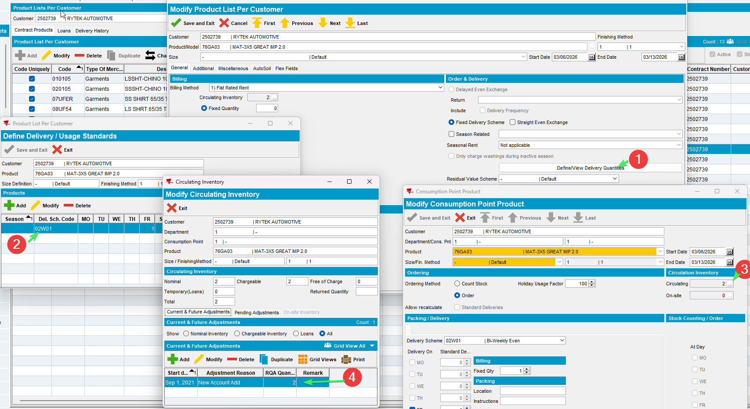
- Check PLSQL for entries in the Rental Quantity Adjustments table
select RQA.*
from PRODUCTLISTPERCUSTOMER PLPC
join CUSTOMER C
on C.CUSTOMER_ID = PLPC.CUSTOMER_ID
join DEPARTMENT D
on C.CUSTOMER_ID = D.CUSTOMER_ID
join DISTRIBUTIONPOINT DP
on D.DEPARTMENT_ID = DP.DEPARTMENT_ID
join PRODUCTLISTPERDISTRIBPOINT PLPD
on PLPD.PRODUCT_ID = PLPC.PRODUCT_ID
and PLPD.SIZEDEFINITION_ID = PLPC.SIZEDEFINITION_ID
and PLPD.FINISHINGMETHOD_ID = PLPC.FINISHINGMETHOD_ID
and PLPD.DISTRIBUTIONPOINT_ID = DP.DISTRIBUTIONPOINT_ID
join RENTALQTYADJUSTMENT RQA
on RQA.PRODUCTLISTPERDISTRIBPOINT_ID =
PLPD.PRODUCTLISTPERDISTRIBPOINT_ID
join PRODUCT P
on P.PRODUCT_ID = PLPC.PRODUCT_ID
where C.CUSTOMERNUMBER = 2502739
and P.CODE = ‘76GA03’
- End the customer by setting a date inactive
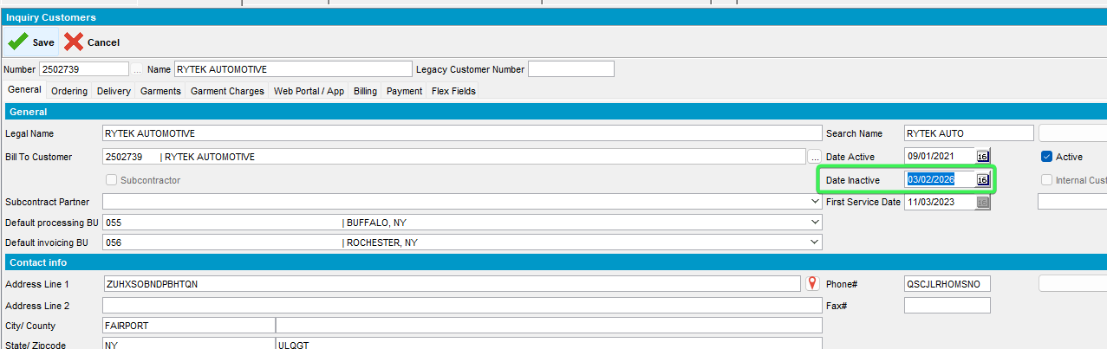
- The pop-up for Lost business is displayed when you save the customer
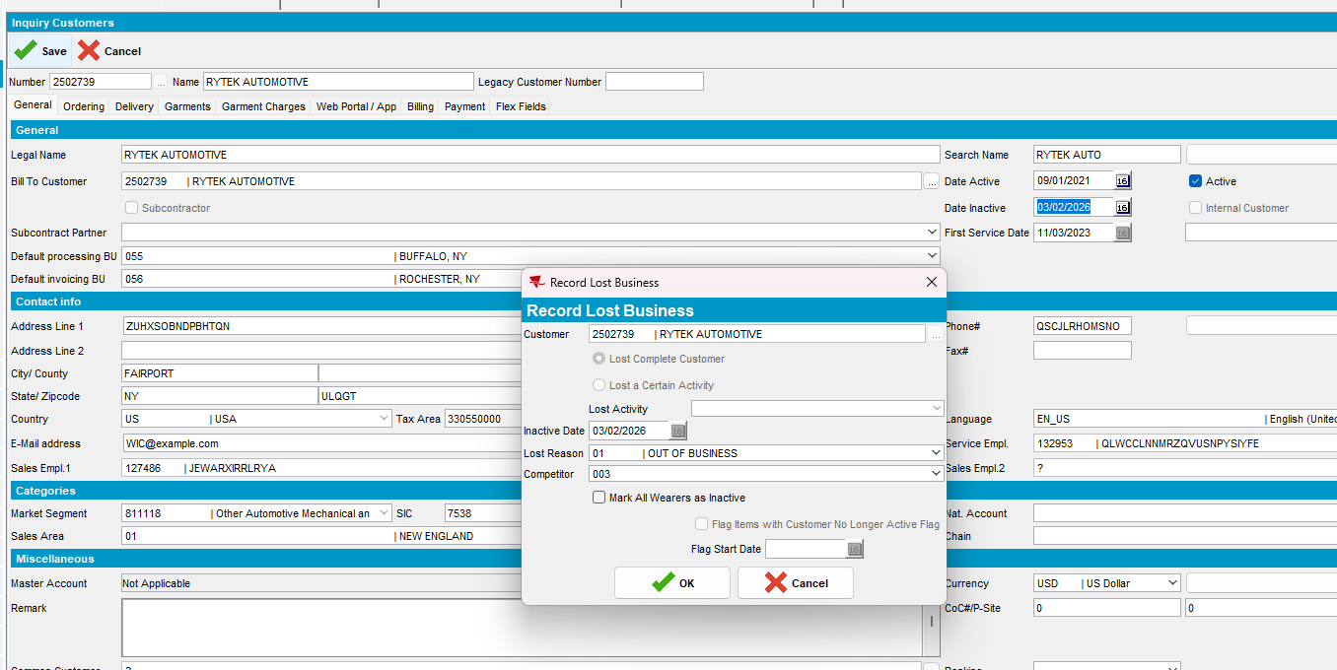
- Fill in a lost reason and a competitor and press OK
- Press OK to add a flag.
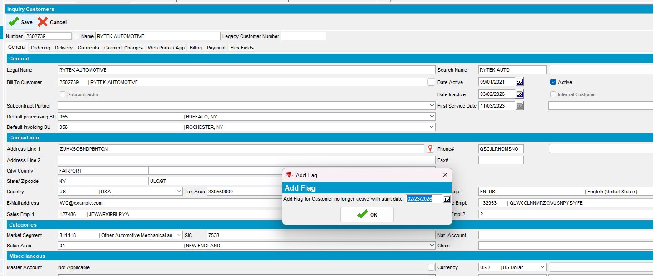
- PLPC: Check if the product for your customer still has a delivery scheme
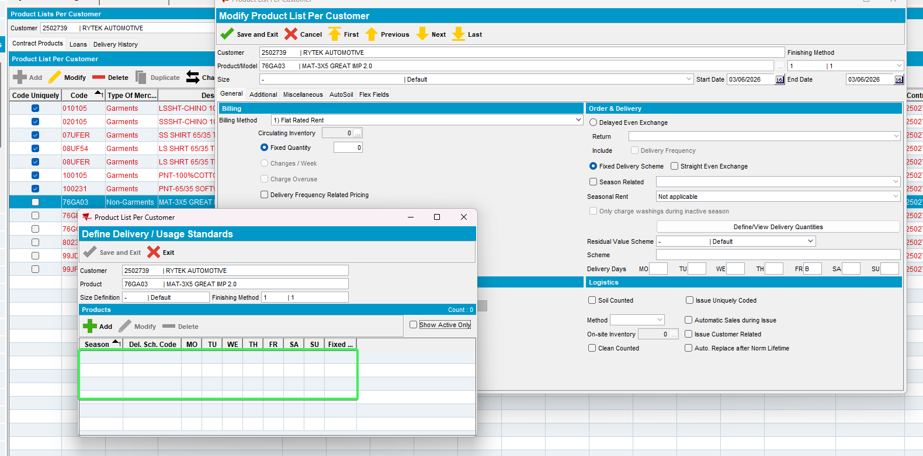
- Check PLSQL if for your product for your customers the lines in the Rental Quantity Adjustments table were removed
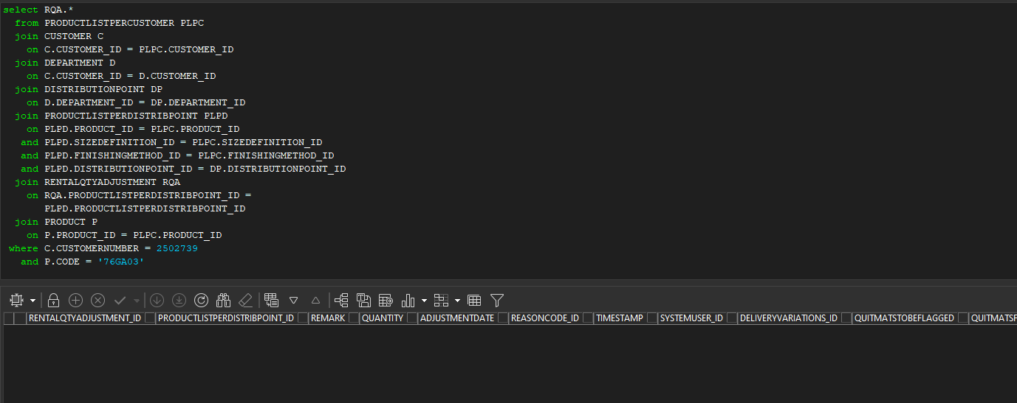
The Line was removed
Tested OK

