ABSN-13567 D_UBS_2097 Settlement Dialog contains values no longer on the route
Environment | Prerequisites
Version:9.07.00.UNF21  DBServerName=abs-srv19.internal.abslbs.com  DBSID=CUST22  DBUser=UNFLIVE  Environment=Production | - Module:  - System setting

Contents
Test after fix 1
Test Case 1 – Customer with Payment Method Charge – Tested OK 1
Test Case 2 – Customer with Payment Method COD – Tested OK 5

Test after fix

Test Case 1 – Customer with Payment Method Charge – Tested OK
Expected behavior: Total Charge Prebilled must update when invoices are moved off
Hash: 035c73044296
- Maintain Invoices DLG: Credit 2 or more invoices for customers with Payment Method Charge on an empty route like 998
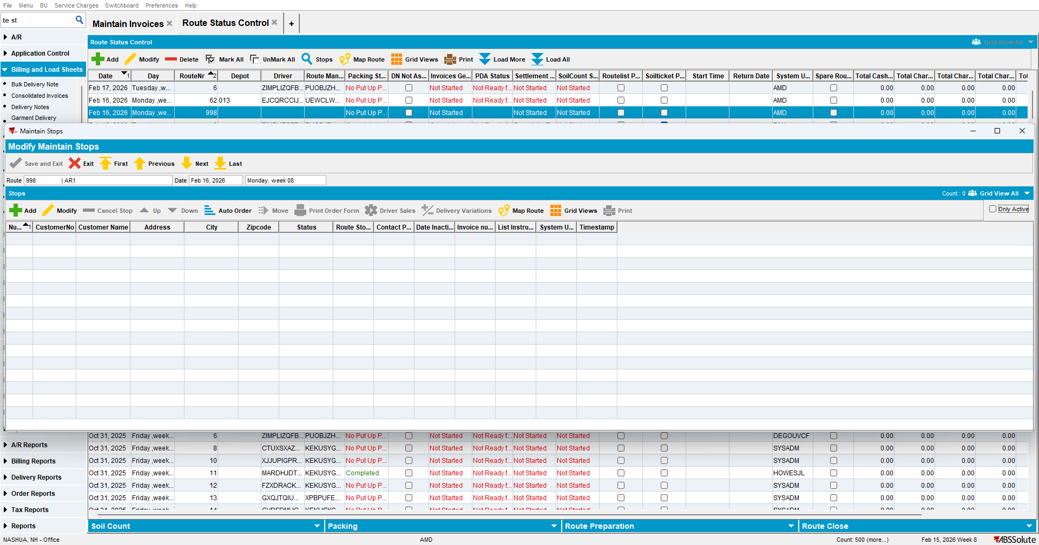
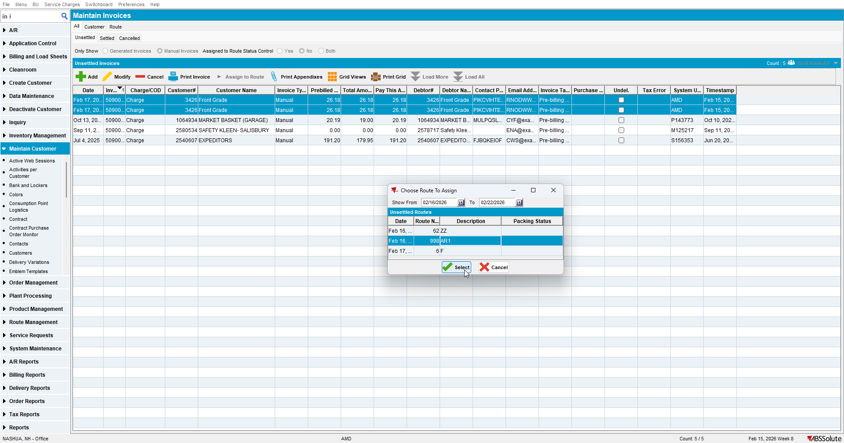

- Route Status Control DLG: Generate invoices for this route (it will go to Complete and tax complete because there are no invoices to generate)
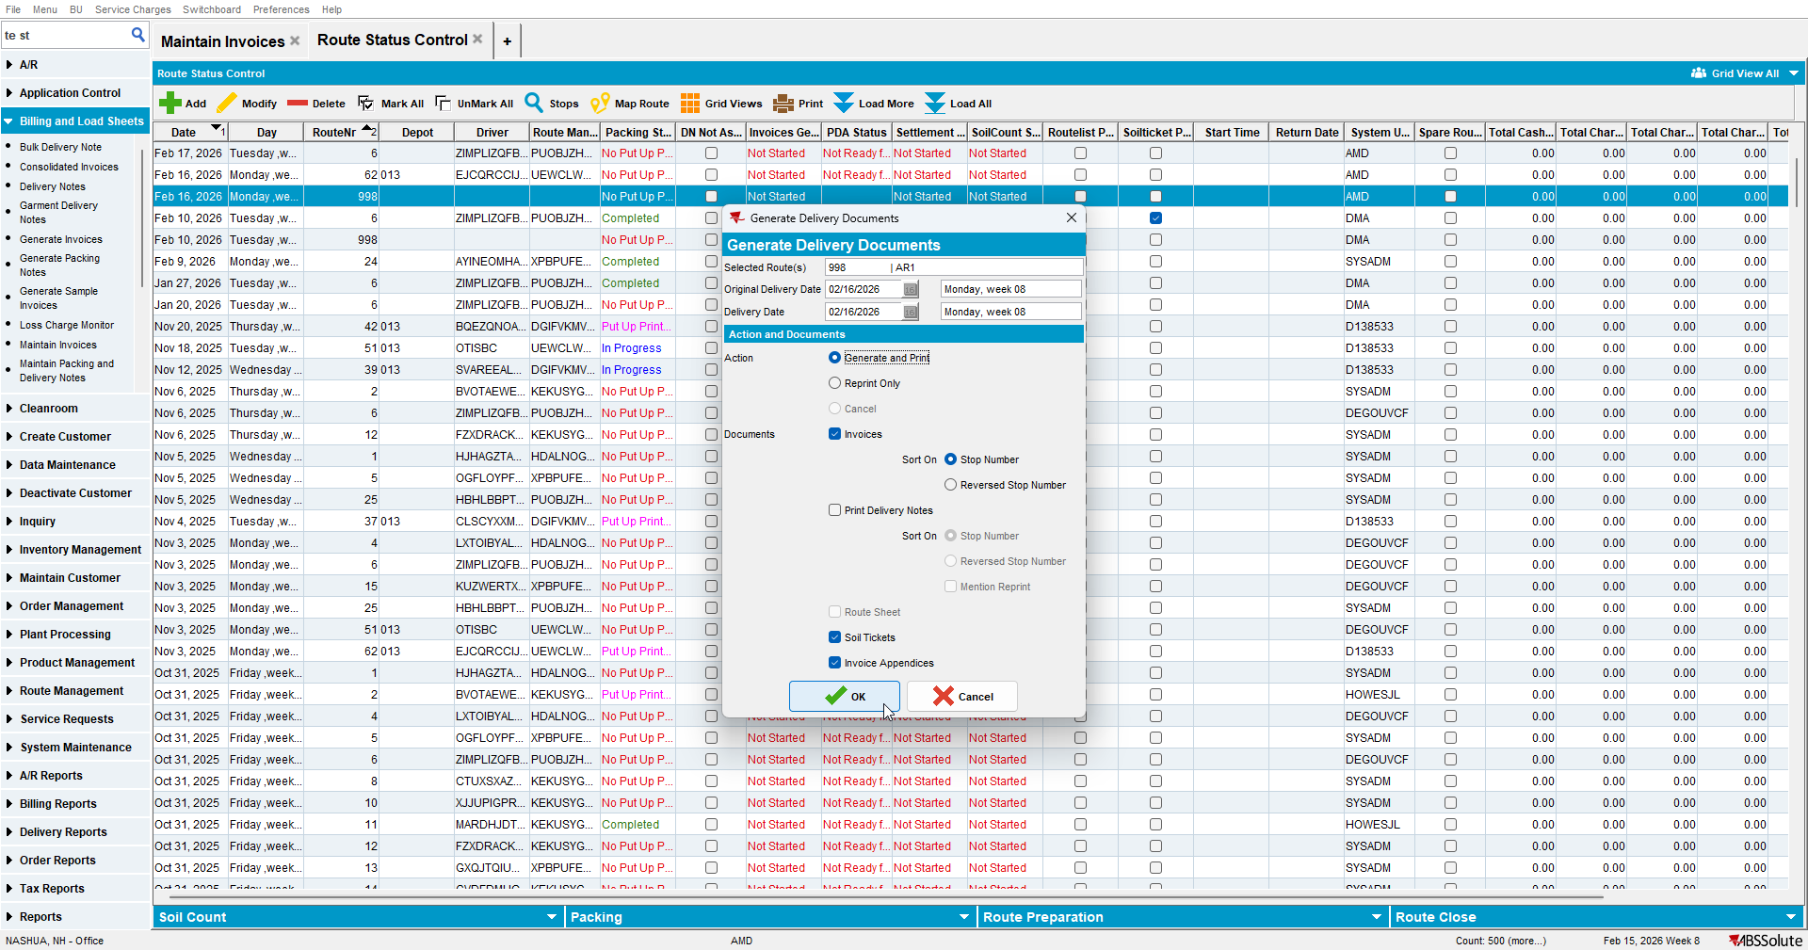

- Open the settlement screen for this route and note the Total Charge Prebilled field
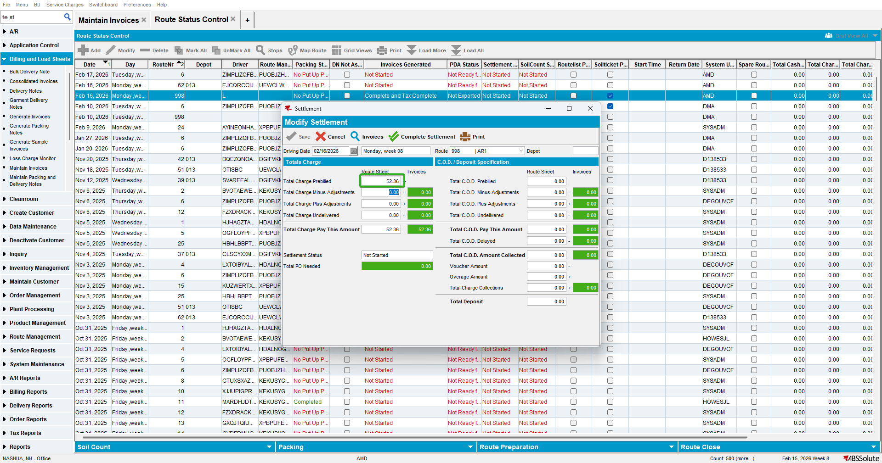

- Maintain Invoices DLG: All tab -> Select Manual invoices that are assigned to routes
- Select one of the Credit invoices you just created and assign it to a different route or date (different routecontrol)
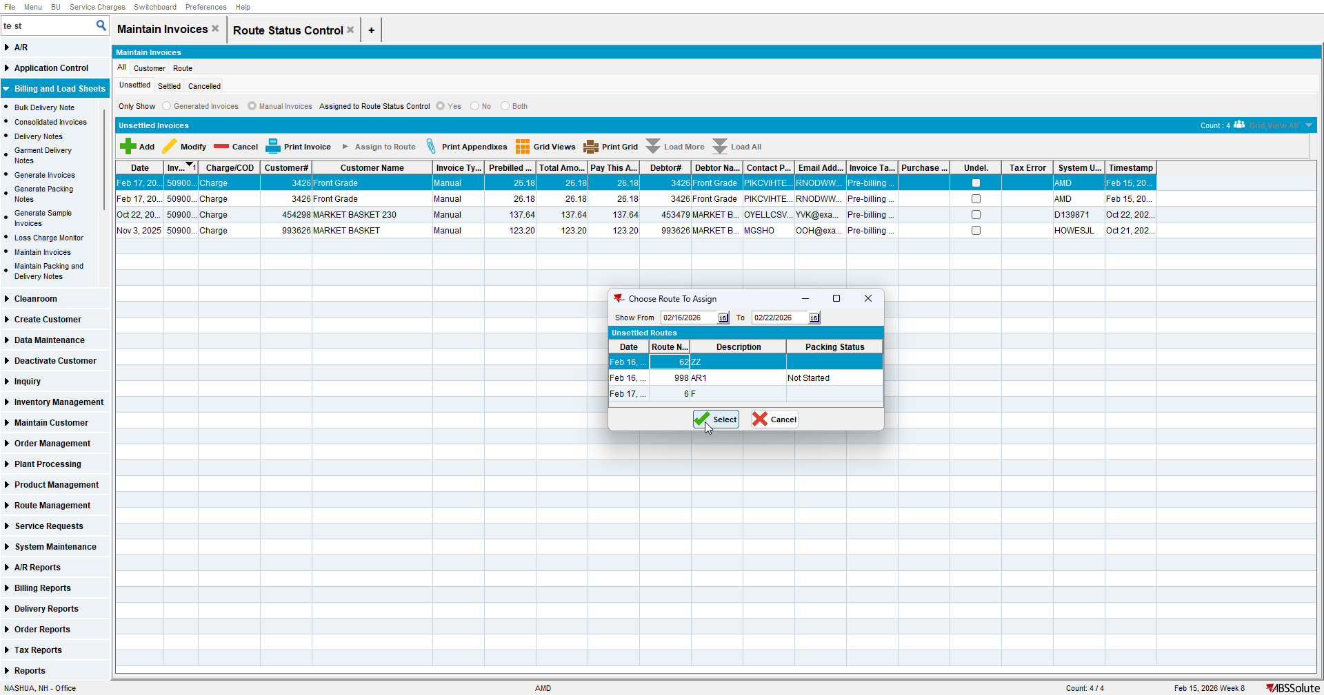

- Go back to Route Status Control dlg and open the settlement screen for your original route and check Total Charge Prebilled
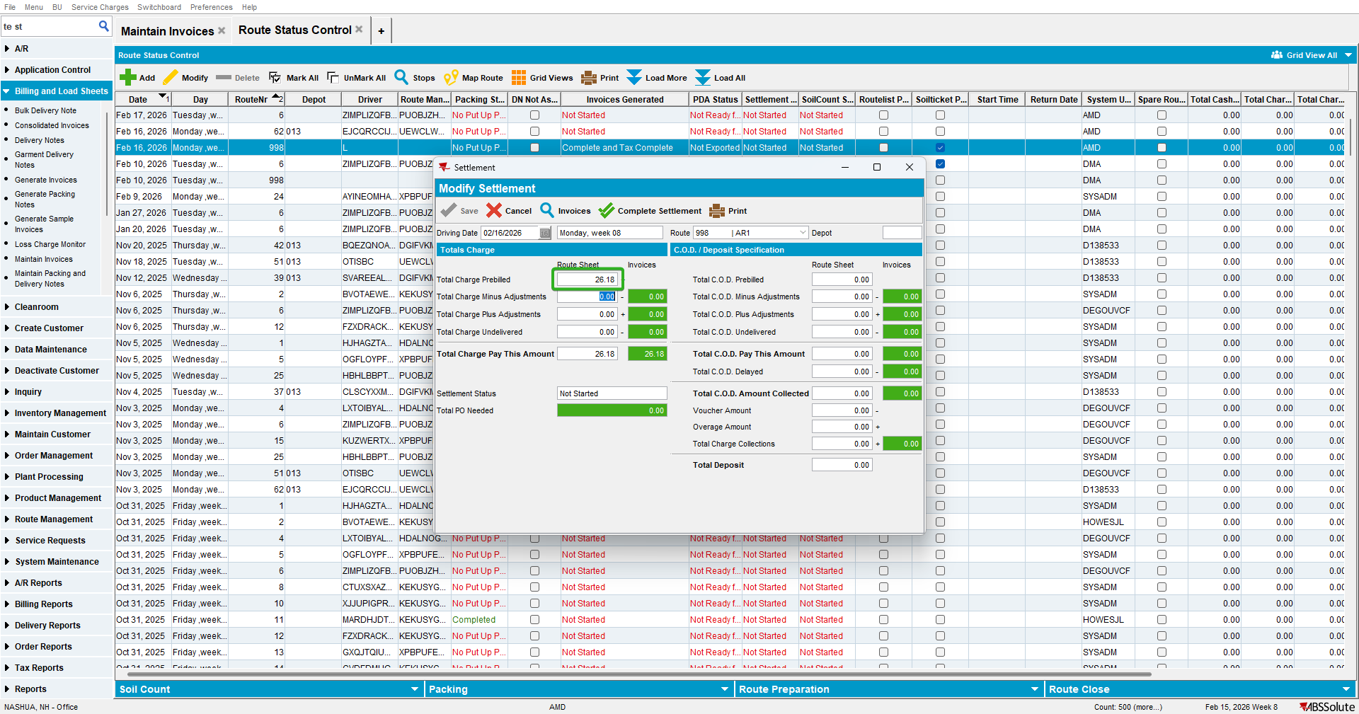

Test Case 2 – Customer with Payment Method COD – Tested OK
Expected behavior: Total COD Prebilled must update when invoices are moved off
Hash: 035c73044296
- Maintain Invoices DLG: Credit 2 or more invoices with Payment Method COD on an empty route like 998
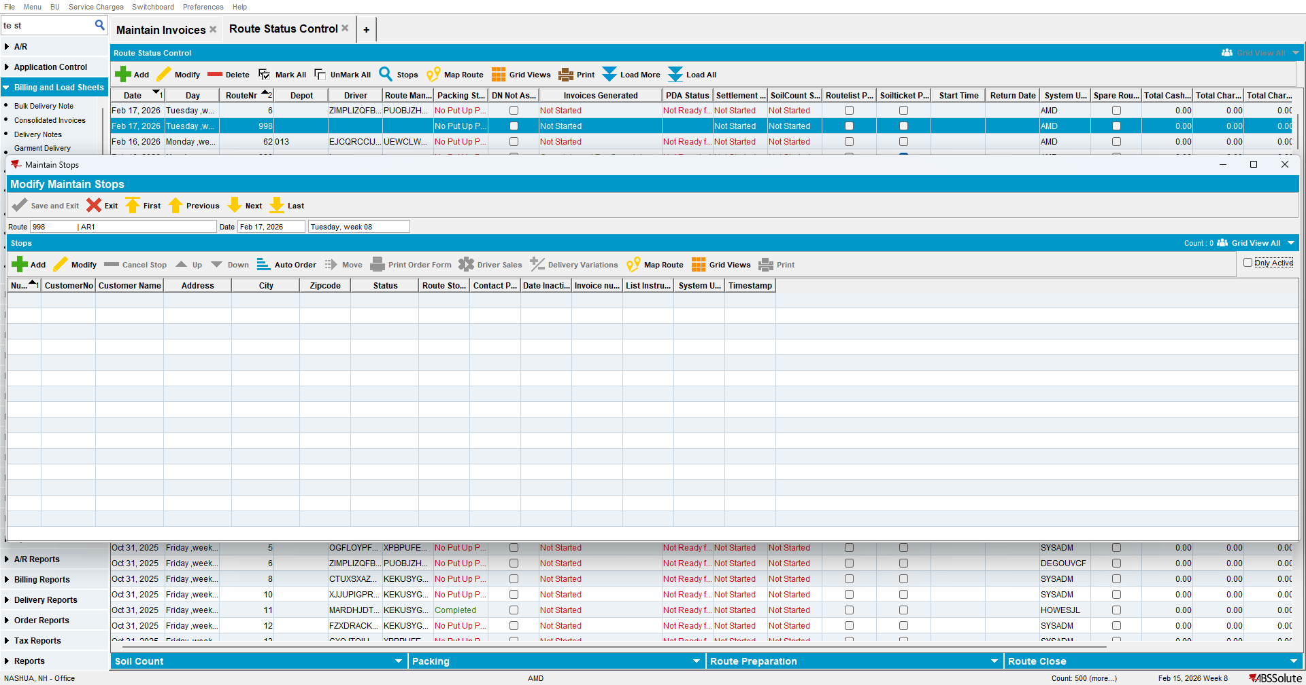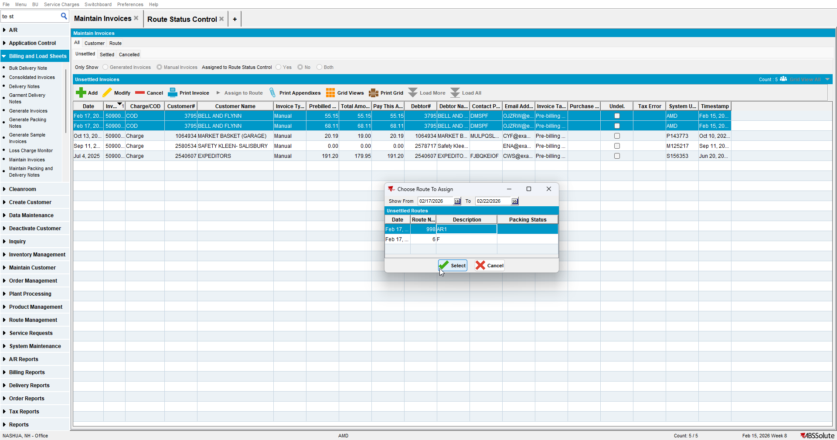

- Route Status Control DLG: Click on generate invoices for this route (it will go to Complete and tax complete because there are no invoices to generate)
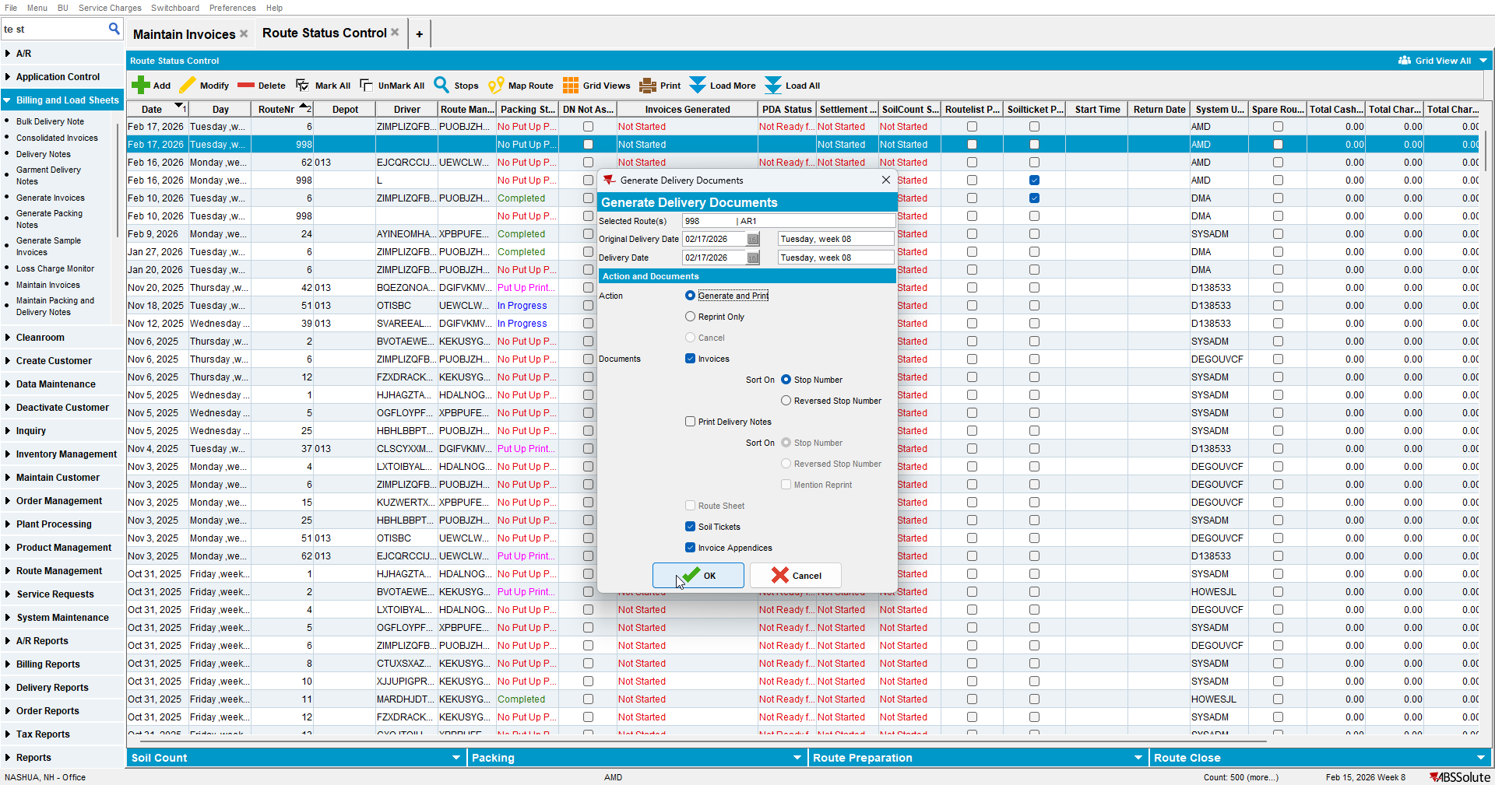

- Open the settlement screen for this route and note the Total COD Prebilled field
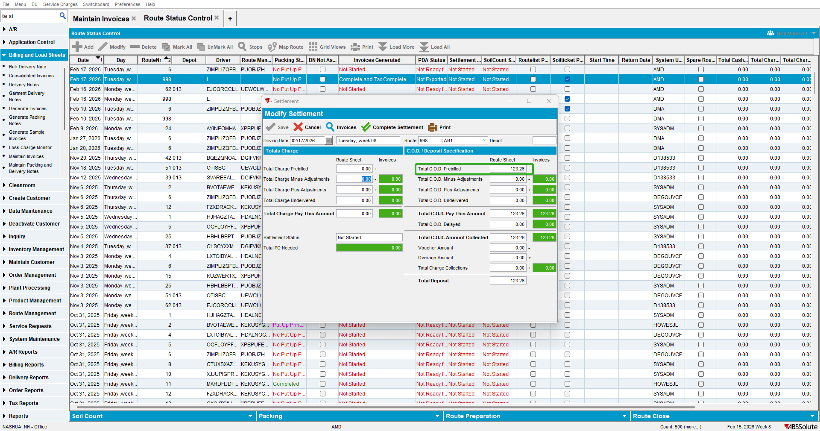

- Maintain Invoices DLG: All tab -> Select Manual invoices that are assigned to routes
- Select one of the Credit invoices you just created and assign it to a different route or date (different routecontrol)
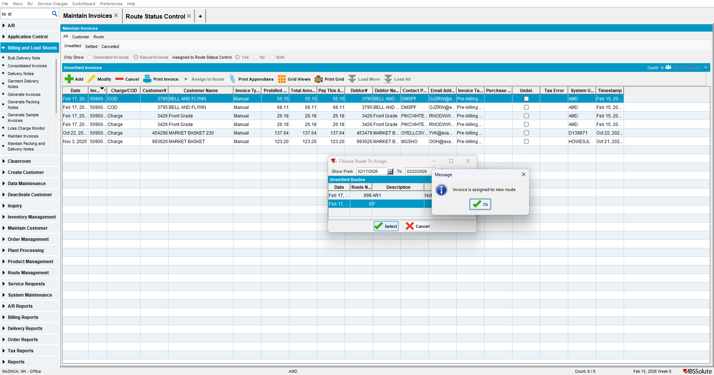

- Go back to Route Status Control dlg and open the settlement screen for your original route and check Total COD Prebilled
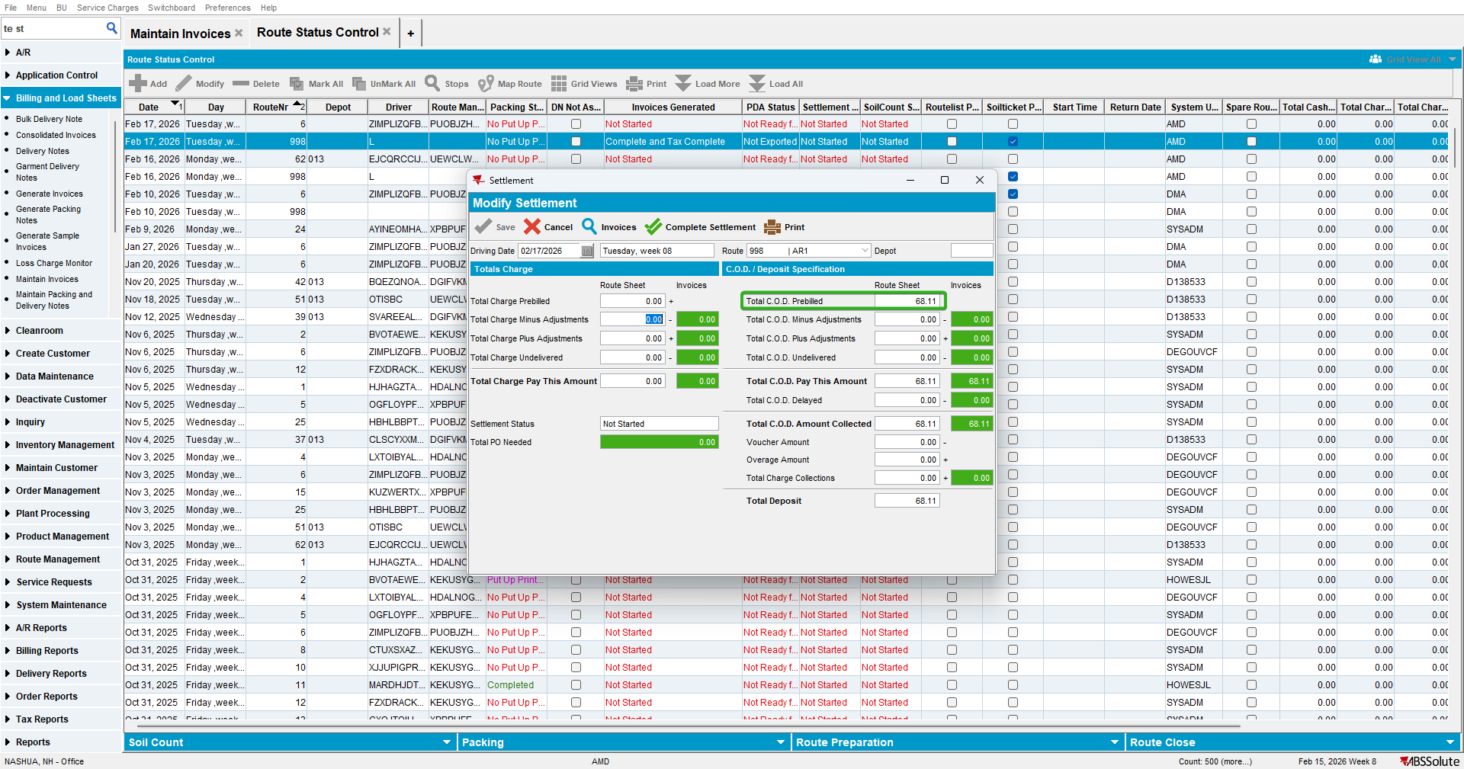
TEST OK

