ABSN-13542 - Freedom Pay Level 3 changes

UNFLIVE@CUST22 – version: 9.07.00.UNF21 hash: ea789927195b
Based on the table below, we will create 7 invoices, one for each case.
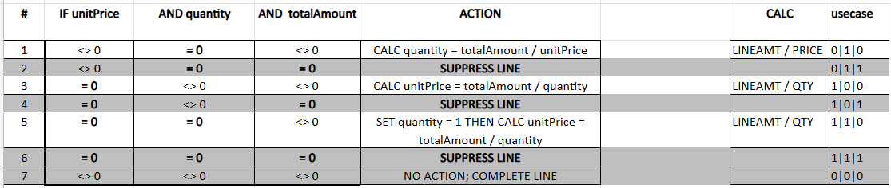
- Customer 3230 – Product 12AK06 –> Price > 0, Qty = 0, Total Amt > 0 – Invoice 5040006423
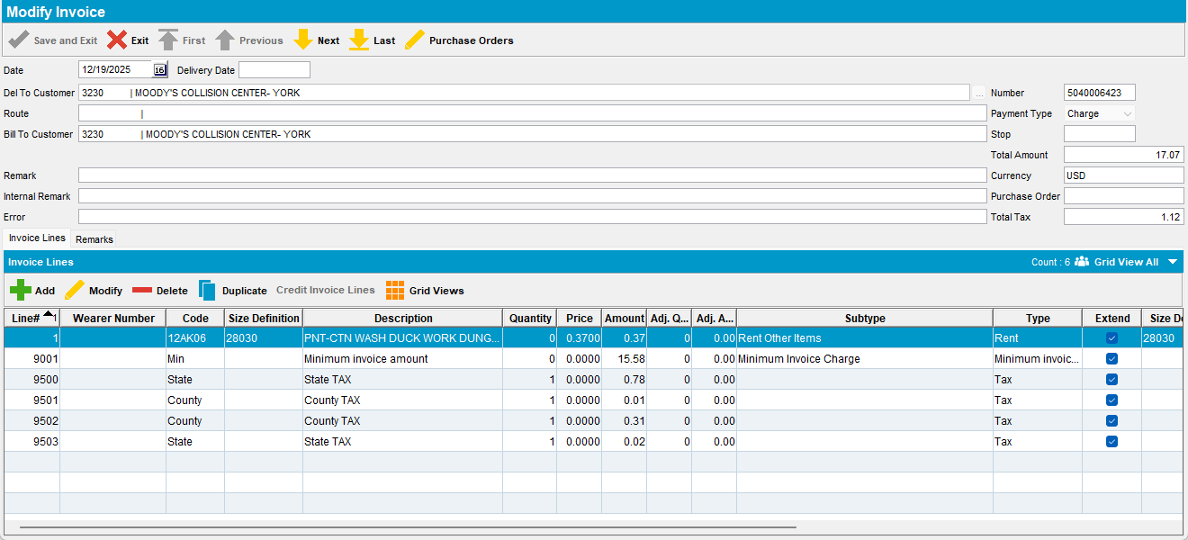

- Customer 3230 – Product 12AK64 -> Price > 0, Qty = 0, Total Amt = 0 – Invoice 5040006424
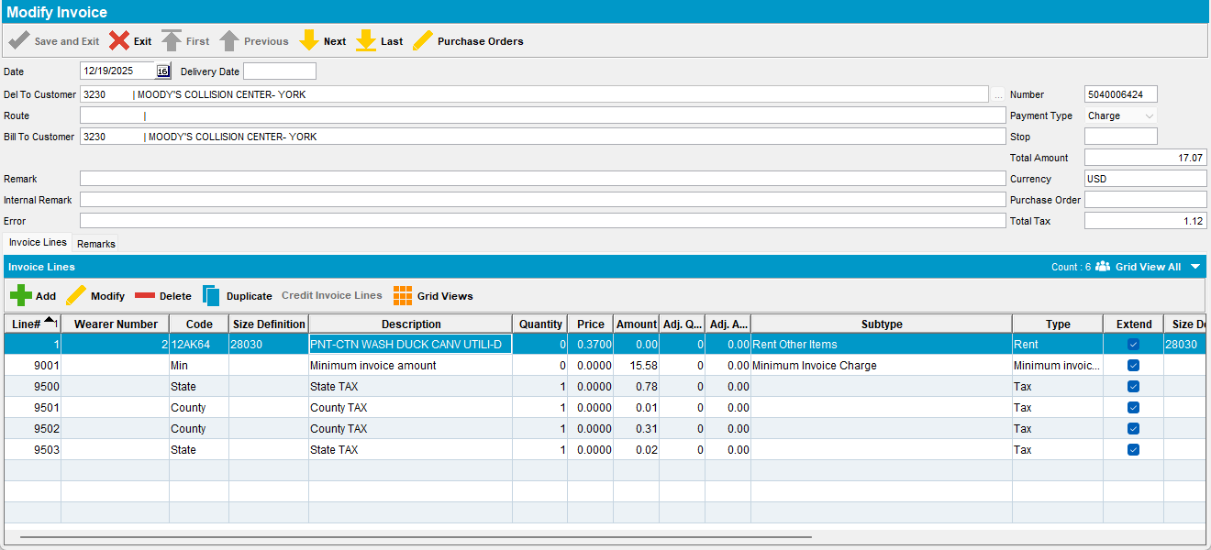

- Customer 3230 – Product 76BJ03 -> Price = 0, Qty > 0, Total Amt > 0 – Invoice 5040006425
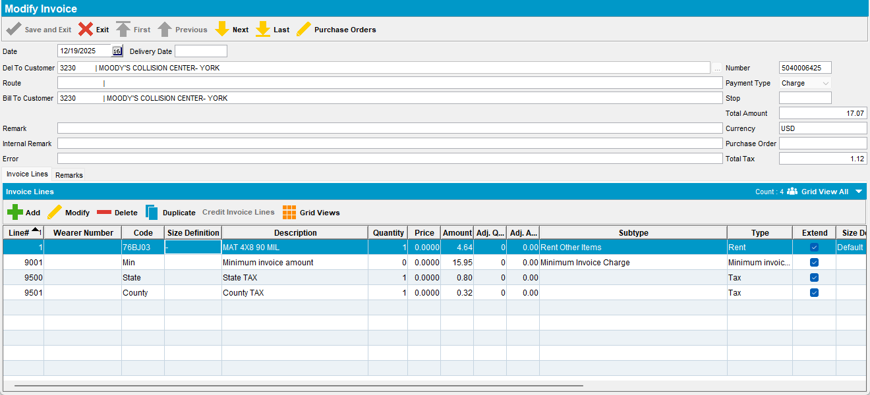

- Customer 3230 – Product 76GB03 -> Price = 0, Qty > 0, Total Amt = 0 – Invoice 5040006426
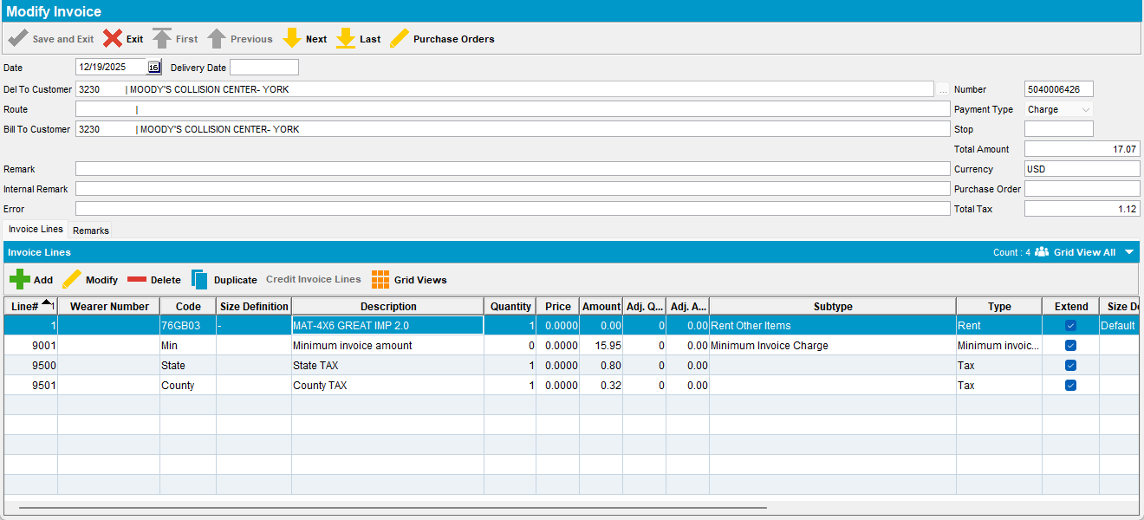

- Customer 3230 – Product 76GC03 -> Price = 0, Qty = 0, Total Amt > 0 – Invoice 5040006427
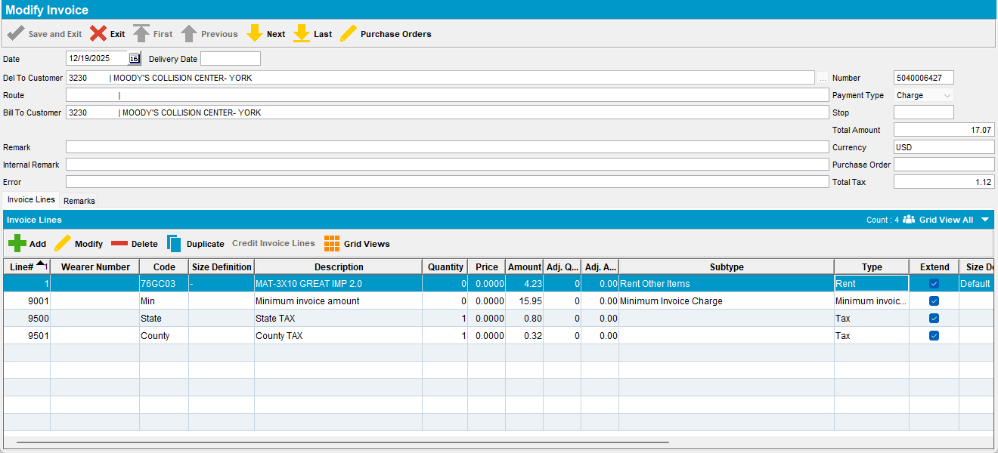

- Customer 3230 – Product 843812 -> Price = 0, Qty = 0, Total Amt = 0 – Invoice 5040006428
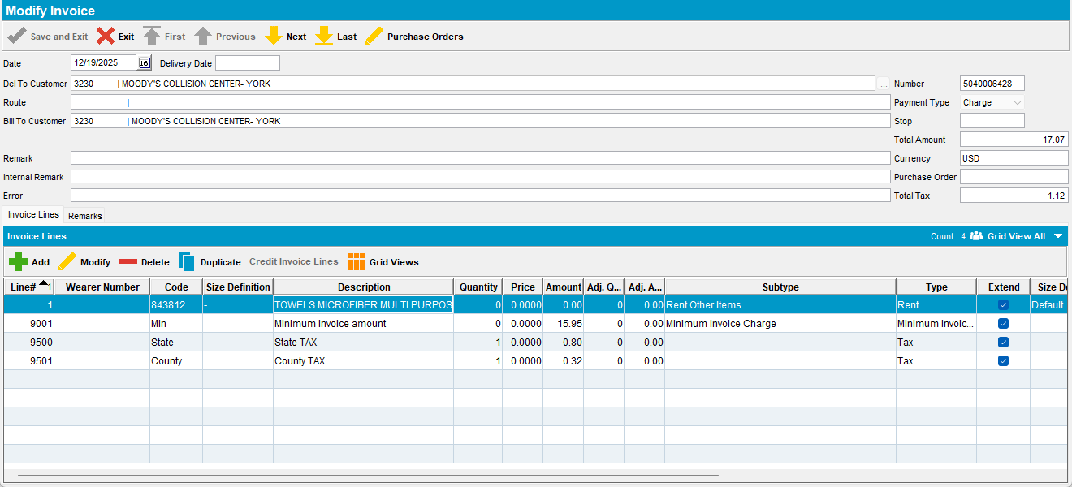

- Customer 3230 – Product 852305 - Price > 0, Qty > 0, Total Amt > 0 – Invoice 5040006429
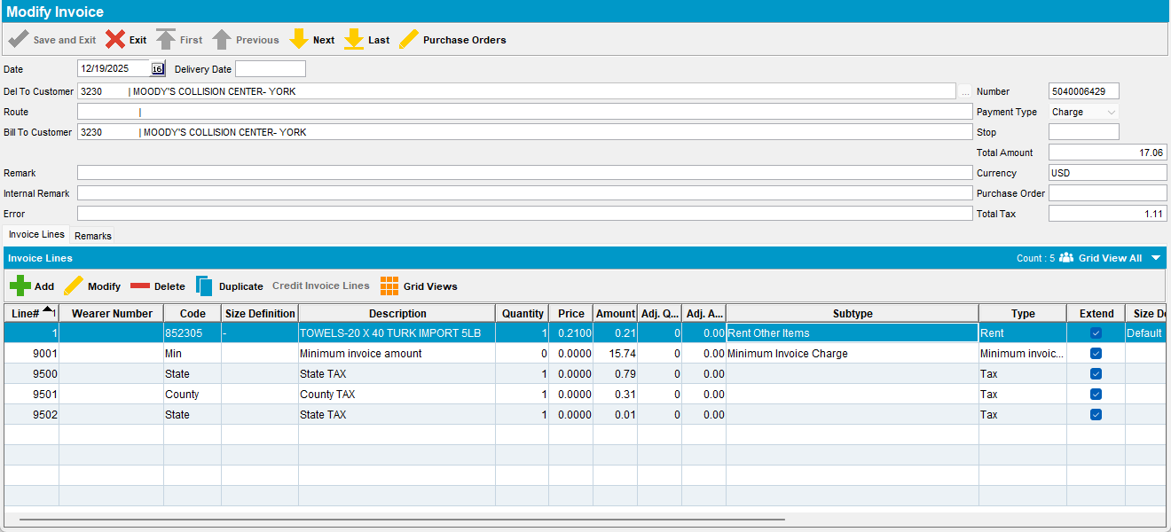

Assign the invoices to a route with a past date.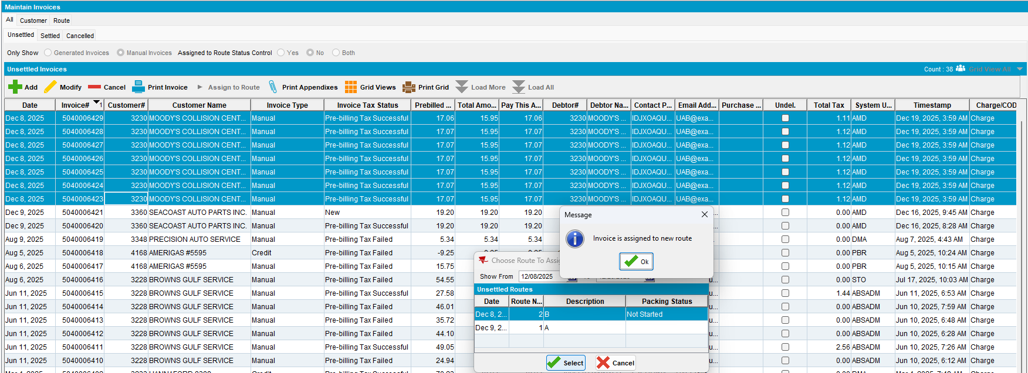

Generate the invoices for that route.
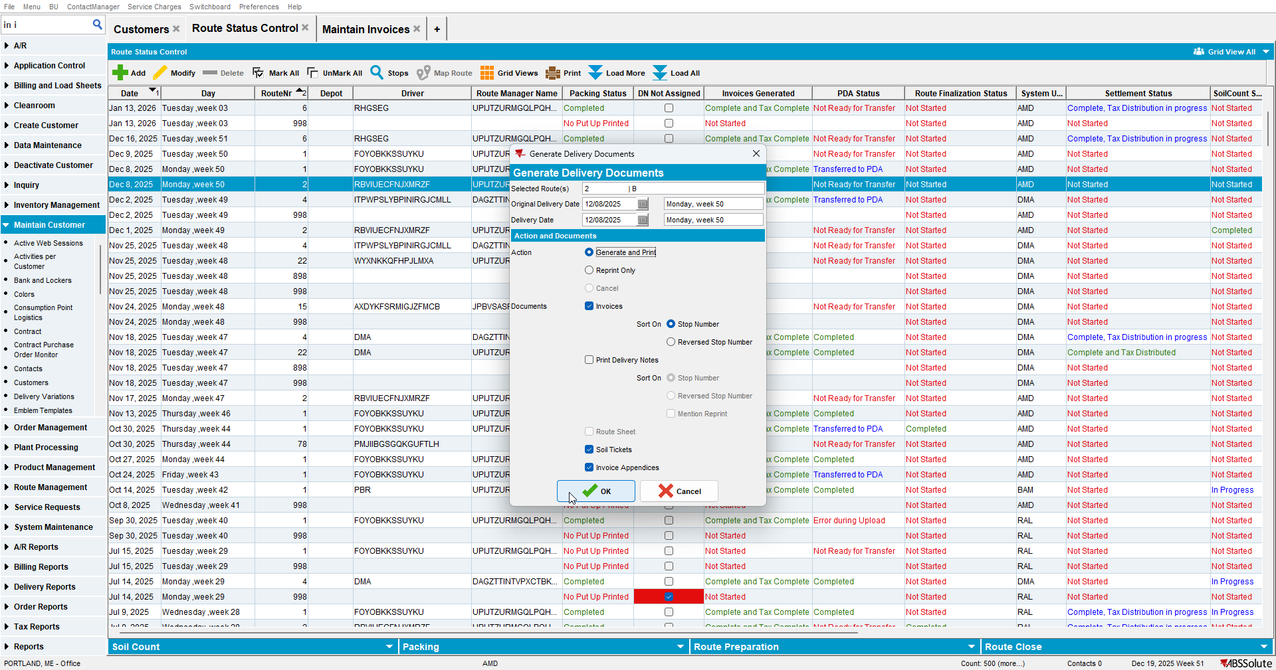

Settle the route.
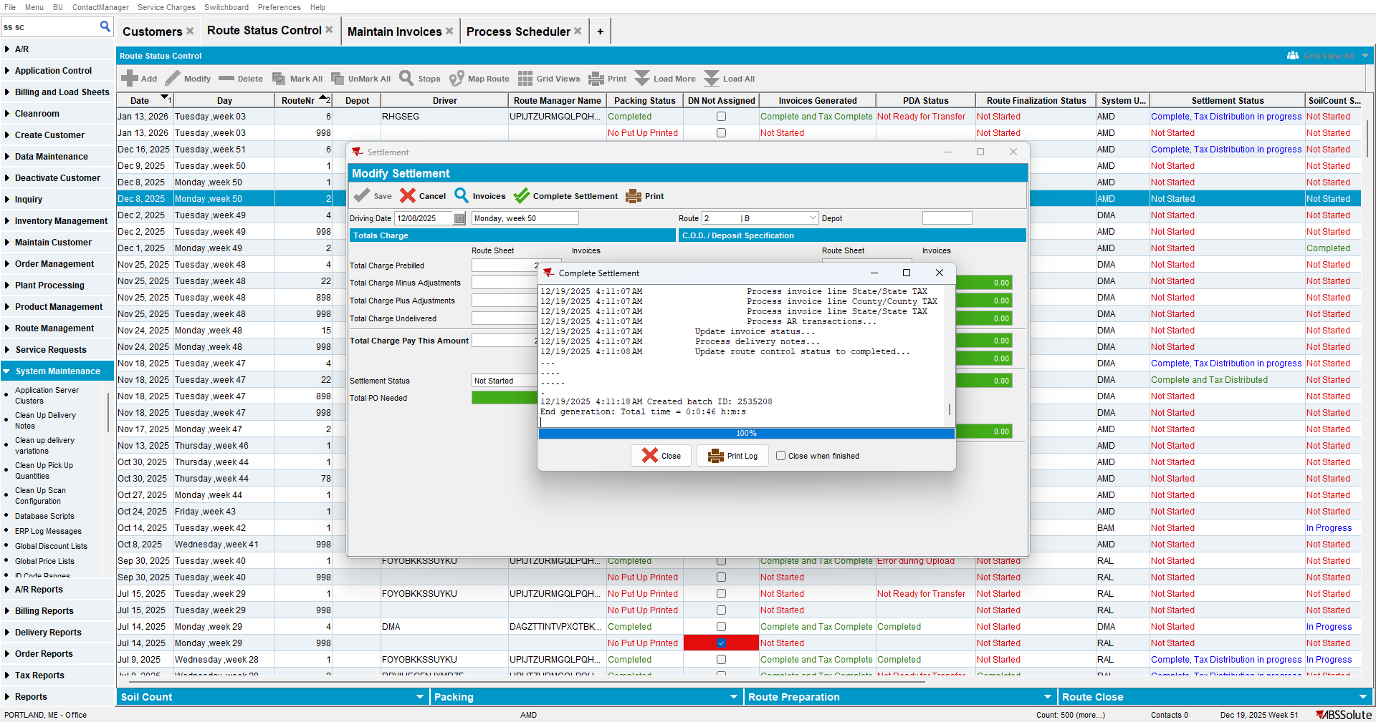

Run “Create Credit Card transaction from payment schedule” process.

Go to Credit Card Transactions dlg and Settle the transactions.
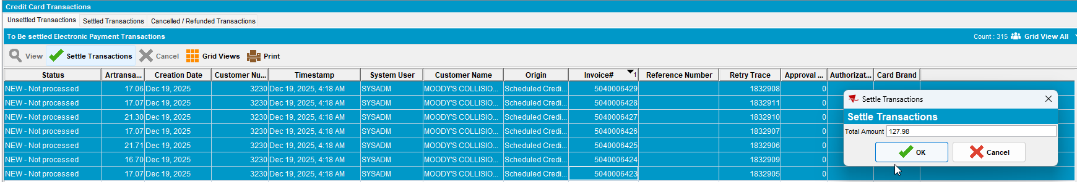
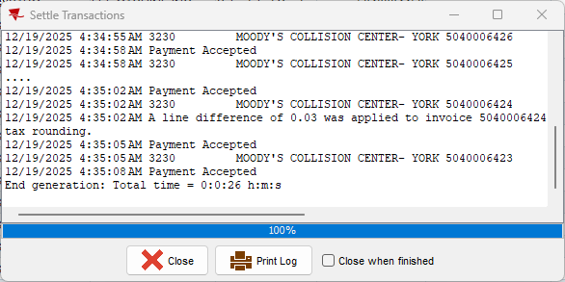

Check the xml for each transaction.

Product 12AK06 –> Price > 0, Qty = 0, Total Amt > 0 – Invoice 5040006423
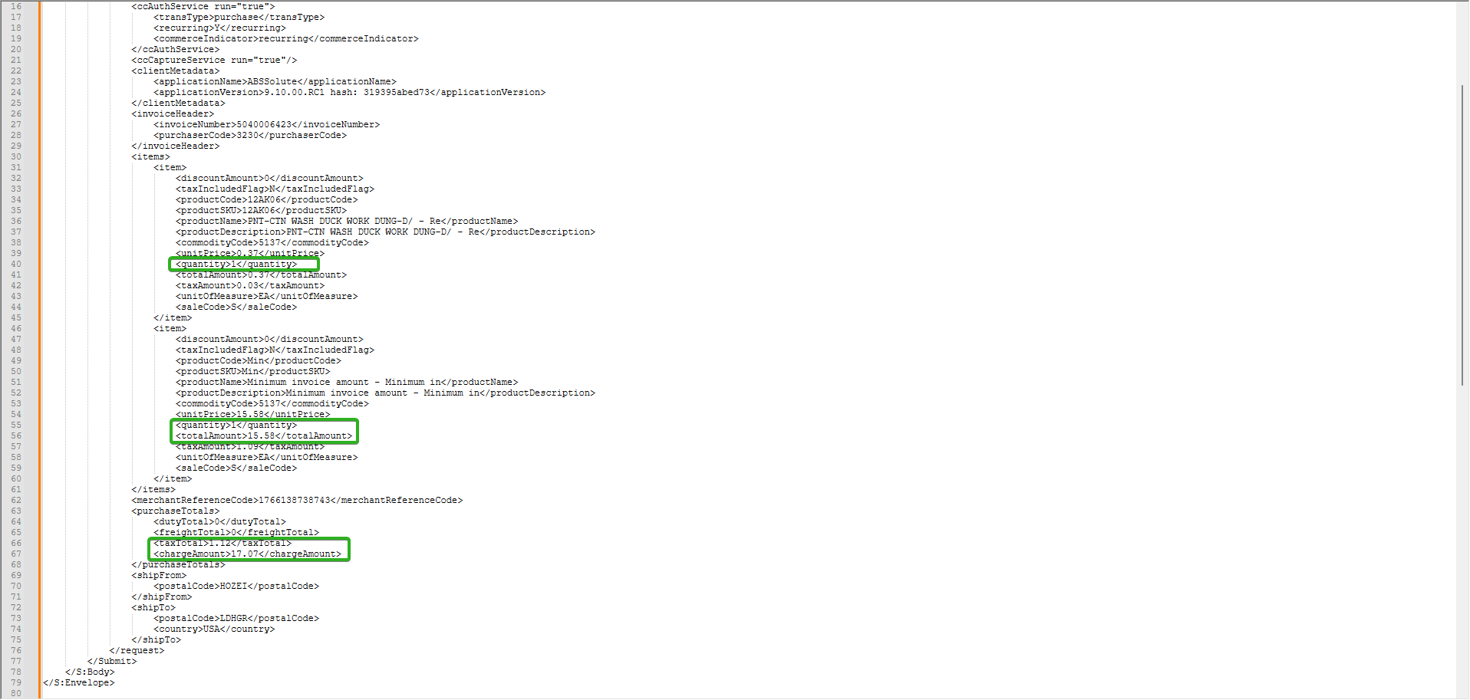
For product 1 CALC quantity = totalAmount/unitPrice (1) as expected
For Minimum Invoice Amount case 5 is applied set quantity = 1 then CALC unitPrice = totalAmount/quatity (15.58)
taxTotal (1.12) is the sum of all the taxAmounts and chargeAmount (17.07) is the sum of all totalAmounts + taxTotal

Product 12AK64 -> Price > 0, Qty = 0, Total Amt = 0 – Invoice 5040006424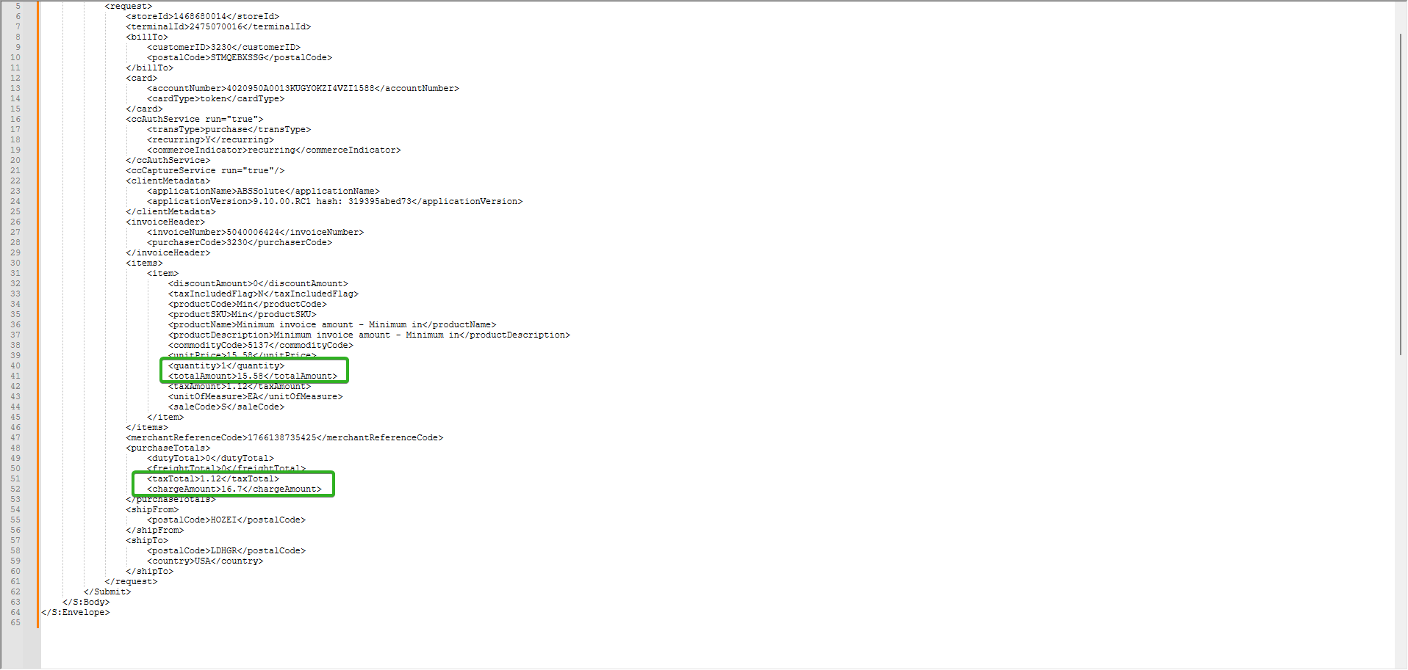
For product 2 Suppress line as expected
For Minimum Invoice Amount case 5 is applied set quantity = 1 then CALC unitPrice = totalAmount/quatity (15.58)
taxTotal (1.12) is the sum of all the taxAmounts and chargeAmount (16.7) is the sum of all totalAmounts + taxTotal

Product 76BJ03 -> Price = 0, Qty > 0, Total Amt > 0 – Invoice 5040006425
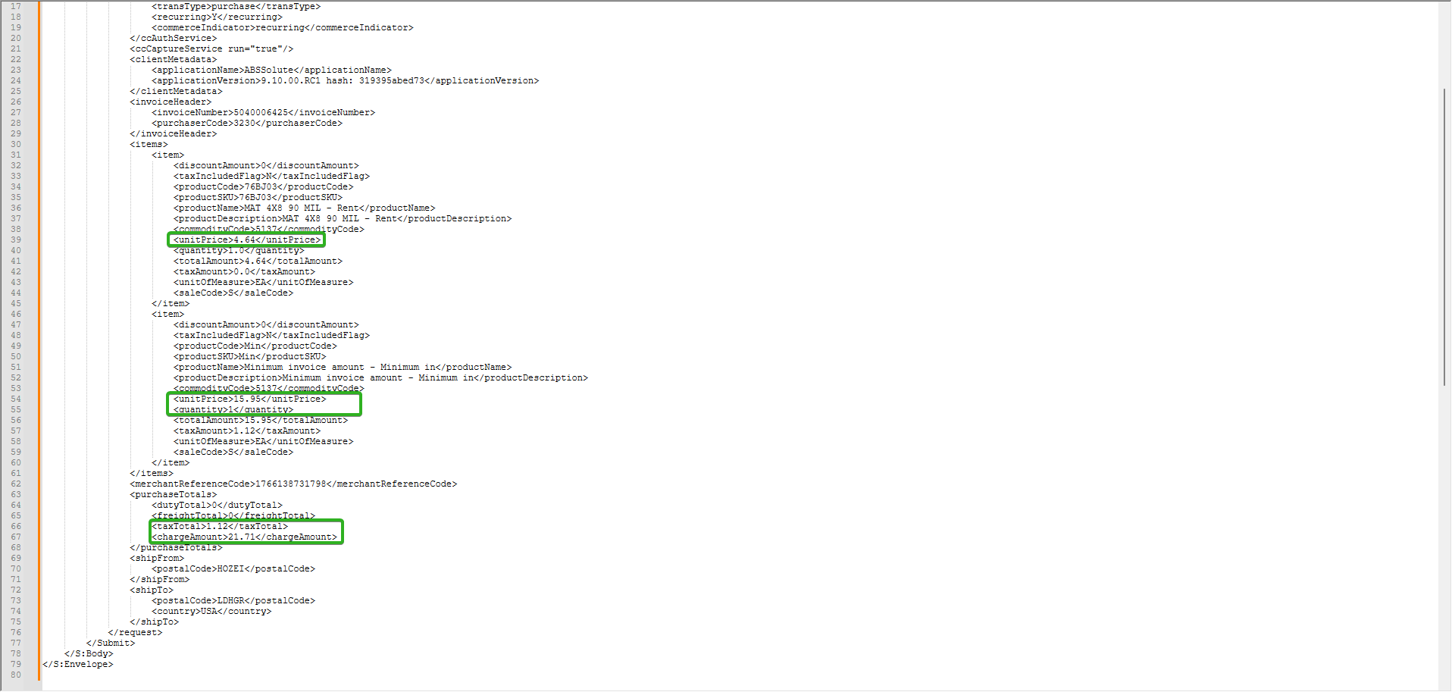
For product 3 CALC unitPrice = totalAmount/quantity (4.64) as expected
For Minimum Invoice Amount case 5 is applied set quantity = 1 then CALC unitPrice = totalAmount/quantity (15.95)
taxTotal (1.12) is the sum of all the taxAmounts and chargeAmount (21.71) is the sum of all totalAmounts + taxTotal

Product 76GB03 -> Price = 0, Qty > 0, Total Amt = 0 – Invoice 5040006426 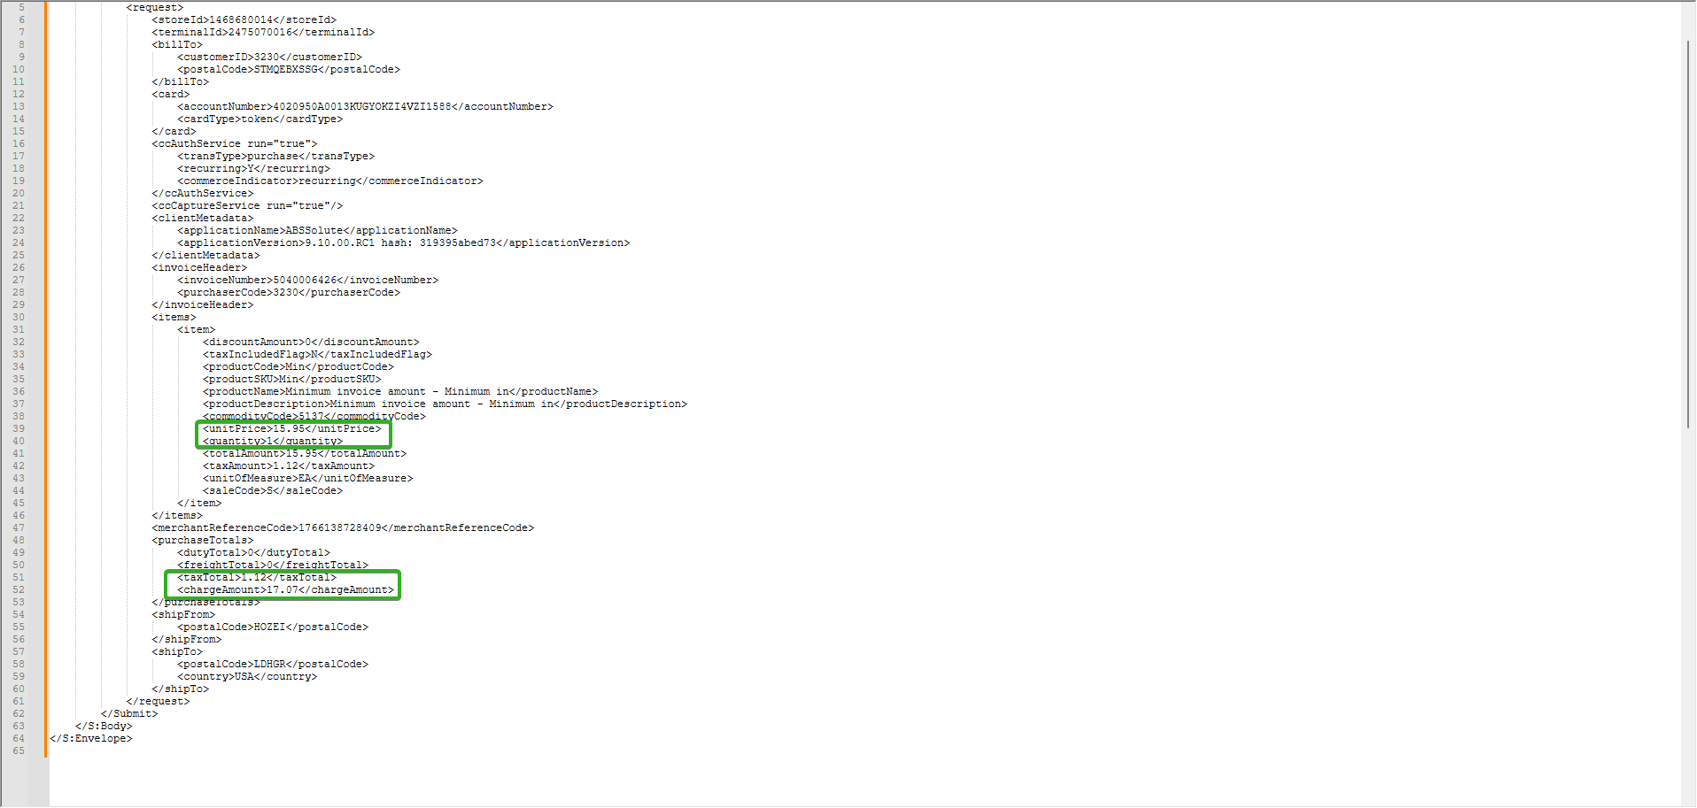
For product 4 Suppress line as expected
For Minimum Invoice Amount case 5 is applied set quantity = 1 then CALC unitPrice = totalAmount/quatity (15.58)
taxTotal (1.12) is the sum of all the taxAmounts and chargeAmount (17.07) is the sum of all totalAmounts + taxTotal

Product 76GC03 -> Price = 0, Qty = 0, Total Amt > 0 – Invoice 5040006427
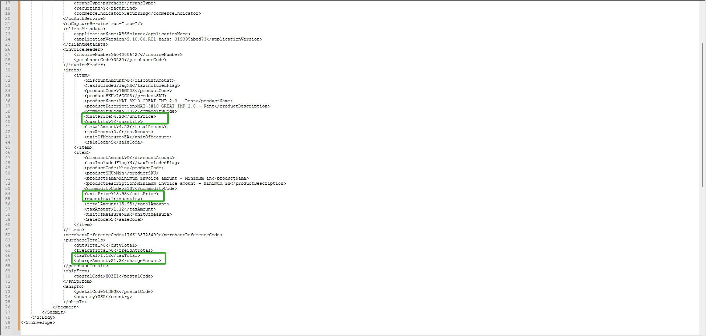
For product 5 CALC unitPrice = set quantity = 1 then CALC unitPrice = totalAmount/quantity (4.23) as expected
For Minimum Invoice Amount case 5 is applied set quantity = 1 then CALC unitPrice = totalAmount/quantity (15.95)
taxTotal (1.12) is the sum of all the taxAmounts and chargeAmount (21.3) is the sum of all totalAmounts + taxTotal

Product 843812 -> Price = 0, Qty = 0, Total Amt = 0 – Invoice 5040006428
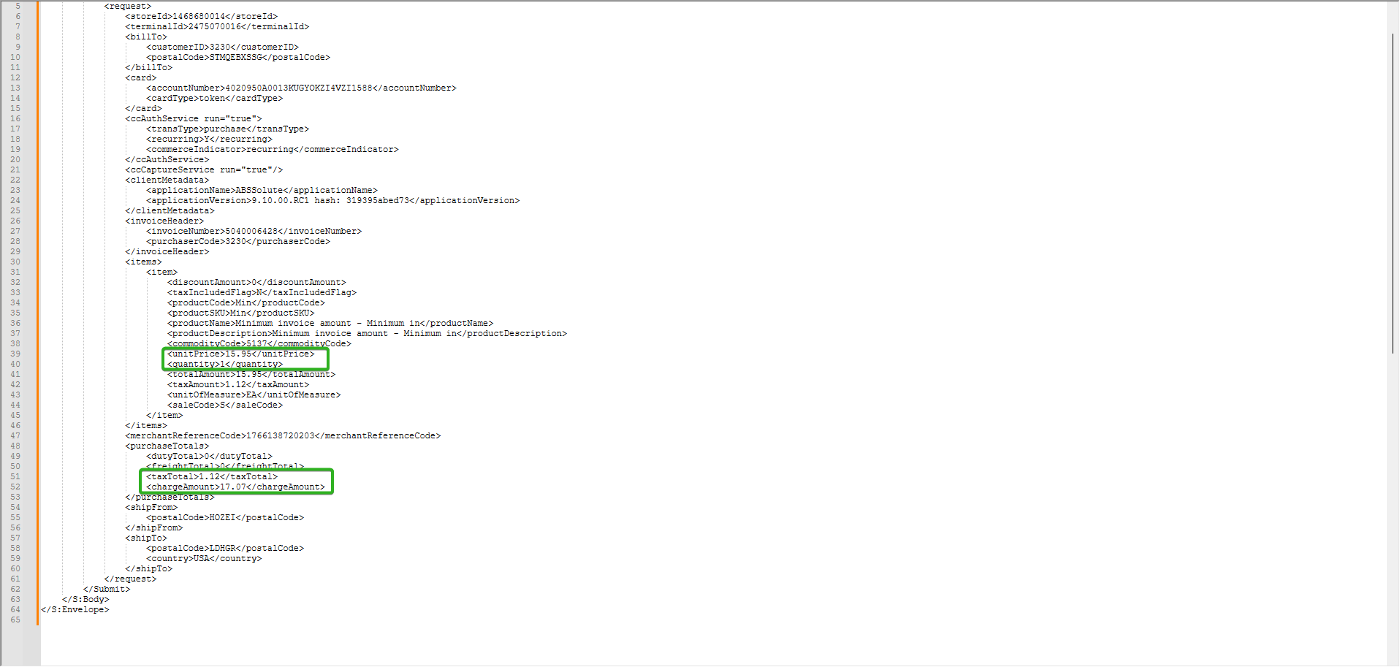
For product 6 Suppress line as expected
For Minimum Invoice Amount case 5 is applied set quantity = 1 then CALC unitPrice = totalAmount/quatity (15.95)
taxTotal (1.12) is the sum of all the taxAmounts and chargeAmount (17.07) is the sum of all totalAmounts + taxTotal

Product 852305 - Price > 0, Qty > 0, Total Amt > 0 – Invoice 5040006429
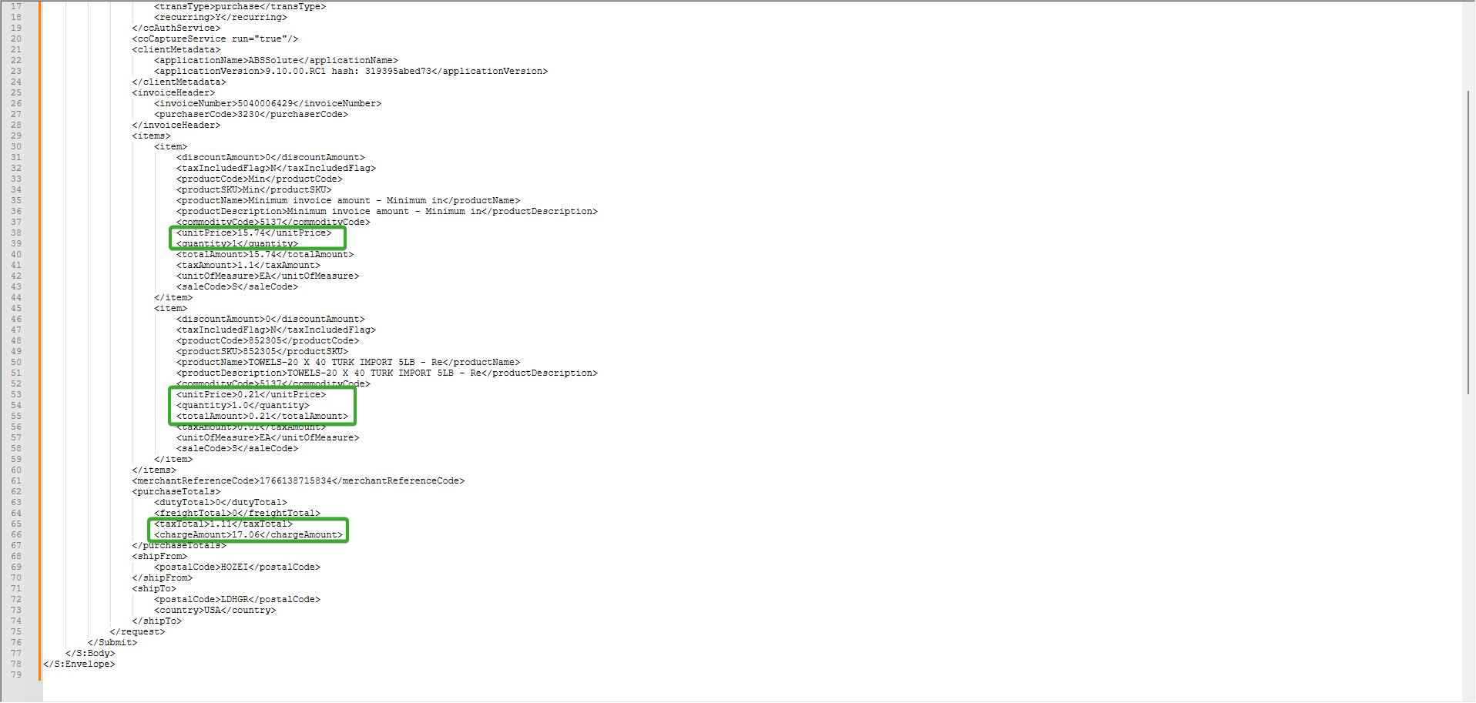
For product 7 No action, complete line
For Minimum Invoice Amount case 5 is applied set quantity = 1 then CALC unitPrice = totalAmount/quatity (15.74)
taxTotal (1.11) is the sum of all the taxAmounts and chargeAmount (17.06) is the sum of all totalAmounts + taxTotal

Now we’ll create two invoices and settle them using the “Take Electronic Payment” scheduled process.
Create two invoices with all the 7 cases.
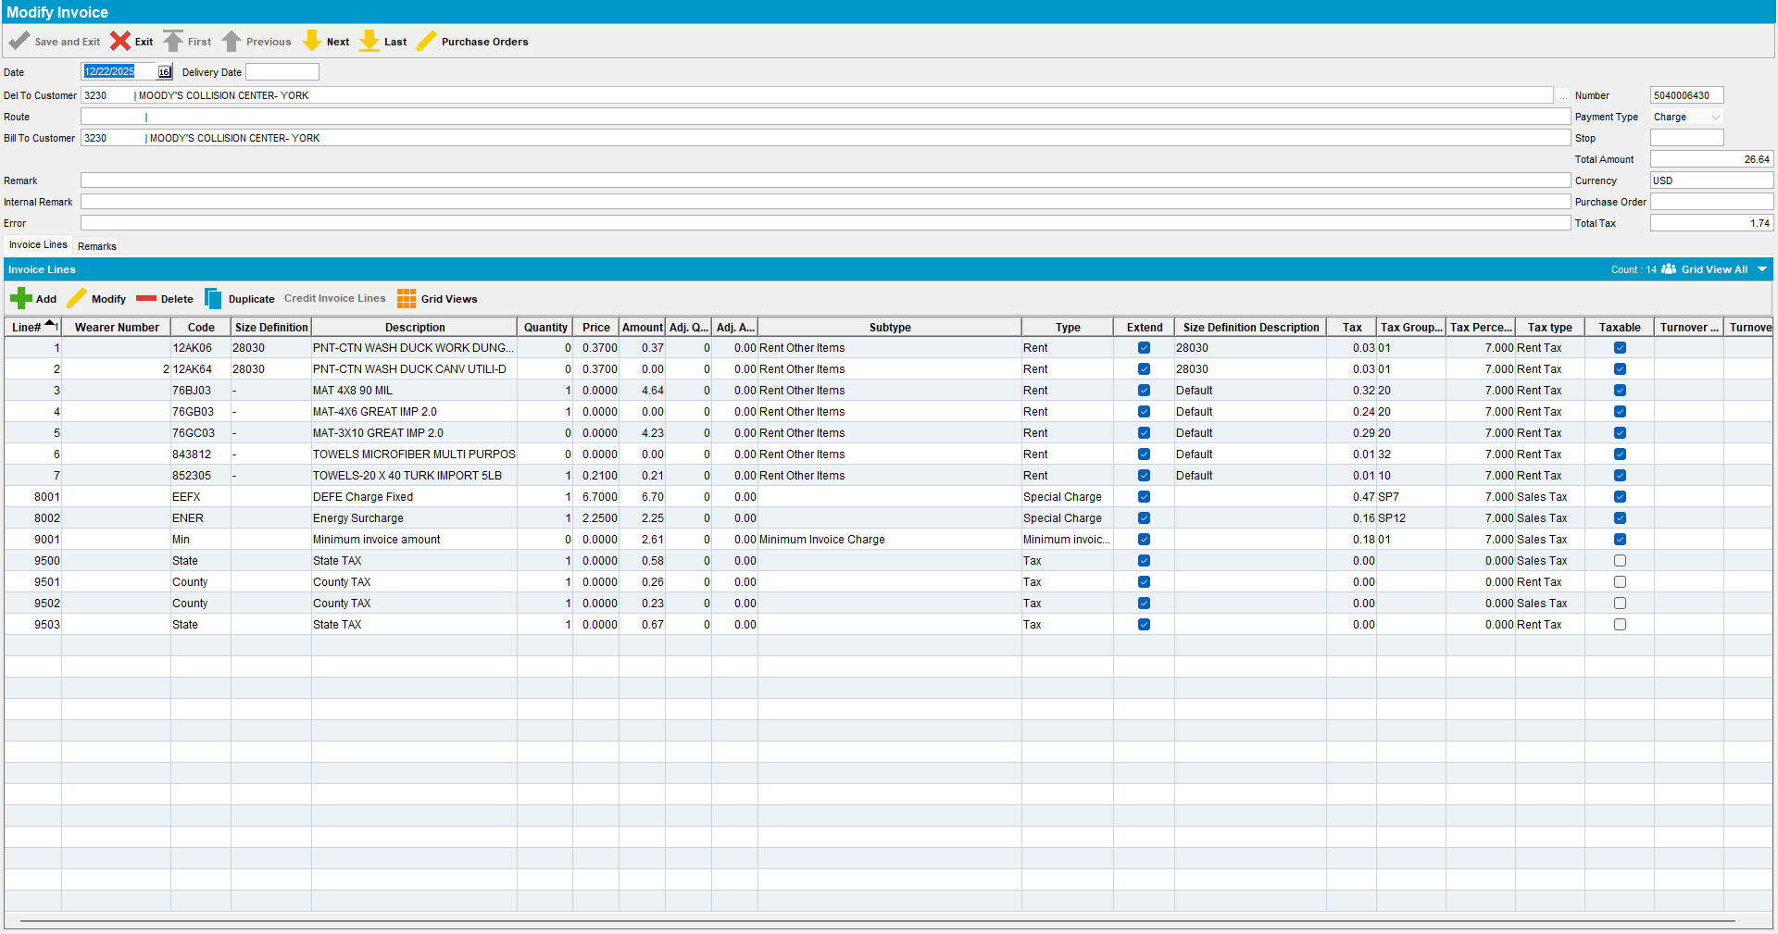
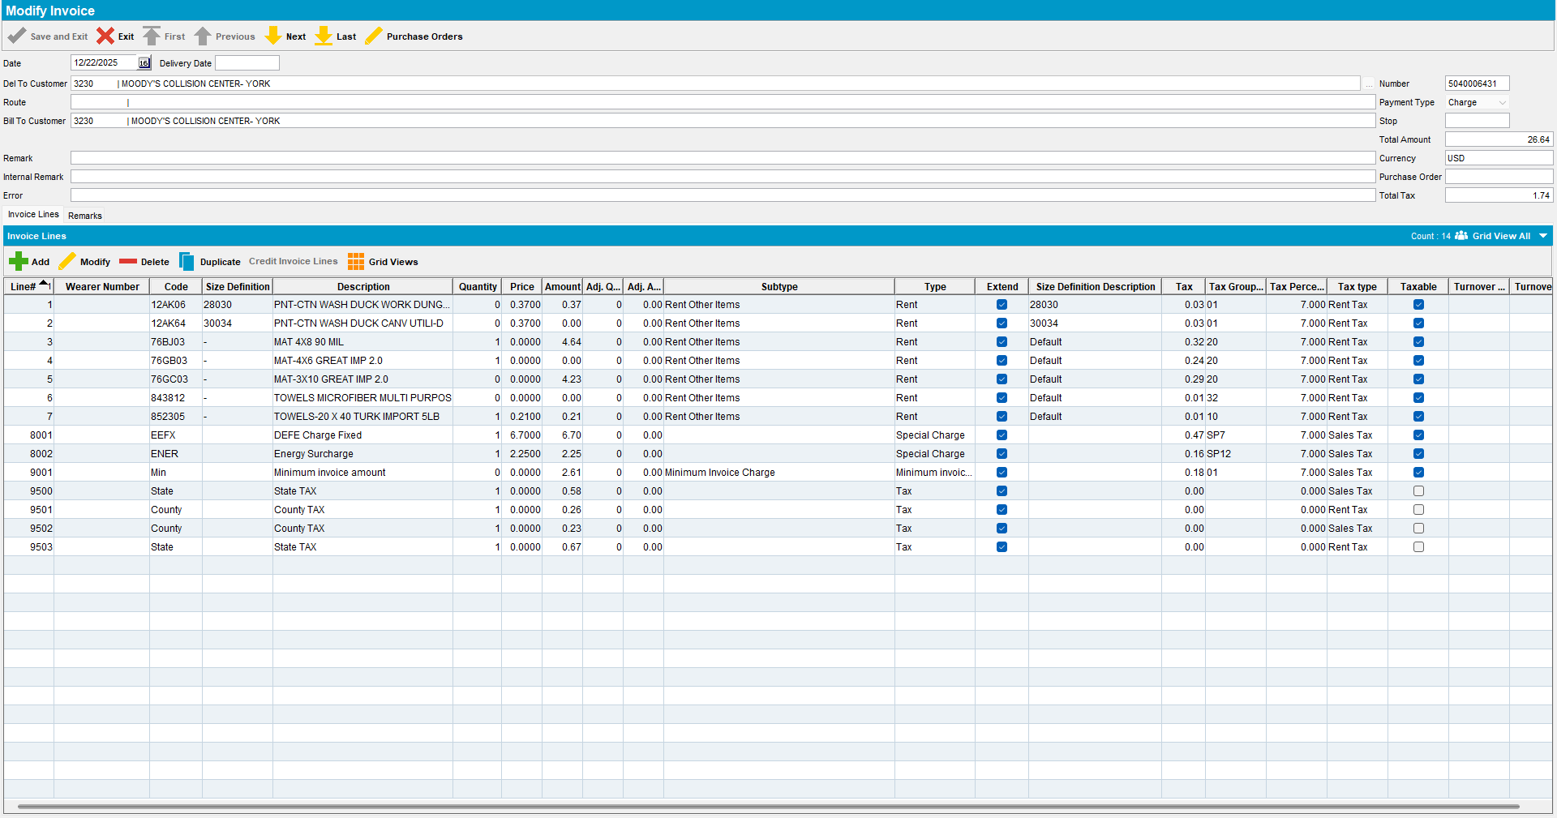

Assign the invoices to a route with a past date. 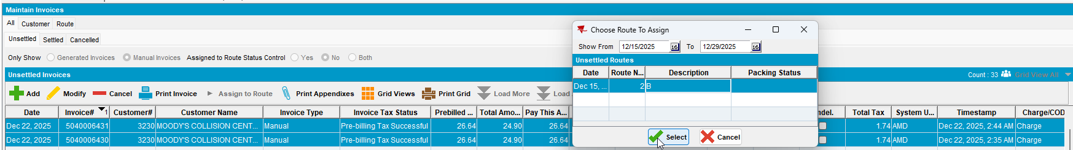

Generate the invoices for that route.
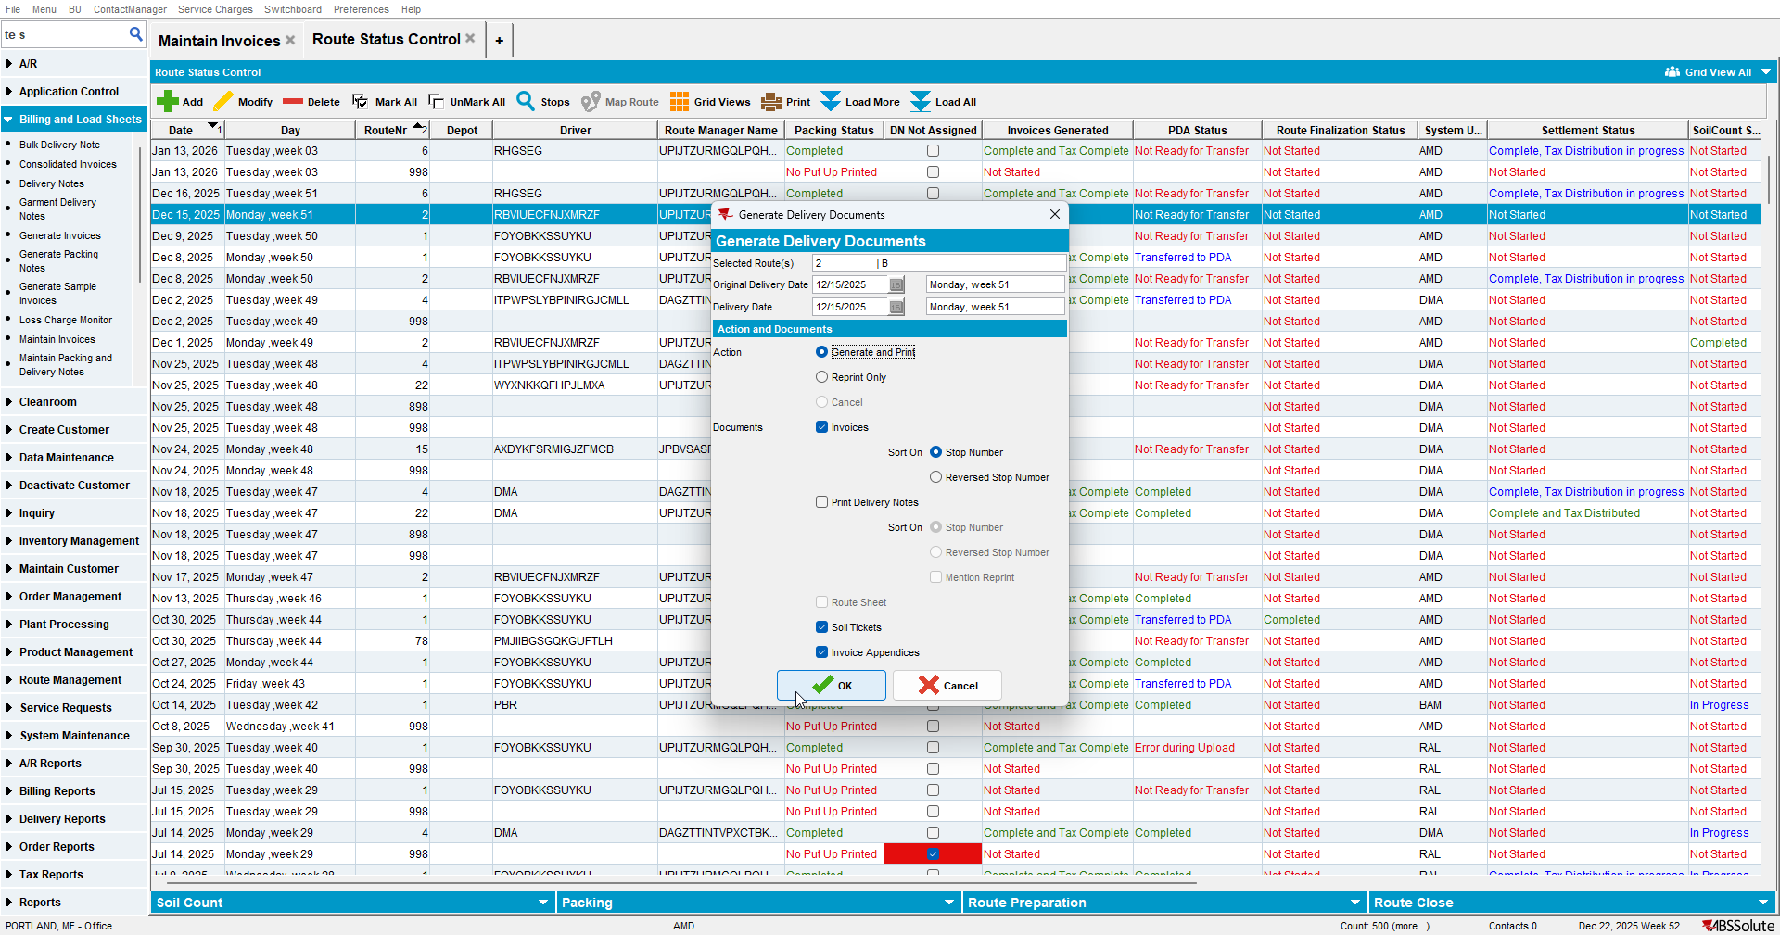

Settle the route.
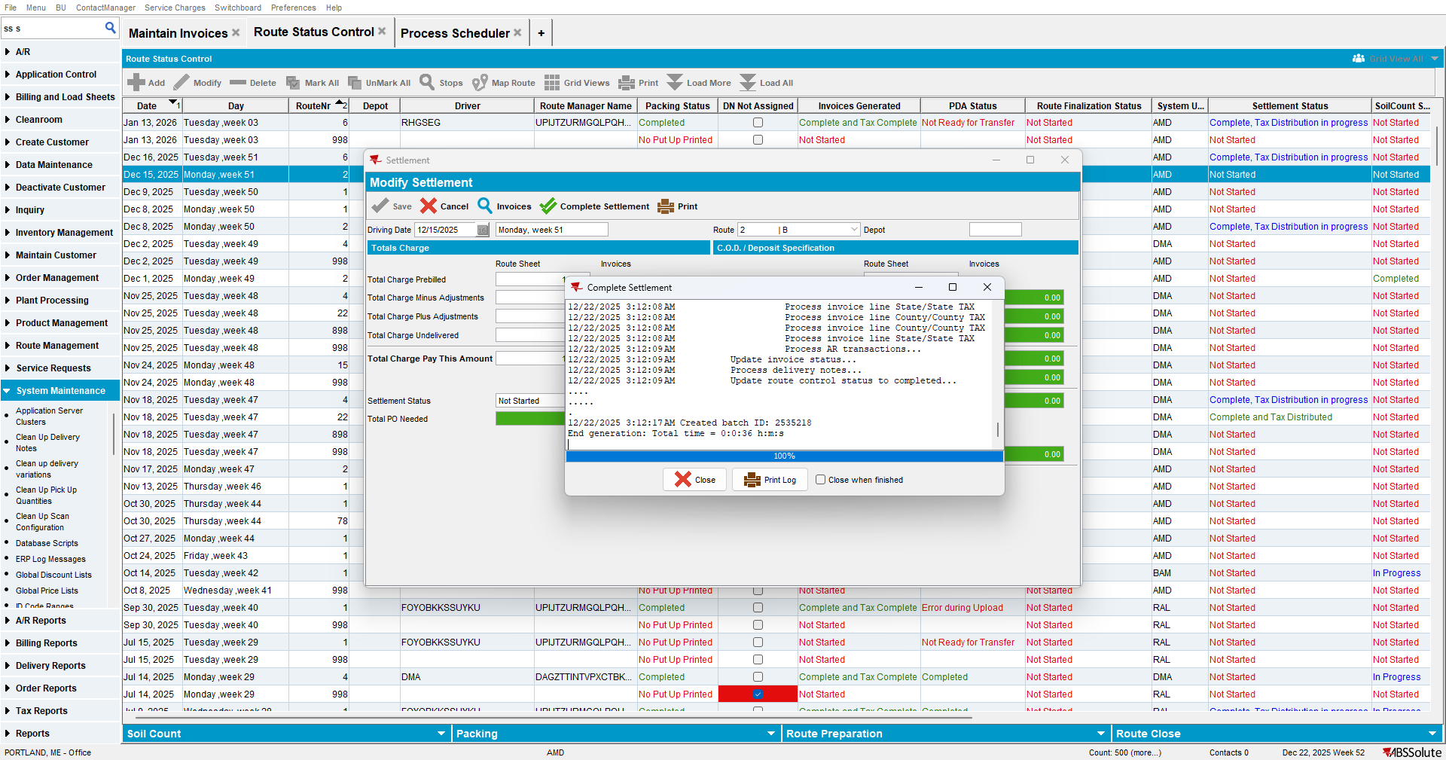

Run “Create Credit Card transaction from payment schedule” process.
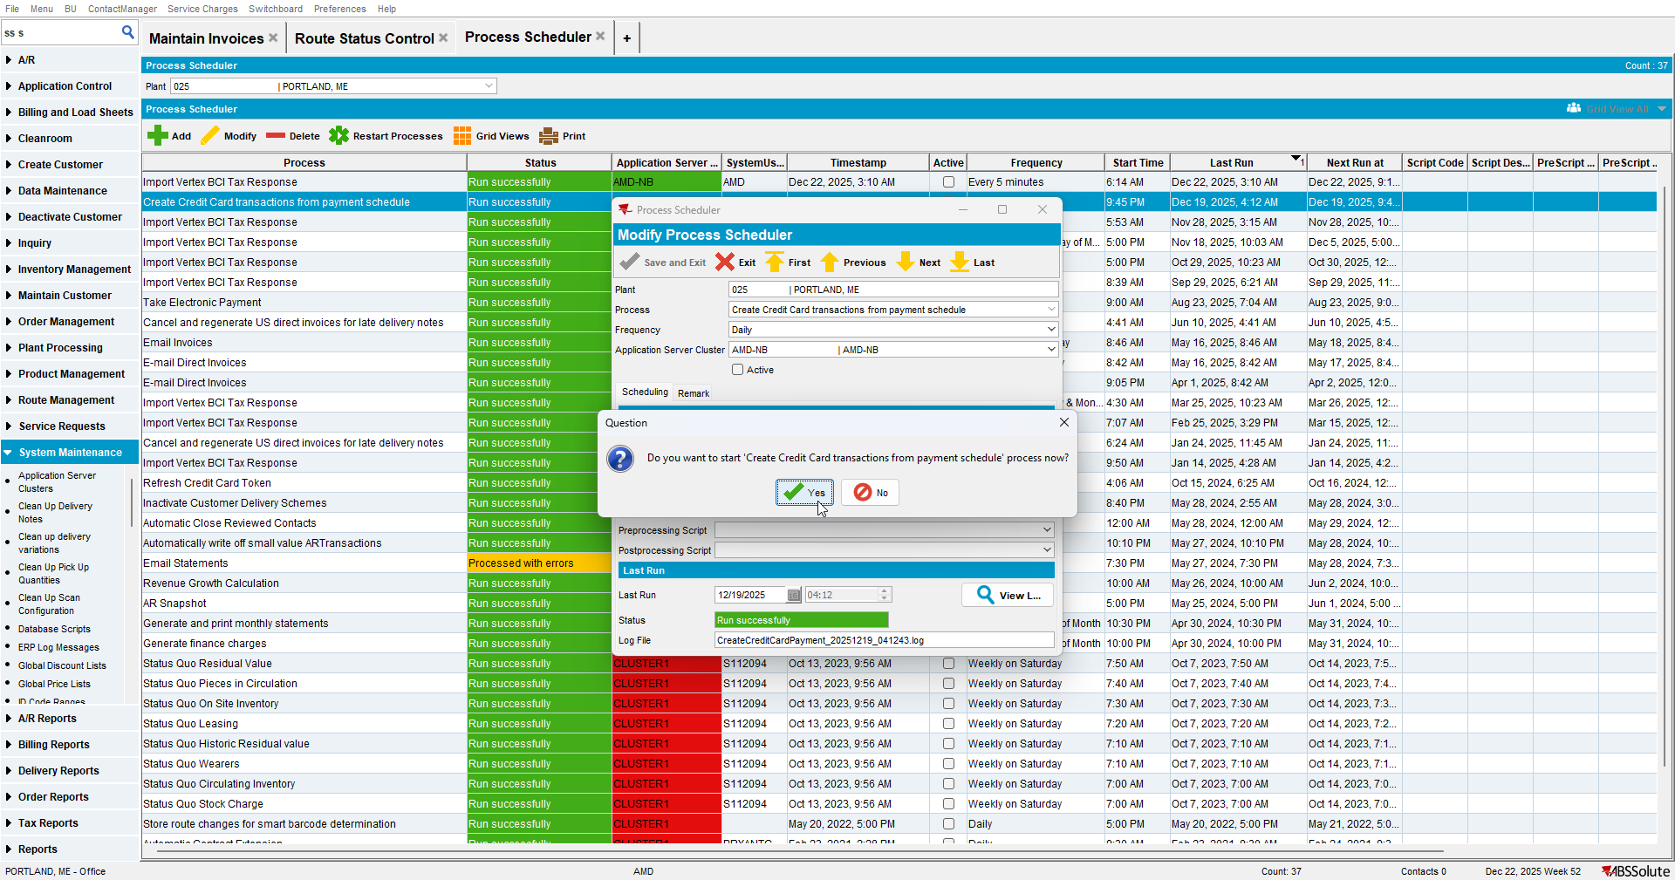
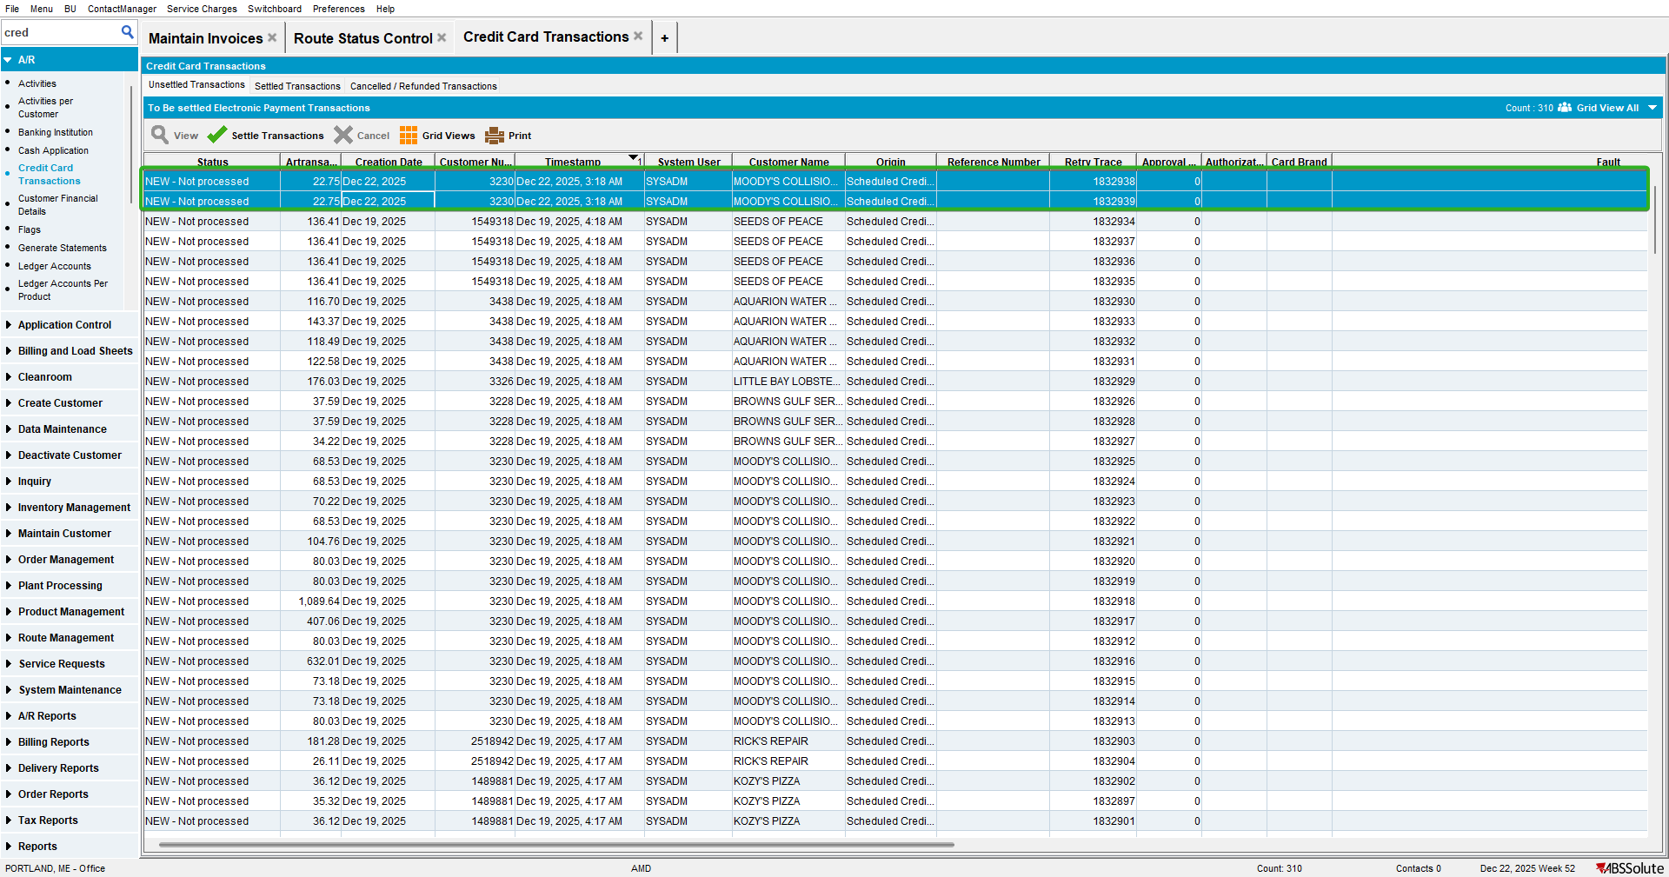

Run “Take Electronic Payment” schedule process.
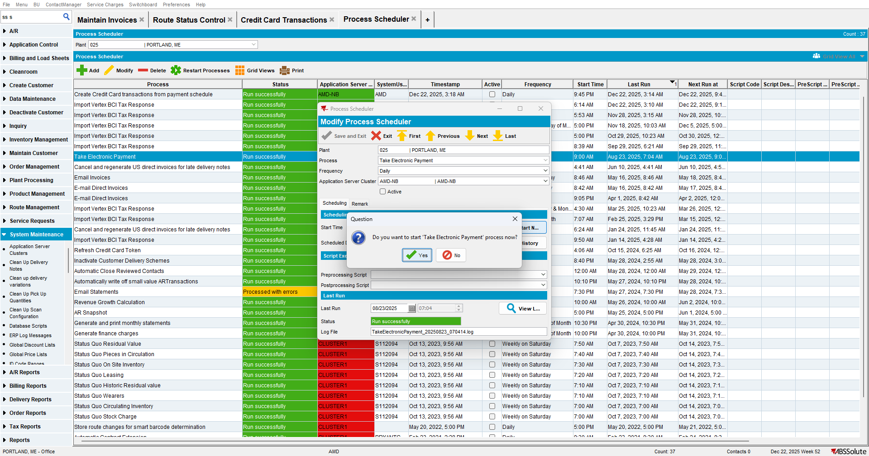

Check the xml (there should be only one for both invoices).
For product 1 (12AK06), there should be two occurrences in the request.
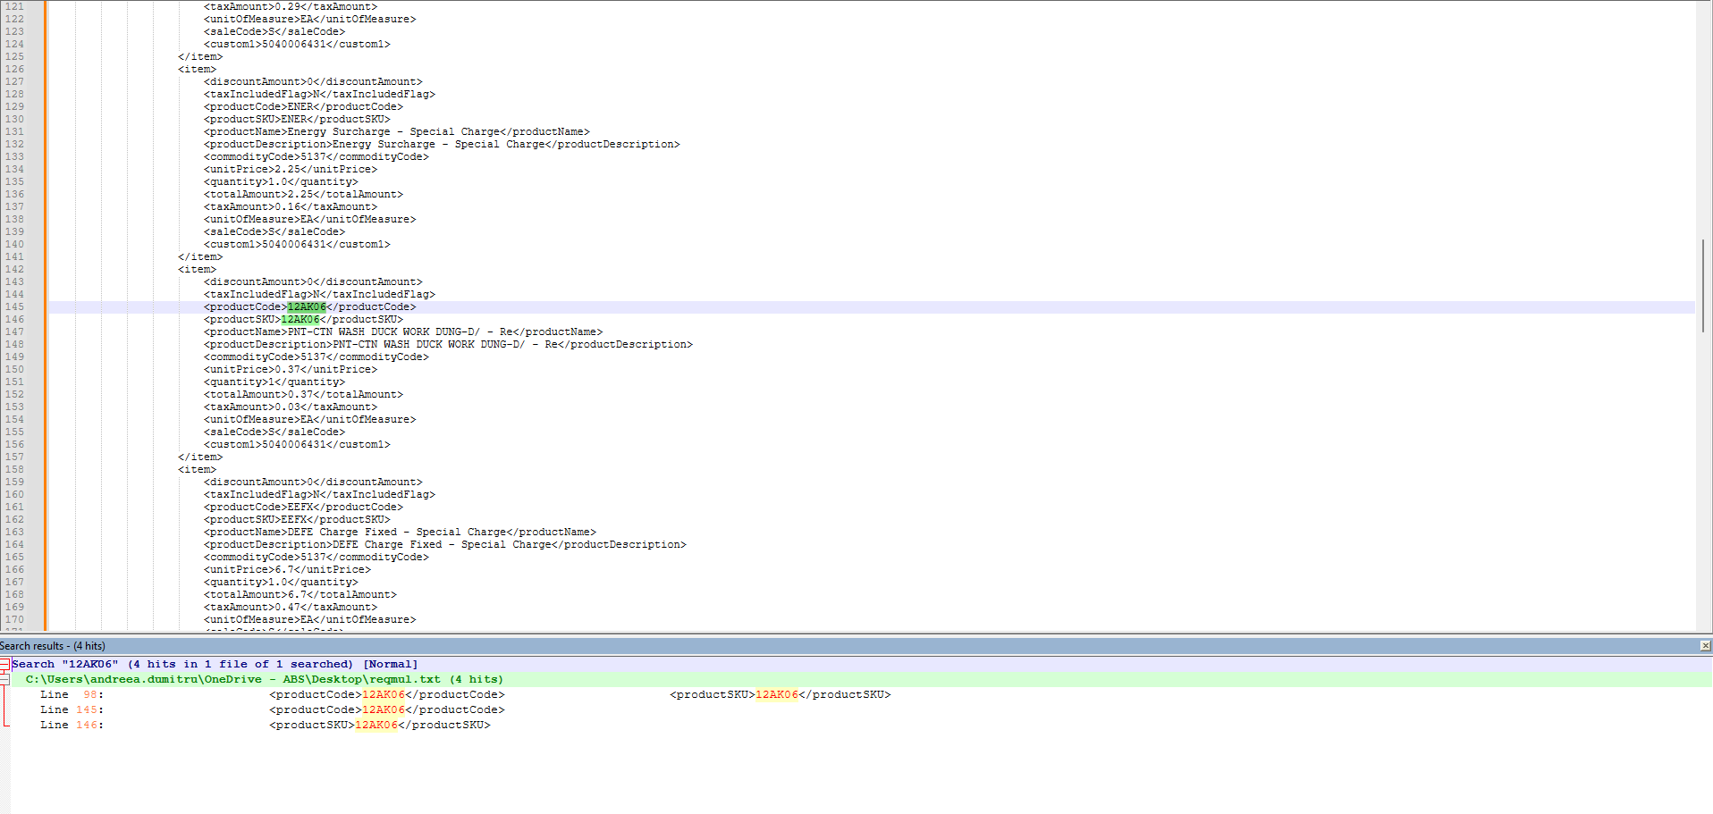

For product 2 (12AK64), no entries should appear in the request, as it is suppressed.

For product 3 (76BJ03), there should be two occurrences in the request.
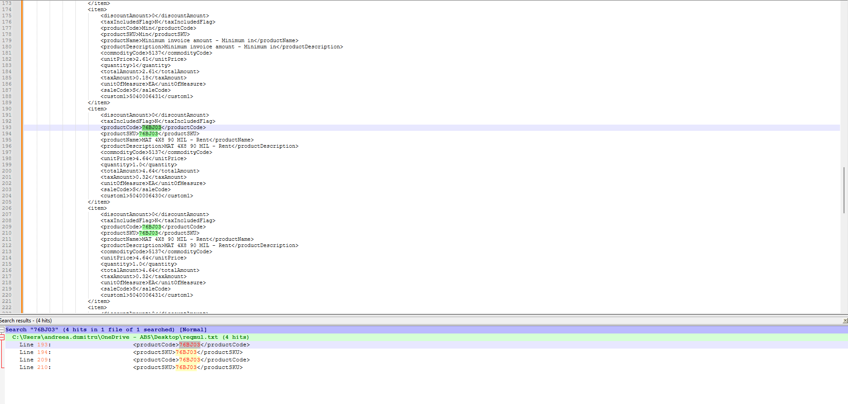

For product 4 (76GB03), no entries should appear in the request, as it is suppressed.

For product 5 (76GC03), there should be two occurrences in the request.
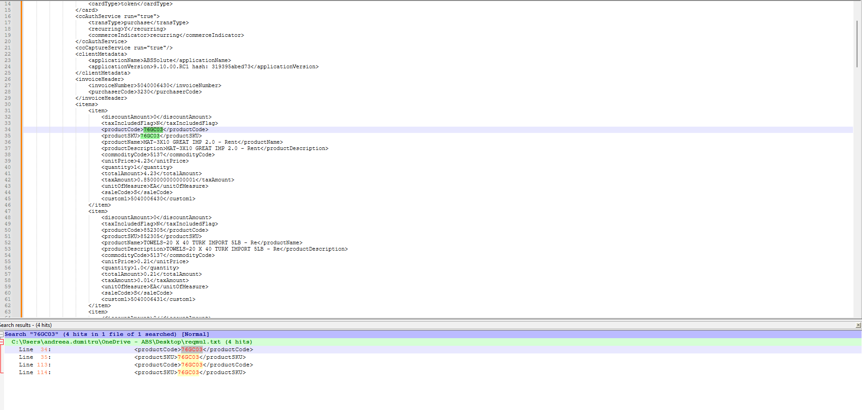

For product 6 (843812), no entries should appear in the request, as it is suppressed.

For product 7 (852305), there should be two occurrences in the request.
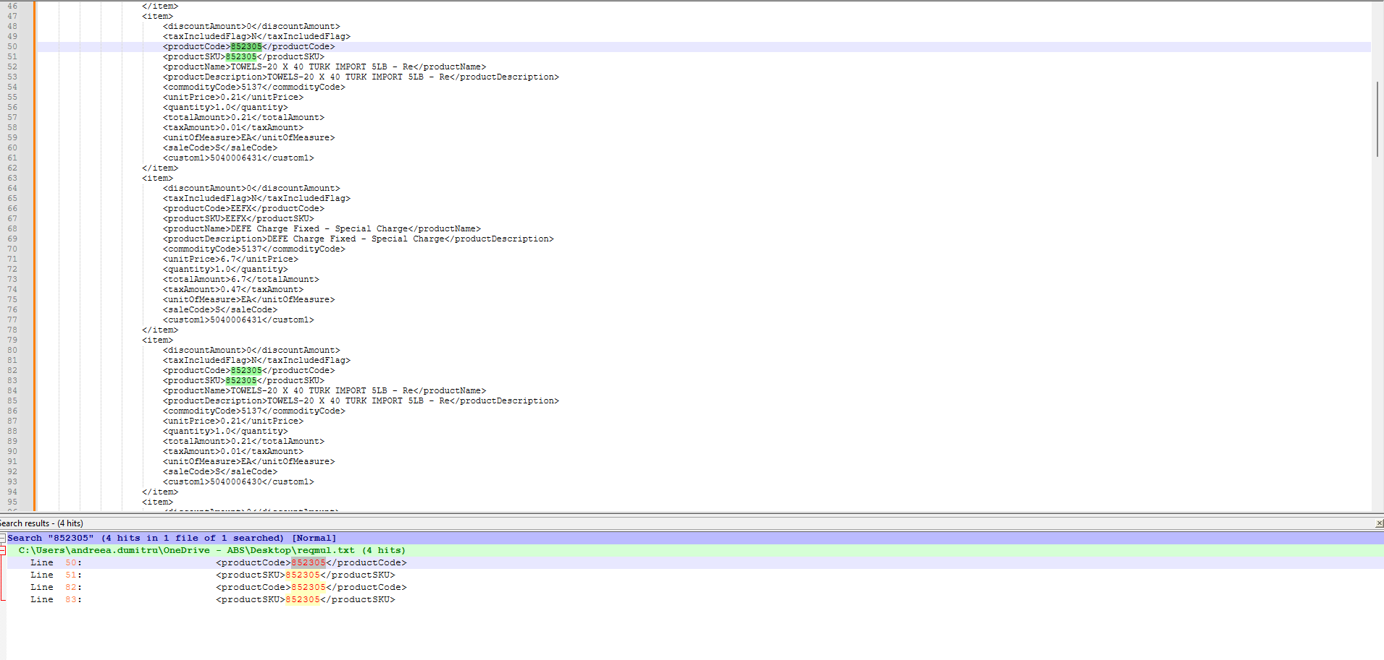
Now we’ll check the rounding.
Create an invoice.
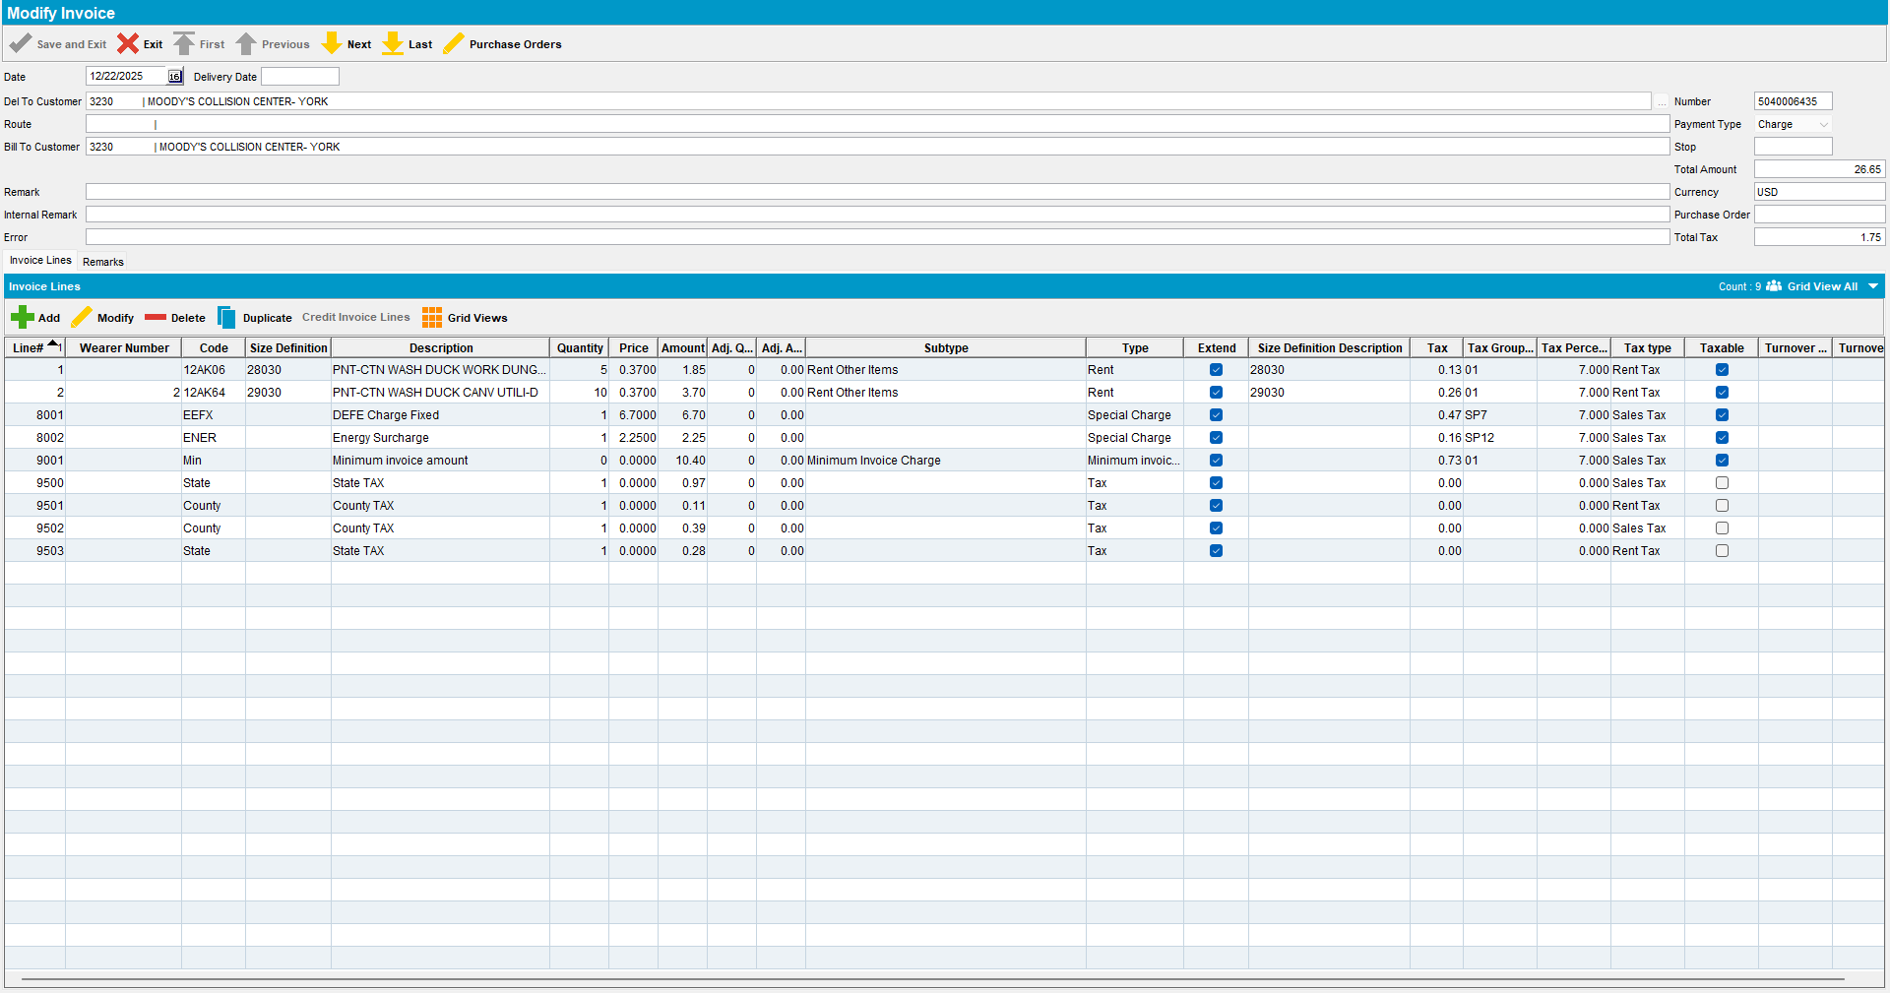

Assign the invoice to a route with a past date.
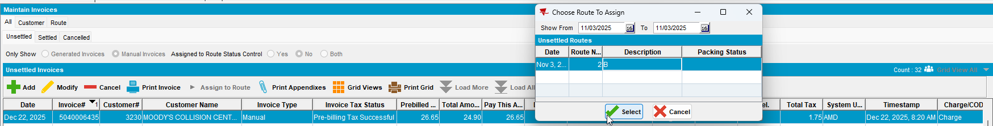

Generate the invoices for that route.
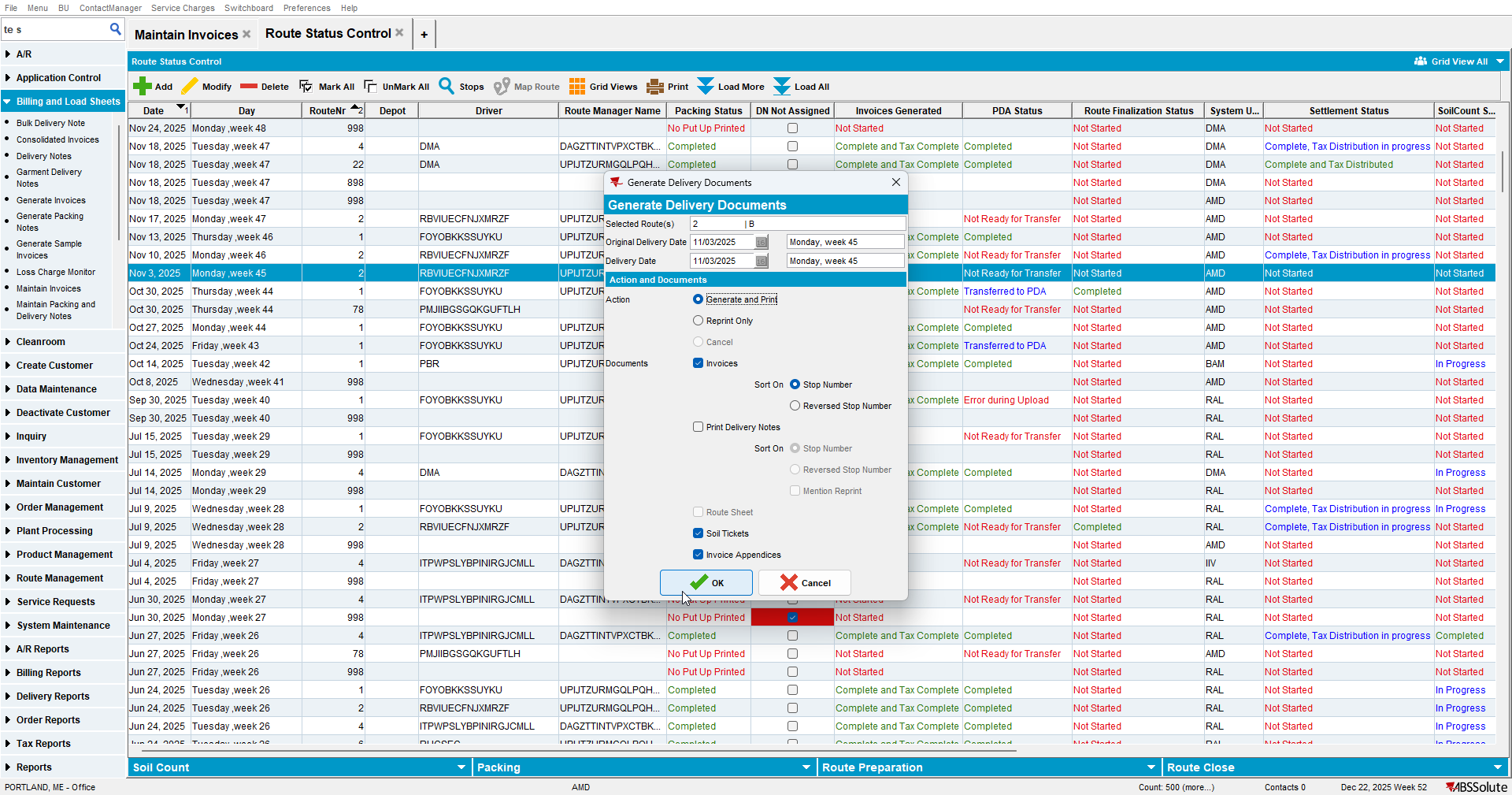

Settle the route.
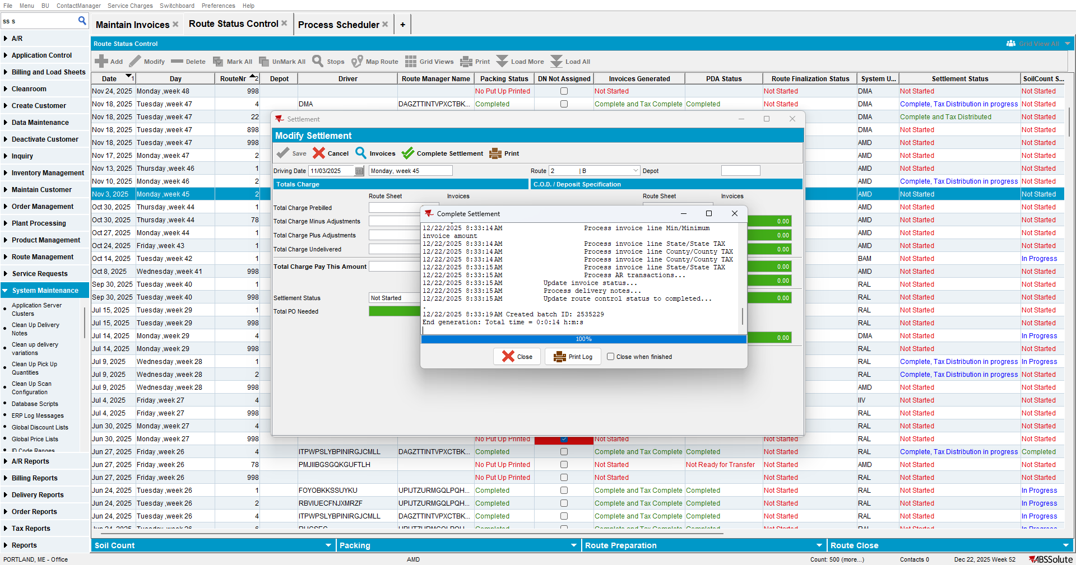

Run “Create Credit Card transaction from payment schedule” process.
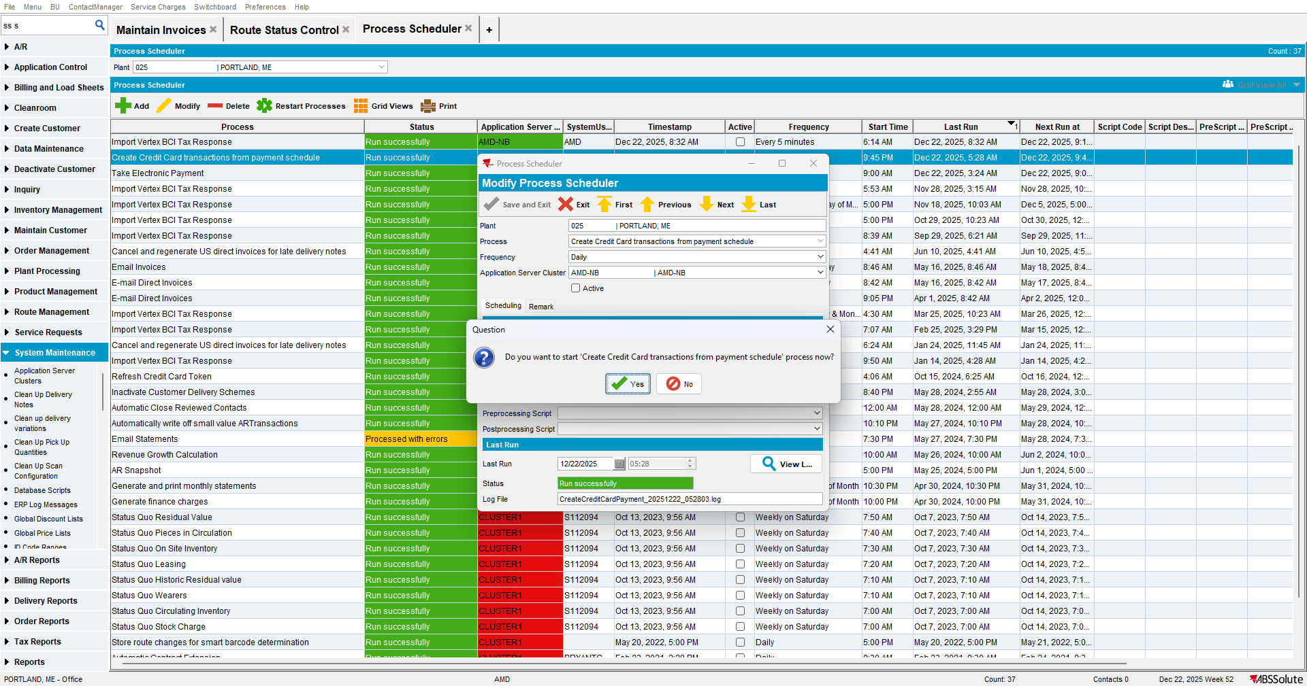

Update line 1 of the invoice in the database by applying a 0.1 adjustment (from 1.85 to 1.75). 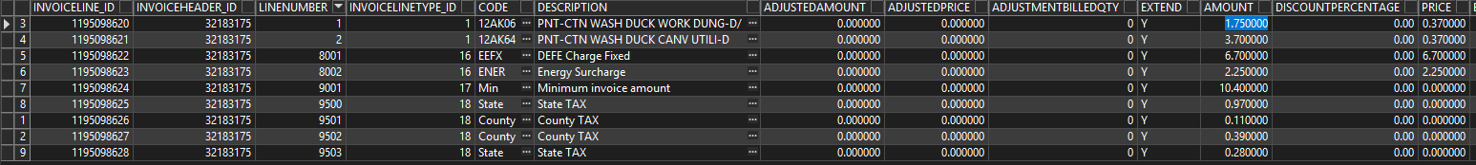

Settle the transaction.
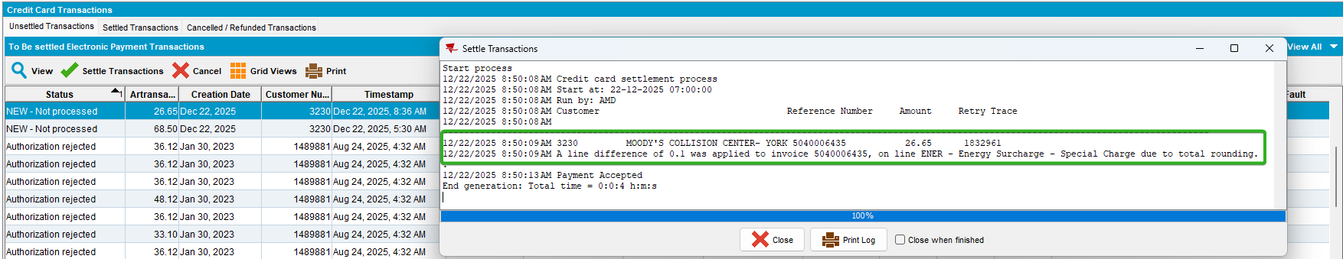

Check the xml.
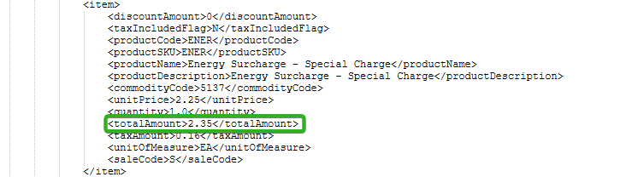
The difference was added to the first line amount.

TESTED OK.

