ASDN-6410 D_UBS_2802 Temp rent stop not working for BM2
Environment | Prerequisites
Version:9.07.00.UNF21  DBServerName= abs-srv20.internal.abslbs.com  DBSID=CUST24  DBUser=UNFDEV  Environment=PRODUCTION | - Module:  - System setting

Contents
Reproduce before fix 1
Steps to reproduce: 2
Retest after fix 4
Test Case 1 – Temporary Delivery Stop Yearly from week, Start week <= end week 4
Steps to reproduce: 4
1.1 Test inside interval of rent stop period - OK 6
1.2 Test outside interval, before rent stop – OK 7
1.3 Test outside interval, after rent stop - OK 9
1.4 Test on the first start week of rent stop - OK 10
1.5 Test on the last end week of rent stop - OK 11
Test Case 2 - Temporary Delivery Stop Yearly from week, Start week >= end week 12
Steps to reproduce: 12
2.1 Test inside interval of rent stop period- OK 14
2.2 Test outside interval, before rent stop - OK 15
2.3 Test outside interval, after rent stop - OK 17
2.4 Test on the first start week of rent stop – OK 18
2.5 Test on the last end week of rent stop - OK 19
Test Case 3 - Temporary Delivery Stop From Year/Week 20
Steps to reproduce: 20
3.1 Test inside interval - OK 22
3.2 Test outside interval - OK 23
Test Case 4 - Temporary Delivery Stop From Date 25
Steps to reproduce: 25
2.1 Test inside interval - OK 26
4.2 Test outside interval - OK 27

Reproduce before fix
Bu: 066 North Canton
Customer: 1448204
9.07.00.UNF17.p17 hash: beebfb3f158f

Steps to reproduce:
- Consumption Point Logistics dlg: Load the customer 1448204 and for product 842309 make a temp rent stop.
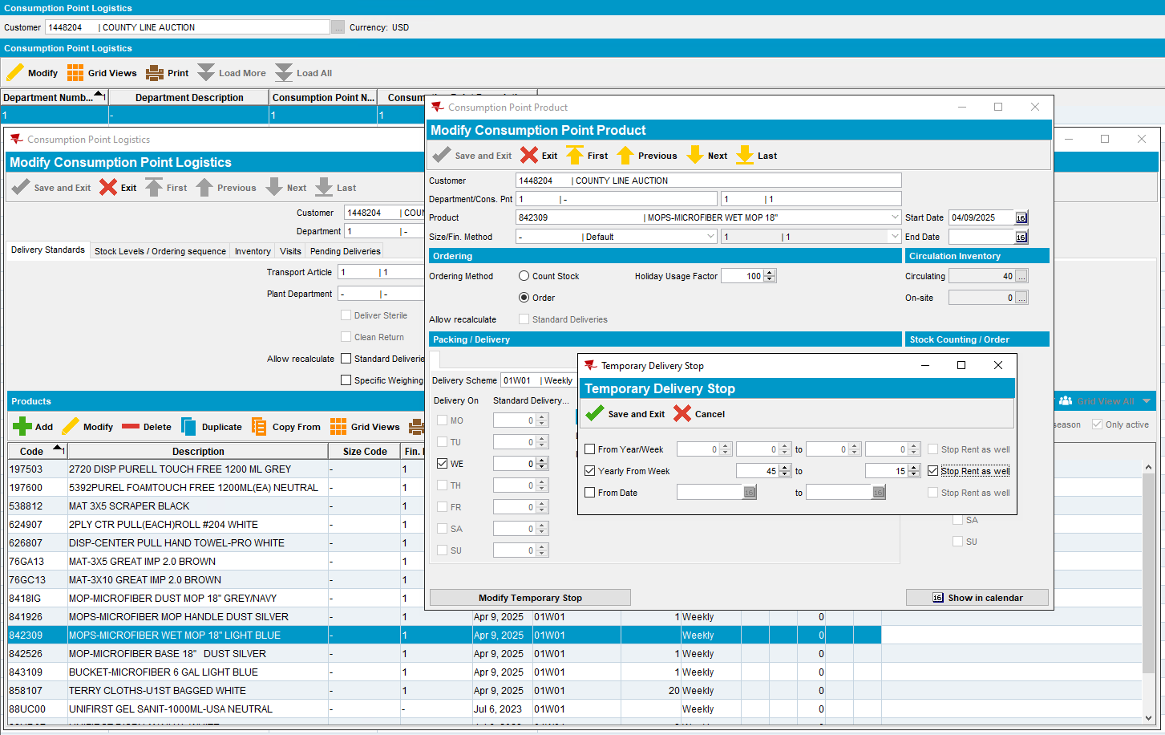
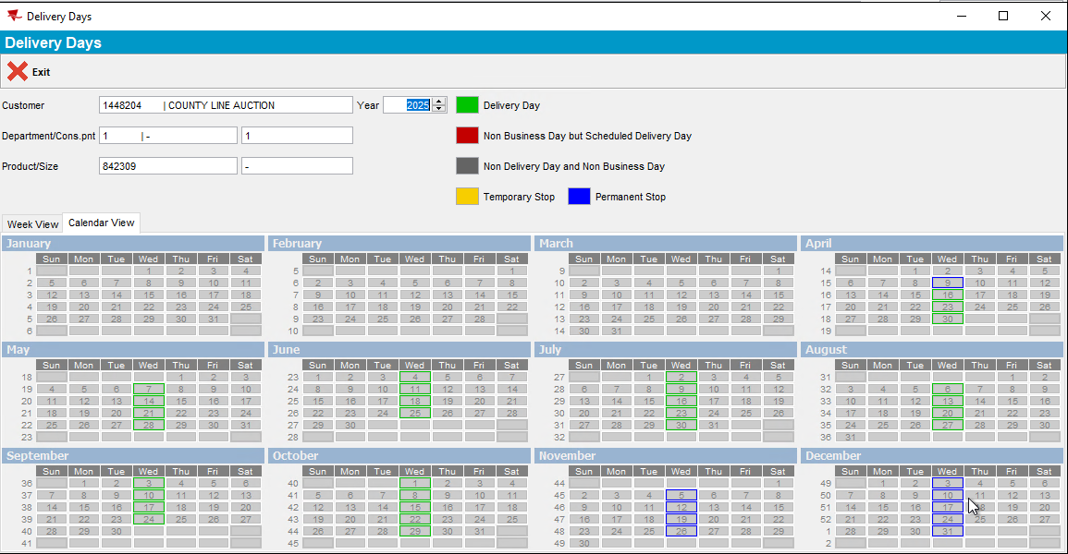
- RSC dlg: Route 1 from 10-12-2025 with the customer 1448204, move out the other customers. Generate packing notes.
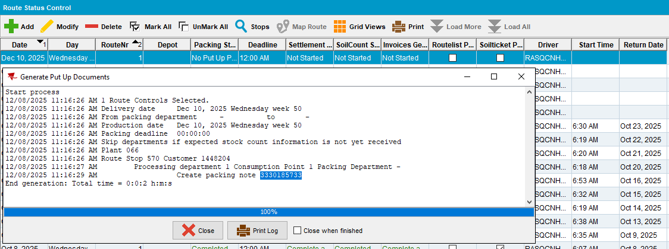
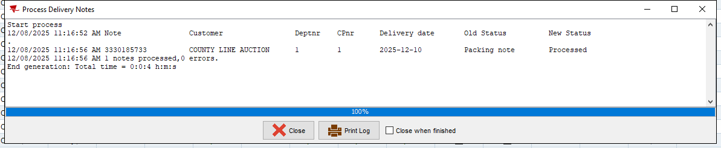
- RSC dlg: Generate invoices.
- Maintain Invoices dlg: Check the invoice for product 842309.
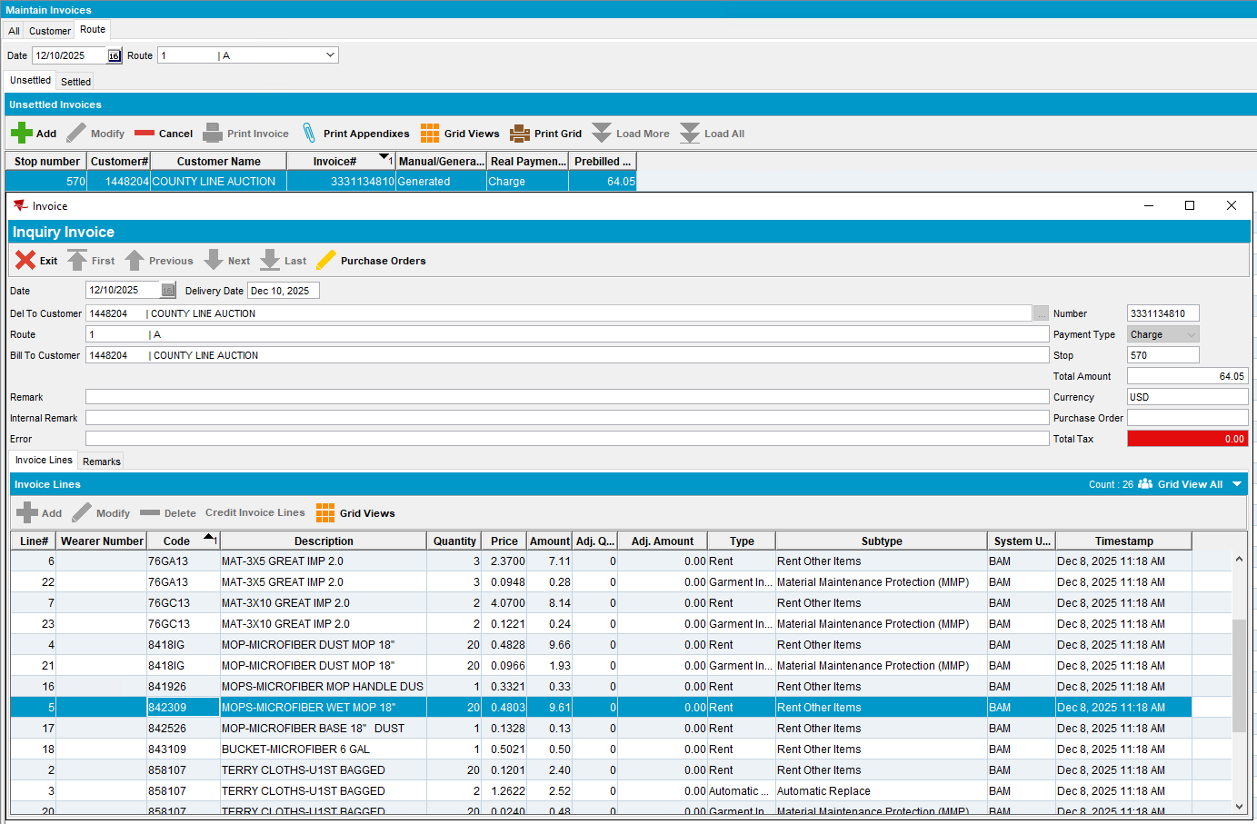

Current behavior:
Rent line is present on the invoice

Reproduced OK

Retest after fix

Test Case 1 – Temporary Delivery Stop Yearly from week, Start week <= end week
Bu: 066 North Canton
Customer: 1786169
9.07.00.UNF21 hash: 651b2deed9c0

Expected behavior:
When temporary rent stop is active on a product, on the specific rent stop periods the rent for the product should be present on the invoice but with billedqty zero

Steps to reproduce:
- PLPC dlg: Load a customer 1786169, that has products 843809 billing method 2.
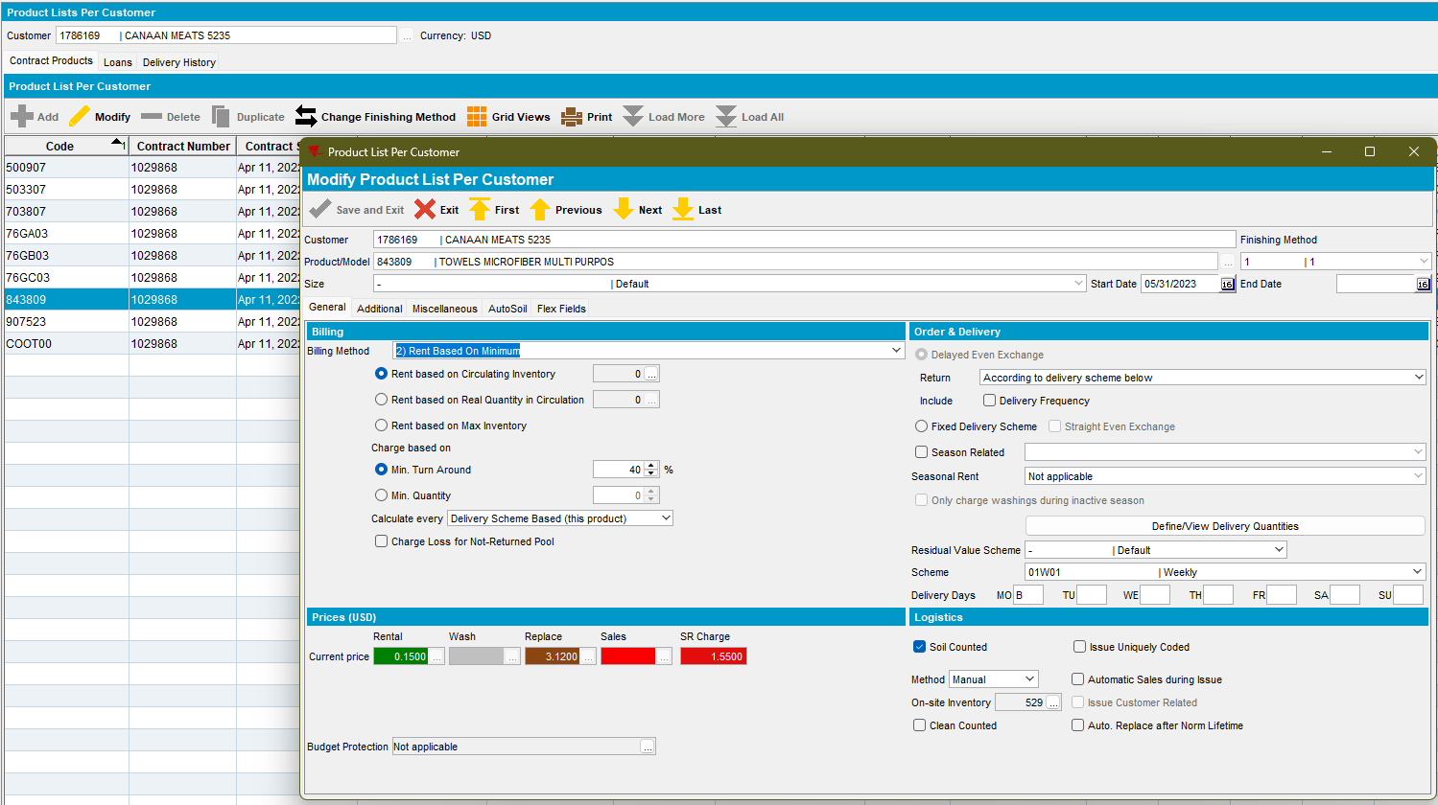
- Consumption Point Logistics dlg: Load the customer 1786169 and for product 843809 make a temp rent stop.
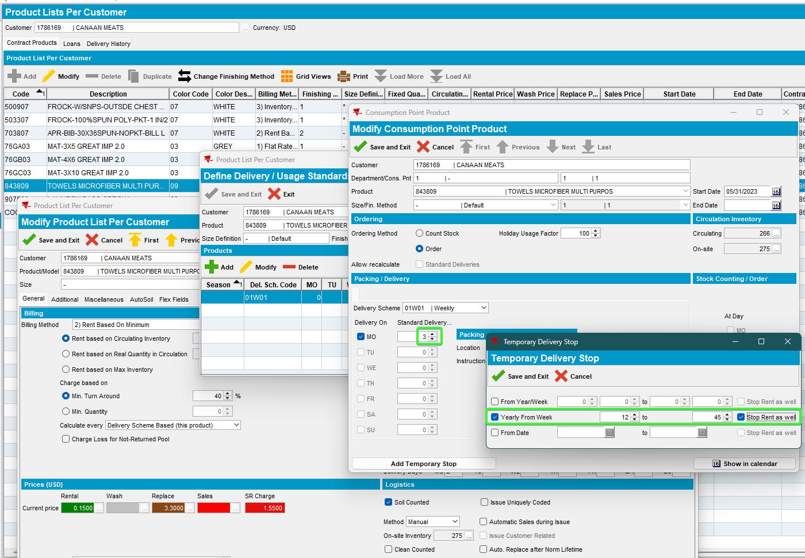
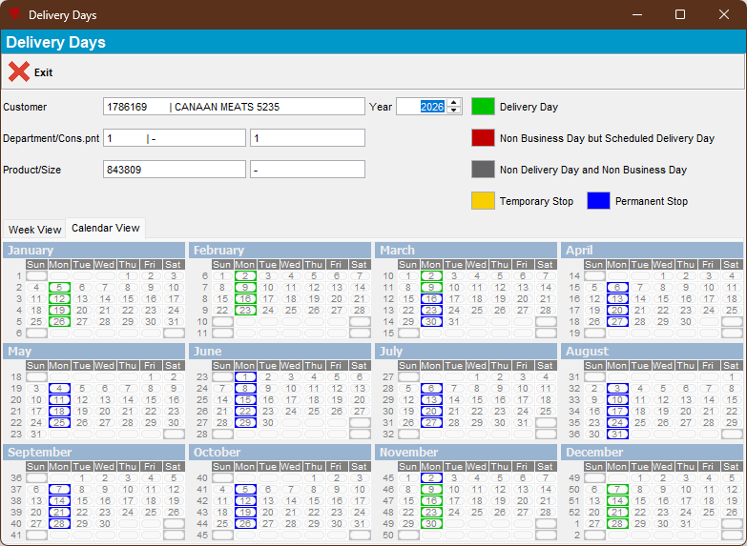

Test inside interval of rent stop period - OK
- RSC dlg: Route 1 from 30-03-2026 with the customer 1786169, move out the other customers.
- RSC dlg: Generate packing notes and generate invoices.
- Maintain Invoices dlg: Check the invoice for product 843809.
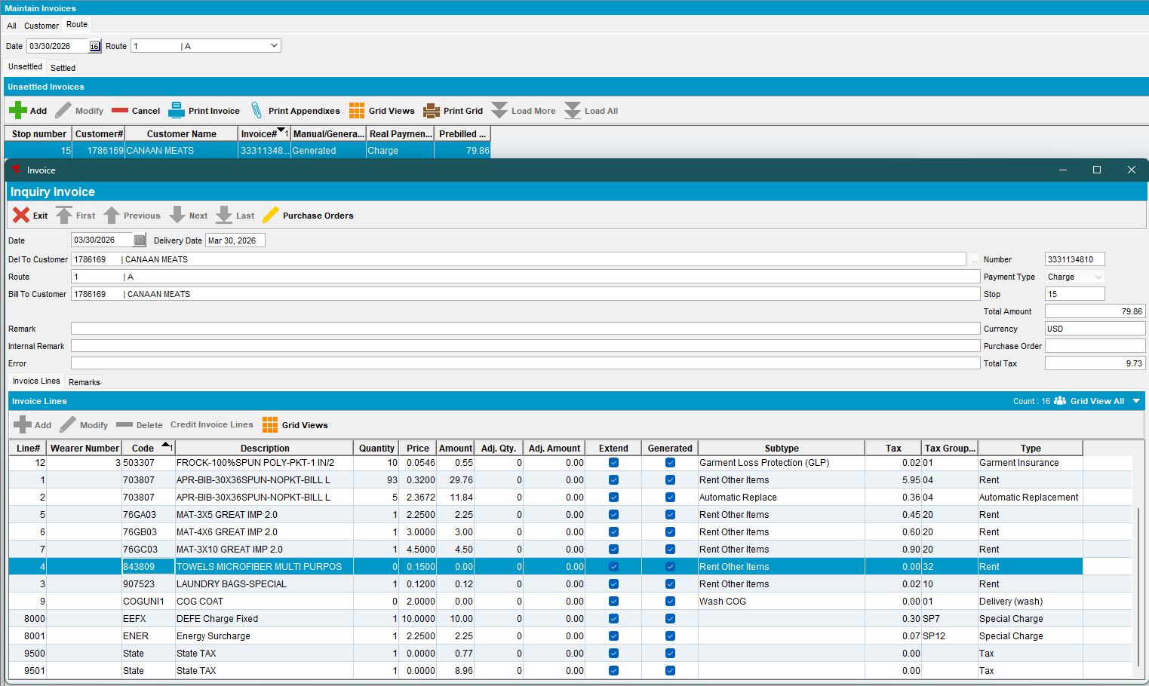
Rent line for product is present on the invoice but with quantity zero and amount zero

Test outside interval, before rent stop – OK
- RSC dlg: Route 1 from 02-02-2026 with the customer 1786169, move out the other customers.
- RSC dlg: Generate packing notes and generate invoices.
- Maintain Invoices dlg: Check the invoice for product 843809.
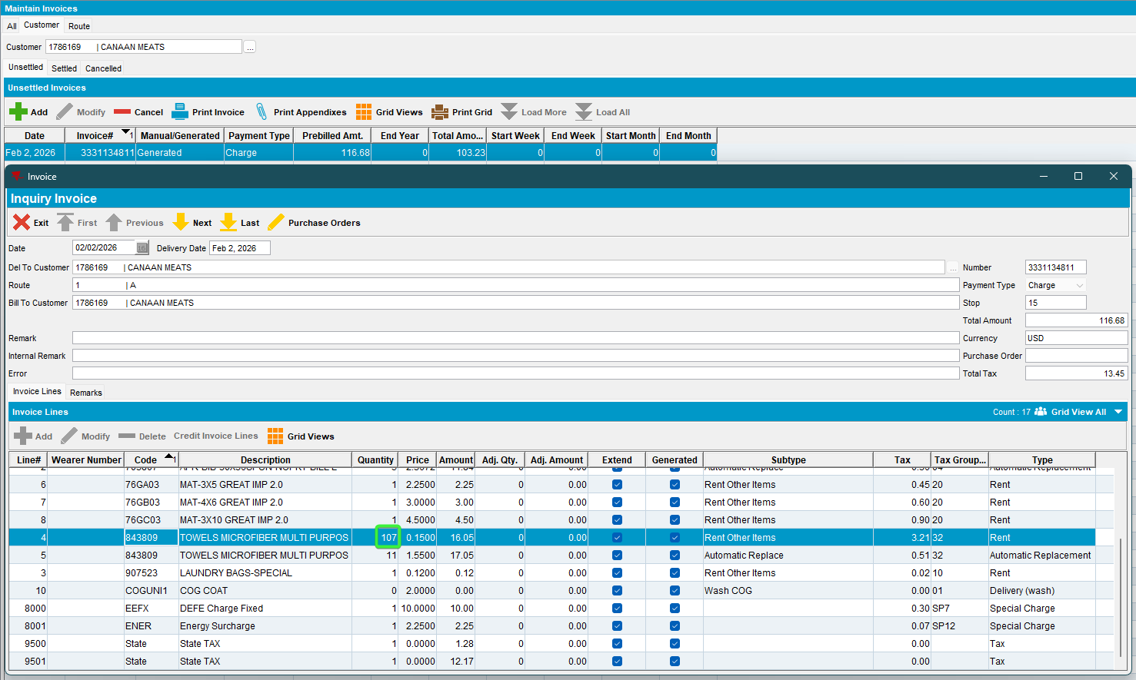
Rent line for product is present on the invoice with specific quantity 107 and amount
40% of 266
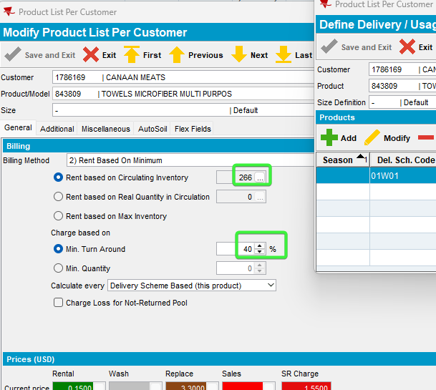

Test outside interval, after rent stop - OK
- RSC dlg: Route 1 from 09-11-2026 with the customer 1786169, move out the other customers.
- RSC dlg: Generate packing notes and generate invoices.
- Maintain Invoices dlg: Check the invoice for product 843809.
Rent line for product is present on the invoice with specific quantity 107 and amount
40% of 266

Test on the first start week of rent stop - OK
- RSC dlg: Route 1 from 16-03-2026 with the customer 1786169, move out the other customers.
- RSC dlg: Generate packing notes and generate invoices.
- Maintain Invoices dlg: Check the invoice for product 843809.
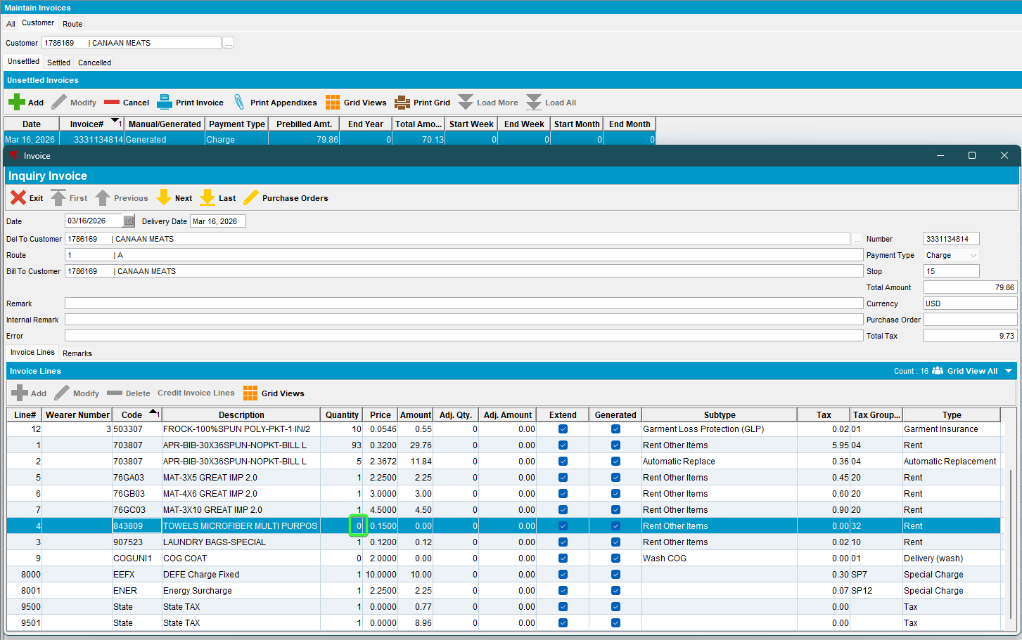
Rent line for product is present on the invoice with zero quantity and zero amount

1.5 Test on the last end week of rent stop - OK
- RSC dlg: Route 1 from 02-11-2026 with the customer 1786169, move out the other customers.
- RSC dlg: Generate packing notes and generate invoices.
- Maintain Invoices dlg: Check the invoice for product 843809.
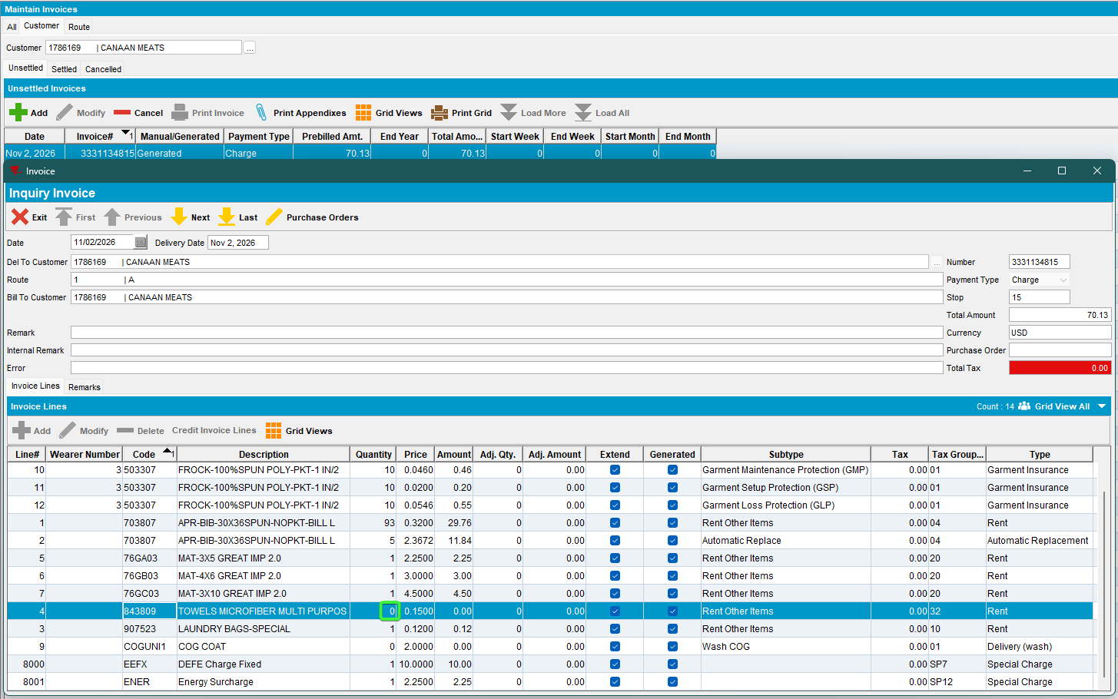
Rent line for product is present on the invoice with zero quantity and zero amount

Test Case 2 - Temporary Delivery Stop Yearly from week, Start week >= end week
Bu: 066 North Canton
Customer: 1448204
9.07.00.UNF21 hash: 651b2deed9c0

Expected behavior:
When temporary rent stop is active on a product, on the specific rent stop periods the rent for the product should be present on the invoice but with billedqty zero

Steps to reproduce:
- PLPC dlg: Load a customer 1448204, that has products 842309 billing method 2.
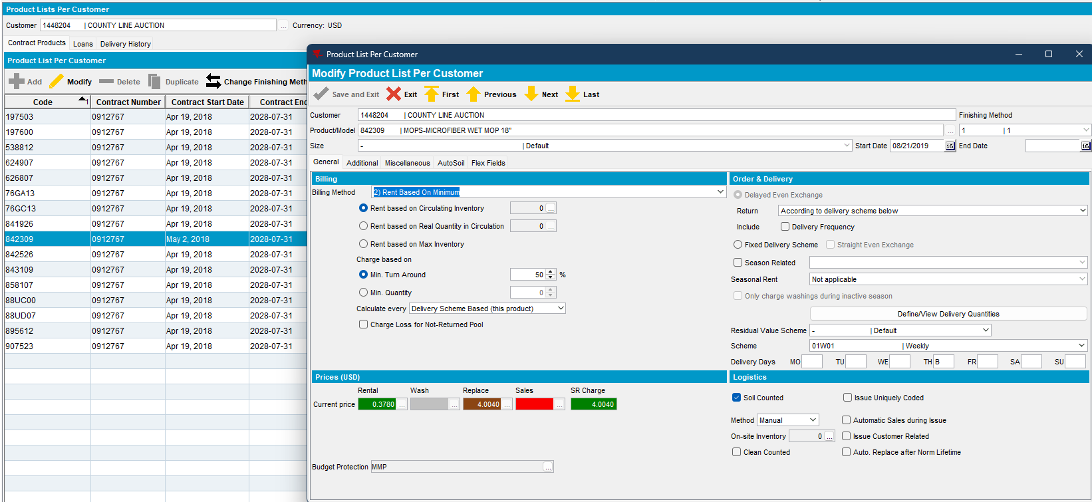
- Consumption Point Logistics dlg: Load the customer 1448204 and for product 842309 make a temp rent stop.
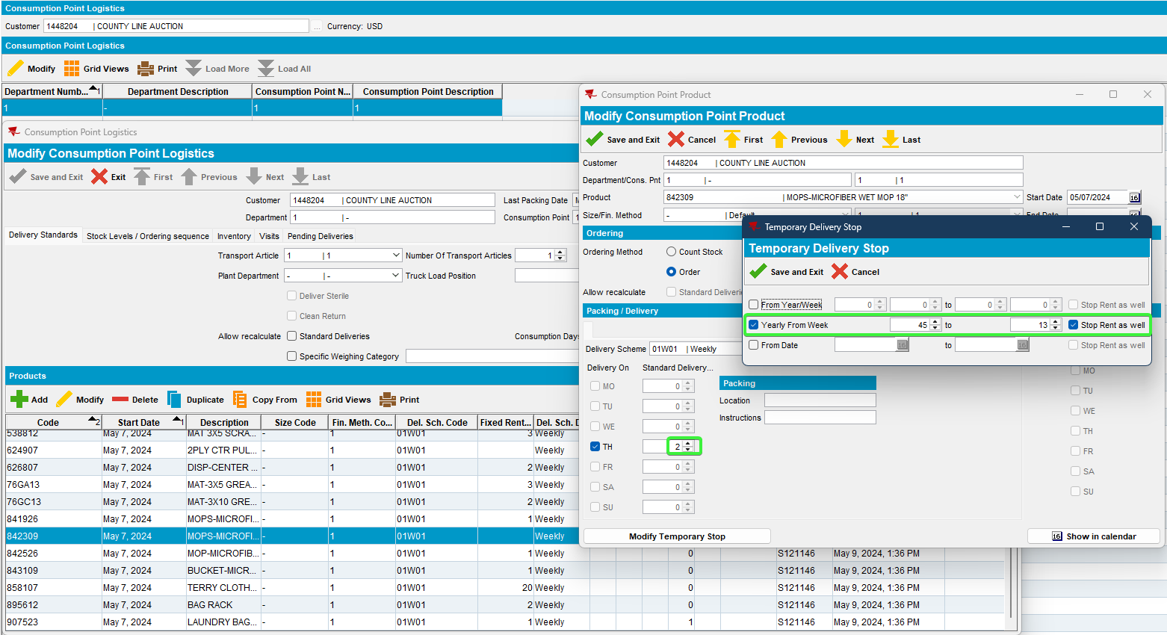
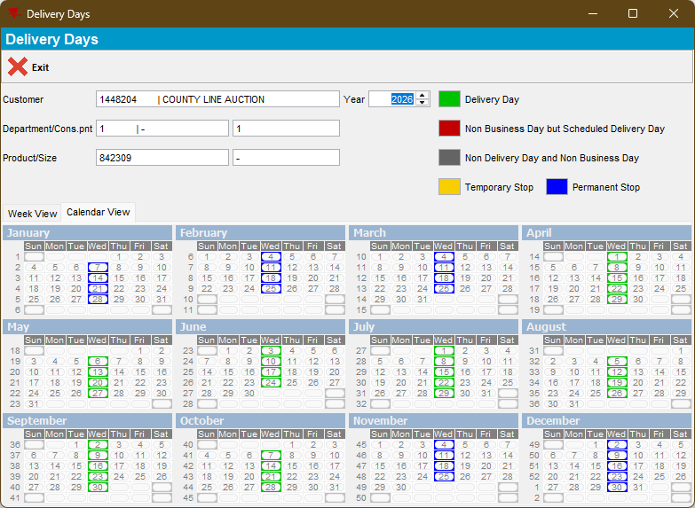

2.1 Test inside interval of rent stop period- OK
- RSC dlg: Route 7 from 04-02-2026 with the customer 1448204, move out the other customers.
- RSC dlg: Generate packing notes and generate invoices.
- Maintain Invoices dlg: Check the invoice for product 842309.
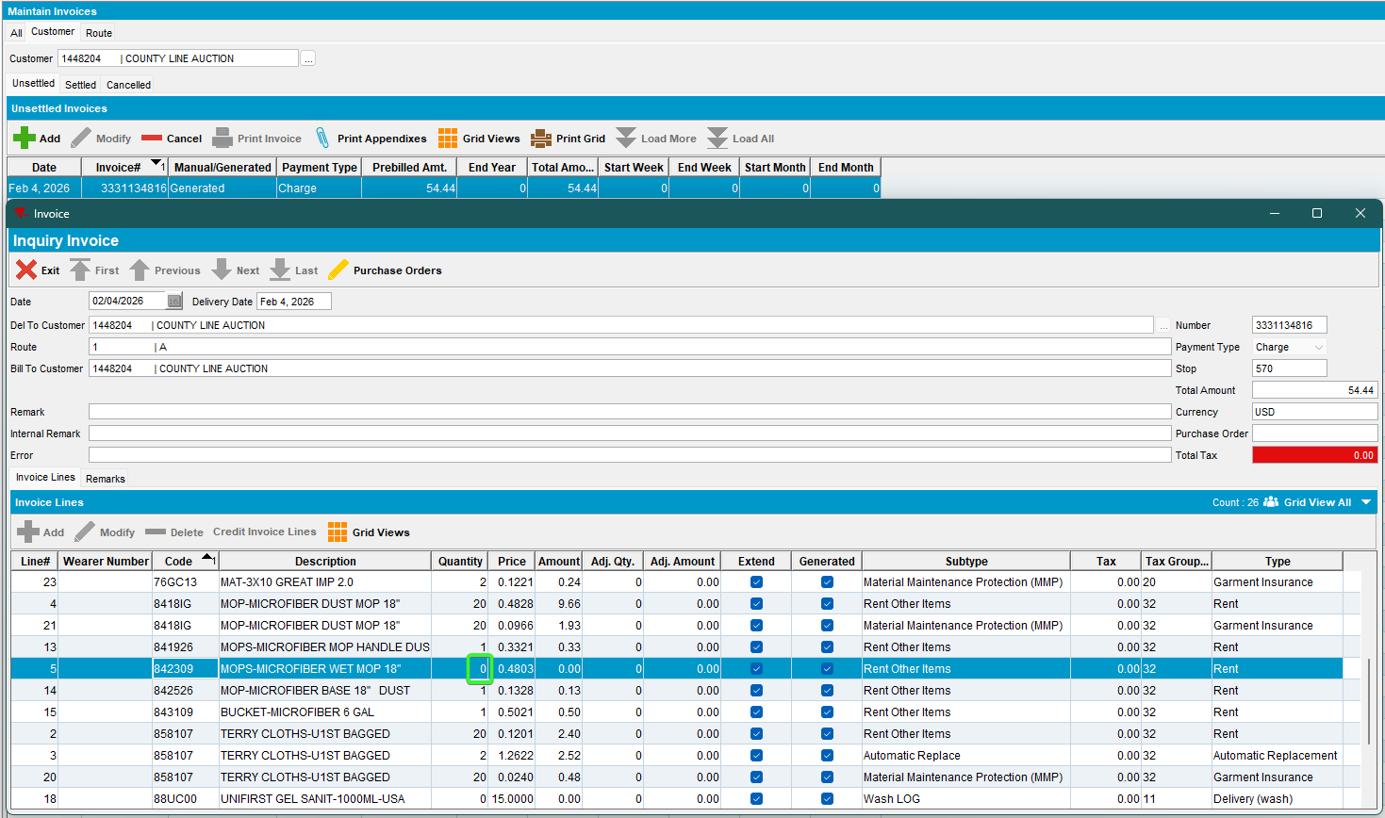
Rent line for product is present on the invoice but with quantity zero and amount zero

2.2 Test outside interval, before rent stop - OK
- RSC dlg: Route 1 from 28-10-2026 with the customer 1448204, move out the other customers.
- RSC dlg: Generate packing notes and generate invoices.
- Maintain Invoices dlg: Check the invoice for product 842309.
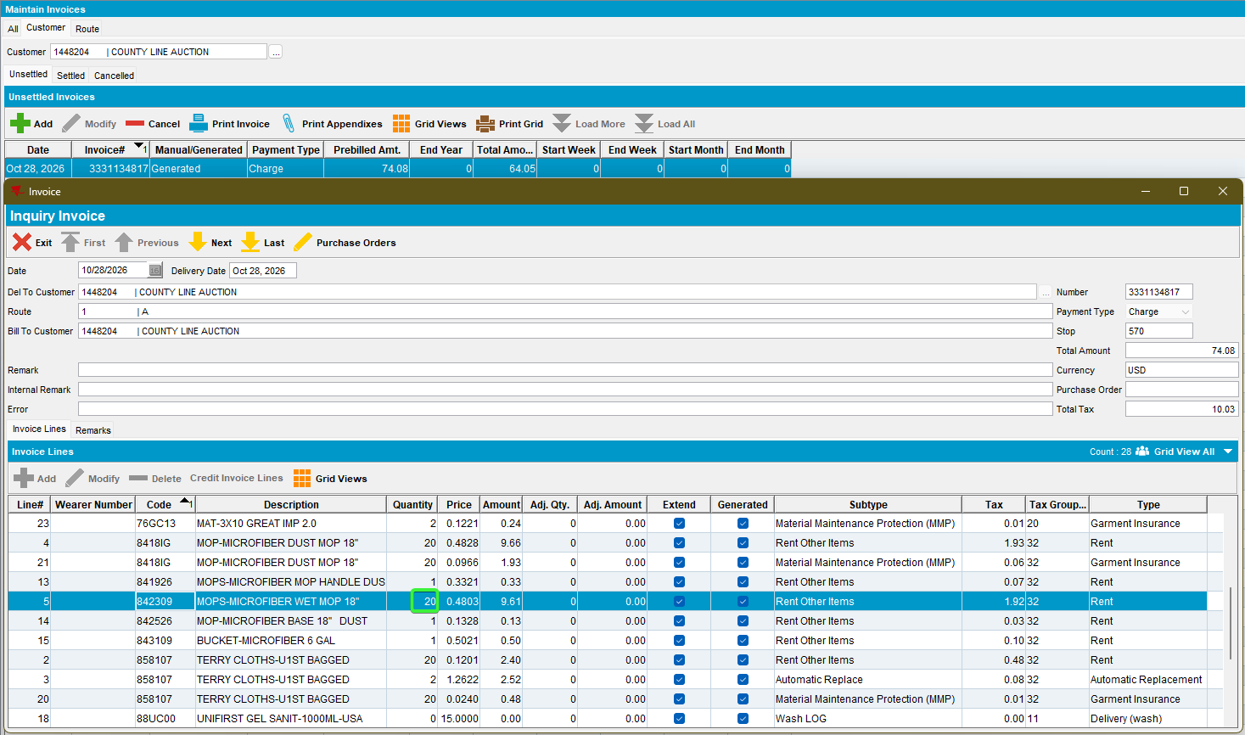
Rent line for product is present on the invoice with a specific quantity 20 and amount
The 20, is calculated 50% from 40 circ inv
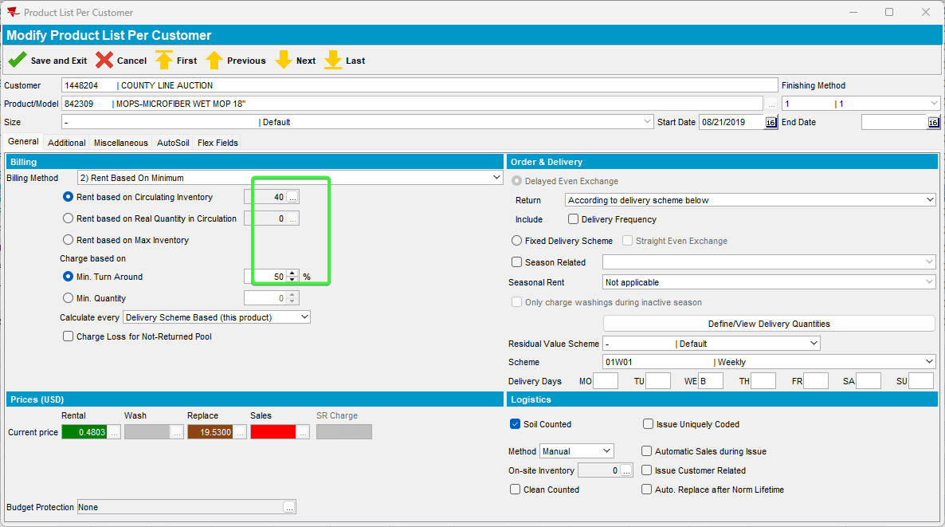

2.3 Test outside interval, after rent stop - OK
- RSC dlg: Route 1 from 01-04-2026 with the customer 1448204, move out the other customers.
- RSC dlg: Generate packing notes and generate invoices.
- Maintain Invoices dlg: Check the invoice for product 842309.
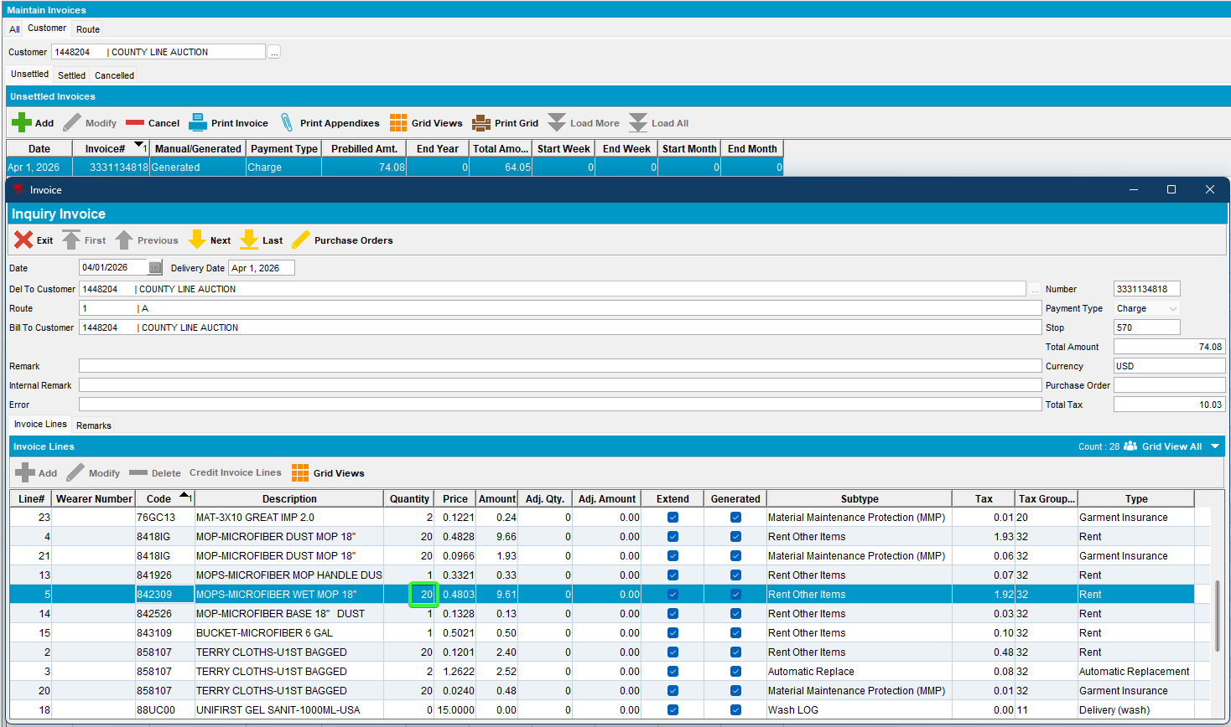
Rent line for product is present on the invoice with a specific quantity 20 and amount
The 20, is calculated 50% from 40 circ inv

2.4 Test on the first start week of rent stop – OK
- RSC dlg: Route 1 from 04-11-2026 with the customer 1448204, move out the other customers.
- RSC dlg: Generate packing notes and generate invoices.
- Maintain Invoices dlg: Check the invoice for product 842309.
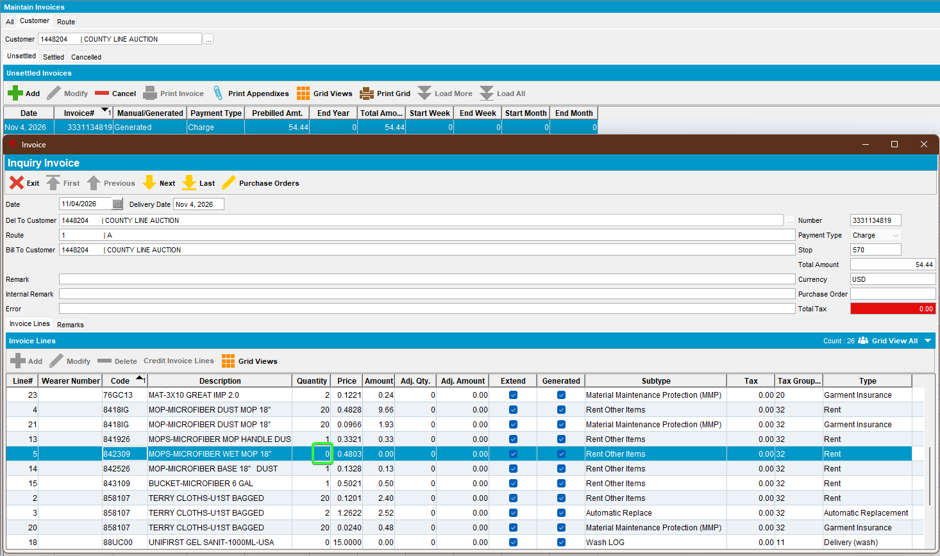
Rent line for product is present on the invoice with zero quantity and zero amount

2.5 Test on the last end week of rent stop - OK
- RSC dlg: Route 1 from 25-03-2026 with the customer 1448204, move out the other customers.
- RSC dlg: Generate packing notes and generate invoices.
- Maintain Invoices dlg: Check the invoice for product 842309.
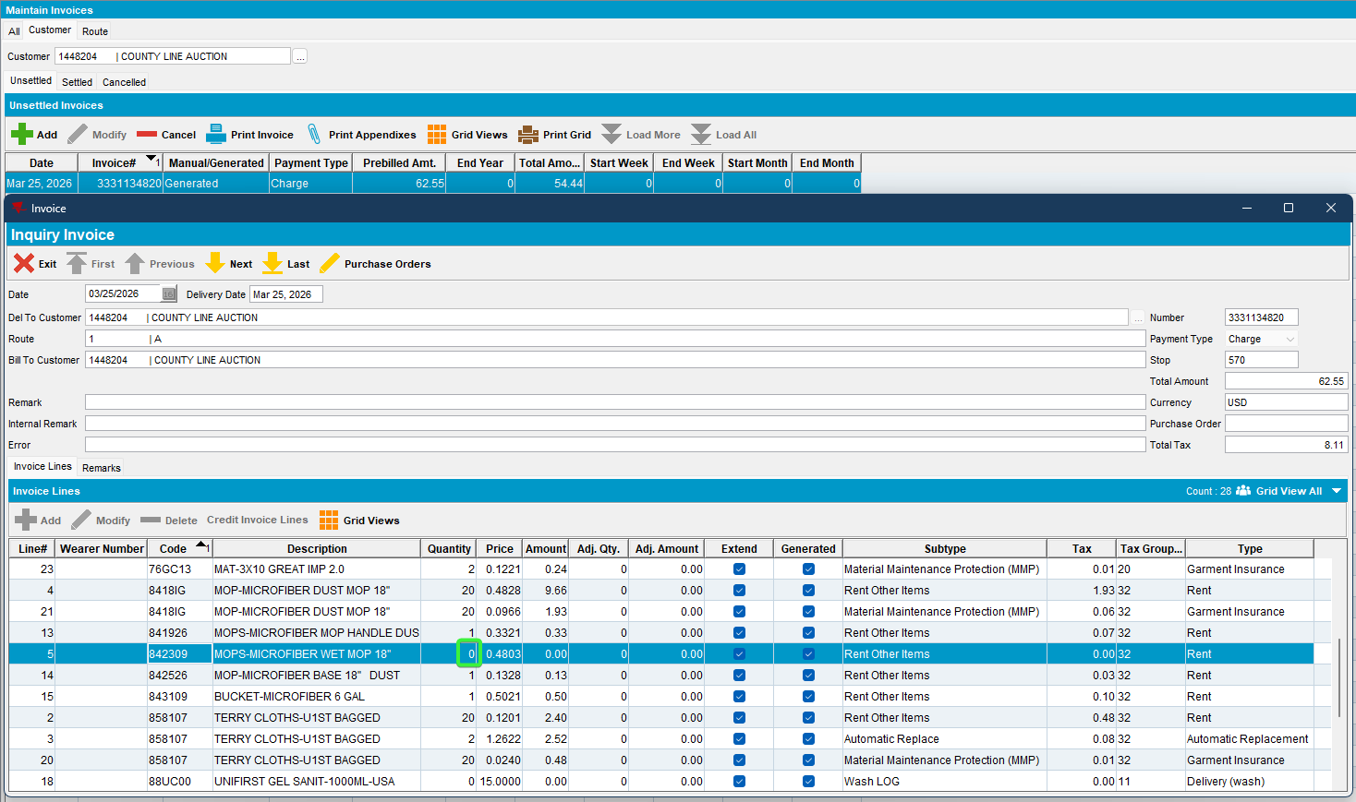
Rent line for product is present on the invoice with zero quantity and zero amount

Test Case 3 - Temporary Delivery Stop From Year/Week
Bu: 066 North Canton
Customer: 1786241
9.07.00.UNF21 hash: 651b2deed9c0

Expected behavior:
When temporary rent stop is active on a product, on the specific rent stop periods the rent for the product should be present on the invoice but with billedqty zero

Steps to reproduce:
- PLPC dlg: Load a customer 1786241, that has products non-garment product 843809.
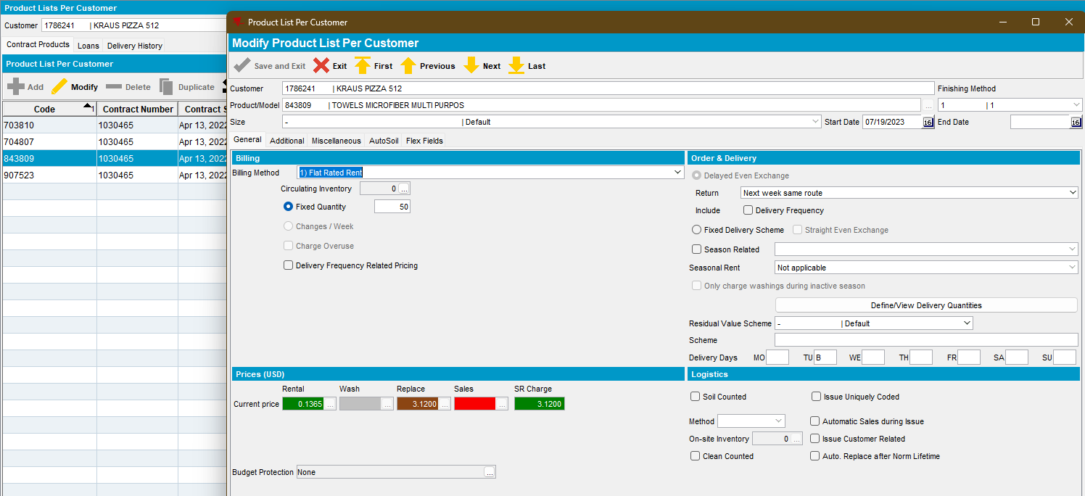
- Consumption Point Logistics dlg: Load the customer 1786241 and for product 843809 make a temp rent stop.
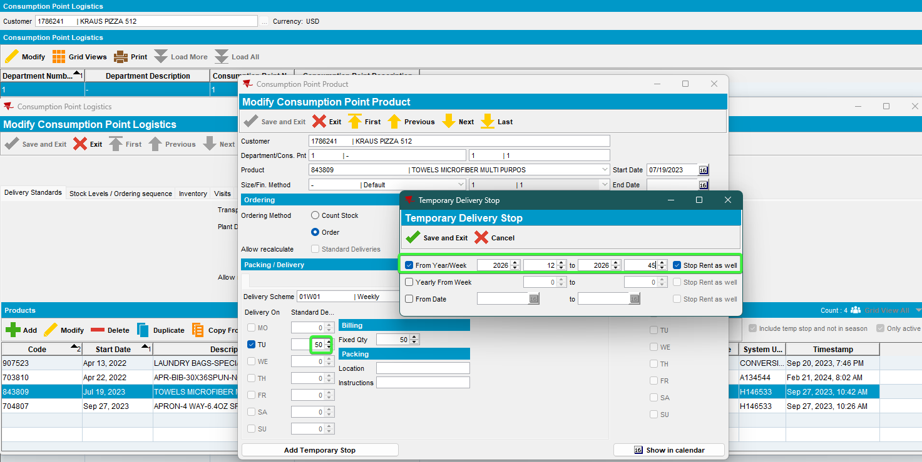
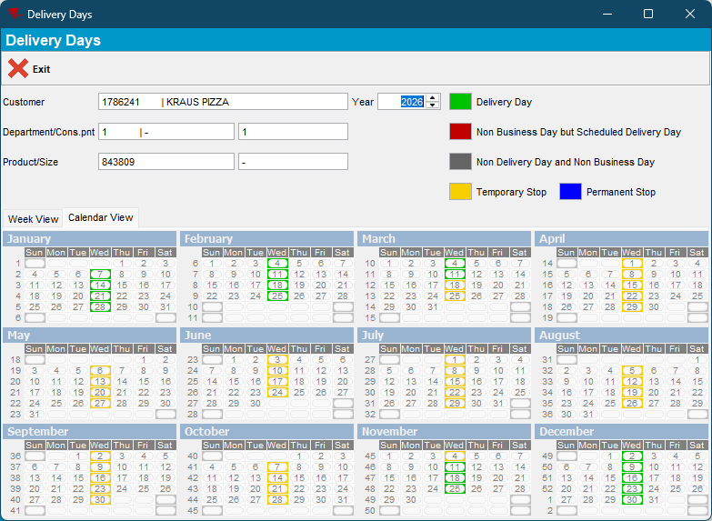

Test inside interval - OK
- RSC dlg: Route 23 from 25-03-2026 with the customer 1786241, move out the other customers.
- RSC dlg: Generate packing notes and generate invoices.
- Maintain Invoices dlg: Check the invoice for product 843809.
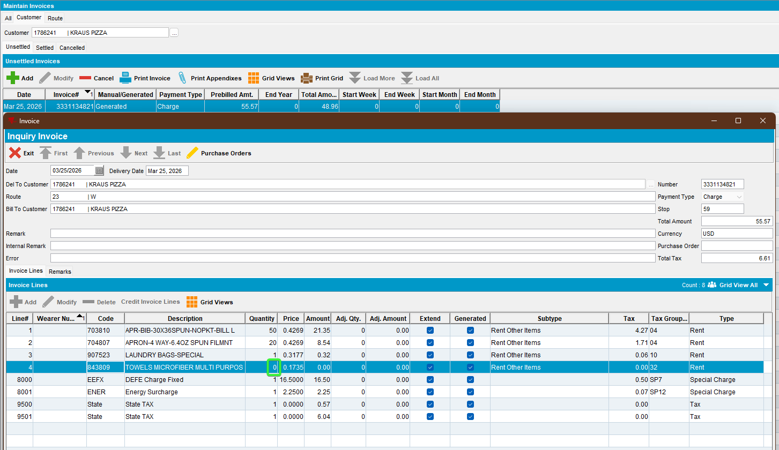
Rent line for product is present on the invoice but with quantity zero and amount zero

Test outside interval - OK
- RSC dlg: Route 23 from 11-03-2026 with the customer 1786241, move out the other customers.
- RSC dlg: Generate packing notes and generate invoices.
- Maintain Invoices dlg: Check the invoice for product 843809.
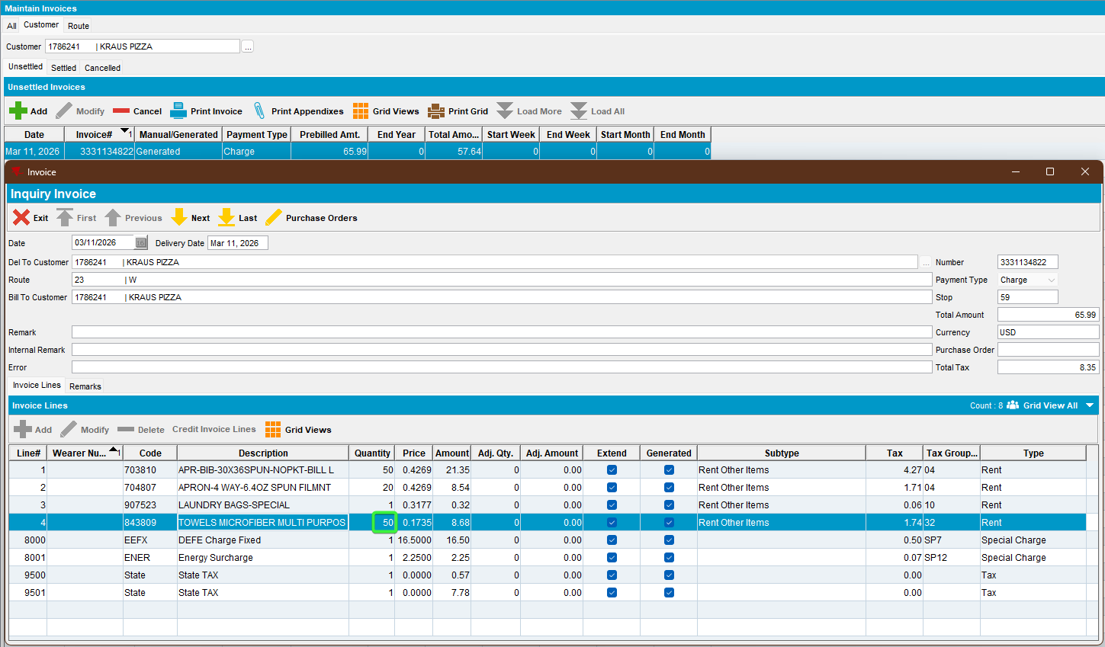
Rent line for product is present on the invoice with standard delivery quantity 50 and specific amount
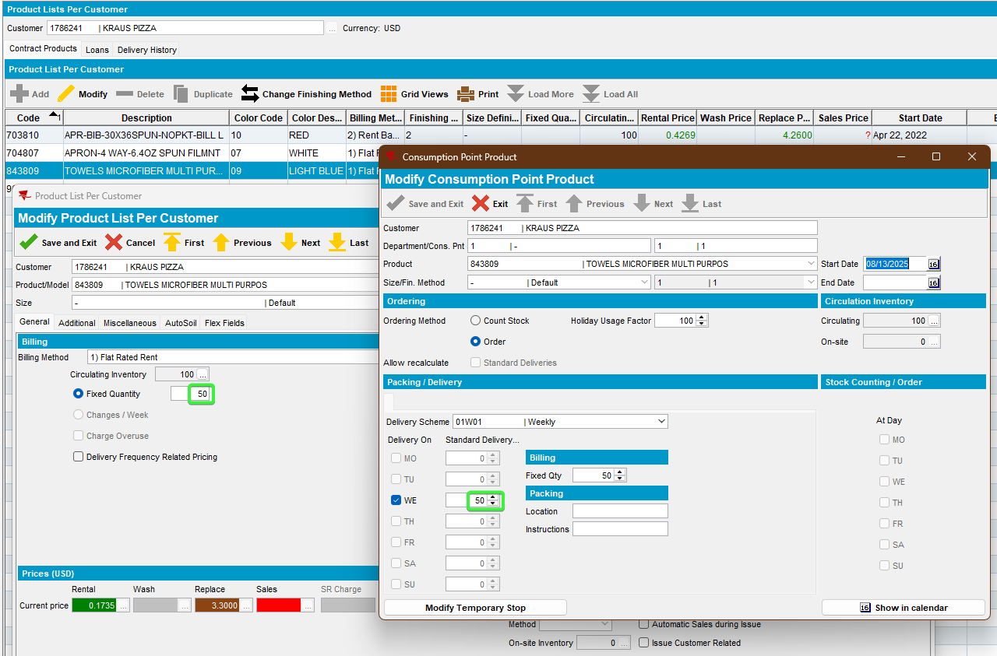

Test Case 4 - Temporary Delivery Stop From Date
Bu: 066 North Canton
Customer: 1786241
9.07.00.UNF21 hash: 651b2deed9c0

Expected behavior:
When temporary rent stop is active on a product, on the specific rent stop periods the rent for the product should be present on the invoice but with billedqty zero

Steps to reproduce:
- PLPC dlg: Load the customer 1103711 and for product 802310 make a temp rent stop.
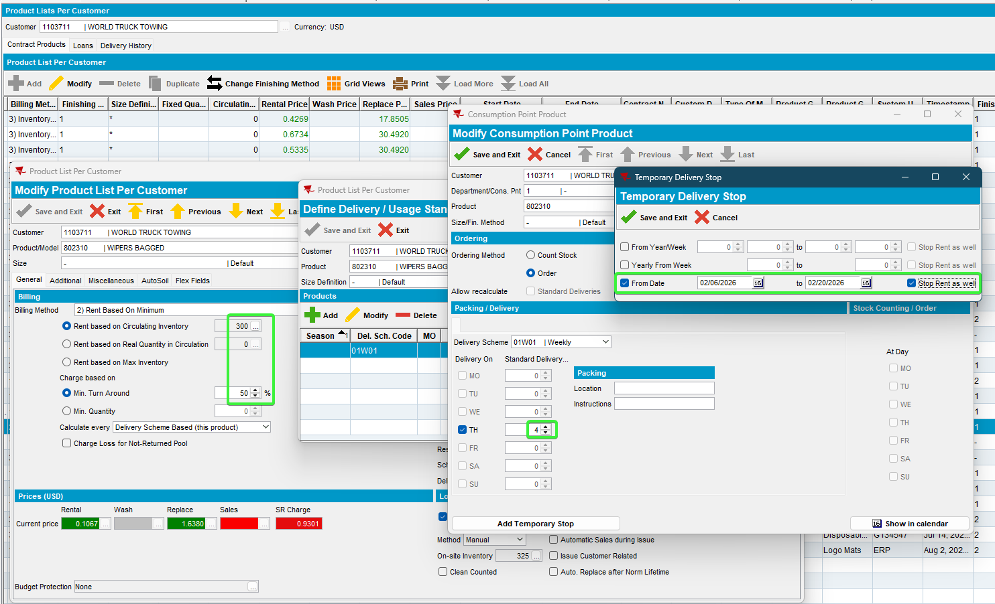
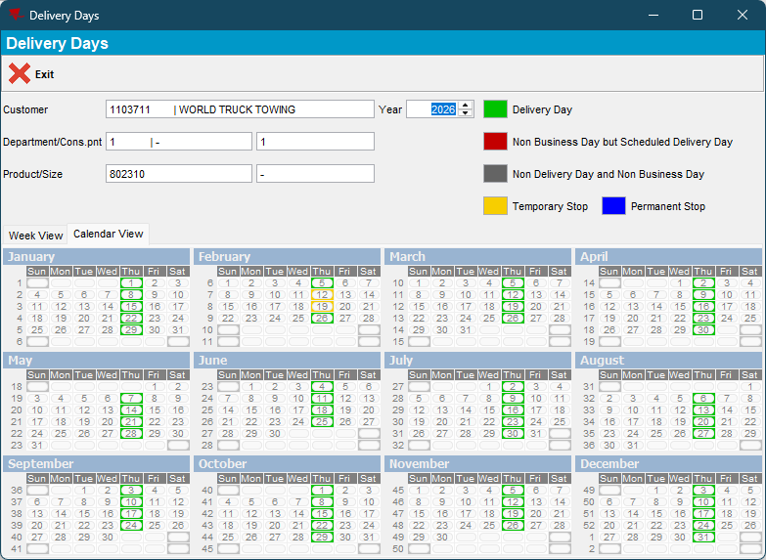

Test inside interval - OK
- RSC dlg: Route 7 from 12-02-2026 with the customer 1103711, move out the other customers.
- RSC dlg: Generate packing notes and generate invoices.
- Maintain Invoices dlg: Check the invoice for product 802310.
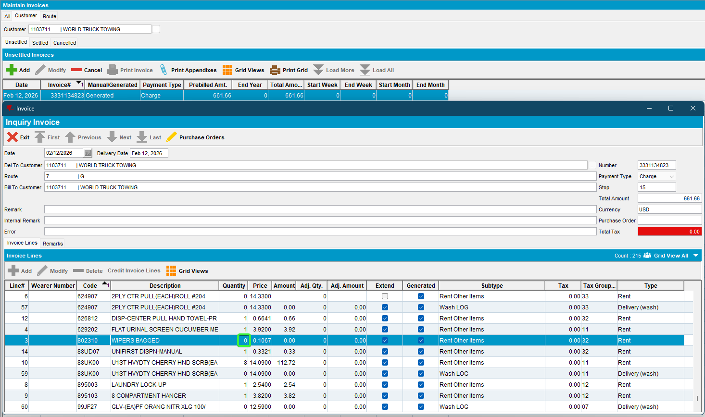
Rent line for product is present on the invoice but with quantity zero and amount zero

4.2 Test outside interval - OK
- RSC dlg: Route 1 from 26-02-2026 with the customer 1103711, move out the other customers.
- RSC dlg: Generate packing notes and generate invoices.
- Maintain Invoices dlg: Check the invoice for product 802310.
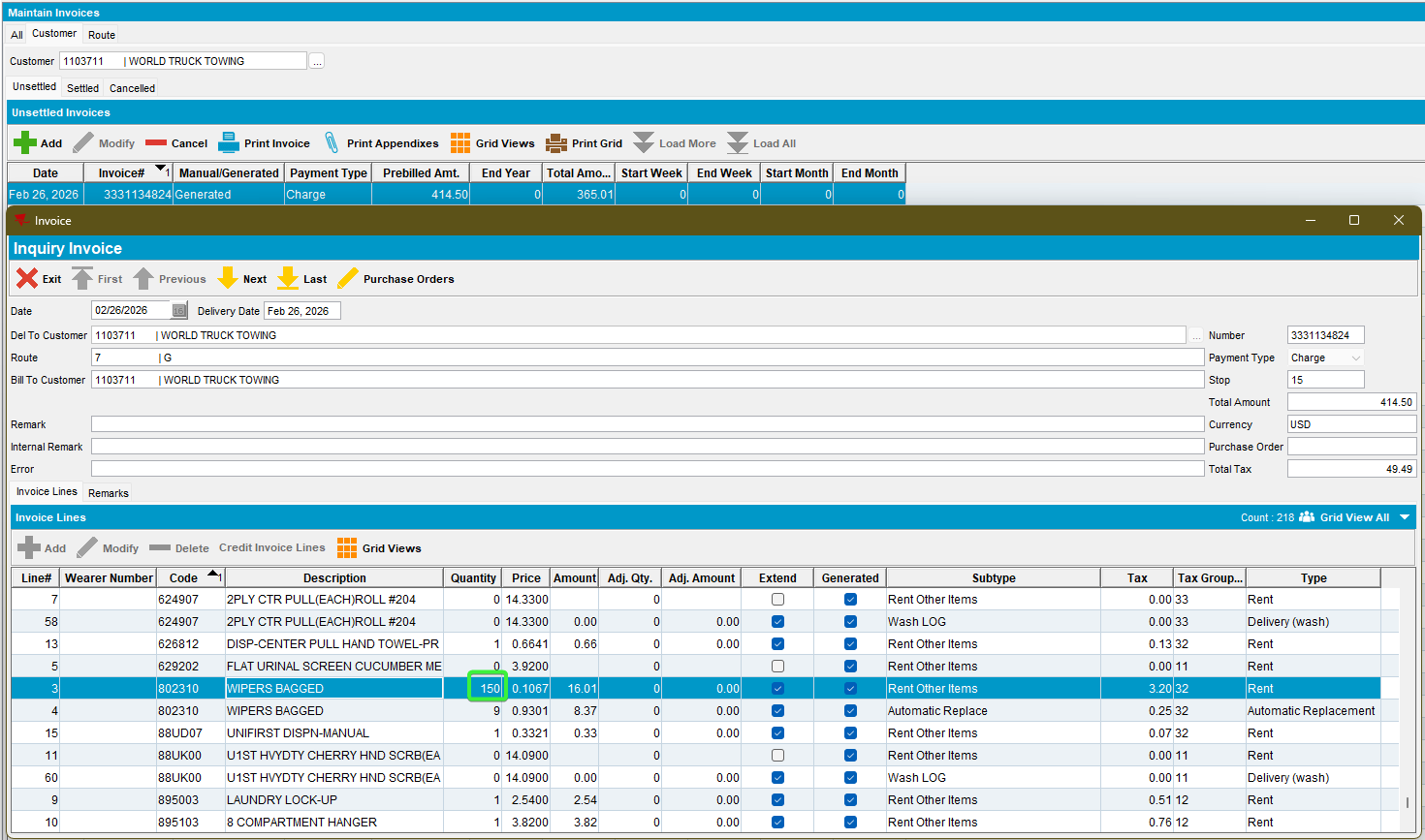
Rent line for product is present on the invoice with quantity 150 and amount.
The 150, is calculated 50% from 300 circ inv
