ABSN-13462 :D_UBS_2797 Prevent deleting a wearer with active work orders from depot business unit
Environment | Prerequisites
Version 9.07.00.UNF21 hash: 0cbd375e8afa  DBServerName=abs-SRV19.internal.abslbs.com  DBSID=CUST22  DBUser=UNFLIVE  Environment=TEST | - Module:  - System settings:  - Others:

Contents
Retest after fix 1
Test Case 1 – Delete the new wearer created from Wearers dlg– Tested OK 1
Test Case 2 – Delete the new wearer created from Dashbord– Tested OK 6

Retest after fix

Test Case 1 – Delete the new wearer created from Wearers dlg– Tested OK
Expected behavior: The wearer must not be deleted

- Take a customer from a business unit that has a depot.
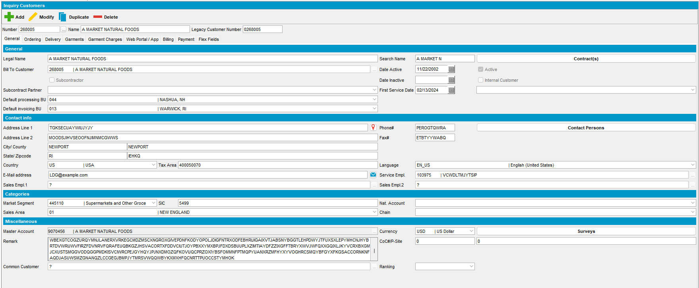

- Select the business unit of the depot, 261
- Open the Wearers dialog
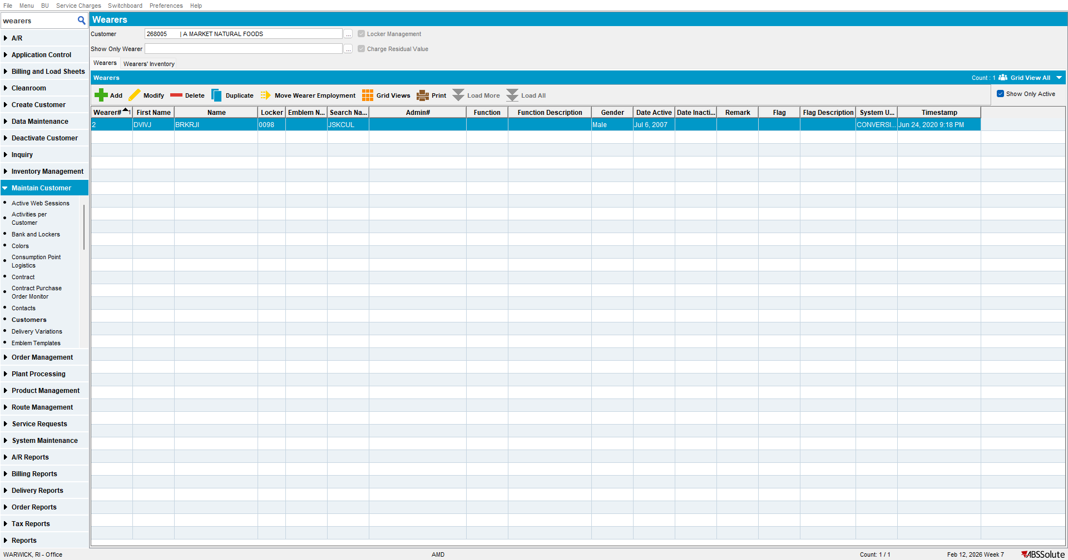

- Create a wearer with a wearer inventory
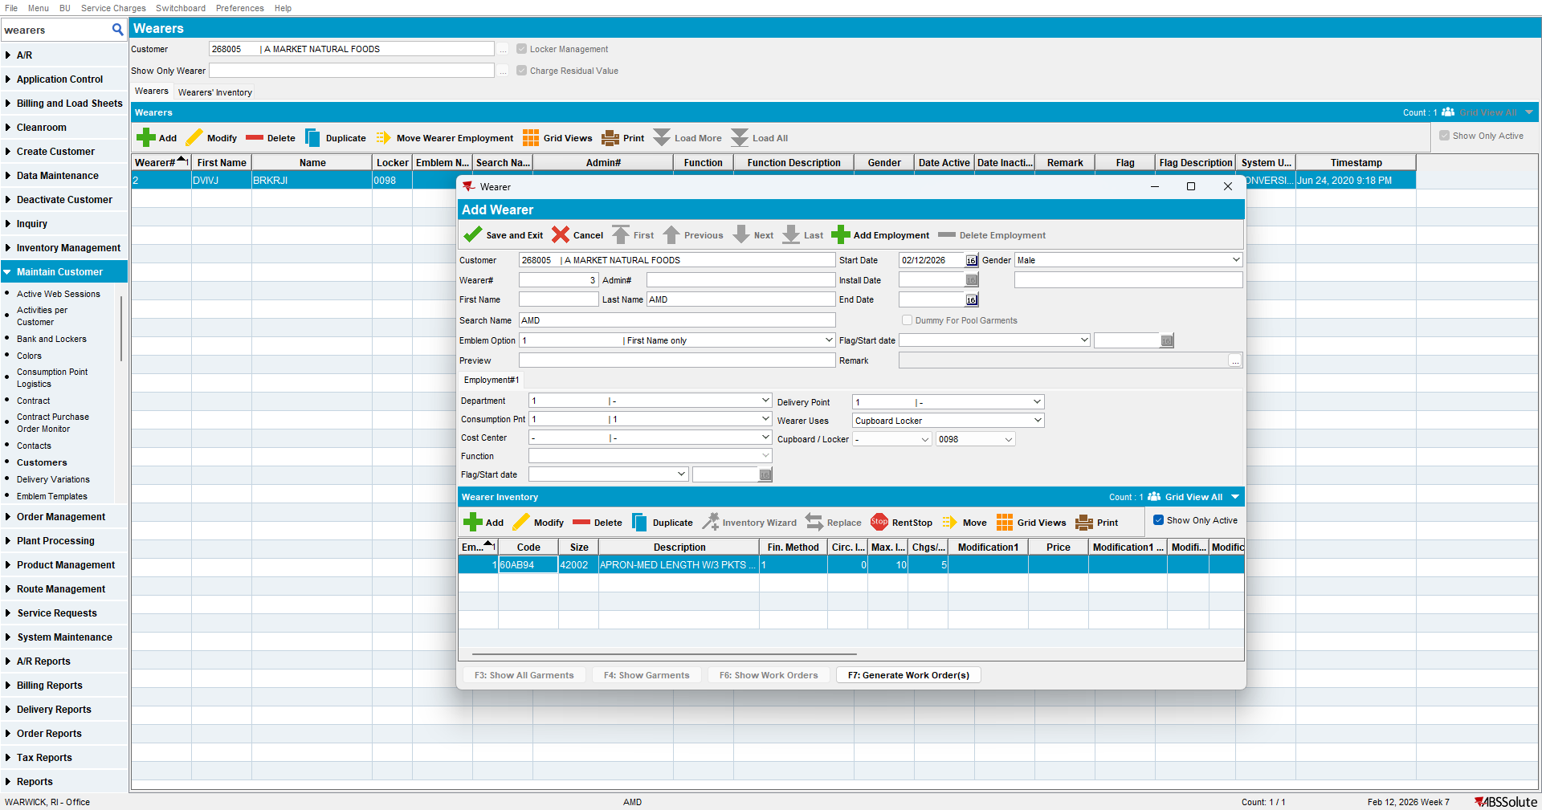

- Generate the work order and leave it in the new status
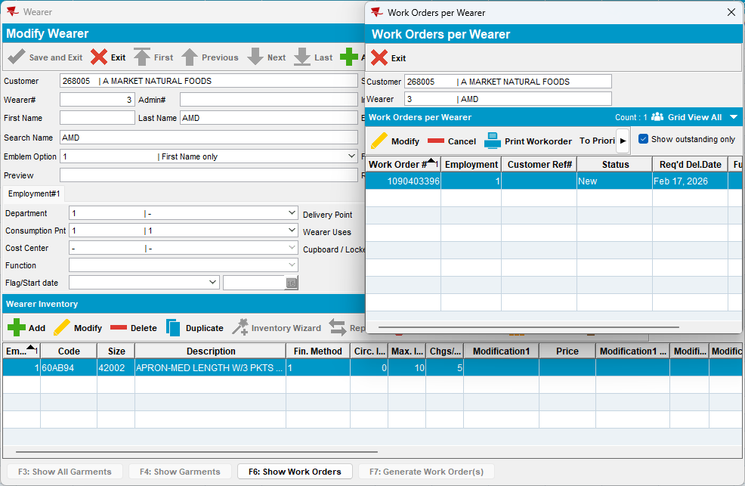
- Go back to the Wearers and delete the newly created wearer.
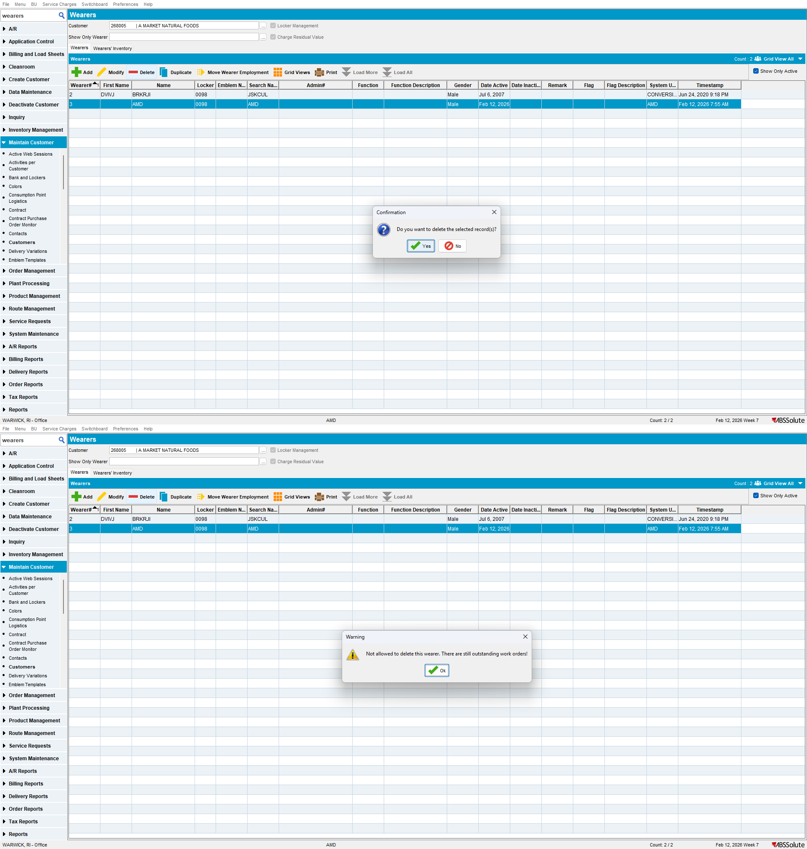
The wearer can’t be deleted.

Test Case 2 – Delete the new wearer created from Dashboard– Tested OK

- Take a customer from a business unit that has a depot.

- Select the business unit of the depot
- Open wearers dlg from Switchboard and add a new wearer with an inventory
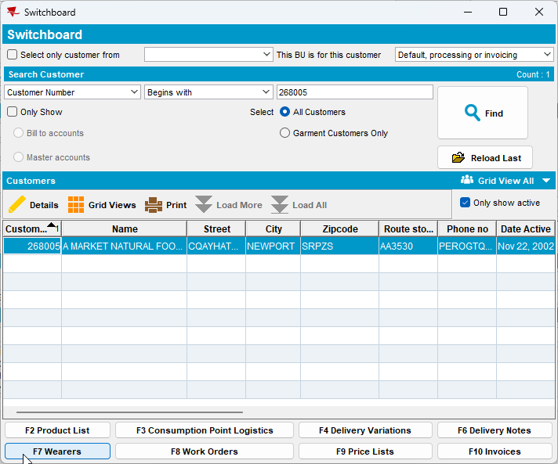
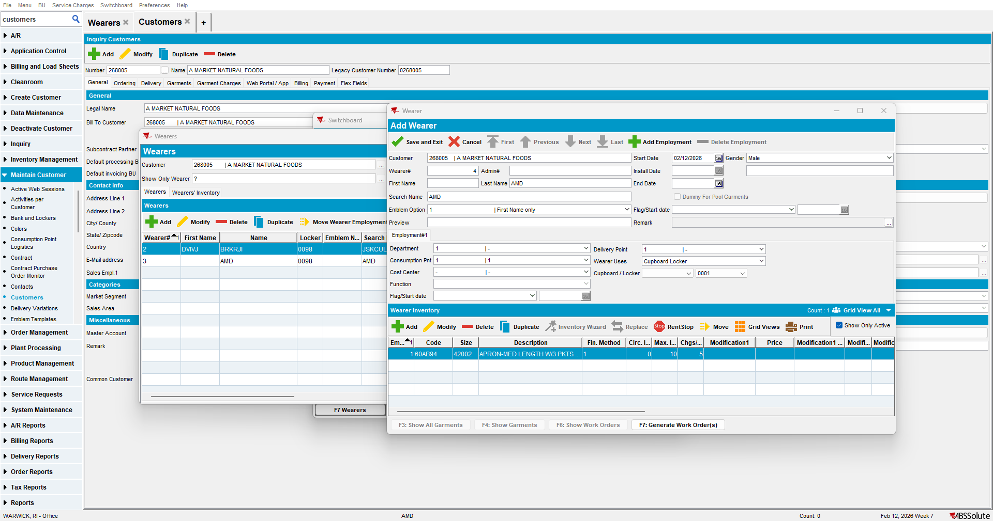

- Generate the work order and leave it in the new status
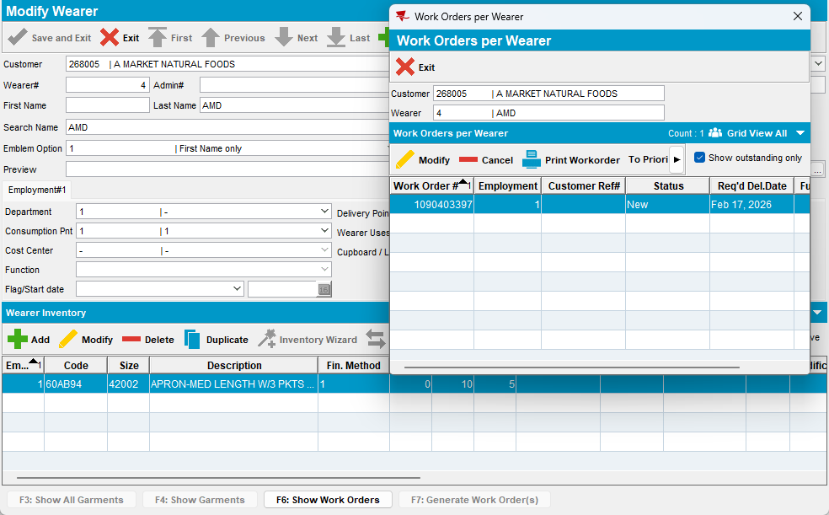

- Go back to the Wearers and delete the newly created wearer.
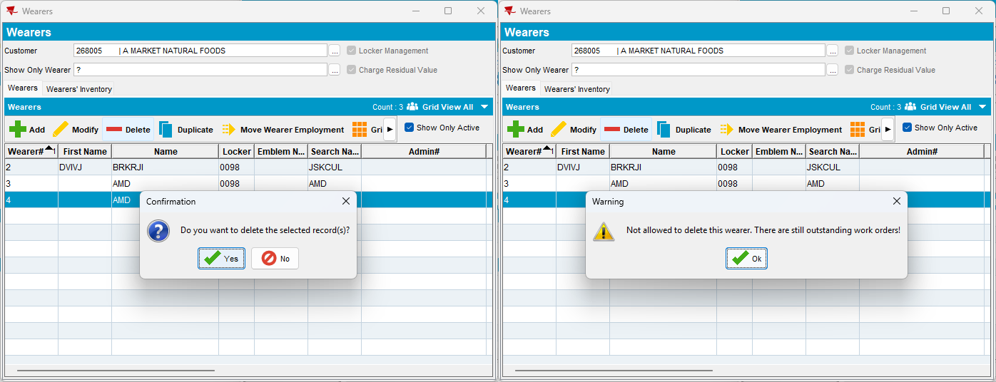
The wearer can’t be deleted.

