ABSN-13041 Problem with ending the price lists when end dating a customer on a predefined contract if there are 2 active contracts
Environment | Prerequisites
Version: 9.07.00.UNF21
DBServerName= abs-srv19.internal.abslbs.com
DBSID= CUST22
DBUser= UNFLIVE
Environment=Production

Contents
Reproducing before fix 1
Retest after fix 3
Version: 9.07.00.UNF21 hash: c4c88140e97b 3
BU/Plant: 044 | NASHUA, NH 3
Test Case #1 – End a customer with 2 active contracts 3
Test Case #2 – End a customer with 1 active contract 5
Test Case #3 – Add a customer with 1 active contract on another contract 7

Reproducing before fix

- Find a customer with 2 active contracts.
- Go to Price List Per Customer.
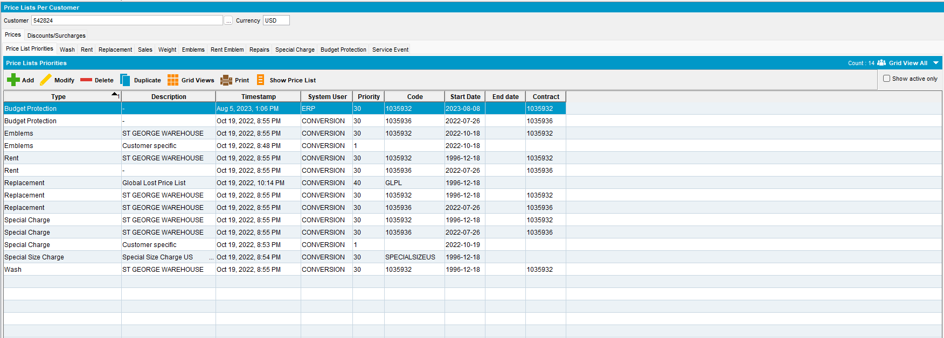

- Go to a contract and end the customer.
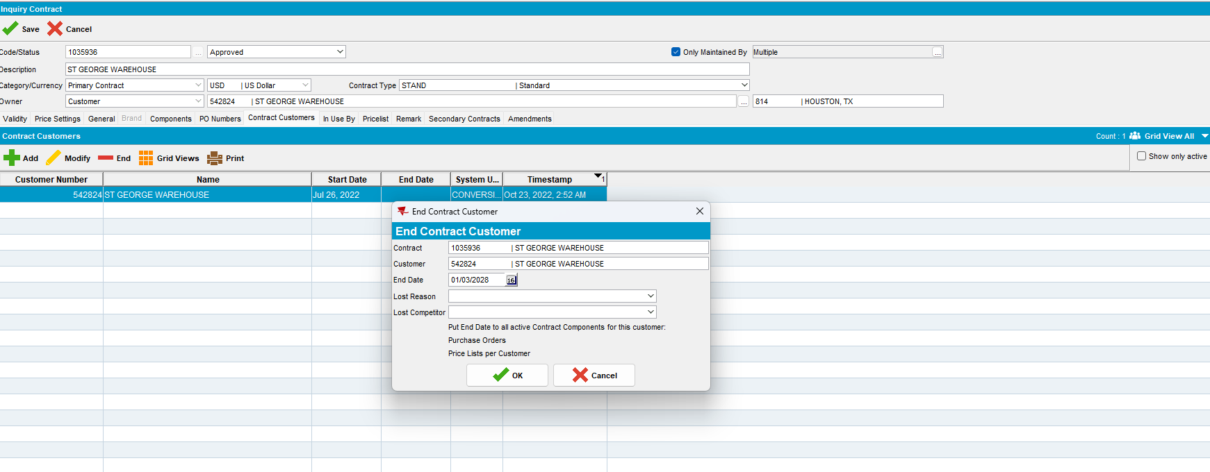

- Check the End date on Price List per Customer dialog.
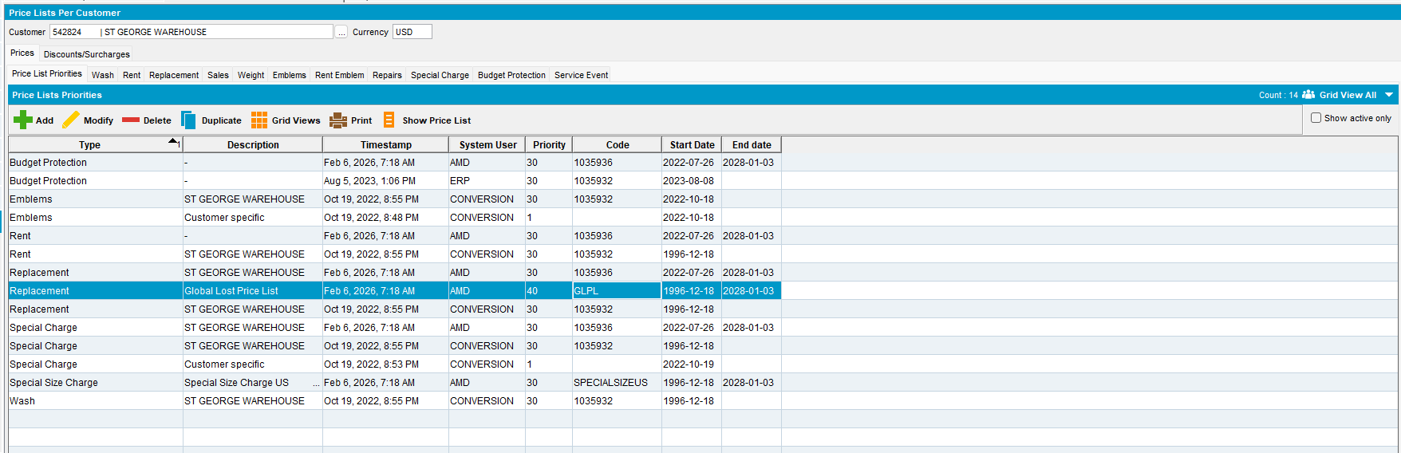
Expected Behavior:
Only the prices that are specific to the contract for which the end customer was assigned should receive an end date.
Actual Behavior:
Prices that are not related to that specific contract also received an end date.

REPRODUCED OK.

Retest after fix

Version: 9.07.00.UNF21 hash: c4c88140e97b

BU/Plant: 044 | NASHUA, NH

Test Case #1 – End a customer with 2 active contracts

- Find a customer with 2 active contracts.
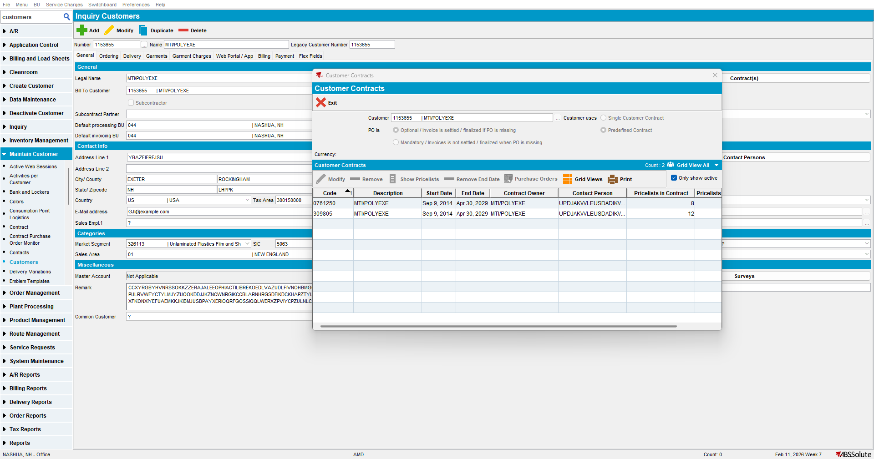

- Go to Price List Per Customer.
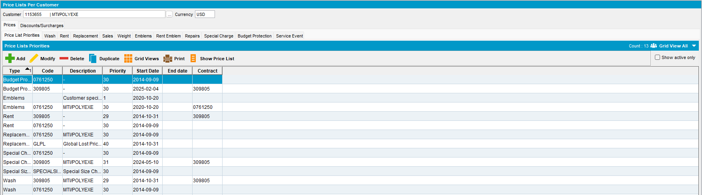

- Go to a contract and end the customer.
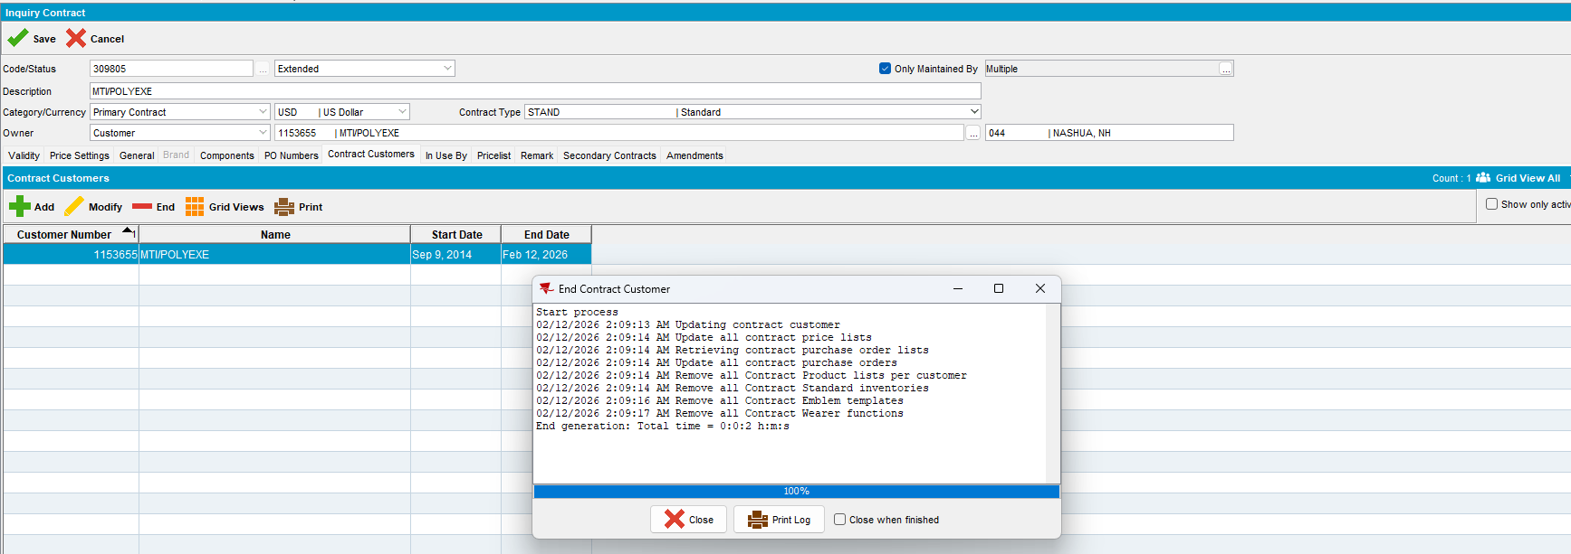

- Check the End date on Price List per Customer dialog.
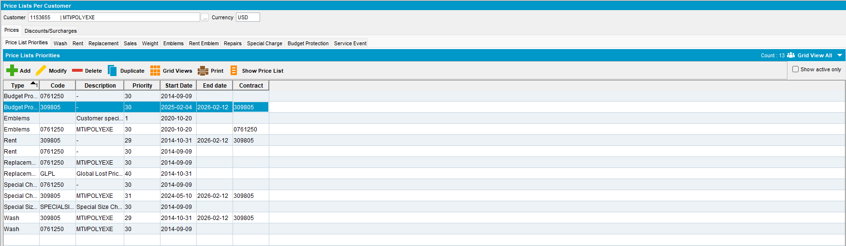
Expected Behavior:
Only the prices that are specific to the contract for which the end customer was assigned should receive an end date.
Actual Behavior:
Only the prices that are specific to the contract for which the end customer was assigned received an end date.

Test Case #2 – End a customer with 1 active contract

- Find a customer with 1 active contract.
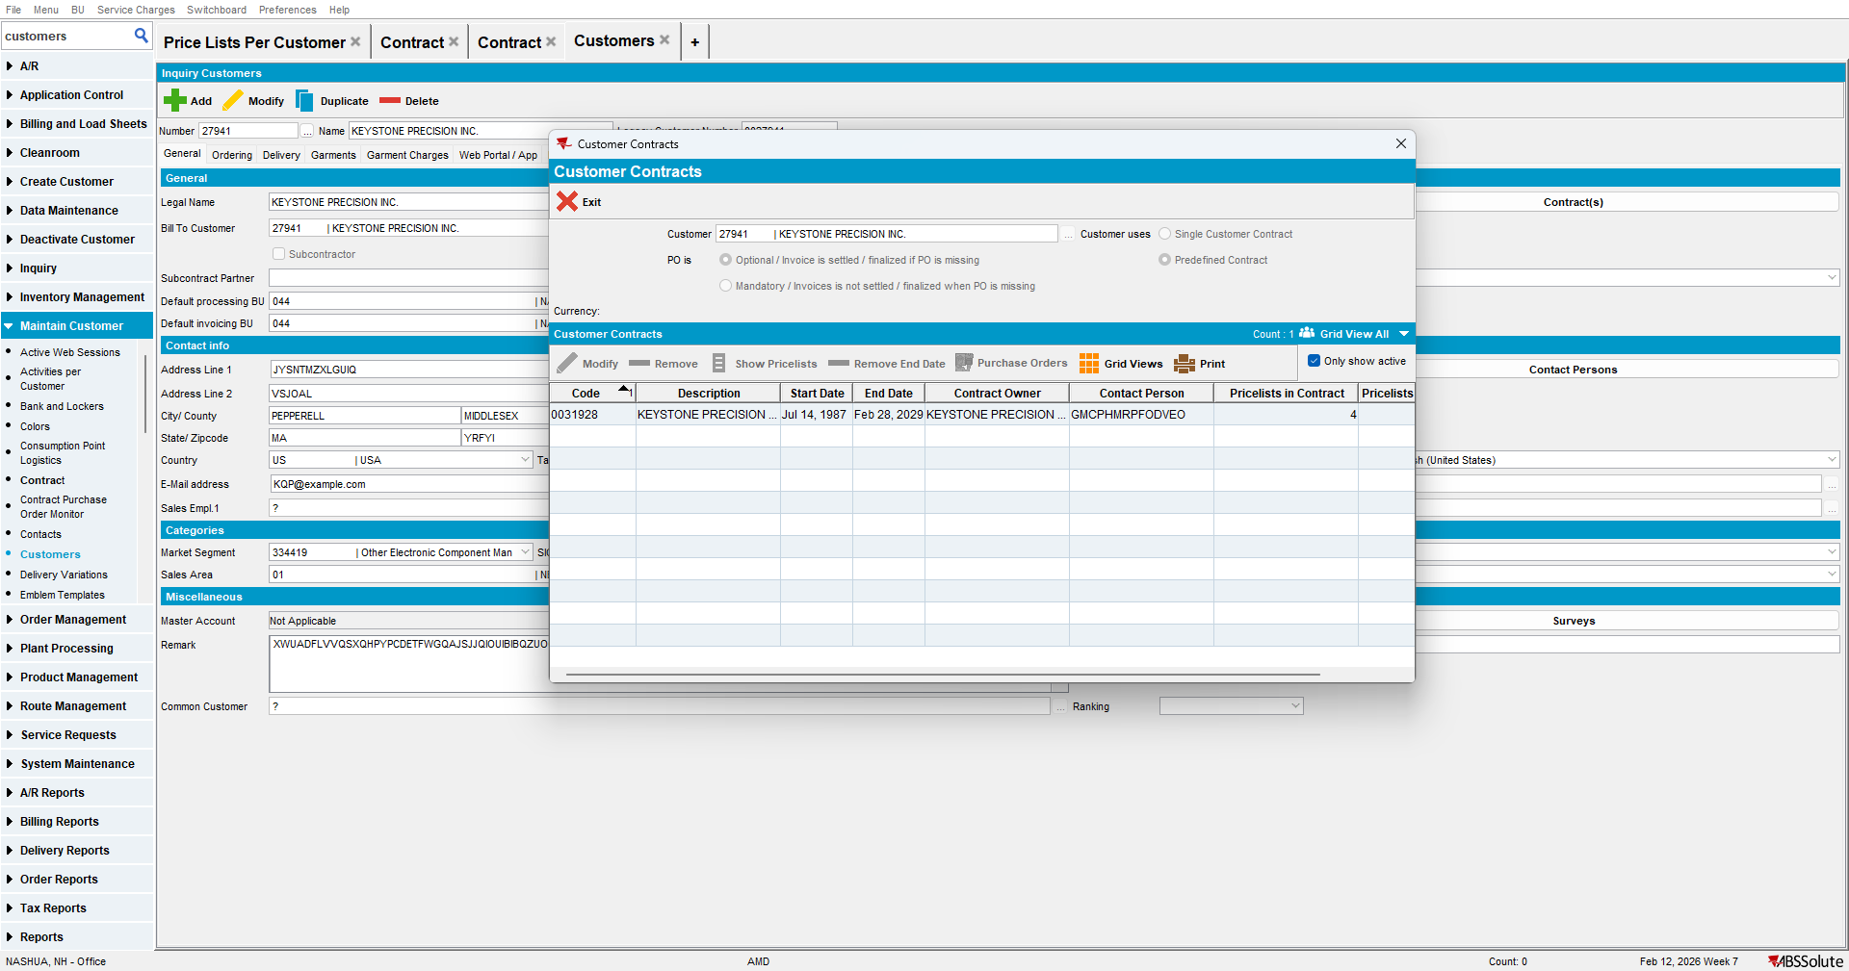

- Go to Price List Per Customer.
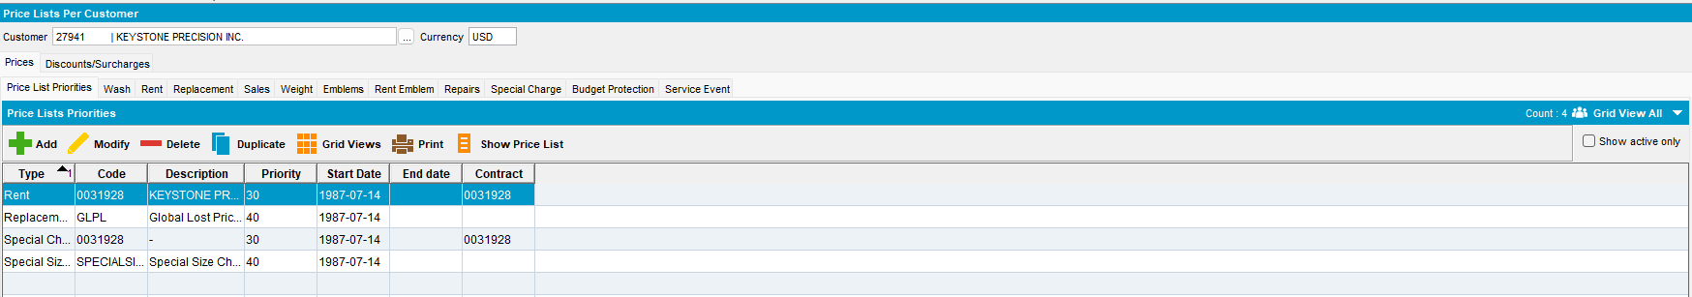

- Go to a contract and end the customer.
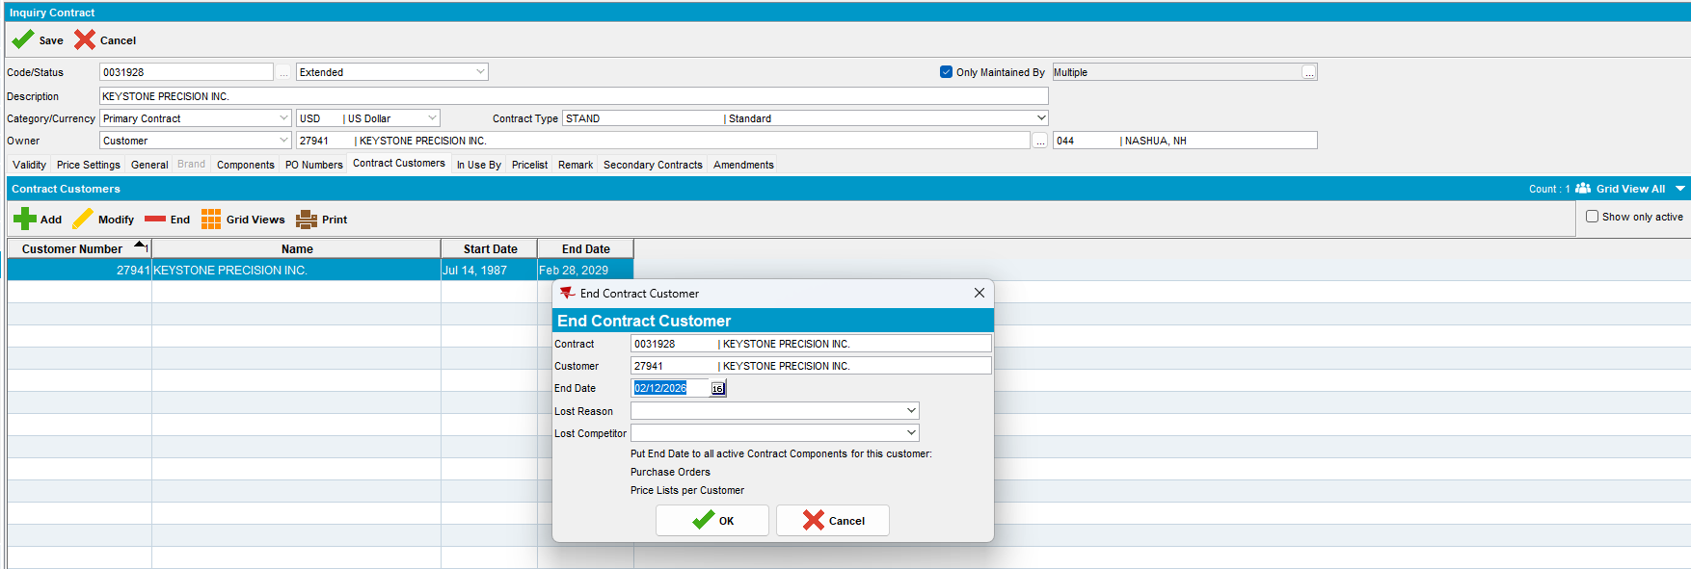

- Check the End date on Price List per Customer dialog.
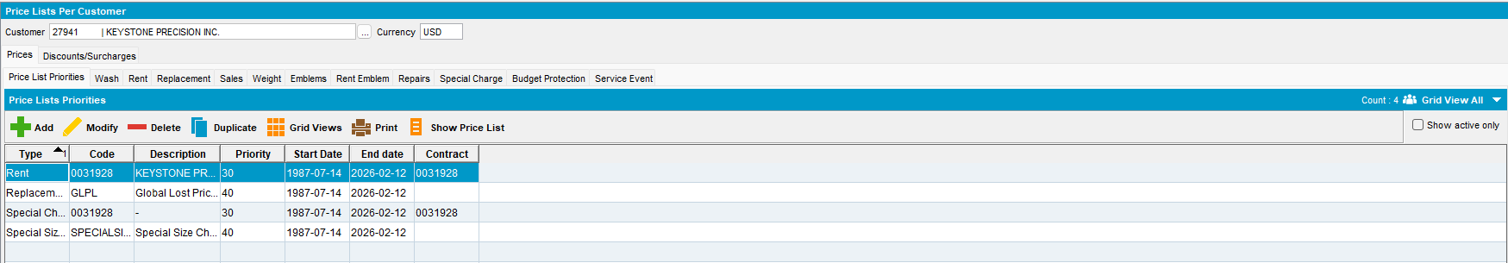
Expected Behavior:
All the prices should receive an end date.
Actual Behavior:
All the prices received an end date.

Test Case #3 – Add a customer with 1 active contract on another contract

- Find a customer with 1 active contract.
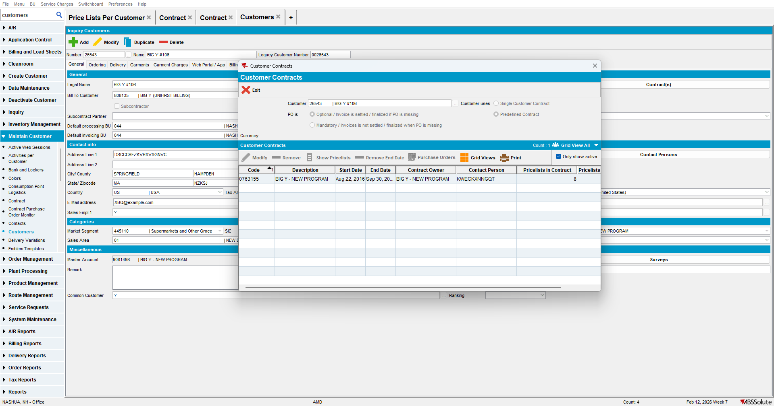
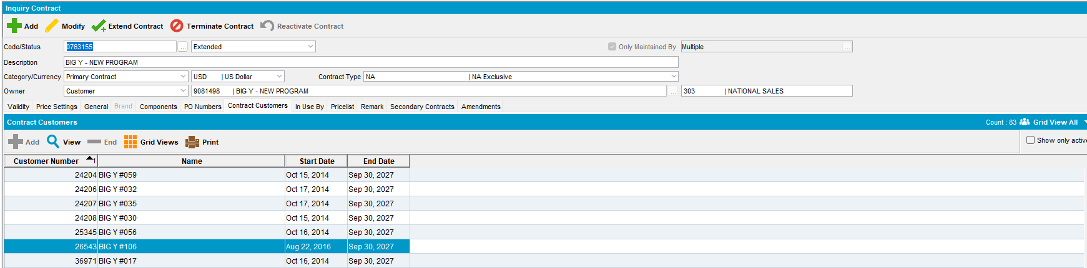

- Go to another contract and try to add this customer.
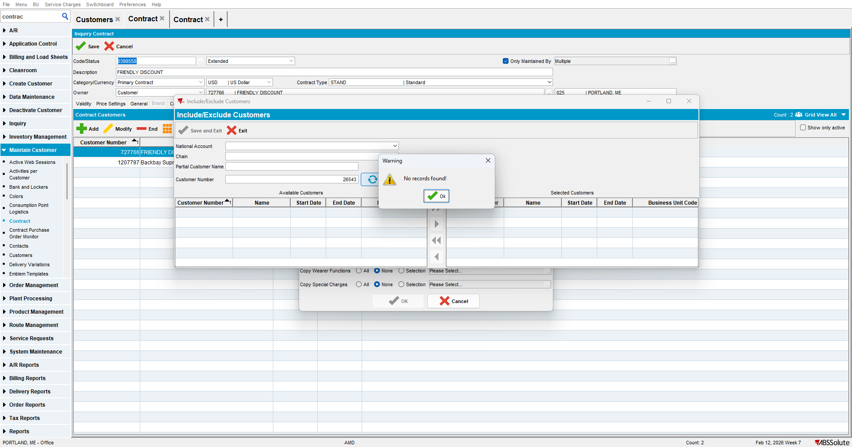
Expected Behavior:
It should not be possible to add a customer to another contract if that customer is already active on a different contract.
Actual Behavior:
It is not possible to add a customer to another contract if the customer is already active on a different contract.
TESTED OK.

