ABSN-12829 TRG_TMP_ROUTECONTROLEXTRAINFO to be updated for web service usage
Environment | Prerequisites
Version: 9.07.00.UNF17.p18
DBServerName=abs-srv20.internal.abslbs.com
DBSID=CUST24
DBUser=UNFLIVE
Environment=Test

Contents
Retest after fix 1
Test Case 1 – Add a Future-Dated Route (> sysdate + 1) and Generate Invoices – Tested OK 2
Test Case 2 – Add a Route for sysdate + 1 and Generate Invoices – Tested OK 3
Test Case 3 – Add a House Route and Generate Invoices – Tested OK 3

Retest after fix
Hash: 9.07.00.UNF17.p18 at hash 31bc8452ed1a
Setup: Scheduled process "Cancel and regenerate US direct invoices for last minute delivery notes" inactive on current plant.
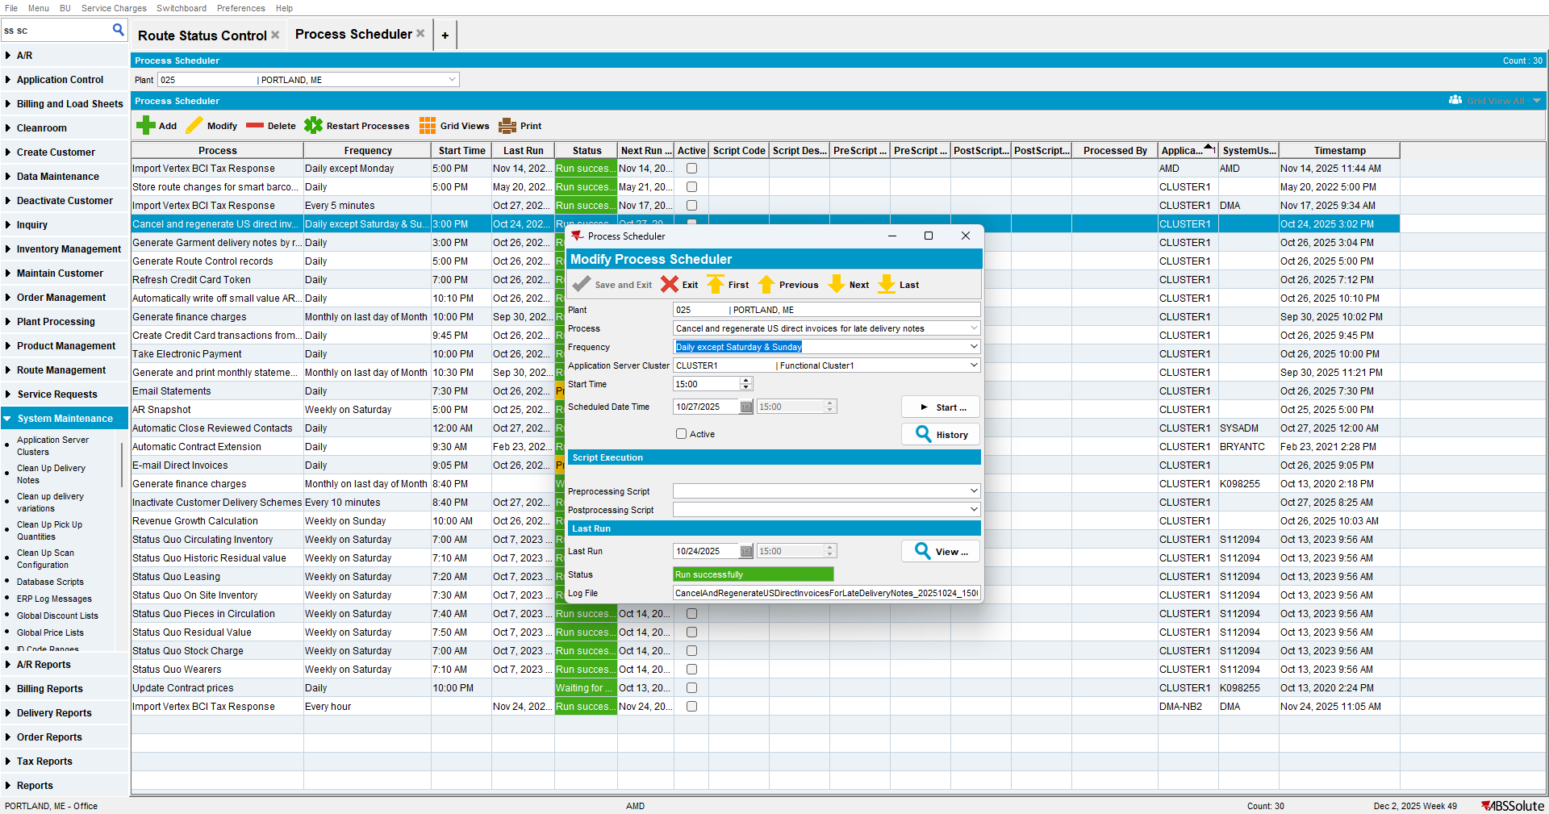

Test Case 1 – Add a Future-Dated Route (> sysdate + 1) and Generate Invoices – Tested OK

- RSC: Add a new route.
Finalization Status = 0 (Not started)

- Generate the invoices and tax them.
Finalization Status = 2 (Completed) and PDA Status = 3 (Ready for Transfer)

- RA: Settle the Route.
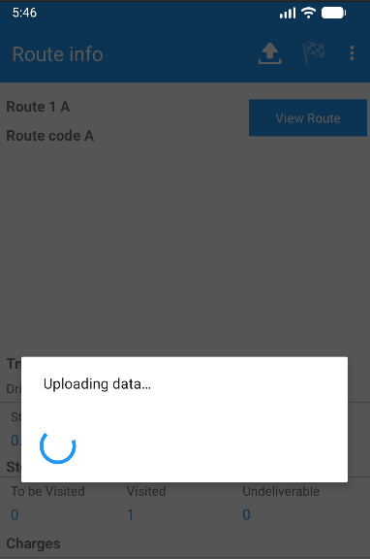

Expected Behavior: After the invoice is generated and taxed, the Finalization Status should be set to Completed, and the PDA Status should update to Ready for Transfer and Completed after settled in RA.
Actual Behavior: After the invoice is generated and taxed, the Finalization Status is set to Completed and the PDA Status updates as expected.

Test Case 2 – Add a Route for sysdate + 1 and Generate Invoices – Tested OK

- RSC: Add a new route.
Finalization Status = 0 (Not started)

- Generate the invoices and tax them.
Finalization Status = 0 (Not Started) and PDA Status = 0 (Not Ready for Transfer)

Expected Behavior: After the invoice is generated and taxed, the Finalization Status should remain Not Started, and the PDA Status should remain Not Ready for Transfer.
Actual Behavior: After the invoice is generated and taxed, the Finalization Status remains Not Started, and the PDA Status remains Not Ready for Transfer, as expected.

Test Case 3 – Add a House Route and Generate Invoices – Tested OK

- RSC: Add a House Route and Generate Invoices.
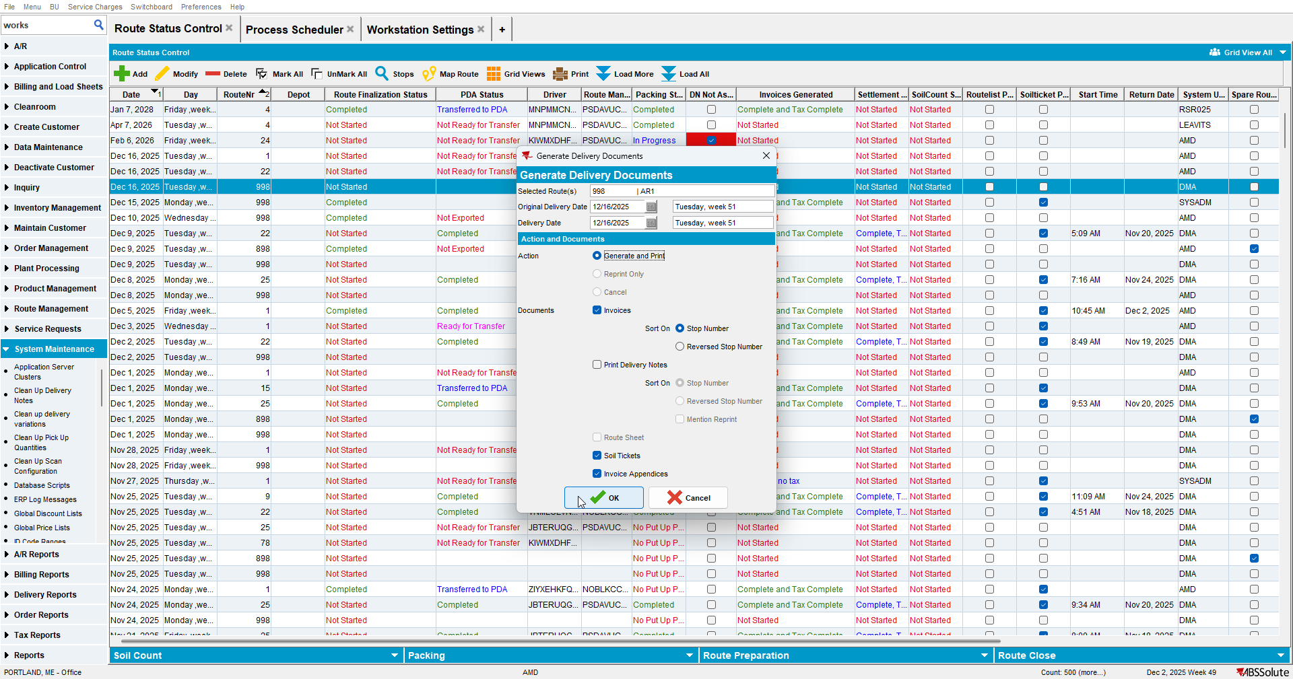
Route Finalization Status is Completed.

