ABSN-1251 - Web Client X - Invoice Adjustments Tab - Approve / Reject column is not exported to Excel
Environment | Prerequisites
Version: 9.07.00.UNF21  DBServerName= abs-srv20.internal.abslbs.com  DBSID=CUST24  DBUser=UNFDEV  Environment=Test | - Module:  - System setting

Contents
Reproducing before fix 1
Steps to reproduce 1
Current Behavior 5
Expected behavior 6
Retest after fix 6
Test Case 1 – Check that the Approve / Reject column is present in the exported Excel Doc for Invoice Adjustments and Wearer Maintenance Tabs. 6
Test Case 2 – Check that the Approve / Reject column is present in the exported Excel Doc for Web Orders tab. 12

Reproducing before fix

Steps to reproduce
- RSC: Create a new RC with few customers on it
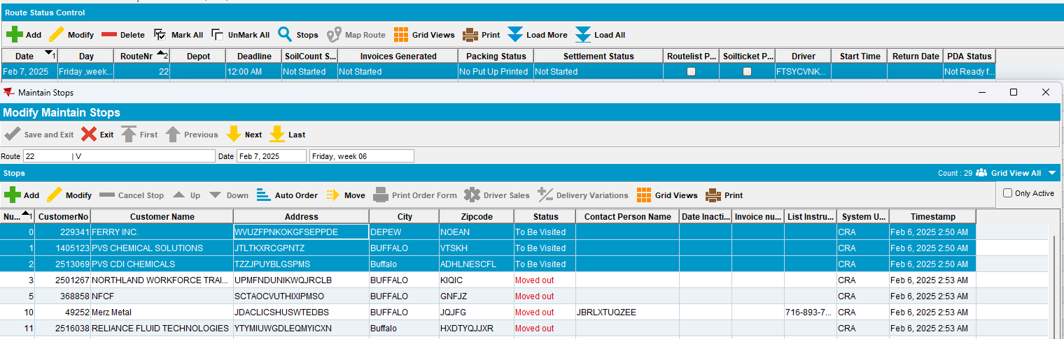
- Generate Invoices and script taxes
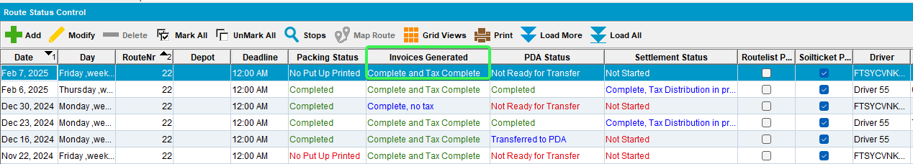
- Set PDA Status as ready for transfer and send the route to RA
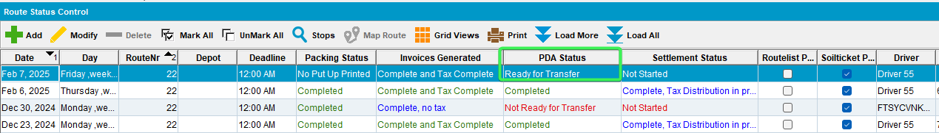
- Arrive at the first customer Wearers tab > Quit a wearer
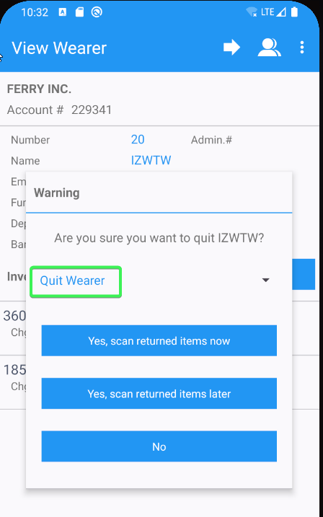
- Increase and Decrease a wearer’s inventory
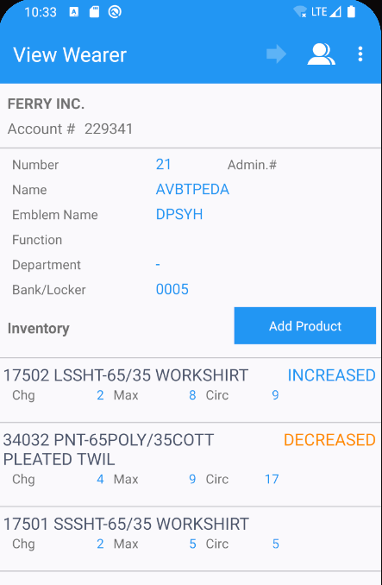
- Add a new wearer and wearer inventory
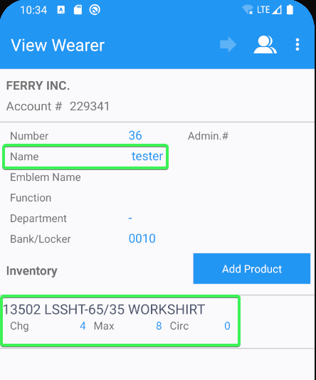
- Arrive at the second customer and perform several invoice adjustments
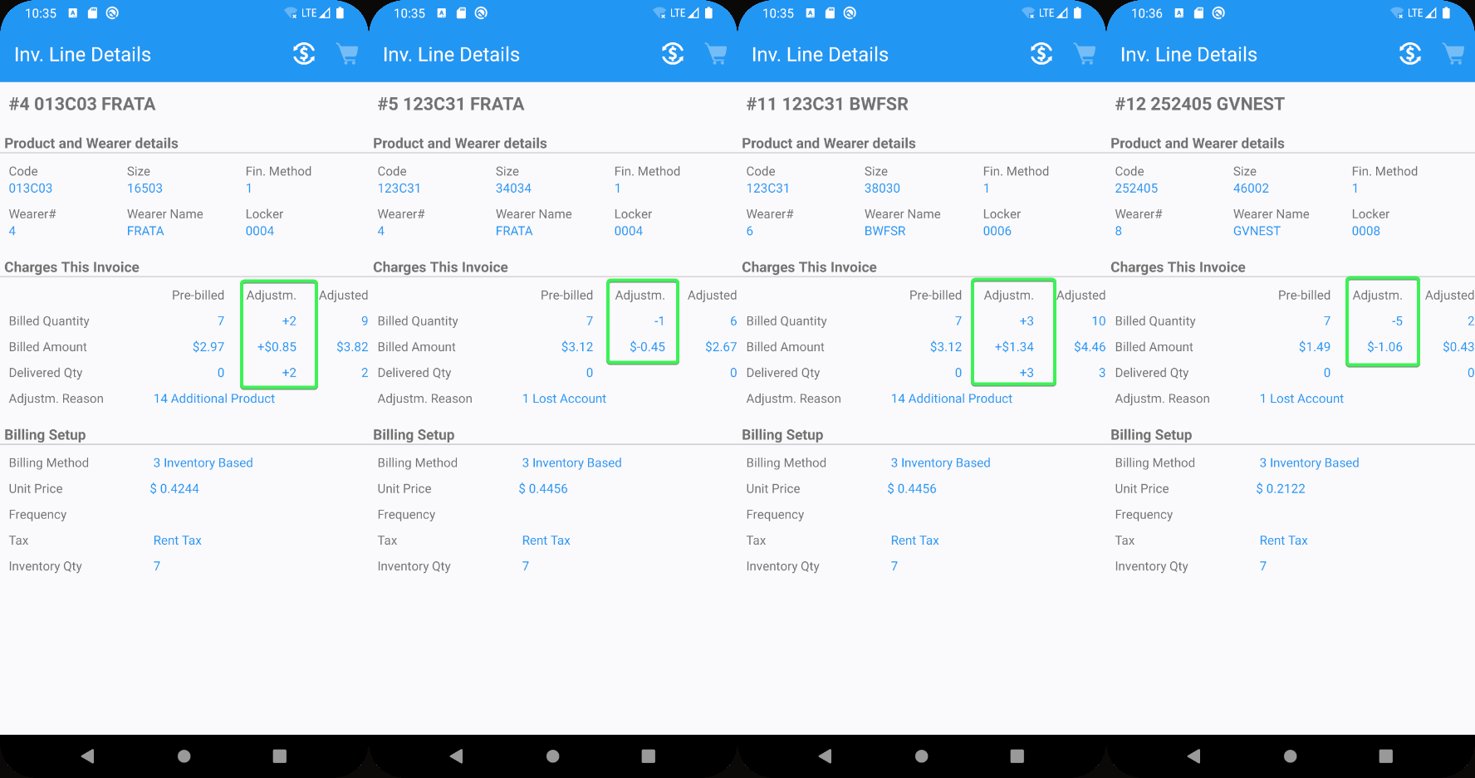
- Finish and upload the data
- WebX: Complete start my day
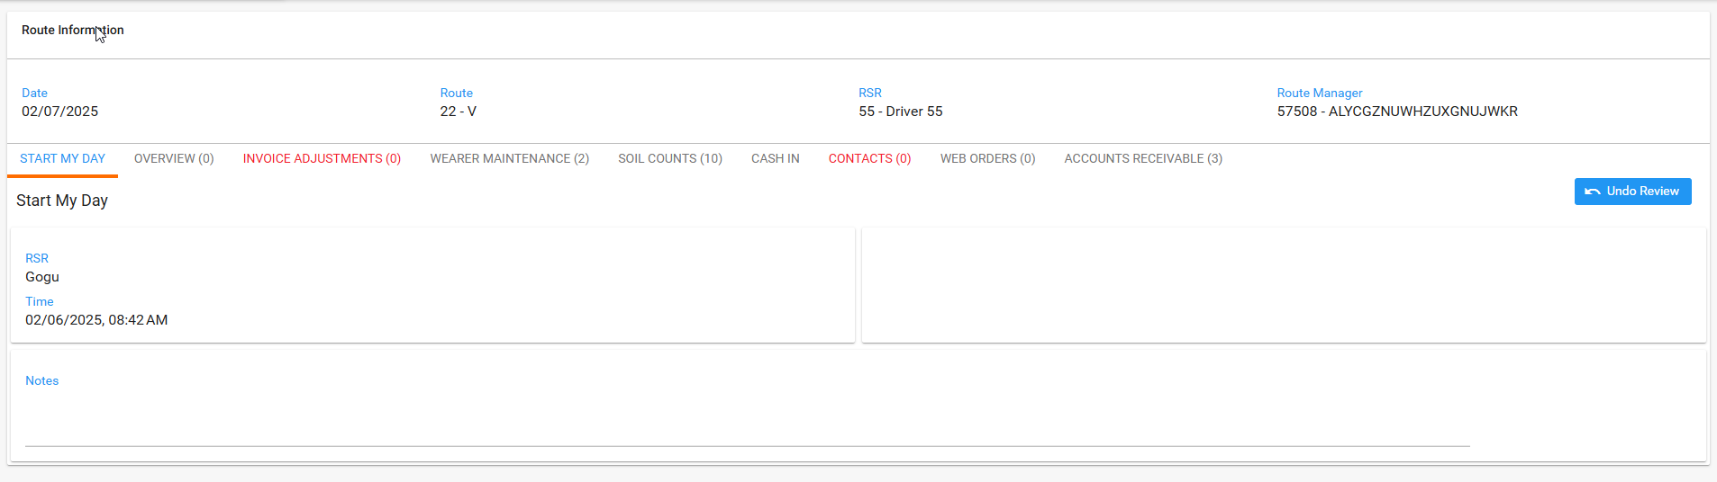
- Invoice adjustments tab: See the approve/reject column
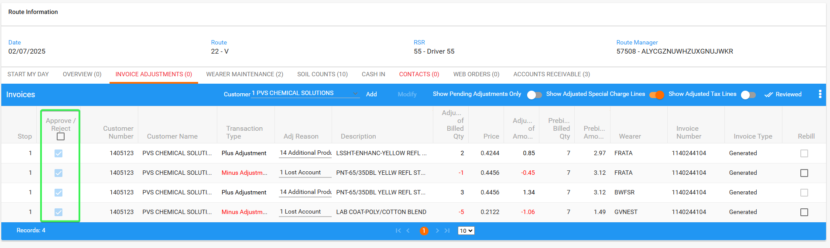
- Export to Excel
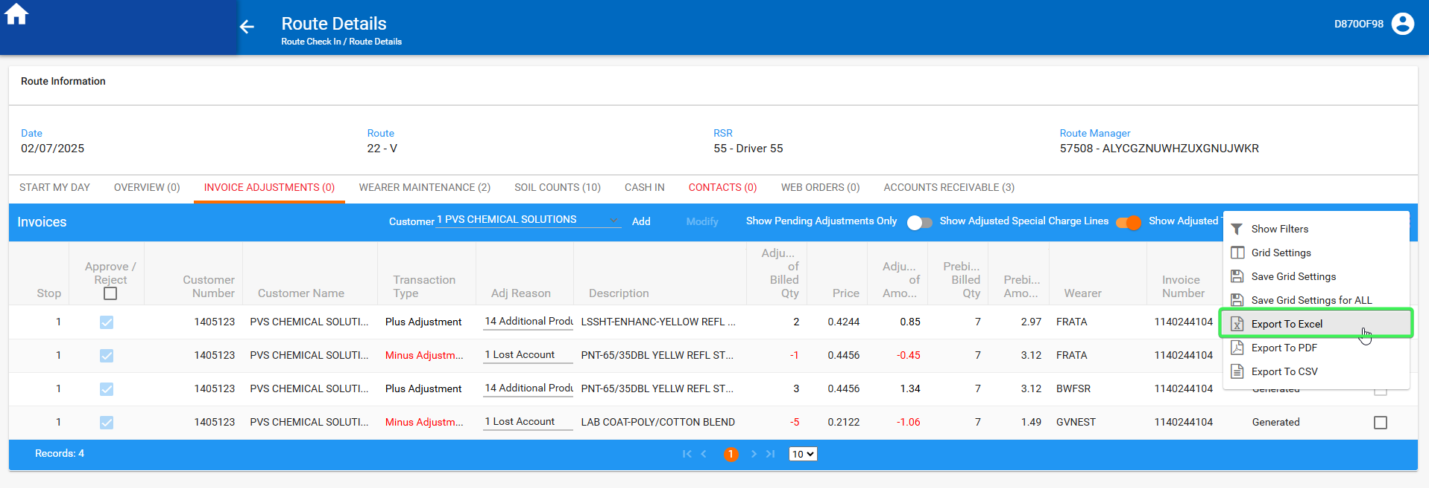
- Check the exported document for the Approve / Reject column
Column is missing

REPRODUCED OK.

Current Behavior
Approve / Reject column from Invoice adjustments is missing when exporting to Excel

Expected behavior
The Approve / Reject column should be present when exporting to Excel

Retest after fix

Test Case 1 – Check that the Approve / Reject column is present in the exported Excel Doc for Invoice Adjustments and Wearer Maintenance Tabs.
Hash: 9f973ba89c6c
- RSC: Create a new RC with few customers on it
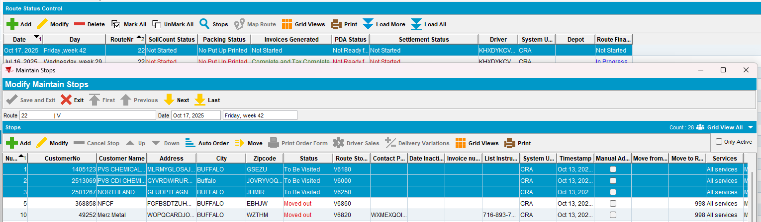
- Generate Invoices and script taxes
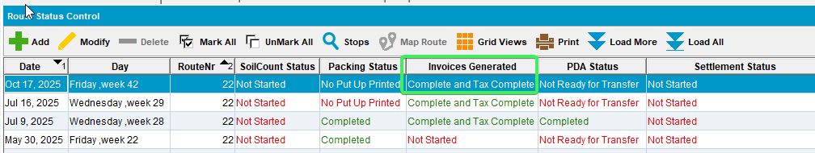
- Set PDA Status as ready for transfer and send the route to RA
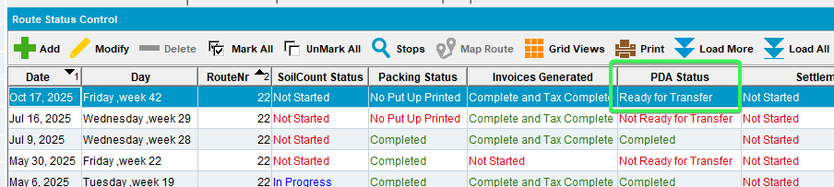
- Arrive at the first customer Wearers tab > Quit a wearer
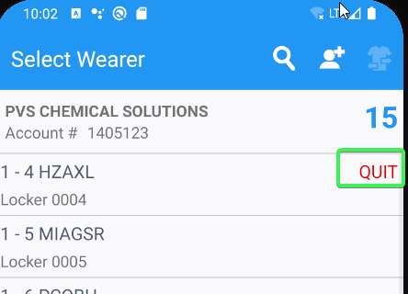
- Increase and decrease a wearer’s inventory
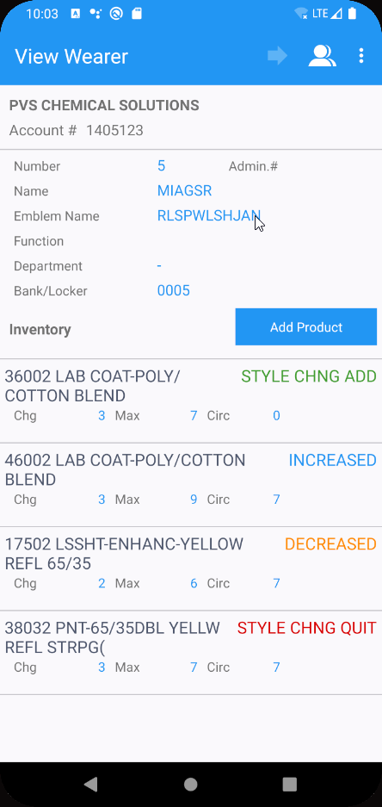
- Add a new wearer and wearer inventory
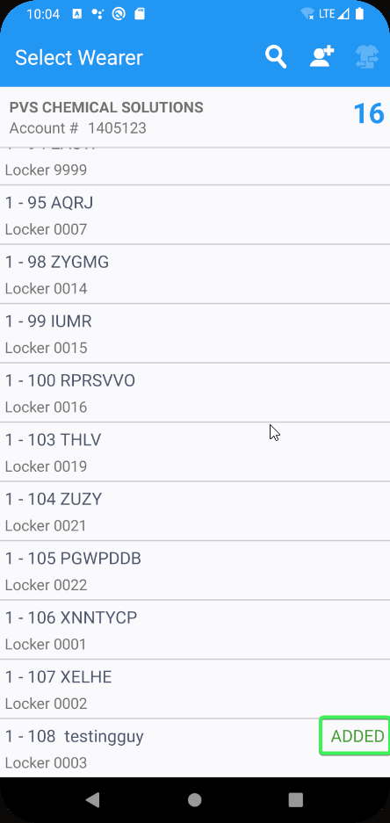
- Arrive at the second customer and perform several invoice adjustments
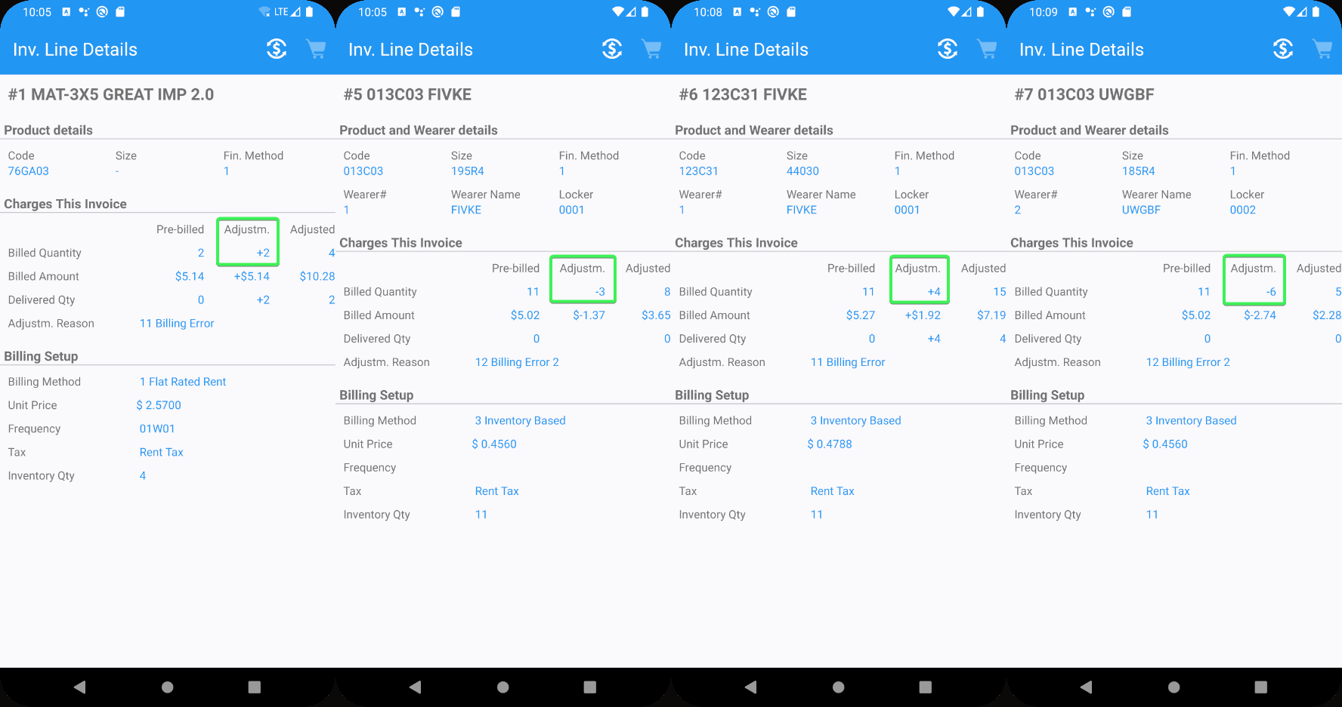
- Finish and upload the data
- WebX: Complete start my day
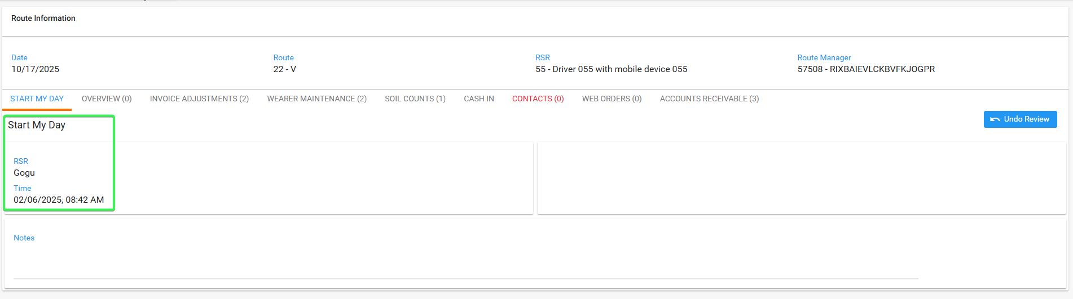
- Invoice Adjustments tab: Add a new invoice adjustment

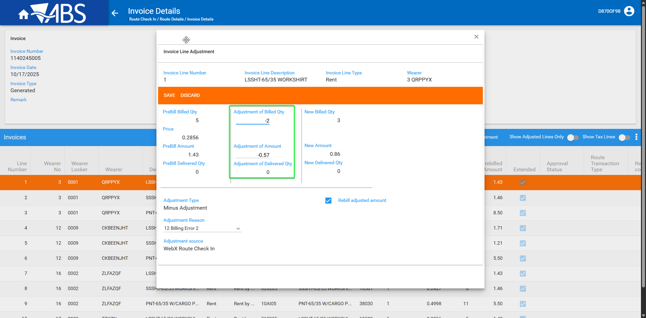
- Have all 3 statuses present in the grid: Approved, Rejected and Pending
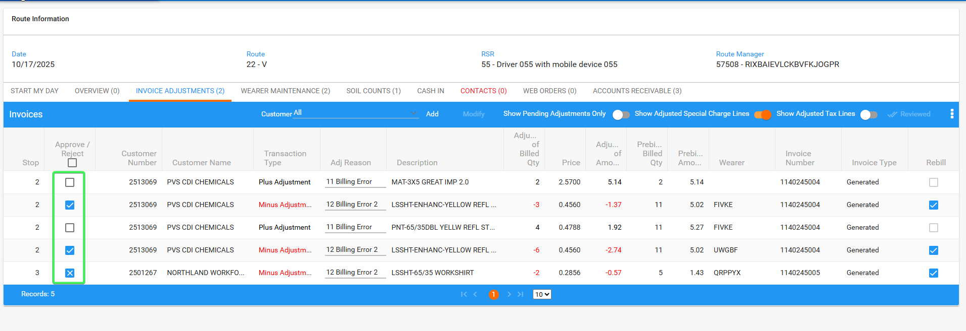
- Export to Excel
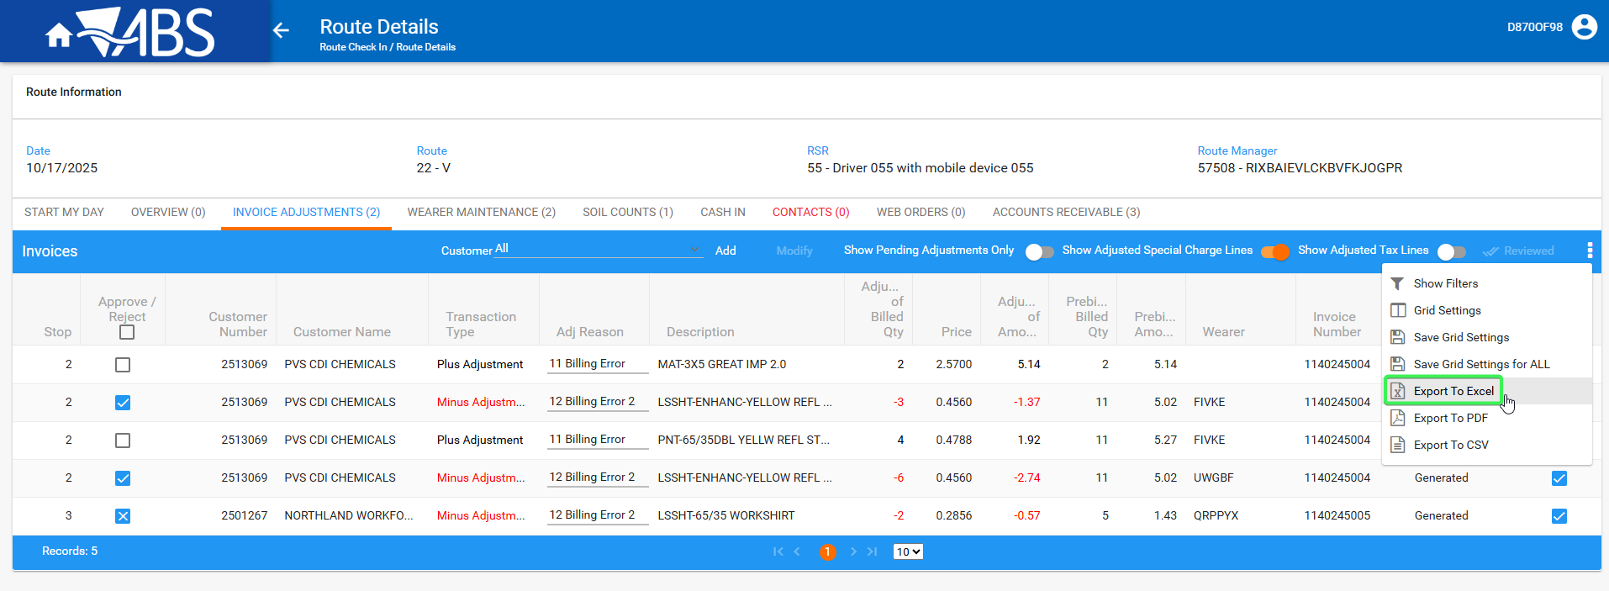
- Check the Exported Document that it has the Approve / Rejected column present and that has Approved Rejected and Pending transactions
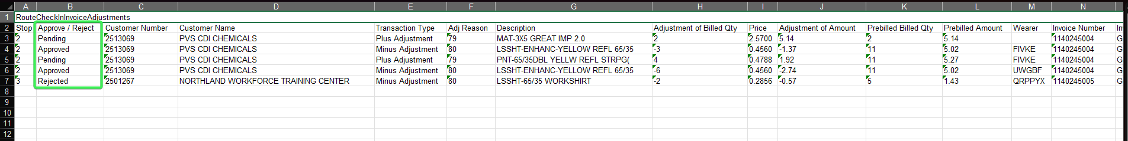
- Wearer Maintenance Tab: Reject the Add wearer transaction and leave the increase wearer inventory transaction as blank
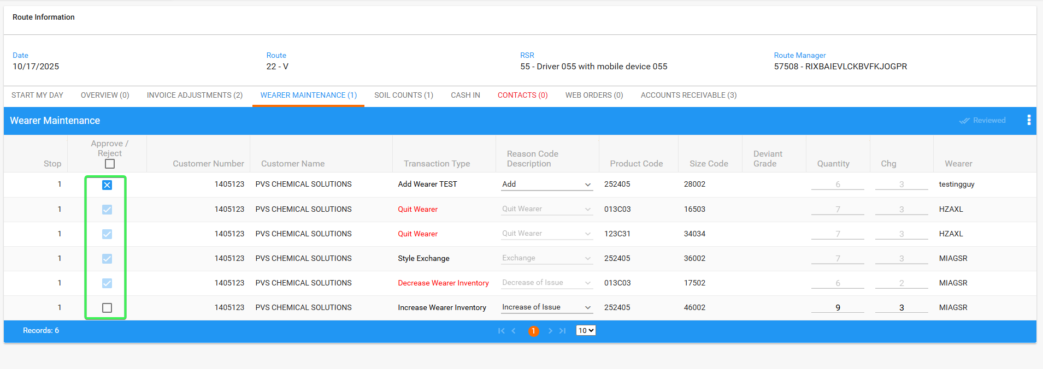
- Export to Excel
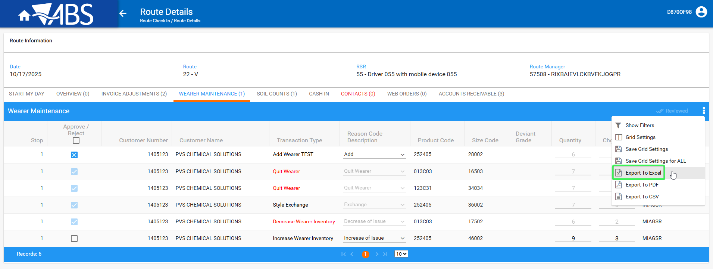
- Check the Exported Document that it has the Approve / Rejected column present and that has Approved Rejected and Pending transactions
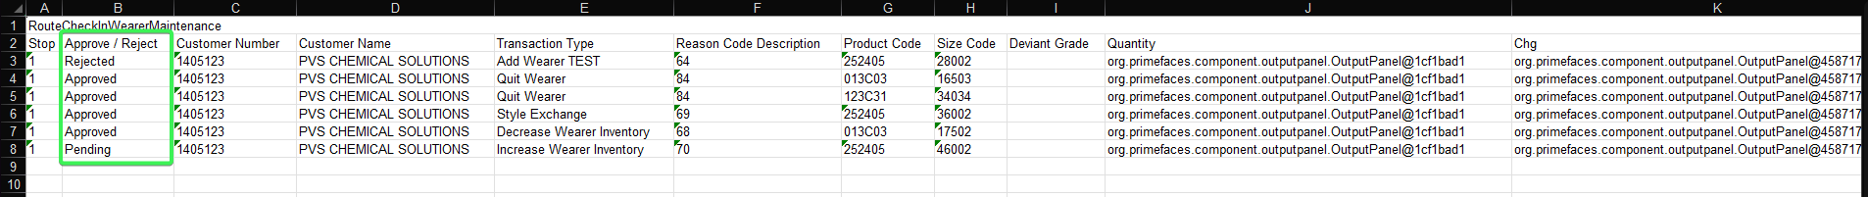
Tested OK

Test Case 2 – Check that the Approve / Reject column is present in the exported Excel Doc for Web Orders tab.
Hash: 9f973ba89c6c
- Web Portal: Select one of the customers
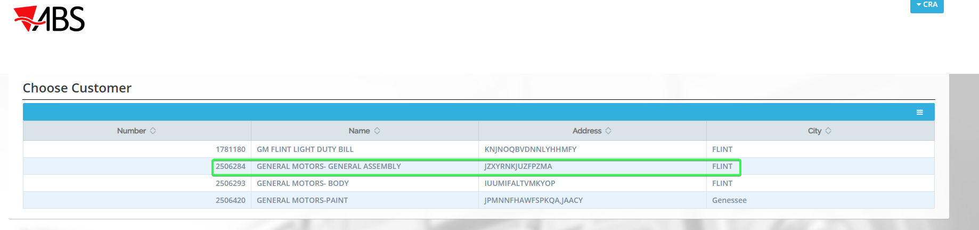
- Garments > Wearers > Add a new wearer
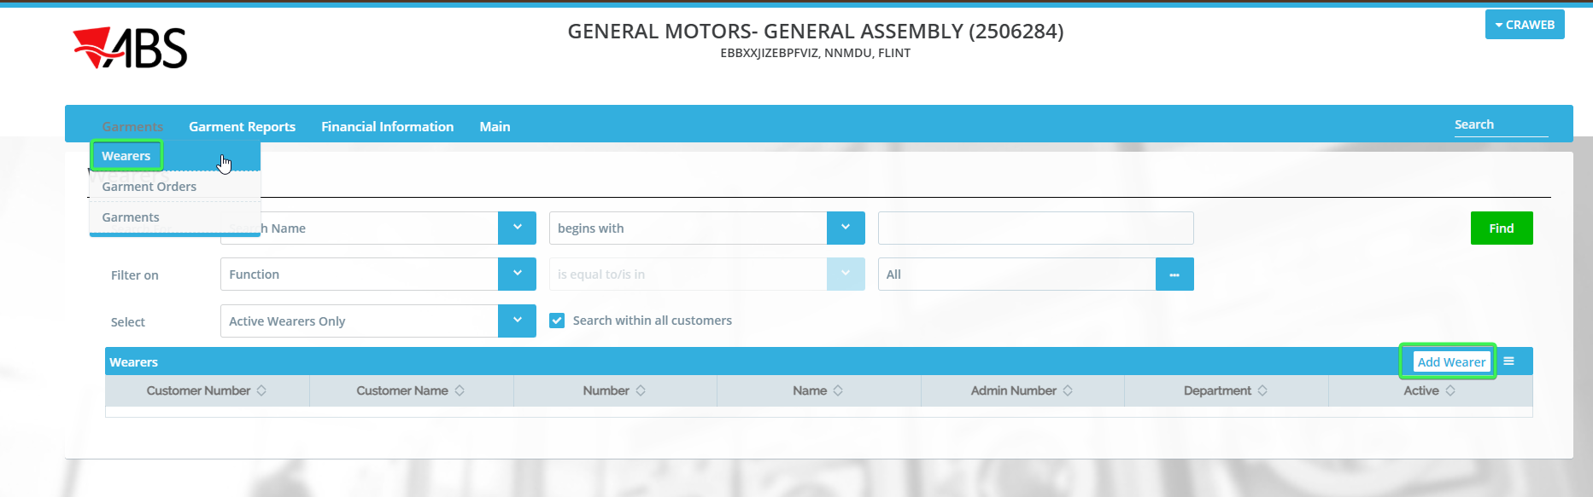

- Add a new Wearer inventory
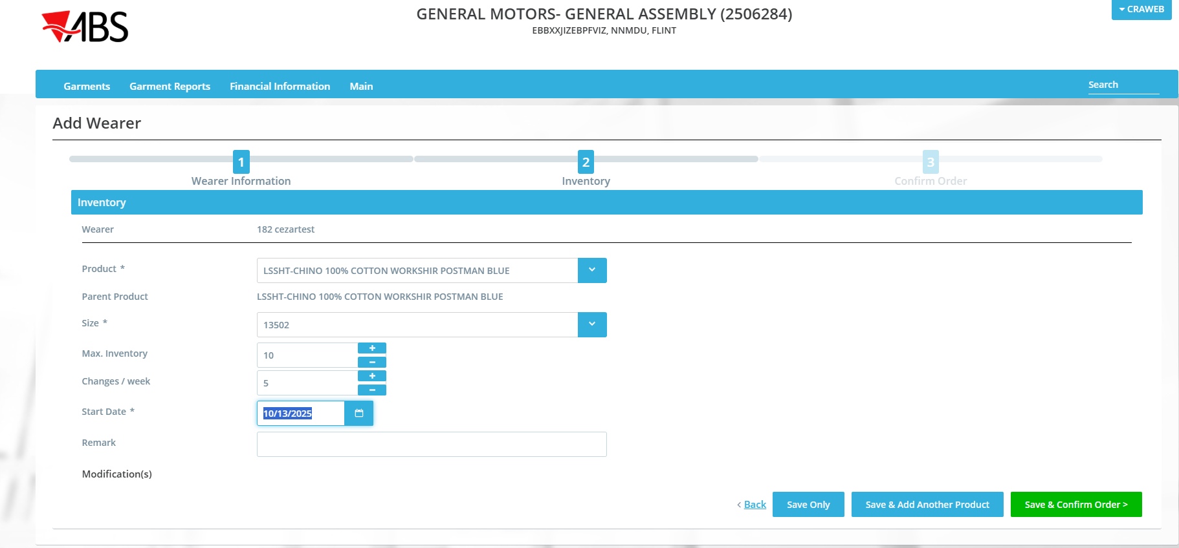
- Confirm the delivery date
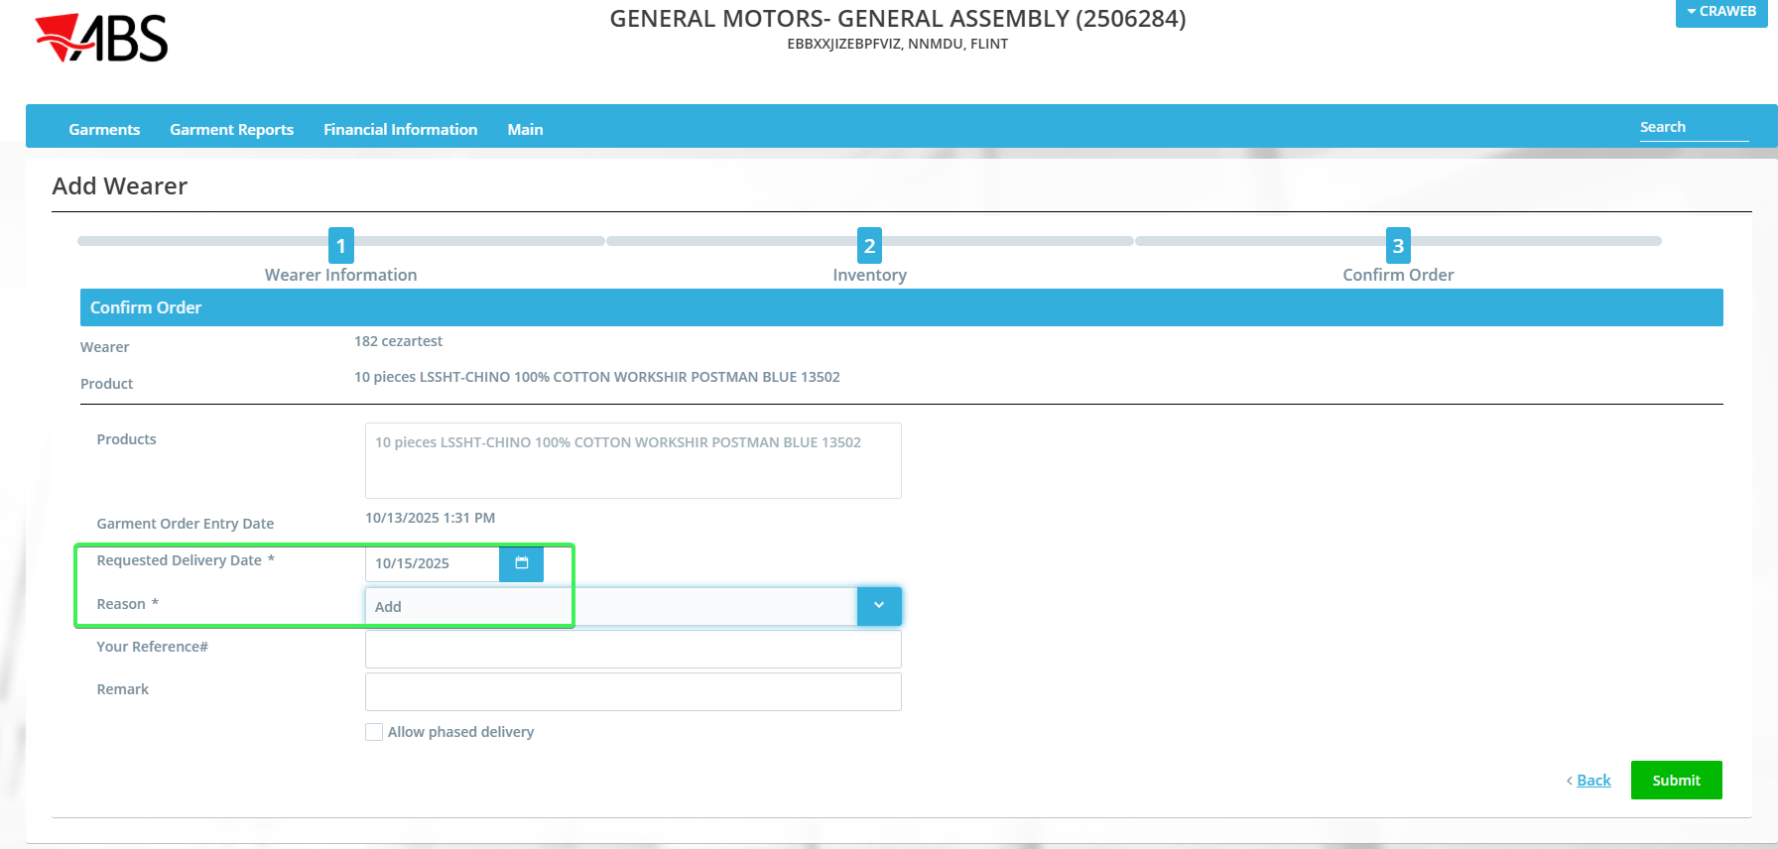
- RSC DLG: Create a route for the day and customer you created the web order for
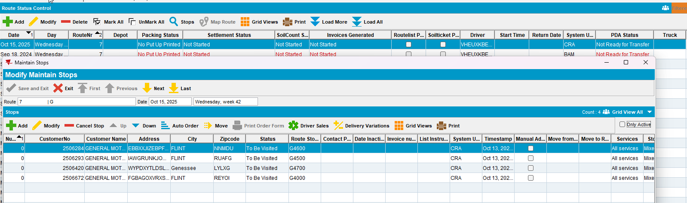
- WebX: Find the route with your customer on it
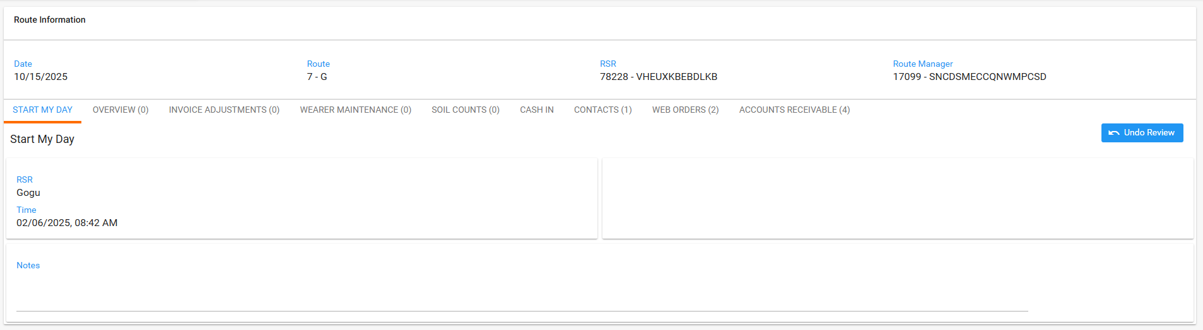
- Go to Web Orders Tab and Export to Excel
- Check the document for the Approve / Reject Column
Tested OK

