ABSN-12319 Route Status Control - Add CreationUser and CreationTimestamp
Environment | Prerequisites
Version: 9.07.00.UNF21  DBServerName= abs-srv20.internal.abslbs.com  DBSID=CUST24  DBUser=UNFLIVE  Environment=Test | - Module:  - System setting

Contents
Retest after fix 1

Retest after fix
Hash: 16d36f712932

The records created in the database over the past few days were checked, and no null values were found.

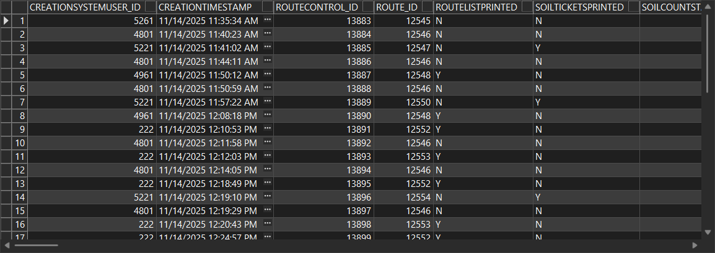

Next, the values will be verified during the route upload process.
Route Status Control dlg.: Add a new route.

Route Status Control dlg.: Generate the invoices and transfer the route to PDA.

RA: Complete the route and upload it.
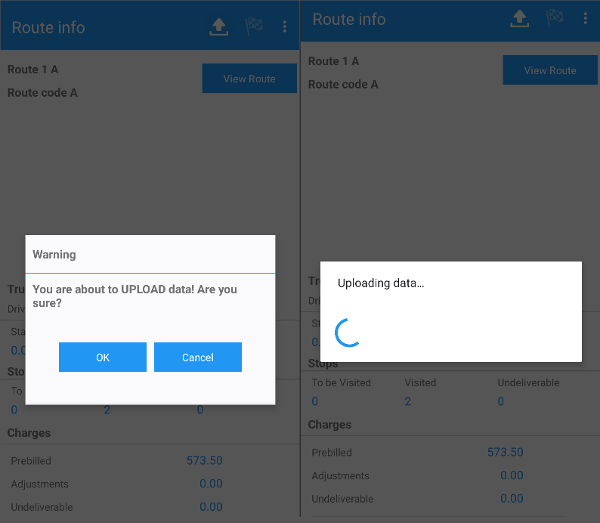

Route Status Control dlg.: Check the columns.
After the upload, all column values are correctly populated.

Maintain Sales Notes dlg.: Add a new sales note.
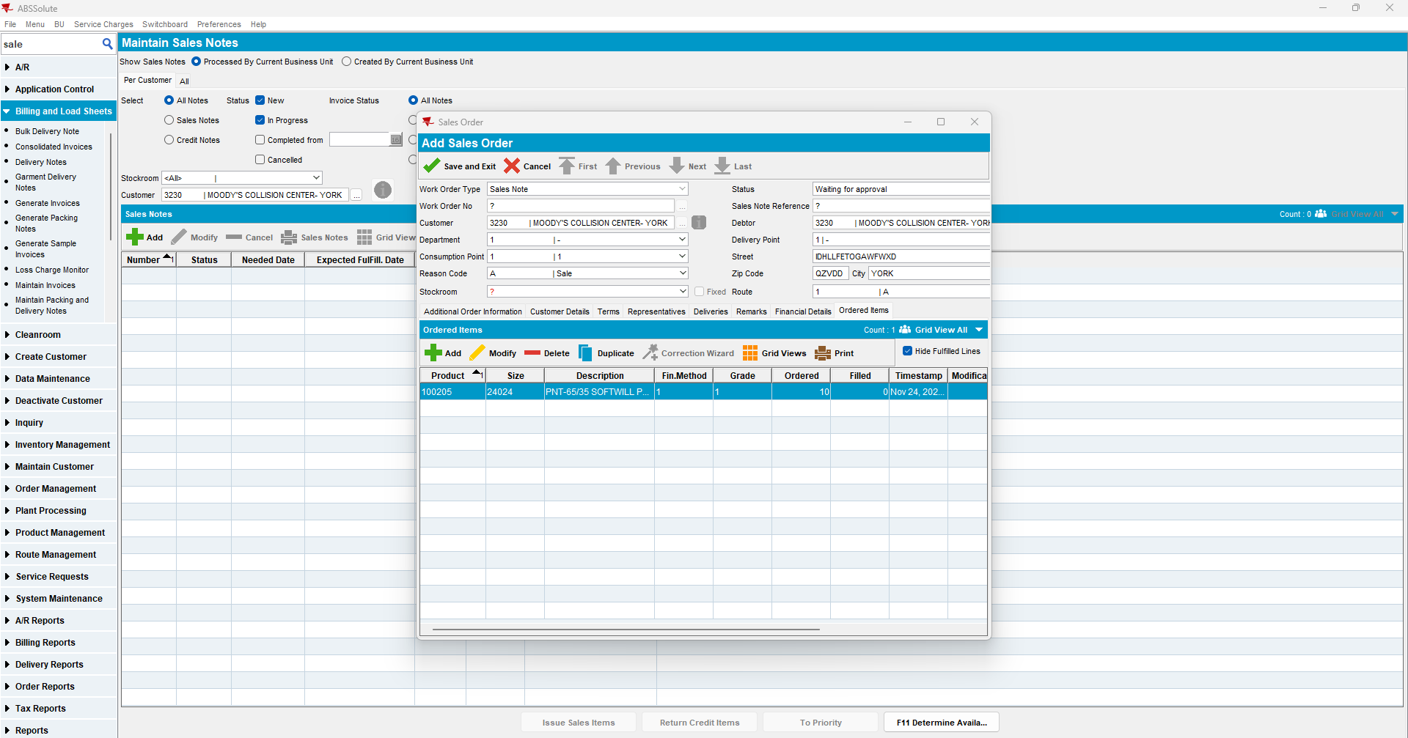

Maintain Sales Notes dlg.: Issue Sales Items.
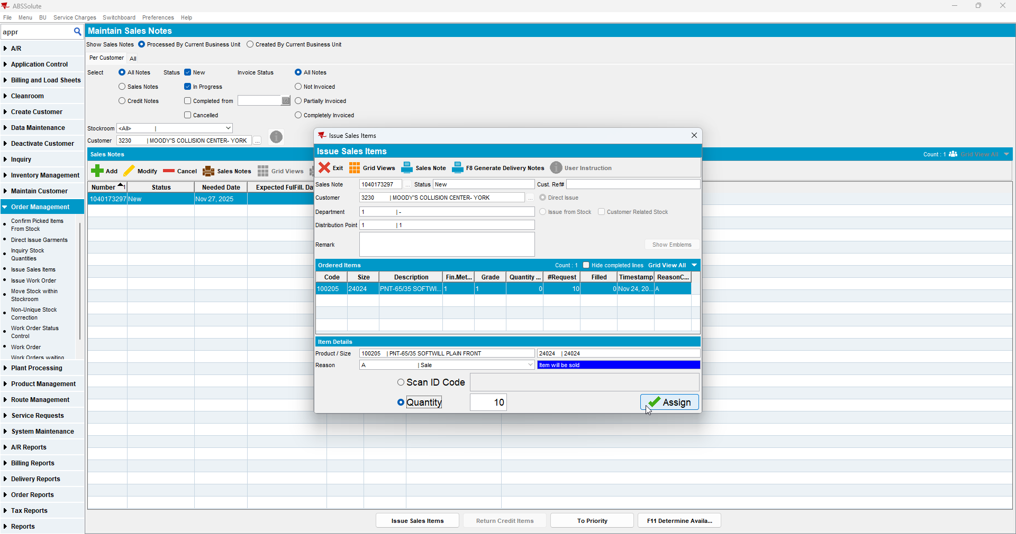
Maintain Sales Notes dlg.: Generate the Invoice.
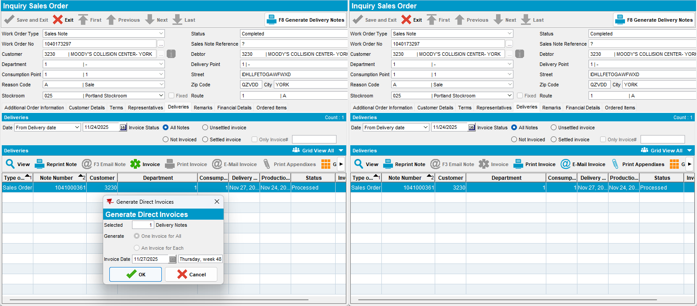

Route Status Control dlg.: Check the columns.
After the invoice generation, all column values are correctly populated.

