ABSN-12315 RSC column Finalization start and end have incorrect timestamp
Environment | Prerequisites
Version:9.07.00.UNF21  DBServerName= abs-srv20.internal.abslbs.com  DBSID=CUST24  DBUser=UNFDEV  Environment=PRODUCTION | - Module:  - System setting

Contents
Reproduce before fix 1
Steps to reproduce: 1
Retest after fix 2
Steps to reproduce: 2

Reproduce before fix
Bu: 288 RICHMOND
9.07.00.UNF20 hash: bff5c103ad26

Steps to reproduce:
- RSC dlg: Have a route with at least one customer. Generate invoices and finish taxes.
- Postman: Send a route finalization post for that route.
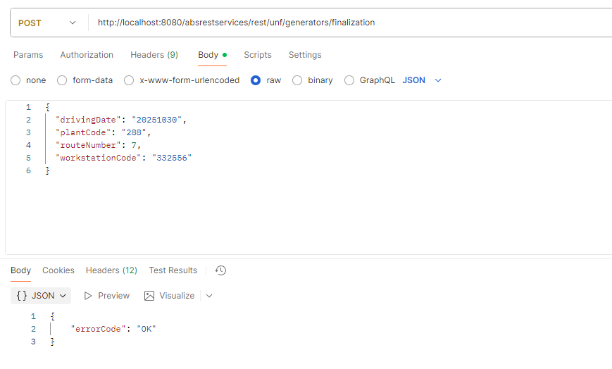
Current behavior:
The columns have incorrect timestamp

Expected behavior:
The start and end timestamp should have correct dates like in the View Process Log
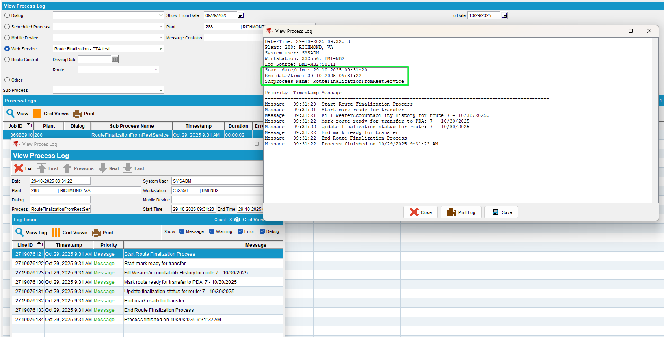

Reproduced OK

Retest after fix
Bu: 288 RICHMOND, VA
9.07.00.UNF21 hash: b8e21b77b284

Steps to reproduce:

- RSC dlg: Have a route with at least one customer. Generate invoices
- RSC dlg: Complete the taxes.
- Postman: Send a route finalization post for that route.
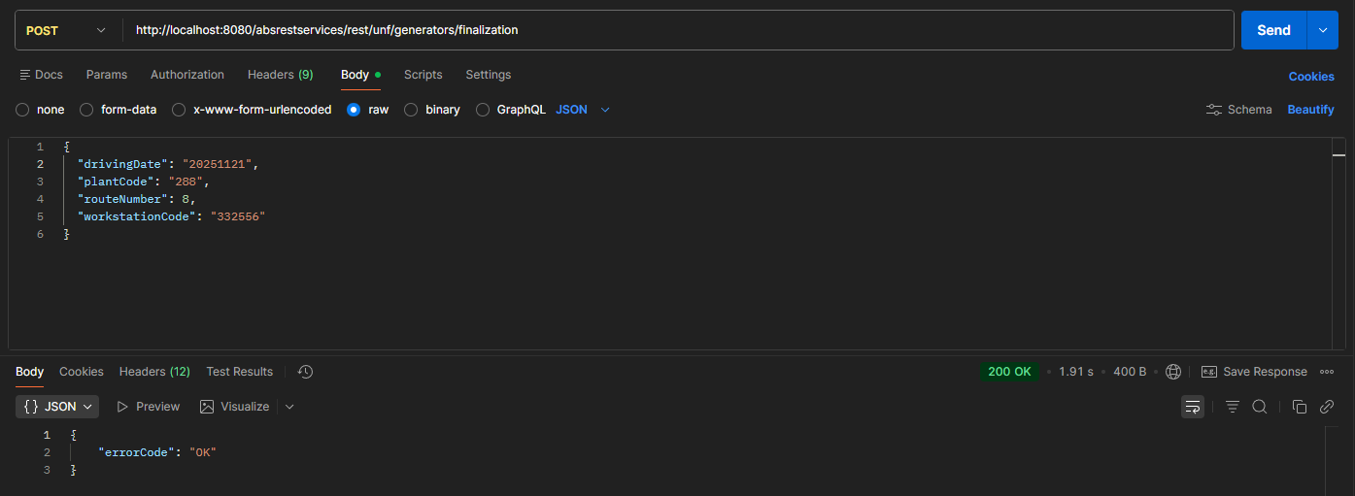
- RSC dlg: Refresh and re-check the dlg.

- View Process Log: Check the route finalization log
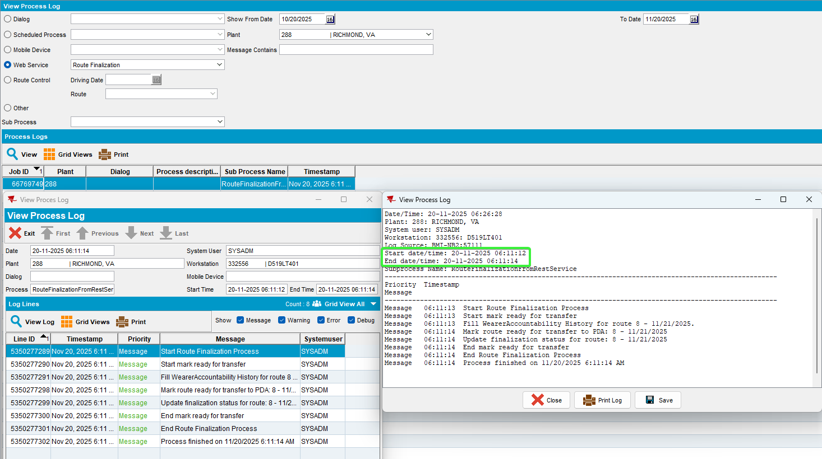
- RSC dlg: Add a new route number, keep few customers. Generate put up documents and invoices, script the taxes.
- Delivery Notes dlg: Add a new delivery note for the customer that Is not on the same delivery date.
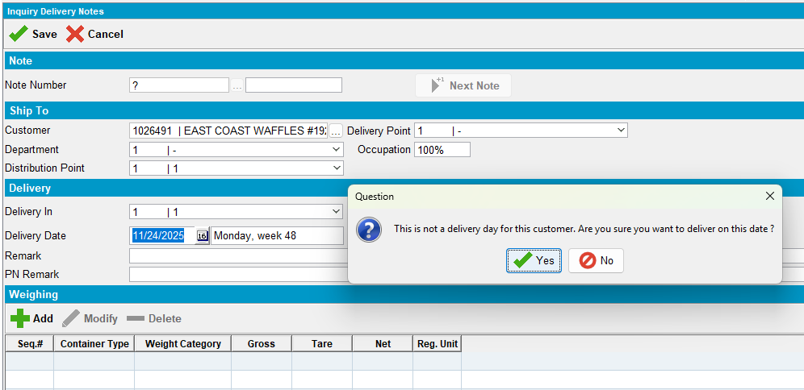
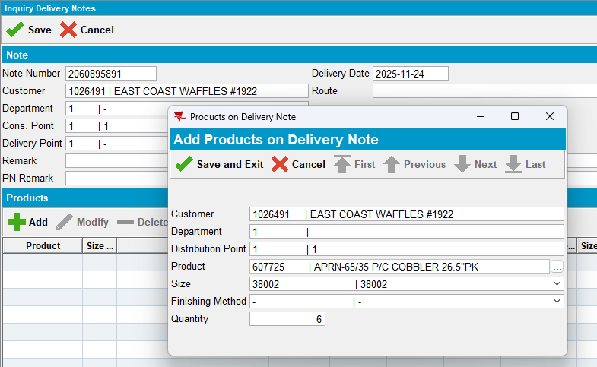
- RSC dlg: Generate invoices and script the taxes.
- Postman: Send a route finalization request.
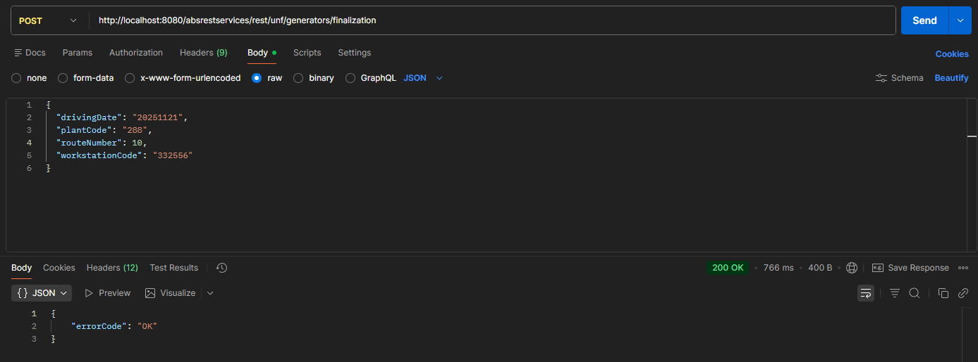

- View Process Log:
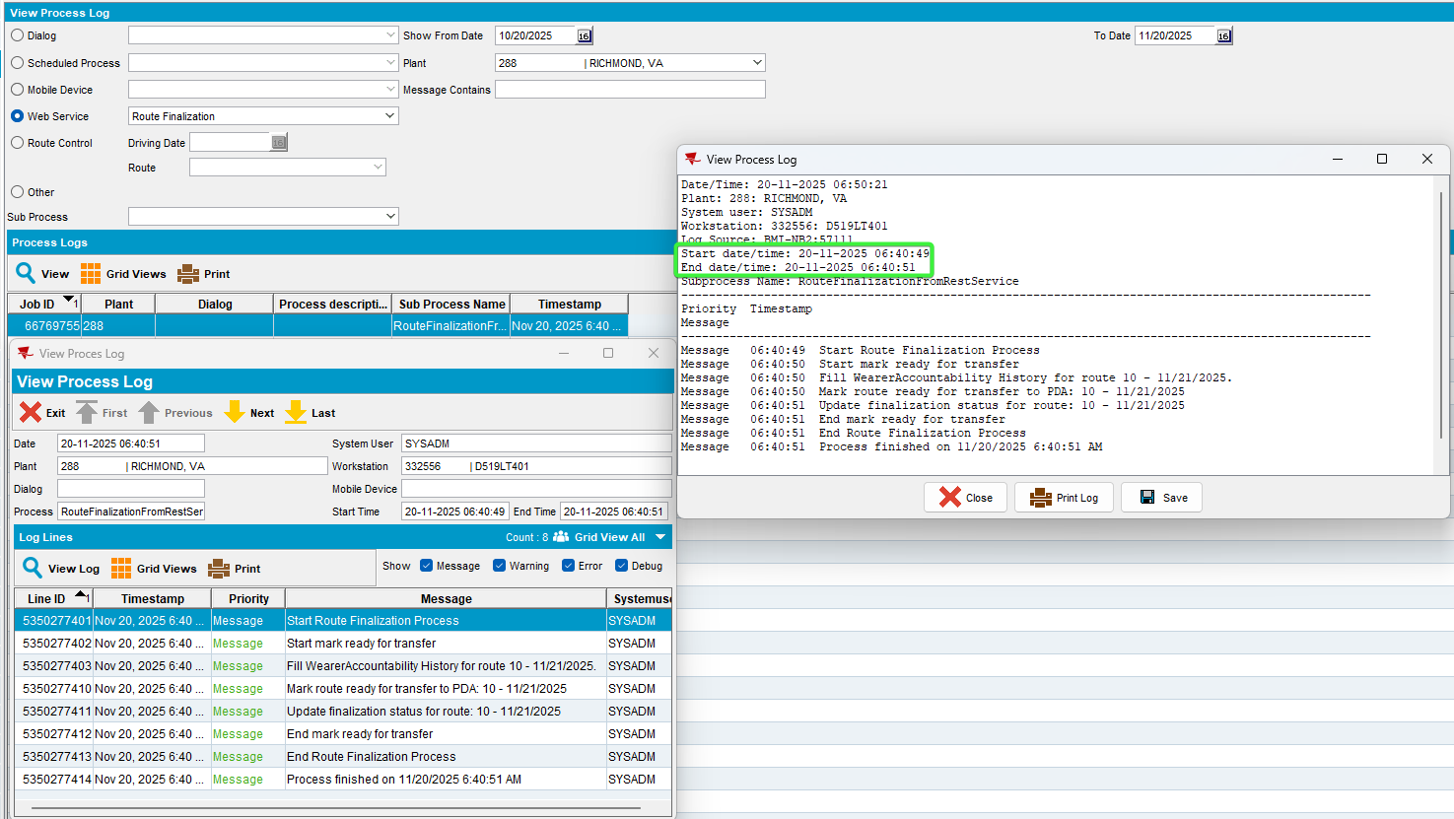
- RSC dlg: Add a new route number, keep few customers. Generate put up documents and invoices, script the taxes.
- Maintain Sales Notes dlg: Add a sales note for one of the customer visited.
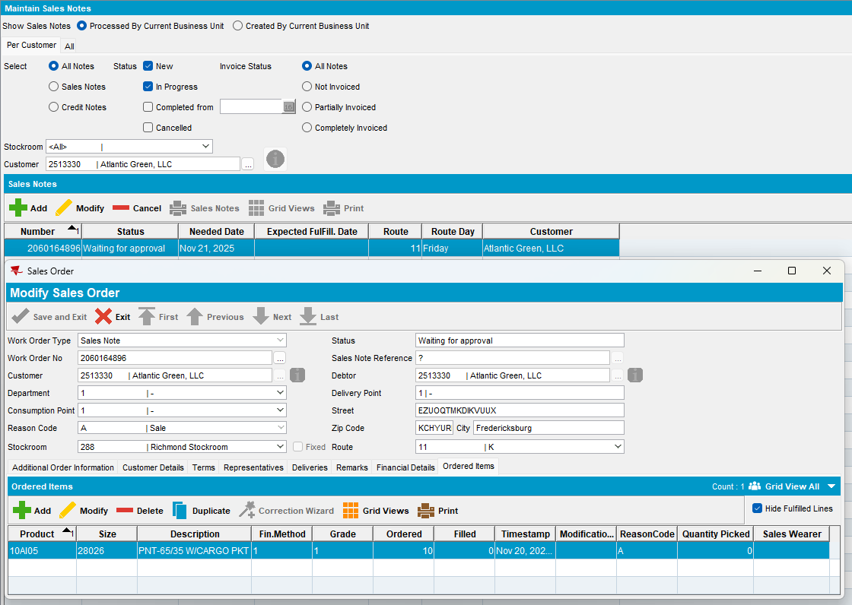
- Work Orders waiting for Approval dlg:
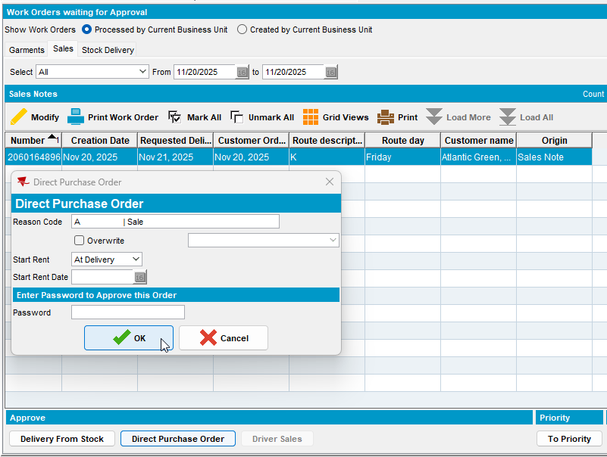
- Maintain Sales Note dlg: Issue sales note and Generate delivery note on a different day than the visiting day.
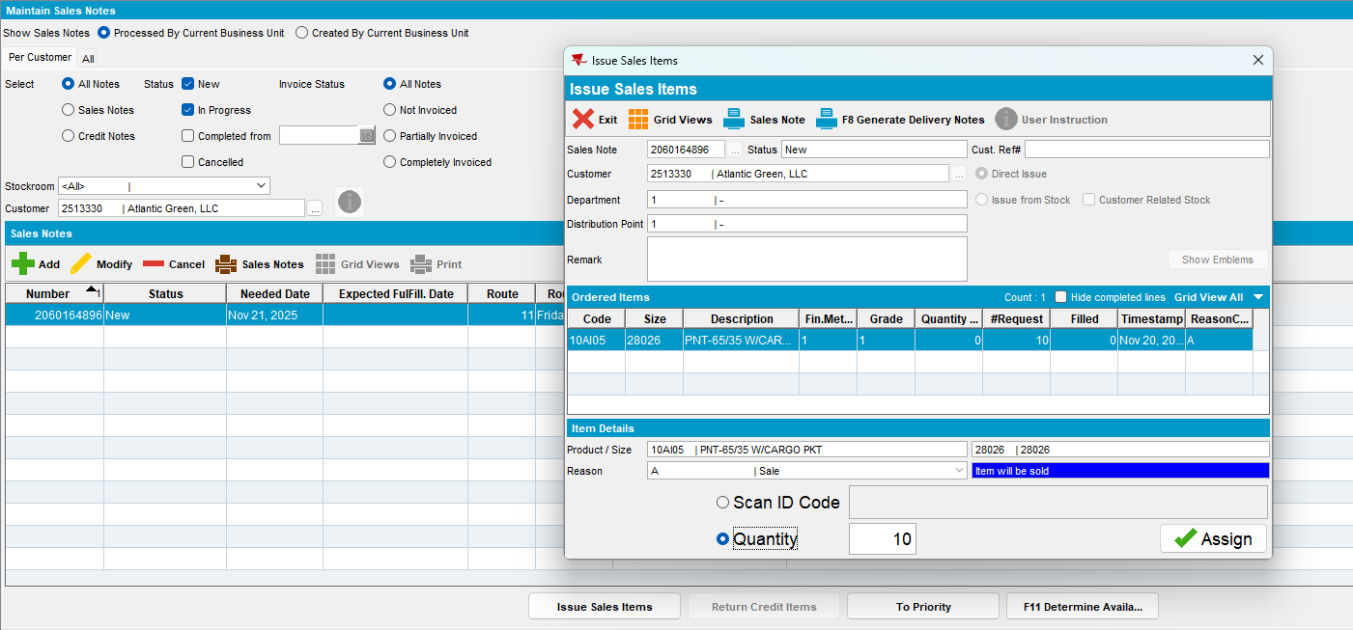

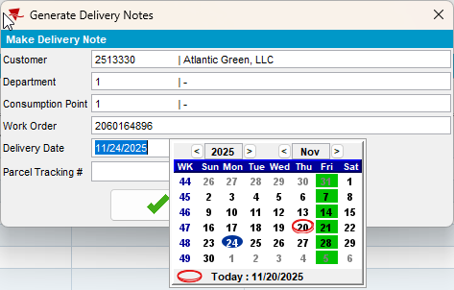
- RSC dlg: Check the packing note, the sales note is present but not assigned.
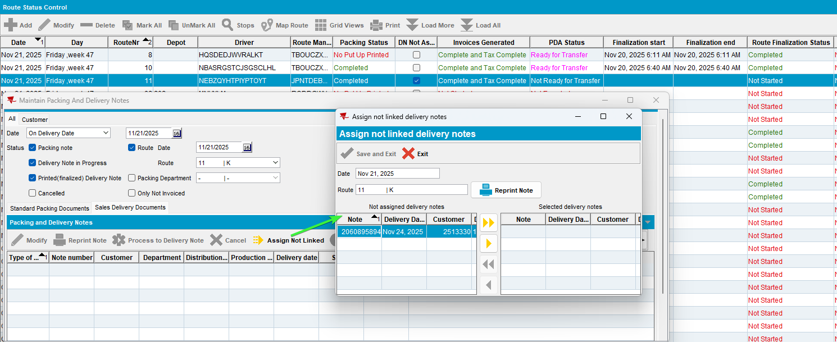
- Postman: Run a route finalization request for the route.
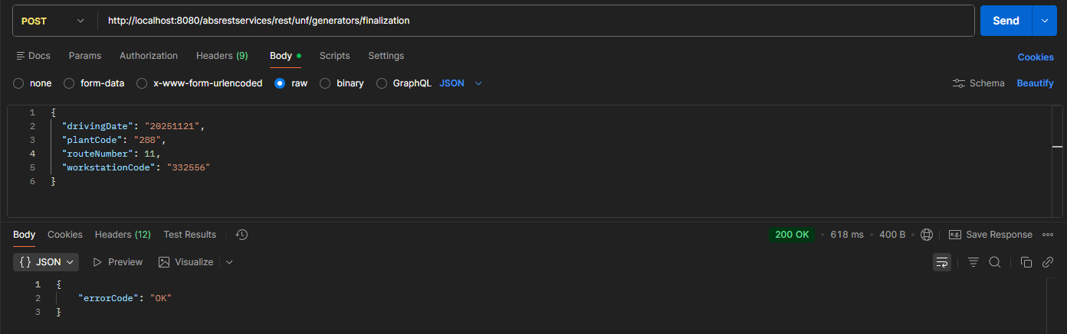
- RSC dlg: Recheck the statuses
- View Process Log: Check the route finalization log.
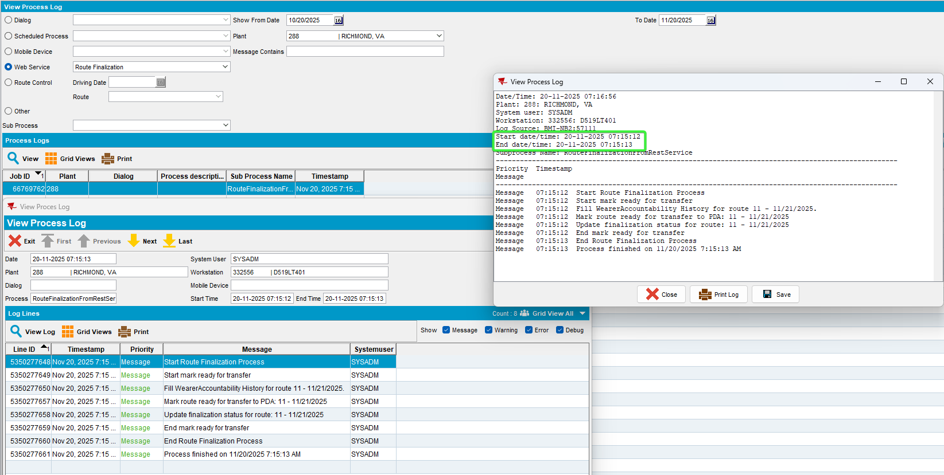
Tested OK

