ABSN-12268 D_UBS_2679 Contract error when using French
Environment | Prerequisites
Version:9.07.00.UNF21  DBServerName= abs-srv19.internal.abslbs.com  DBSID=CUST22  DBUser=UNFLIVE  Environment=PRODUCTION | - Module:  - System setting

Contents
Test before fix 1
Retest after fix 3

Test before fix
Hash: 181c328a399f

- Choose language francais (France).
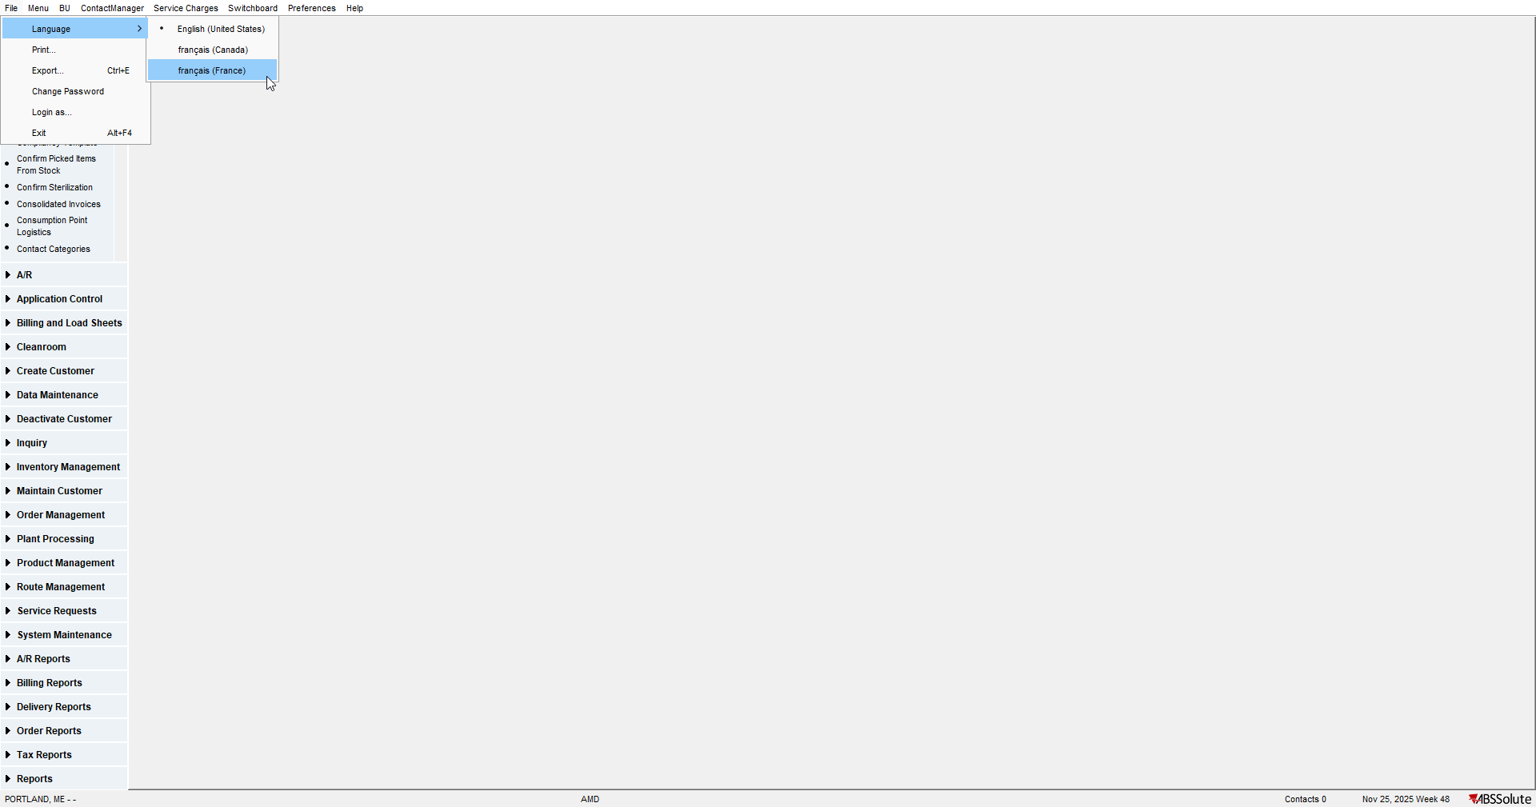

- Contract with autosoil products.
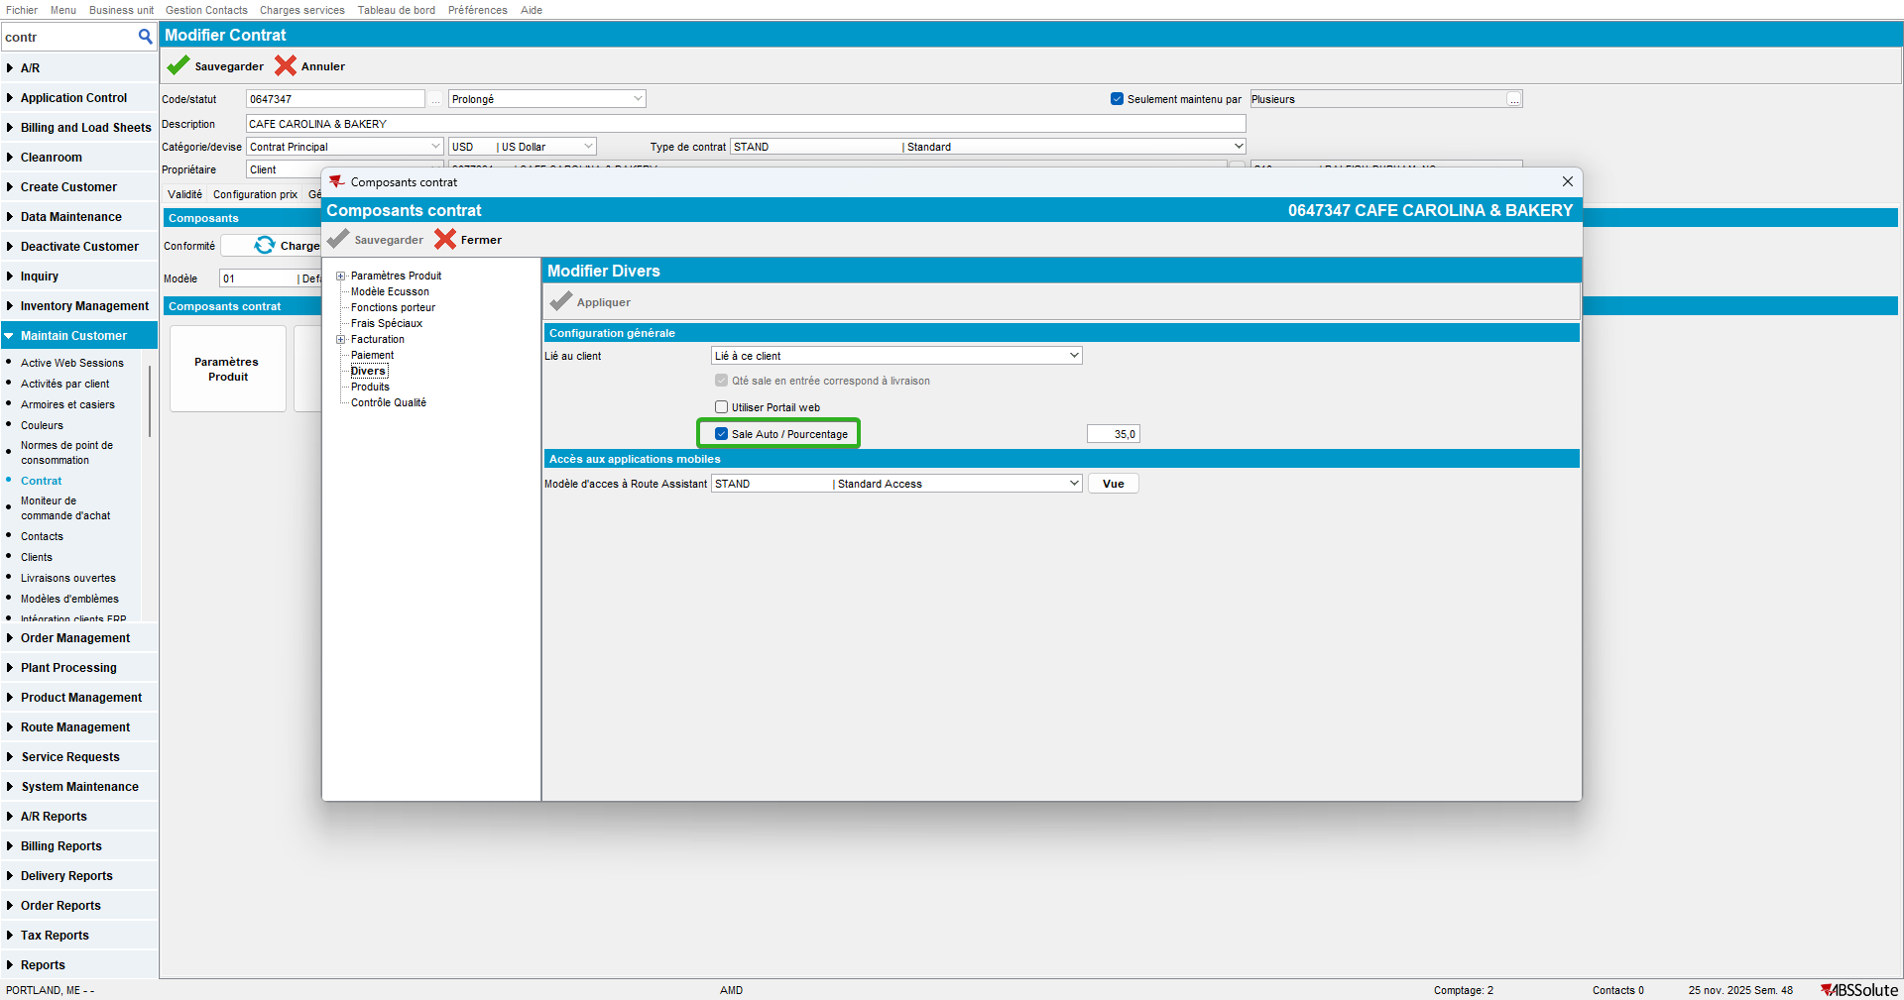

- Make sure there is a percentage for auto soil - it shows like 35,0 (instead of 35.0).
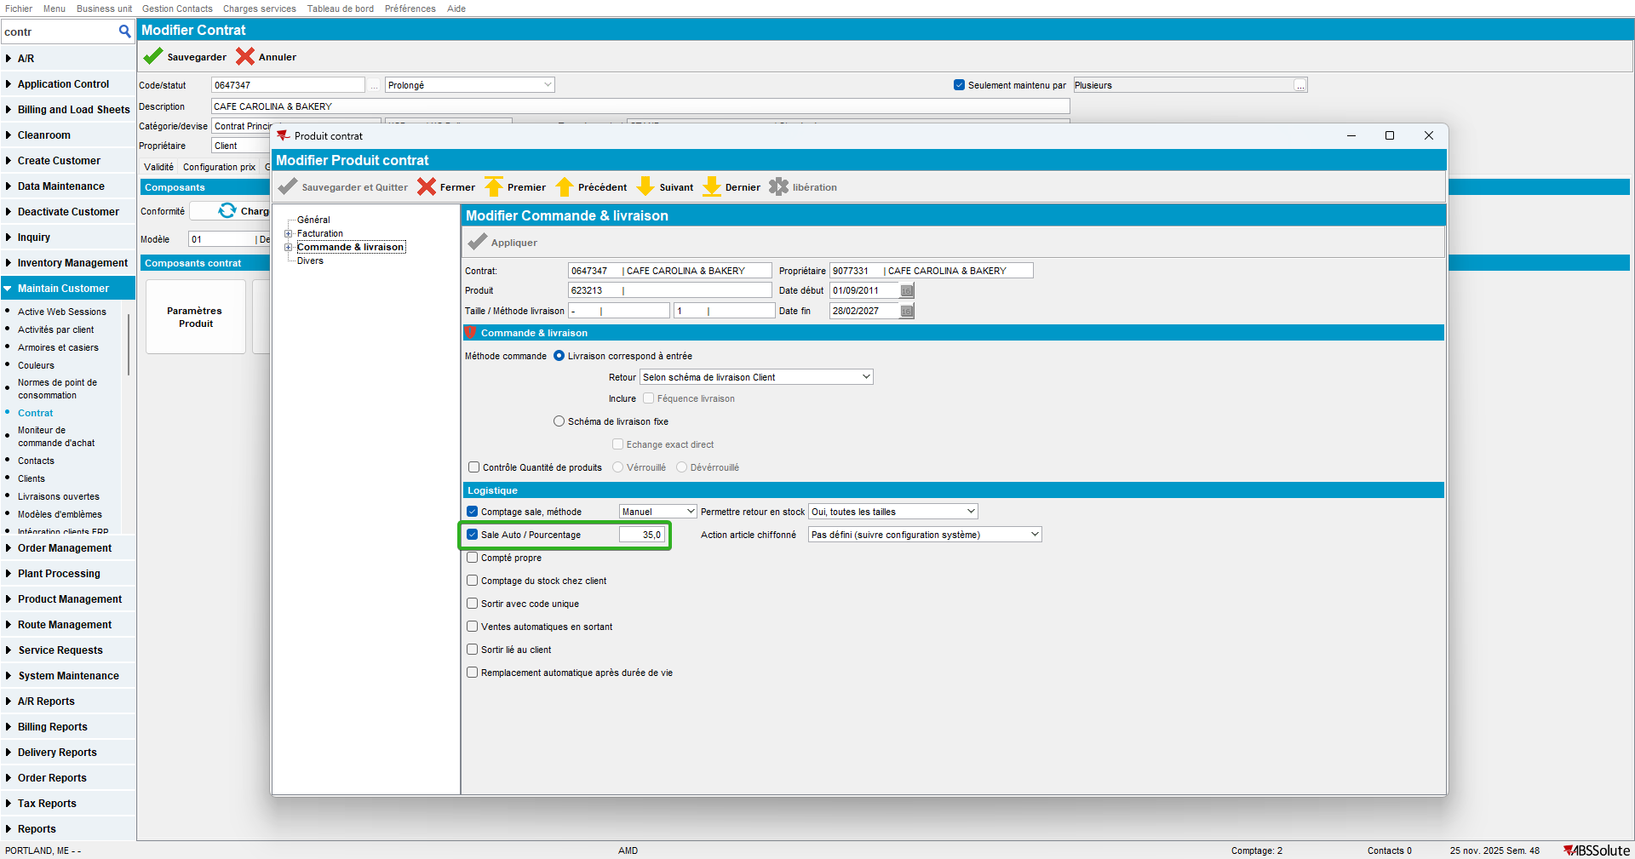

- Edit something and save.
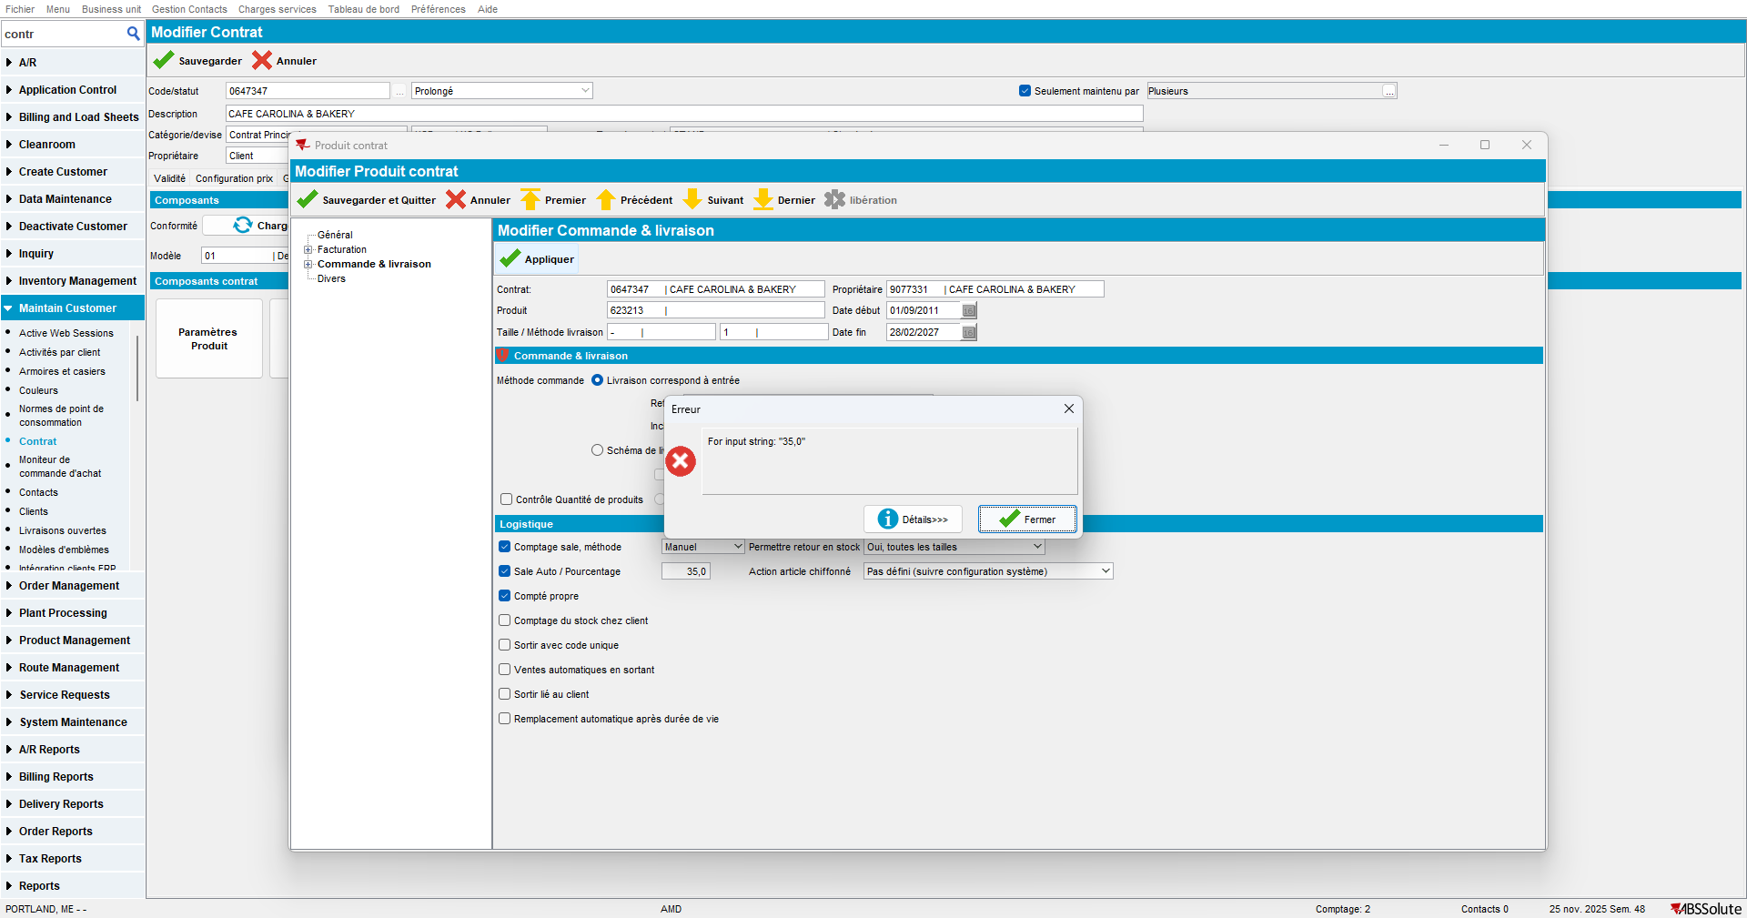

Current behaviour:
Save is performed but error is shown.

Expected behaviour:
No error caused by showing numbers in French format, using comma instead of dot as decimal separator.

Retest after fix
Hash: 57e436376448

- Choose language francais (France).

- Contract with autosoil products.
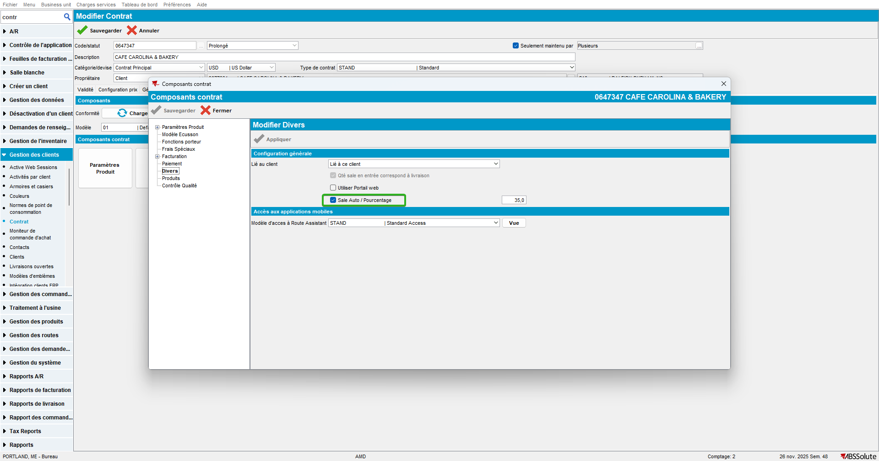

- Make sure there is a percentage for auto soil - it shows like 35,0 (instead of 35.0).
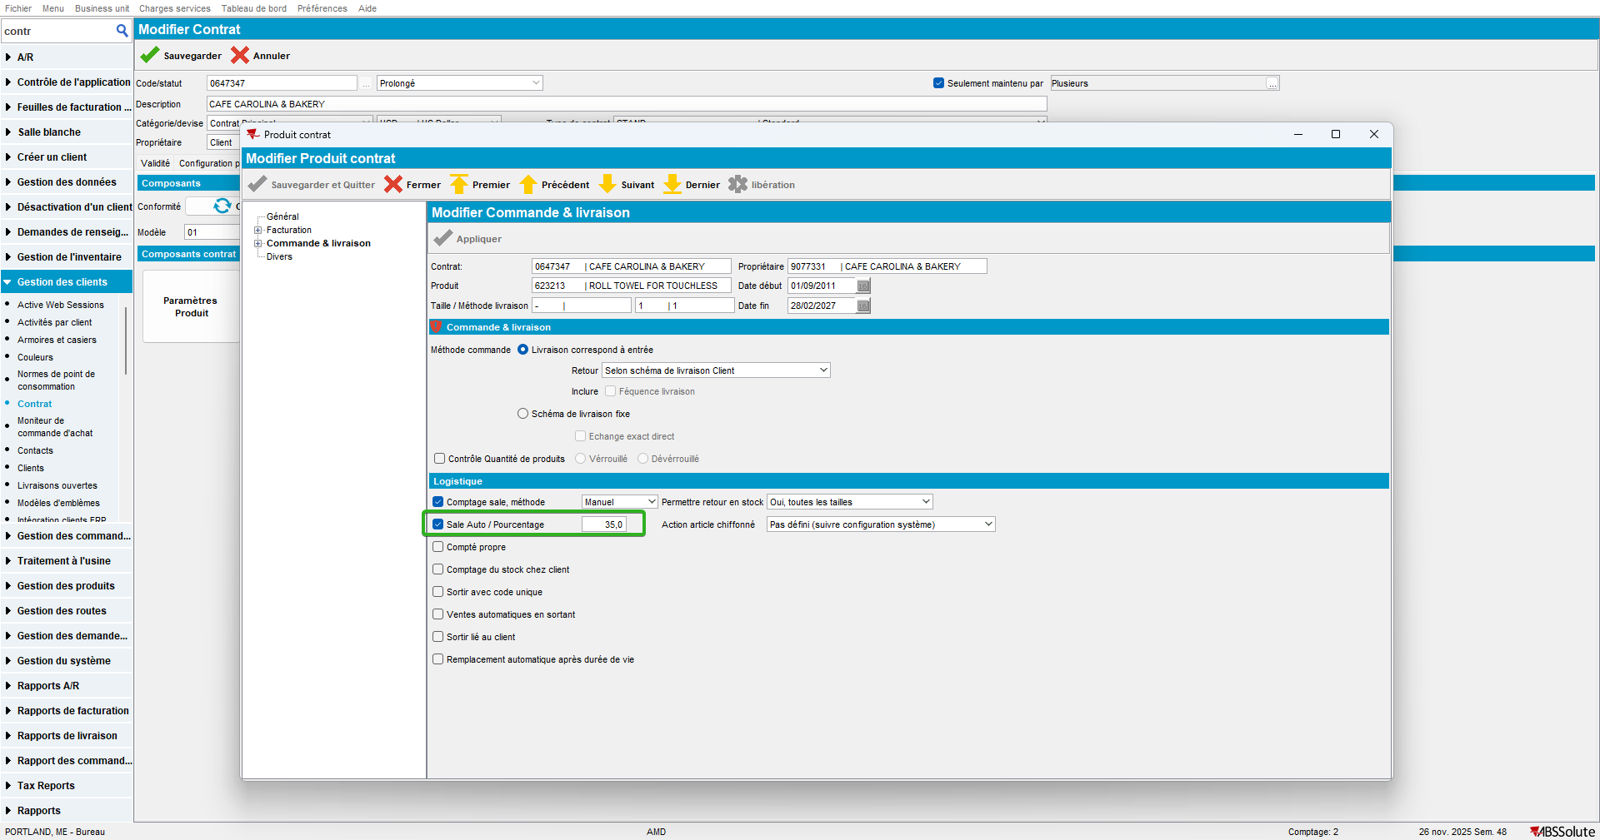

- Edit something and save.
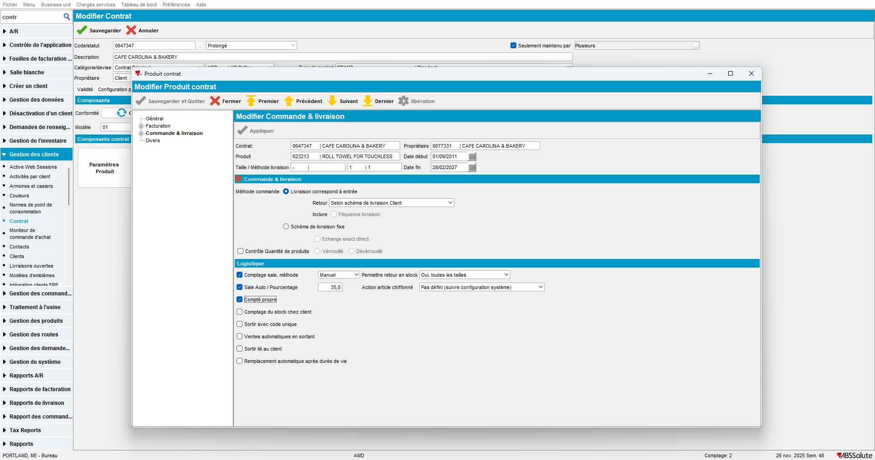

No errors occur.

Tested OK

