ABSN-11717 Flex fields not in same order since update in 9.06.00
Environment | Prerequisites
Version: 9.07.00.UNF21
DBServerName=abs-srv20.internal.abslbs.com
DBSID=CUST24
DBUser=UNFDEV
Environment=Test

Contents
Current Behavior 1
Expected behavior 1
Retest after fix 2
Test Case 1 – Predefined Flex Fields are correctly displayed – Tested OK 2
Test Case 2 – New Plants Flex Fields are correctly displayed – Tested OK 3

Current Behavior
Flex Fields defined in Flex Groups for different dialogs in the Flex Field Definition dialog, should be displayed on the Flex Fields tab of the dialogs for which they were defined for and were ordered, on the right side the flex fields which had an even number as an index in the table and on the left the flex fields which had an odd number as an index in table. What happens now is that these flex fields groups together with the fields they contain are displayed without any criteria and appear in a chaotic order.

Expected behavior
Flex Fields defined in Flex Groups for different dialogs in the Flex Field Definition dialog, should be displayed on the Flex Fields tab of the dialogs for which they were defined for and were ordered, on the right side the flex fields which had an even number as an index in the table and on the left the flex fields which had an odd number as an index in table.

Retest after fix
Hash: 9.07.00.UNF21 at hash 299acd7515c3

Test Case 1 – Predefined Flex Fields are correctly displayed – Tested OK
Step 1) Open the Flex Field Definition dialog and check the Flex Field Groups for the Customers dialog
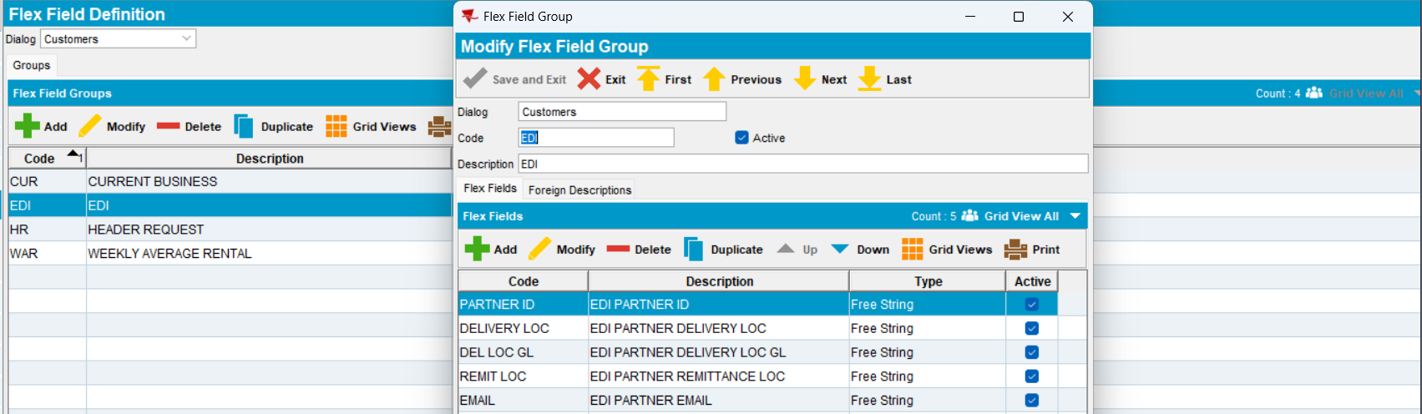

Step 2) Open the Customers dialog and go to the Flex Fields tab and check if the Flex Field Groups together with their fields appears in the correct order
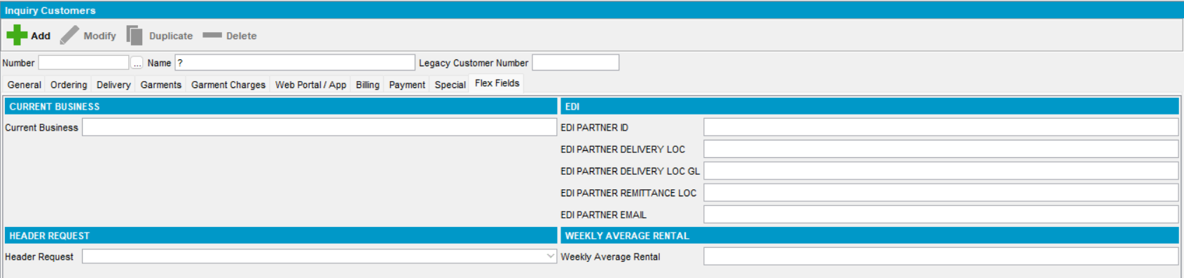
RETEST OK

Test Case 2 – New Plants Flex Fields are correctly displayed – Tested OK
1) Open the Flex Field Definition dialog and add new flex field groups and flex fields for the Customers dialog
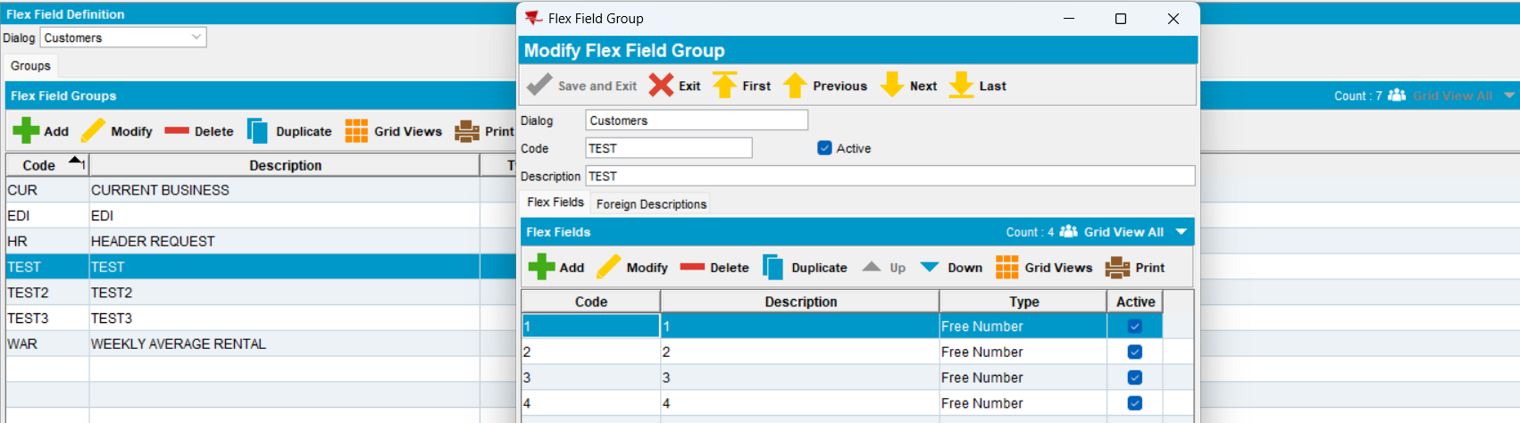
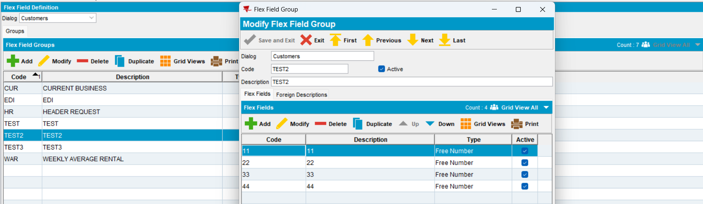
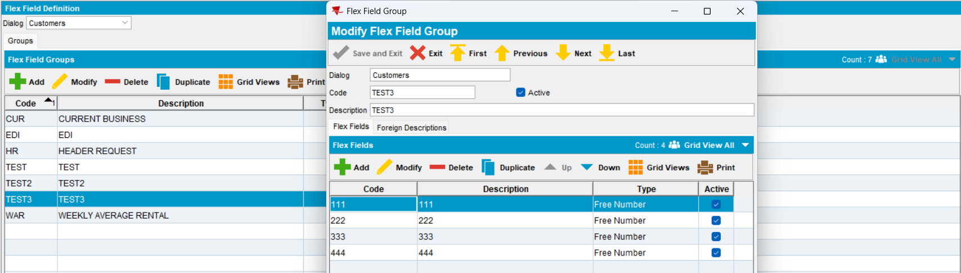

Step 2) Open the Customers dialog and check for a customer if the flex field groups together with their flex fields are displayed ok
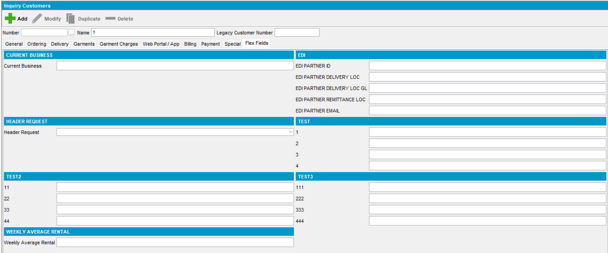
RETEST OK

