ABSN-11474 - D_UBS_2776 Unable to print the Soil Reasonability Report
Environment | Prerequisites
Version: 9.07.00.UNF21  DBServerName= abs-srv20.internal.abslbs.com  DBSID=CUST24  DBUser=UNFDEV  Environment=Test | - Module:  - System setting

Contents
Reproducing before fix 1
Steps to reproduce 1
Current Behavior 4
Expected behavior 4
Retest after fix 4
Test Case 1 – Check the availability of Soil Reasonability Report button when SoilCount Status is Not Started 4

Reproducing before fix

Steps to reproduce
- Make sure system setting RAMANDATORYSOILCOUNT = 0.
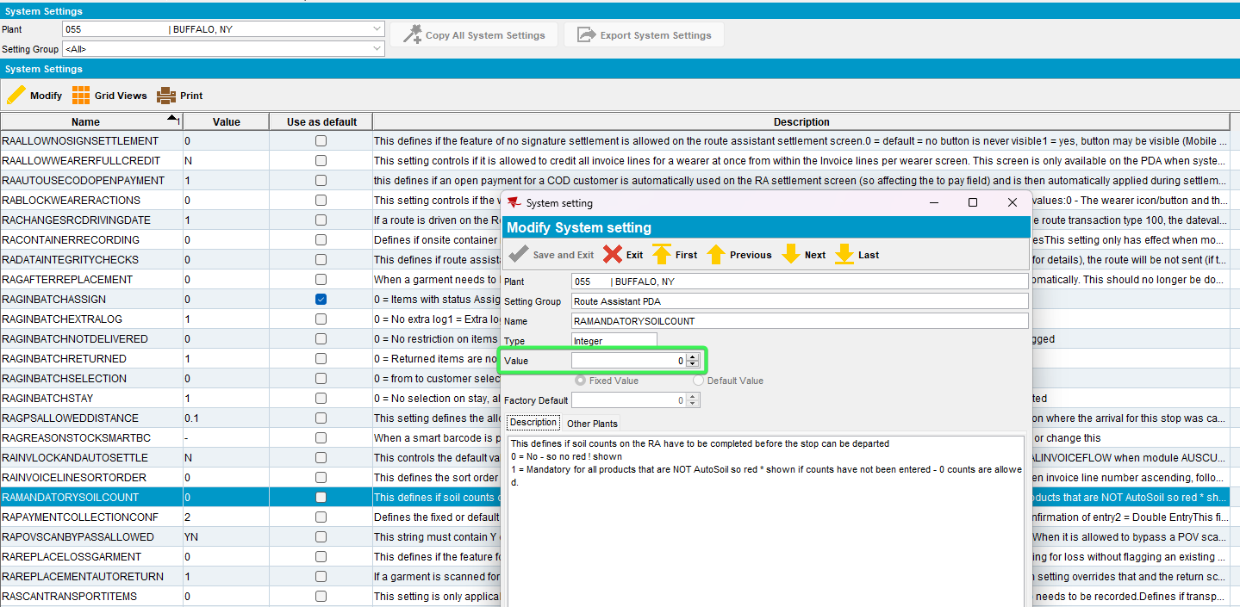
- Add a route in Route Status Control
- Generate invoices
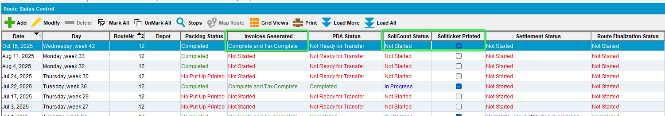
- Download to RA
- Don't add soil counts on RA
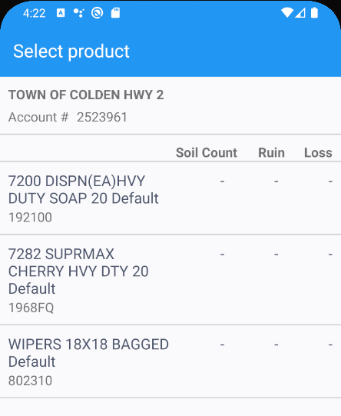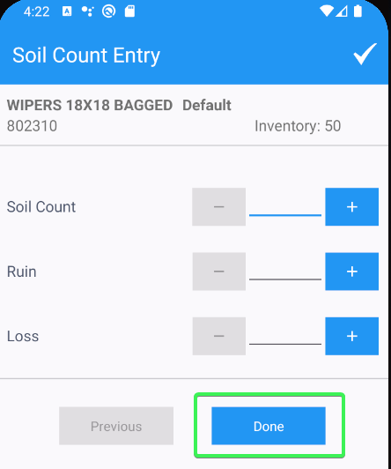
- Upload
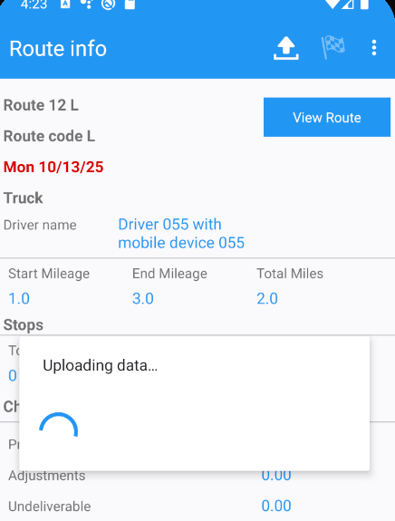
- Route Status Control DLG: Check the Soil Reasonability Report button availability
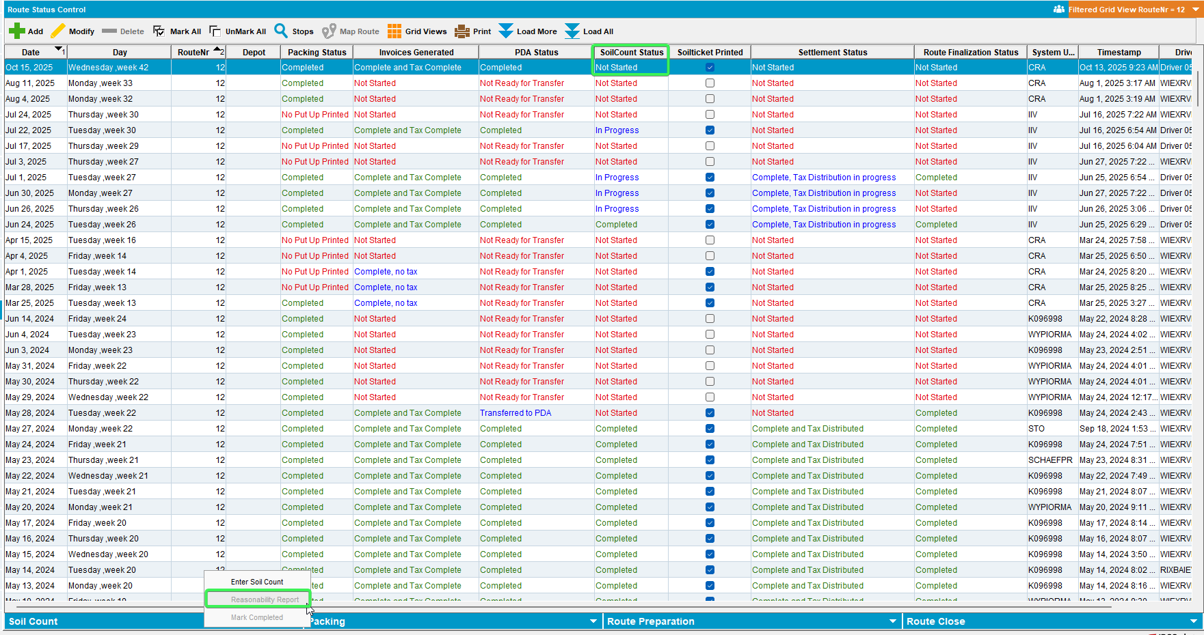
- Route Check in DLG: Check the availability of the button
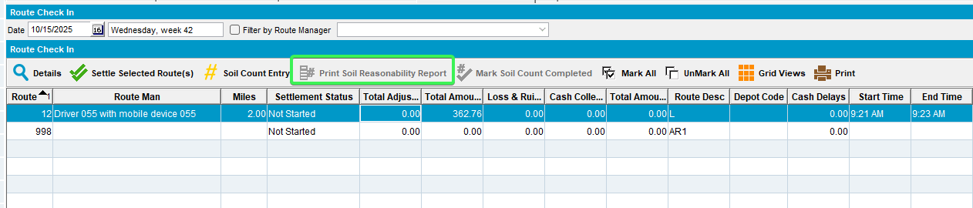
- WebX: Select your route and check the availability of the Soil Reasonability Report button
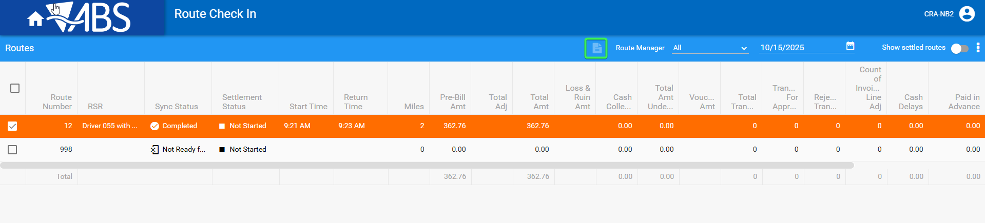
REPRODUCED OK.

Current Behavior
Soil Reasonability Report button is disabled when route has Soil Count Status = Not Started.
Button is in Route Check In from ABSSolute and from Web Client X

Expected behavior
Soil Reasonability Report button is enabled even if Soil Count Status = Not Started, when pressed the user should receive a warning message "Soil Count is not started. Do you want to generate the Soil Reasonability Report?".

Retest after fix

Test Case 1 – Check the availability of Soil Reasonability Report button when SoilCount Status is Not Started
Hash: 31bc8452ed1a
- Make sure system setting RAMANDATORYSOILCOUNT = 0.
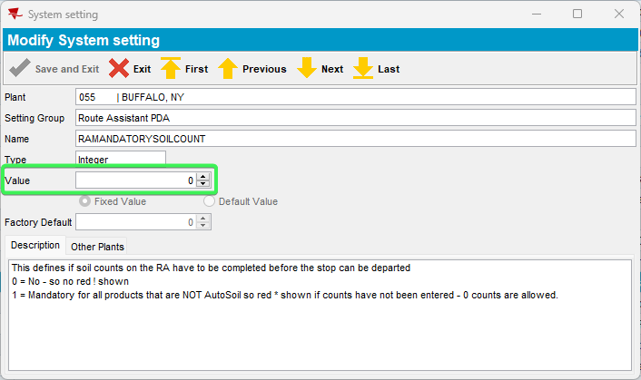
- Add a route in Route Status Control
- Generate invoices
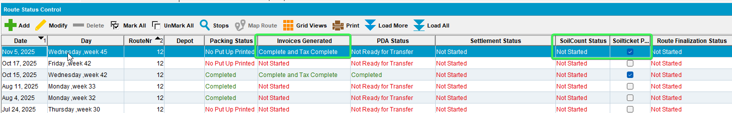
- Download to RA
- Don't add soil counts on RA
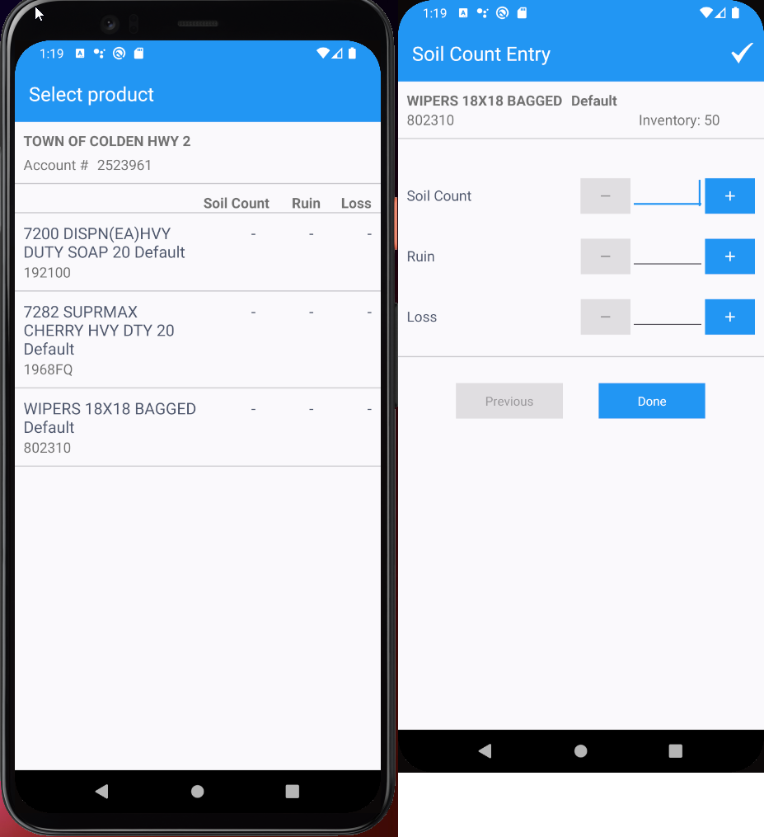
- Finish the route and Upload
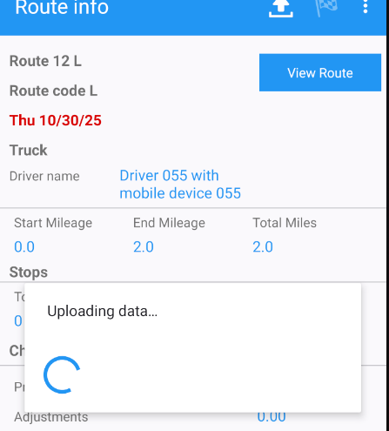
- Route Status Control DLG: Check the Soil Reasonability Report button availability
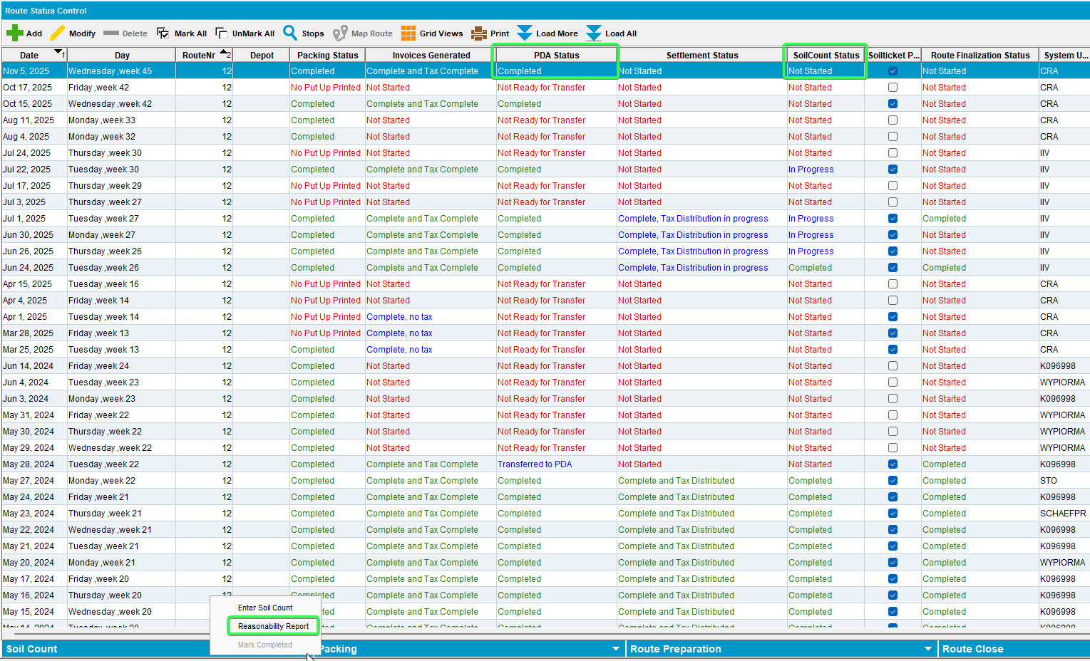
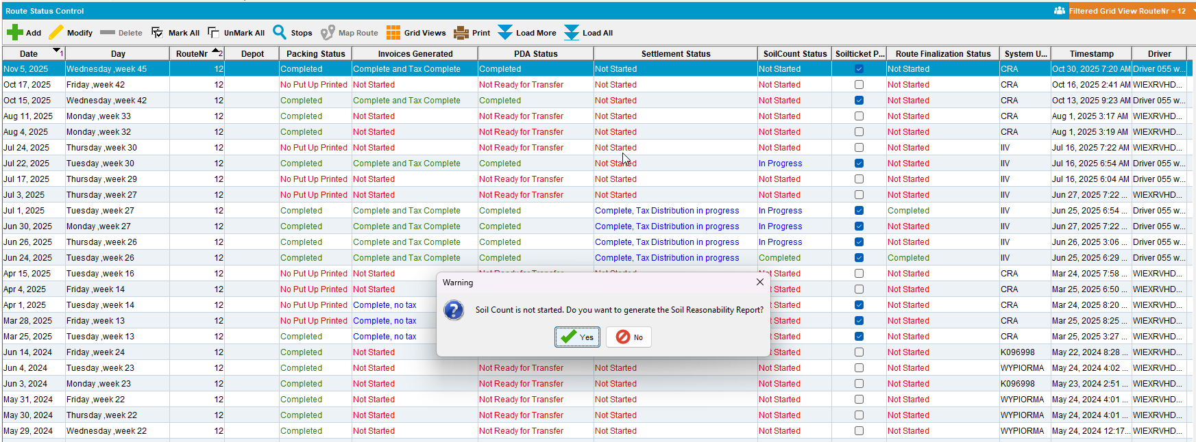
- Route Check in DLG: Check the availability of the button
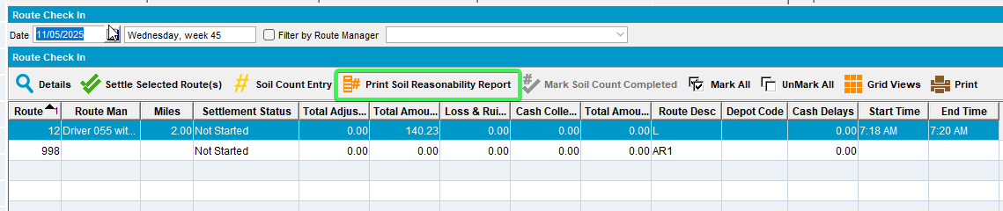
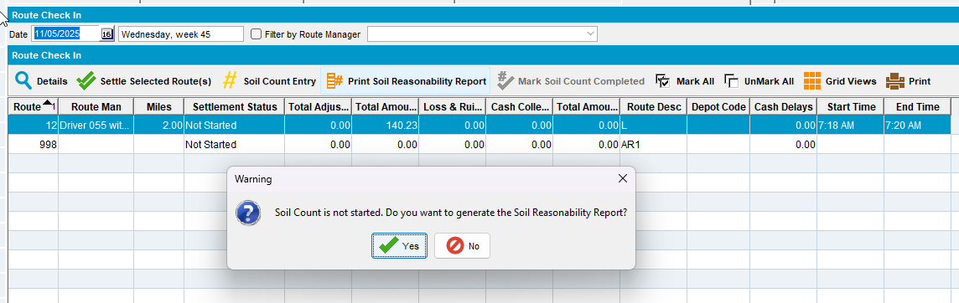
- WebX: Select your route and check the availability of the Soil Reasonability Report button
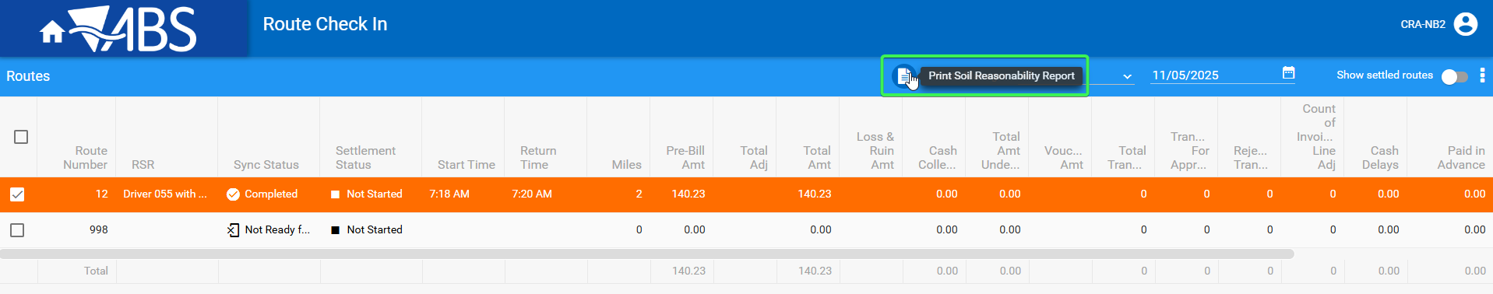
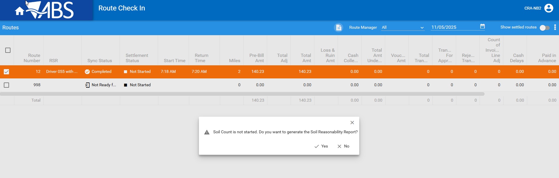
- Print the report from Route Check in DLG
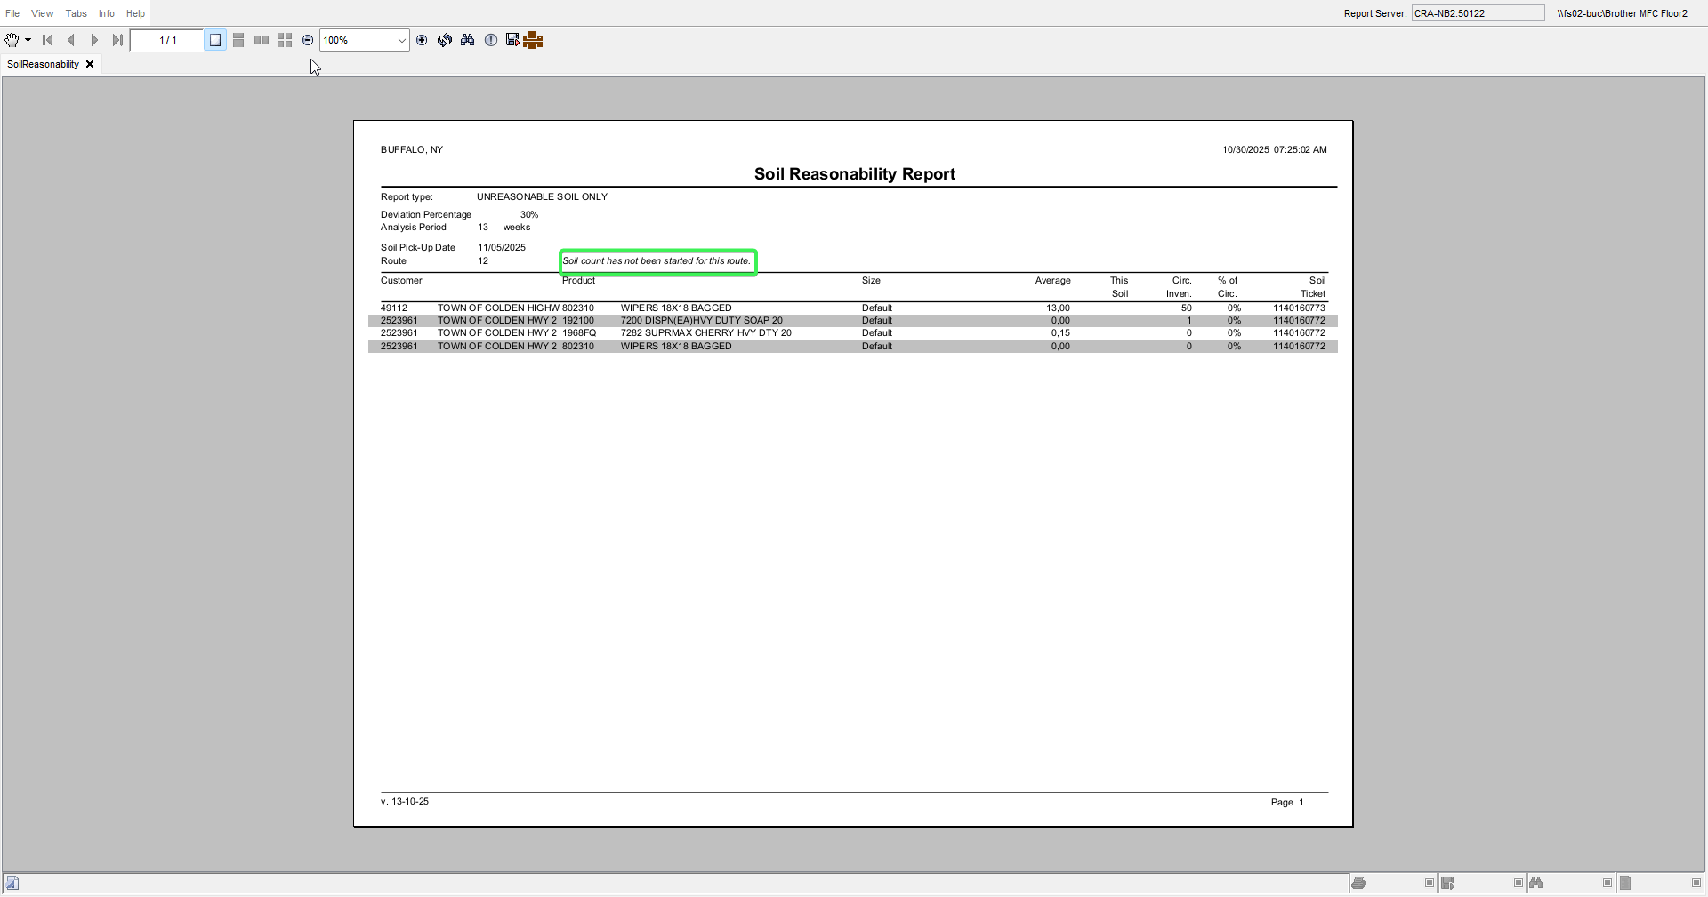
- Print the report from Route Status Control DLG
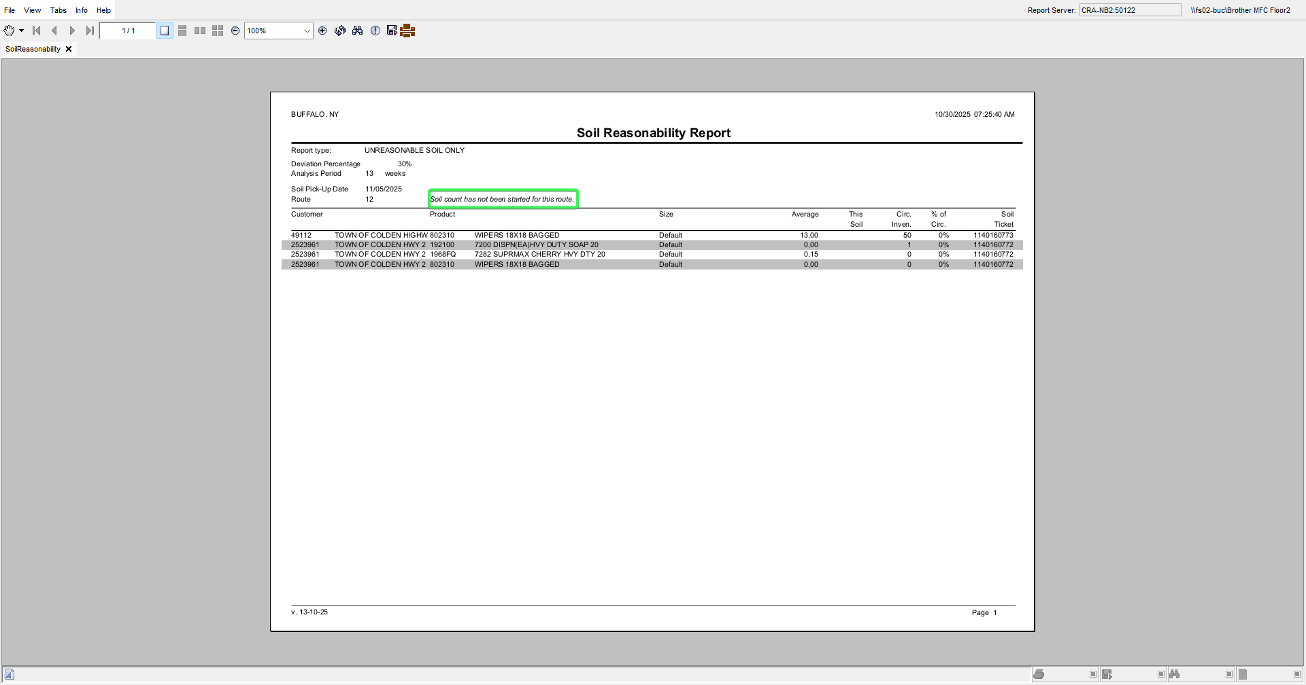
- Print the report from WebX
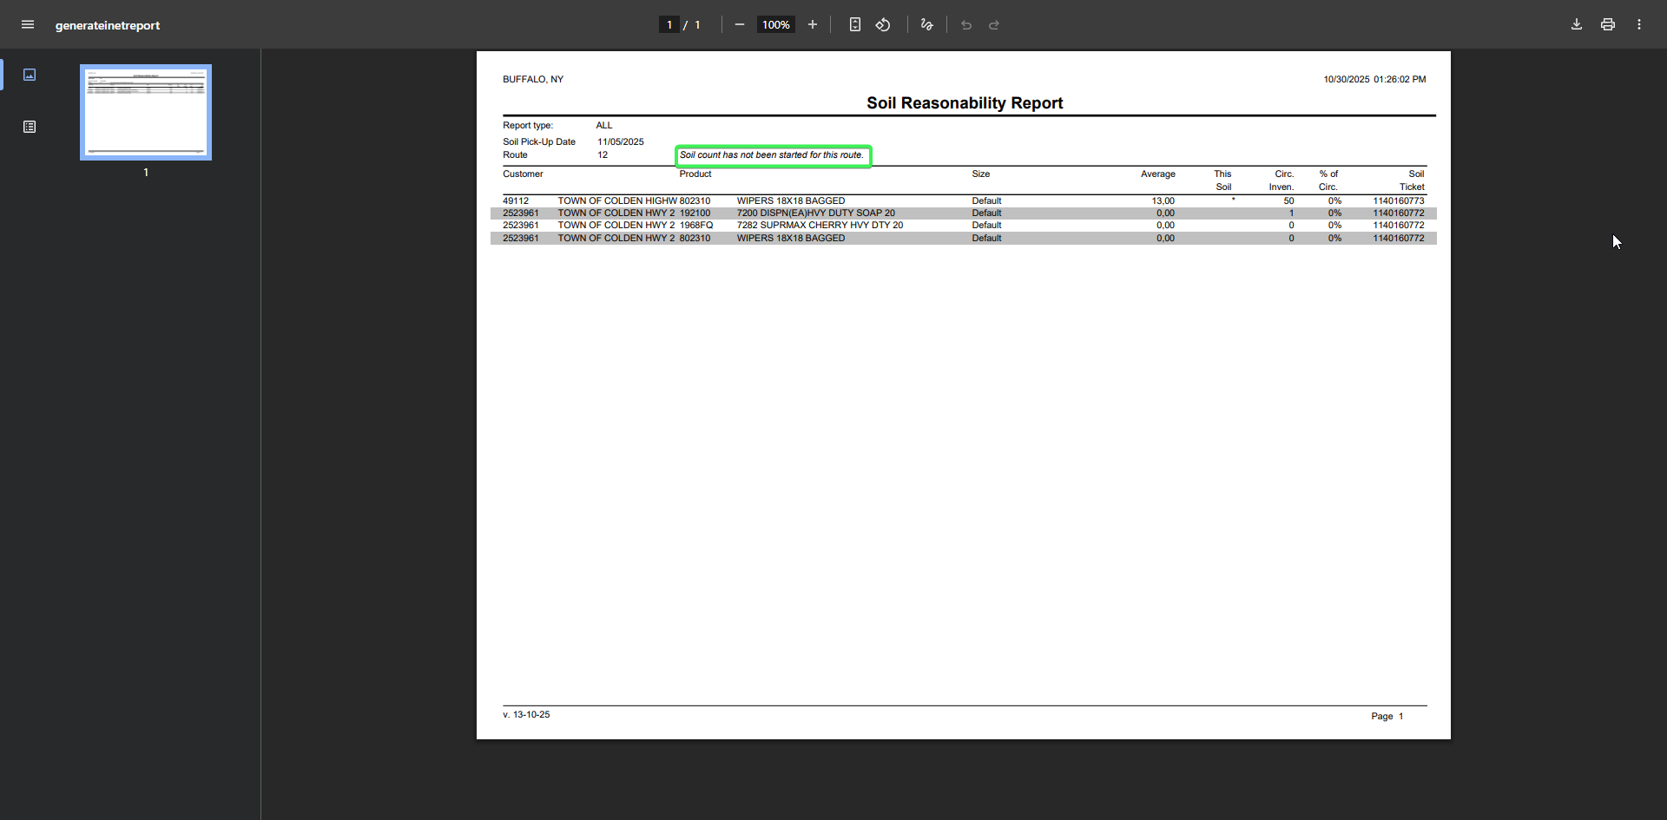
Tested OK

