ABSN-11348 - When increasing the Max Inventory in the Add Replacement Renewal Rule dialog while keeping the size and style the same, the additional inventory amount is not included in the new work order
Environment | Prerequisites
Version: 9.07.00.UNF21  DBServerName= abs-srv20.internal.abslbs.com  DBSID=CUST24  DBUser=UNFDEV  Environment=Test | - Module:  - System setting

Contents
Reproducing before fix 1
Steps to reproduce 1
Current Behavior 6
Retest after fix 6
Test Case 1 - Replacement/Renewal – New Max > Old Max 6
Test Case 2 - Replacement/Renewal – New Max < Old Max 10
Test Case 3 - Replacement/Renewal – New Max = Old Max 13
Test Case 4 - Wearer > Replace button – New Max > Old Max 16
Test Case 5 - Wearer > Replace button – New Max < Old Max 19
Test Case 6 - Wearer > Replace button – New Max = Old Max 21

Reproducing before fix

Steps to reproduce
- Replace/Renewal DLG: Input a customer and add a new Replacement
- Select the product you want to replace / renew and for which wearer
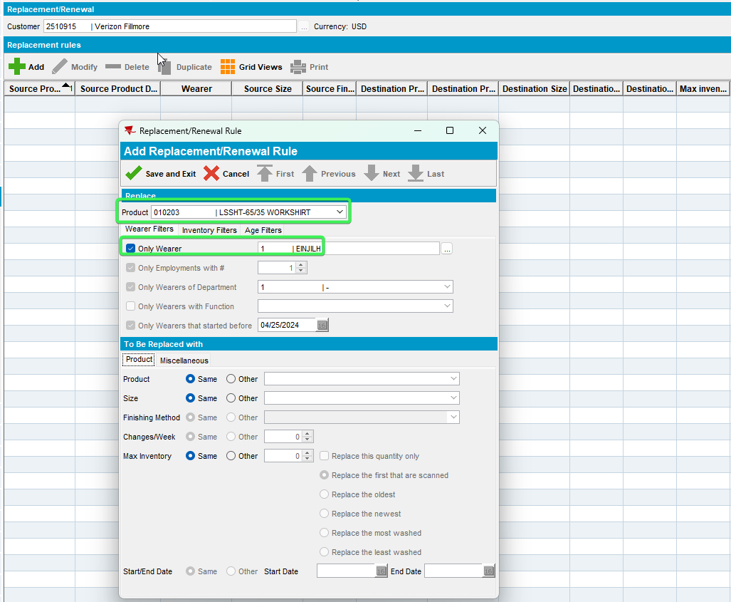
- Select Max Inventory Other radio button and increase the original value
Original Max Inventory for this product in this wearer inventory was of 8
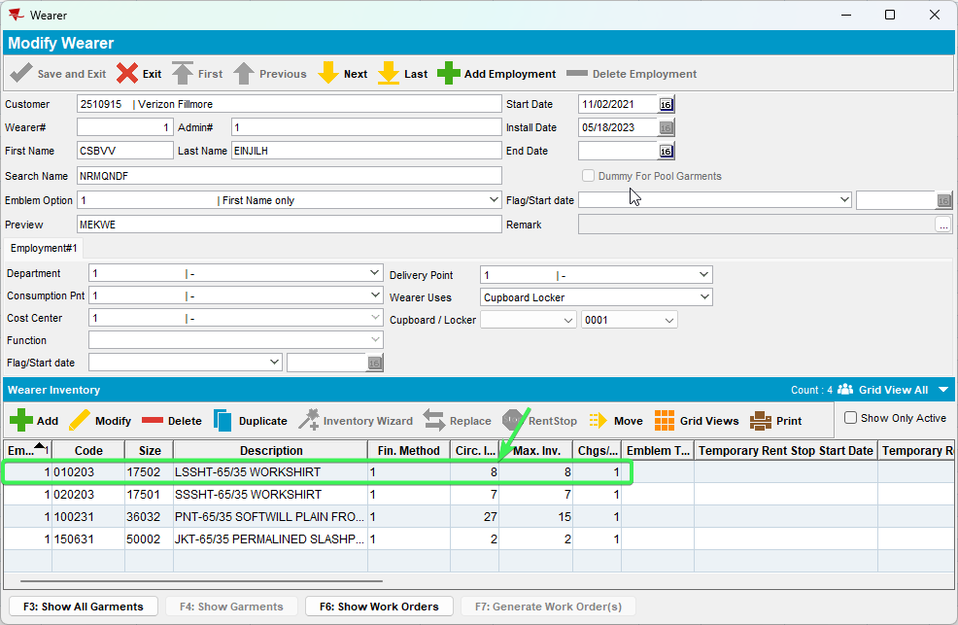
And we Replaced it but with Max inventory of 10
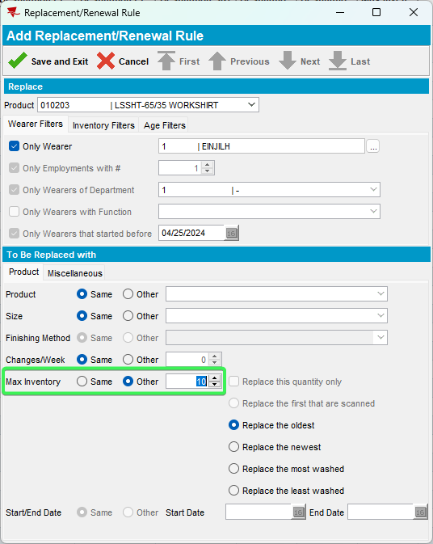
- Press Final Run > select a Reason Code
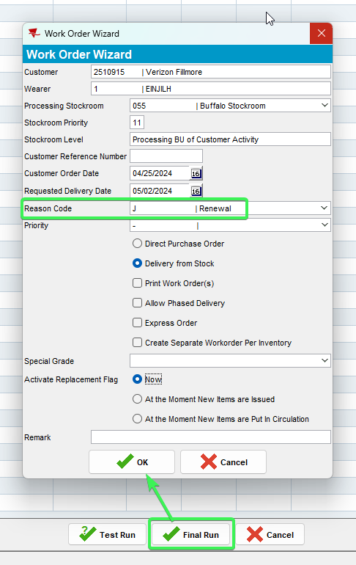
- Check the log, the order was placed for the original 8
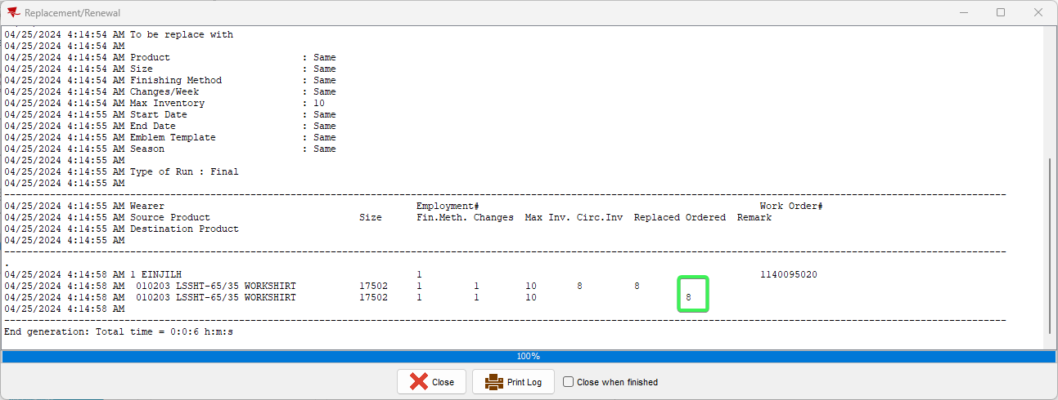
REPRODUCED OK.

Current Behavior
The order is only placed for the original number of items not taking in account the increase of inventory.

Retest after fix

Test Case 1 - Replacement/Renewal – New Max > Old Max
Expected behavior: Workorder Ordered quantity = New Max
Hash: 049bec816abe
Steps:
- Replace/Renewal DLG: Input a customer and add a new Replacement
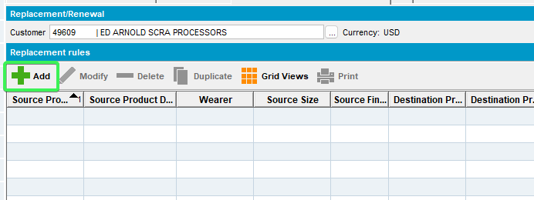
- Select the product you want to replace / renew and for which wearer
- Select Max Inventory Other radio button and increase the original value
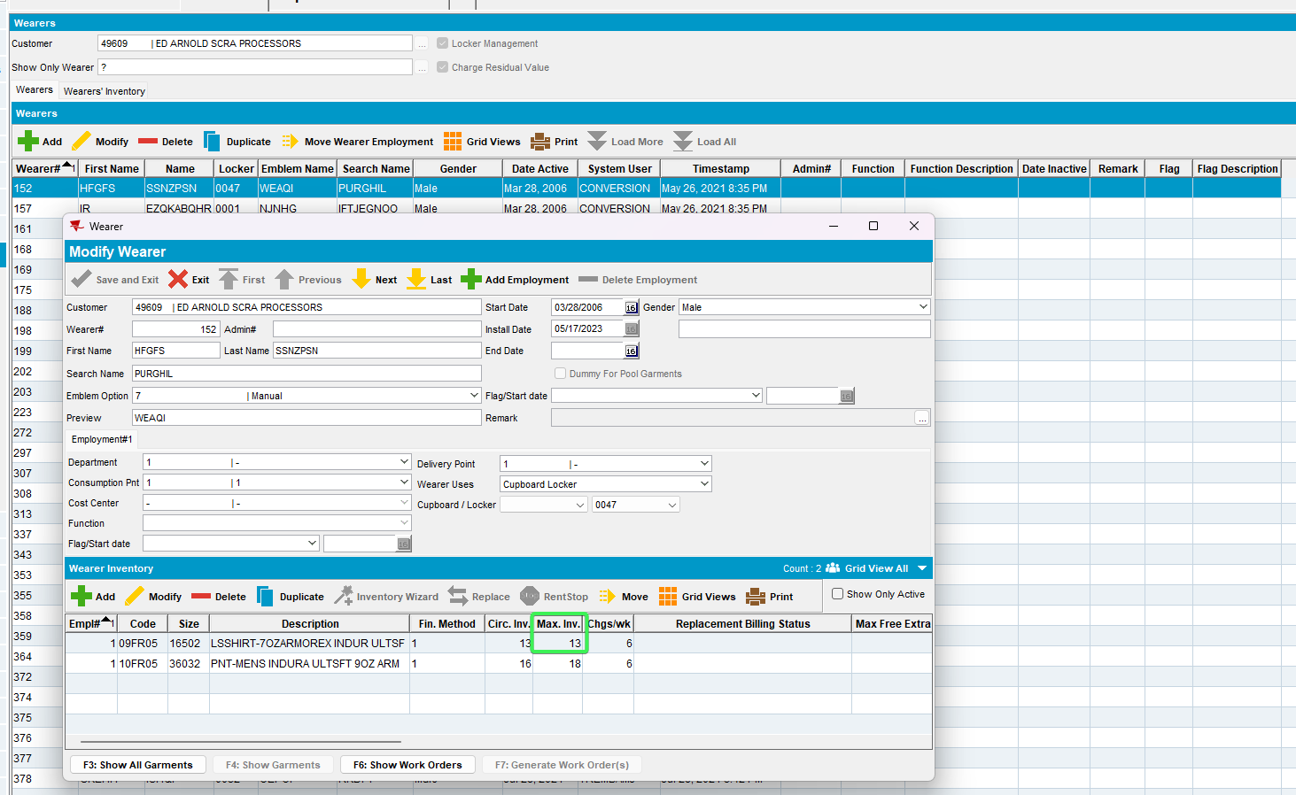
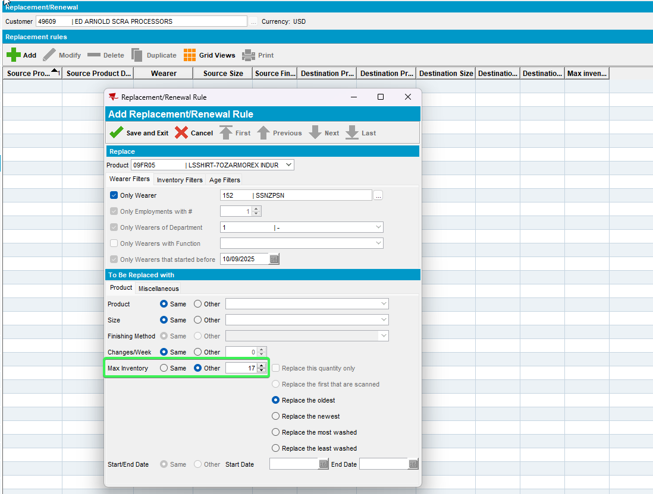
- Press Final Run > select a Reason Code
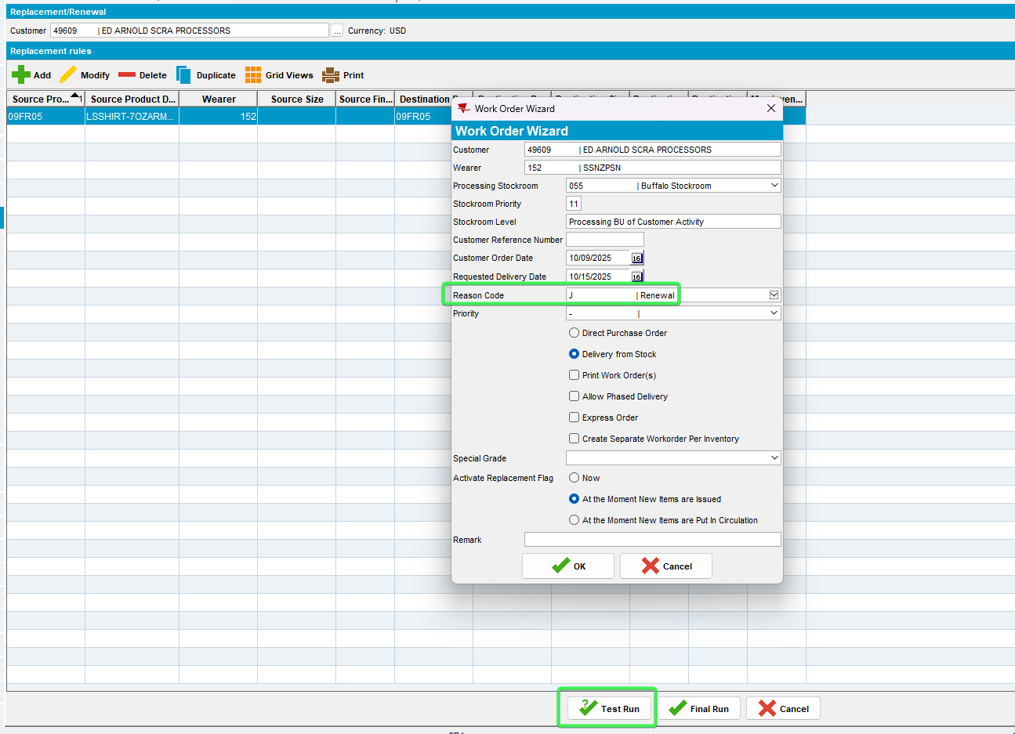
- Check the log, the order was placed for the new max inv 17
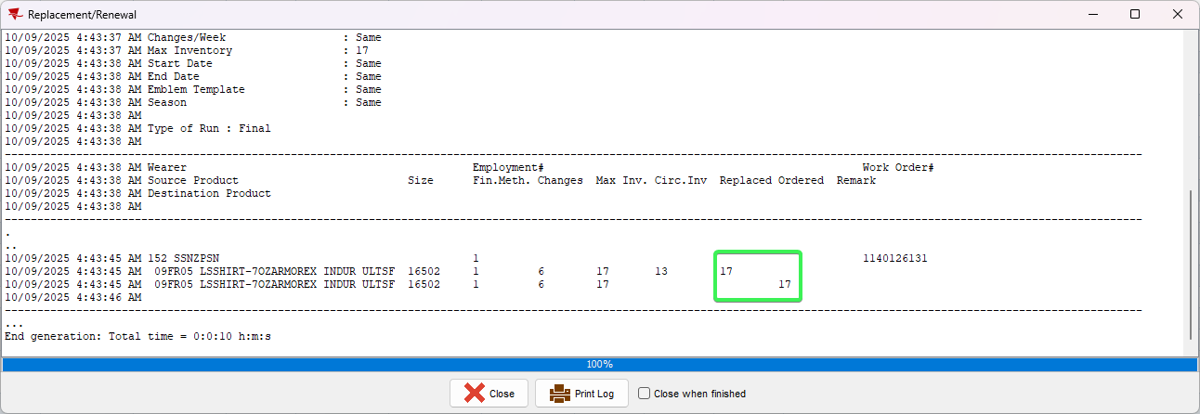
- Wearer DLG: Check the new Max Inv of the wearer inventory
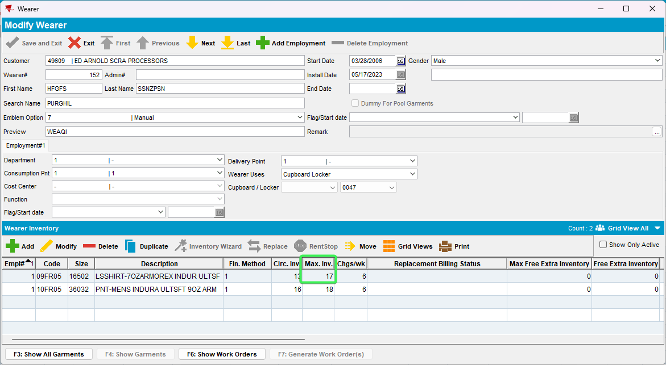

Tested OK

Test Case 2 - Replacement/Renewal – New Max < Old Max
Expected behavior: Wokrorder Orderd quantity = New Max
Hash: 049bec816abe
Steps:
- Replace/Renewal DLG: Input a customer and add a new Replacement
- Select the product you want to replace / renew and for which wearer
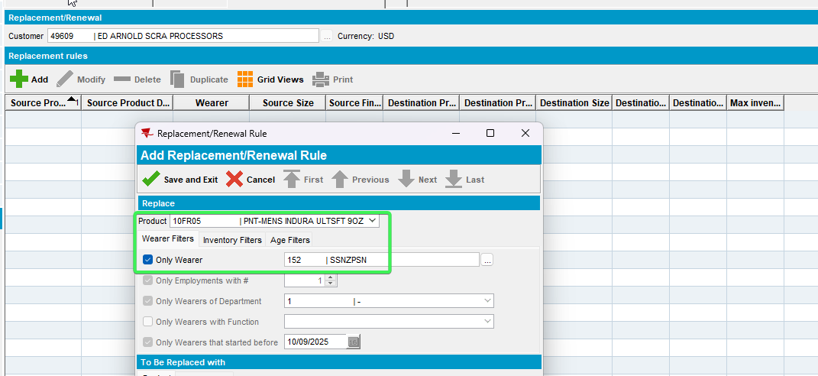
- Select Max Inventory Other radio button and decrease the original value
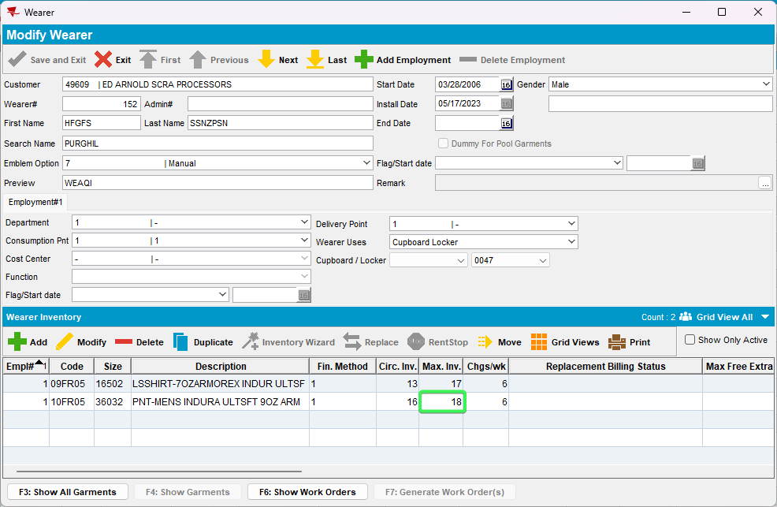
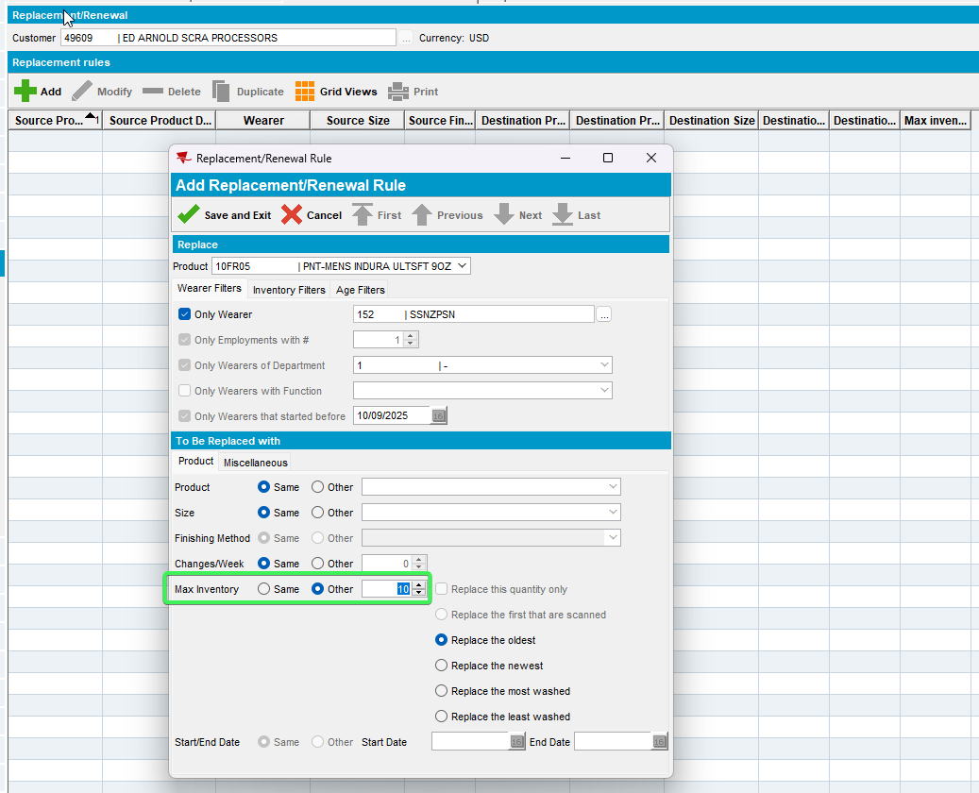

- Press Final Run > select a Reason Code
- Check the log, the order was placed for the new Max Inv of 10
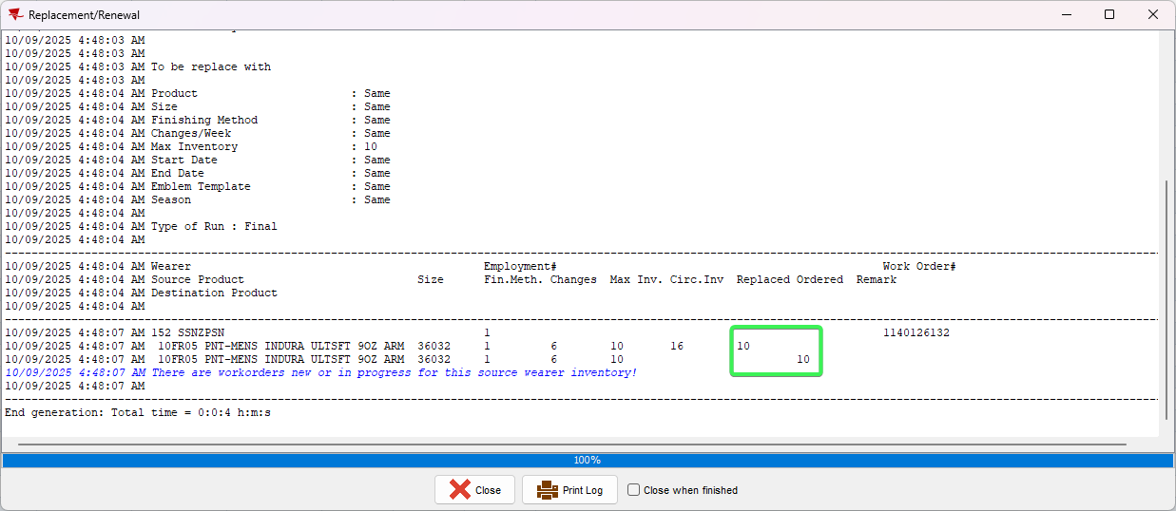
- Wearer DLG: Check the new Max Inv of the wearer inventory
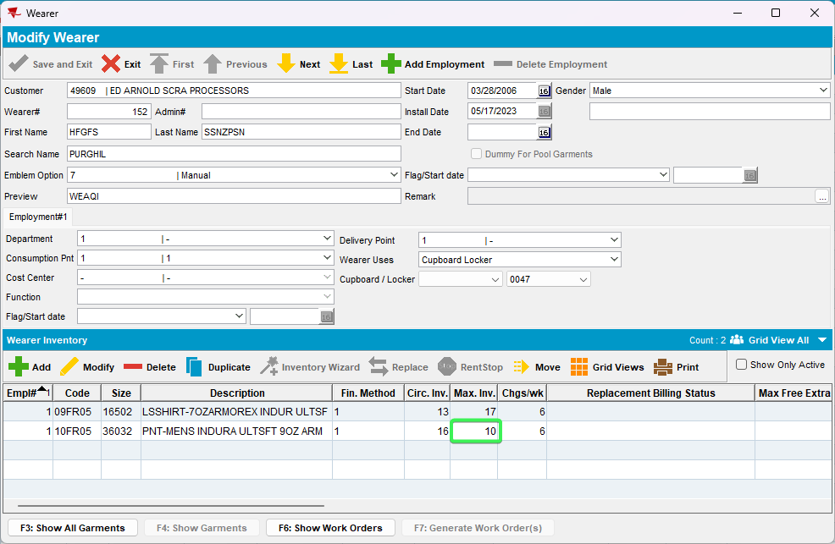
Tested OK

Test Case 3 - Replacement/Renewal – New Max = Old Max
Expected behavior: Wokrorder Orderd quantity = New Max
Hash: 049bec816abe
Steps:
- Replace/Renewal DLG: Input a customer and add a new Replacement
- Select the product you want to replace / renew and for which wearer
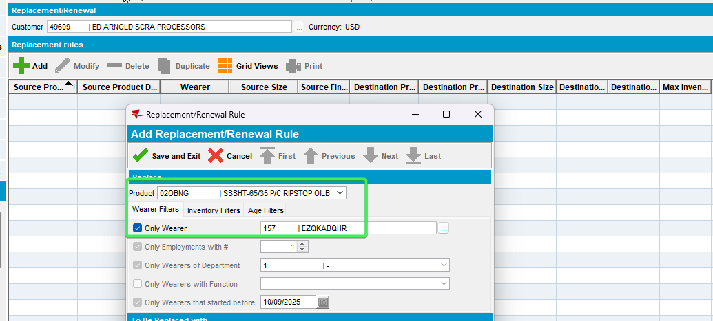
- Select Max Inventory Other radio button and place the same value as the original value
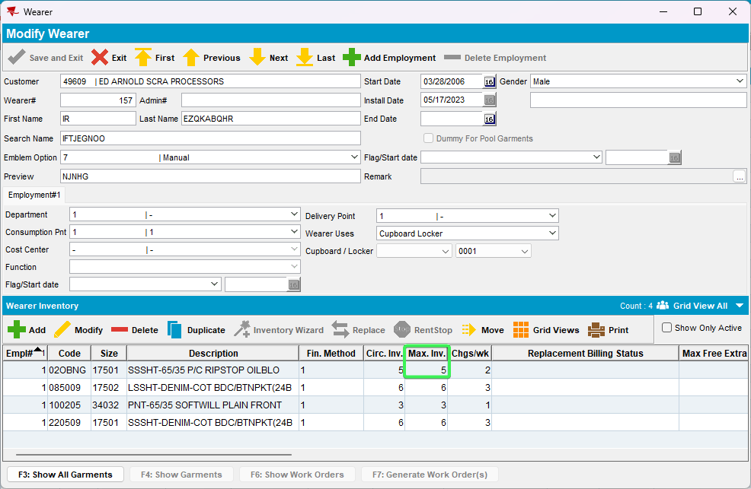
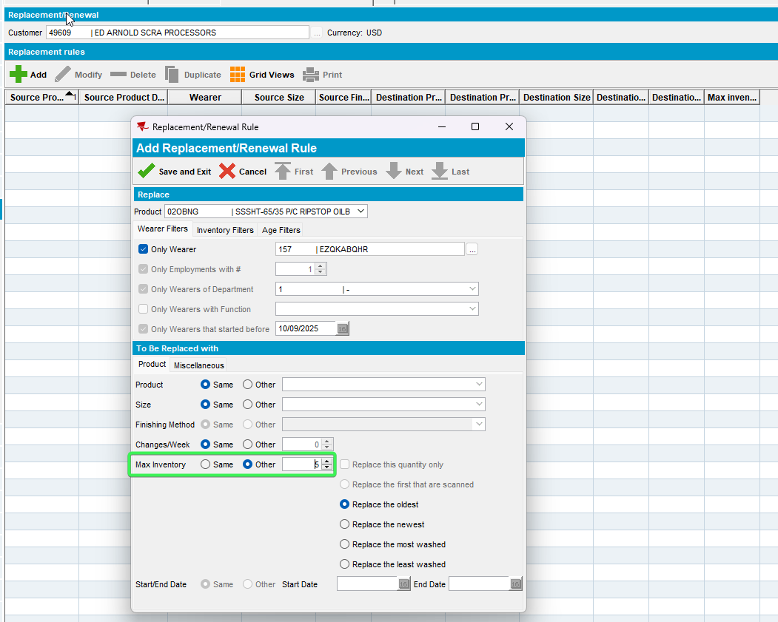
- Press Final Run > select a Reason Code
- Check the log, the order was placed for the original 5
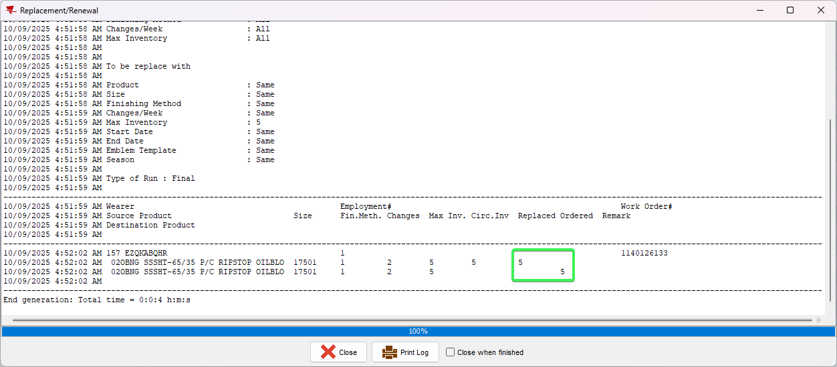
- Wearer DLG: Check the new Max Inv of the wearer inventory
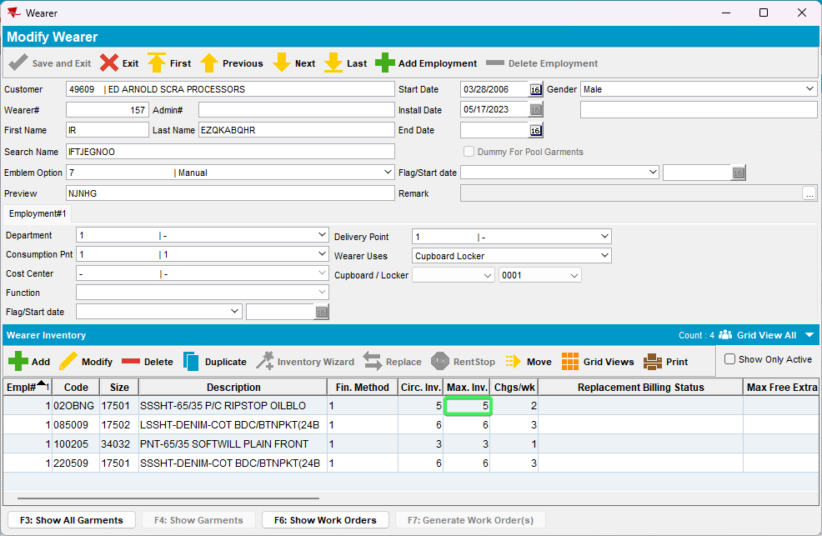
Tested OK

Test Case 4 - Wearer > Replace button – New Max > Old Max
Expected behavior: Wokrorder Orderd quantity = New Max
Hash: 049bec816abe
Steps:
- Wearer DLG: Input a customer with wearers
- Open a wearer select a wearer inventory and press Replace Button
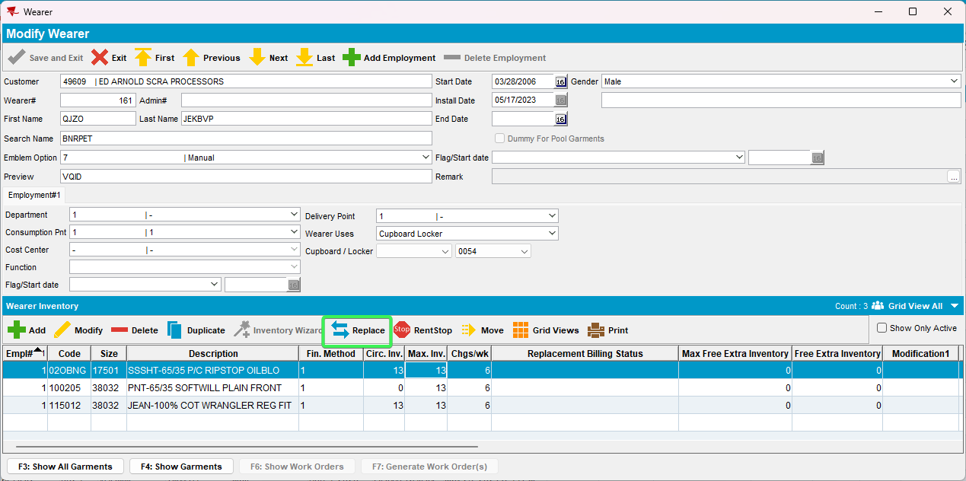
- Select Max Inventory “Other” Radio button and increase the value of the original Max Inv.
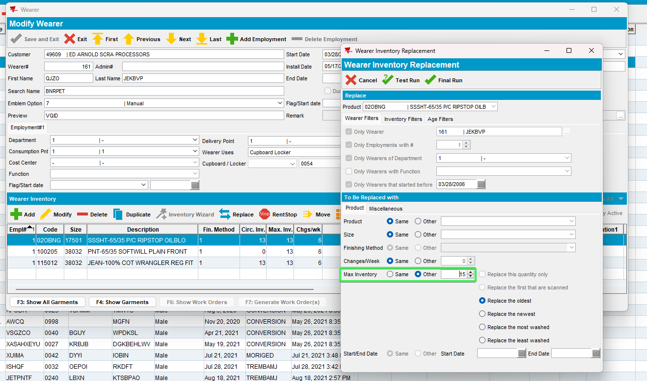
- Press Final Run button
- Select a reason code and press OK
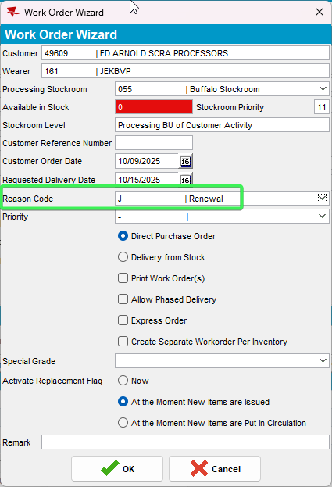
- Check the log, the order was placed for 15 items
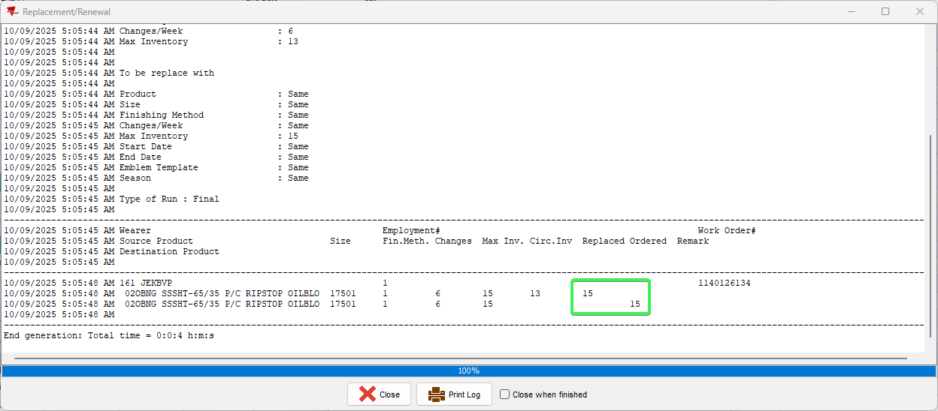
- Wearer DLG: Check the new Max Inv of the wearer inventory
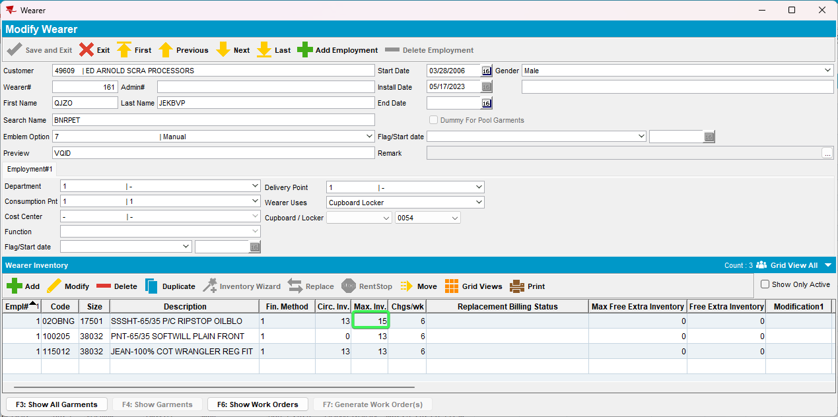
Tested OK

Test Case 5 - Wearer > Replace button – New Max < Old Max
Expected behavior: Wokrorder Orderd quantity = New Max
Hash: 049bec816abe
Steps:
- Wearer DLG: Input a customer with wearers
- Open a wearer select a wearer inventory and press Replace Button
- Select Max Inventory “Other” Radio button and decrease the value of the original Max Inv.
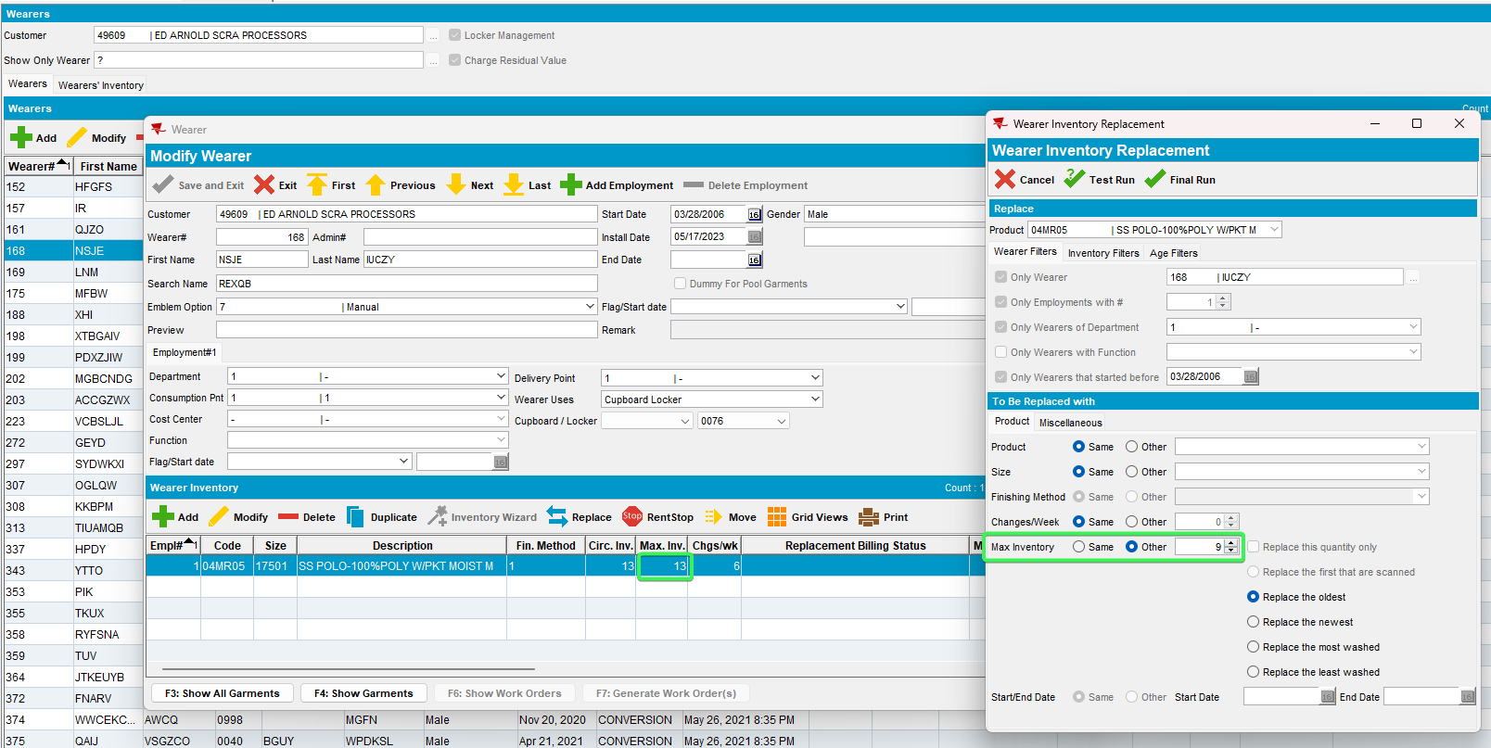
- Press Final Run button
- Select a reason code and press OK
- Check the log, the order was placed for the decreased amount of 9
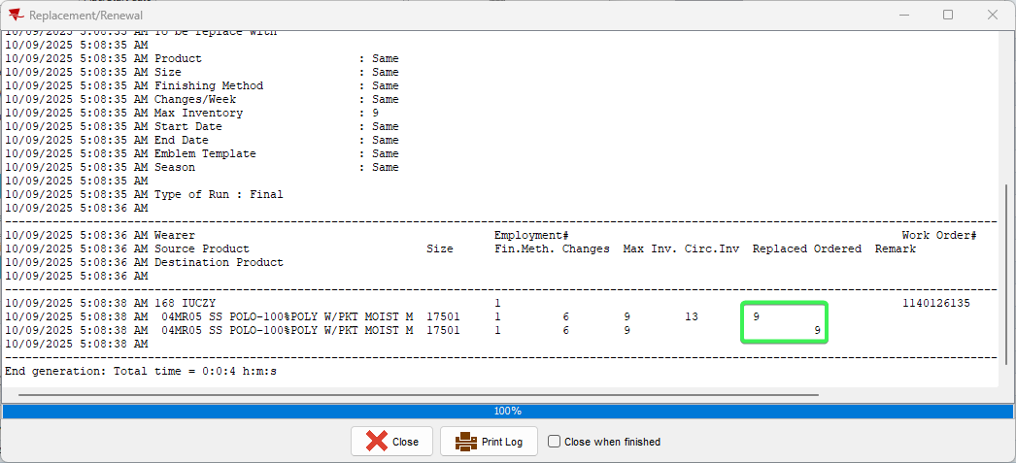
- Wearer DLG: Check the new Max Inv of the wearer inventory
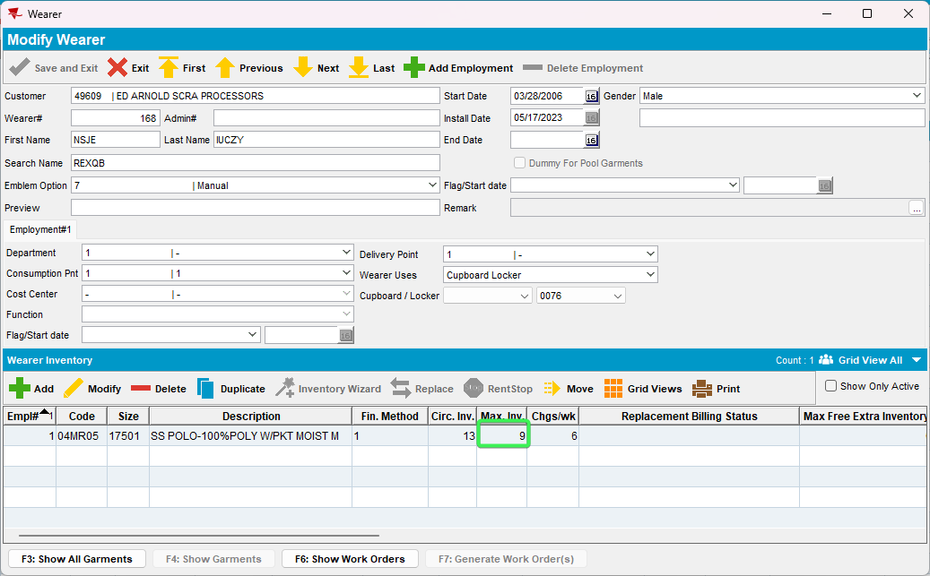
Tested OK

Test Case 6 - Wearer > Replace button – New Max = Old Max
Expected behavior: Wokrorder Orderd quantity = New Max
Hash: 049bec816abe
Steps:
- Wearer DLG: Input a customer with wearers
- Open a wearer select a wearer inventory and press Replace Button
- Select Max Inventory “Other” Radio button and keep the value of the original Max Inv.
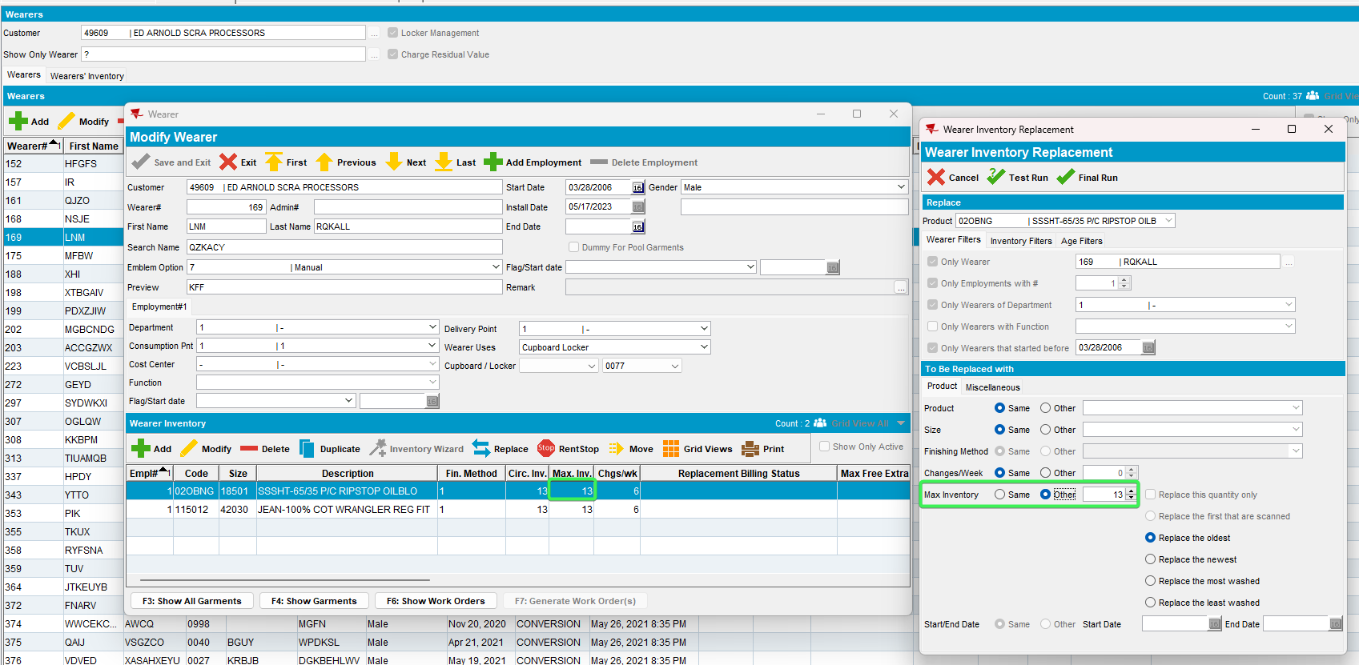
- Press Final Run button
- Select a reason code and press OK
- Check the log, the order was placed for the original 13
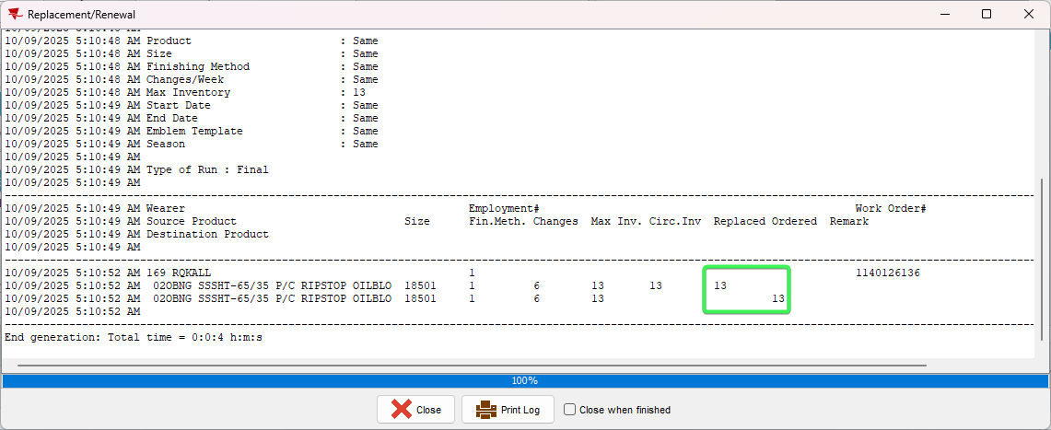
- Wearer DLG: Check the new Max Inv of the wearer inventory
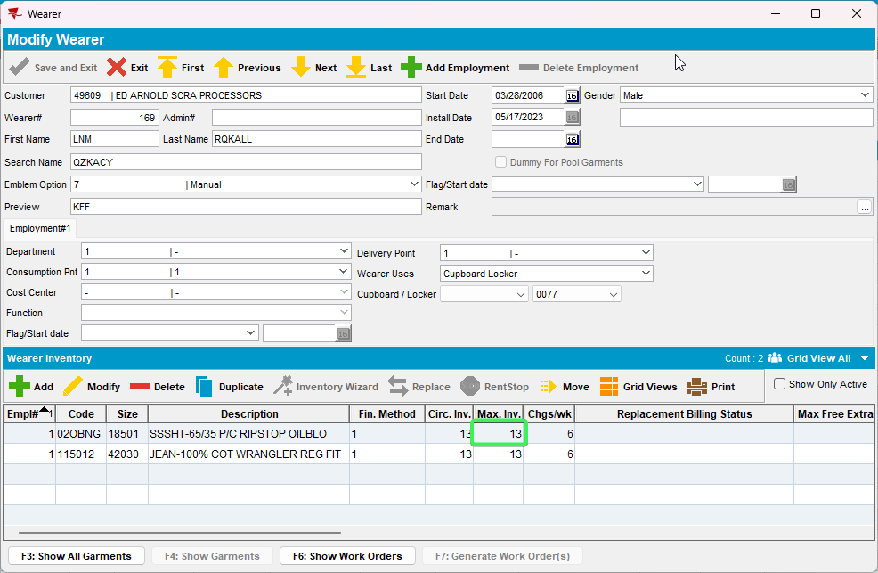
Tested OK

