ABSN-11173+RASAN-365 Error when ragging non unique+D_UBS_2775 The value of a new locker number set on RA is not updated on the wearer
Environment | Prerequisites
Version: 9.07.00.UNF21 + RouteAssistant_v12.40  DBServerName= abs-srv20.internal.abslbs.com  DBSID= CUST24  DBUser= UNFDEV  Environment=Test | - Module:  - System setting:

Contents
Retest after fix 1
version 9.07.00.UNF21 hash: d645dfb85342+ RouteAssistant_v12.40.INTERNAL_TEST_ONLY.e5b442ace 1

Retest after fix

version 9.07.00.UNF21 hash: d645dfb85342+ RouteAssistant_v12.40.INTERNAL_TEST_ONLY.e5b442ace
- Create a route with a customer who has garments.
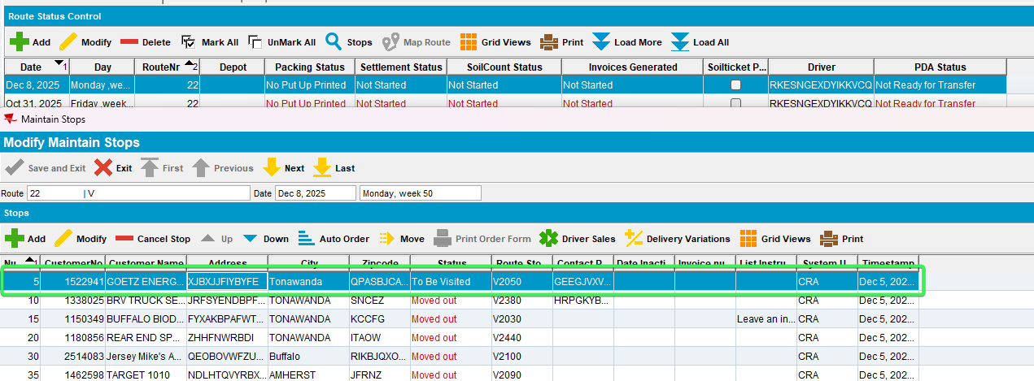
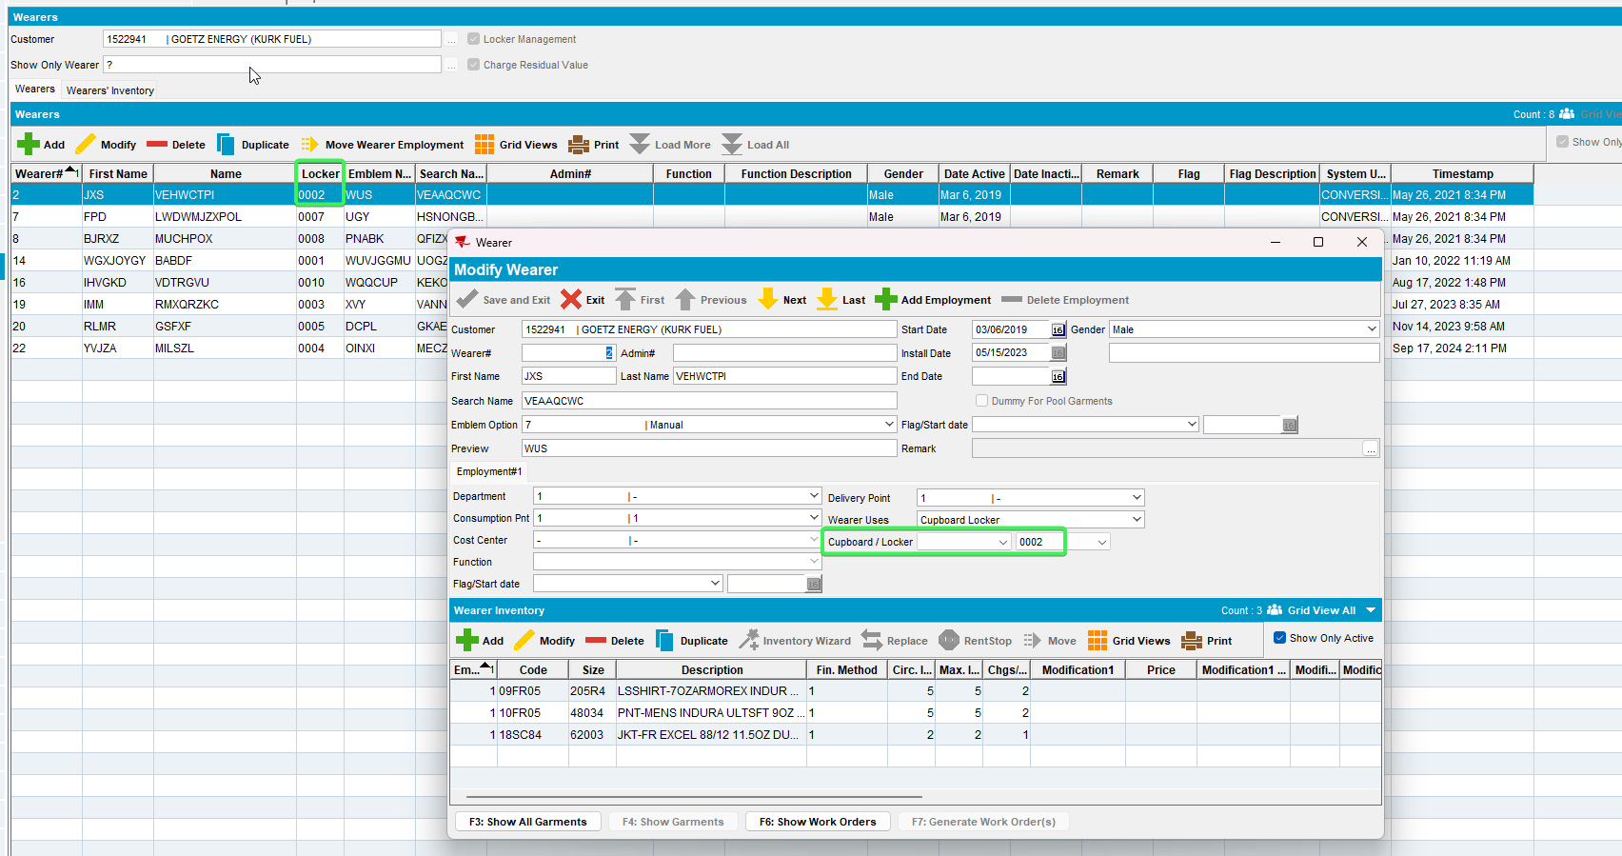
- Generate invoices and send the route to RA
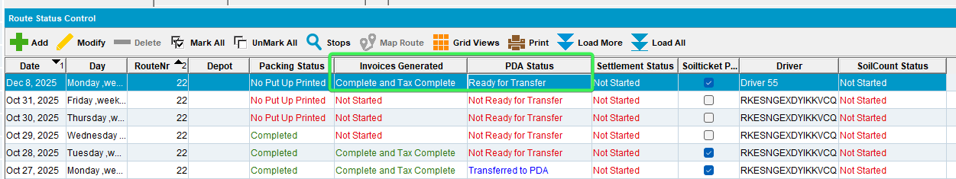
- Change the locker of a wearer and save it, settle the route and upload it.
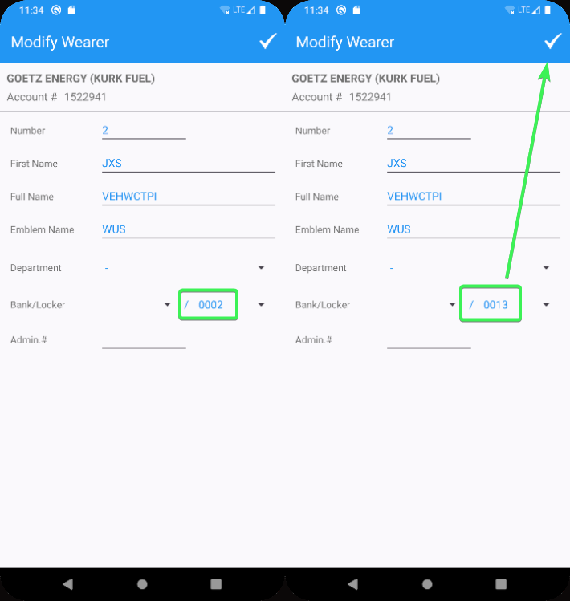
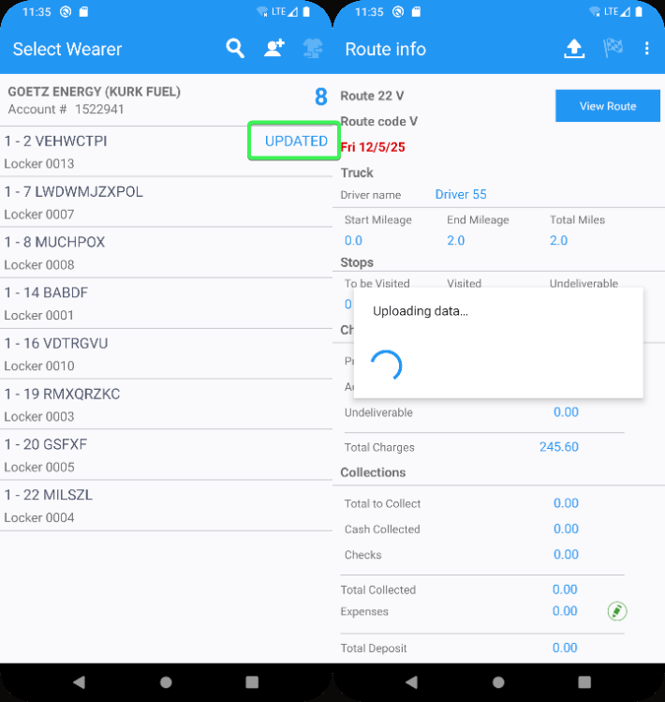
- Check the wearer’s locker in wearers dialog.
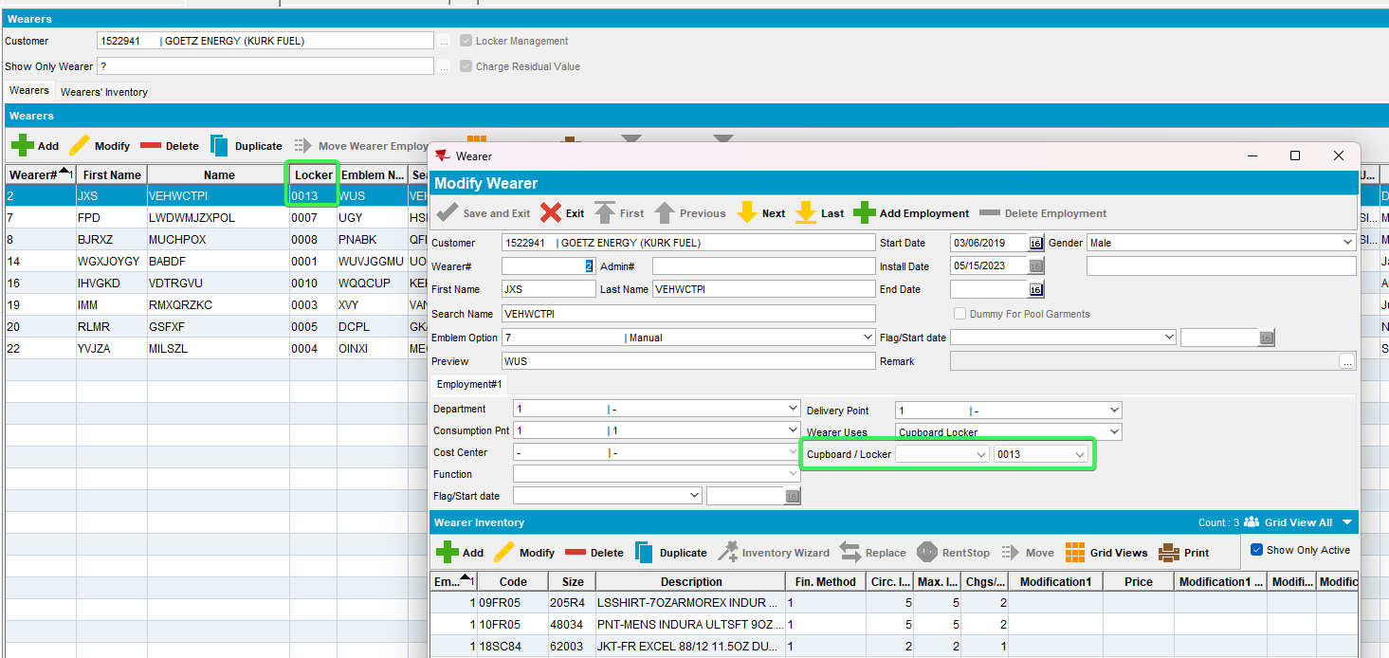
- Check the wearer's locker in route check in dialog.
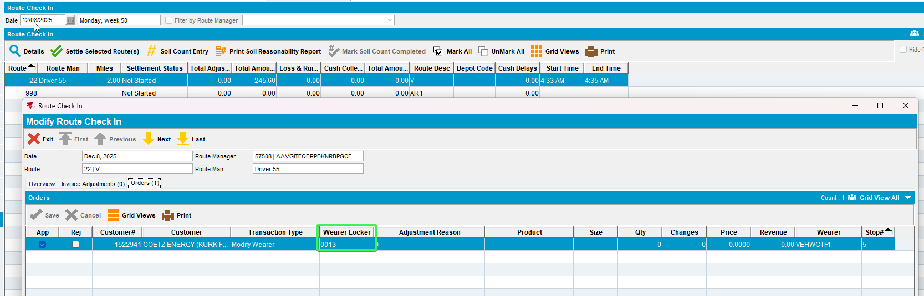

Expected behavior: After modifying a wearer's locker in the RA app, it should be visible in both the Wearers dialog and the Route Check In dialog.
Current behavior: After modifying a wearer’s locker in the RA app, it is visible in both the Wearers dialog and the Route Check In dialog.

