ABSN-10990 - D_UBS_2775 Modify wearer changes to a wearers locker number not triggering flags on unique garments
Environment | Prerequisites
Version: 9.07.00.UNF21 + RouteAssistant_v12.41  DBServerName= abs-srv20.internal.abslbs.com  DBSID=CUST24  DBUser=UNFDEV  Environment=Test | - Module:  - System setting

Contents
Test after development 1
Test Case 1 – RAALLOWFLAGONWEARERMODIFY = 1 change locker for Wearer on RA (Settlement test) 1
Test Case 2 – RAALLOWFLAGONWEARERMODIFY = 0 change locker for Customer 2, Wearer 1 (Settlement test) 16
Test Case 3 – Multiple employments on the same wearer, both have unique items attached to WI on them 23
Test Case 4 – Change locker on the client for a wearer, on RA flag the same wearer for locker change 29
Test Case 5 – Web X Test that the Flag Unique items column is read only when start my day is not completed 37
Test Case 6 – Web X Test that when all new columns are visible they are also present in all exports 39
Test Case 7 – Test Web X modification / development 40

Test after development

Test Case 1 – RAALLOWFLAGONWEARERMODIFY = 1 change locker for Wearer on RA (Settlement test)
Hash: 9.07.00.UNF21 hash: b612015a789f + RouteAssistant_v12.42.INTERNAL_TEST_ONLY.a75c1112d
Expected behavior:
After upload but before settlement NO relabeling flags are present on any of the WI that had locker changes on RA.
After Settlement ONLY the unique garments have all been flagged for relabeling.
The garments for wearers and wearer inventories that have transactions that were NOT approved AND checked on WebX did not get the flag.

- System Settings DLG: have RAALLOWFLAGONWEARERMODIFY = 1
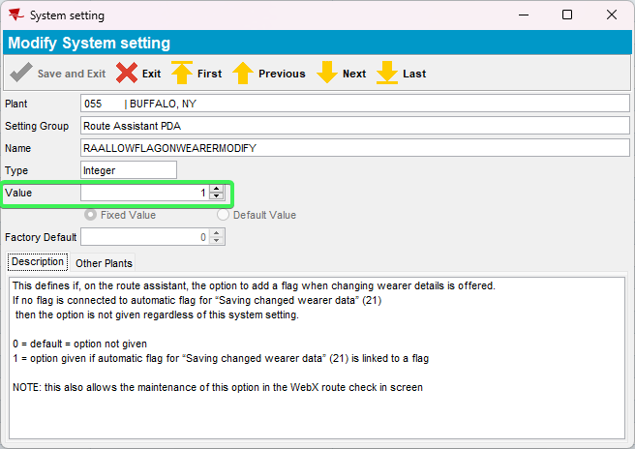
- Wearers DLG: Add a new wearer with 3 wearer inventories 1 with UIDs, second one with no UIDs, and the third with mixed inventory
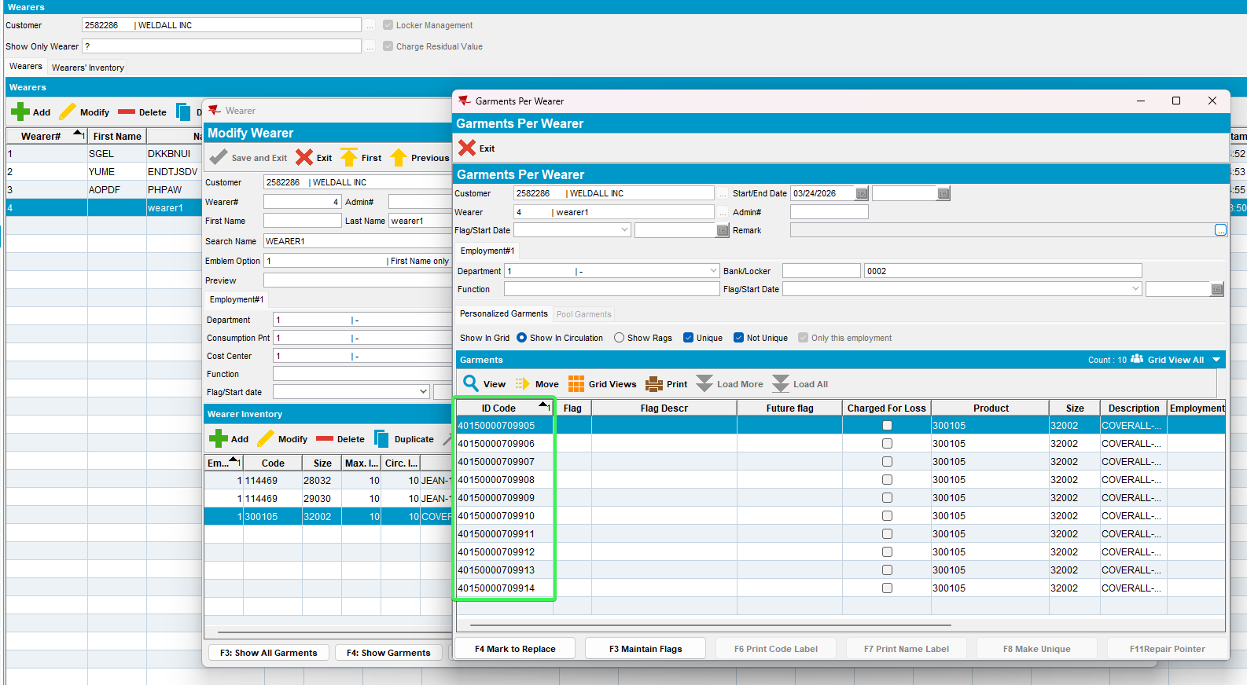
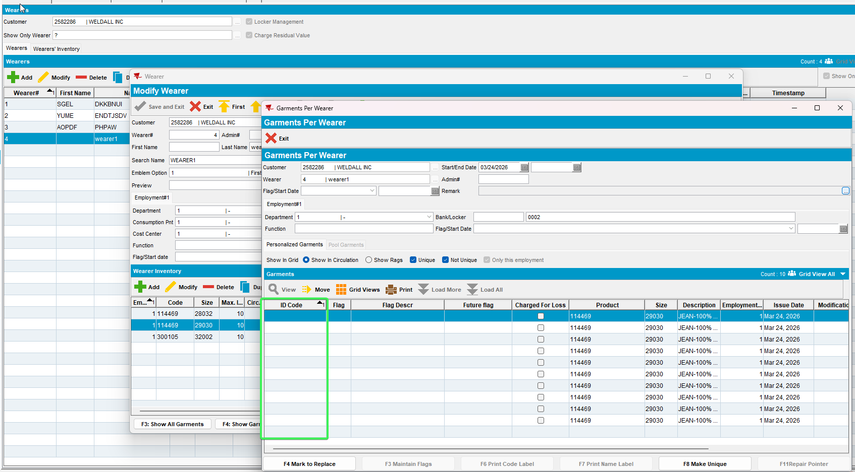
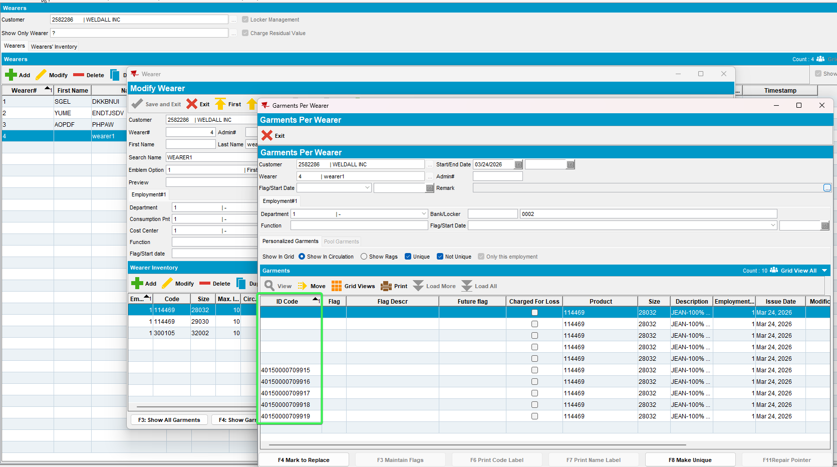
- Add a second wearer with a WI with all UIDs
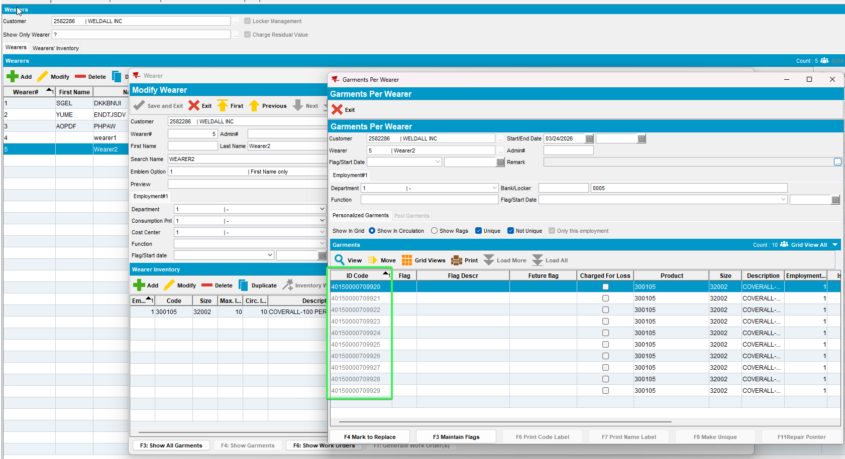
- RSC: Have your customer for which data was created earlier on a route for today
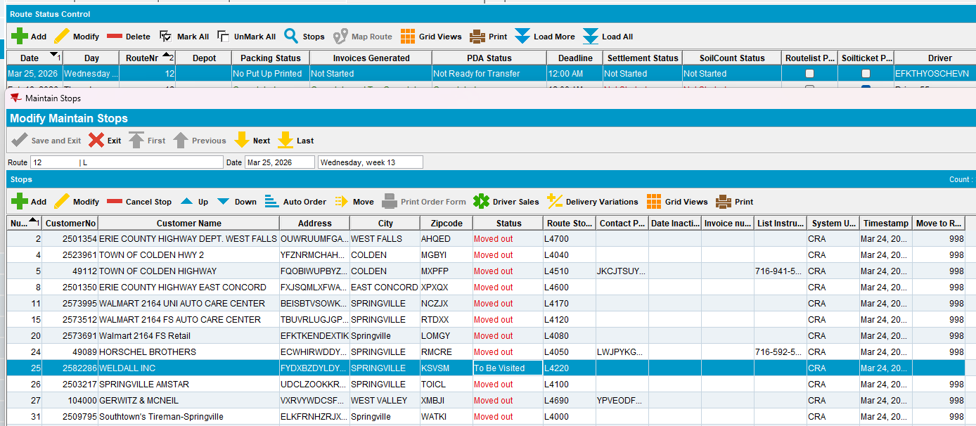
- Generate PutUp Docs
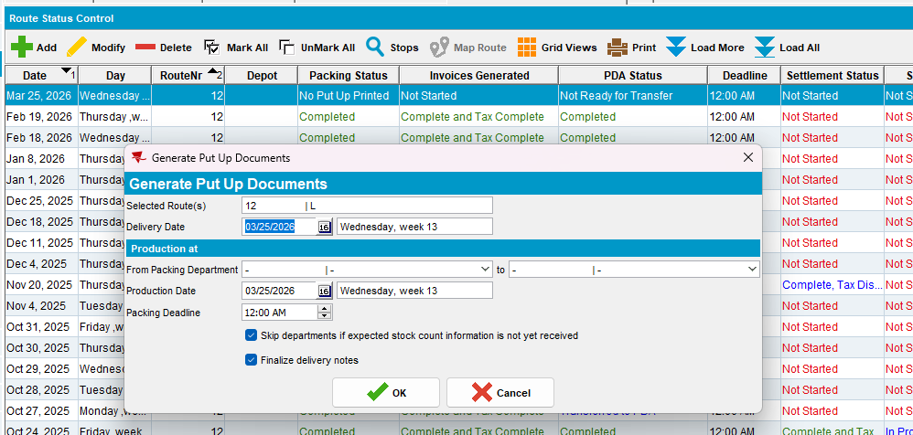
- Generate invoices and send the route to RA
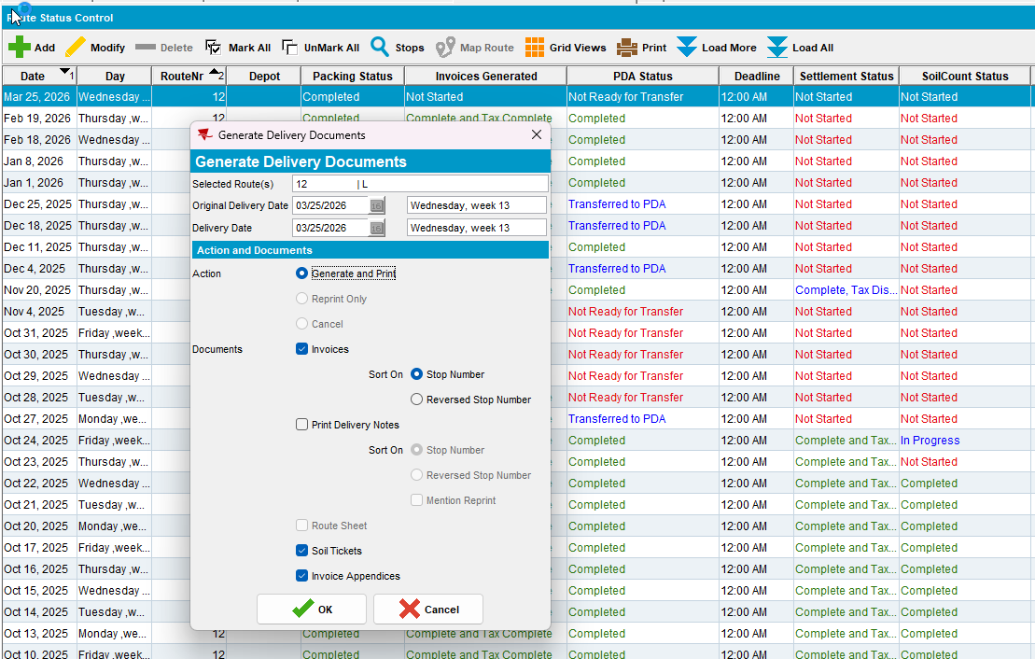
- RA: Wearers tab > Modify the locker of the 2 wearers and see that for the unique IDs a message is received asking the user if he wants to put a relabeling flag on them
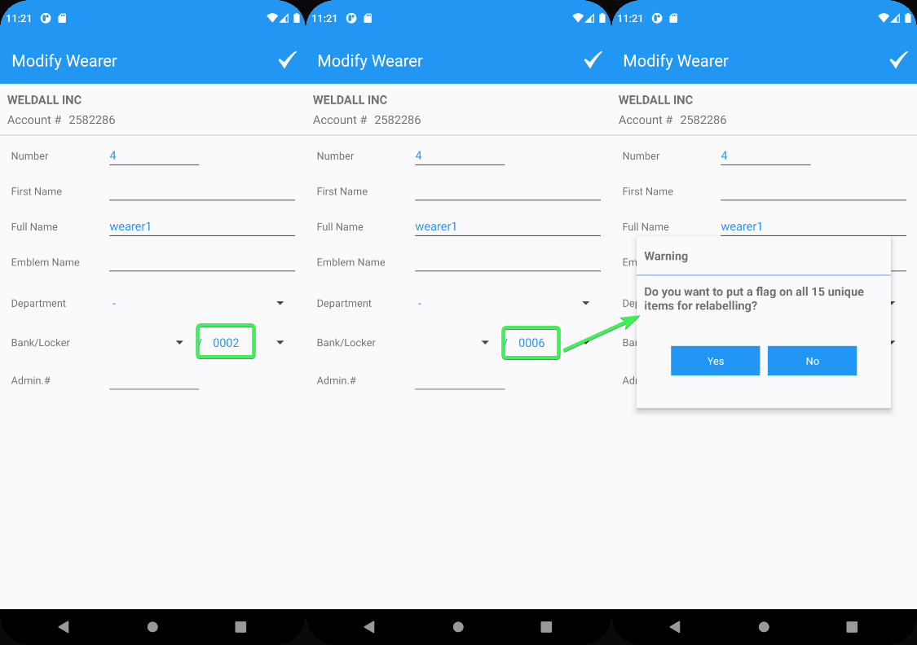
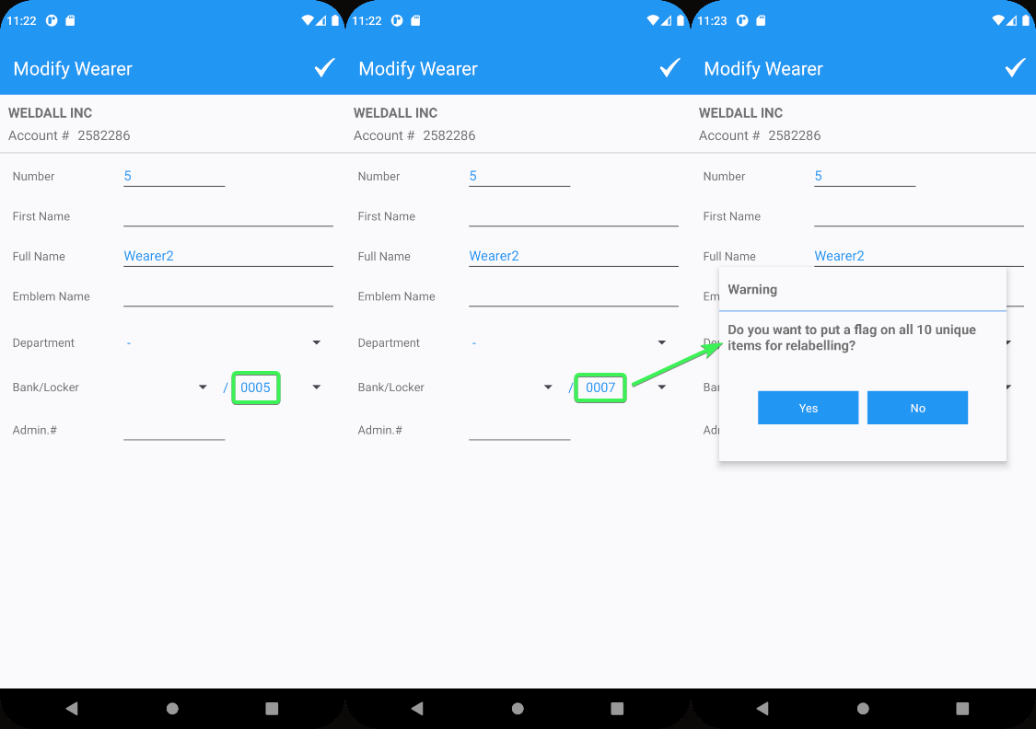
- Settle the Route and Upload the data
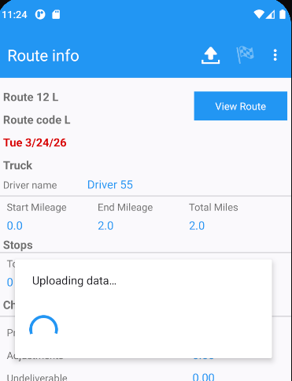
- WebX: Complete start my day
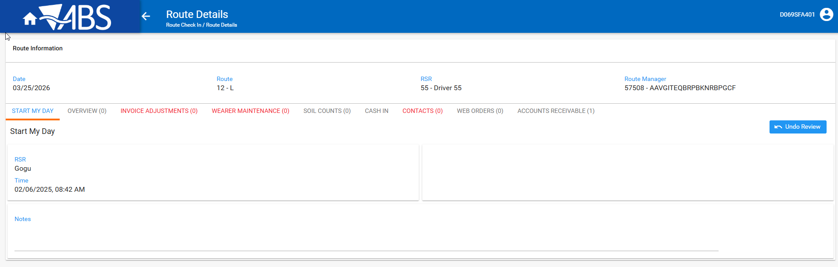
- Change the rt.approvalstatus=0 (pending) from PLSQL using the following select
select rt.approvalstatus, rt.routetransactiontype_id, rt.*
from ROUTETRANSACTION RT
where RT.ROUTECONTROL_ID = 3039146
and RT.ROUTETRANSACTIONTYPE_ID between 300 and 350 for update;
- See that any change to the Flag Unique Items checkbox triggers a Save / Discard message
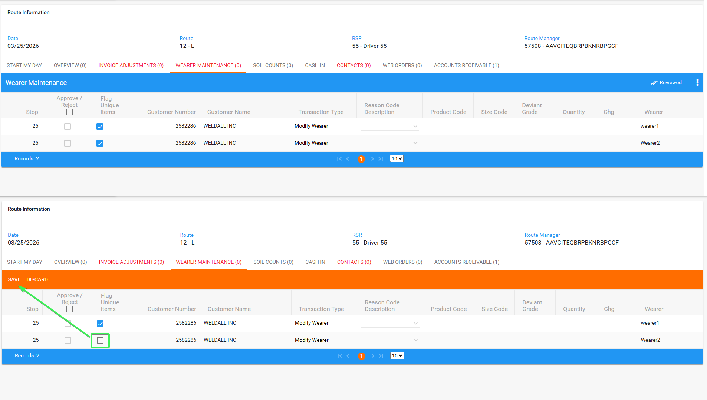
- Approve Flag Unique Items for the 1st wearer and don’t approve it for the second
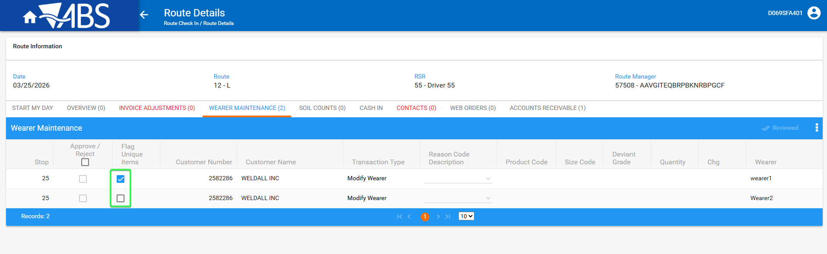
- Change back to rt.approvalstatus=1 (approved) from PLSQL
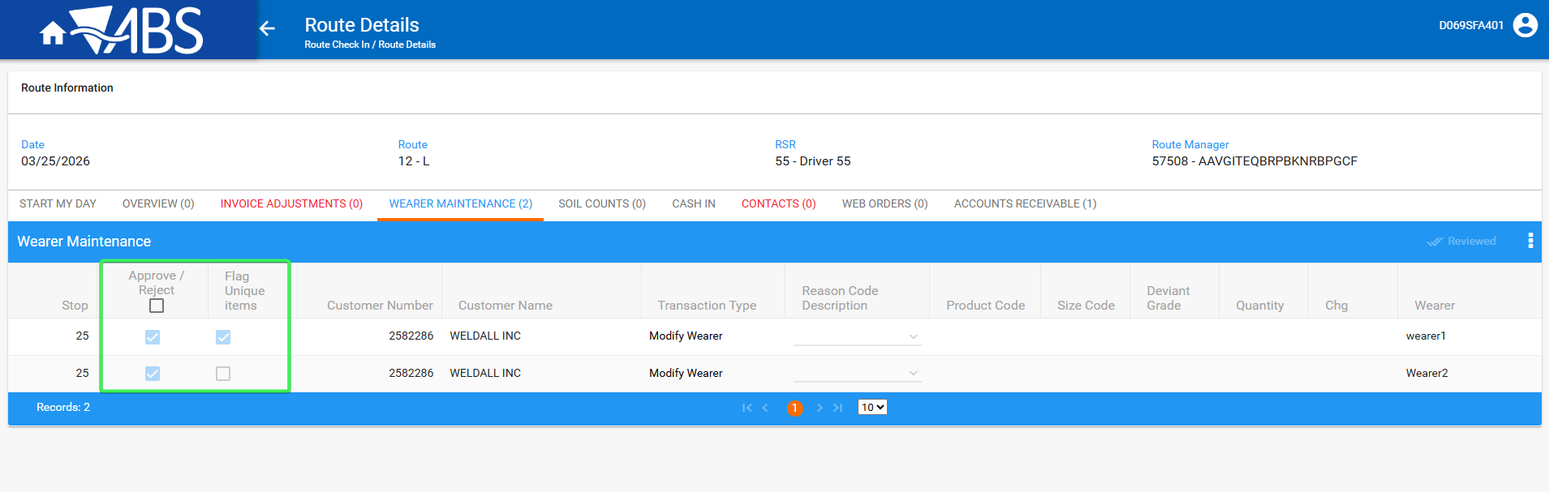
- Wearers DLG: check that relabeling flags are NOT present on any of the wearers that had locker changes on RA
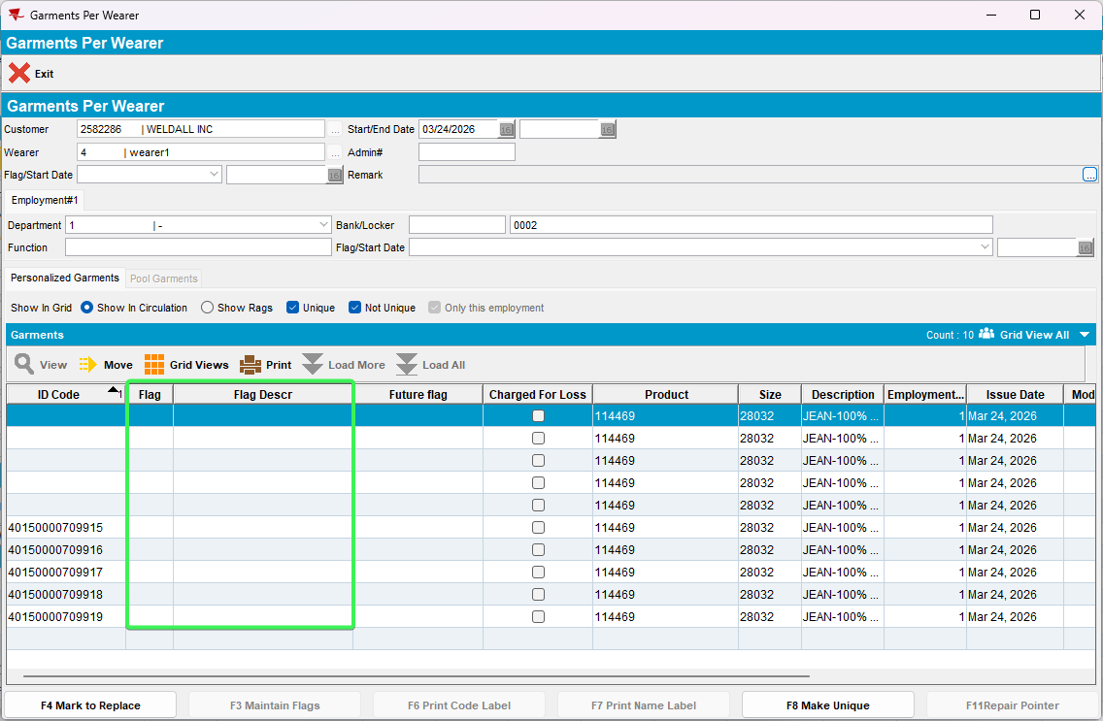
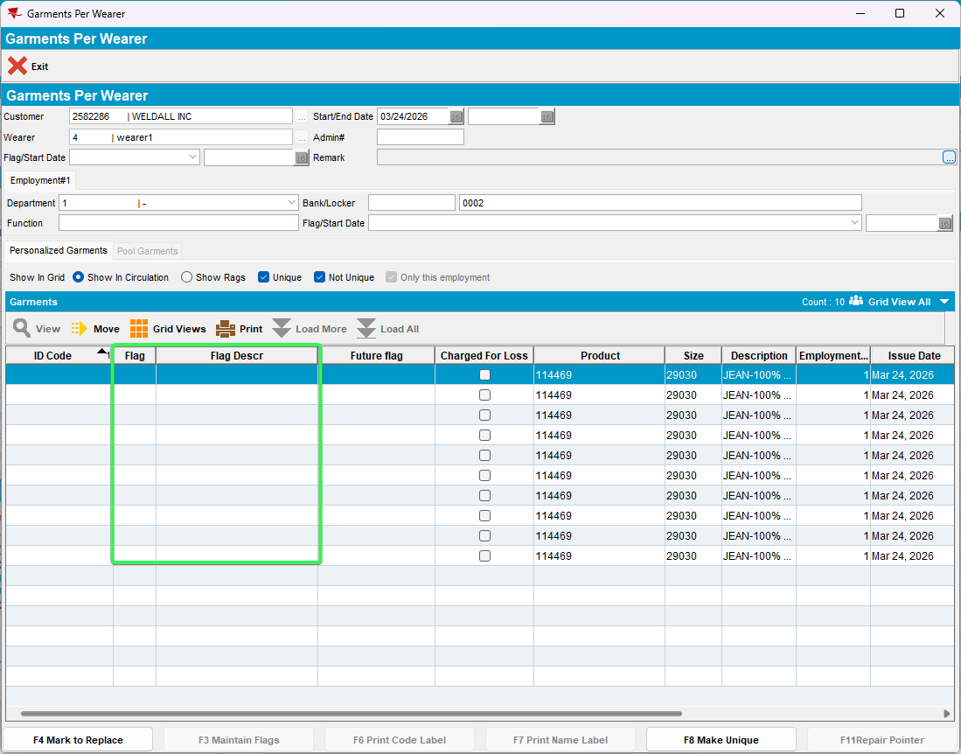

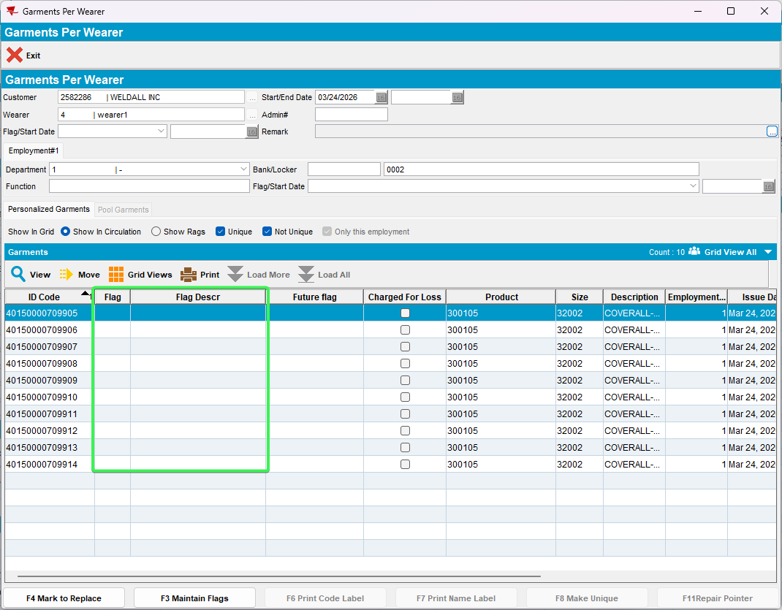
- Check that the wearer for which the Flag Unique Items was not approves have no flags on the UIDs
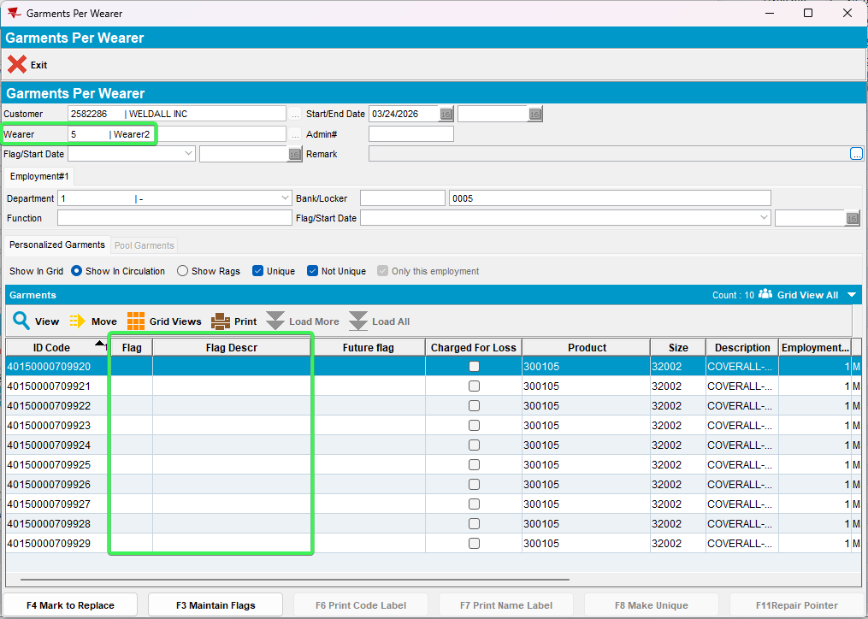
- WebX: Review tabs and settle the route
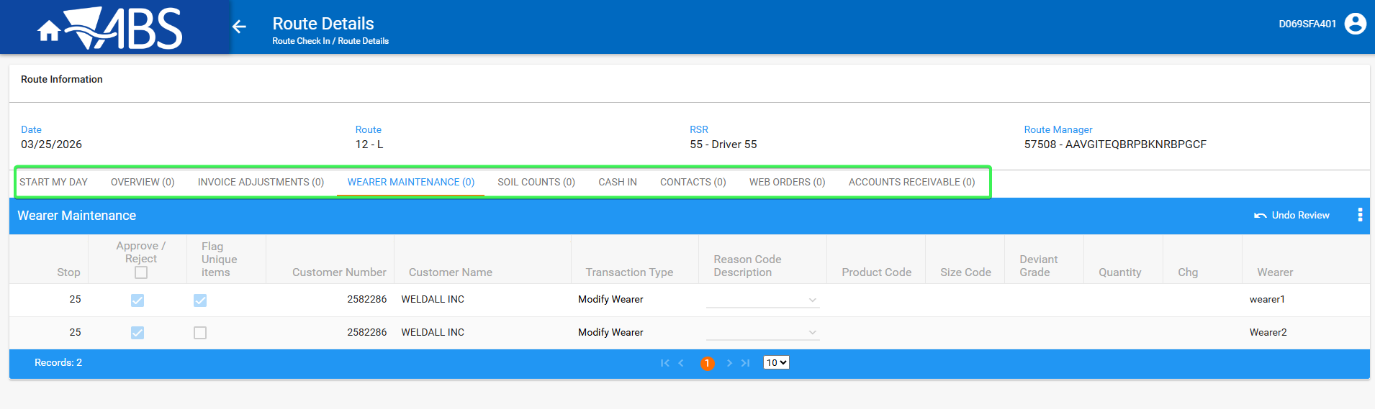
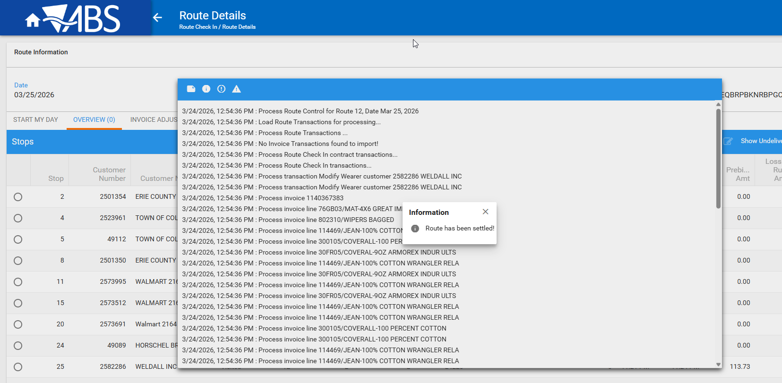
- Wearers DLG: Check that After Settlement ONLY the unique garments have been flagged
Wearer 1UIDs WI
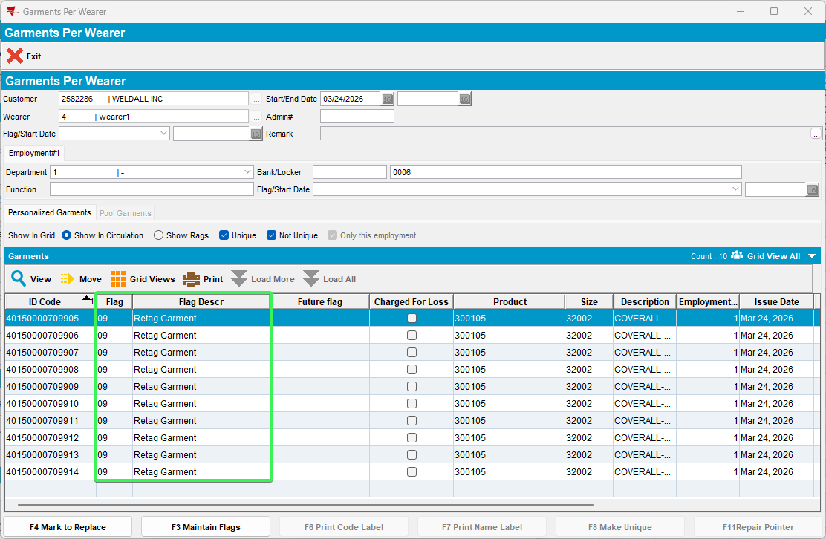
Wearer 1 Mixed WI
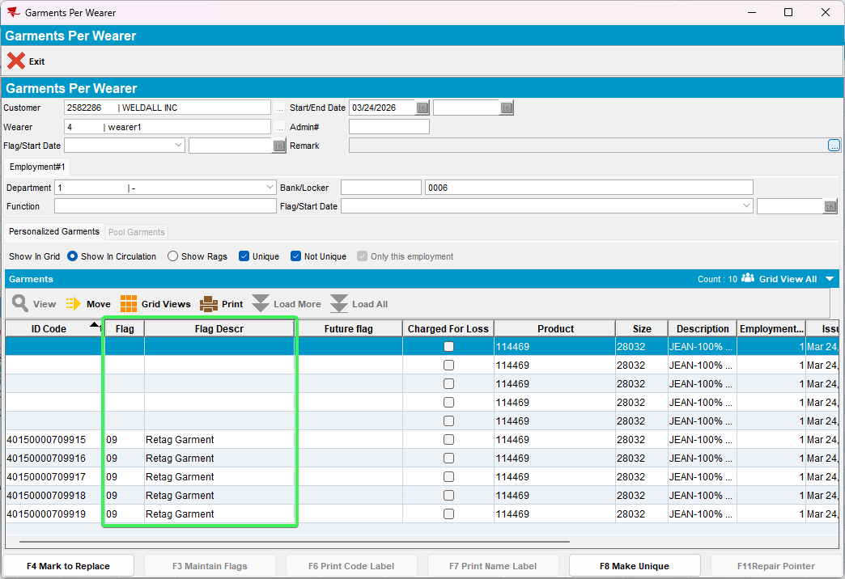
Wearer 1 Non-UIDs WI
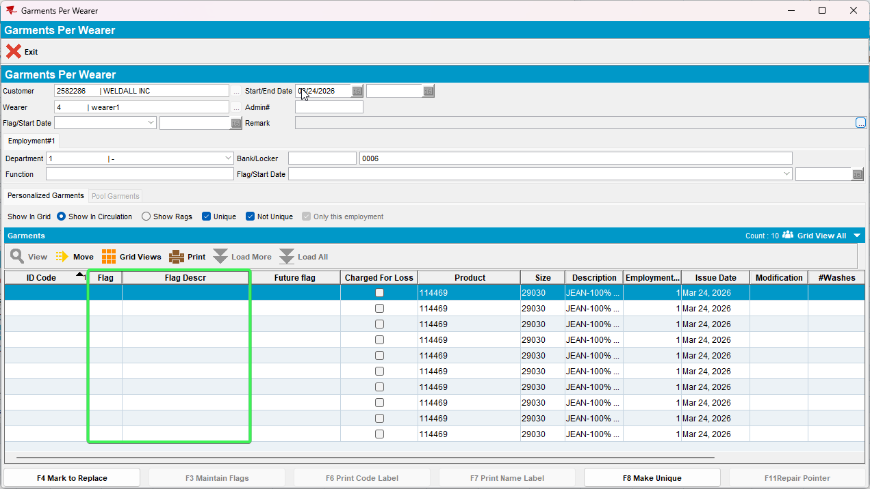
- Check that After Settlement for the garments that were not accepted for Flag Unique Items the flag is not present
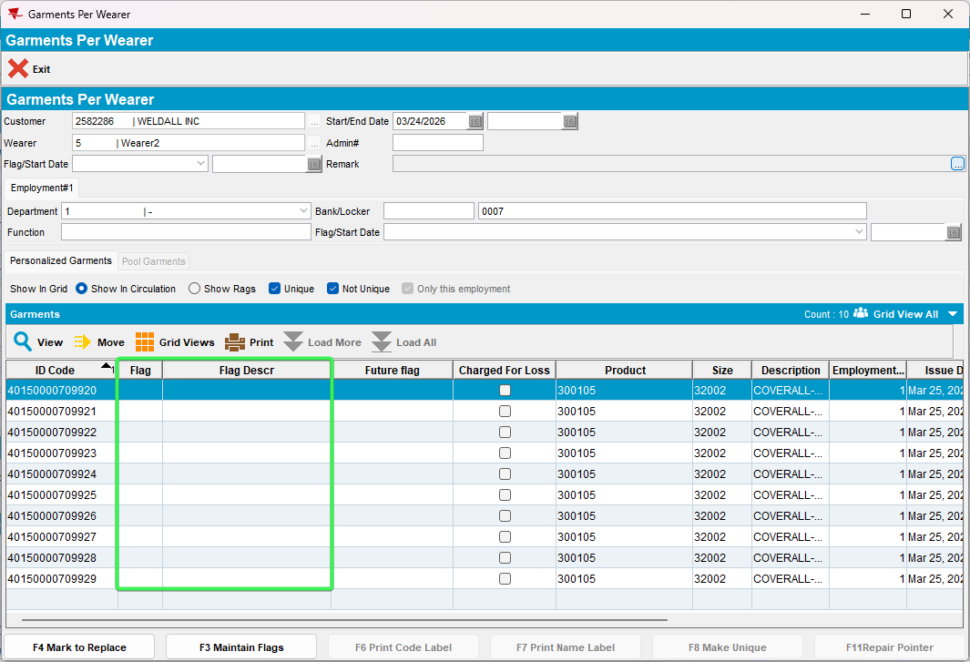
Tested OK

Test Case 2 – RAALLOWFLAGONWEARERMODIFY = 0 change locker for Customer 2, Wearer 1 (Settlement test)
Hash: 9.07.00.UNF21 hash: b612015a789f + RouteAssistant_v12.42.INTERNAL_TEST_ONLY.a75c1112d
Expected behavior:
After Settlement no unique garments have relabel flags.

- System Settings DLG: have RAALLOWFLAGONWEARERMODIFY = 0
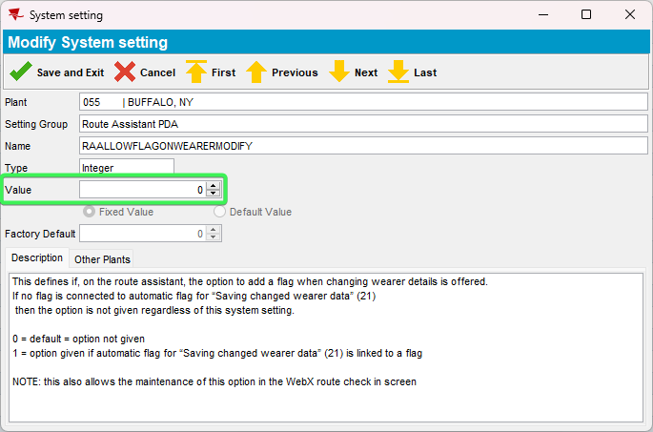
- Pick up a customer that has Wearers and a Wi with all unique items
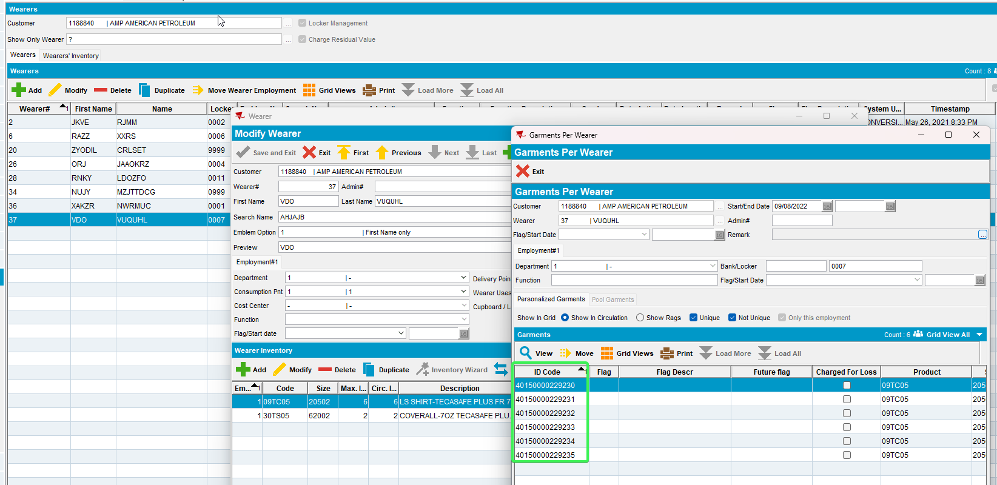
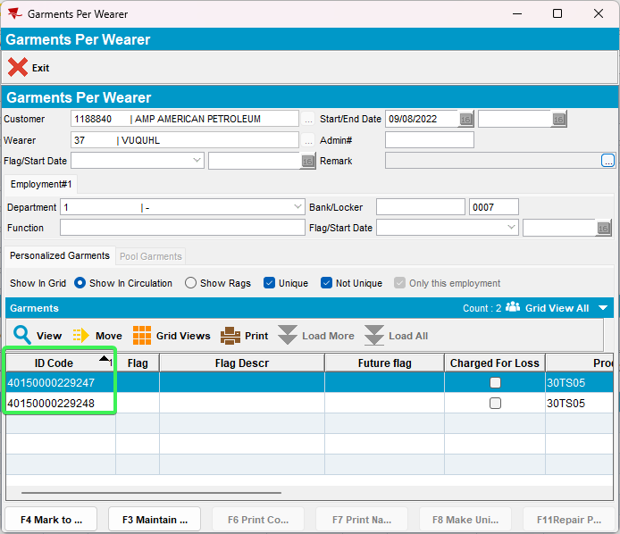
- RSC: Have your customer on a route for today
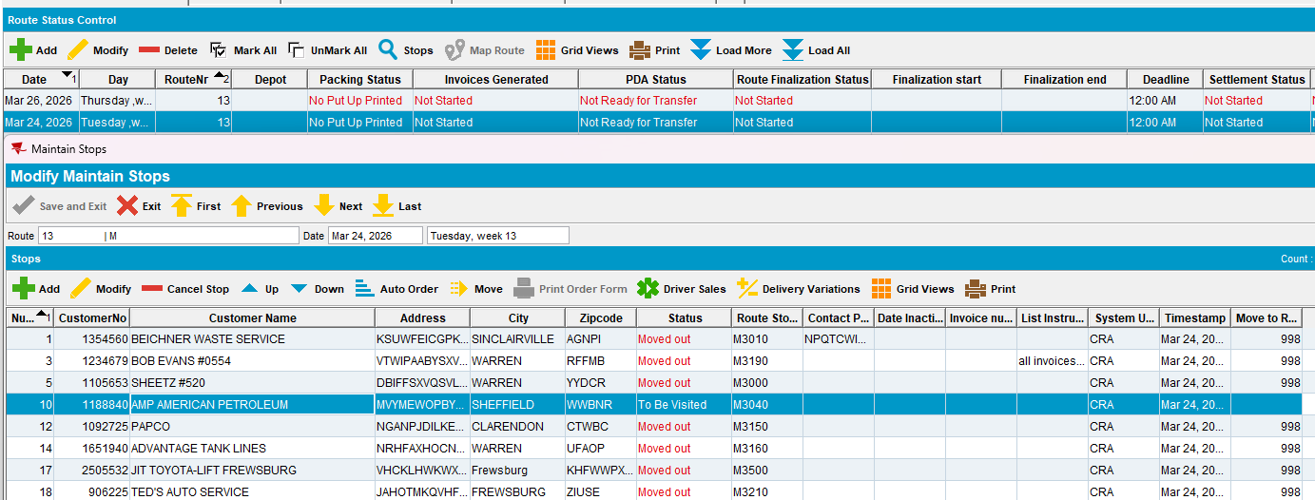
- Generate invoices and send the route to RA
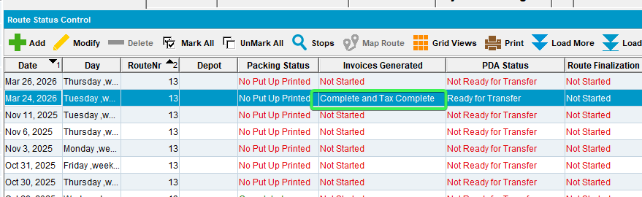
- RA: Arrive at the customer and go to Wearers tab
- RA: Modify the wearer’s locker and see that no message is prompted to put a flag on the unique IDs
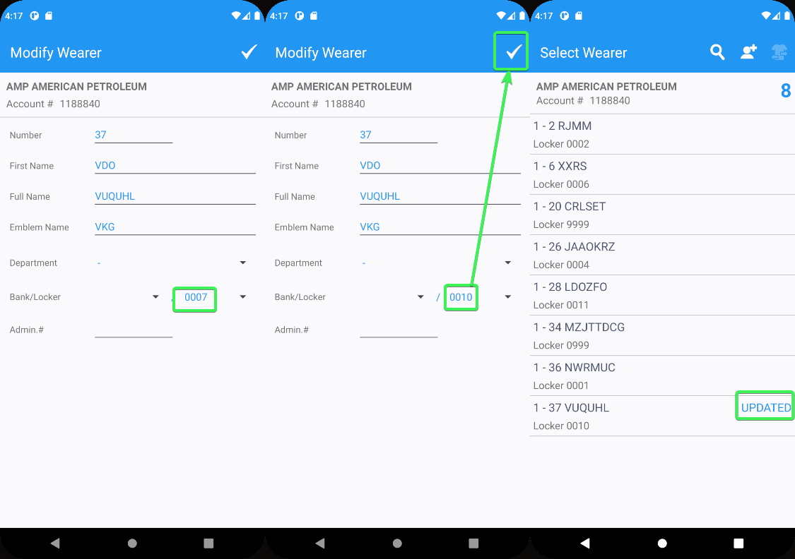
- Settle the route and upload the data back to server
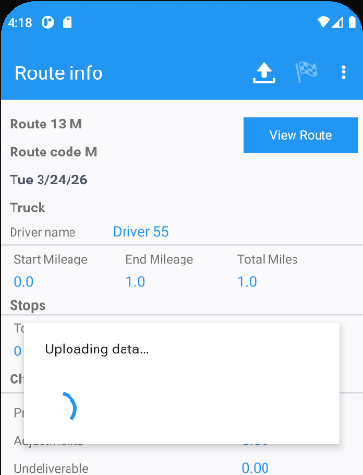
- WebX: Complete start my day
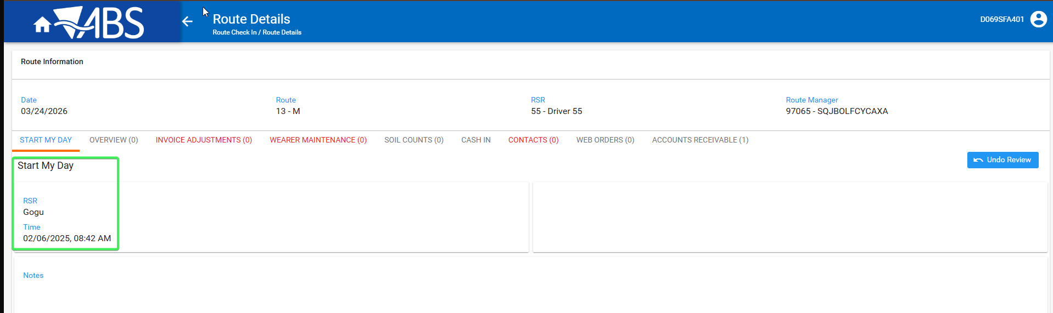
- Wearer Maintenance tab: See that the column Flag Unique Items is not present
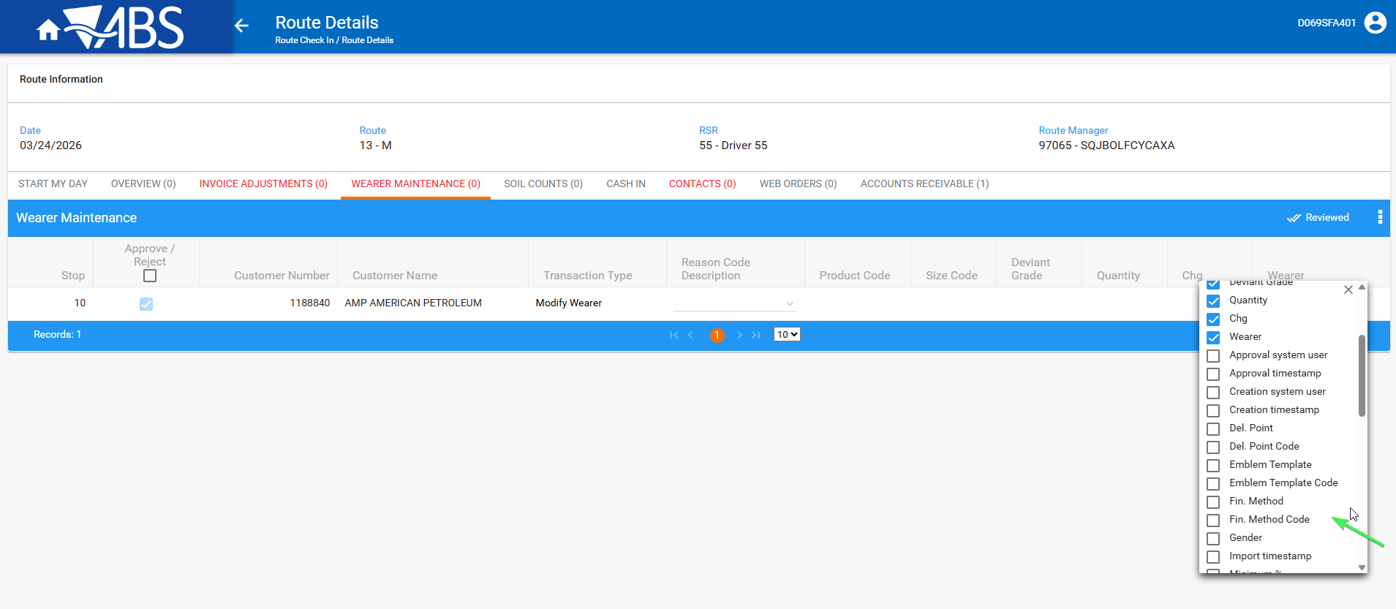
- Wearer DLG: Check that a relabel flag was not set on the UIDs
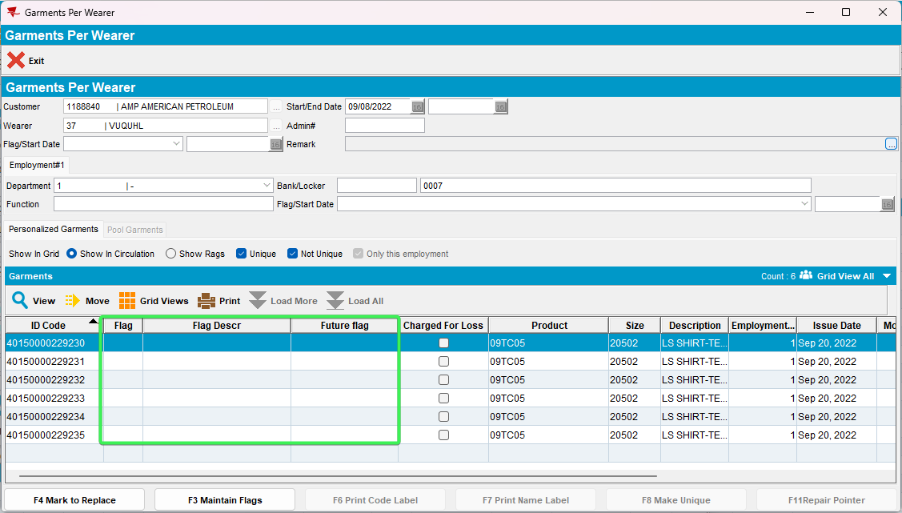
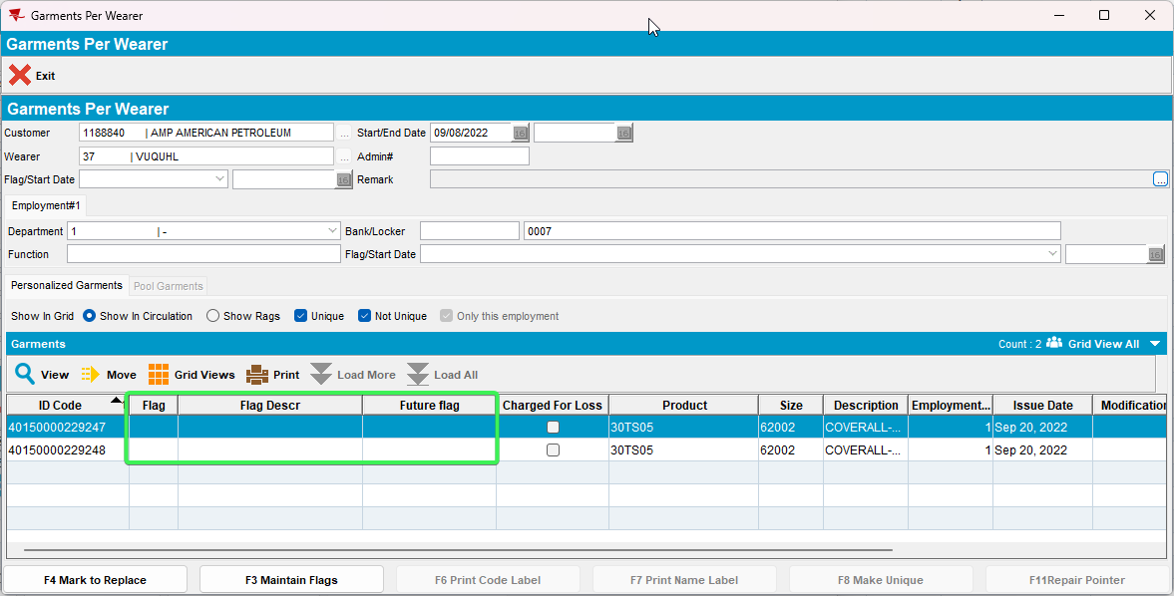
- WebX: Settle the route
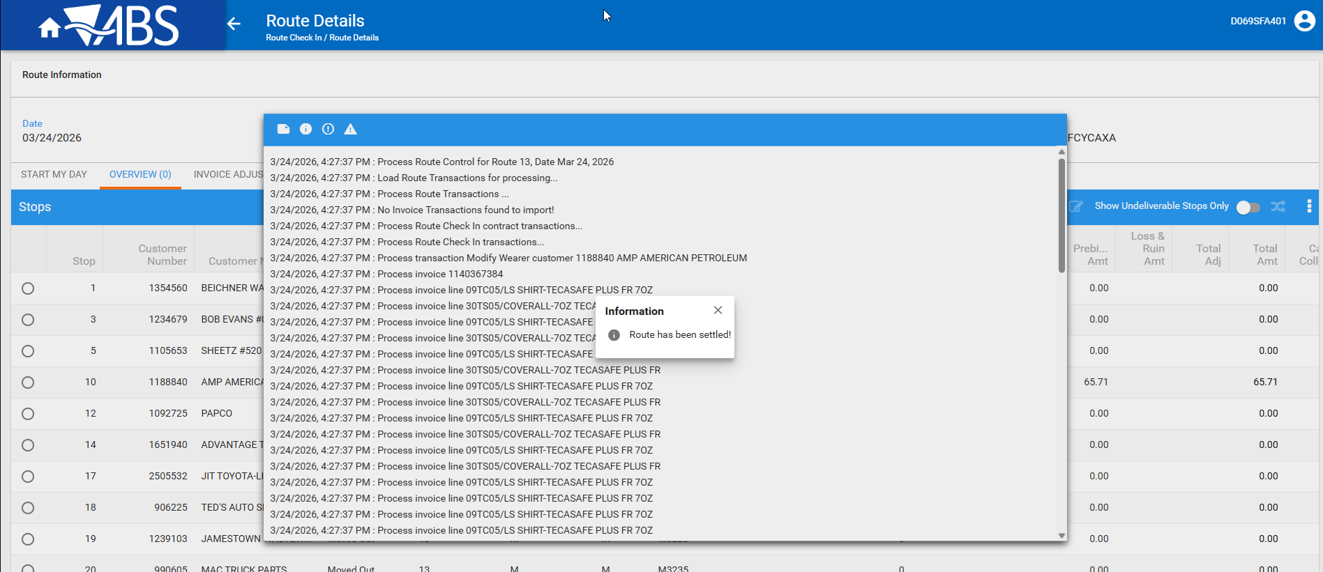
- Wearer DLG: Check that a relabel flag was not set on the UIDs
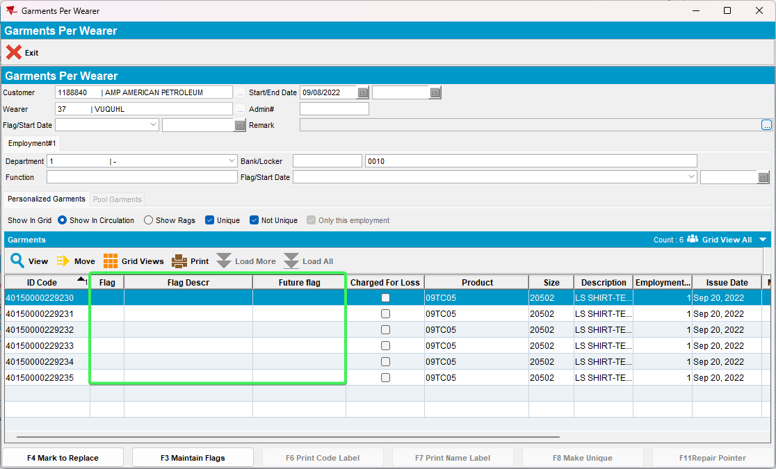
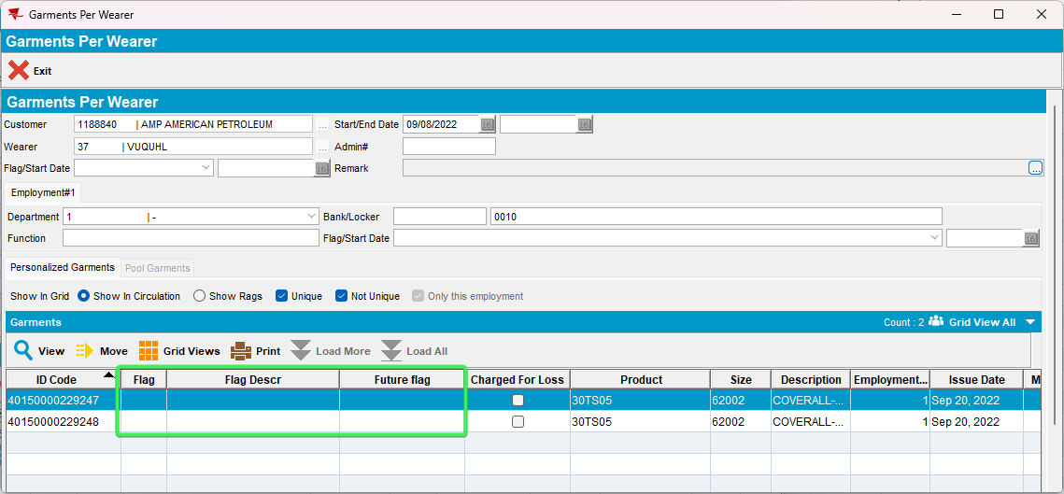
Tested OK

Test Case 3 – Multiple employments on the same wearer, both have unique items attached to WI on them
Hash: 9.07.00.UNF21 hash: b612015a789f + RouteAssistant_v12.42.INTERNAL_TEST_ONLY.a75c1112d

Expected behavior:
When the locker is changed on RA it is updated for all employments, so the settlement process should flag all garments on all employments
- System Settings DLG: have RAALLOWFLAGONWEARERMODIFY = 1
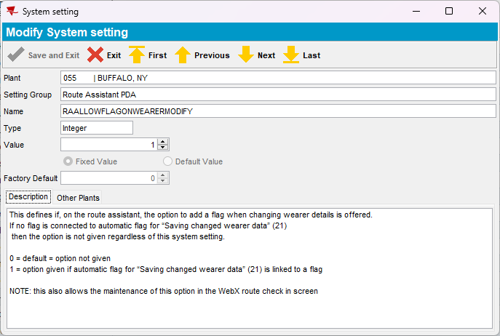
- Wearers DLG: Add a new wearer with 2 Wearer Employments, both have WI with UIDs
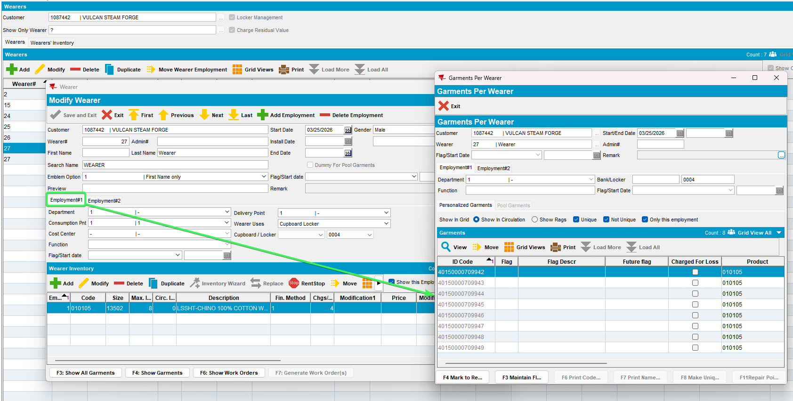
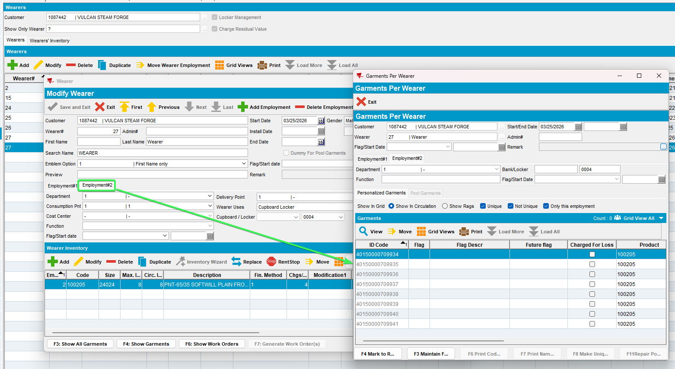
- RSC: Have your customer for which data was created earlier on a route
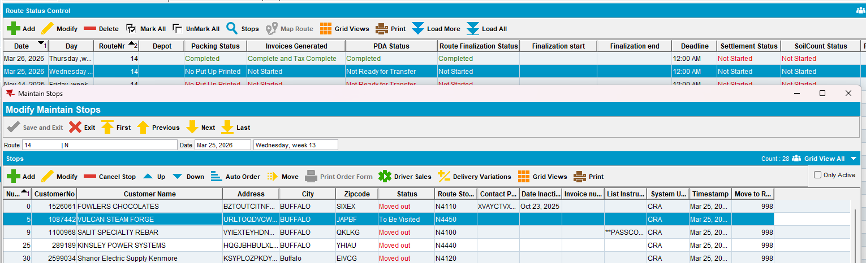
- Generate invoices and send the route to RA
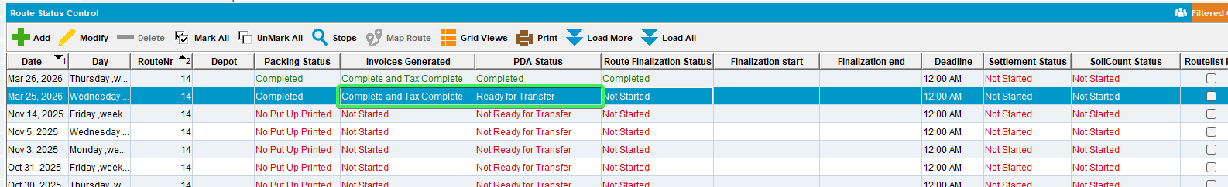
- RA: Wearers tab > user will only see employment 1 > change the locker on that employment
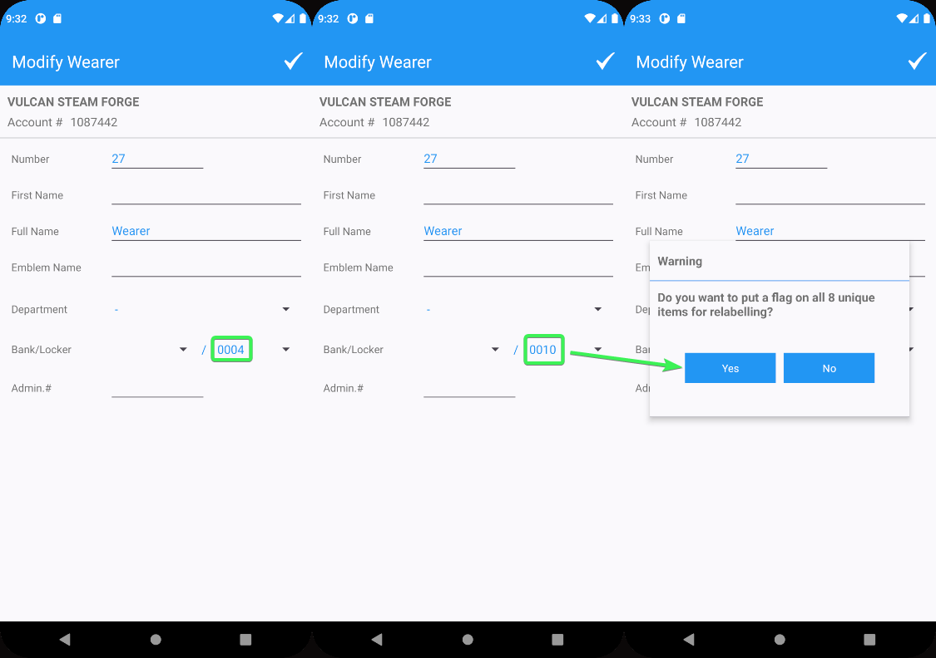
- Settle the route and upload the data
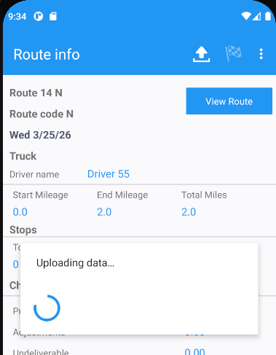
- WebX: Complete Start my day
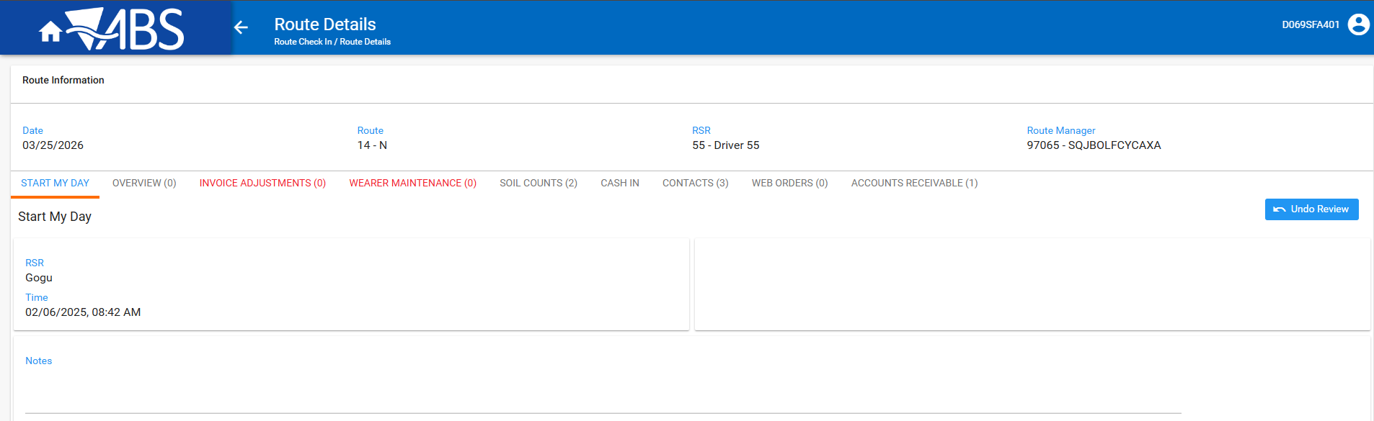
- Review all tabs and settle the route
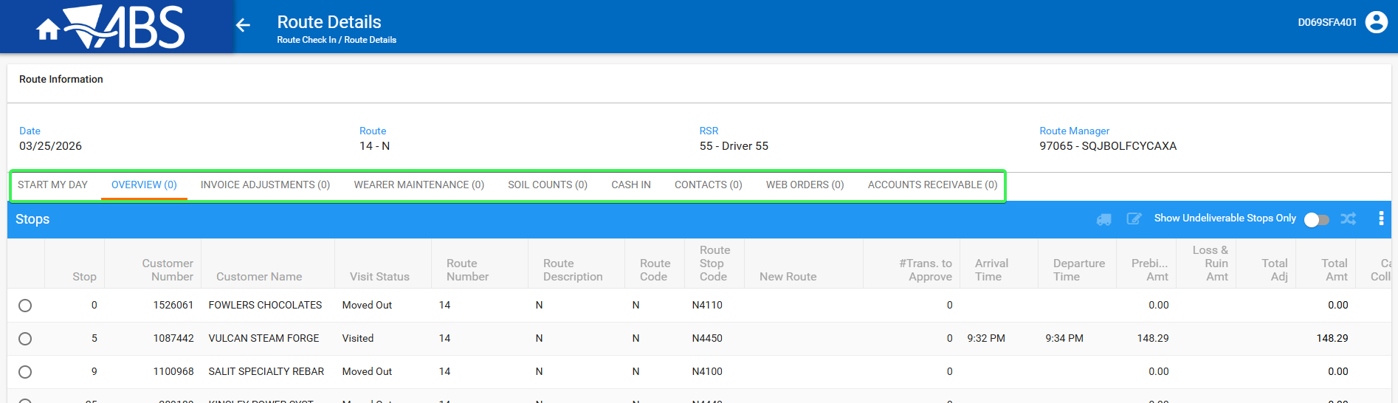
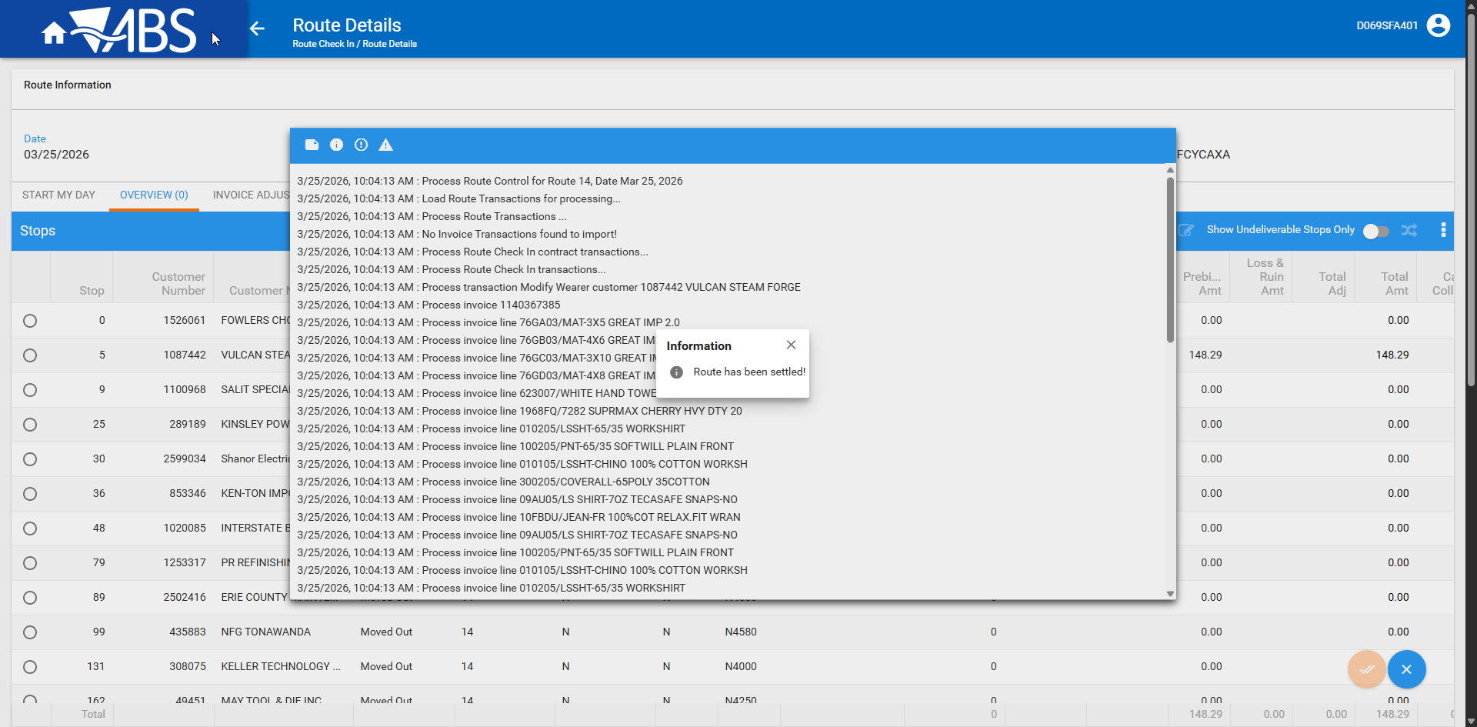
- Wearer DLG: Check both employments WI UIDs and see that frags were added to both
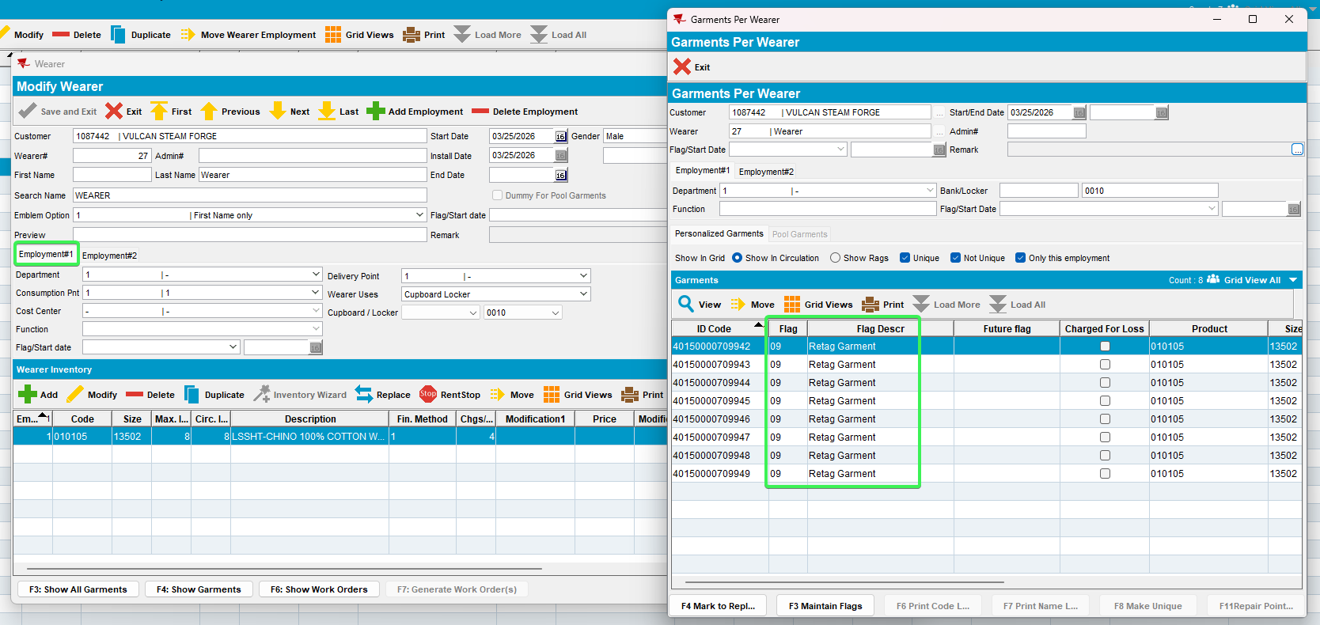
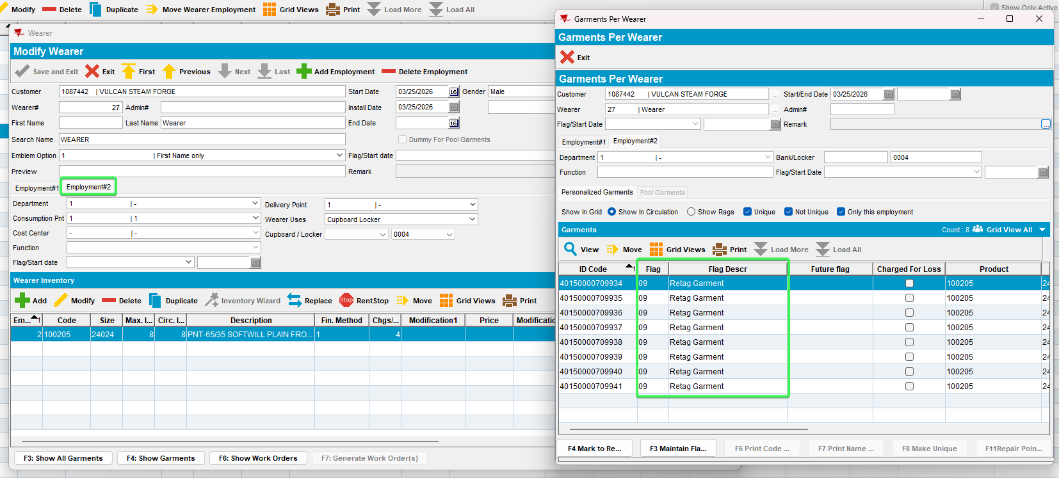
Tested OK

Test Case 4 – Change locker on the client for a wearer, on RA flag the same wearer for locker change
Hash: 9.07.00.UNF21 hash: b612015a789f + RouteAssistant_v12.42.INTERNAL_TEST_ONLY.a75c1112d

Expected behavior: When the route is settled the settlement process does not error out, it may display a warning that the uniqueitemflag insert failed
- System Settings DLG: have RAALLOWFLAGONWEARERMODIFY = 1
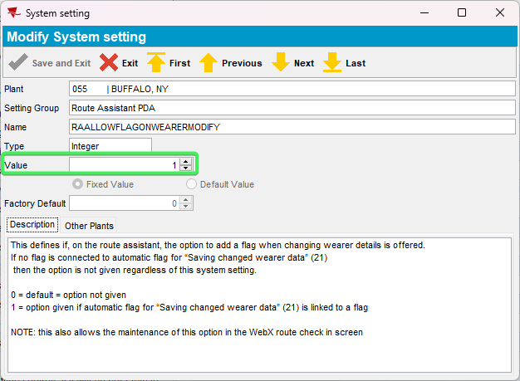
- Wearers DLG: Have a customer with a WI of UIDs
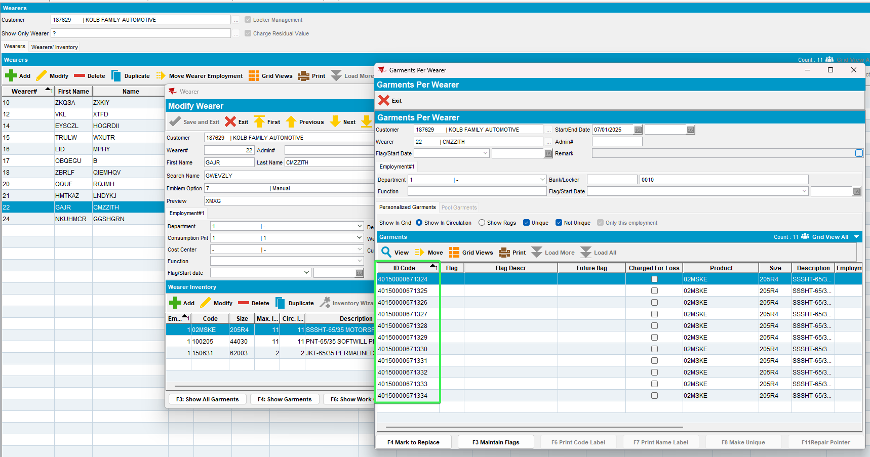
- Change locker for this Wearer
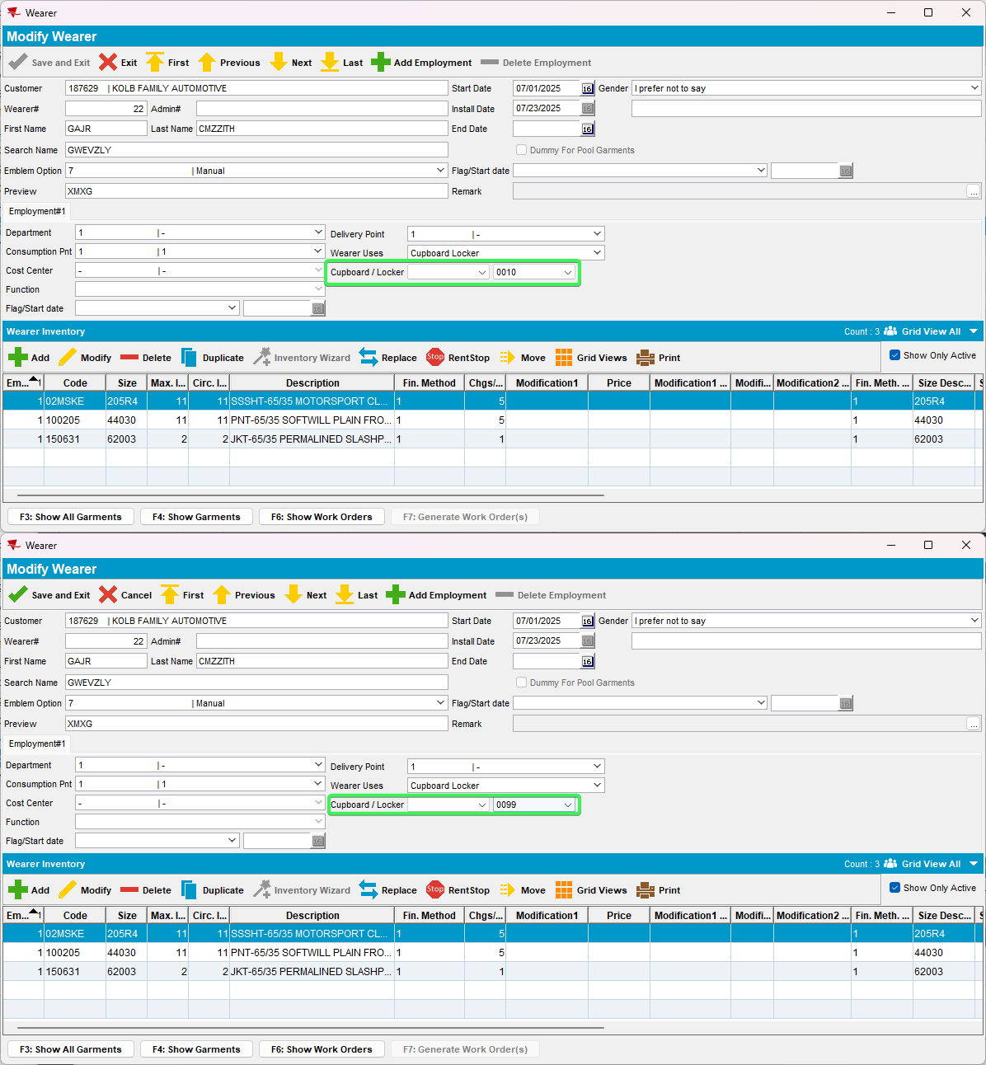
- See that a warning is prompted that a flag will be put on all Unique Items
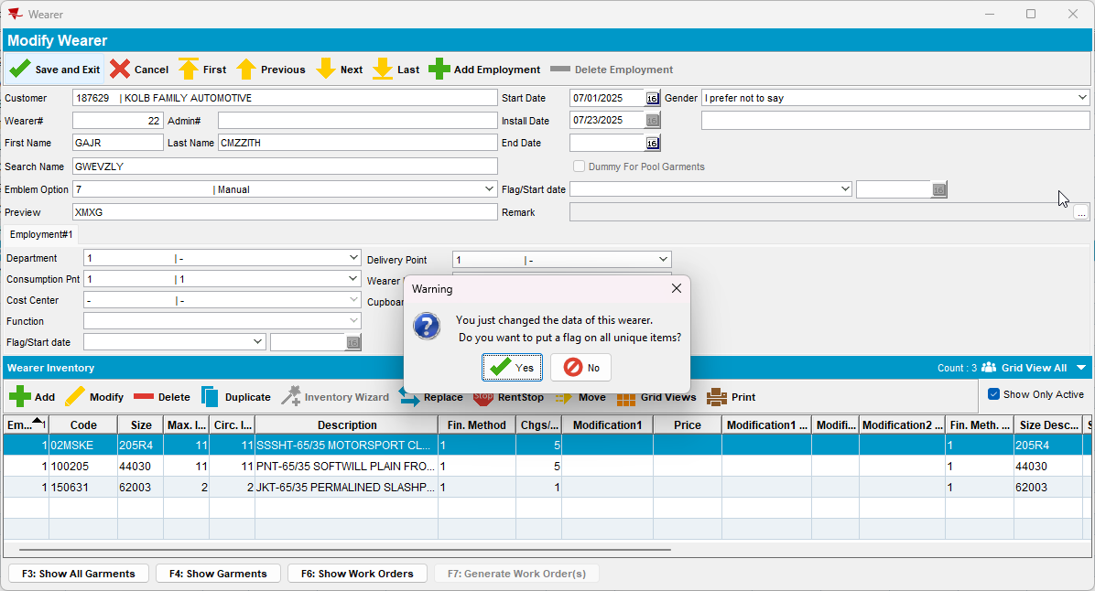
- Check that the UIDs have retag flags put on them
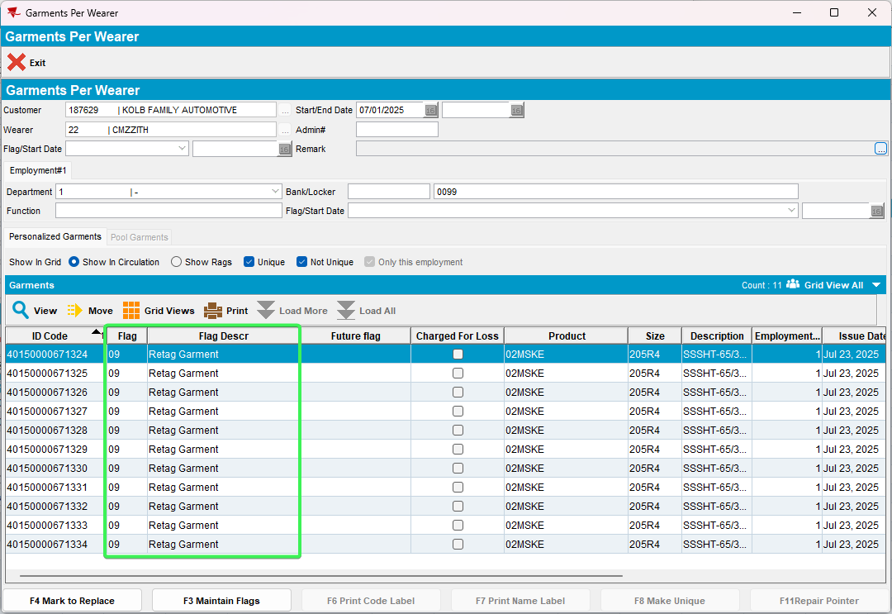
- RSC: Have your customer on a route
- Generate invoices and send the route to RA
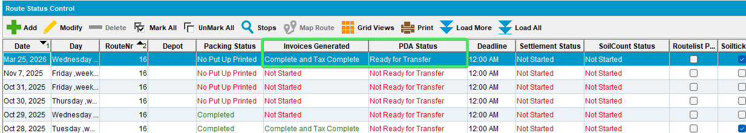
- RA: Wearers tab > Change the wearer locker to the wearer you already changed it on client and already has retag flags on his UIDs
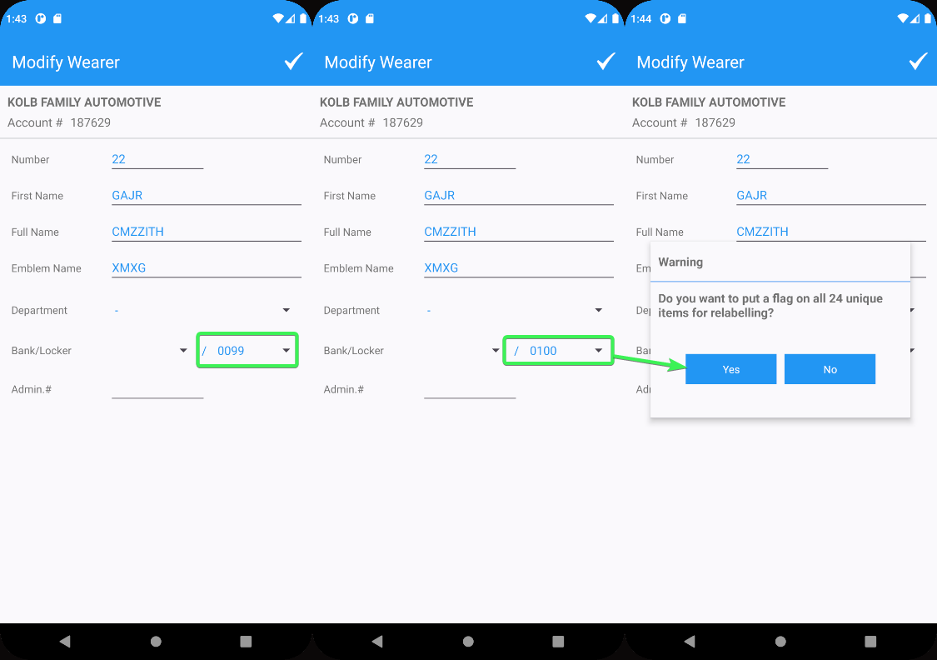
- Settle the route and upload the data
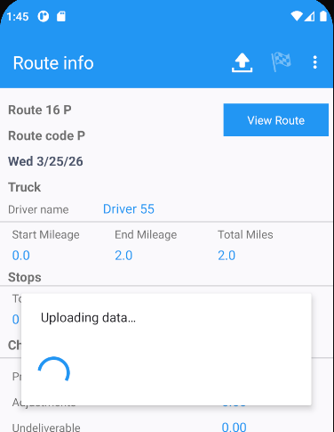
- WebX: Complete Start my day
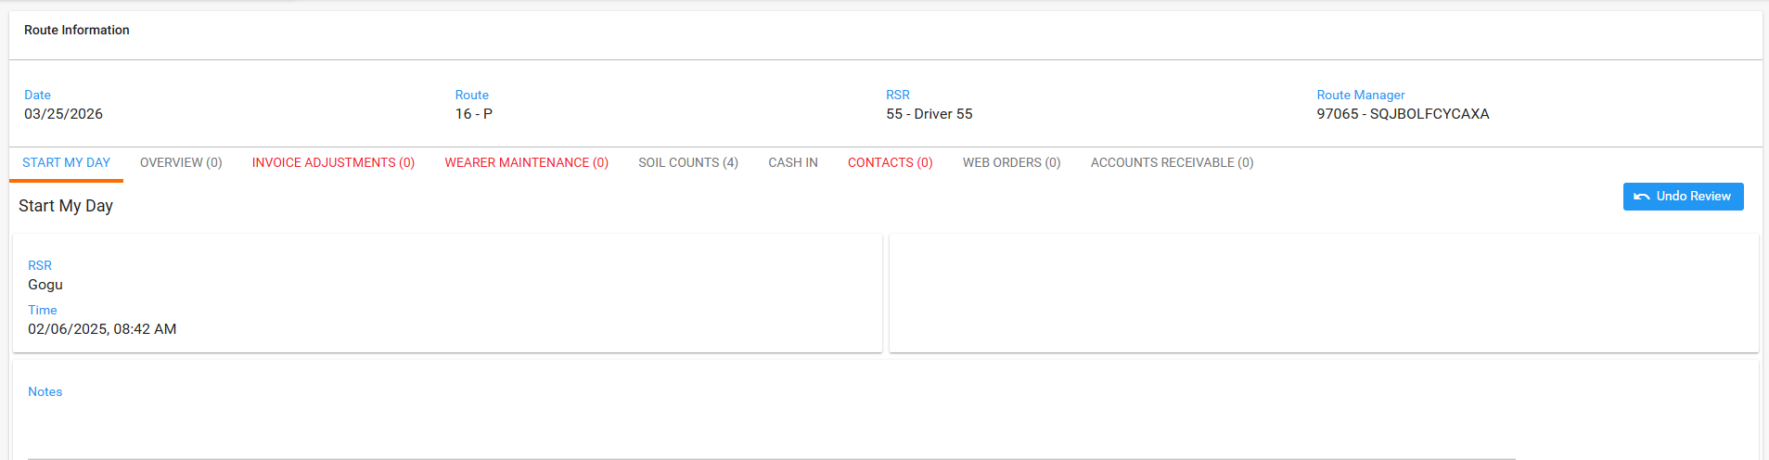
- Wearer Maintenance tab: See that the Flag Unique Items is approved
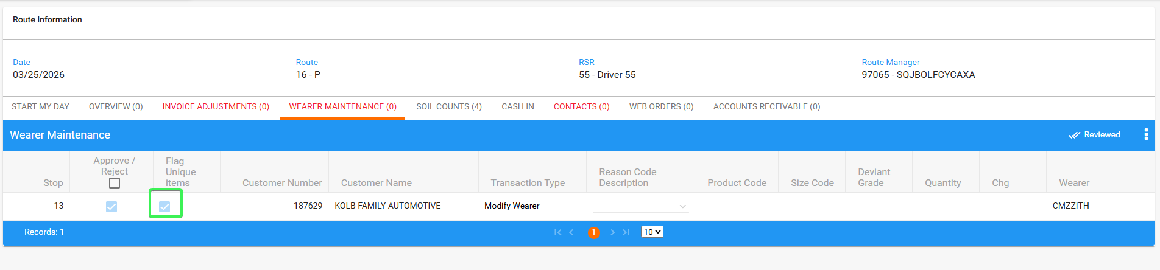
- Review all tabs and settle the route
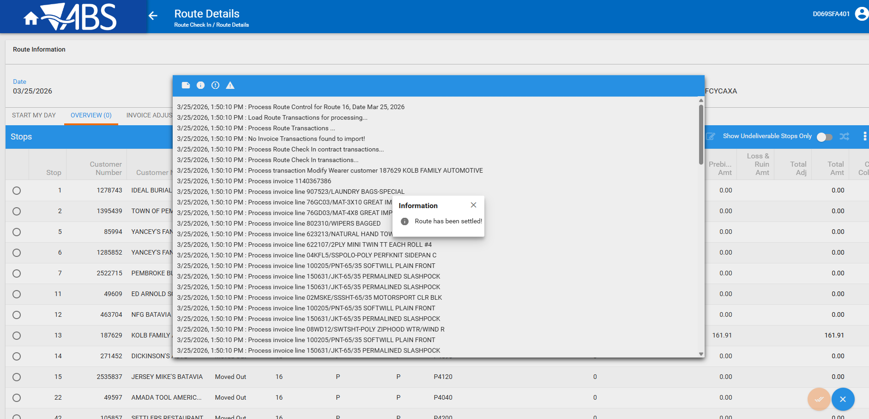
- Check that there are no errors in the log regarding the Modify wearer transaction
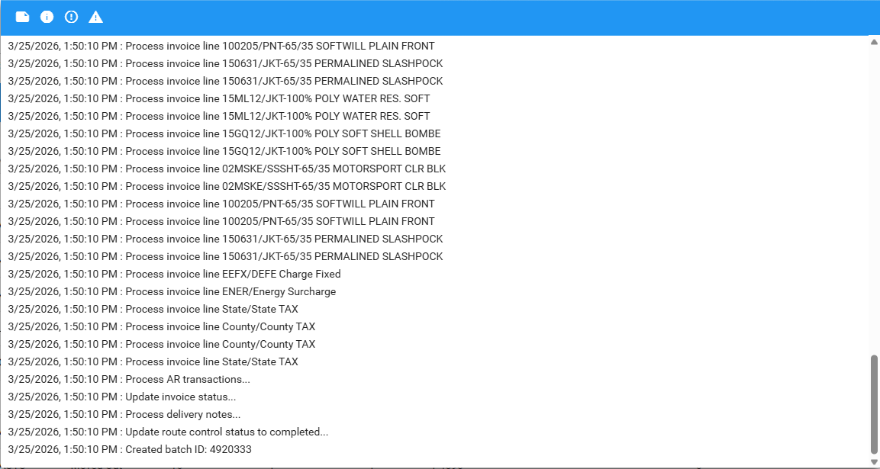
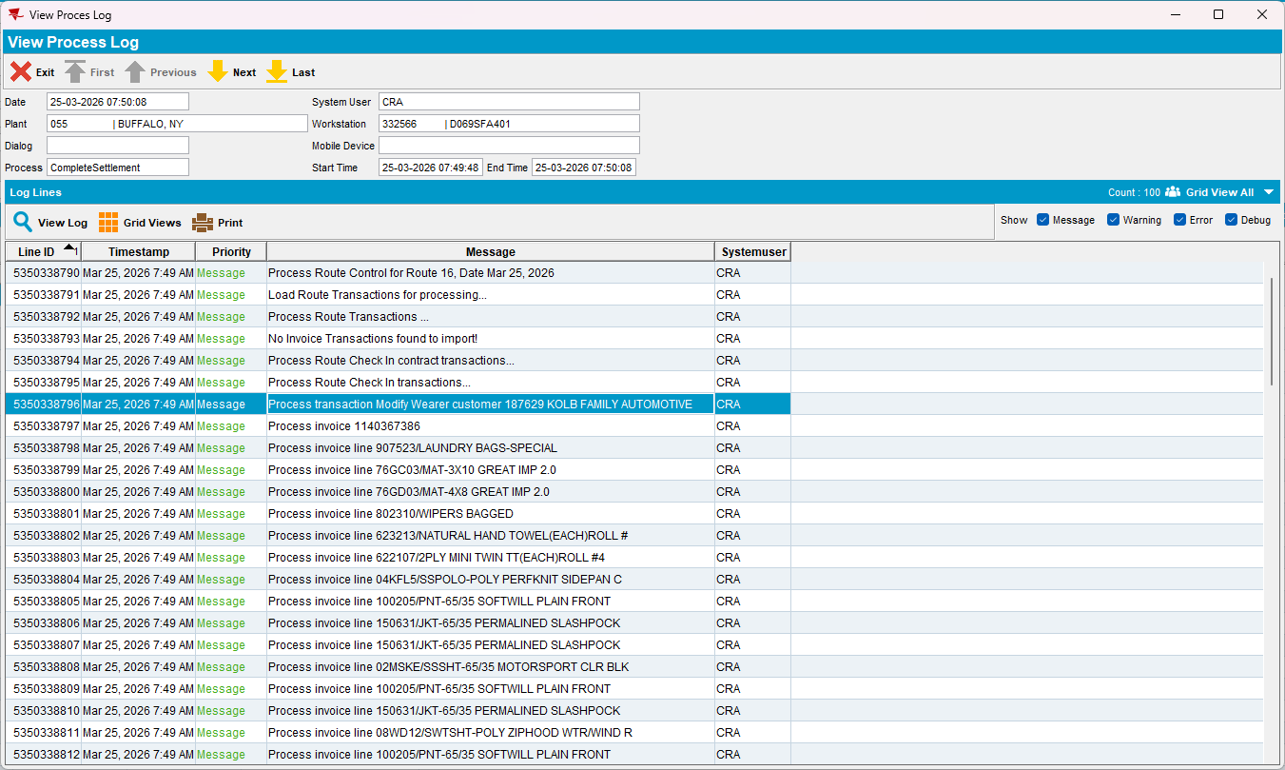
- Wearer DLG: Check that the locker has changed to the one set on RA
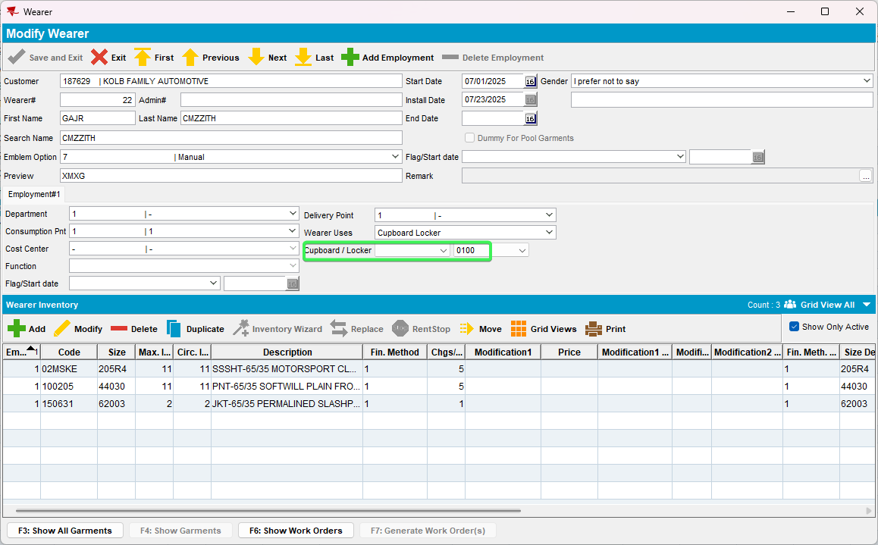
- Check that Retag Flag has been added to your UIDs
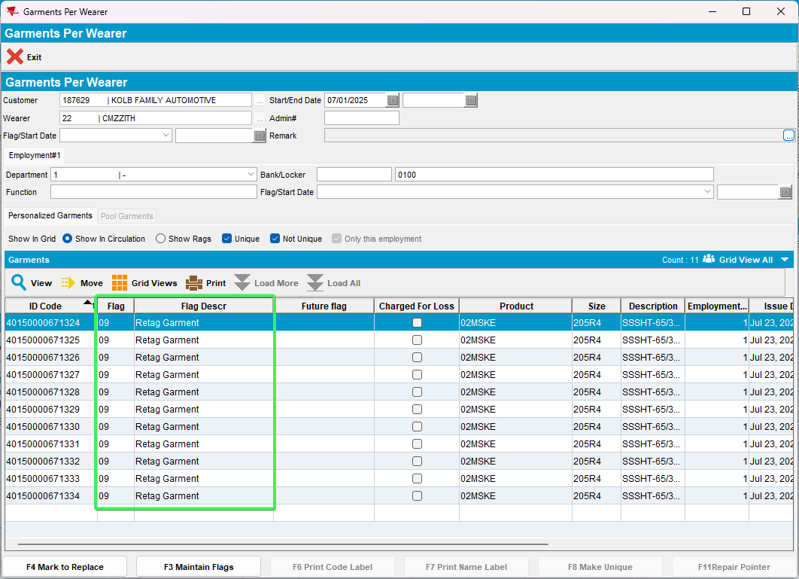
Tested OK

Test Case 5 – Web X Test that the Flag Unique items column is read only when start my day is not completed
Hash: 9.07.00.UNF21 hash: b612015a789f + RouteAssistant_v12.42.INTERNAL_TEST_ONLY.a75c1112d
Steps:
- WebX: Have a route which has been on RA and has Wearers with UIDs WI which lockers have been changed
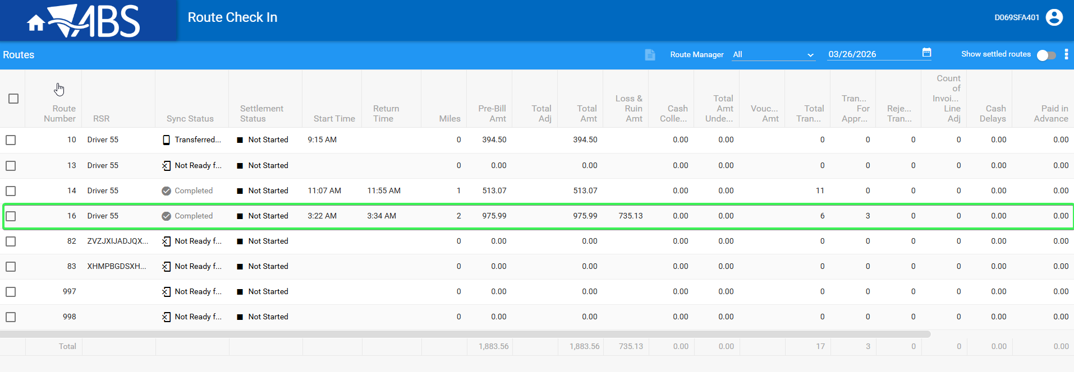
- Don’t complete start my day
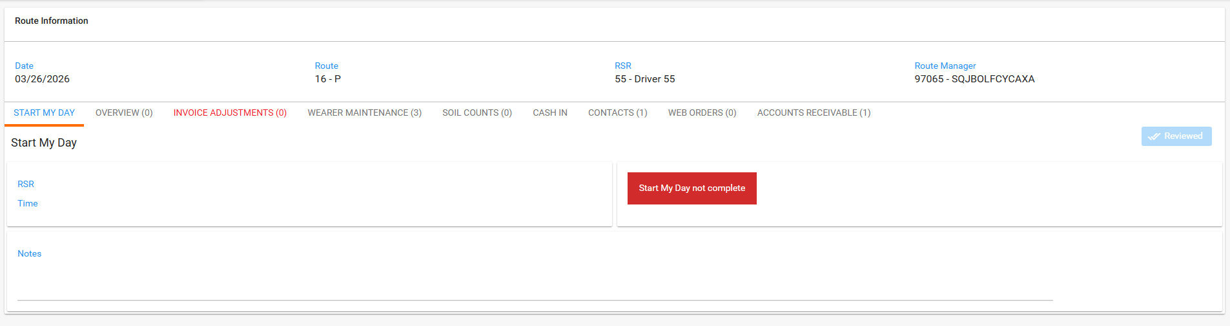
- Change the approval status to pending of rt.approvalstatus=0
select rt.approvalstatus, rt.routetransactiontype_id, RT.Stringvalue9, rt.*
from ROUTETRANSACTION RT
where RT.ROUTECONTROL_ID = 2126992
and RT.ROUTETRANSACTIONTYPE_ID between 300 and 350 for update;
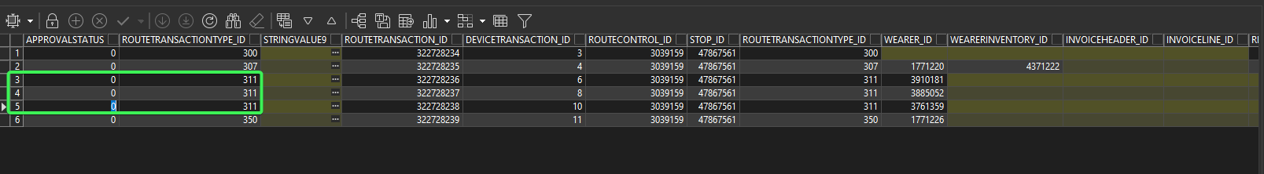
- Wearer Maintenance: Check that Flag Unique items column is read only
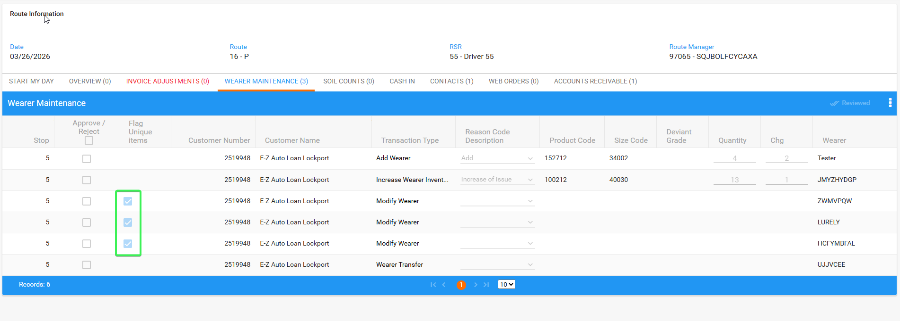
Tested OK

Test Case 6 – Web X Test that when all new columns are visible they are also present in all exports
Hash: 9.07.00.UNF21 hash: b612015a789f + RouteAssistant_v12.42.INTERNAL_TEST_ONLY.a75c1112d
Steps:
- WebX: Have a route which has been on RA and has Wearers with UIDs WI which lockers have been changed
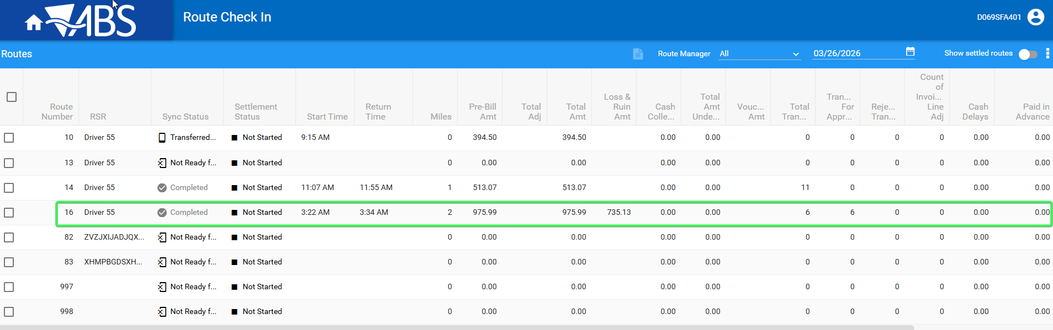
- WebX: Complete start my day
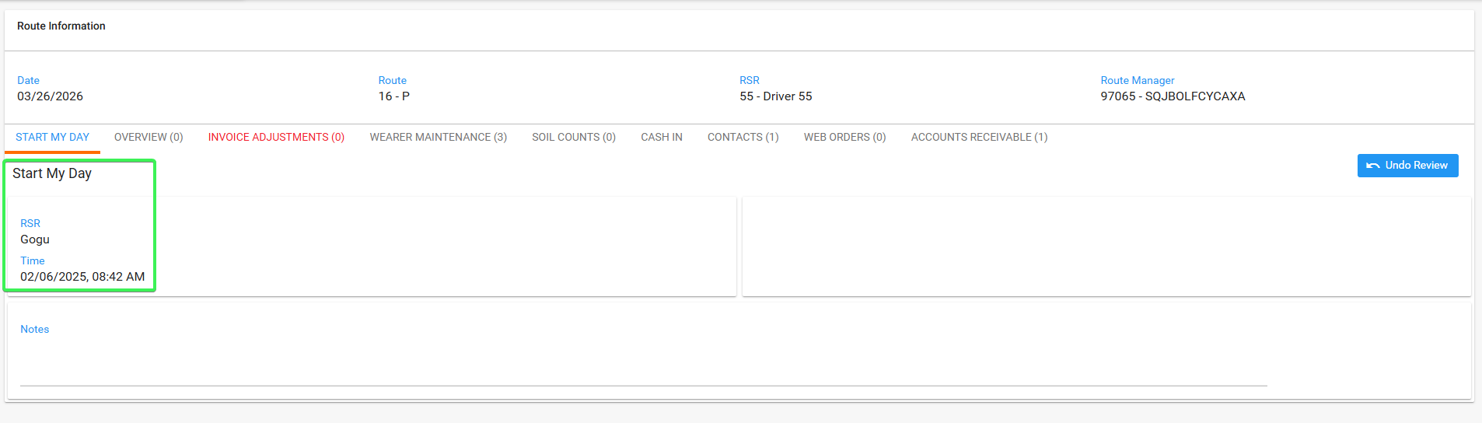
- PLSQL: Check that the transaction types are of 311(Modify wearer)
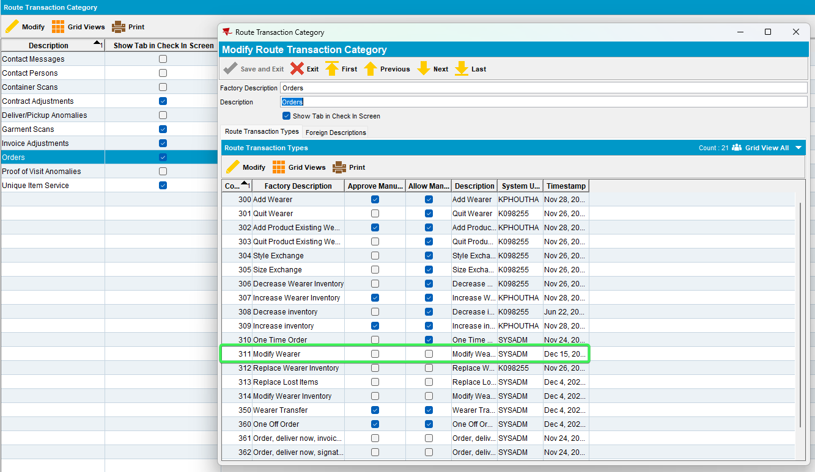
- Wearer Maintenance: Check that the Quantity, Changes, Flag Unique Items, New Locker and New Bank columns are present when the transaction type is of 311 – Modify Wearer
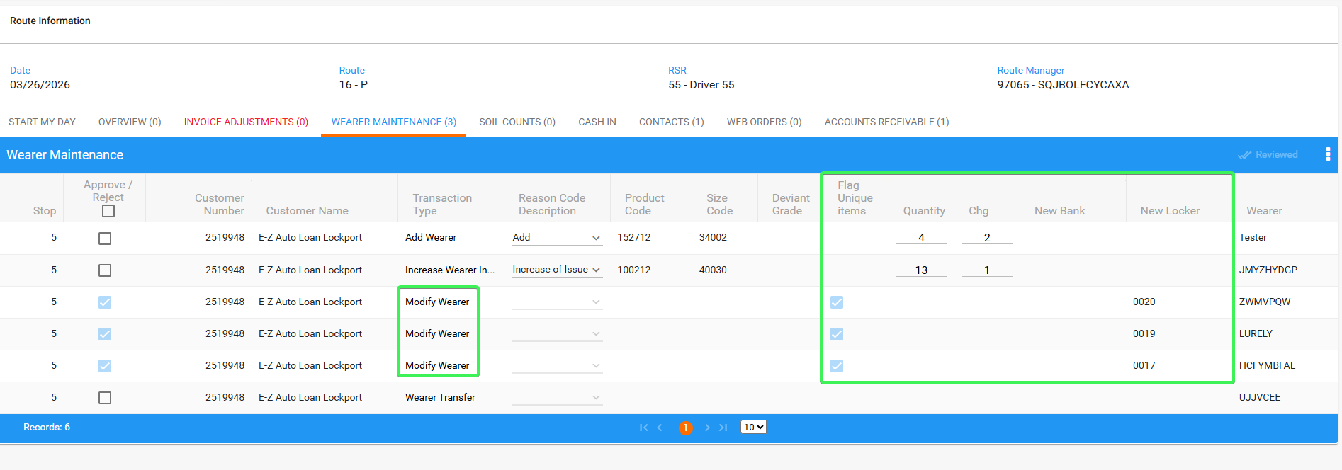
Tested OK

Test Case 7 – Test Web X modification / development
Hash: 9.07.00.UNF21 hash: b612015a789f + RouteAssistant_v12.42.INTERNAL_TEST_ONLY.a75c1112d
Steps:
- System Settings DLG: have RAALLOWFLAGONWEARERMODIFY = 1
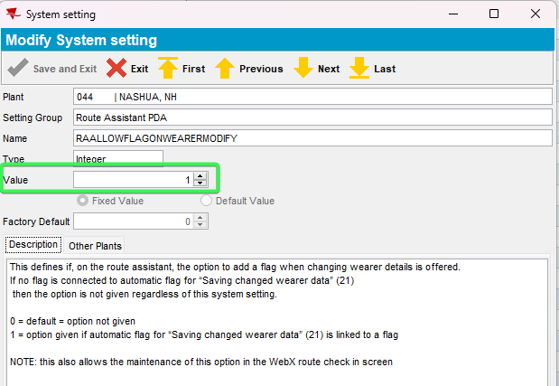
- Create a route with a customer that has wearers with UIDs on it
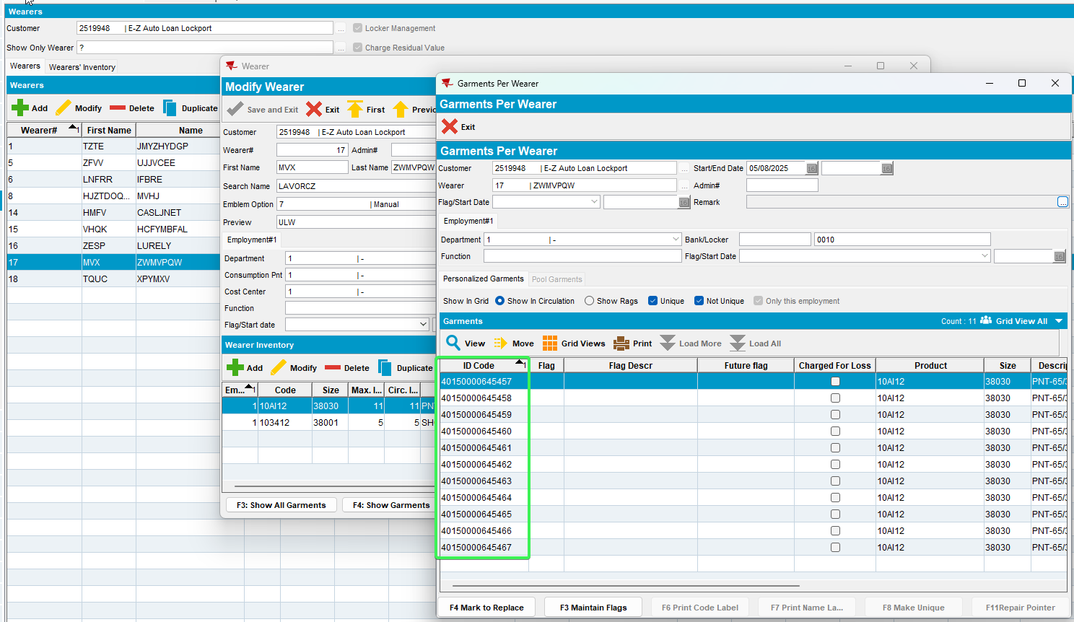
- RSC: Generate Invoices and send the route to RA
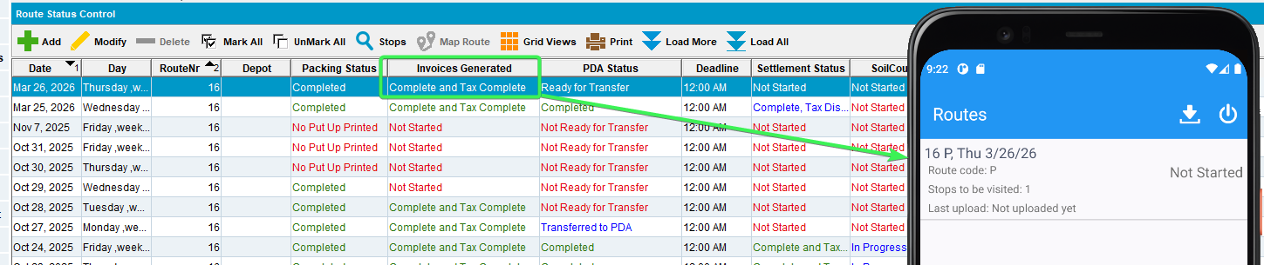
- RA: Wearers Tab > Add a new wearer with a WI
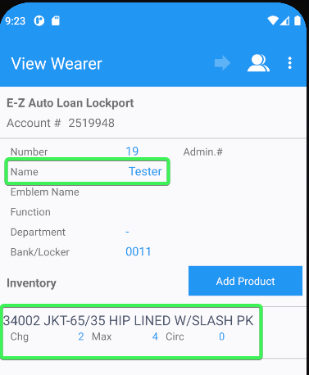
- Increase a wearers inventory
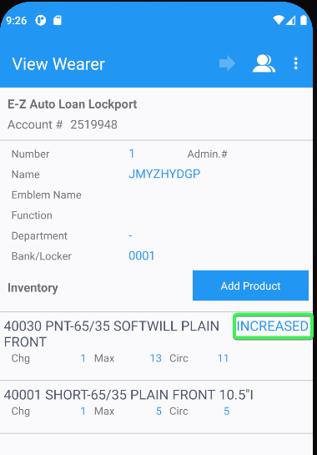
- Change a wearer’s locker
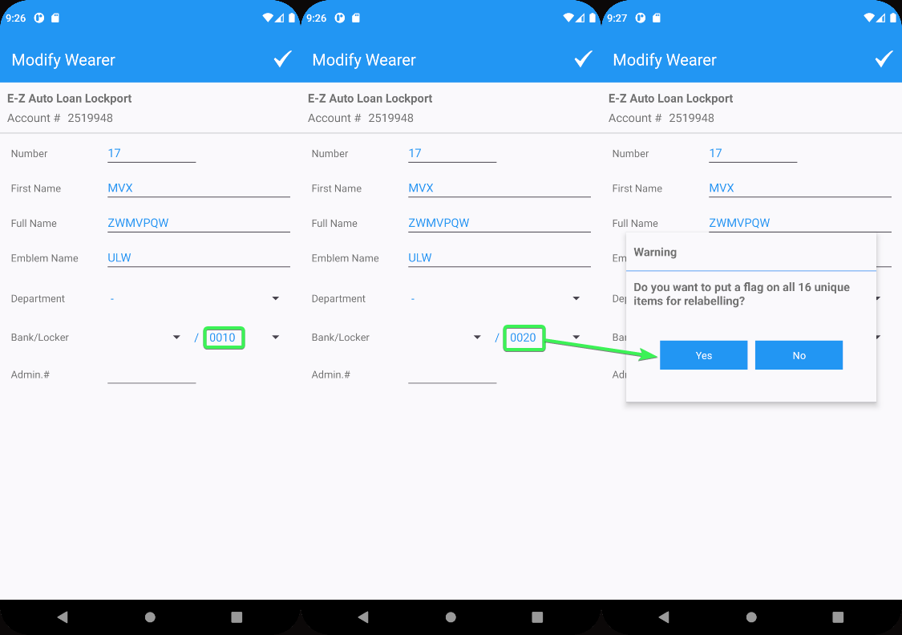
- Perform a Wearer transfer
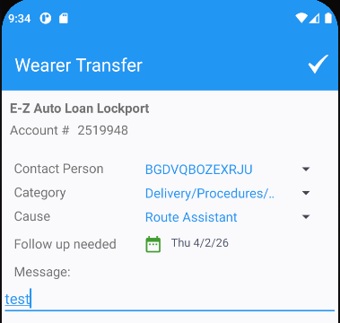
- Settle and Upload the data
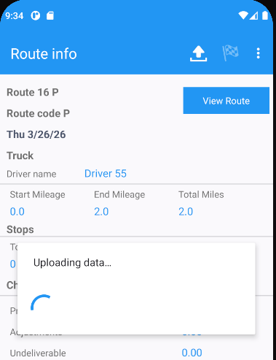
- WebX: Complete start my day
- Wearer Maintenance tab: Check that the column Flag Unique items is only populated for transactions type 311 – Modify wearer
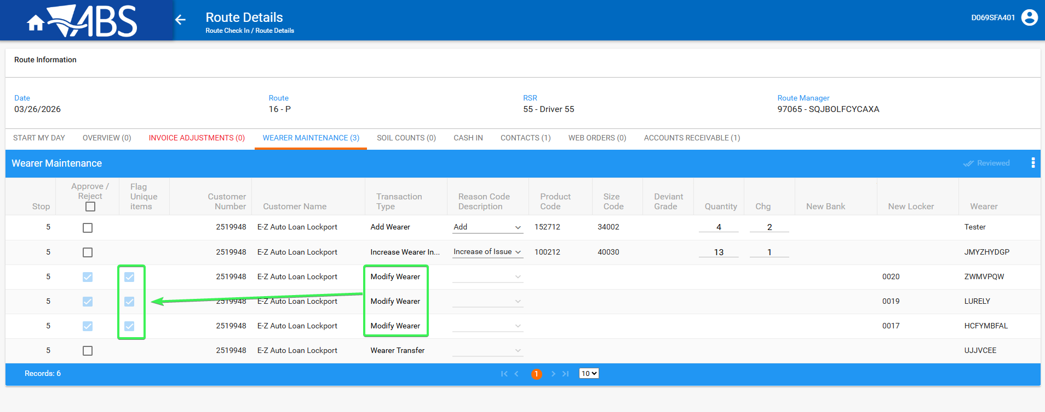
- See that the Flag Unique items column is blank when having other types of transactions except 311 modify wearer
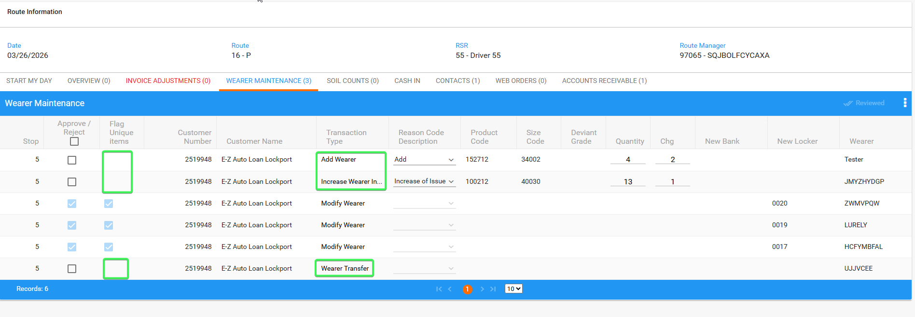
- Check that New Locker field is populated with RT.StringValue10 if the value is not equal to the current value of the locker
Current locker value:
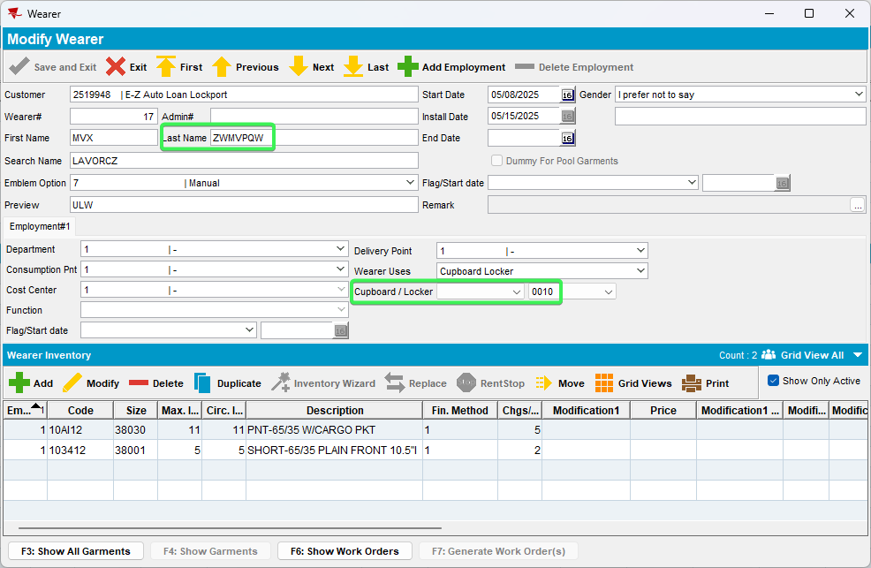
Use this select to see the value of RT.StringValue10
SELECT rt.approvalstatus,
rt.routetransactiontype_id,
rt.stringvalue10,
rt.*
FROM routetransaction rt
WHERE rt.routecontrol_id =
(SELECT rc.routecontrol_id
FROM routecontrol rc
JOIN route r
ON r.route_id = rc.route_id
JOIN plant p
ON p.plant_id = r.plant_id
WHERE rc.drivingdate = TO_DATE('26/03/2026', 'dd/mm/yyyy')
AND r.routenumber = 16
AND p.code = '055')
AND rt.routetransactiontype_id BETWEEN 300 AND 350;
Value in WebX
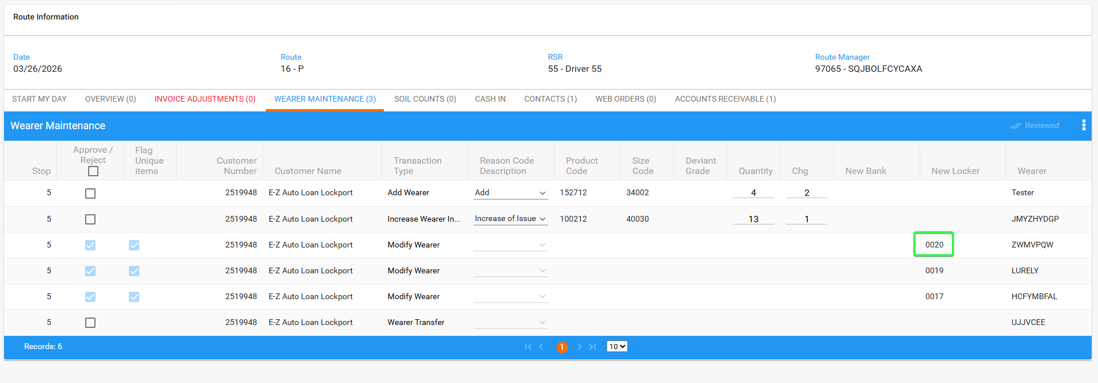

- Check that Quantity and Changes fields are blank and never editable for transaction type 311 Modify Wearer
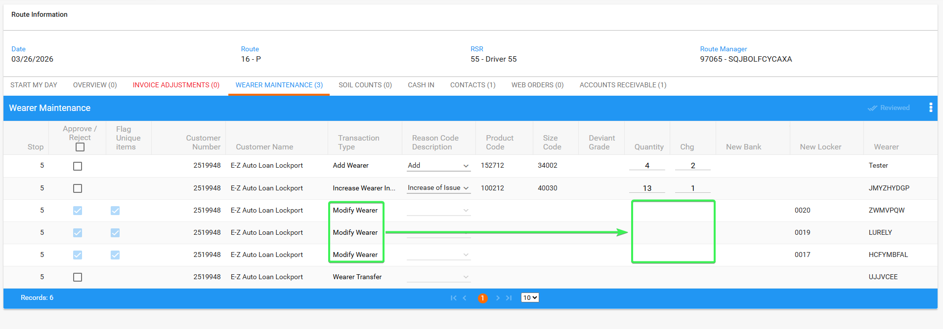
- Check that Quantity and Changes fields are blank and never editable for transaction type 315 Wearer Transfer
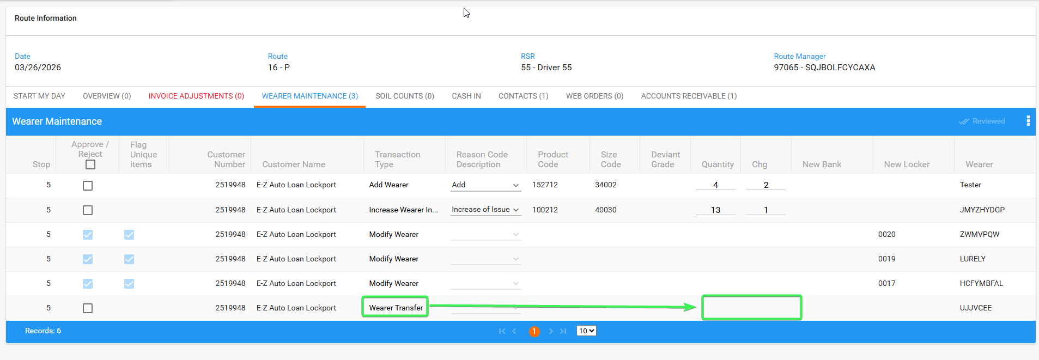
Tested OK

