ABSN-10805 Refresh problem when enforcing compliancy for emblem templates or wearer functions
Environment | Prerequisites
Version:9.07.00  DBServerName=abs-SRV20.internal.abslbs.com  DBSID=CUST24  DBUser=UNFDEV  Environment=Test | - Module:  - System setting

Contents
ABSN-10805 Refresh problem when enforcing compliancy for emblem templates or wearer functions 1
Test after fix 1
Test Case 1 – Enforce compliancy for emblem templates and wearer functions – Tested OK 1

Test after fix

Test Case 1 – Enforce compliancy for emblem templates and wearer functions – Tested OK
Expected behavior: The text column needs to be cleared for all customers enforced during the refresh after enforcing
Hash: cee321d
- Go to Contract dlg and load a contract
- Press Modify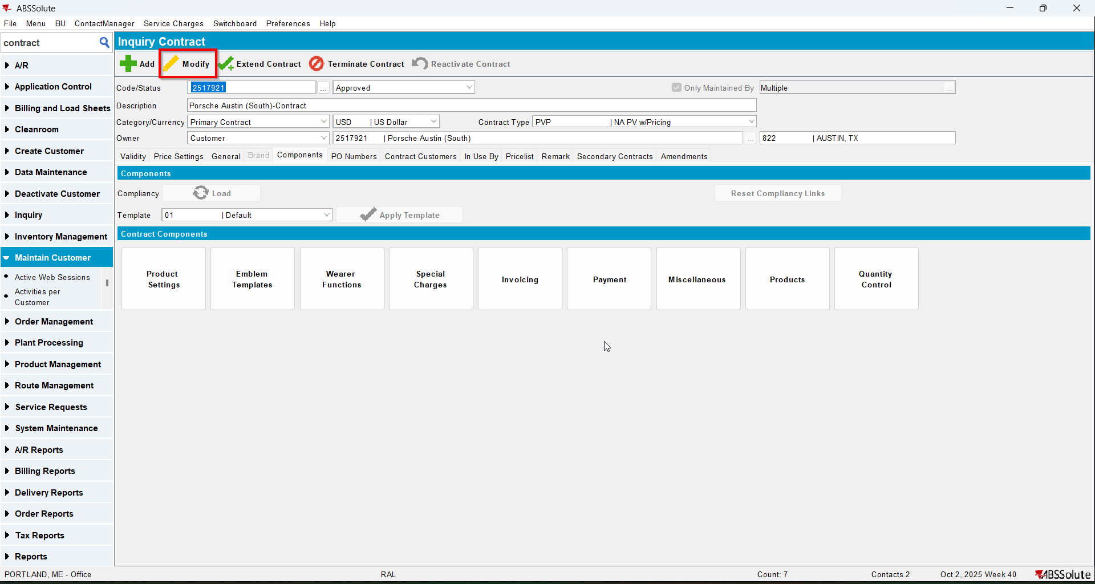
- Load compliancy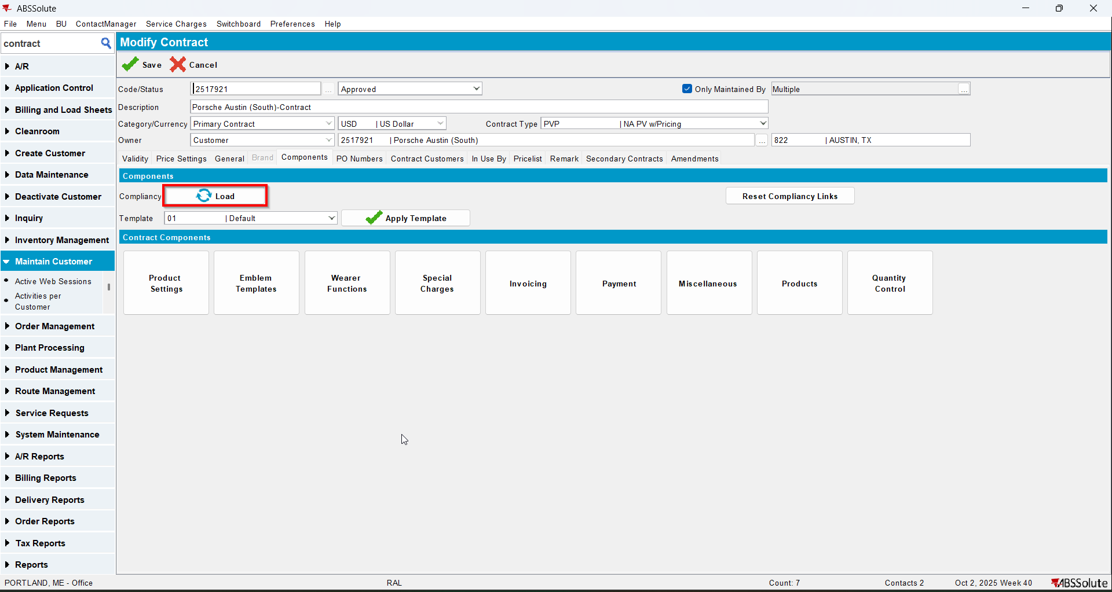
- Go to Emblem Templates and Modify an emblem template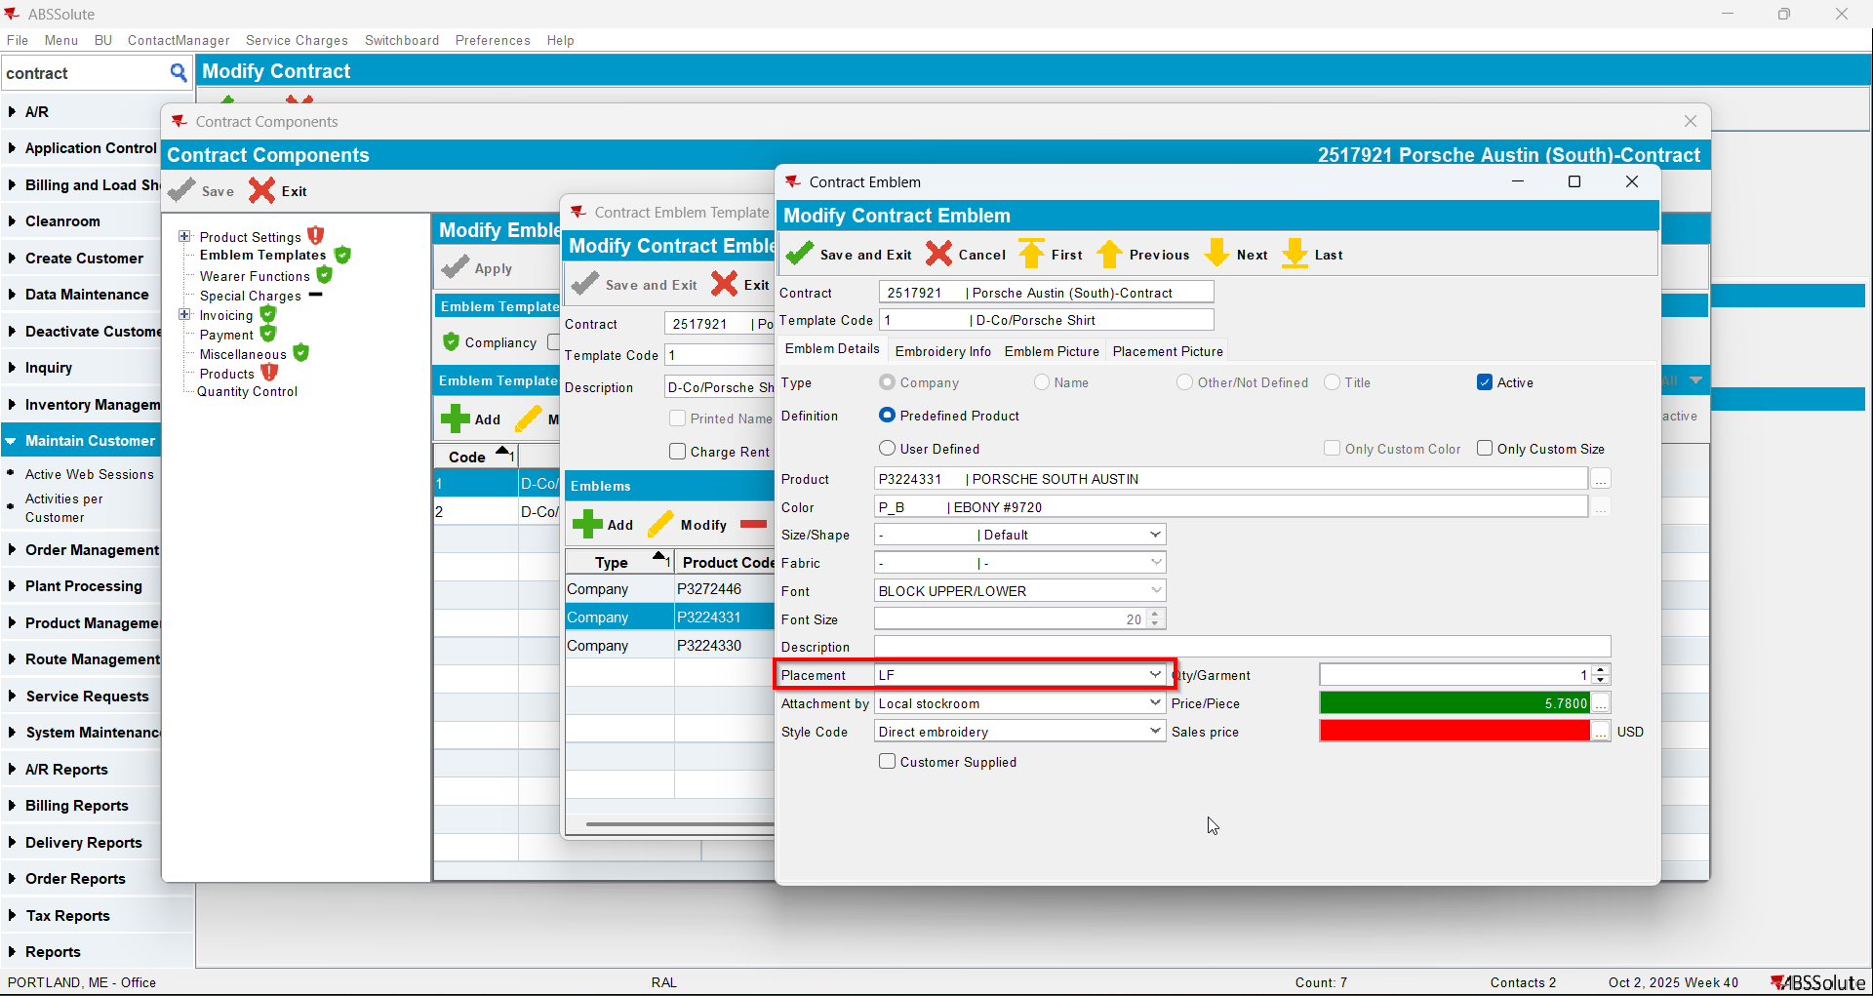
- Go to Wearer functions and modify a wearer function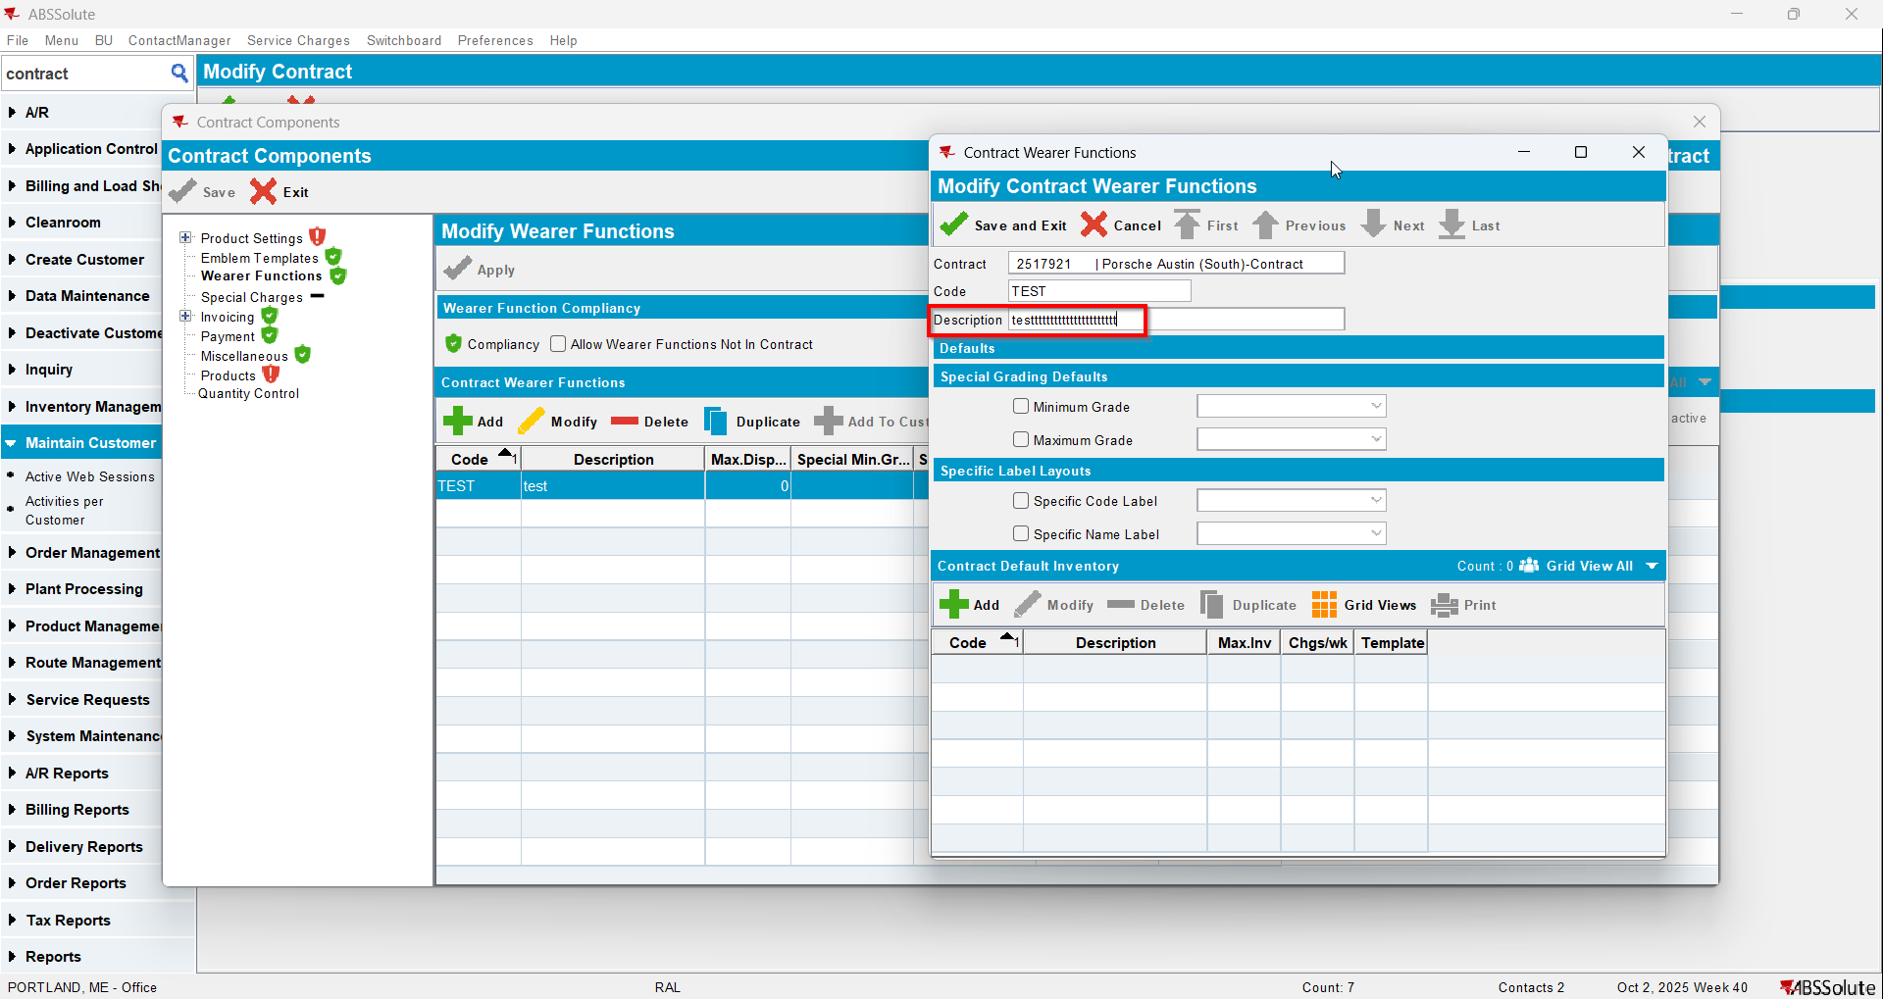
- Save and load the contract again then press Modify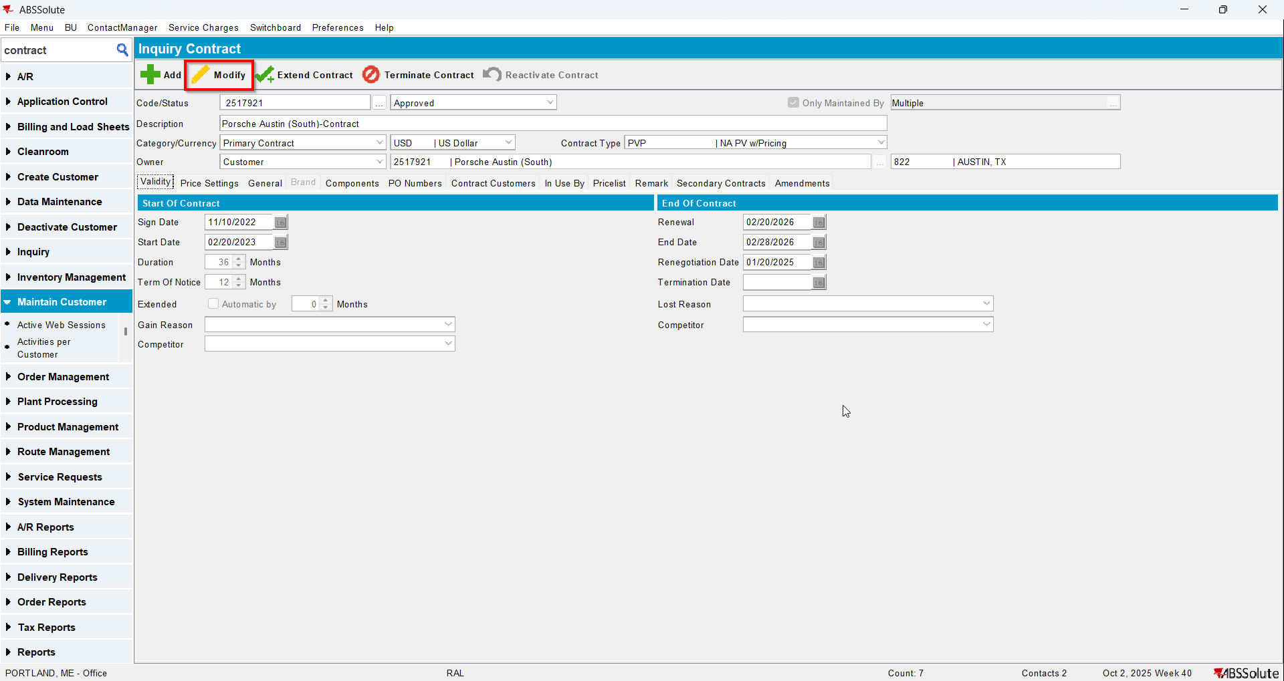
- Load compliancy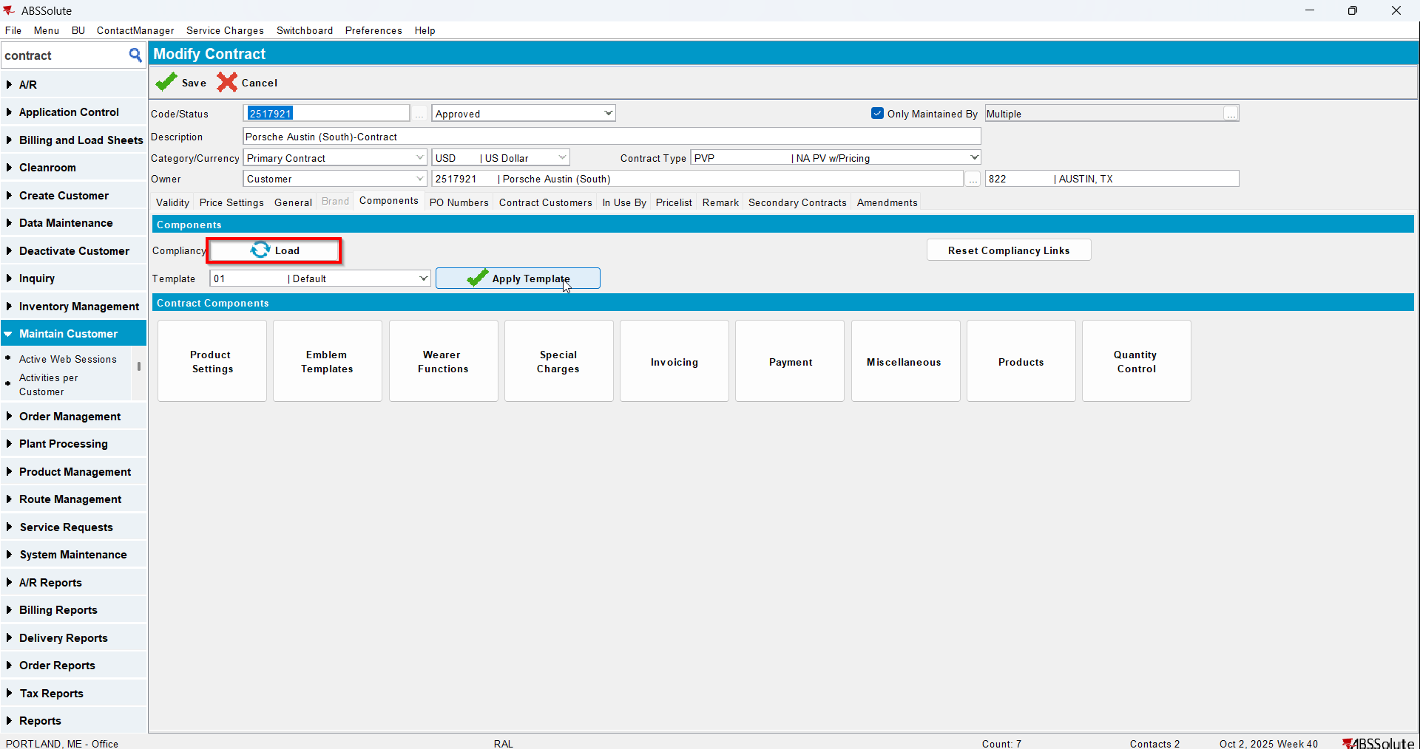
- Go to Emblem Templates to compliancy and Enforce All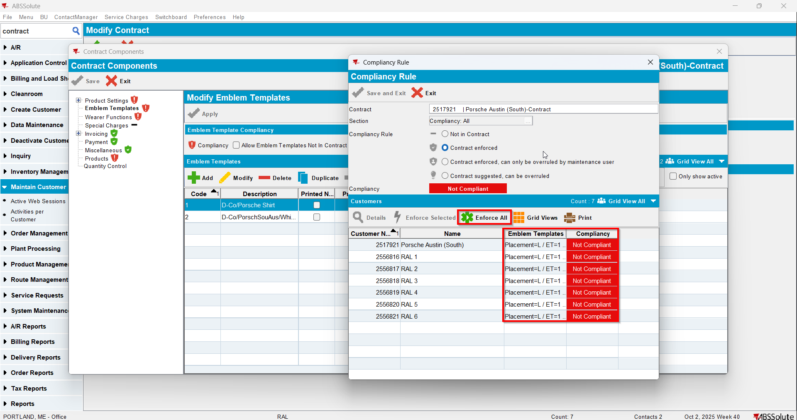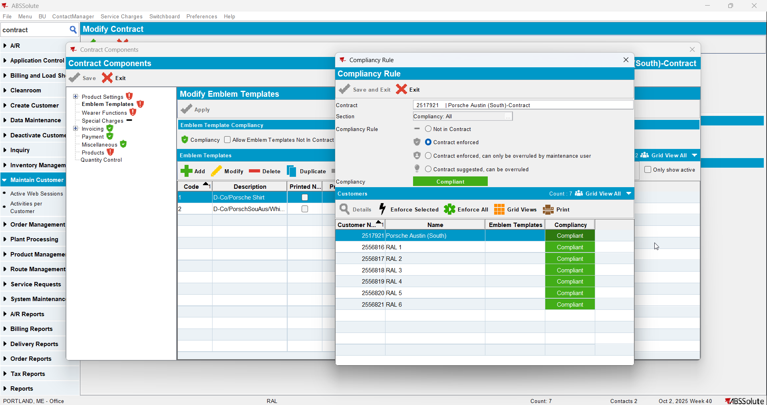
- Go to Wearer Functions to compliancy and Enforce All