ABSN-10802 - Improve message when Invoice Generation is already started
Environment | Prerequisites
Version: 9.07.00.UNF21  DBServerName= abs-srv20.internal.abslbs.com  DBSID=CUST24  DBUser=UNFDEV  Environment=Test | - Module:  - System setting

Contents
Reproducing before fix 1
Data preparation 1
Steps to reproduce 1
Current Behavior 3
Expected behavior 3
Retest after fix 3

Reproducing before fix

Steps to reproduce
- Add a new route with data to be invoiced in RSC
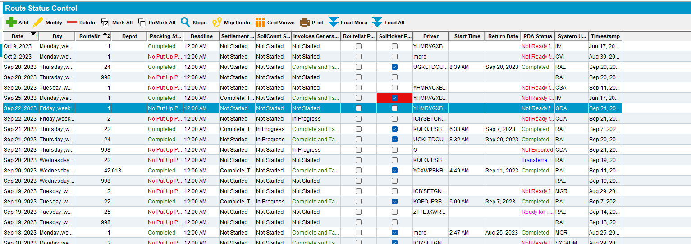
- Open another client in RDWEB
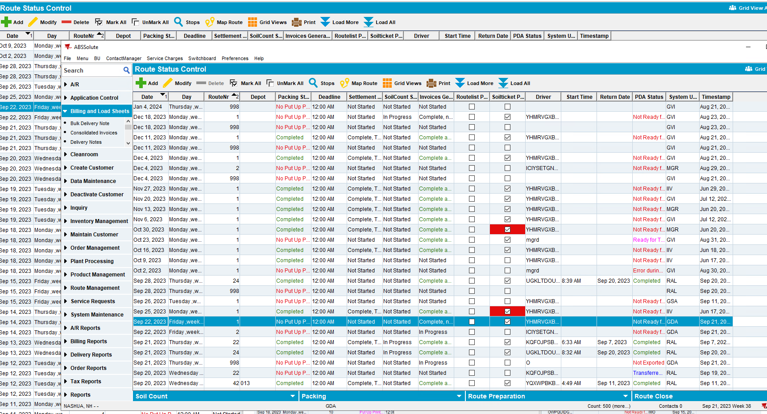
- Press generate invoices for the route from the initial client. Press immediately the same button for the same route from the second client ( while the status of the invoices is not started)
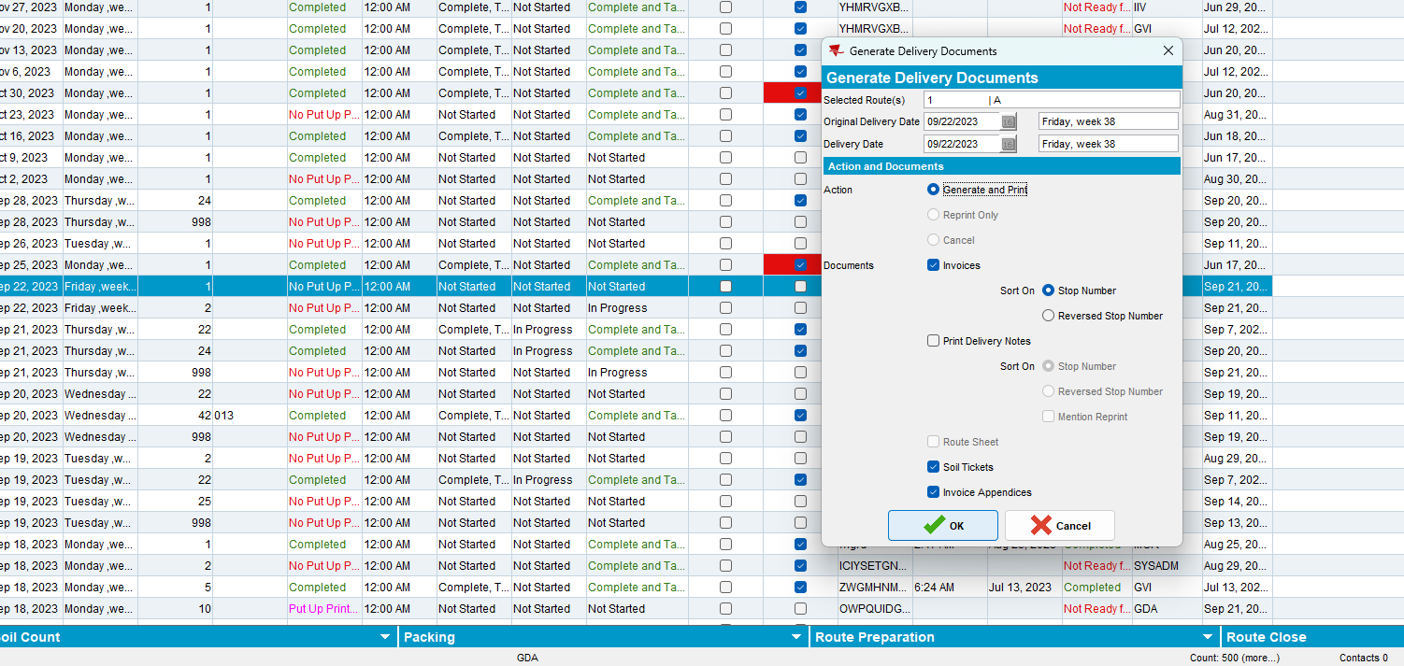
- Check if the second process is started
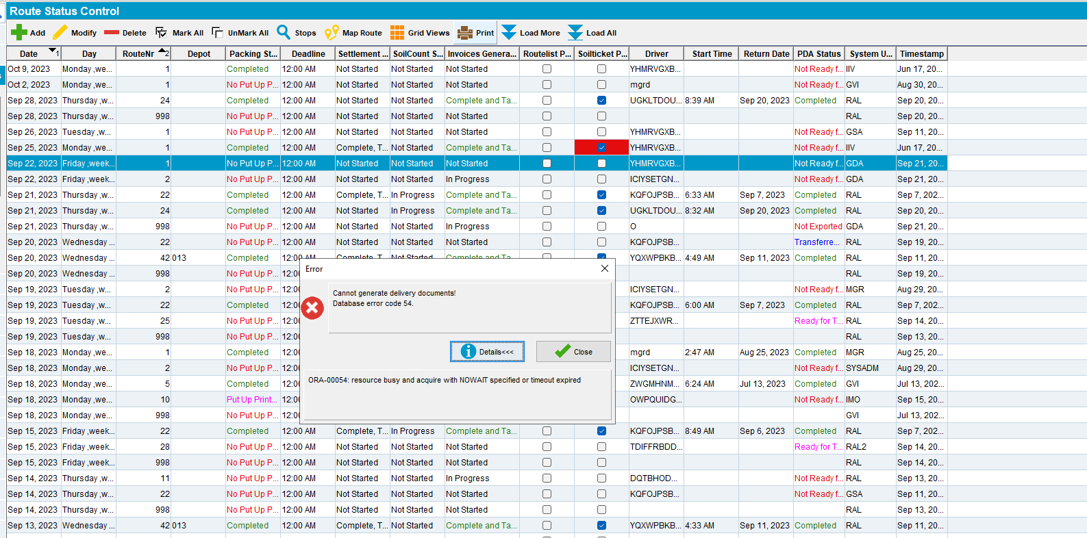
I noticed that the process is stopped and the message regarding nowait appears.
REPRODUCED OK.

Current Behavior
The following message appears and it’s not clear
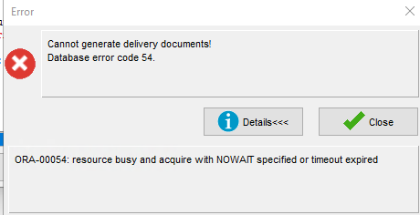

Expected behavior
A new message more specific should appear on the screen
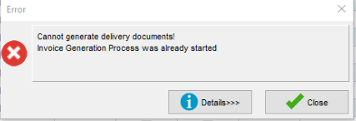

Retest after fix
Hash: bff5c103ad26
- Add a new route with data to be invoiced in RSC
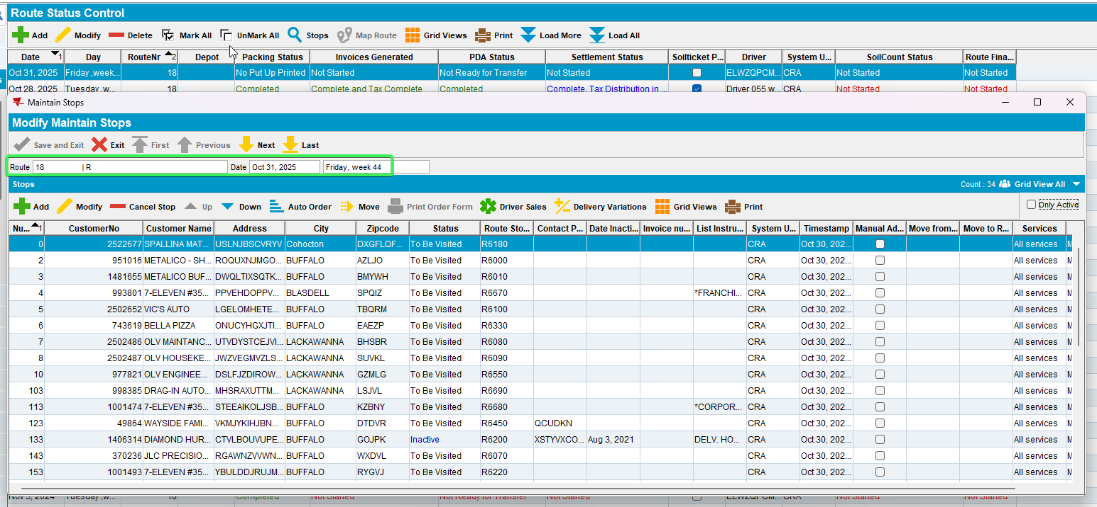
- Open another client in RDWEB
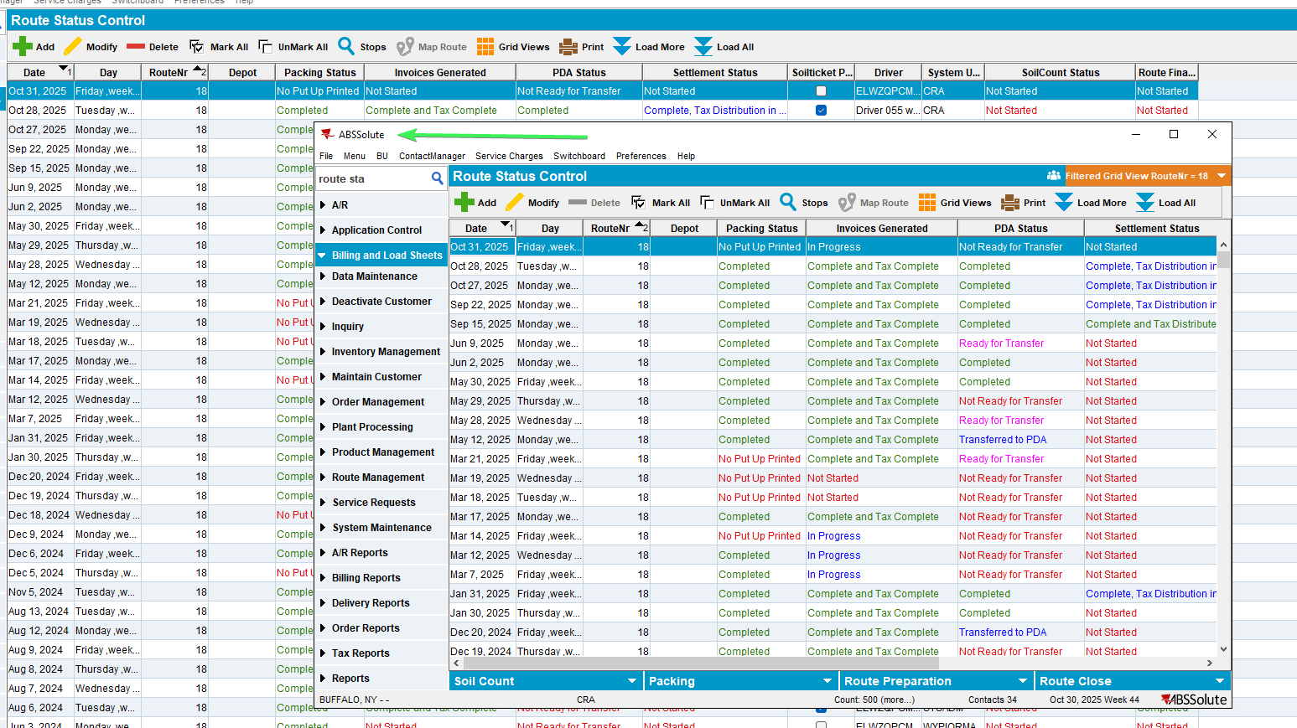
- Press generate invoices for the route from the second client (RDWEB). Press immediately the same button for the same route from the initial client ( while the status of the invoices is not started)
- Check if the second process is stopped and the correct message appears on the screen
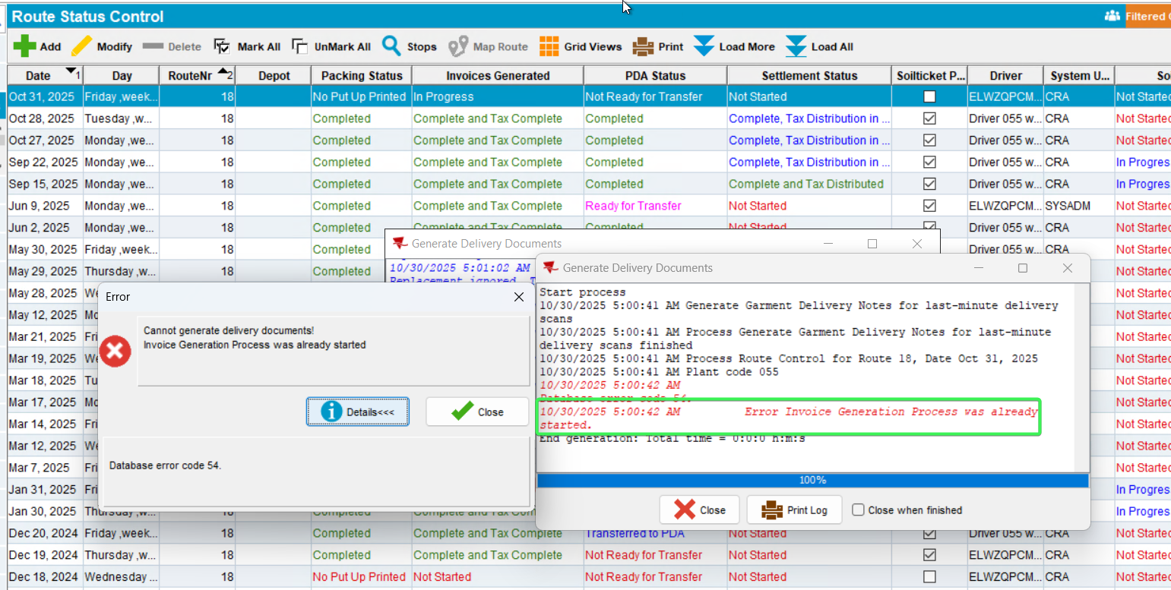
- View Process log and see that the error is clear
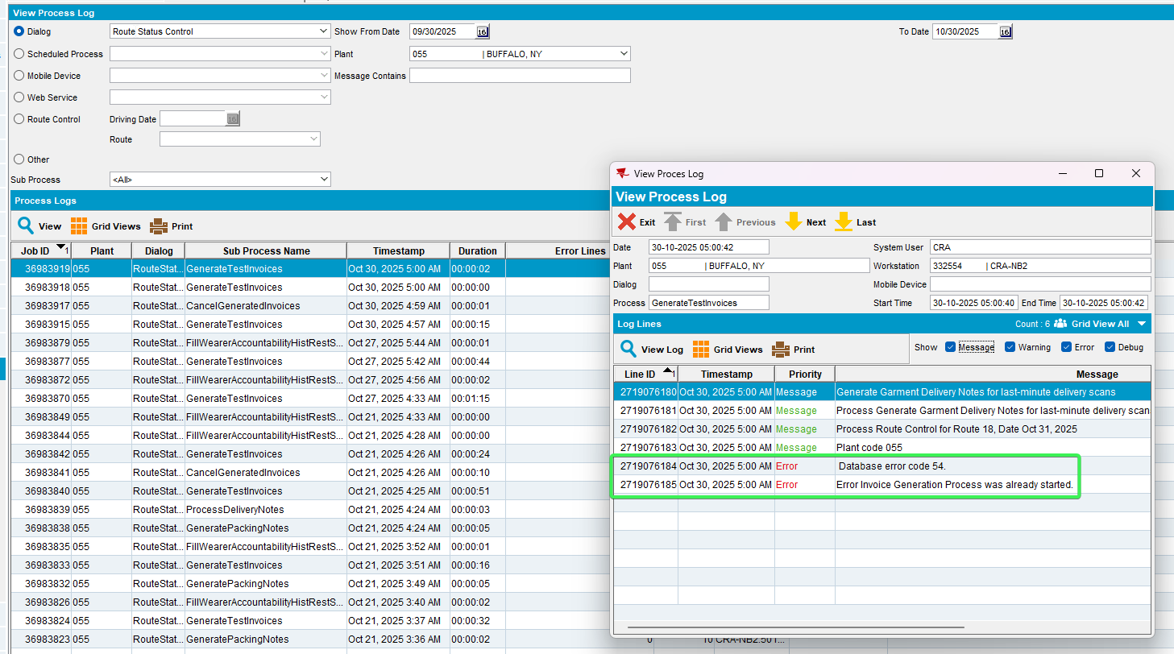
Tested OK

