ABSN-10801 - Delivery Variations - Generate Packing Notes pop-up add a print checkbox which defaults to yes or no depending on put-up docs status
Environment | Prerequisites
Version: 9.07.00.UNF21  DBServerName= abs-srv20.internal.abslbs.com  DBSID=CUST24  DBUser=UNFDEV  Environment=Test | - Module:  - System setting

Contents
Retest after fix 1
Test Case 1 – Check that button is disabled and unchecked when Workstation.PutUpDocuments=1 1
Test Case 2 – Check that button is enabled and active when Workstation.PutUpDocuments= 0 or 2 6
Test Case 3 – Check that button is Visible and Unchecked if this customer does not have a future route control 8
Test Case 4 – Check that button is Visible and Unchecked if this customer has a future route control but is Packing Status is NOT Complete 11
Test Case 5 – Check that button is Visible and Checked if this customer has a future route control and It’s Packing Status is Complete 13
Test Case 6 – Check that button is Visible if the put-up type of the product is “bulk” 16
Test Case 7 – Check that button is NOT Visible if the put-up type of the product is NOT “bulk” 18
Test Case 8 – Check that if BulkPackingStatus is complete and BULKPACKINGASSISTANT is in license show a waring 20
Test Case 9 – Check that if BulkPackingStatus is NOT complete and BULKPACKINGASSISTANT is in license DON’T show a waring 29
Test Case 10 – Check that if BulkPackingStatus is complete and BULKPACKINGASSISTANT is NOT in license the checkbox is still visible 34
Test Case 11 – Check that a Packing note can be printed from RSC 36
Test Case 12 – Check that a Packing note can be printed from Delivery Variations DLG for a product with Show put up QTY on: Packing note or Bundle tag 40
Test Case 13 – Make sure the Packing Note report can be printed form other places when having “Print Delivery Note for BulkPutUp Items” on and off 43

Retest after fix

Test Case 1 – Check that button is disabled and unchecked when Workstation.PutUpDocuments=1
Hash: 31bc8452ed1a
Expected Behavior: “Print Bulk Putup Packing Note” button should be disabled and unchecked
- WorkStation DLG: Open your Workstation and go to Miscellaneous tab
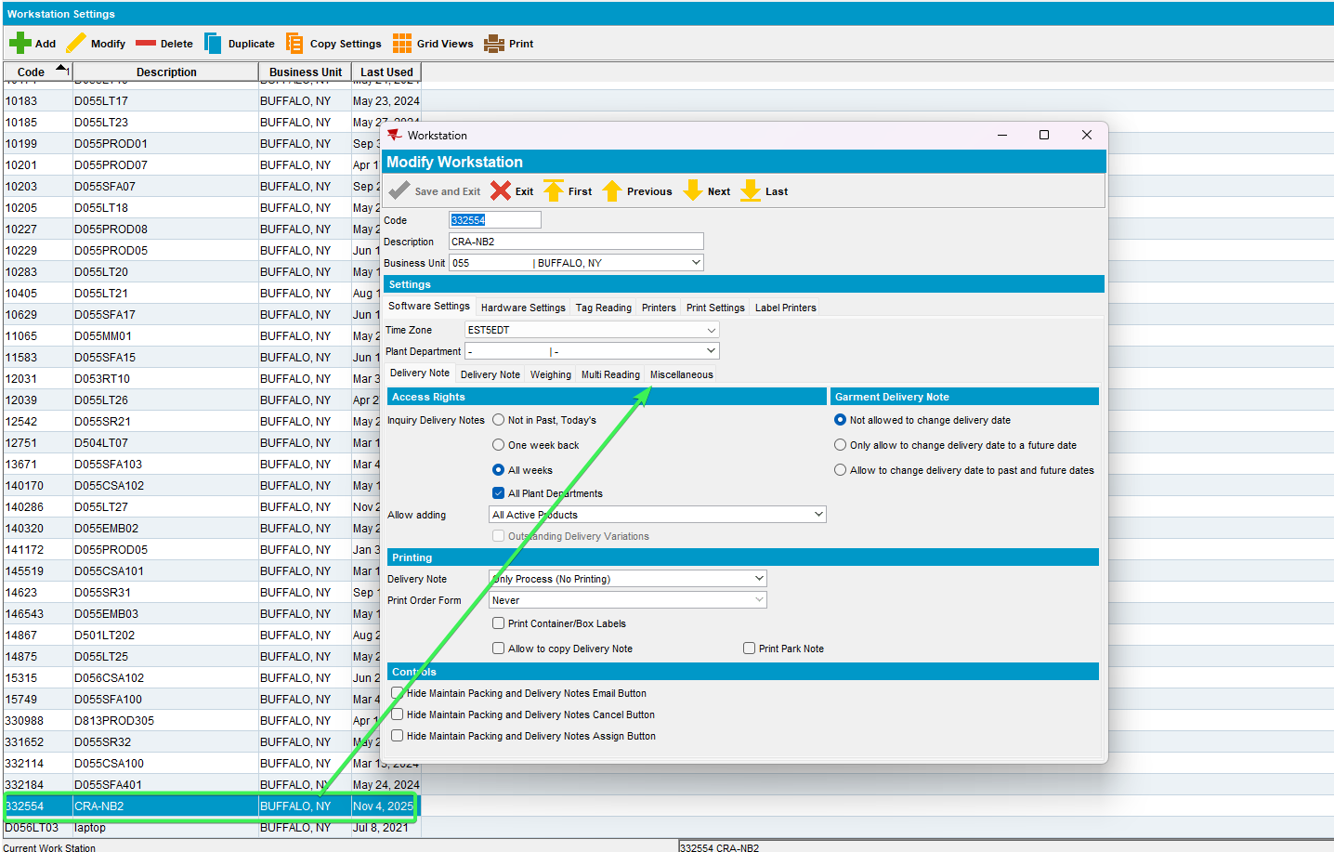
- Set Put UP documents radio button to “Generate put up documents, no print” Workstation.PutUpDocuments = 1
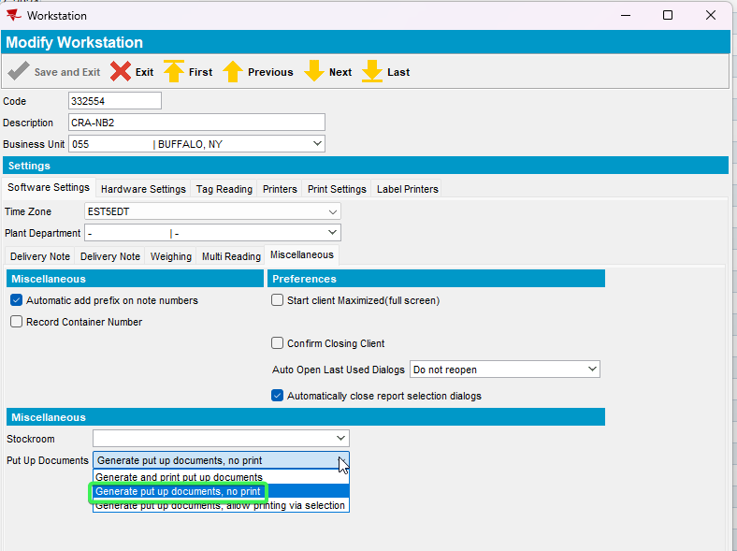
- Find a customer which has a product that packing notes are being generated for is put up type “bulk” using the following select:
select p.code, c.customernumber from customer c
join productlistpercustomer plpc on plpc.customer_id = c.customer_id
join product p on p.product_id = plpc.product_id
join businessunit bu on bu.businessunit_id = c.defaultbusinessunit_id
where bu.code = '055'
and plpc.dateinactive > sysdate
and ((PLPC.SpecificPutUpType = 0 and P.PutUpType = 2) OR PLPC.SpecificPutUpType = 2 );
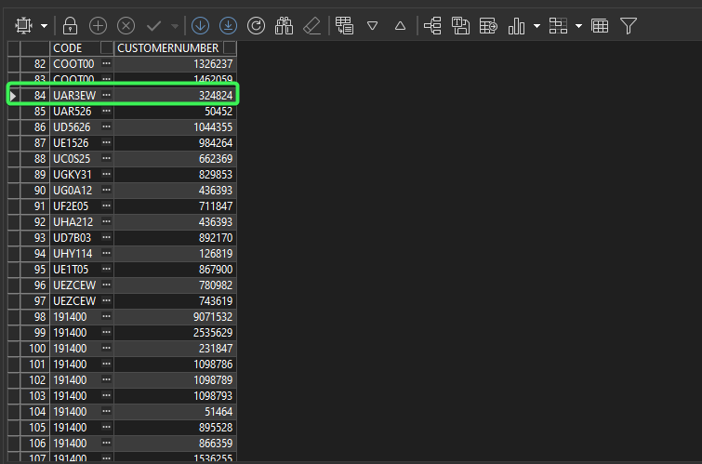
- Delivery Variations DLG: Input your customer and for your Product add a new delivery variation
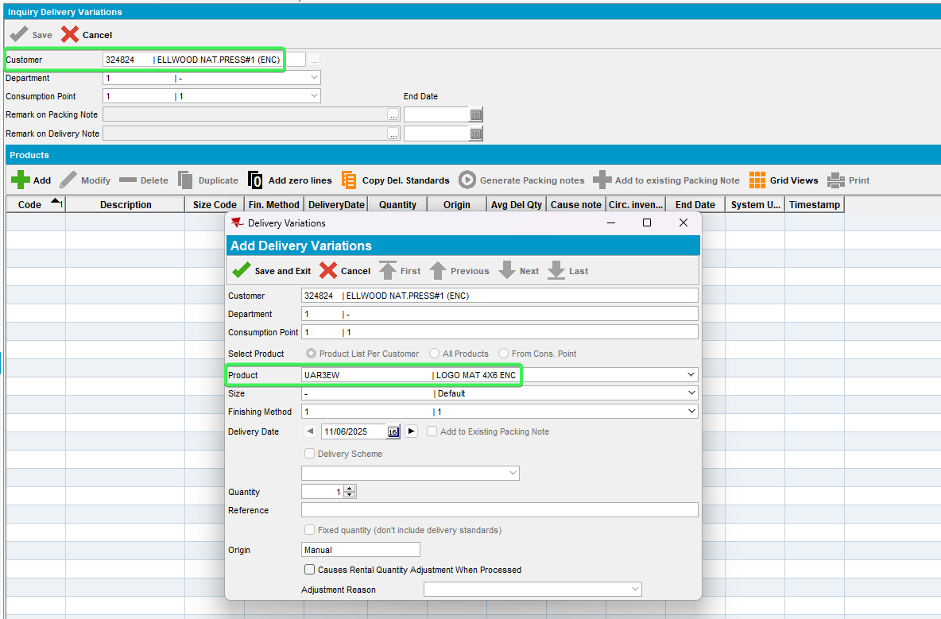
- Press the Generate Packing notes button
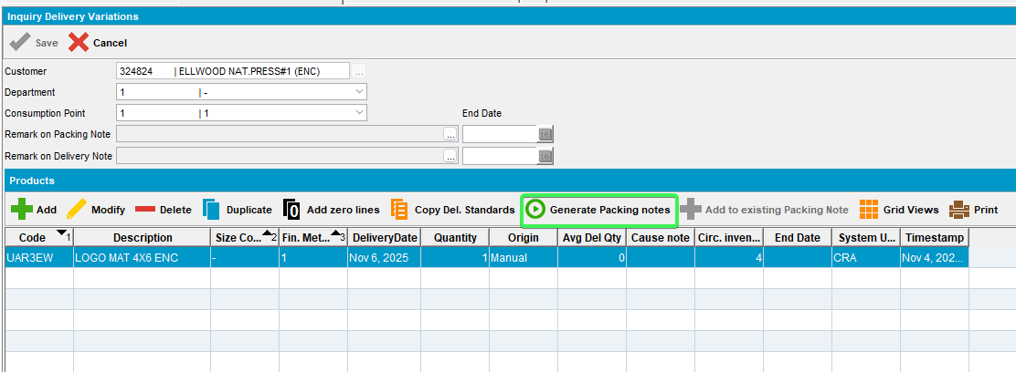
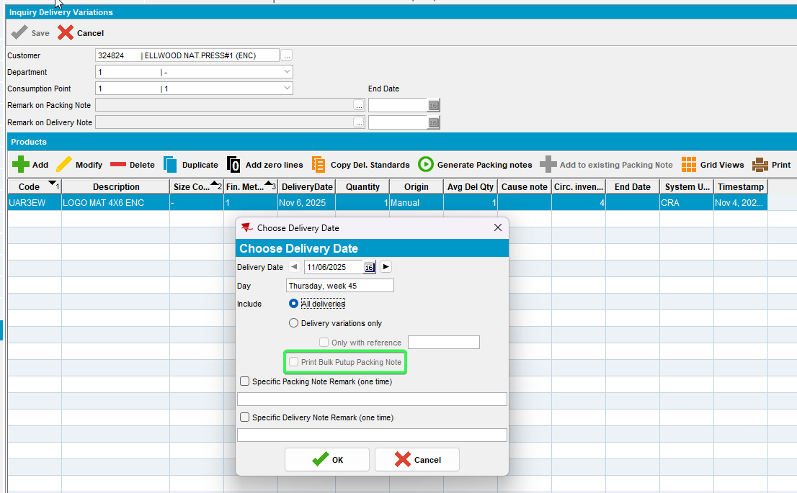
Tested OK

Test Case 2 – Check that button is enabled and active when Workstation.PutUpDocuments= 0 or 2
Hash: 31bc8452ed1a
Expected Behavior: “Print Bulk Putup Packing Note” button should be enabled

- WorkStation DLG: Open your Workstation and go to Miscellaneous tab
- Set Put UP documents radio button to “Generate put up documents, no print” Workstation.PutUpDocuments = 0 or 2
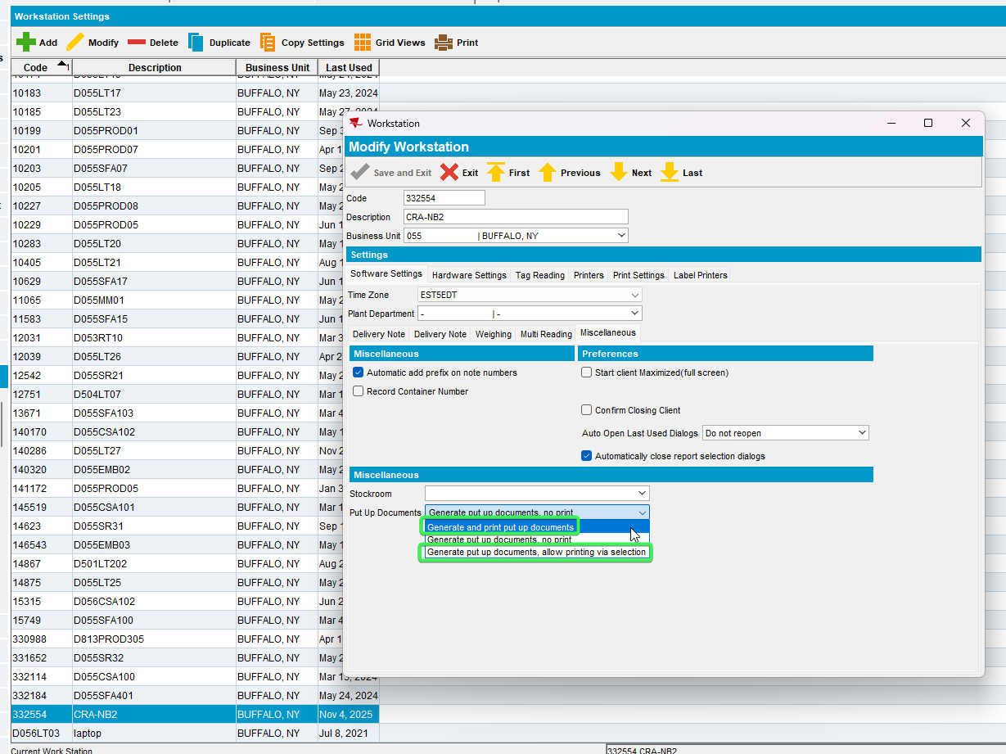
- Find a customer which has a product that packing notes are being generated for is put up type “bulk” using the following select:
select p.code, c.customernumber from customer c
join productlistpercustomer plpc on plpc.customer_id = c.customer_id
join product p on p.product_id = plpc.product_id
join businessunit bu on bu.businessunit_id = c.defaultbusinessunit_id
where bu.code = '055'
and plpc.dateinactive > sysdate
and ((PLPC.SpecificPutUpType = 0 and P.PutUpType = 2) OR PLPC.SpecificPutUpType = 2 );
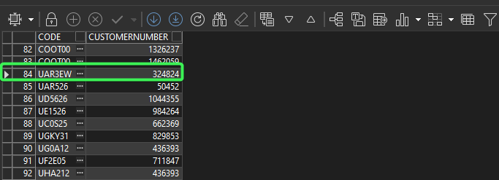
- Delivery Variations DLG: Input your customer and for your Product add a new delivery variation
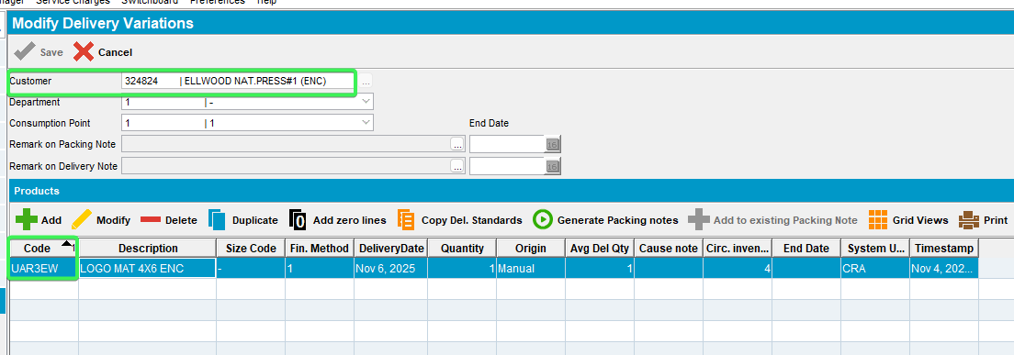
- Press the Generate Packing notes button
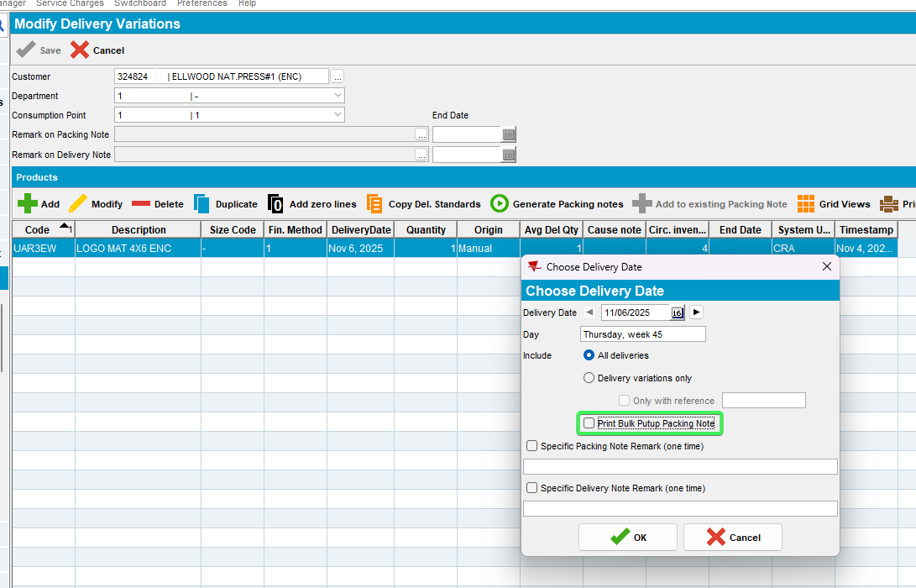
Tested OK

Test Case 3 – Check that button is Visible and Unchecked if this customer does not have a future route control
Hash: 31bc8452ed1a
Expected Behavior: When visible and enabled, the default value depends on the status of the route control.
Find the route control for this customer and date (customers route number for the delivery day and route control for this route on the delivery date) – if none found then default this to N
- Find a customer which has a product that packing notes are being generated for is put up type “bulk” using the following select:
select p.code, c.customernumber from customer c
join productlistpercustomer plpc on plpc.customer_id = c.customer_id
join product p on p.product_id = plpc.product_id
join businessunit bu on bu.businessunit_id = c.defaultbusinessunit_id
where bu.code = '055'
and plpc.dateinactive > sysdate
and ((PLPC.SpecificPutUpType = 0 and P.PutUpType = 2) OR PLPC.SpecificPutUpType = 2 );
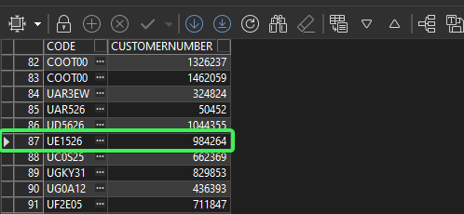
- Customers: Check the customer’s delivery day
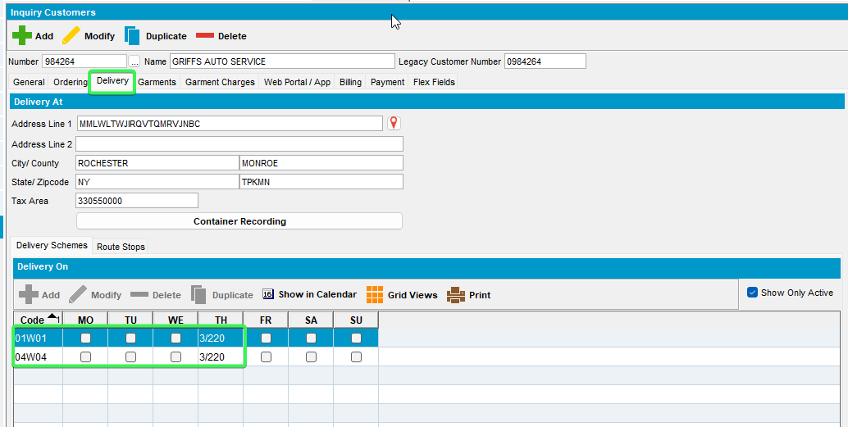
- Route Status Control DLG: Make sure there is no future route controls for this date
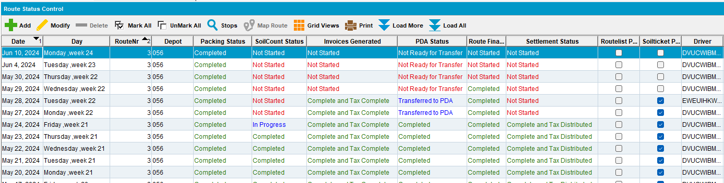
- Delivery Variations DLG: Input your customer and for your Product add a new delivery variation
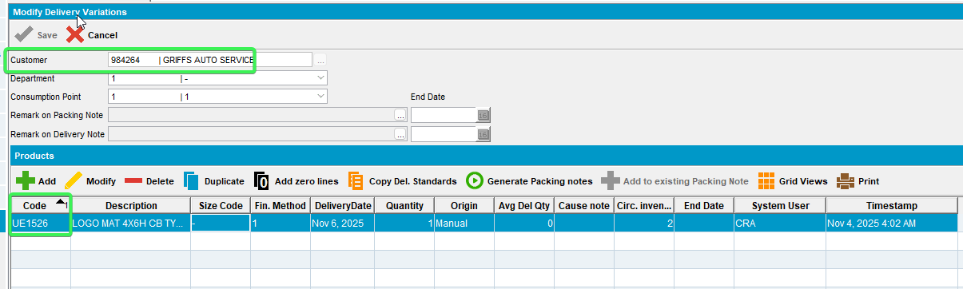
- Press the Generate Packing notes button
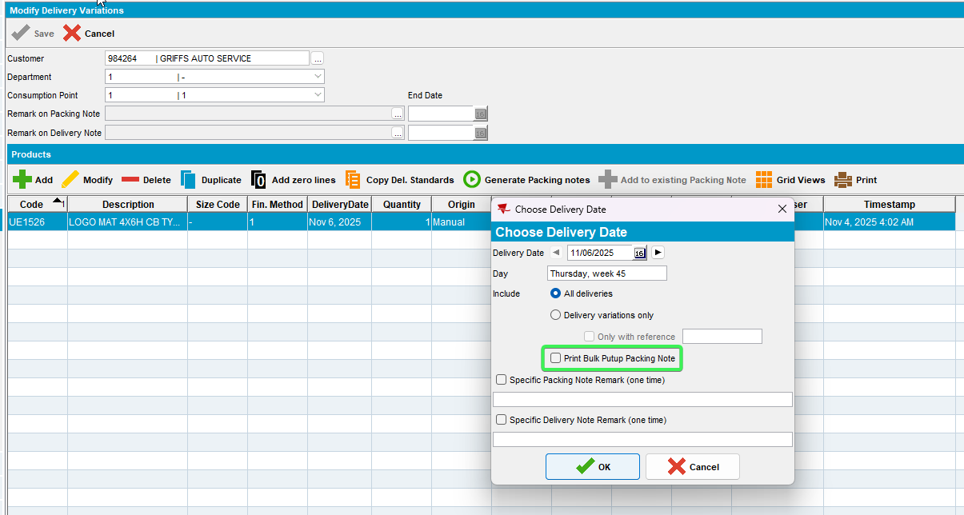
Tested OK

Test Case 4 – Check that button is Visible and Unchecked if this customer has a future route control but is Packing Status is NOT Complete
Hash: 31bc8452ed1a
Expected Behavior: If the route control packing note generation status is complete (RC.PackingStatus = 4 completed), then default this to Y else default to N
- Find a customer which has a product that packing notes are being generated for is put up type “bulk” using the following select:
select p.code, c.customernumber from customer c
join productlistpercustomer plpc on plpc.customer_id = c.customer_id
join product p on p.product_id = plpc.product_id
join businessunit bu on bu.businessunit_id = c.defaultbusinessunit_id
where bu.code = '055'
and plpc.dateinactive > sysdate
and ((PLPC.SpecificPutUpType = 0 and P.PutUpType = 2) OR PLPC.SpecificPutUpType = 2 );
- Customers: Check the customer’s delivery day
- Route Status Control DLG: Add a future route control for this customer but don’t generate Packing Notes
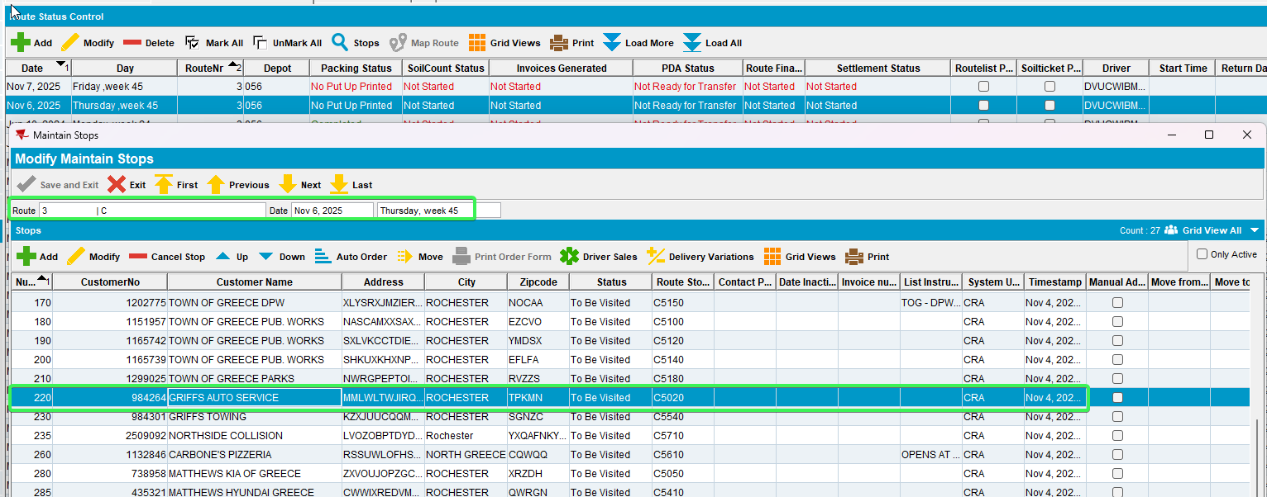
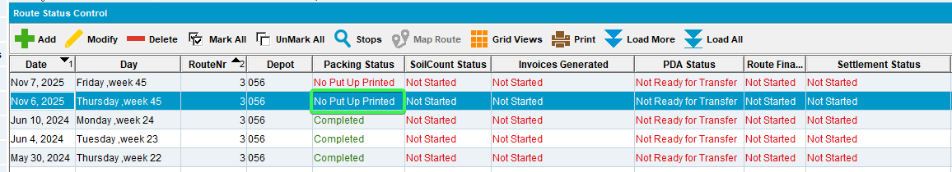
- Delivery Variations DLG: Input your customer and for your Product add a new delivery variation
- Press the Generate Packing notes button
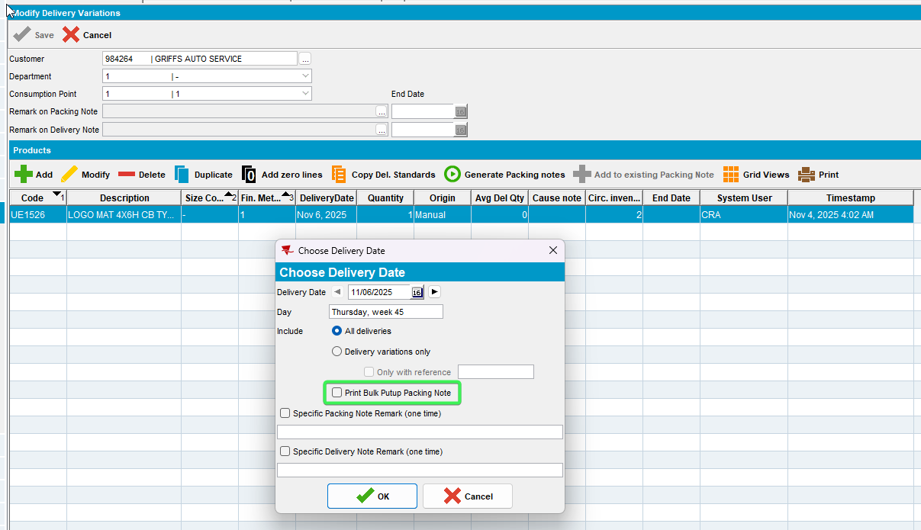
Tested OK

Test Case 5 – Check that button is Visible and Checked if this customer has a future route control and It’s Packing Status is Complete
Hash: 31bc8452ed1a
Expected Behavior: If the route control packing note generation status is complete (RC.PackingStatus = 4 completed), then default this to Y else default to N
- Find a customer which has a product that packing notes are being generated for is put up type “bulk” using the following select:
select p.code, c.customernumber from customer c
join productlistpercustomer plpc on plpc.customer_id = c.customer_id
join product p on p.product_id = plpc.product_id
join businessunit bu on bu.businessunit_id = c.defaultbusinessunit_id
where bu.code = '055'
and plpc.dateinactive > sysdate
and ((PLPC.SpecificPutUpType = 0 and P.PutUpType = 2) OR PLPC.SpecificPutUpType = 2 );
- Customers: Check the customer’s delivery day
- Route Status Control DLG: Add a future route control for this customer

- Generate Put Up Doc for this route
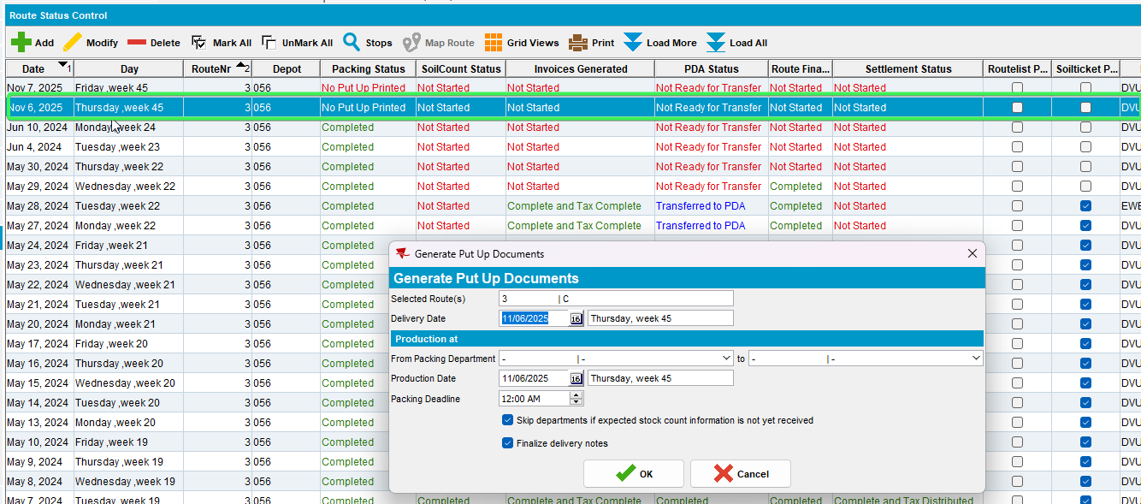
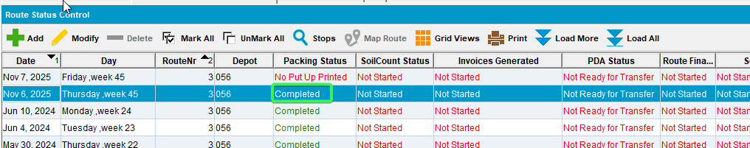
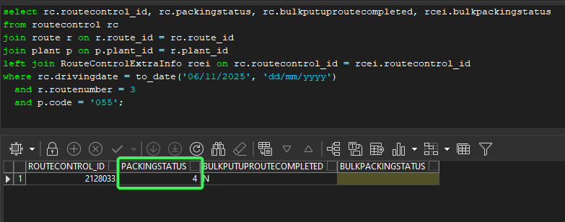
- Delivery Variations DLG: Input your customer and for your Product add a new delivery variation
- Press the Generate Packing notes button
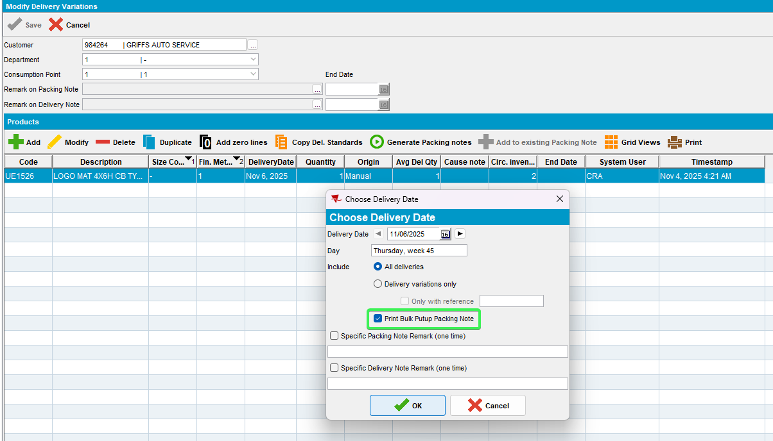
Tested OK

Test Case 6 – Check that button is Visible if the put-up type of the product is “bulk”
Hash: 31bc8452ed1a
Expected Behavior: Only visible if any of the products that packing notes are being generated for is put up type “bulk” (PLPC.SpecificPutUpType = 2 or, if (PLPC.SpecificPutUpType = 0 and Product.PutUpType = 2)
- Products DLG: Pick a product and go to logistics tab
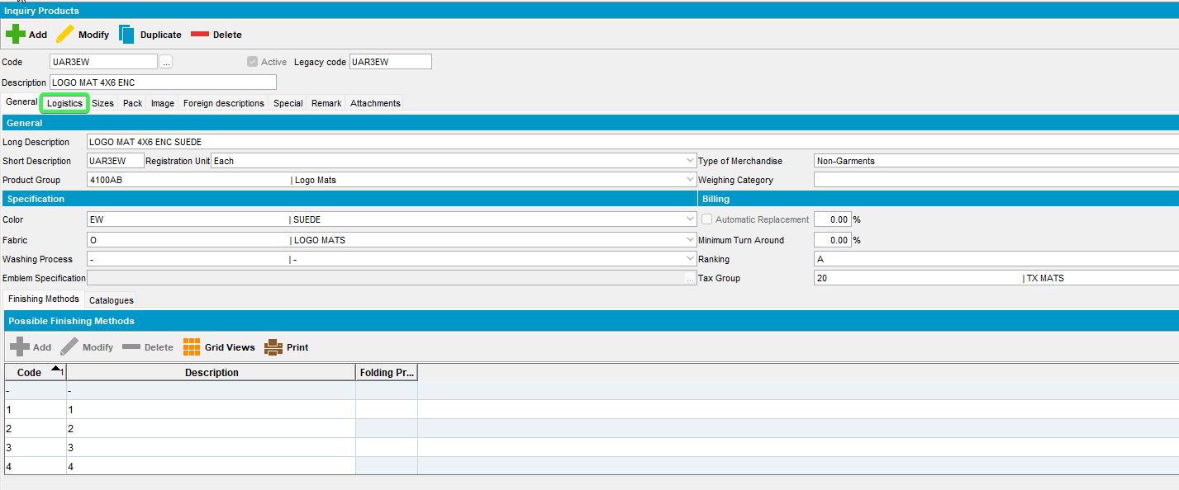
- Check that “Show Put Up Qty On” radio button is set as “Bulk put up”
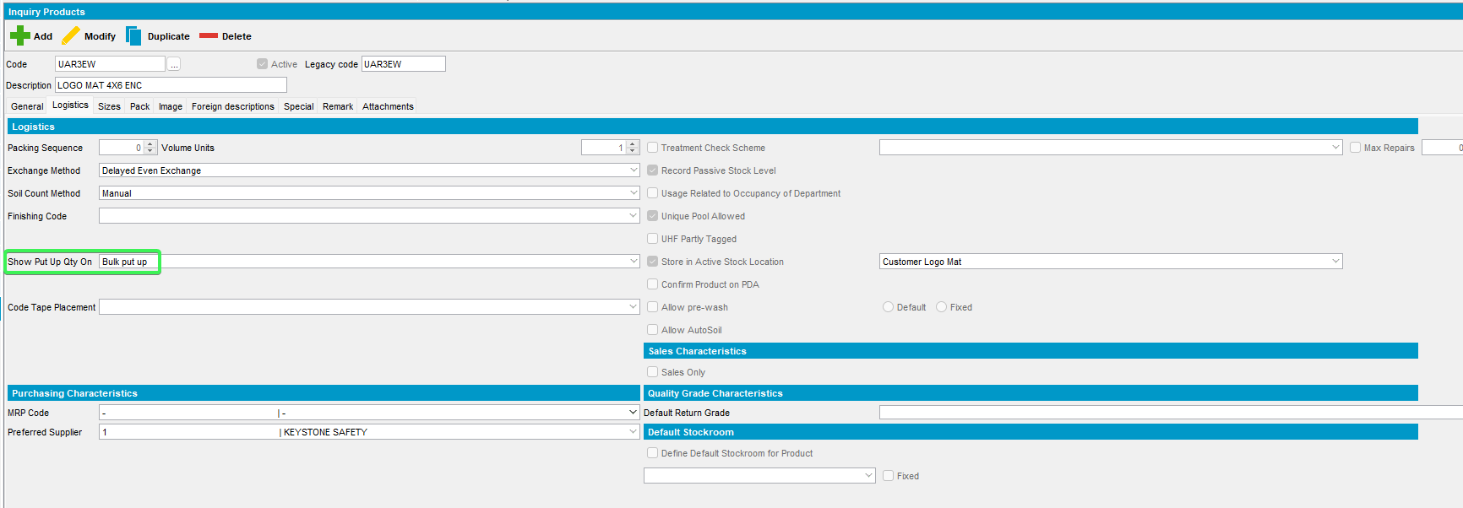
- Delivery Variation DLG: Add a new delivery variation for this product
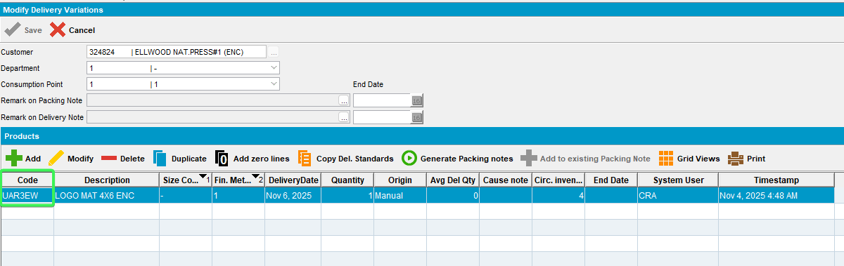
- Press Generate Packing notes button
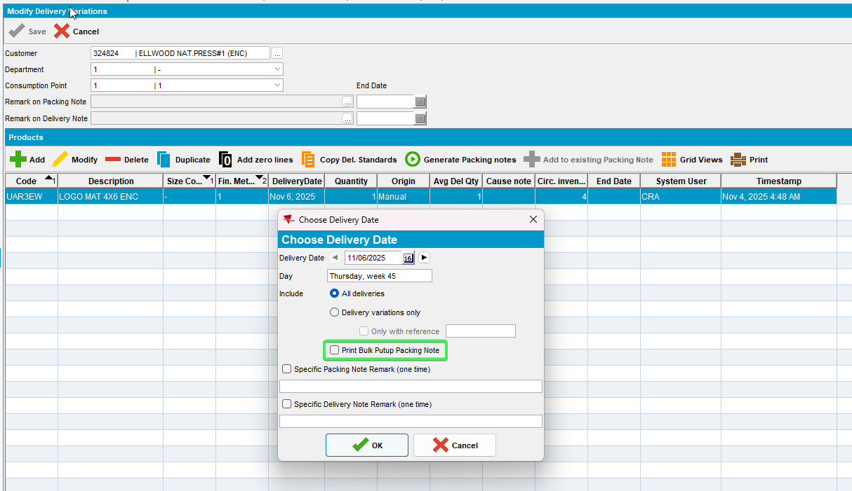
Tested OK

Test Case 7 – Check that button is NOT Visible if the put-up type of the product is NOT “bulk”
Hash: 31bc8452ed1a
Expected Behavior: Only visible if any of the products that packing notes are being generated for is put up type “bulk” (PLPC.SpecificPutUpType = 2 or, if (PLPC.SpecificPutUpType = 0 and Product.PutUpType = 2)

- Products DLG: Pick a product and go to logistics tab
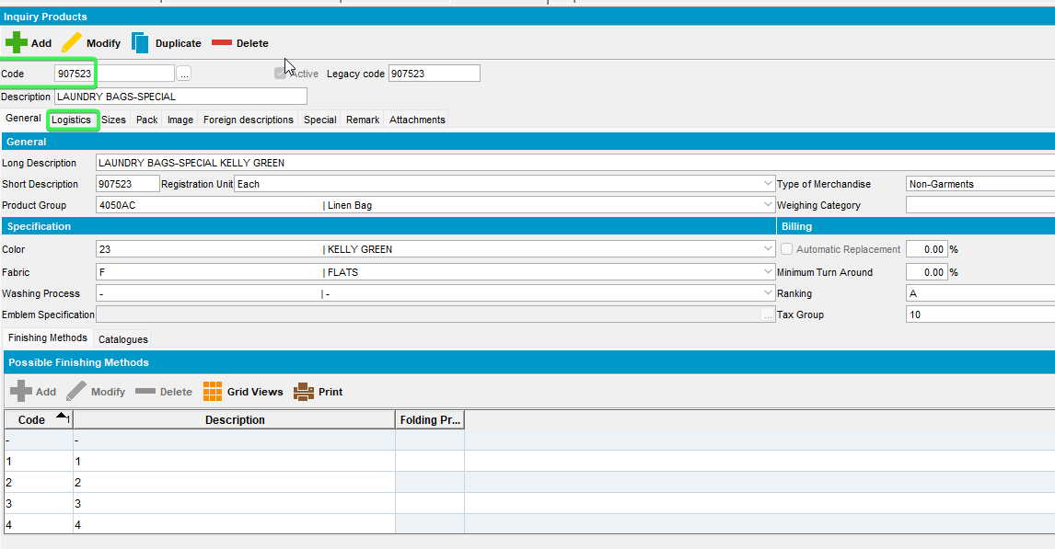
- Check that “Show Put Up Qty On” radio button is set as “Packing Note”
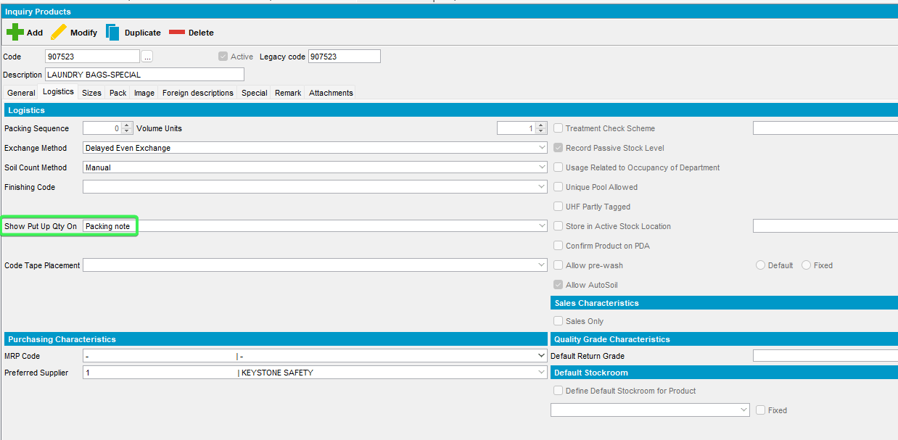
- Delivery Variation DLG: Add a new delivery variation for this product
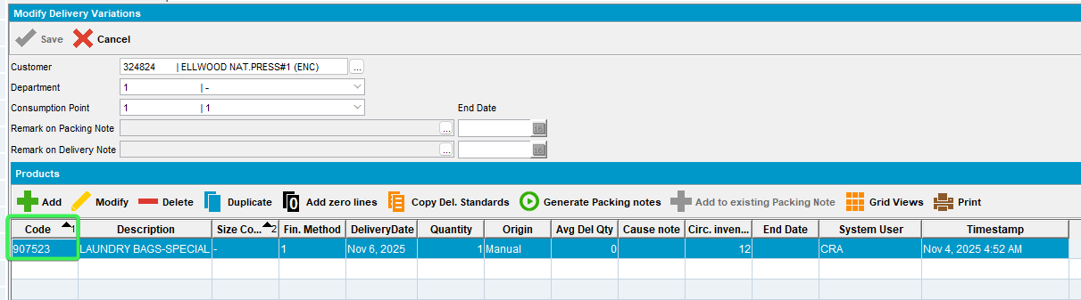
- Press Generate Packing notes button
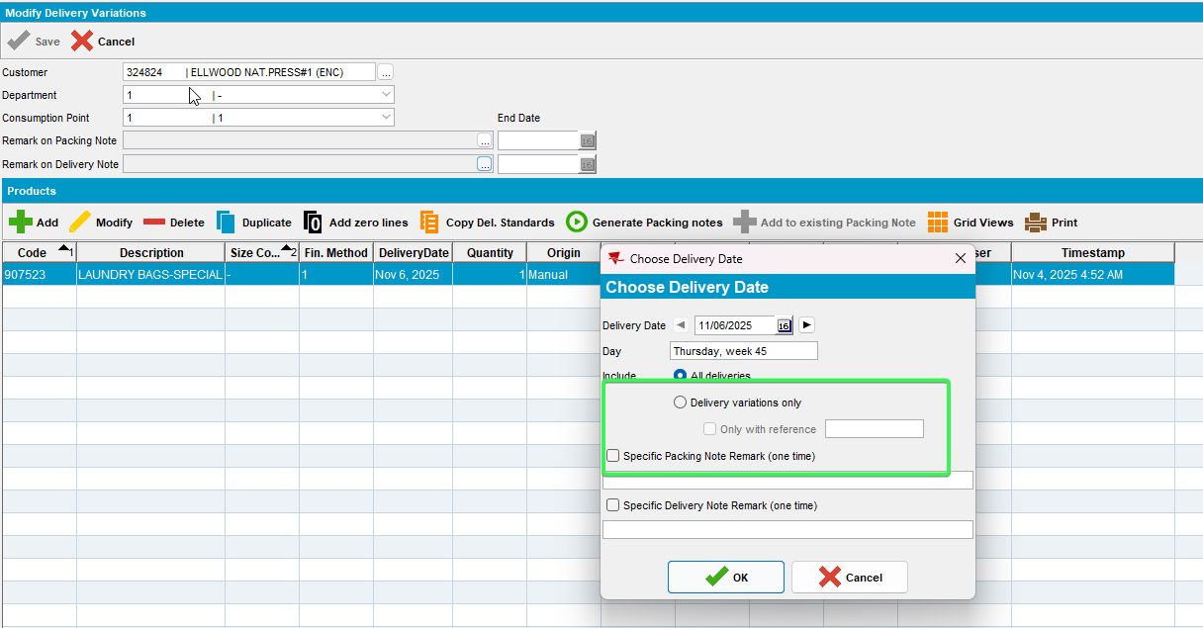
The button is not present
Tested OK

Test Case 8 – Check that if BulkPackingStatus is complete and BULKPACKINGASSISTANT is in license show a waring
Hash: 398d4cd67ea0
Expected Behavior:
If module BULKPACKINGASSISTANT is in the license and the bulk packing status of the route control is complete (RouteControlExtraInfo.BulkPackingStatus = 3 or 4) then when OK is pressed, show a warning “Bulk packing is already complete for this route”
If this is set to Y, then after the packing note is generated, it should be printed.

- Have module BULKPACKINGASSISTANT in license
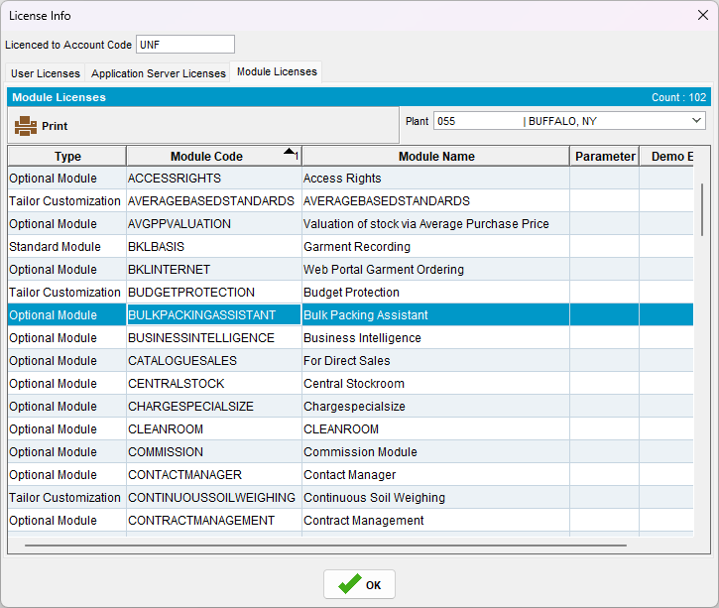
- Find a customer which has a product that packing notes are being generated for is put up type “bulk” using the following select:
select p.code, c.customernumber from customer c
join productlistpercustomer plpc on plpc.customer_id = c.customer_id
join product p on p.product_id = plpc.product_id
join businessunit bu on bu.businessunit_id = c.defaultbusinessunit_id
where bu.code = '055'
and plpc.dateinactive > sysdate
and ((PLPC.SpecificPutUpType = 0 and P.PutUpType = 2) OR PLPC.SpecificPutUpType = 2 );
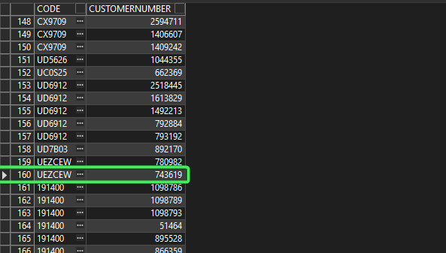
- RSC dlg: Add a new route where Packing Status and Bulk Packing Status was not started
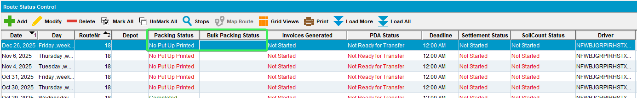
- Generate Put up Docs
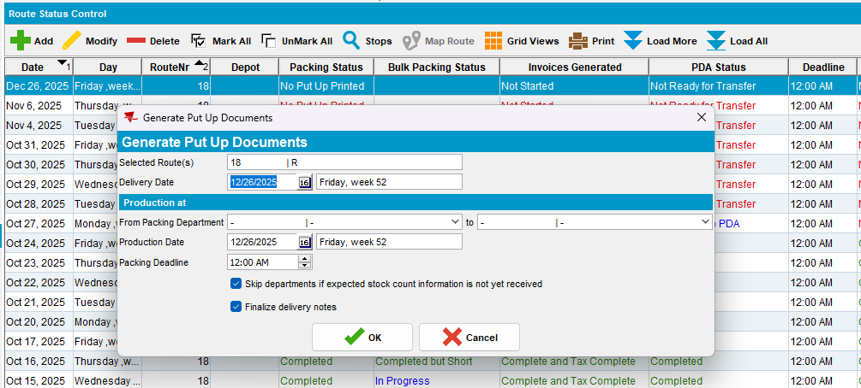
- BPA: Start the BPA Bulk Packing
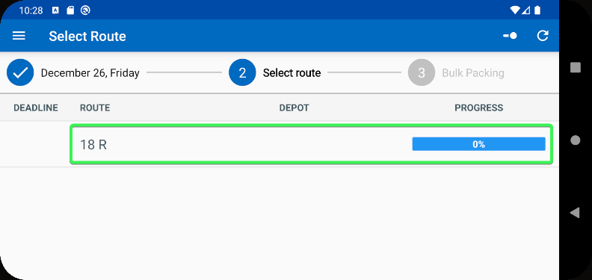
- Complete the Bulk Packing on BPA
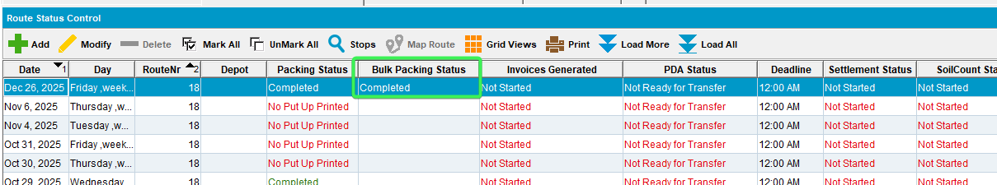
- Delivery Variations DLG: Input your customer and for your Product add a new delivery variation
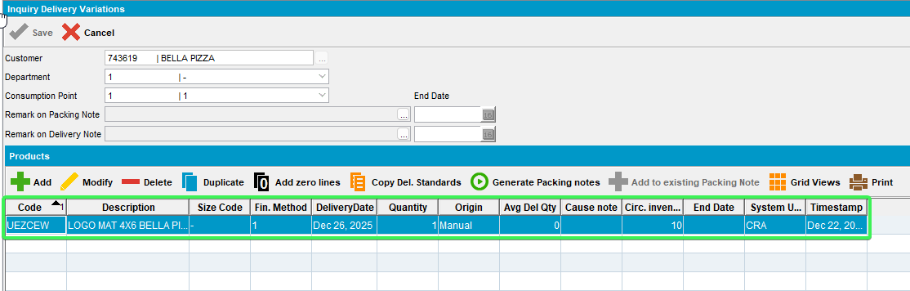
- Customers DLG: Go to Delivery tab and see that the “Print Delivery Note For BulkPutup Items checkbox” is unchecked
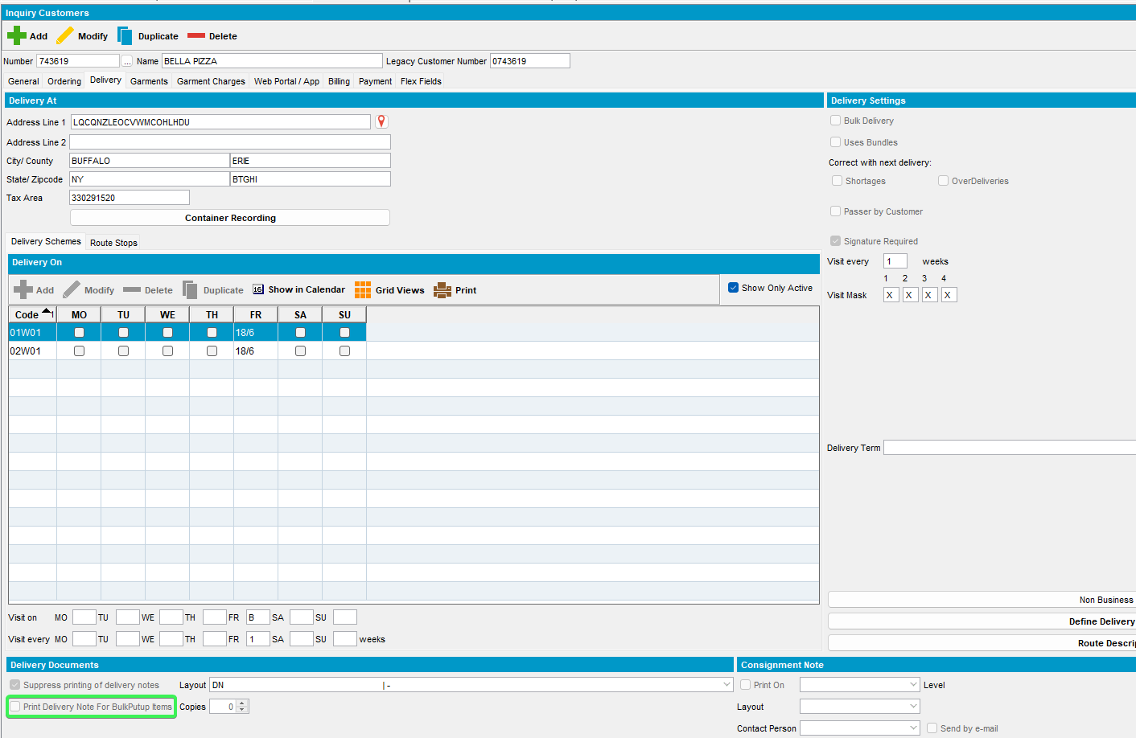
- Delivery Variations DLG: Press the Generate Packing notes button
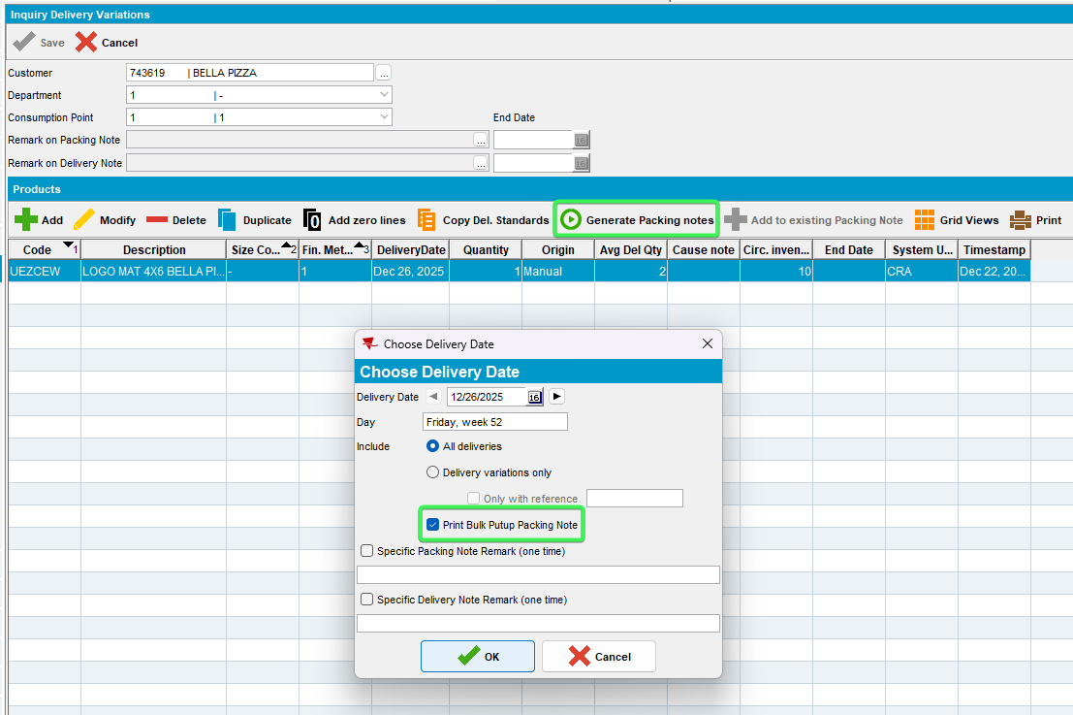
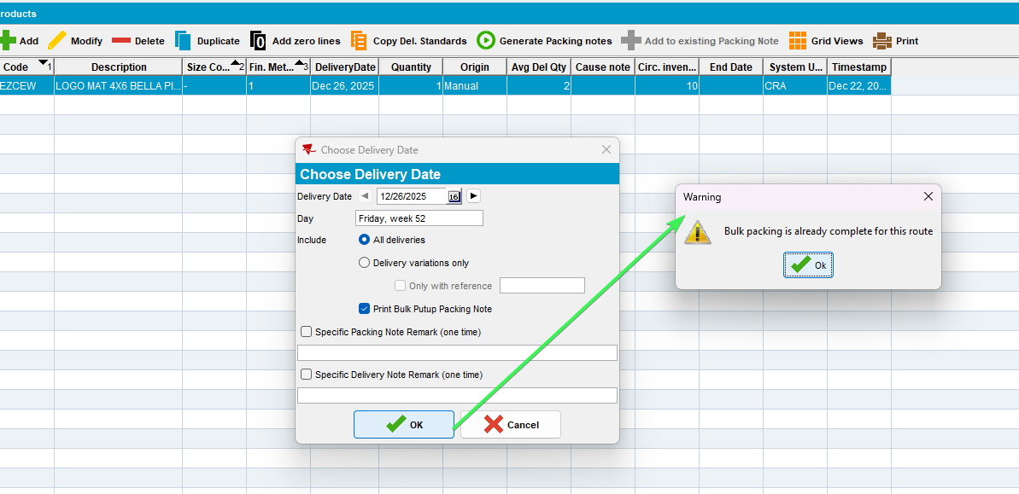
- Press OK on the Warning
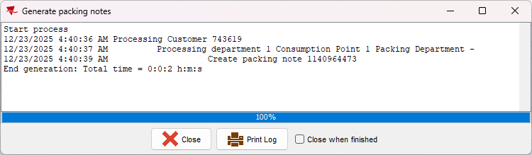
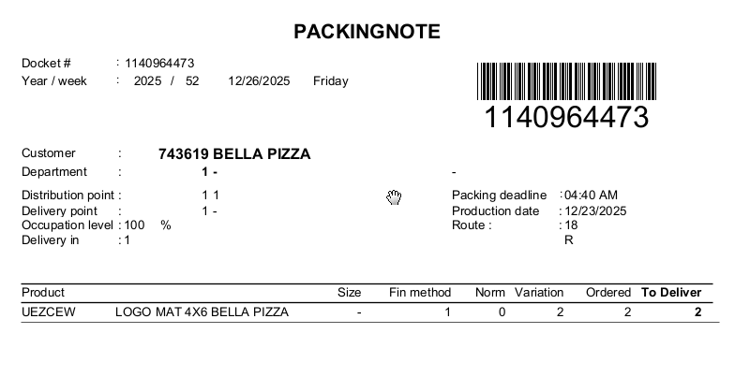
- Customers DLG: Set “Print Delivery Note For BulkPutup Items checkbox” as checked
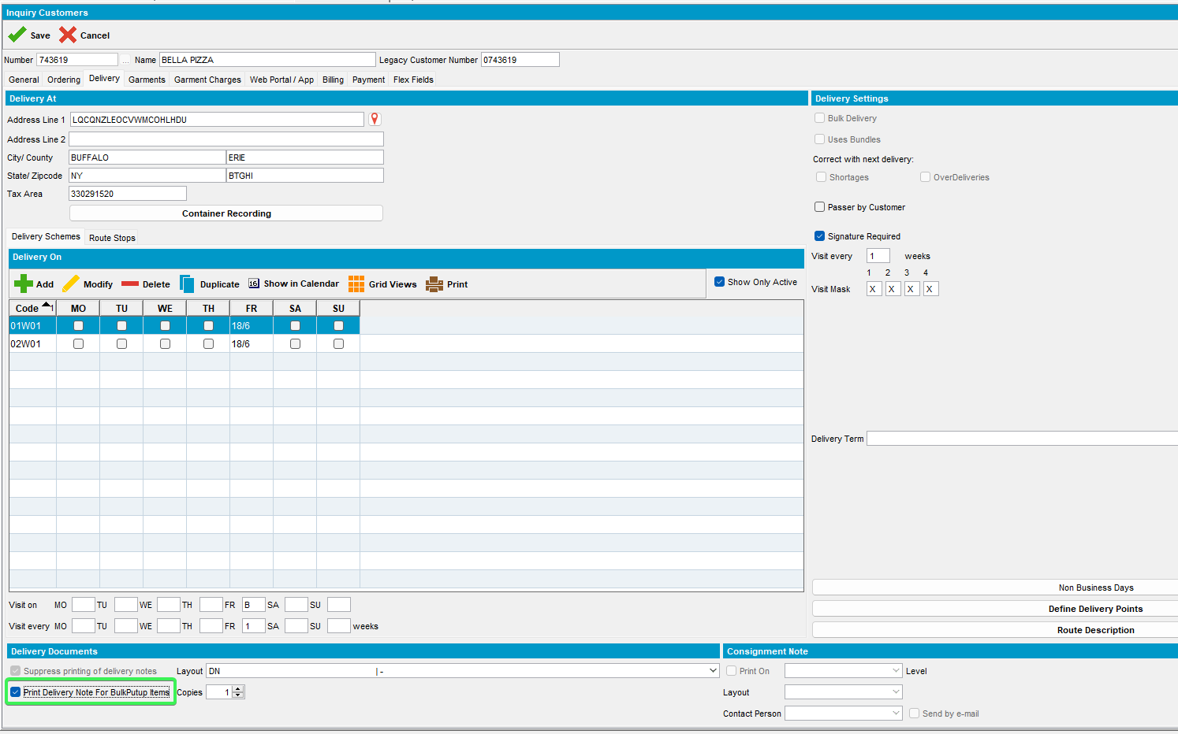
- RSC: Complete the Packing status again
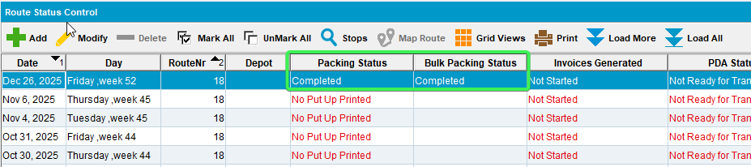
- Delivery Variations: Add another delivery variation for your product
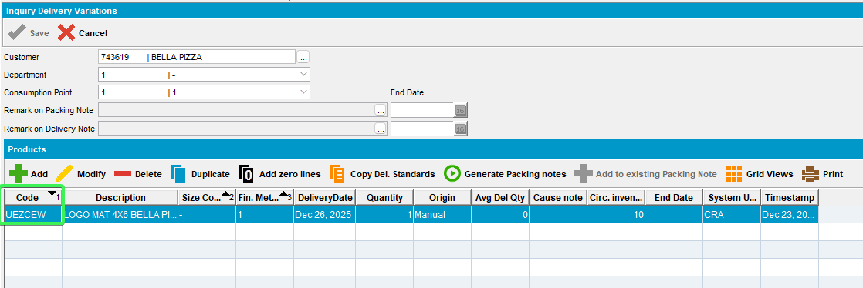
- Generate packing note and see that the report is printed
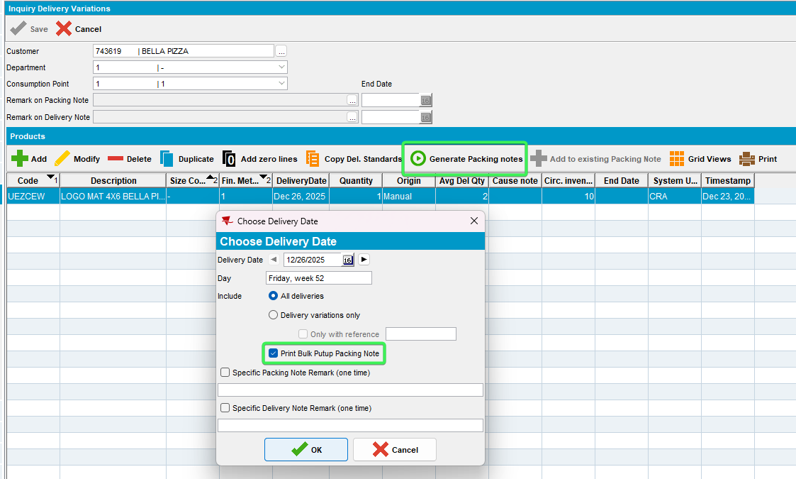
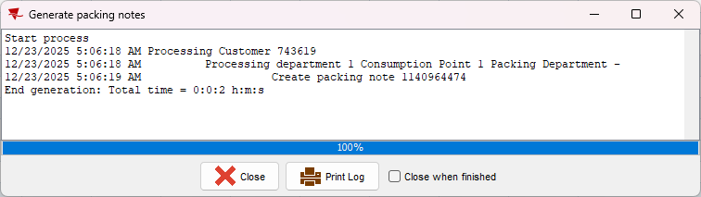
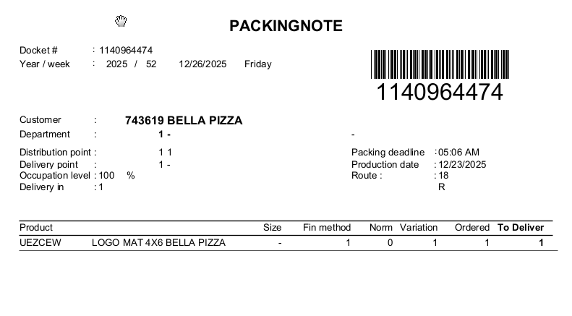
Tested OK

Test Case 9 – Check that if BulkPackingStatus is NOT complete and BULKPACKINGASSISTANT is in license DON’T show a waring
Hash: 31bc8452ed1a
Expected Behavior:
If module BULKPACKINGASSISTANT is in the license and the bulk packing status of the route control is complete (RouteControlExtraInfo.BulkPackingStatus = 3 or 4) then when OK is pressed, show a warning “Bulk packing is already complete for this route”
If this is set to Y, then after the packing note is generated, it should be printed.

- Have module BULKPACKINGASSISTANT in license
- RSC dlg: Add a new route where Packing Status and Bulk Packing Status was not started
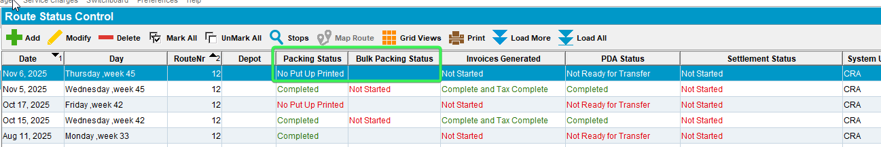
- Generate Put up Docs
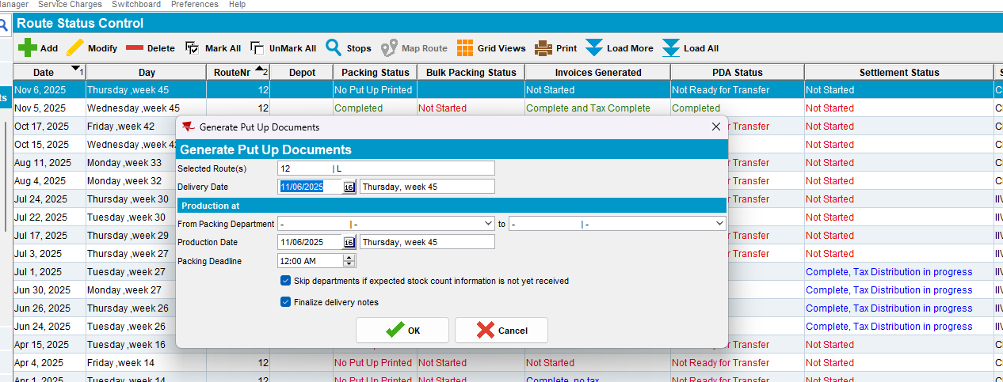
- BPA: Start the BPA Bulk Packing
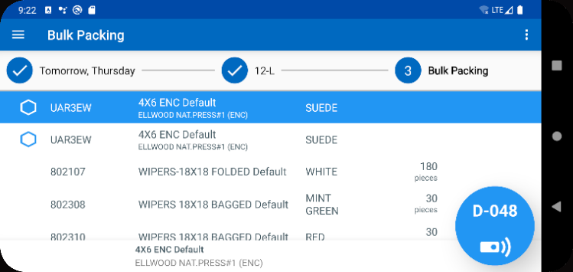
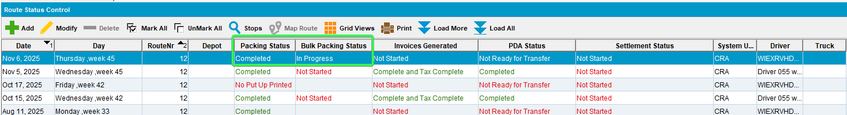

- Find a customer which has a product that packing notes are being generated for is put up type “bulk” using the following select:
select p.code, c.customernumber from customer c
join productlistpercustomer plpc on plpc.customer_id = c.customer_id
join product p on p.product_id = plpc.product_id
join businessunit bu on bu.businessunit_id = c.defaultbusinessunit_id
where bu.code = '055'
and plpc.dateinactive > sysdate
and ((PLPC.SpecificPutUpType = 0 and P.PutUpType = 2) OR PLPC.SpecificPutUpType = 2 );
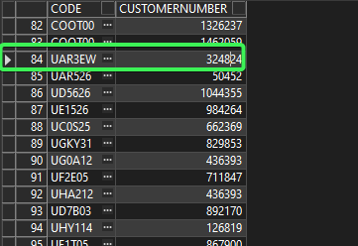
- Delivery Variations DLG: Input your customer and for your Product add a new delivery variation
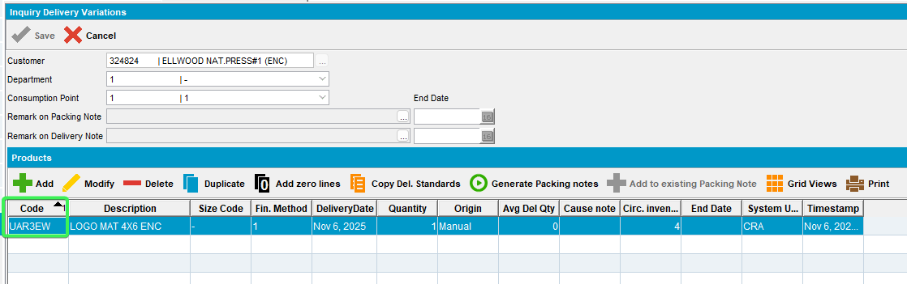
- Press the Generate Packing notes button
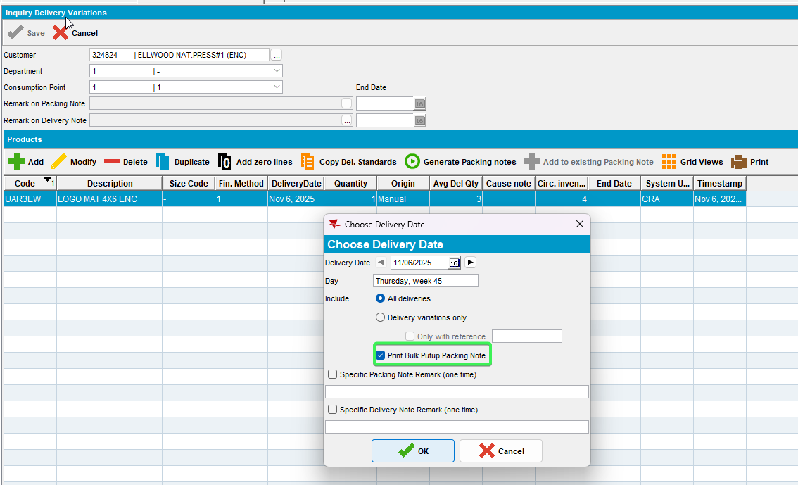
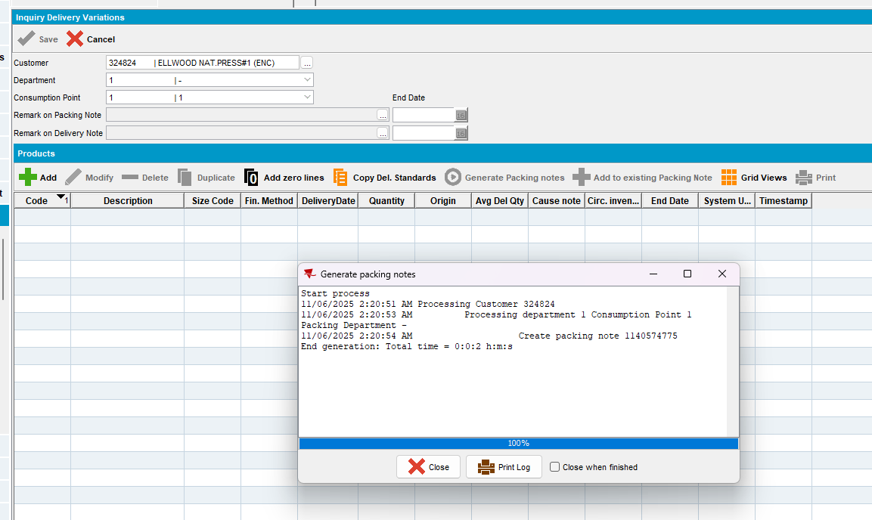
Tested OK

Test Case 10 – Check that if BulkPackingStatus is complete and BULKPACKINGASSISTANT is NOT in license the checkbox is still visible
Hash: 31bc8452ed1a
Expected Behavior:
If module BULKPACKINGASSISTANT is NOT in the license the Check box should still be visible

- Check that BULKPACKINGASSISTANT is NOT in the license
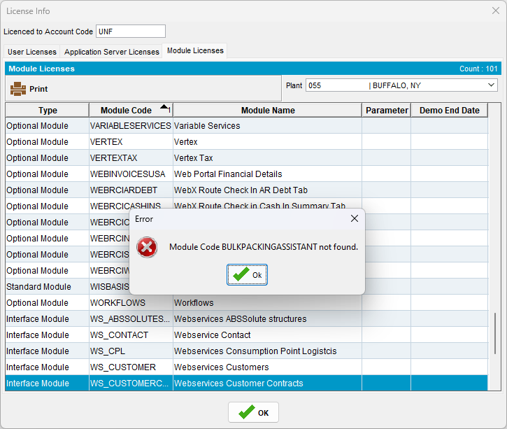

- Find a customer which has a product that packing notes are being generated for is put up type “bulk” using the following select:
select p.code, c.customernumber from customer c
join productlistpercustomer plpc on plpc.customer_id = c.customer_id
join product p on p.product_id = plpc.product_id
join businessunit bu on bu.businessunit_id = c.defaultbusinessunit_id
where bu.code = '055'
and plpc.dateinactive > sysdate
and ((PLPC.SpecificPutUpType = 0 and P.PutUpType = 2) OR PLPC.SpecificPutUpType = 2 );
- Delivery Variations DLG: Input your customer and for your Product add a new delivery variation
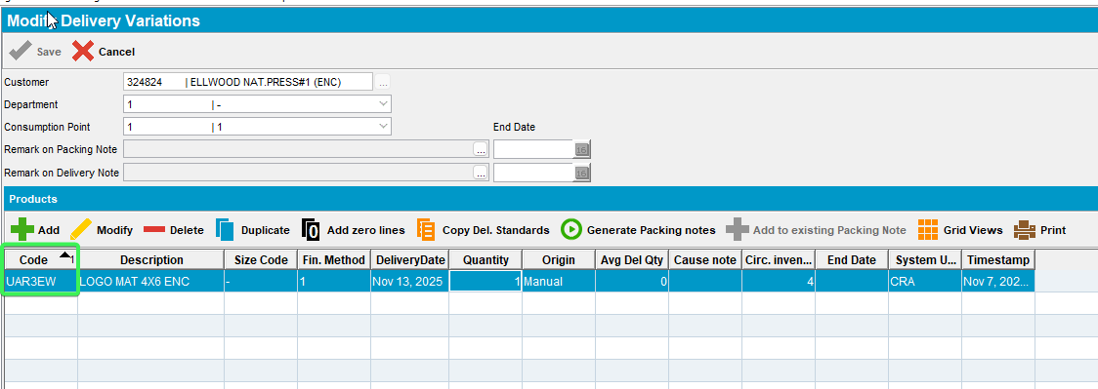
- Press the Generate Packing notes button
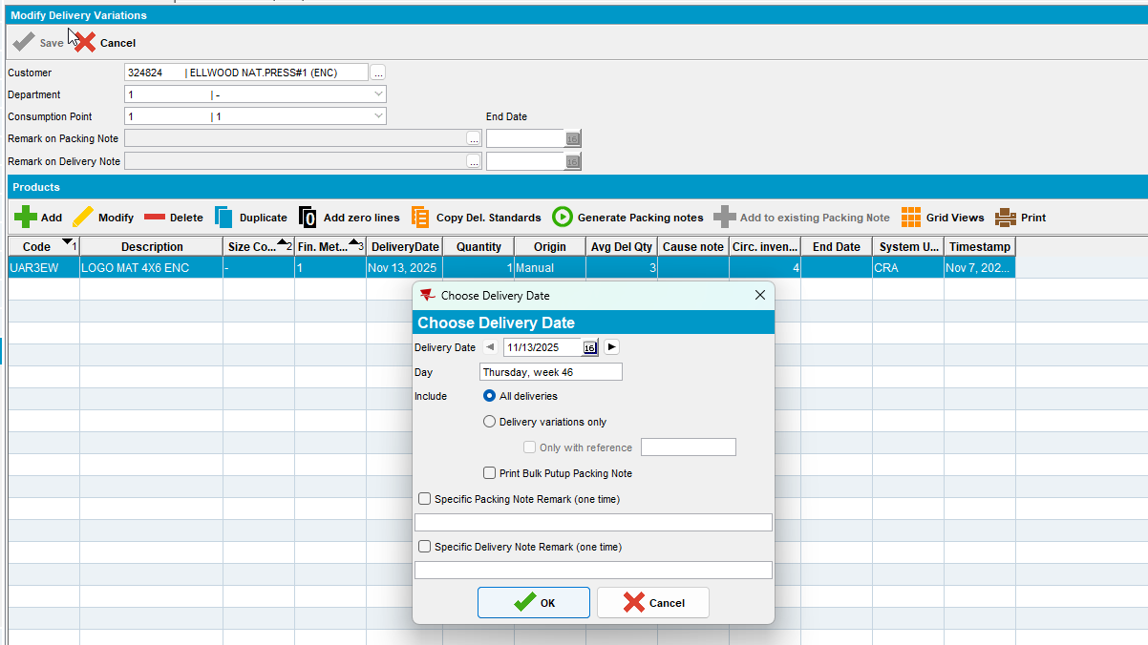

Test Case 11 – Check that a Packing note can be printed from RSC
Hash: 398d4cd67ea0
Expected Behavior: The Packing Note report should be printed
- PLPC: Find a customer with products and pick one of them: in this case I picked 802310
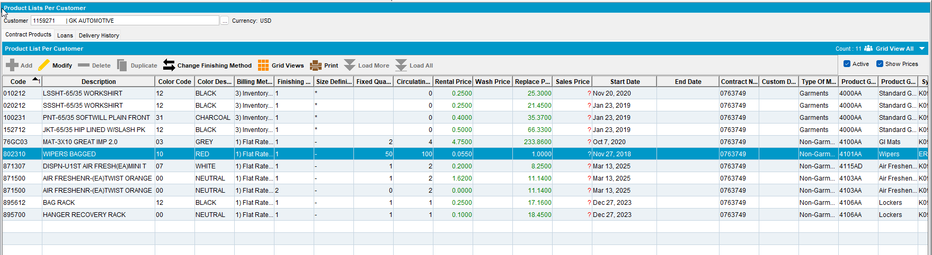
- Products DLG: Input the product and go to Logistics tab
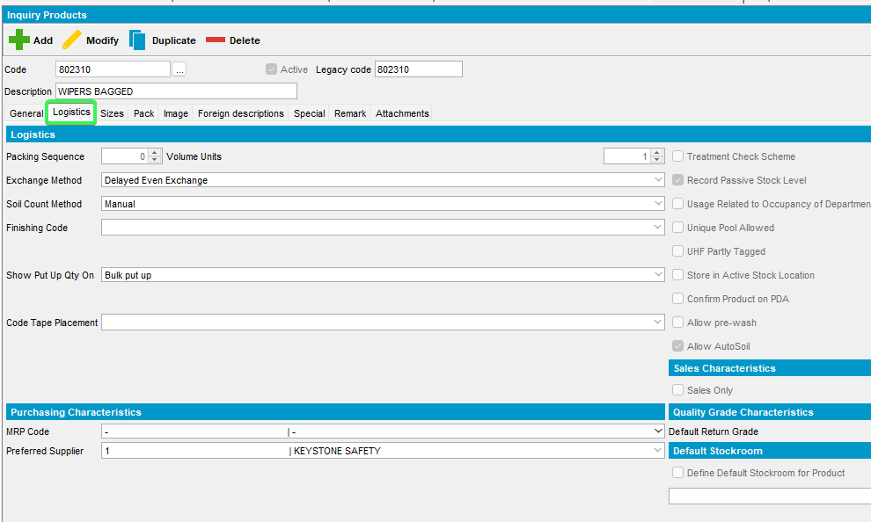
- Change the “Show Put Up QTY on” field to “Packing note”
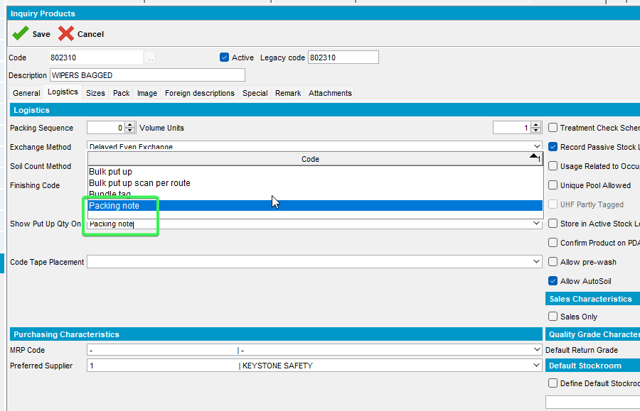
- RSC: Add the route your customer is present on and Generate Put Up doc but uncheck the Finalize Delivery Notes check box
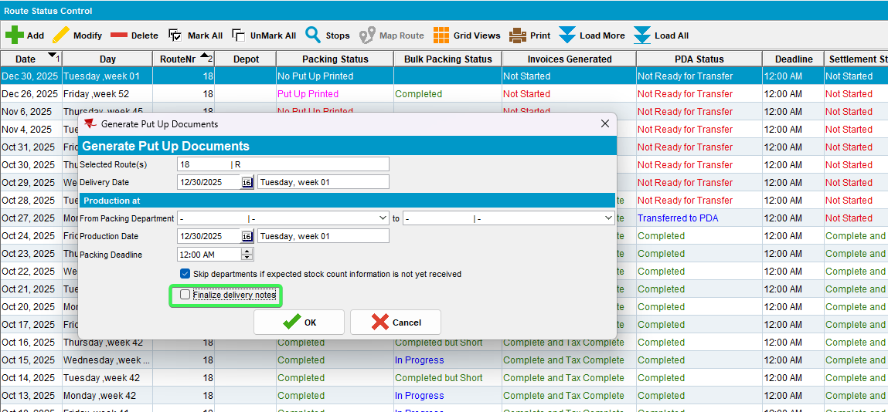
- Go to View packing and delivery notes
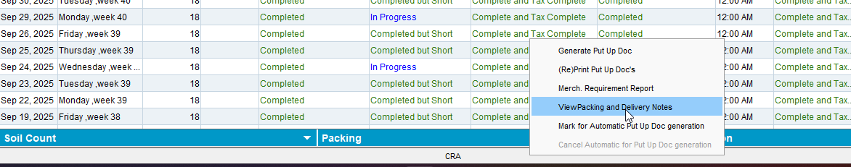
- Select your customer’s Packing notes and press Reprint Note button check only Preview Before Print checkbox
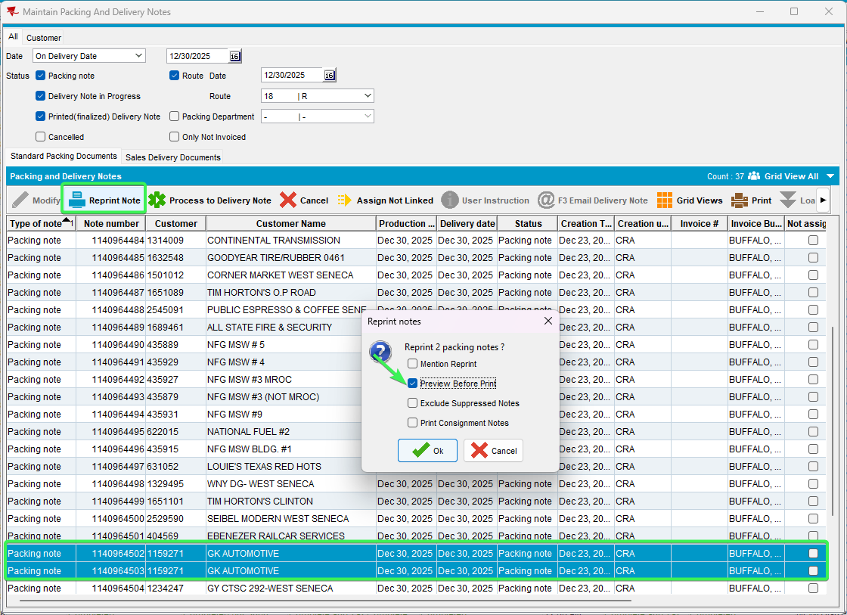
- Check if the Packing note for your product is printed
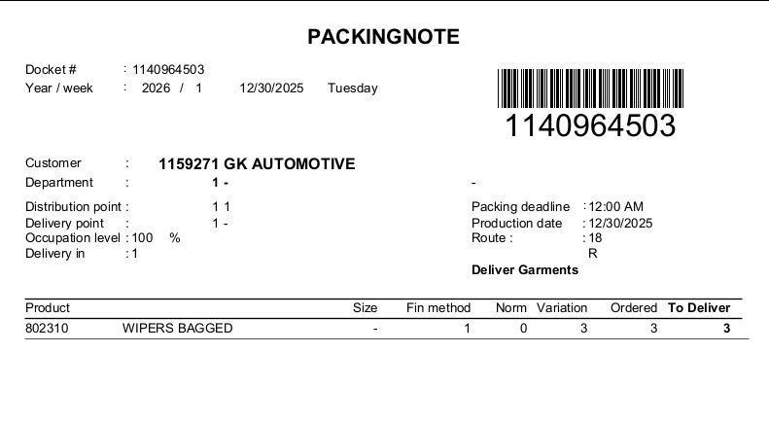
Tested OK

Test Case 12 – Check that a Packing note can be printed from Delivery Variations DLG for a product with Show put up QTY on: Packing note or Bundle tag
Hash: 398d4cd67ea0
Expected Behavior: The Packing Note report should be printed
- PLPC: Find a customer with products and pick one of them: in this case I picked 802310
- Products DLG: Input the product and go to Logistics tab
- Change the “Show Put Up QTY on” field to “Packing note”
- Delivery Variations DLG: Add a delivery variation for this product
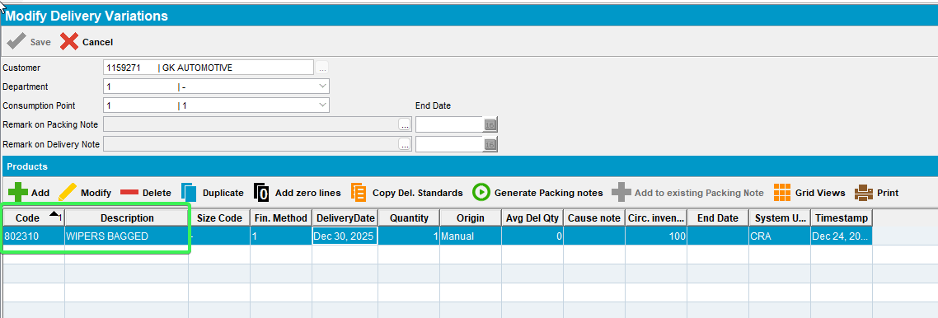
- Generate Packing notes
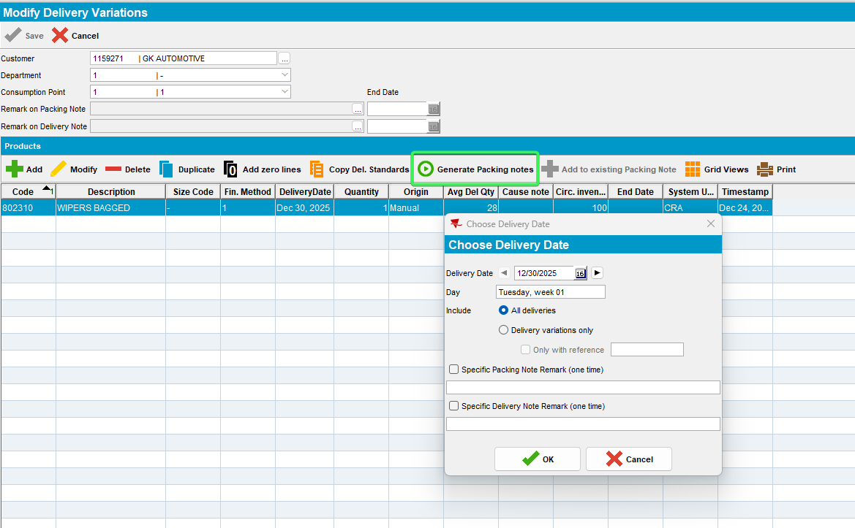
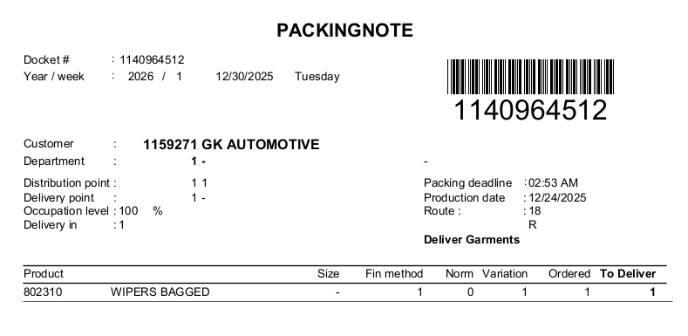

Tested OK

Test Case 13 – Make sure the Packing Note report can be printed form other places when having “Print Delivery Note for BulkPutUp Items” on and off
Hash: 398d4cd67ea0
Expected Behavior: The Packing Note report should be printed

- PLPC: Find a customer with products and pick one of them: in this case I picked 802310
- Products DLG: Input the product and go to Logistics tab
- Change the “Show Put Up QTY on” field to “Packing note”
- Customers DLG: Delivery tab, have the “Print Delivery Note for BulkPutUp Items” checkbox as unchecked
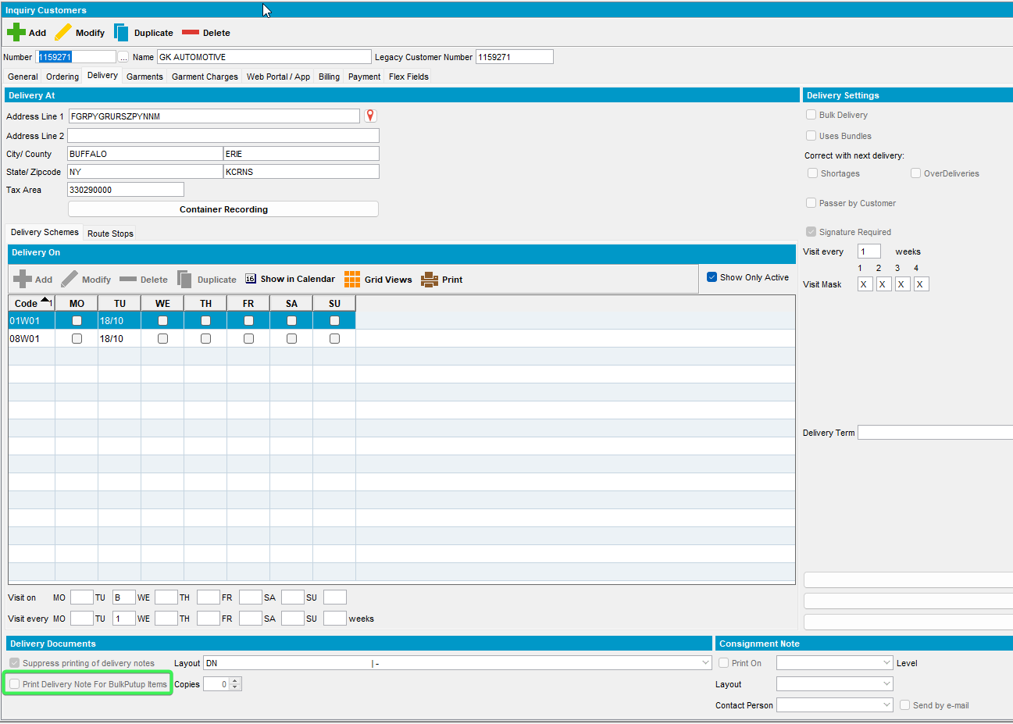
- RSC: Add a new route with your customer on it
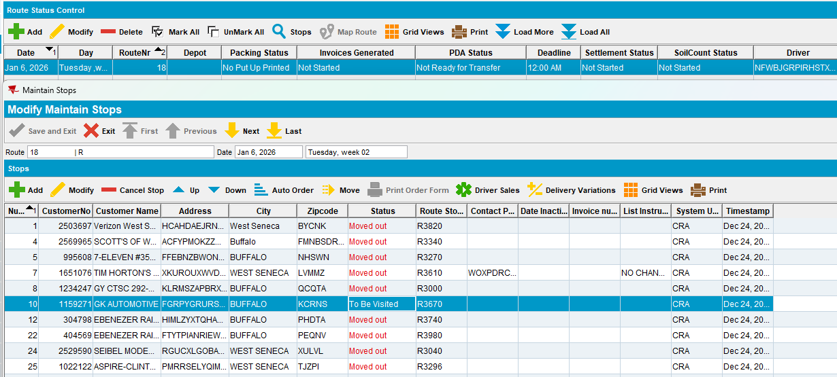
- Generate Put up Doc but don’t finalize the delivery notes
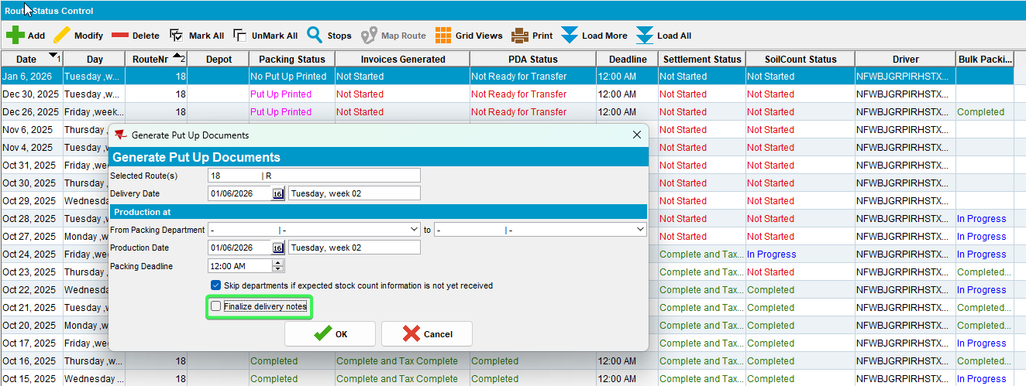
- Press on View Packing and delivery notes select your customer and press Reprint Note and select Preview before print
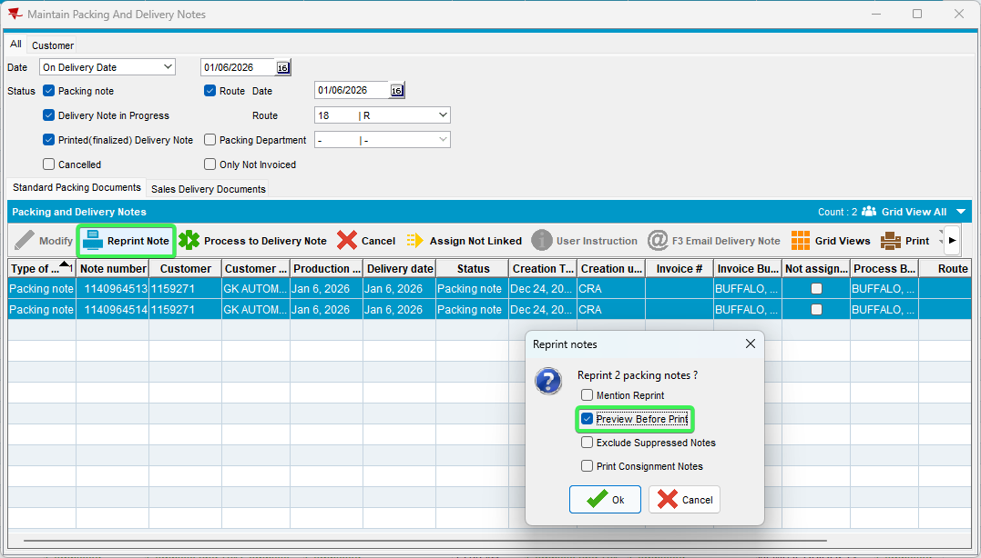
- Check that your product appears in the report
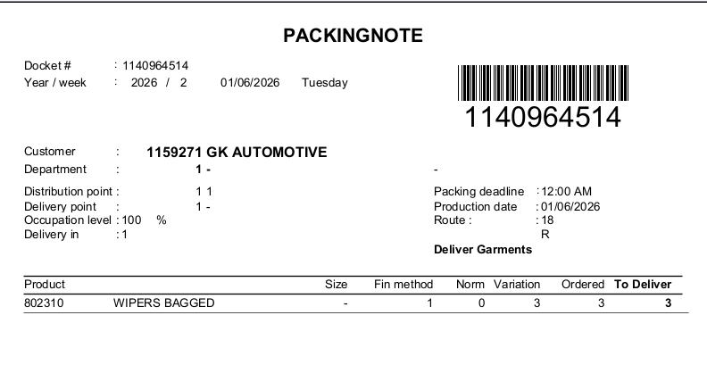
The packing Note report was printed
- Reprint Packing Notes DLG: Select the date your route is on and print the report
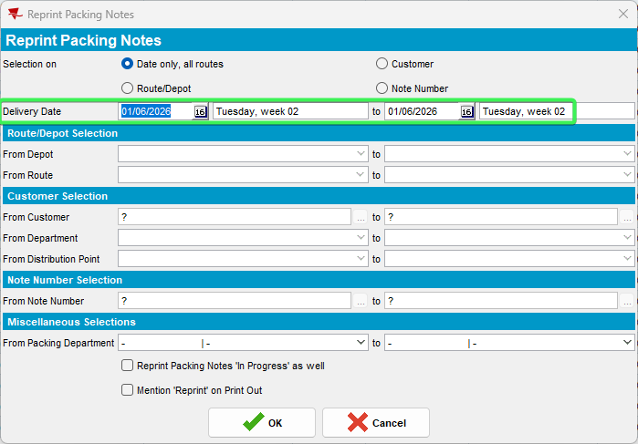
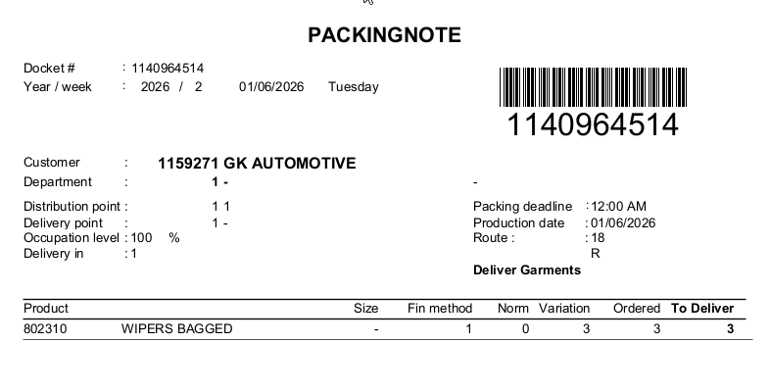
The Packing Note report is printed
- Customers DLG: Modify the customer and have the “Print Delivery Note for BulkPutUp Items” as checked
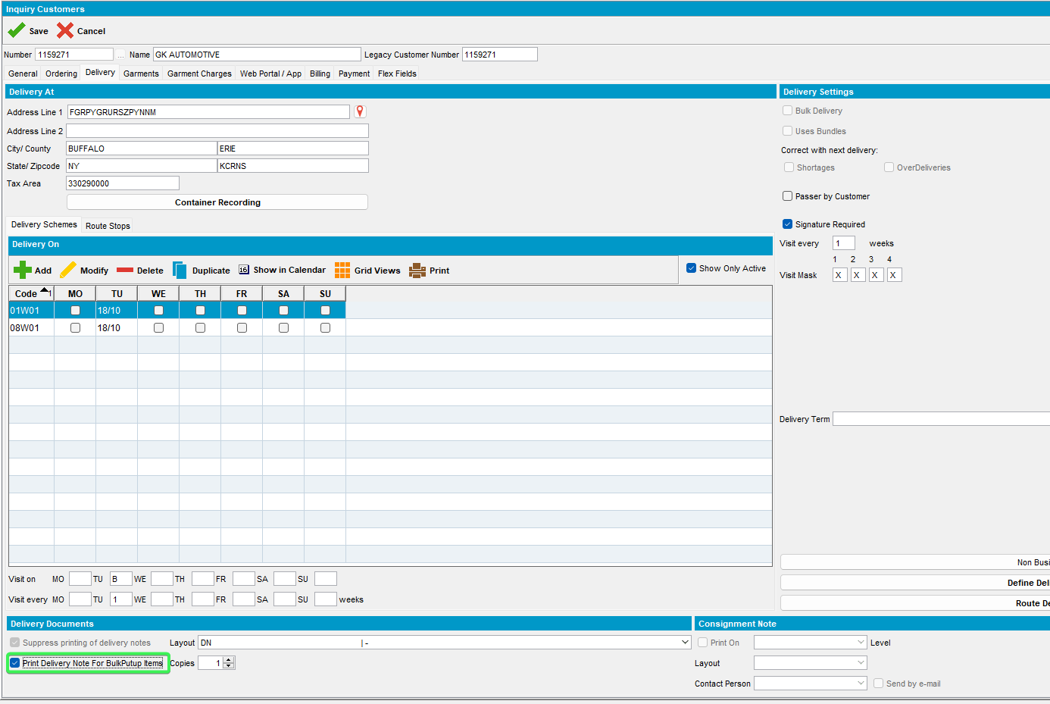
- RSC: Generate Put Up Doc again without finalizing the Delivery notes
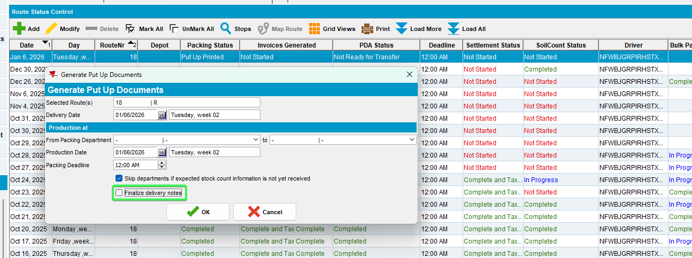
- Press on View Packing and delivery notes select your customer and press Reprint Note and select Preview before print
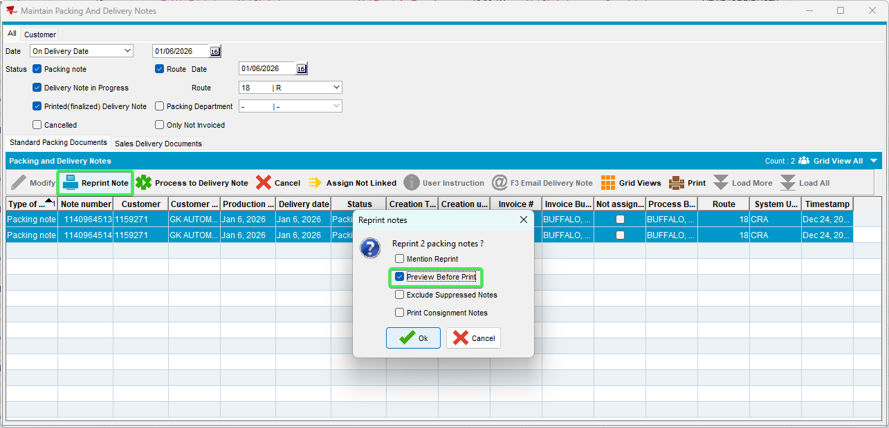
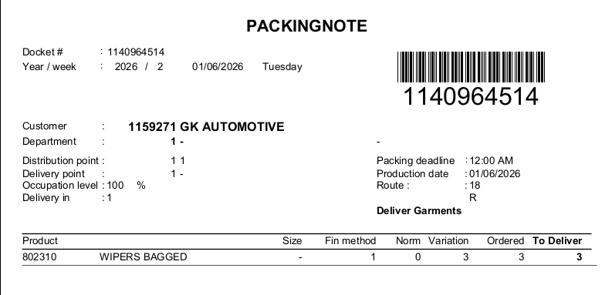
The Packing Note report was printed
- Reprint Packing Notes DLG: Select the date your route is on and print the report
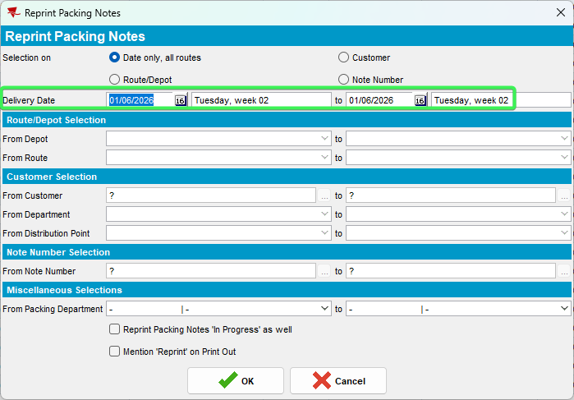
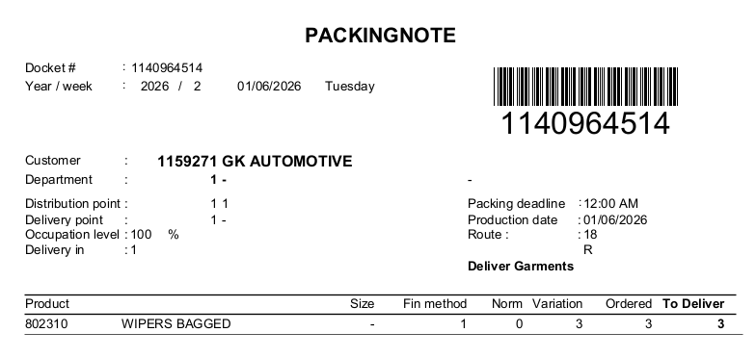
The Packing Note report was printed
Tested OK

