ABSN-10792 Error when ragging non unique
Environment | Prerequisites
Version: 9.07.00.UNF21  DBServerName= abs-srv20.internal.abslbs.com  DBSID= CUST24  DBUser= UNFDEV  Environment=Test | - Module:  - System setting:

Contents
Reproducing before fix 1
Hash: 9.07.00.UNF21 hash: 3700d8afc910. 1
Retest after fix 3
Hash: 9.07.00.UNF21 hash: 8d9e27e5f9f1. 3

Reproducing before fix

Hash: 9.07.00.UNF21 hash: 3700d8afc910.

Step 1) Open the ‘Business Units’ dialog. Select the current BU. Go to the ‘Stockroom’ tab. Uncheck the ‘Determine default stockroom upon return to stock’ checkbox.
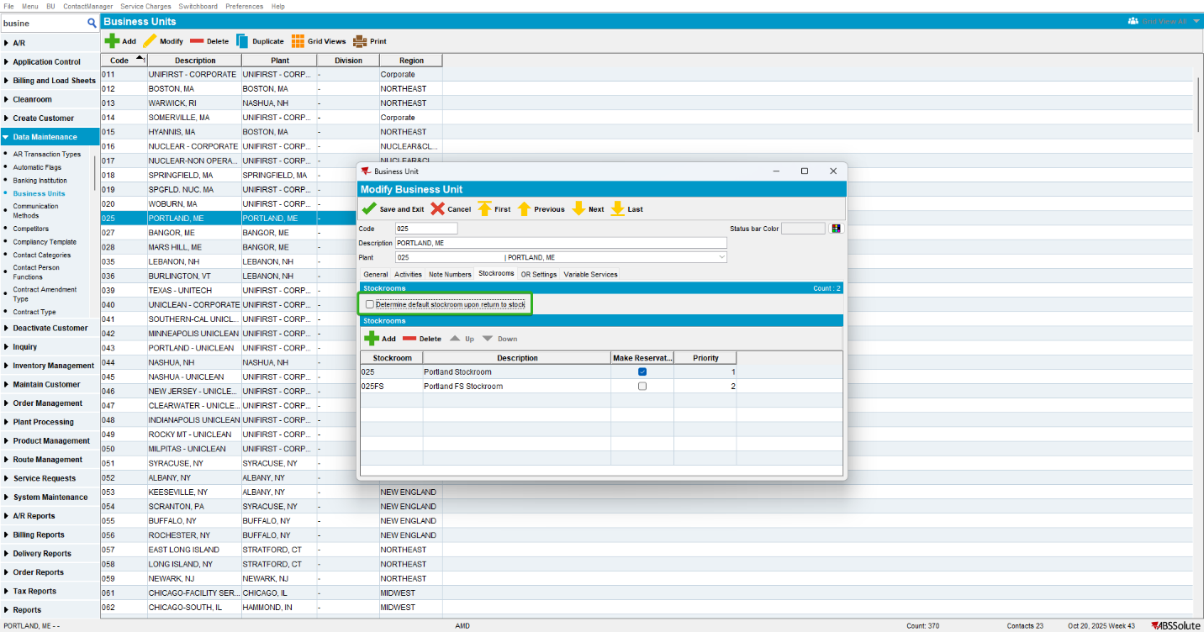
Step 2) Open the ‘Take Items Out Of Circulation’ dialog. Go to the ‘Not Unique’ tab. Select a customer, a wearer, and a product. Mark the Product. Select the ‘Record as Rag’ and the ‘Residual Value’ radio buttons. Select a Reason and a Rag Reason. Press the ‘Rag’ button.
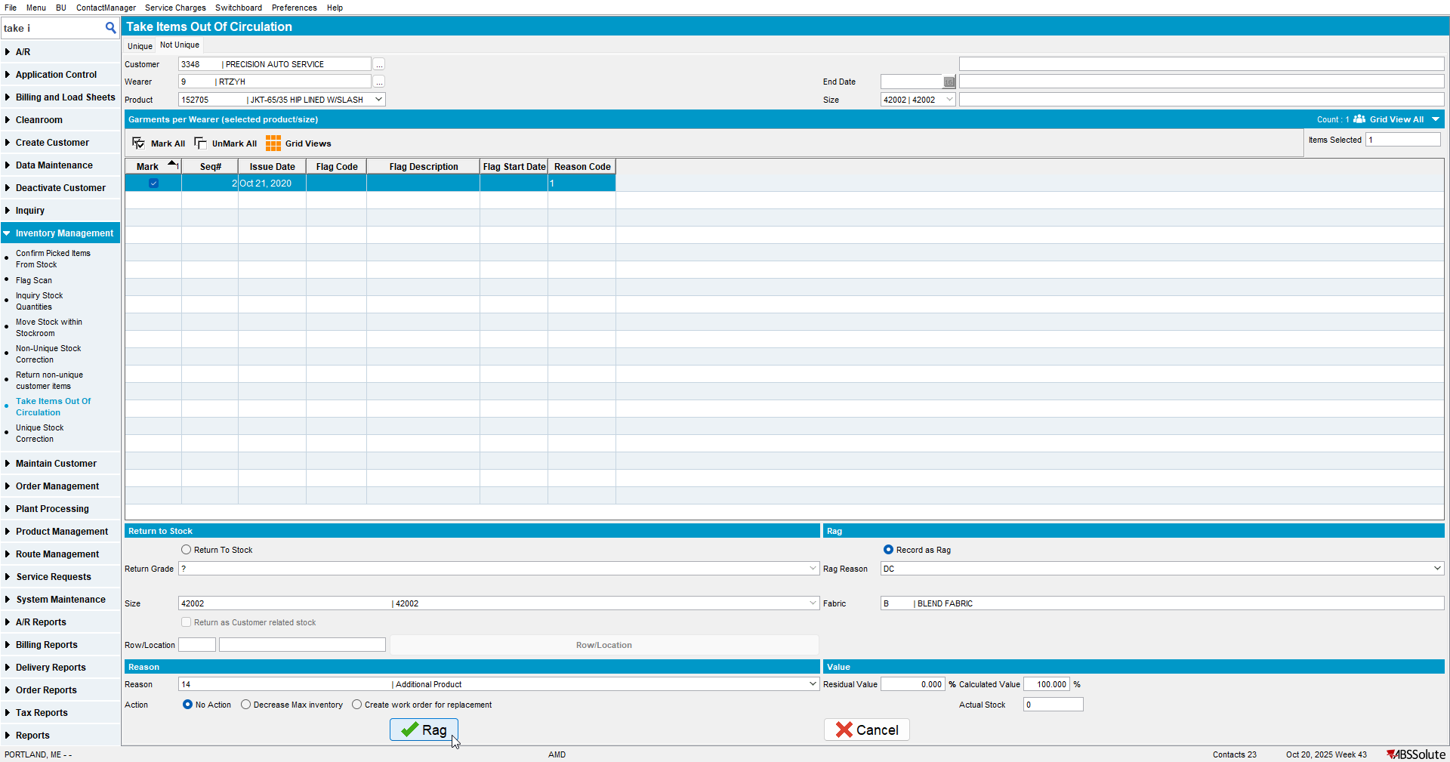
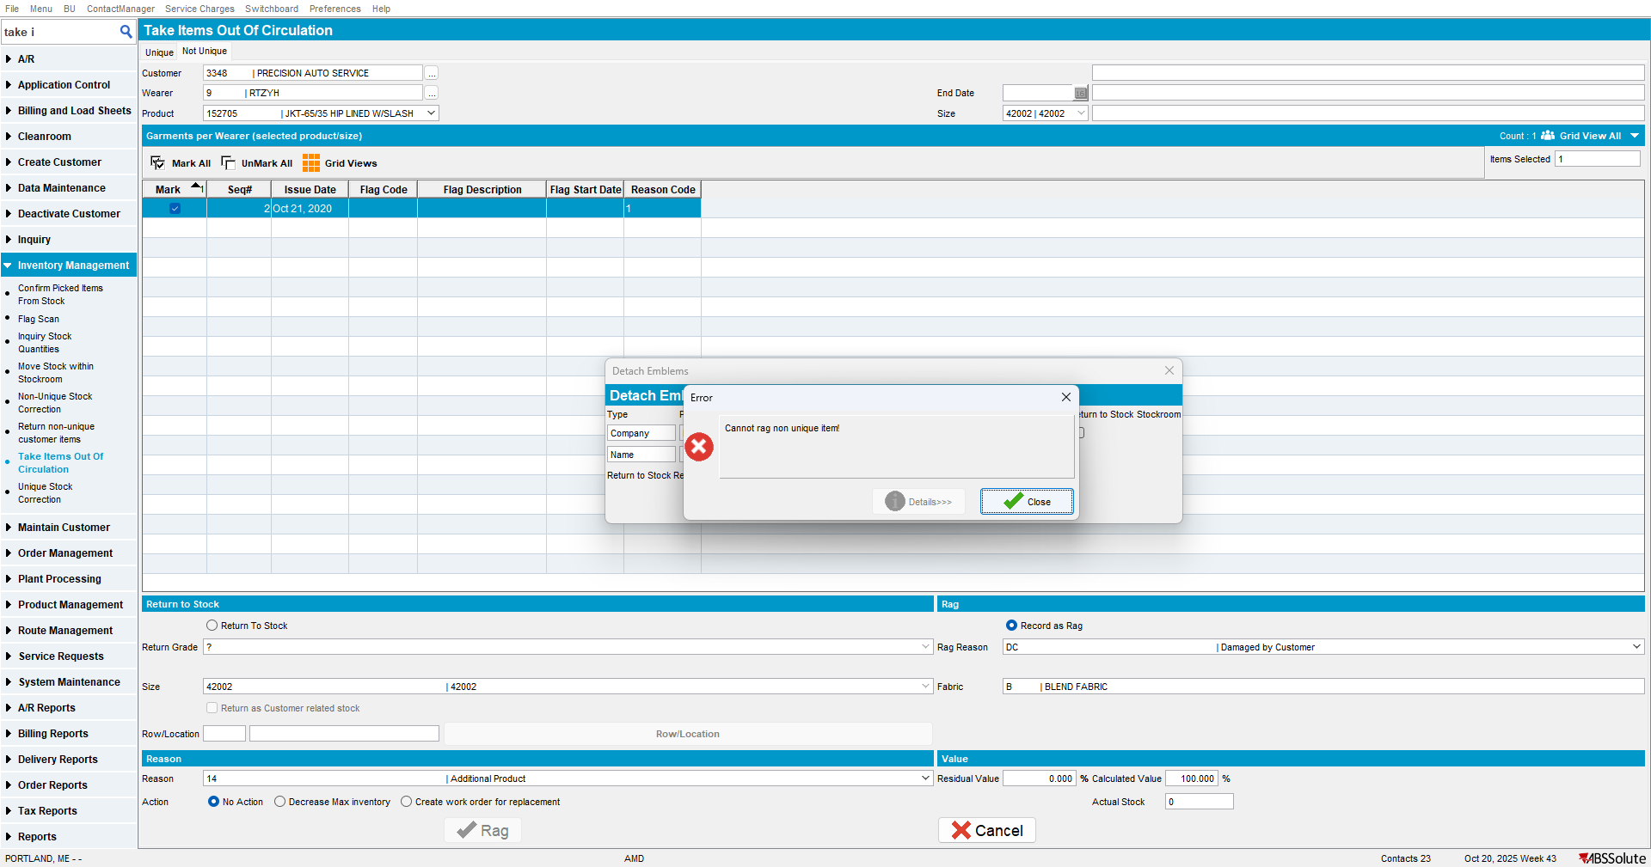
Expected behavior: The items should be ragged.
Current behavior: The items have not been ragged. An error occurred.

Retest after fix

Hash: 9.07.00.UNF21 hash: 8d9e27e5f9f1.

Step 1) Open the ‘Business Units’ dialog. Select the current BU. Go to the ‘Stockroom’ tab. Uncheck the ‘Determine default stockroom upon return to stock’ checkbox.
Step 2) Open the ‘Take Items Out Of Circulation’ dialog. Go to the ‘Not Unique’ tab. Select a customer, a wearer, and a product. Mark the Product. Select the ‘Record as Rag’ and the ‘Residual Value’ radio buttons. Select a Reason and a Rag Reason. Press the ‘Rag’ button.
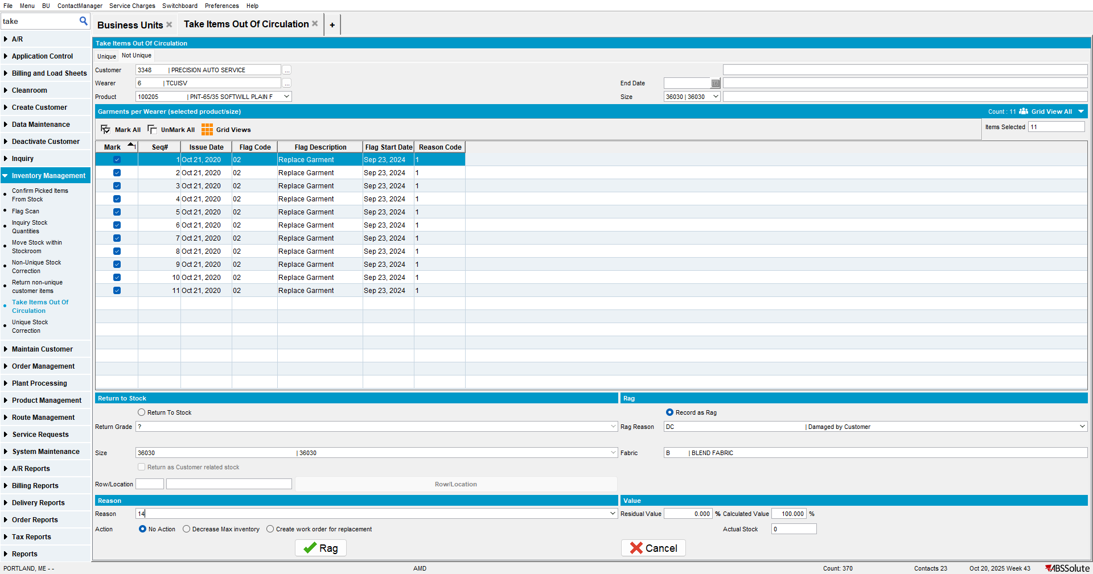
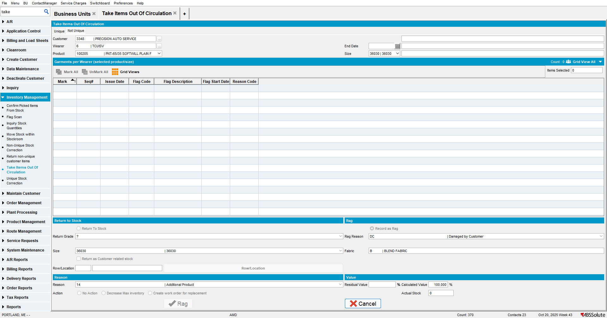
Expected behavior: The items should be ragged.
Current behavior: The items have been ragged. No error occurred.

Tested OK.

