ABSN-1064 - Contract Compliancy - Special charge showing non-compliant
Environment | Prerequisites
Version: 9.07.00.UNF21  DBServerName= abs-srv20.internal.abslbs.com  DBSID=CUST24  DBUser=UNFDEV  Environment=Test | - Module:  - System setting

Contents
Reproducing before fix 1
Steps to reproduce 1
Current Behavior 3
Expected behavior 3
Retest after fix 3
Test Case 1 – Check that the Special Charge is compliant 3

Reproducing before fix

Steps to reproduce
- Find a Contract that appears non-Compliant from the Special Charges point of view, EX: 1050376
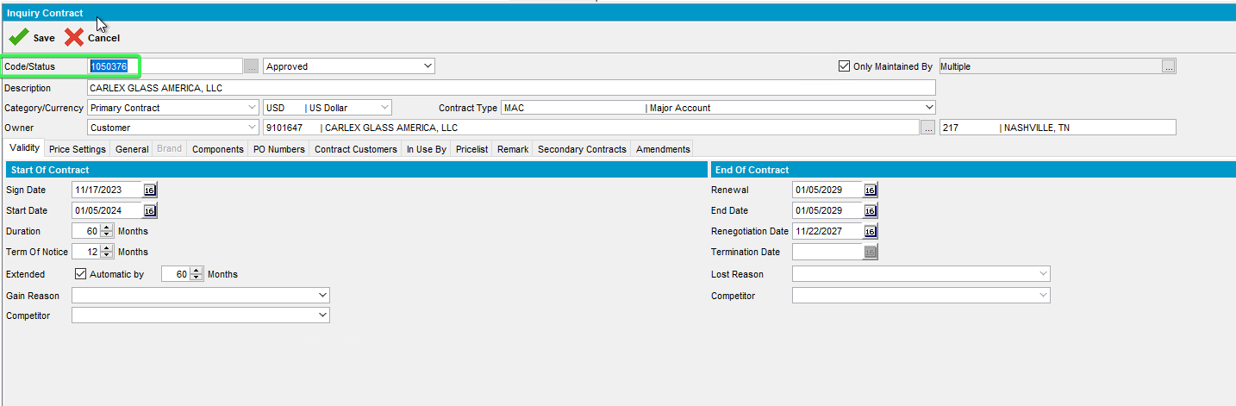
- Open the Contract dlg. in Modify mode
- Move to the Components Tab and load the compliancy
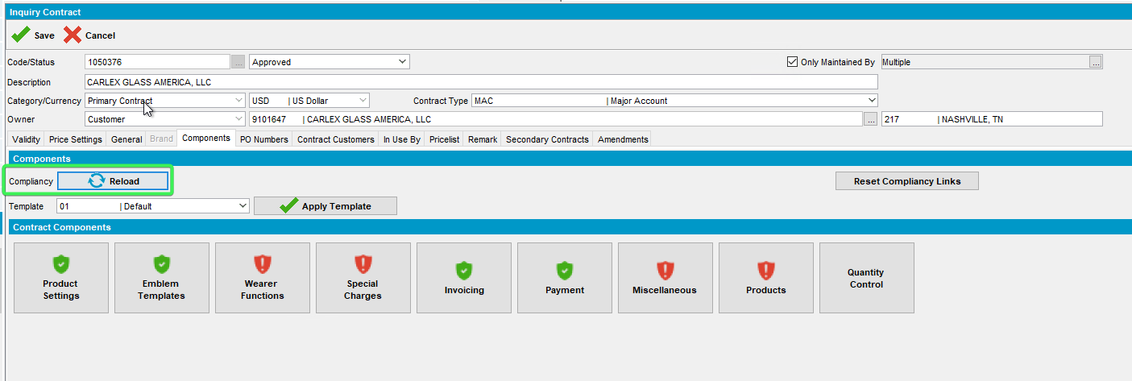
- After Loading the Compliancy button the Special Charges are marked as non-compliant
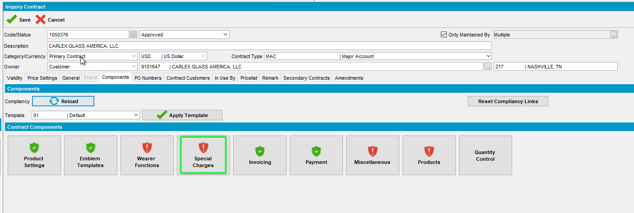
- Open the Special Charges
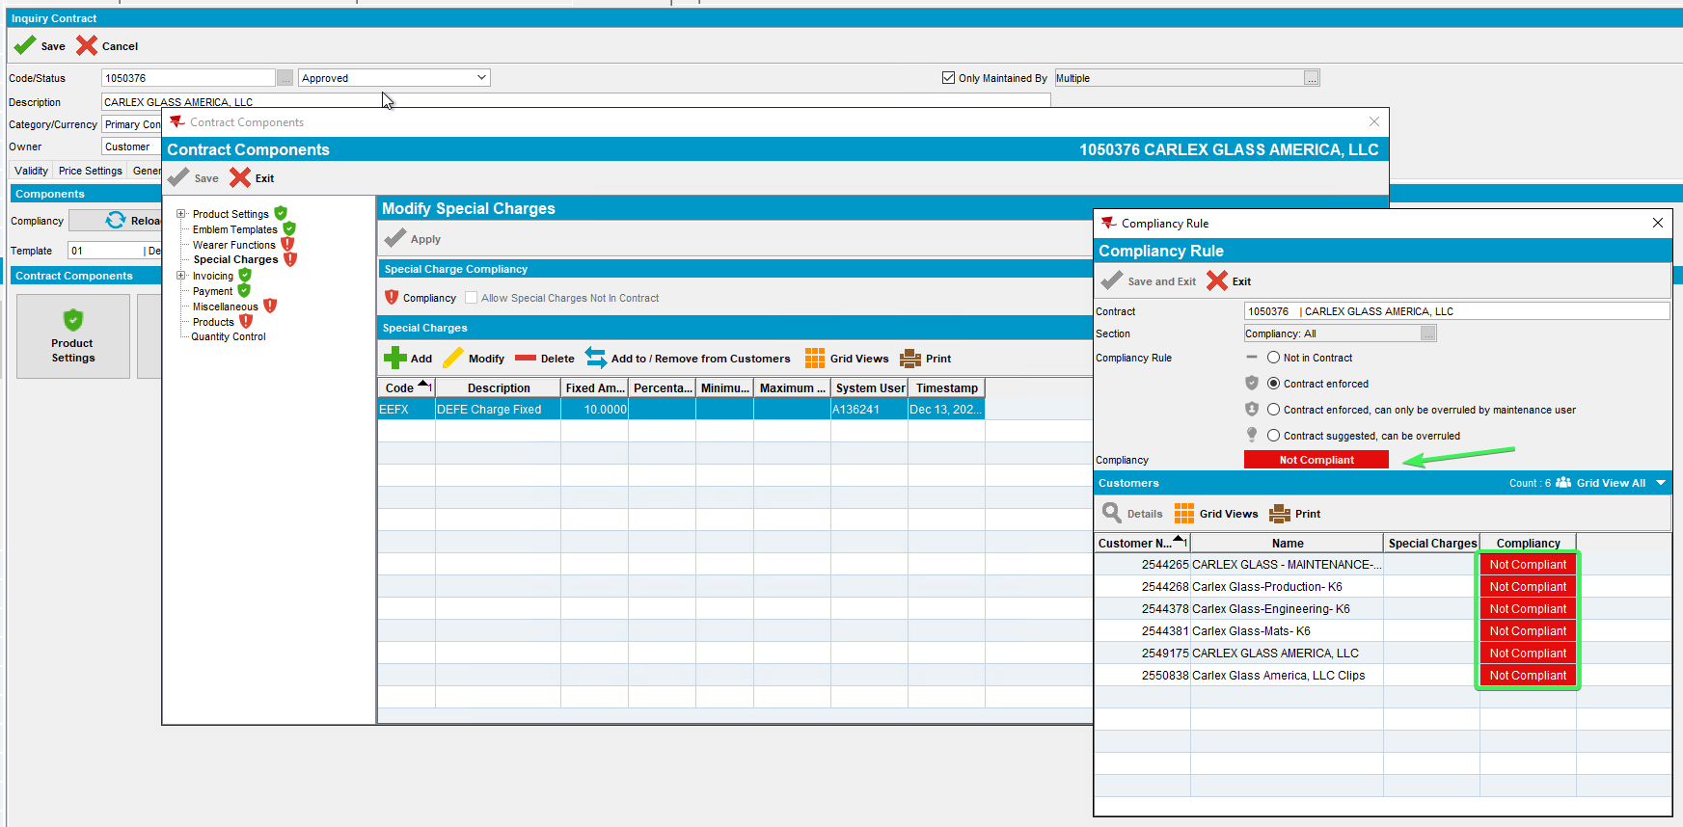
- Check the contract customer price list
- Check Price Lists for one of the contract’s customers
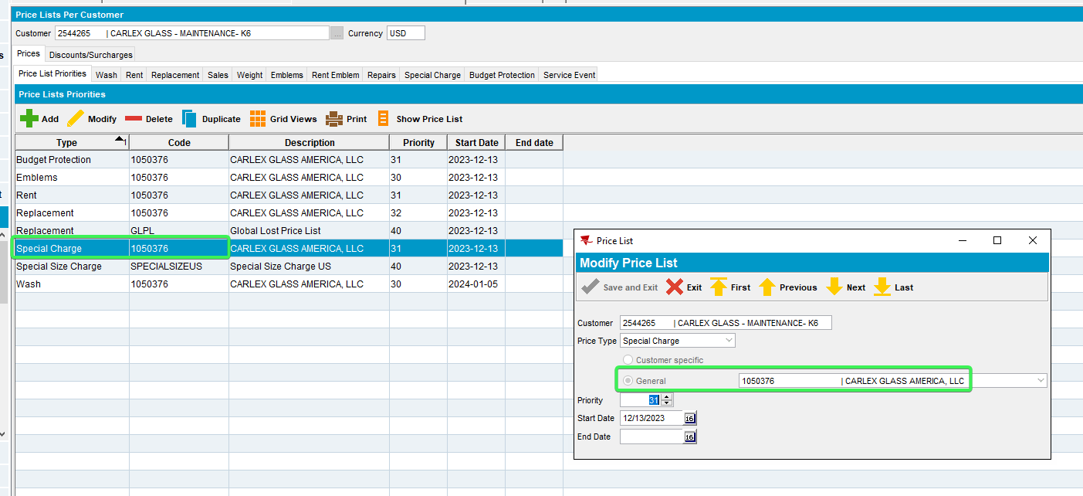
Special Charge Price list is defined for this Customer and it is linked to the correct contract.
So the Compliancy Criteria are met. The contract should not be marked as Non-Compliant
REPRODUCED OK.

Current Behavior
Special Charge shows as not compliant on contract when the special charge is linked in Price Lists per Customers DLG to the correct contract .

Expected behavior
Special Charge should show as compliant .

Retest after fix

Test Case 1 – Check that the Special Charge is compliant
Hash: bff5c103ad26
- Find a Contract that appears non-Compliant from the Special Charges point of view, EX: 1050376
- Open the Contract dlg. in Modify mode
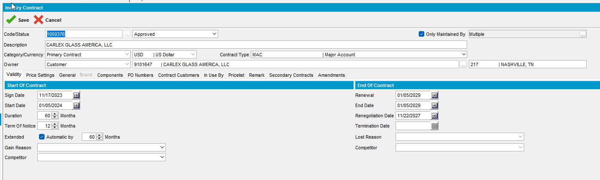
- Move to the Components Tab and load the compliancy
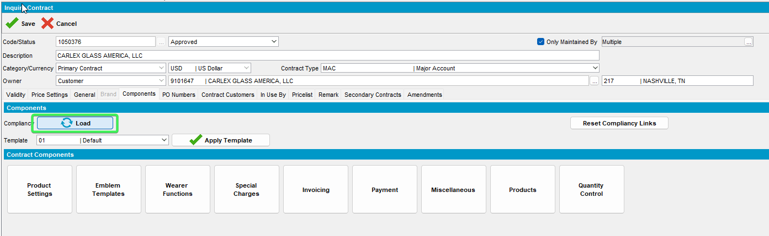
- After Loading the Compliancy see that the Special Charges is marked as compliant
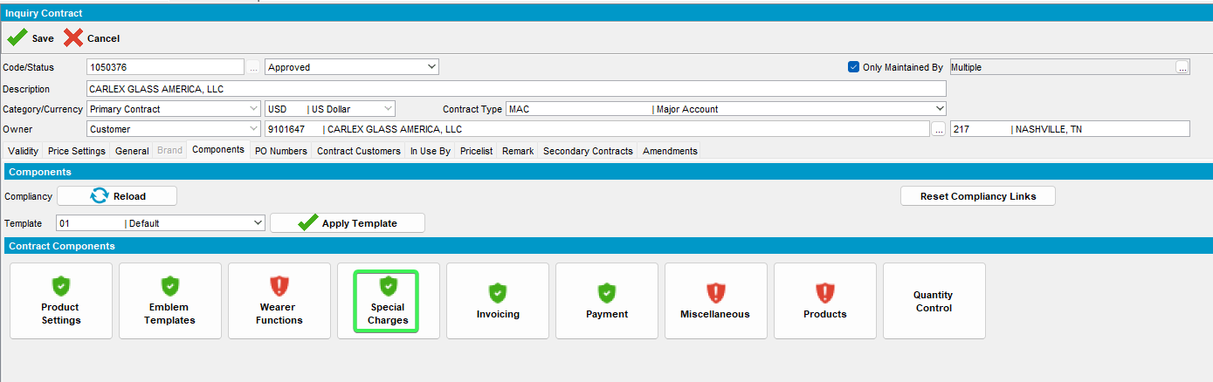
- Open the Special Charges
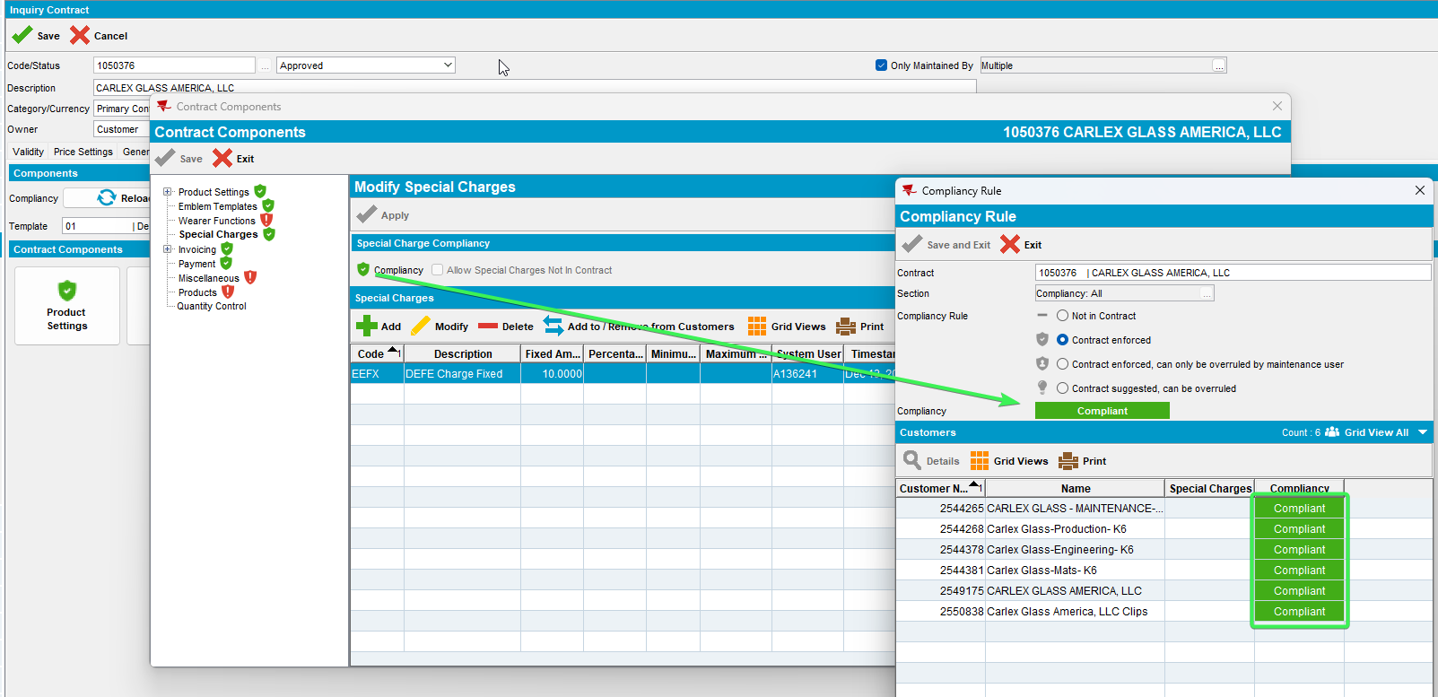
All clients appear as compliant
- Check the contract customer price list
- Check Price Lists for one of the contract’s customers
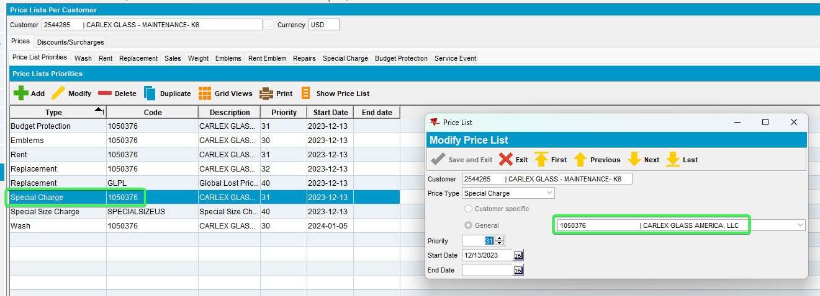
Special charge comes from contract
Tested OK

