ABSN-10497 - D_UBS_2768 RSM is able to put SR InProgress in the DBM App
Environment | Prerequisites
Version: 9.07.00.UNF21  DBServerName= abs-srv20.internal.abslbs.com  DBSID=CUST24  DBUser=UNFDEV  Environment=Test | - Module:  - System setting

Contents
Reproducing before fix 1
Steps to reproduce 1
Current Behavior 4
Expected behavior 4
Retest after fix 4
Test Case 1 – Check that contacts which need a follow up on RA cannot be completed on WebX 4

Reproducing before fix

Steps to reproduce
- RSC: Create a new route with a few customers on it
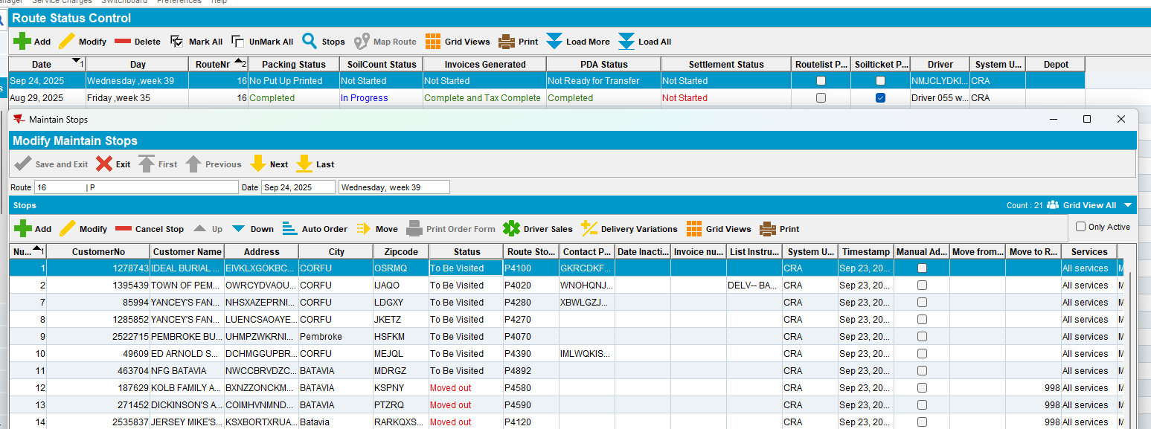
- Generate invoices and script taxes
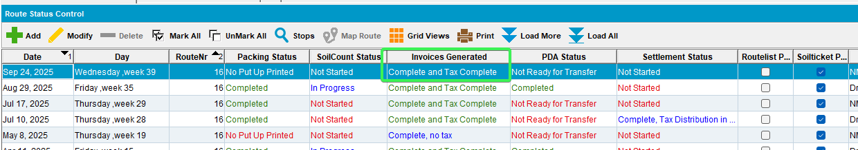
- Set PDA Status to Ready for Transfer and download the route to PDA
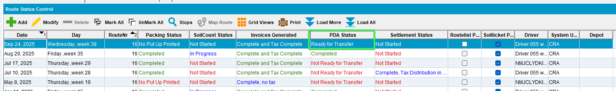
- Arrive at a customer and create a new Contact Note
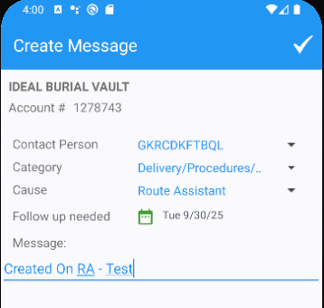
- Create Contact for few more customers
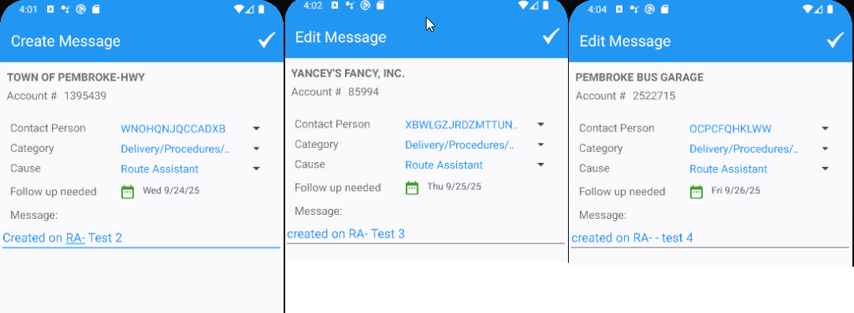
- Settle and depart
- WebX: Complete Start my day
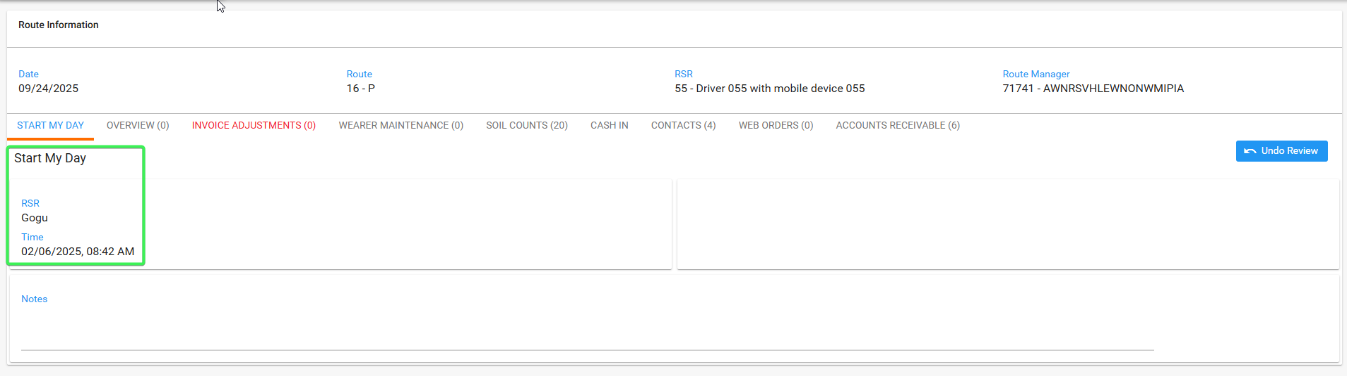
- Contacts Tab: For one of the Contacts you created on RA set it “In Progress”
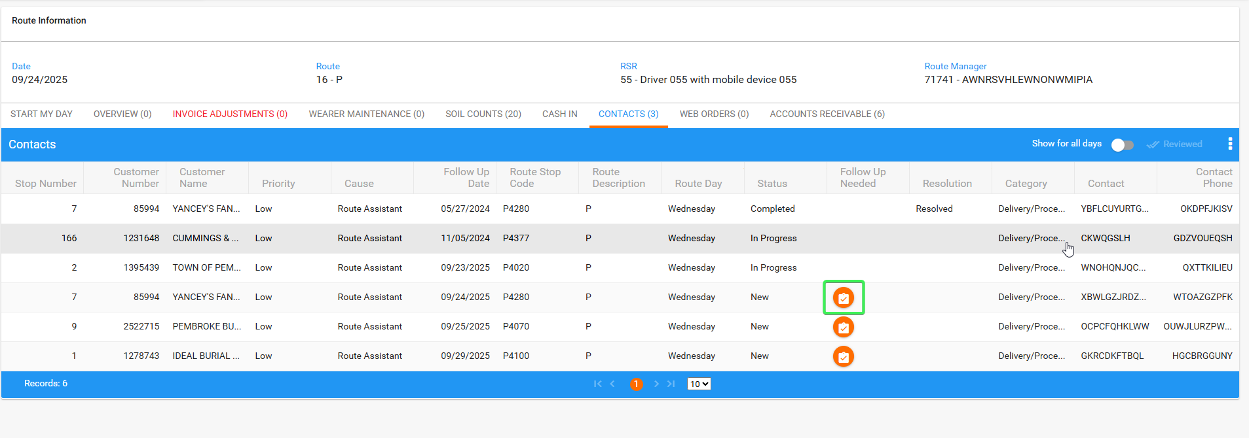
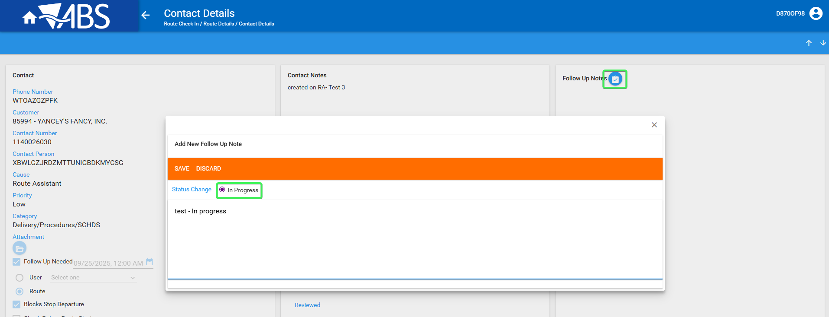
- The same contact, now In Progress, set it as complete
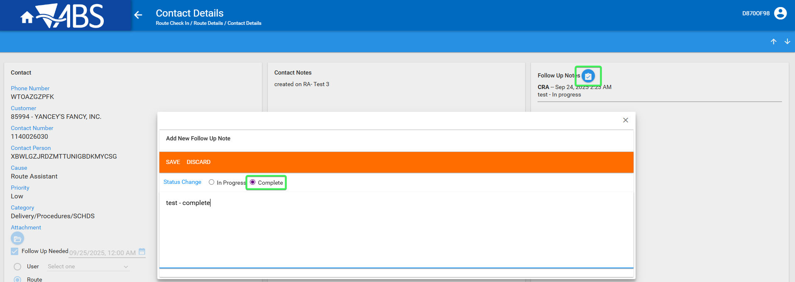
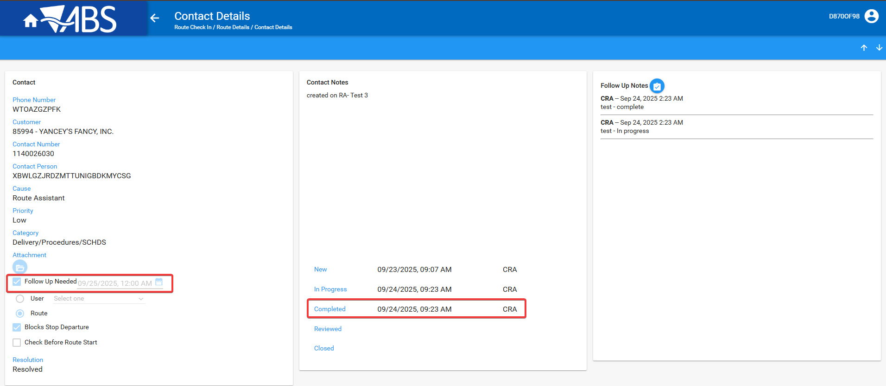
REPRODUCED OK.

Current Behavior
The contact can be set as complete on WebX, but it should be done on RA

Expected behavior
The contact cannot be processed as complete on WebX when it has a follow up on route

Retest after fix

Test Case 1 – Check that contacts which need a follow up on RA cannot be completed on WebX
Hash: 9.07.00.UNF21 hash: 8849b4e7d95a
- RSC: Create a new route with a few customers on it
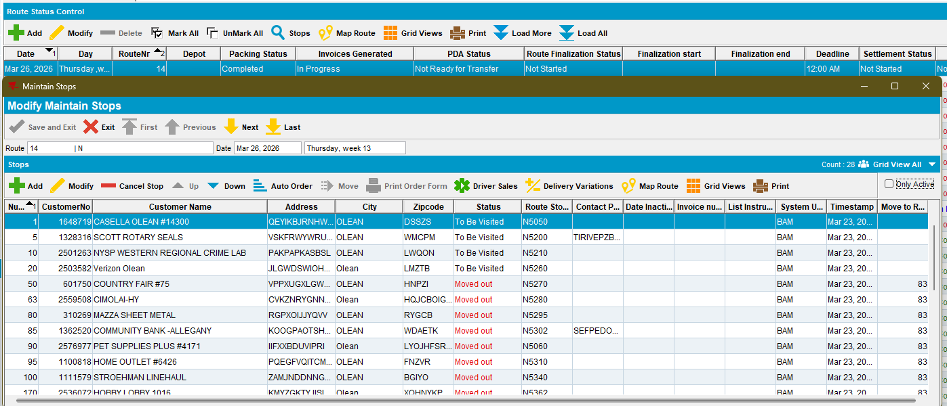
- Generate invoices and script taxes
- Set PDA Status to Ready for Transfer and download the route to PDA
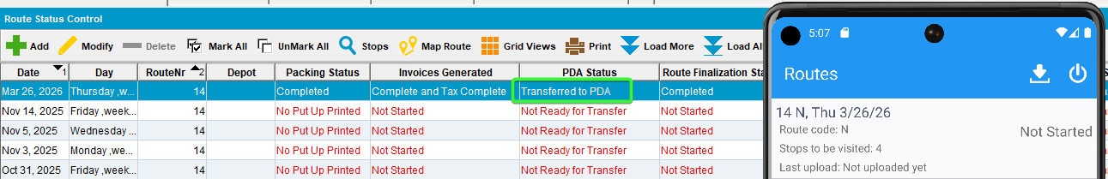
- Arrive at customers and create a new Contact Note for each of them
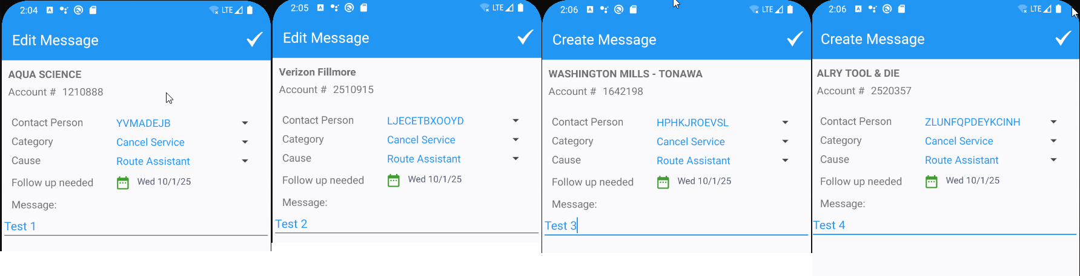
- Settle and depart > upload data
- WebX: Complete Start my day
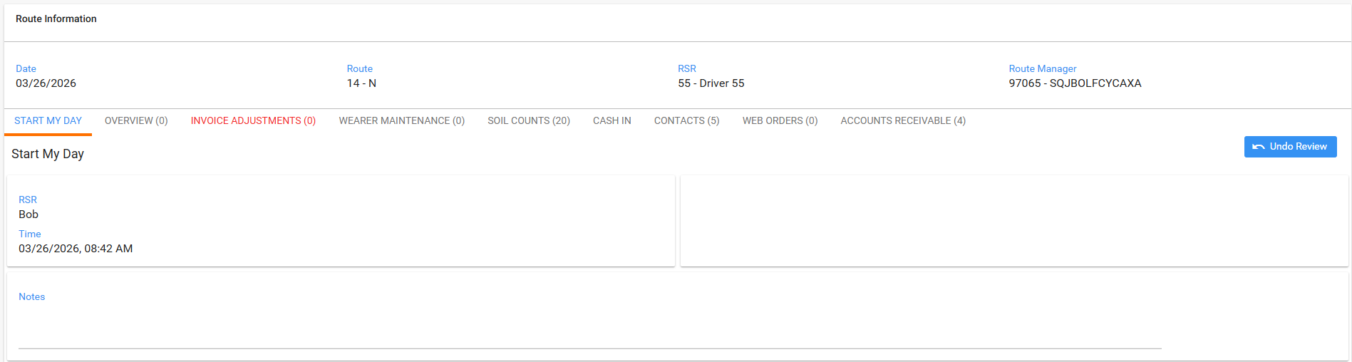
- Contacts Tab: For one of the Contacts you created on RA set it “In Progress”
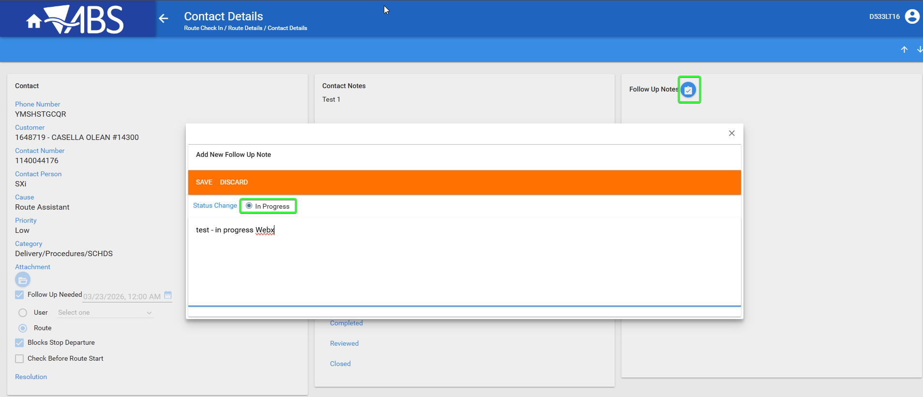
- The same contact, now In Progress, set it as complete
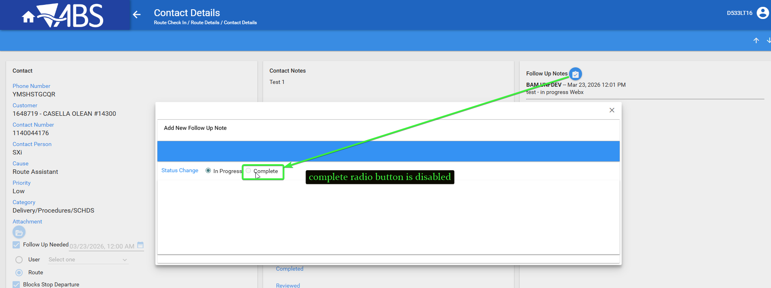
Tested OK

