ABSN-10115 Contact followup notes Customer Communication flag
Environment | Prerequisites
Version: 9.07.00.UNF20  DBServerName= abs-srv20.internal.abslbs.com  DBSID=CUST24  DBUser=UNFDEV  Environment=TEST | - Module:  - System setting: CONTACTCUSTOMERCOMS  - Others…

Contents
Test case 1 – System Setting CONTACTCUSTOMERCOMS = 0 1
1.1 – Contact categories – Tested OK 2
1.2 - Contact manager, Contact Monitor dlg – Tested OK 3
1.3 - Route Assistant – Tested OK 5
1.4 - RouteTransaction table – Tested OK 9
1.5 – WebClientX – Tested OK 10
Test case 2 – System Setting CONTACTCUSTOMERCOMS = 1 11
2.1 – Contact categories – Tested OK 12
2.2 - Contact manager, Contact Monitor dlg, Contacts dlg – Tested OK 13
2.3 - Route Assistant – Tested OK 17
2.4 - RouteTransaction table – Tested OK 22
2.5 – WebClientX – Tested OK 22
Test case 3 – Check that ContactFollowUpNote.CustomerComsName and ContactCategory.CustomerCommunication are present after updating RA from an older version 28

Test case 1 – System Setting CONTACTCUSTOMERCOMS = 0
Hash: 9.07.00.UNF21 hash: 7f3c7851619d

System Settings dlg: Set CONTACTCUSTOMERCOMS =0
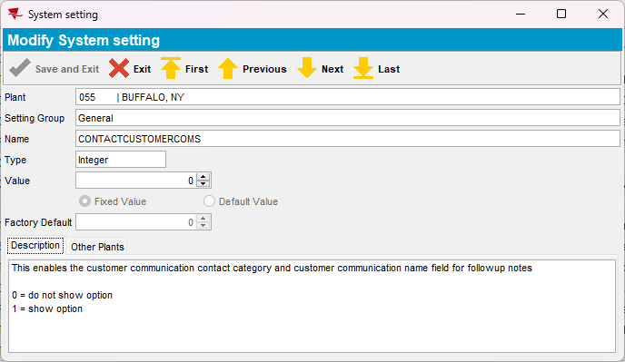

1.1 – Contact categories – Tested OK

Expected behavior:
Contact name – 40 characters max
Customer Communication – Y/N field to enable customer communication name field for followup notes. Default is N
Contact Category dlg - If system setting CONTACTCUSTOMERCOMS = 1 then show ContactCategory.CustomerCommunication

Steps:

- Contact Categories dlg: Add a new contact and check for the Customer Communication option, is not present.
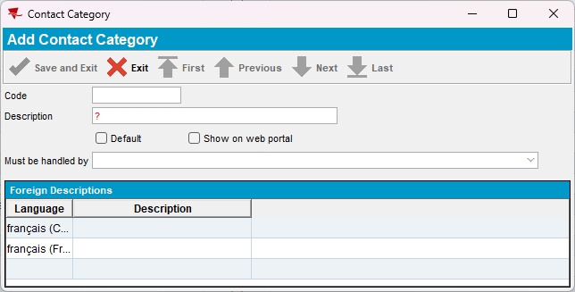
- Contact Category dlg: Check for the column Customer Communication, is not present.
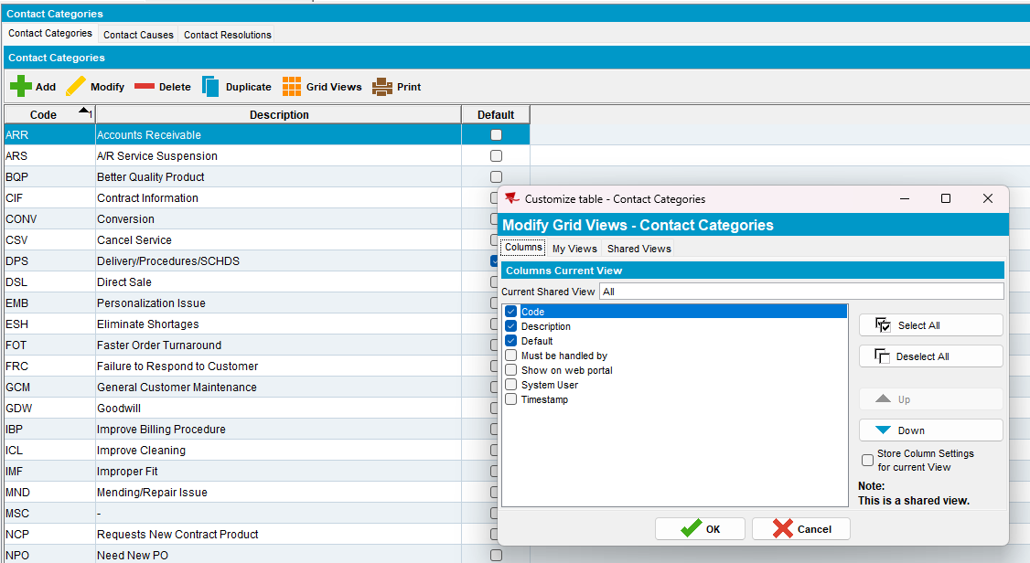

1.2 - Contact manager, Contact Monitor dlg – Tested OK

If system setting CONTACTCUSTOMERCOMS = 1 and ContactFollowUpNote.CustomerComsName is not NULL then line 2 becomes line 3 and on line 2, we show the text “Customer Communication With: <ContactFollowupNote. CustomerComsName>”
Free non mandatory text entry field (40 characters) for the name of the person you spoke with
Visible if system setting CONTACTCUSTOMERCOMS = 1 and contact category is for customer communication (Contact.ContractCategory. CustomerCommunication = Y)
Enabled if in ADD mode
Redisplay in Modify / View mode
CFU. CustomerComsName = value from screen field (May be NULL)

Steps:
- Contact Manager dlg: Add a new contact
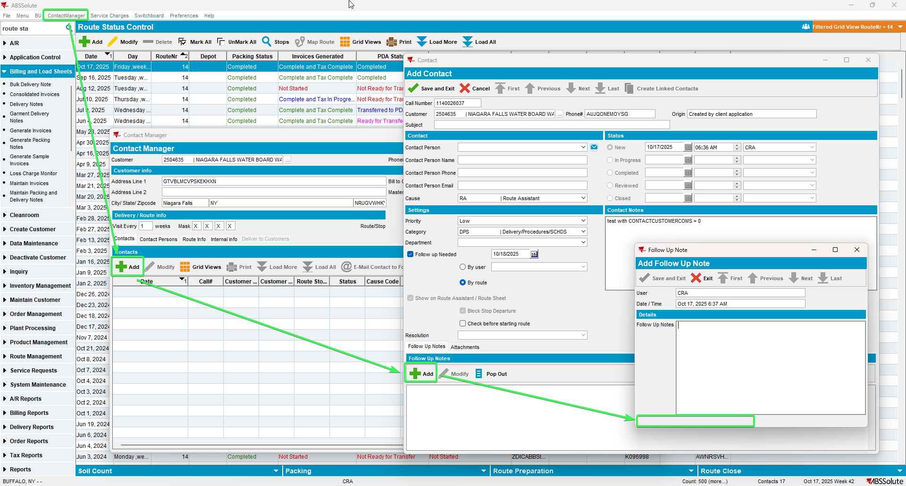
The customer communication section is not present.
- PLSQL: Make a check in database for table contact followupnote of column CUSTOMERCOMSNAME

select cfn.contactfollowupnote_id, cfn.customercomsname, cfn.* from contactfollowupnote cfn
join contact c on c.contact_id = cfn.contact_id
where c.callnumber= 1140026037;
Was not populated
- Contact Monitor dlg: Add a new contact for the same customer.
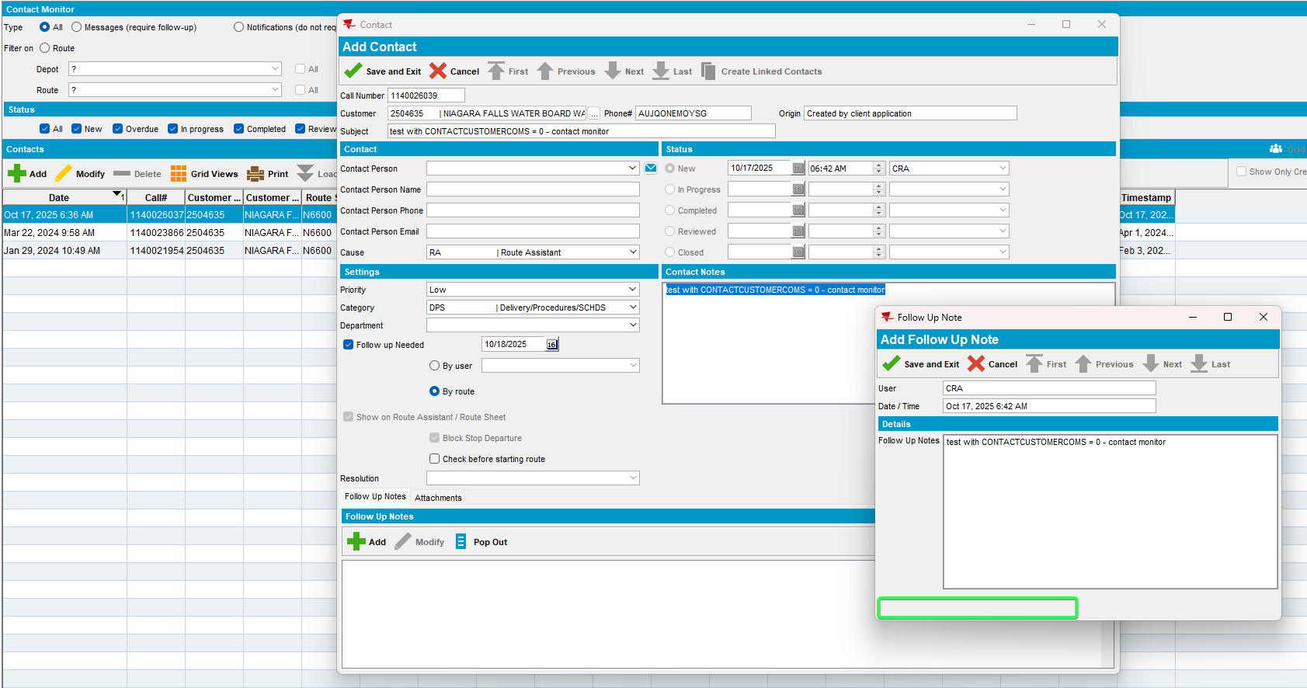
- PLSQL: Make a check in database for table contact followupnote of column CUSTOMERCOMSNAME

select cfn.contactfollowupnote_id, cfn.customercomsname, cfn.* from contactfollowupnote cfn
join contact c on c.contact_id = cfn.contact_id
where c.callnumber= 1140026039;
Was not populated

1.3 - Route Assistant – Tested OK
Hash: RouteAssistant_v12.40.INTERNAL_TEST_ONLY.a9d200977

- RSC dlg: Add a new route containing the customer, generate packing note and invoices and send the route to PDA.
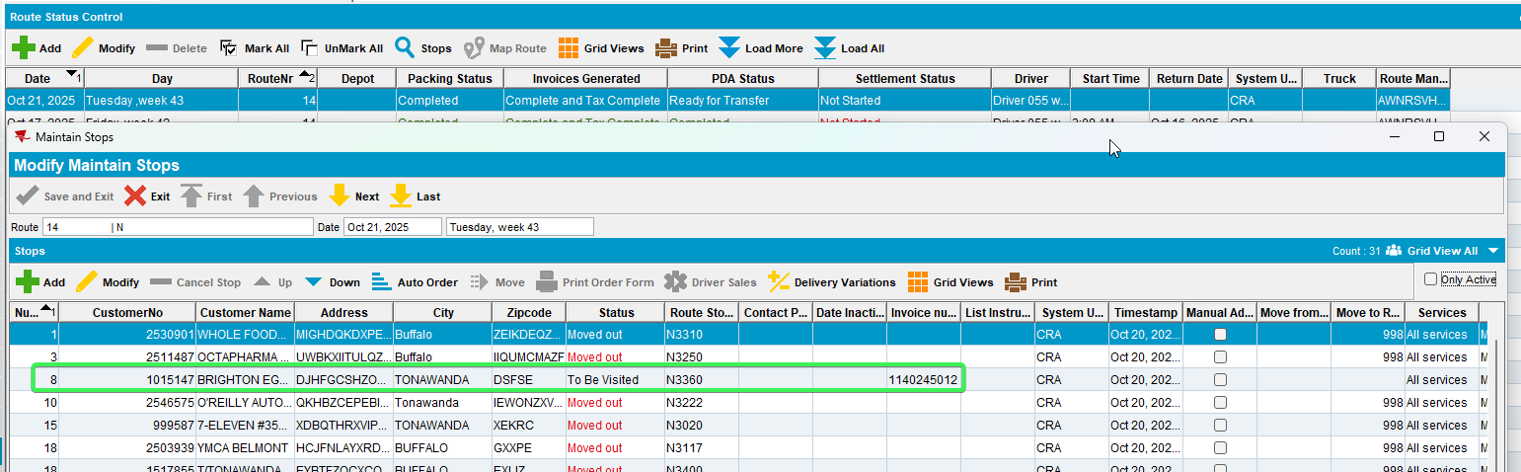
- RA: Arrive at the customer and check the contact messages. Respond to a contact while completed it.
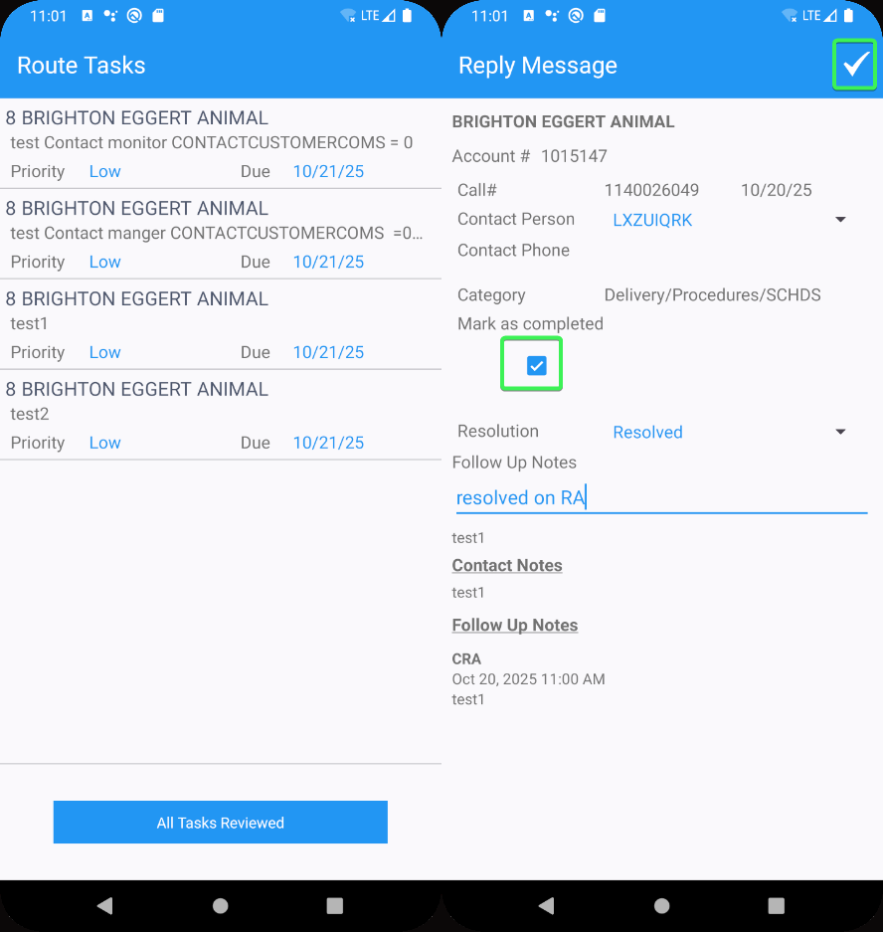

- RA: Respond to another contact while not complete it.
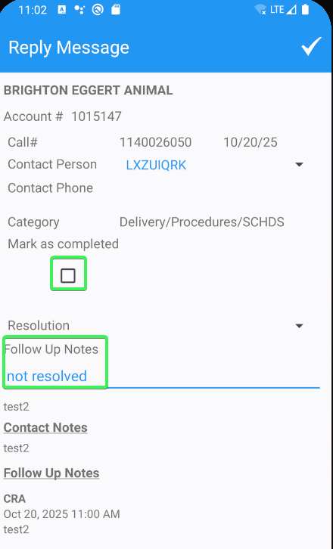
- RA: The other 2 contacts do not respond to them.
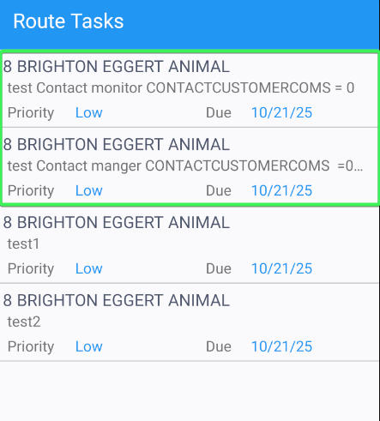
- RA: Create a new contact message from RA.
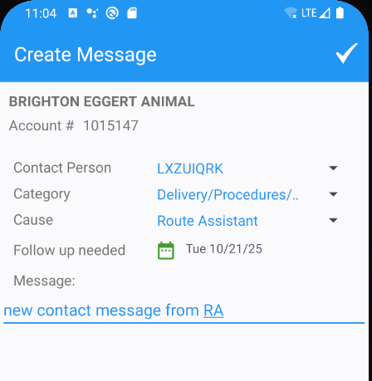
- RA: Replay to the remaining messages to settle and depart from customer.
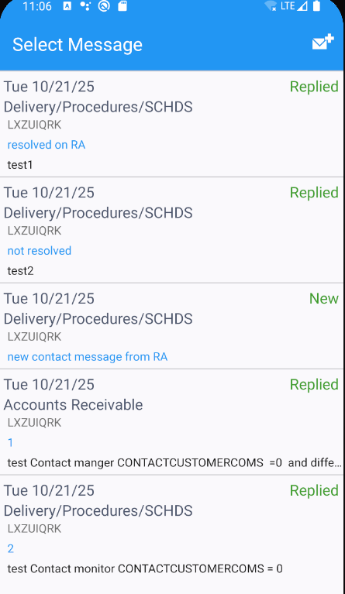

The follow up notes are shown from the table ContactFollowUpNotes in timestamp descending order (most recent at the top)
Line 1: Username in bold
Line 2: Timestamp
Line 3: Only shown if ContactFollowUpNoteDTO. CustomerComsName is not NULL then “Customers Coms With: < ContactFollowUpNoteDTO. CustomerComsName>”

This field is only shown if the contact category is marked for “Customer Communication” (ContactCategoryDTO. CustomerCommunication = Y)
40-character non mandatory text field to enter the name of the person at the customer site that this was discussed with.
Check from RA database the following tables and contents.

ContactCategoryDTO table - Y/N ContactCategory. CustomerCommunication
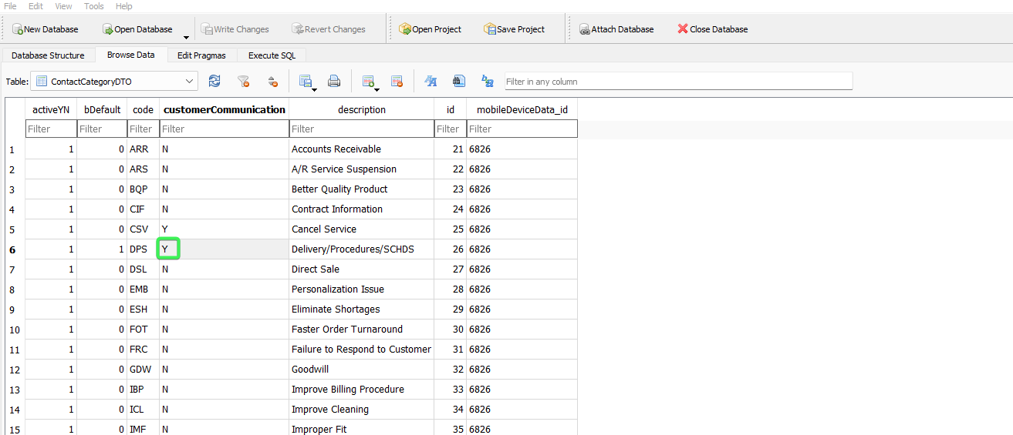
ContactFollowUpNoteDTO – Field name CustomerComsName

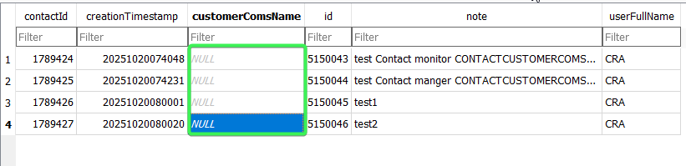

TransactionDTO

String3 | ContactFollowUpNote.CustomerComsName
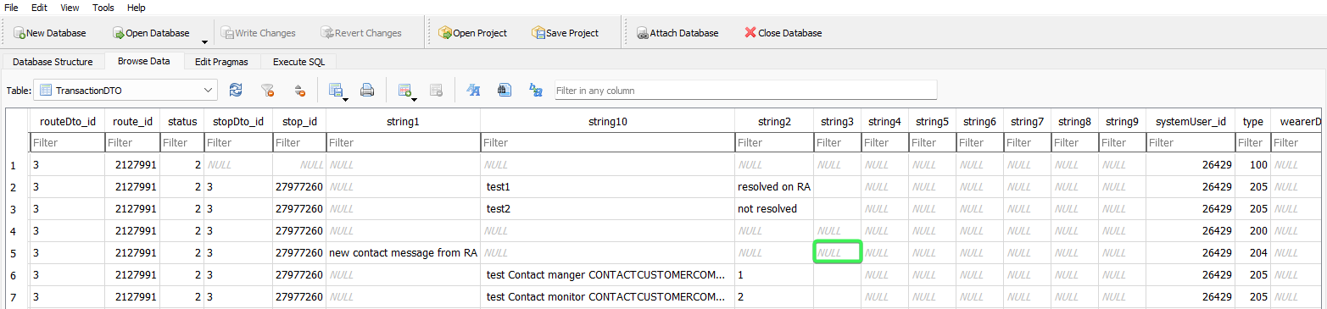
11. RA: Finish the route and upload it.

1.4 - RouteTransaction table – Tested OK

- Check in database the route for transaction type 205
stringvalue 3 for transaction type 205
select rt.stringvalue3, rt.* from routetransaction rt
join routecontrol rc on rc.routecontrol_id = rt.routecontrol_id
where rc.routecontrol_id =
(select rc.routecontrol_id
from routecontrol rc
join route r
on r.route_id = rc.route_id
join plant p
on p.plant_id = r.plant_id
where rc.drivingdate = to_date('21/10/2025', 'dd/mm/yyyy')
and r.routenumber = 14
and p.code = '055')
and rt.routetransactiontype_id = 205;
The column doesn’t contain anything because there was no customer communication with added

1.5 – WebClientX – Tested OK

Line 2 If system setting CONTACTCUSTOMERCOMS = 1 and ContactFollowUpNote.CustomerComsName is not NULL then line 2 becomes line 3 and on line 2, we show the text “Customer Communication With: <ContactFollowupNote. CustomerComsName>”

Free text entry field (40 characters), not mandatory
Visible if system setting CONTACTCUSTOMERCOMS = 1 and contact category is for customer communication (Contact.ContractCategory. CustomerCommunication = Y)
Enabled if in ADD mode
Redisplay in Modify / View mode

- WebX: Load the route that was uploaded and finish the start my day.
- WebX: Go to Contacts and open a contact message.
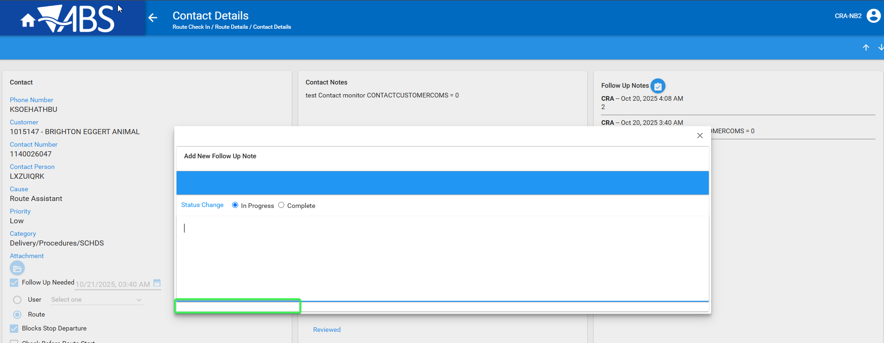
There is no presence of the customer communication with
- WebX: Reply to the new contact message follow up note
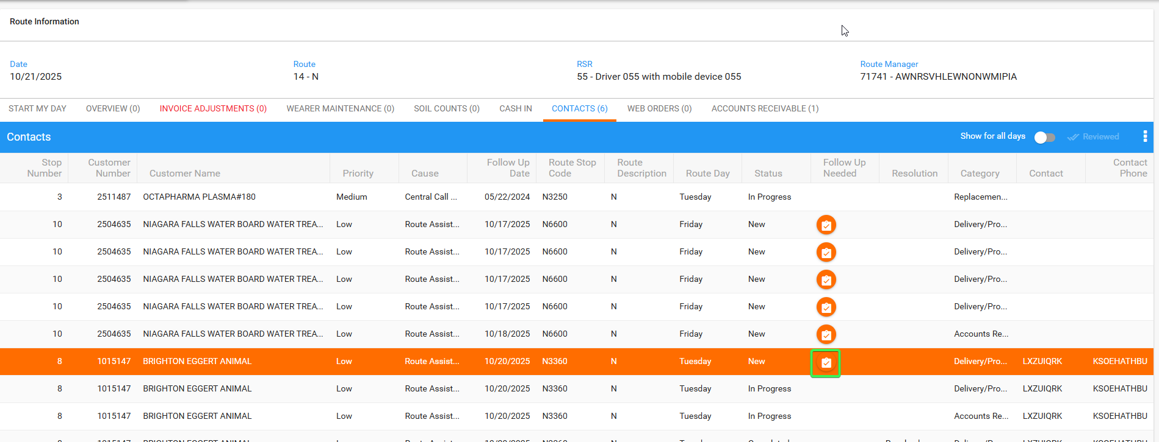
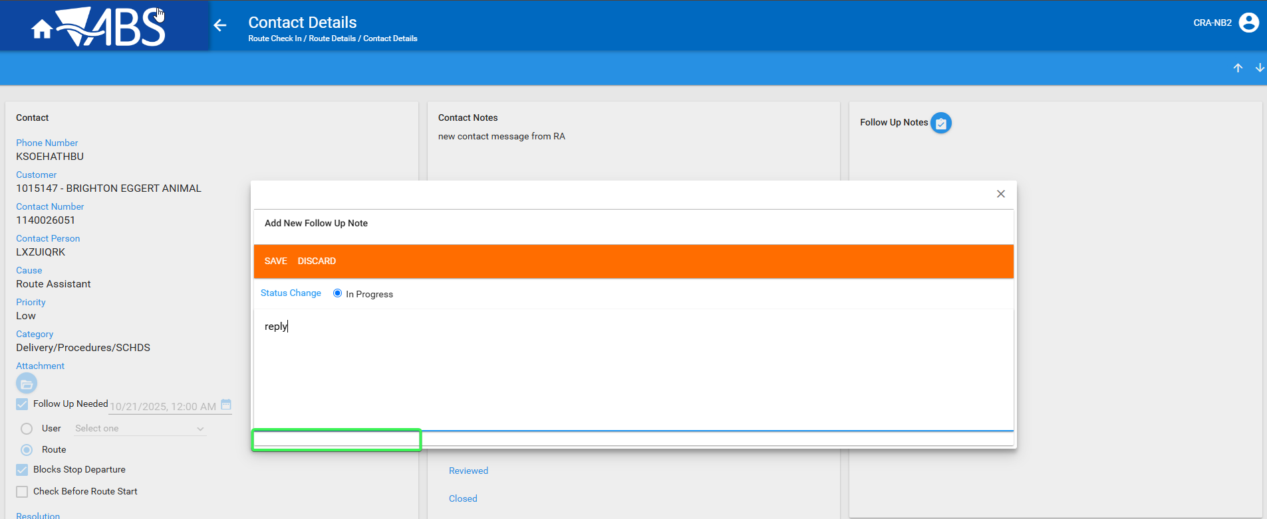

There is no presence of the customer communication with

Test case 2 – System Setting CONTACTCUSTOMERCOMS = 1
Hash: 9.07.00.UNF21 hash: 7f3c7851619d
System Settings dlg: Set CONTACTCUSTOMERCOMS =1
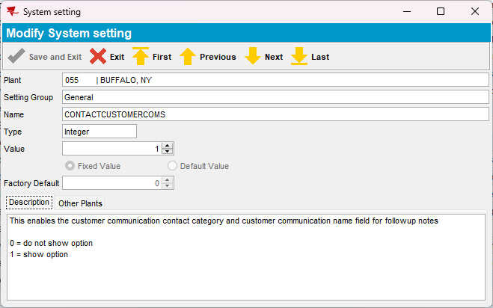

2.1 – Contact categories – Tested OK

Expected behavior:
Contact name – 40 characters max
Customer Communication – Y/N field to enable customer communication name field for followup notes. Default is N
Contact Category dlg - If system setting CONTACTCUSTOMERCOMS = 1 then show ContactCategory.CustomerCommunication

Steps:

- Contact Categories dlg: Add a new contact and check for the Customer Communication option, is present.
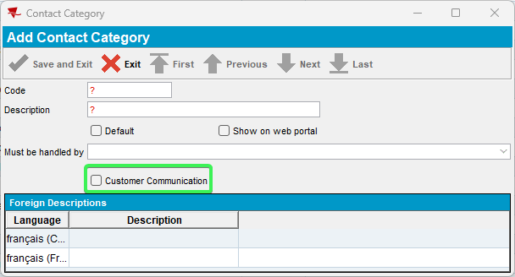
- Contact Category dlg: Check for the column Customer Communication, is present.
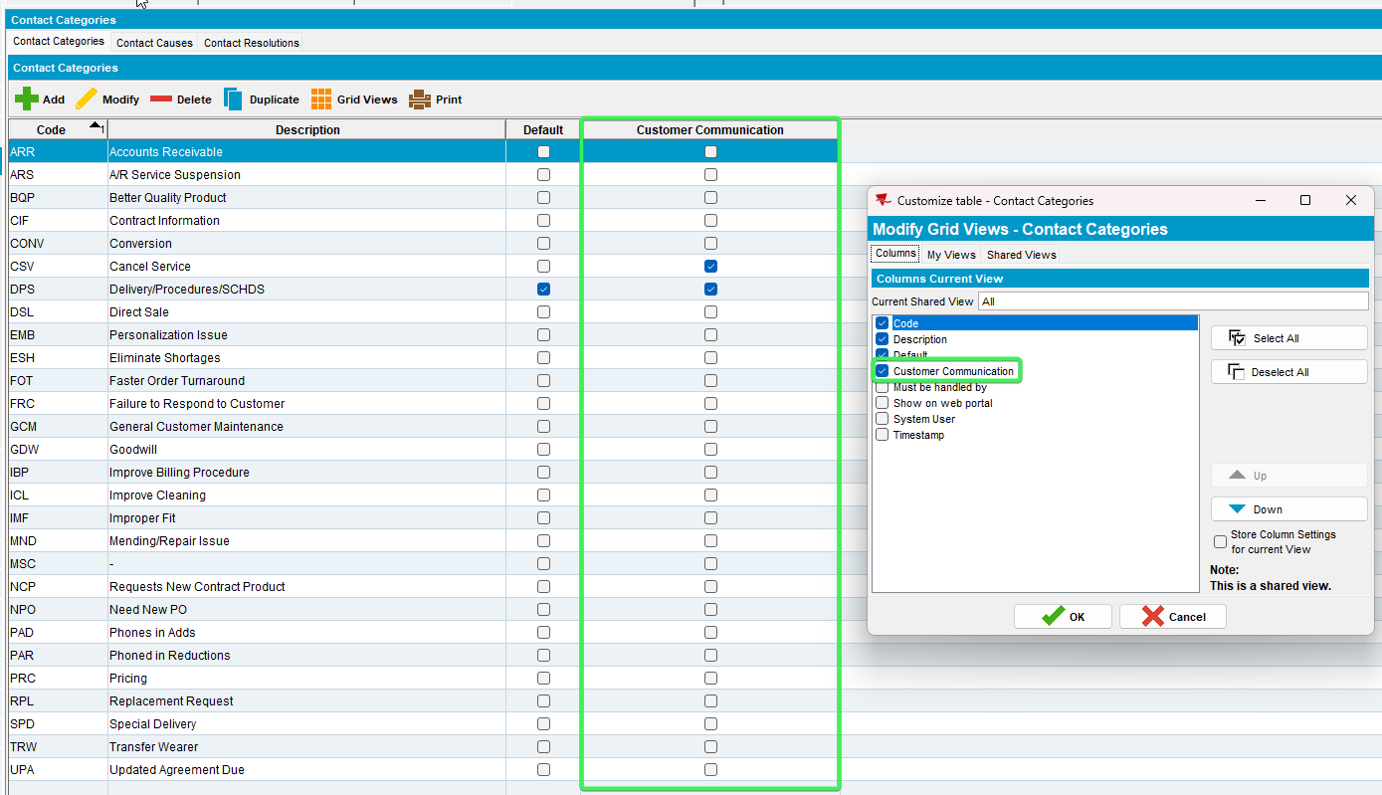

2.2 - Contact manager, Contact Monitor dlg, Contacts dlg – Tested OK

If system setting CONTACTCUSTOMERCOMS = 1 and ContactFollowUpNote.CustomerComsName is not NULL then line 2 becomes line 3 and on line 2, we show the text “Customer Communication With: <ContactFollowupNote. CustomerComsName>”
Free non mandatory text entry field (40 characters) for the name of the person you spoke with
Visible if system setting CONTACTCUSTOMERCOMS = 1 and contact category is for customer communication (Contact.ContractCategory. CustomerCommunication = Y)
Enabled if in ADD mode
Redisplay in Modify / View mode
CFU. CustomerComsName = value from screen field (May be NULL)

Steps:
- Contact Manager dlg: Add a new contact
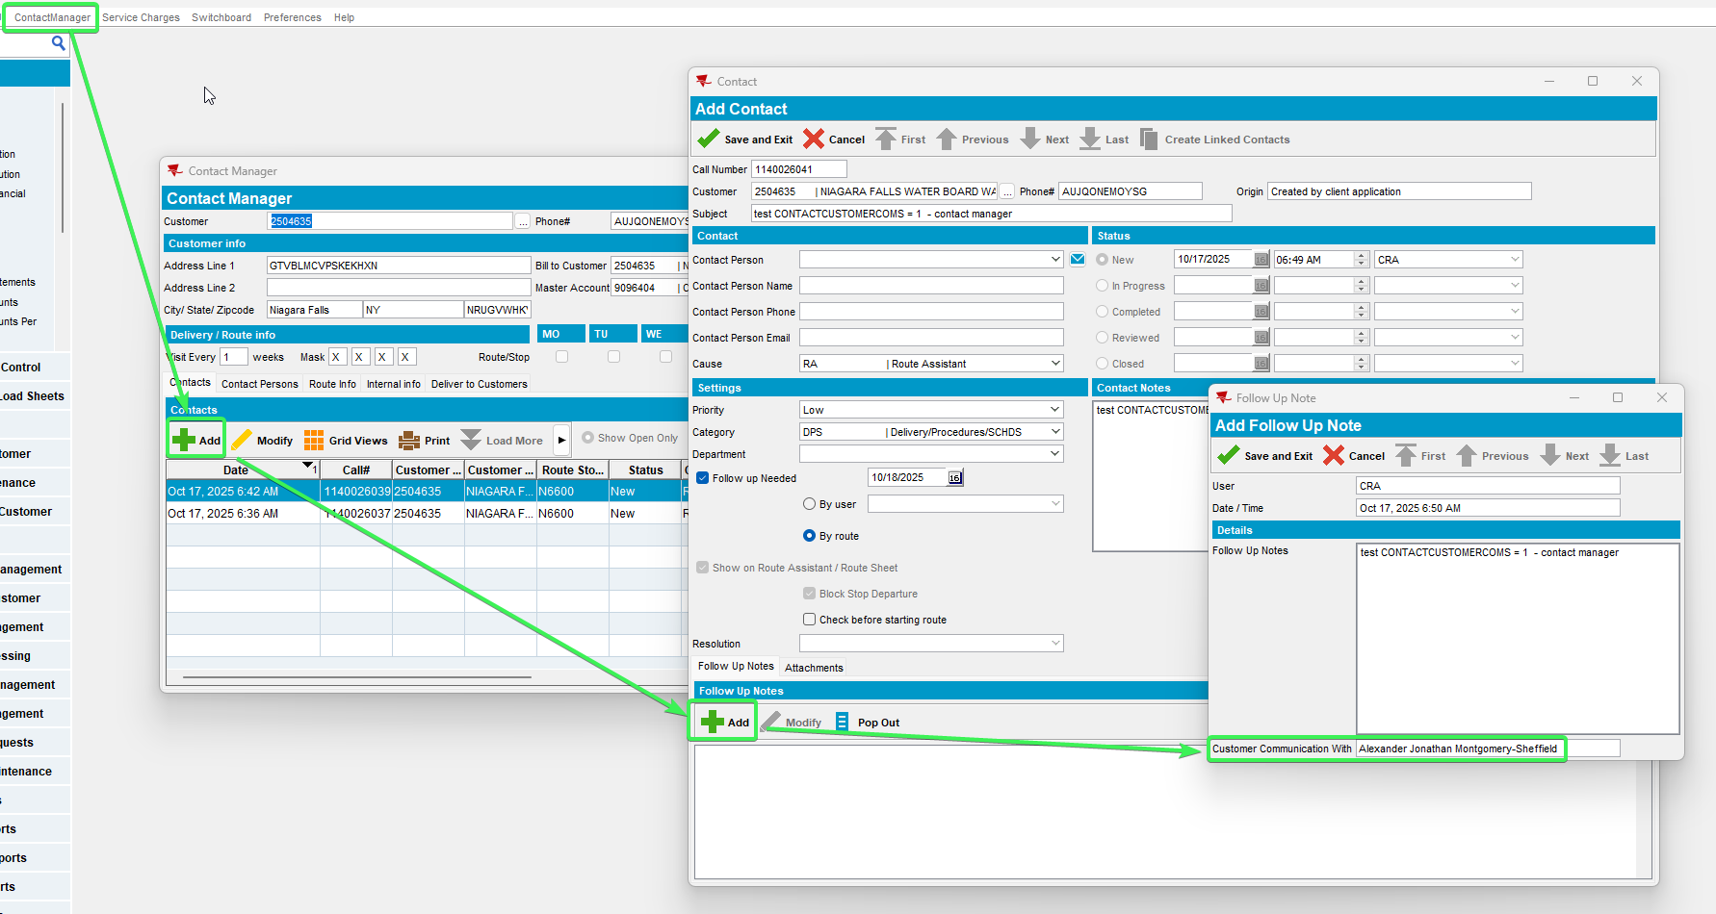
The customer communication section is present.

- PLSQL: Male a check in database for table contact followupnote of column CUSTOMERCOMSNAME

select cfn.contactfollowupnote_id, cfn.customercomsname, cfn.* from contactfollowupnote cfn
join contact c on c.contact_id = cfn.contact_id
where c.callnumber= 1140026041;
Was populated with 40 characters
- Contact Manager dlg: Change the category and put one that wasn’t configured with Customer Communication With
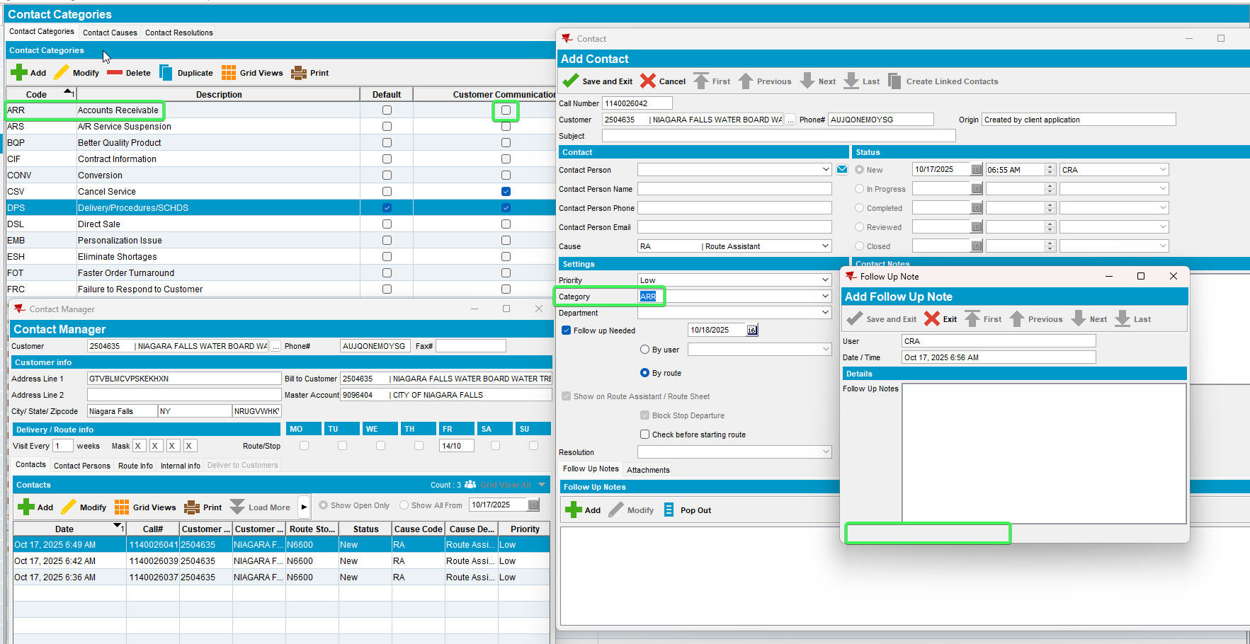
The customer communication section is not present.

- Contact Monitor dlg: Add a new contact for the same customer.
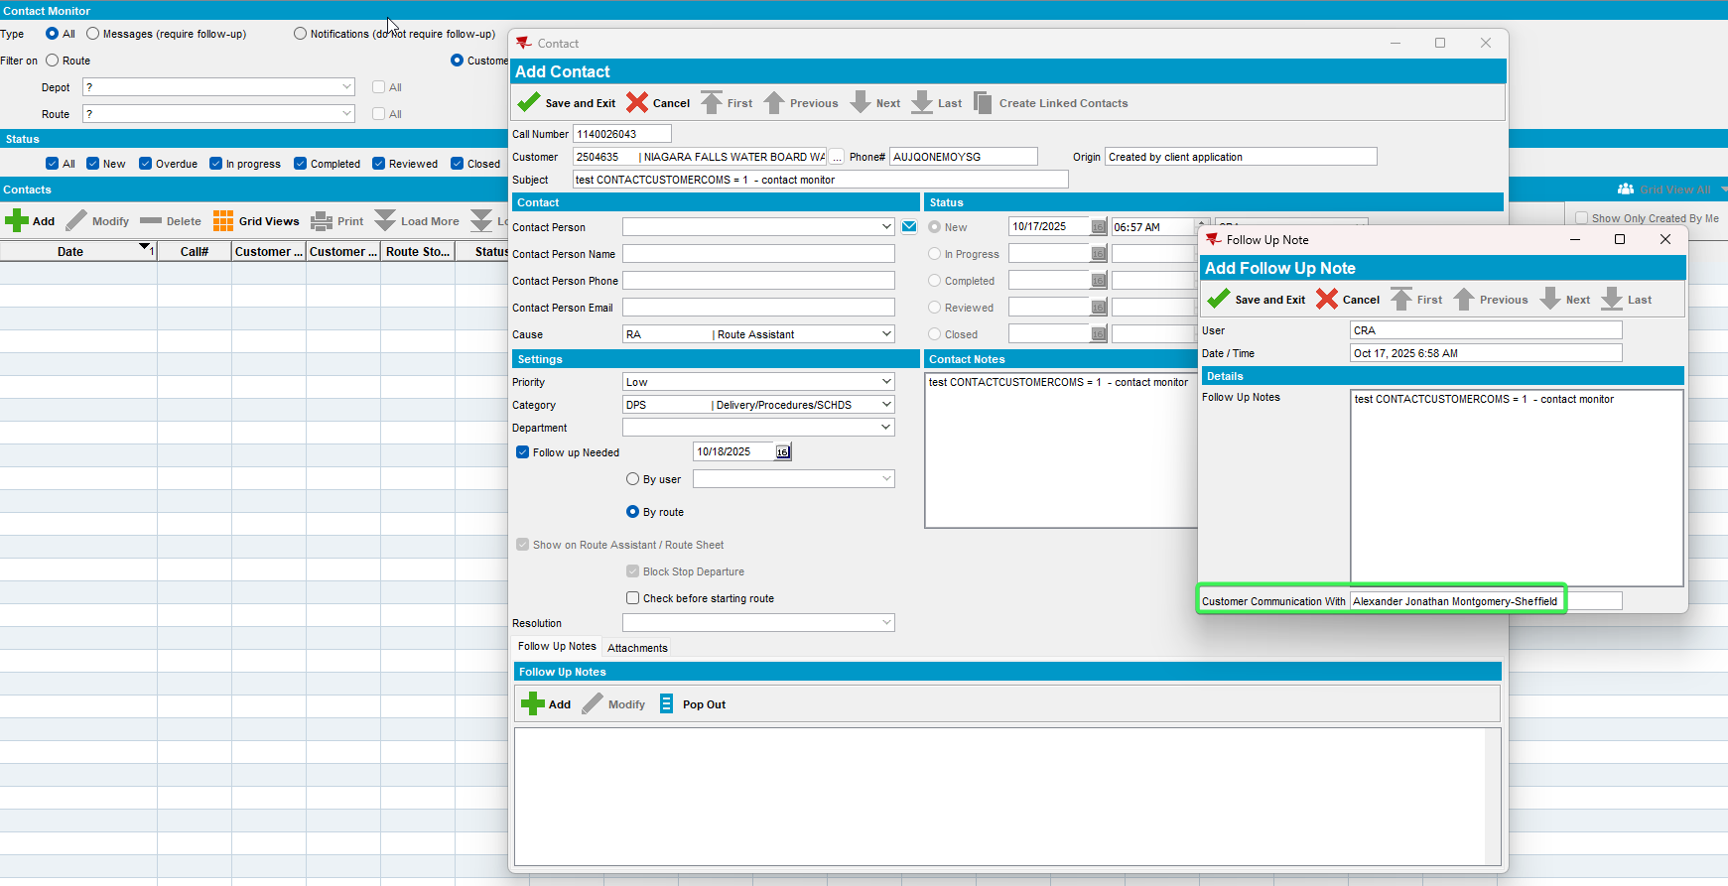
- PLSQL: Make a check in database for table contact followupnote of column CUSTOMERCOMSNAME

select cfn.contactfollowupnote_id, cfn.customercomsname, cfn.* from contactfollowupnote cfn
join contact c on c.contact_id = cfn.contact_id
where c.callnumber= 1140026043;
Was populated
- Contact Monitor dlg: Change the category and put one that wasn’t configured with Customer Communication With. The customer communication section is not present.
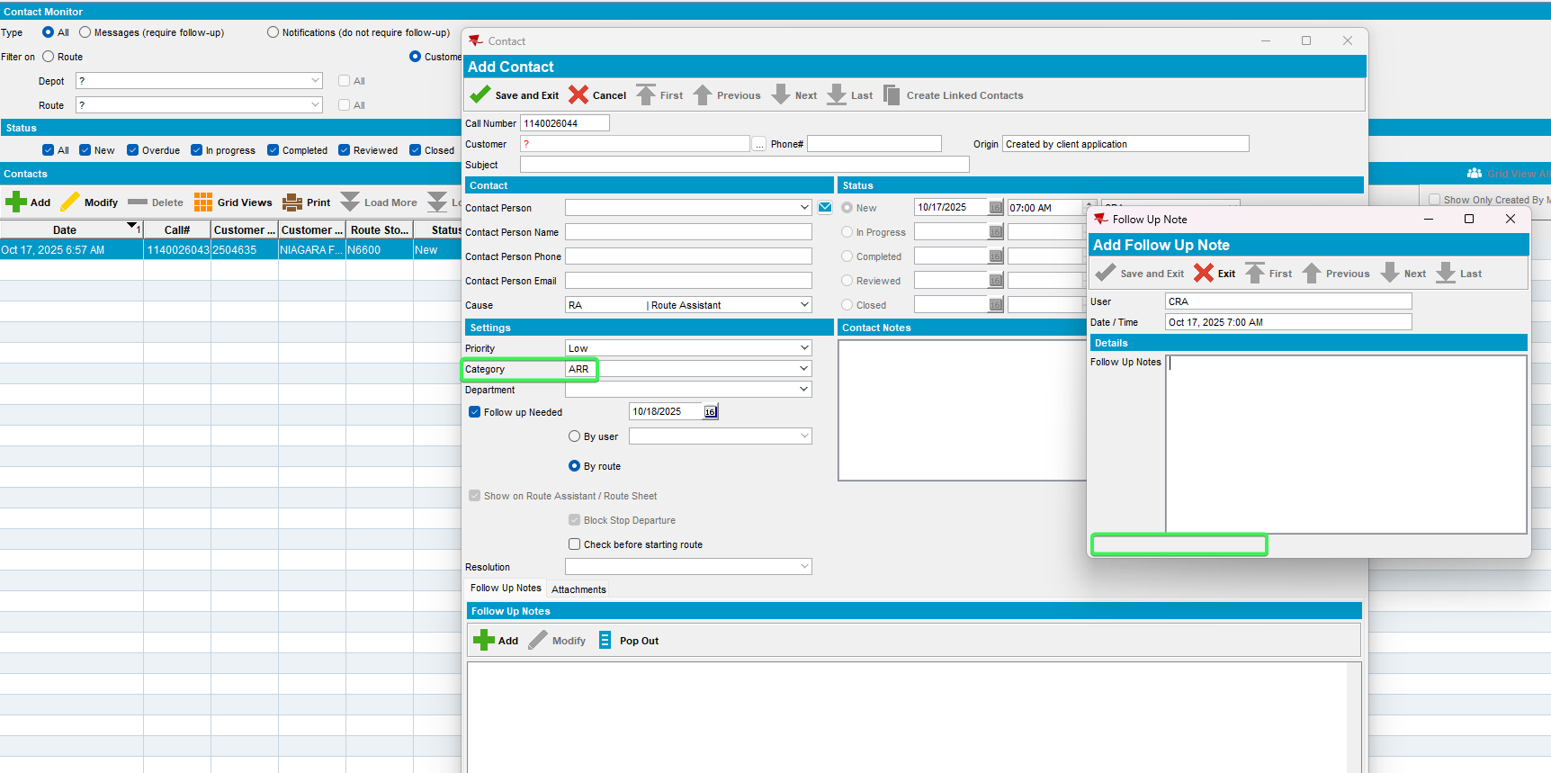
- Contacts dlg: Add a new contact message with a category that doesn’t have configured the customer communication with
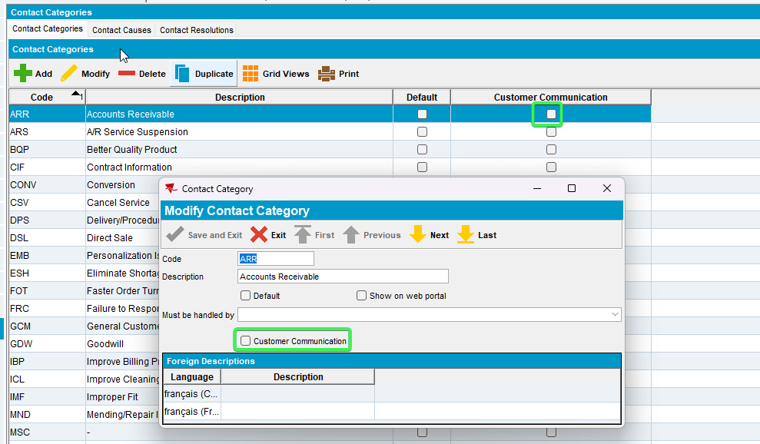
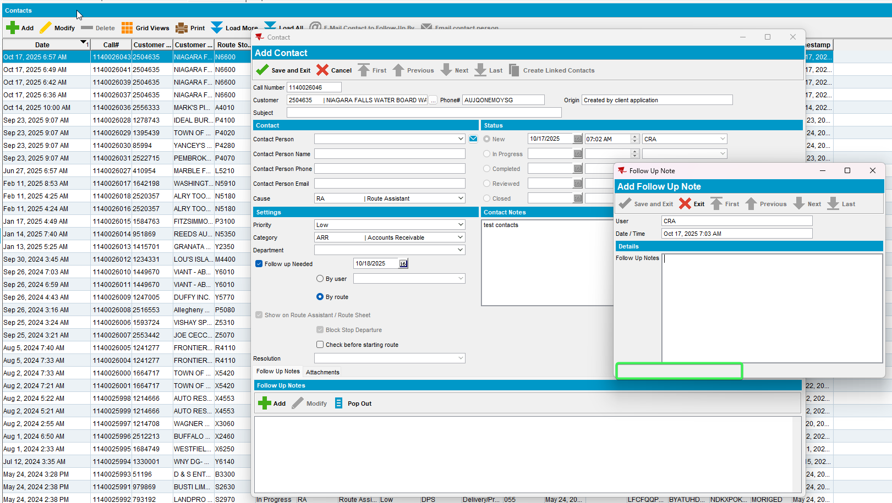
The field customer communication with is not present

2.3 - Route Assistant – Tested OK
Hash: RouteAssistant_v12.40.INTERNAL_TEST_ONLY.1f4d6b730

- RSC dlg: Add a new route containing the customer, generate packing note and invoices and send the route to PDA.
- RA: Arrive at the customer and check the contact messages. Respond to a contact that has a category without customer communication with checked, completed it.
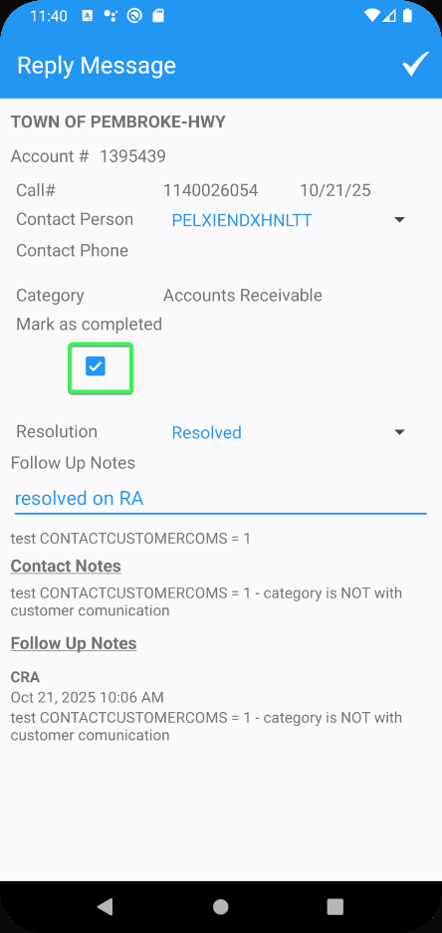
The Customer communication with is not present
- RA: Respond to another contact that has a category configured with customer communication with. while not complete it.
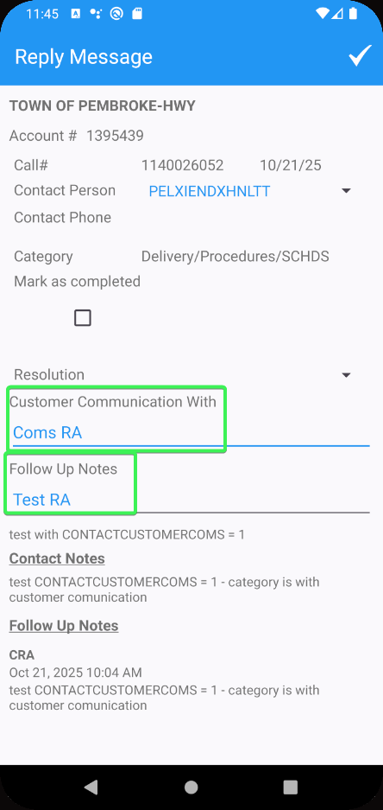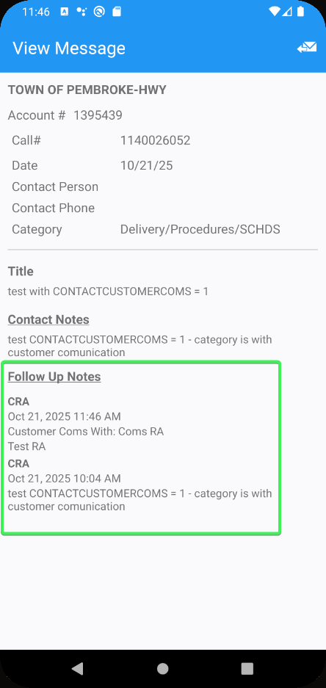
The follow up notes are shown from the table ContactFollowUpNotes in timestamp descending order (most recent at the top)
- RA: Respond to a contact using a 40 character customer communication with.
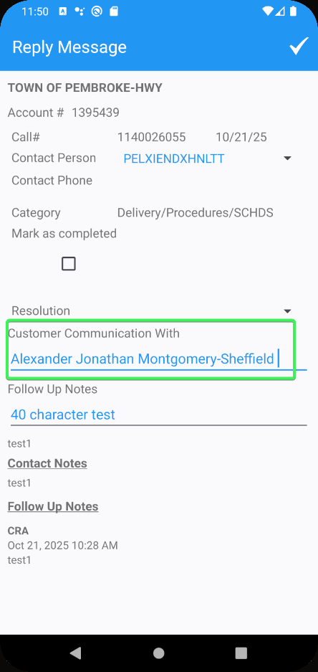
- RA: Do not respond to other contacts. Arrive at the customer and enter messages
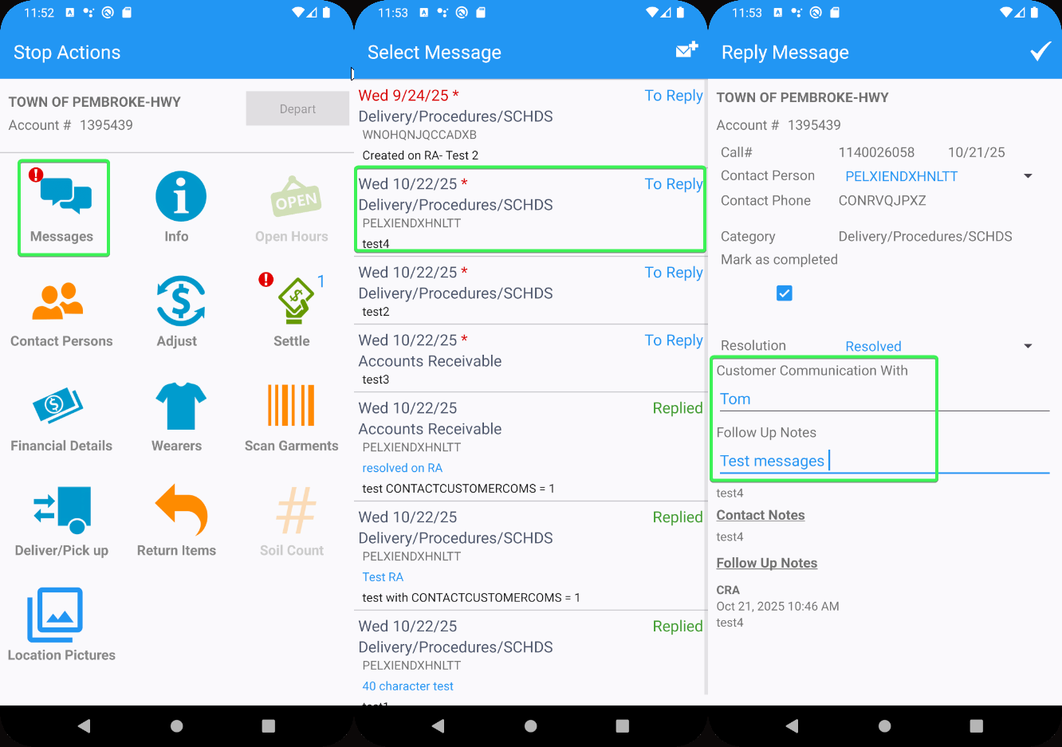

- RA: Reply to the remaining messages to settle and depart from customer.
- Check the RA database for the following tables and contents.

ContactCategoryDTO table - Y/N ContactCategory. CustomerCommunication , here are the categories configured with customer communication with
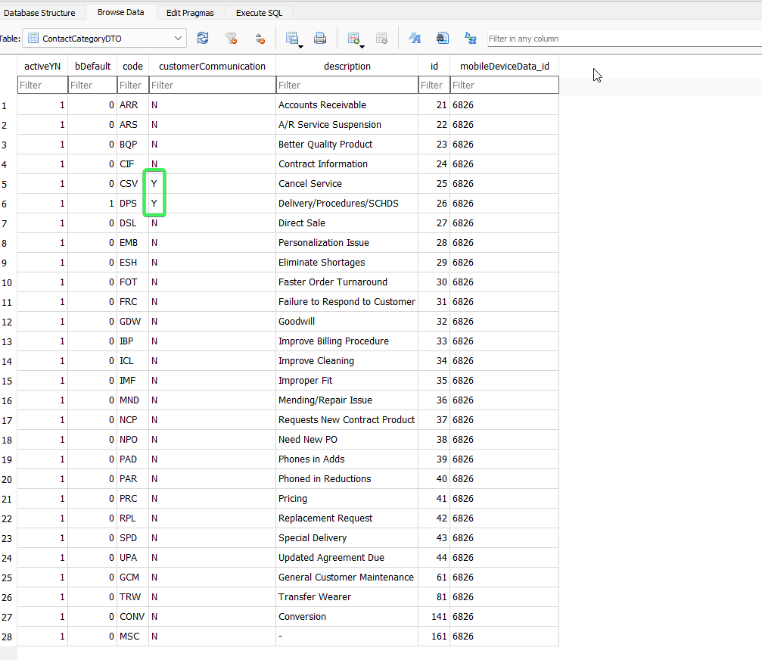
ContactFollowUpNoteDTO – Field name CustomerComsName

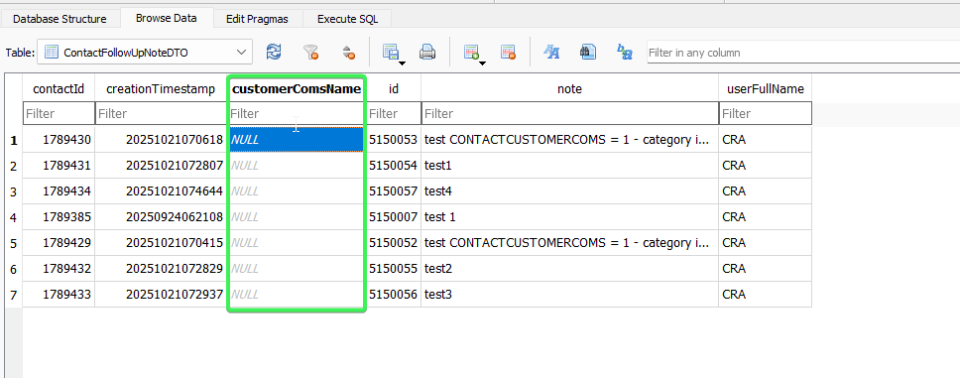

TransactionDTO

String3 | ContactFollowUpNote.CustomerComsName
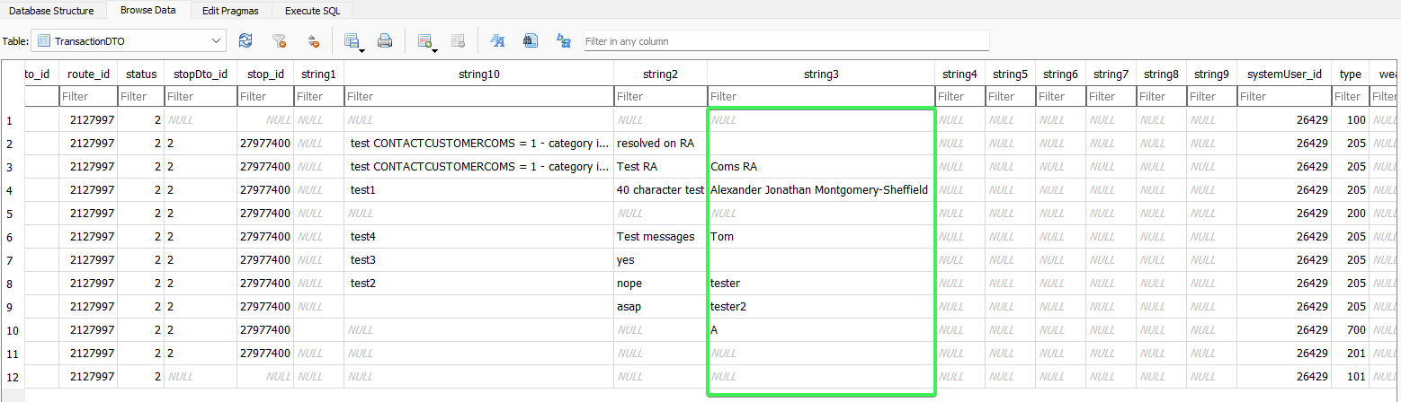
11. RA: Finish the route and upload it.

2.4 - RouteTransaction table – Tested OK

- Check in database the route for transaction type 205
Added stringvalue 3 for transaction type 205

select rt.stringvalue3, rt.* from routetransaction rt
join routecontrol rc on rc.routecontrol_id = rt.routecontrol_id
where rc.routecontrol_id =
(select rc.routecontrol_id
from routecontrol rc
join route r
on r.route_id = rc.route_id
join plant p
on p.plant_id = r.plant_id
where rc.drivingdate = to_date('08/10/2025', 'dd/mm/yyyy')
and r.routenumber = 1
and p.code = '073')
and rt.routetransactiontype_id = 205;

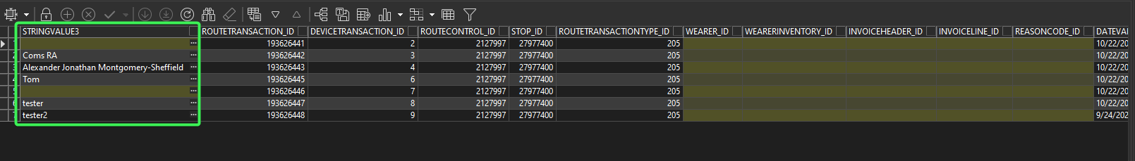
The stringvalue 3 column of routetransactiontype 205 , contain the customer communication with added on RA

2.5 – WebClientX – Tested OK

Line 2 If system setting CONTACTCUSTOMERCOMS = 1 and ContactFollowUpNote.CustomerComsName is not NULL then line 2 becomes line 3 and on line 2, we show the text “Customer Communication With: <ContactFollowupNote. CustomerComsName>”

Free text entry field (40 characters), not mandatory
Visible if system setting CONTACTCUSTOMERCOMS = 1 and contact category is for customer communication (Contact.ContractCategory. CustomerCommunication = Y)
Enabled if in ADD mode
Redisplay in Modify / View mode

- WebX: Load the route that was uploaded and finish the start my day.
- WebX: Go to Contacts and open a contact message.
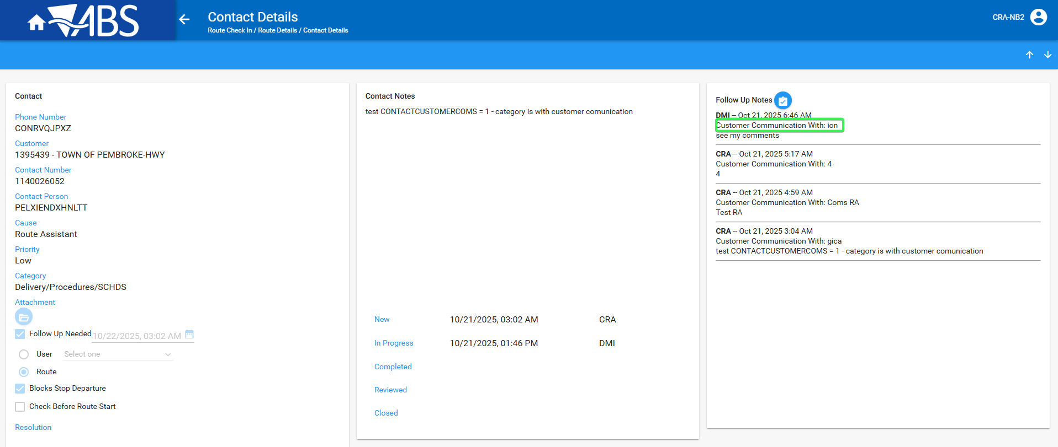
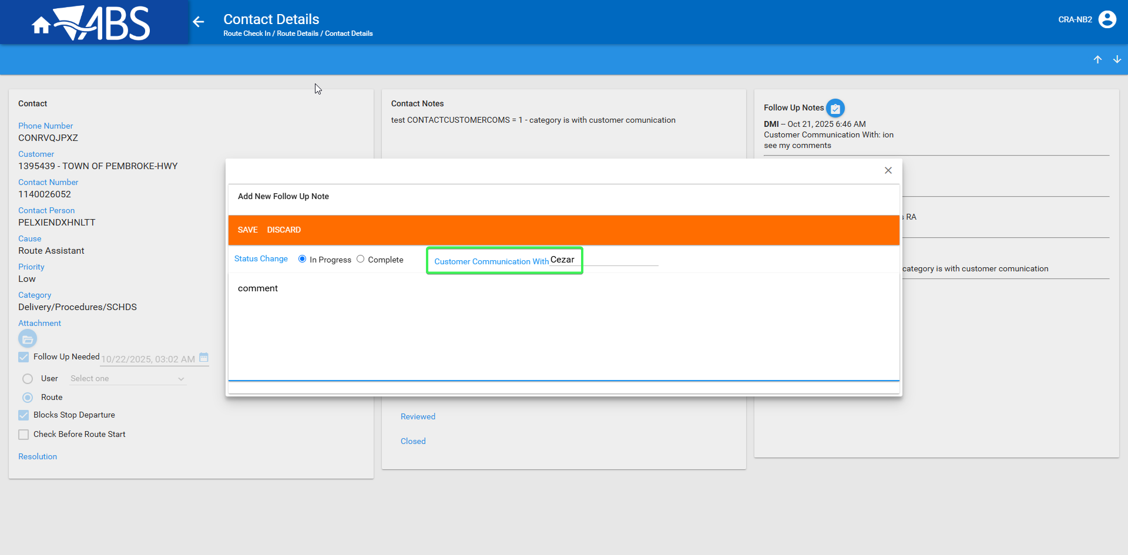

The customer communication with is present
- WebX: Reply to a contact message which has follow up needed.
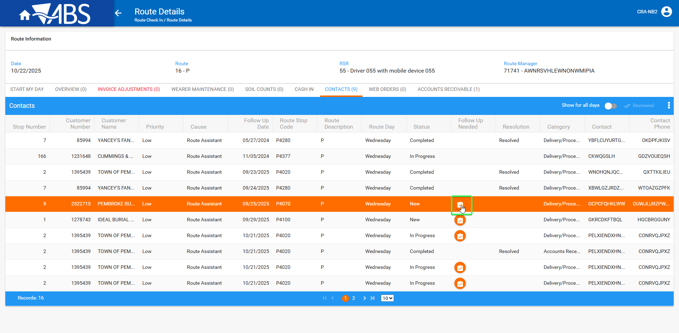
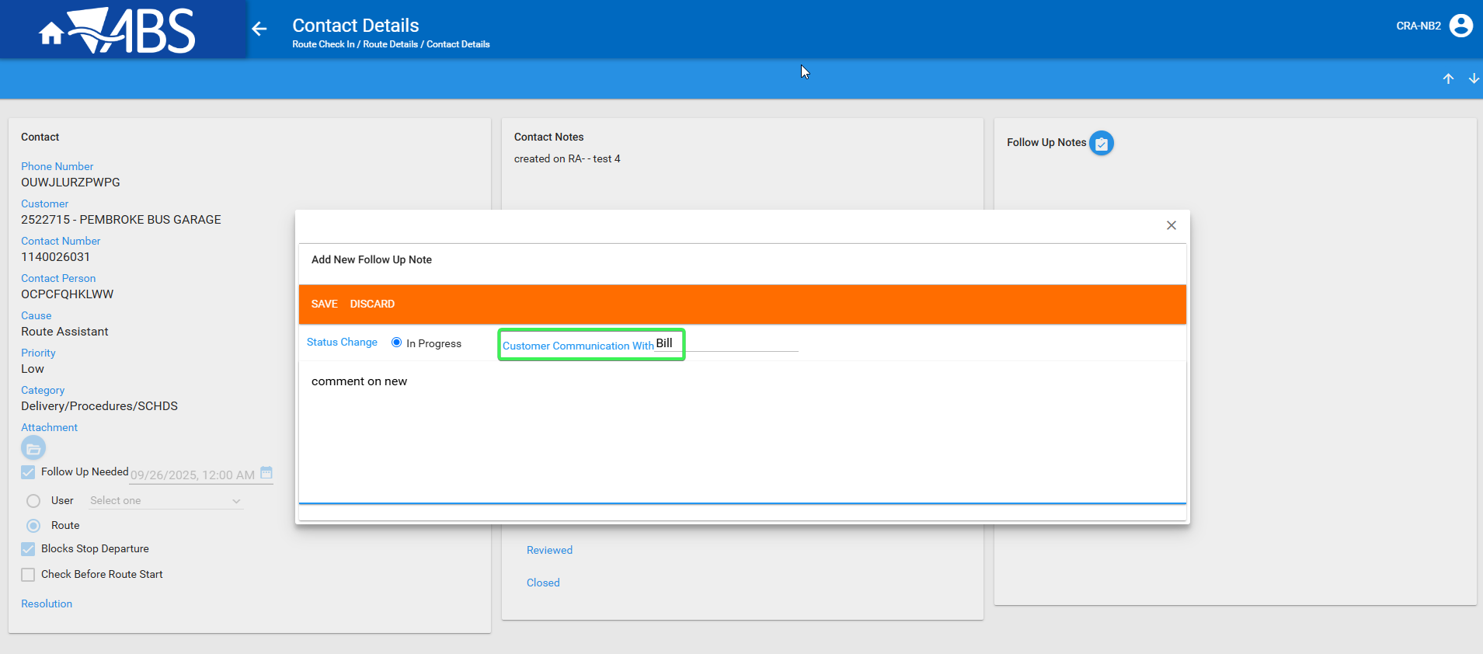

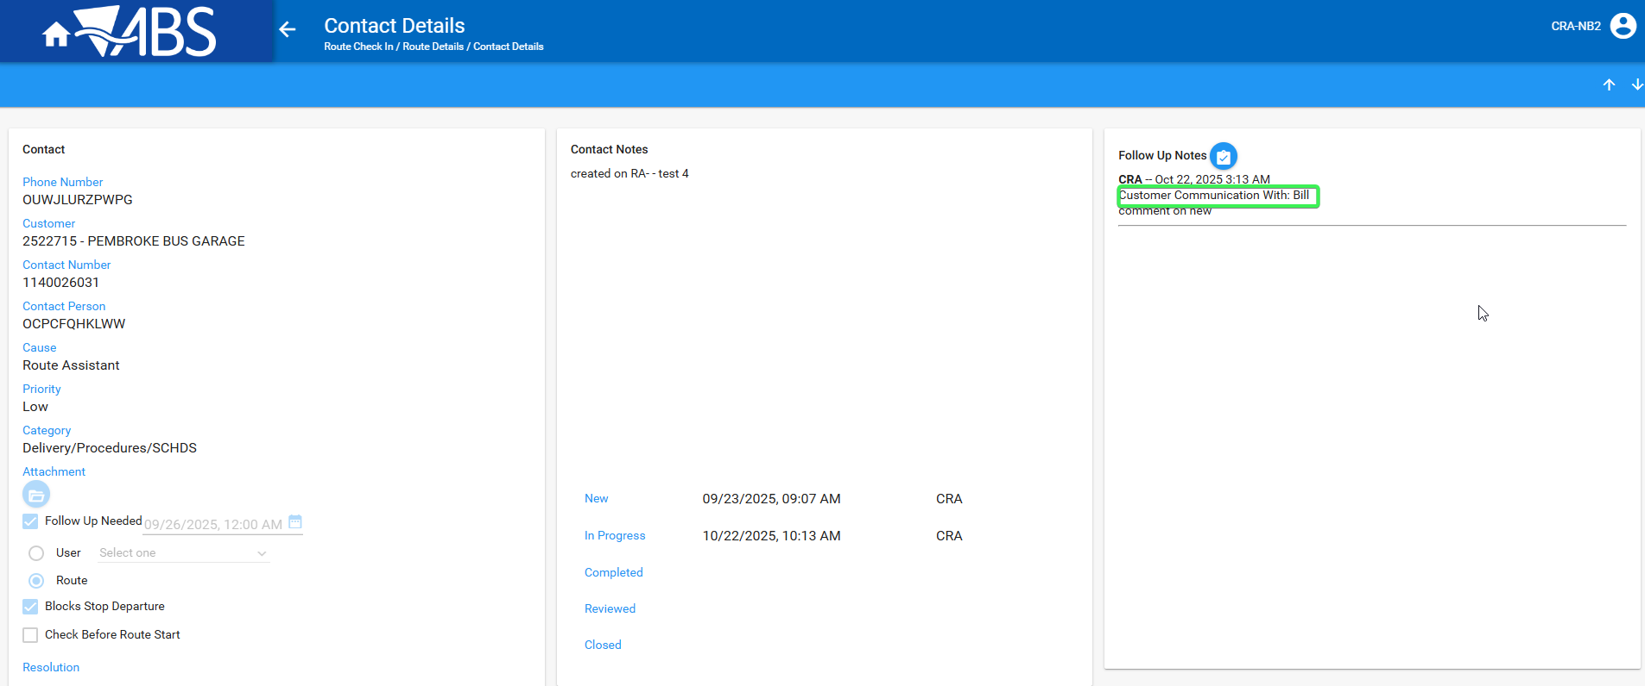

Make another reply where customer communication with is not written.
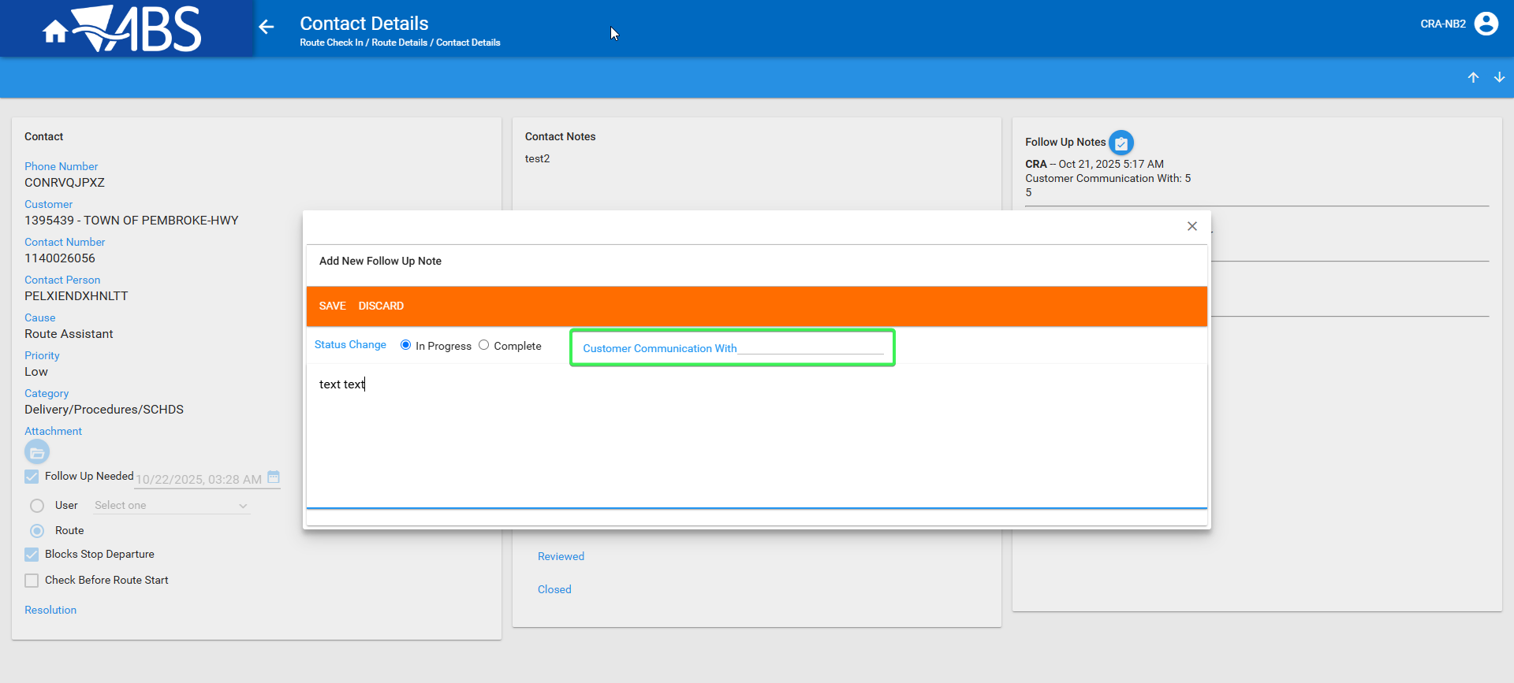

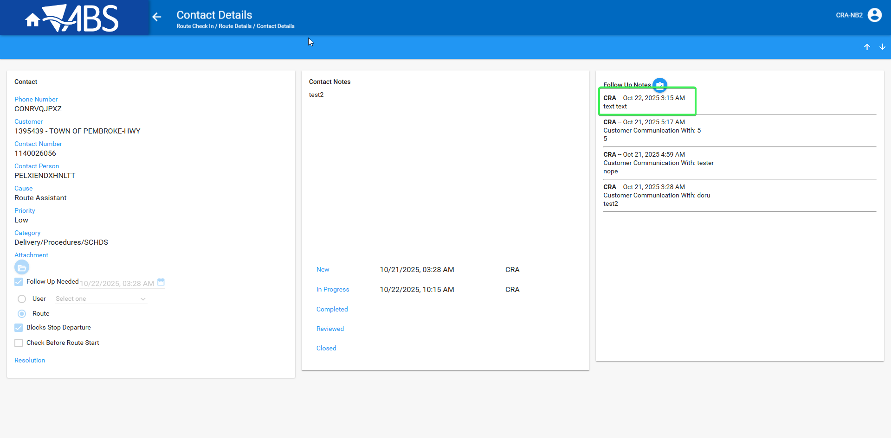
The mentioning of Customer Communication With: is not present if nothing was written in that field.
- Contacts: Check what was written in RA and WebX
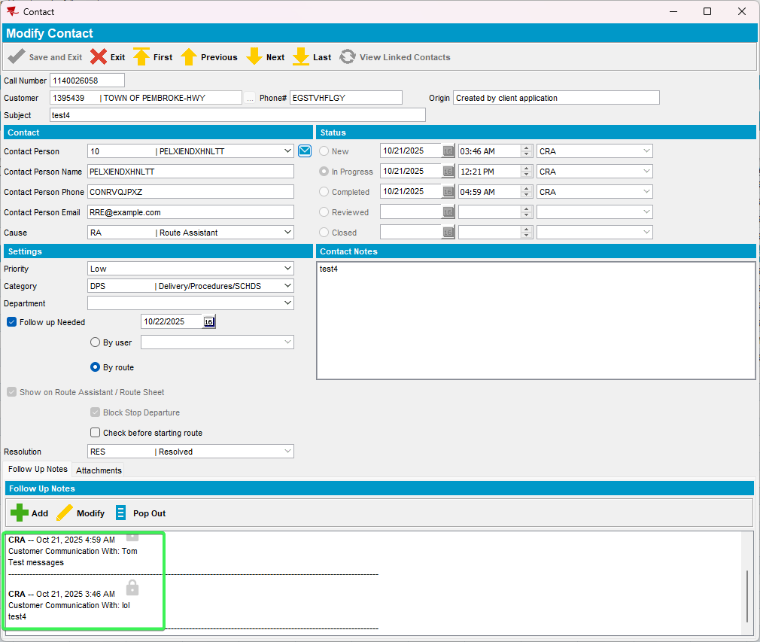
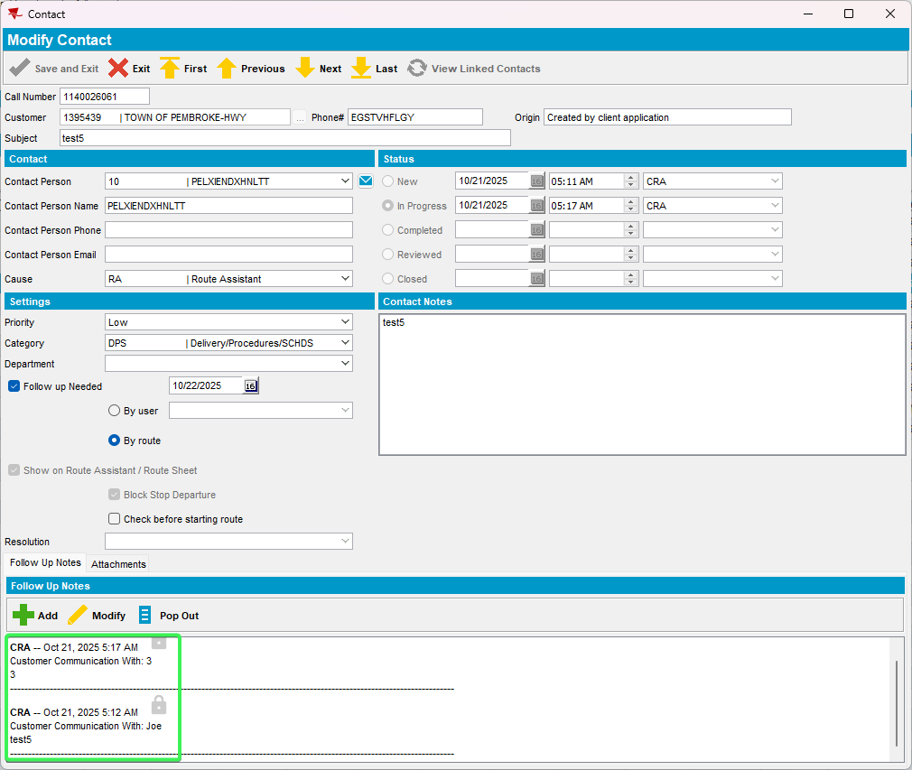

Tested OK

Test case 3 – Check that ContactFollowUpNote.CustomerComsName and ContactCategory.CustomerCommunication are present after updating RA from an older version

- Route status control DLG: Prepare route with at least 1 customer with garment delivery days
- Generate invoices and mark it as Ready for PDA transfer
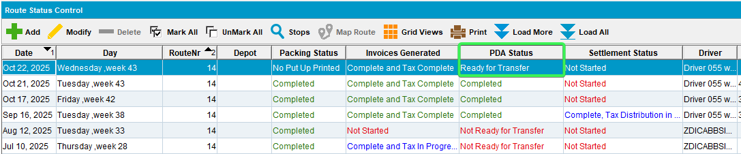
- Download the route to PDA where you have an older RA version which does not contain the 2 new added columns
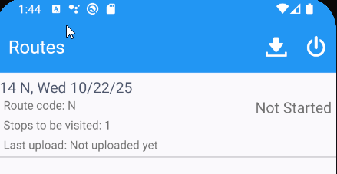
- Check the routeAssistDB and see that the 2 columns are not present in ContactFollowUpNoteDTO and ContactCategory.CustomerCommunication
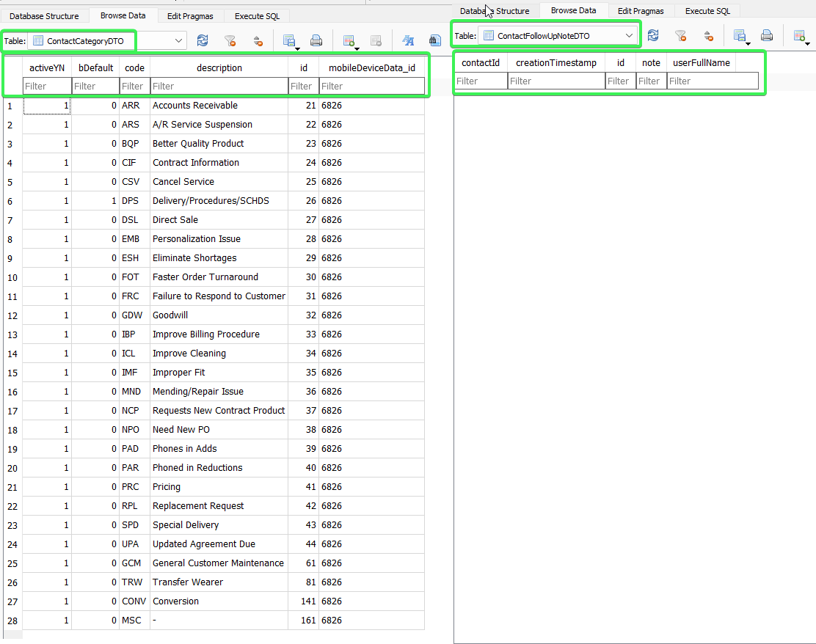
- Update the RA to the lates version that contains the 2 new columns, drag and drop the new apk in your PDA menu
- Log in and synchronize the routeAssistDB data
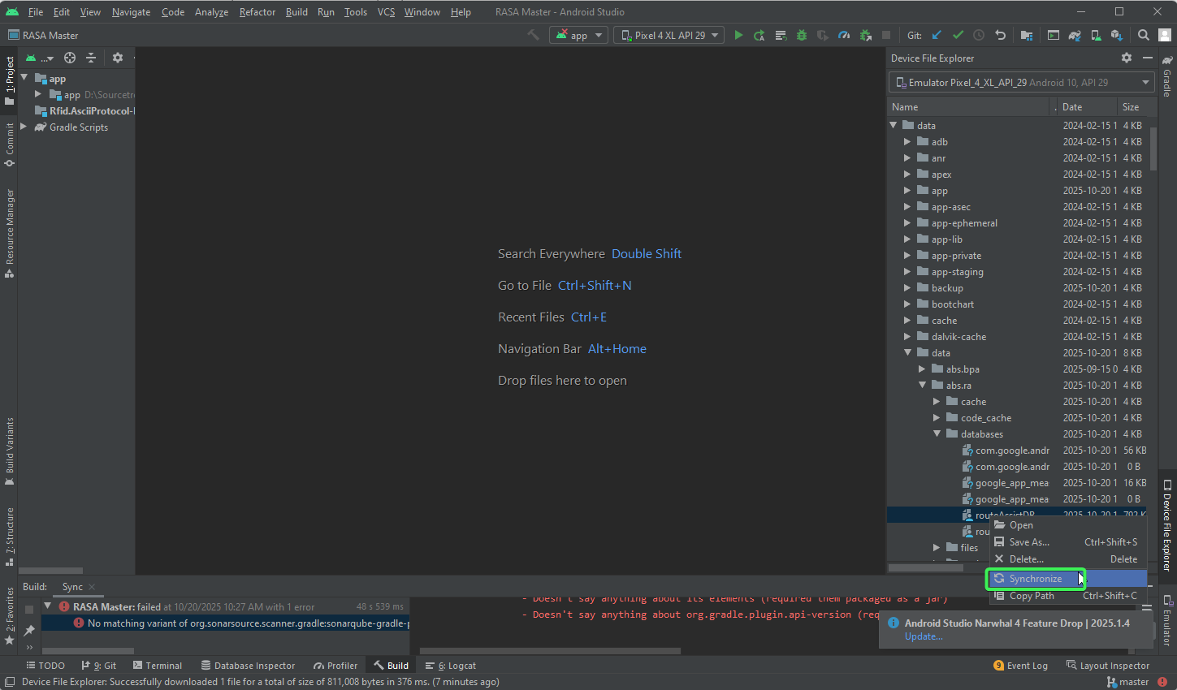
- Download the database the check the see if the 2 columns are now present
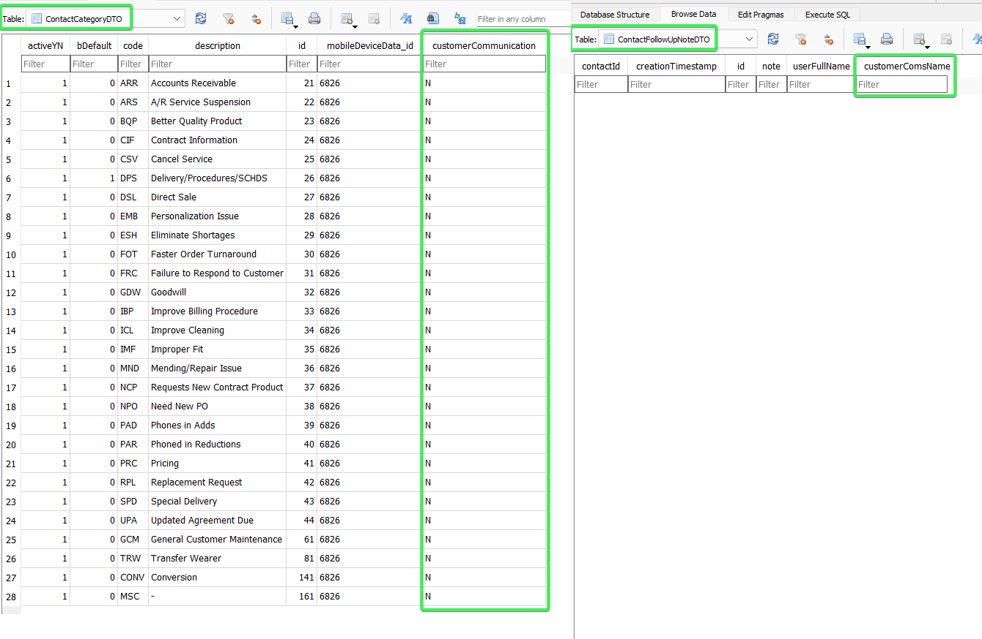
Tested OK

