ABSN-9997 - Server side - Create folders for French and Spanish resources in BPA
Environment | Prerequisites
Version: 9.07.00.UNF19 hash: b72e077ed5f2  DBServerName= abs-srv20.internal.abslbs.com  DBSID=CUST24  DBUser=UNFDEV  Environment=Test | - Module:  - System setting

Contents
Retest after fix 1
Test Case 1 – Check that the weekday is translated when scanning a Mat ID 1

Retest after fix

Test Case 1 – Check that the weekday is translated when scanning a Mat ID
Hash: 9.07.00.UNF19 hash: b72e077ed5f2
- Mobile device: Switch the language to Franch
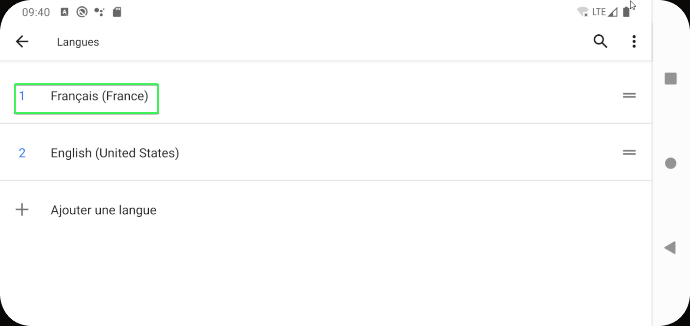
- Set the System User to have French as language
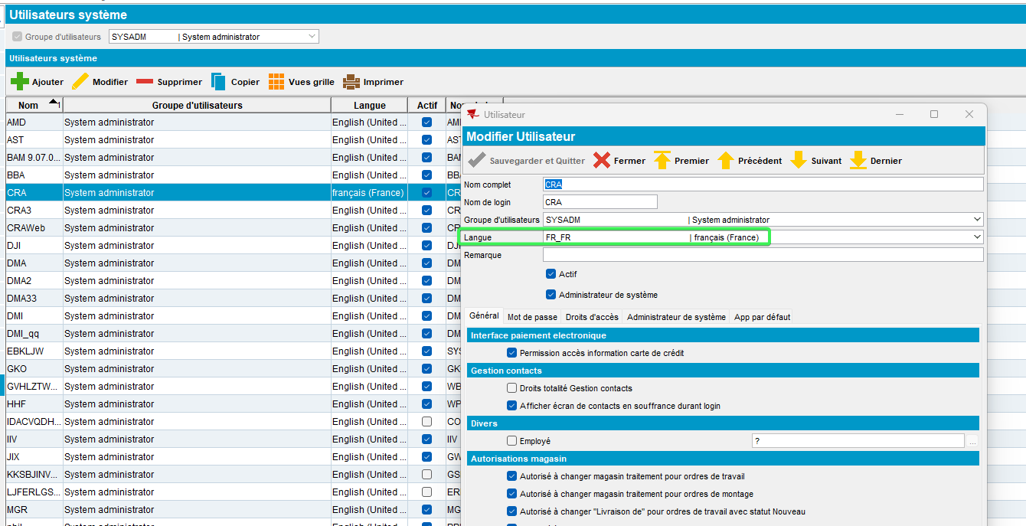
- RSC DLG: Add 2 new routes
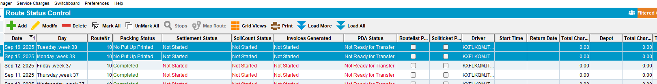
- Generate Put-up Docs for these routes
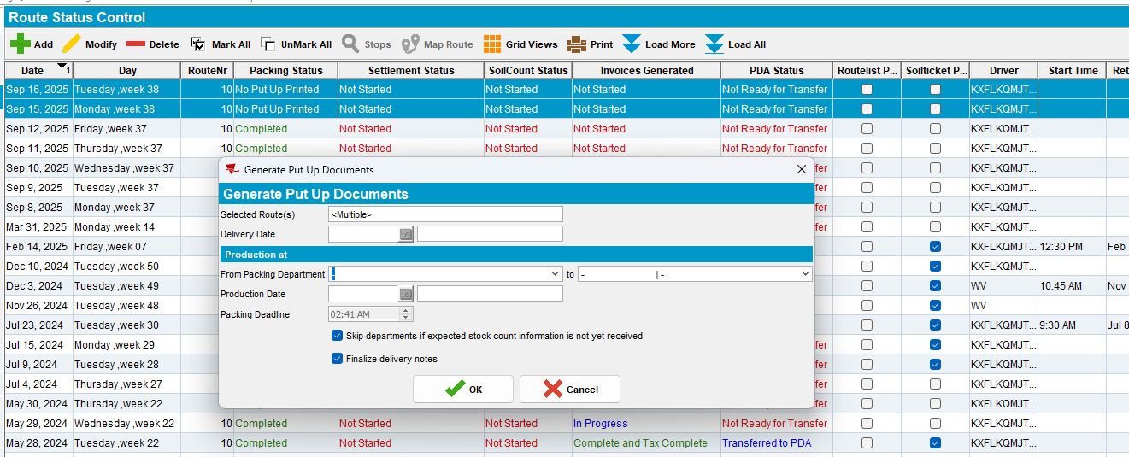
- PLPC: Load a customer with Logo mats from one of the routes
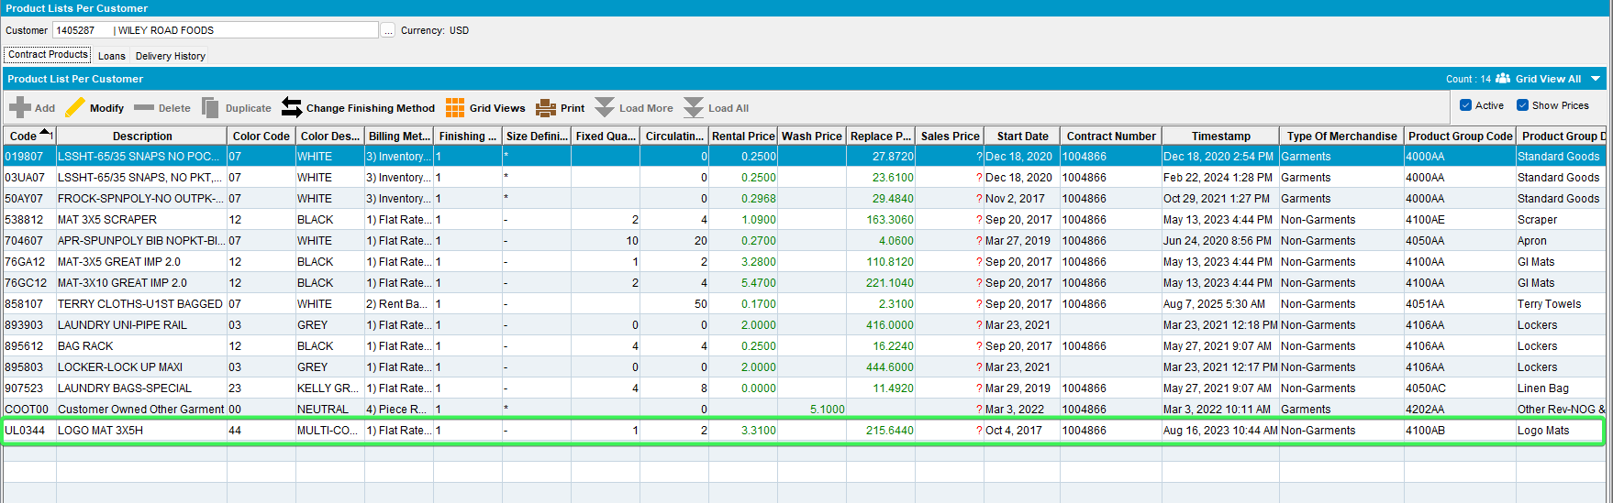
- Pick one of the Uniquely Coded IDs
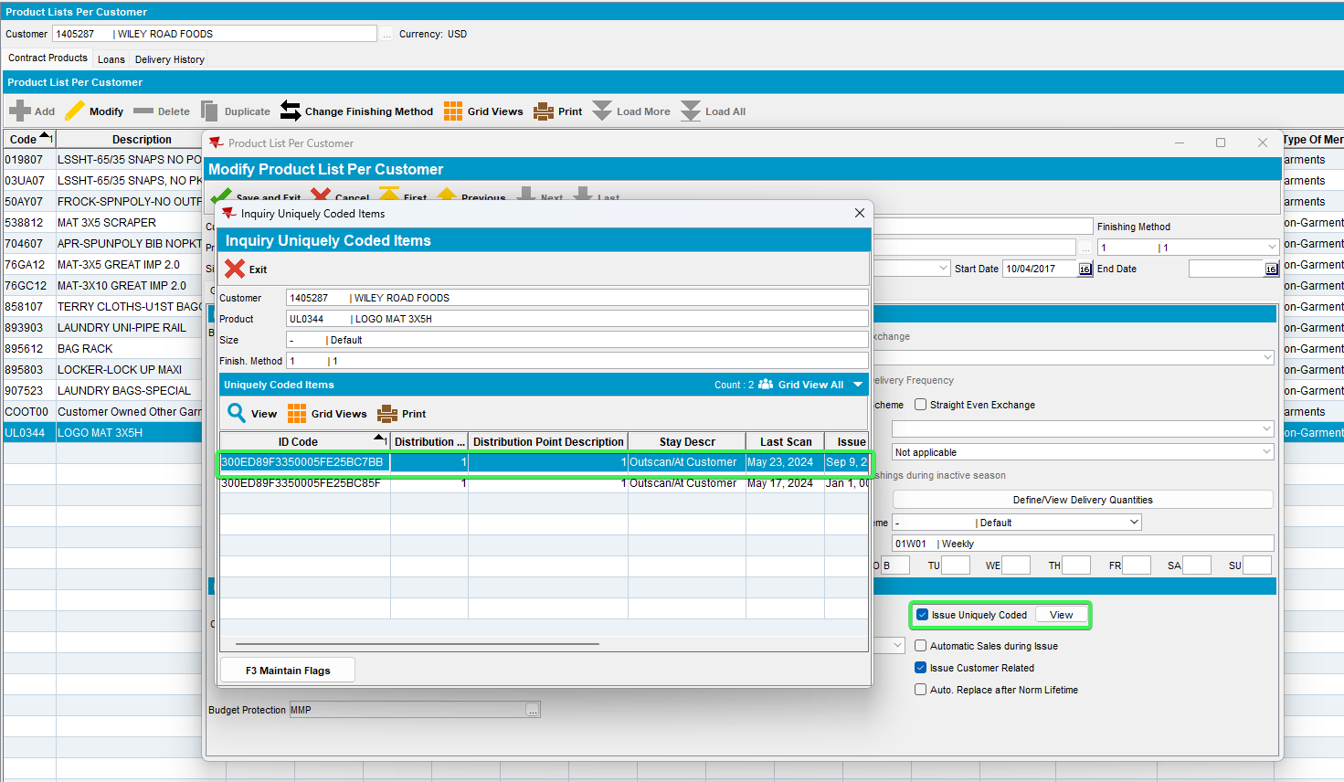
- BPA: Pack tab > Short a logmat
- BPA: go to Stock tab and scan one of the codes
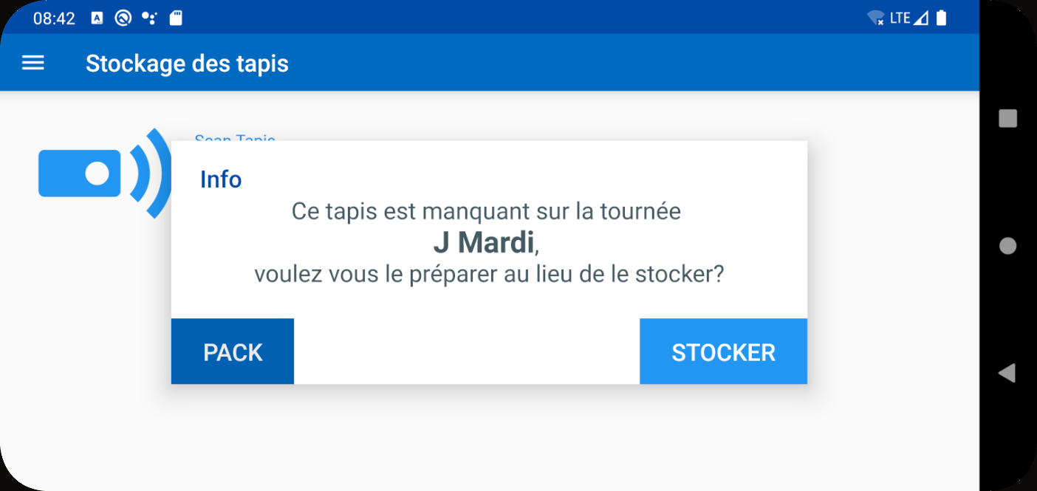
Tested OK

