ABSN-9974 - Customer - Payment - Put Finance Charge On is not controlled by ss PAYMENTTABWITHEXTERNALAR
Environment | Prerequisites
Version: 9.07.00.UNF20 hash: bac9293fb677  DBServerName= abs-srv20.internal.abslbs.com  DBSID=CUST24  DBUser=UNFDEV  Environment=Test | - Module:  - System setting

Contents
Reproducing before fix 1
Steps to reproduce 1
Current Behavior 4
Retest after fix 4
Test Case 1 – Have SS PAYMENTTABWITHEXTERNALAR to NNNN and SS FINANCECHARGEPUTON to Default value 4
Test Case 2 – Have SS PAYMENTTABWITHEXTERNALAR to NNNR and SS FINANCECHARGEPUTON to Default value 6
Test Case 3 – Have SS PAYMENTTABWITHEXTERNALAR to NNNH and SS FINANCECHARGEPUTON to Default value 8
Test Case 4 – Have SS PAYMENTTABWITHEXTERNALAR to NNNH and SS FINANCECHARGEPUTON to Fixed value 10
Test Case 5 – Have SS PAYMENTTABWITHEXTERNALAR to NNNR and SS FINANCECHARGEPUTON to Fixed value 12

Reproducing before fix

Steps to reproduce
- Set SS PAYMENTTABWITHEXTERNALAR to NNNN
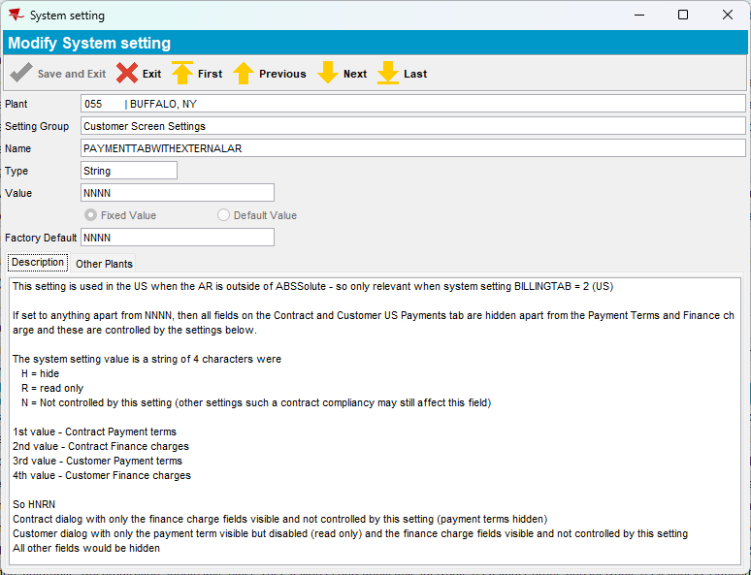
- Set SS FINANCECHARGEPUTON to Default value
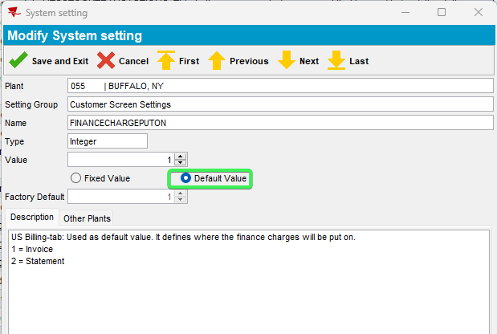
- Customers DLG: Load a customer and press Modify
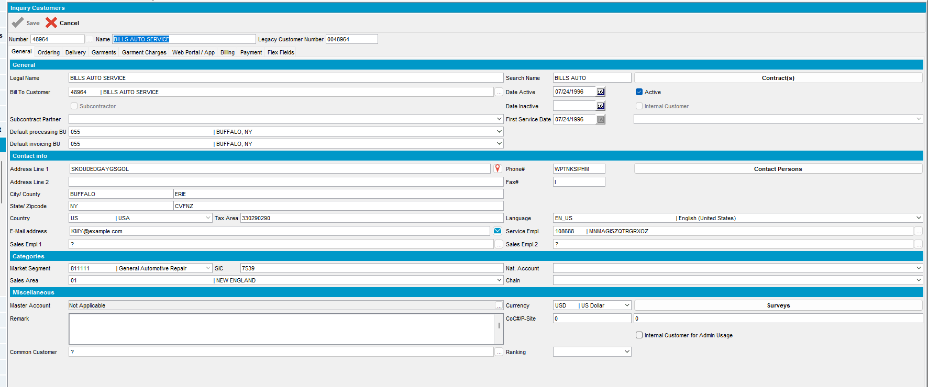
- Go to Payment field and notice “Put Finance Charge On” is disabled
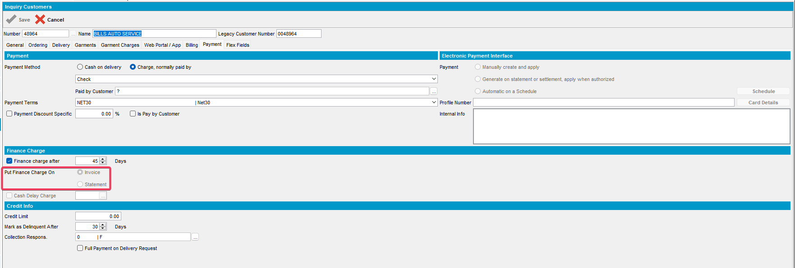

REPRODUCED OK.

Current Behavior
Finance Charge Put On is always set as disabled and is controlled only by FINANCECHARGEPUTON SS and access rights values.

Retest after fix

Test Case 1 – Have SS PAYMENTTABWITHEXTERNALAR to NNNN and SS FINANCECHARGEPUTON to Default value
Hash: bac9293fb677
Expected: “Put Finance Charge On” is enabled
- Set SS PAYMENTTABWITHEXTERNALAR to NNNN
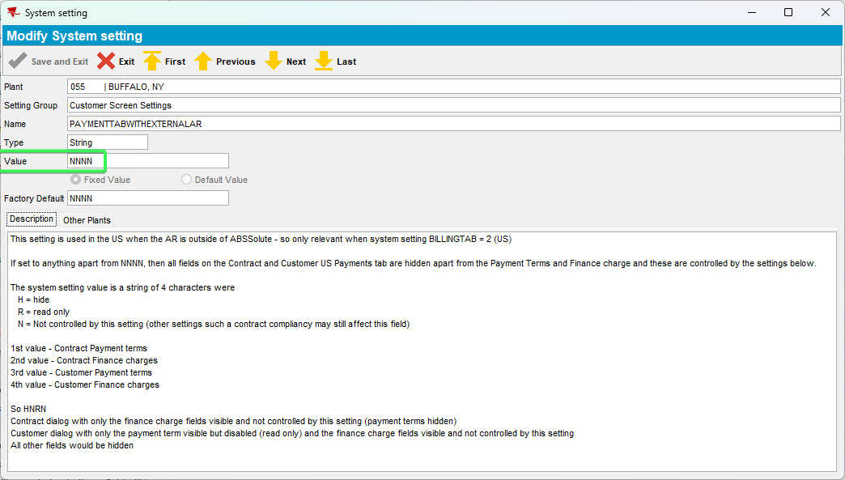
- Set SS FINANCECHARGEPUTON to Default value
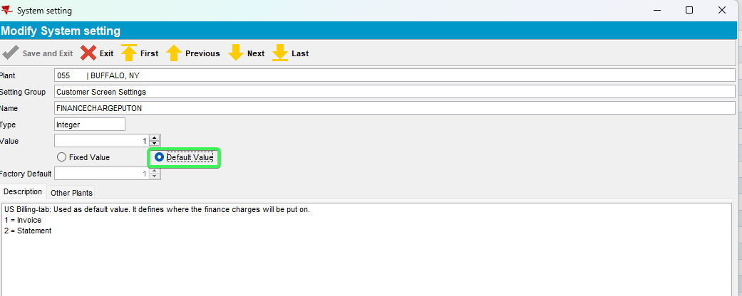
- Go to Customers Contract > Load compliancy and set Put Finance Charge On compliancy as Contract suggested, can be overruled
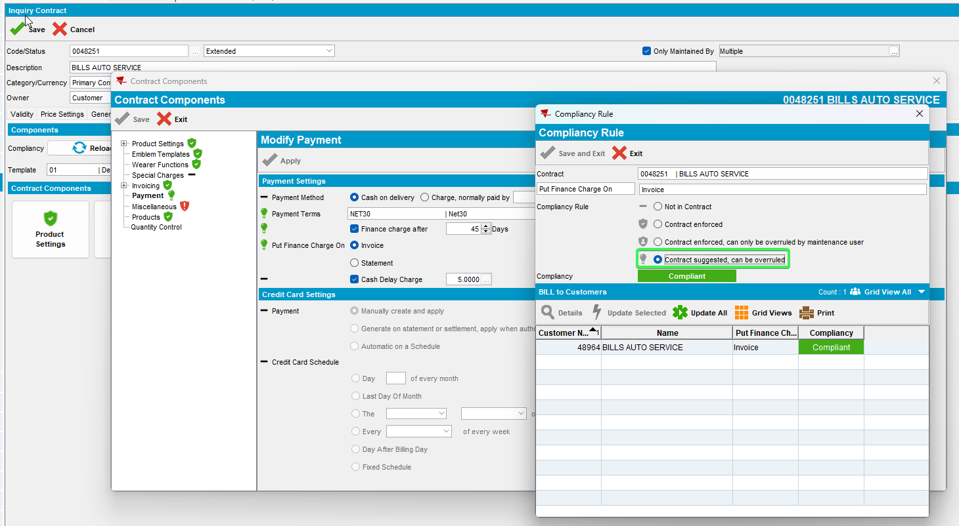
- Customers DLG: Load a customer and press Modify
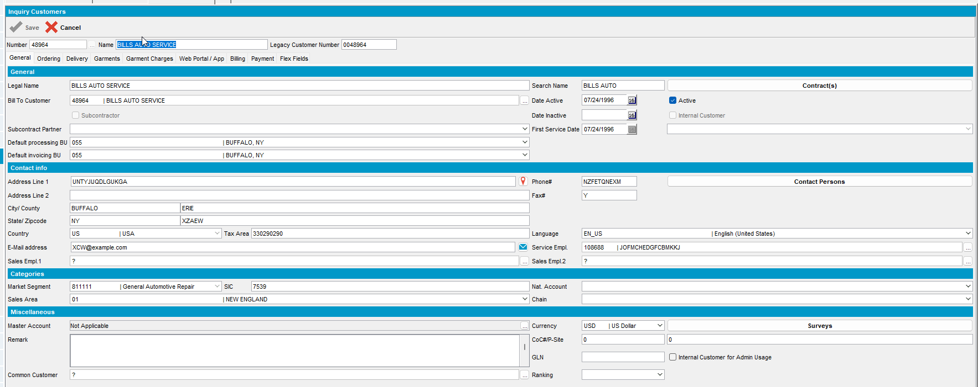
- Go to Payment field and notice “Put Finance Charge On”
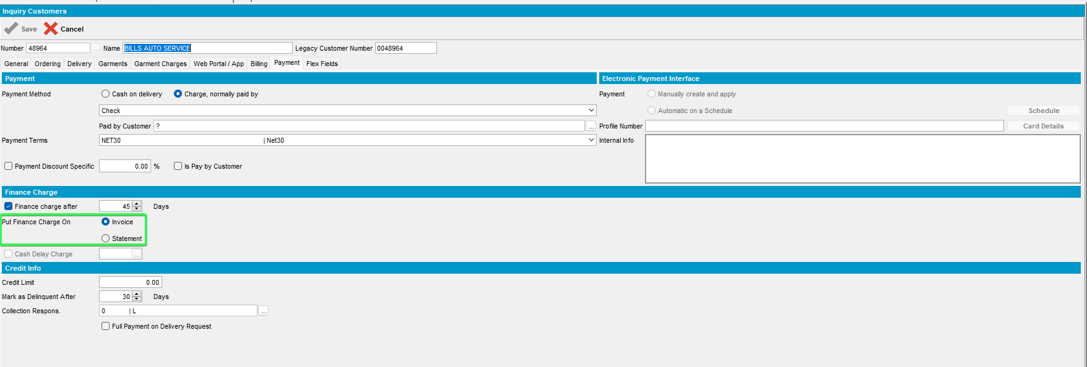
Tested OK

Test Case 2 – Have SS PAYMENTTABWITHEXTERNALAR to NNNR and SS FINANCECHARGEPUTON to Default value
Hash: bac9293fb677
Expected: “Put Finance Charge On” is disabled
- Set SS PAYMENTTABWITHEXTERNALAR to NNNR
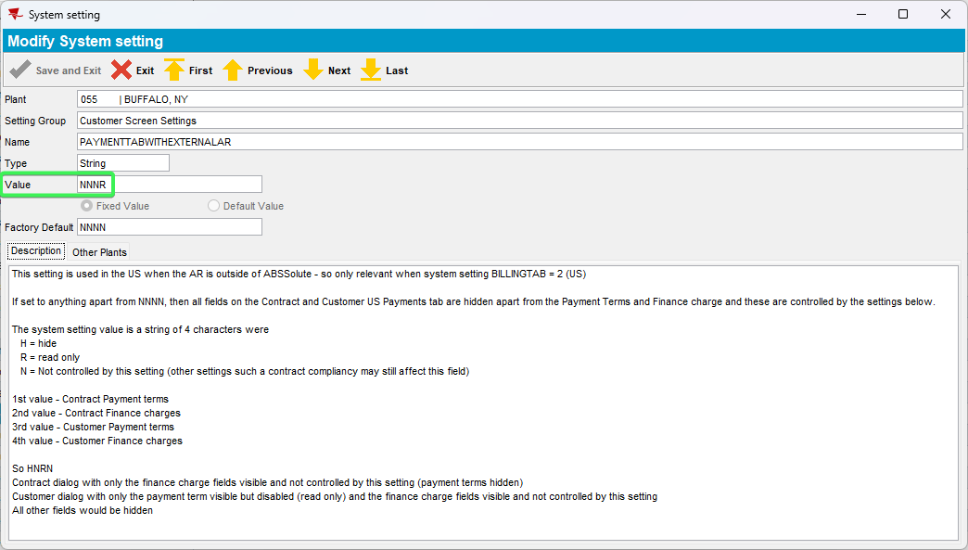
- Set SS FINANCECHARGEPUTON to Default value
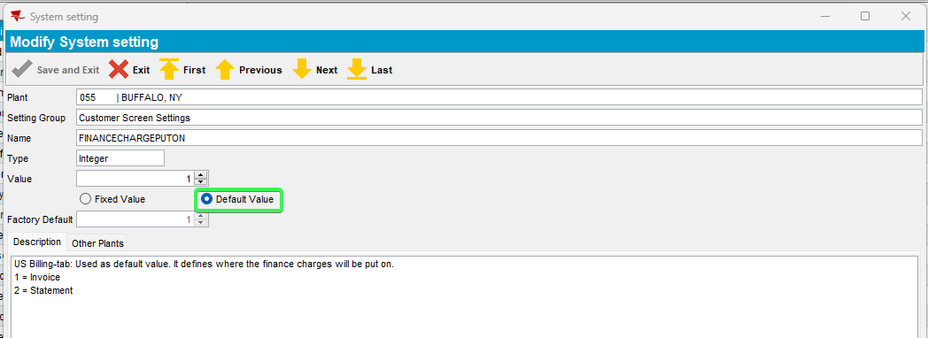
- Go to Customers Contract > Load compliancy and set Put Finance Charge On compliancy as Contract suggested, can be overruled
- Customers DLG: Load a customer and press Modify
- Go to Payment field and notice “Put Finance Charge On”
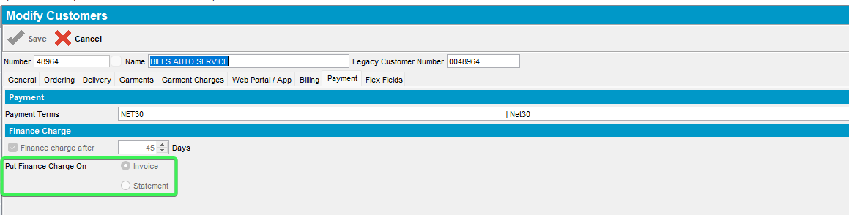
Tested OK

Test Case 3 – Have SS PAYMENTTABWITHEXTERNALAR to NNNH and SS FINANCECHARGEPUTON to Default value
Hash: bac9293fb677
Expected: “Put Finance Charge On” is not visible
- Set SS PAYMENTTABWITHEXTERNALAR to NNNH
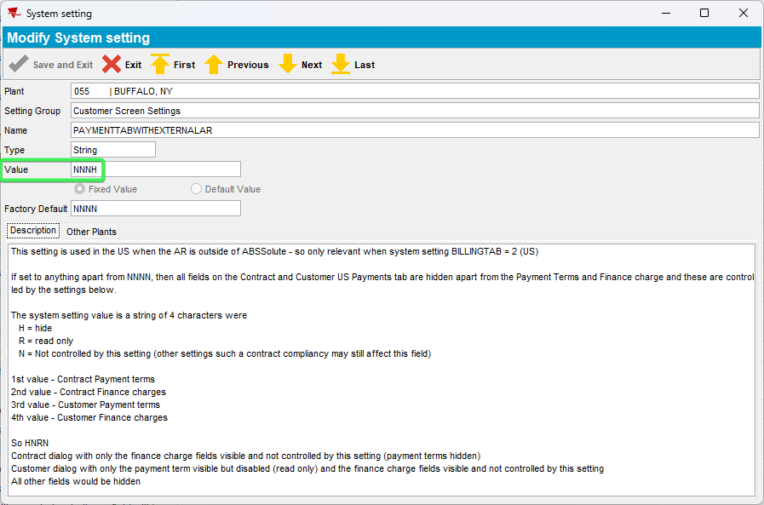
- Set SS FINANCECHARGEPUTON to Default value
- Go to Customers Contract > Load compliancy and set Put Finance Charge On compliancy as Contract suggested, can be overruled
- Customers DLG: Load a customer and press Modify
- Go to Payment field and notice “Put Finance Charge On”
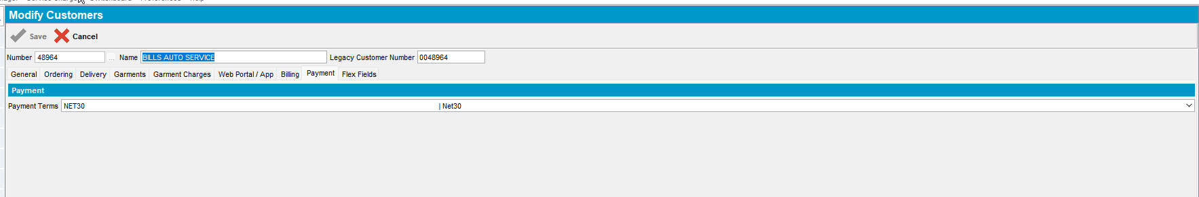
Tested OK

Test Case 4 – Have SS PAYMENTTABWITHEXTERNALAR to NNNH and SS FINANCECHARGEPUTON to Fixed value
Hash: bac9293fb677
Expected: “Put Finance Charge On” is not visible
- Set SS PAYMENTTABWITHEXTERNALAR to NNNH
- Set SS FINANCECHARGEPUTON to Fixed value
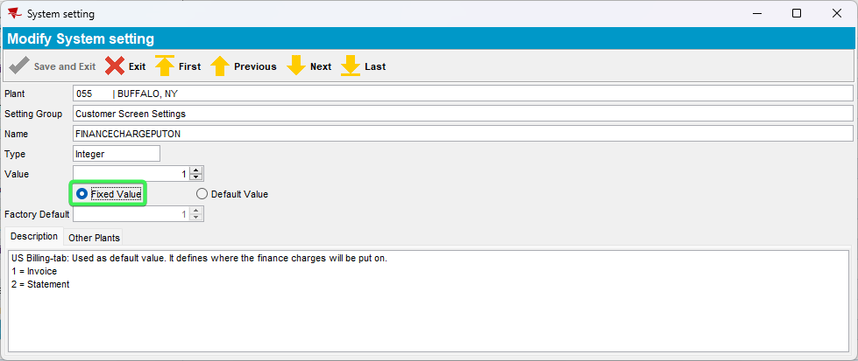
- Go to Customers Contract > Load compliancy and set Put Finance Charge On compliancy as Contract suggested, can be overruled
- Customers DLG: Load a customer and press Modify
- Go to Payment field and notice “Put Finance Charge On”
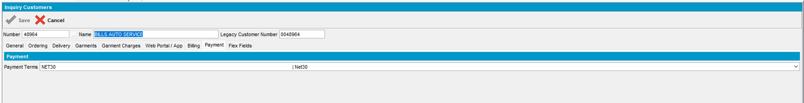
Tested OK

Test Case 5 – Have SS PAYMENTTABWITHEXTERNALAR to NNNR and SS FINANCECHARGEPUTON to Fixed value
Hash: bac9293fb677
Expected: “Put Finance Charge On” is disabled
- Set SS PAYMENTTABWITHEXTERNALAR to NNNR
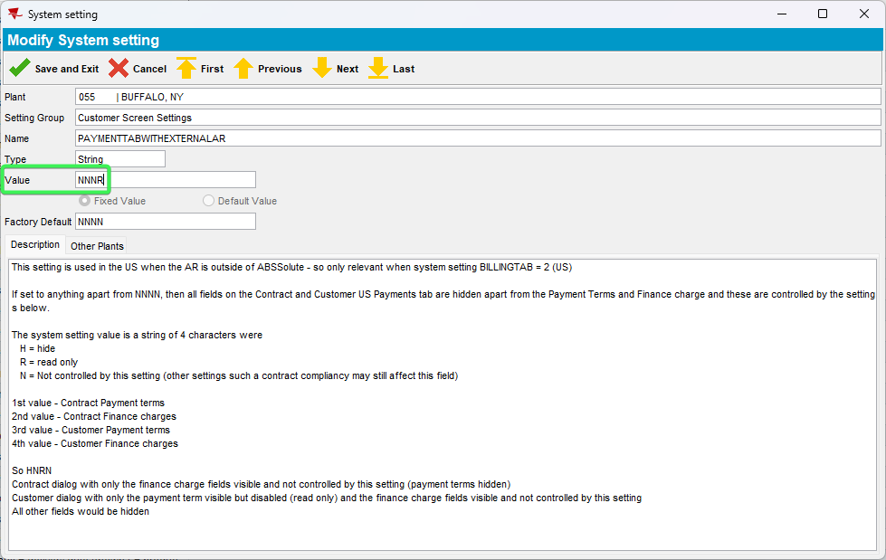
- Set SS FINANCECHARGEPUTON to Fixed value
- Go to Customers Contract > Load compliancy and set Put Finance Charge On compliancy as Contract suggested, can be overruled
- Customers DLG: Load a customer and press Modify
- Go to Payment field and notice “Put Finance Charge On”
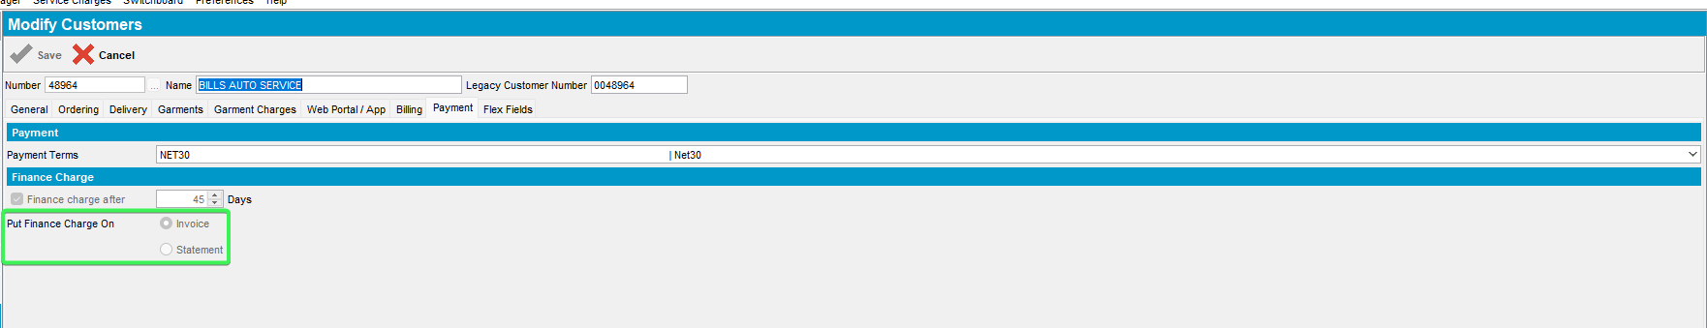
Tested OK

