ABSN-9943 D_UBS_2748 Freedom Pay - Unapply should disconnect ARTransaction from CreditCardTransaction
Environment | Prerequisites
Version: 9.07.00.UNF17.p15  DBServerName=abs-srv20.internal.abslbs.com  DBSID=CUST24  DBUser=UNFDEV  Environment=Test | - Module:  - System setting

Contents
Retest after fix 1
Test Case 1 – Unapply AR transaction from singlepayment -> Settle again by pressing settle button 1
Test Case 2 – Unapply AR transaction from singlepayment -> Settle again by running process scheduler 5
Test Case 3 – Unapply AR transaction from batch payment -> Settle again by pressing settle button 8
Test Case 4 – Unapply AR transaction from batch payment -> Settle again by running process scheduler 10
Test Case 5 – Unapply AR transaction from single payment -> Create Remit Batch and apply 1$ to the invoice -> Settle again by pressing settle button 13

Retest after fix
Hash: 903f90cc9fd6

Test Case 1 – Unapply AR transaction from singlepayment -> Settle again by pressing settle button

- Choose an existing payment done via Freedom Pay. Use Credit Card Transaction dialog -> tab Settled transactions.
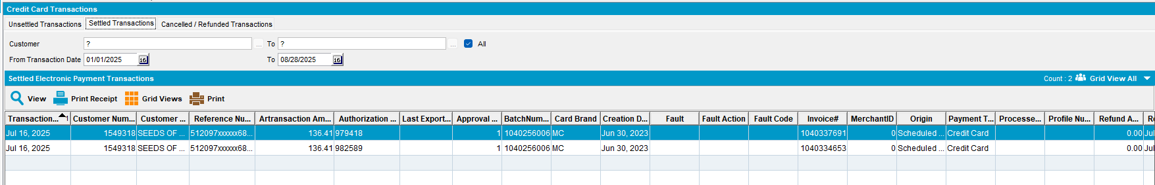

- Unapply payment from Cash Application screen. This reopens ARTransactions and sets CreditCardTransaction to status New.
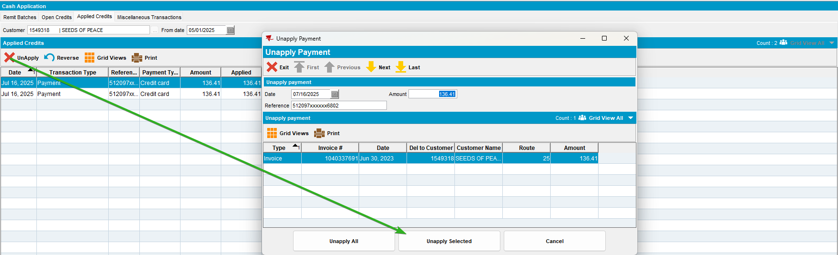

- Create a miscellaneous ARTransaction of type NSF. Use Cash Application -> Miscellaneous Transactions.
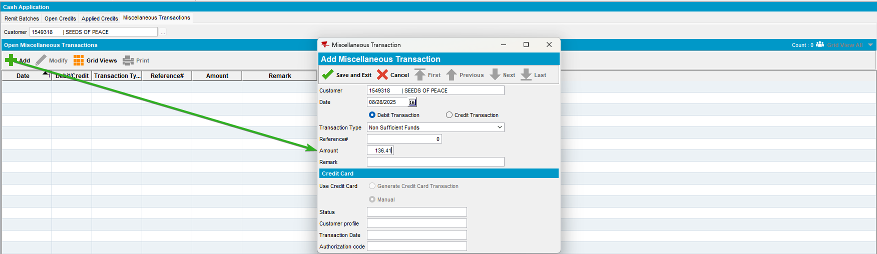

- Use transaction created at previous step to close the initial payment. This is closing the ARTransaction linked to CCT. Use Cash Application -> Open Credits -> Apply.
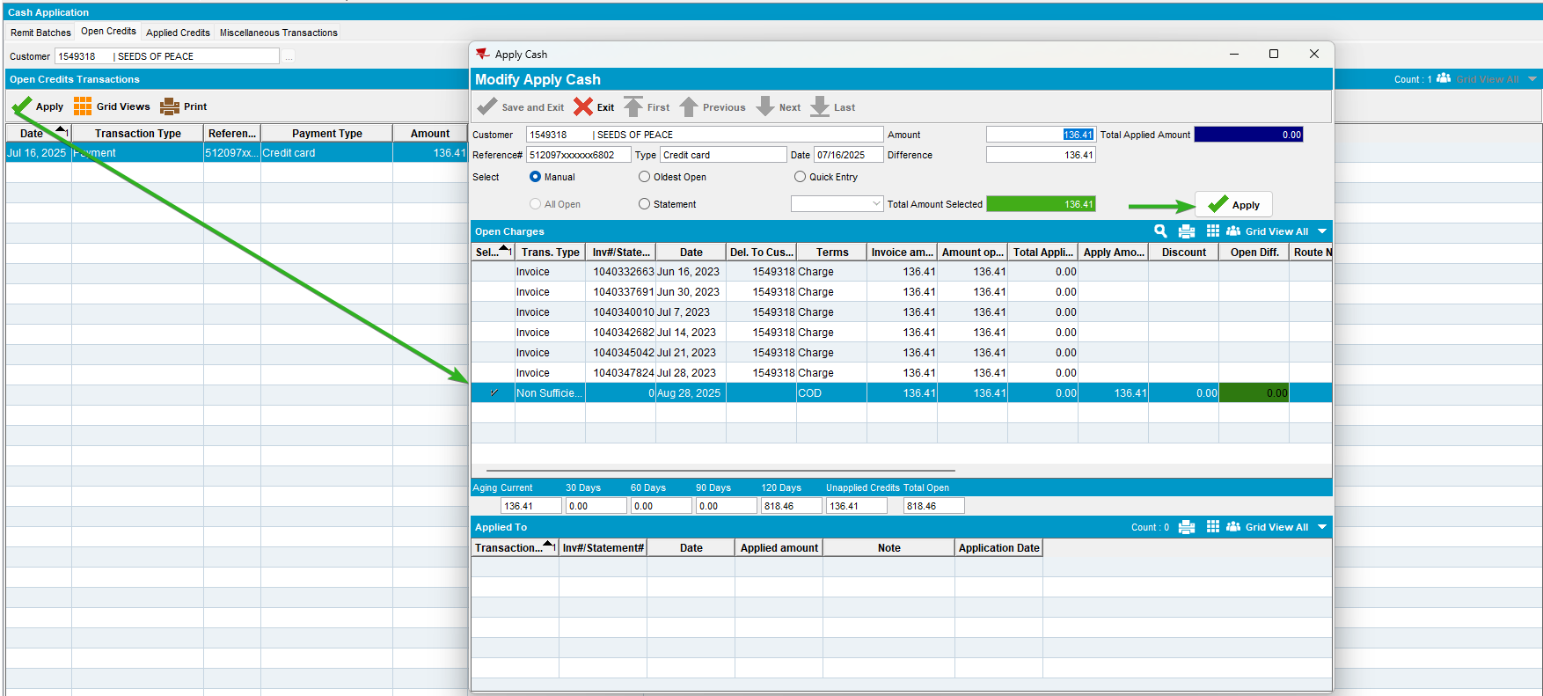

- Settle initial CreditCardTransaction. Use Credit Card Transaction dialog -> tab Unsettled transactions.
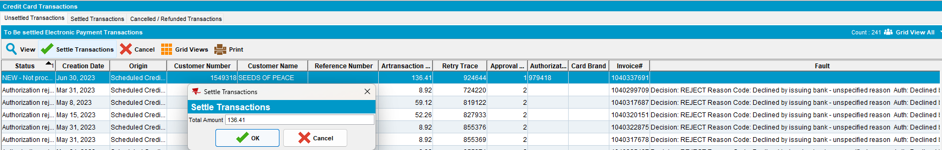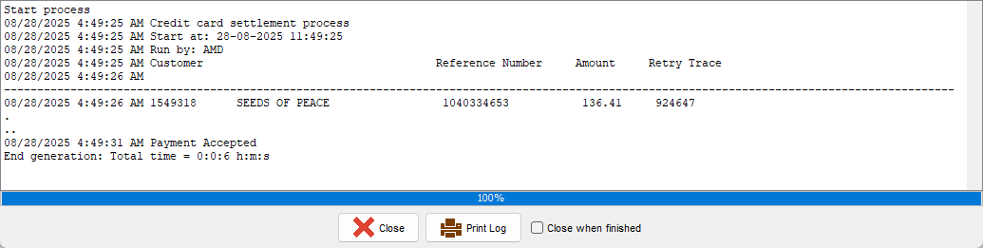

Test Case 2 – Unapply AR transaction from singlepayment -> Settle again by running process scheduler

- Choose an existing payment done via Freedom Pay. Use Credit Card Transaction dialog -> tab Settled transactions.
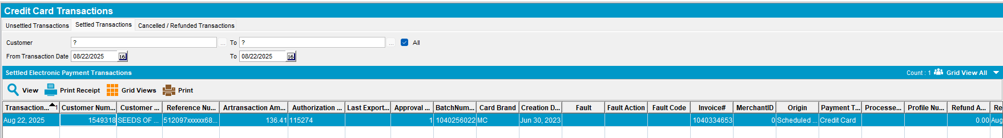

- Unapply payment from Cash Application screen. This reopens ARTransactions and sets CreditCardTransaction to status New.
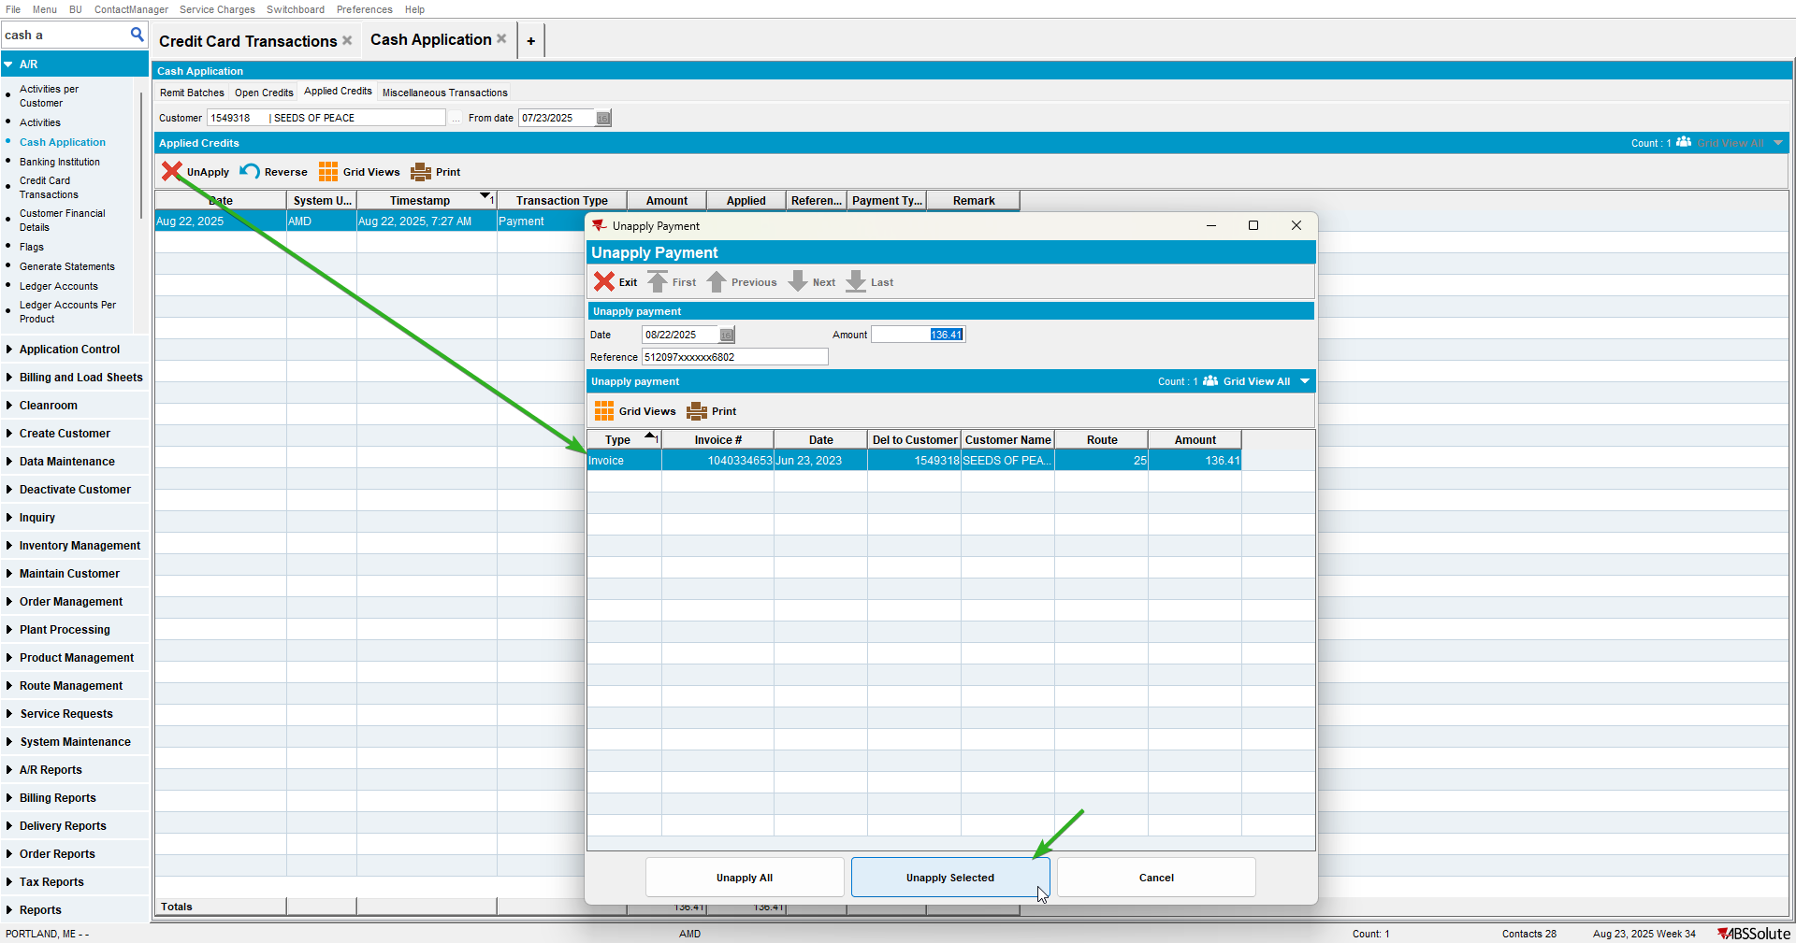

- Create a miscellaneous ARTransaction of type NSF. Use Cash Application -> Miscellaneous Transactions.
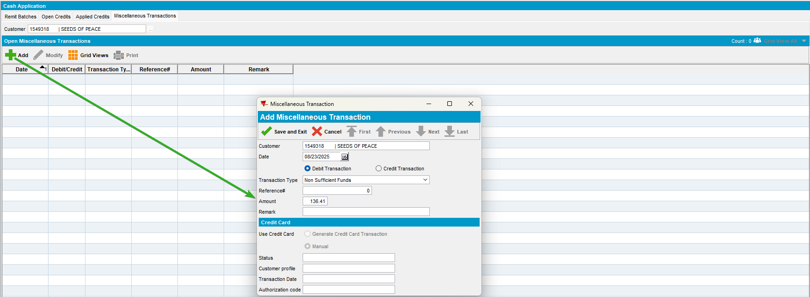

- Use transaction created at previous step to close the initial payment. This is closing the ARTransaction linked to CCT. Use Cash Application -> Open Credits -> Apply.
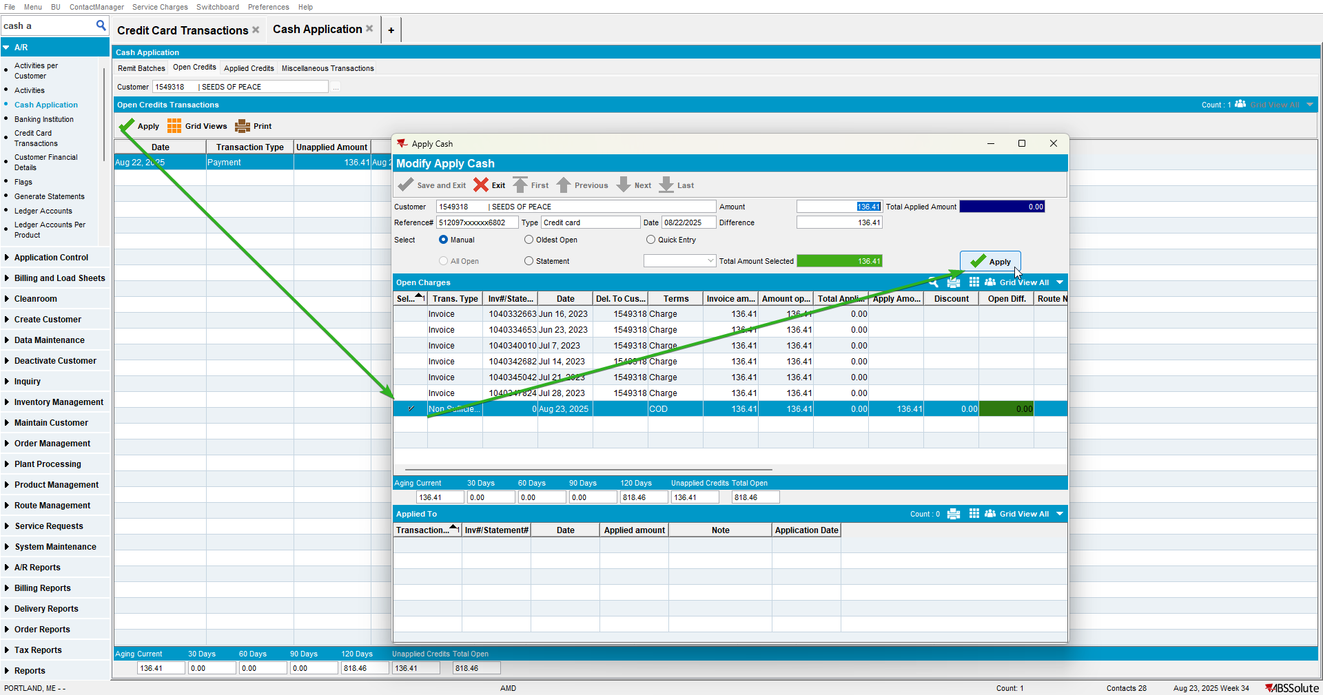

- Settle by running process scheduler.
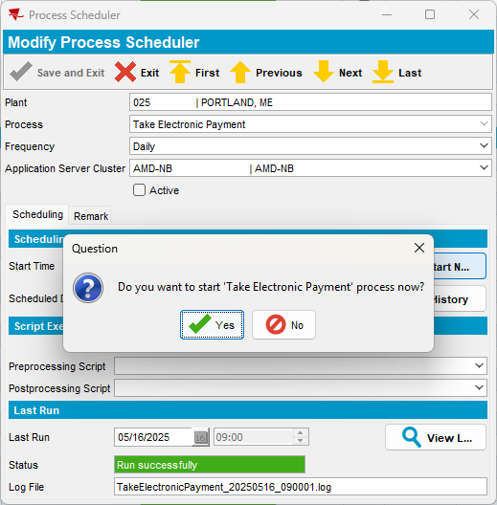
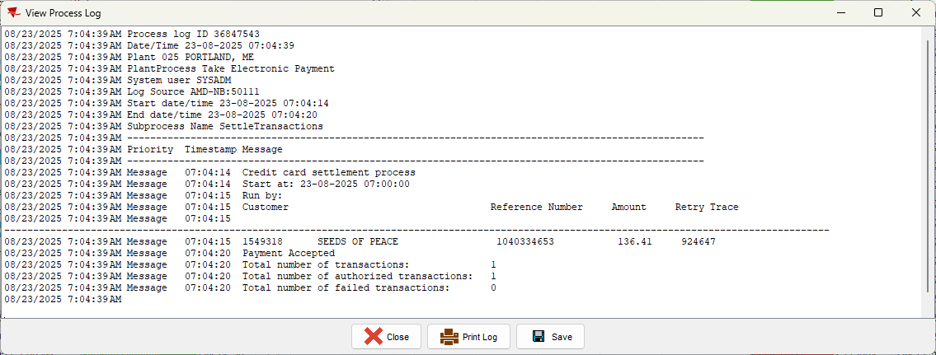

Test Case 3 – Unapply AR transaction from batch payment -> Settle again by pressing settle button

- Choose an existing payment done via Freedom Pay. Use Credit Card Transaction dialog -> tab Settled transactions.
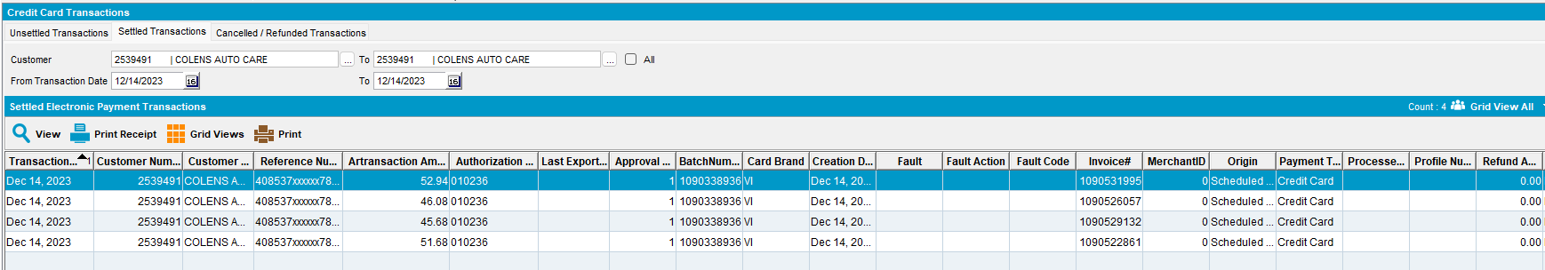

- Unapply payment from Cash Application screen. This reopens ARTransactions and sets CreditCardTransaction to status New.
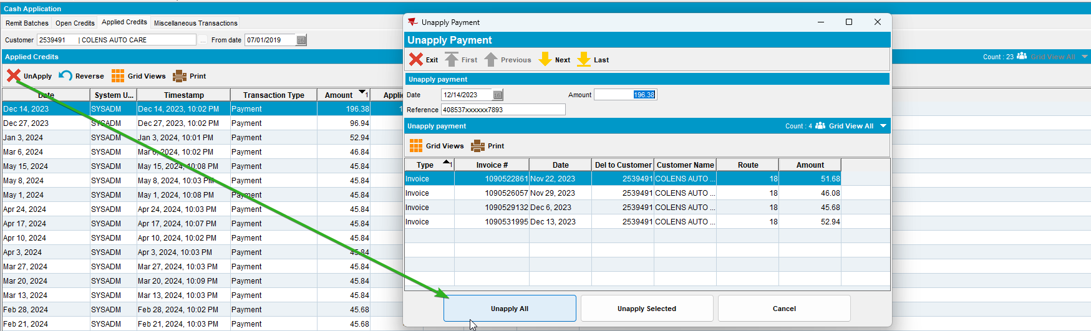

- Create a miscellaneous ARTransaction of type NSF. Use Cash Application -> Miscellaneous Transactions.
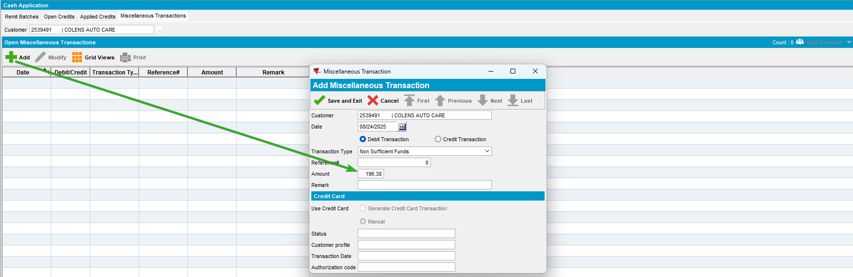

- Use transaction created at previous step to close the initial payment. This is closing the ARTransaction linked to CCT. Use Cash Application -> Open Credits -> Apply.
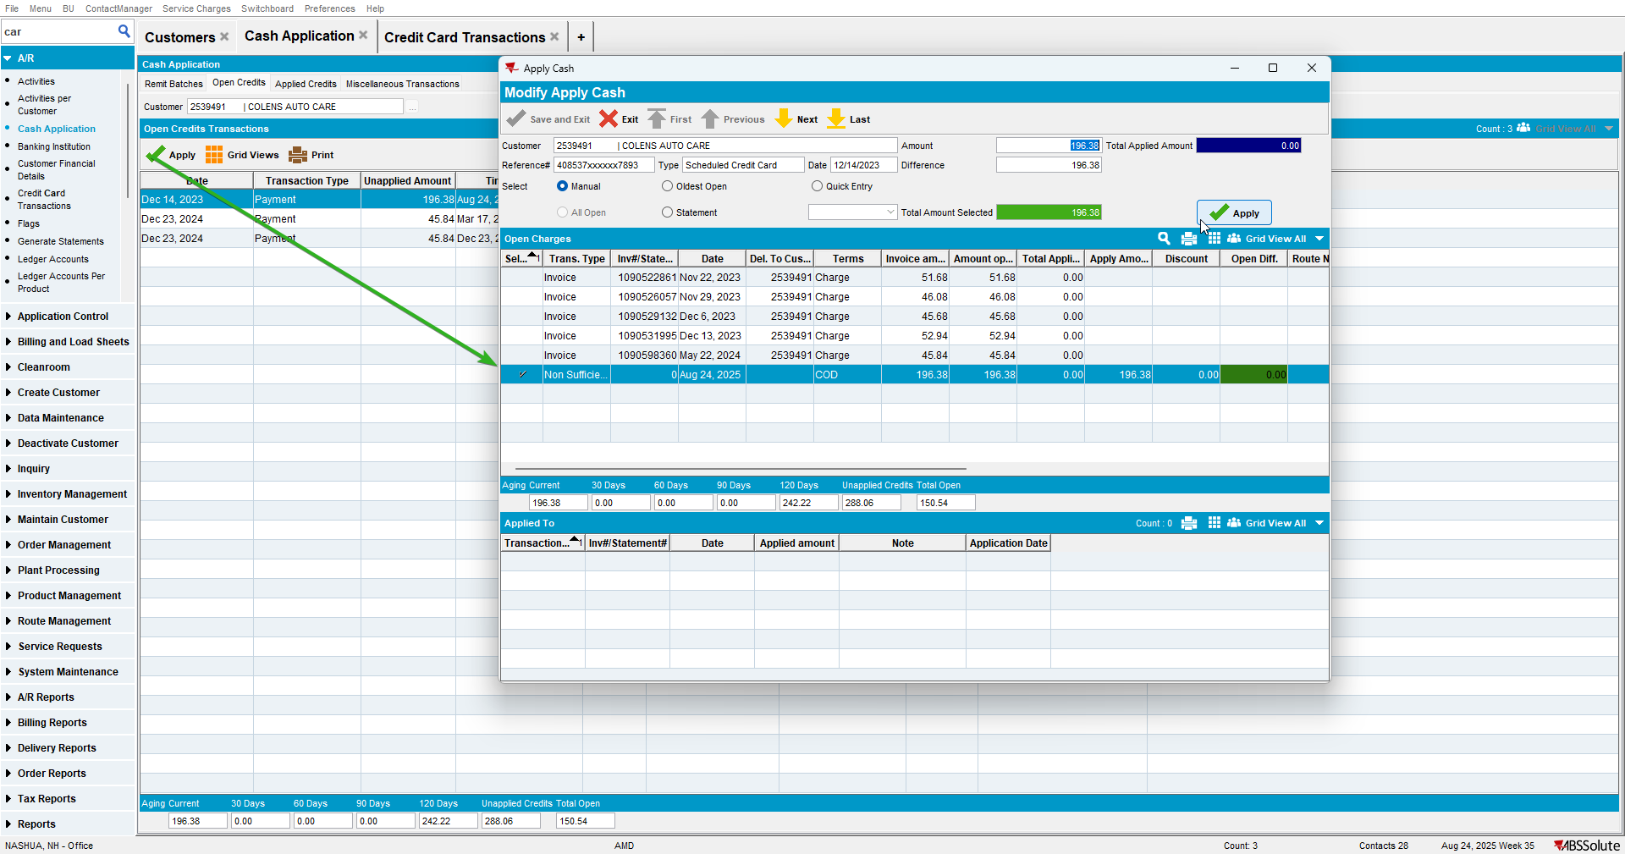

- Settle initial CreditCardTransaction. Use Credit Card Transaction dialog -> tab Unsettled transactions.
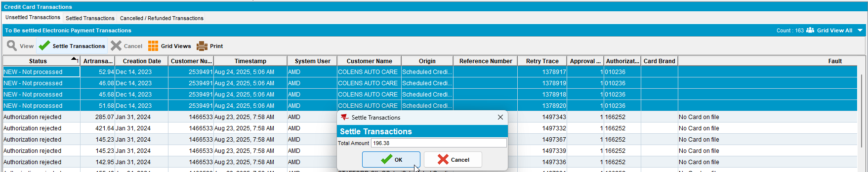
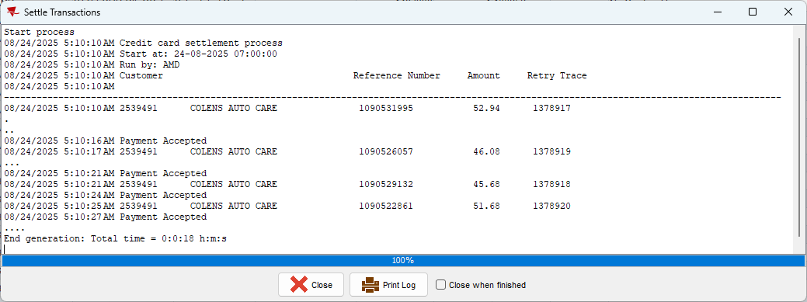

Test Case 4 – Unapply AR transaction from batch payment -> Settle again by running process scheduler

- Choose an existing payment done via Freedom Pay. Use Credit Card Transaction dialog -> tab Settled transactions.
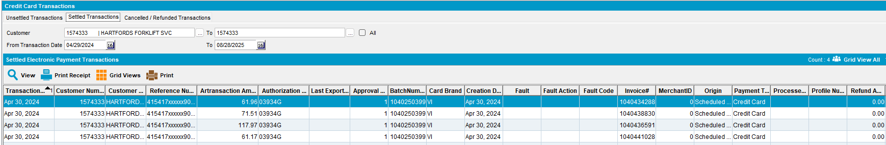

- Unapply payment from Cash Application screen. This reopens ARTransactions and sets CreditCardTransaction to status New.
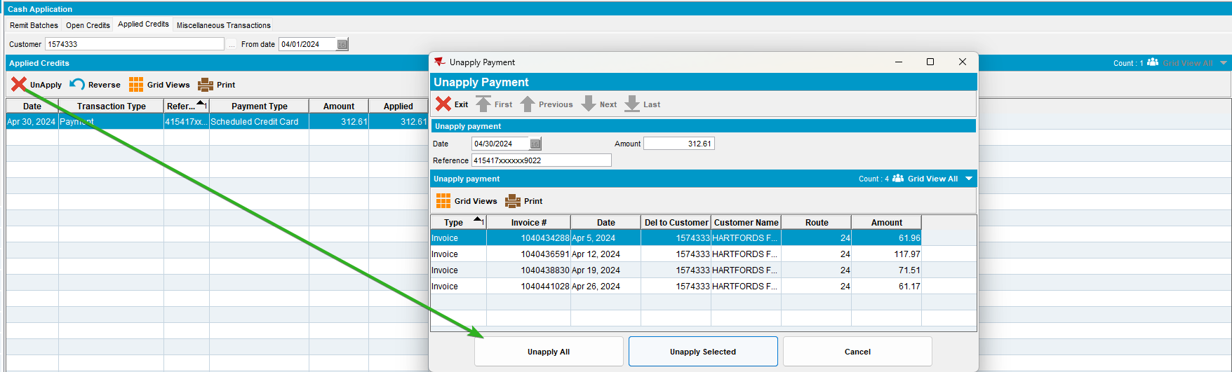

- Create a miscellaneous ARTransaction of type NSF. Use Cash Application -> Miscellaneous Transactions.
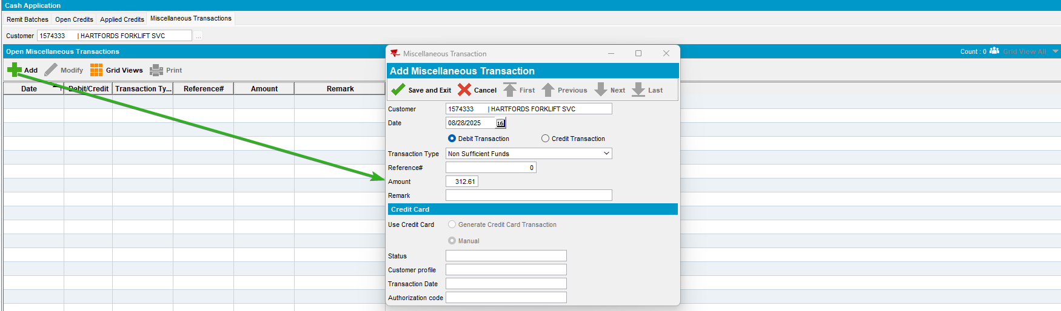

- Use transaction created at previous step to close the initial payment. This is closing the ARTransaction linked to CCT. Use Cash Application -> Open Credits -> Apply.
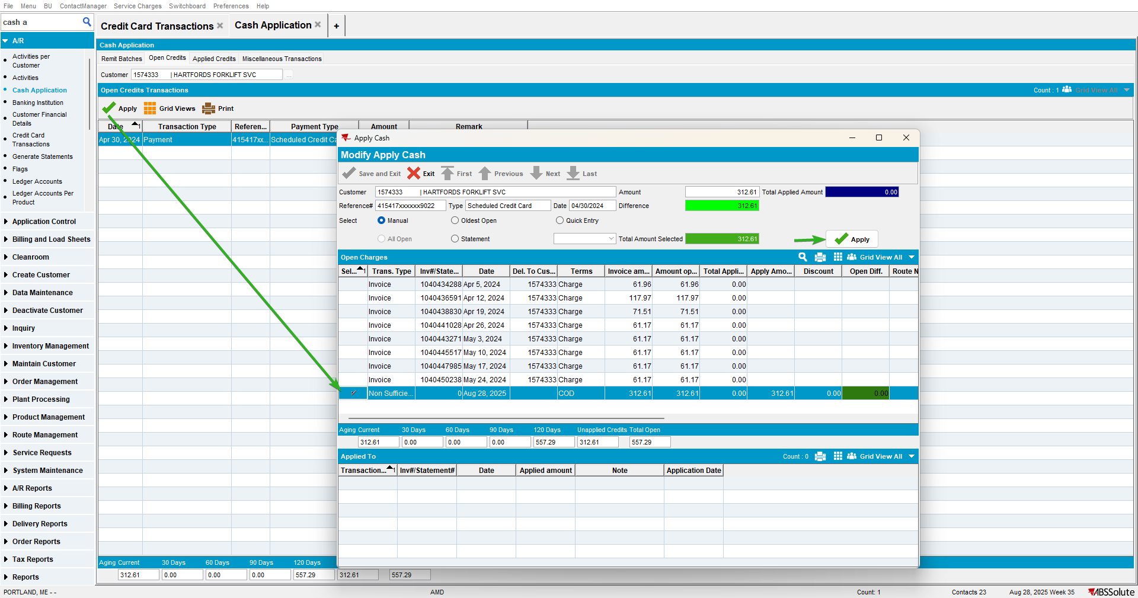

- Settle by running process scheduler.
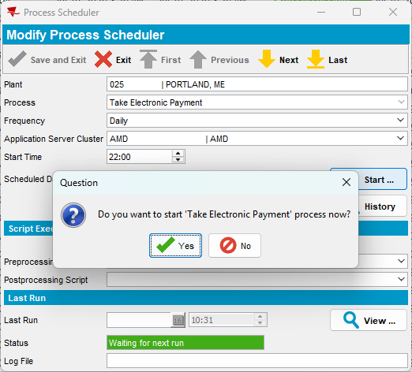
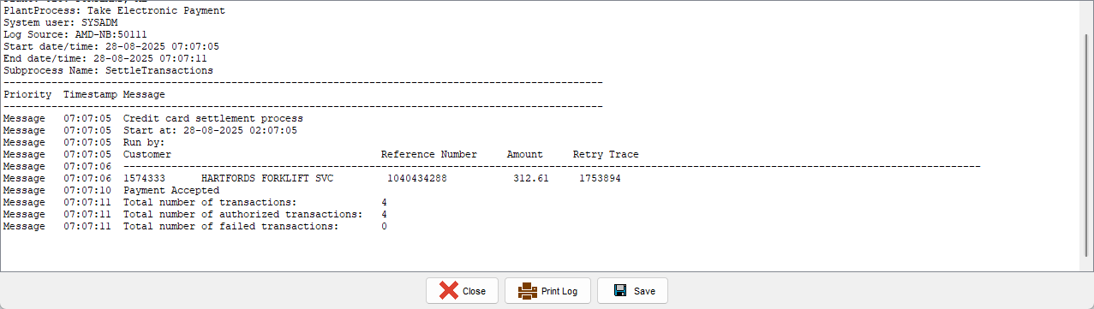

Test Case 5 – Unapply AR transaction from single payment -> Create Remit Batch and apply 1$ to the invoice -> Settle again by pressing settle button

- Choose an existing payment done via Freedom Pay. Use Credit Card Transaction dialog -> tab Settled transactions.
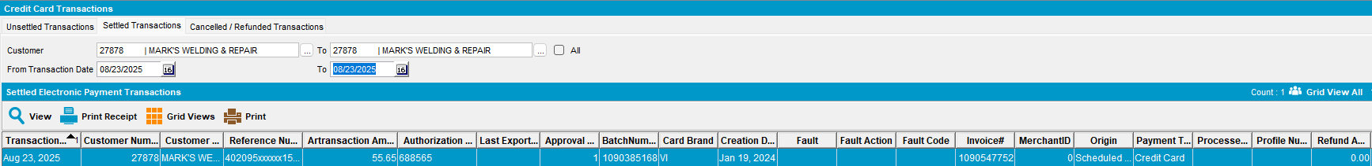

- Create Remit Batch and apply 1$ to the invoice. Use Cash Application dialog -> tab Remit Batches.
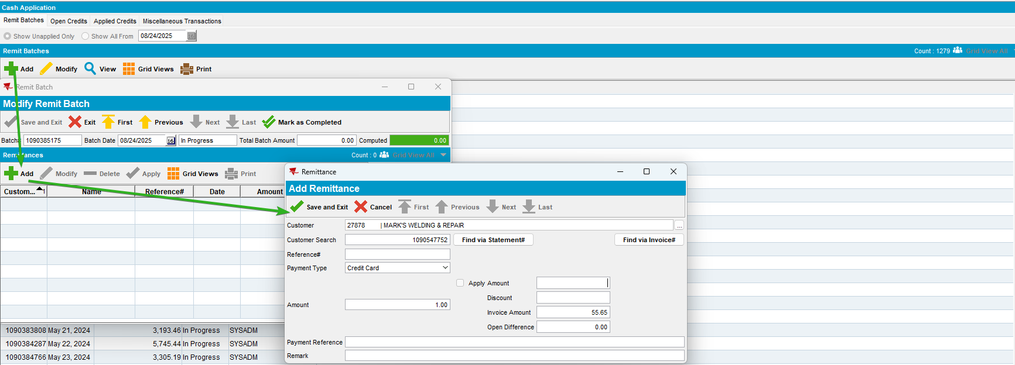

- Unapply payment from Cash Application screen. This reopens ARTransactions and sets CreditCardTransaction to status New.
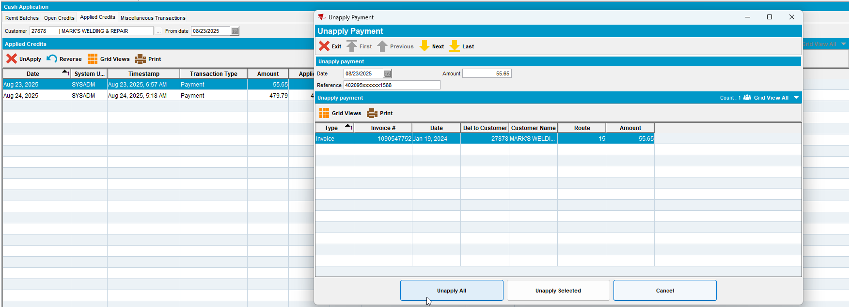
- Create a miscellaneous ARTransaction of type NSF. Use Cash Application -> Miscellaneous Transactions.
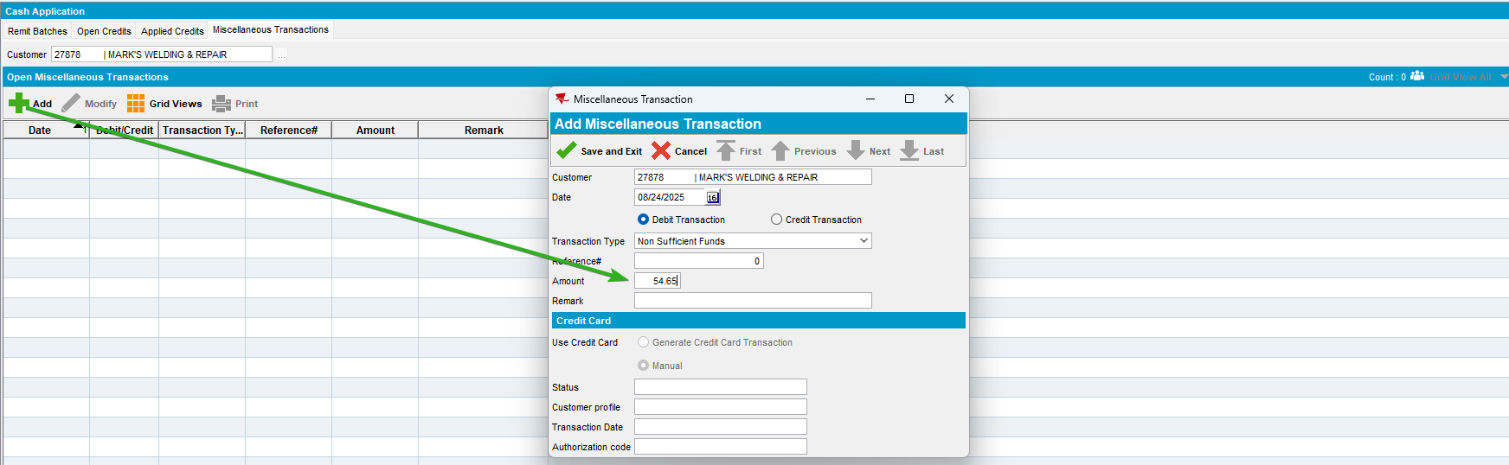

- Use transaction created at previous step to close the initial payment. This is closing the ARTransaction linked to CCT. Use Cash Application -> Open Credits -> Apply.
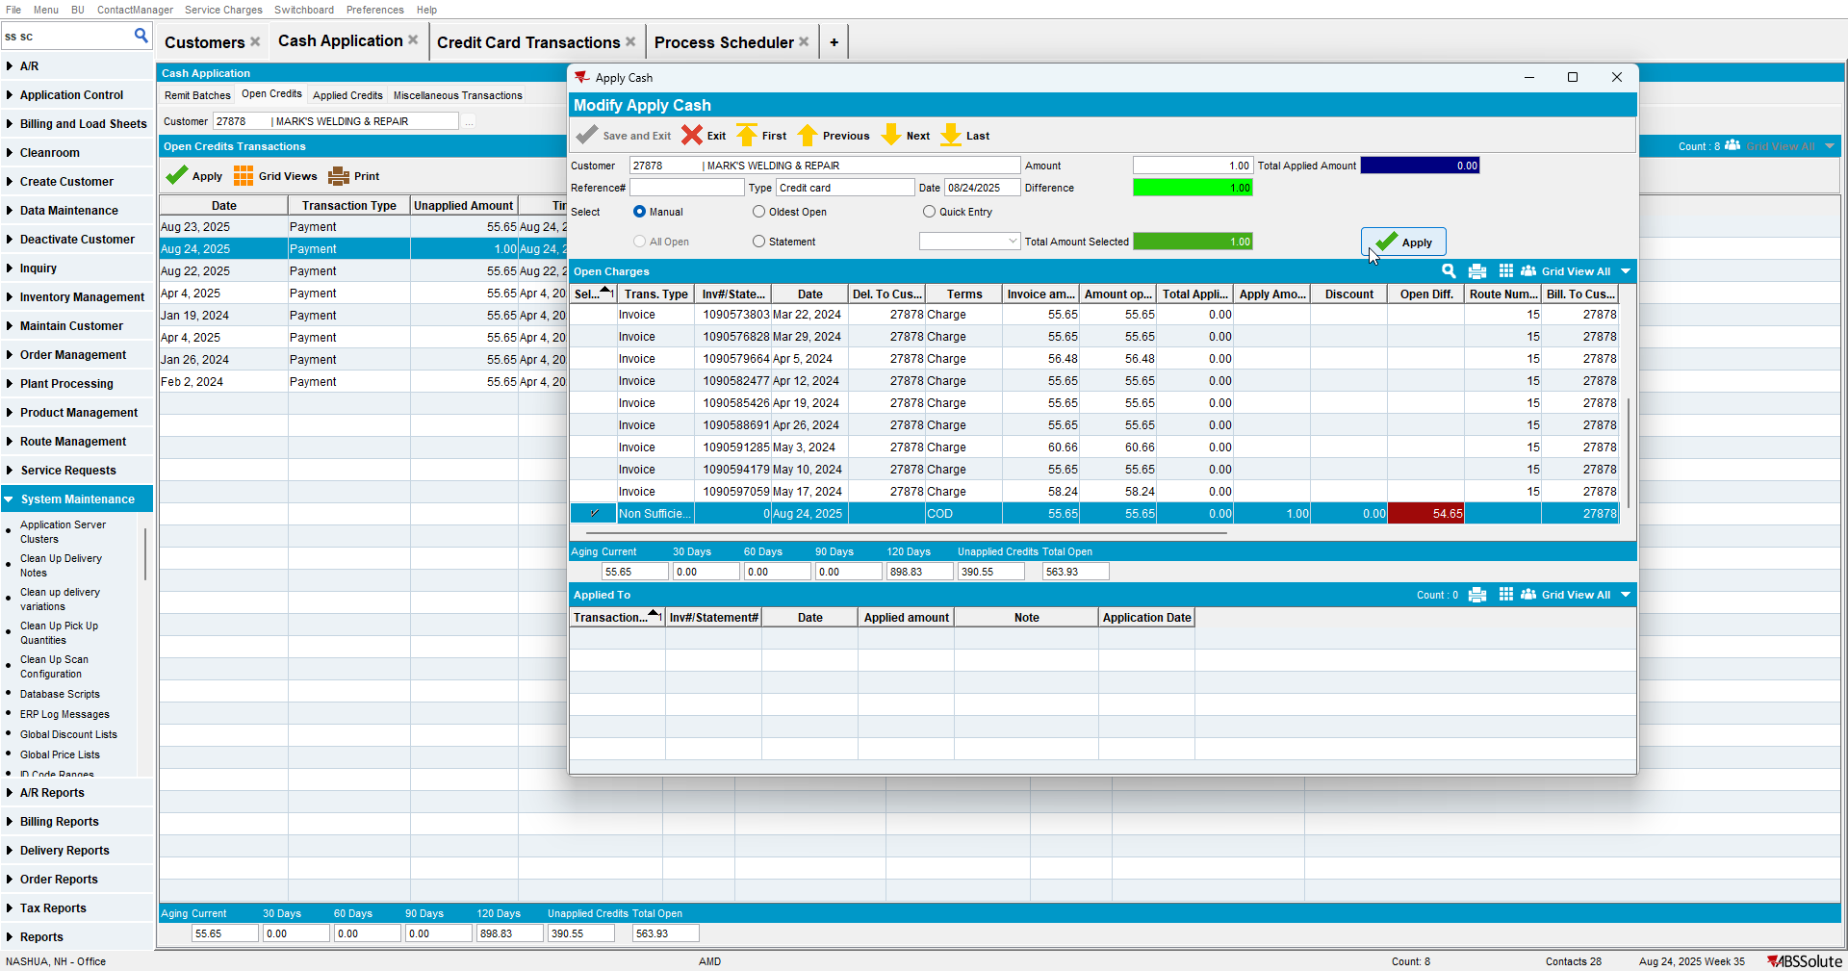

- Settle initial CreditCardTransaction. Use Credit Card Transaction dialog -> tab Unsettled transactions.
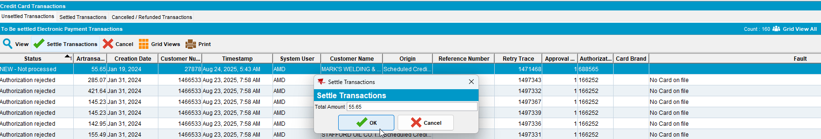
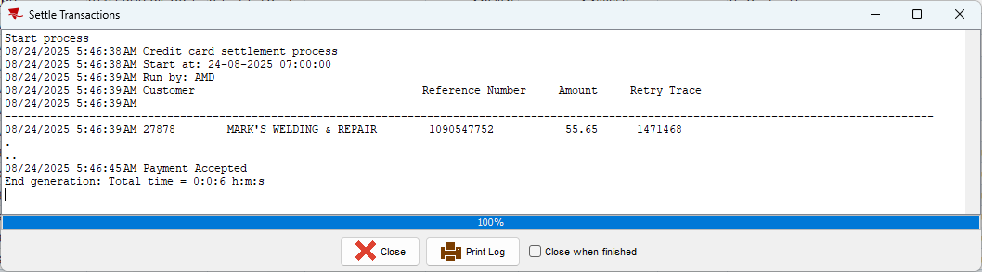

TESTED OK.

