ABSN-9835 IndexOutOfBoundsException when saving prices
Environment | Prerequisites
Version:9.07.00.UNF20  DBServerName=abs-srv16.internal.abslbs.com  DBSID=CUST21  DBUser=UNFDEV  DBPassword=UNFDEV  Environment=Production | - Module:  - System setting

Contents
Test after fix 1
Test Case 1 – Open a contract product and check for No Data Found errors – Tested OK 1
Test Case 2 – Add more price lines than the size of the dialog – Tested OK 3

Test after fix

Test Case 1 – Open a contract product and check for No Data Found errors – Tested OK
Expected behavior: The number of No Data Found errors should be lower
Hash: 07365a9530b5
- Go to Contract dlg and open a contract
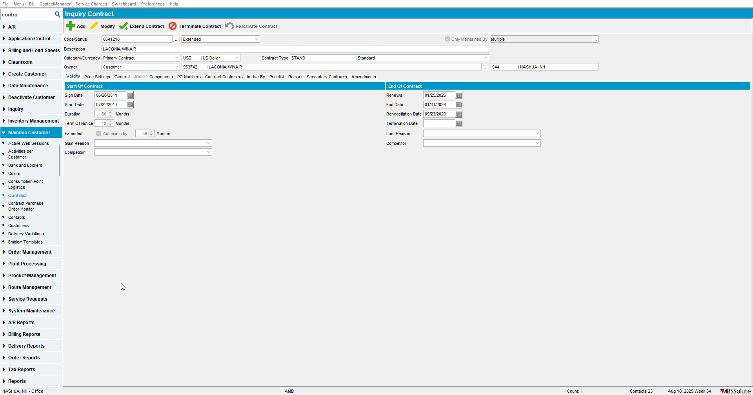
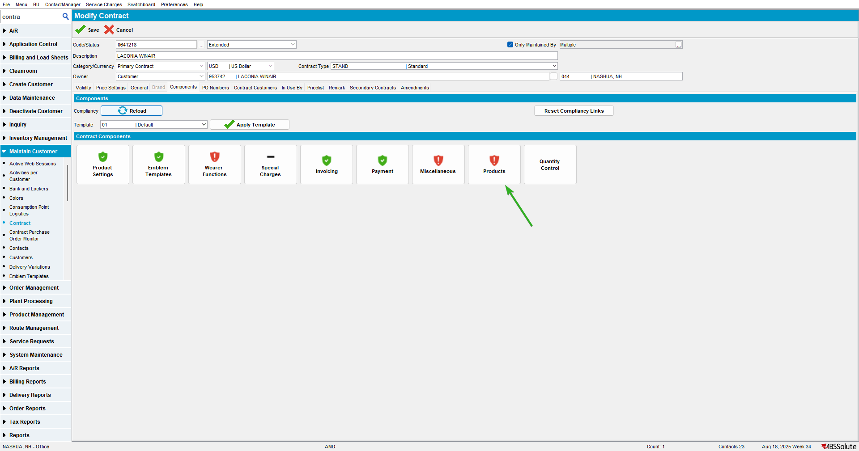
- Select a contract product
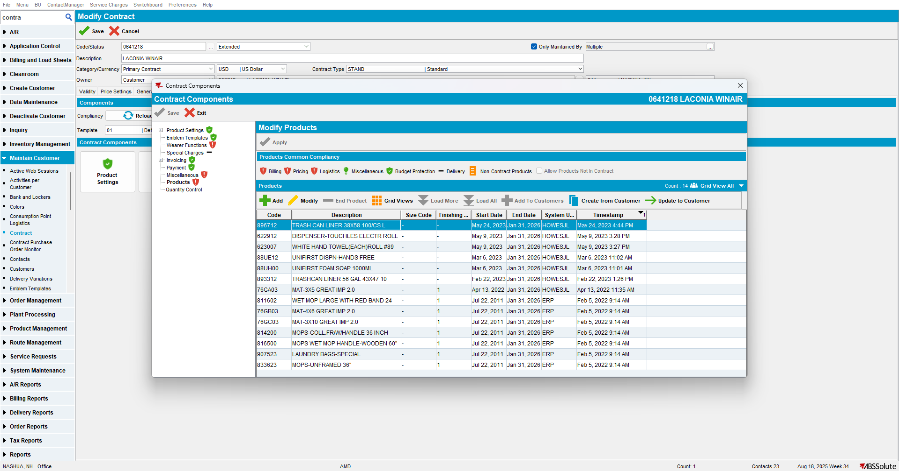
Check the console for No Data Found errors

Test Case 2 – Add more price lines than the size of the dialog – Tested OK
Expected behavior: The IndexOutOfBoundsException should not appear
Hash: 07365a9530b5
- Go to Contract dlg and select a contract

- Add more price lines than the window can show(until the scroll button appears on the window)
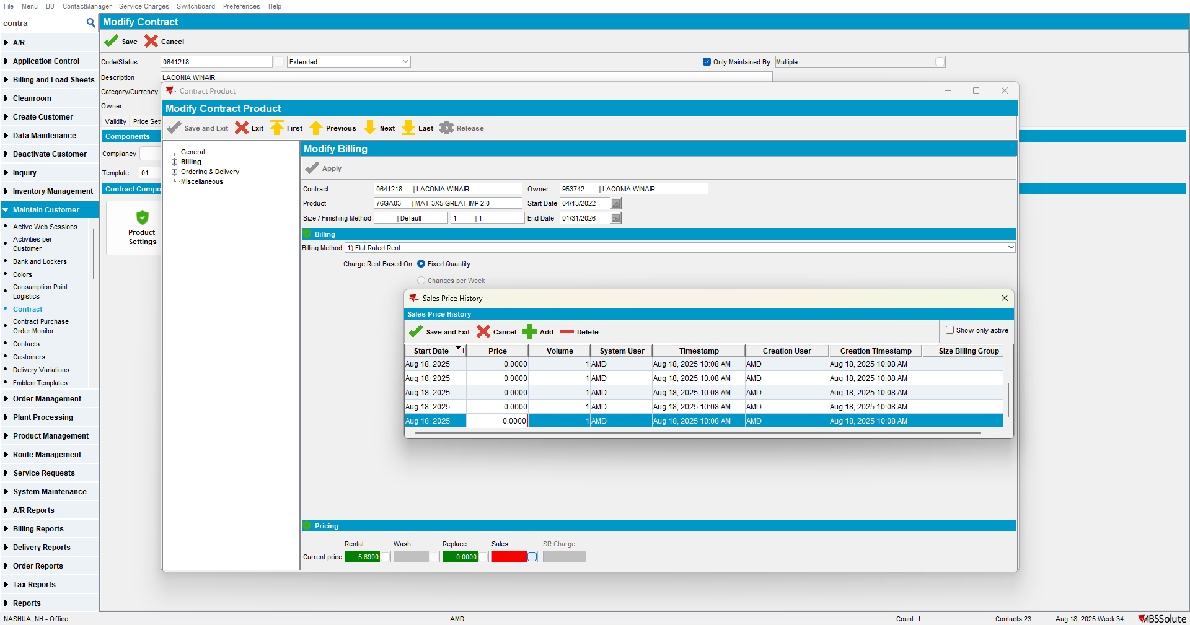
- Press Cancel or X
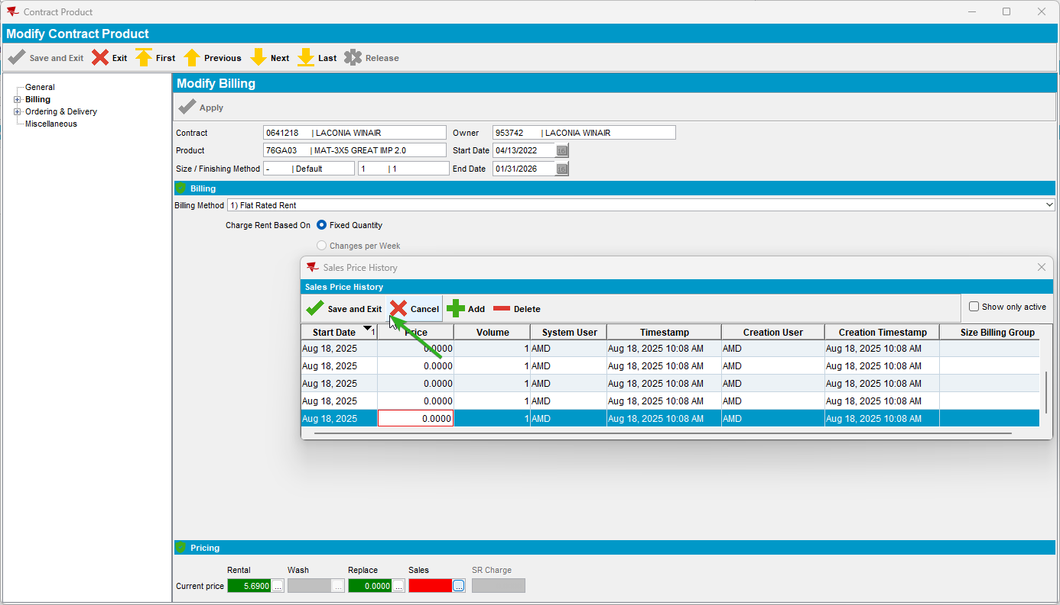

- Do not save the changes
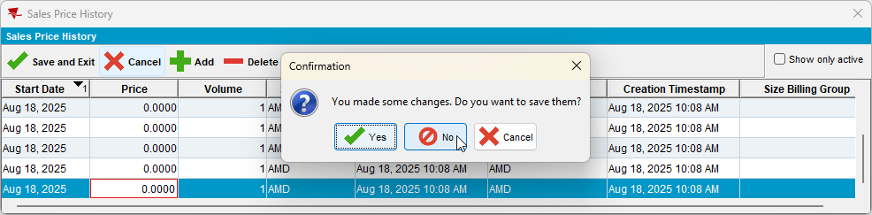
No error occurs.

TEST OK

