ABSN-9669 - D_UBS_2751 Compliancy setting Size Surcharge Pricing when enforcing Special Size Charge
Environment | Prerequisites
Version: 9.07.00.UNF17.p13  DBServerName= abs-srv20.internal.abslbs.com  DBSID=CUST24  DBUser=UNFDEV  DBPassword= UNFDEV  Environment=Test | - Module:  - System setting

Contents
Retest after fix 1
Test Case 1 – Set Special Surcharge Pricing value to Y while Special Size Charging value is Y 1
Test Case 2 – Set Special Surcharge Pricing value to N 4
Test Case 3 – Set Special Size Charging value to Y while Special Surcharge Pricing is N 7
Test Case 4 – Set Special Size Charging value to N 9

Retest after fix

Test Case 1 – Set Special Surcharge Pricing value to Y while Special Size Charging value is Y
Hash: bae26c0c0a7f
- Contract DLG: Components > Product Settings
- Contract DLG: See the status of Special Size Charging and Size Surcharge Pricing
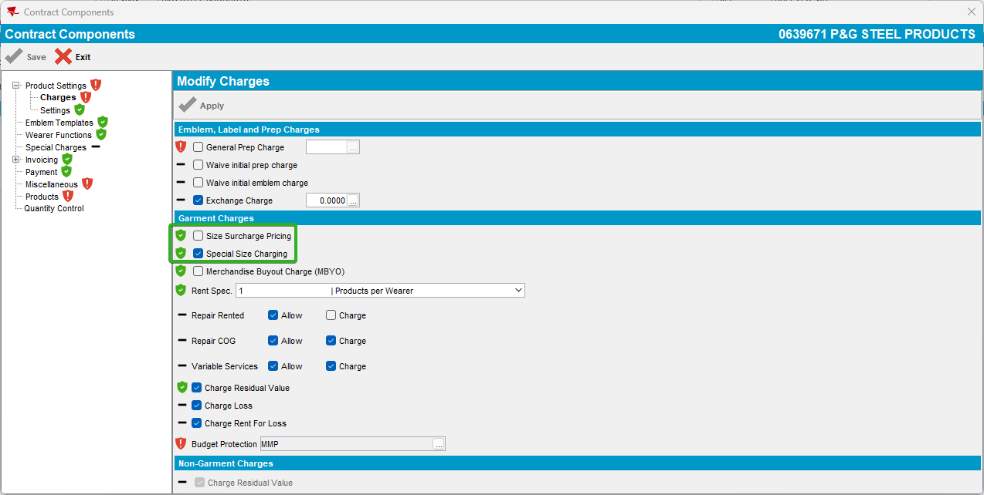

- Check that both are compliant
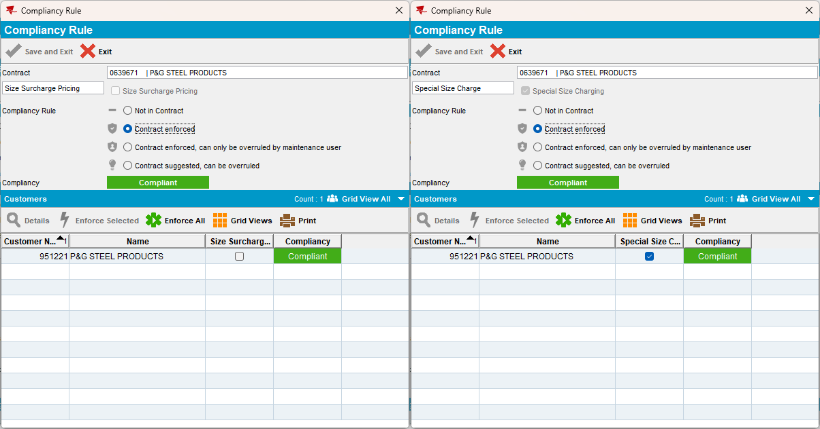

- Customers DLG: Garment Charges check that both “Product/Size Surcharge Pricing” and “Product Special Size Charging” are as set-up in the contract at step 3
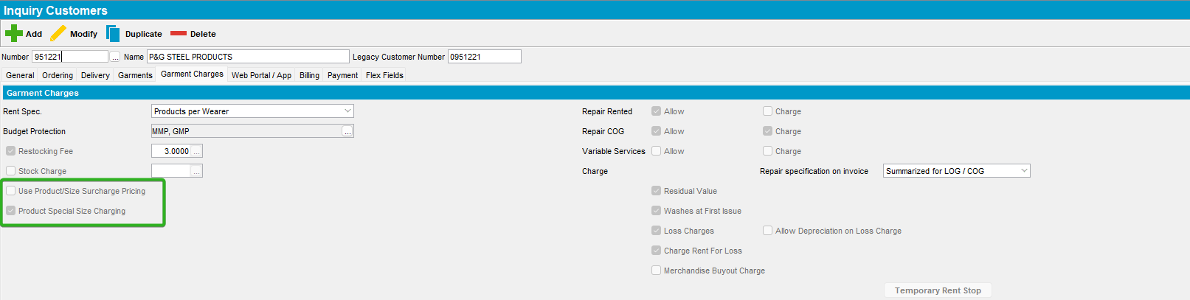

- Contract DLG: Set Special Surcharge Pricing to Y
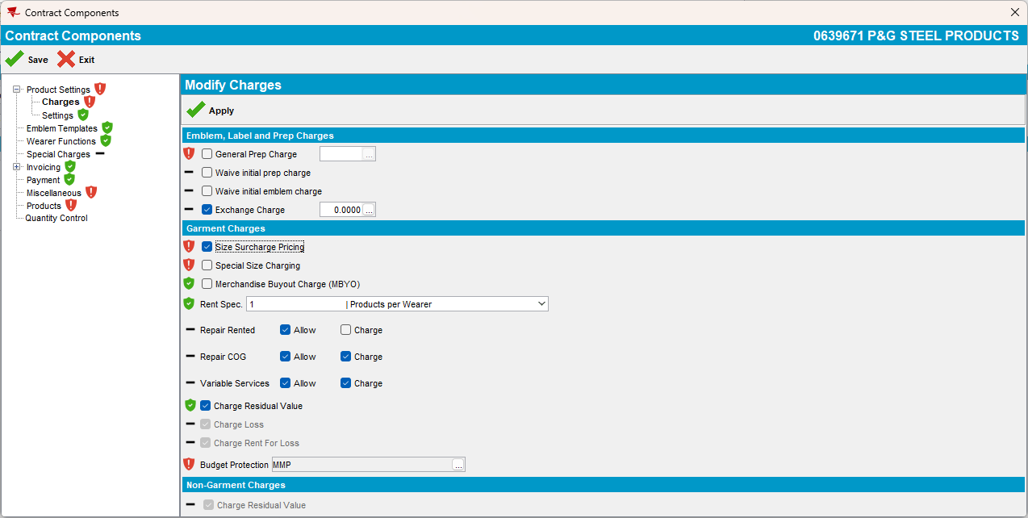
Notice that Special Size Charging value automatically changed to N.
- Change the compliancy of Size Surcharge Pricing to compliant.
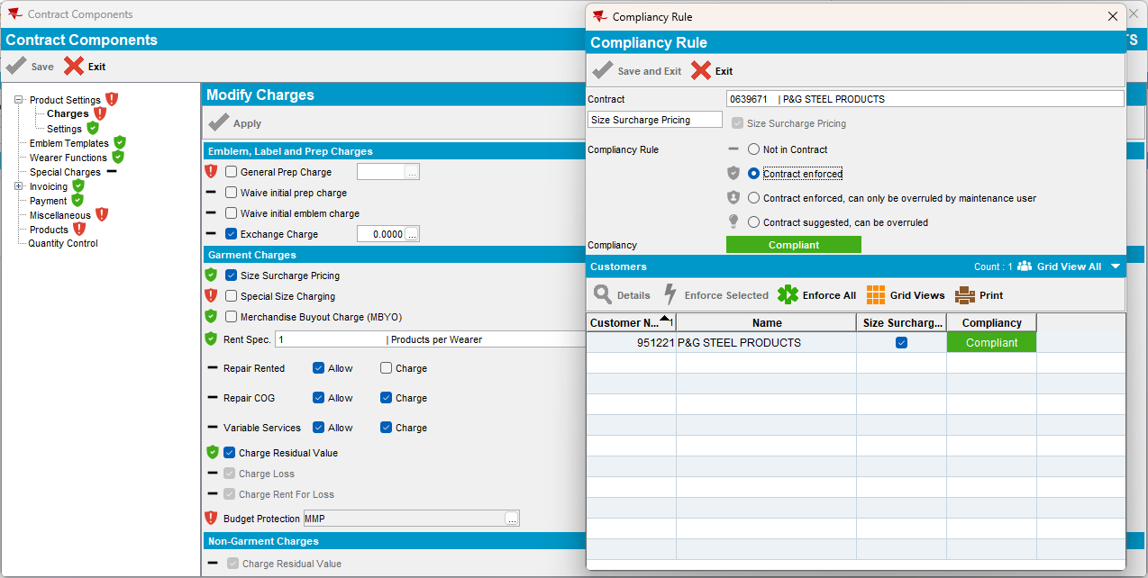

- Customer DLG: Check the status of the “Product/Size Surcharge Pricing” and “Product Special Size Charging”
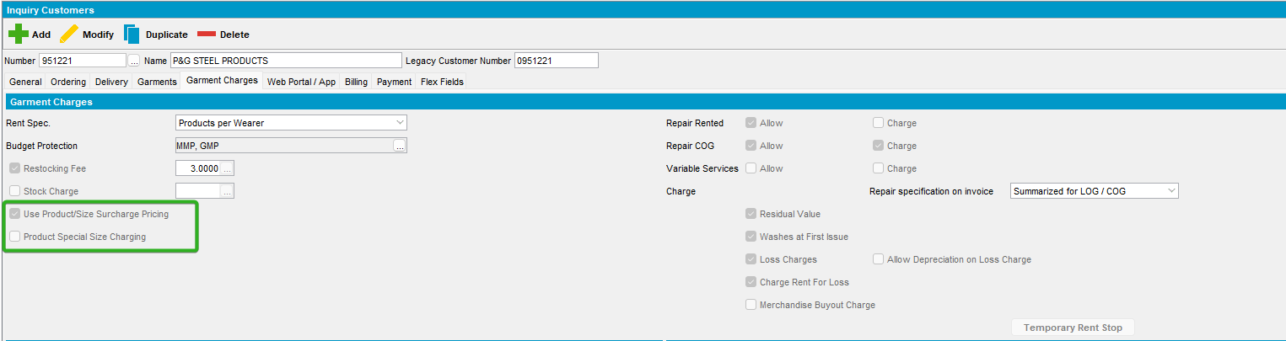

Test Case 2 – Set Special Surcharge Pricing value to N

- Contract DLG: Components > Product Settings
- Contract DLG: See the status of Special Size Charging and Size Surcharge Pricing
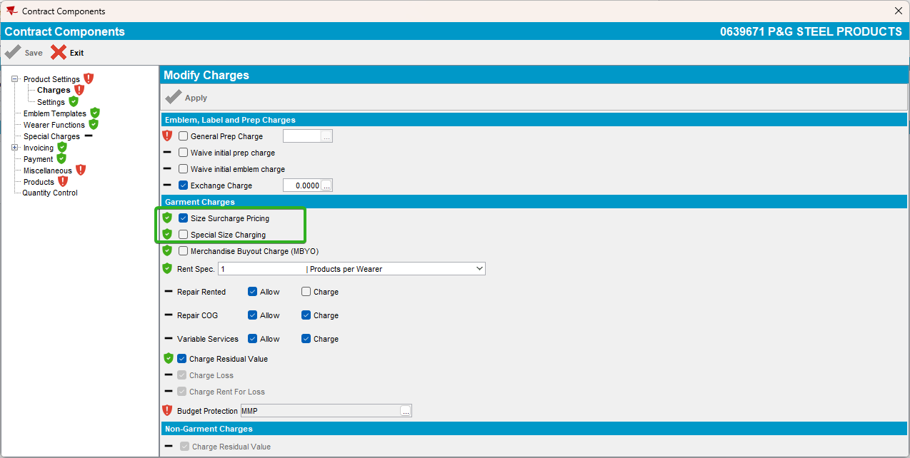

- Customers DLG: Garment Charges check that both “Product/Size Surcharge Pricing” and “Product Special Size Charging” are as set-up in the contract at step 3

- Contract DLG: Set Special Surcharge Pricing to N
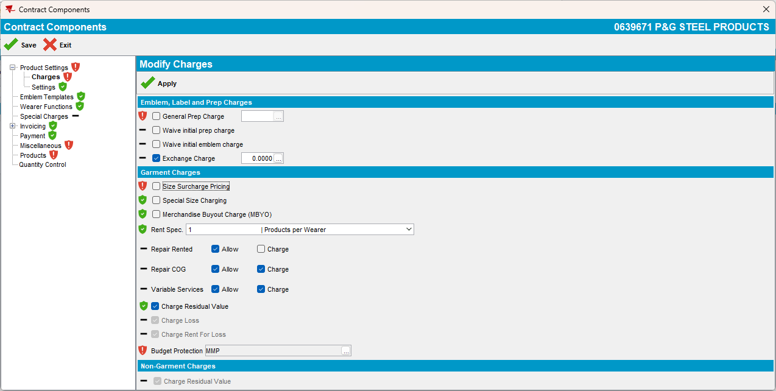
Notice that there is no change at Special Size Charging.

- Change the compliancy of Size Surcharge Pricing to compliant.
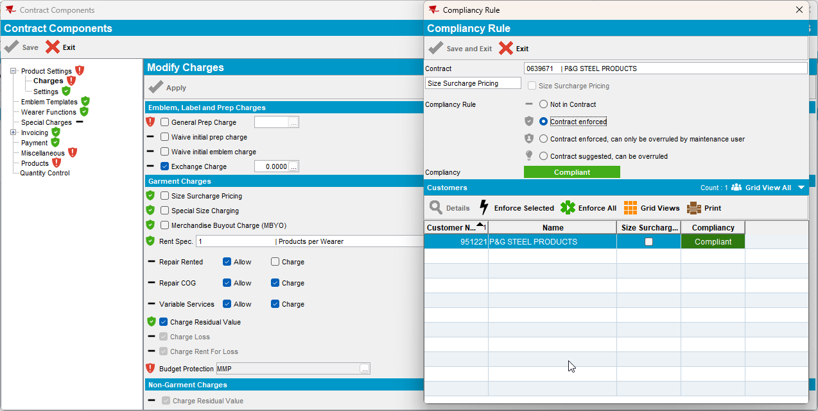

- Customer DLG: Check the status of the “Product/Size Surcharge Pricing” and “Product Special Size Charging”
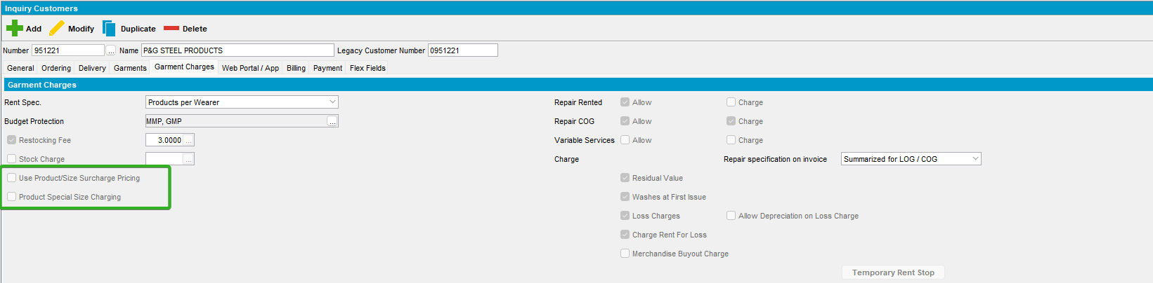

Test Case 3 – Set Special Size Charging value to Y while Special Surcharge Pricing is N

- Contract DLG: Components > Product Settings
- Contract DLG: See the status of Special Size Charging and Size Surcharge Pricing
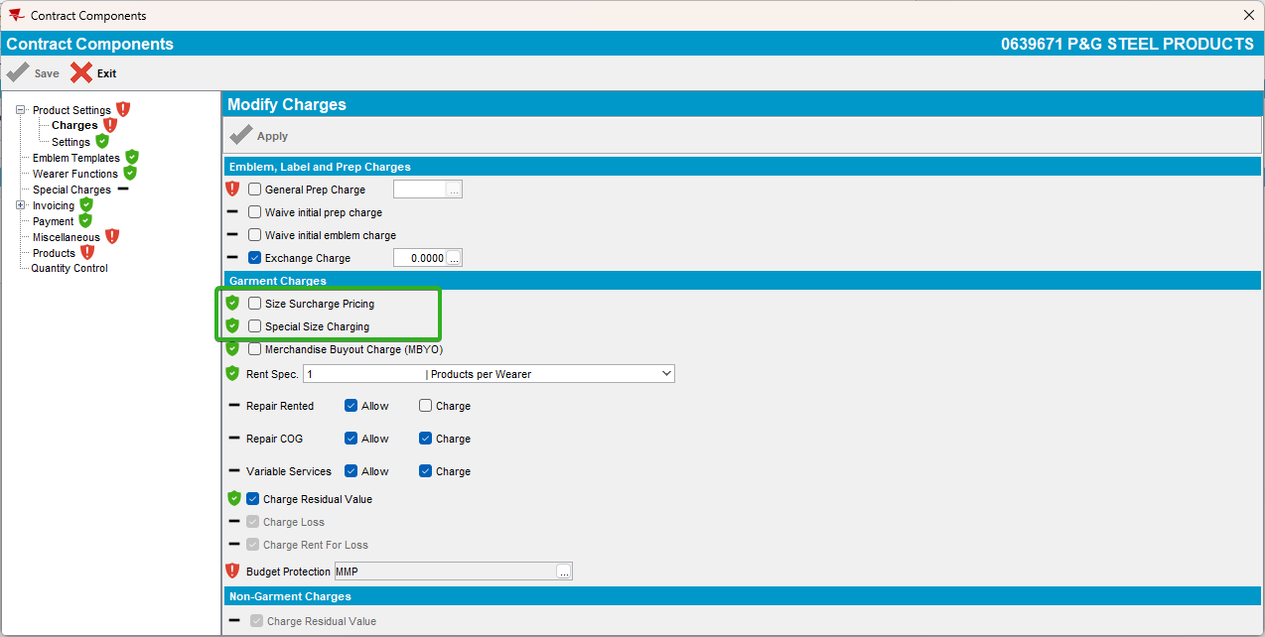

- Customers DLG: Garment Charges check that both “Product/Size Surcharge Pricing” and “Product Special Size Charging” are as set-up in the contract at step 3

- Contract DLG: Set Special Size Charging to Y
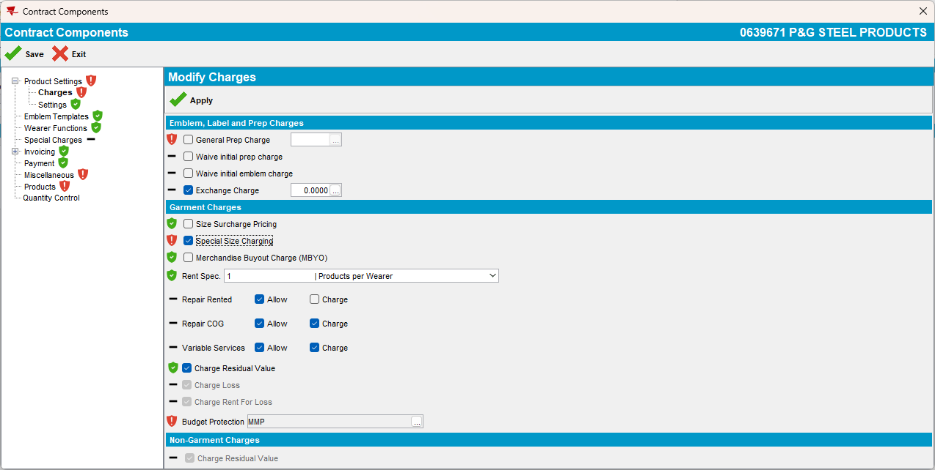
Notice that there is no change at Special Surcharge Pricing.

- Change the compliancy of Special Size Charging to compliant.
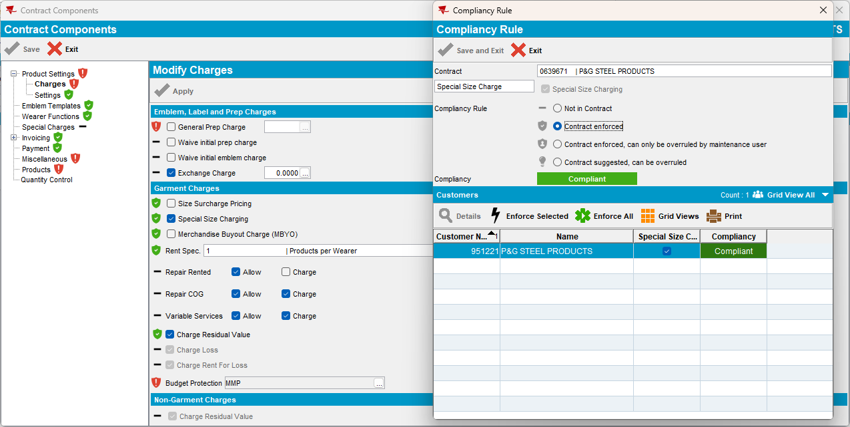

- Customer DLG: Check the status of the “Product/Size Surcharge Pricing” and “Product Special Size Charging”
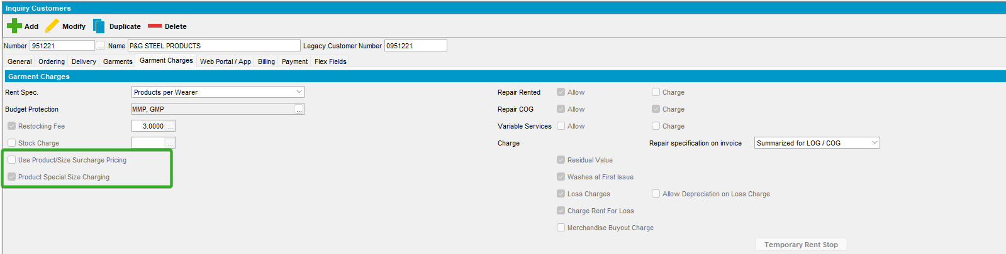

Test Case 4 – Set Special Size Charging value to N

- Contract DLG: Components > Product Settings
- Contract DLG: See the status of Special Size Charging and Size Surcharge Pricing
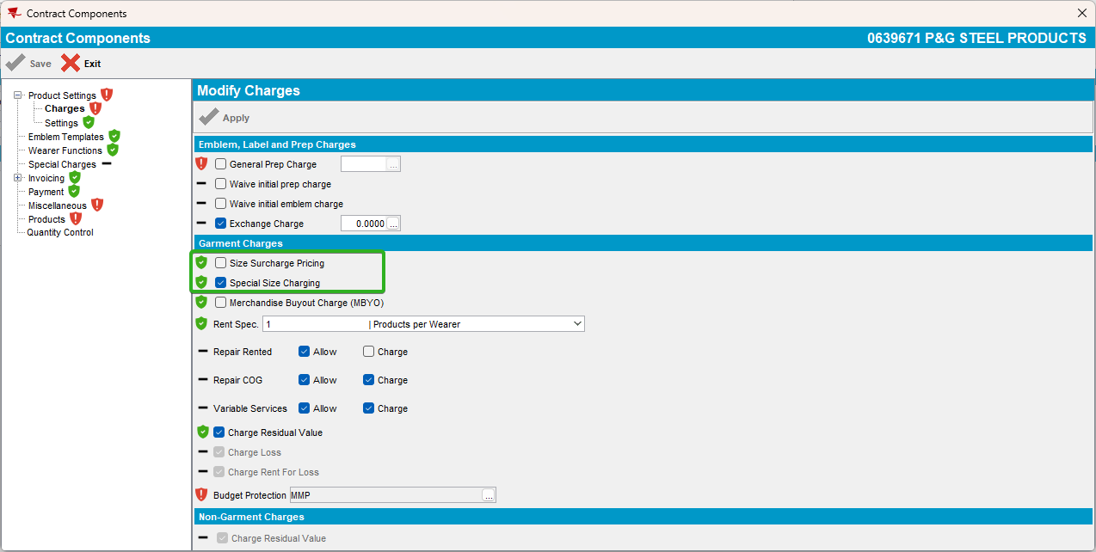

- Customers DLG: Garment Charges check that both “Product/Size Surcharge Pricing” and “Product Special Size Charging” are as set-up in the contract at step 3

- Contract DLG: Set Special Size Charging to N
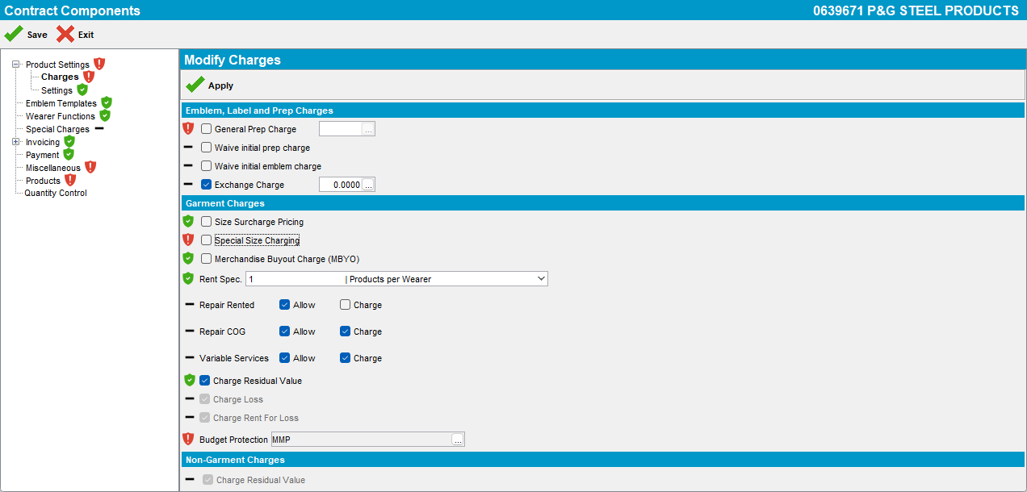
Notice that there is no change at Special Surcharge Pricing.

- Change the compliancy of Special Size Charging to compliant.
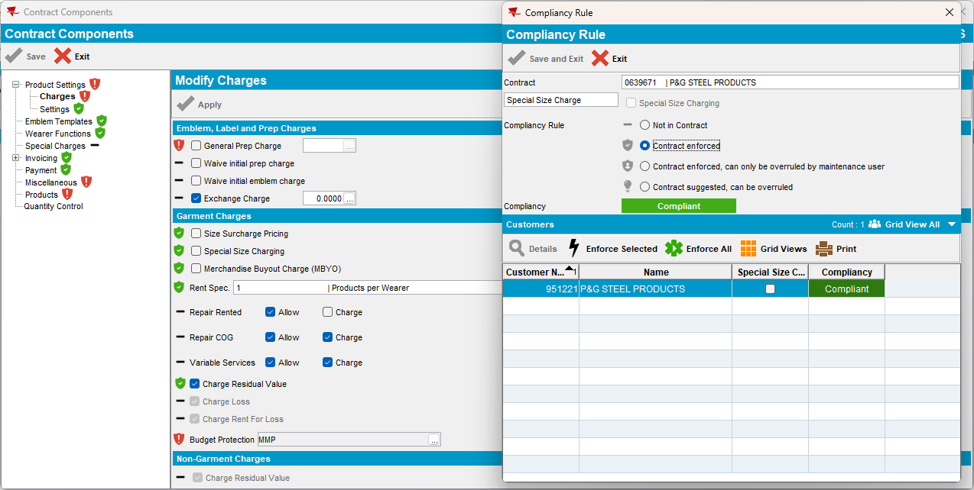

- Customer DLG: Check the status of the “Product/Size Surcharge Pricing” and “Product Special Size Charging”
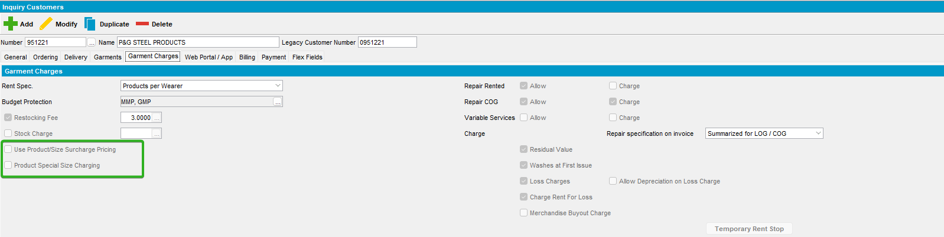

TESTED OK.

