ABSN-9565 D_UBS_2749 Vertex distribution failed - duplicate line numbers
Environment | Prerequisites
Version:9.07.00  DBServerName=abs-SRV20.internal.abslbs.com  DBSID=CUST24  DBUser=UNFDEV  Environment=Test | - Module:  - System setting

Contents
Test after fix 1
Test Case 1 – Generate an invoice with more than 9500 lines – Tested OK 1

Test after fix

Test Case 1 – Generate an invoice with more than 9500 lines – Tested OK
Expected behavior: After settle the Vertex BCI Distribution process should not fail.
Hash: 3f073d1
- Create a route for customer which will have more than 9510 invoice line on the invoice ( use customer 1540775). If the invoice needs a little more invoice lines you can check all budget protection for a garment and after that create some wearer inventories with it. You can also find a customer that has invoices with a lot of lines with the below select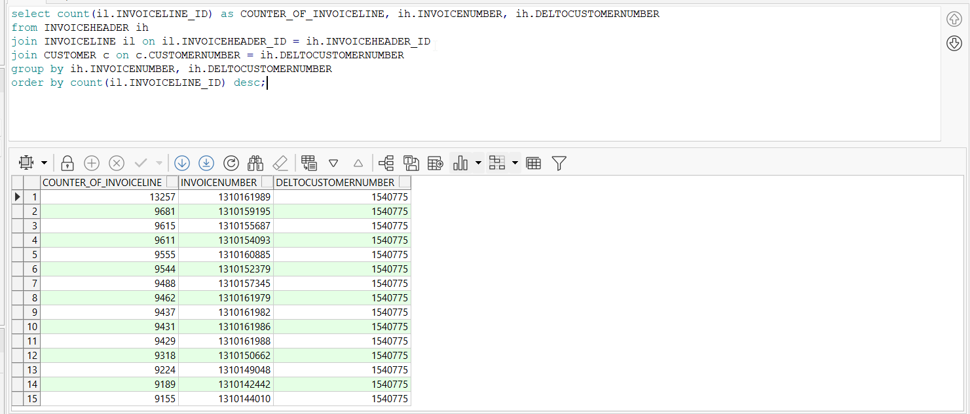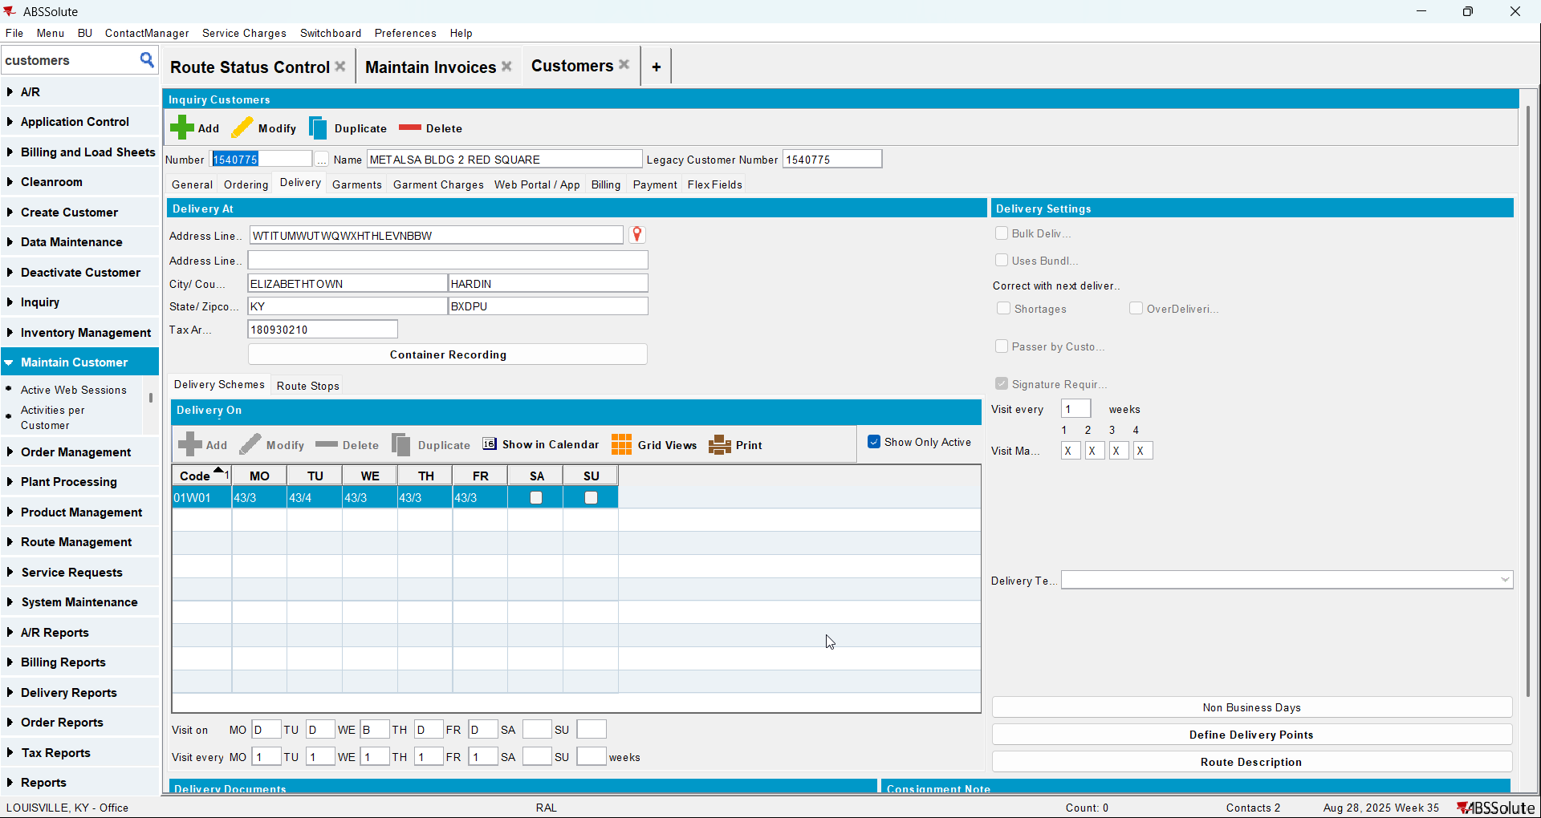
- Generate invoices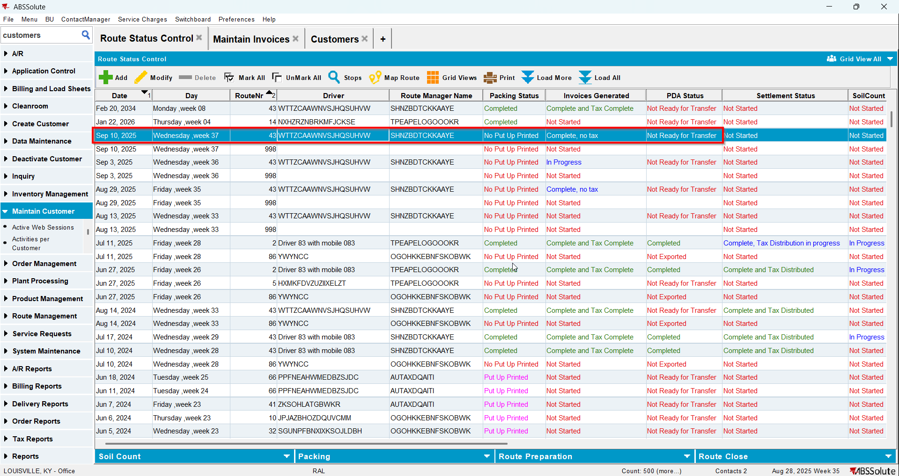
- Script the BCI vertex tax
- Run the process Import Vertex BCI tax
- Check the invoice. You will have duplicate lines for 9500 and 9501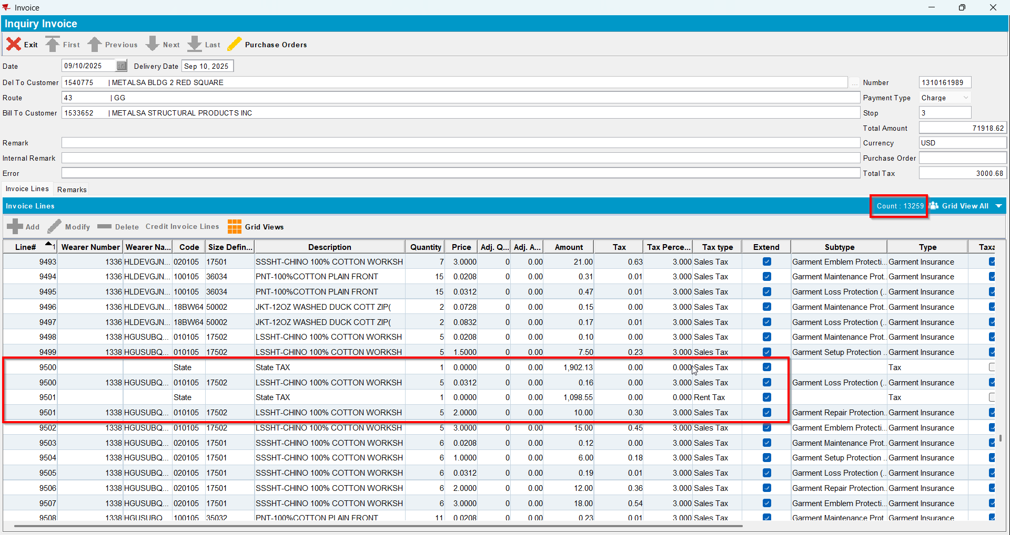
- Settle the route but don’t run the Vertex BCI Distribution process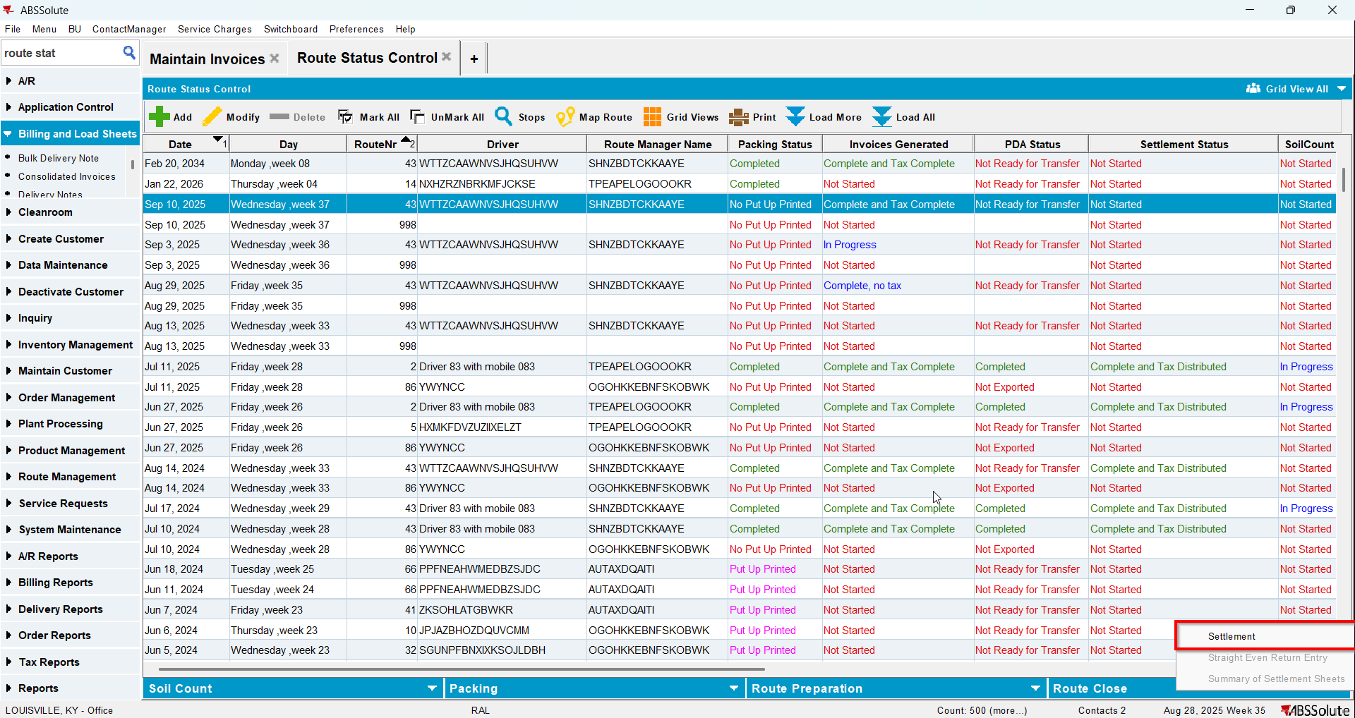
- Check again the invoice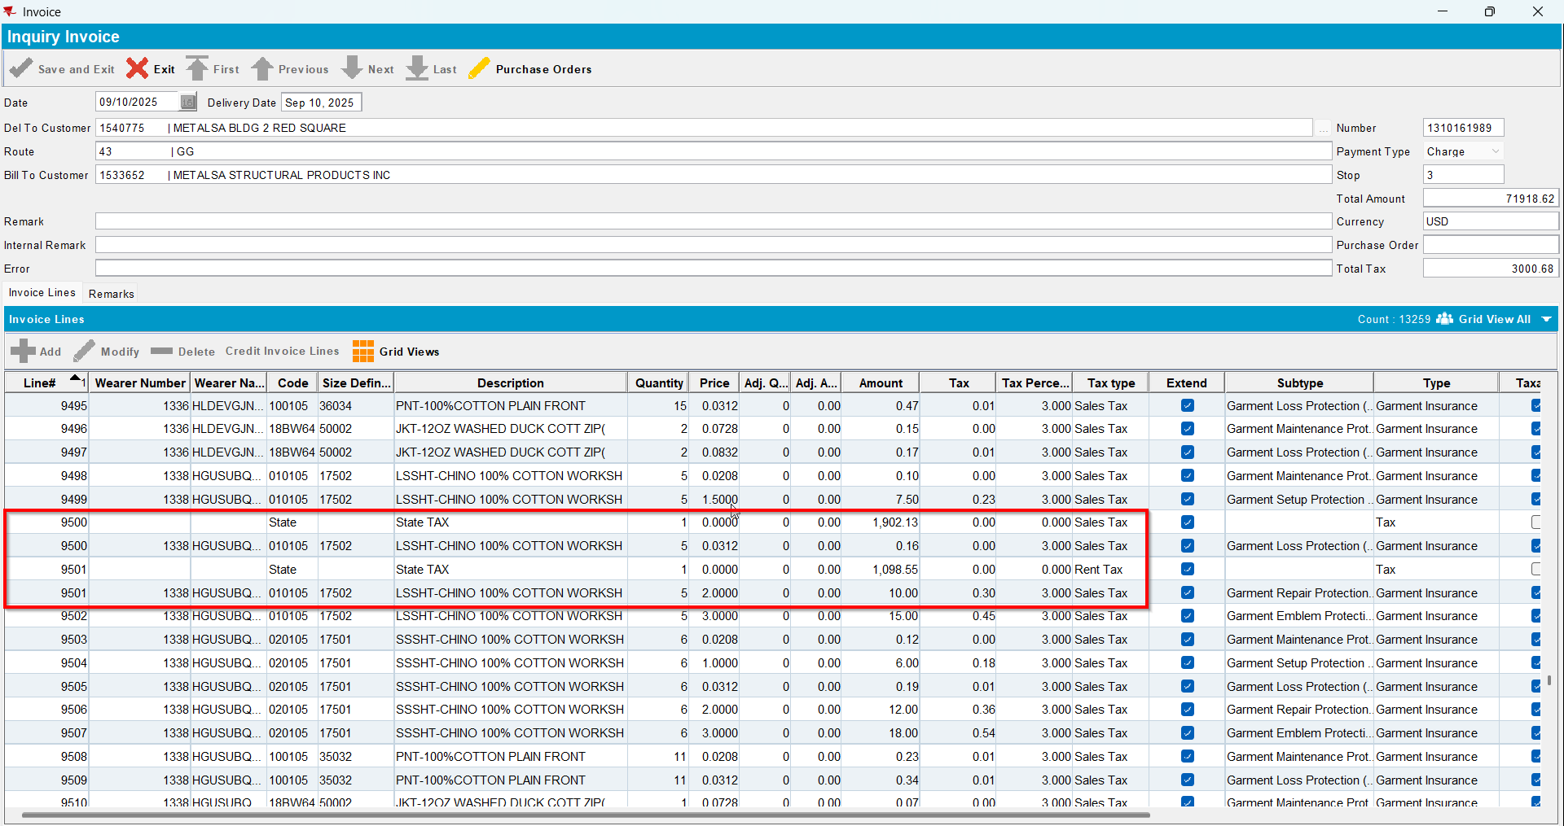
- For that invoice export the invoice lines 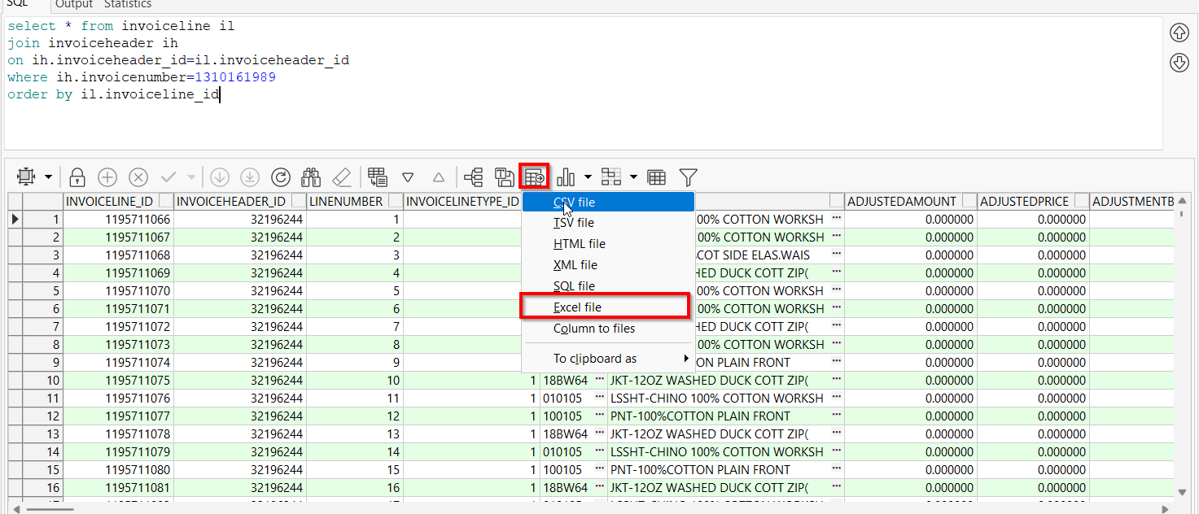
- Script the BCI Distribution
- Run the process Import Vertex BCI tax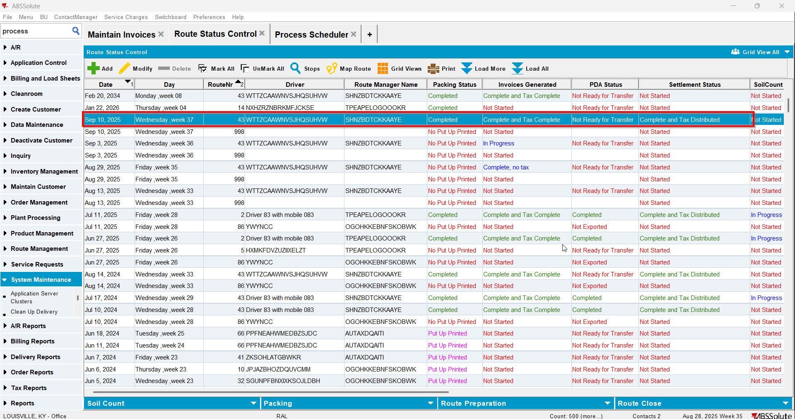
- Check the invoice again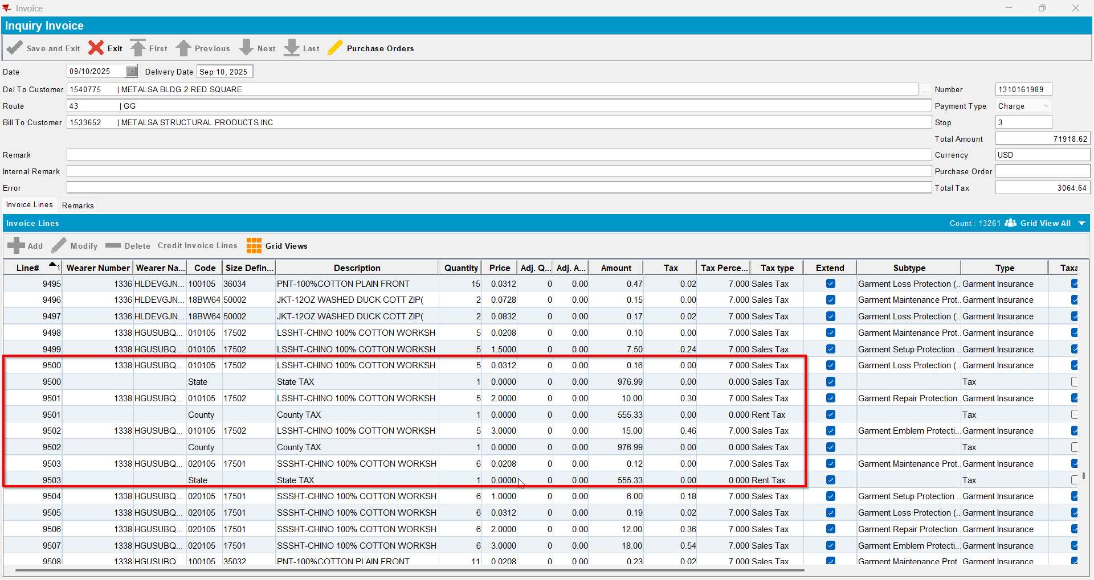
- For that invoice export the invoice lines again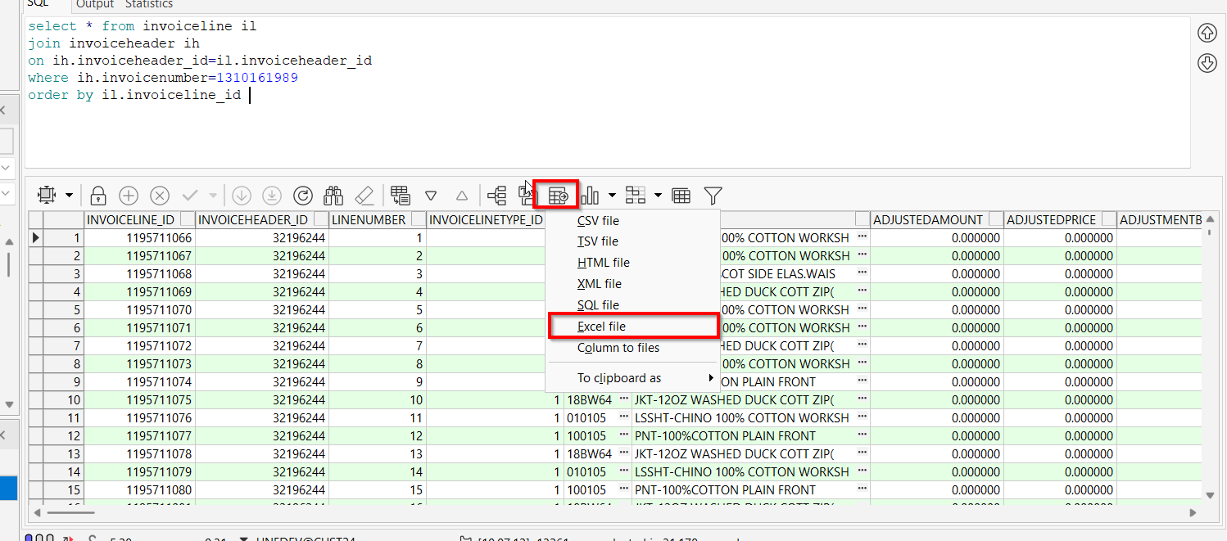
- Compare the 2 exports. Nothing should differ exept the 9502 and 9503 lines added for state and county tax