ABSN-9493 D_UBS_2747 Contract customer price list retains original end date after the end date on the contract customer is pushed out again
Environment | Prerequisites
Version:9.07.00.UNF20  DBServerName= abs-srv20.internal.abslbs.com  DBSID=CUST24  DBUser=UNFDEV  Environment=PRODUCTION | - Module:  - System setting

Contents
Retest after fix 1
Test Case 1 – Extend Contract 1
Test Case 2 – Terminate Contract 5

Retest after fix
Bu: 025 PORTLAND, ME
9.07.00.UNF20 hash: 6304d8e45a73

Test Case 1 – Extend Contract

- Contract dlg: Load a contract like 0003667 check the original end date 08-31-2028
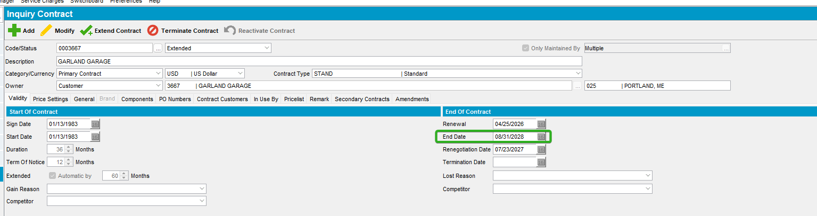

- Contract dlg: From Contract Customers tab End a customer with date 05-08-2025
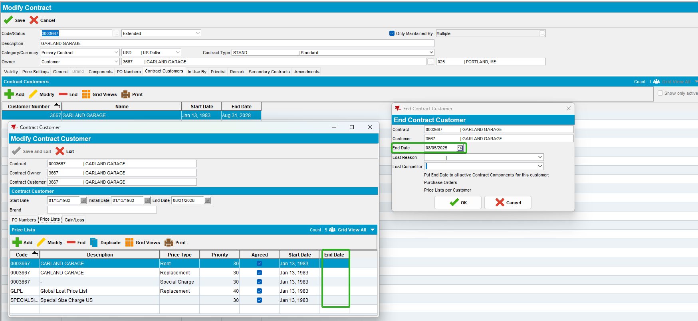
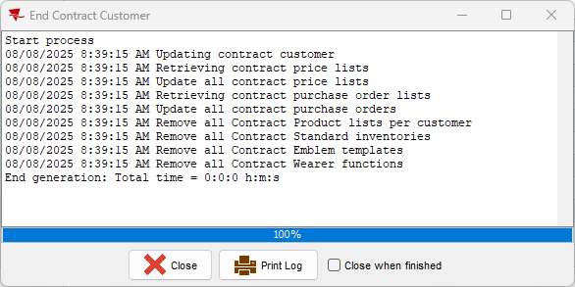

- Contract dlg: Re-open the contract customer, see that 05-08-2025 date was addd to the end date column.
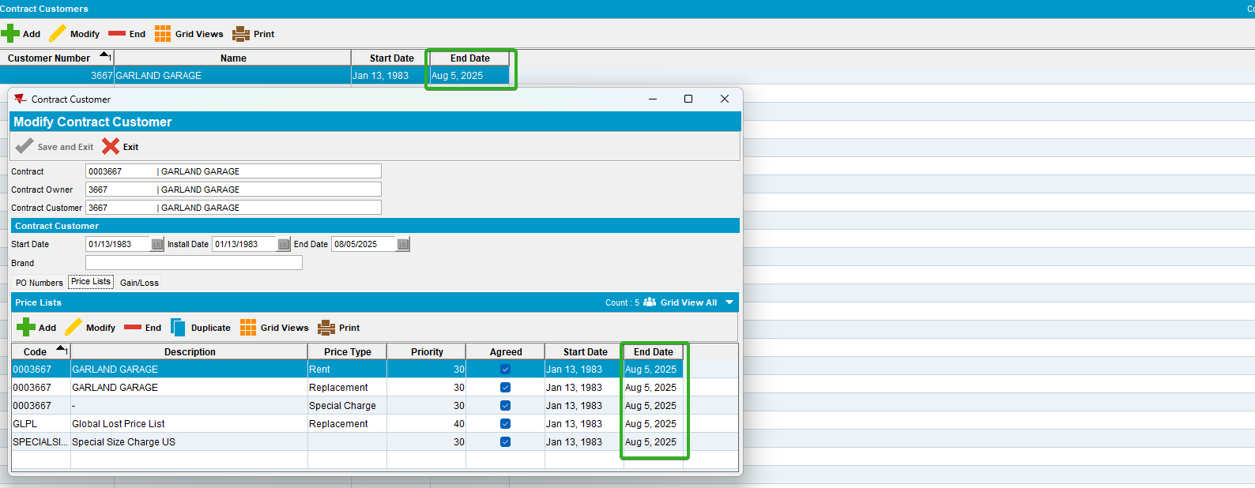

- Price Lists Per Customer dlg: Check the end date of the customer 3667
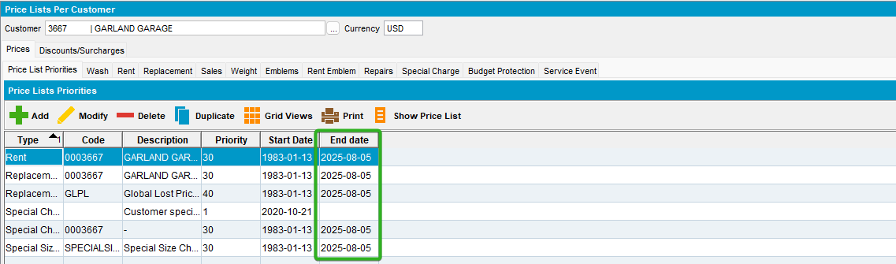

- Contract dlg: On the Validity tab change the End date of the contract from 08-31-2028 to the past < sysdate 01-08-2025.
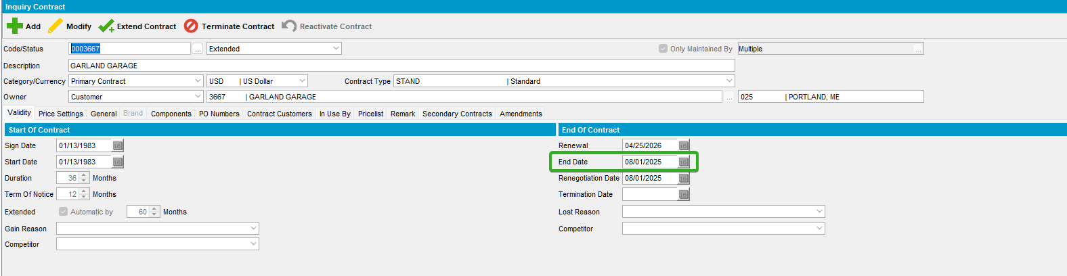

- Contract dlg: Using the Extend Contract button, extend the contract.
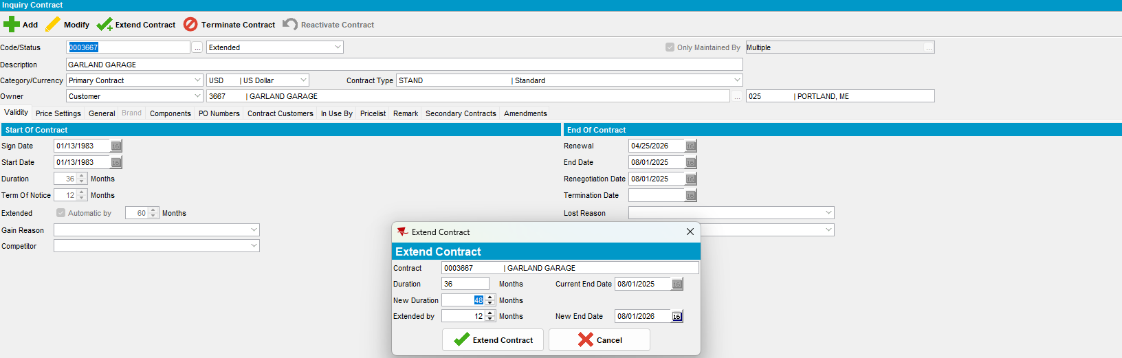
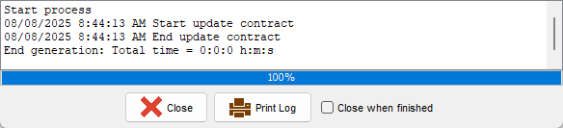

- Contract dlg: The End date of the contract was extended
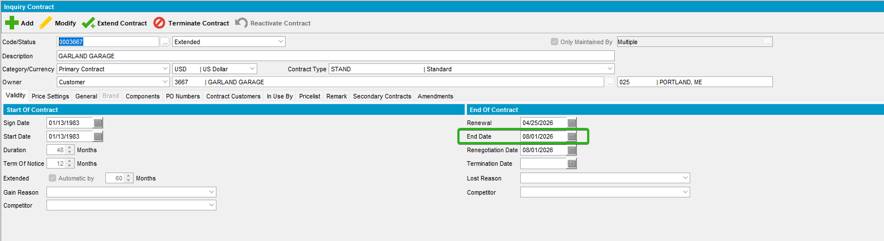

- Contract Customers tab. The End date for the customer and the price list were updated.
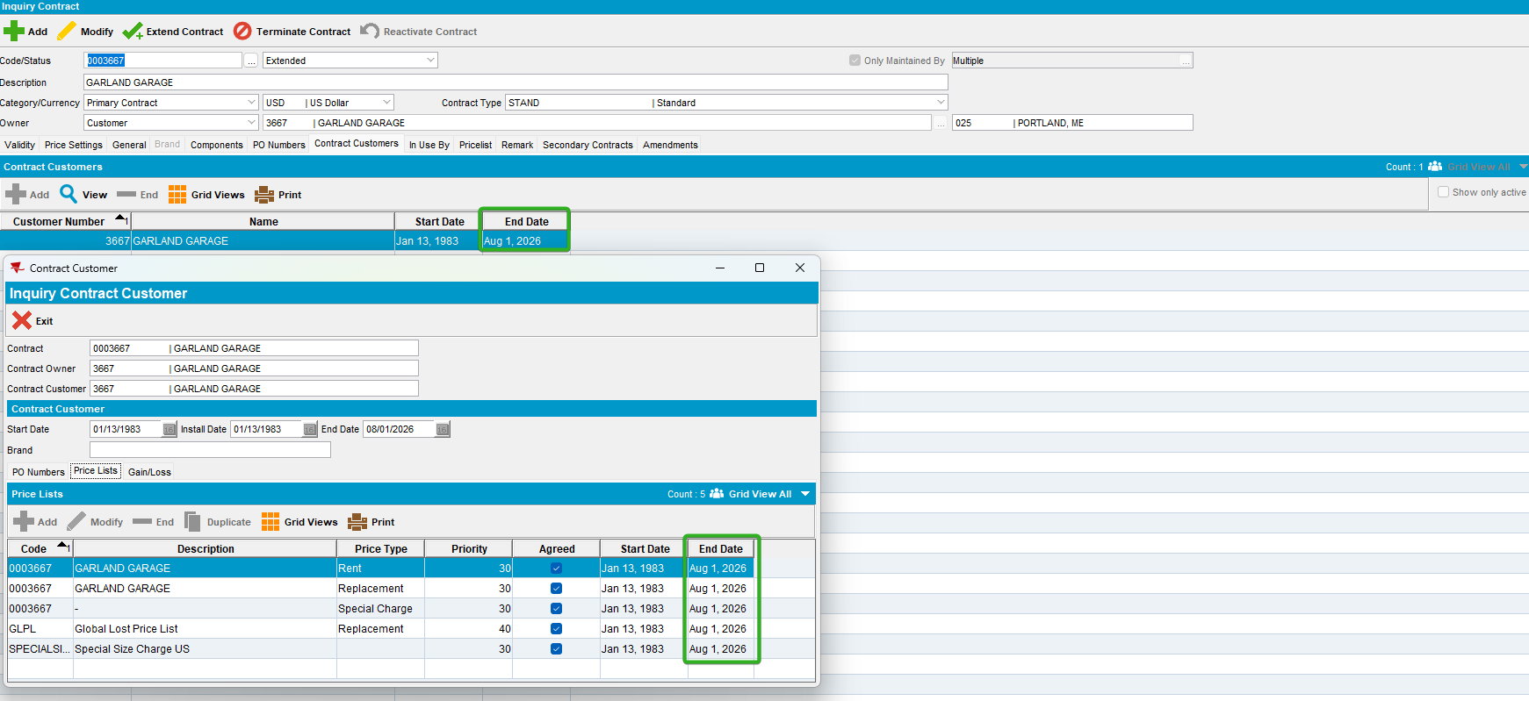

- Price Lists per Customer dlg: Check there as well, the end date is updated.
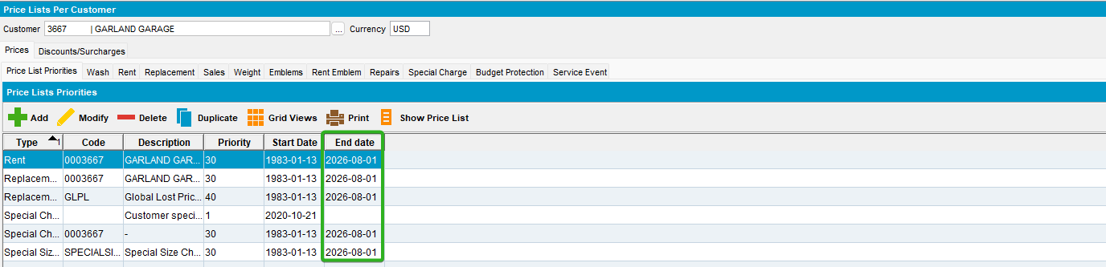

Test Case 2 – Terminate Contract

- Contract dlg: On the Validity tab change the End date of the contract to 01-09-2025.
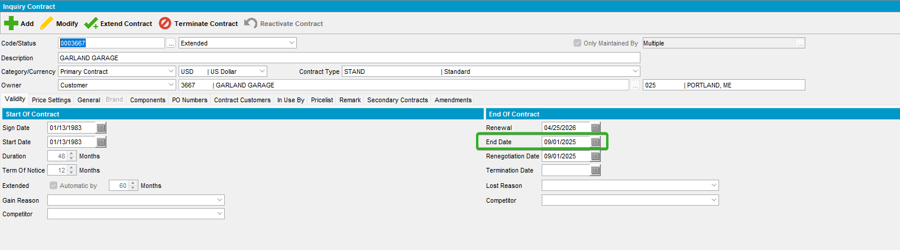

- Contract dlg: Using the Terminate Contract button, terminate the contract.
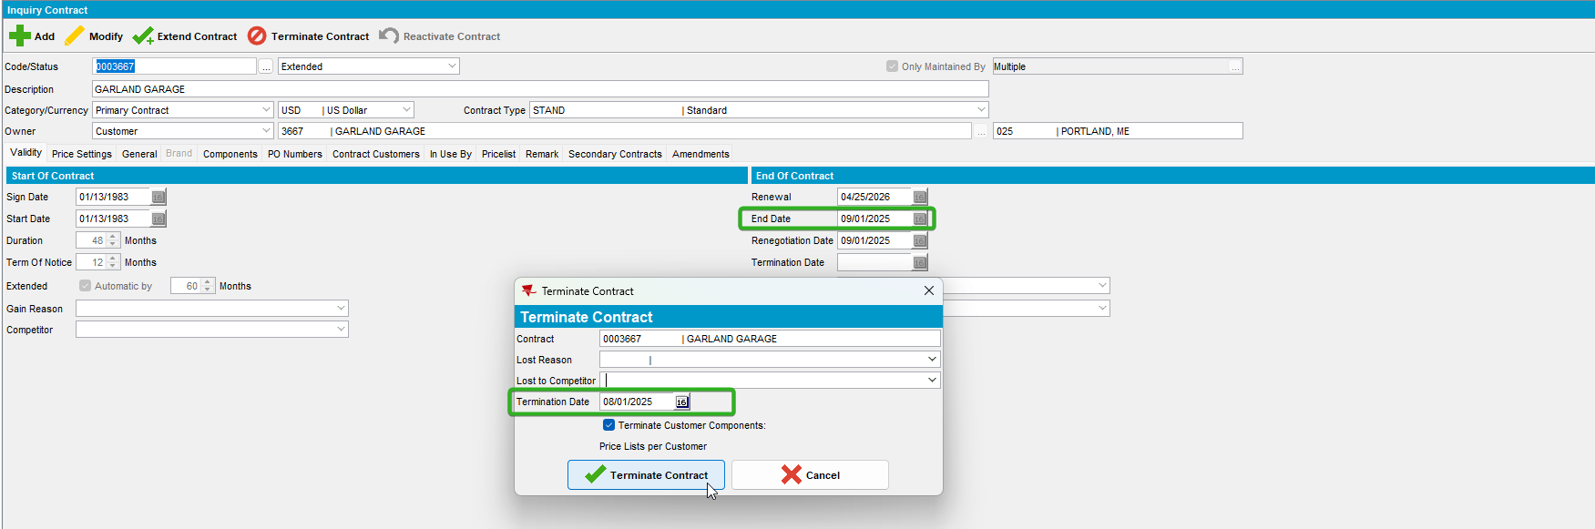
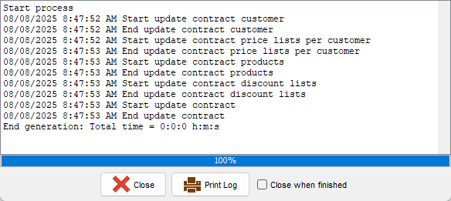

- Contract dlg: The End date of the contract was updated.
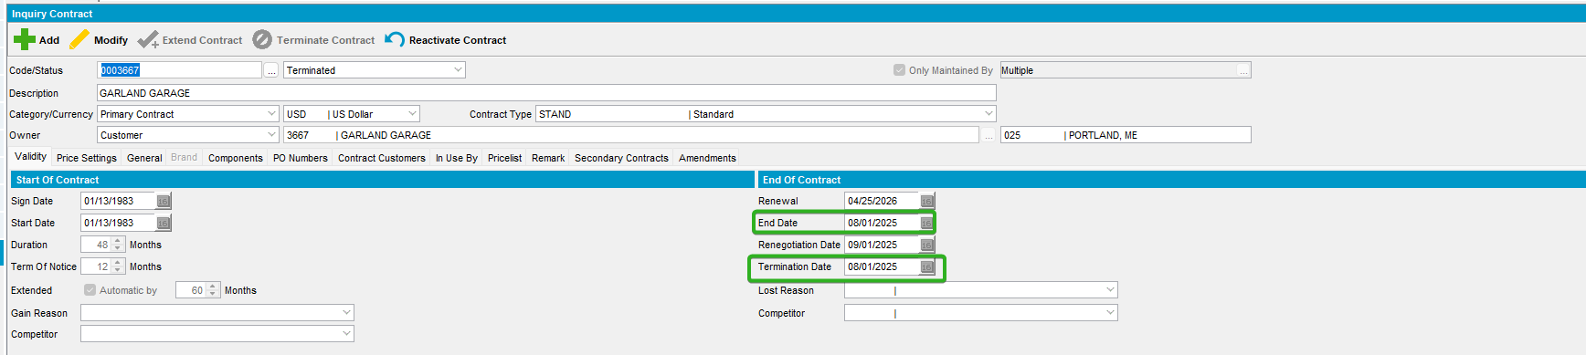

- Contract Customers tab. The End date for the customer and the price list were updated.
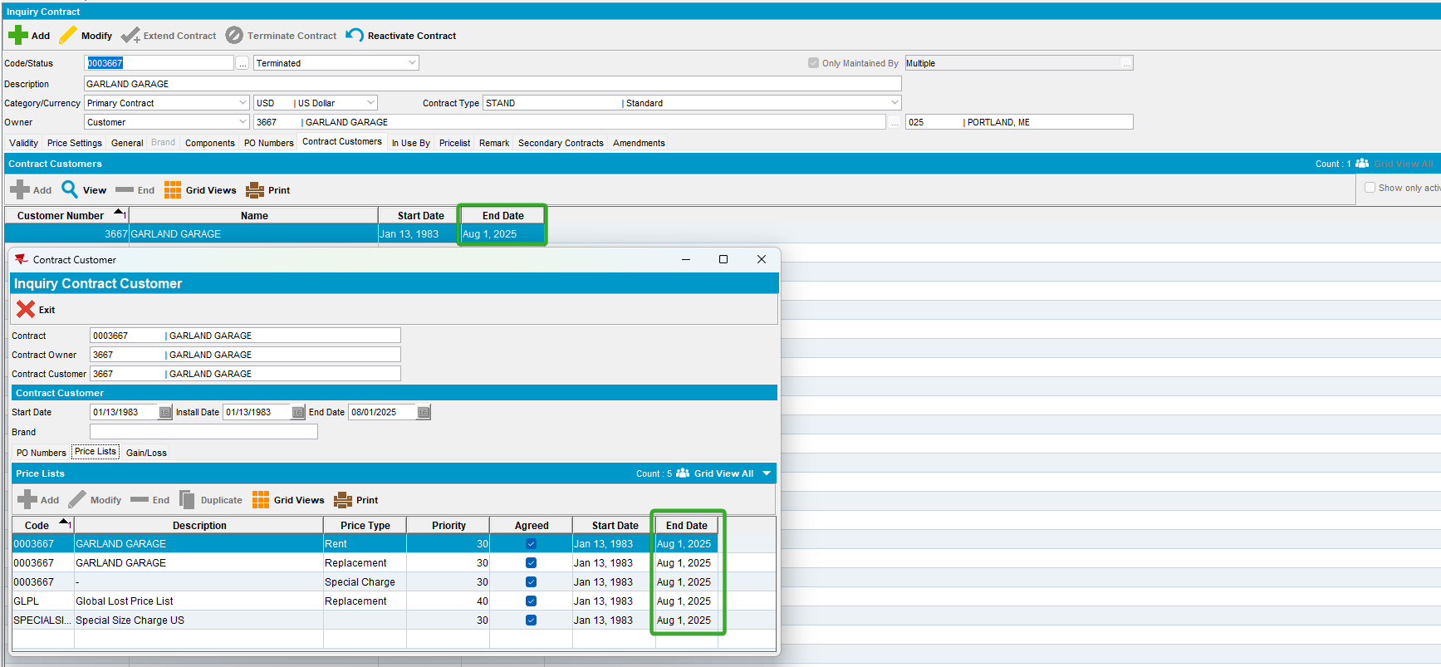

- Price Lists per Customer dlg: Check there as well, the end date is updated.
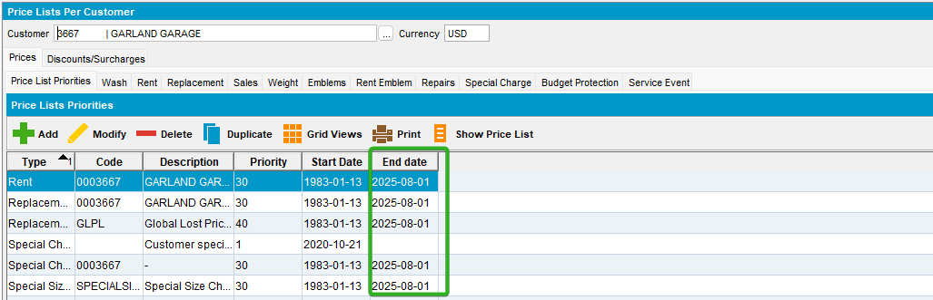

TESTED OK.

