ABS-144779 Qty garments flagged when doing a decrease of max whilst part exchange is also happening
Environment | Prerequisites
Version:9.07.00  DBServerName=abs-SRV20.internal.abslbs.com  DBSID=CUST24  DBUser=UNFDEV  Environment=Test | - Module:  - System setting

Contents
ABS-144779 Qty garments flagged when doing a decrease of max whilst part exchange is also happening 1
Test after fix 2
Test Case 1 – Wearer inventory= 11 Circ 11 max, uniqueitems only. Replacement for new product for 4 garments and decrease to 2 (decrease by 5). Replacement flag on issue and issue new replacement WO – Tested OK 2
Test Case 2 – Wearer inventory= 11 Circ 11 max, uniqueitems only. Replacement for the same product for 4 garments and decrease to 4 (decrease by 7). Replacement flag on issue and issue new replacement WO– Tested OK 7
Test Case 3 – Wearer inventory= 11 Circ 11 max, uniqueitems only. Replacement for new product for 4 garments and decrease to 4 (decrease by 3) and then decrease to 2 (decrease by 2). Replacement flag on issue and issue new replacement WO– Tested OK 13
Test Case 4 – Wearer inventory= 11 Circ 11 max, nonuniqueitems only. Replacement for new product for 4 garments and decrease to 2 (decrease by 5). Replacement flag on issue and issue new replacement WO– Tested OK 19
Test Case 5 – Wearer inventory= 11 Circ 11 max, nonuniqueitems only. Replacement for the same product for 4 garments and decrease to 4 (decrease by 7). Replacement flag on issue and issue new replacement WO– Tested OK 24
Test Case 6 – Wearer inventory= 11 Circ 11 max, nonuniqueitems only. Replacement for new product for 4 garments and decrease to 4 (decrease by 3) and then decrease to 2 (decrease by 2). Replacement flag on issue and issue new replacement WO– Tested OK 28
Test Case 7 – Wearer inventory= 11 Circ 11 max, mixed uniqueitems and nonuniqueitems. Replacement for new product for 4 garments and decrease to 2 (decrease by 5). Replacement flag on issue and issue new replacement WO– Tested OK 34
Test Case 8 – Wearer inventory= 11 Circ 11 max, mixed uniqueitems and nonuniqueitems. Replacement for the same product for 4 garments and decrease to 4 (decrease by 7). Replacement flag on issue and issue new replacement WO– Tested OK 40
Test Case 9 – Wearer inventory= 11 Circ 11 max, mixed uniqueitems and nonuniqueitems. Replacement for new product for 4 garments and decrease to 4 (decrease by 3) and then decrease to 2 (decrease by 2). Replacement flag on issue and issue new replacement WO– Tested OK 45
Test Case 10 – Wearer inventory= 11 Circ 11 max, mixed uniqueitems and nonuniqueitems. Replacement for new product for 4 garments but don’t issue the WO and decrease to 4 (decrease by 3)– Tested OK 51

Test after fix

Test Case 1 – Wearer inventory= 11 Circ 11 max, uniqueitems only. Replacement for new product for 4 garments and decrease to 2 (decrease by 5). Replacement flag on issue and issue new replacement WO – Tested OK
Expected behavior: You should be allowed to decrease and 5 garments should be flagged for decrease
Hash: 463f282
- Wearer dlg: Select a wearer. Create a wearer inventory of max 11 and generate work order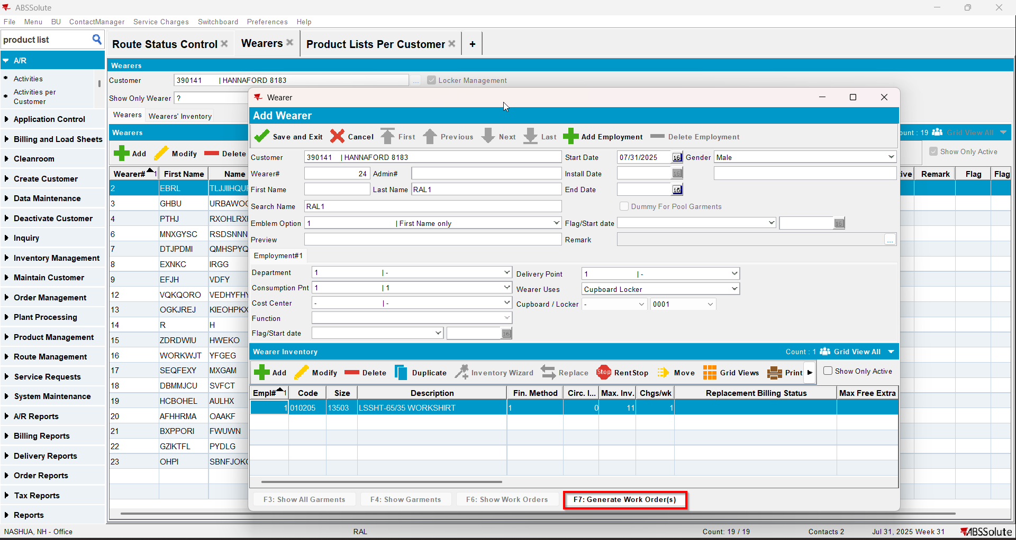
- Issue Work Order dlg: Issue all 11 items and generate delivery notes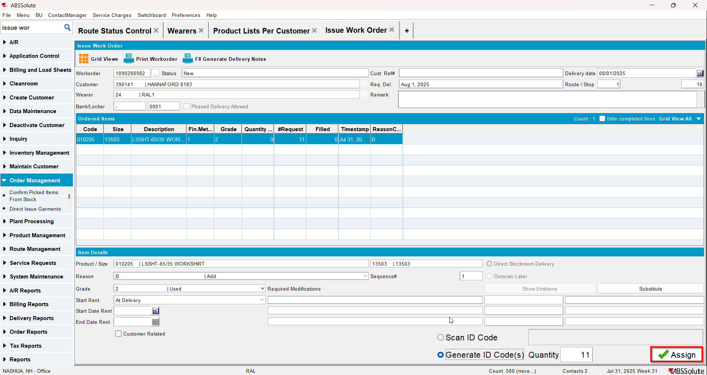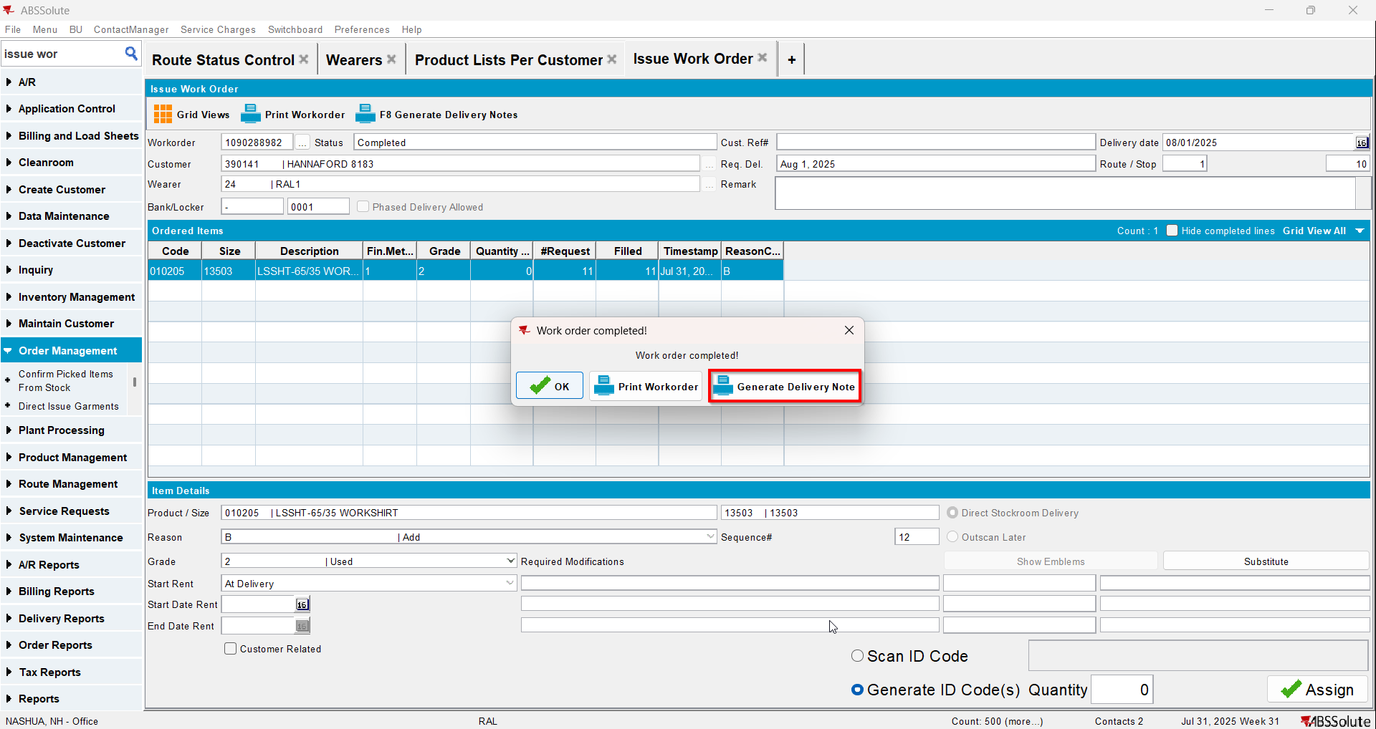
- Wearer dlg: Select your wearer and wearer inventory. Replace 4 garments with a new product.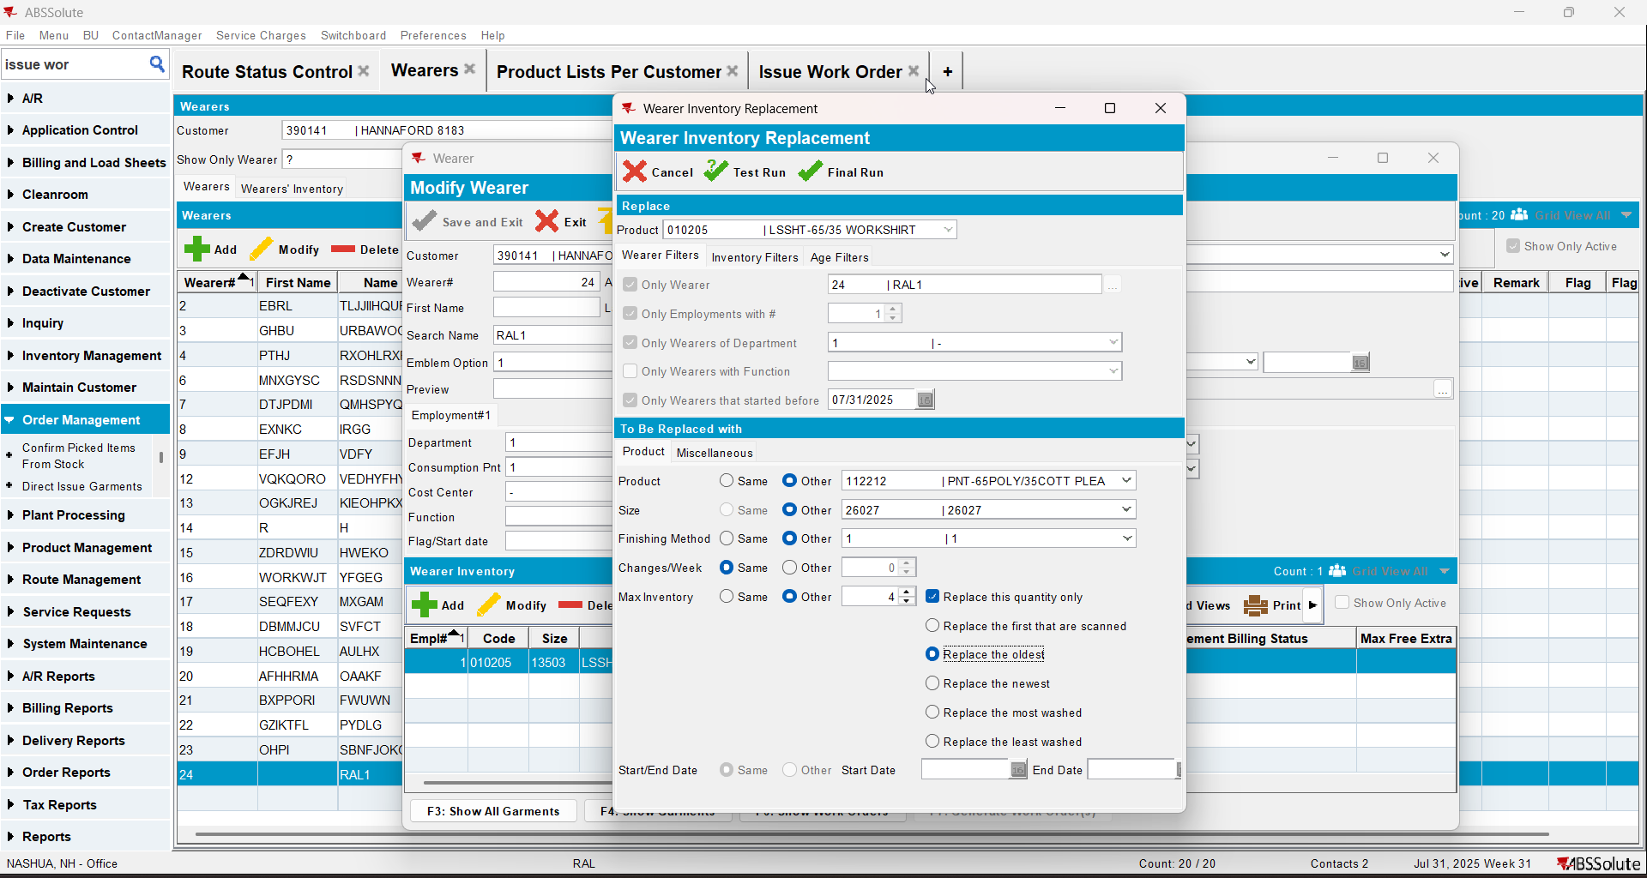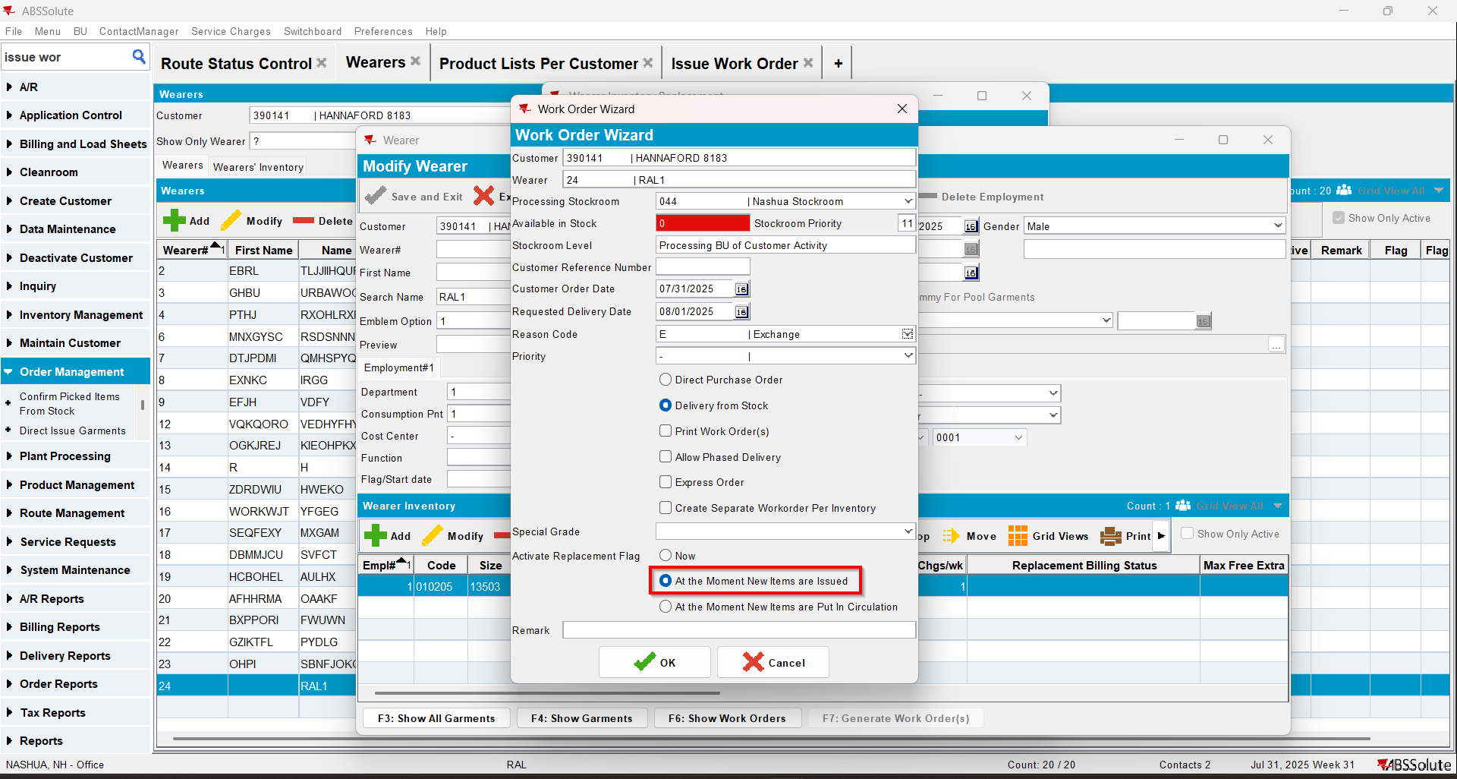
- Issue Work Order dlg: Issue the 4 items that you replaced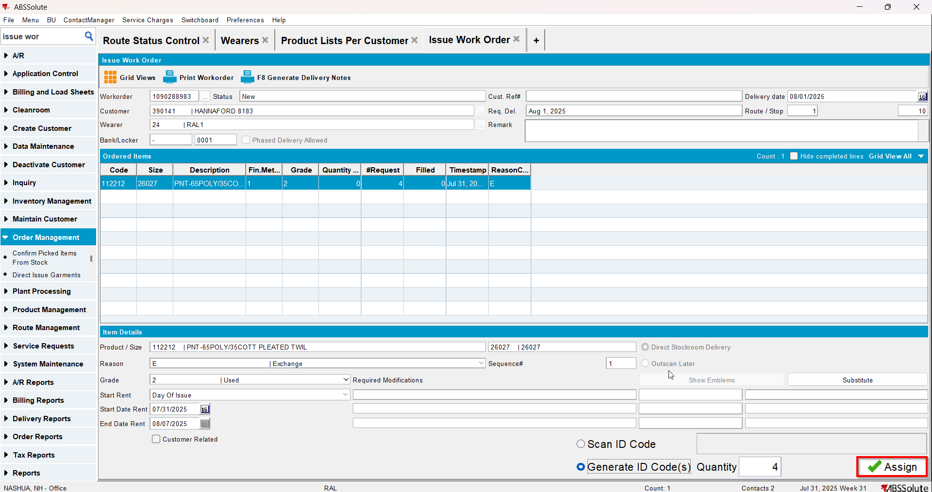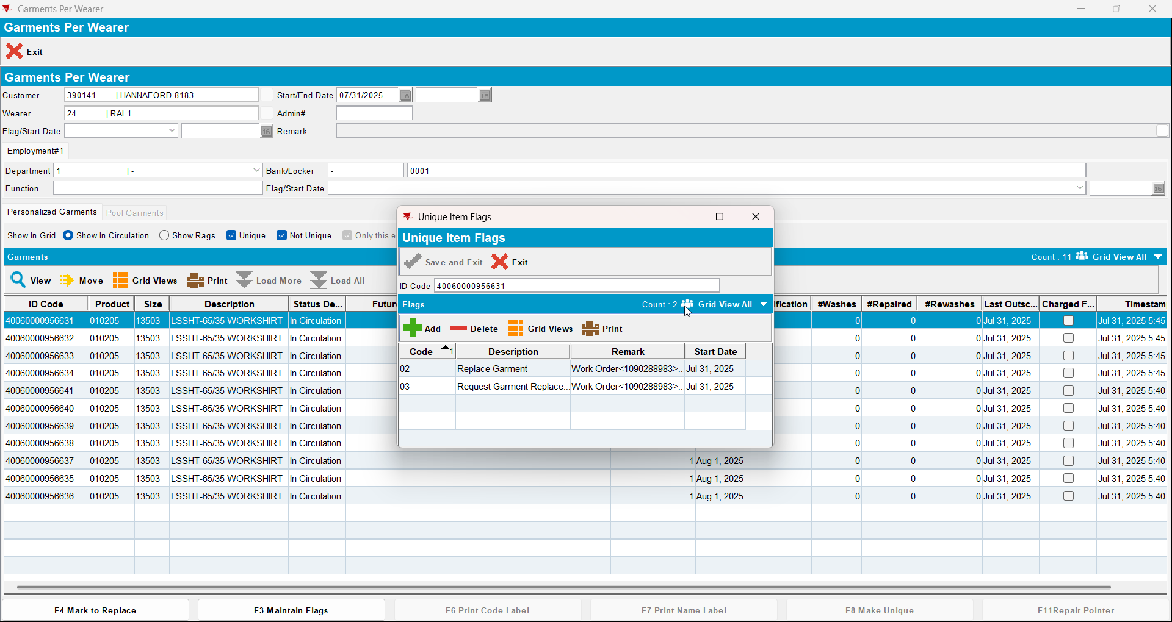
- Wearer dlg: Decrease the max inv for your wearer inventory to 2 (decrease by 5)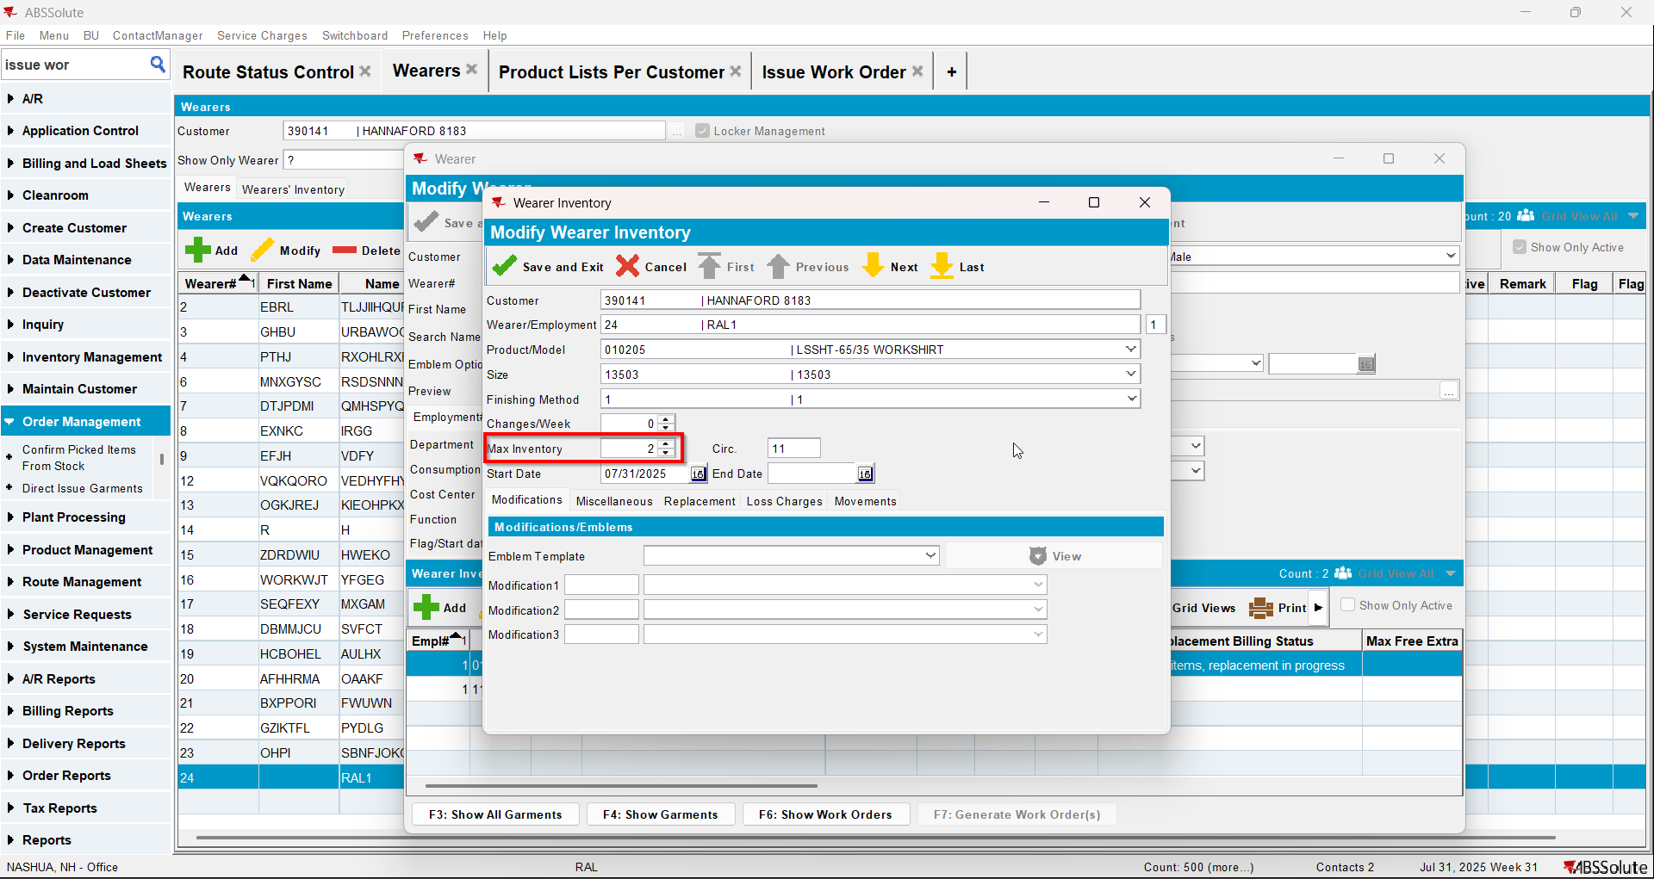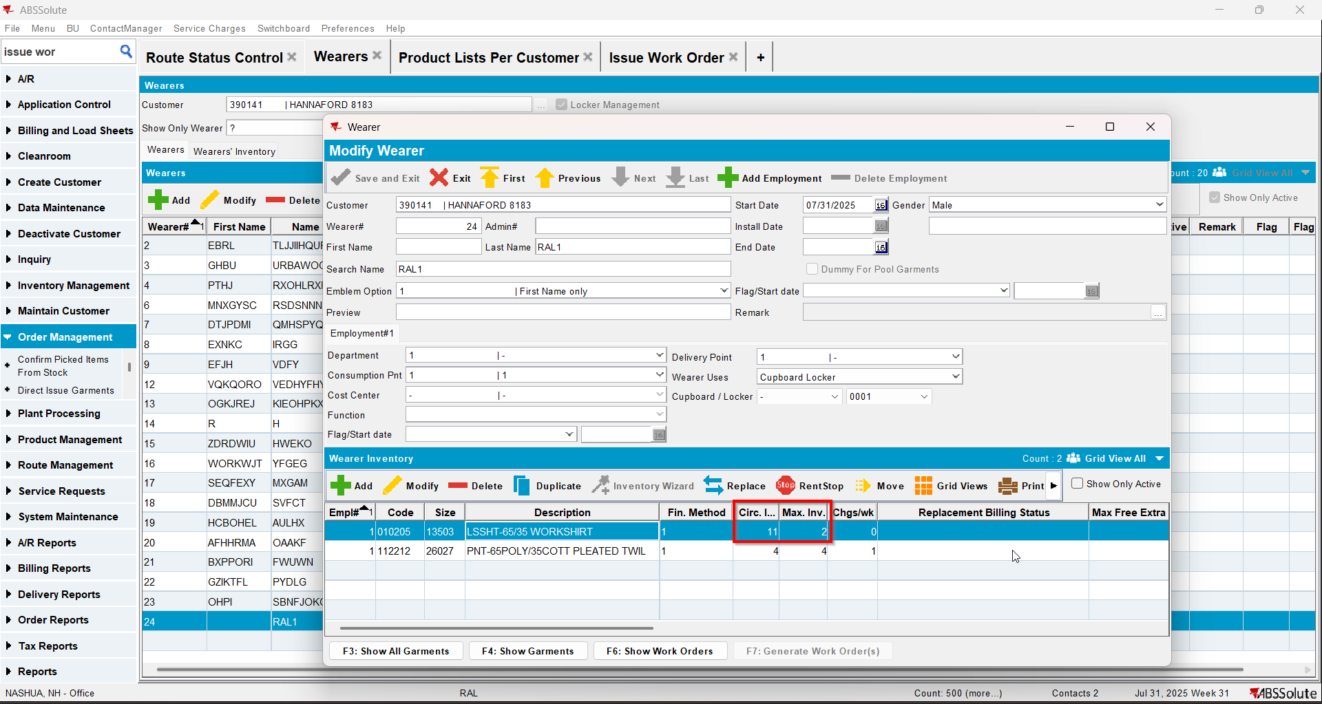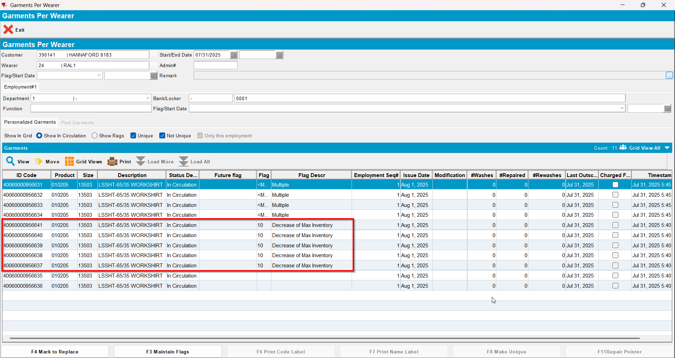

Test Case 2 – Wearer inventory= 11 Circ 11 max, uniqueitems only. Replacement for the same product for 4 garments and decrease to 4 (decrease by 7). Replacement flag on issue and issue new replacement WO– Tested OK
Expected behavior: You should be allowed to decrease and 7 garments should be flagged for decrease
Hash: 463f282
- Wearer dlg: Select a wearer. Create a wearer inventory of max 11 and generate work order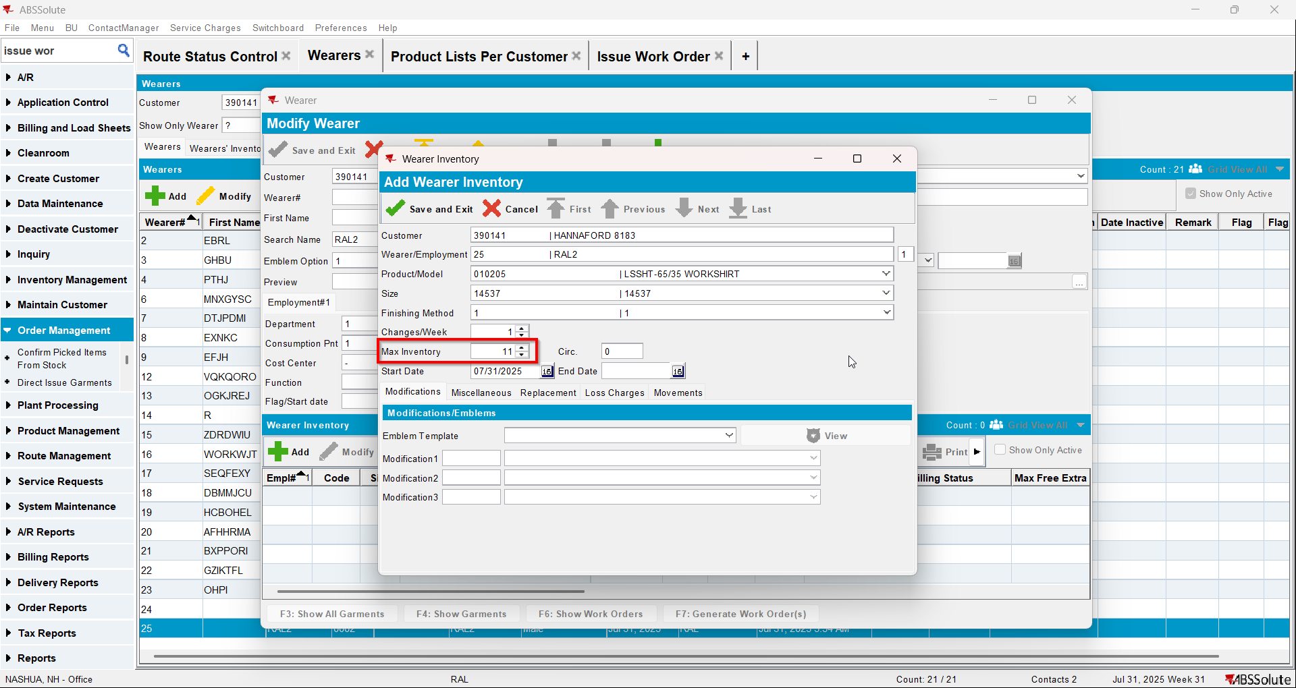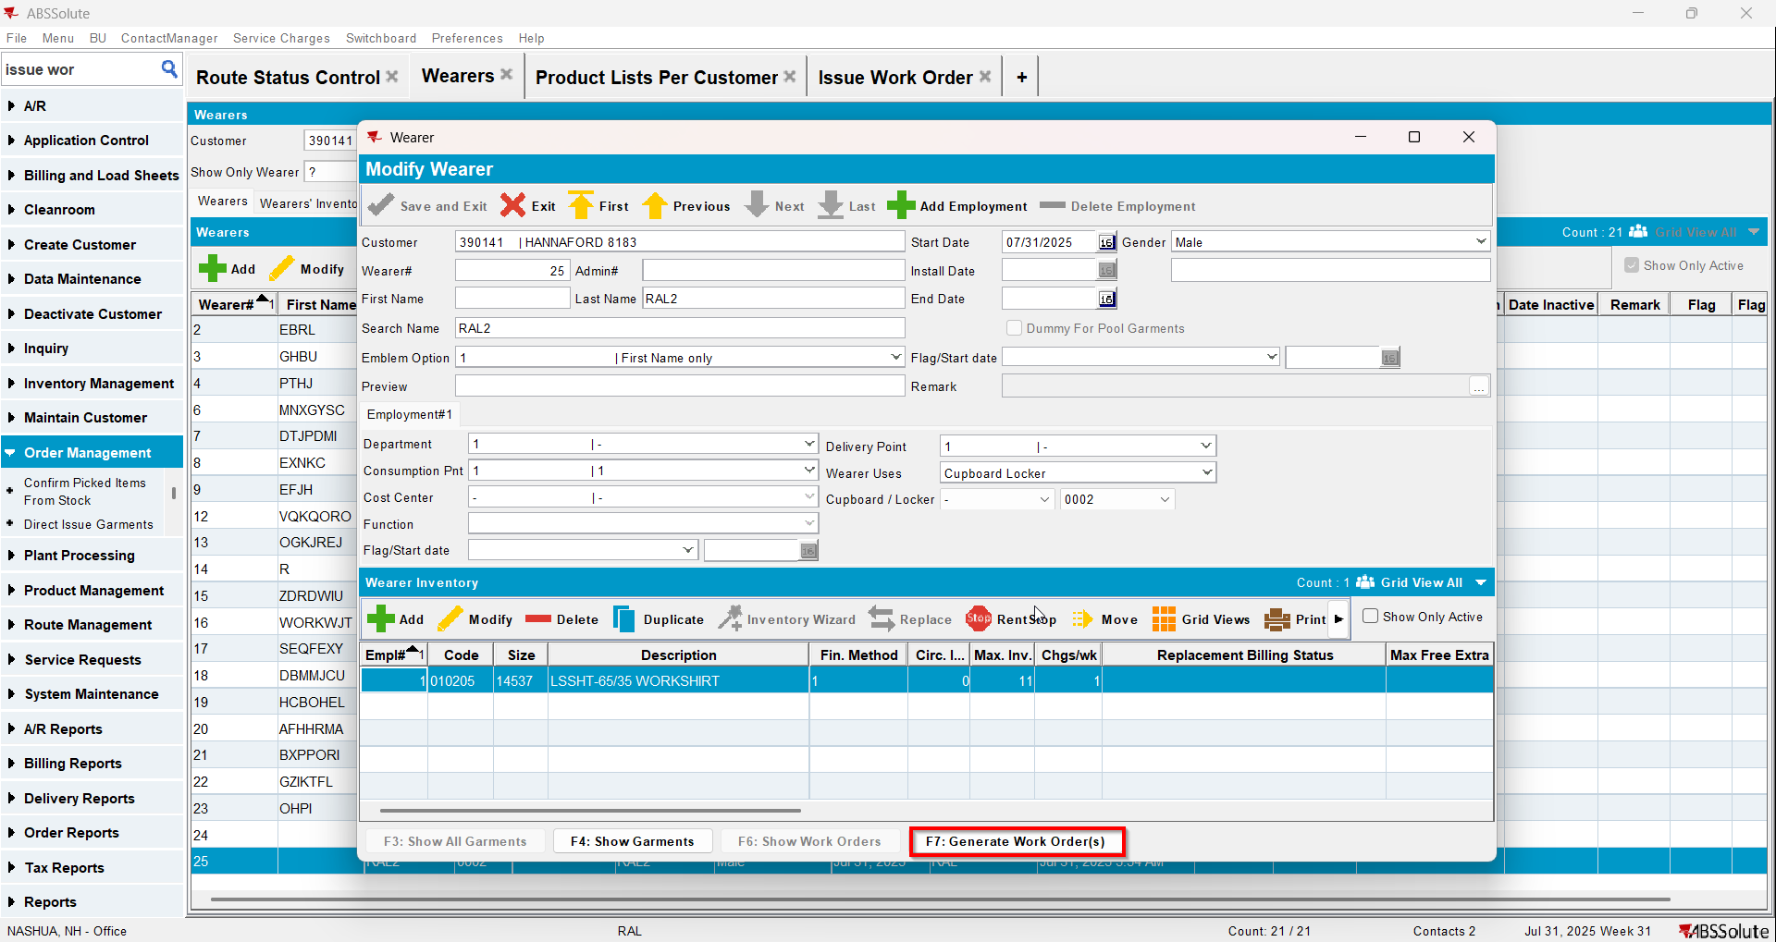
- Issue Work Order dlg: Issue all 11 items and generate delivery notes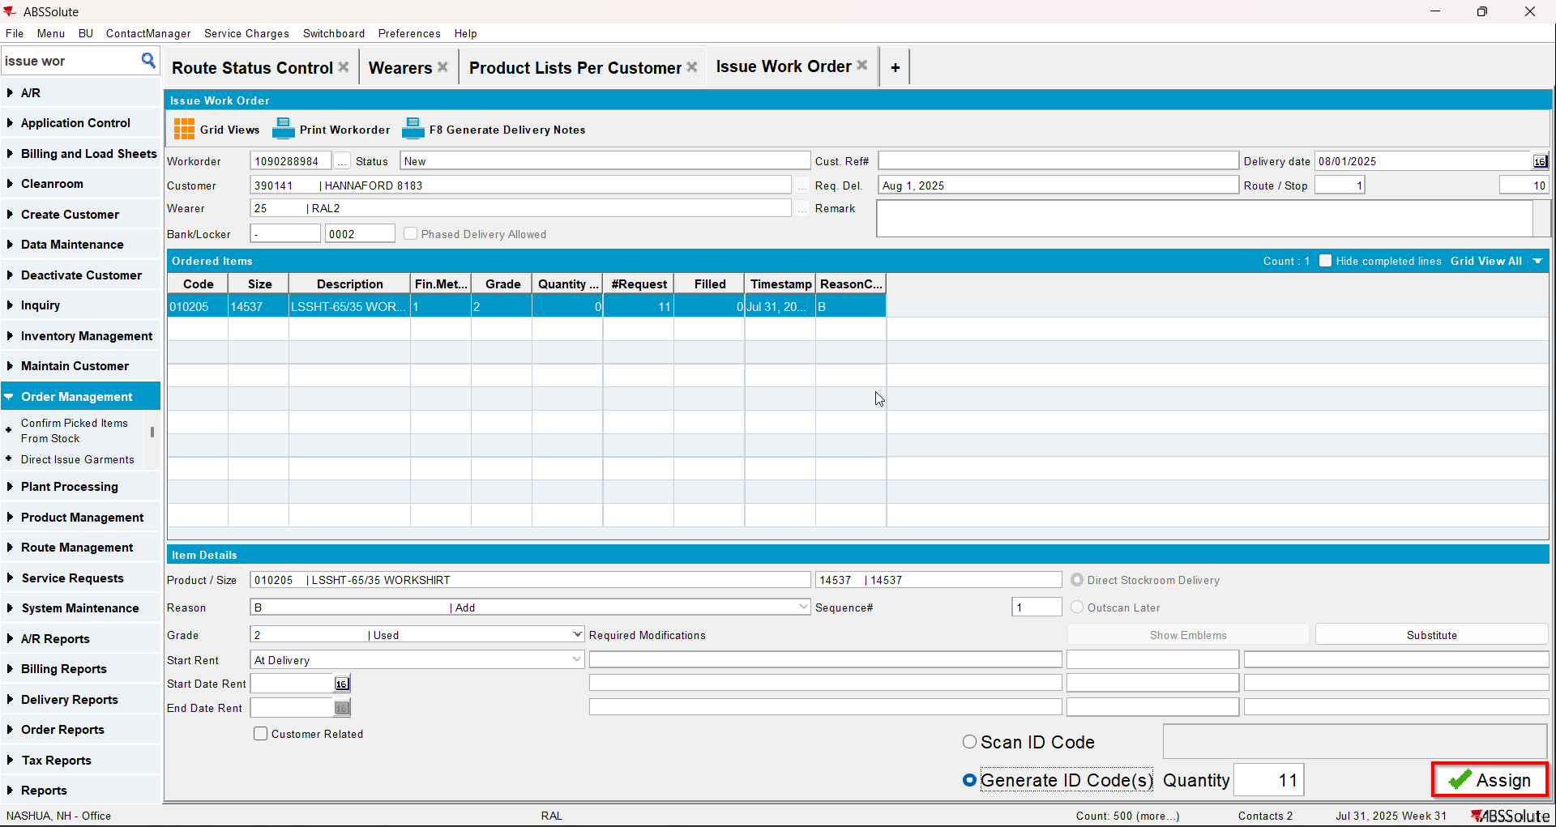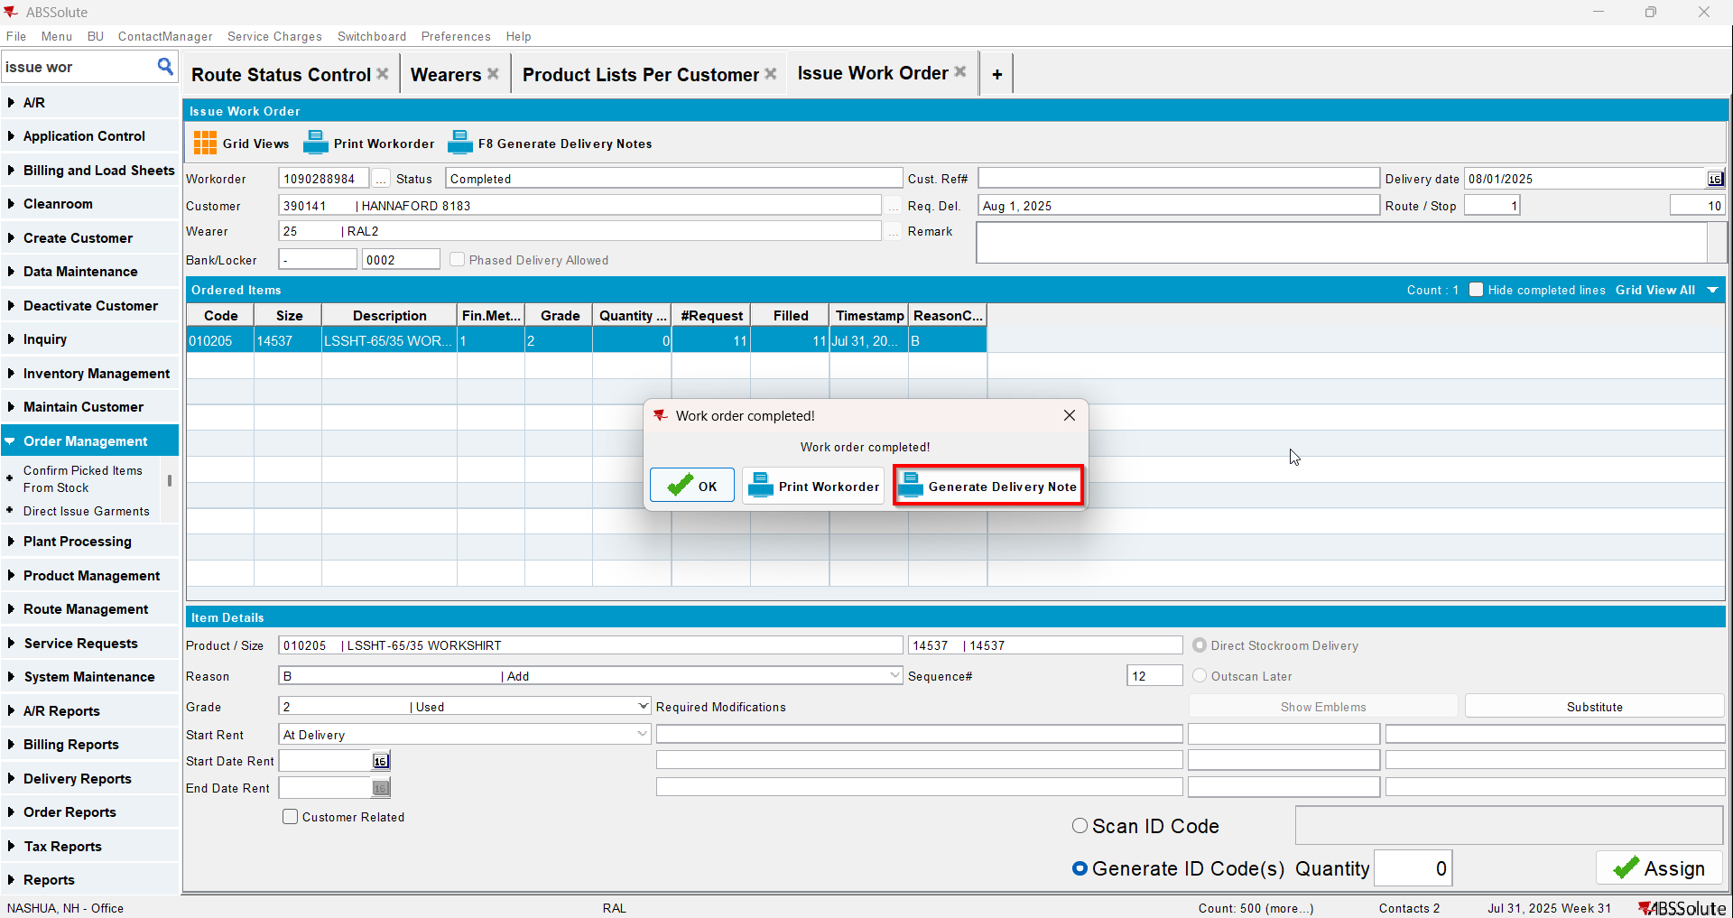
- Wearer dlg: Select your wearer and wearer inventory. Go to Show Garments and Mark to Replace 4 items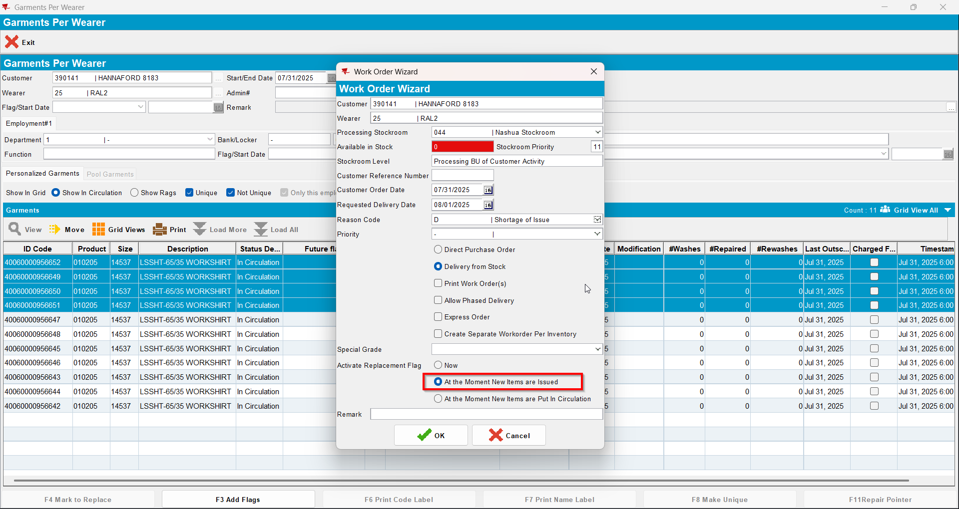
- Issue Work Order dlg: Issue the 4 items marked for replace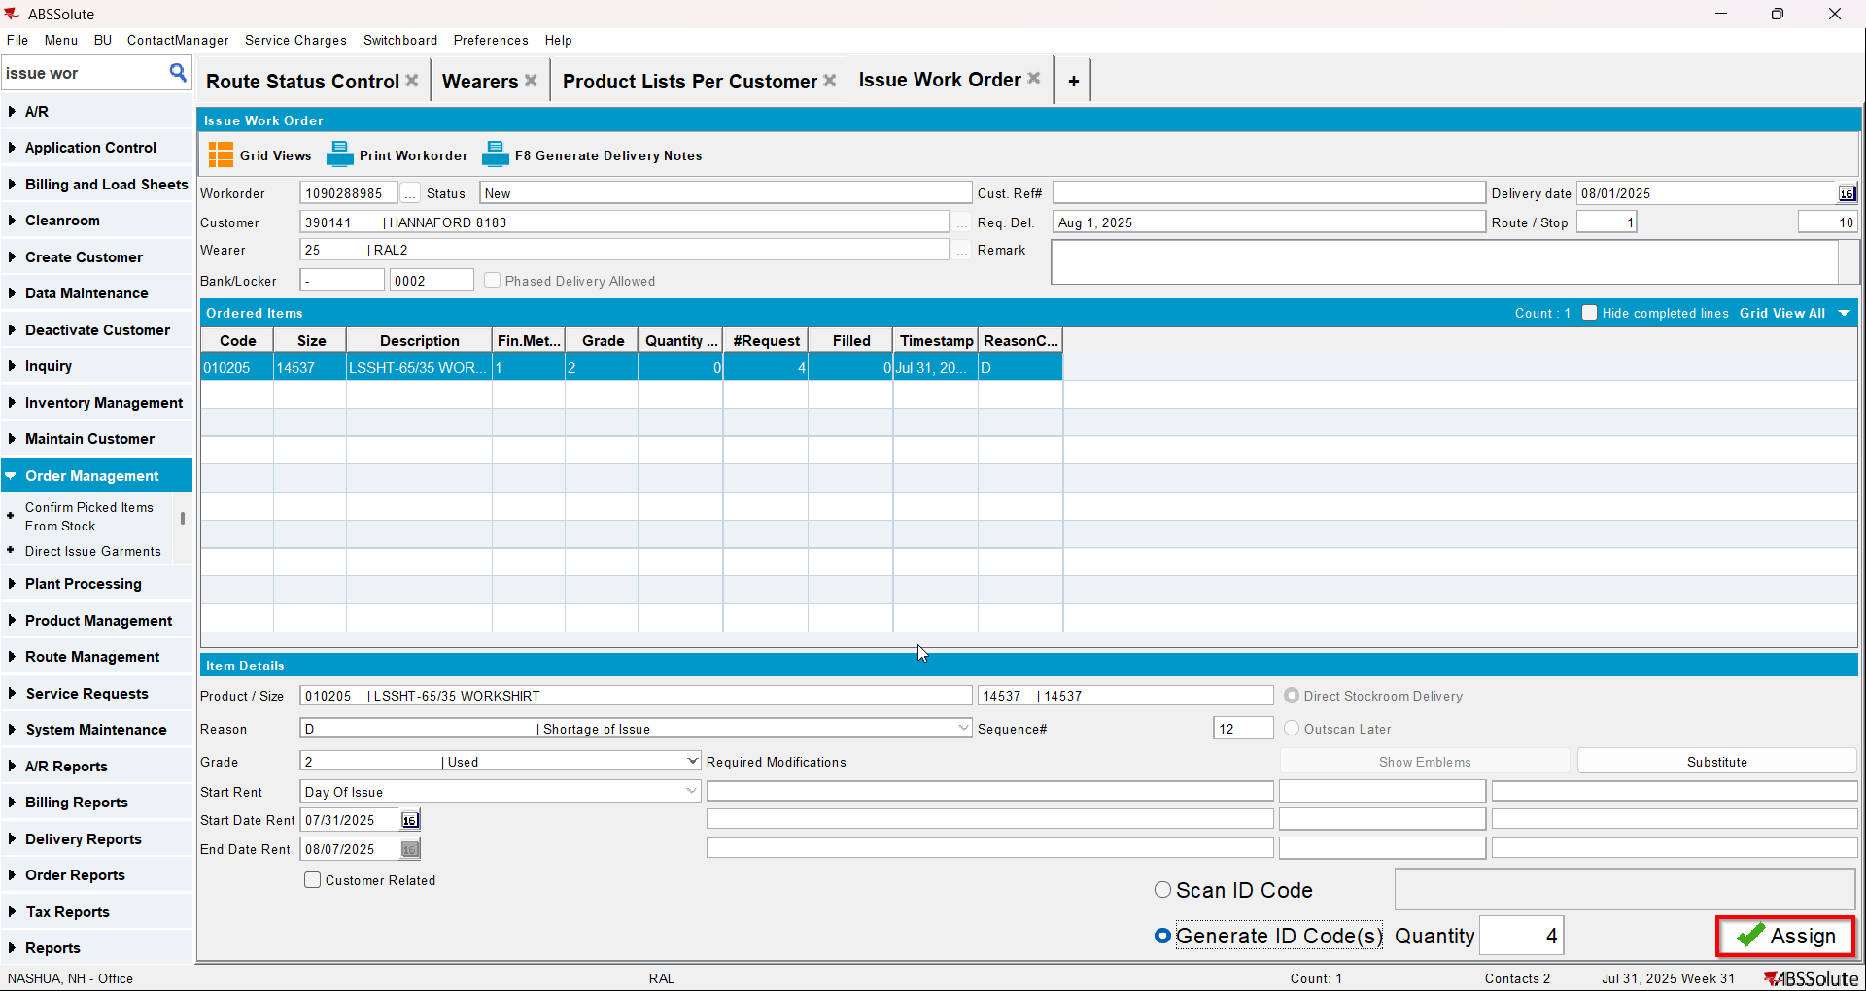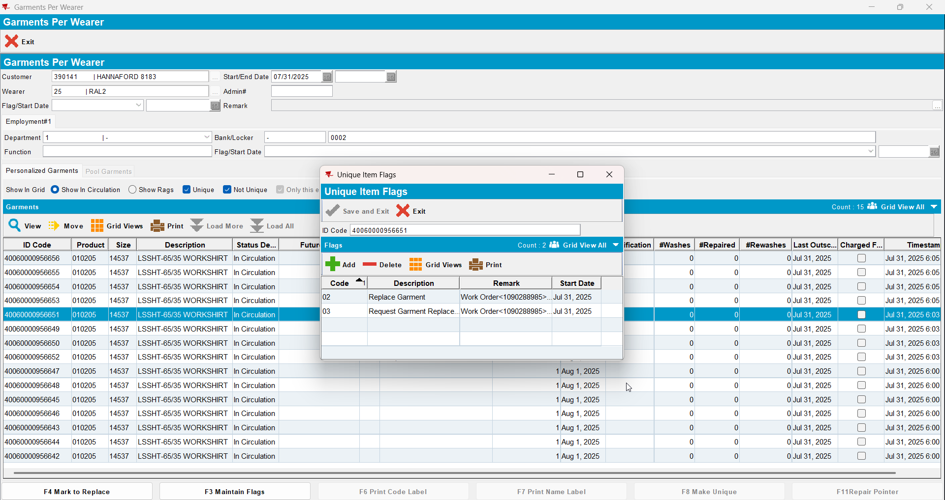
- Wearer dlg: Decrease the max inv for your wearer inventory to 4 (decrease by 7) 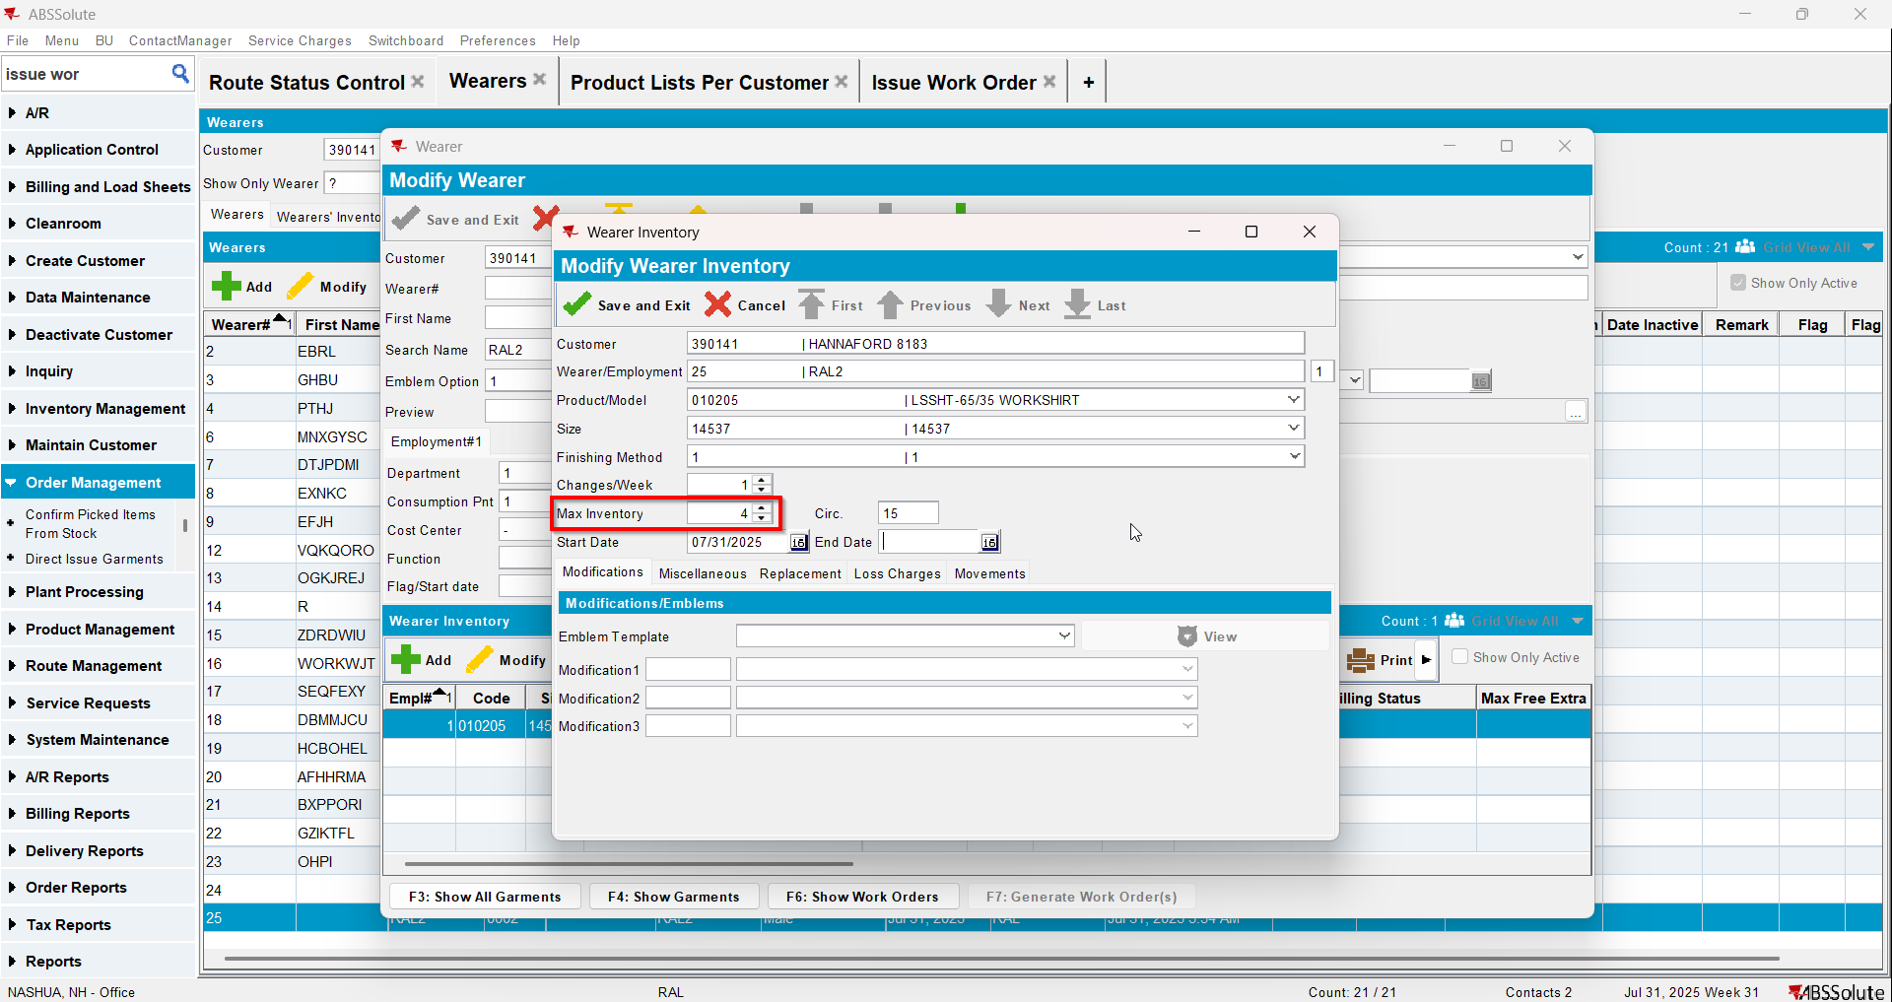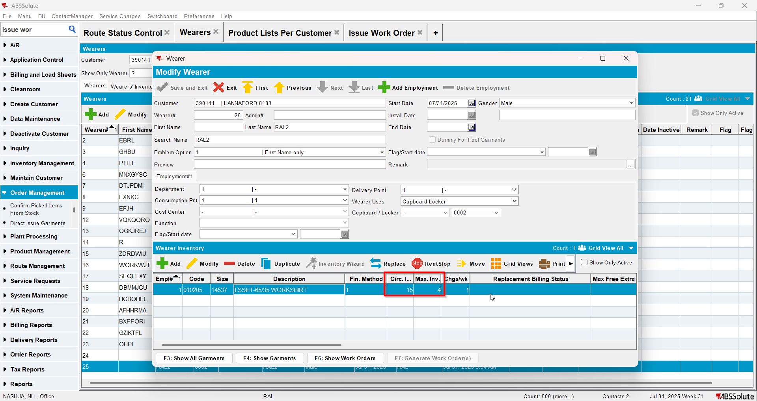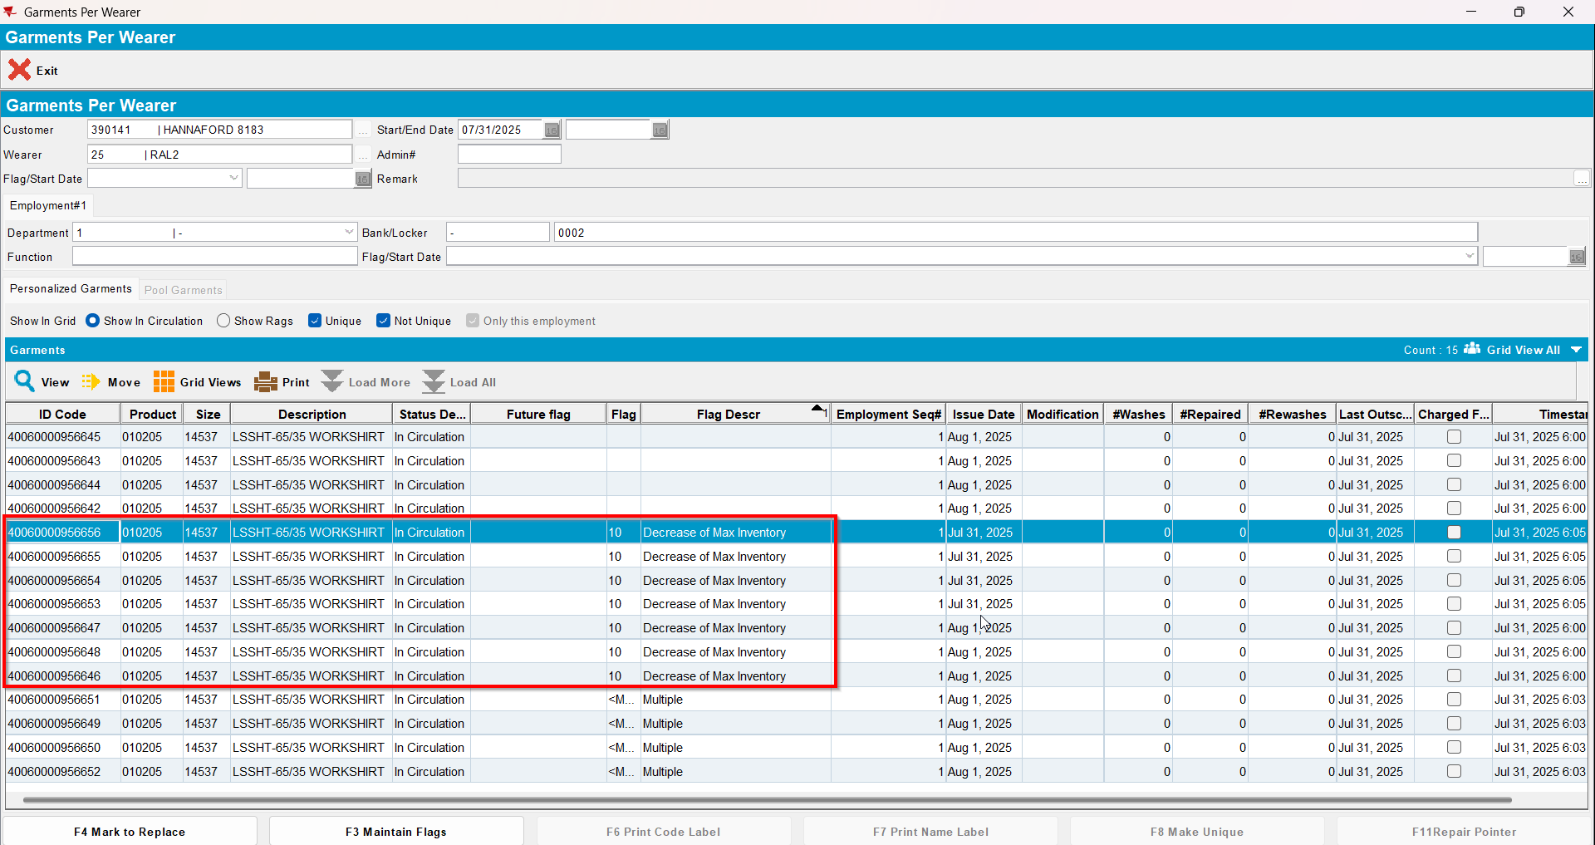

Test Case 3 – Wearer inventory= 11 Circ 11 max, uniqueitems only. Replacement for new product for 4 garments and decrease to 4 (decrease by 3) and then decrease to 2 (decrease by 2). Replacement flag on issue and issue new replacement WO– Tested OK
Expected behavior: You should be allowed to decrease and 5 garments should be flagged for decrease
Hash: 463f282
- Wearer dlg: Select a wearer. Create a wearer inventory of max 11 and generate work order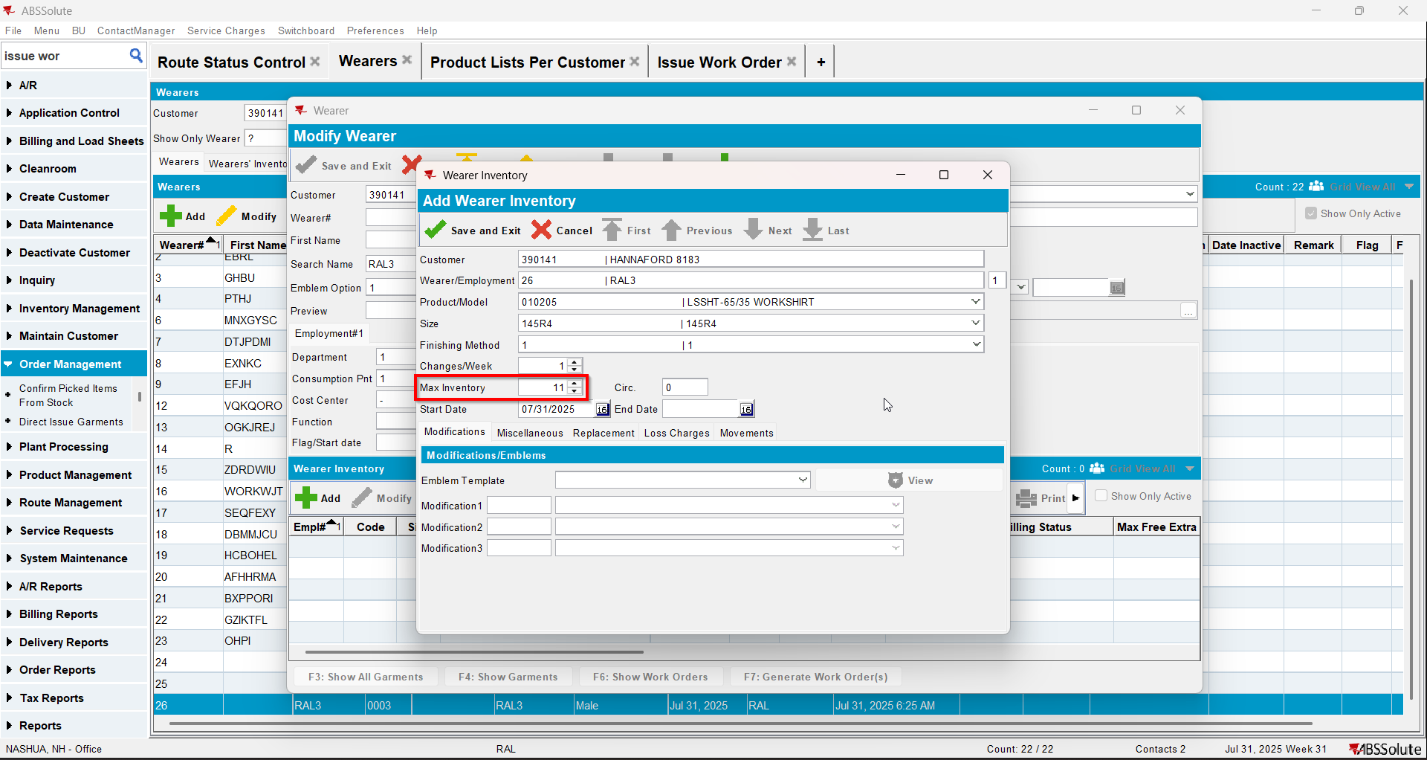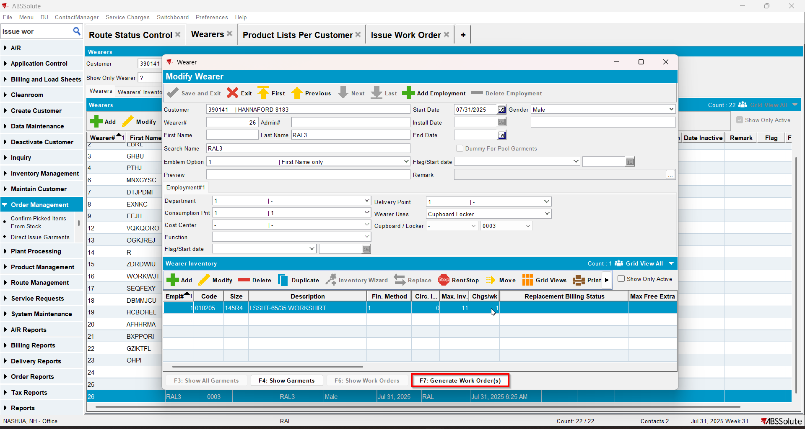
- Issue Work Order dlg: Issue all 11 items and generate delivery notes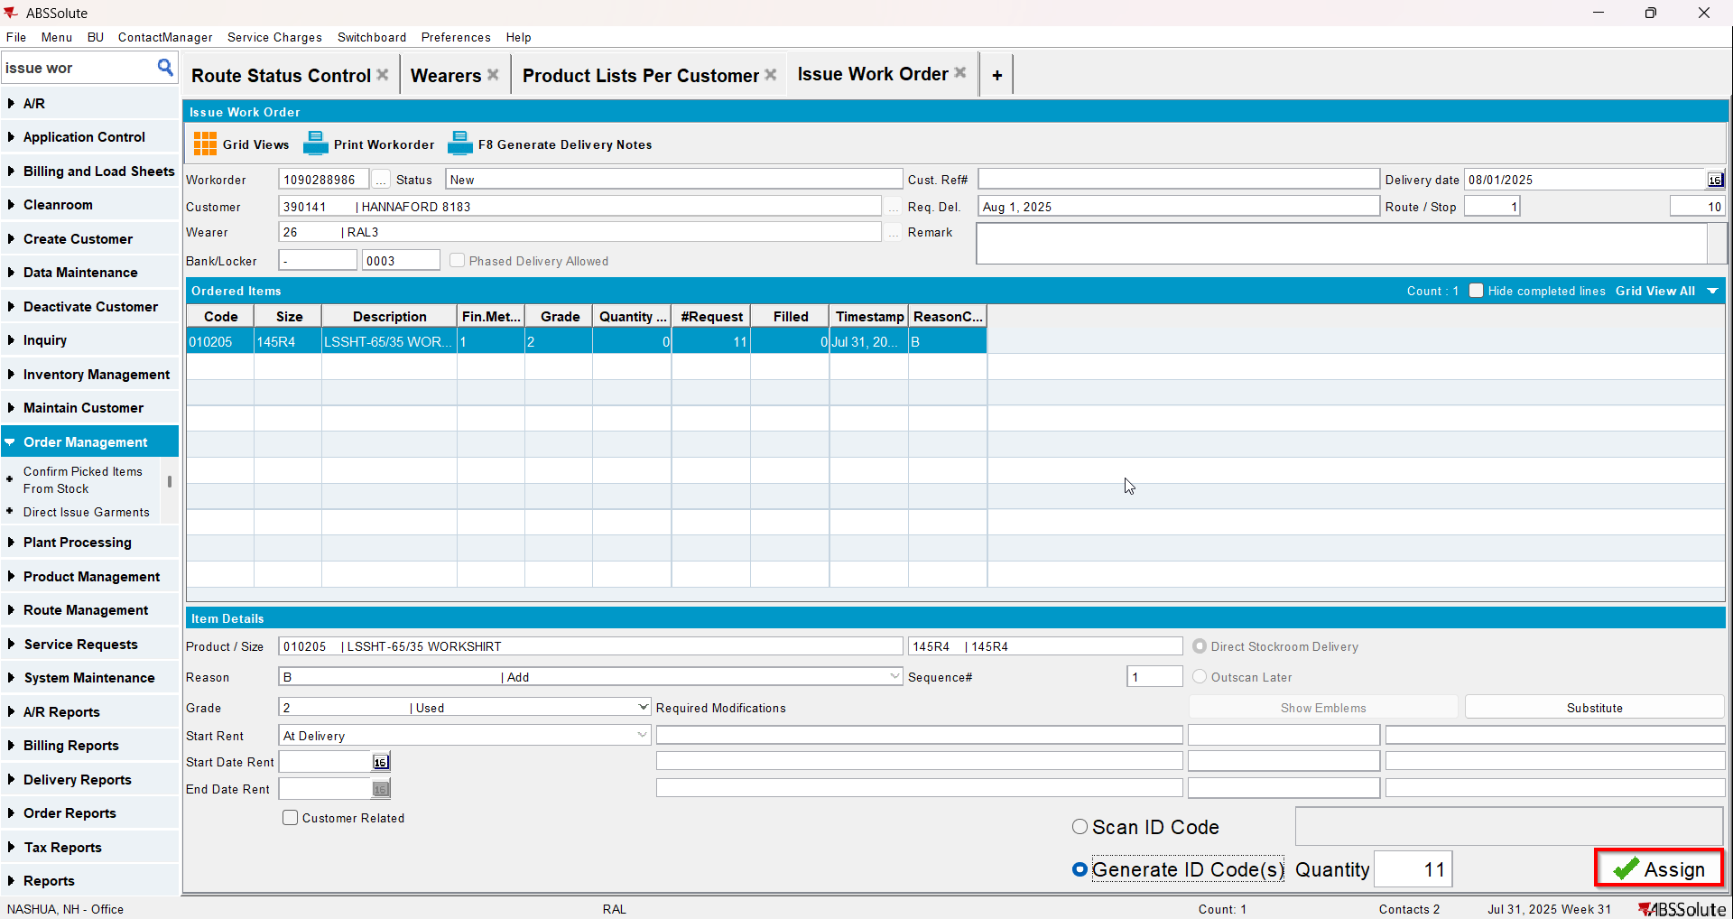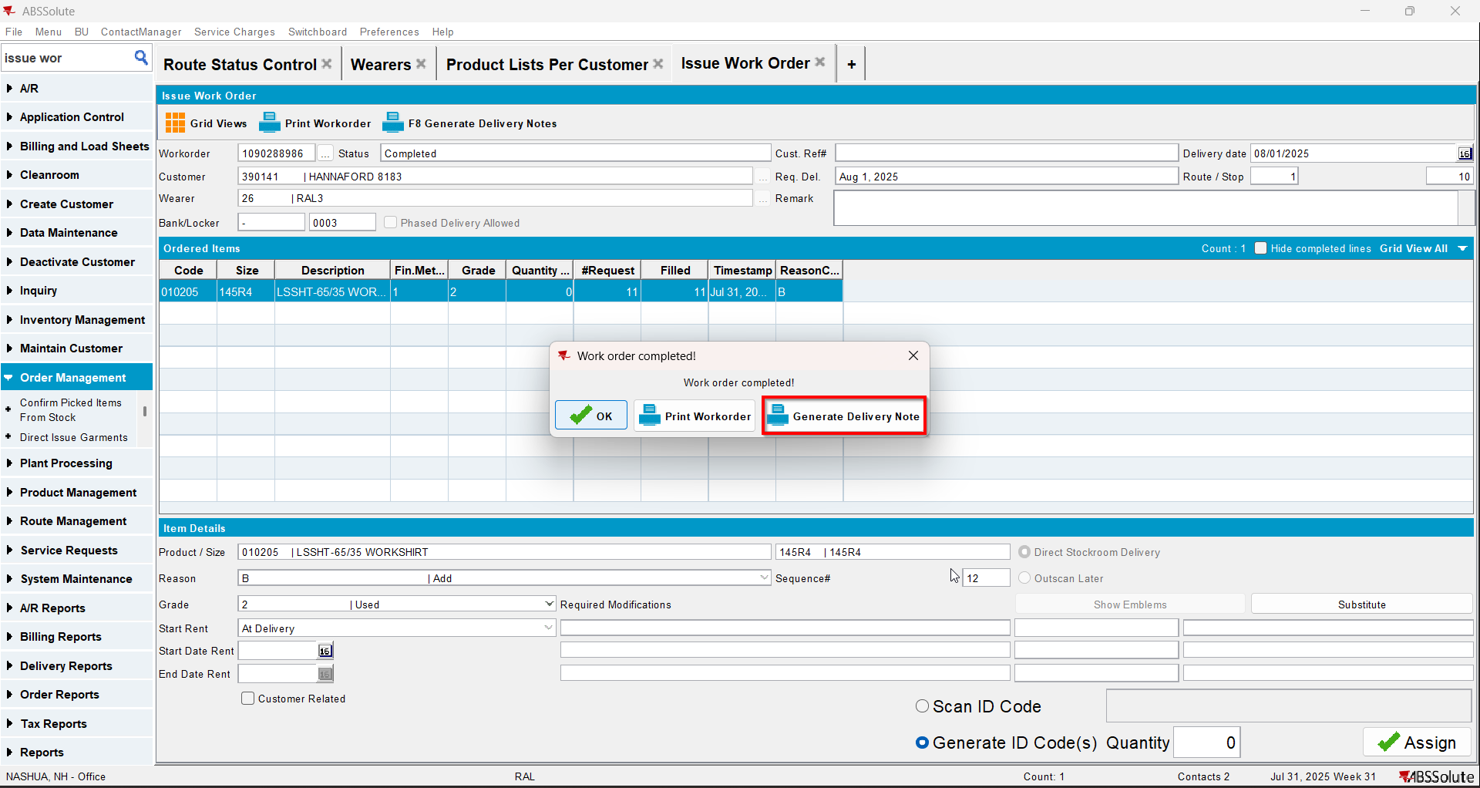
- Wearer dlg: Select your wearer and wearer inventory. Replace 4 garments with a new product.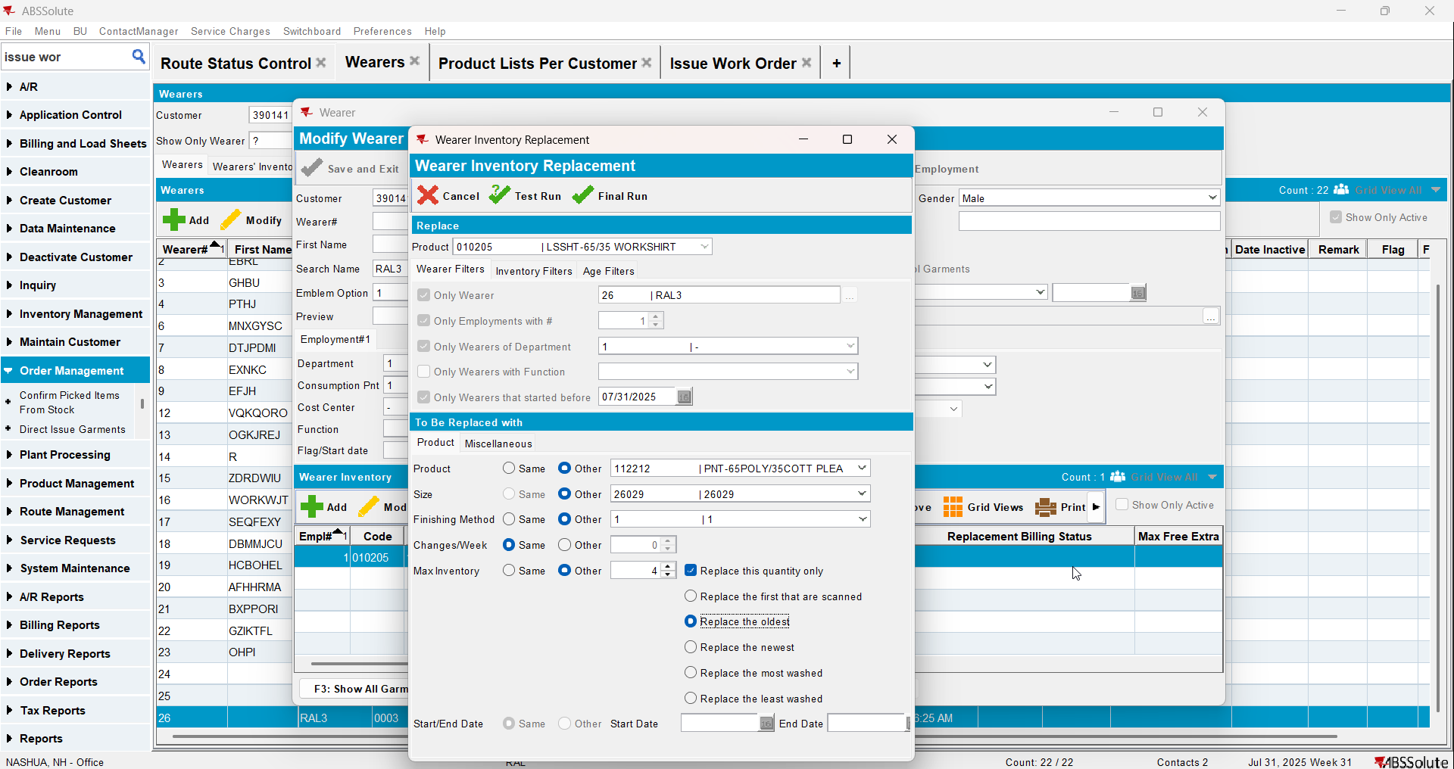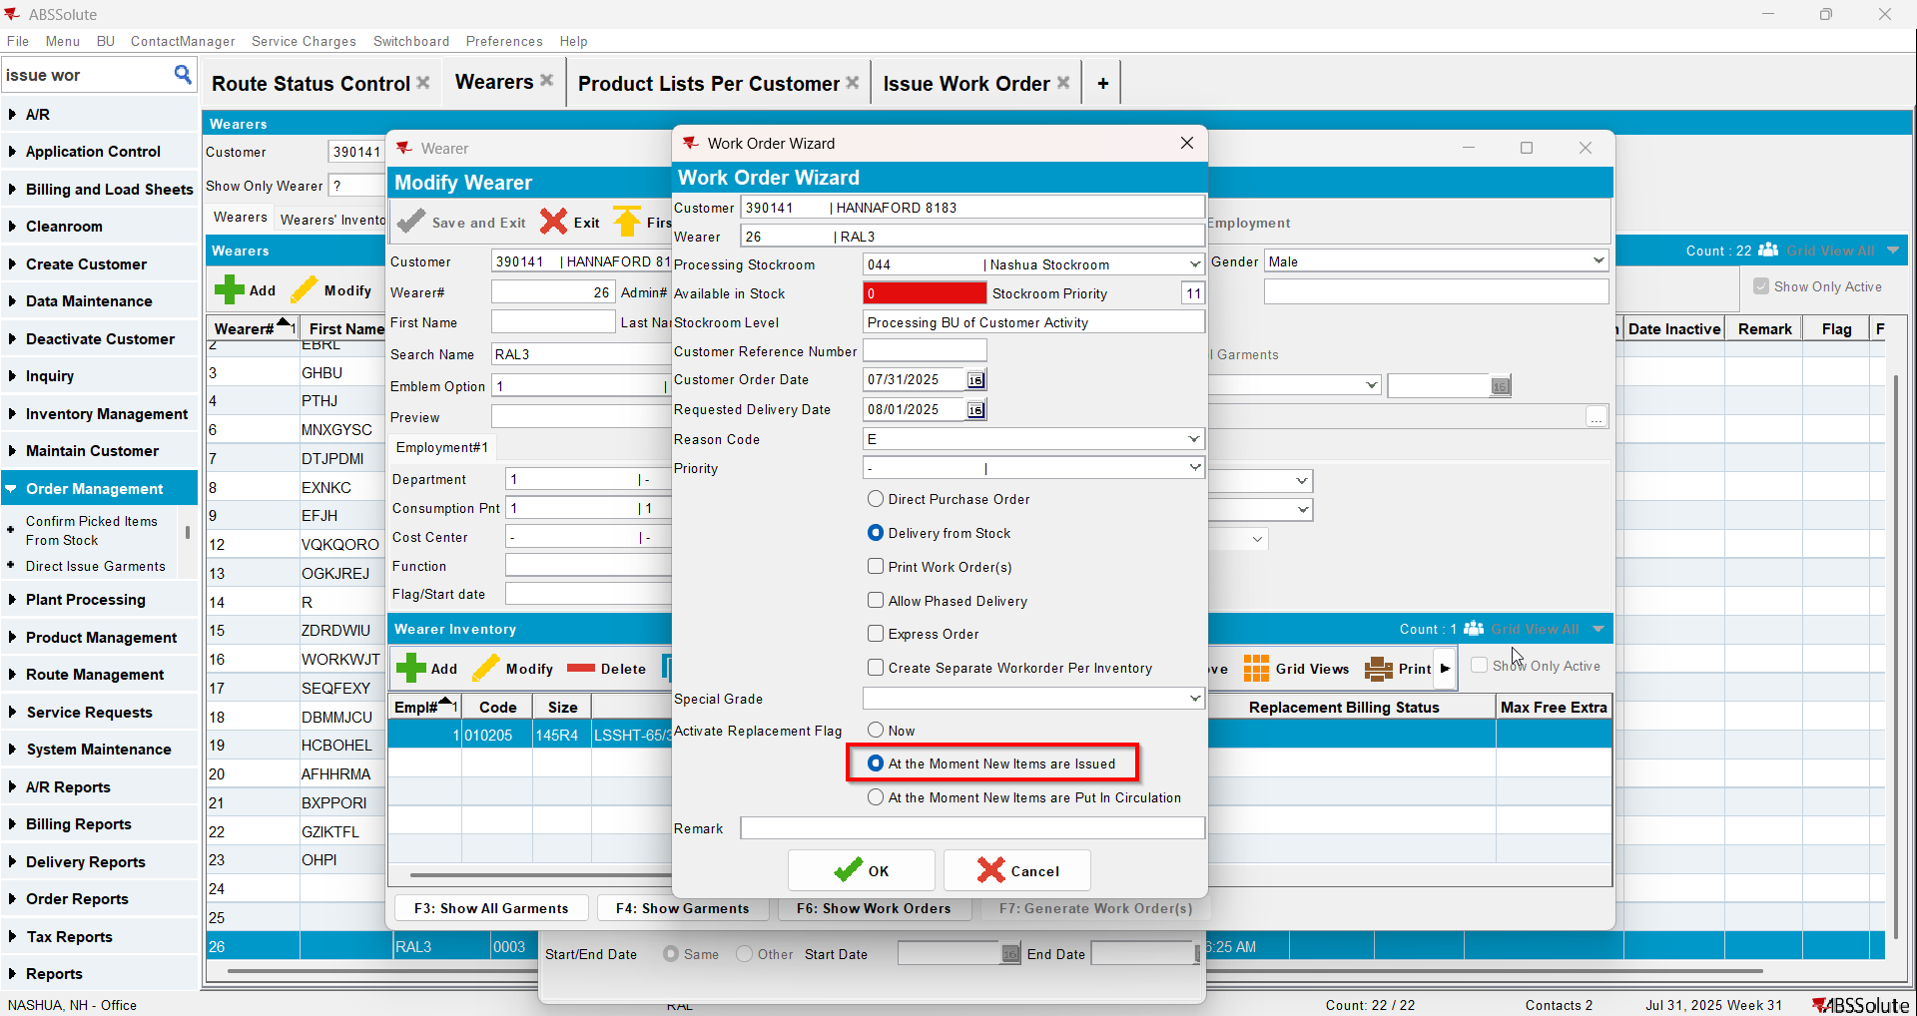
- Issue Work Order dlg: Issue the 4 items marked for replace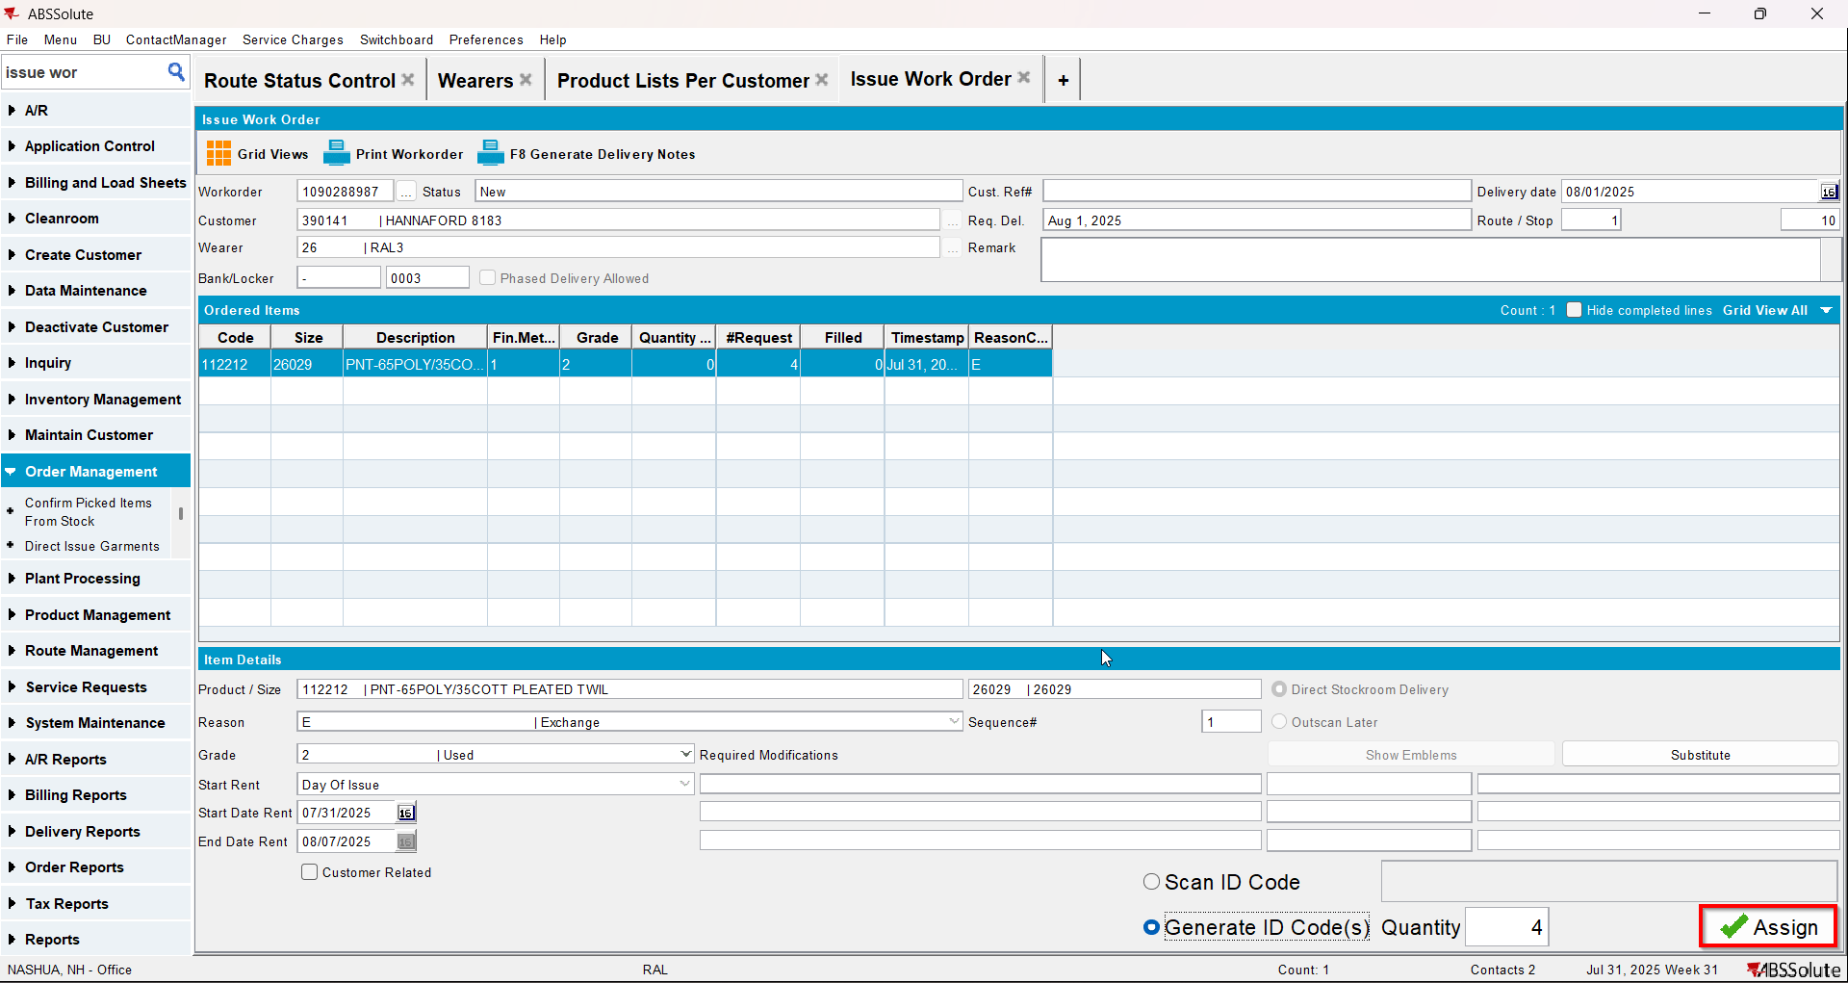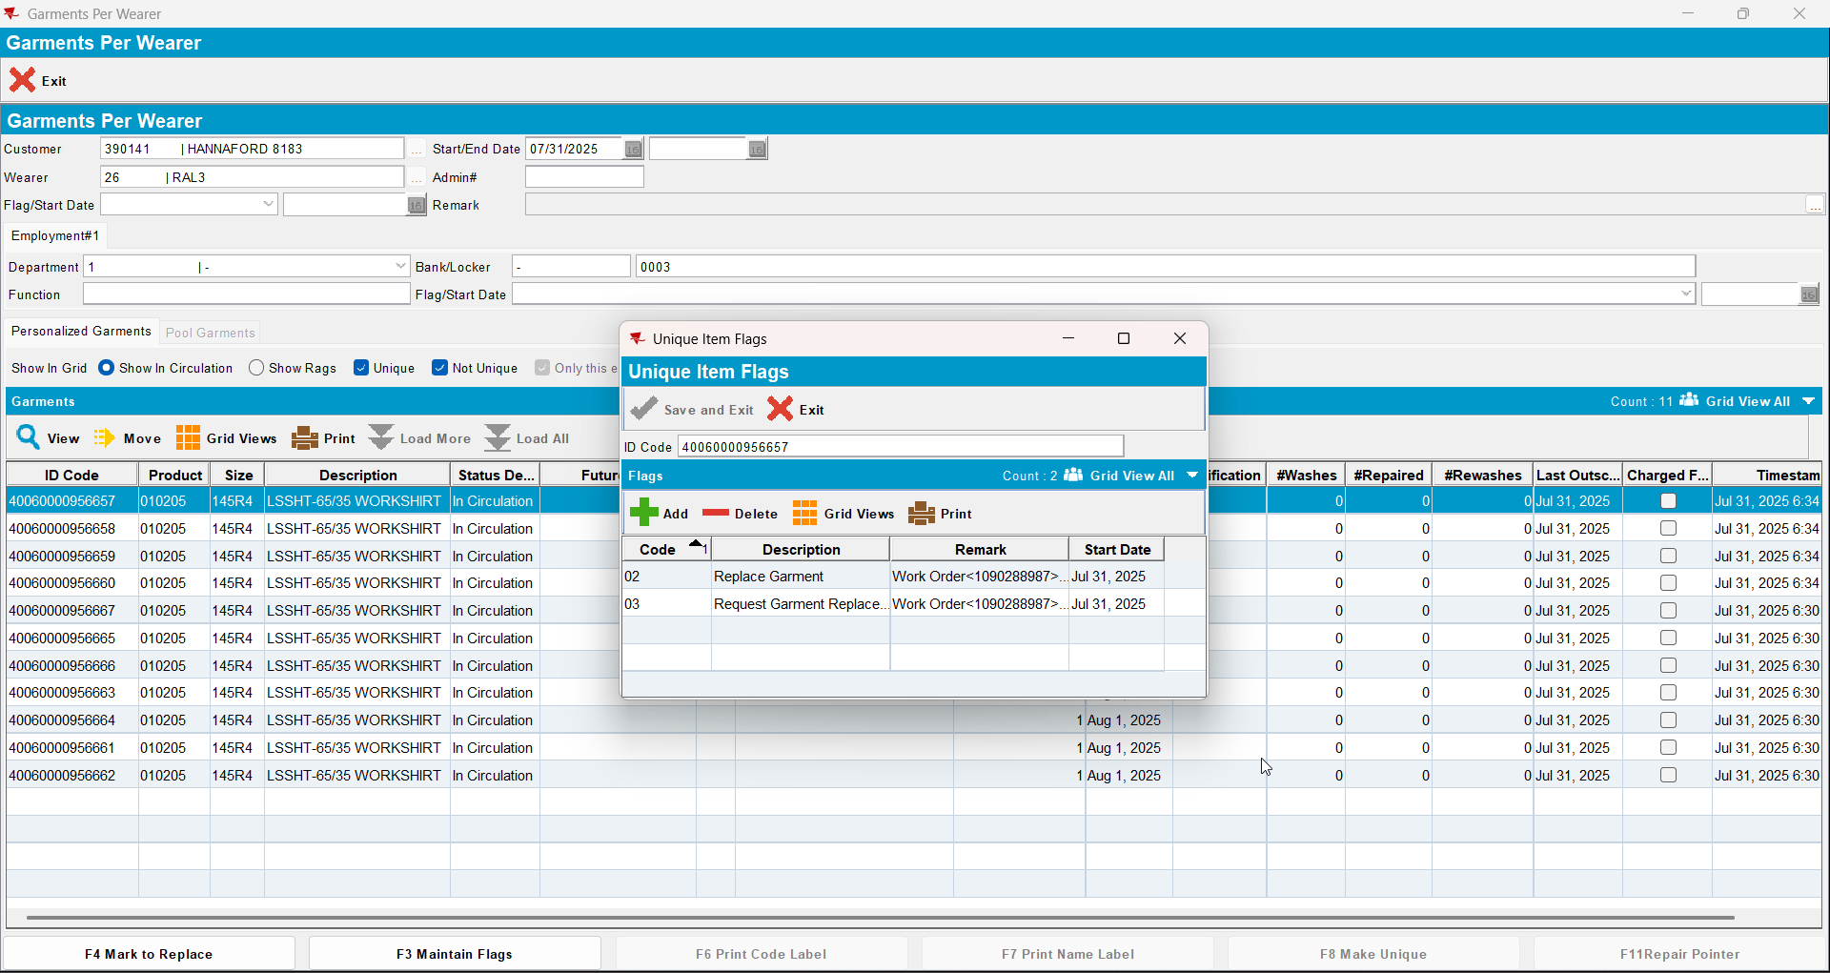
- Wearer dlg: Decrease the max inv for your wearer inventory to 4 (decrease by 3) and then decrease to 2(decrease by 2)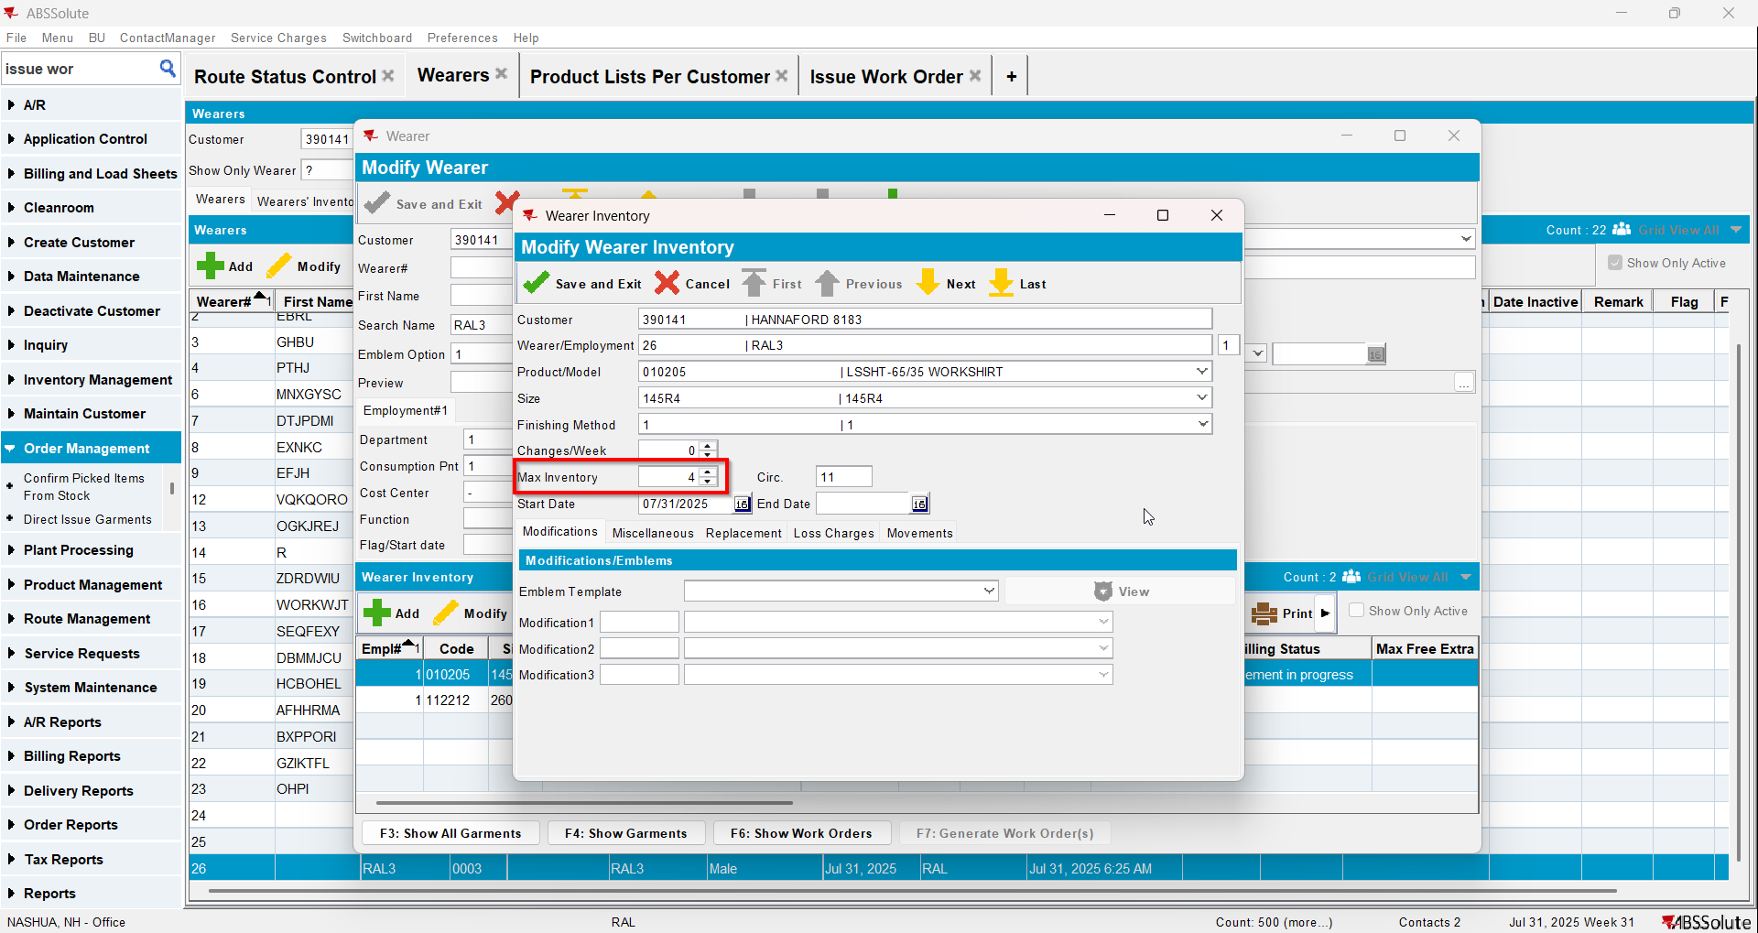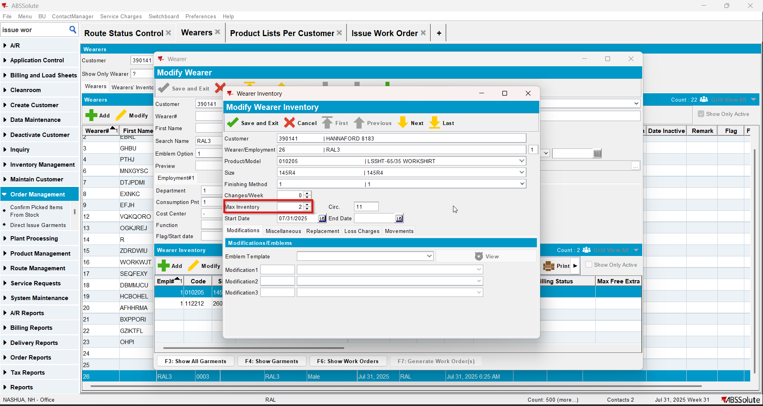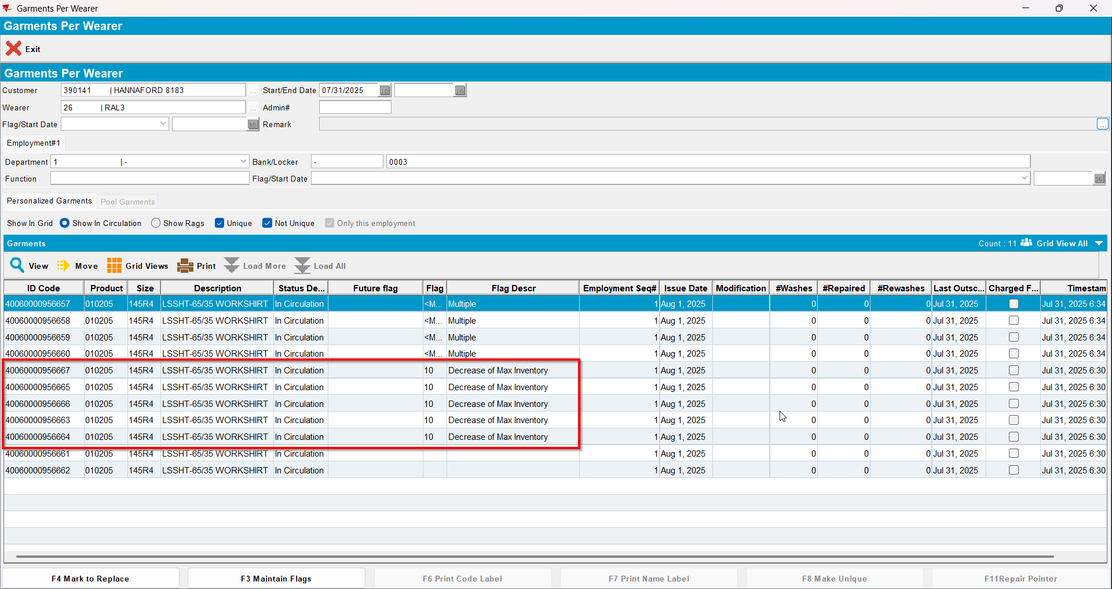

Test Case 4 – Wearer inventory= 11 Circ 11 max, nonuniqueitems only. Replacement for new product for 4 garments and decrease to 2 (decrease by 5). Replacement flag on issue and issue new replacement WO– Tested OK
Expected behavior: You should be allowed to decrease and 5 garments should be flagged for decrease
Hash: 463f282
- Wearer dlg: Select a wearer. Create a wearer inventory of max 11 and generate work order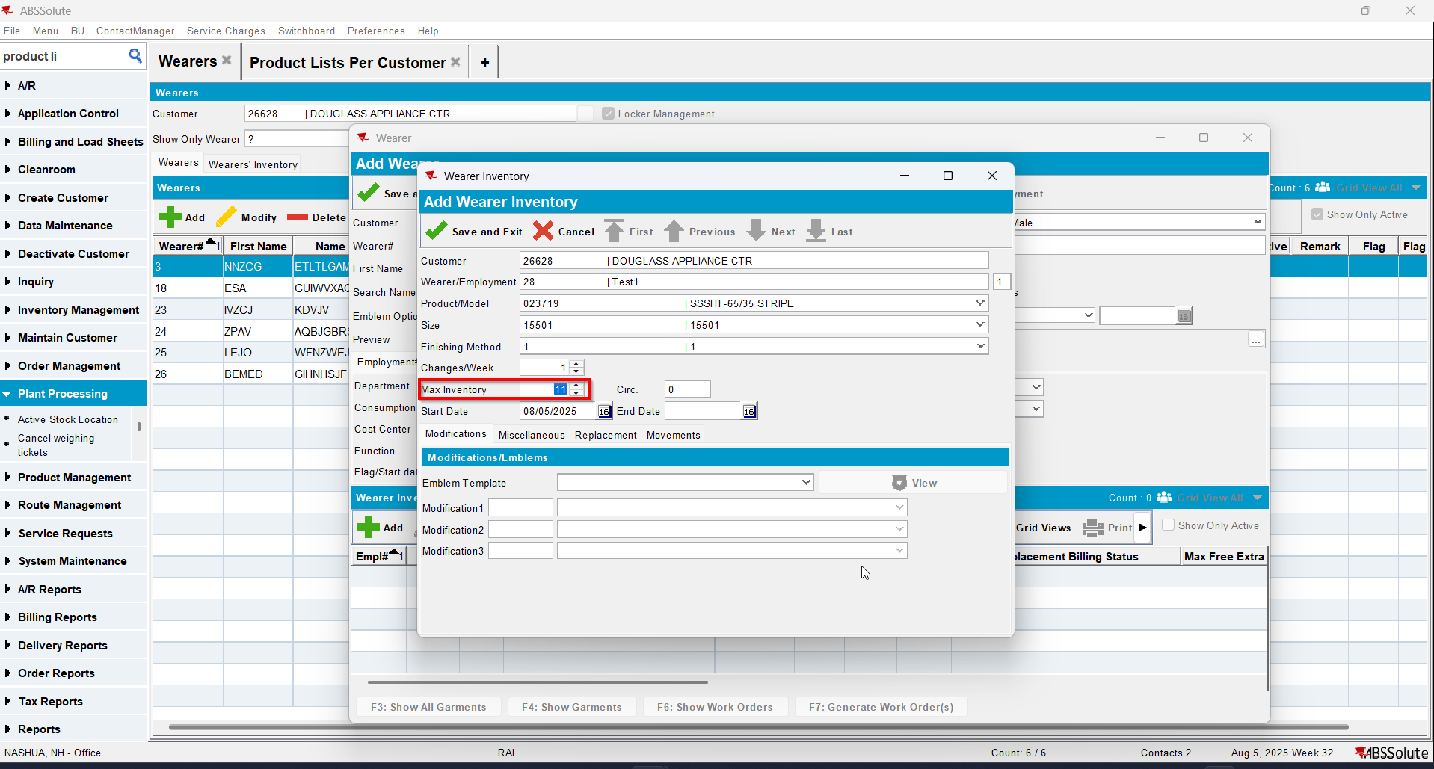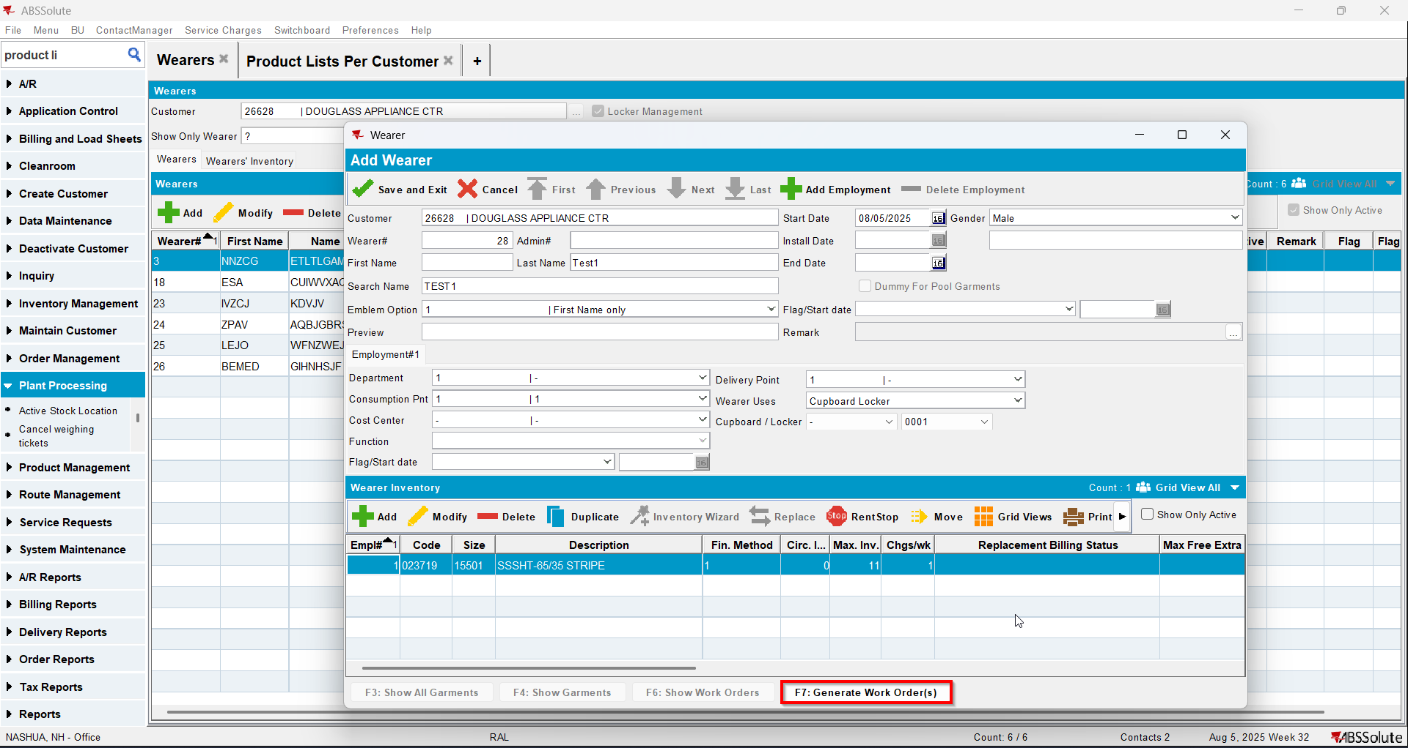
- Issue Work Order dlg: Issue all 11 items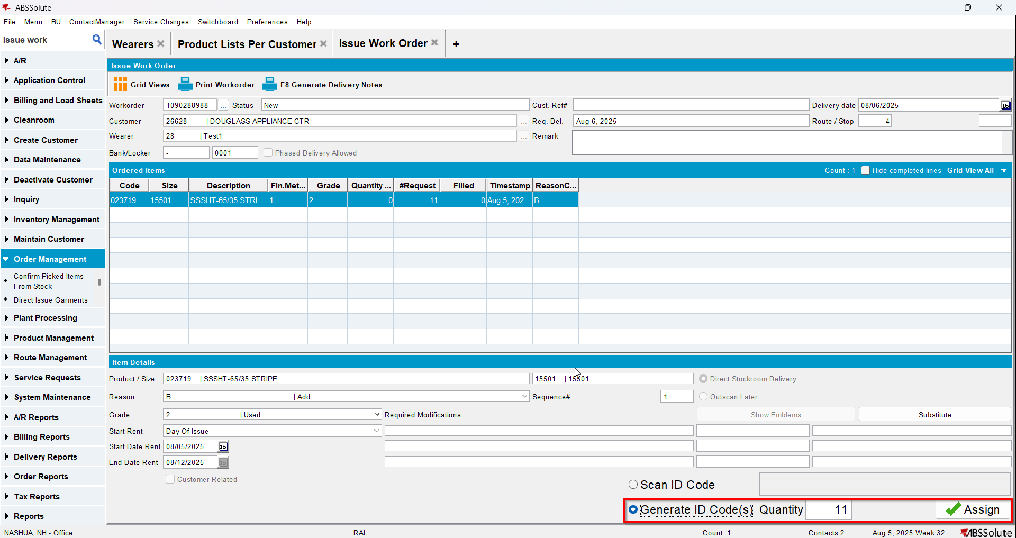
- Wearer dlg: Select your wearer and wearer inventory. Replace 4 garments with a new product.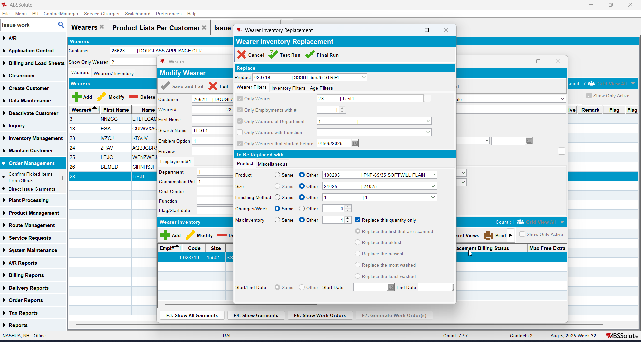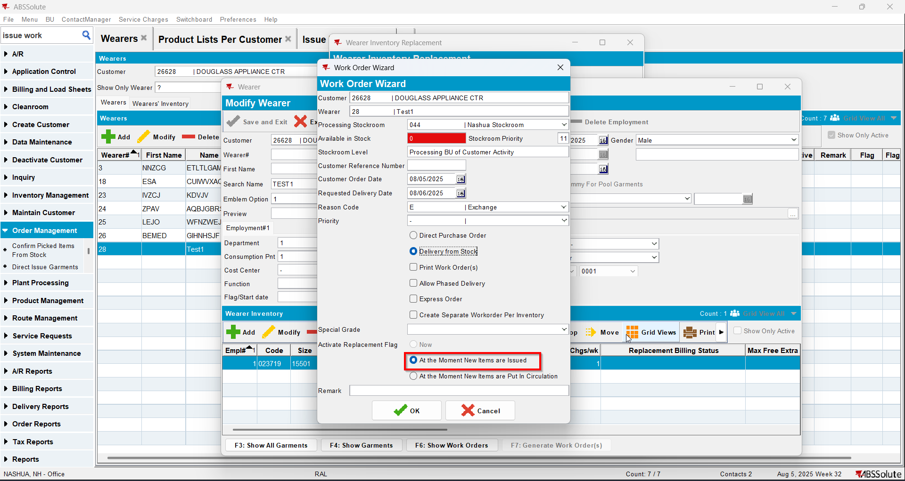
- Issue Work Order dlg: Issue the 4 items that you replaced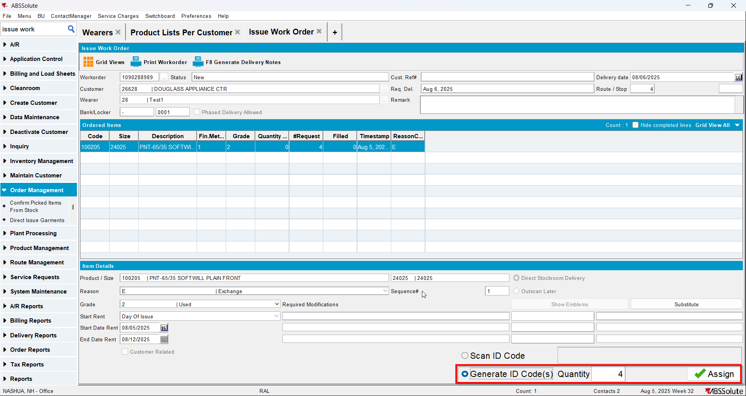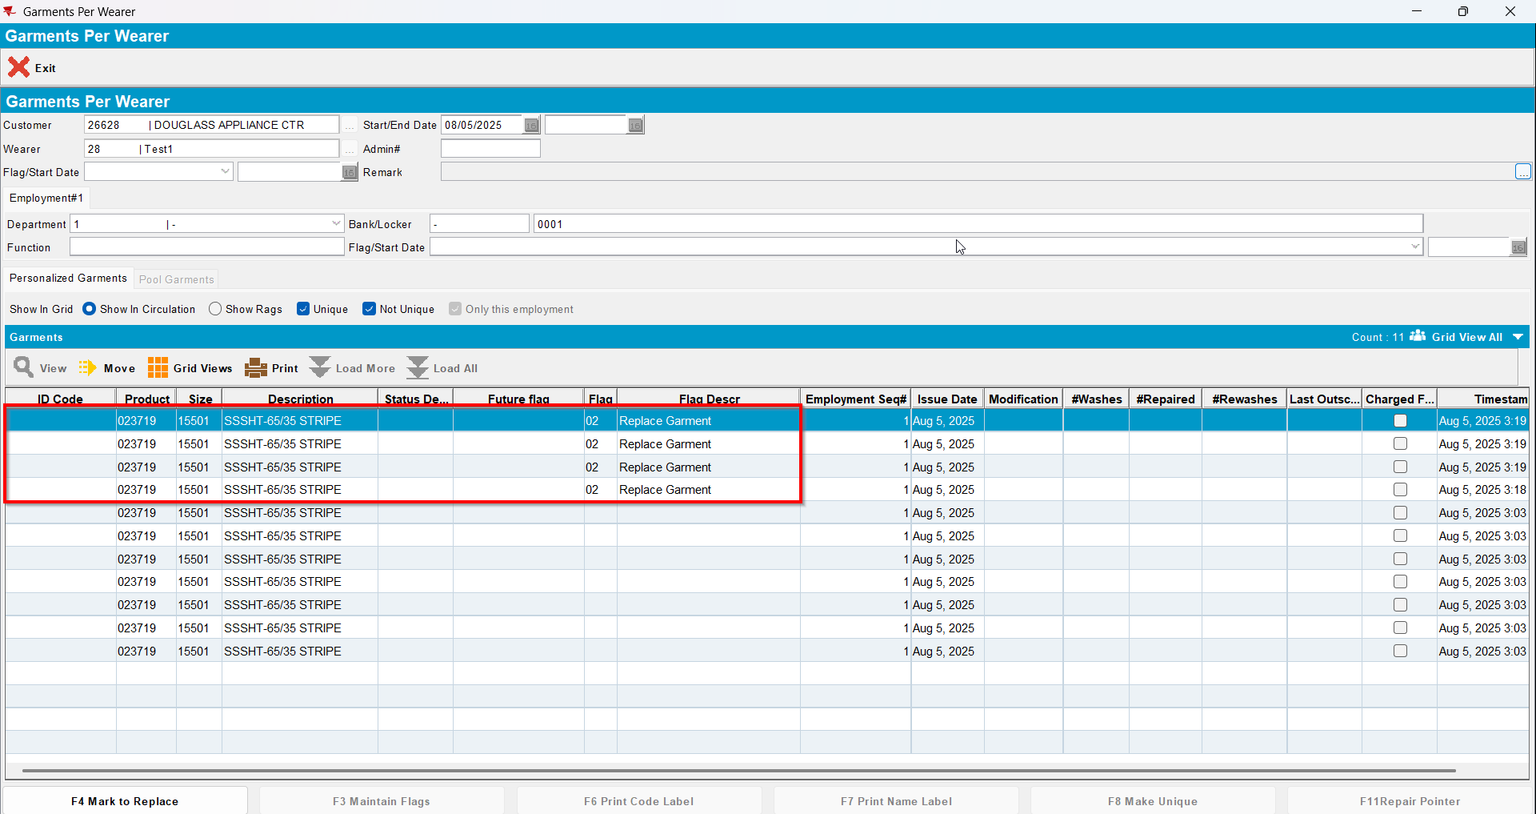
- Wearer dlg: Decrease the max inv for your wearer inventory to 2 (decrease by 5)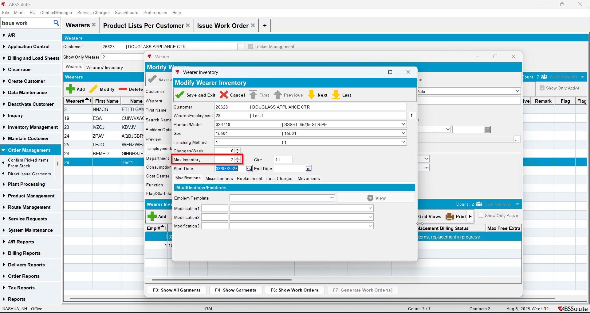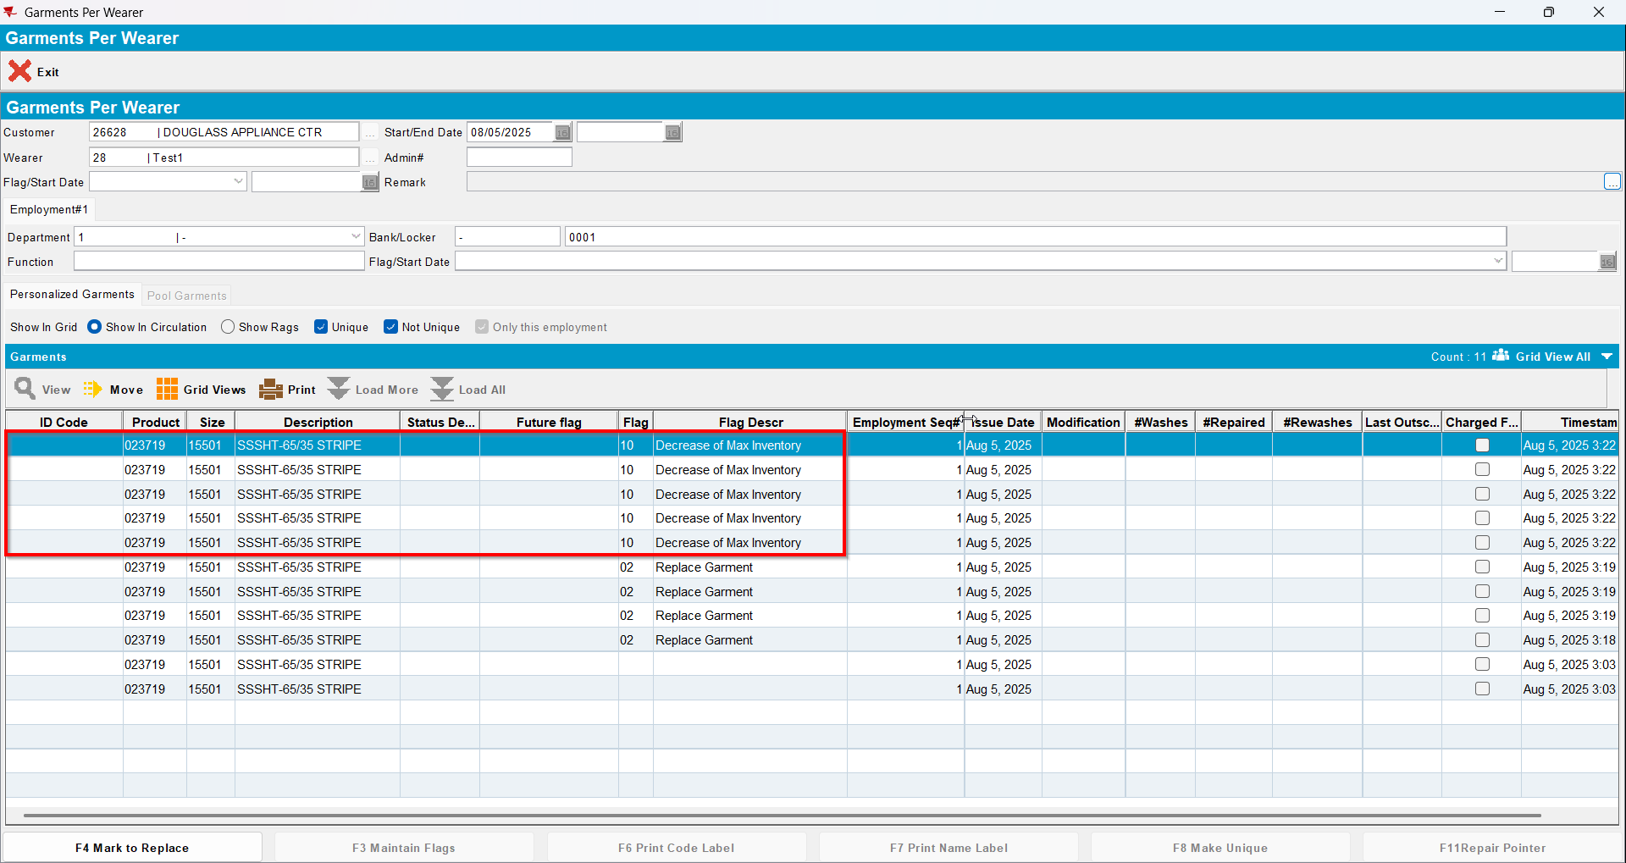

Test Case 5 – Wearer inventory= 11 Circ 11 max, nonuniqueitems only. Replacement for the same product for 4 garments and decrease to 4 (decrease by 7). Replacement flag on issue and issue new replacement WO– Tested OK
Expected behavior: You should be allowed to decrease and 7 garments should be flagged for decrease
Hash: 463f282
- Wearer dlg: Select a wearer. Create a wearer inventory of max 11 and generate work order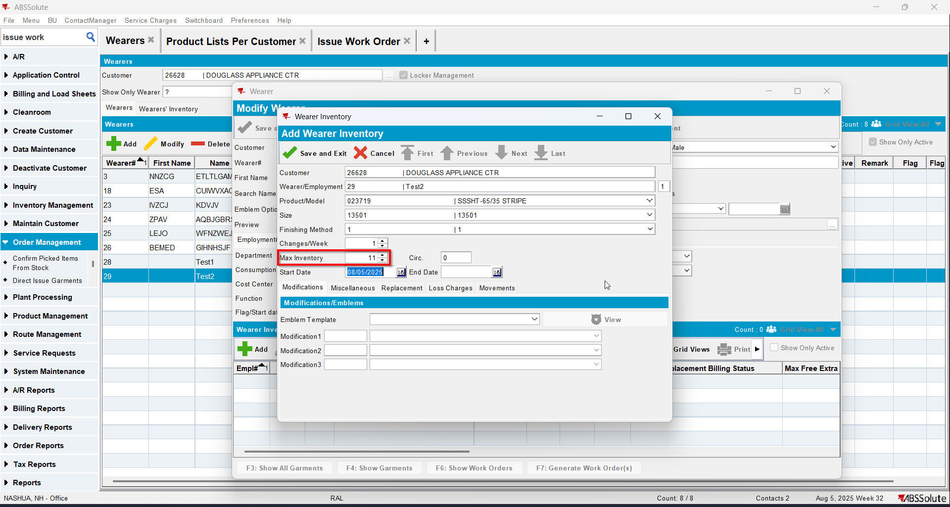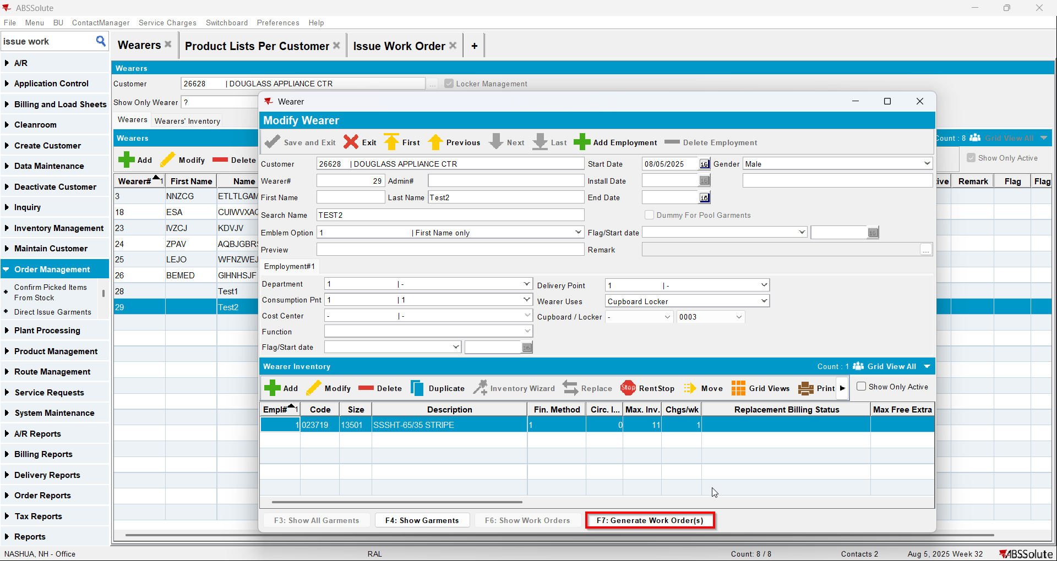
- Issue Work Order dlg: Issue all 11 items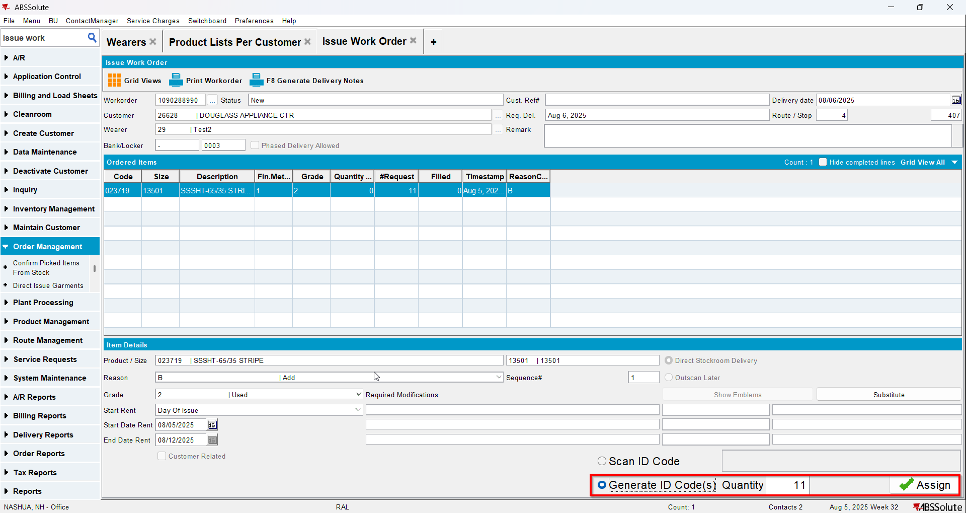
- Wearer dlg: Select your wearer and wearer inventory. Go to Show Garments and Mark to Replace 4 items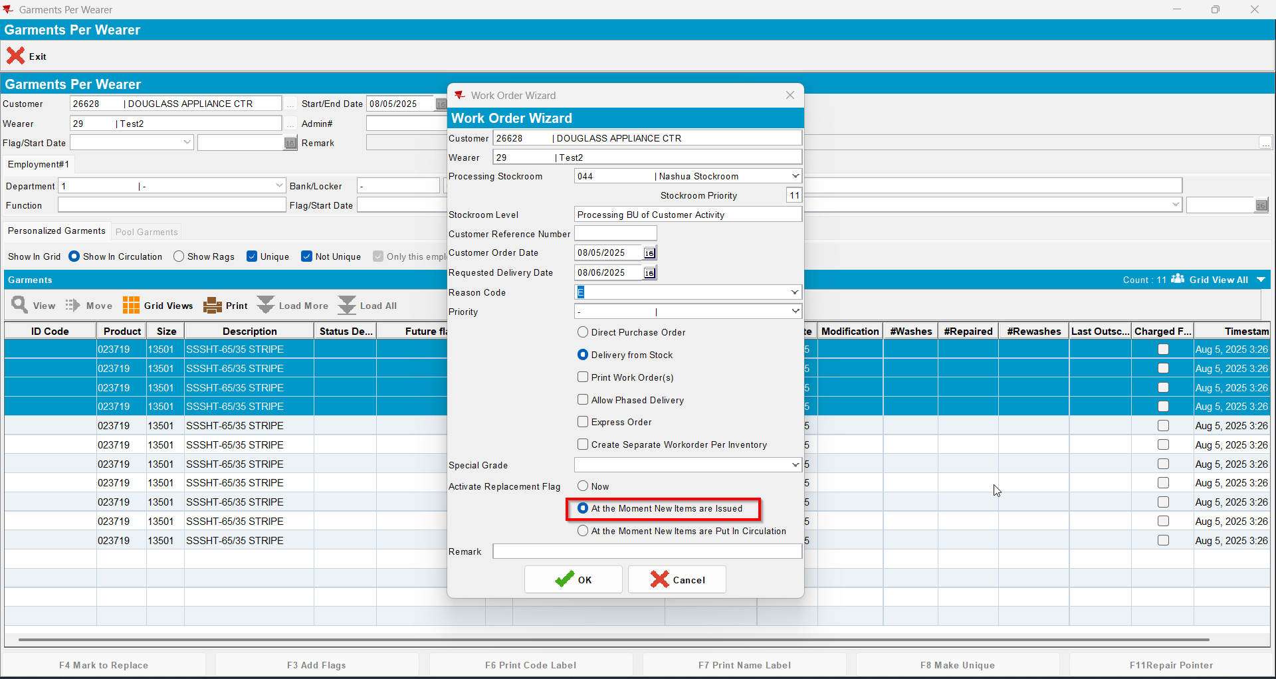
- Issue Work Order dlg: Issue the 4 items marked for replace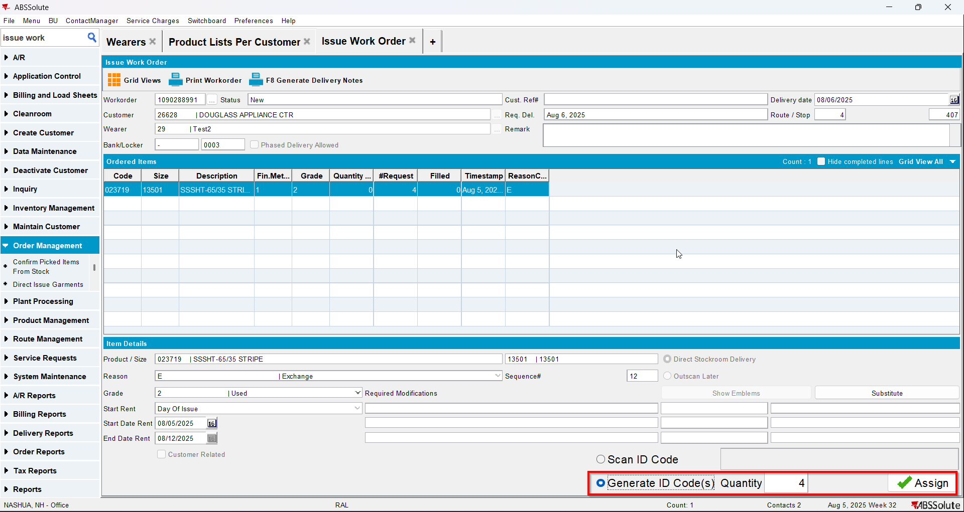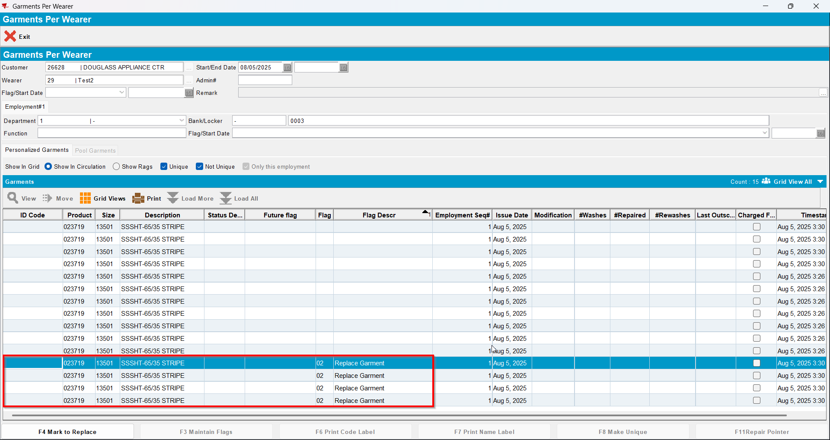
- Wearer dlg: Decrease the max inv for your wearer inventory to 4 (decrease by 7)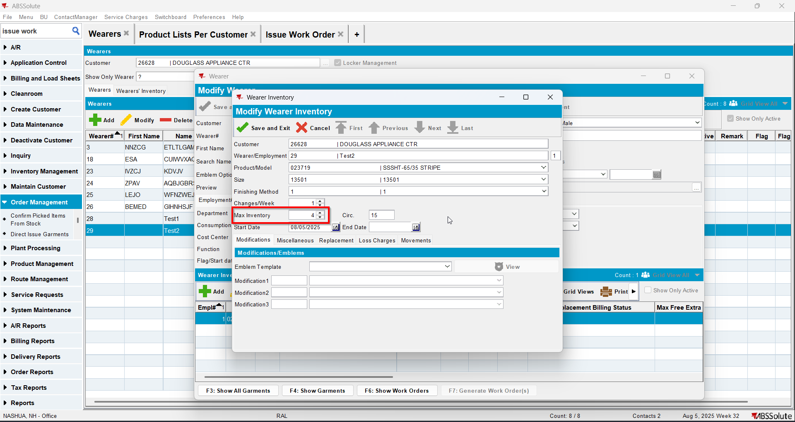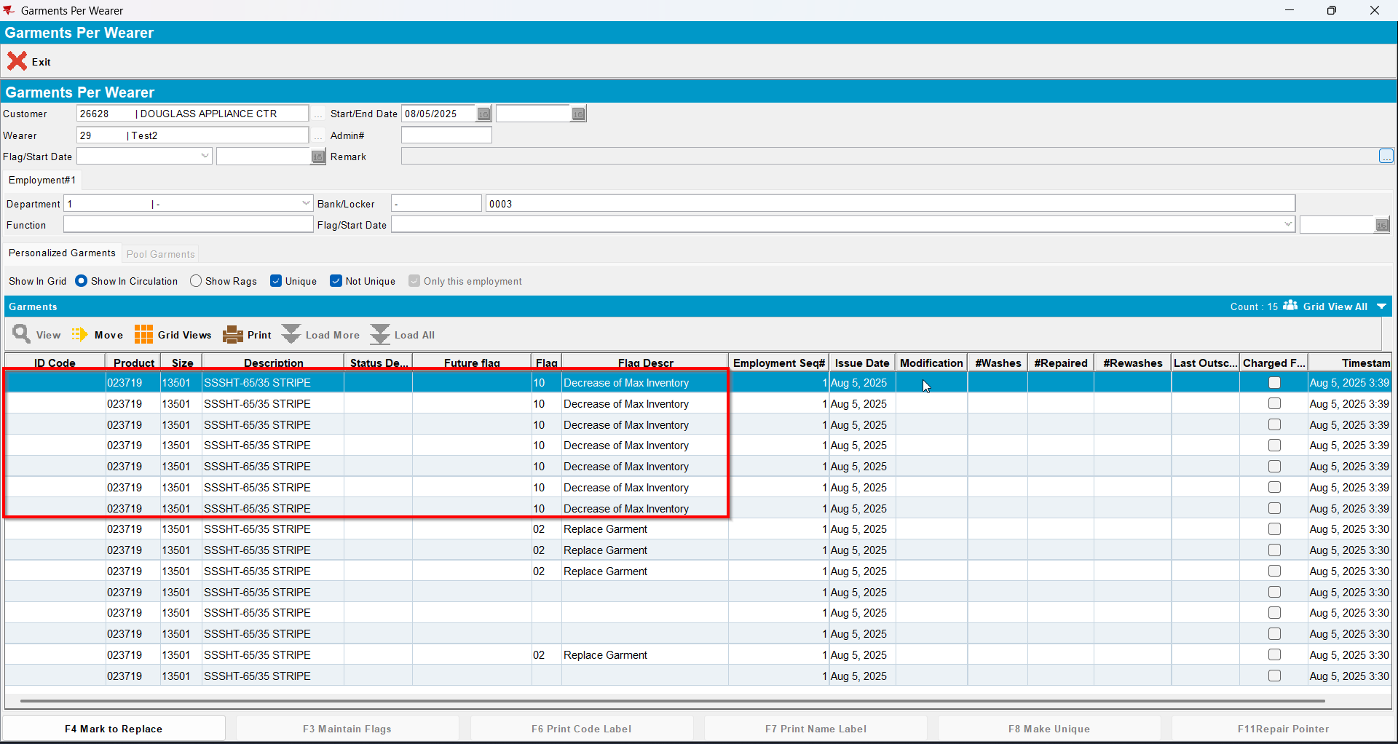

Test Case 6 – Wearer inventory= 11 Circ 11 max, nonuniqueitems only. Replacement for new product for 4 garments and decrease to 4 (decrease by 3) and then decrease to 2 (decrease by 2). Replacement flag on issue and issue new replacement WO– Tested OK
Expected behavior: You should be allowed to decrease and 5 garments should be flagged for decrease
Hash: 463f282
- Wearer dlg: Select a wearer. Create a wearer inventory of max 11 and generate work order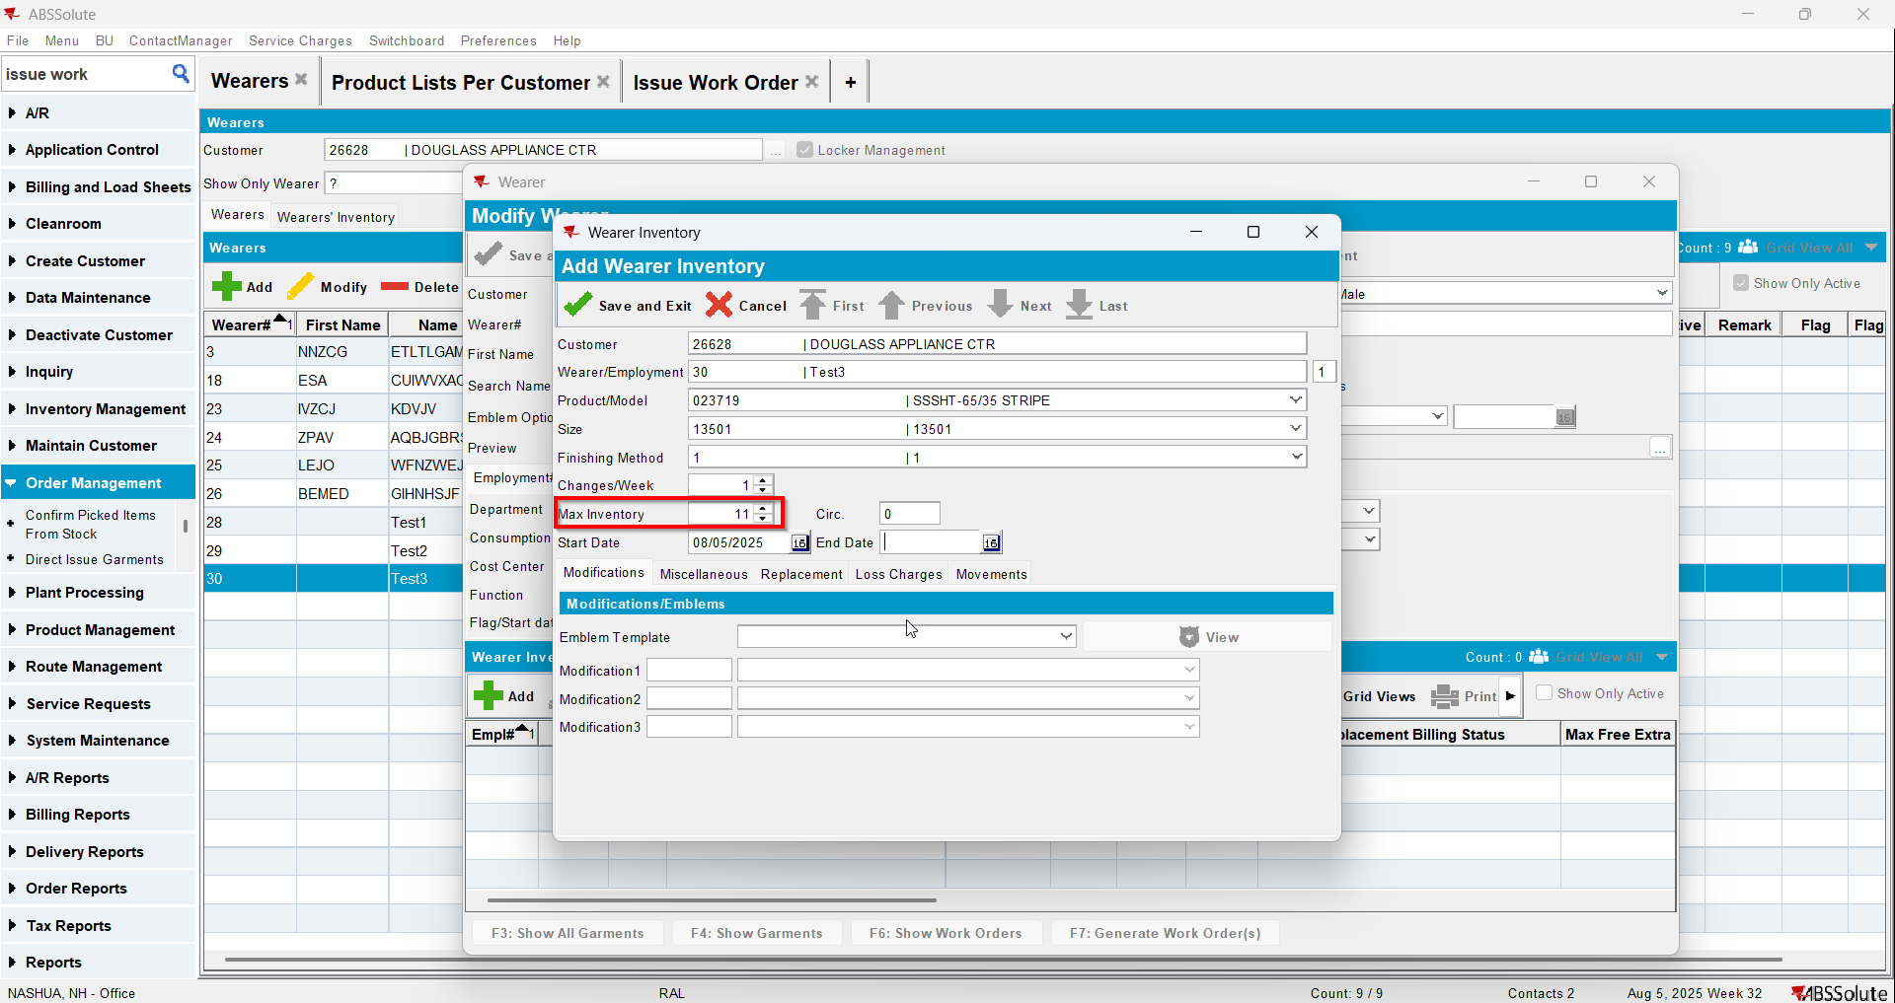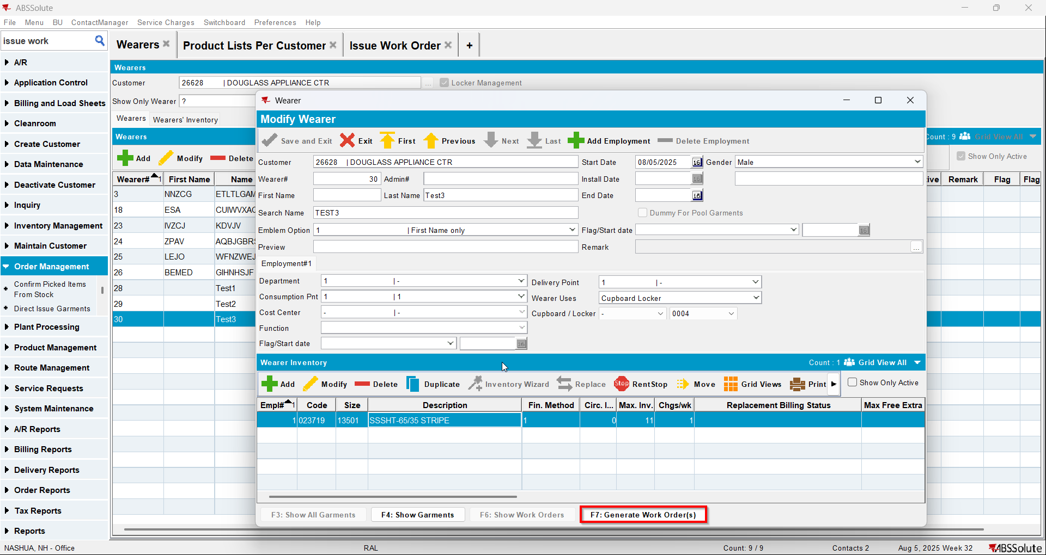
- Issue Work Order dlg: Issue all 11 items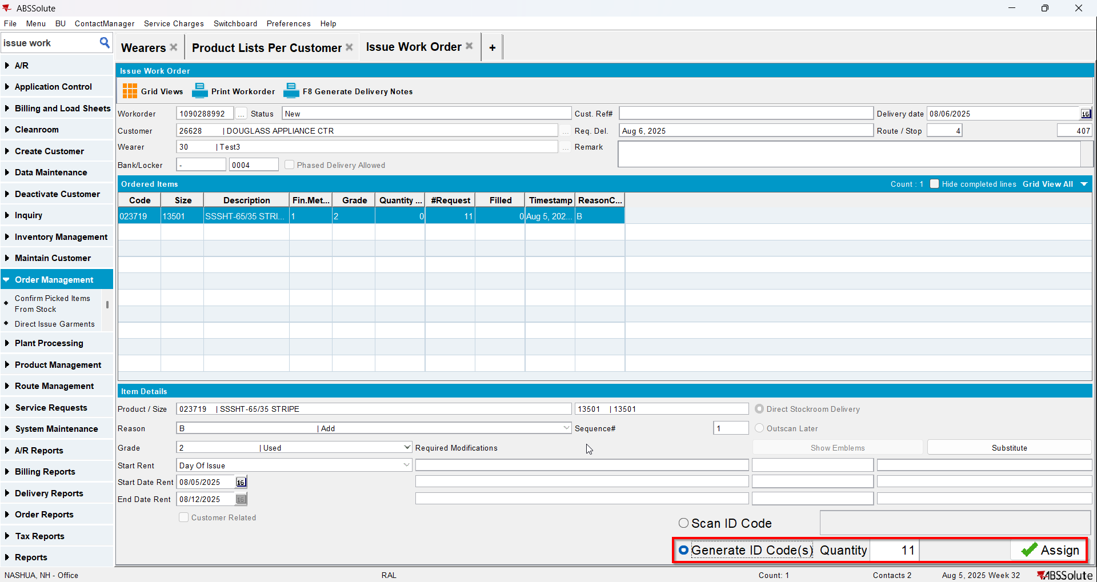
- Wearer dlg: Select your wearer and wearer inventory. Replace 4 garments with a new product.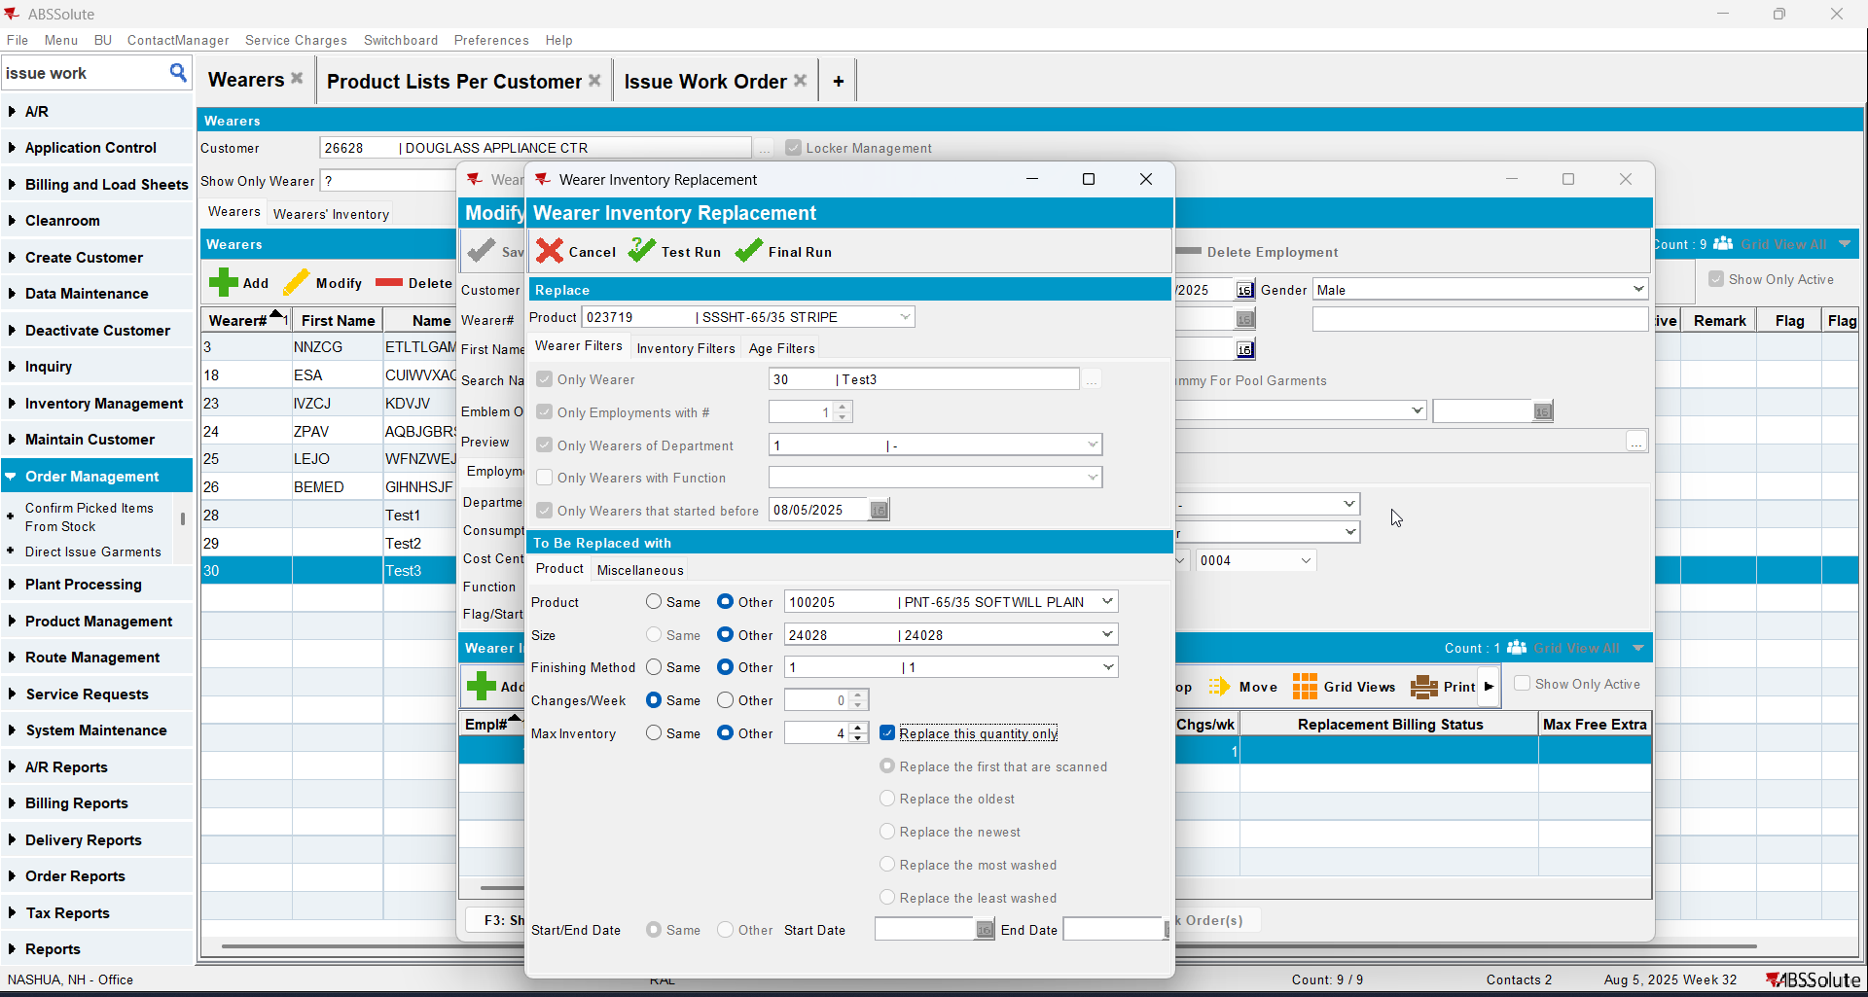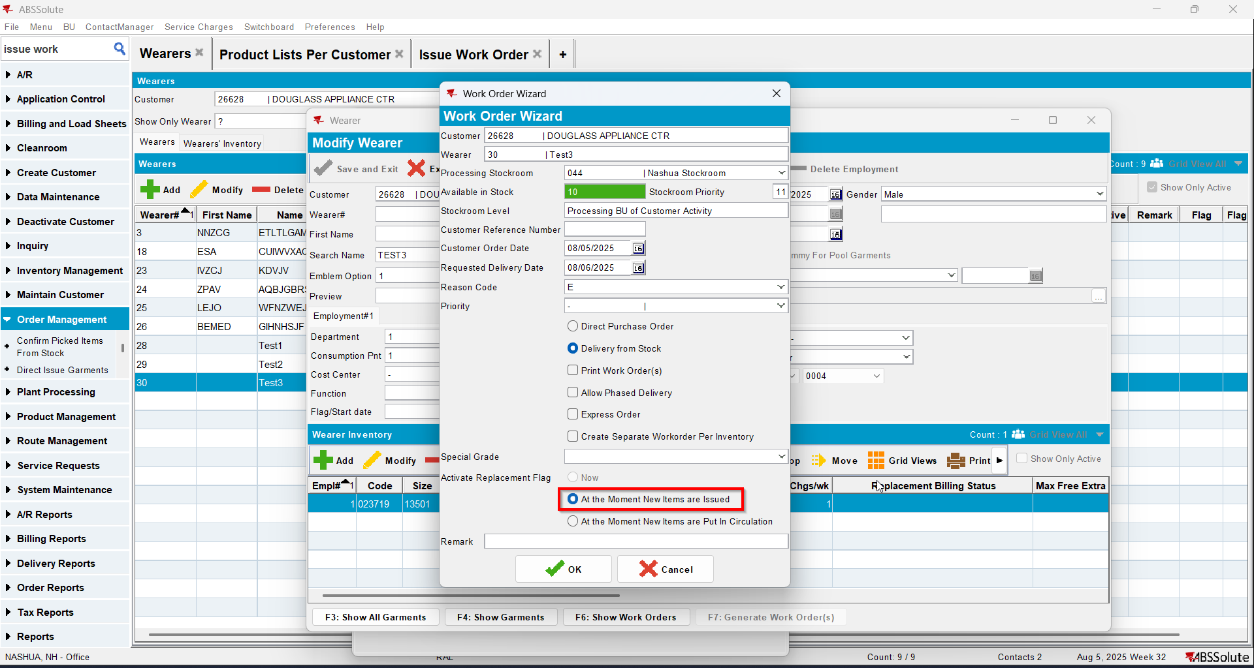
- Issue Work Order dlg: Issue the 4 items marked for replace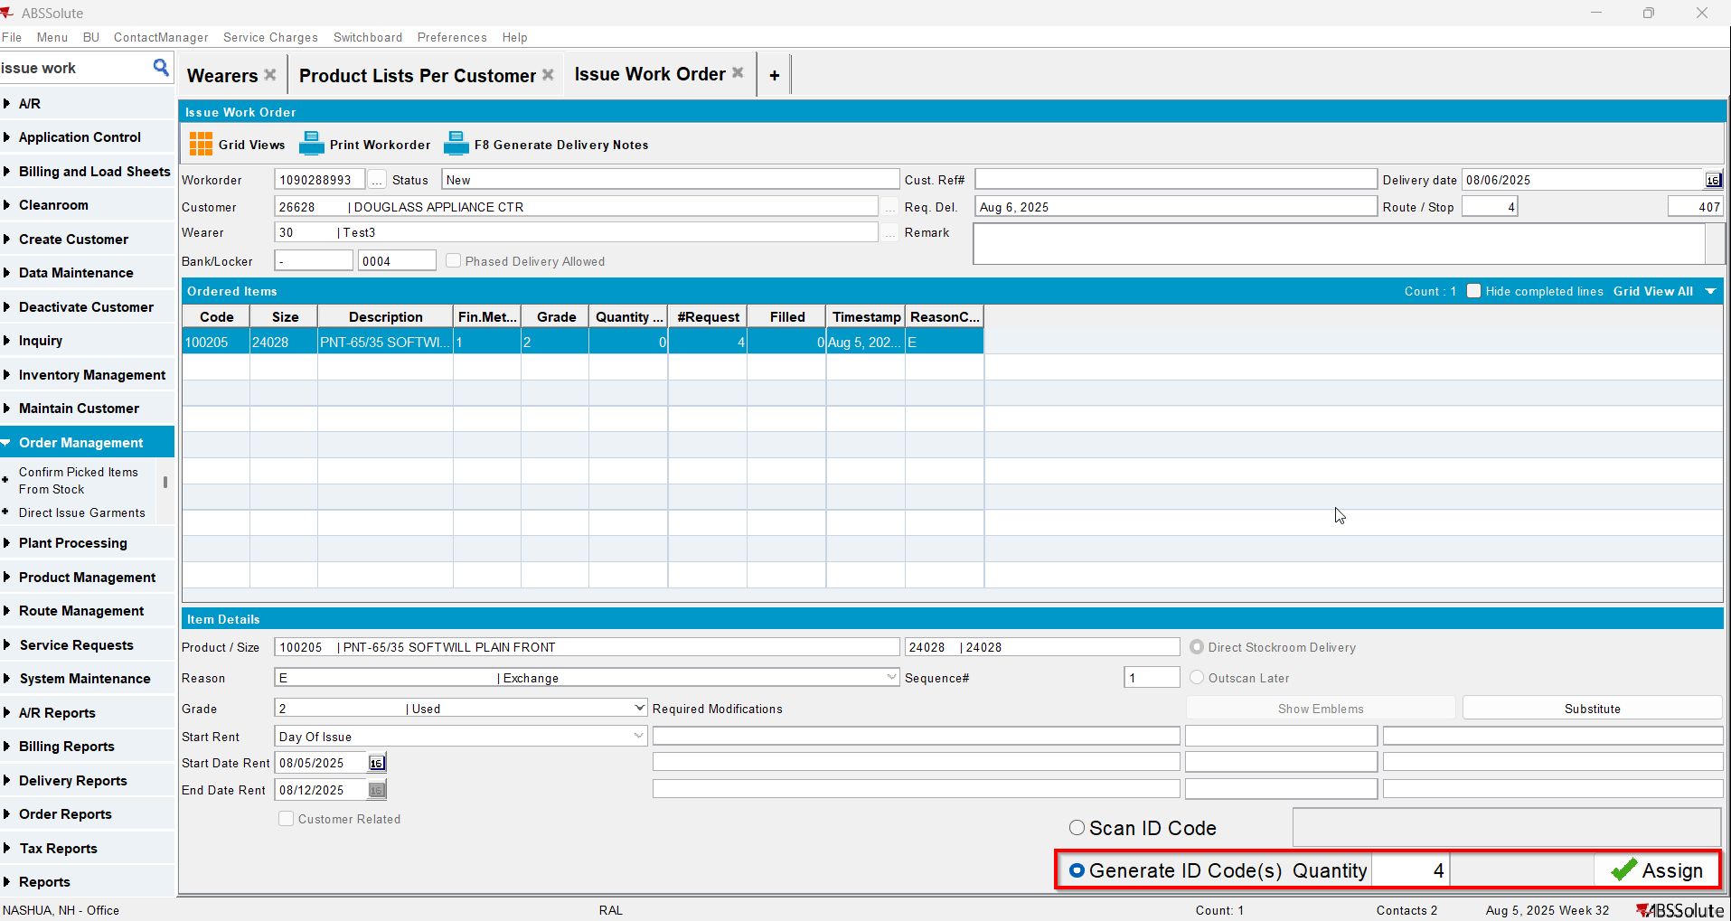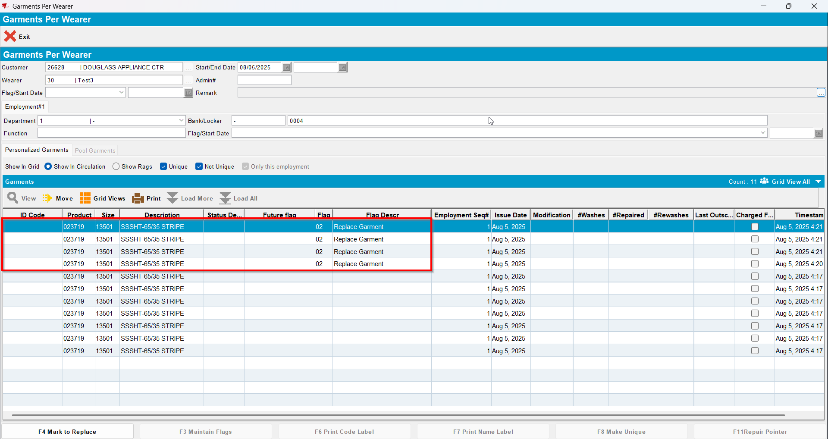
- Wearer dlg: Decrease the max inv for your wearer inventory to 4 (decrease by 3) and then decrease to 2(decrease by 2)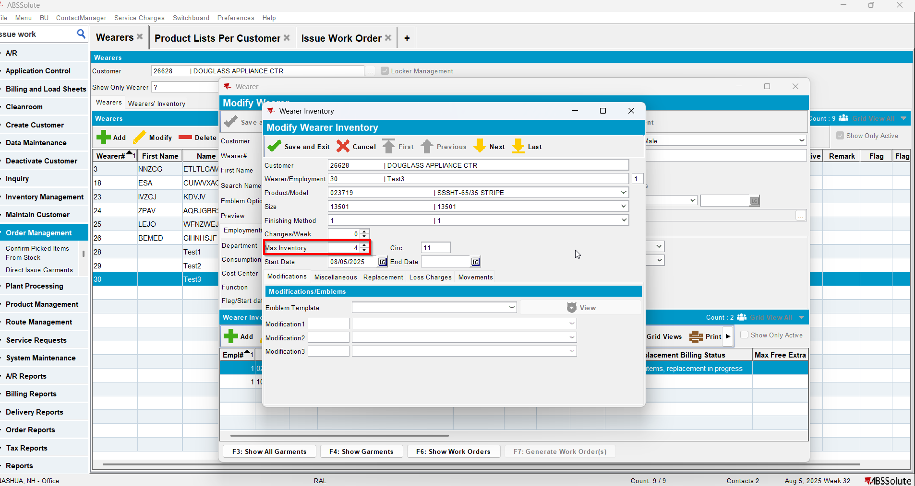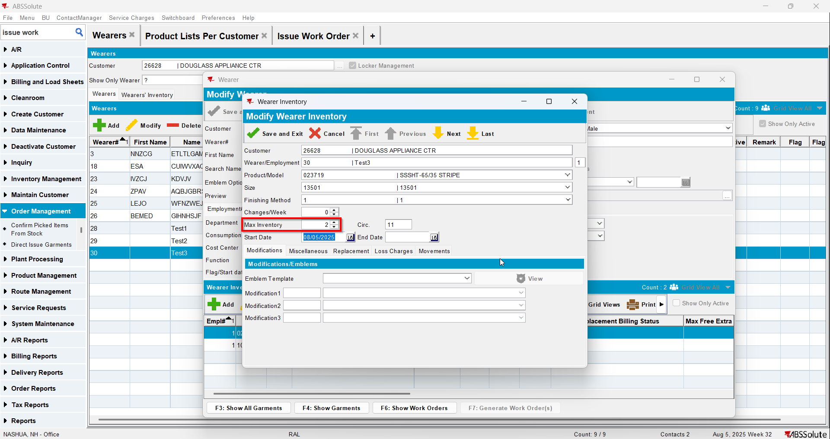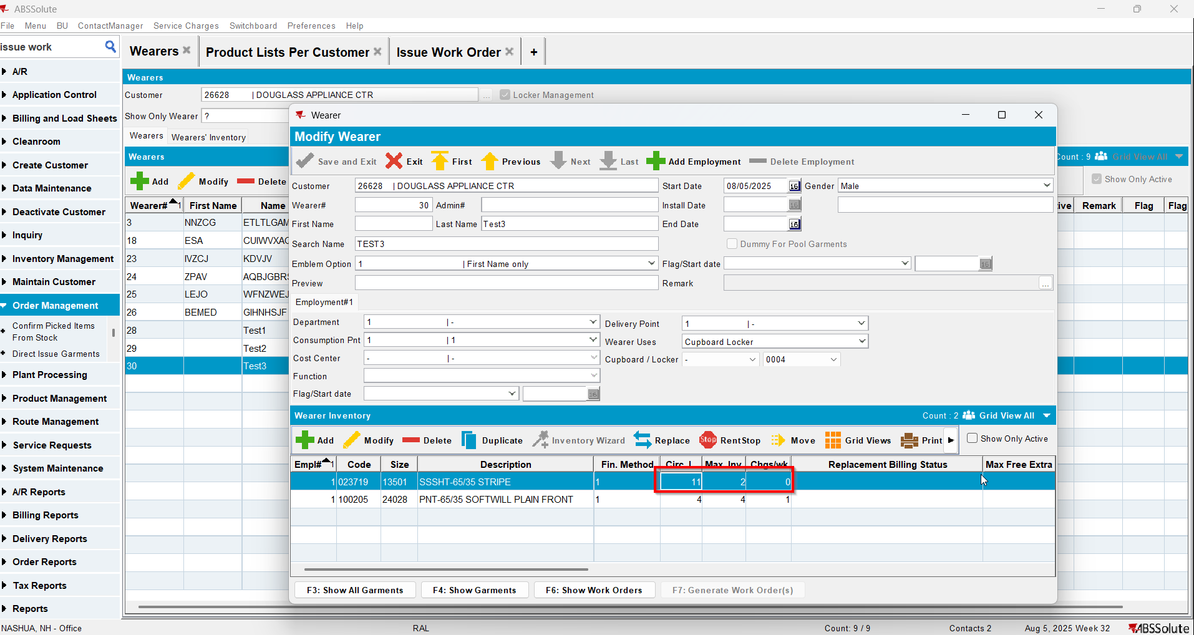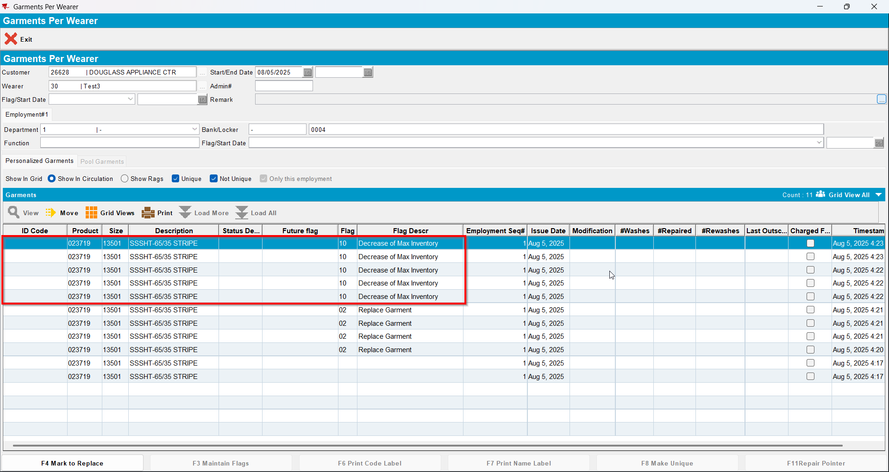

Test Case 7 – Wearer inventory= 11 Circ 11 max, mixed uniqueitems and nonuniqueitems. Replacement for new product for 4 garments and decrease to 2 (decrease by 5). Replacement flag on issue and issue new replacement WO– Tested OK
Expected behavior: You should be allowed to decrease and 5 garments should be flagged for decrease
Hash: 463f282
- Wearer dlg: Select a wearer. Create a wearer inventory of max 11 and generate work order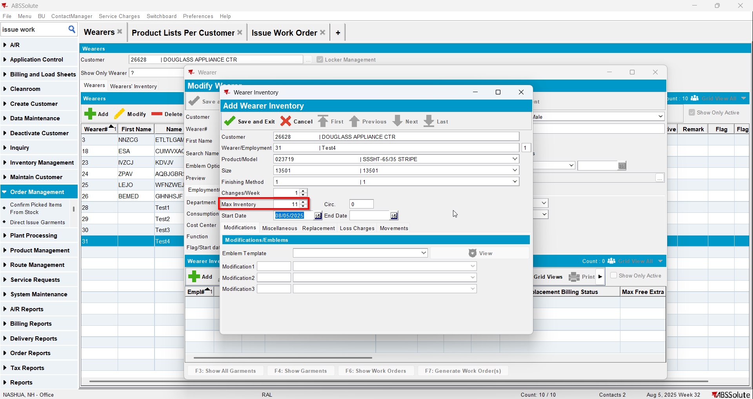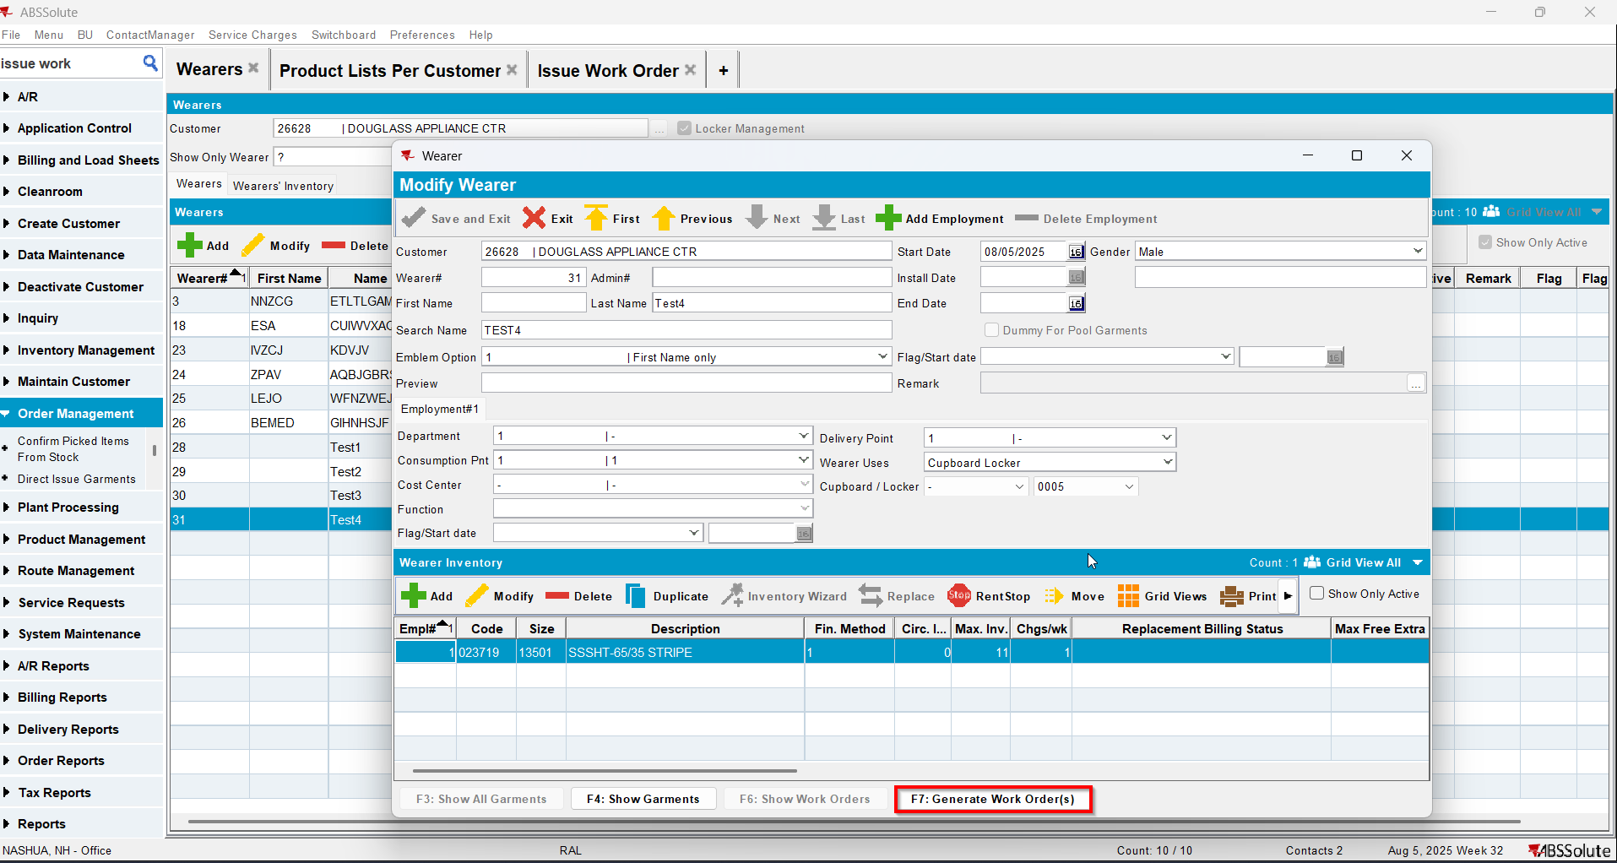
- Issue Work Order dlg: Issue all 11 items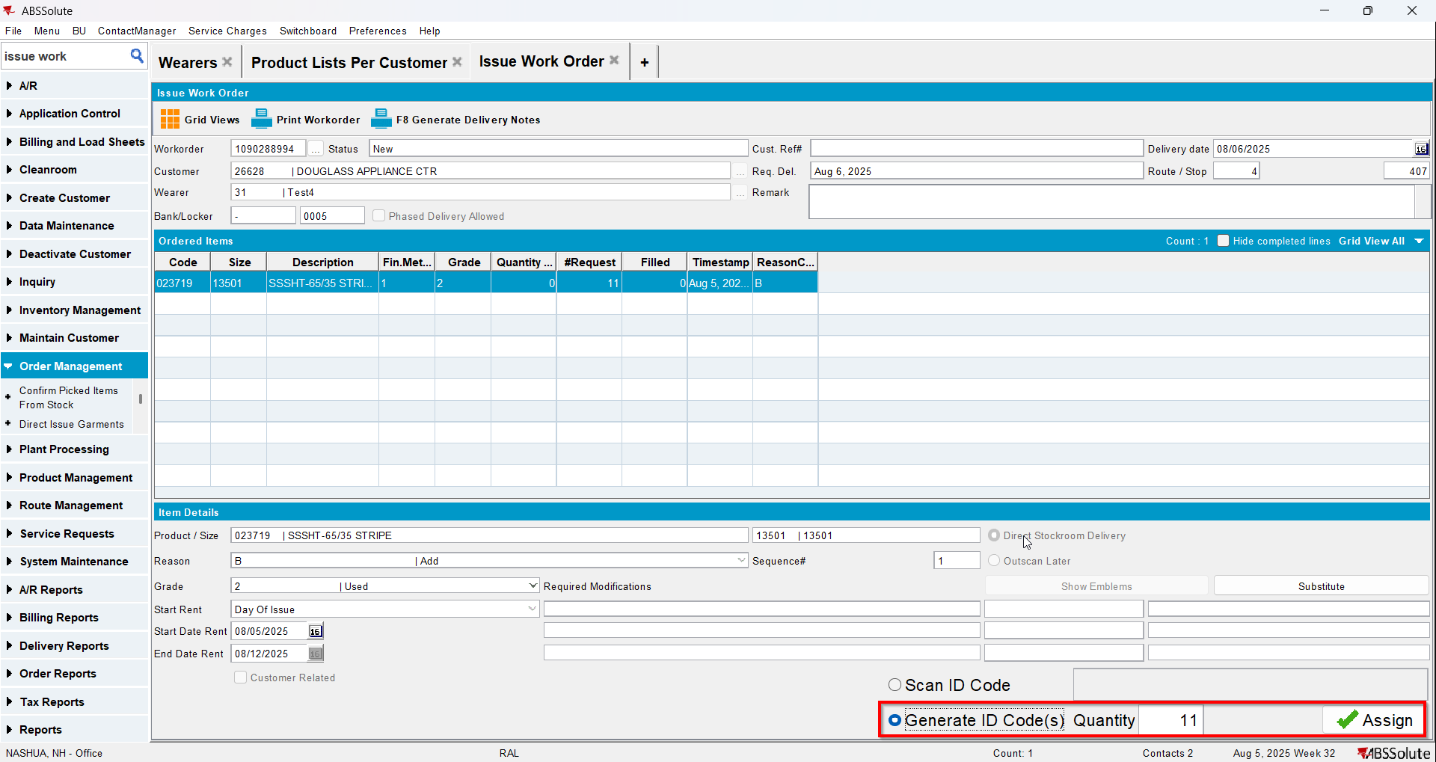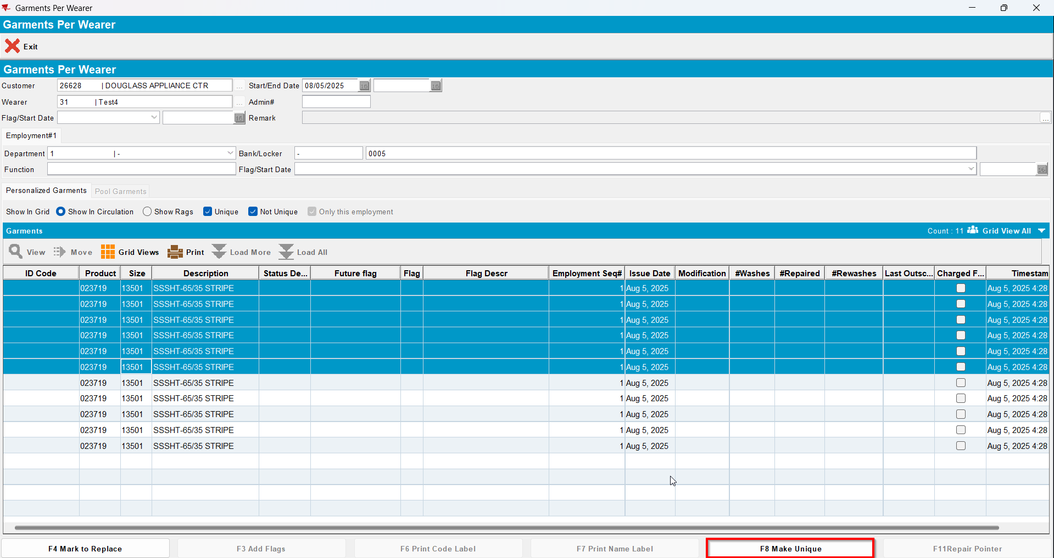
- Wearer dlg: Select your wearer and wearer inventory. Replace 4 garments with a new product.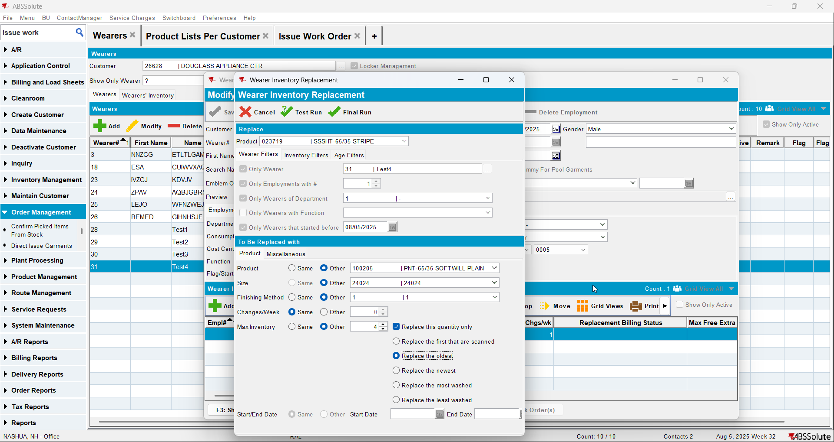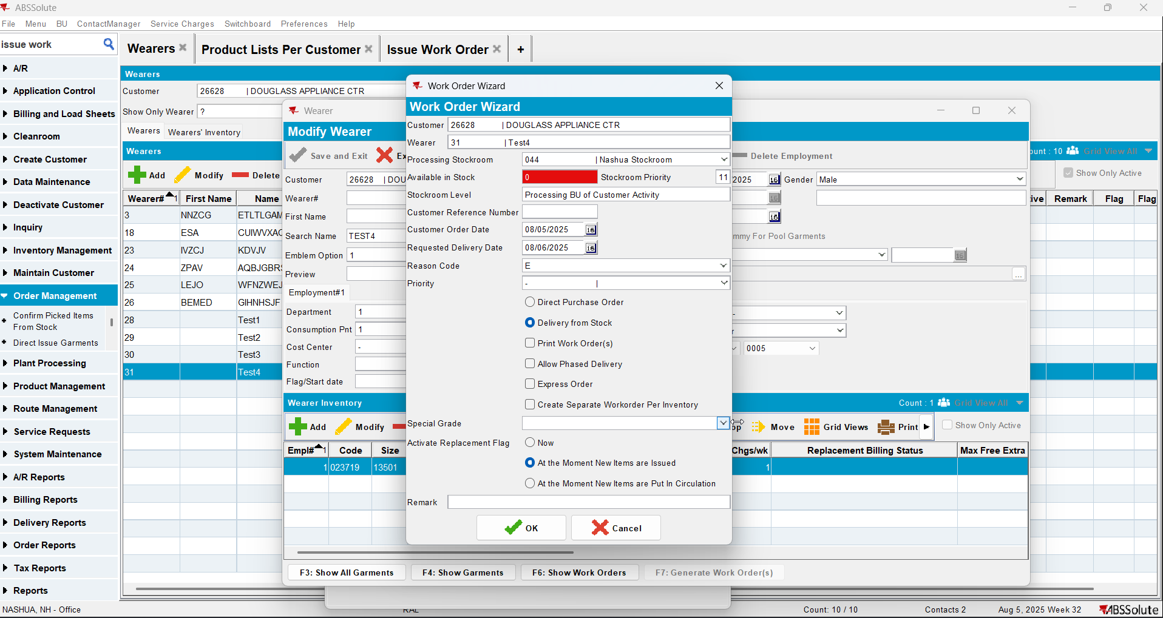
- Issue Work Order dlg: Issue the 4 items that you replaced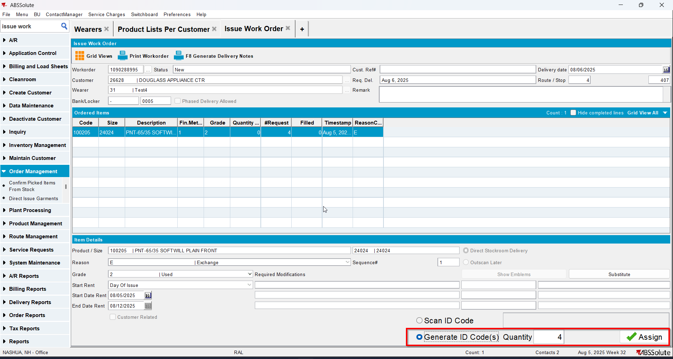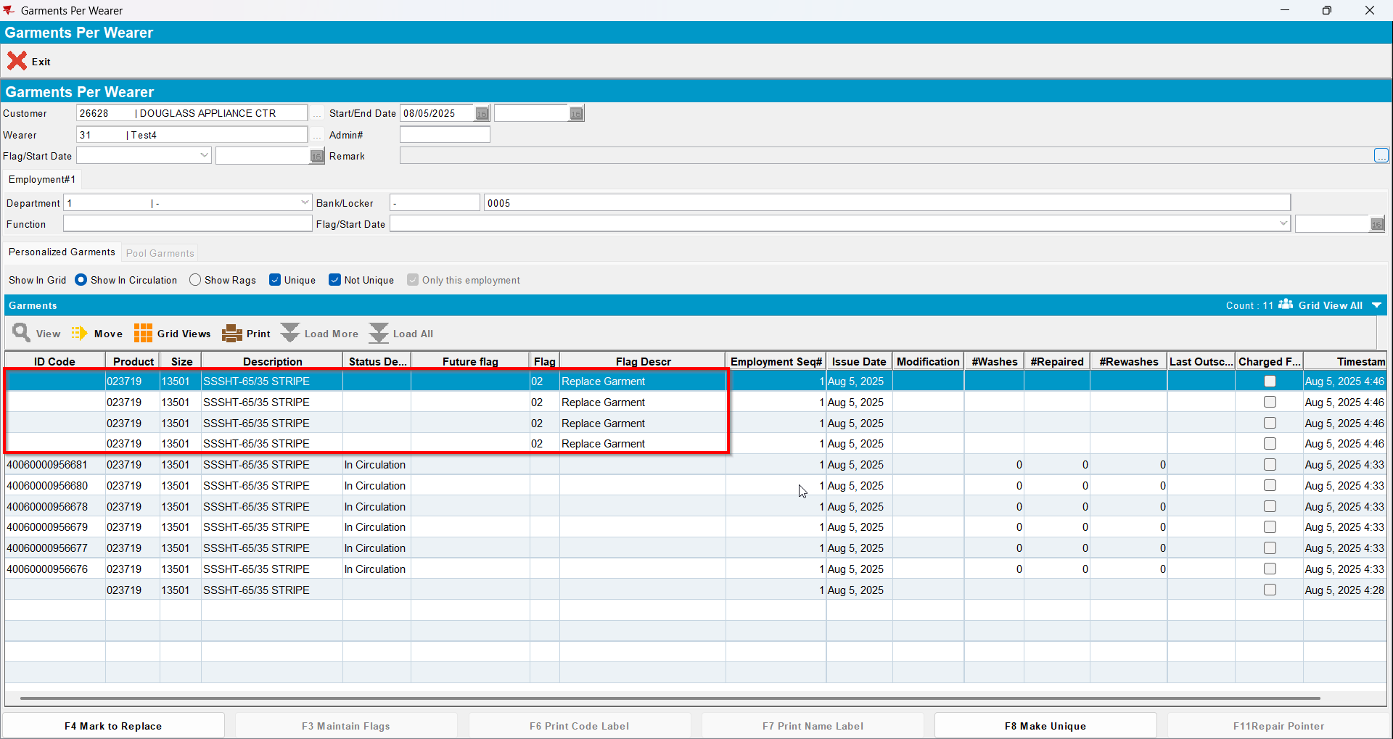
- Wearer dlg: Decrease the max inv for your wearer inventory to 2 (decrease by 5)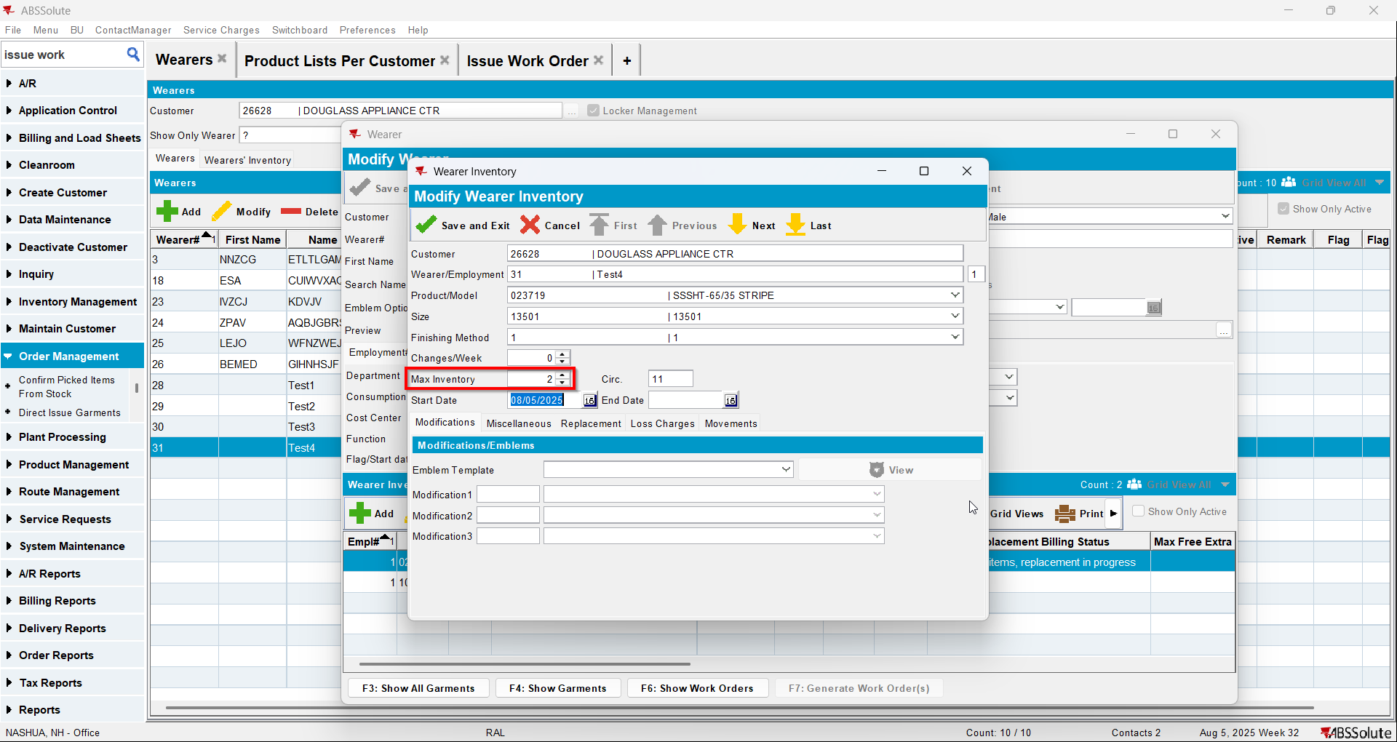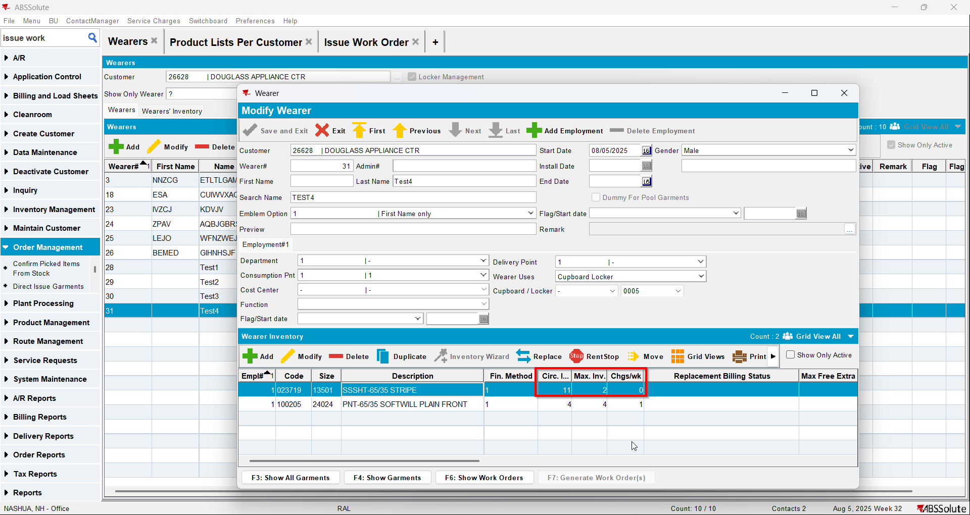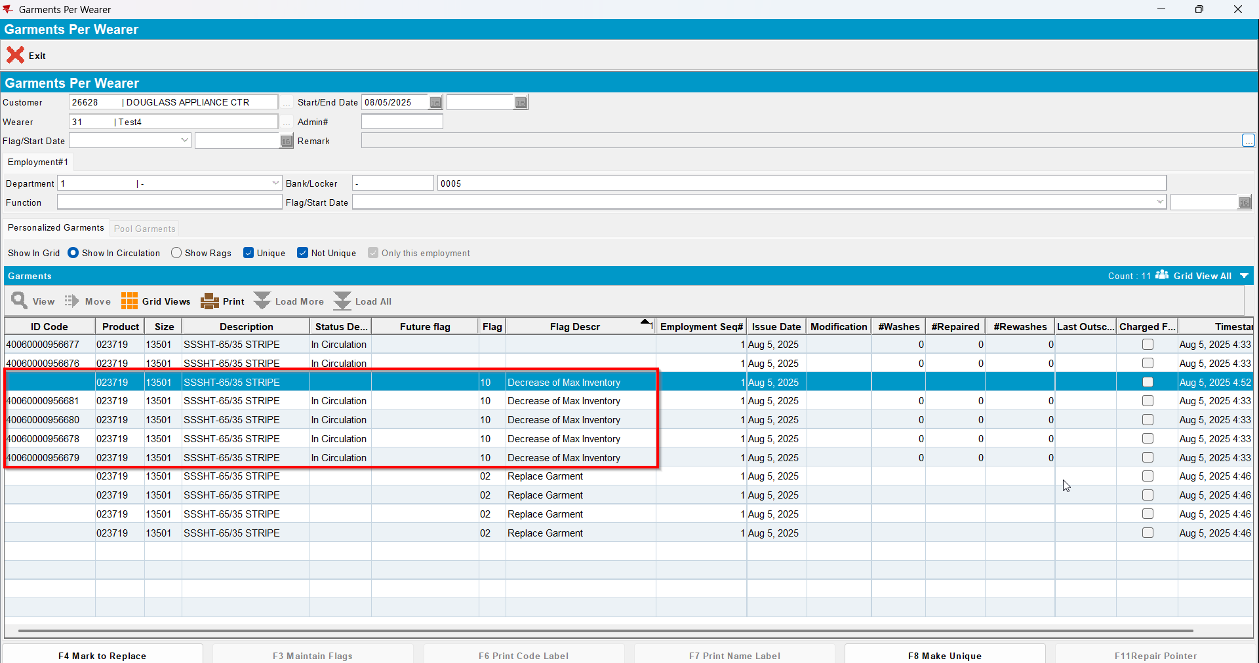

Test Case 8 – Wearer inventory= 11 Circ 11 max, mixed uniqueitems and nonuniqueitems. Replacement for the same product for 4 garments and decrease to 4 (decrease by 7). Replacement flag on issue and issue new replacement WO– Tested OK
Expected behavior: You should be allowed to decrease and 7 garments should be flagged for decrease
Hash: 463f282
- Wearer dlg: Select a wearer. Create a wearer inventory of max 11 and generate work order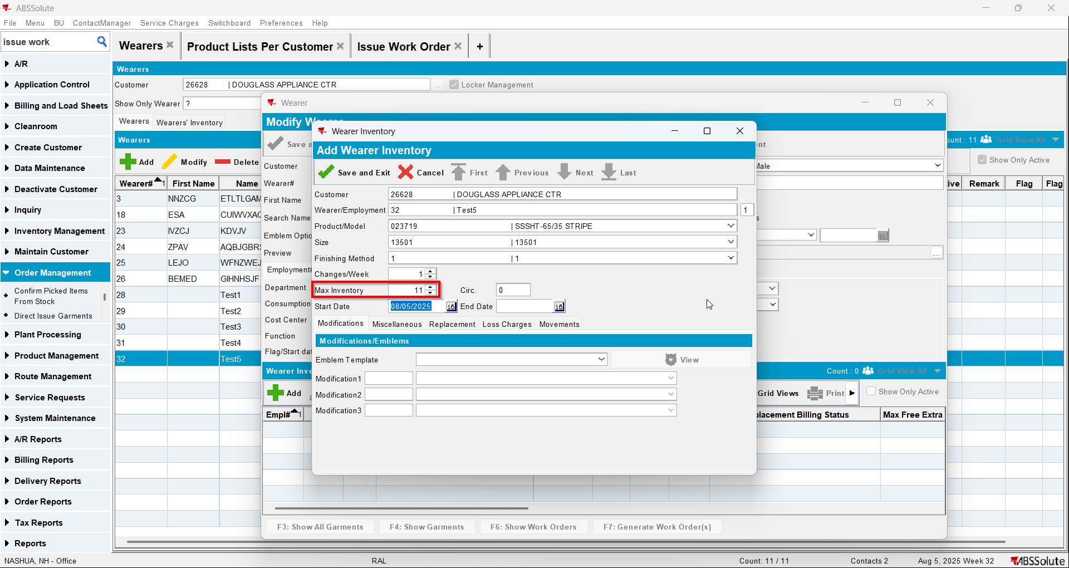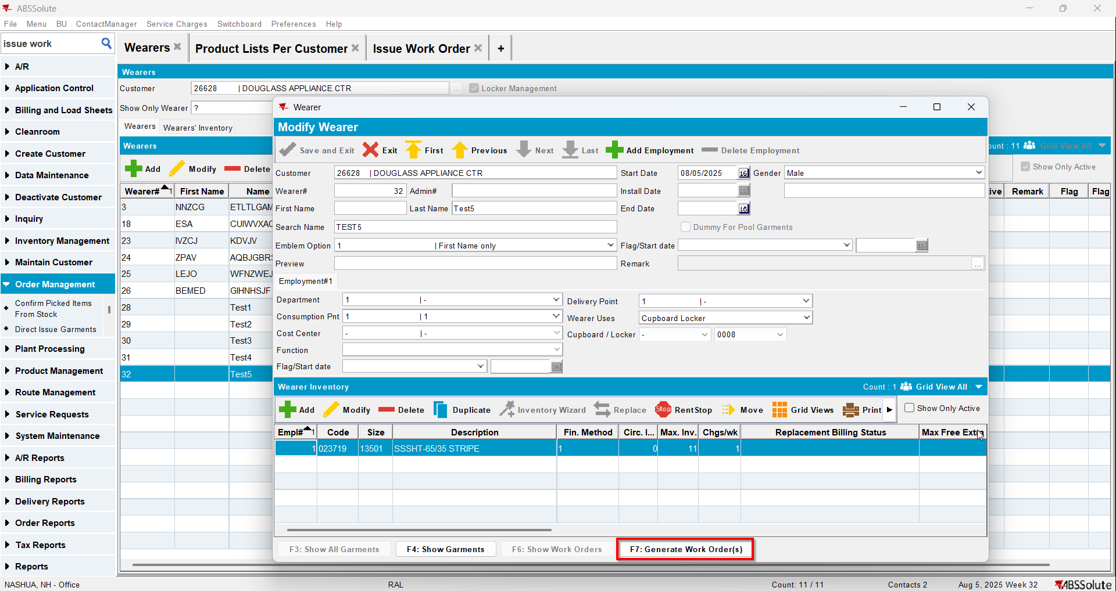
- Issue Work Order dlg: Issue all 11 items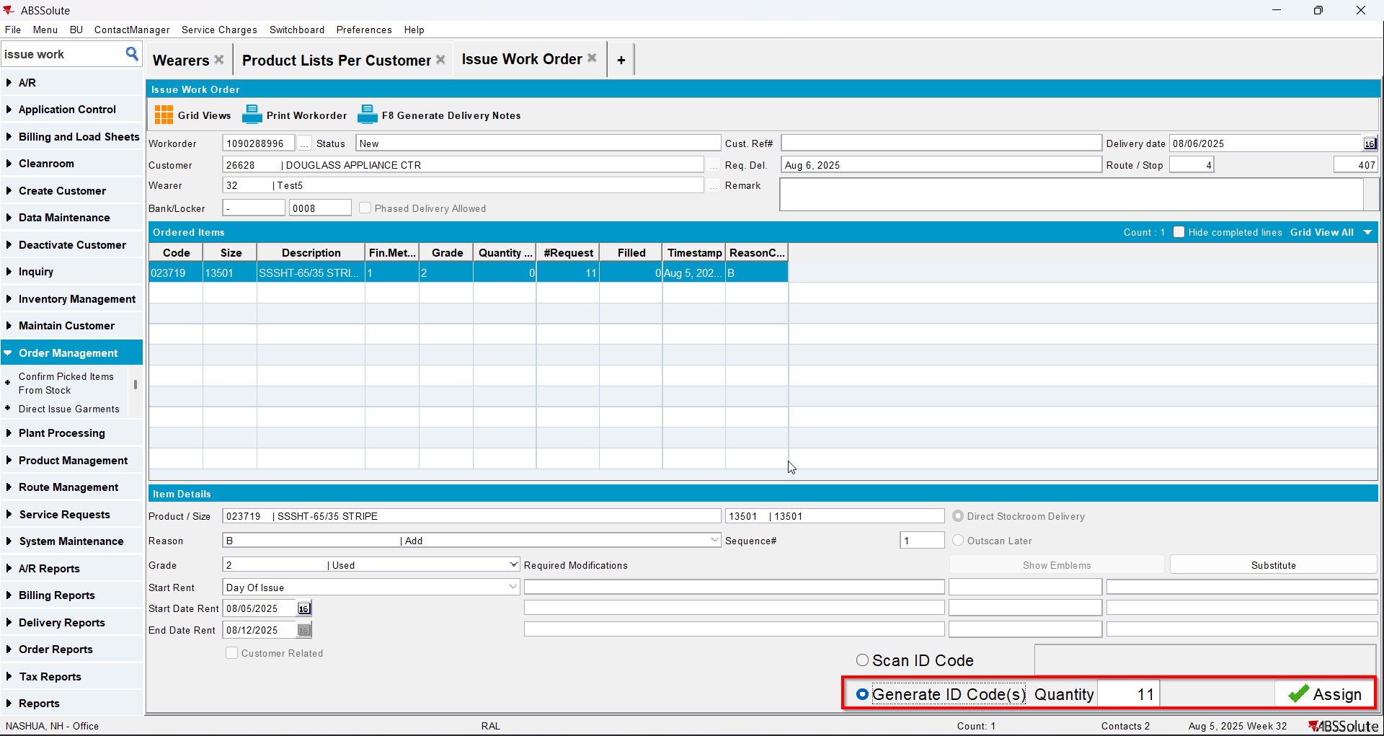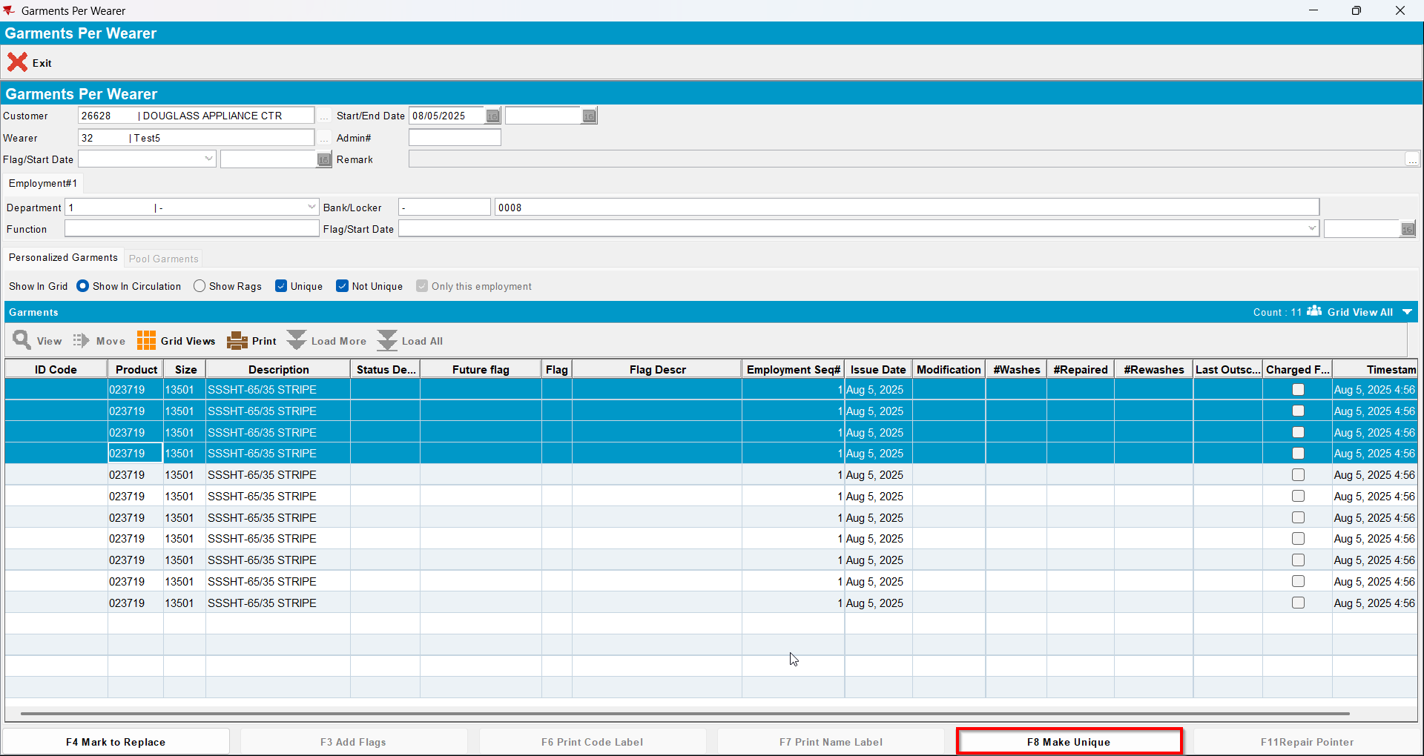
- Wearer dlg: Select your wearer and wearer inventory. Go to Show Garments and Mark to Replace 4 items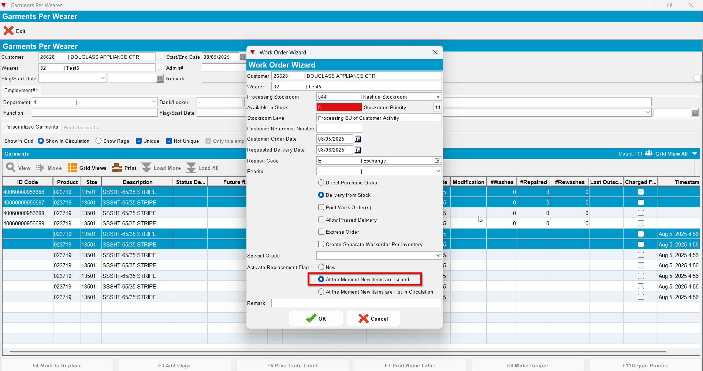
- Issue Work Order dlg: Issue the 4 items marked for replaceWearer dlg: Decrease the max inv for your wearer inventory to 4 (decrease by 7)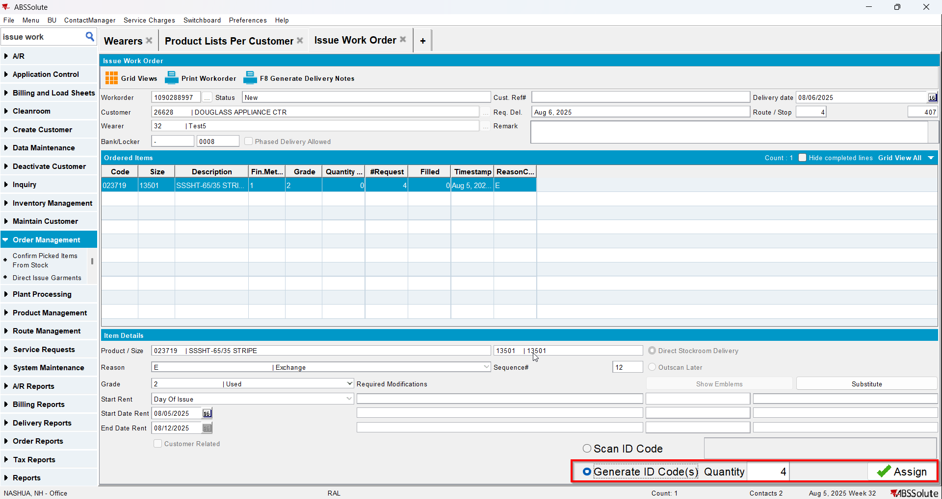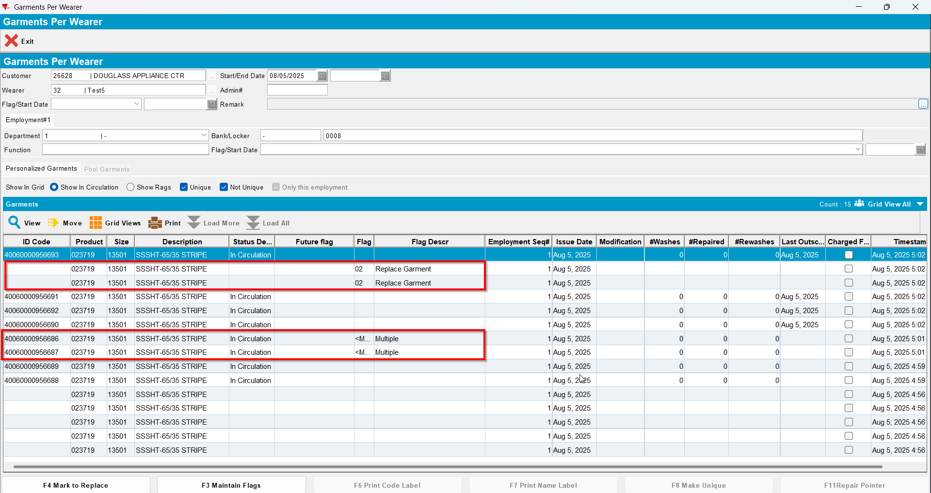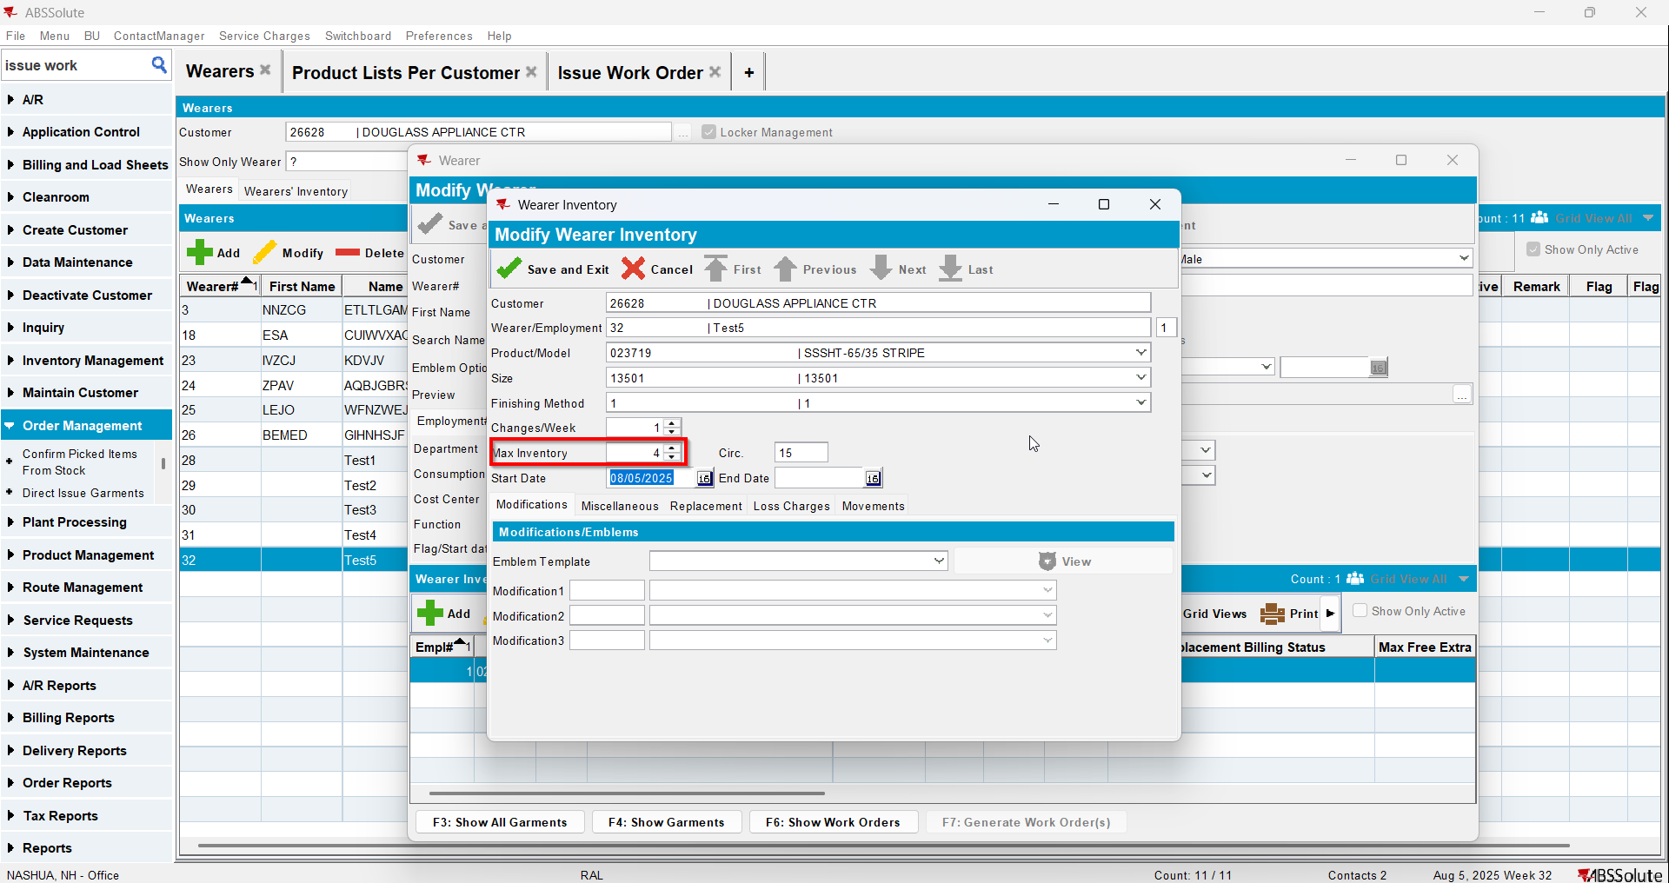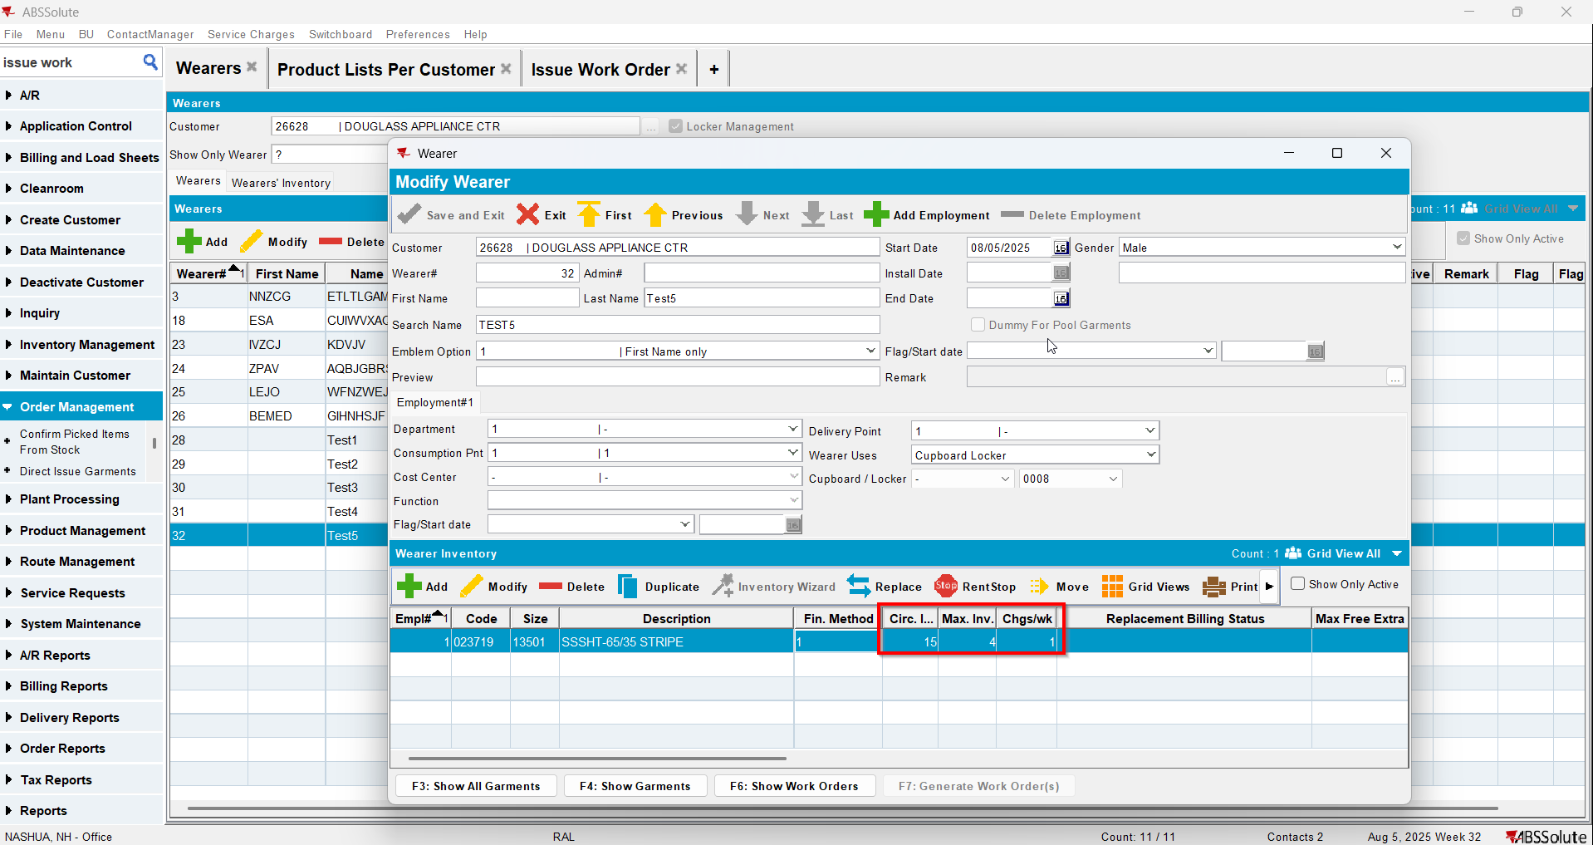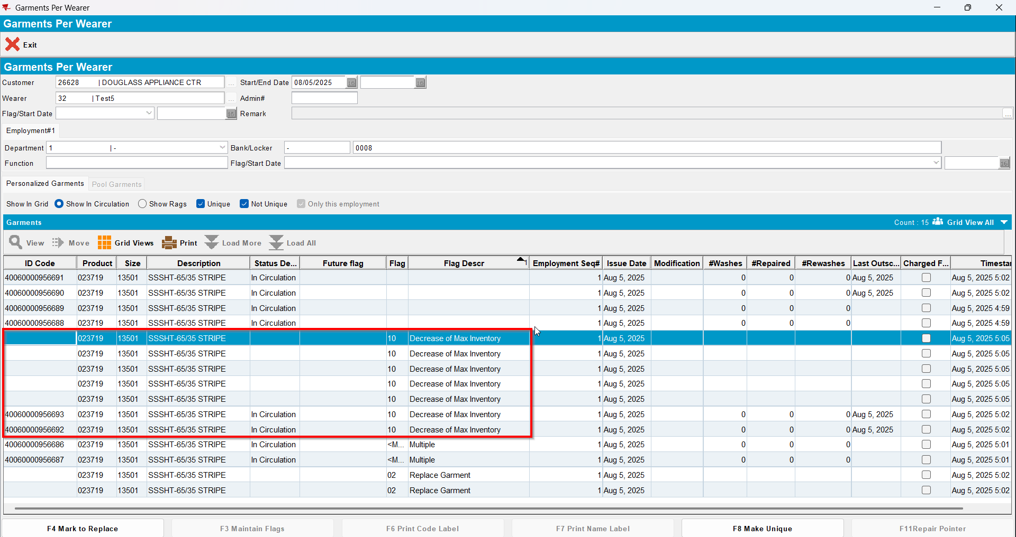

Test Case 9 – Wearer inventory= 11 Circ 11 max, mixed uniqueitems and nonuniqueitems. Replacement for new product for 4 garments and decrease to 4 (decrease by 3) and then decrease to 2 (decrease by 2). Replacement flag on issue and issue new replacement WO– Tested OK
Expected behavior: You should be allowed to decrease and 7 garments should be flagged for decrease
Hash: 463f282
- Wearer dlg: Select a wearer. Create a wearer inventory of max 11 and generate work order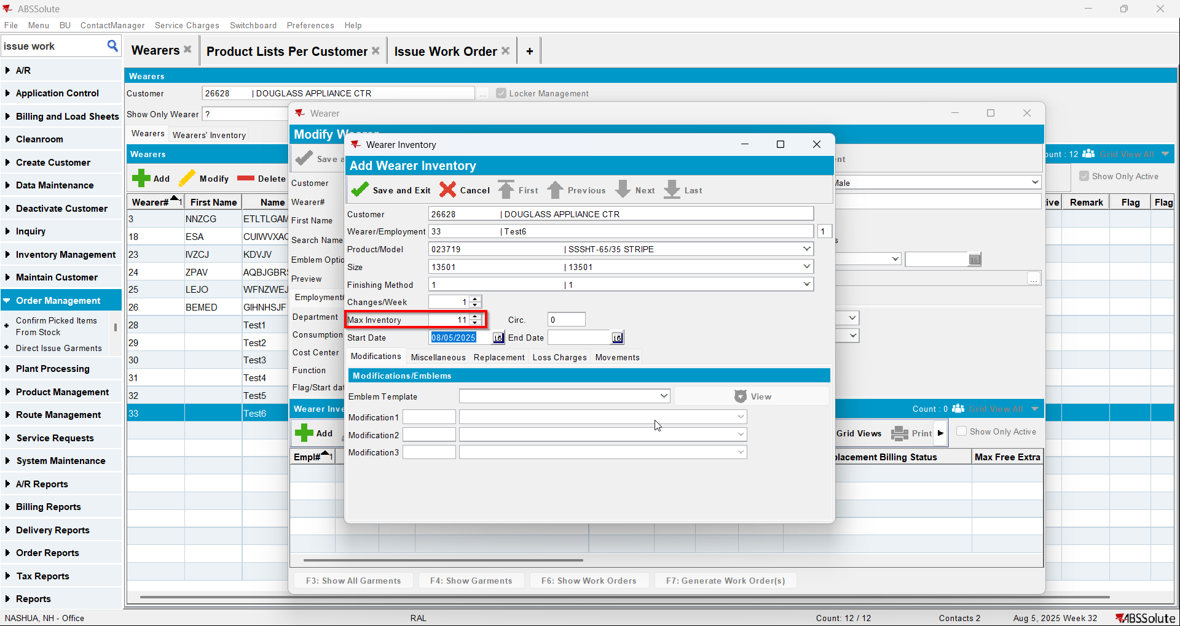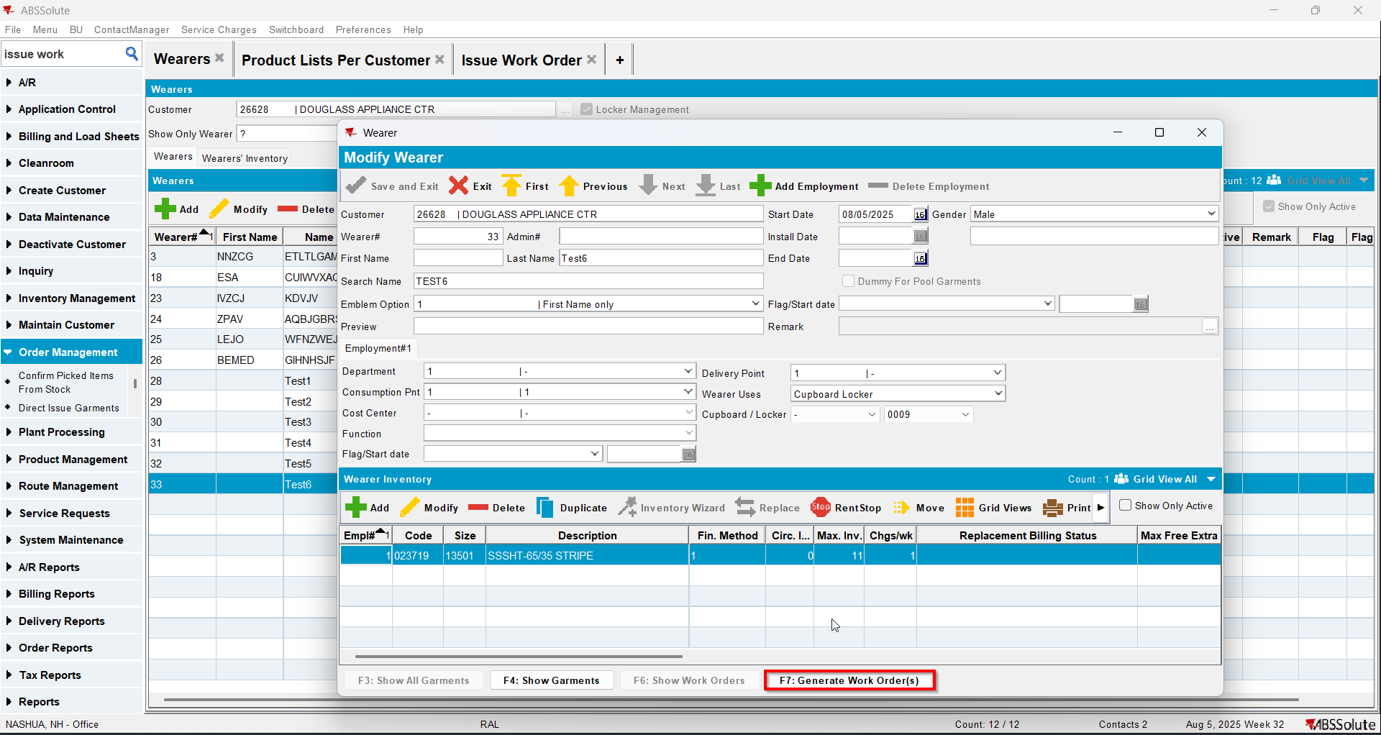
- Issue Work Order dlg: Issue all 11 items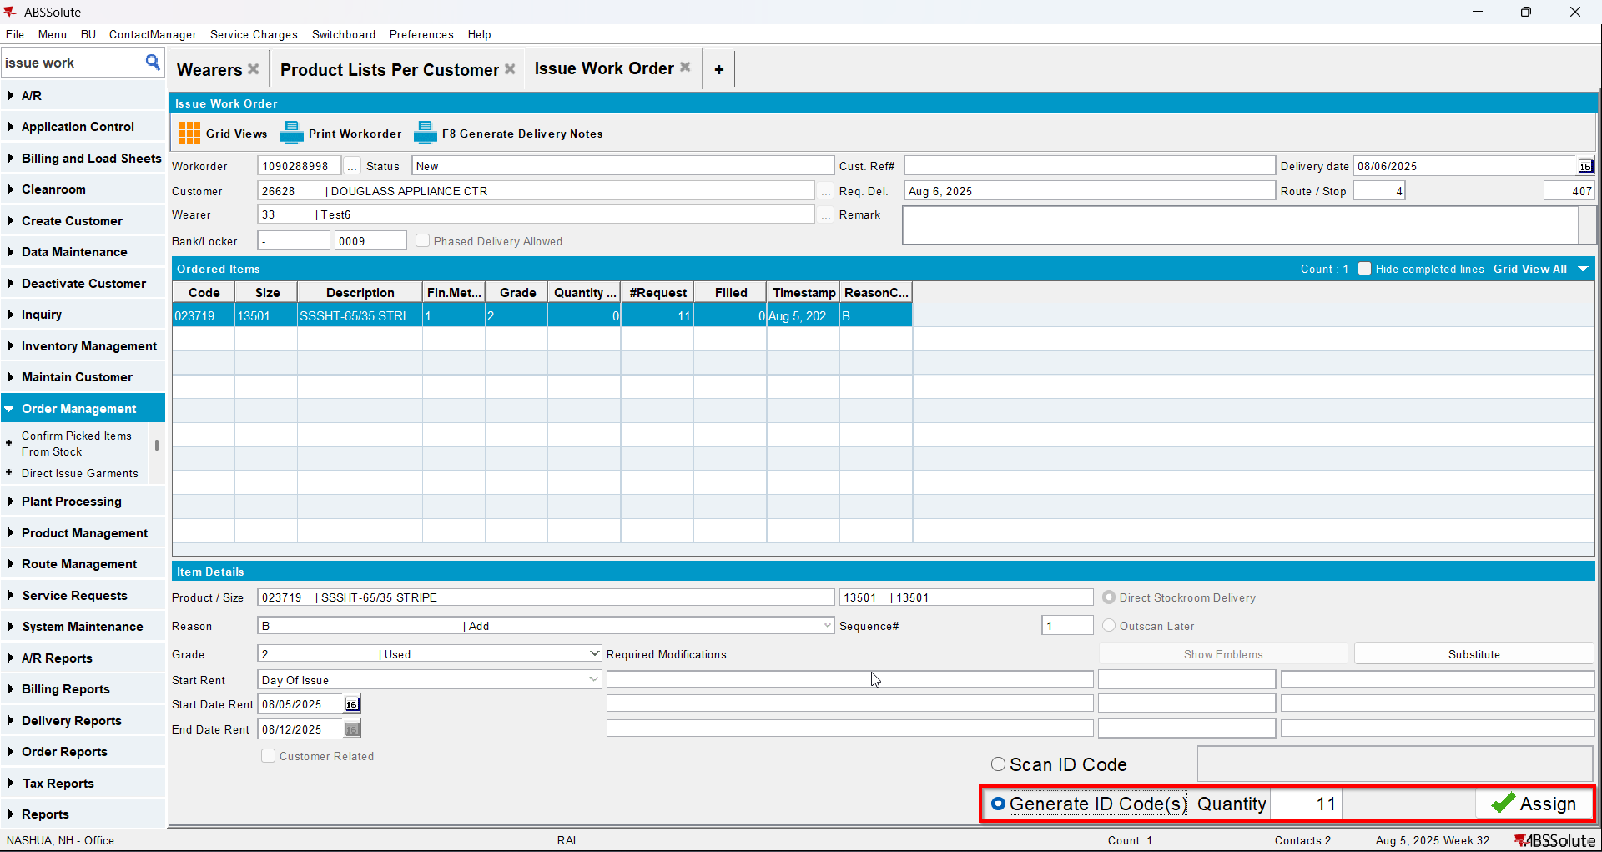
- Wearer dlg: Select your wearer and wearer inventory. Replace 4 garments with a new product.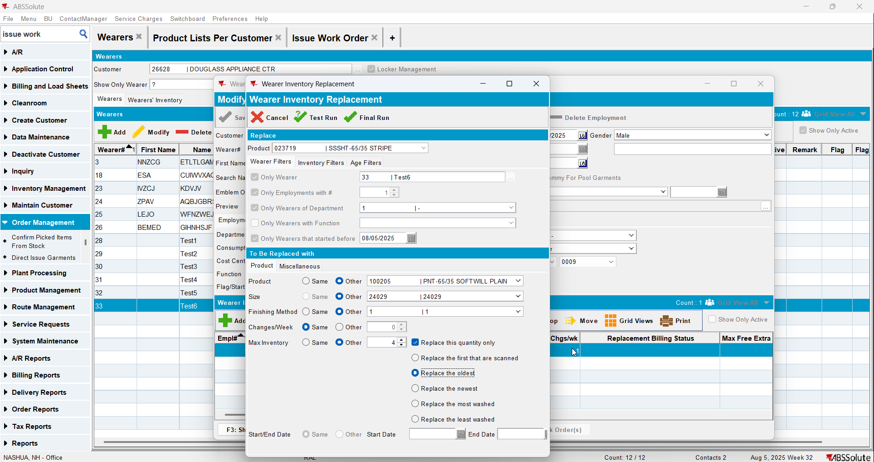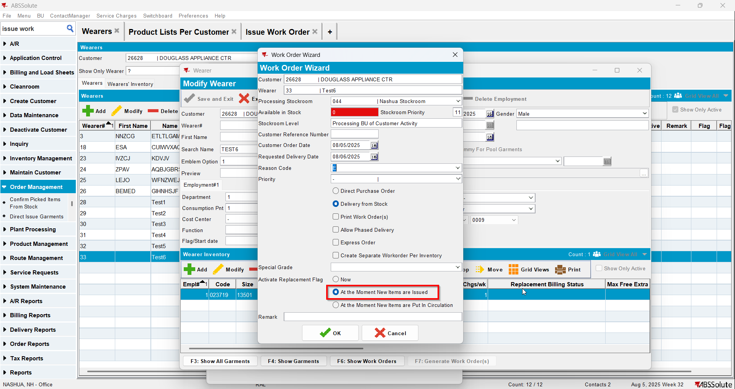
- Issue Work Order dlg: Issue the 4 items marked for replace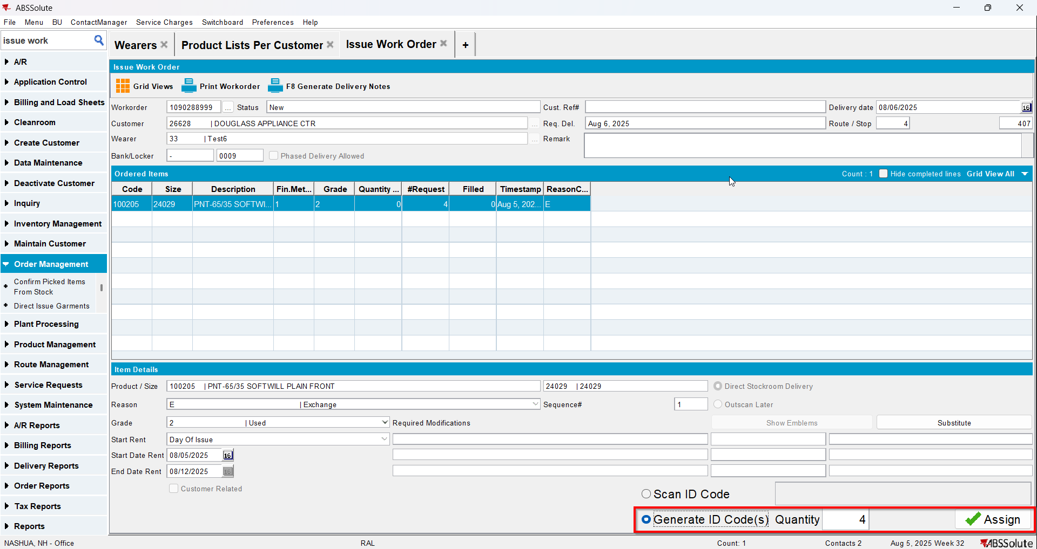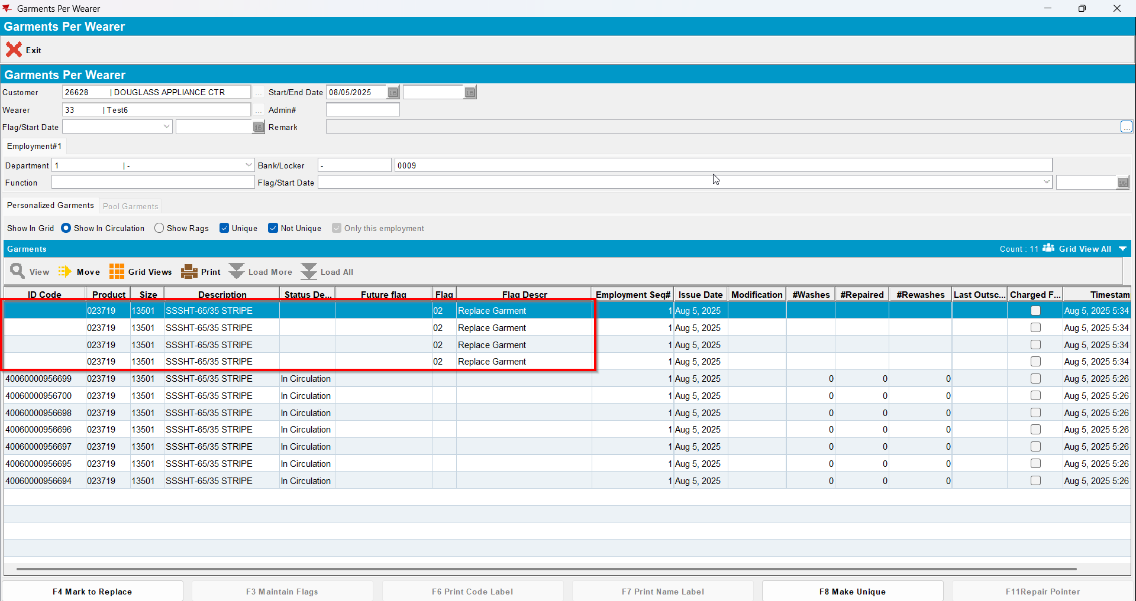
- Wearer dlg: Decrease the max inv for your wearer inventory to 4 (decrease by 3) and then decrease to 2(decrease by 2)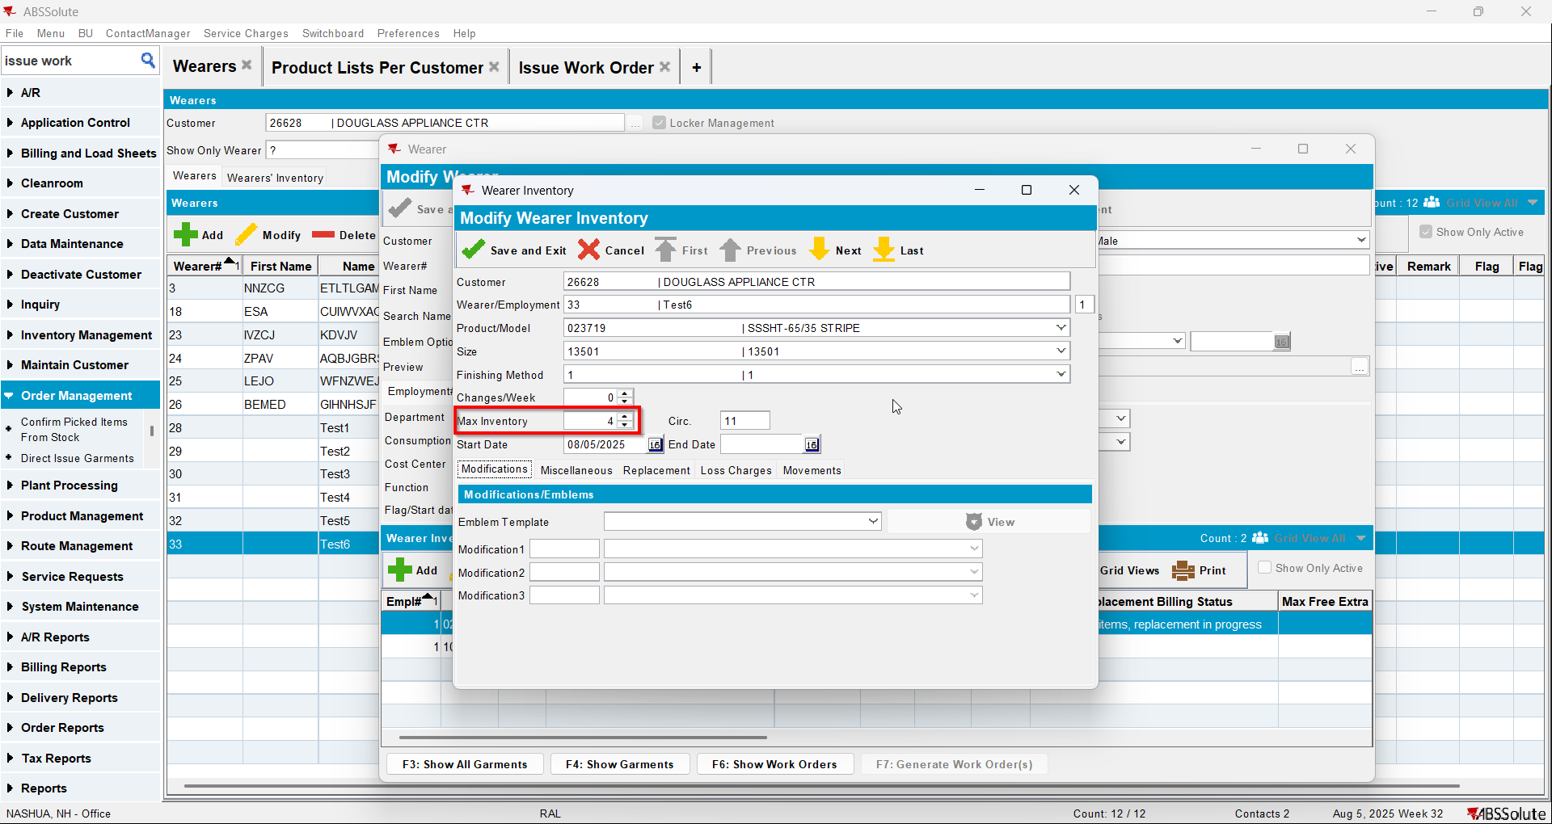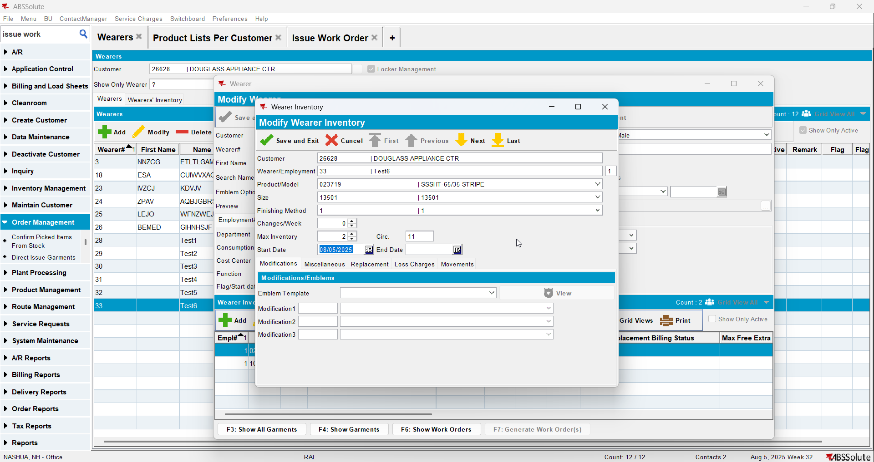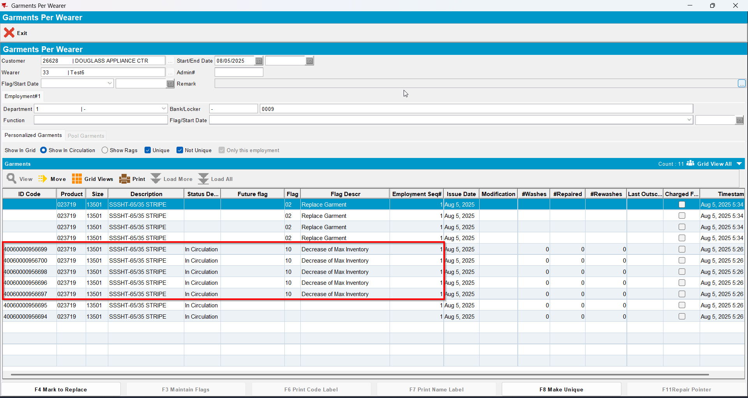

Test Case 10 – Wearer inventory= 11 Circ 11 max, mixed uniqueitems and nonuniqueitems. Replacement for new product for 4 garments but don’t issue the WO and decrease to 4 (decrease by 3)– Tested OK
Expected behavior: An error should appear when decreasing the inventory
Hash: 463f282
- Wearer dlg: Select a wearer. Create a wearer inventory of max 11 and generate work order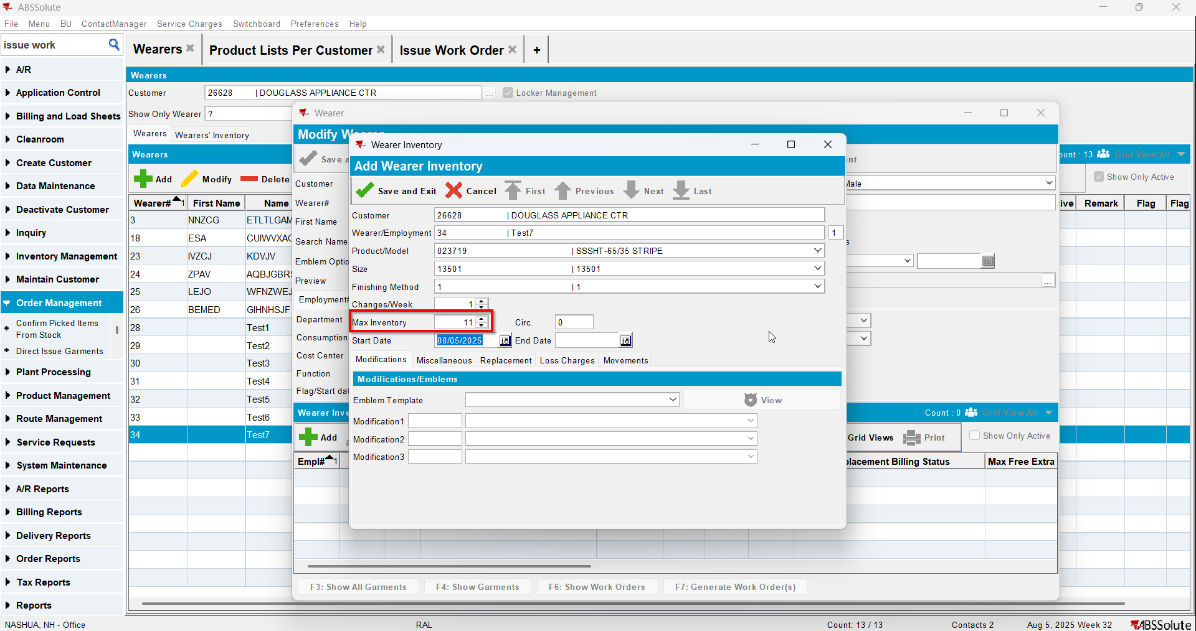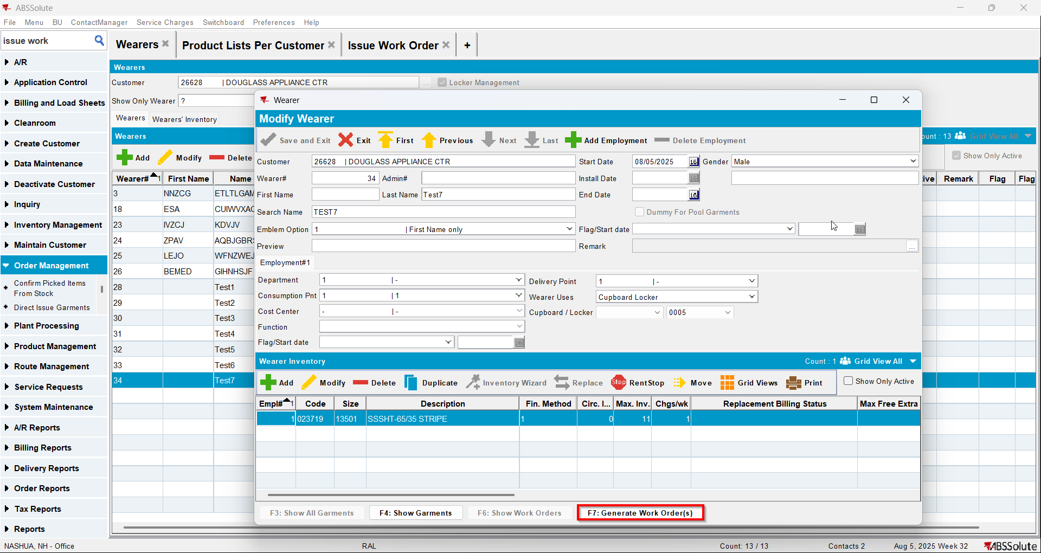
- Issue Work Order dlg: Issue all 11 items and generate delivery notes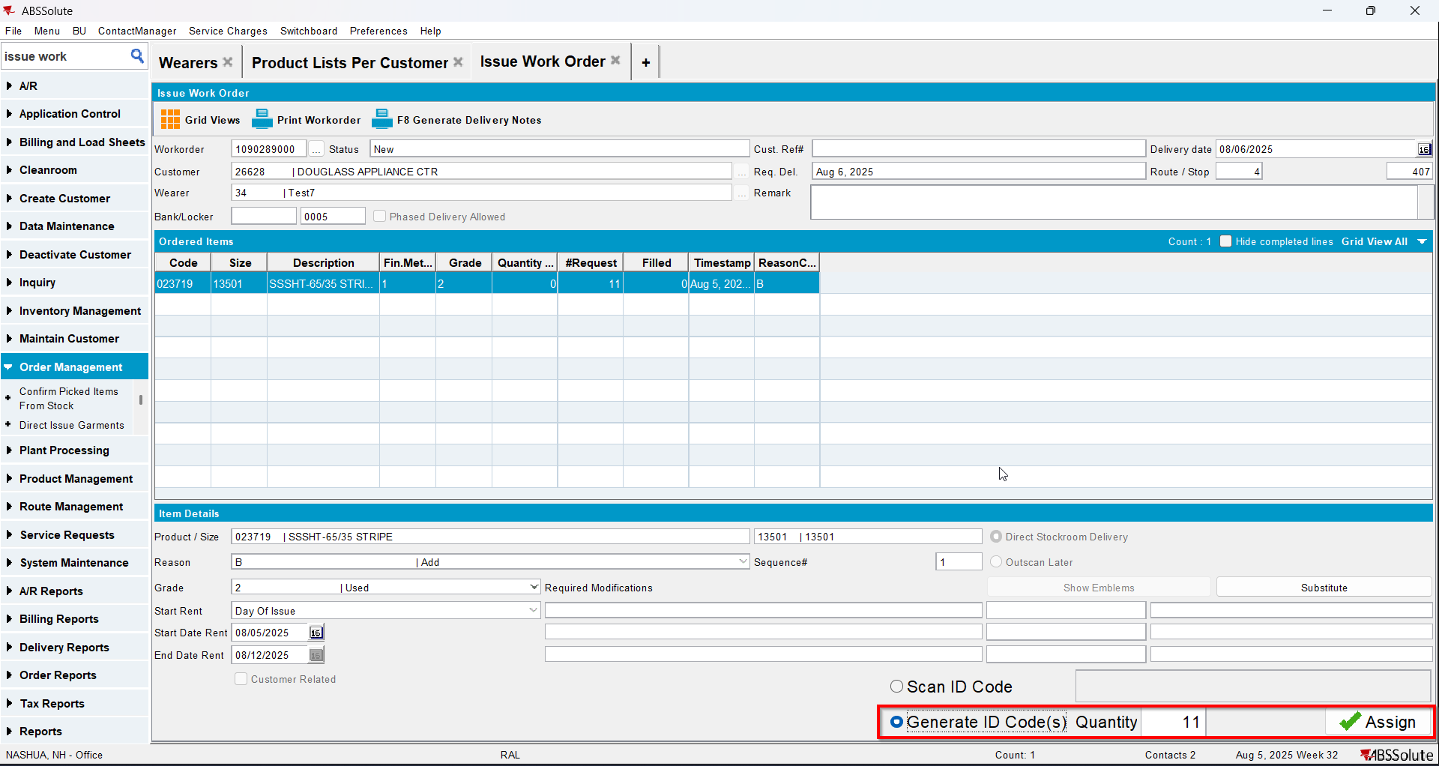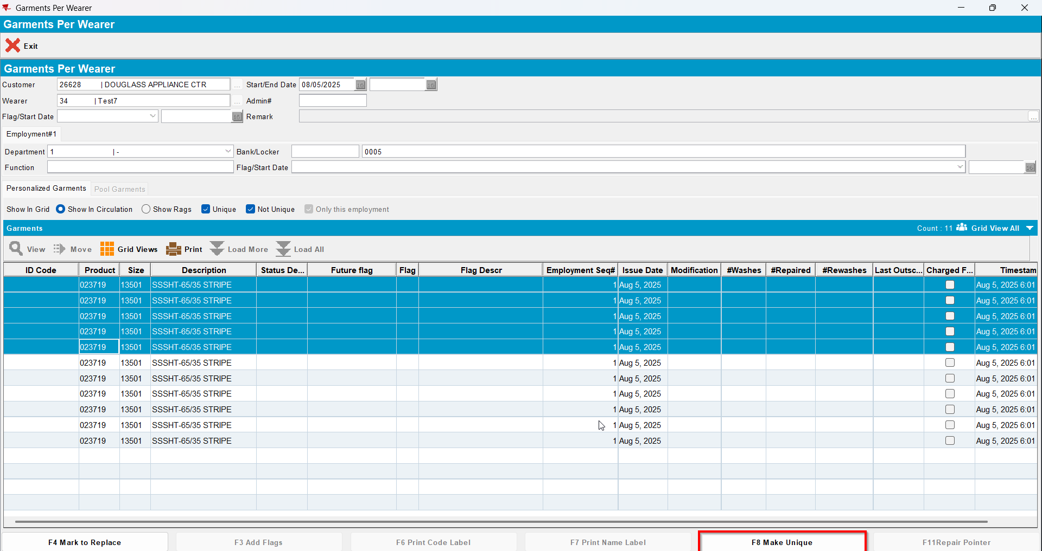
- Wearer dlg: Select your wearer and wearer inventory. Replace 4 garments with a new product and don’t issue them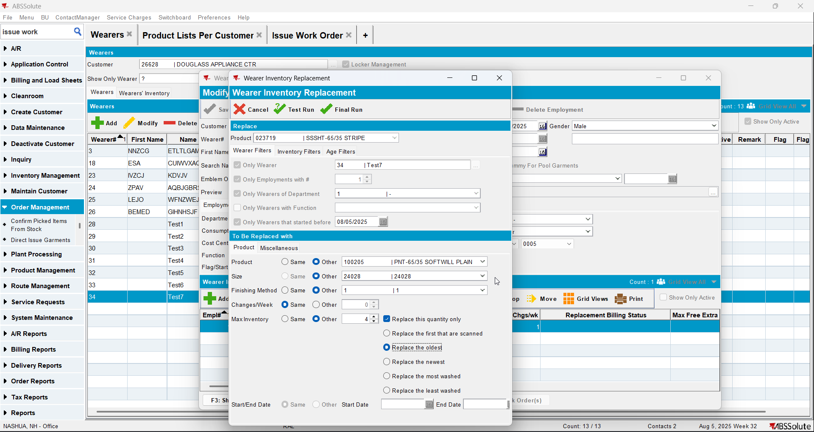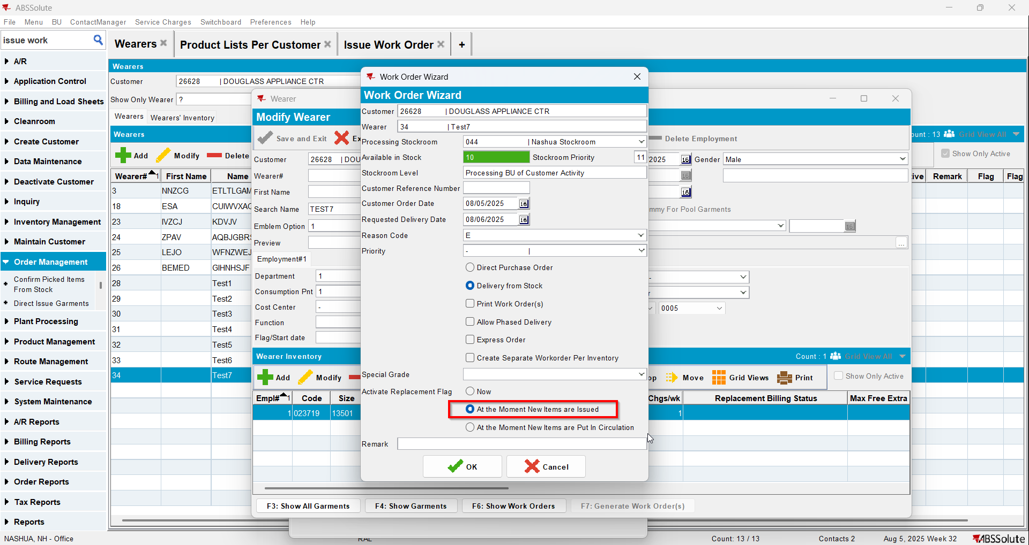
- Wearer dlg: Decrease the max inv for your wearer inventory to 4 (decrease by 3) and then decrease to 2(decrease by 2)