ABSN-8853 View Process Log - loading improvement
Environment | Prerequisites
Version:9.07.00  DBServerName=abs-SRV20.internal.abslbs.com  DBSID=CUST24  DBUser=UNFDEV  Environment=Test | - Module:  - System setting

Contents
Reproducing before fix 1
Steps to reproduce 1
Current Behavior 3
Expected behavior 3
Retest after fix 3
Test Case 1 – View Log Process dlg Dialog dropdown – Tested OK 3

Reproducing before fix

Steps to reproduce
- Open View Process Log dlg
- Change Show From Date to a date in the past(a few months)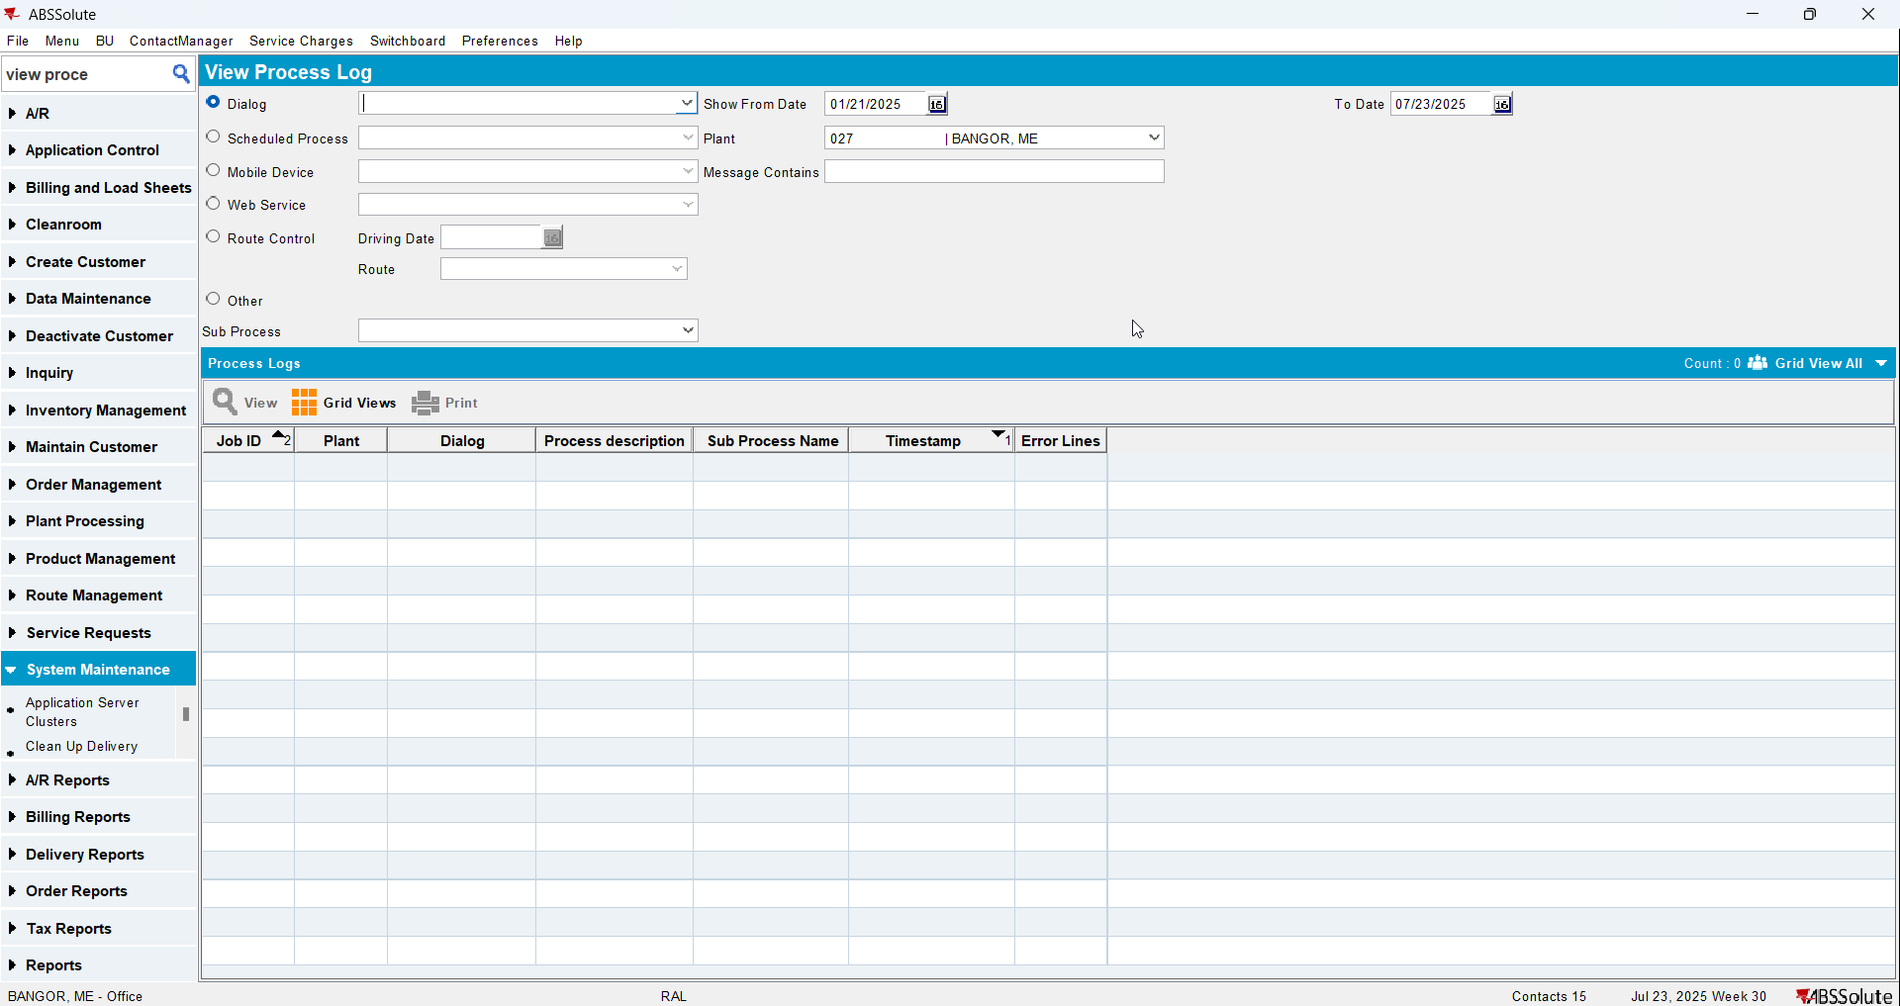
- Check Executed Transactions for the select that populates the Dialog dropdown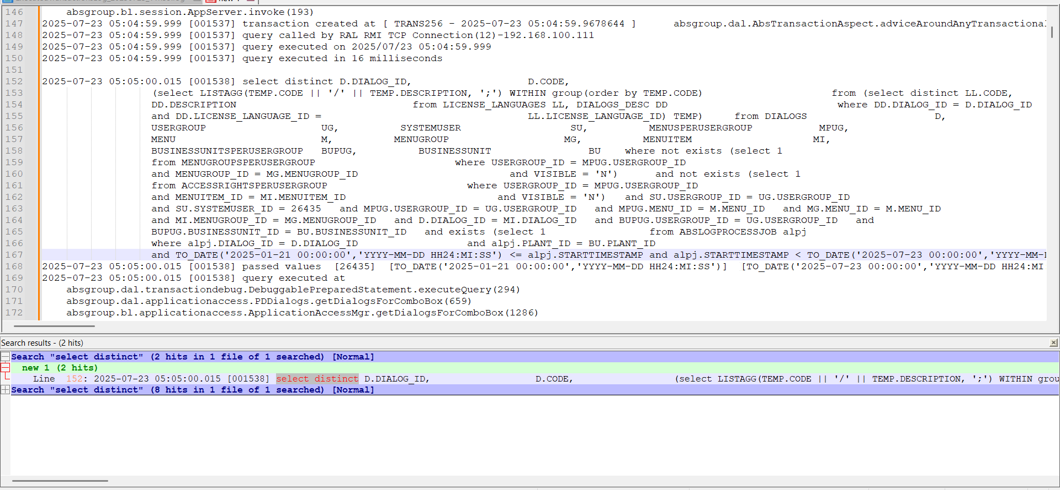
This is the select found:
select distinct D.DIALOG_ID,
D.CODE,
(select LISTAGG(TEMP.CODE || '/' || TEMP.DESCRIPTION, ';') WITHIN group(order by TEMP.CODE)
from (select distinct LL.CODE, DD.DESCRIPTION
from LICENSE_LANGUAGES LL, DIALOGS_DESC DD
where DD.DIALOG_ID = D.DIALOG_ID
and DD.LICENSE_LANGUAGE_ID =
LL.LICENSE_LANGUAGE_ID) TEMP)
from DIALOGS D,
USERGROUP UG,
SYSTEMUSER SU,
MENUSPERUSERGROUP MPUG,
MENU M,
MENUGROUP MG,
MENUITEM MI,
BUSINESSUNITSPERUSERGROUP BUPUG,
BUSINESSUNIT BU
where not exists (select 1
from MENUGROUPSPERUSERGROUP
where USERGROUP_ID = MPUG.USERGROUP_ID
and MENUGROUP_ID = MG.MENUGROUP_ID
and VISIBLE = 'N')
and not exists (select 1
from ACCESSRIGHTSPERUSERGROUP
where USERGROUP_ID = MPUG.USERGROUP_ID
and MENUITEM_ID = MI.MENUITEM_ID
and VISIBLE = 'N')
and SU.USERGROUP_ID = UG.USERGROUP_ID
and SU.SYSTEMUSER_ID = 26435
and MPUG.USERGROUP_ID = UG.USERGROUP_ID
and MPUG.MENU_ID = M.MENU_ID
and MG.MENU_ID = M.MENU_ID
and MI.MENUGROUP_ID = MG.MENUGROUP_ID
and D.DIALOG_ID = MI.DIALOG_ID
and BUPUG.USERGROUP_ID = UG.USERGROUP_ID
and BUPUG.BUSINESSUNIT_ID = BU.BUSINESSUNIT_ID
and exists
(select 1
from ABSLOGPROCESSJOB alpj
where alpj.DIALOG_ID = D.DIALOG_ID
and alpj.PLANT_ID = BU.PLANT_ID
and TO_DATE('2025-01-21 00:00:00', 'YYYY-MM-DD HH24:MI:SS') <=
alpj.STARTTIMESTAMP
and alpj.STARTTIMESTAMP <
TO_DATE('2025-07-23 00:00:00', 'YYYY-MM-DD HH24:MI:SS'))
group by D.DIALOG_ID, D.CODE
As you can see it is with DISTINCT and does not contain the plant that you selected.
REPRODUCED OK.

Current Behavior
Populates the Dialog dropdown with the dialogs from all plants

Expected behavior
Populates the Dialog dropdown with the dialogs from the selected plant.

Retest after fix

Test Case 1 – View Log Process dlg Dialog dropdown – Tested OK
Expected behavior: Populates the Dialog dropdown with the dialogs from the selected plant.
Hash: 9c5902e
- Open View Process Log dlg
- Change Show From Date to a date in the past(a few months)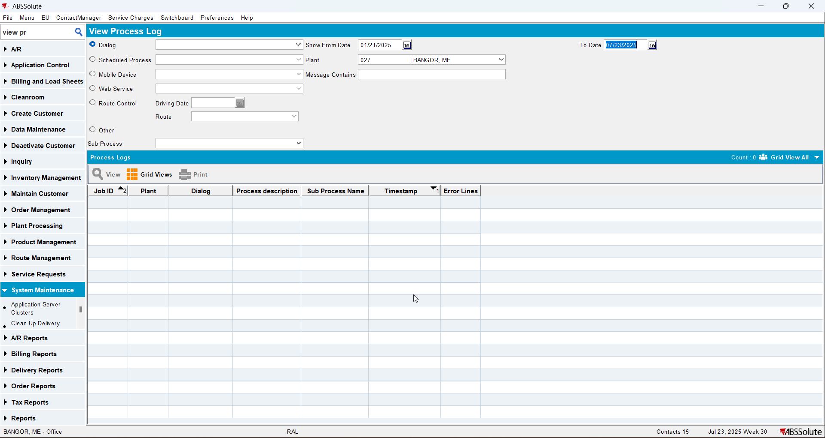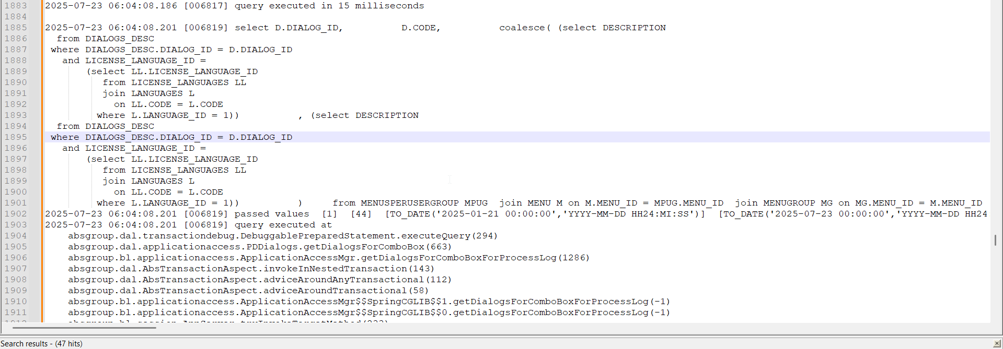
- Select other dropdown and then come back to the Dialog dropdown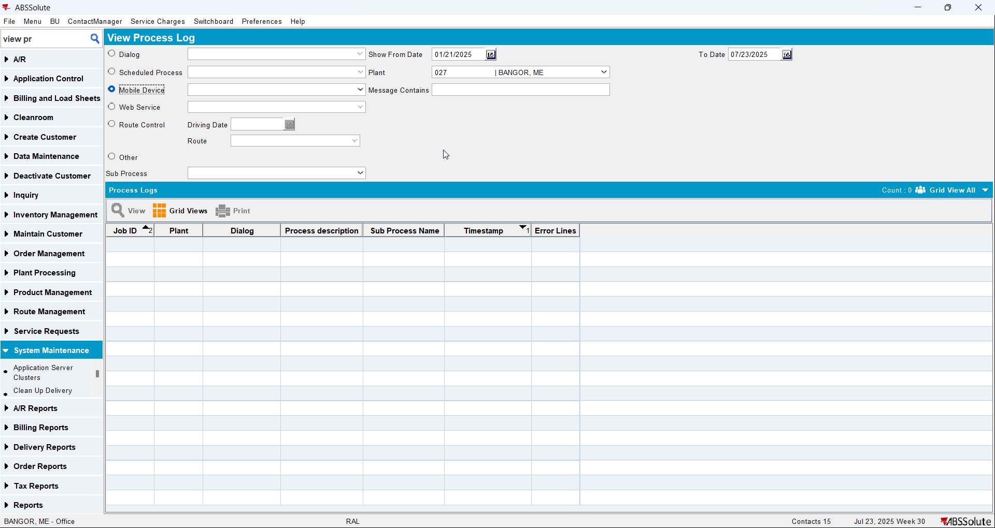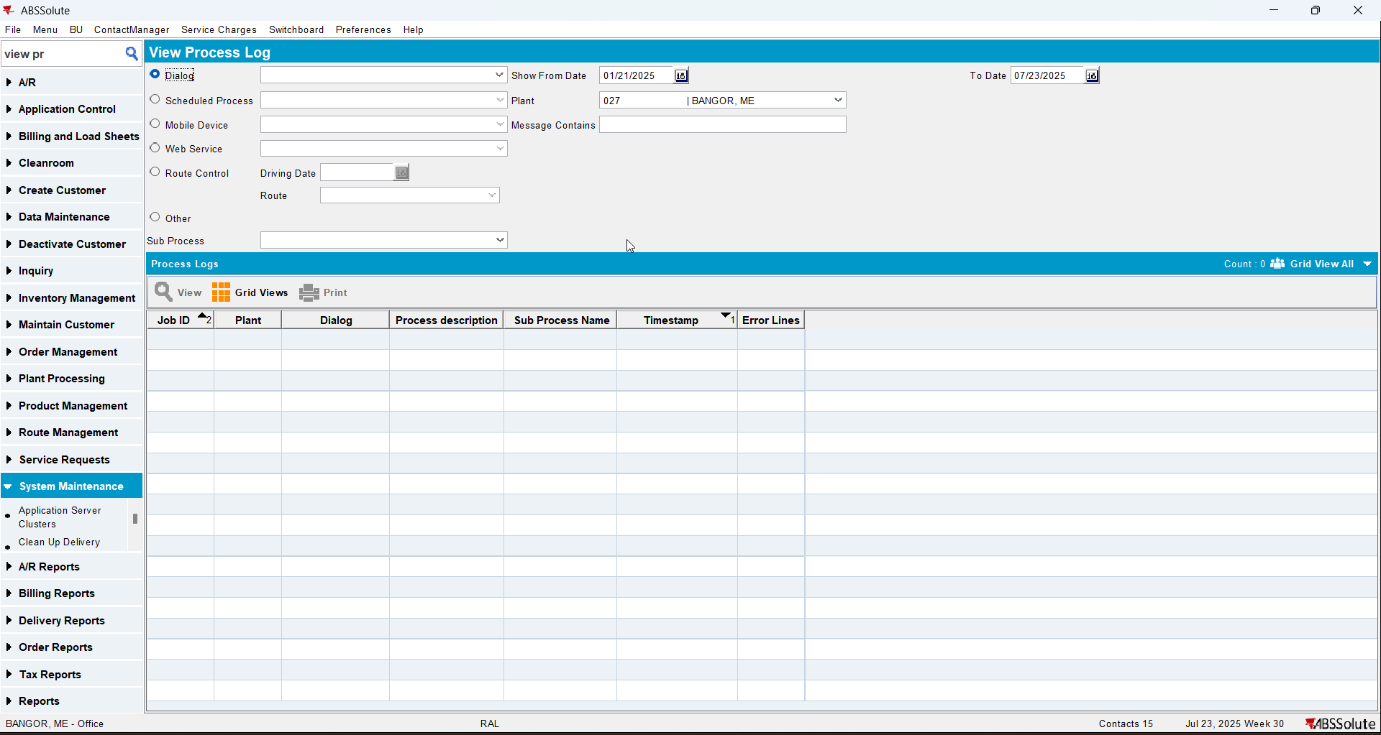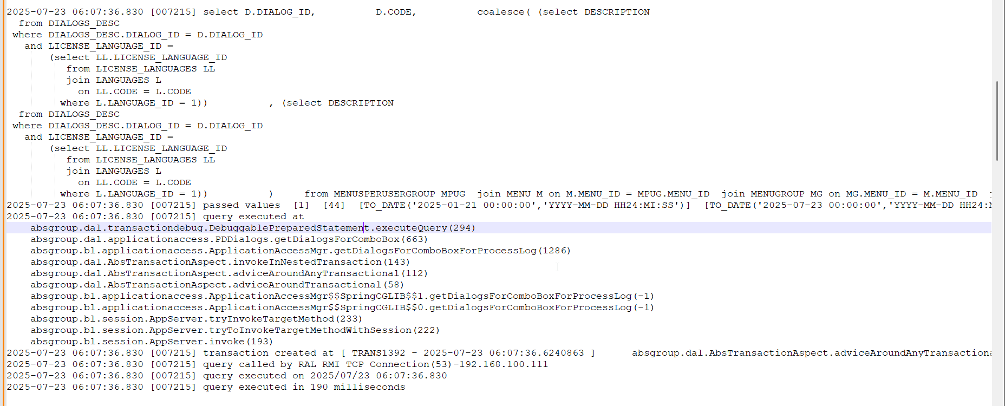
- Change the plant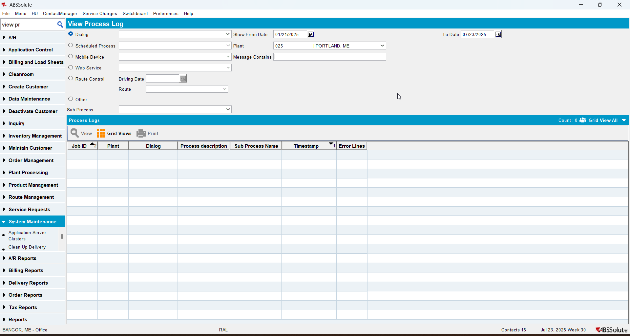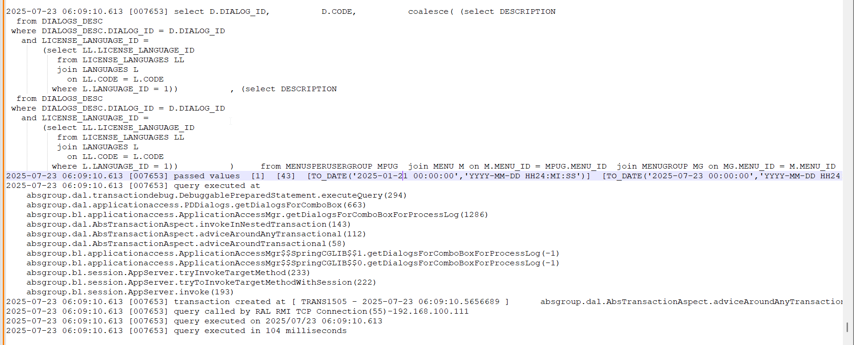

This is the select found:
select D.DIALOG_ID,
D.CODE,
coalesce((select DESCRIPTION
from DIALOGS_DESC
where DIALOGS_DESC.DIALOG_ID = D.DIALOG_ID
and LICENSE_LANGUAGE_ID =
(select LL.LICENSE_LANGUAGE_ID
from LICENSE_LANGUAGES LL
join LANGUAGES L
on LL.CODE = L.CODE
where L.LANGUAGE_ID = 1)),
(select DESCRIPTION
from DIALOGS_DESC
where DIALOGS_DESC.DIALOG_ID = D.DIALOG_ID
and LICENSE_LANGUAGE_ID =
(select LL.LICENSE_LANGUAGE_ID
from LICENSE_LANGUAGES LL
join LANGUAGES L
on LL.CODE = L.CODE
where L.LANGUAGE_ID = 1)))
from MENUSPERUSERGROUP MPUG
join MENU M
on M.MENU_ID = MPUG.MENU_ID
join MENUGROUP MG
on MG.MENU_ID = M.MENU_ID
join MENUITEM MI
on MI.MENUGROUP_ID = MG.MENUGROUP_ID
join DIALOGS D
on D.DIALOG_ID = MI.DIALOG_ID
where not exists (select 1
from MENUGROUPSPERUSERGROUP
where USERGROUP_ID = MPUG.USERGROUP_ID
and MENUGROUP_ID = MG.MENUGROUP_ID
and VISIBLE = 'N')
and not exists
(select 1
from ACCESSRIGHTSPERUSERGROUP
where USERGROUP_ID = MPUG.USERGROUP_ID
and MENUITEM_ID = MI.MENUITEM_ID
and VISIBLE = 'N')
and MPUG.USERGROUP_ID = 1
and MI.DIALOG_ID in
(select ALPJ.DIALOG_ID
from ABSLOGPROCESSJOB ALPJ
where ALPJ.PLANT_ID = 48
and TO_DATE('2025-01-14 00:00:00', 'YYYY-MM-DD HH24:MI:SS') <=
alpj.STARTTIMESTAMP
and alpj.STARTTIMESTAMP <
TO_DATE('2025-07-25 00:00:00', 'YYYY-MM-DD HH24:MI:SS'))
group by D.DIALOG_ID, D.CODE
As you can see it is not with DISTINCT and does contain the plant that you selected.

