ABSN-8327 Multiple contacts to be marked to receive email invoice (without using ABS Emailing process)
Environment | Prerequisites
Version:9.07.00  DBServerName=abs-SRV20.internal.abslbs.com  DBSID=CUST24  DBUser=UNFDEV  Environment=Test | - Module:  - System setting

Contents
Test cases 2
Customers dialog 2
Test Case 1 – MULTIPLEINVANDSTMCONTACTS=0 and customer is its own bill to – Tested OK 2
Test Case 2 – MULTIPLEINVANDSTMCONTACTS=0 and customer is not its own bill to– Tested OK 6
Test Case 3 – MULTIPLEINVANDSTMCONTACTS=1 and customer is its own bill to – Tested OK 11
Test Case 4 – MULTIPLEINVANDSTMCONTACTS=1 and customer is not its own bill to– Tested OK 17
Add customer 22
Test Case 1 – MULTIPLEINVANDSTMCONTACTS=0 – Tested OK 22
Test Case 2 – MULTIPLEINVANDSTMCONTACTS=1 – Tested OK 27
Customer Financial Details dialog 35
Test Case 1 – MULTIPLEINVANDSTMCONTACTS=0 and customer is its own bill to – Tested OK 35
Test Case 2 – MULTIPLEINVANDSTMCONTACTS=0 and customer is not its own bill to – Tested OK 38
Test Case 3 – Send E-Mail when MULTIPLEINVANDSTMCONTACTS=0 and customer is its own bill to – Tested OK 42
Test Case 4 – Send E-Mail when MULTIPLEINVANDSTMCONTACTS=0 and customer is not its own bill to – Tested OK 45
Test Case 5 – MULTIPLEINVANDSTMCONTACTS=1 and customer is its own bill to – Tested OK 53
Test Case 6 – MULTIPLEINVANDSTMCONTACTS=1 and customer is not its own bill to – Tested OK 55
Test Case 7 – Send E-Mail when MULTIPLEINVANDSTMCONTACTS=1 and customer is its own bill to – Tested OK 58
Test Case 8 – Send E-Mail when MULTIPLEINVANDSTMCONTACTS=1 and customer is not its own bill to – Tested OK 61
Maintain Invoices dialog 71
Test Case 1 – Send E-Mail when MULTIPLEINVANDSTMCONTACTS=0 and customer is its own bill to – Tested OK 72
Test Case 2 – Send E-Mail when MULTIPLEINVANDSTMCONTACTS=0 and customer is not its own bill to – Tested OK 74
Test Case 3 – Send E-Mail when MULTIPLEINVANDSTMCONTACTS=1 and customer is its own bill to – Tested OK 82
Test Case 4 – Send E-Mail when MULTIPLEINVANDSTMCONTACTS=1 and customer is not its own bill to – Tested OK 86
Switchboard 97
Test Case 1 – Send E-Mail when MULTIPLEINVANDSTMCONTACTS=0 and customer is its own bill to – Tested OK 97
Test Case 2 – Send E-Mail when MULTIPLEINVANDSTMCONTACTS=0 and customer is not its own bill to – Tested OK 101
Test Case 3 – Send E-Mail when MULTIPLEINVANDSTMCONTACTS=1 and customer is its own bill to – Tested OK 109
Test Case 4 – Send E-Mail when MULTIPLEINVANDSTMCONTACTS=1 and customer is not its own bill to – Tested OK 113
Scheduled process E-mail Direct Invoices 124
Test Case 1 – Send E-Mail when MULTIPLEINVANDSTMCONTACTS=1 – Tested OK 125
Test Case 2 – Send E-Mail when MULTIPLEINVANDSTMCONTACTS=0 and customer is its own bill to – Tested OK 126
Test Case 3 – Send E-Mail when MULTIPLEINVANDSTMCONTACTS=0 and customer is not its own bill to – Tested OK 130

Test cases

Customers dialog

Test Case 1 – MULTIPLEINVANDSTMCONTACTS=0 and customer is its own bill to – Tested OK
Expected behavior: only 1 contact person can be an invoice/statement contact
Hash: ff9c238
- Check that SS MULTIPLEINVANDSTMCONTACTS=0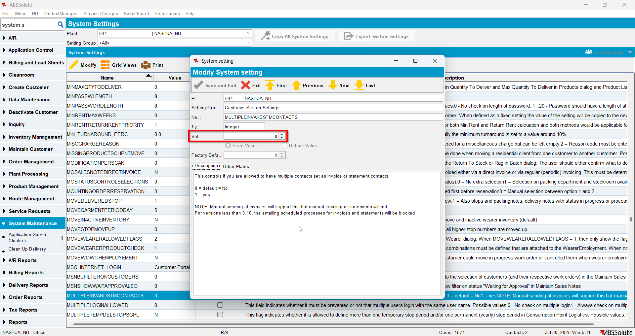
- Have a customer that it is its own bill to and has a contact person already being invoice and statement contact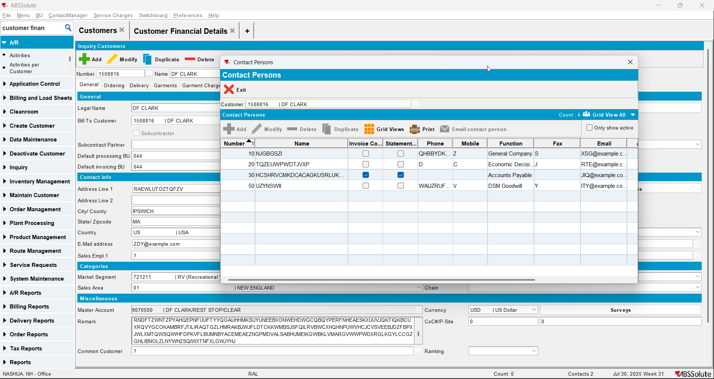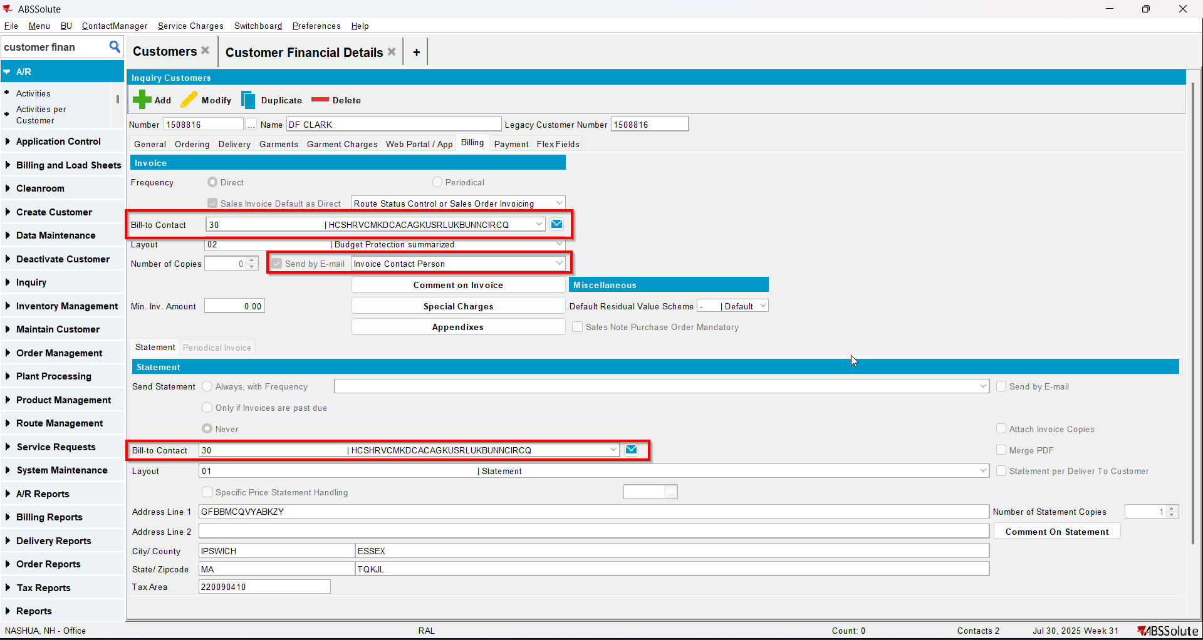
- Modify another contact person making it invoice and statement contact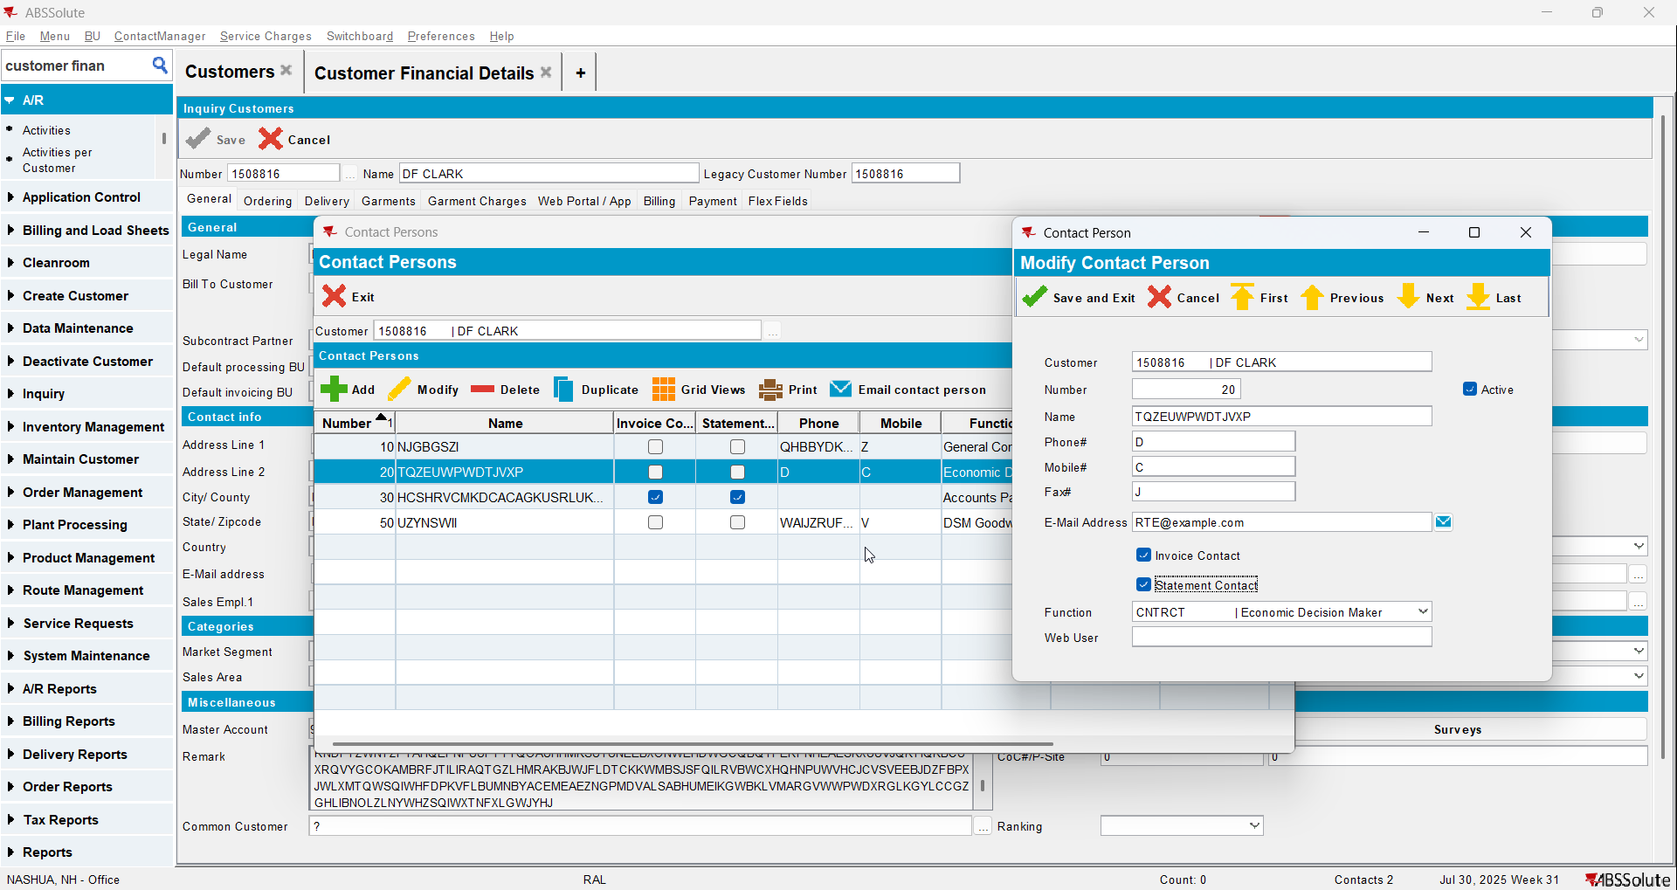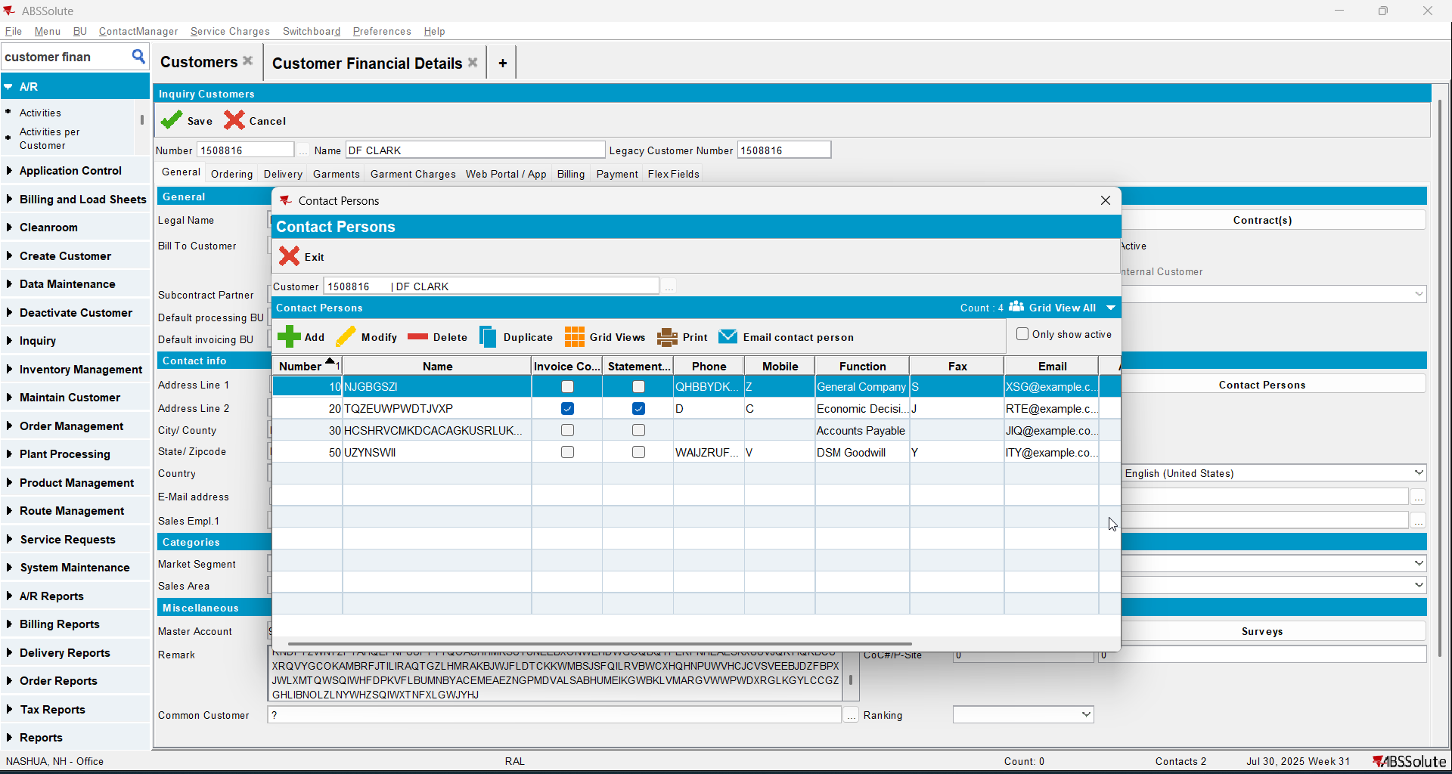
- Save the customer and check the changes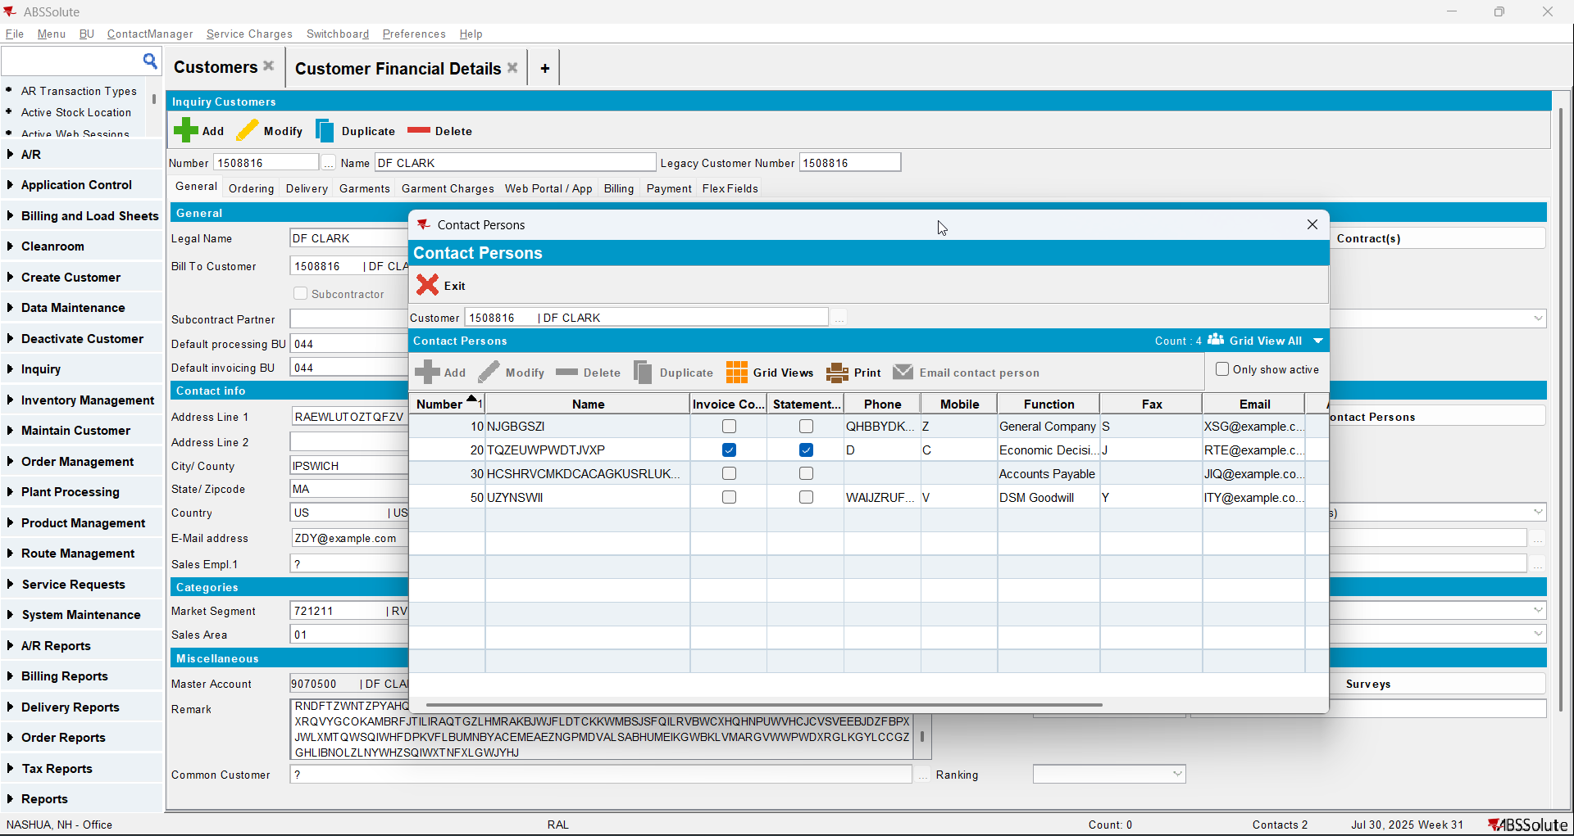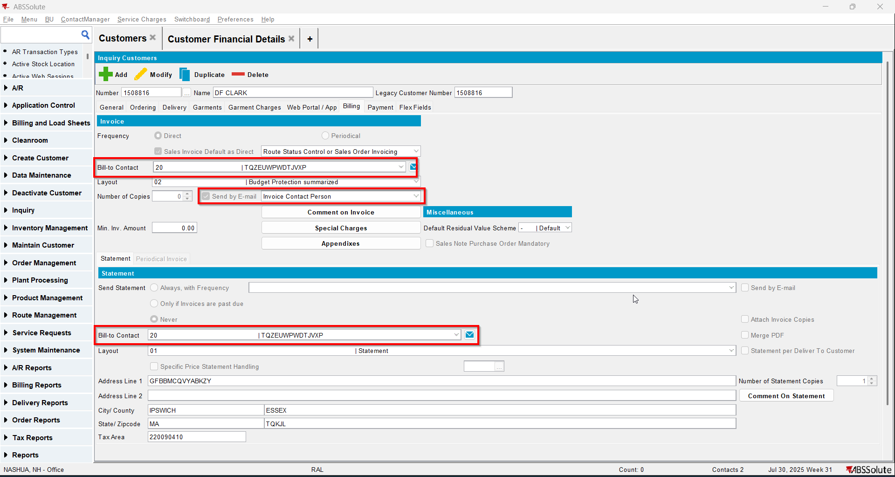

Test Case 2 – MULTIPLEINVANDSTMCONTACTS=0 and customer is not its own bill to– Tested OK
Expected behavior: only 1 contact person can be an invoice/statement contact
Hash: ff9c238
- Check that SS MULTIPLEINVANDSTMCONTACTS=0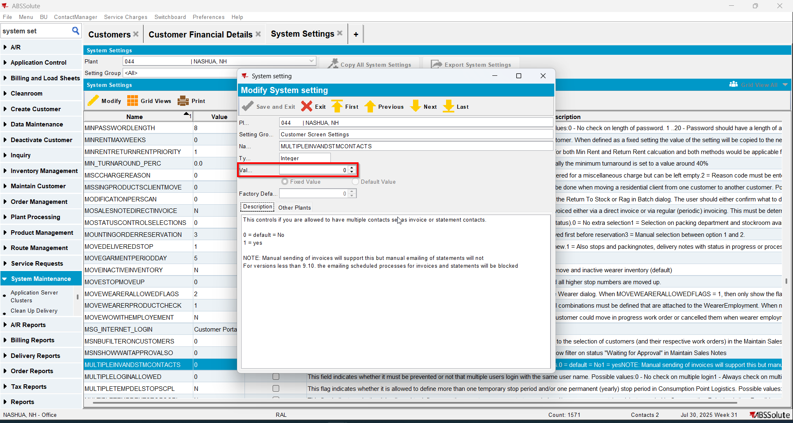
- Have a customer that is not its own bill to and has a contact person already being invoice and statement contact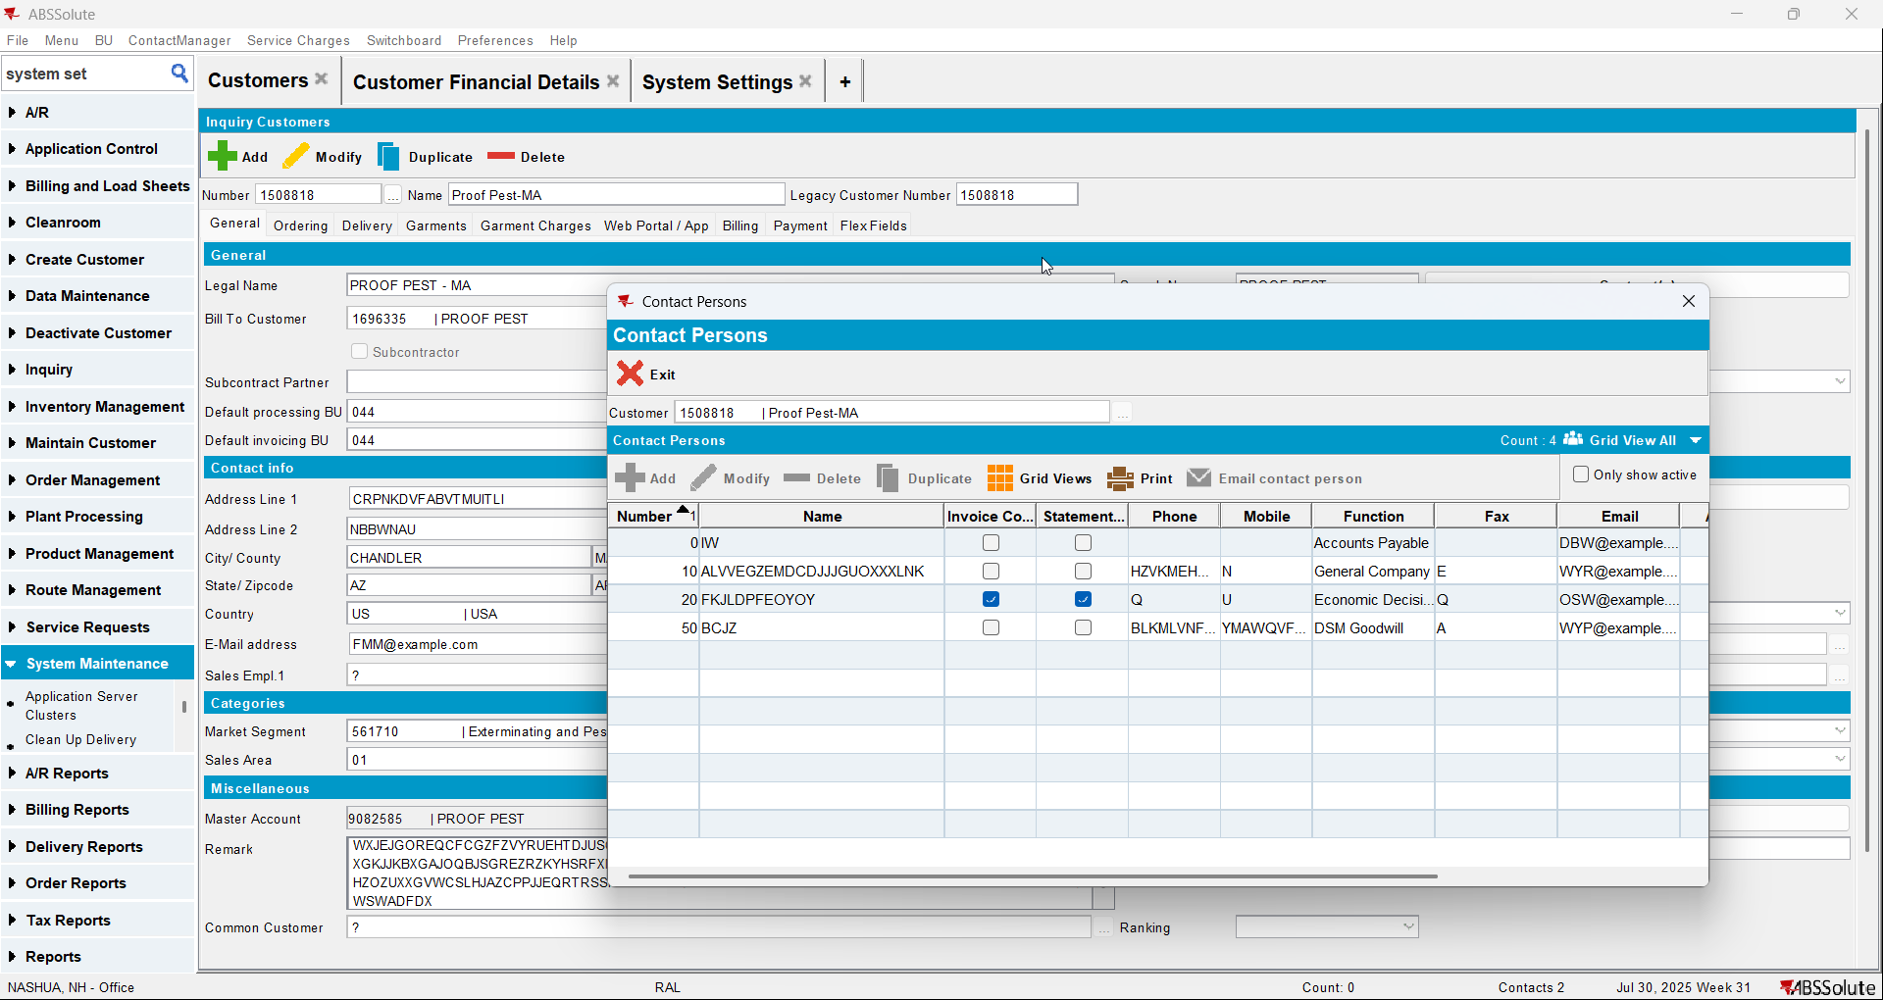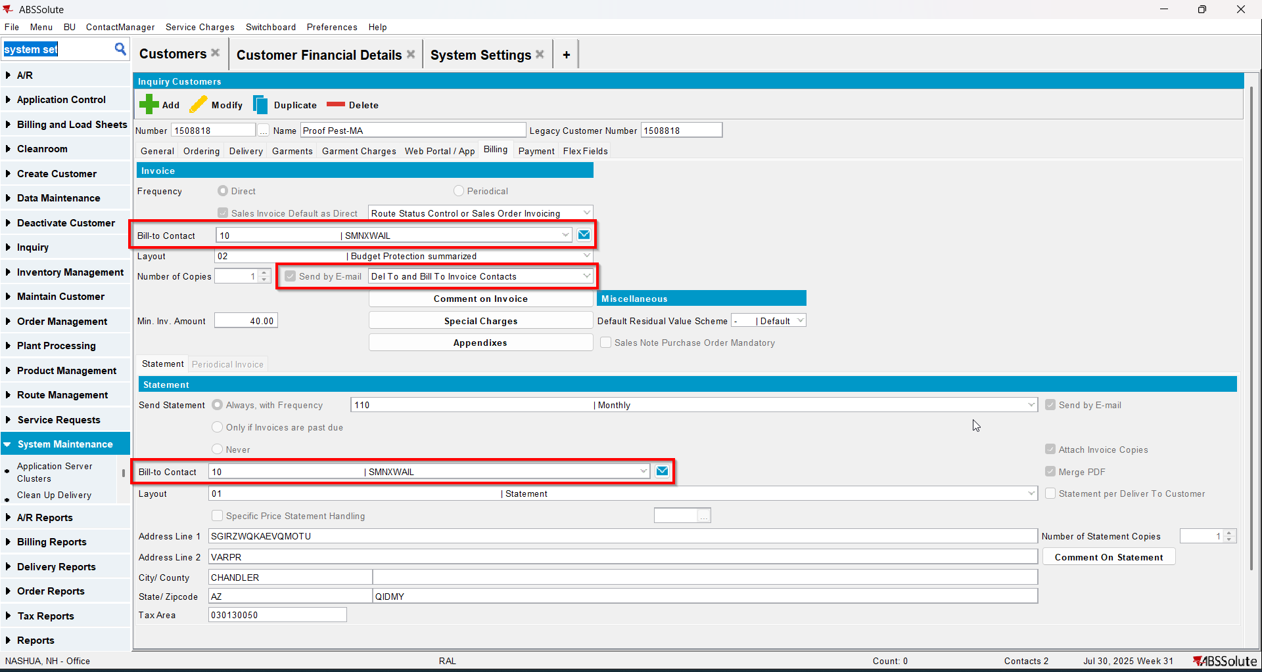
- Modify another contact person making it invoice and statement contact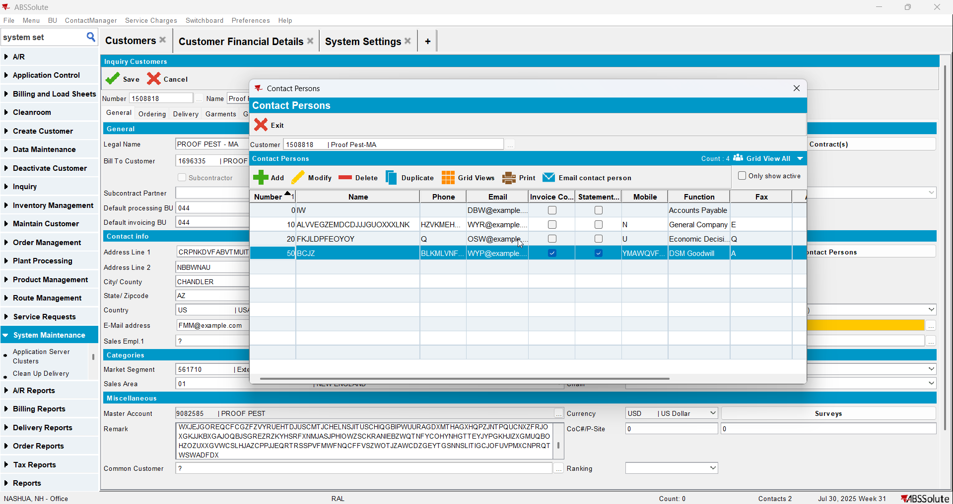
- Save the customer and check the changes. On the billing tab the Bill to Contact will not change because the customer has another customer as its bill to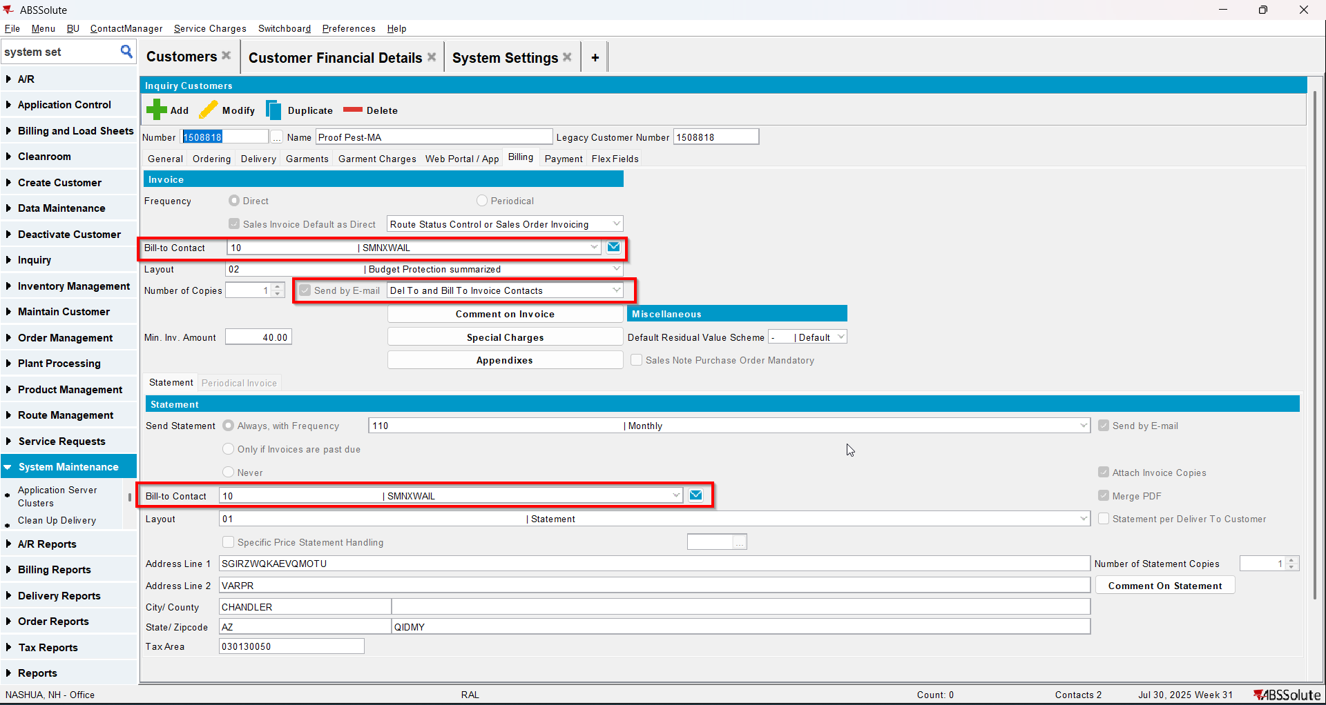
- Load your bill to customer and modify another contact to be invoice and statement contact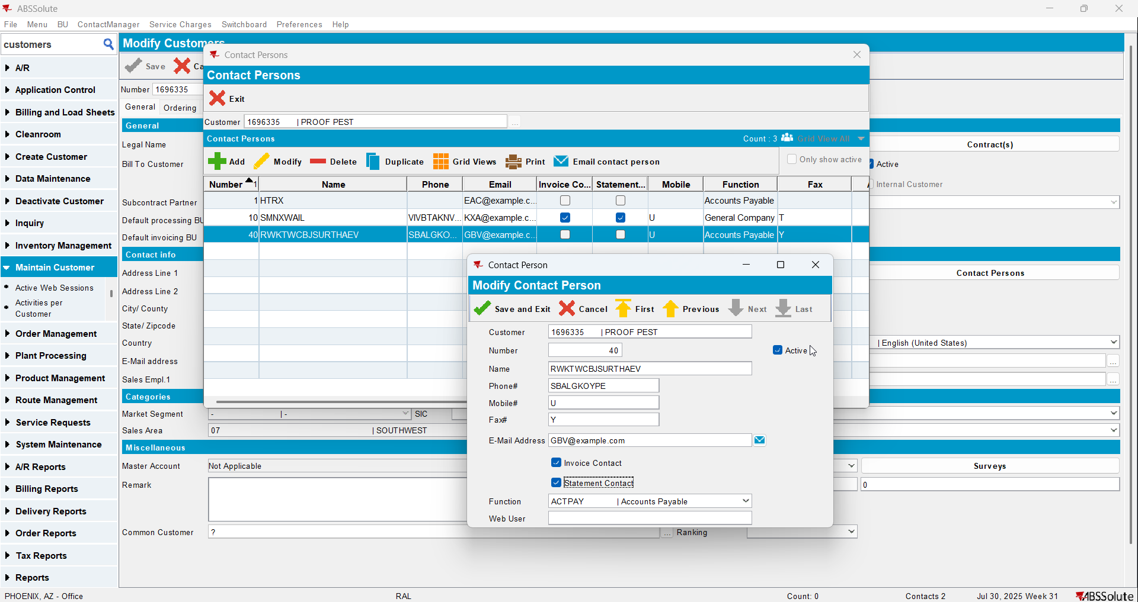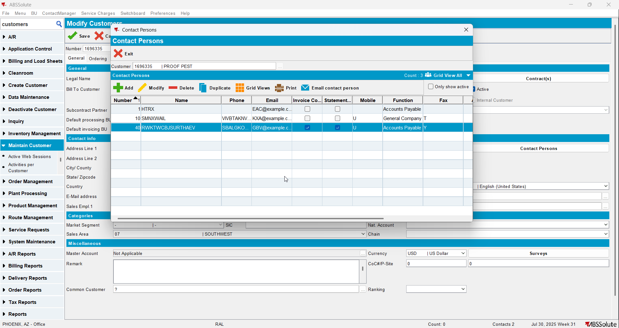
- Check that the Bill to Contact on the Billing tab changed for both customers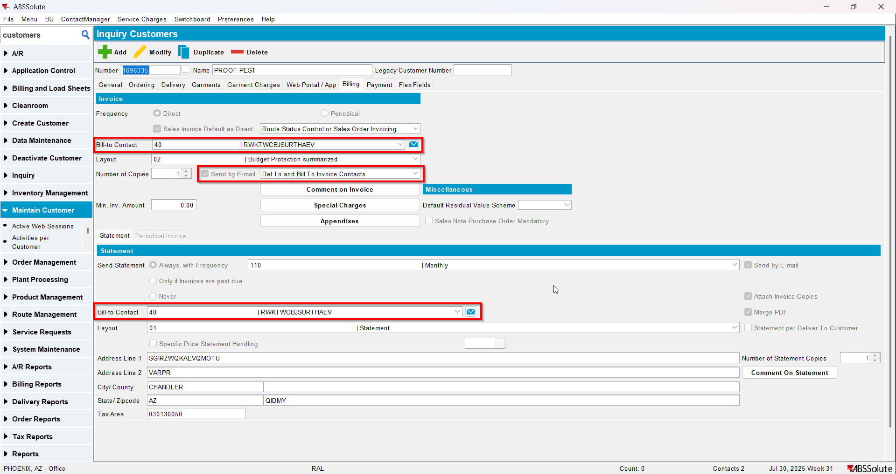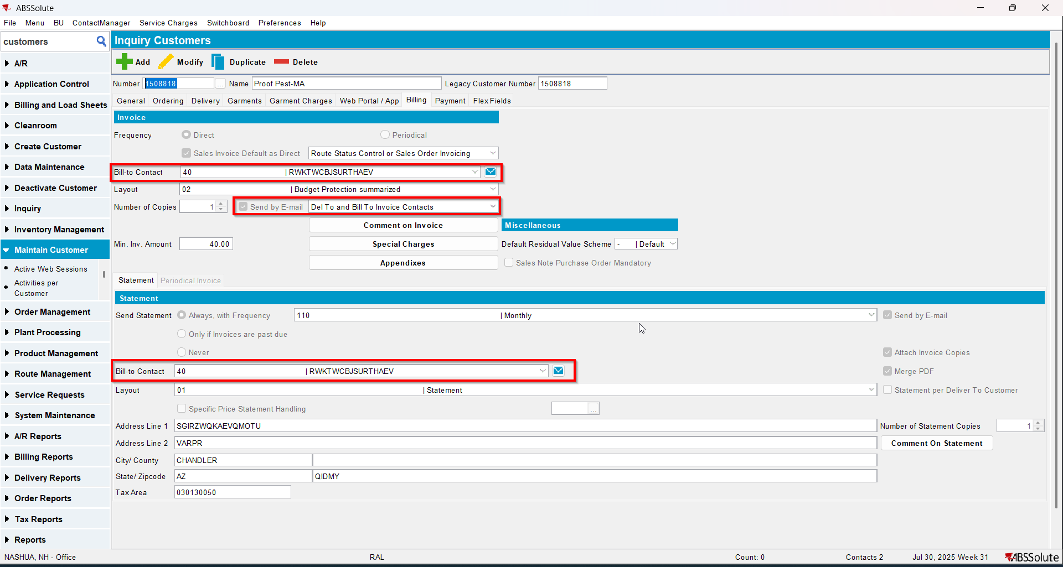

Test Case 3 – MULTIPLEINVANDSTMCONTACTS=1 and customer is its own bill to – Tested OK
Expected behavior: more contact persons can be invoice/statement contacts
Hash: ff9c238
- Check that SS MULTIPLEINVANDSTMCONTACTS=1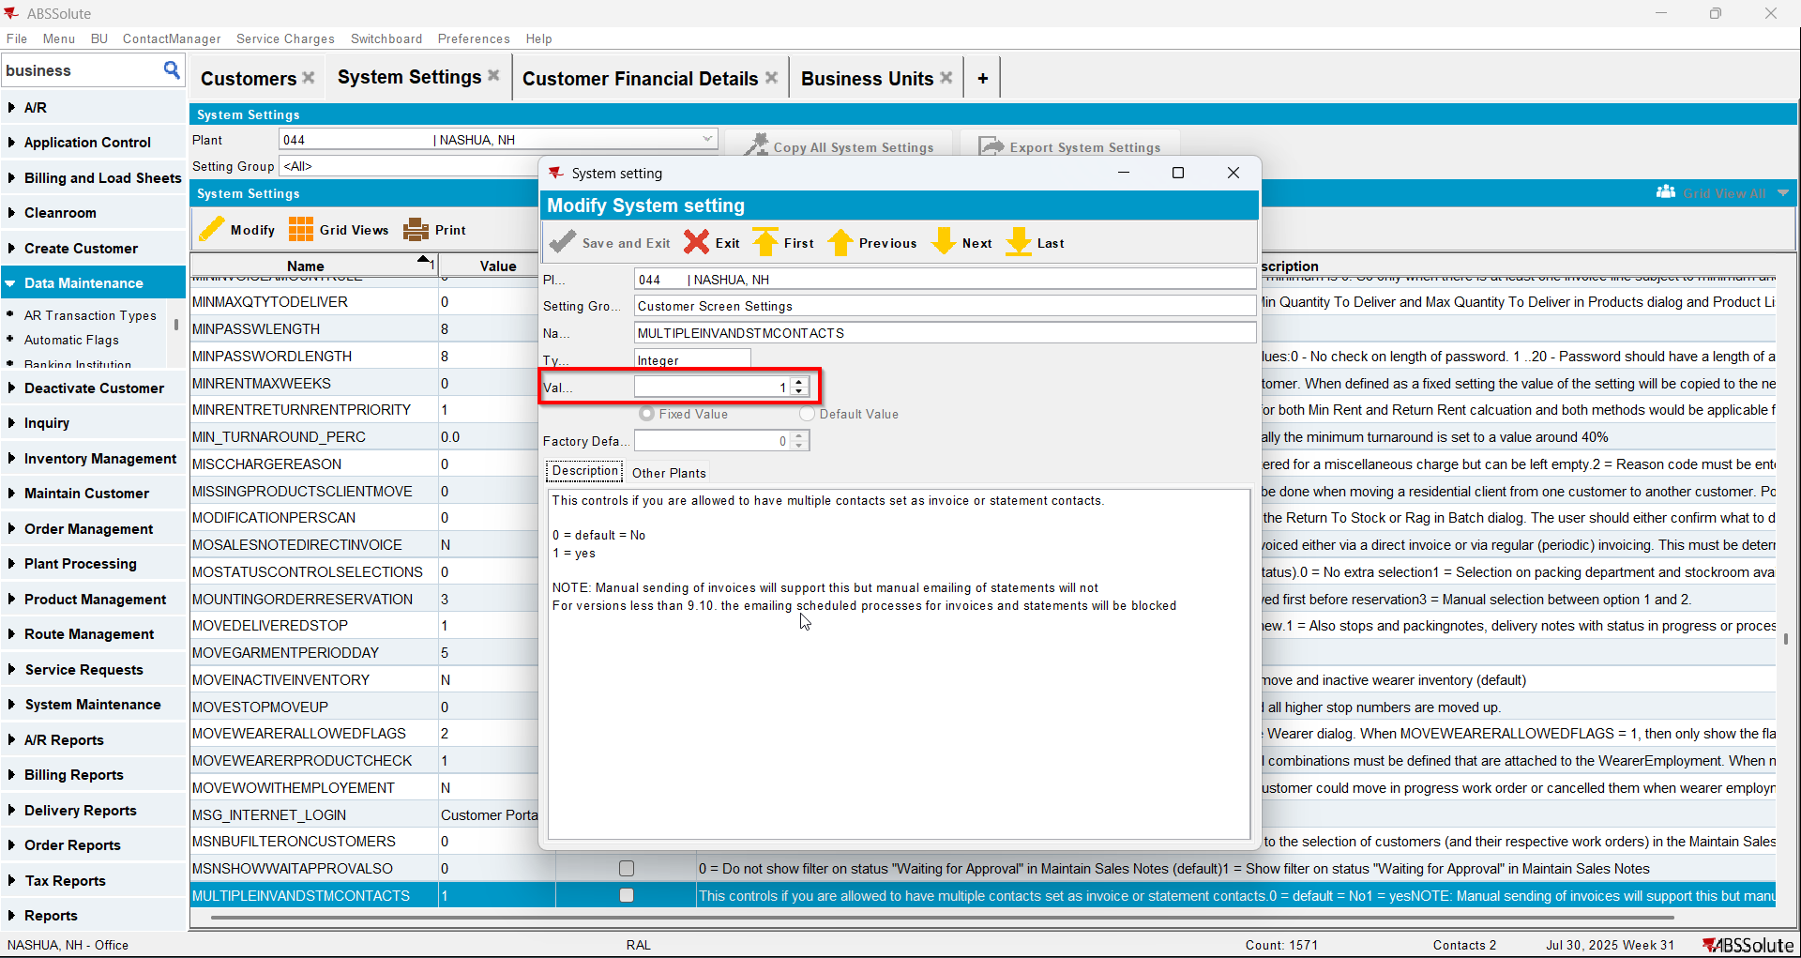
- Have a customer that it is its own bill to and has a contact person already being invoice and statement contact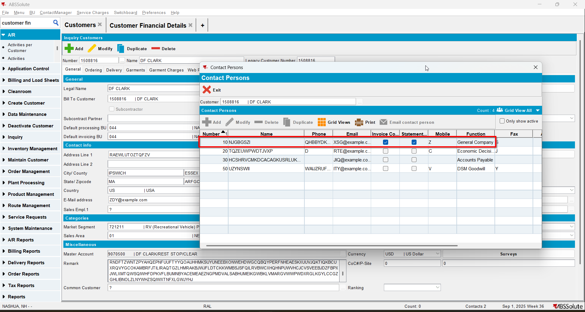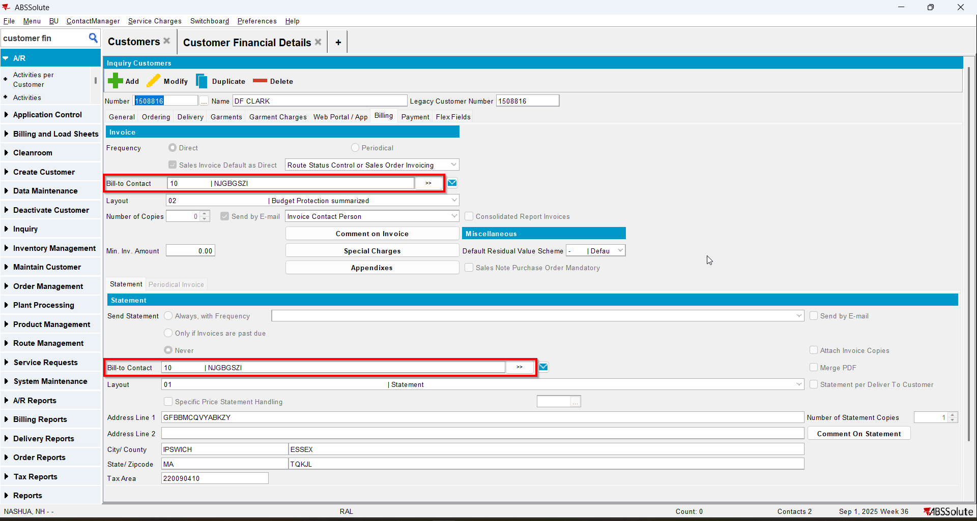
- Modify other contact persons to be invoice and statement contacts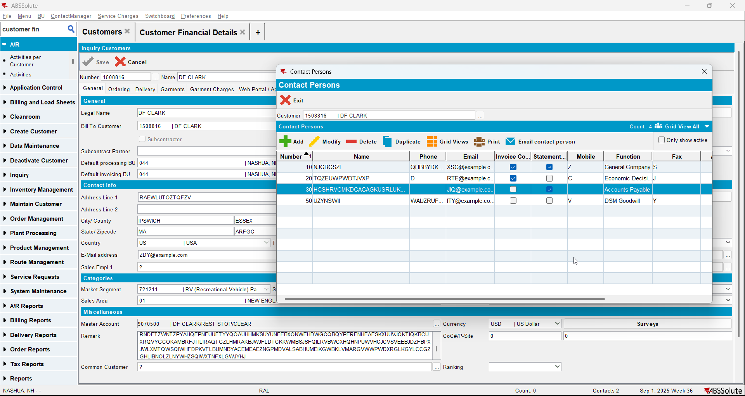
- On the Billing tab now the Bill to Contact for statement and invoices will say ‘<Multiple>’ and will open an Include/Exclude window.
- Check that the contact persons that are invoice contacts will appear as Selected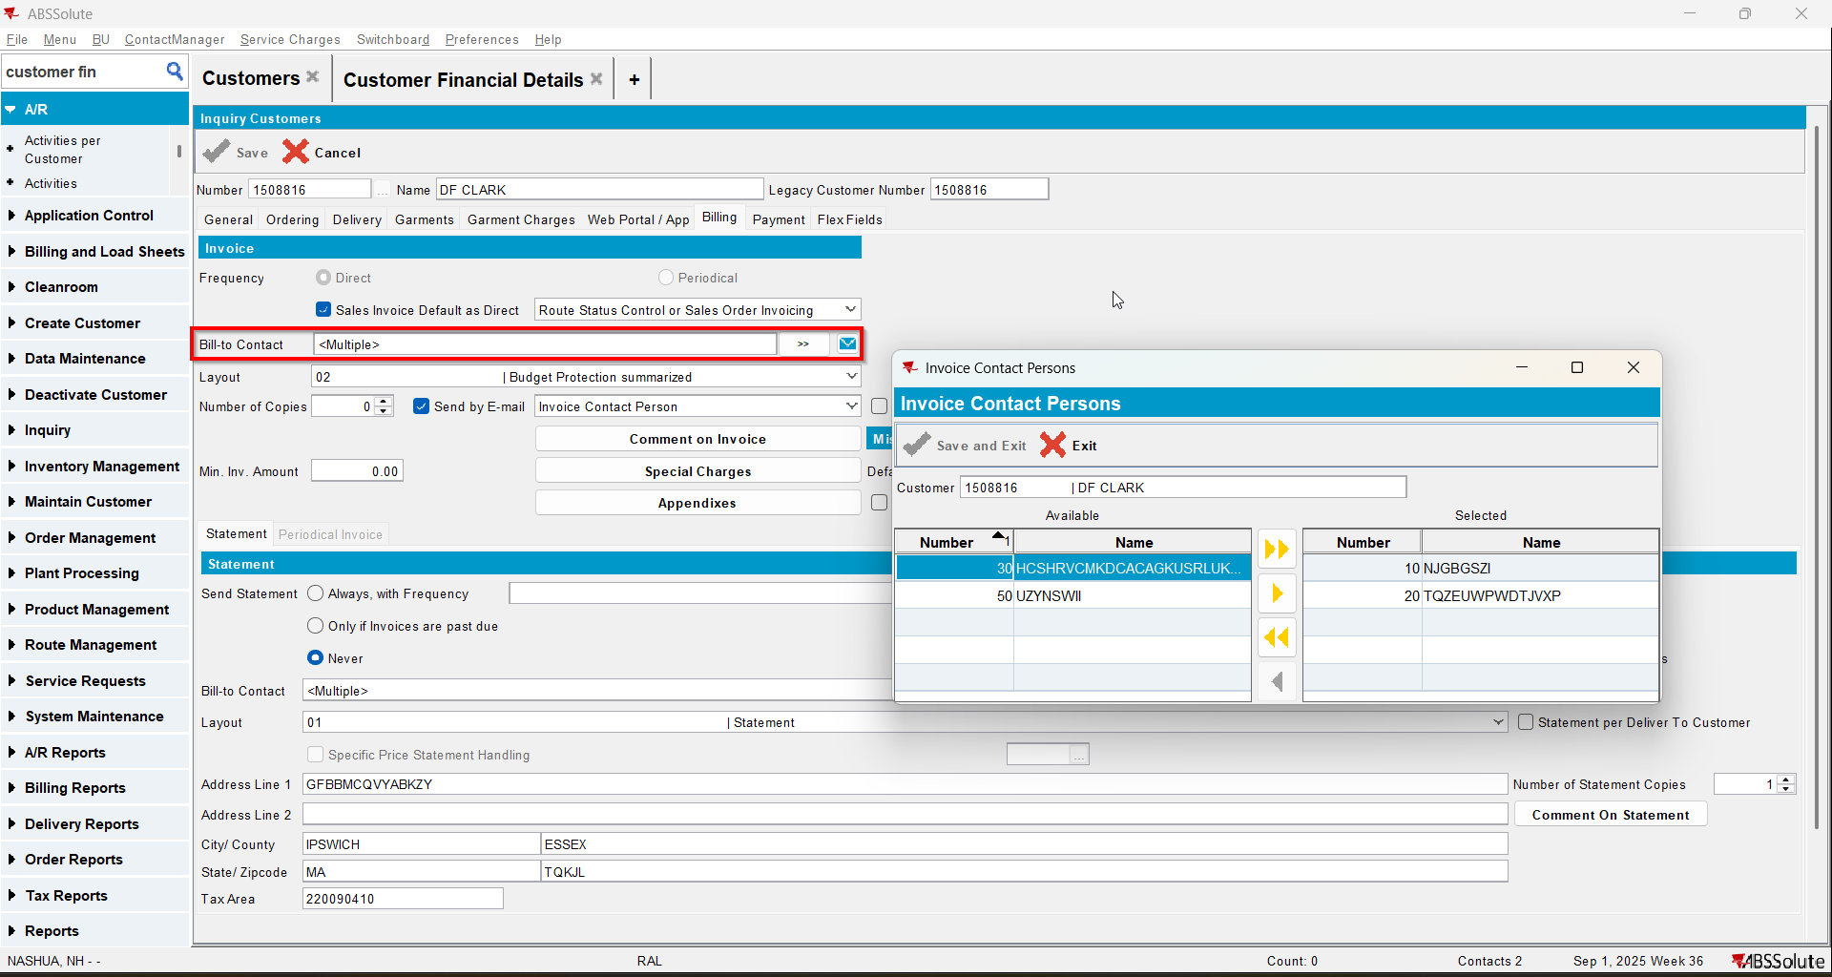
- Check that the contact persons that are statement contacts will appear as Selected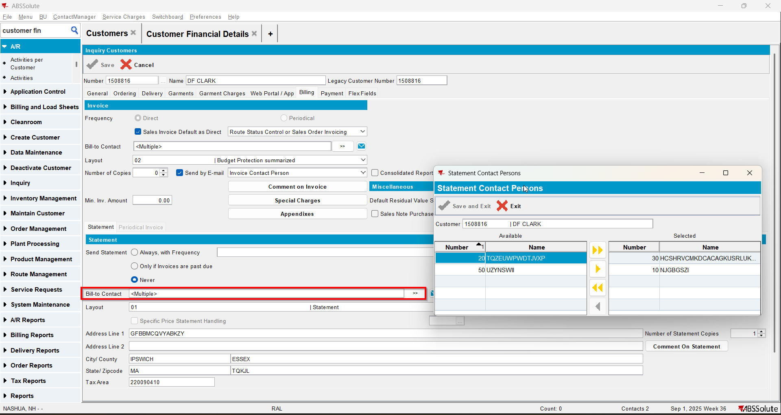
- On the Bill to Contact for invoice include another contact person and exclude an already selected one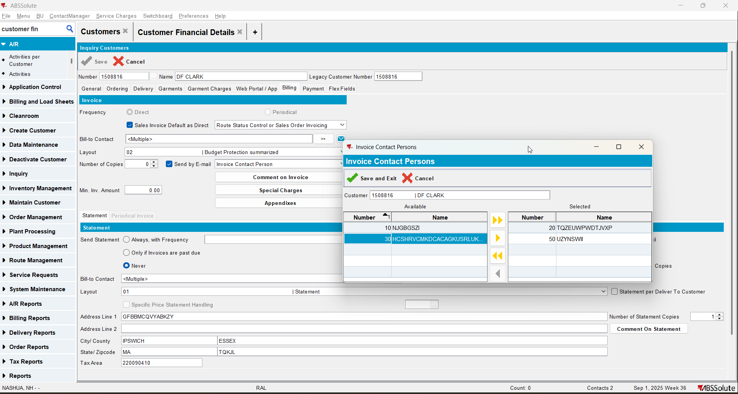
- On the Bill to Contact for statement include another contact person and exclude an already selected one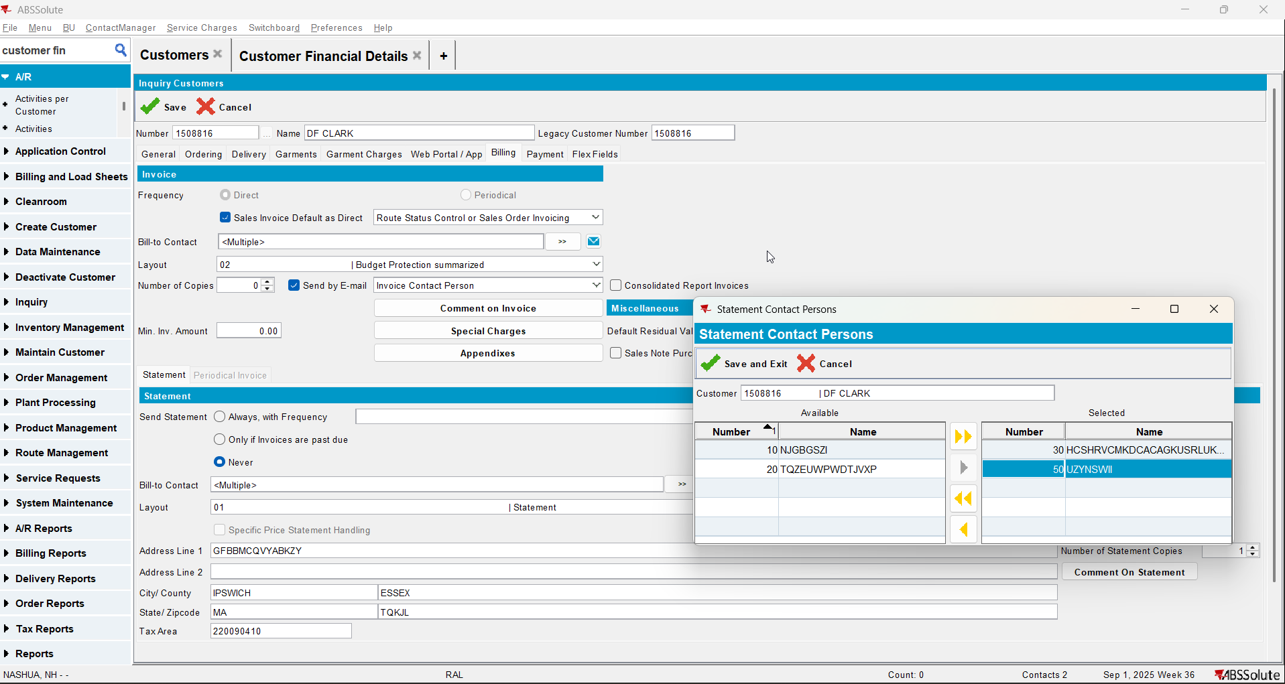
- Save your customer
- Check that on the General Tab on Contact Persons your changes were saved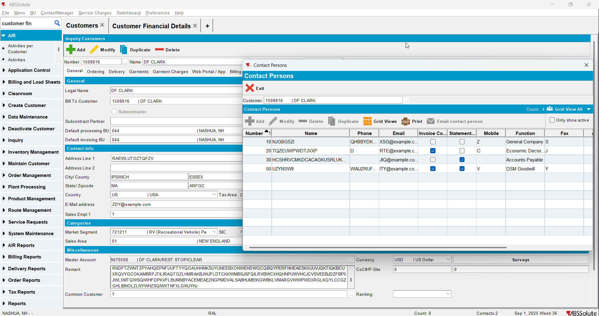
- Check that on the Billing tab your changes were saved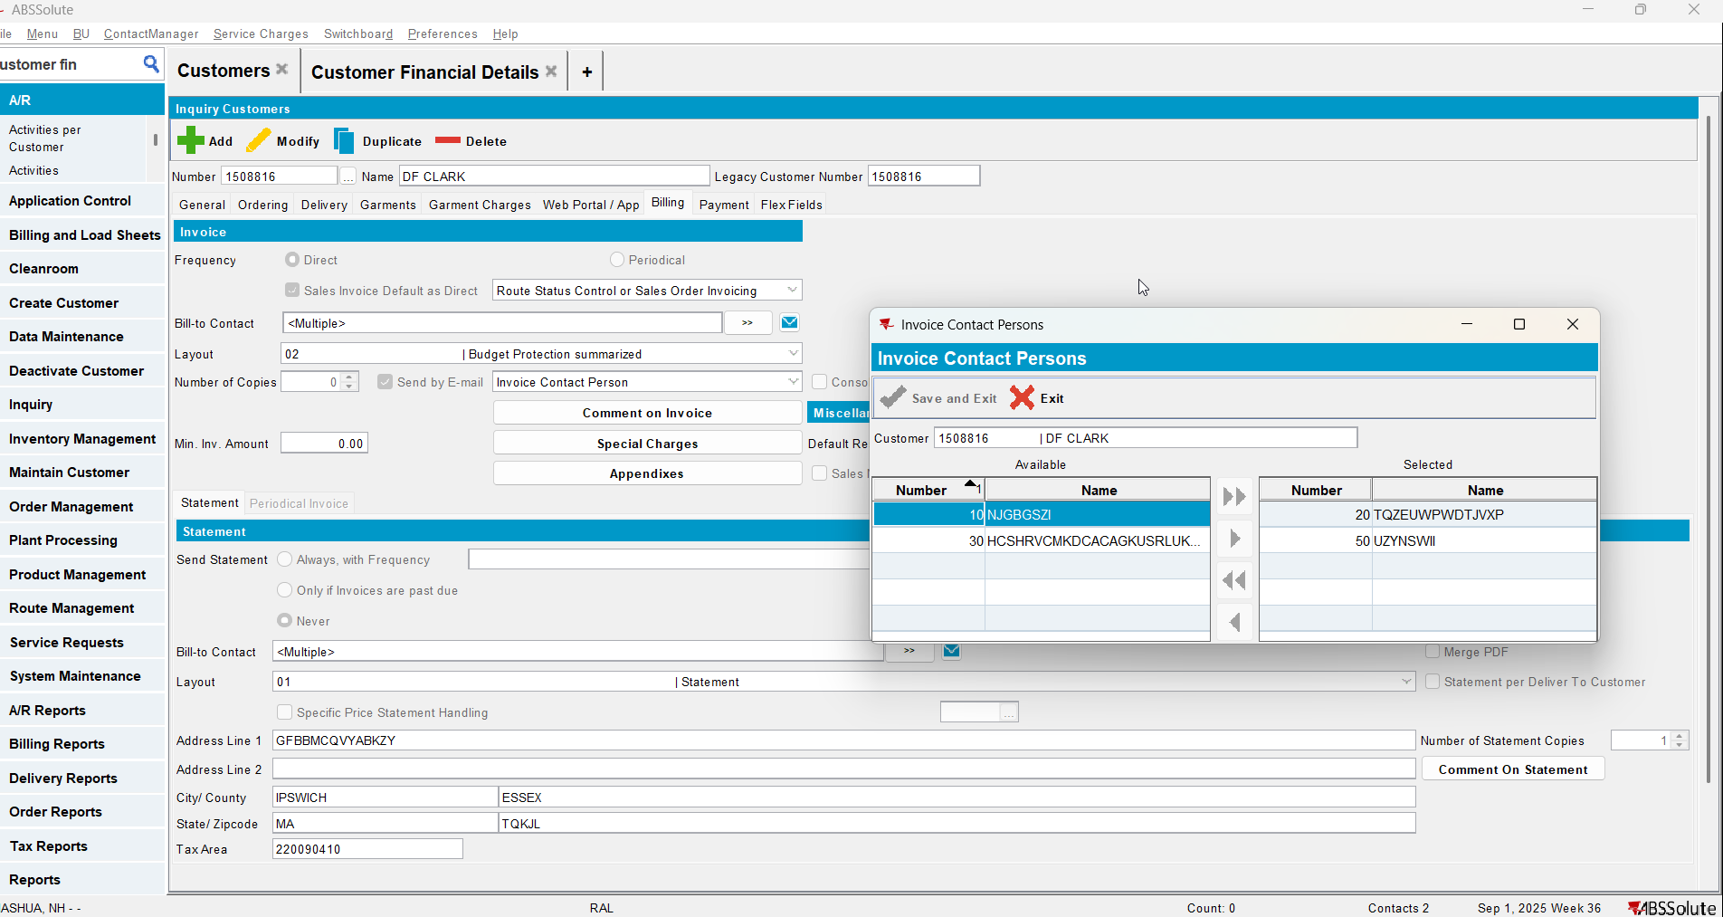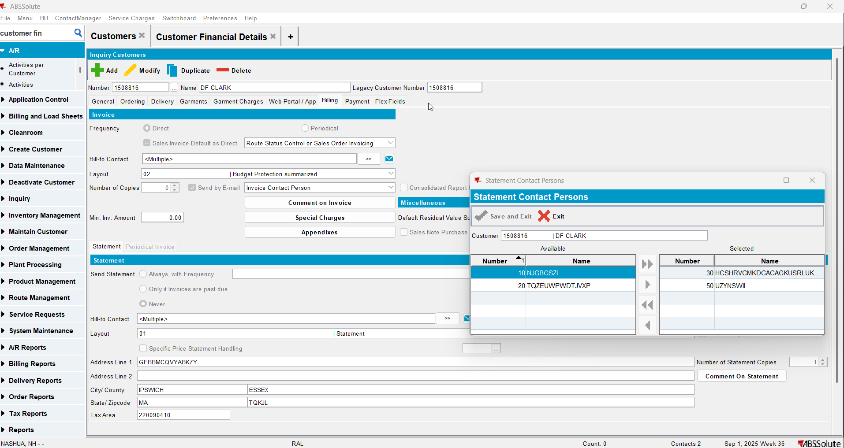

Test Case 4 – MULTIPLEINVANDSTMCONTACTS=1 and customer is not its own bill to– Tested OK
Expected behavior: more contact persons can be invoice/statement contacts
Hash: ff9c238
- Check that SS MULTIPLEINVANDSTMCONTACTS=1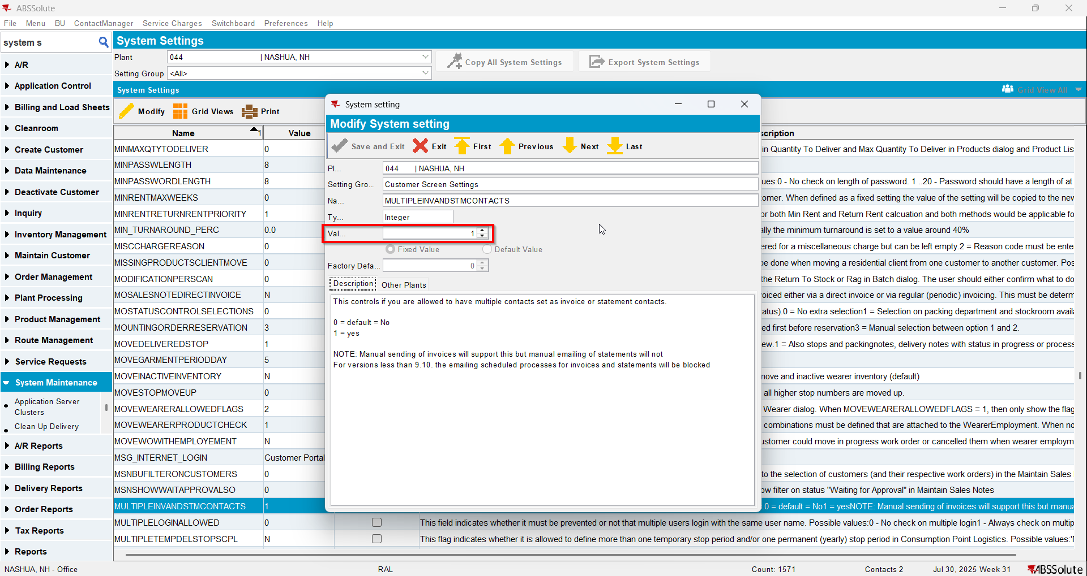
- Have a customer that is not its own bill to and has a contact person already being invoice and statement contact
- Modify other contact persons to be invoice and statement contacts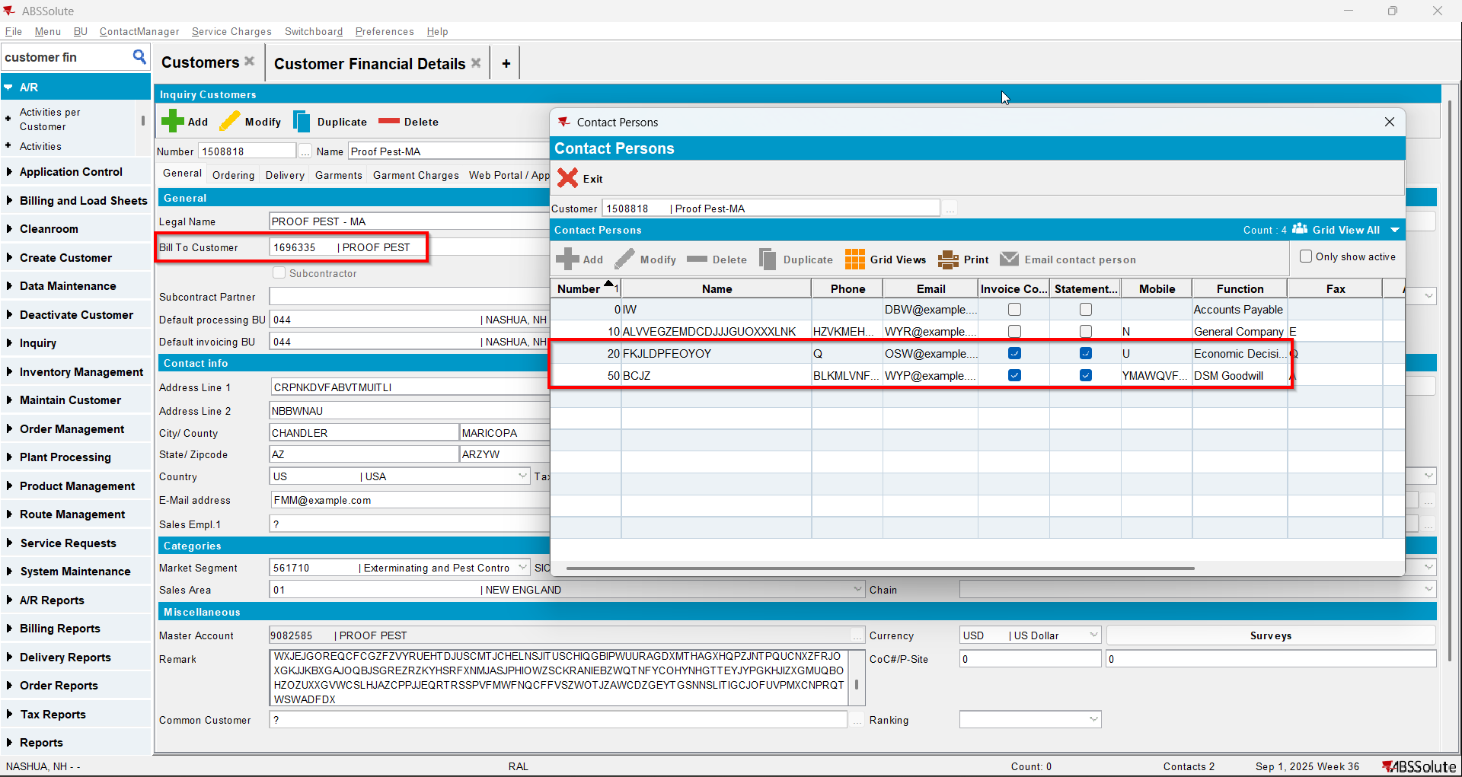
- Load your bill to customer and modify another contact to be invoice and statement contact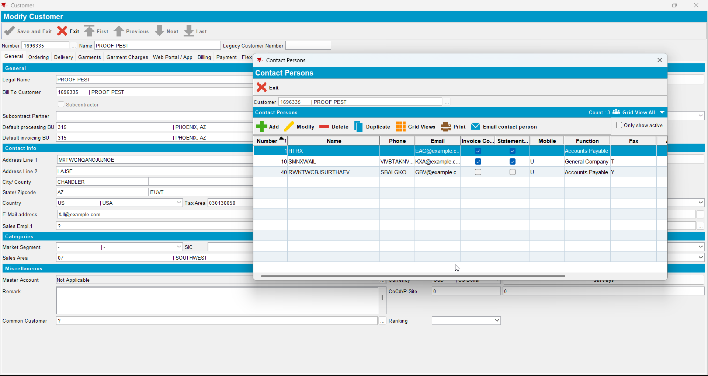
- Load again the del to customer
- On the Billing tab now the Bill to Contact for statement and invoices will say ‘<Multiple>’ and will open an Include/Exclude window.
- Check that the contact persons of the del to customer that are invoice contacts will appear as Selected. The invoice contacts names of the bill to customer will appear on the field ‘Bill to contacts that receive invoice emails’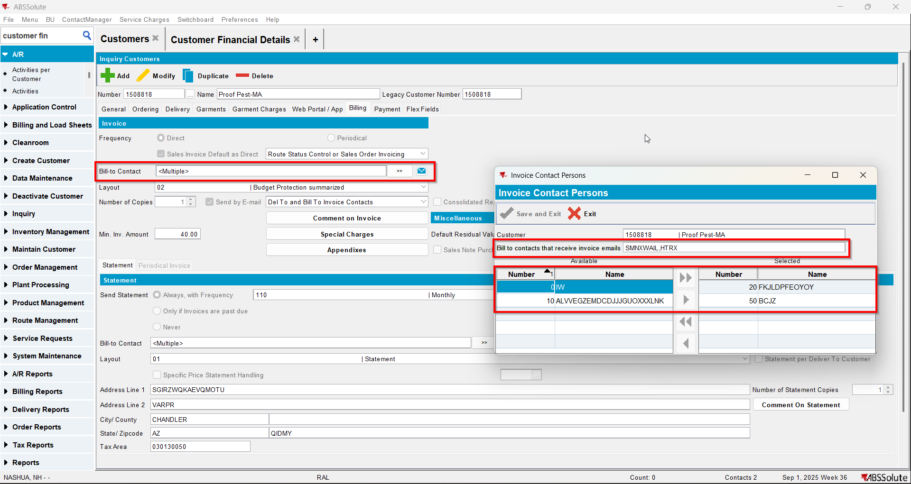
- Check that the contact persons of the del to customer that are statement contacts will appear as Selected. The statement contacts names of the bill to customer will appear on the field ‘Bill to contacts that receive statement emails’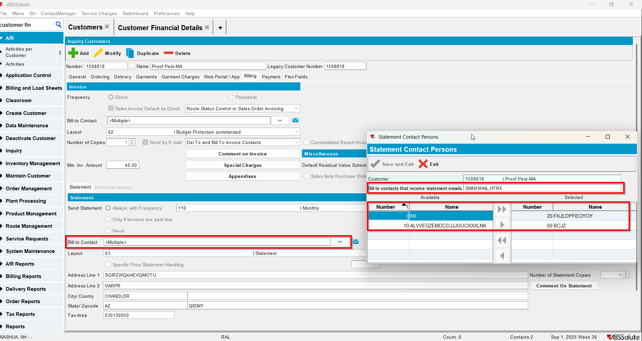
- Load again the bill to customer
- On the Bill to Contact for invoice include another contact person and exclude an already selected one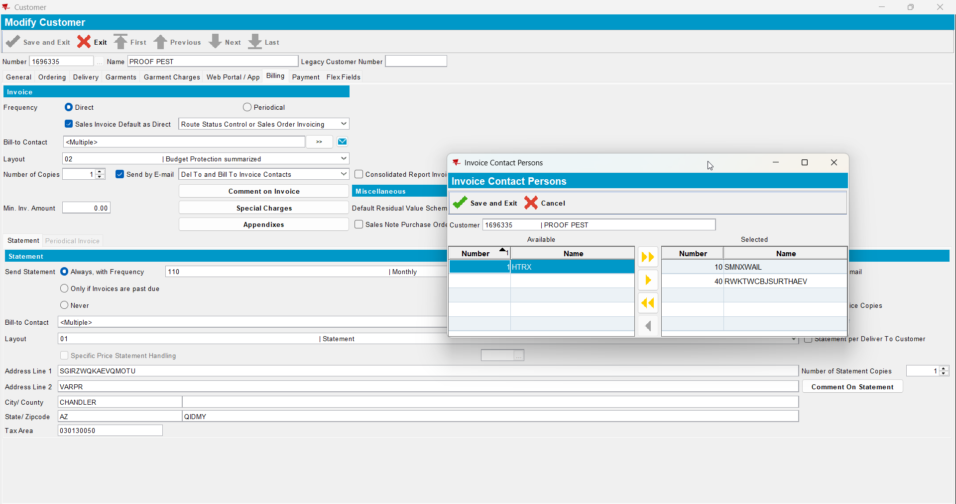
- On the Bill to Contact for statement include another contact person and exclude an already selected one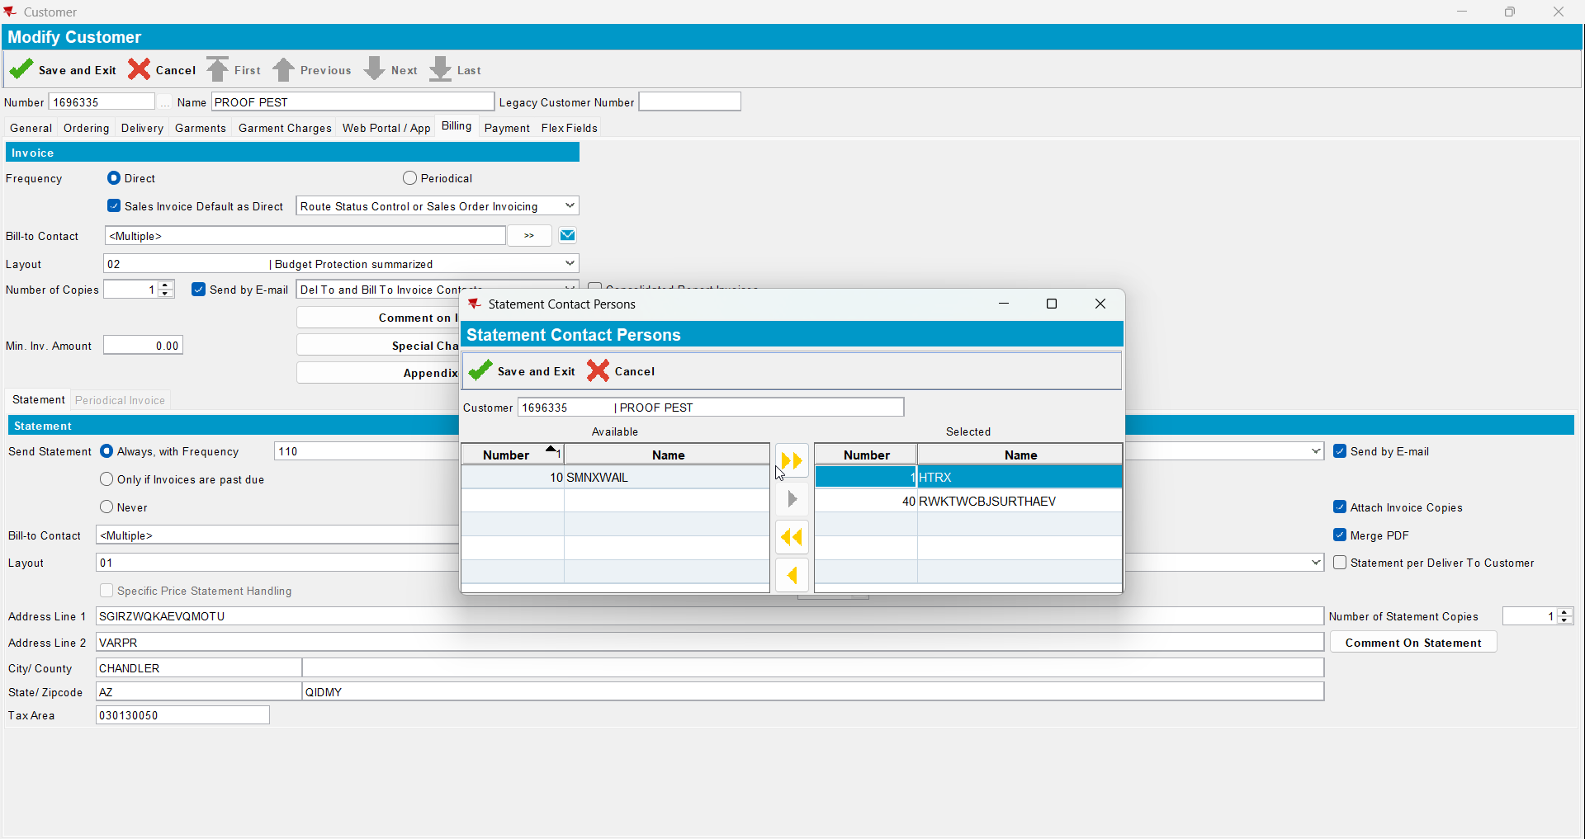
- Save your customer
- Load the del to customer
- Check that on the Billing tab your changes were saved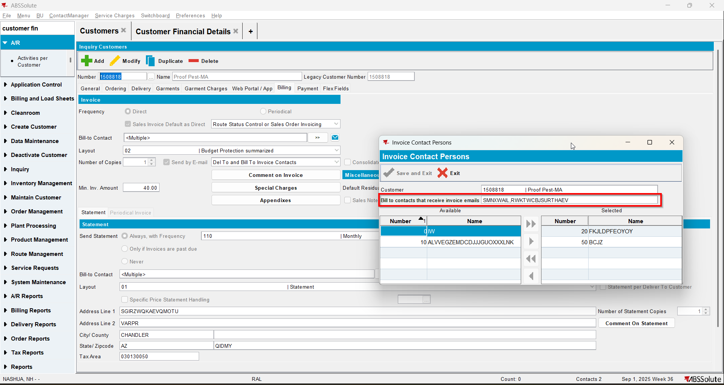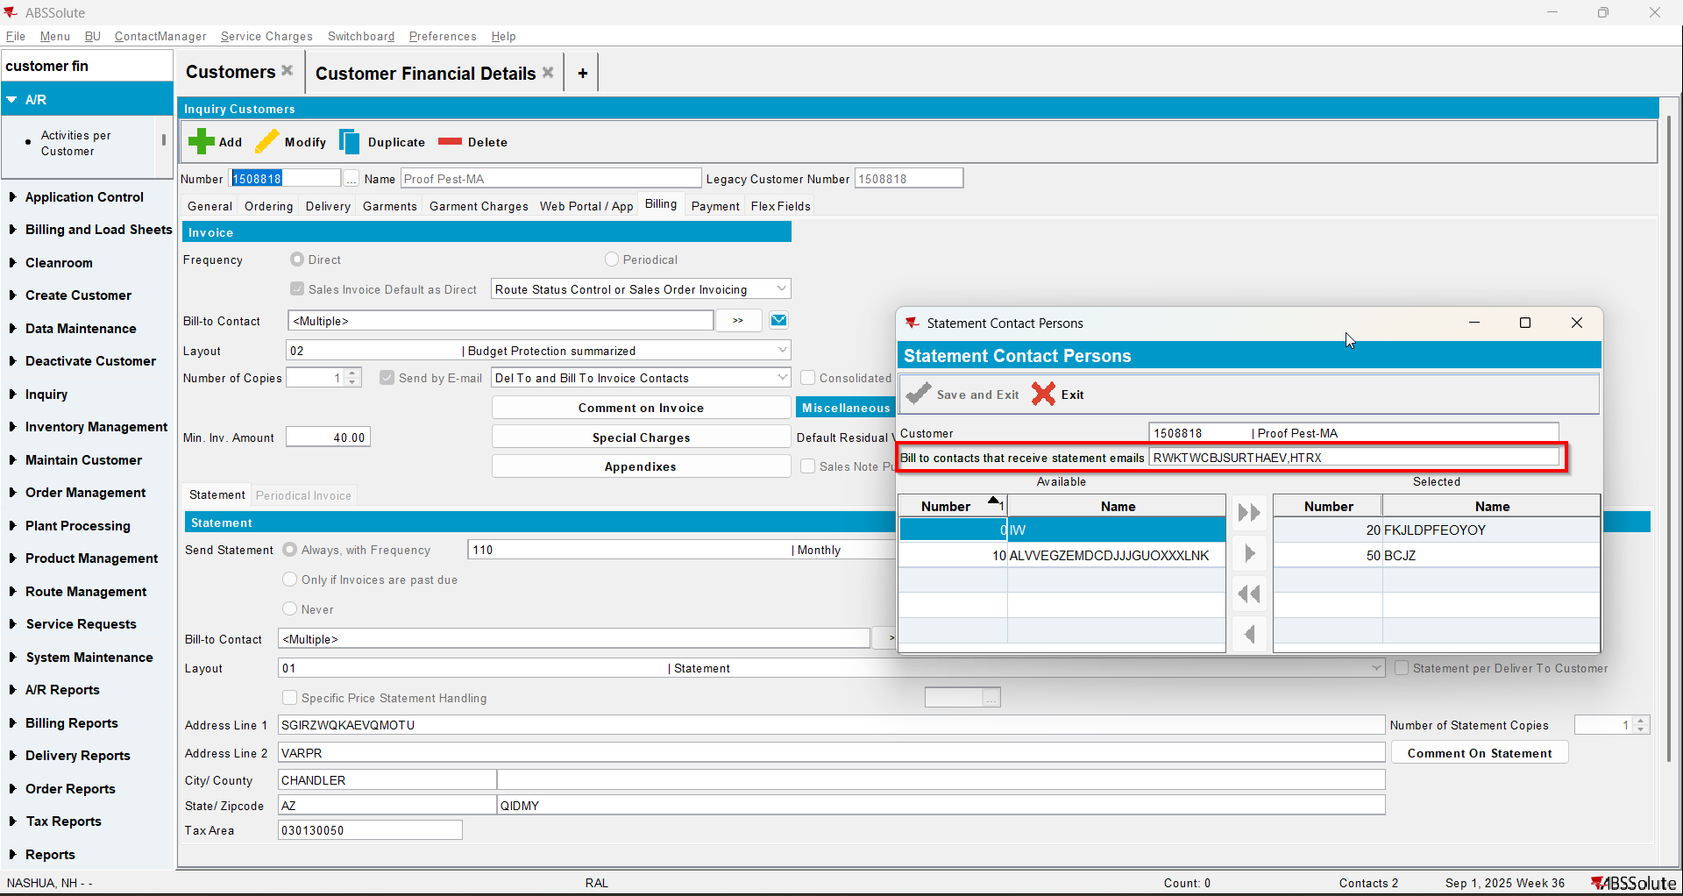

Add customer

Test Case 1 – MULTIPLEINVANDSTMCONTACTS=0 – Tested OK
Expected behavior: customer is added and everything is saved
Hash: ff9c238
- Check that SS MULTIPLEINVANDSTMCONTACTS=0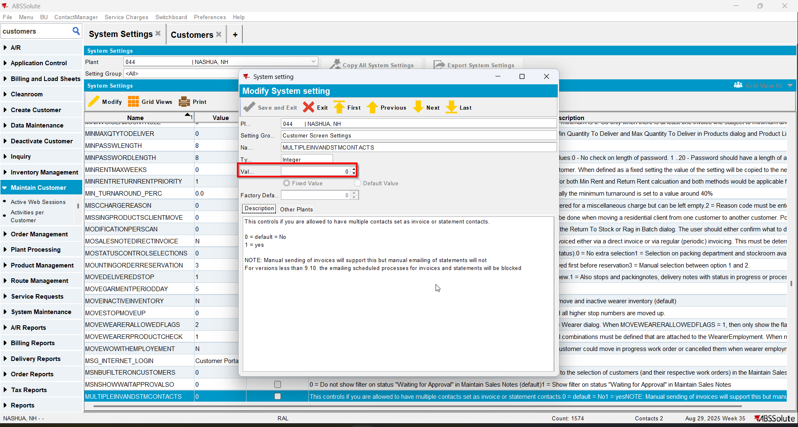
- Add a customer(Customer 1) but don’t save
- Add a contact person that is also invoice and statement contact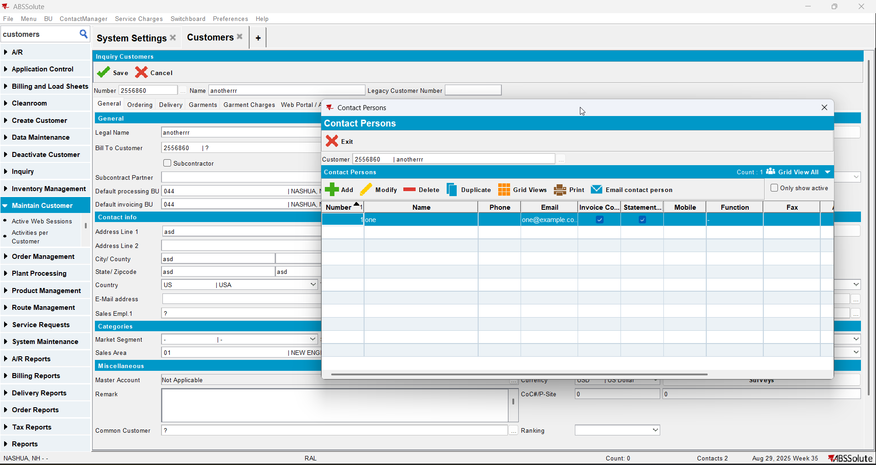
- Add another contact person that is also invoice and statement contact. After adding it, the first contact should have the checkboxes for Invoice Contact and Statement Contact unchecked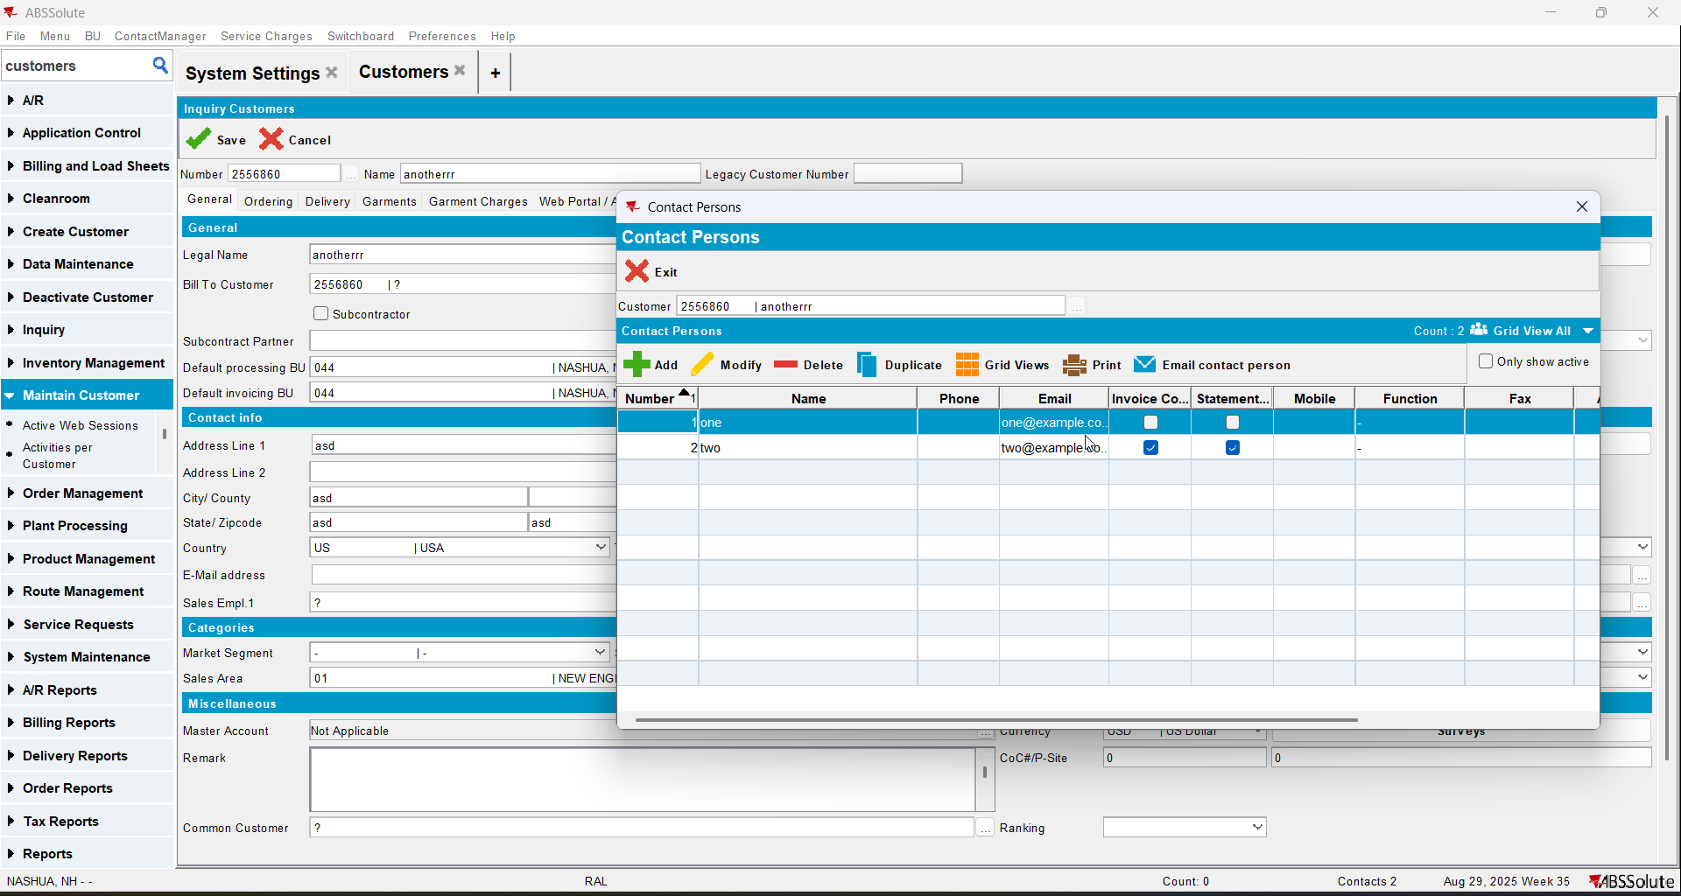
- Go to Billing tab and check that the second contact appears as the bill to contact for invoice and statements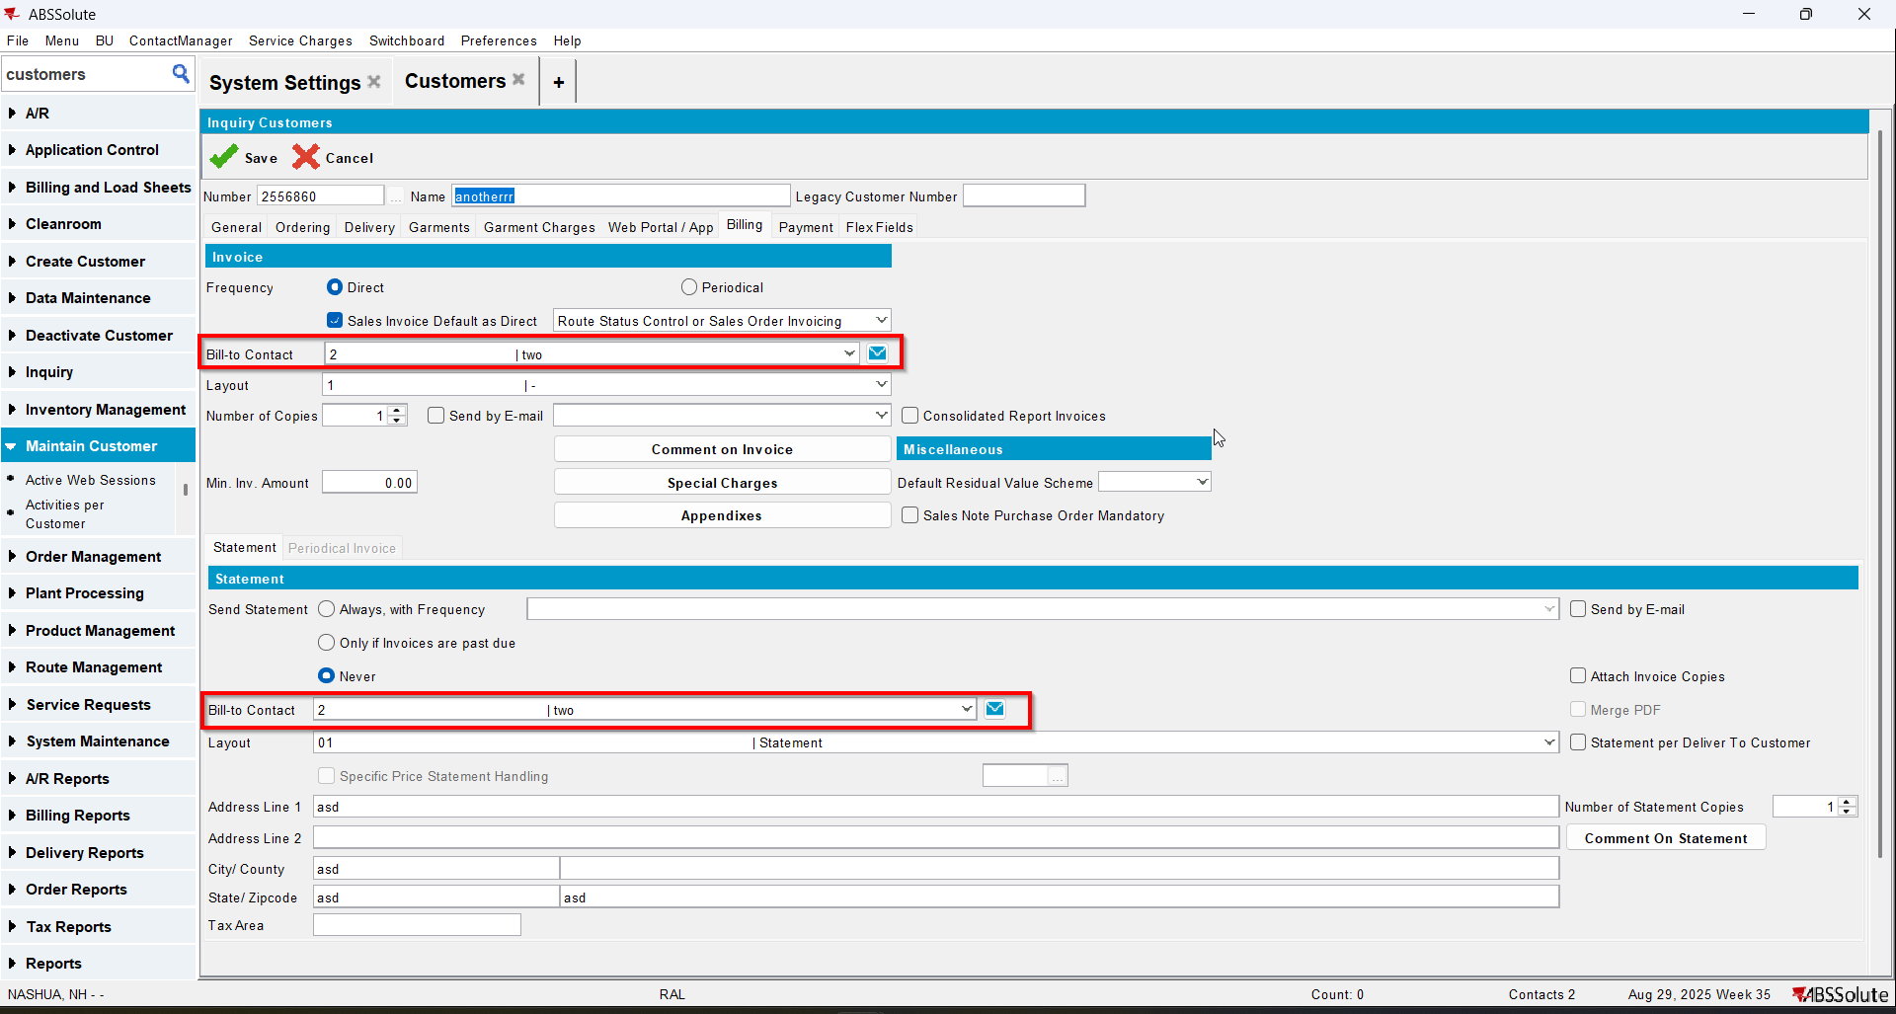
- Save your customer and check that everything was saved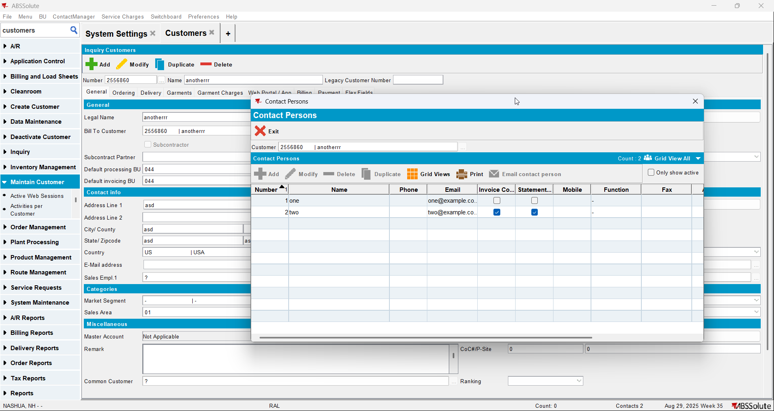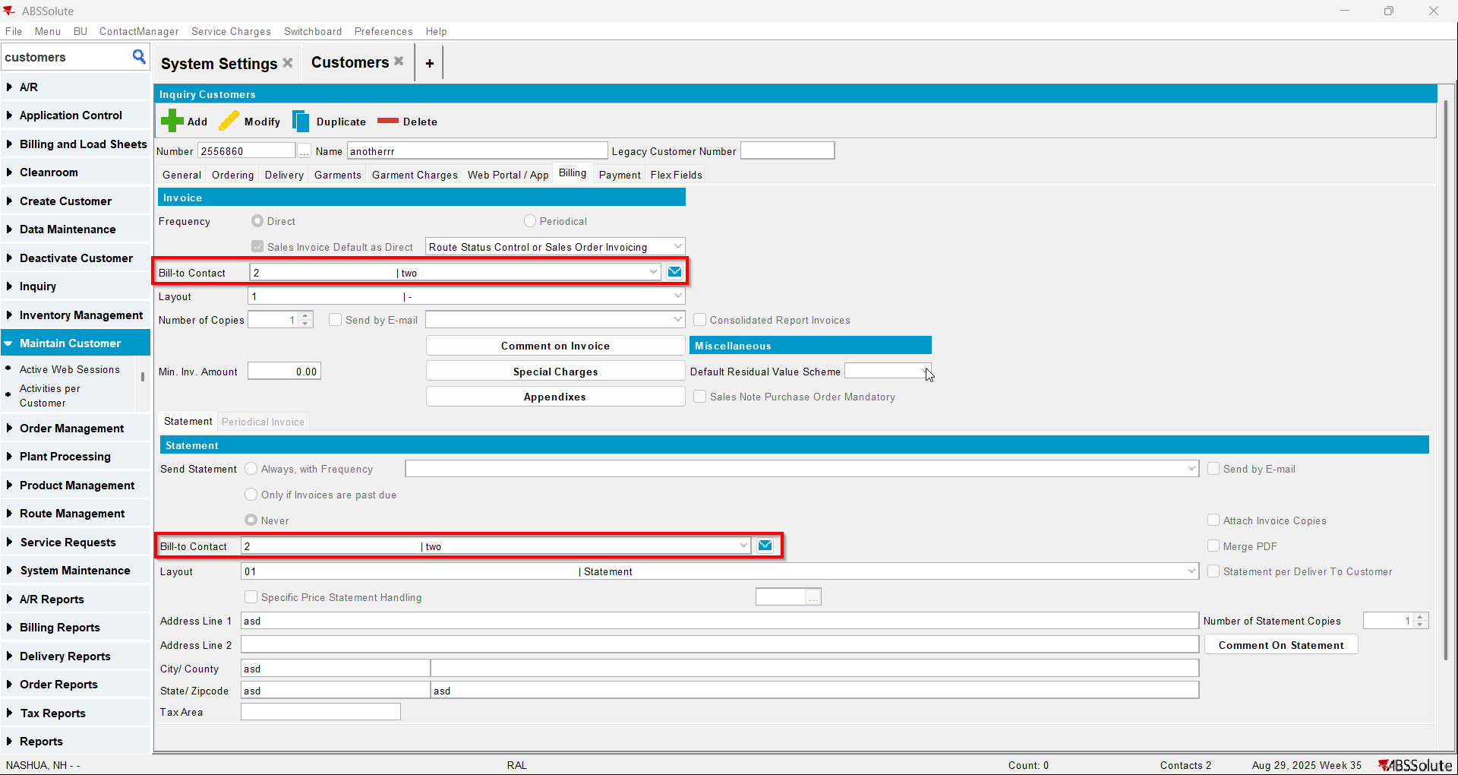
- Add another customer(Customer 2) but don’t save
- Put Customer 1 as the bill to for Customer 2
- Add a contact person that is also invoice and statement contact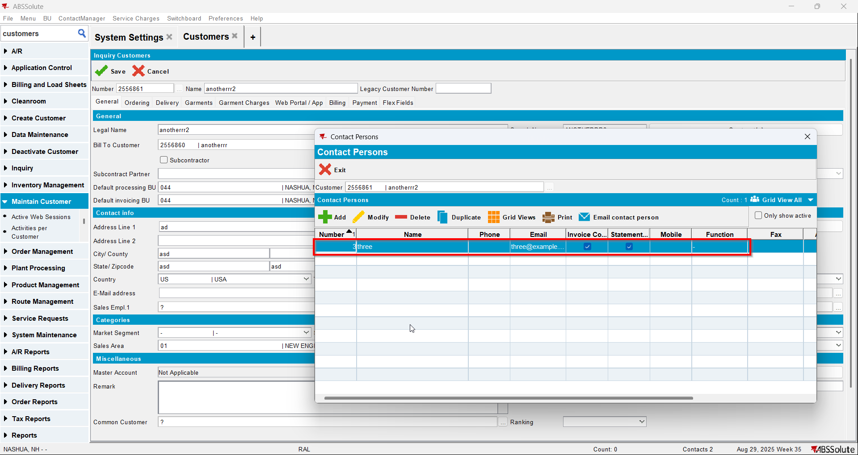
- Add another contact person that is also invoice and statement contact. After adding it, the first contact should have the checkboxes for Invoice Contact and Statement Contact unchecked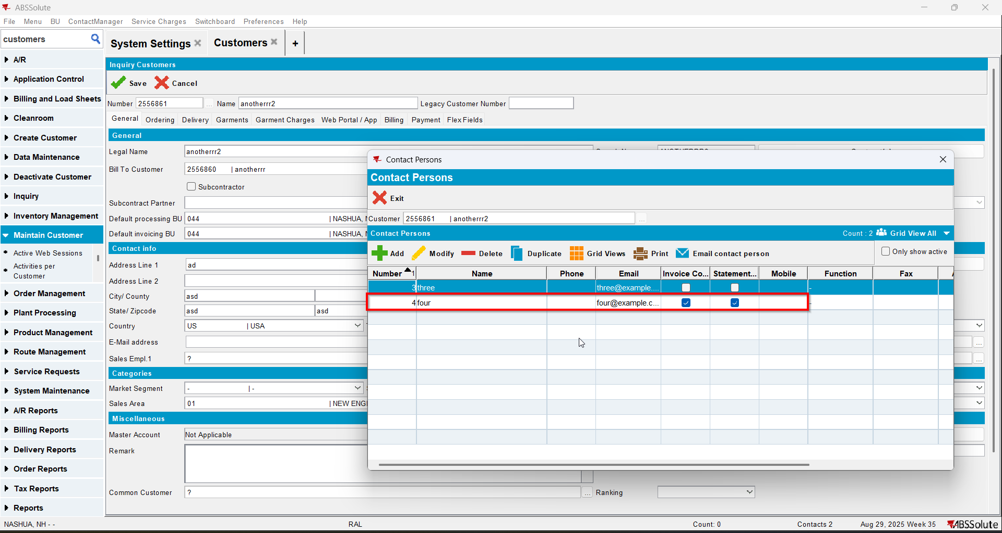
- Save your customer and check that everything was saved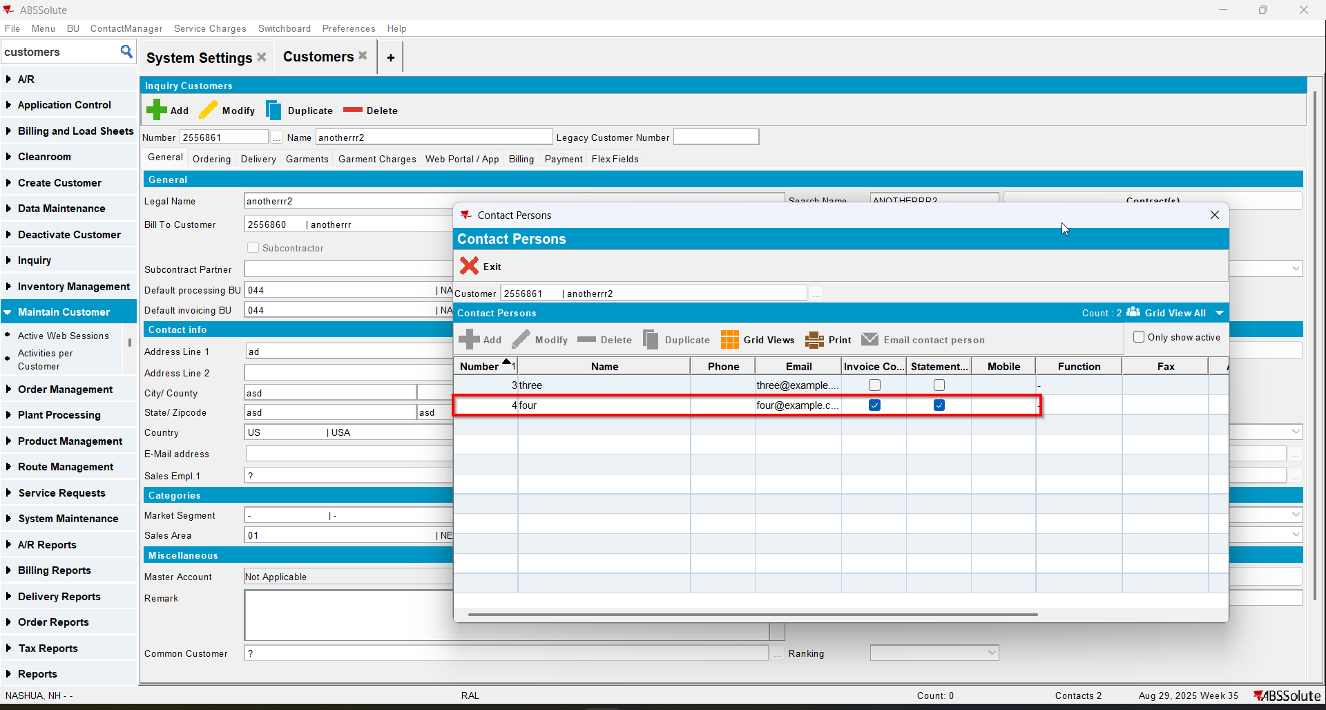
- Go to Billing tab and check that the second contact of the Bill To customer appears as the bill to contact for invoice and statements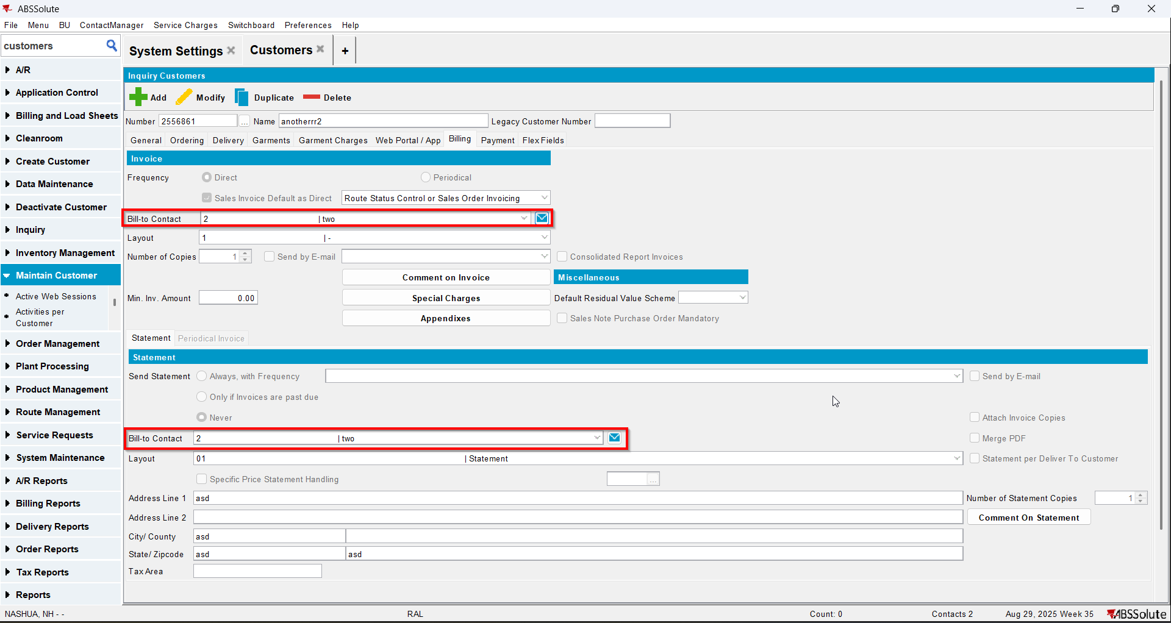

Test Case 2 – MULTIPLEINVANDSTMCONTACTS=1 – Tested OK
Expected behavior: customer is added and everything is saved
Hash: ff9c238
- Check that SS MULTIPLEINVANDSTMCONTACTS=1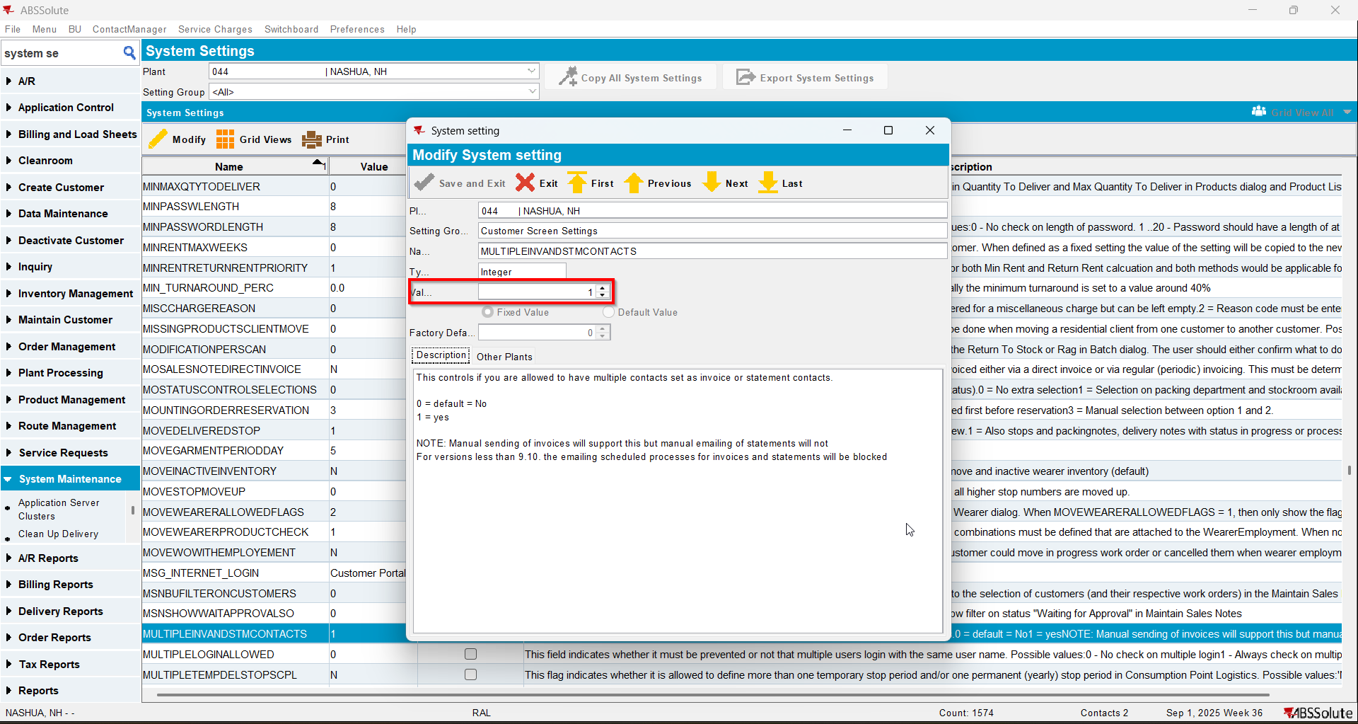
- Add a customer(Customer 1) but don’t save
- Add more contact persons and make some of them invoice and statement contacts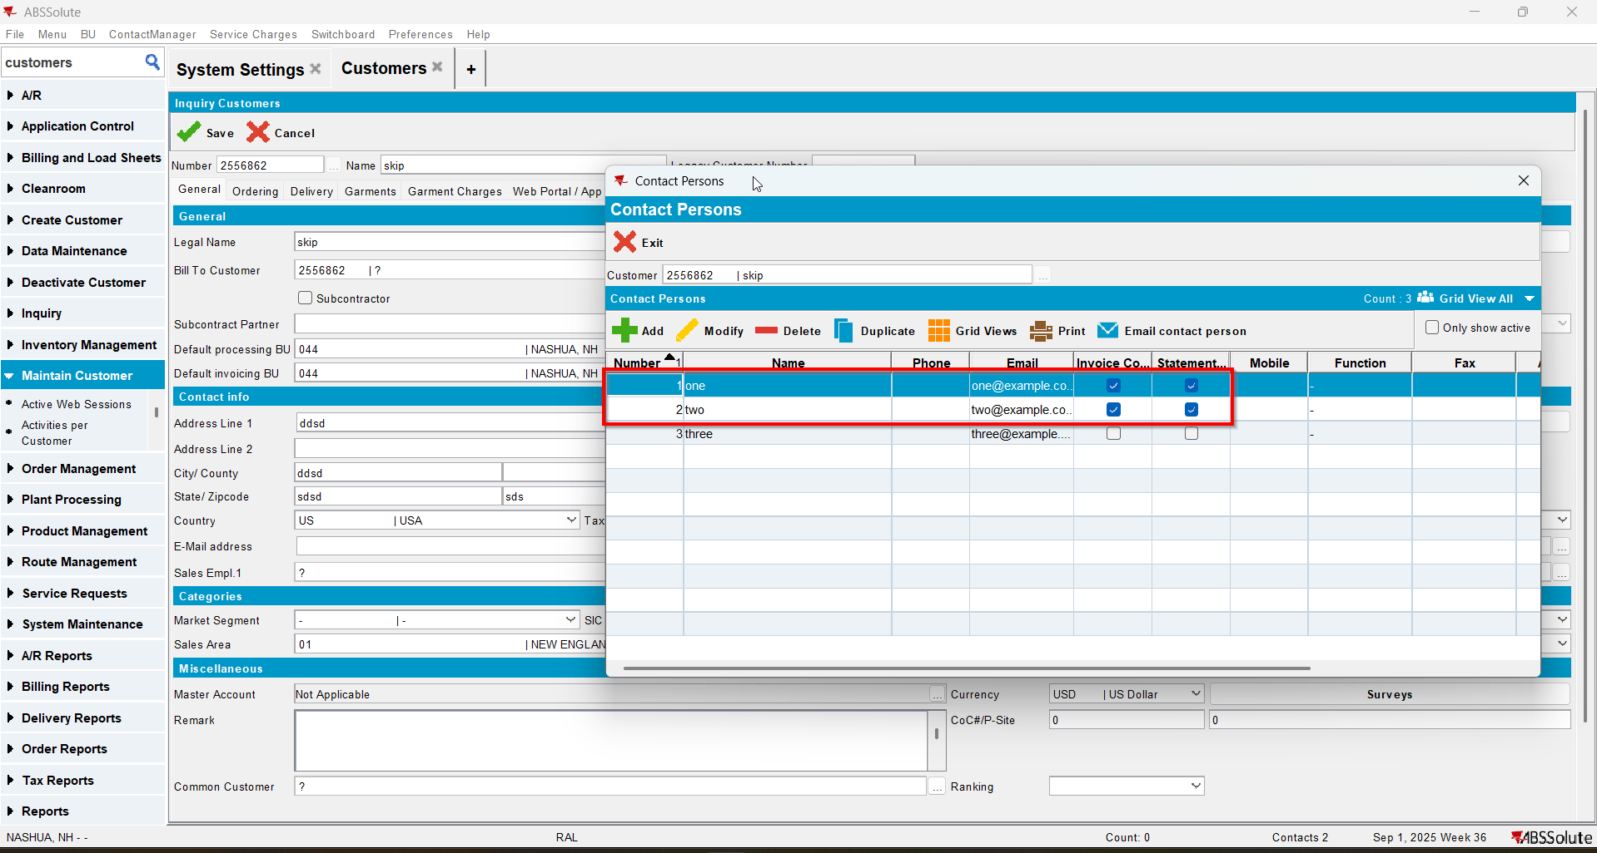
- Go to Billing tab and check that the contact persons that are set as invoice/statement contacts will also appear here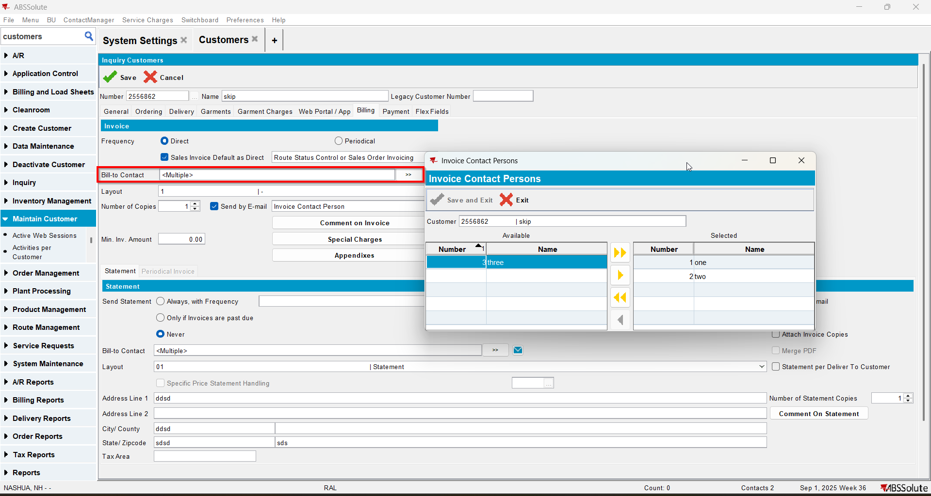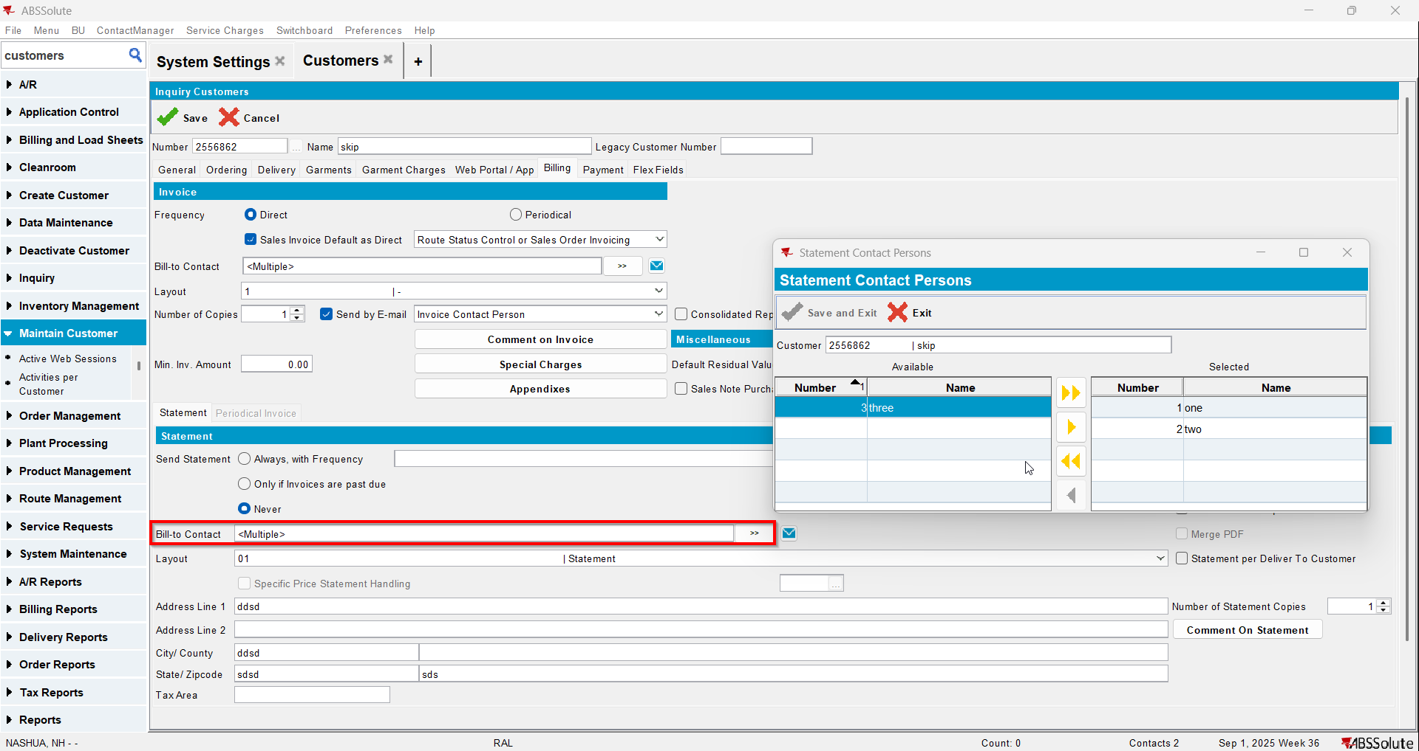
- Save your customer and check that everything was saved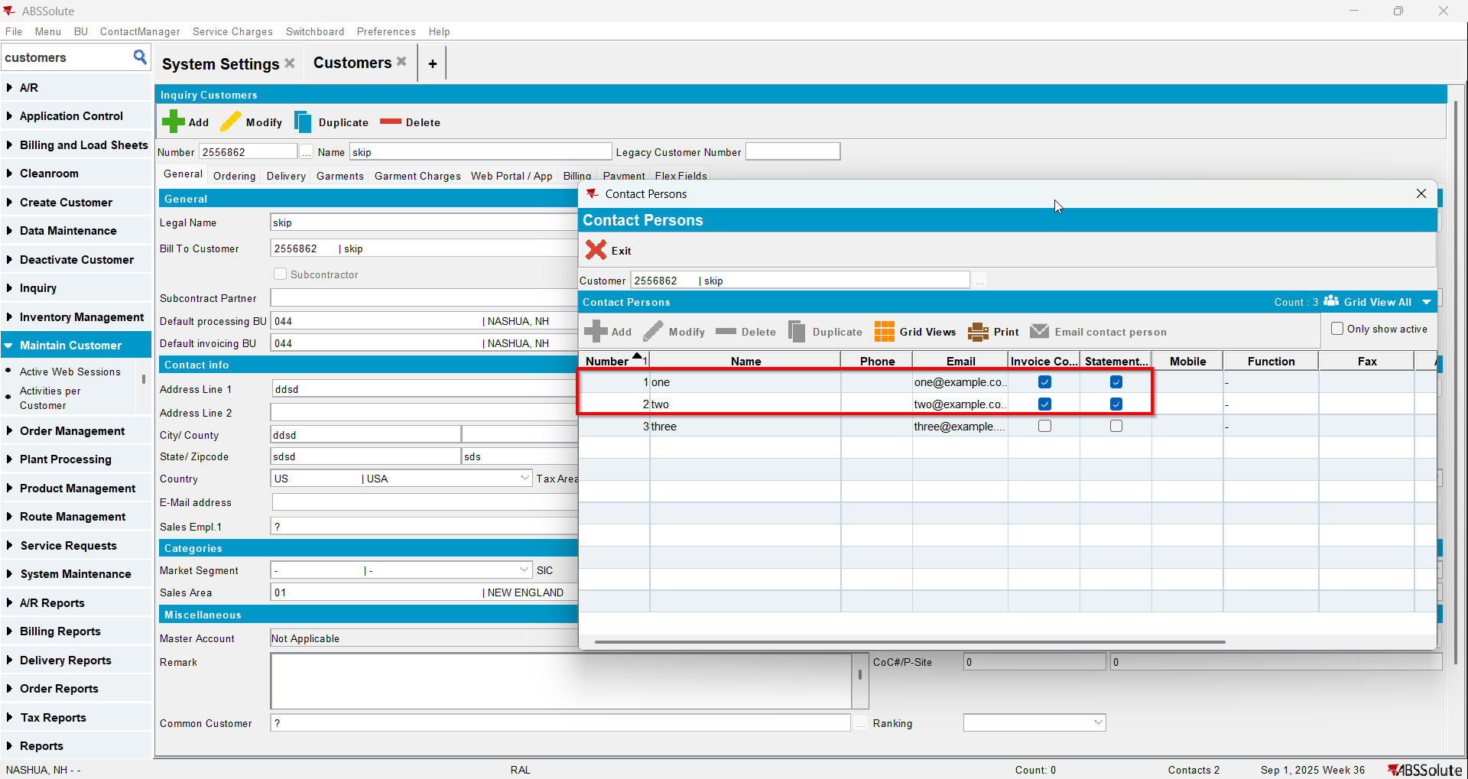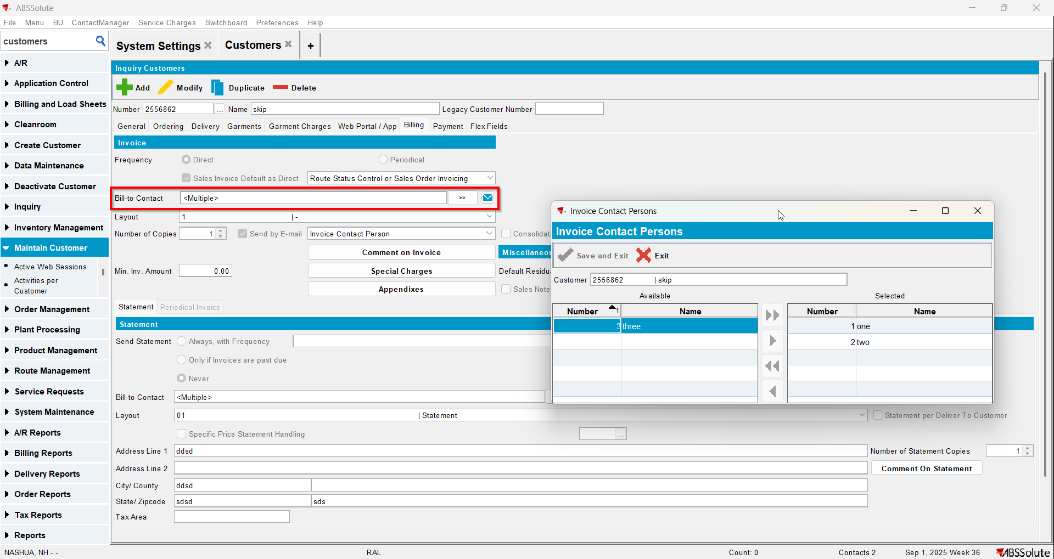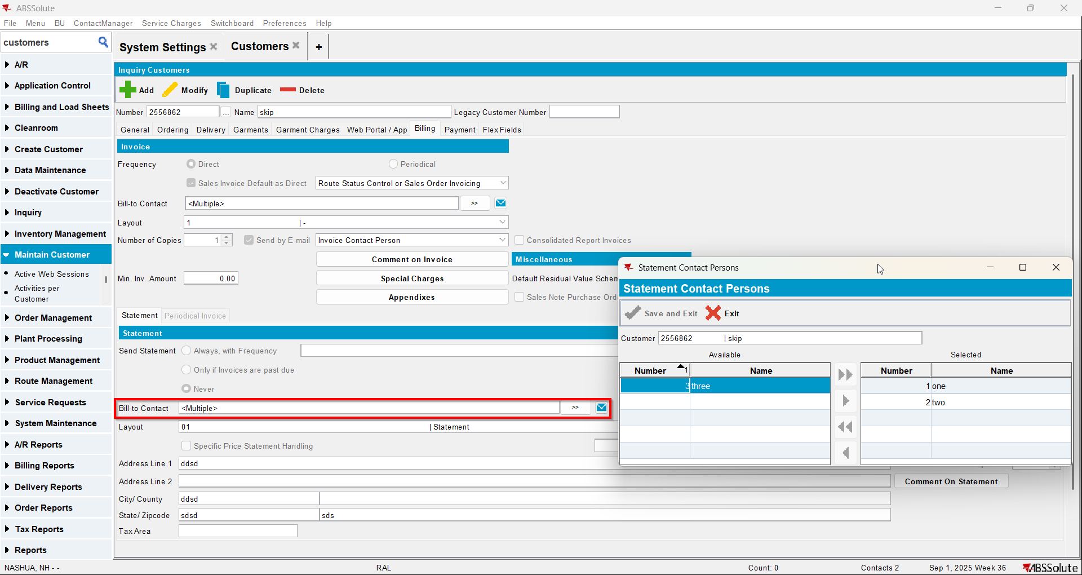
- Add another customer(Customer 2) but don’t save
- Put Customer 1 as the bill to for Customer 2
- Add more contact persons and make some of them invoice and statement contacts 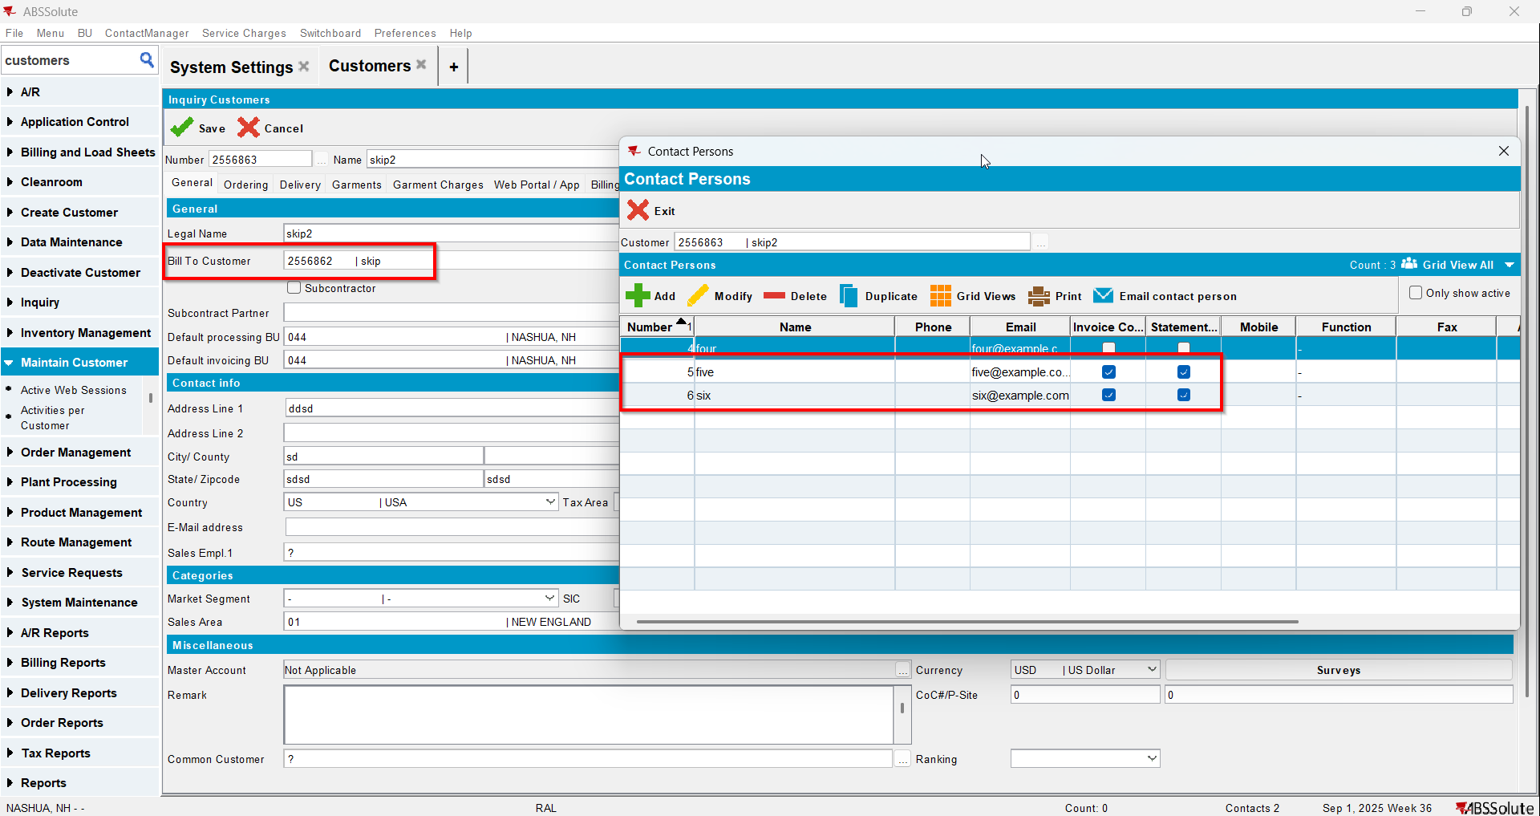
- Go to Billing tab and check that the contact persons that are set as invoice/statement contacts will also appear here 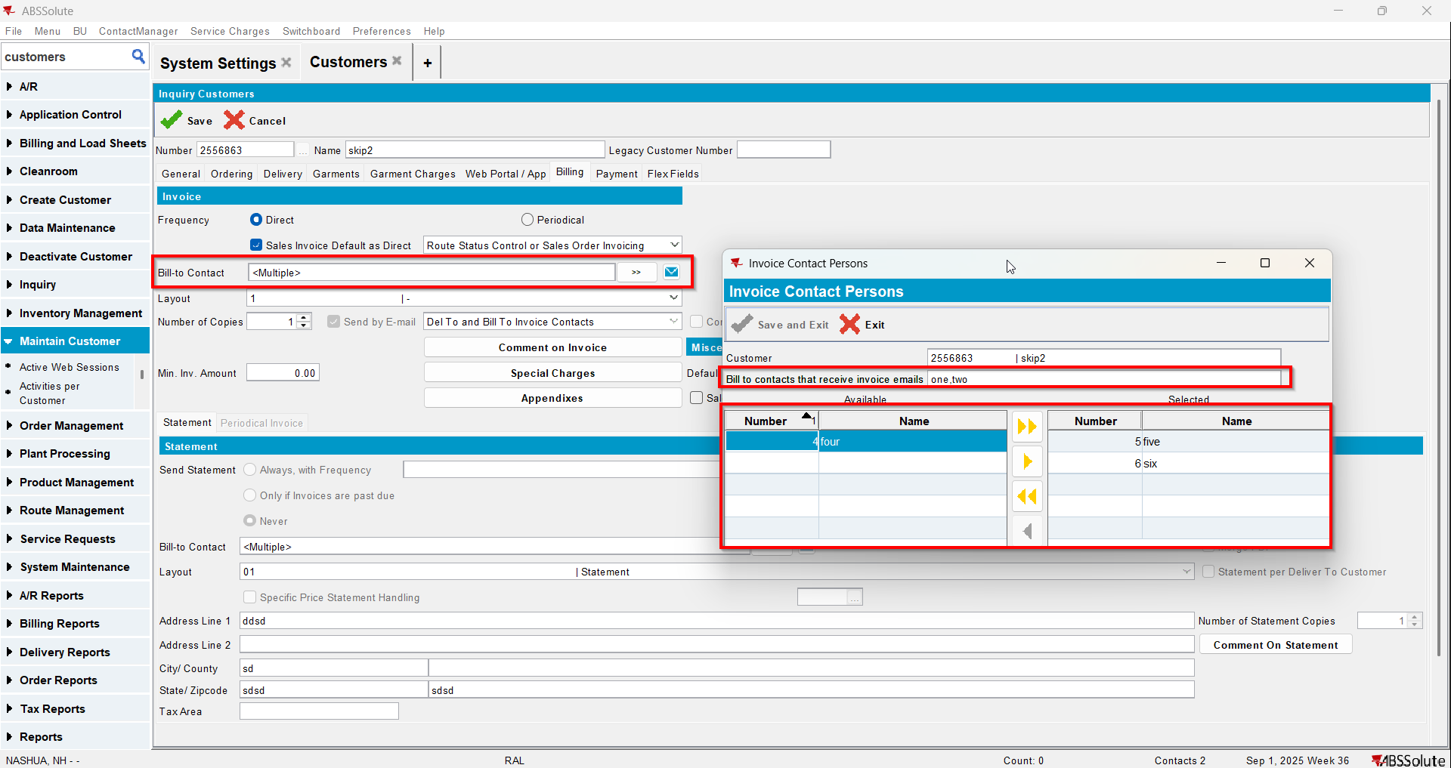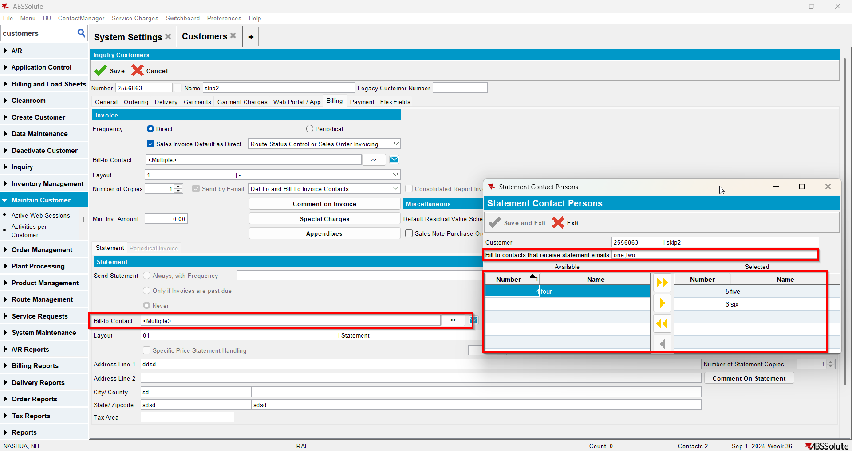
- Save your customer and check that everything was saved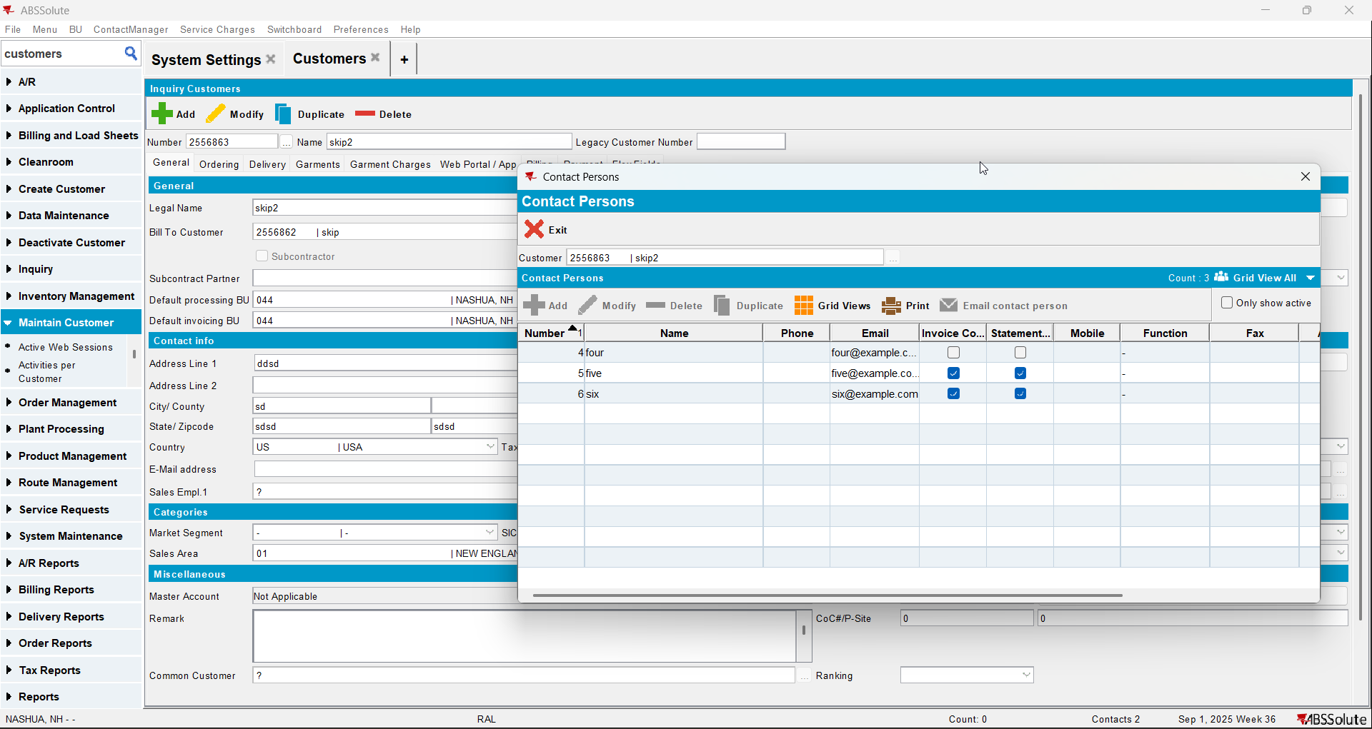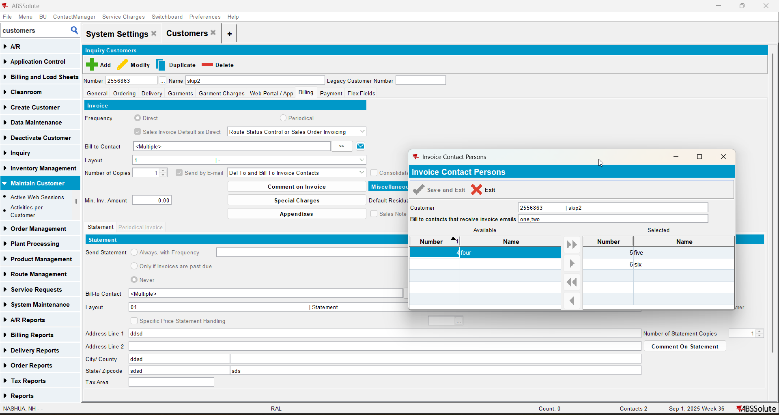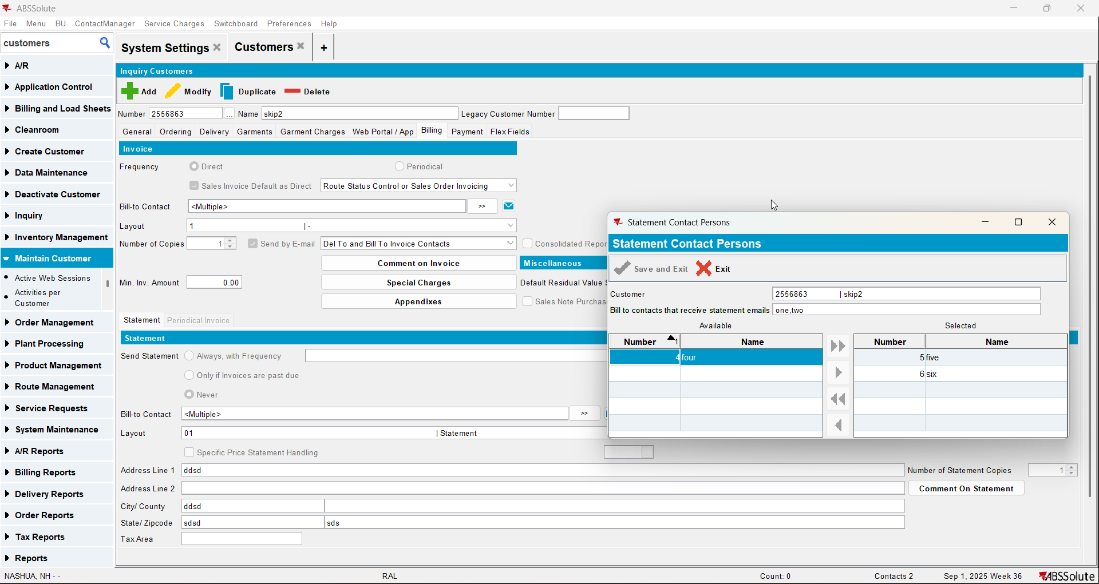

Customer Financial Details dialog

Test Case 1 – MULTIPLEINVANDSTMCONTACTS=0 and customer is its own bill to – Tested OK
Expected behavior: Information about the contact person appears and E-Mail statement button is enabled
Hash: ff9c238
- Check that SS MULTIPLEINVANDSTMCONTACTS=0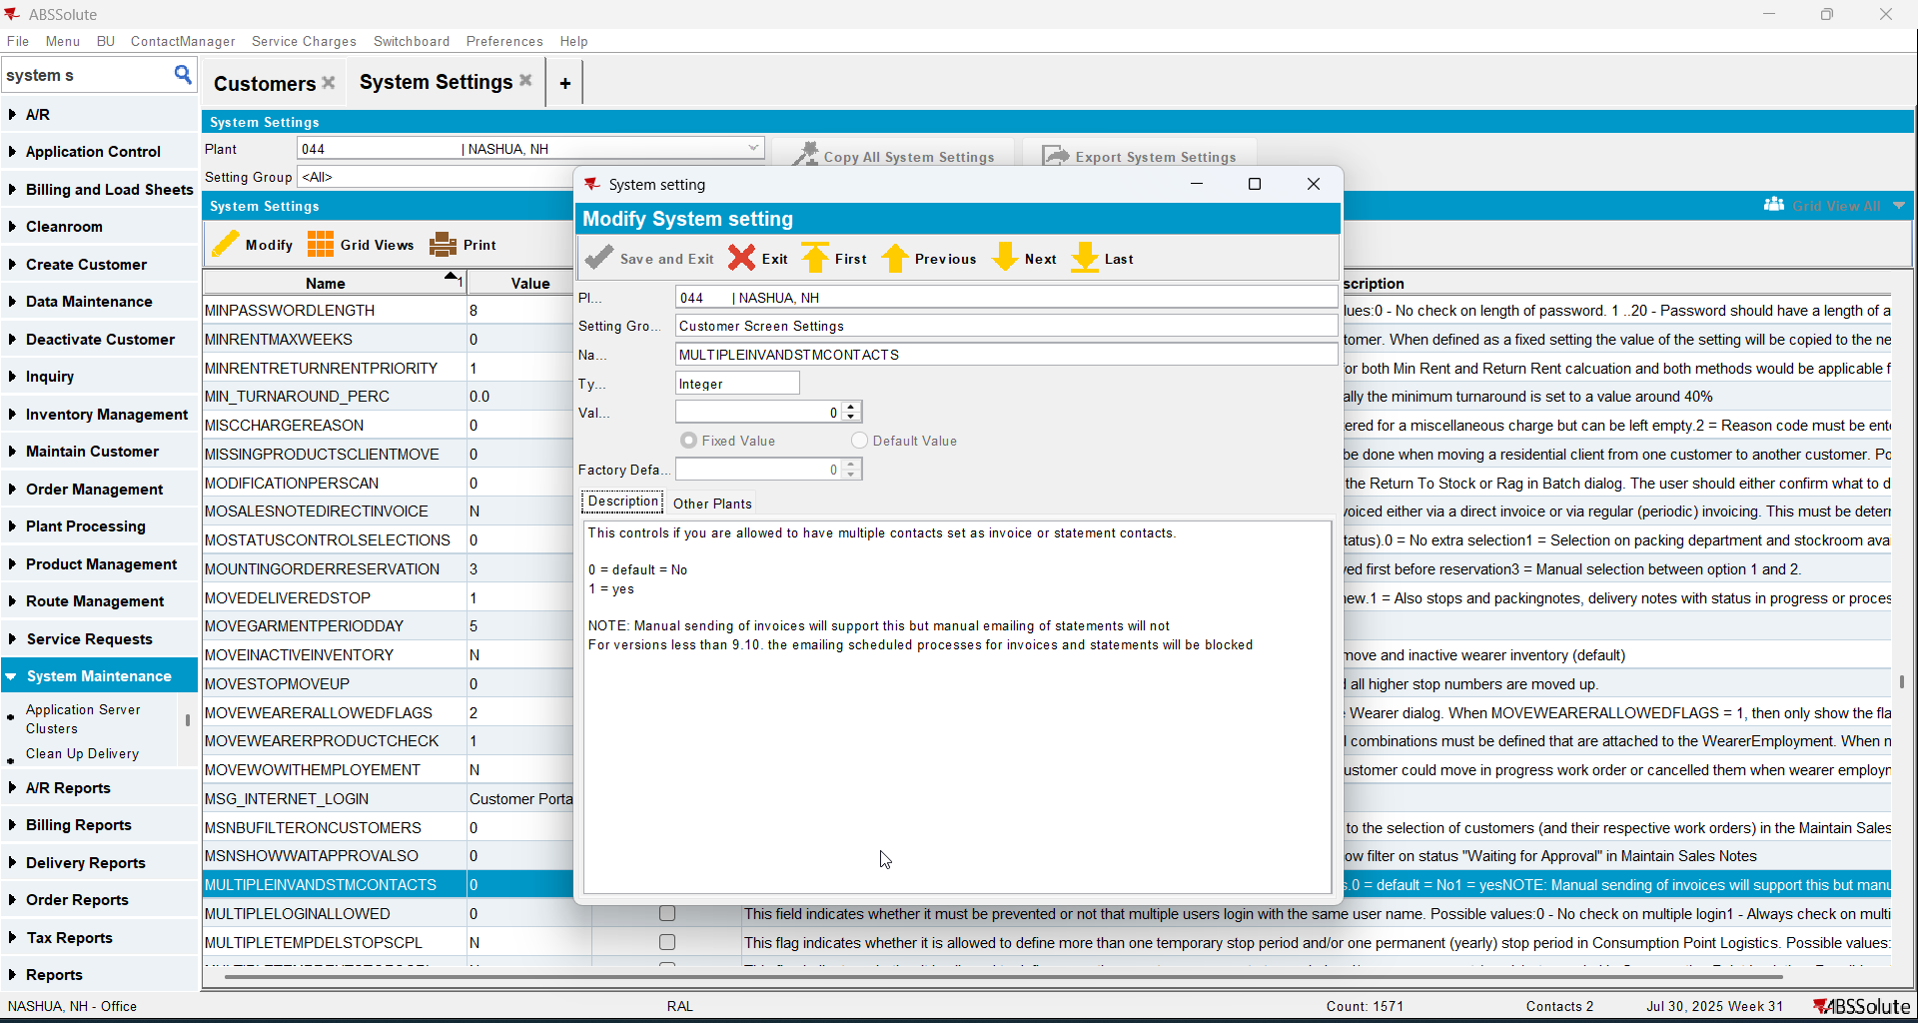
- Have a customer that is its own bill to and has 1 contact person that is invoice and statement contact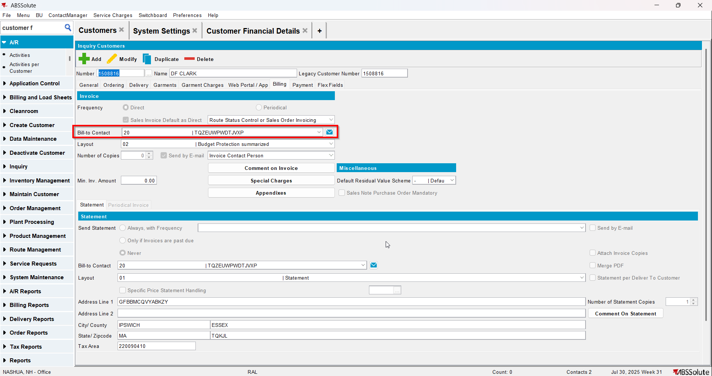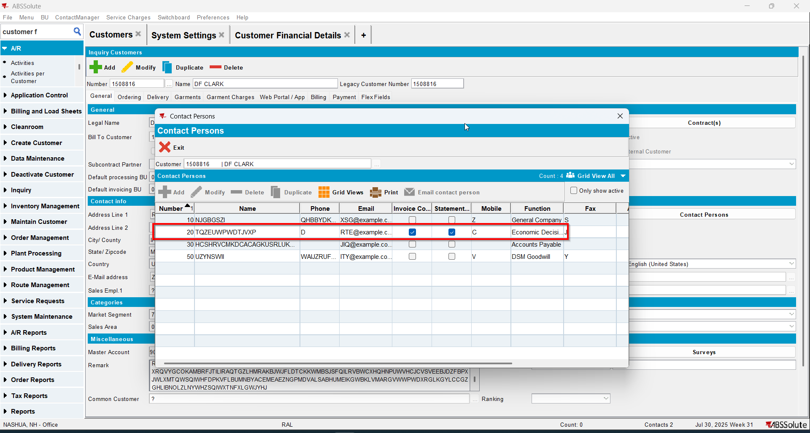
- Go to Customer Financial Details dlg
- Check that the information about the contact person appears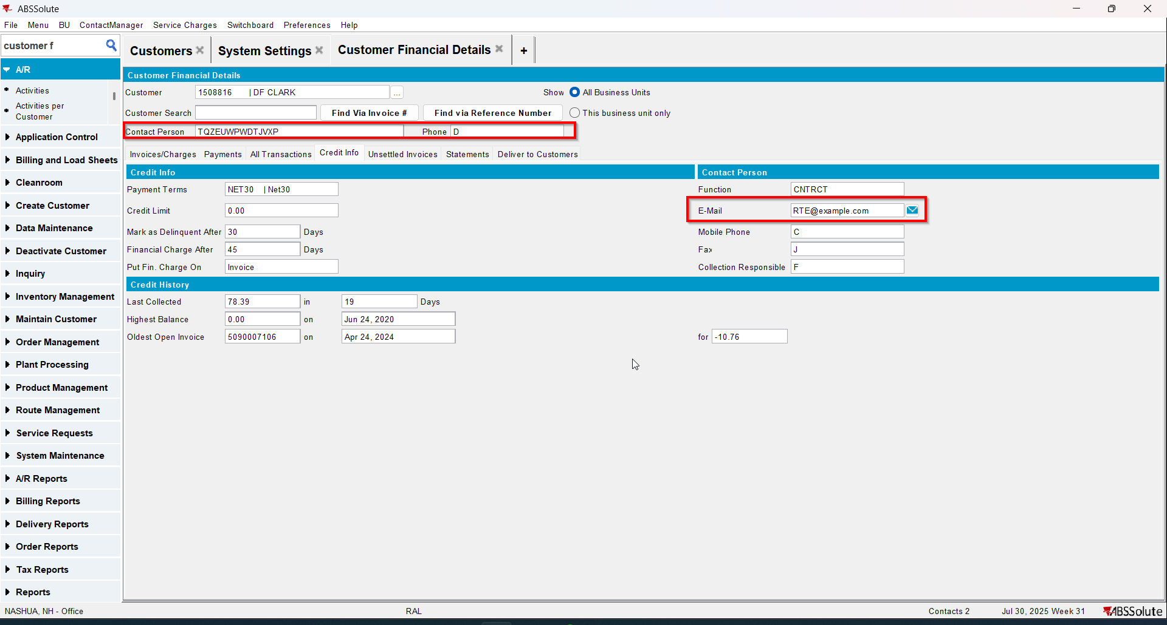
- Go to Statement tab and load some statements
- Select a statement and check that the E-Mail statement button is enabled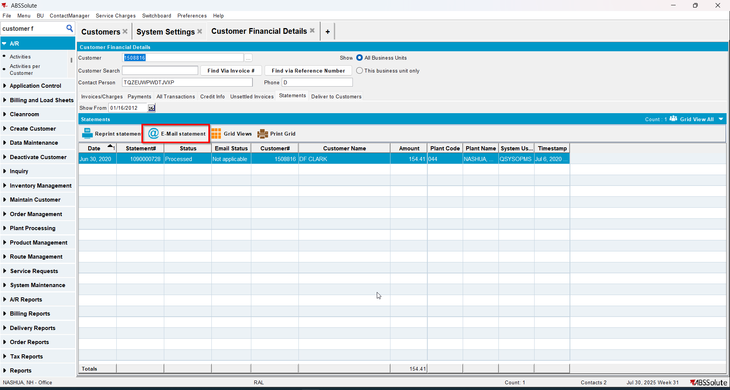

Test Case 2 – MULTIPLEINVANDSTMCONTACTS=0 and customer is not its own bill to – Tested OK
Expected behavior: Information about the contact person appears and E-Mail statement button is enabled
Hash: ff9c238
- Check that SS MULTIPLEINVANDSTMCONTACTS=0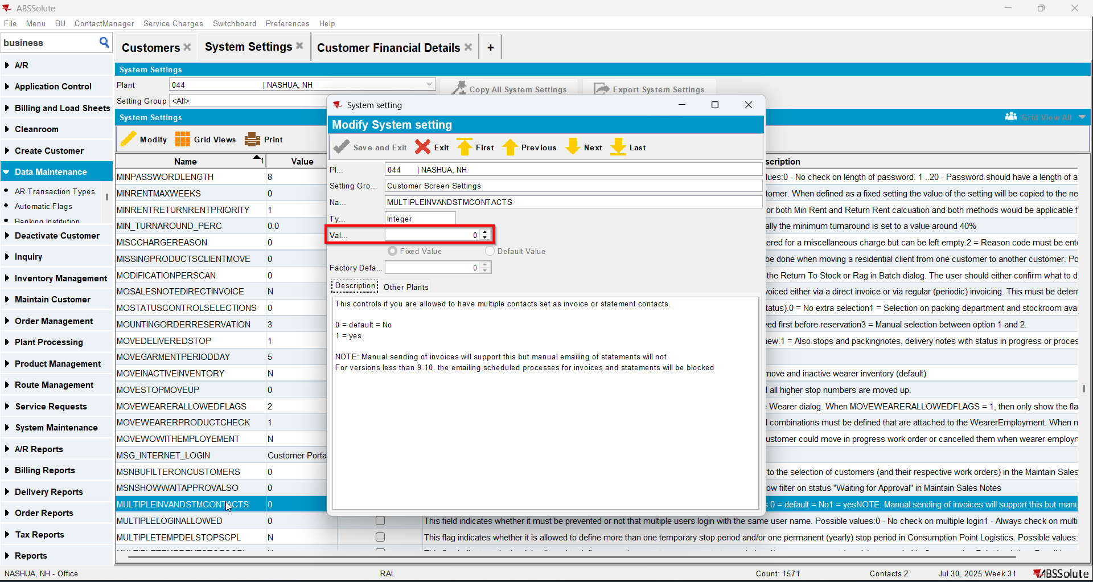
- Have a customer that is not its own bill to 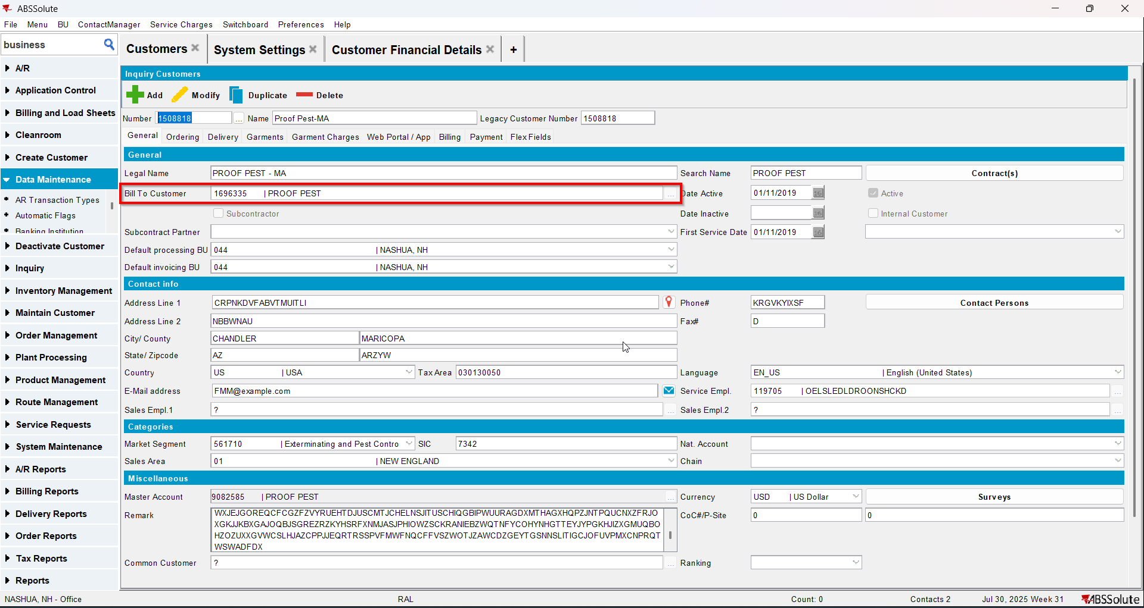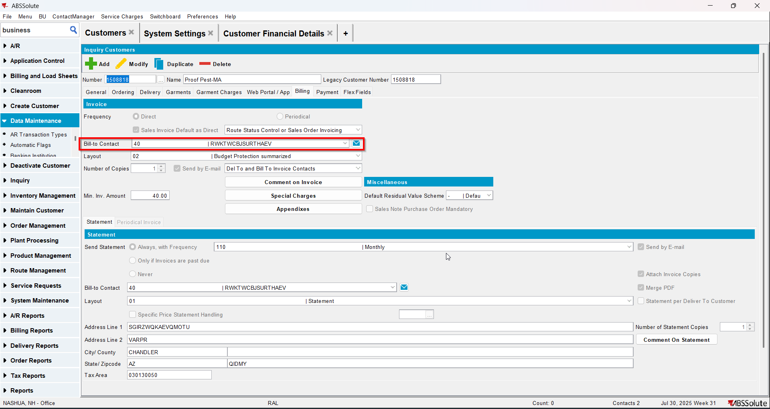
- Bill to customer has 1 contact person that is invoice and statement contact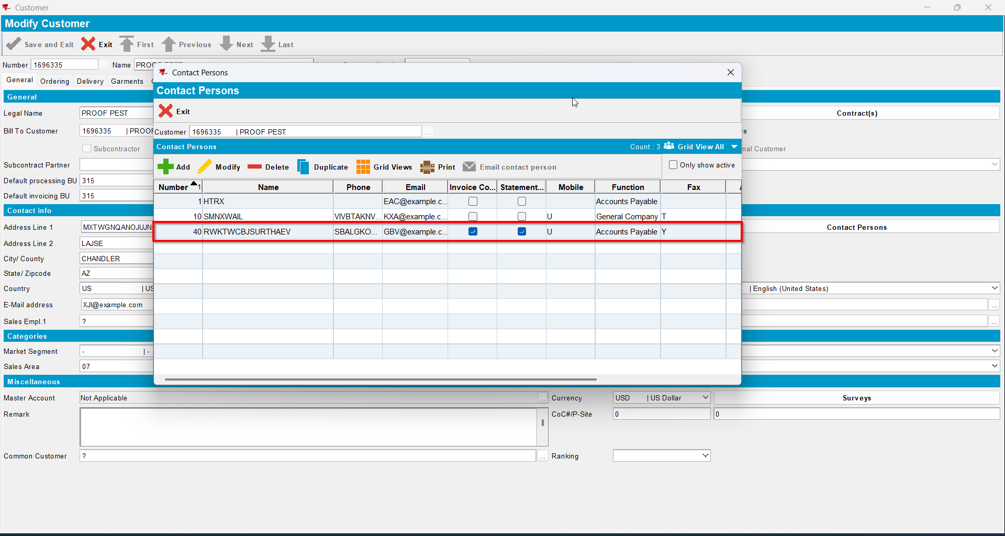
- Go to Customer Financial Details dlg and load the del to customer
- Check that the information about the contact person of the bill to appears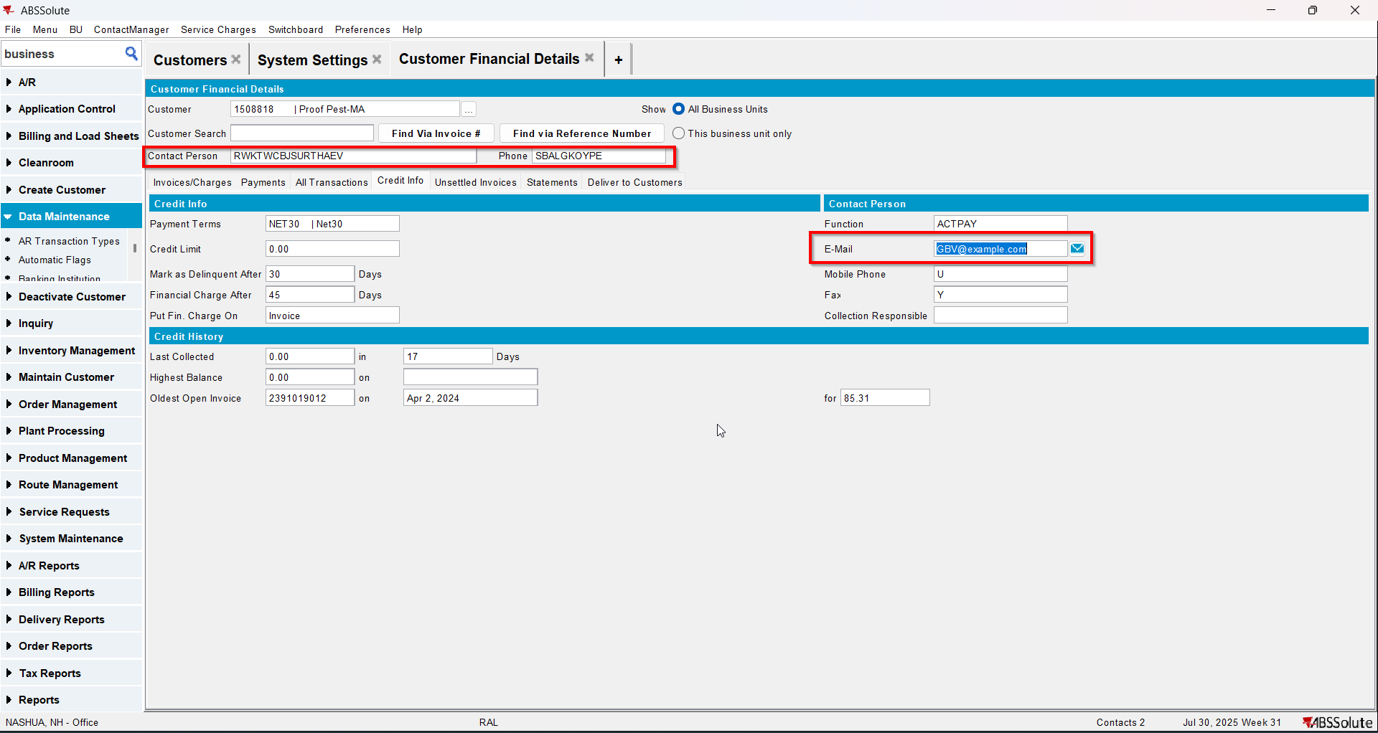
- Go to Statement tab and load some statements
- Select a statement and check that the E-Mail statement button is enabled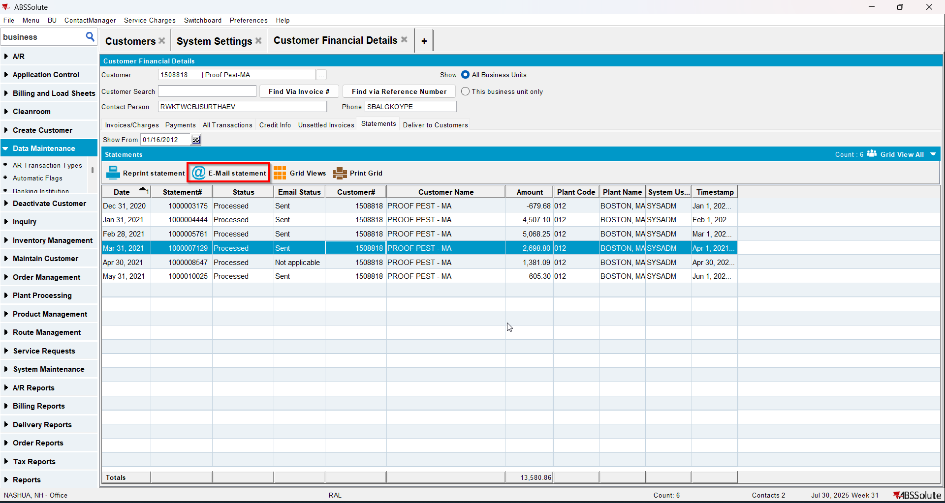

Test Case 3 – Send E-Mail when MULTIPLEINVANDSTMCONTACTS=0 and customer is its own bill to – Tested OK
Expected behavior: The invoice should be emailed to the email address of the contact persons that is invoice contact, not on the email address that is on the invoice header
Hash: ff9c238
- Check that SS MULTIPLEINVANDSTMCONTACTS=0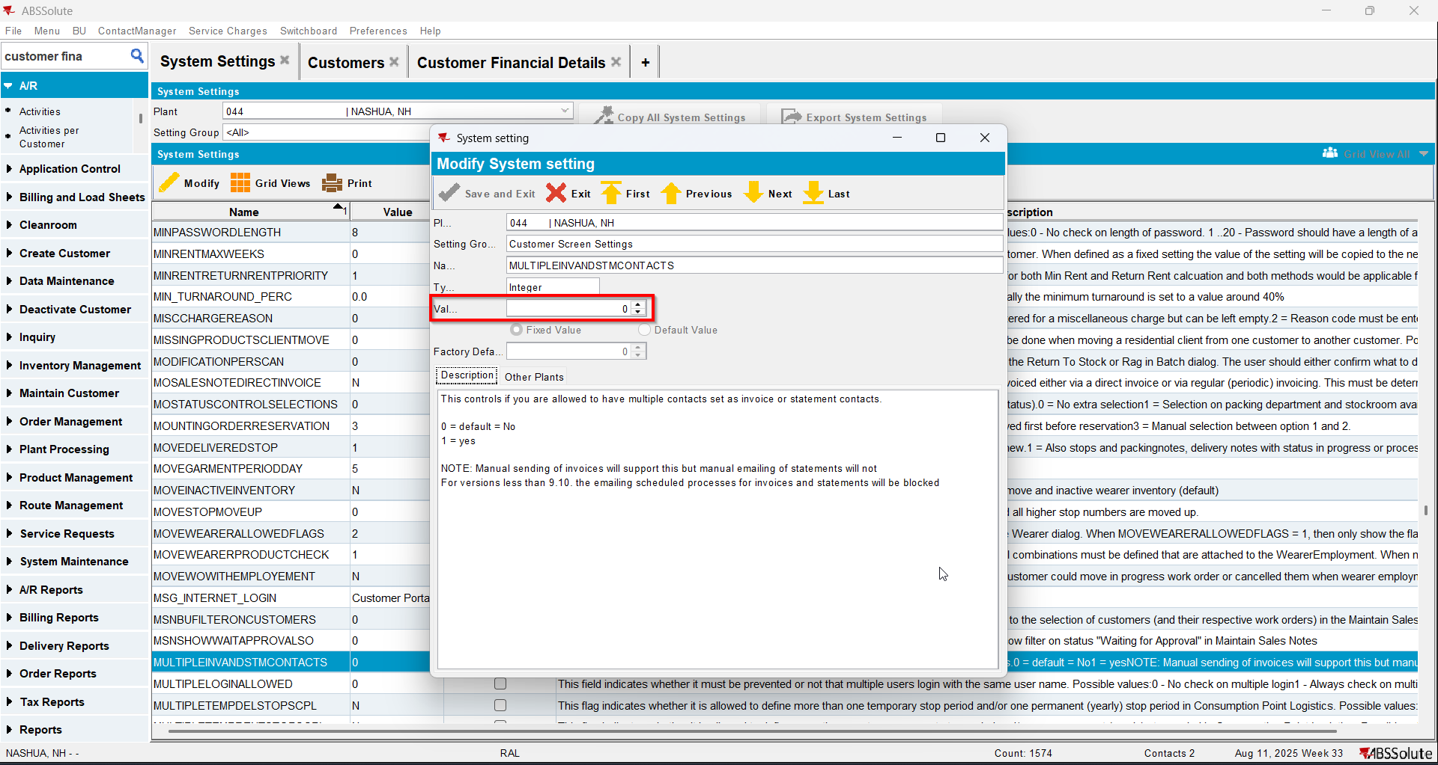
- Have a customer that is its own bill to
- Check that he has 1 contact person that is invoice contact and has a valid email address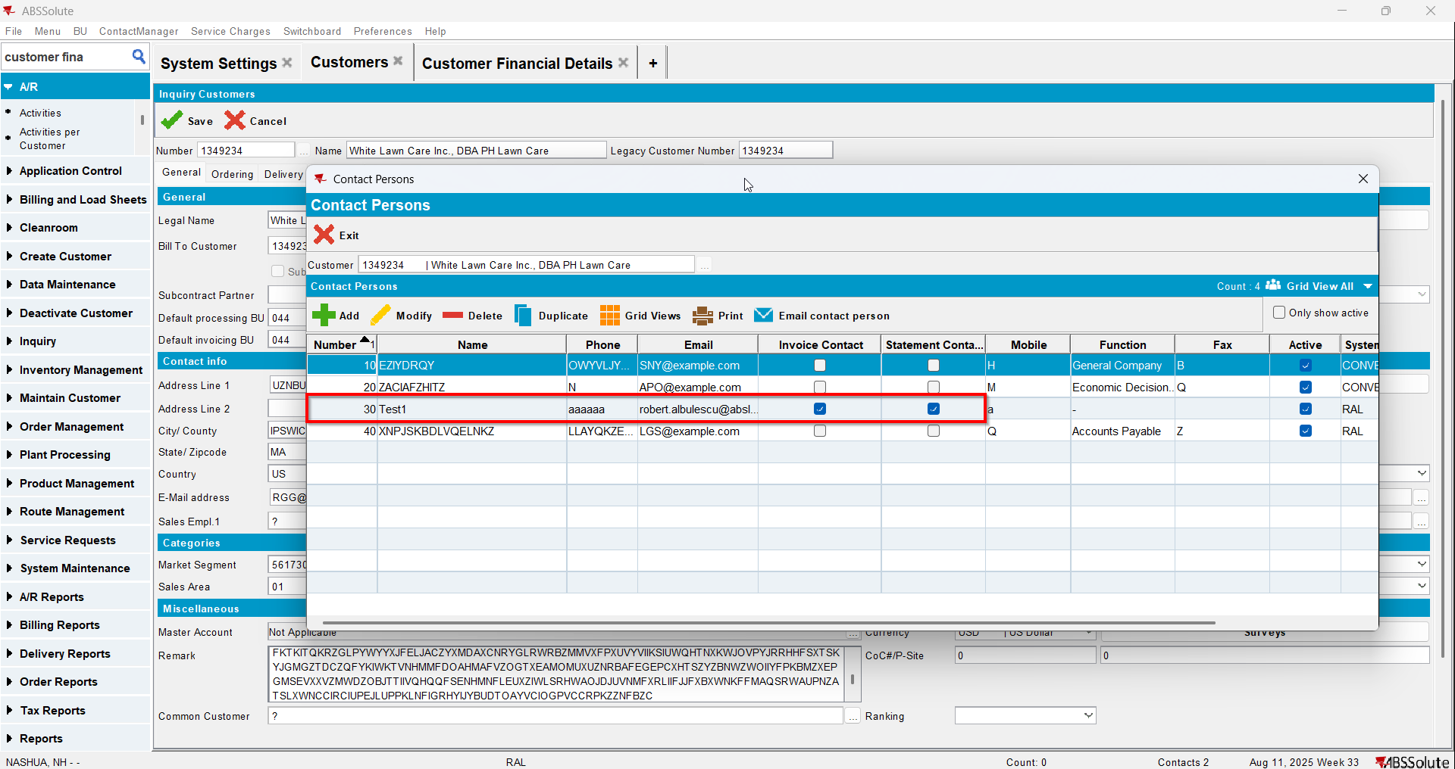
- For an invoice check what email address is on the invoice header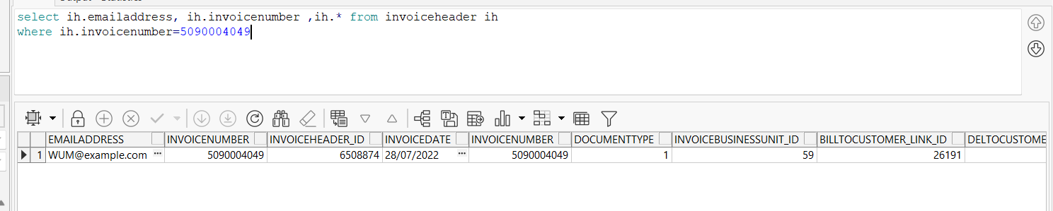
- Go to Customer Financial Details dlg and load your customer
- To Invoices tab select your invoice from step 4 and press E-mail Invoice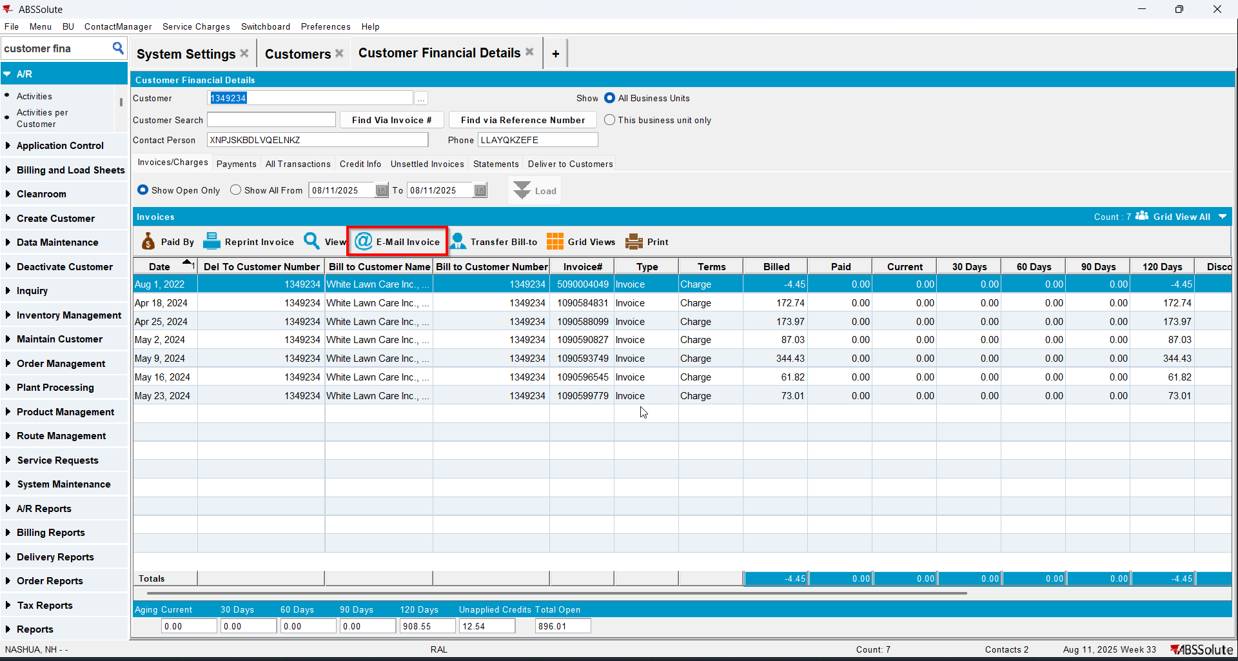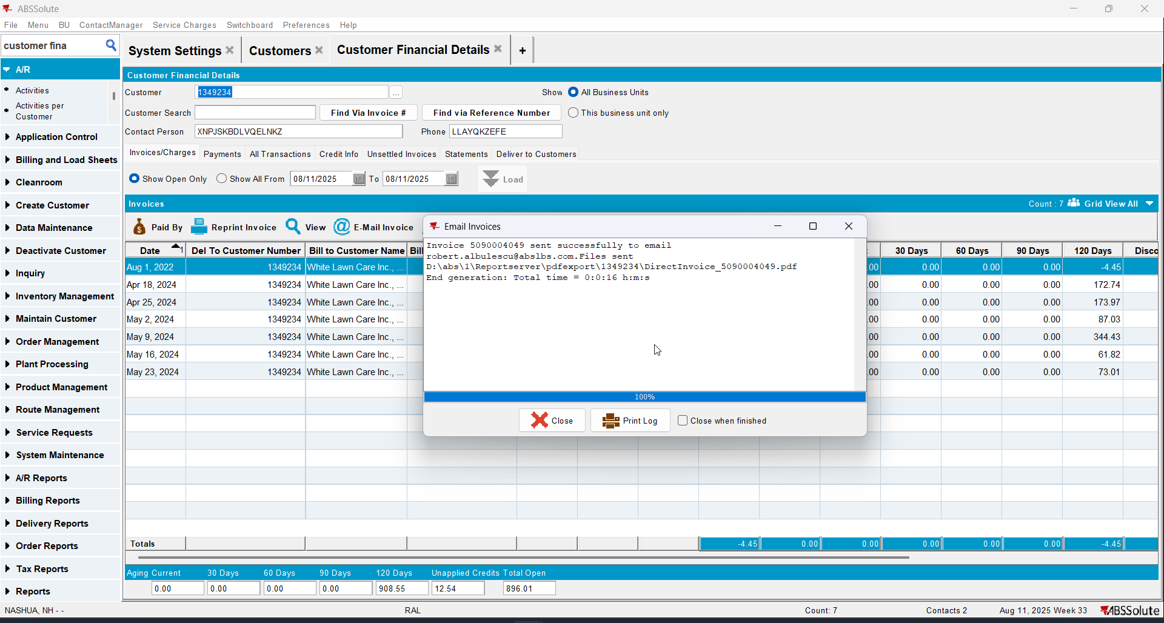
- Check if the email was sent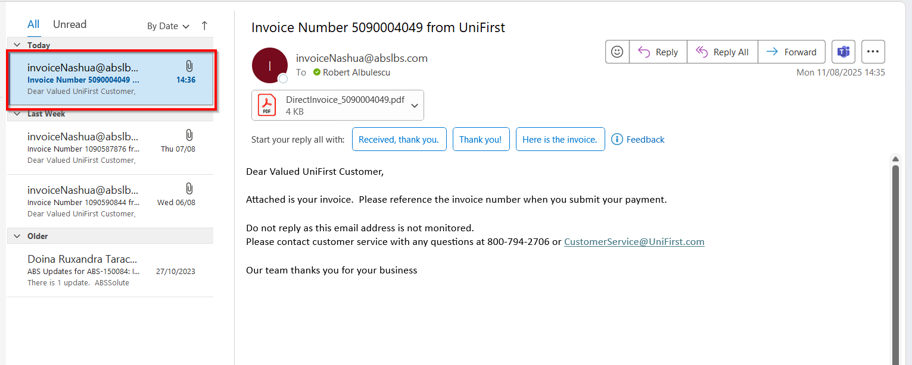

Test Case 4 – Send E-Mail when MULTIPLEINVANDSTMCONTACTS=0 and customer is not its own bill to – Tested OK
Expected behavior: The invoice should be emailed to the email address of the contact persons that is invoice contact, not on the email address that is on the invoice header
Hash: ff9c238
- Check that SS MULTIPLEINVANDSTMCONTACTS=0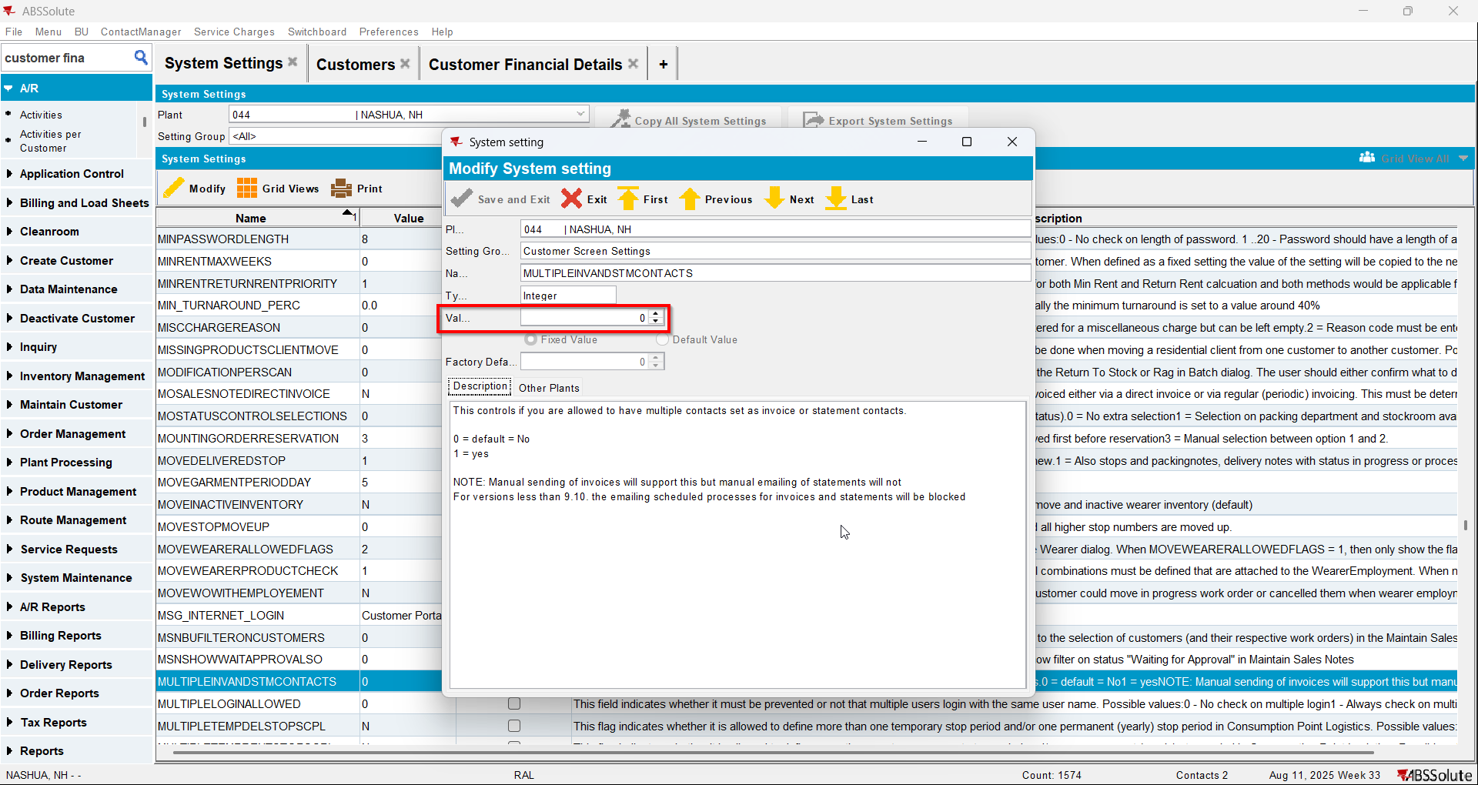
- Have a customer that is not its own bill to
- Check that he has 1 contact person that is invoice contact and has a valid email address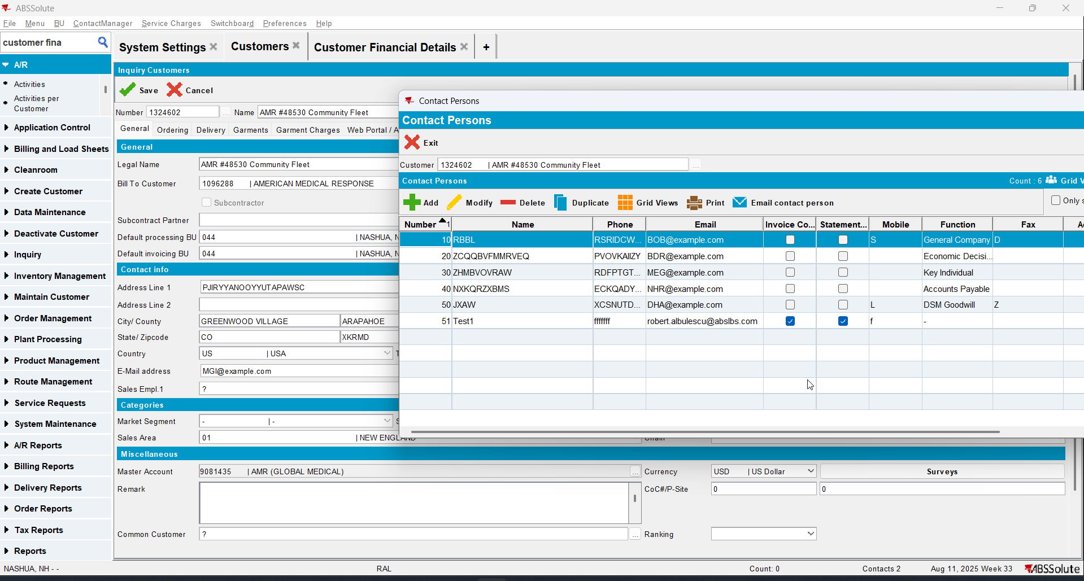
- Go on the bill to customer and also check that he has 1 contact person that is invoice contact and has a valid email address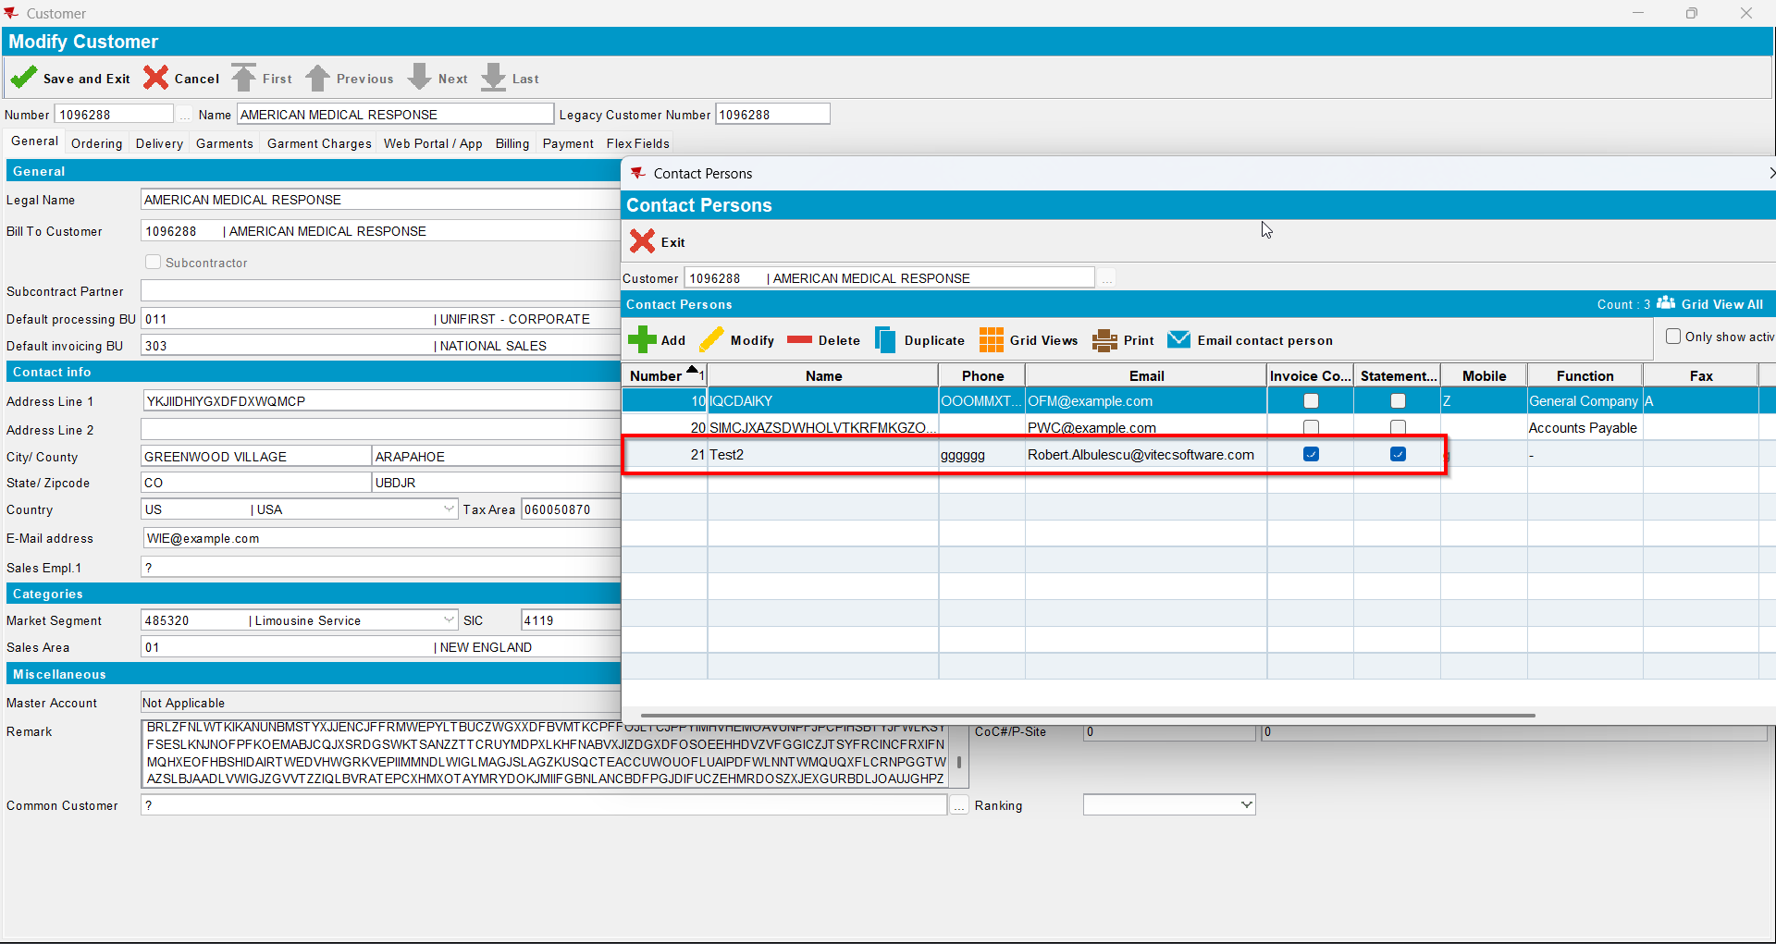
- Also on the bill to customer check that checkbox Send by E-mail is checked and on the drop-down selection the ‘Bill To Invoice Contact’ option is selected(modifying this on bill to customer will also modify on del to customer )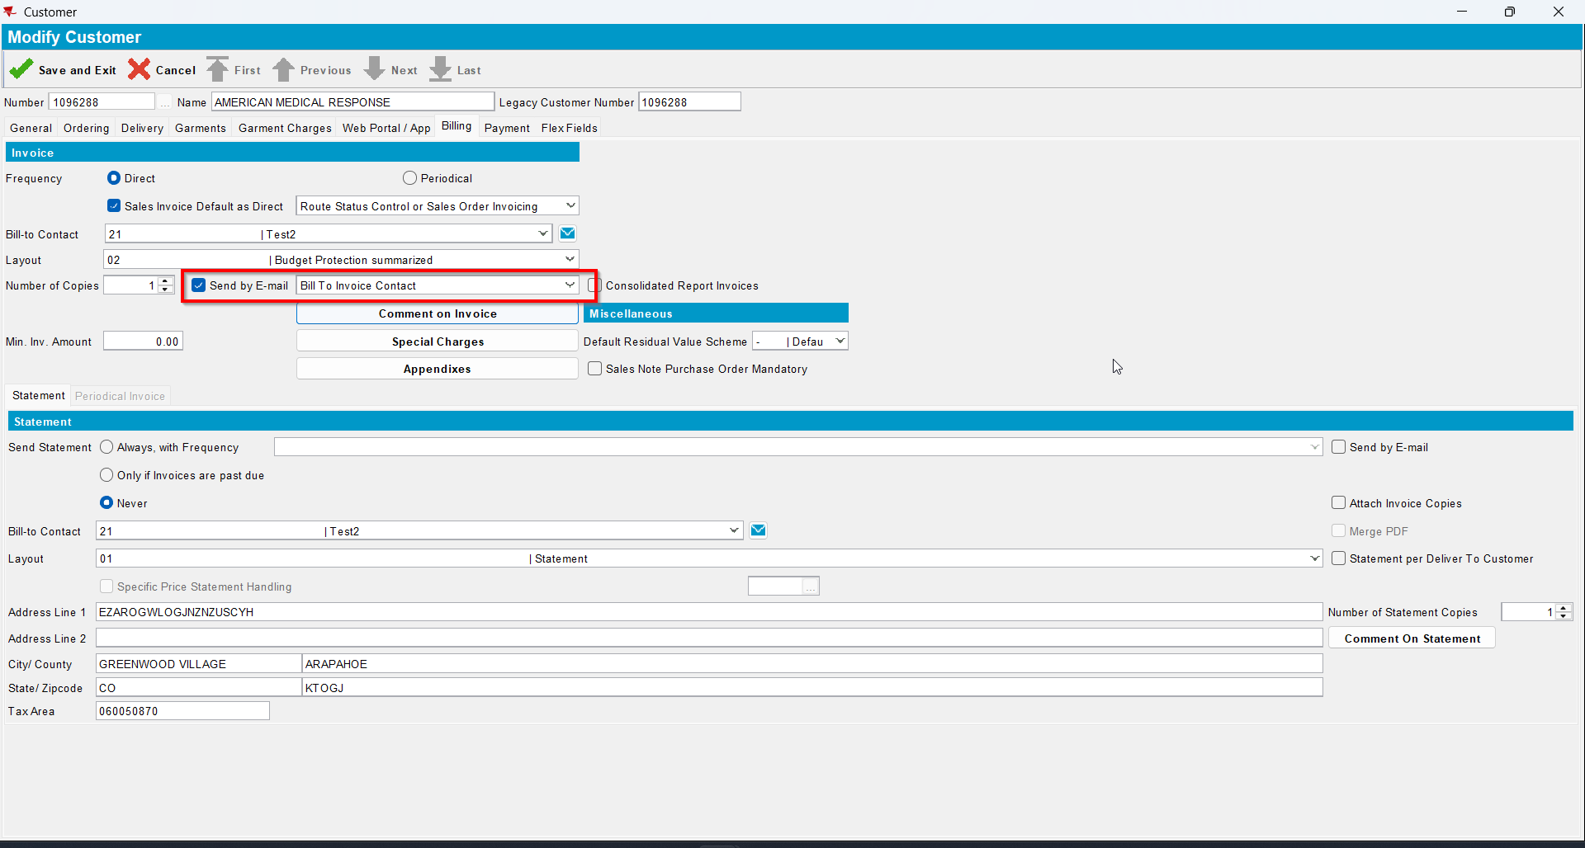
- For an invoice check what email address is on the invoice header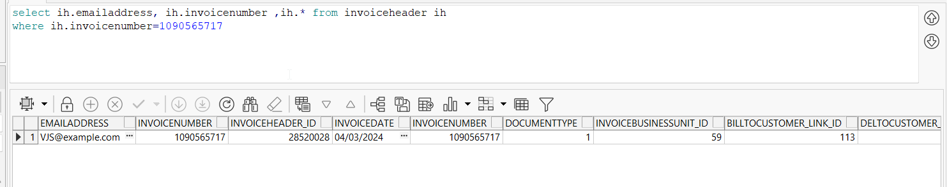
- Go to Customer Financial Details dlg and load your del to customer
- To Invoices tab select your invoice from step 6 and press E-mail Invoice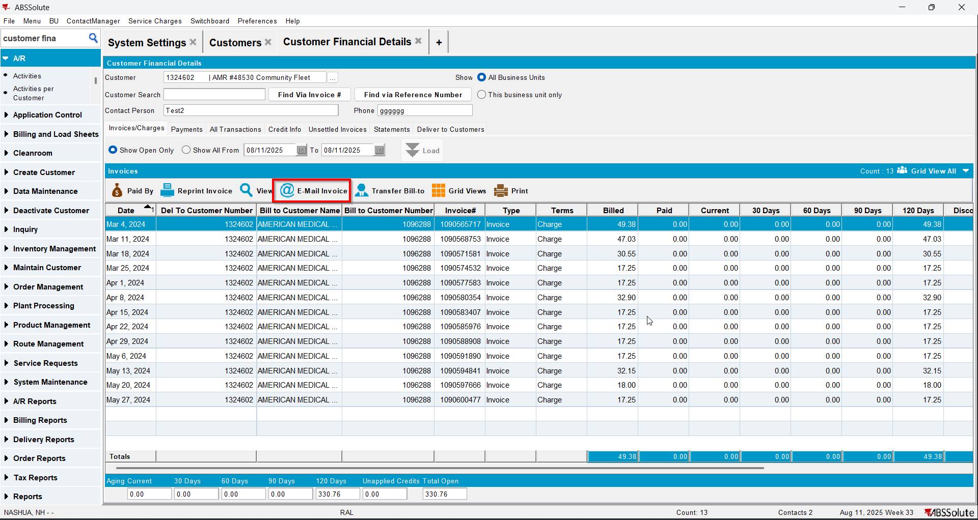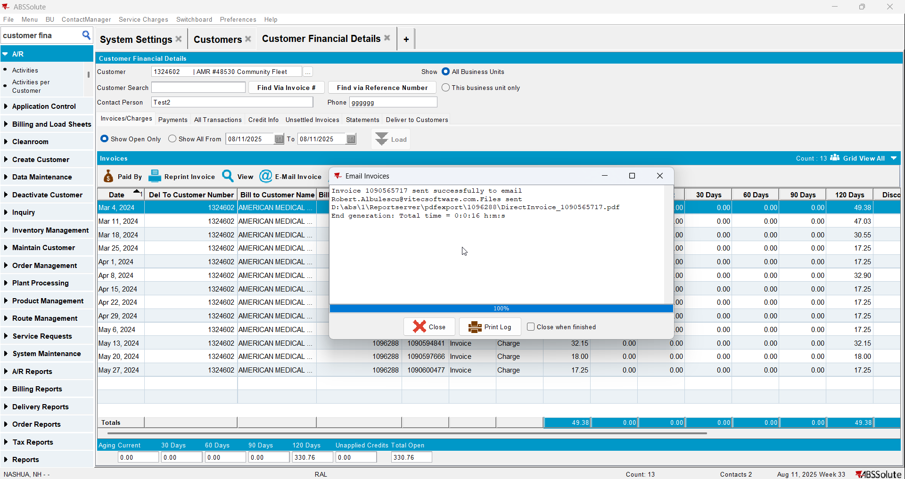
- Check if the email was sent to the contact person of the bill to customer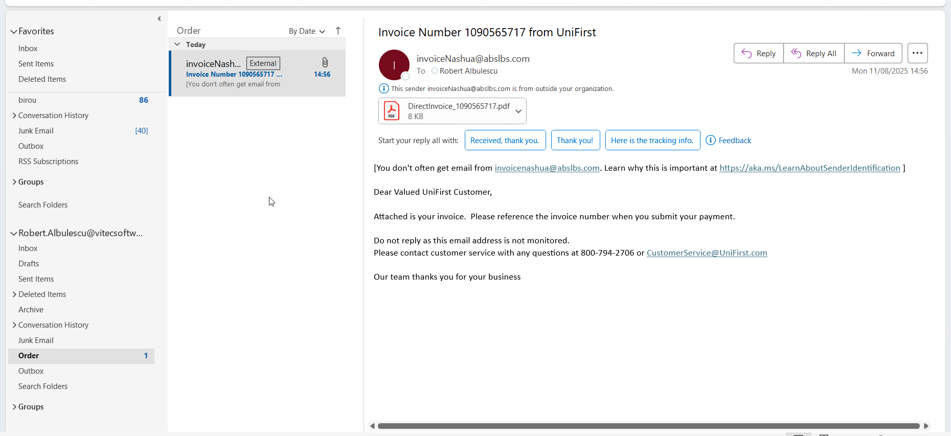
- Go on the bill to customer and on the drop-down select ‘Del To Invoice Contact’ option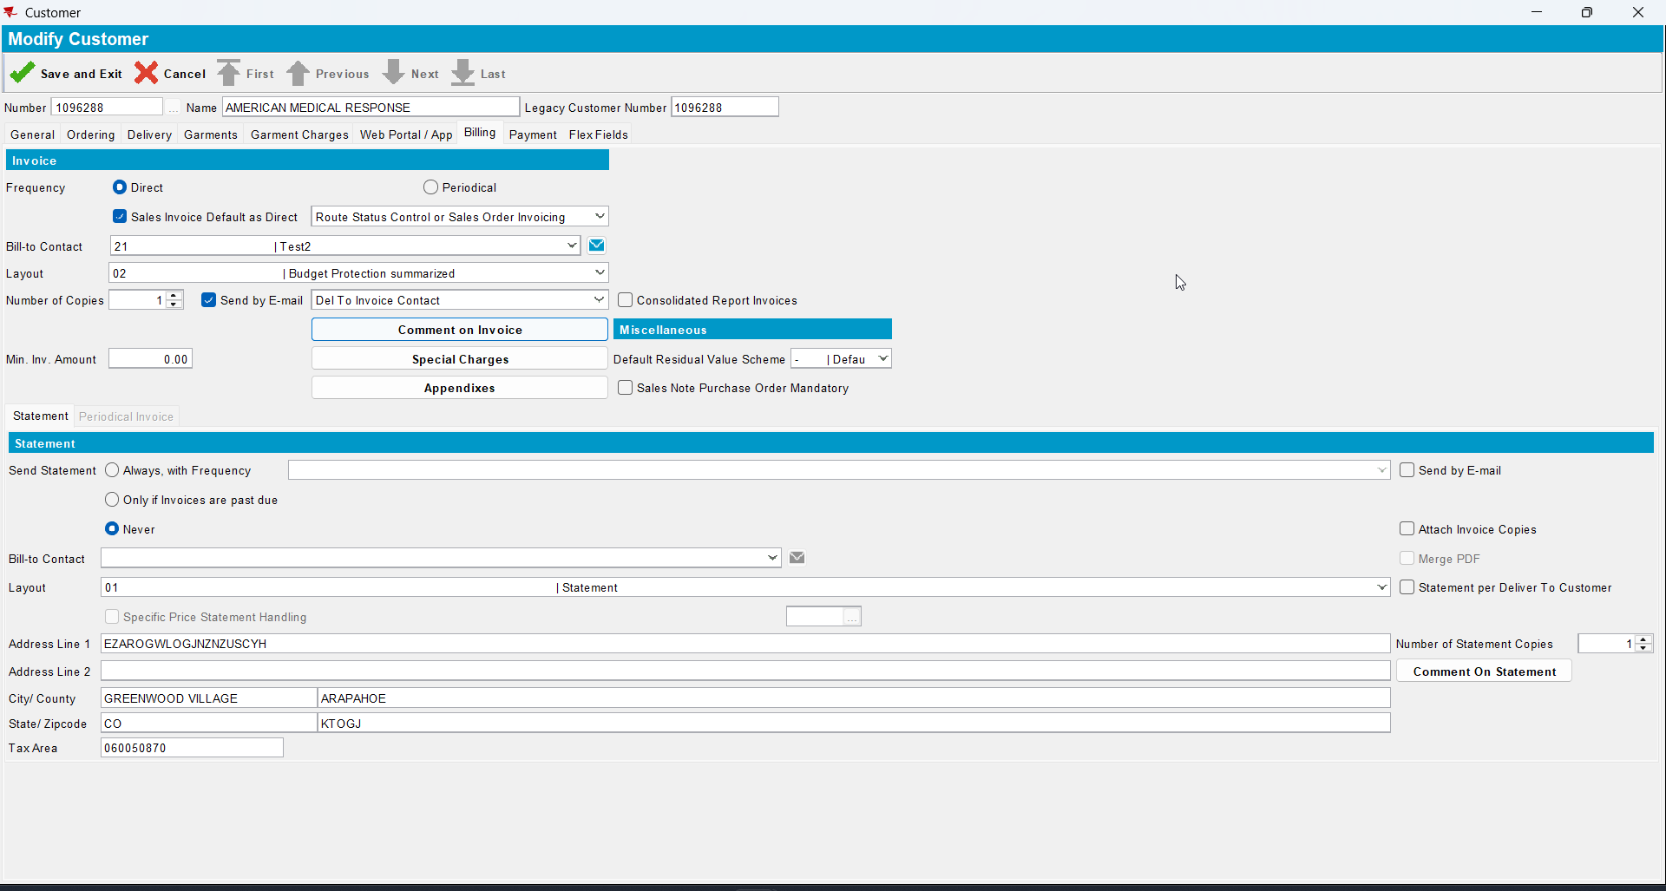
- Go to Customer Financial Details dlg and load your del to customer
- To Invoices tab select your invoice from step 6 and press E-mail Invoice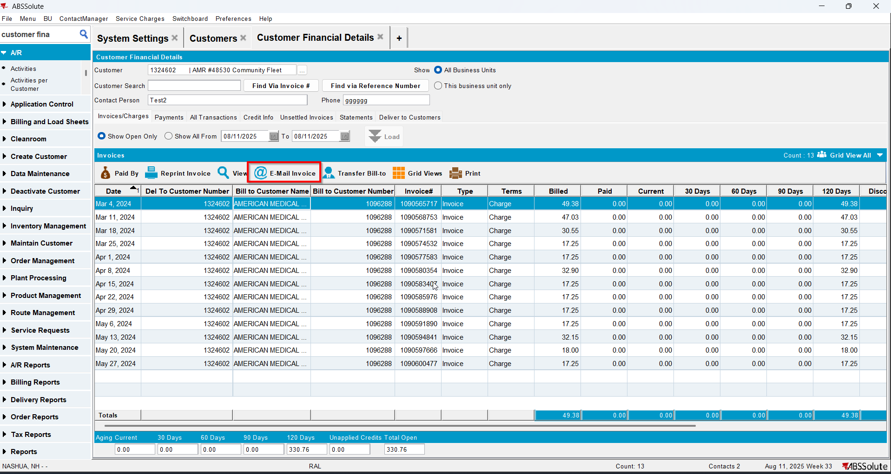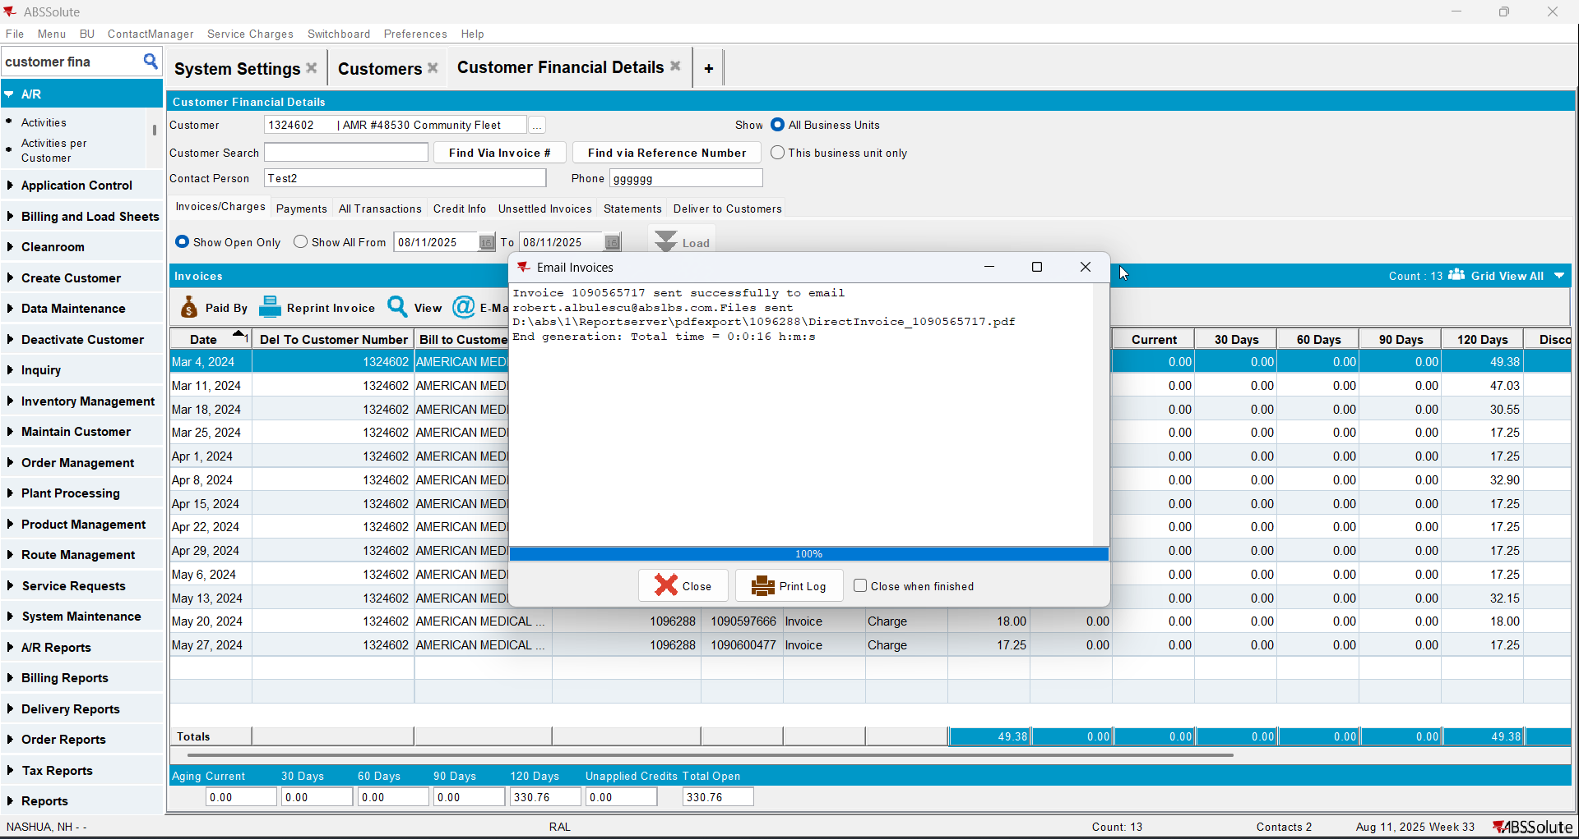
- Check if the email was sent to the contact person of the del to customer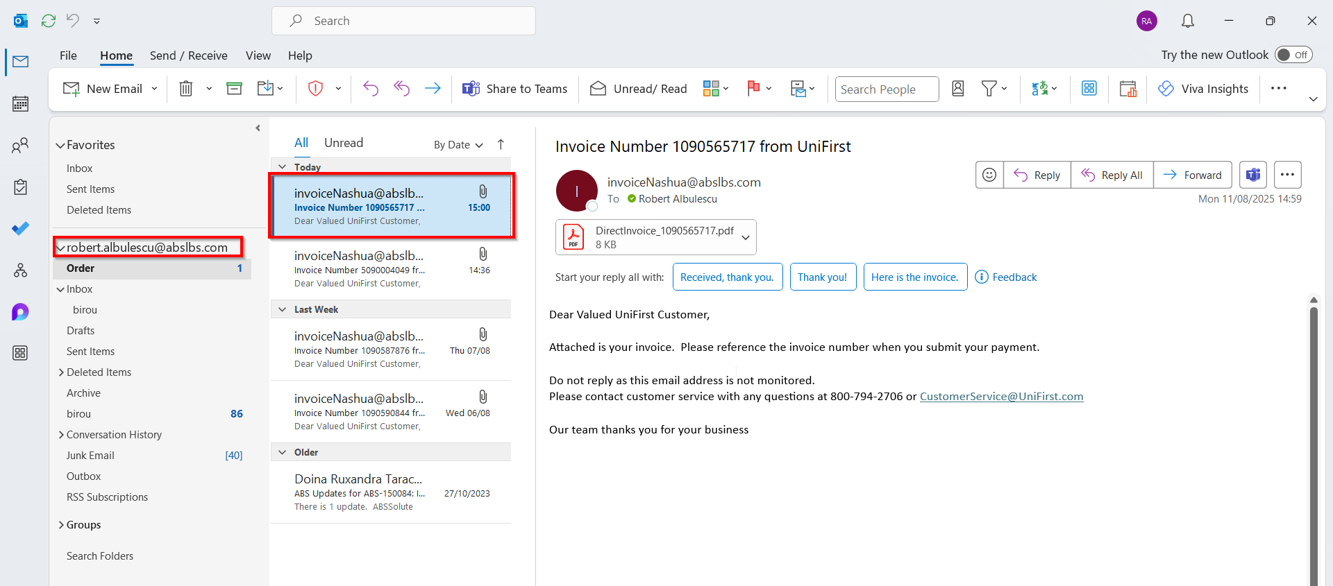
- Go on the bill to customer and on the drop-down select ‘Del To and Bill To Invoice Contacts’ option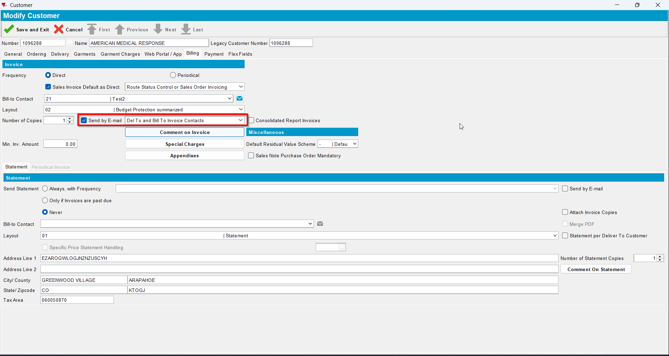
- Go to Customer Financial Details dlg and load your del to customer
- To Invoices tab select your invoice from step 6 and press E-mail Invoice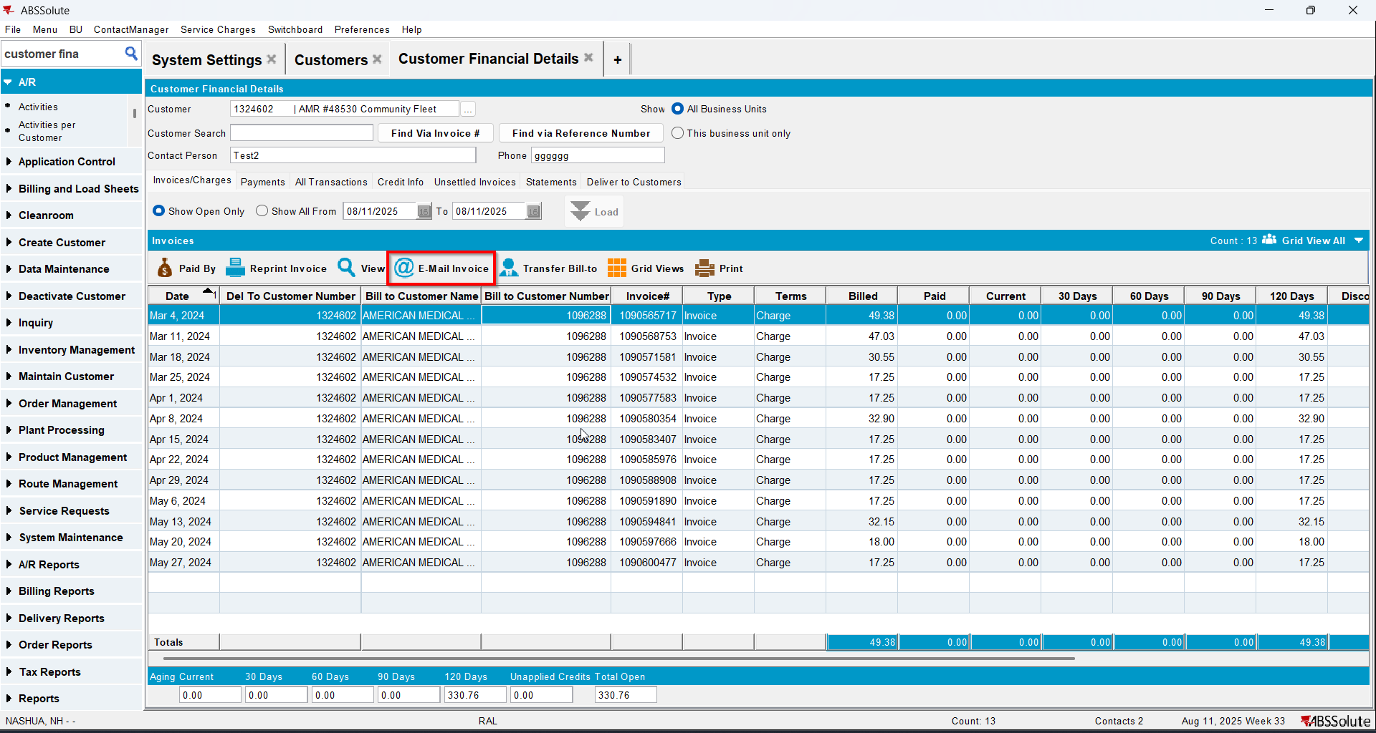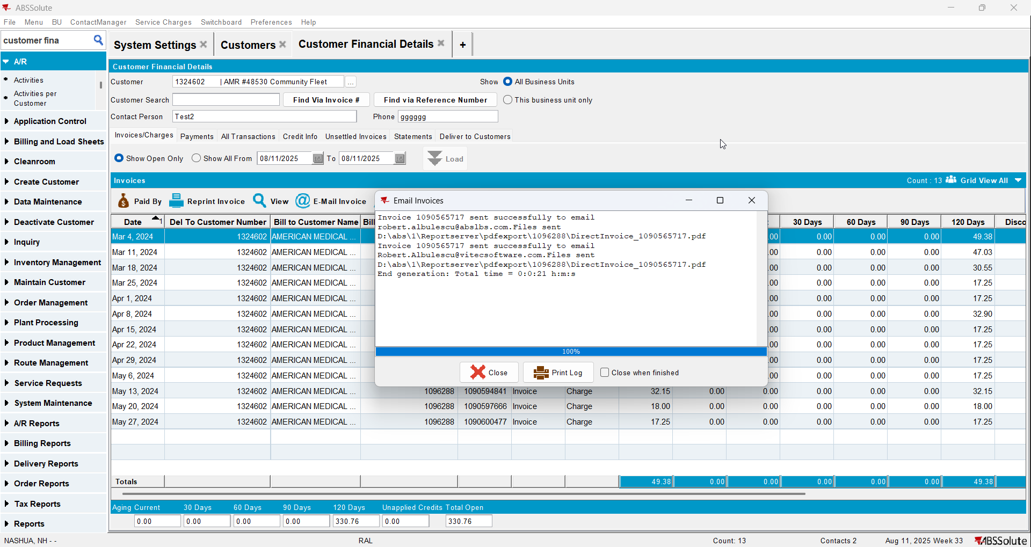
- Check if the email was sent to the contact persons of the del to customer and bill to customer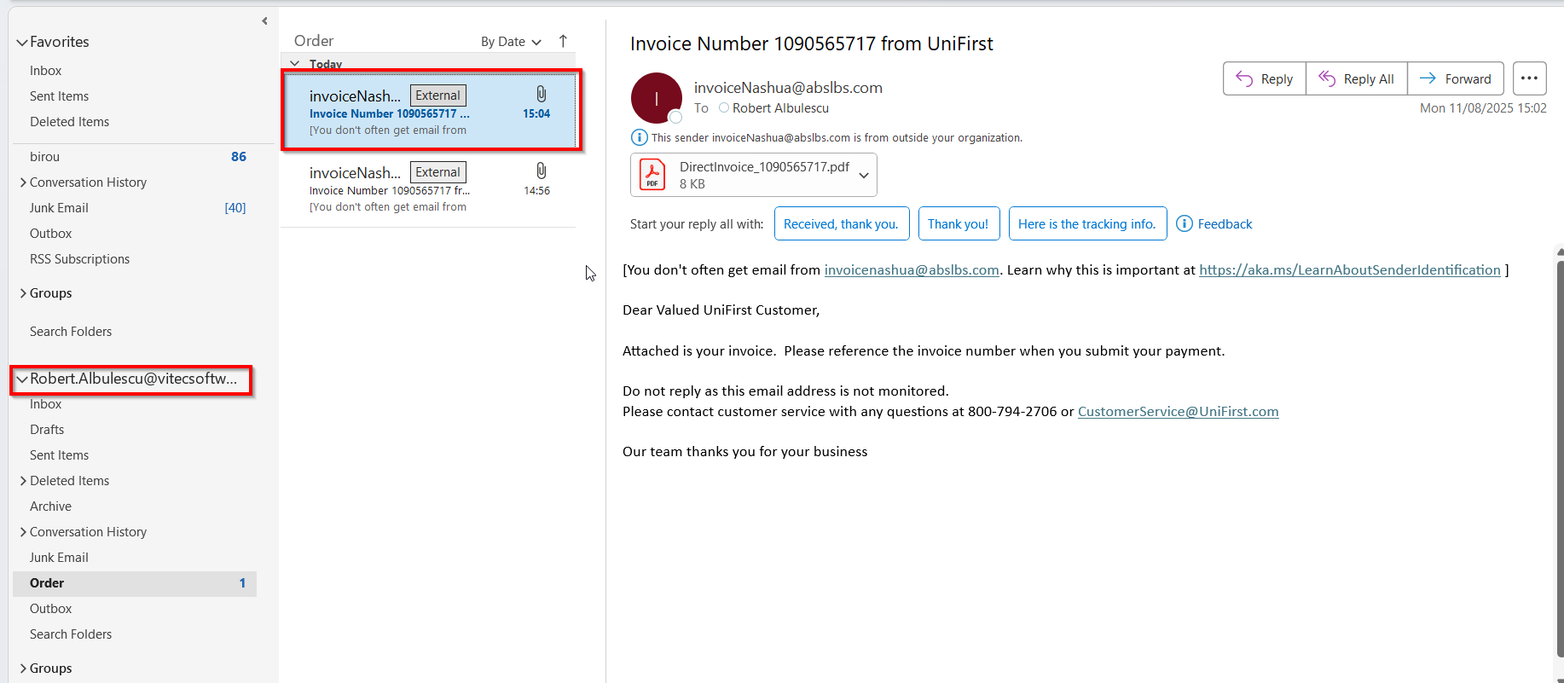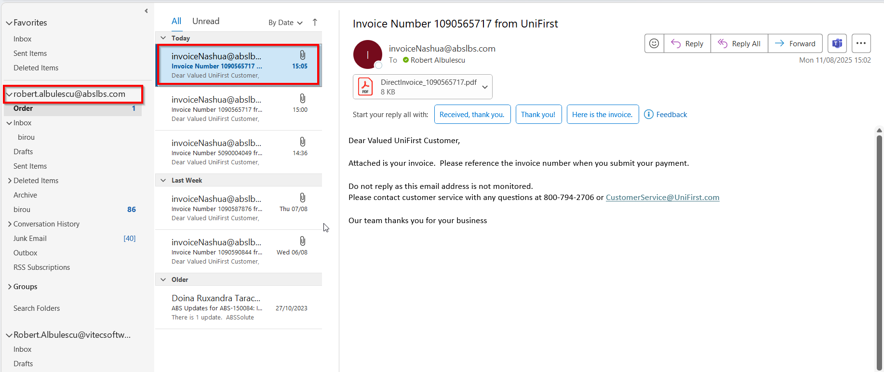

Test Case 5 – MULTIPLEINVANDSTMCONTACTS=1 and customer is its own bill to – Tested OK
Expected behavior: Information about the contact persons appears and E-Mail statement button is disabled
Hash: ff9c238
- Check that SS MULTIPLEINVANDSTMCONTACTS=1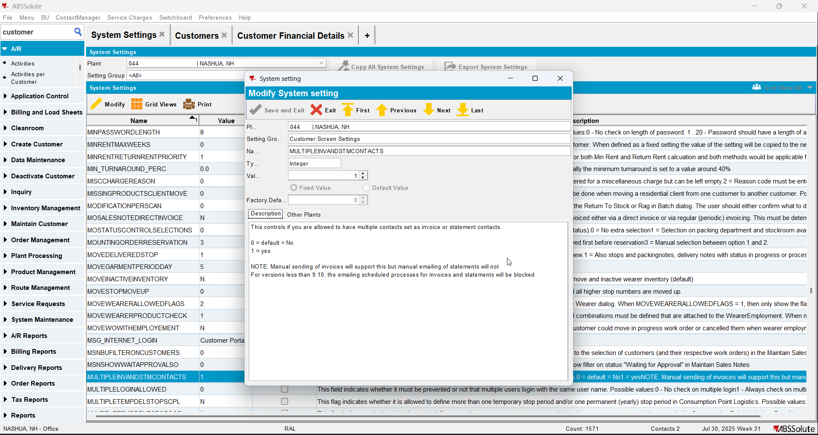
- Have a customer that is its own bill to and has at least 2 contact persons that are invoice and statement contacts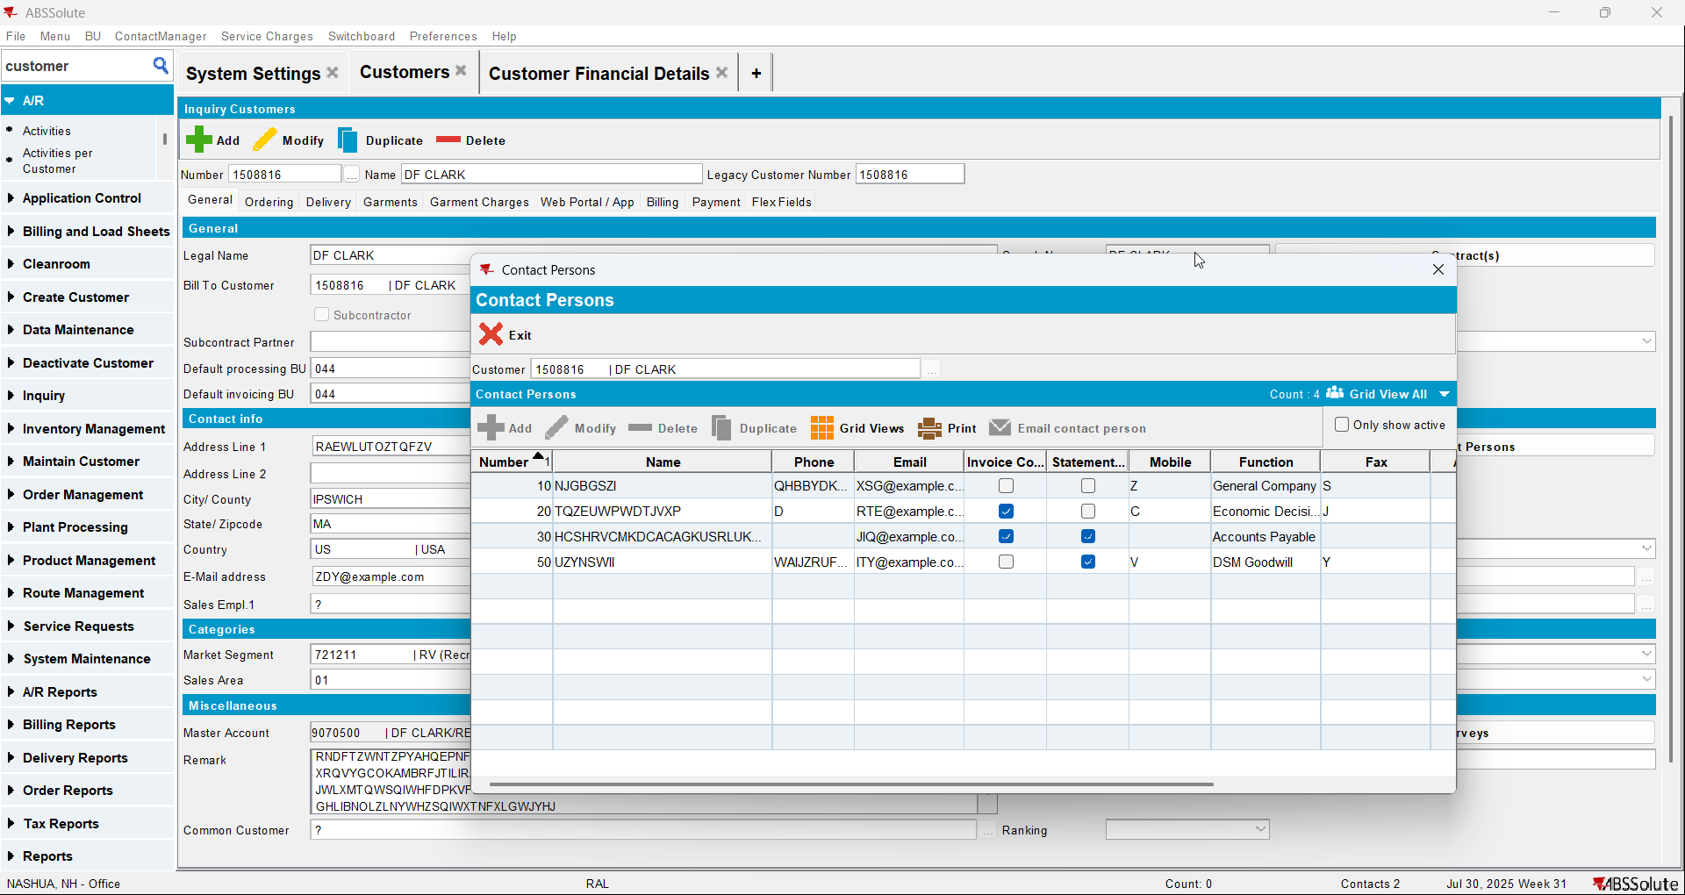
- Go to Customer Financial Details dlg
- Check that the information about the contact person appears. On Contact person field the names of the contact persons appear and on the E-mail field if you hover the mouse over it the emails of all contact persons that are invoice contacts will appear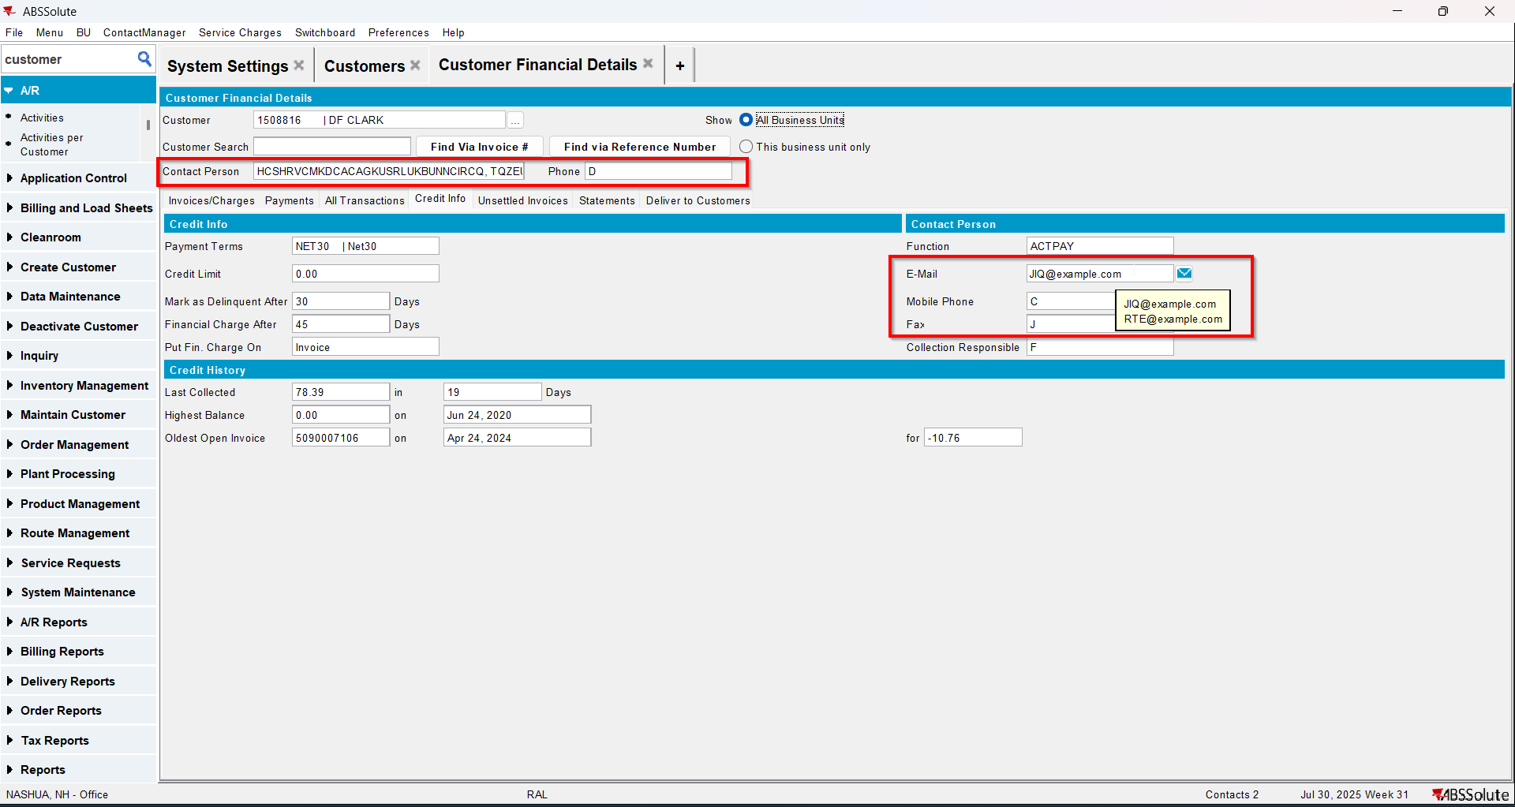
- Go to Statement tab and load some statements
- Select a statement and check that the E-Mail statement button is disabled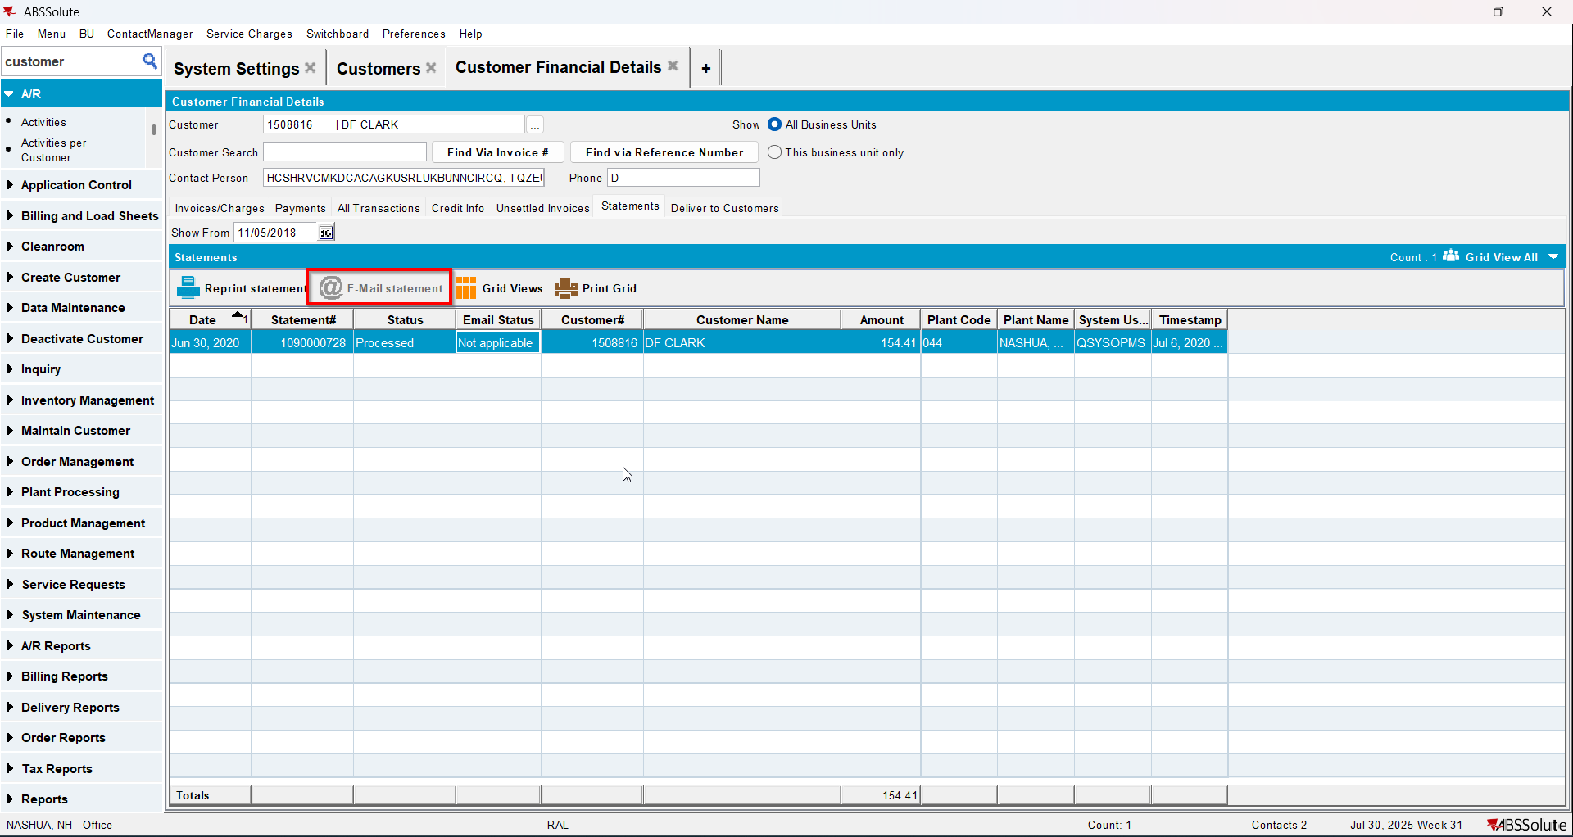

Test Case 6 – MULTIPLEINVANDSTMCONTACTS=1 and customer is not its own bill to – Tested OK
Expected behavior: Information about the contact persons appears and E-Mail statement button is disabled
Hash: ff9c238
- Check that SS MULTIPLEINVANDSTMCONTACTS=1
- Have a customer that is not its own bill to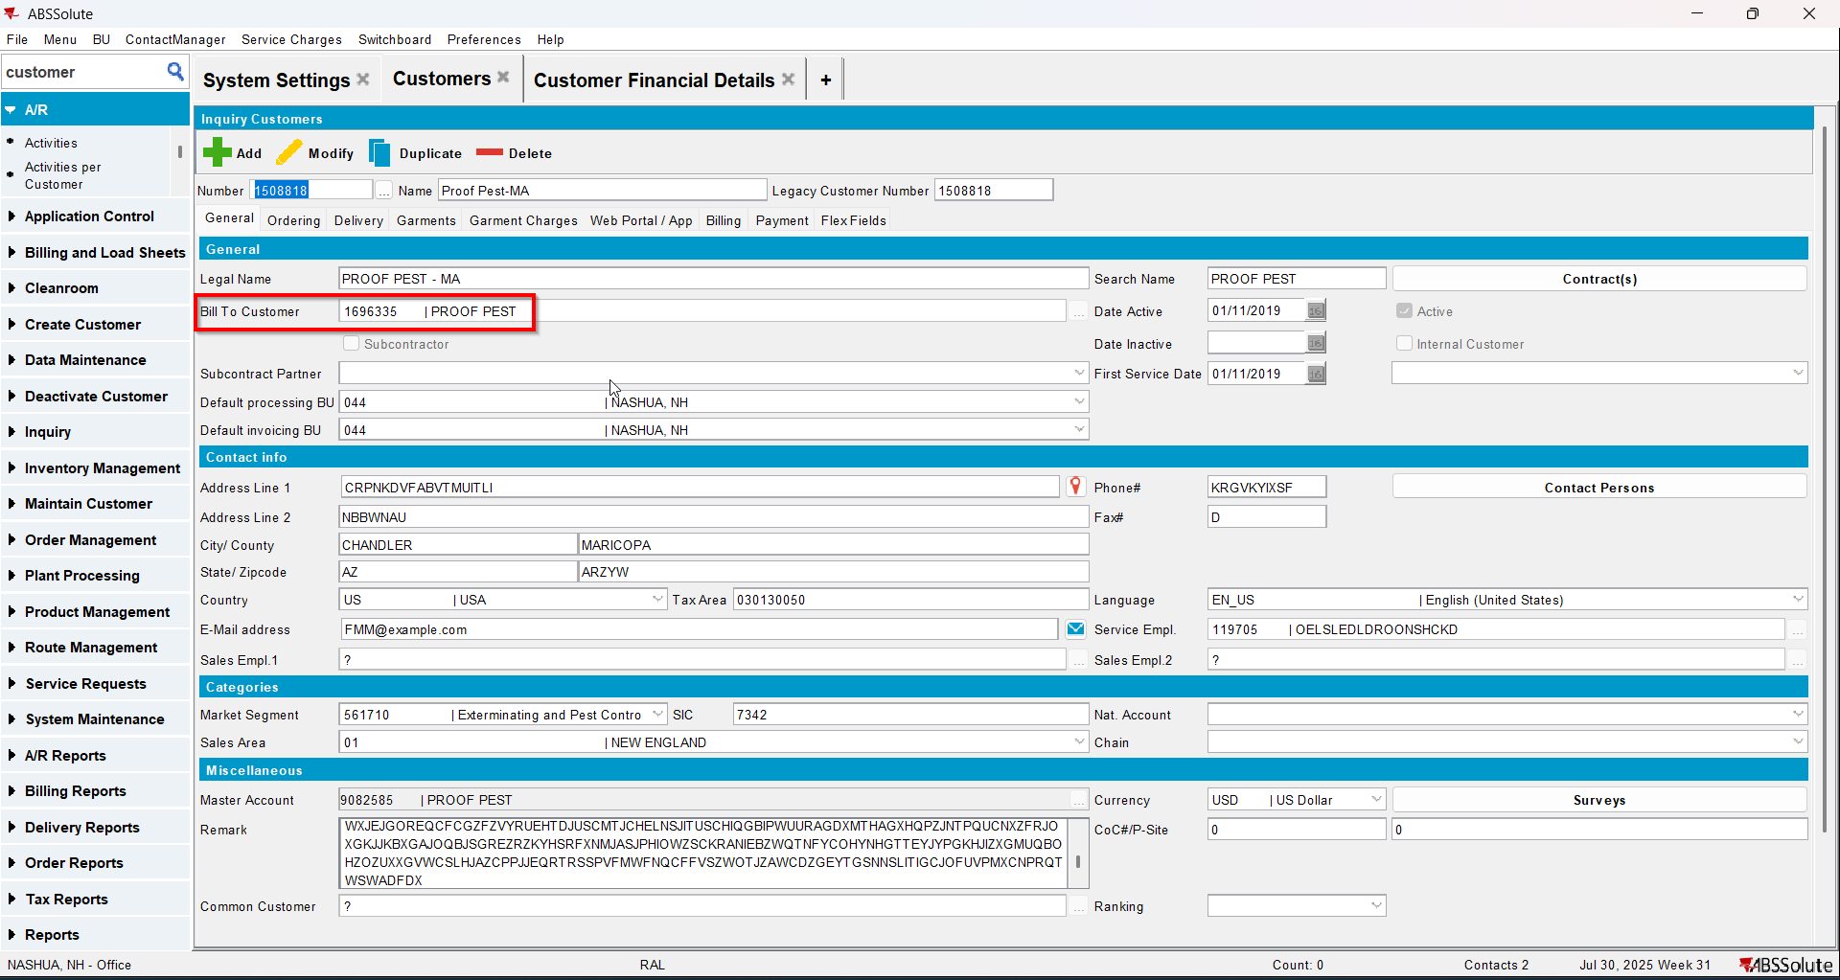
- Load the bill to customer and check that it has at least 2 contact persons that are invoice and statement contacts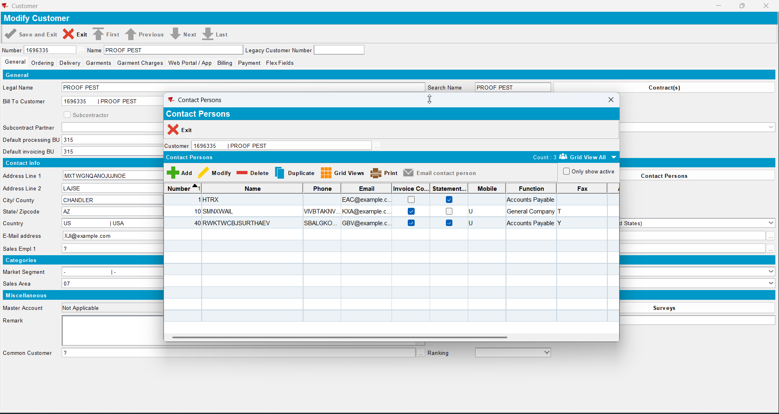
- Go to Customer Financial Details dlg and load the del to customer
- Check that the information about the contact person appears. On Contact person field the names of the contact persons appear and on the E-mail field if you hover the mouse over it the emails of all contact persons that are invoice contacts will appear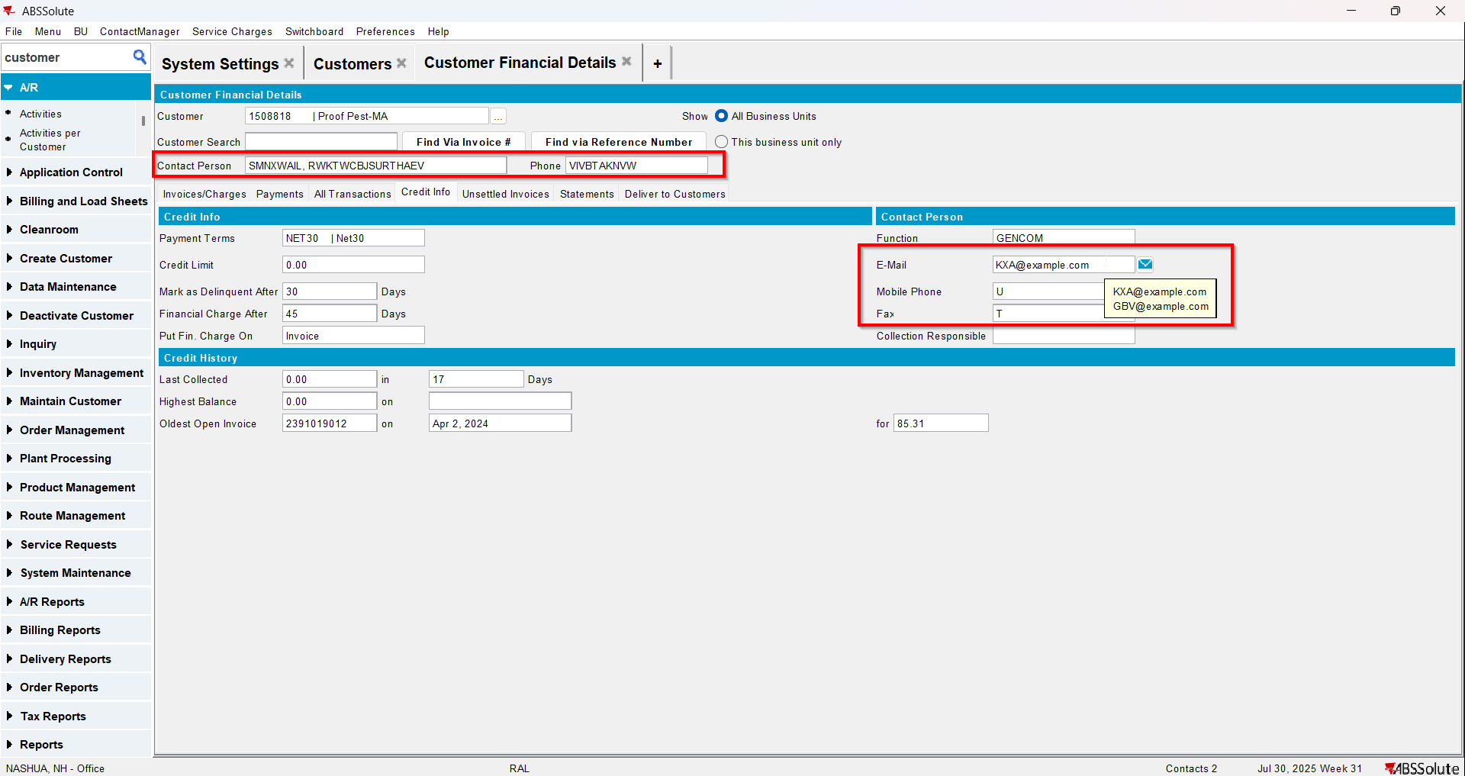
- Go to Statement tab and load some statements
- Select a statement and check that the E-Mail statement button is disabled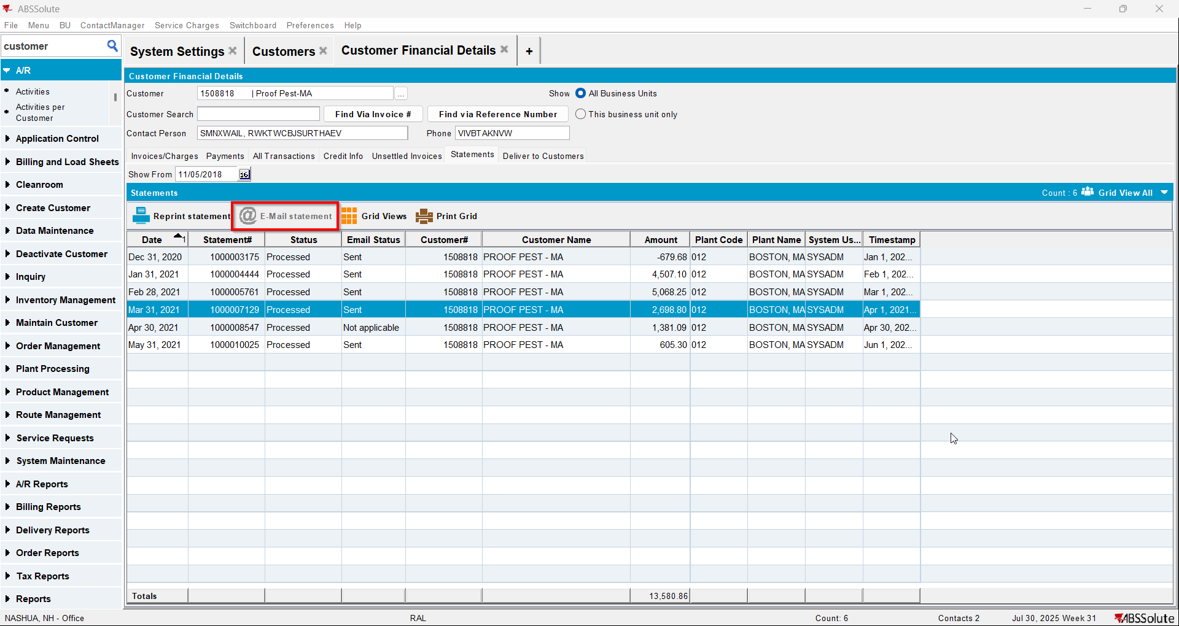

Test Case 7 – Send E-Mail when MULTIPLEINVANDSTMCONTACTS=1 and customer is its own bill to – Tested OK
Expected behavior: The invoice should be emailed to the email address of the contact persons that is invoice contact, not on the email address that is on the invoice header
Hash: ff9c238
- Check that SS MULTIPLEINVANDSTMCONTACTS=1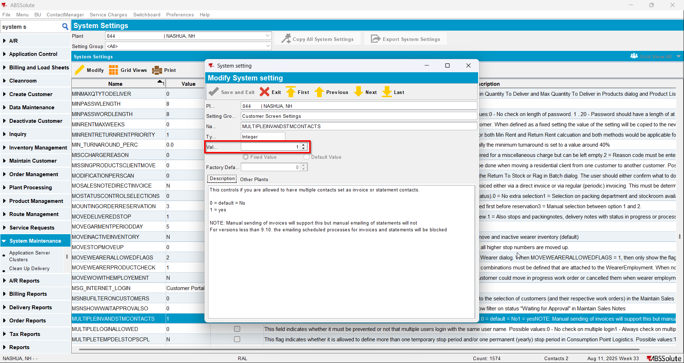
- Have a customer that is its own bill to
- Check that he has at least 2 contact persons that are invoice contact and have a valid email address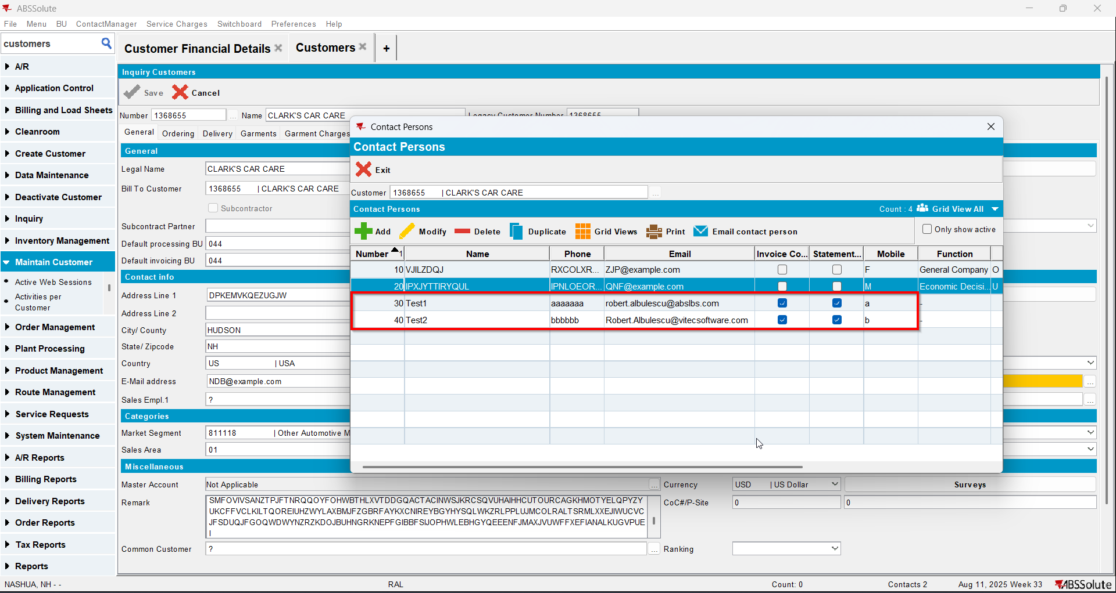
- For an invoice check what email address is on the invoice header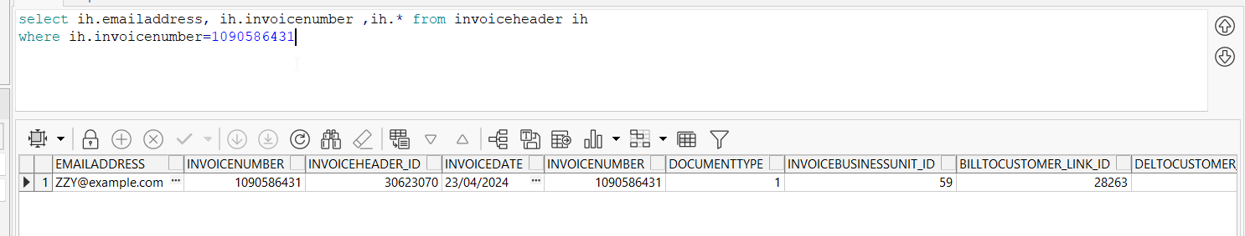
- Go to Customer Financial Details dlg and load your customer
- To Invoices tab select your invoice from step 4 and press E-mail Invoice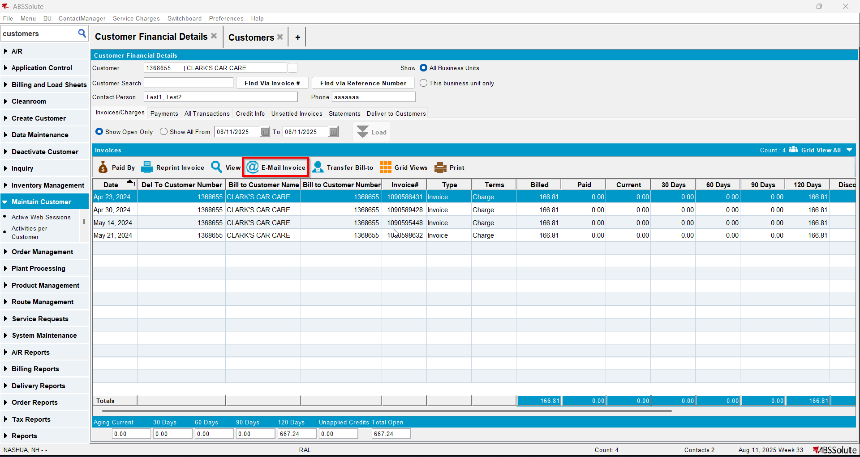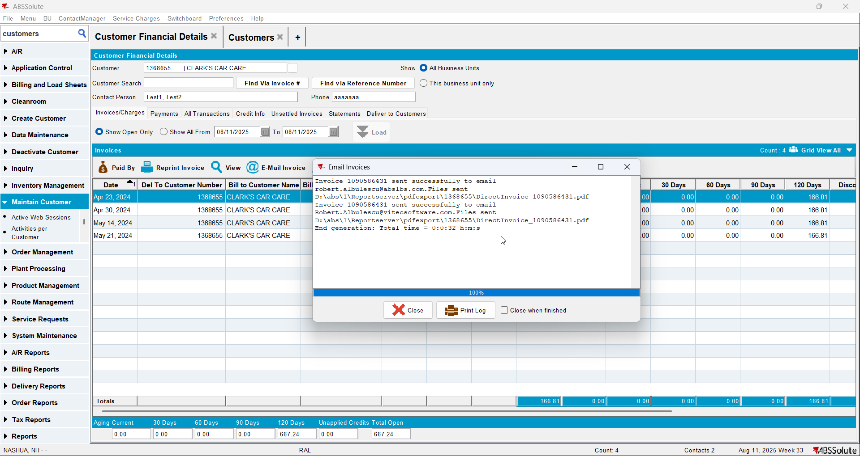
- Check if the email was sent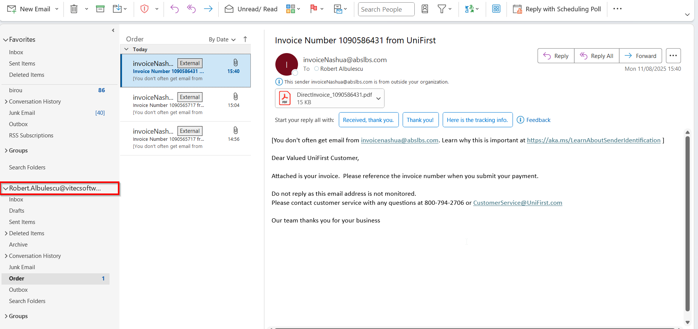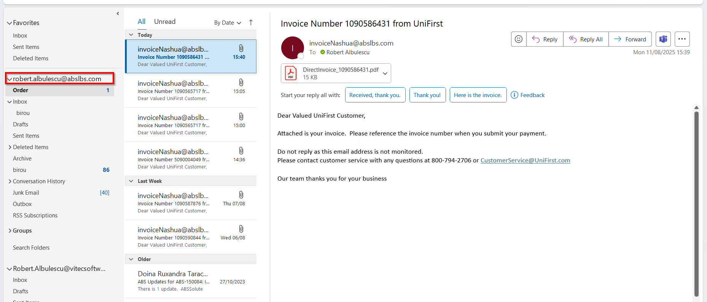

Test Case 8 – Send E-Mail when MULTIPLEINVANDSTMCONTACTS=1 and customer is not its own bill to – Tested OK
Expected behavior: The invoice should be emailed to the email address of the contact persons that is invoice contact, not on the email address that is on the invoice header
Hash: ff9c238
- Check that SS MULTIPLEINVANDSTMCONTACTS=1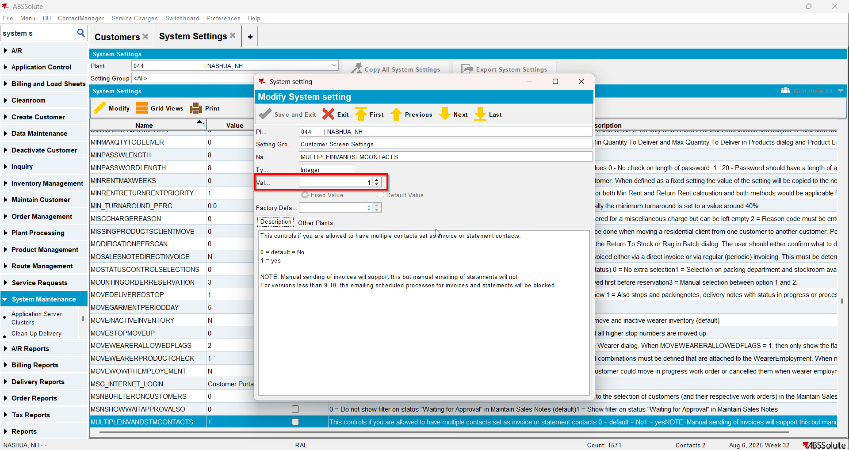
- Have a customer that is not its own bill to
- Check that he has at least 2 contact persons that are invoice contacts and have a valid email address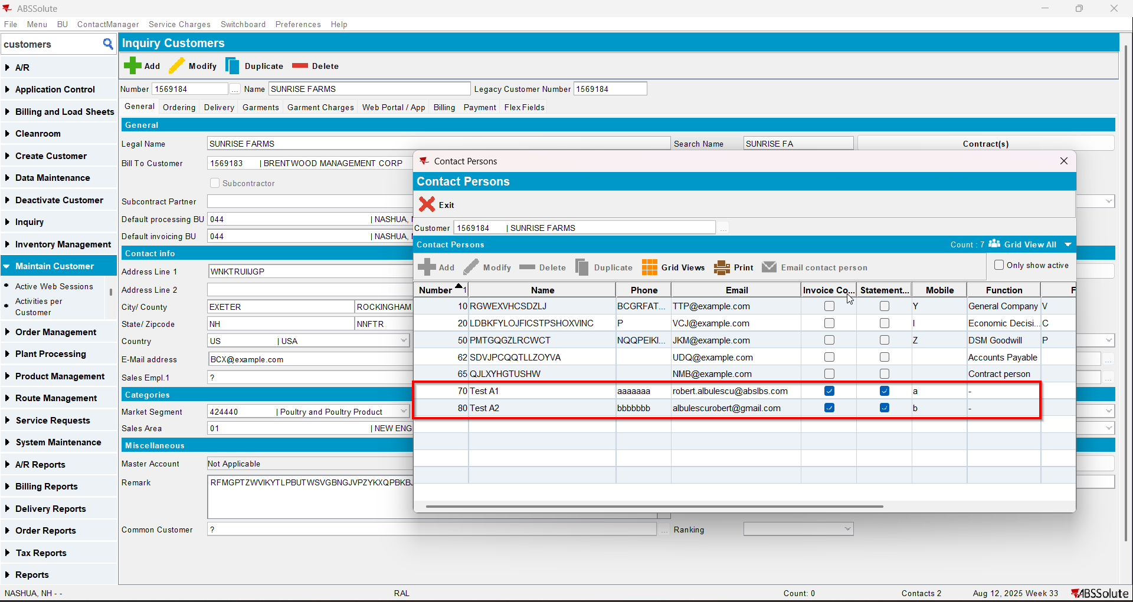
- Go on the bill to customer and check that he has at least 2 contact person that are invoice contacts and have a valid email address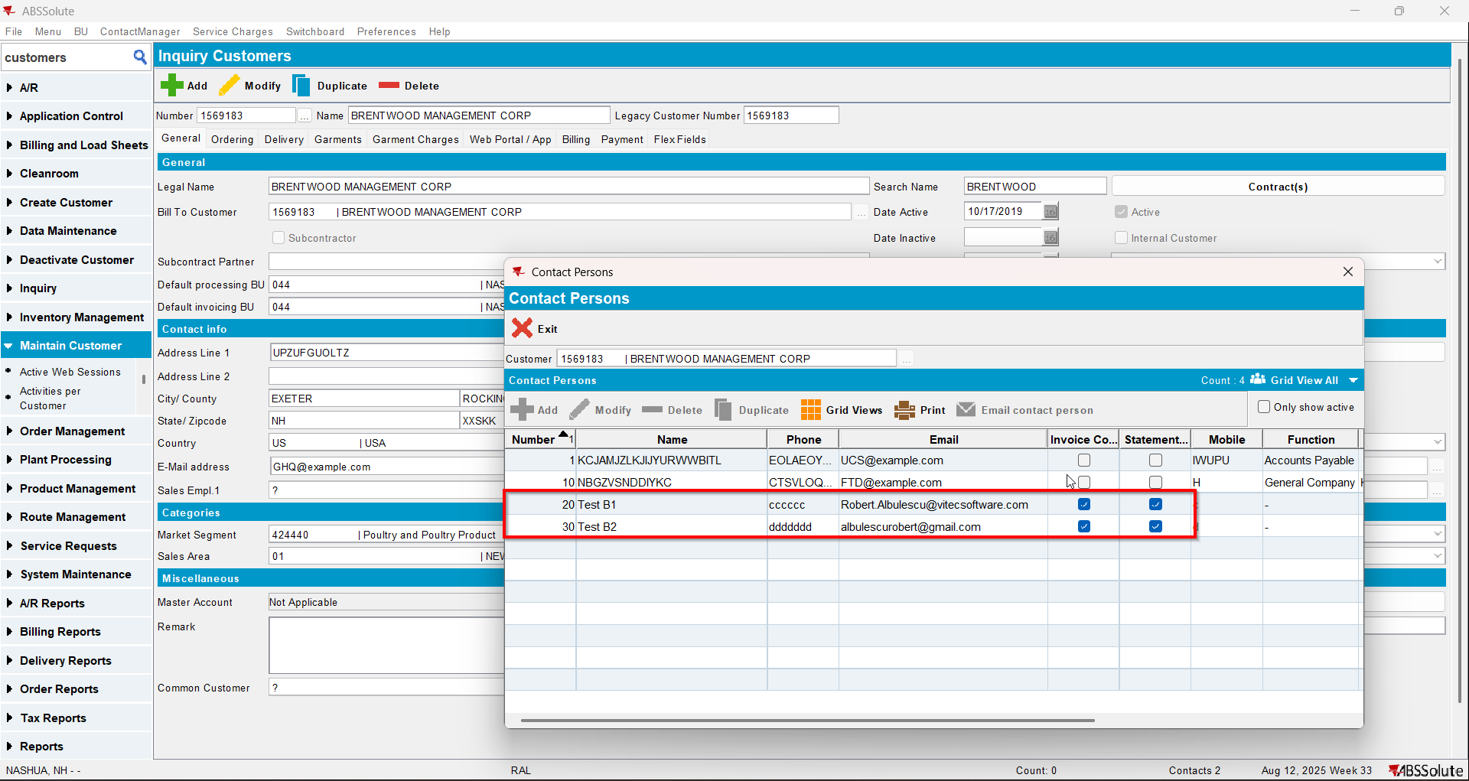
- Also, on the bill to customer check that checkbox Send by E-mail is checked and on the drop-down selection the ‘Del To Invoice Contact’ option is selected(modifying this on bill to customer will also modify on del to customer )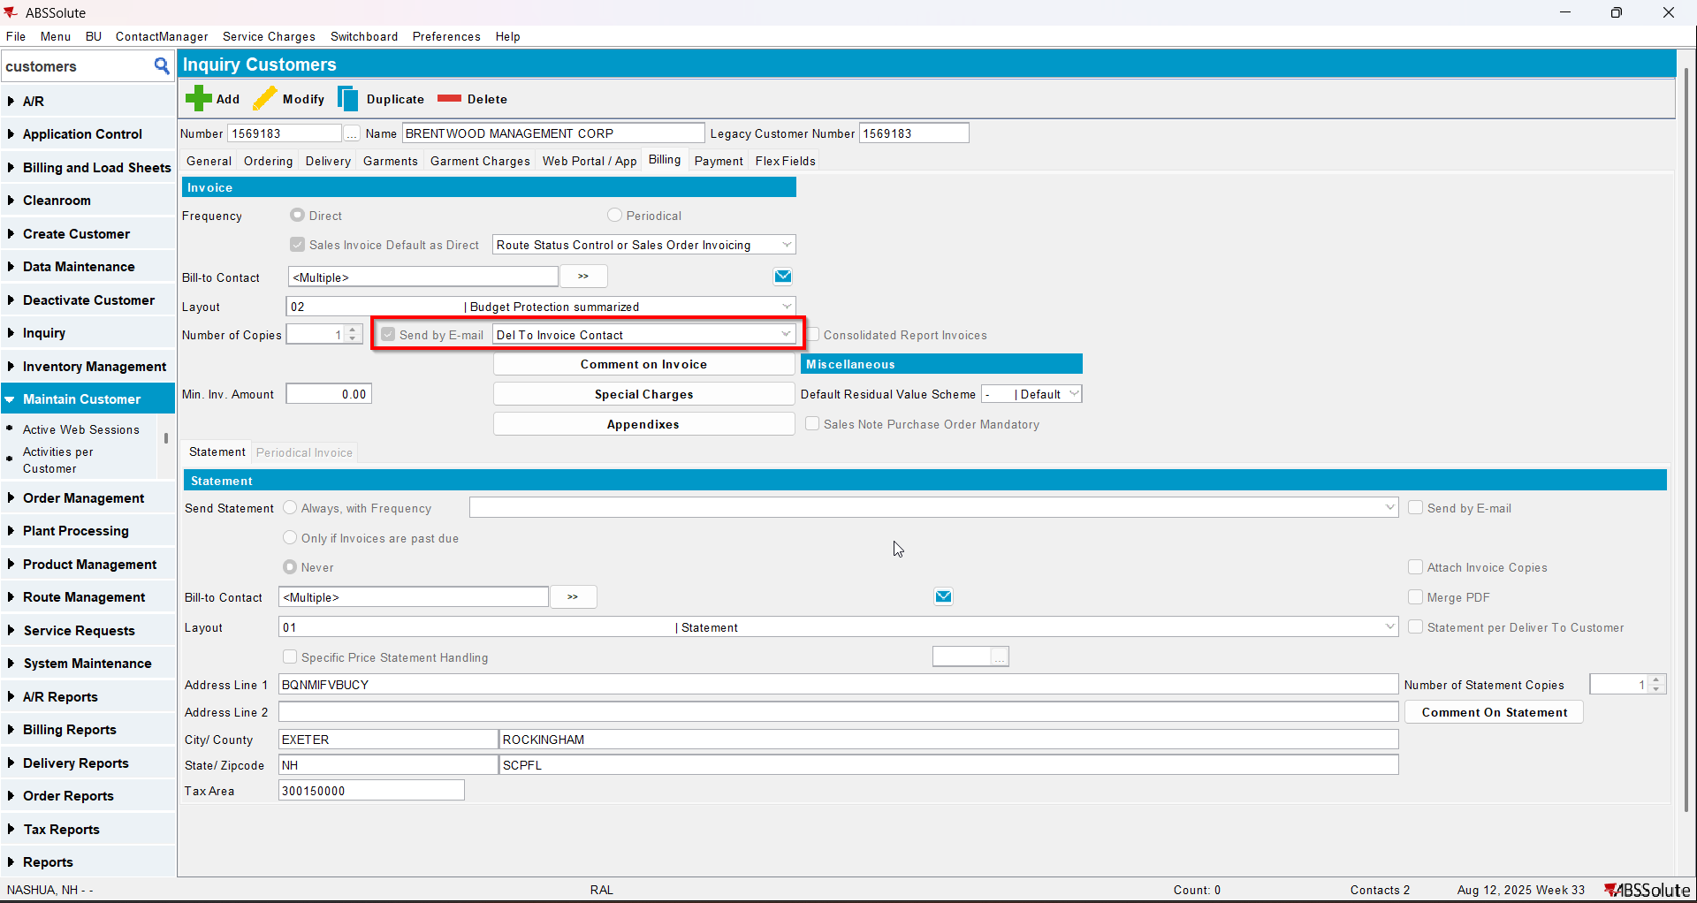
- For an invoice check what email address is on the invoice header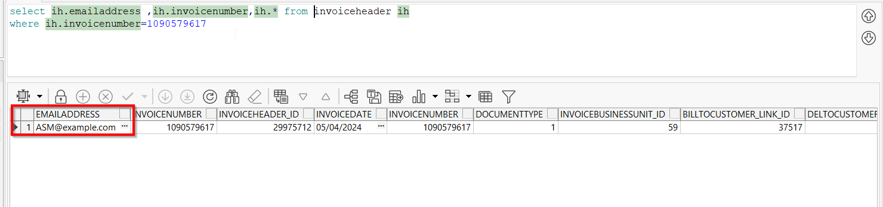
- Go to Customer Financial Details dlg and load your del to customer
- To Invoices tab select your invoice from step 6 and press E-mail Invoice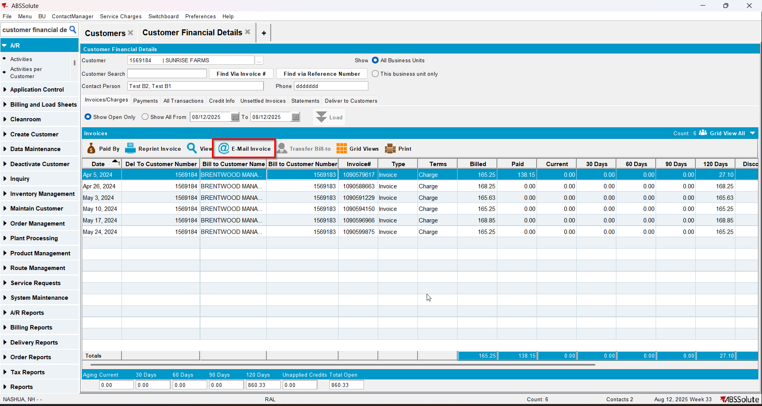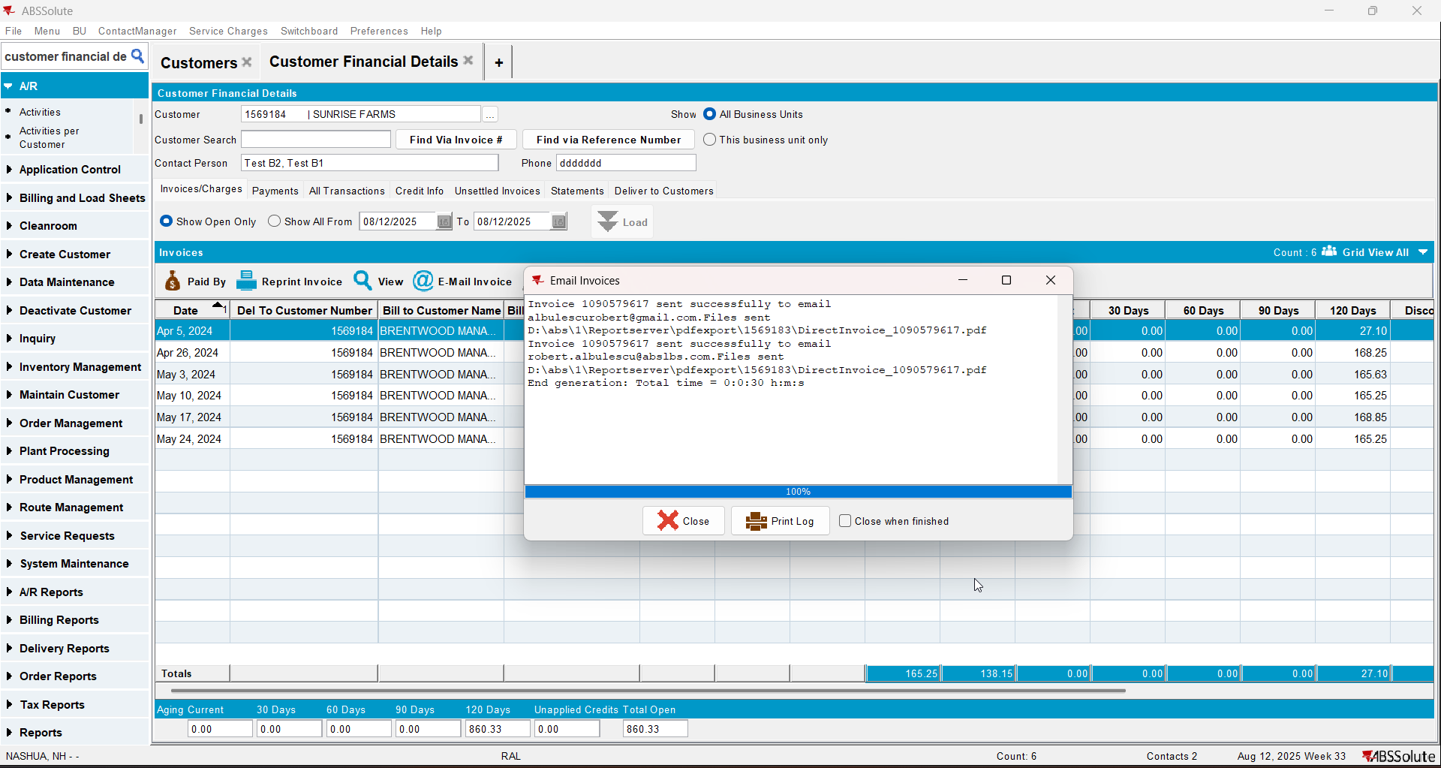
- Check if the email was sent to the contact persons of the del to customer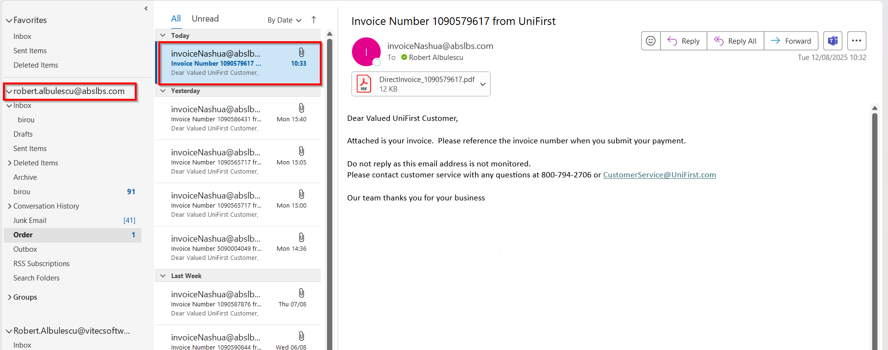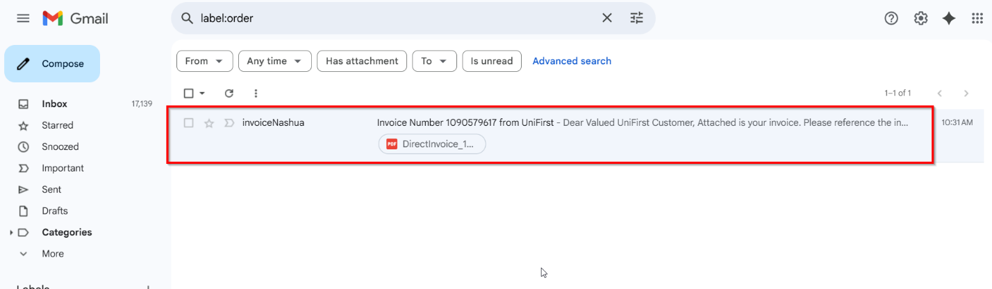
- Go on the bill to customer and on the drop-down select ‘Bill To Invoice Contact’ option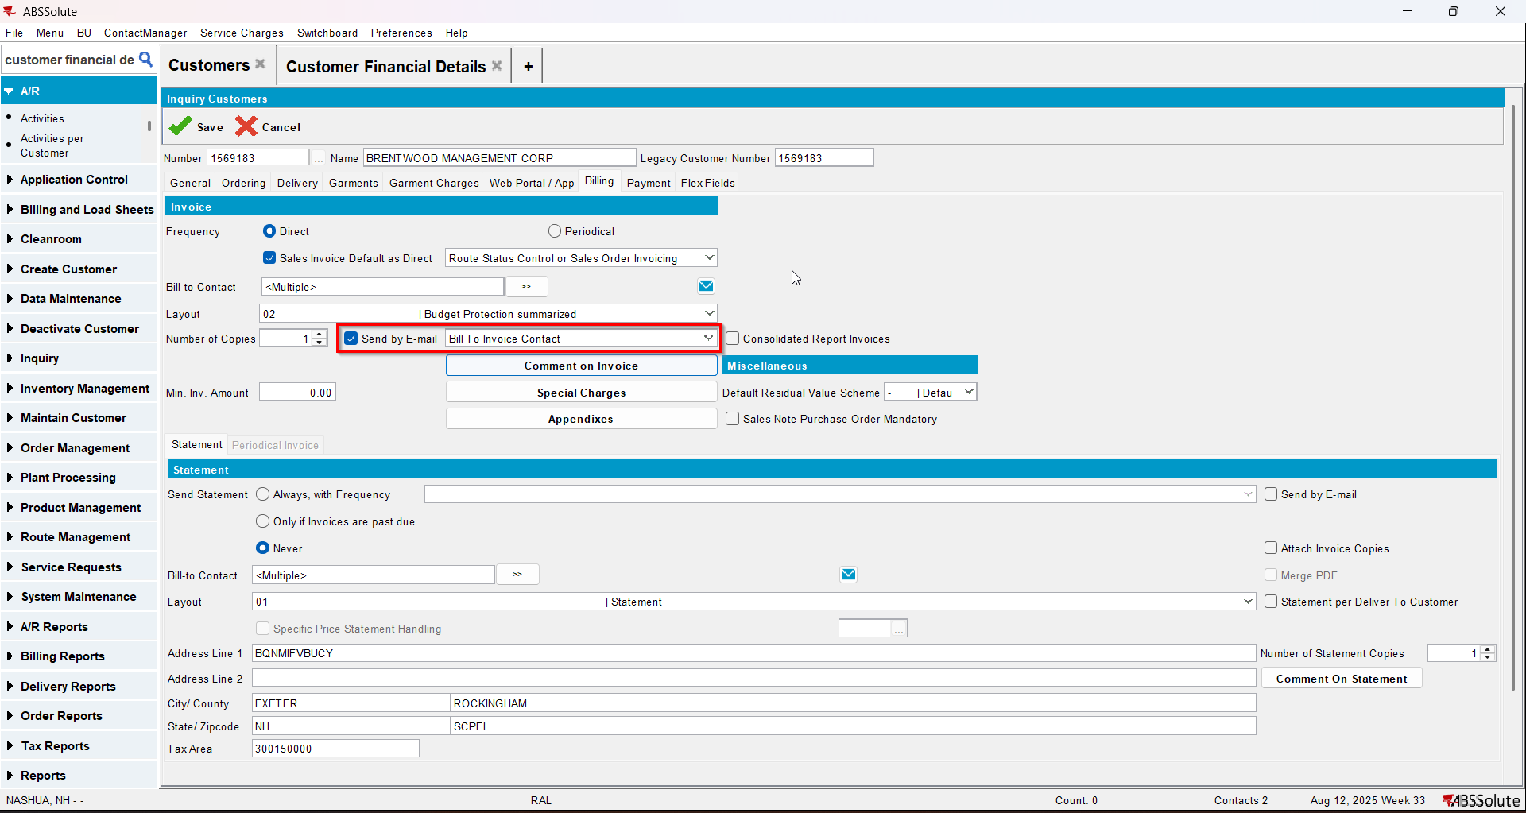
- Go to Customer Financial Details dlg and load your del to customer
- To Invoices tab select your invoice from step 6 and press E-mail Invoice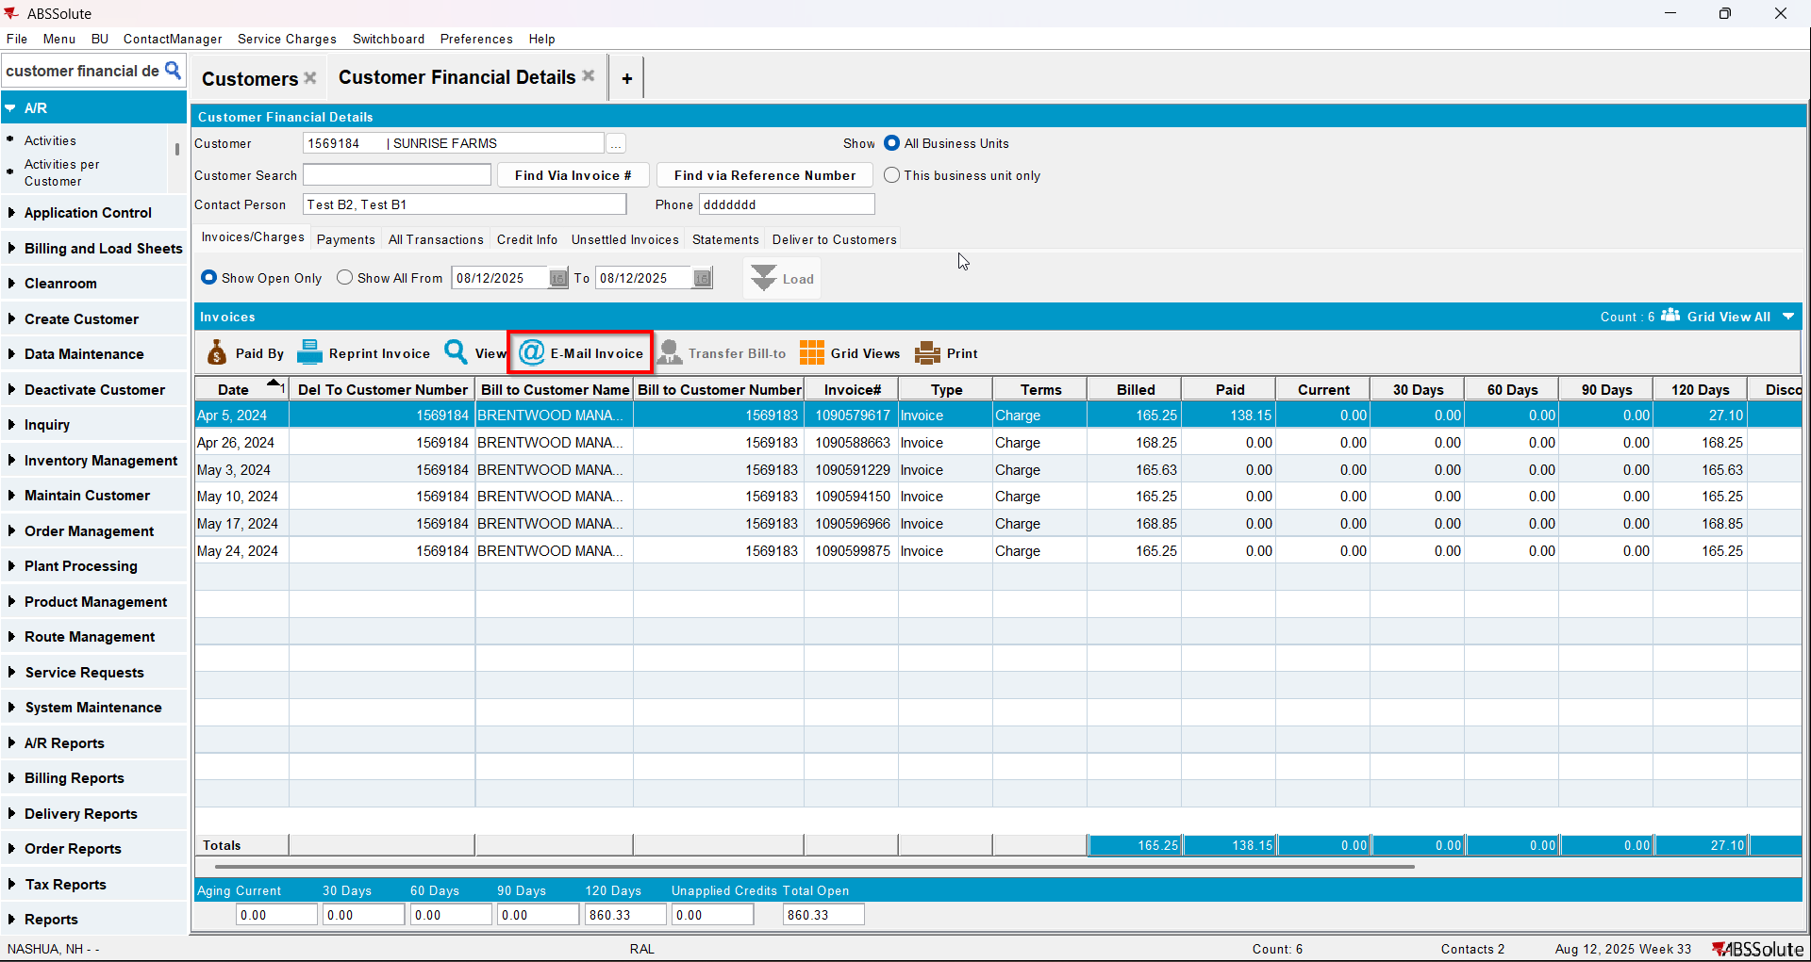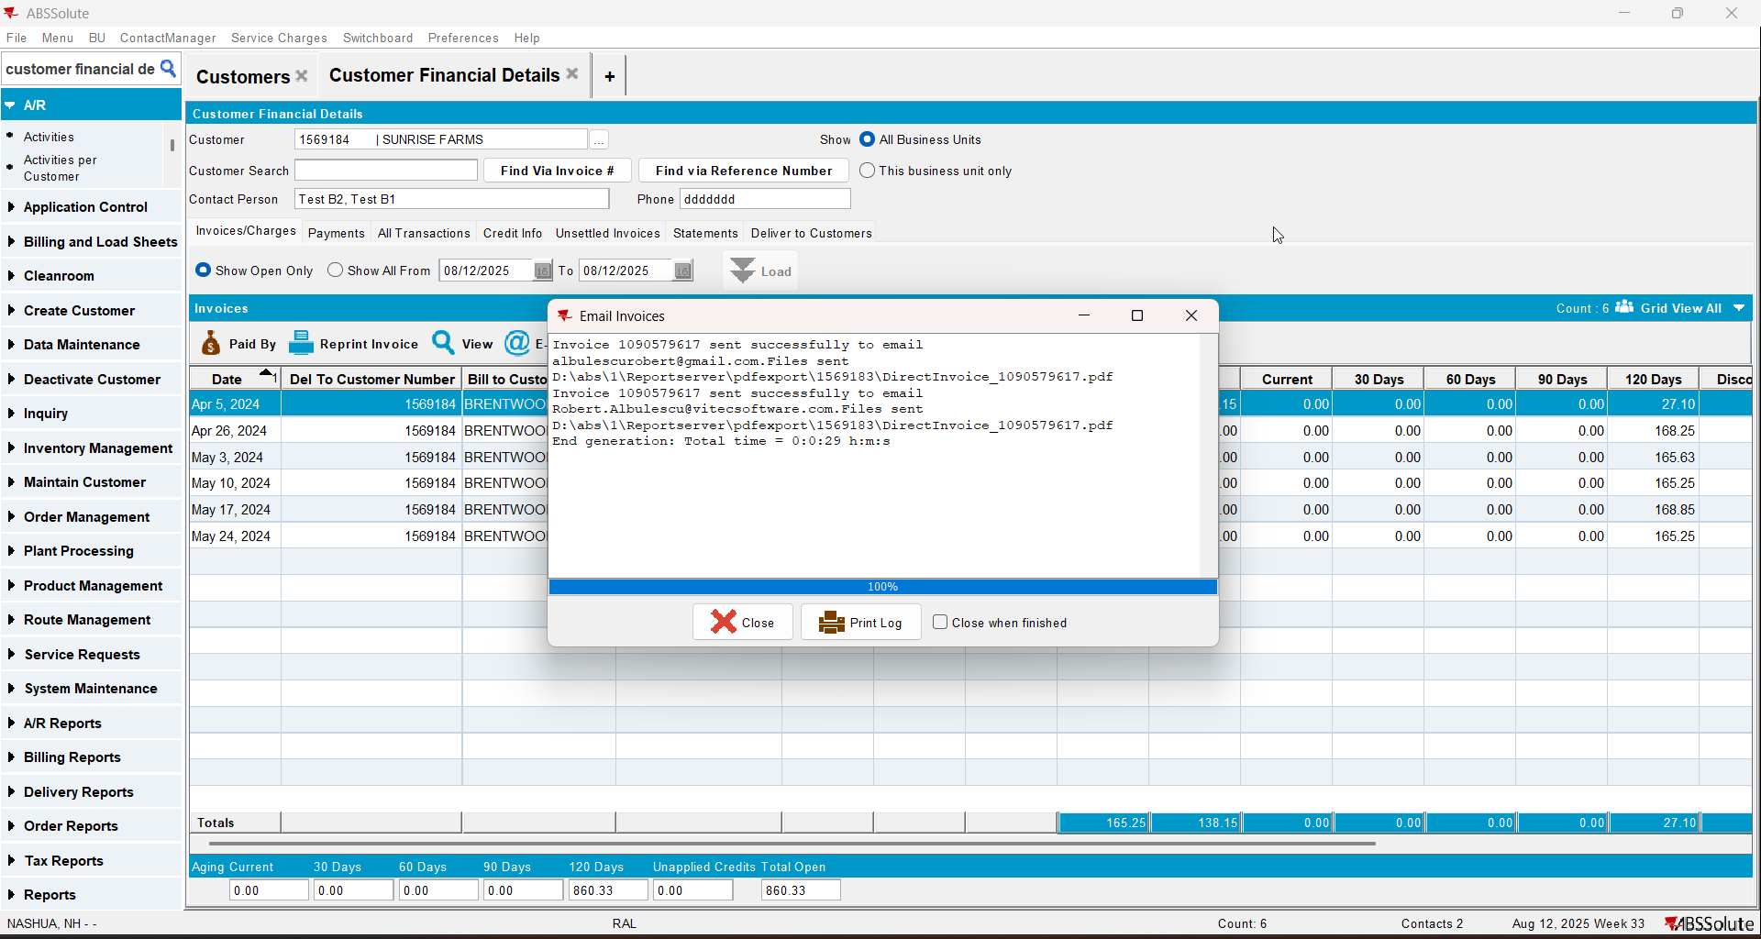
- Check if the email was sent to the contact persons of the bill to customer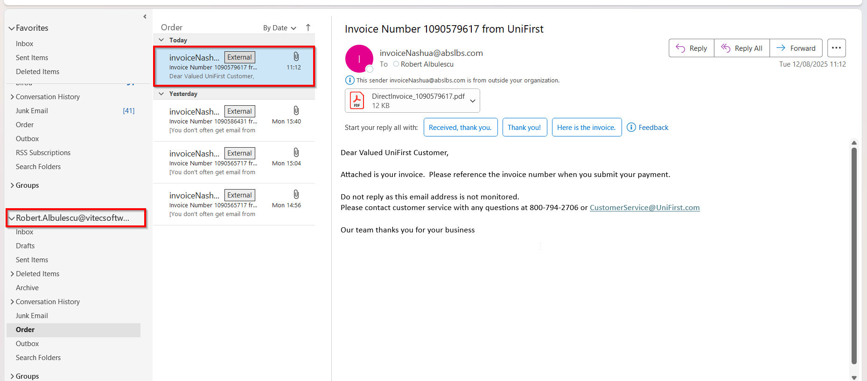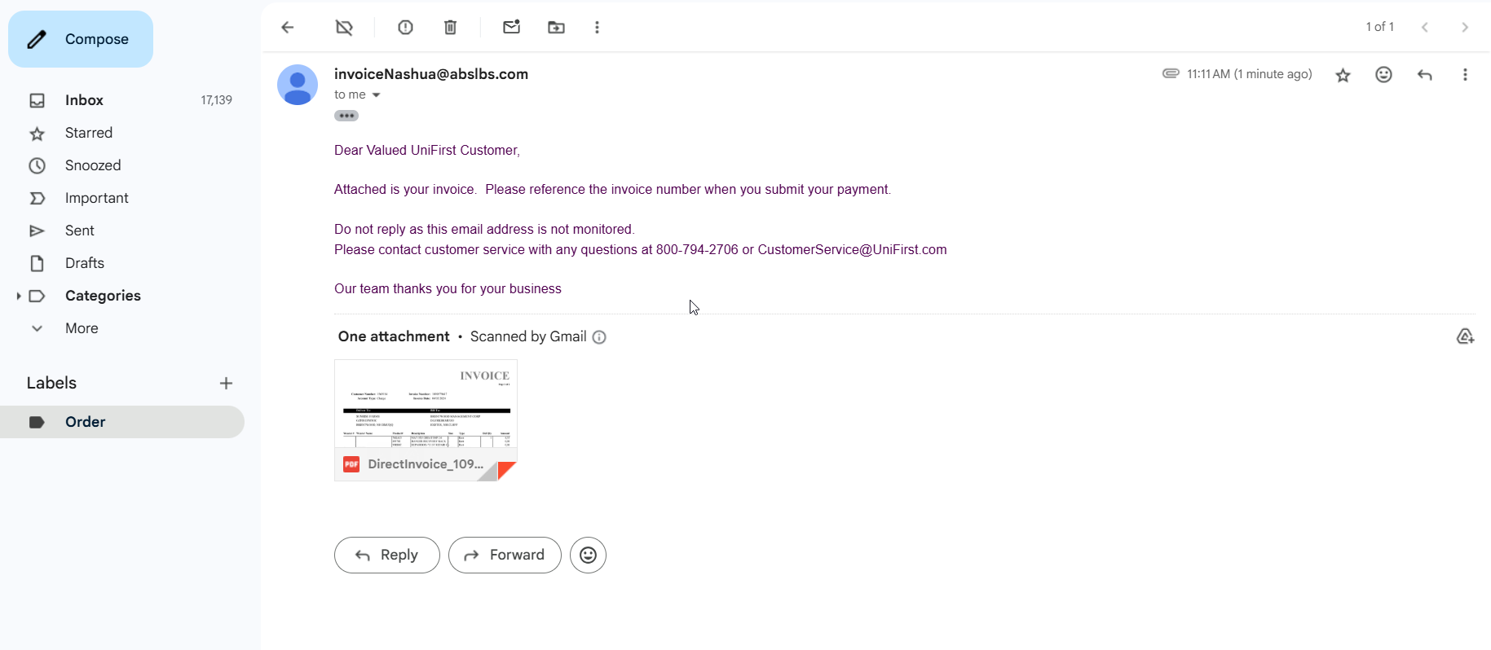
- Go on the bill to customer and on the drop-down select ‘Del To and Bill To Invoice Contacts’ option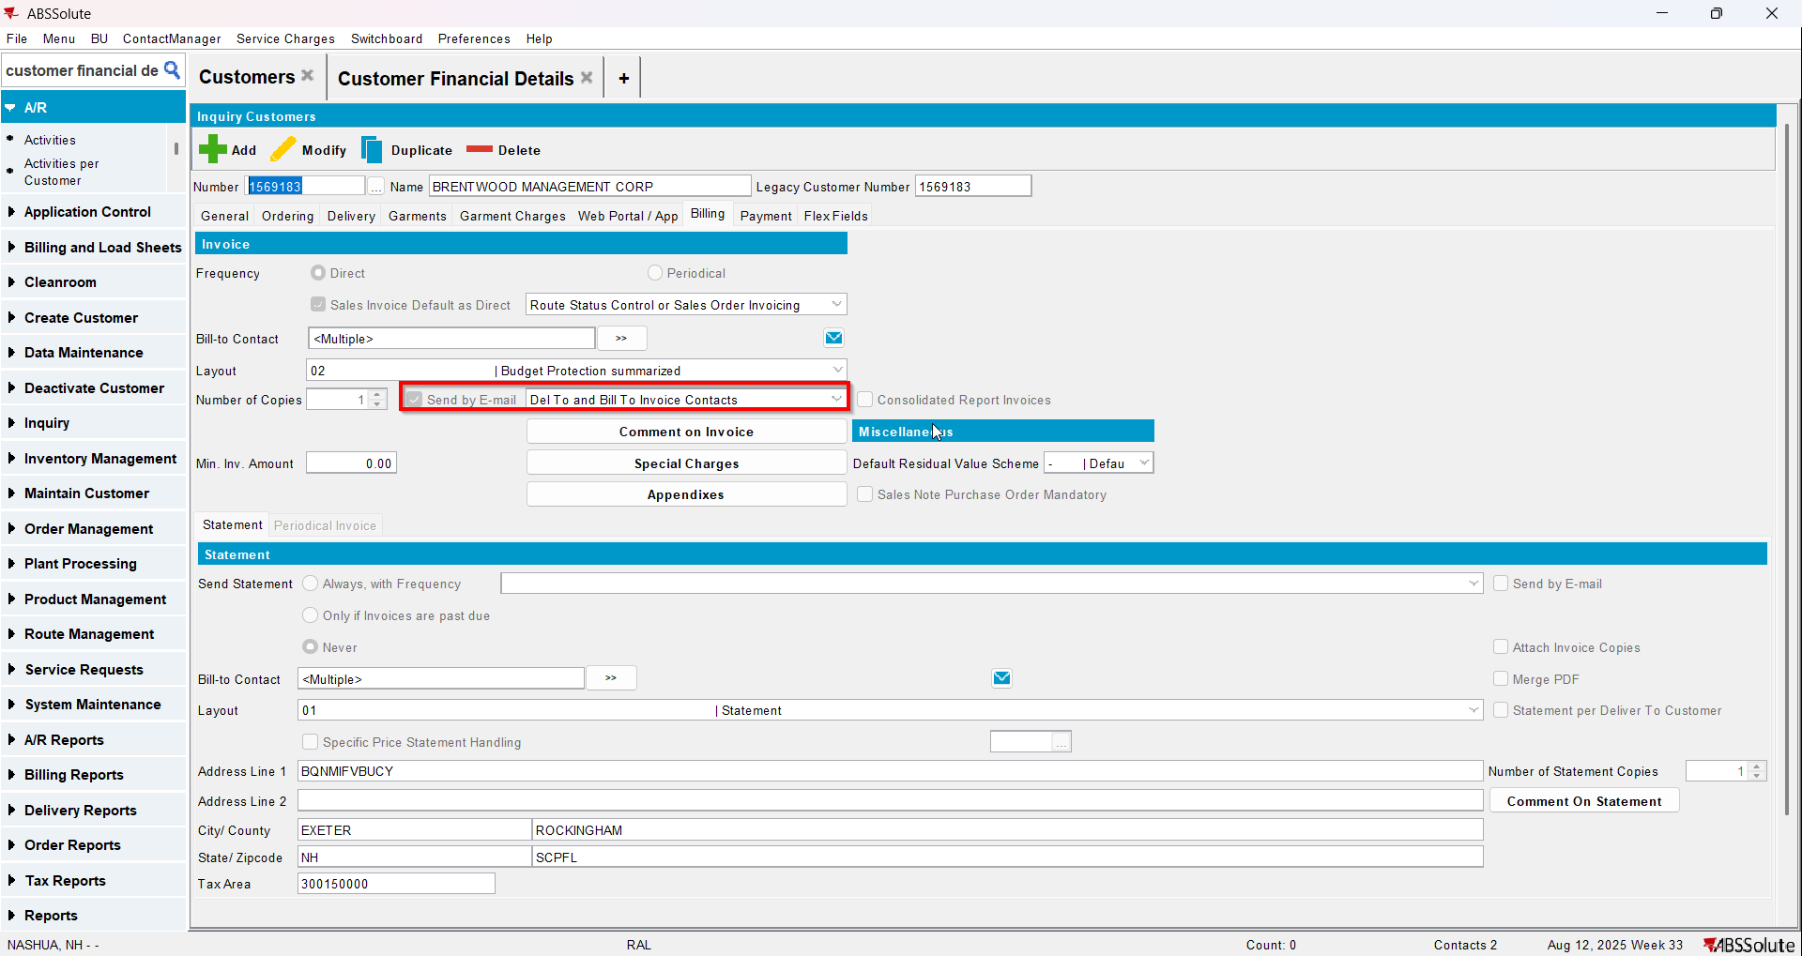
- Go to Customer Financial Details dlg and load your del to customer
- To Invoices tab select your invoice from step 6 and press E-mail Invoice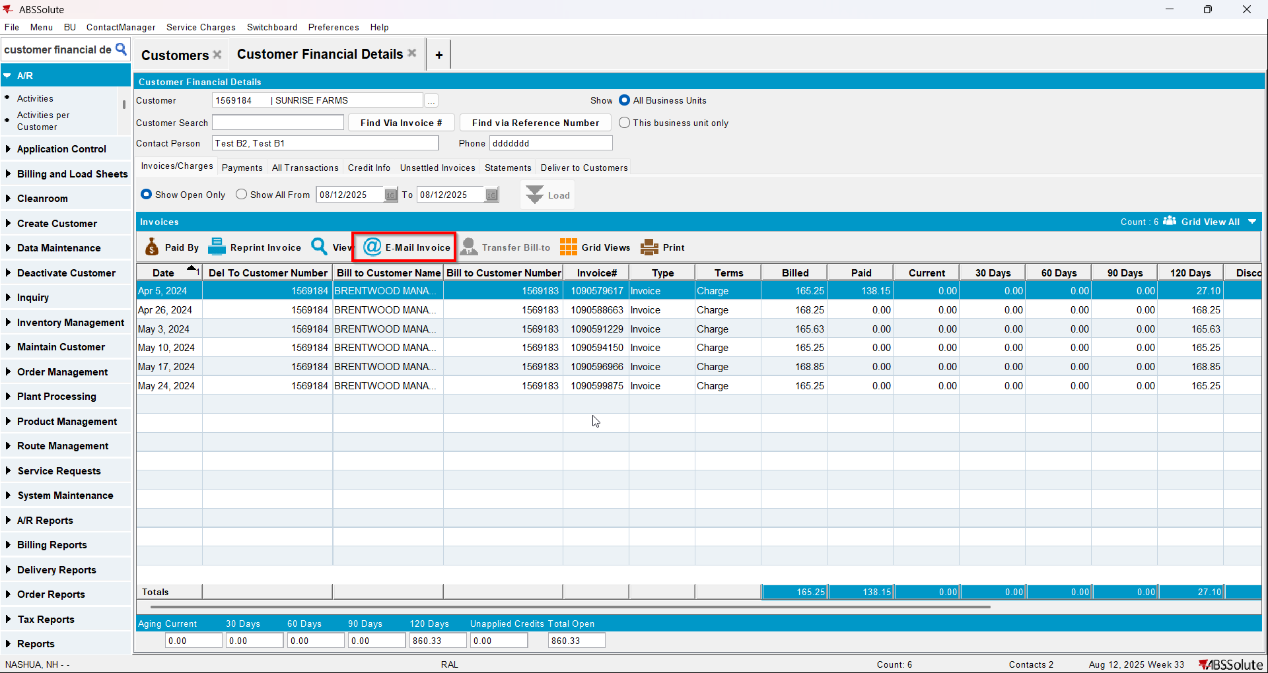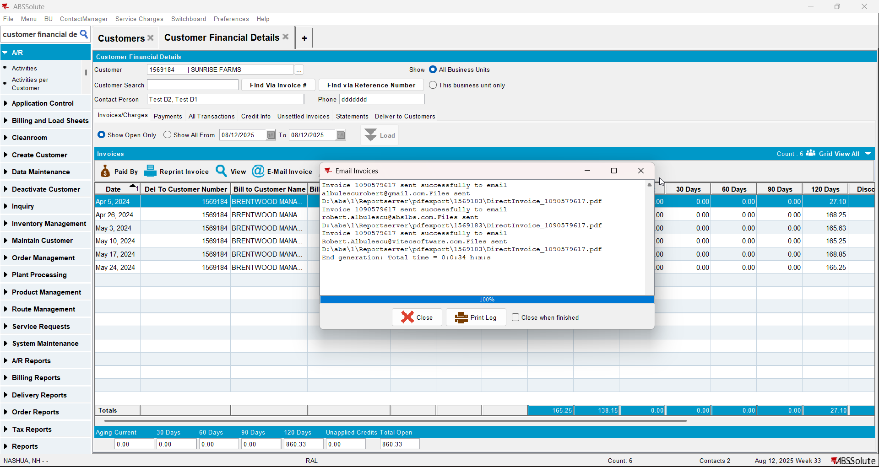
- Check if the email was sent to the contact persons of the del to customer and bill to customer. Note that if more contact persons have the same email address, it will only send 1 email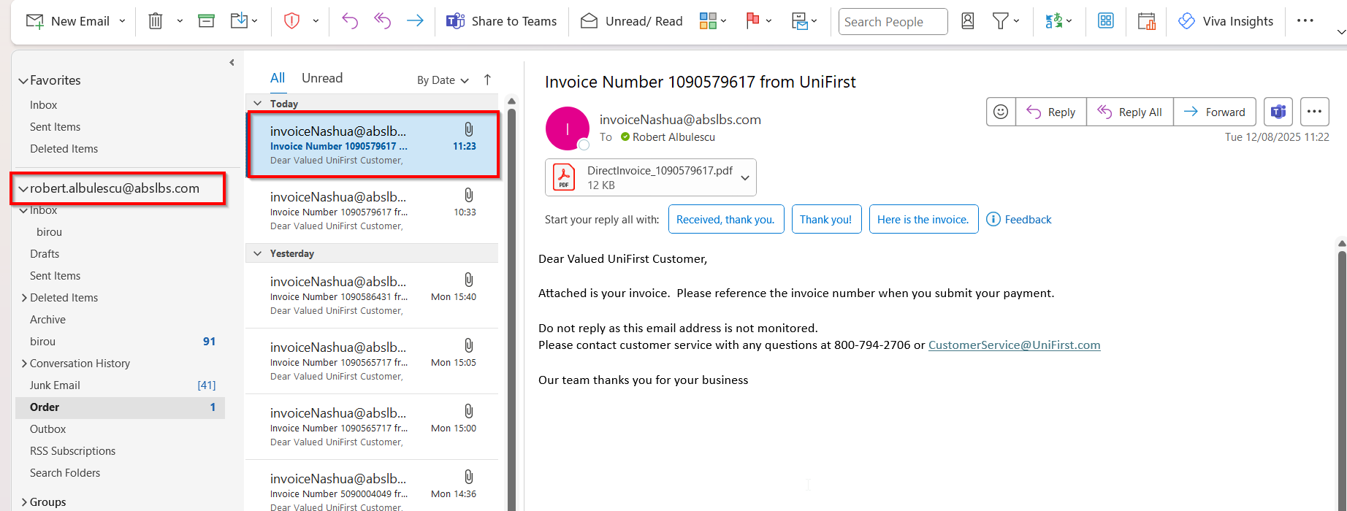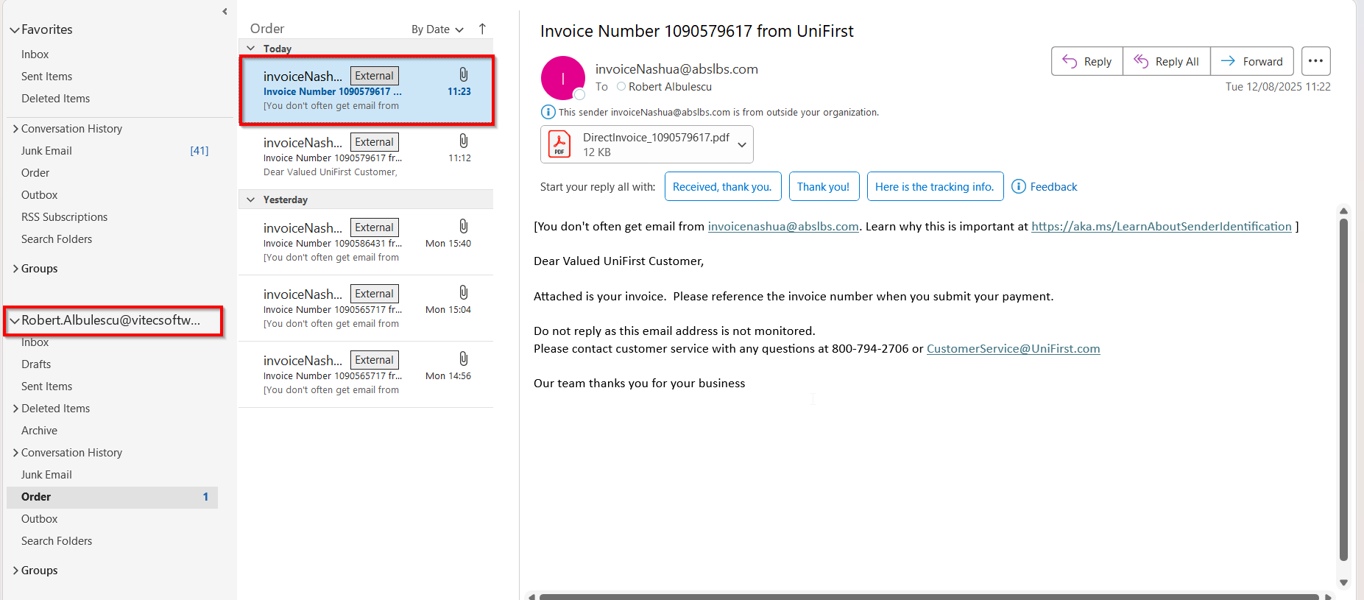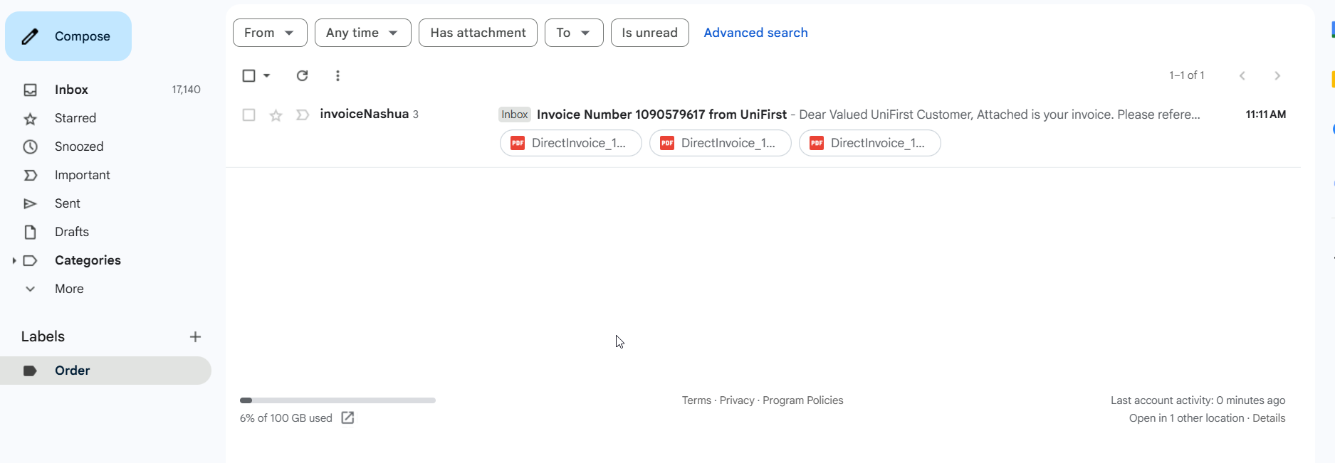

Maintain Invoices dialog

Test Case 1 – Send E-Mail when MULTIPLEINVANDSTMCONTACTS=0 and customer is its own bill to – Tested OK
Expected behavior: The invoice should be emailed to the email address of the contact persons that is invoice contact, not on the email address that is on the invoice header
Hash: ff9c238
- Check that SS MULTIPLEINVANDSTMCONTACTS=0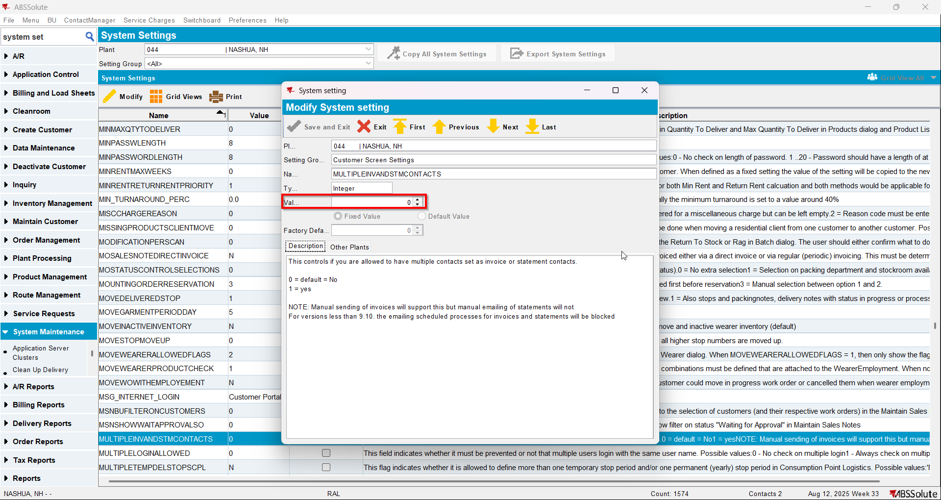
- Have a customer that is its own bill to
- Check that he has 1 contact person that is invoice contact and has a valid email address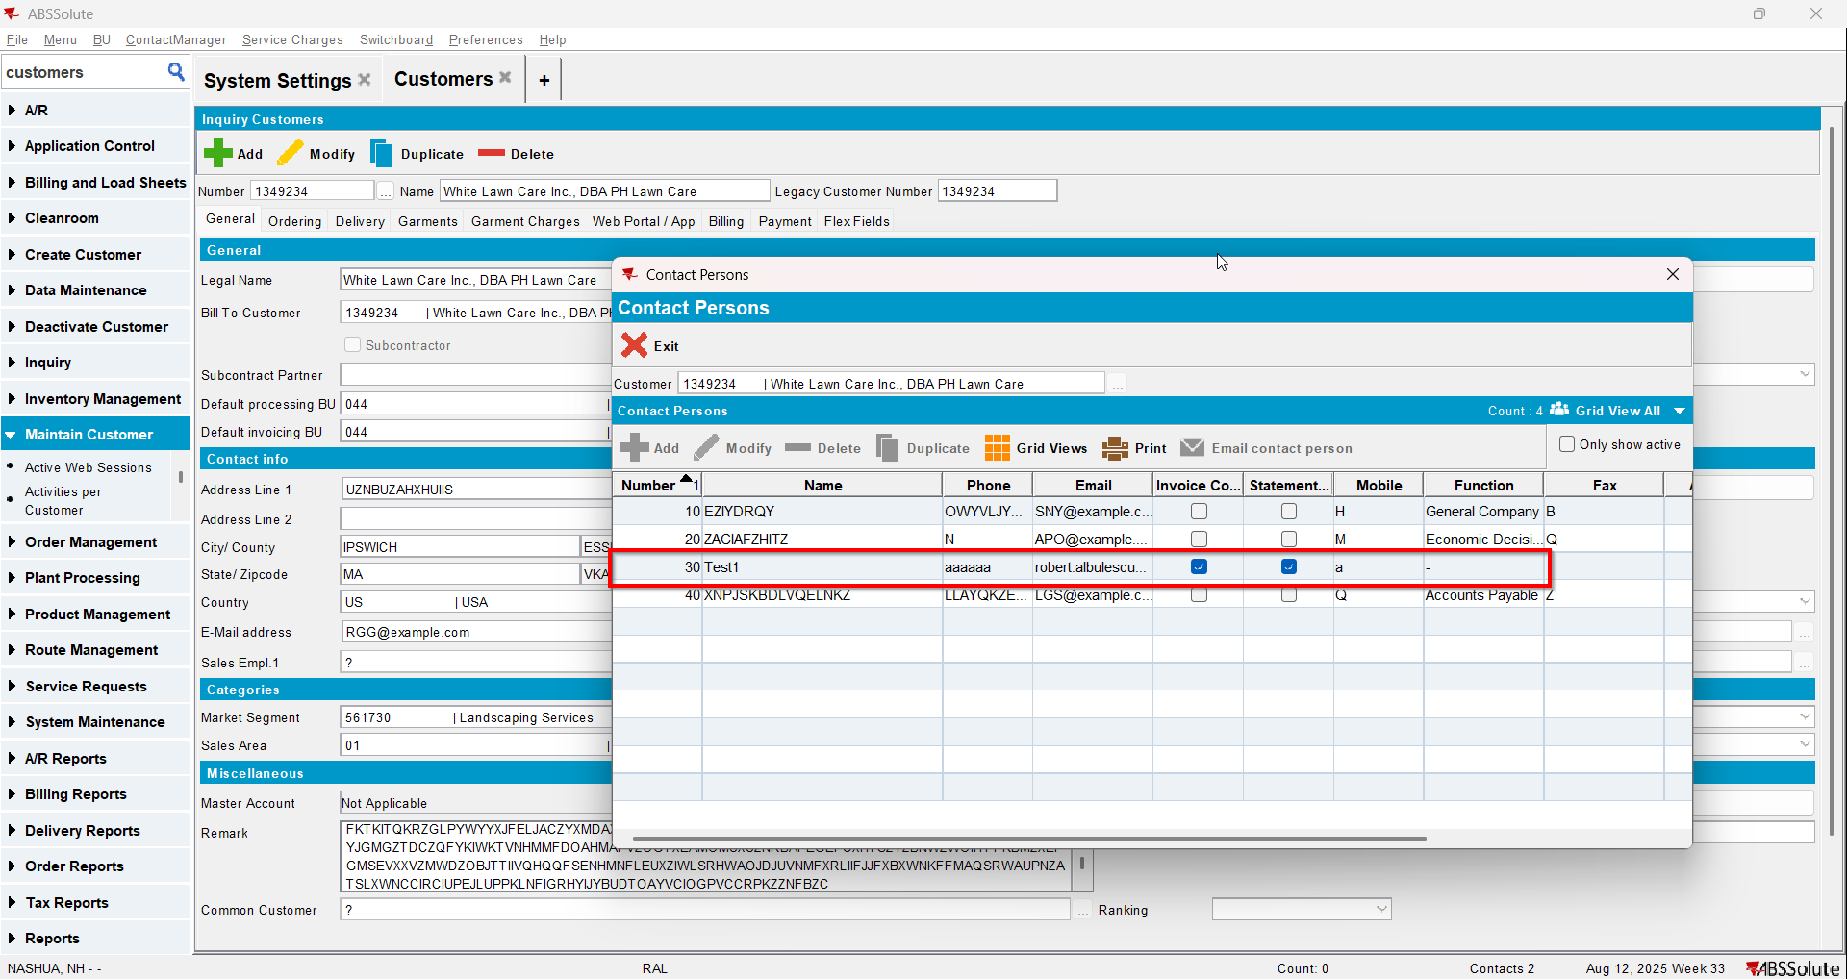
- For an invoice check what email address is on the invoice header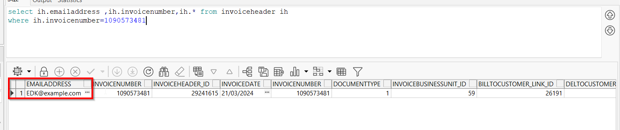
- Go to Maintain Invoices dlg and load your customer
- To Settled tab select your invoice from step 4 and press E-mail Invoice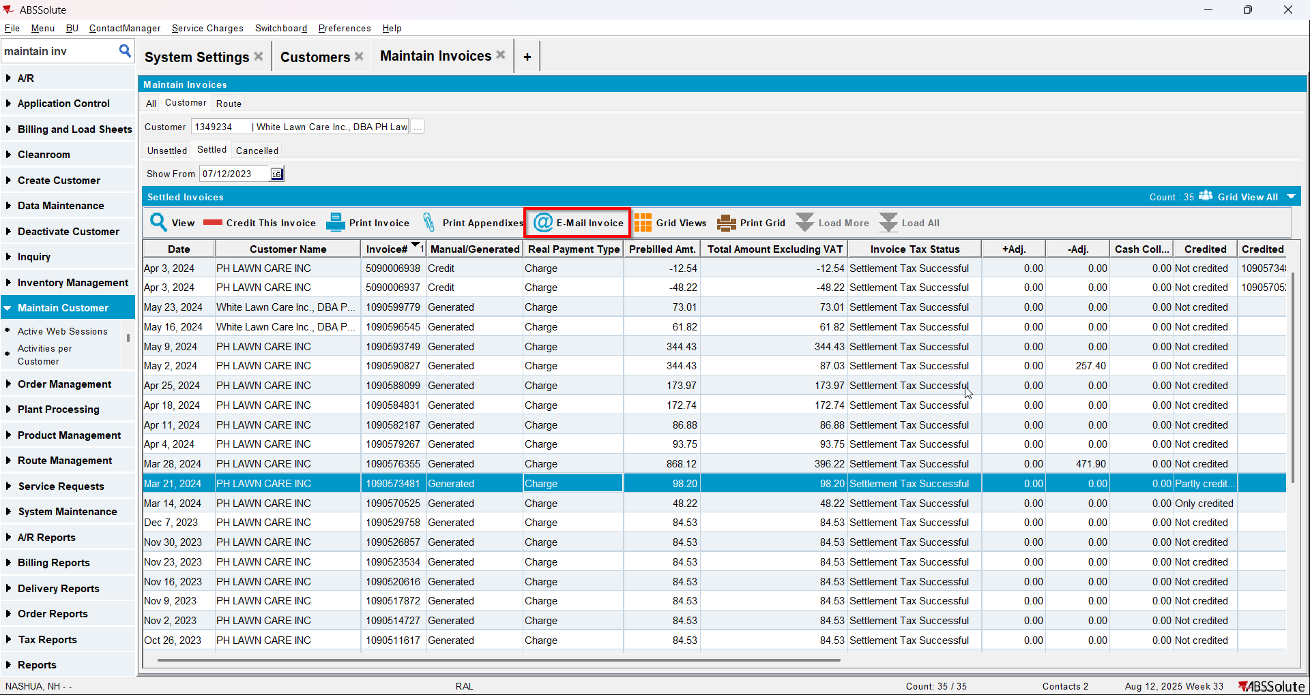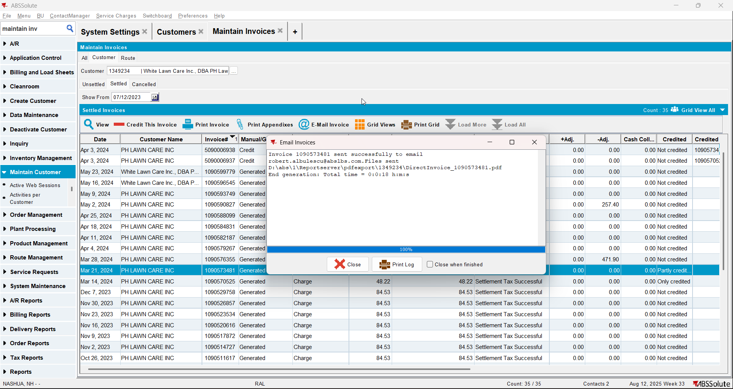
- Check if the email was sent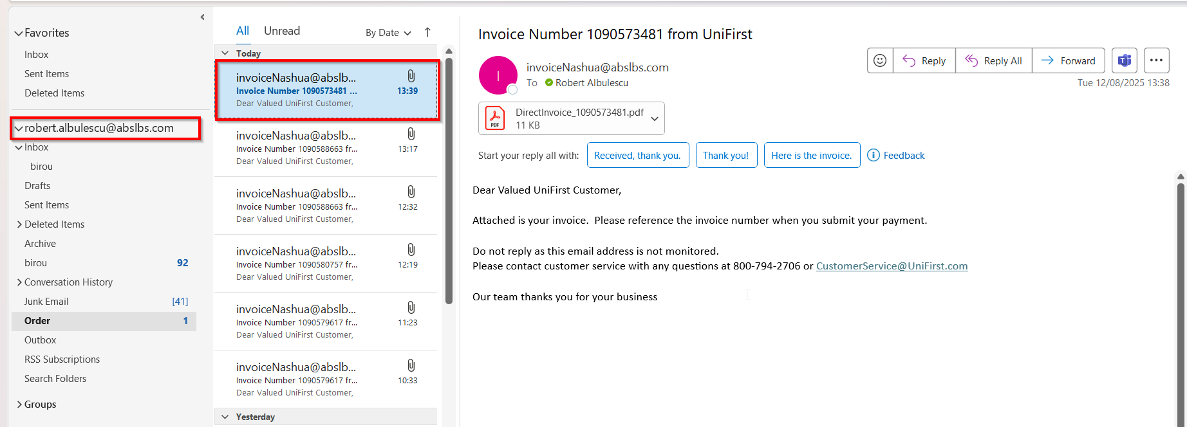

Test Case 2 – Send E-Mail when MULTIPLEINVANDSTMCONTACTS=0 and customer is not its own bill to – Tested OK
Expected behavior: The invoice should be emailed to the email address of the contact persons that is invoice contact, not on the email address that is on the invoice header
Hash: ff9c238
- Check that SS MULTIPLEINVANDSTMCONTACTS=0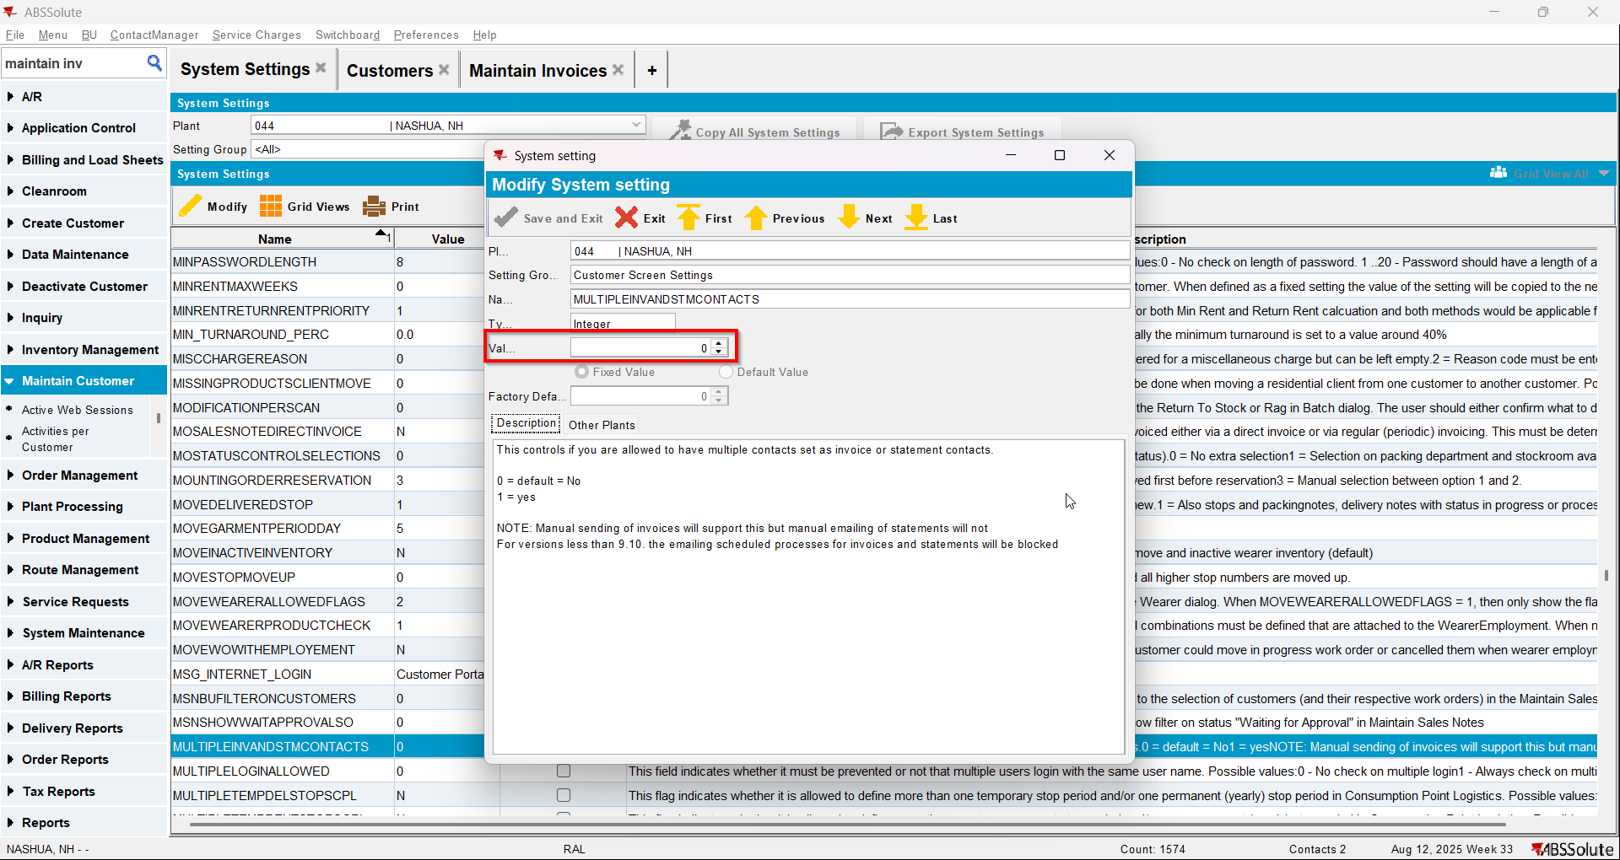
- Have a customer that is not its own bill to
- Check that he has 1 contact person that is invoice contact and has a valid email address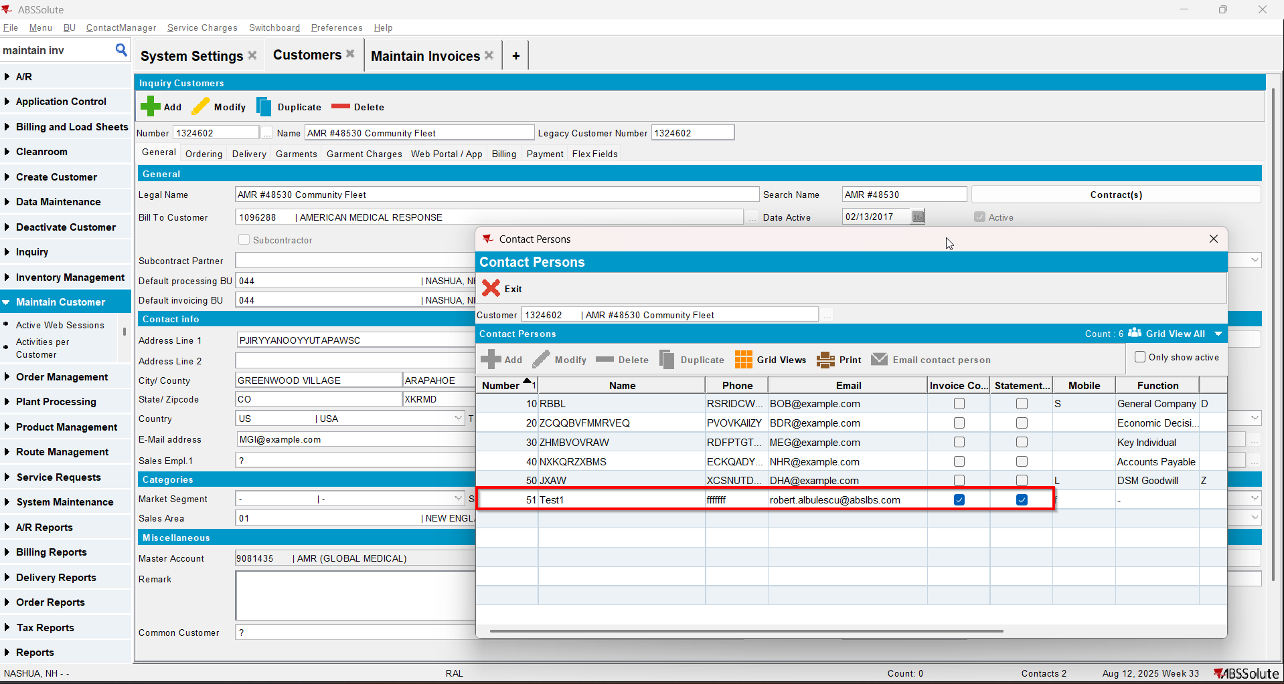
- Go on the bill to customer and also check that he has 1 contact person that is invoice contact and has a valid email address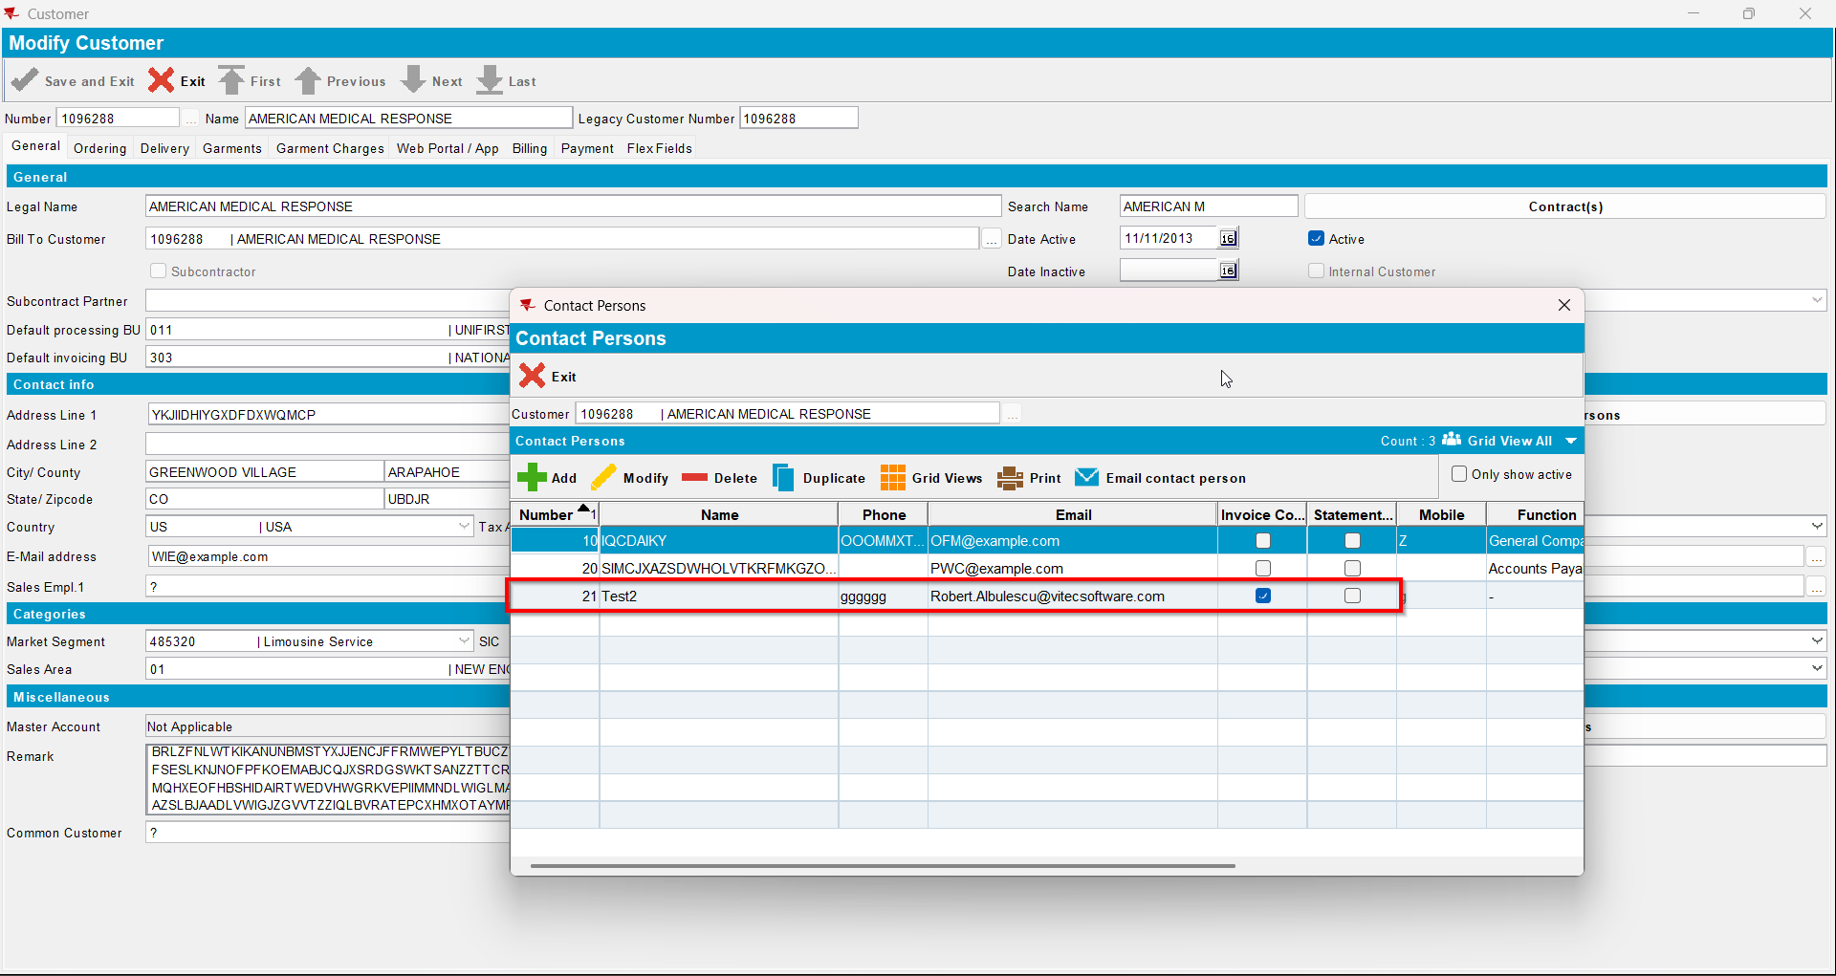
- Also on the bill to customer check that checkbox Send by E-mail is checked and on the drop-down selection the ‘Del To Invoice Contact’ option is selected(modifying this on bill to customer will also modify on del to customer )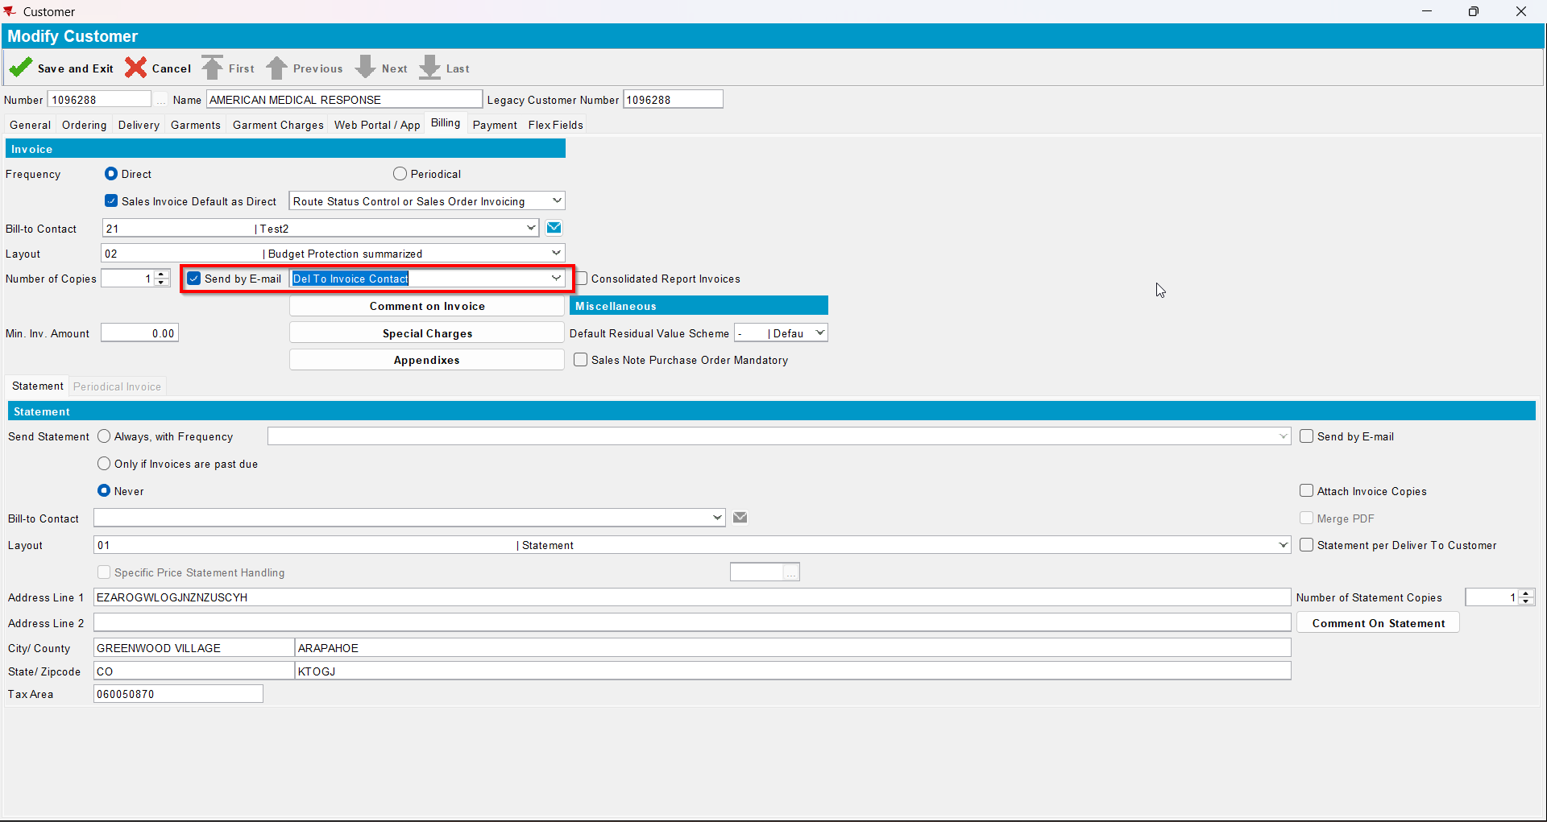
- For an invoice check what email address is on the invoice header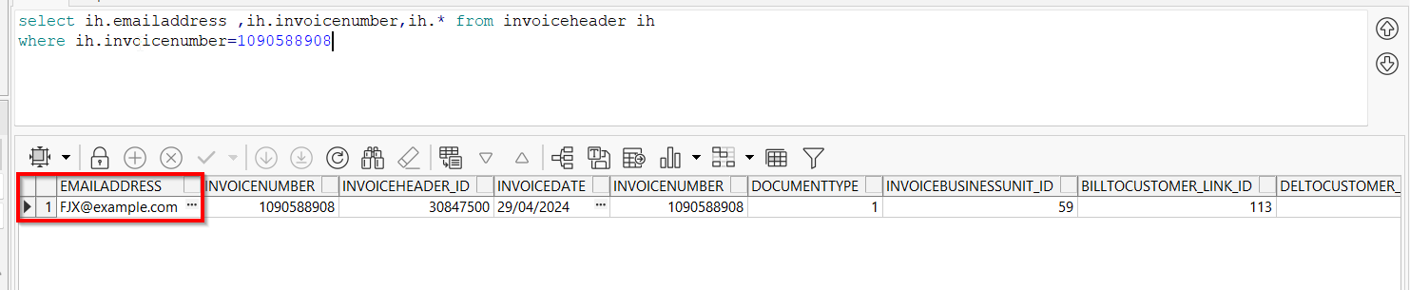
- Go to Maintain Invoices dlg and load your del to customer
- To Settled tab select your invoice from step 6 and press E-mail Invoice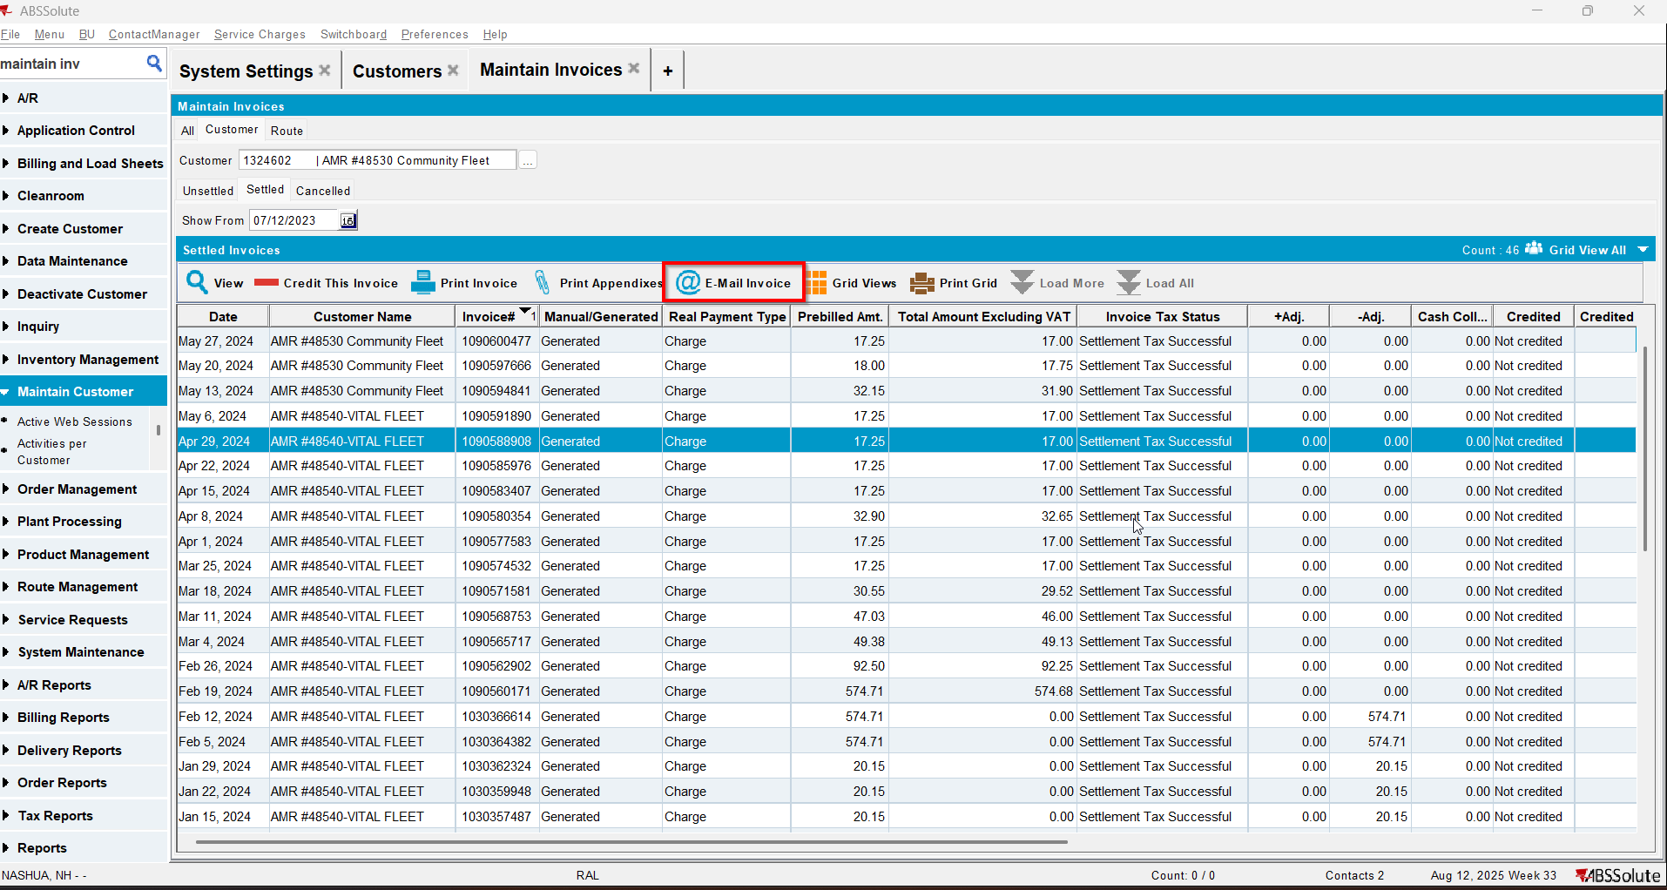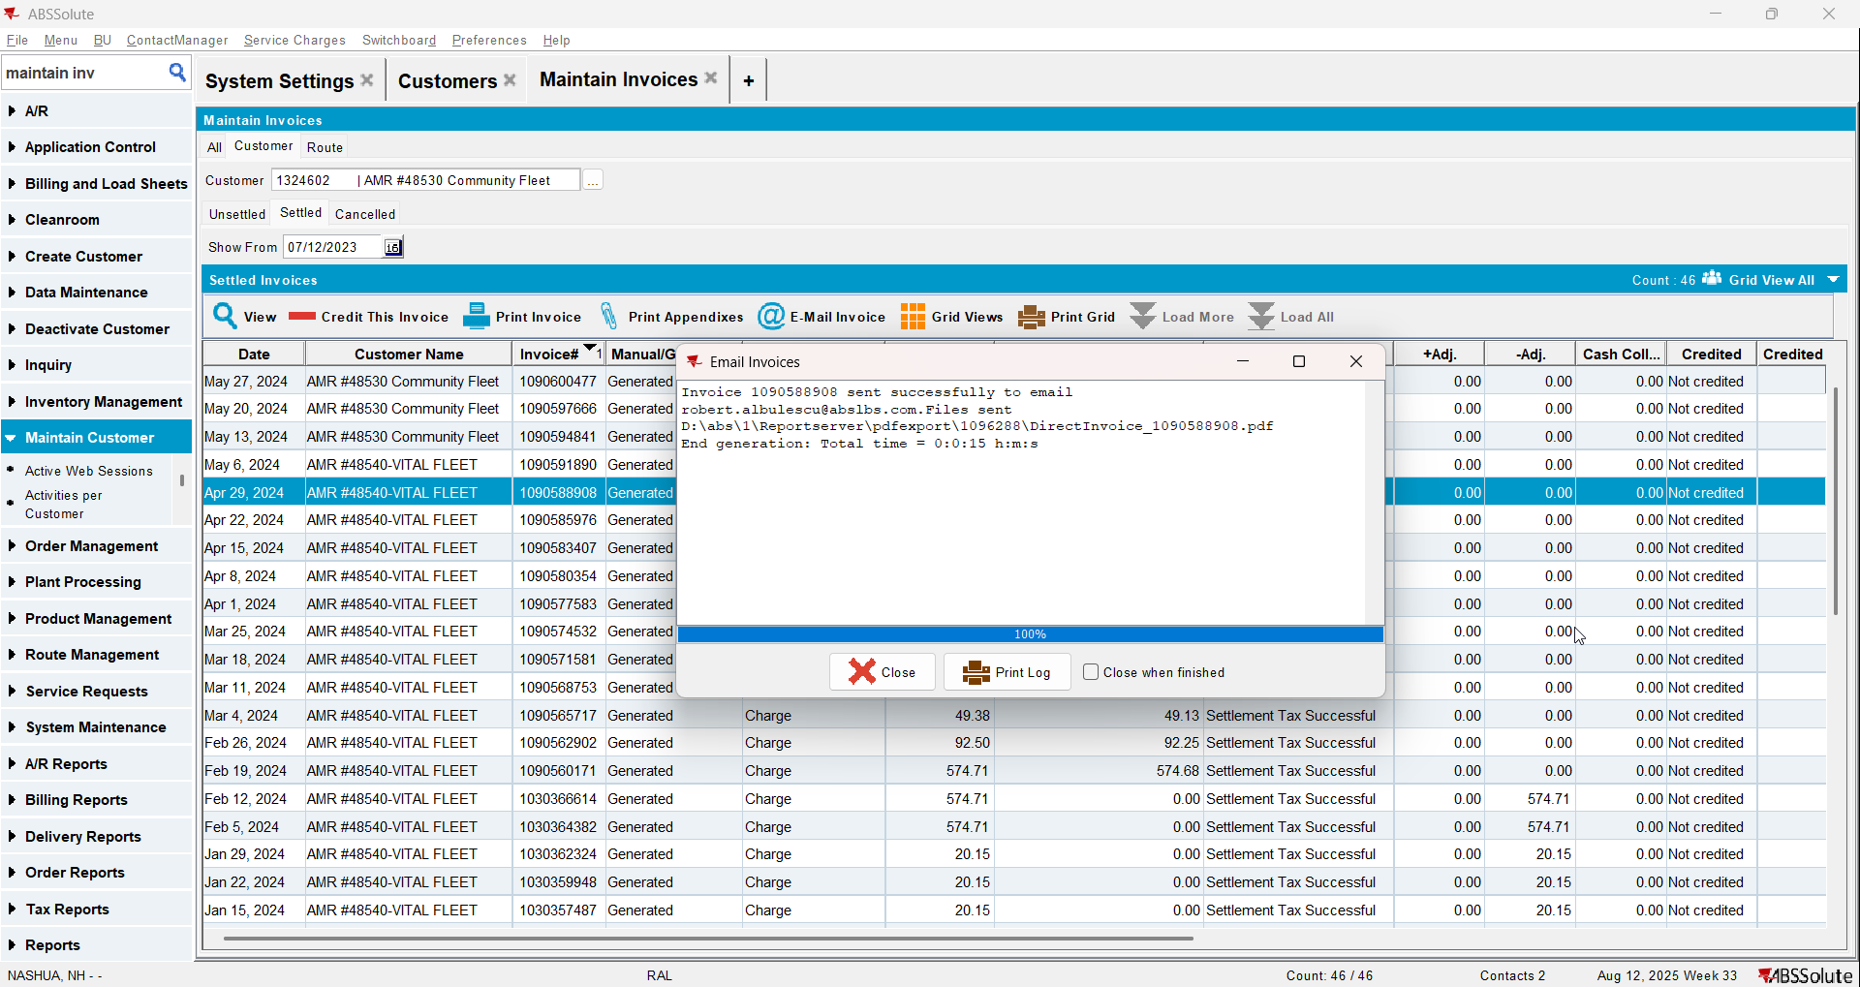
- Check if the email was sent to the contact person of the del to customer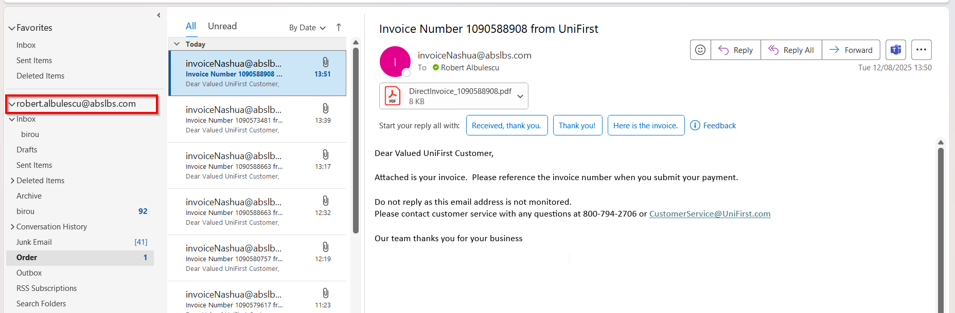
- Go on the bill to customer and on the drop-down select ‘Bill To Invoice Contact’ option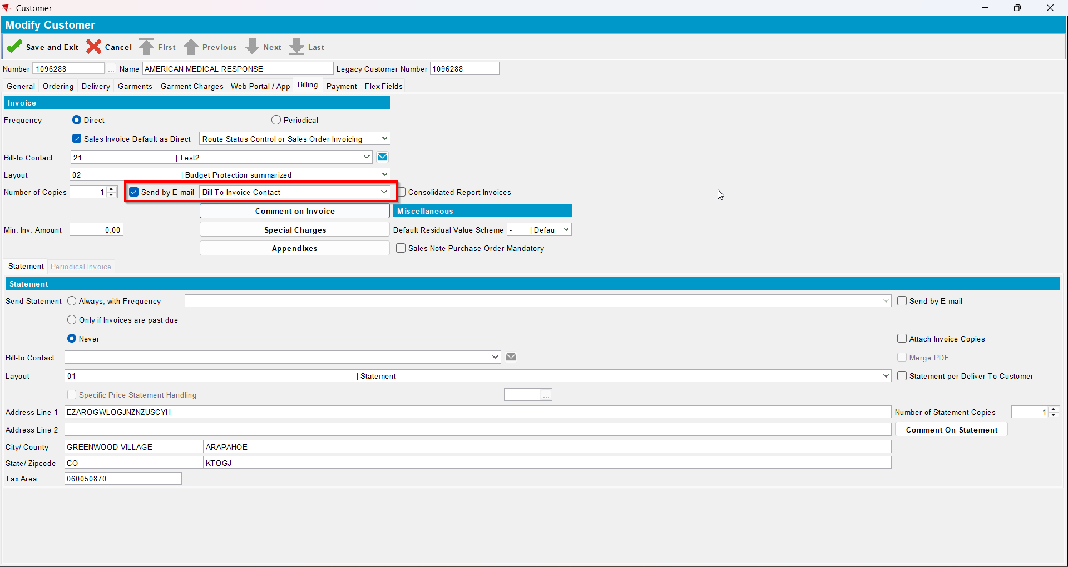
- Go to Customer Financial Details dlg and load your del to customer
- To Settled tab select your invoice from step 6 and press E-mail Invoice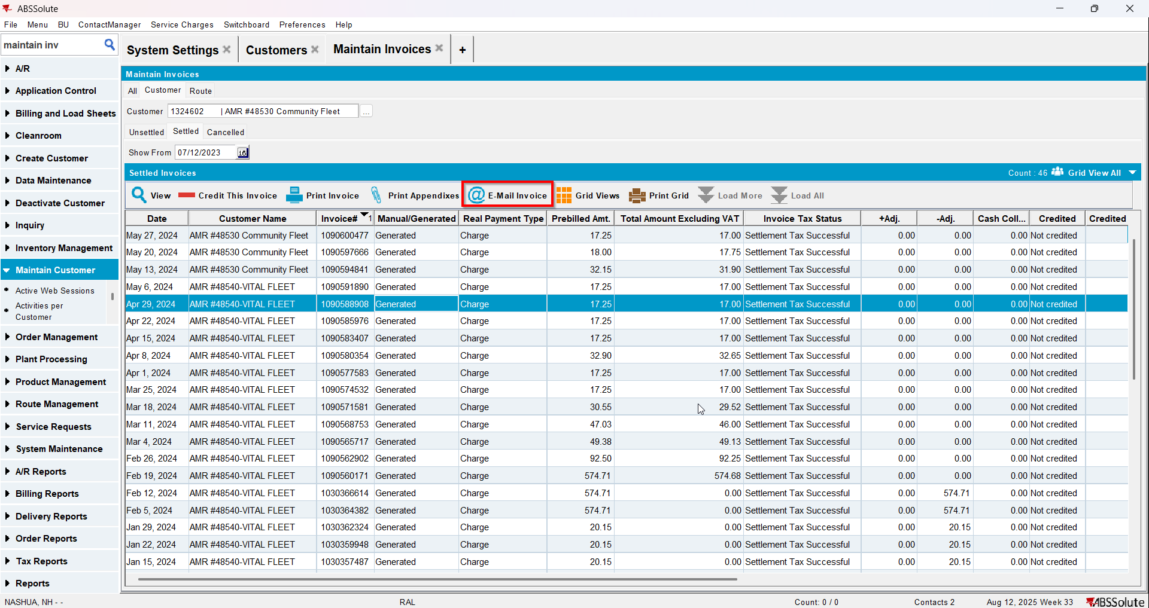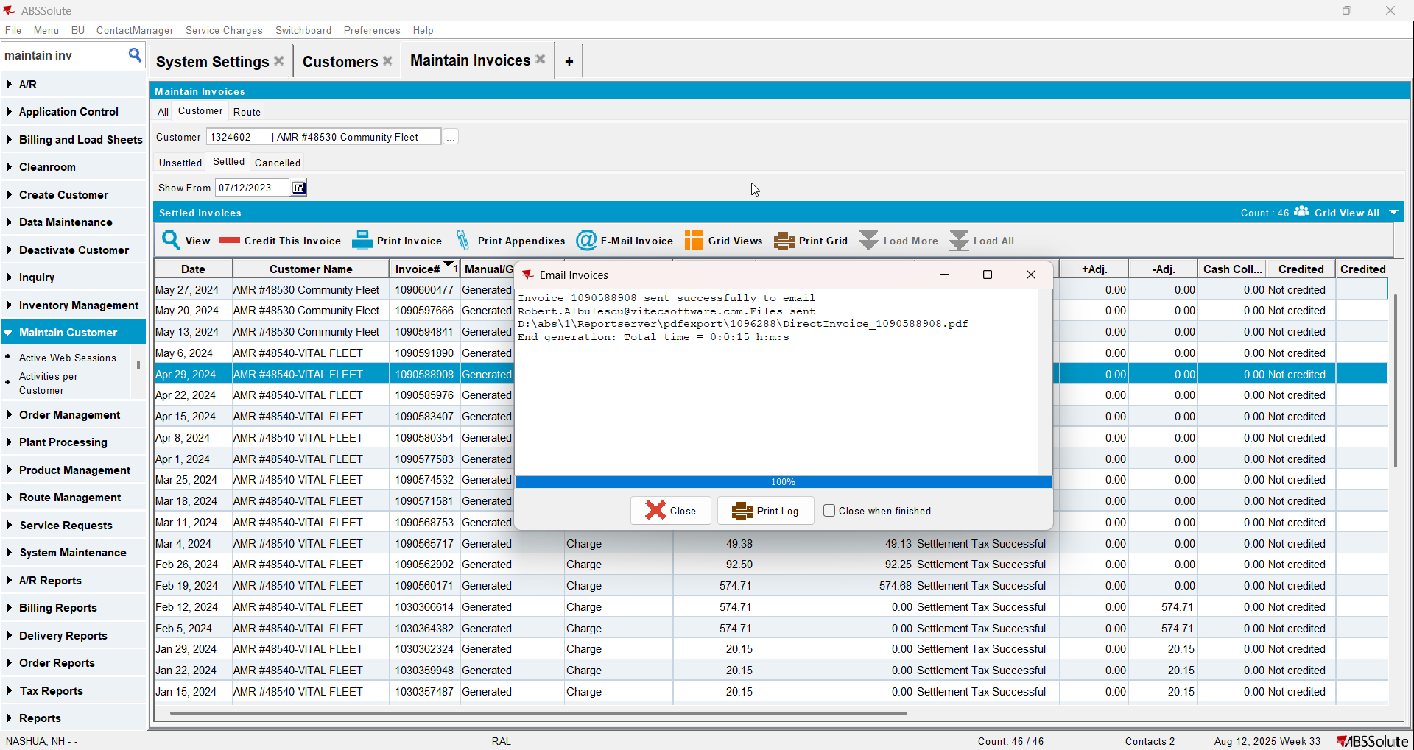
- Check if the email was sent to the contact person of the bill to customer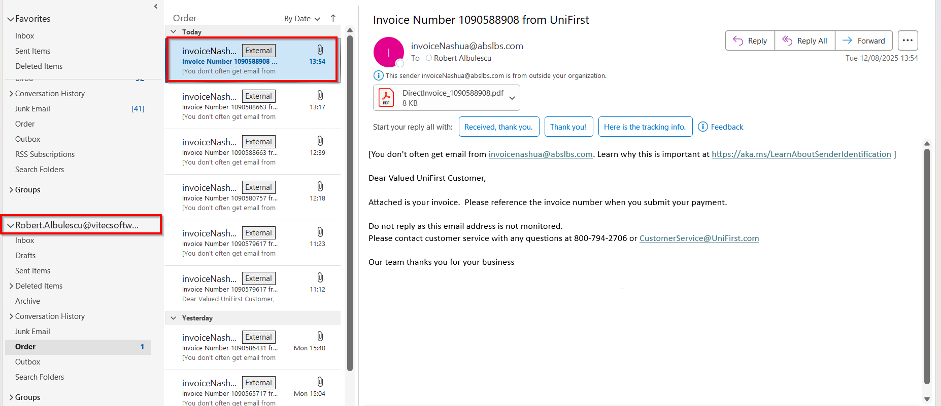
- Go on the bill to customer and on the drop-down select ‘Del To and Bill To Invoice Contacts’ option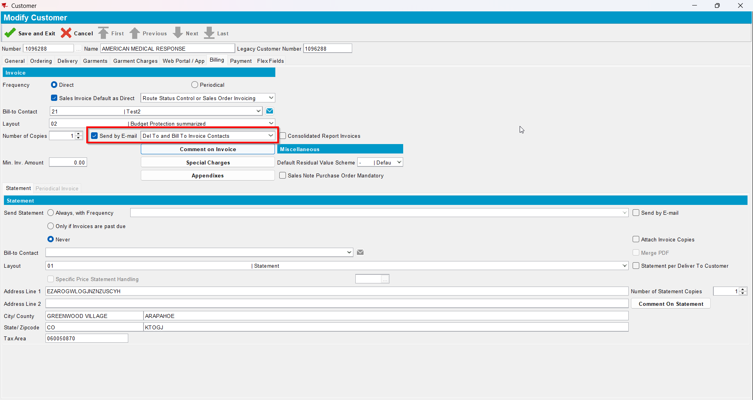
- Go to Customer Financial Details dlg and load your del to customer
- To Invoices tab select your invoice from step 6 and press E-mail Invoice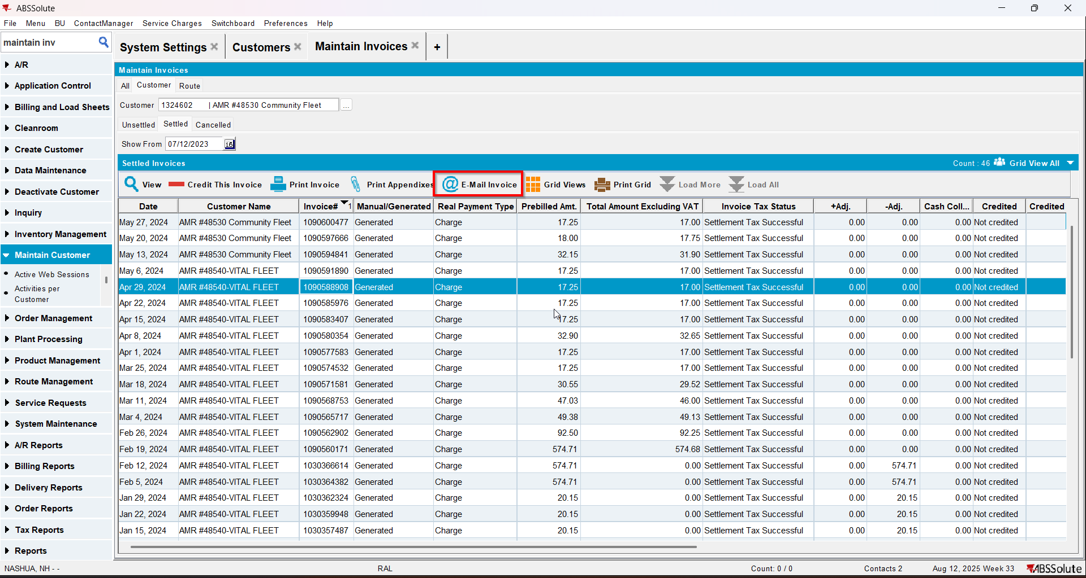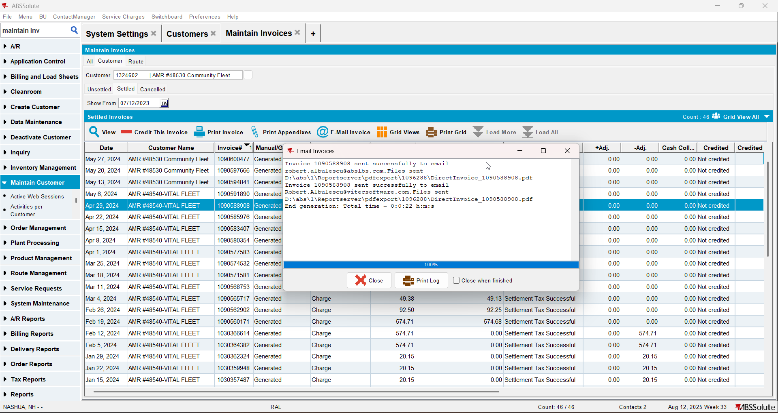
- Check if the email was sent to the contact persons of the del to customer and bill to customer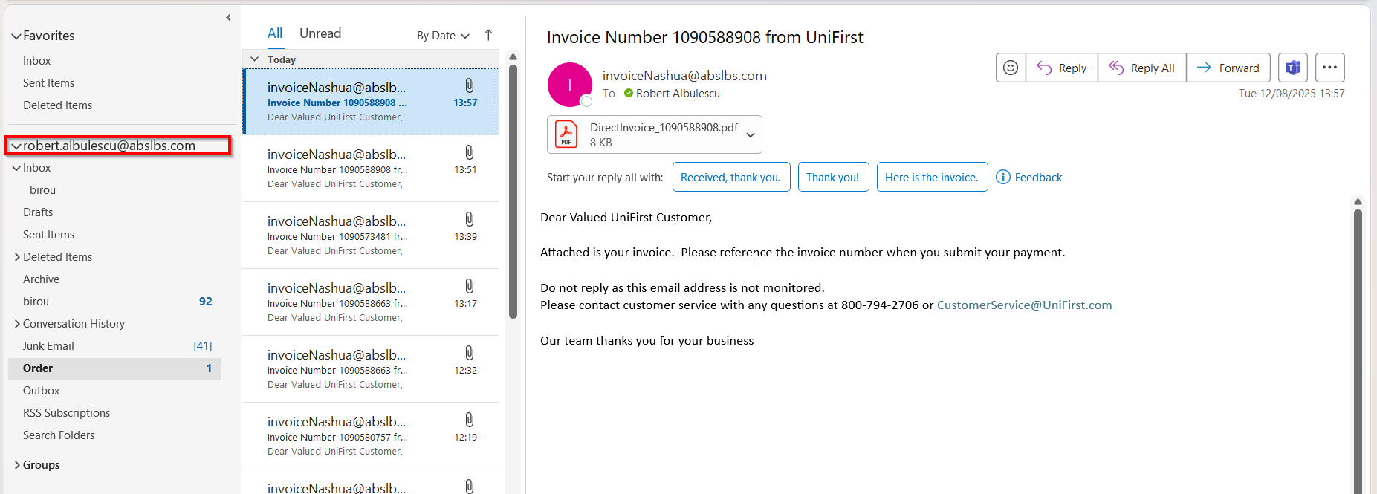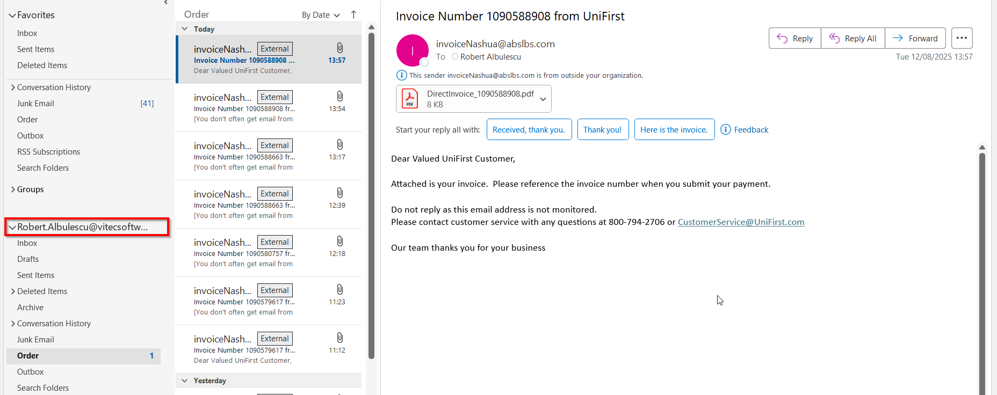

Test Case 3 – Send E-Mail when MULTIPLEINVANDSTMCONTACTS=1 and customer is its own bill to – Tested OK
Expected behavior: The invoice should be emailed to the email address of the contact persons that is invoice contact, not on the email address that is on the invoice header
Hash: ff9c238
- Check that SS MULTIPLEINVANDSTMCONTACTS=1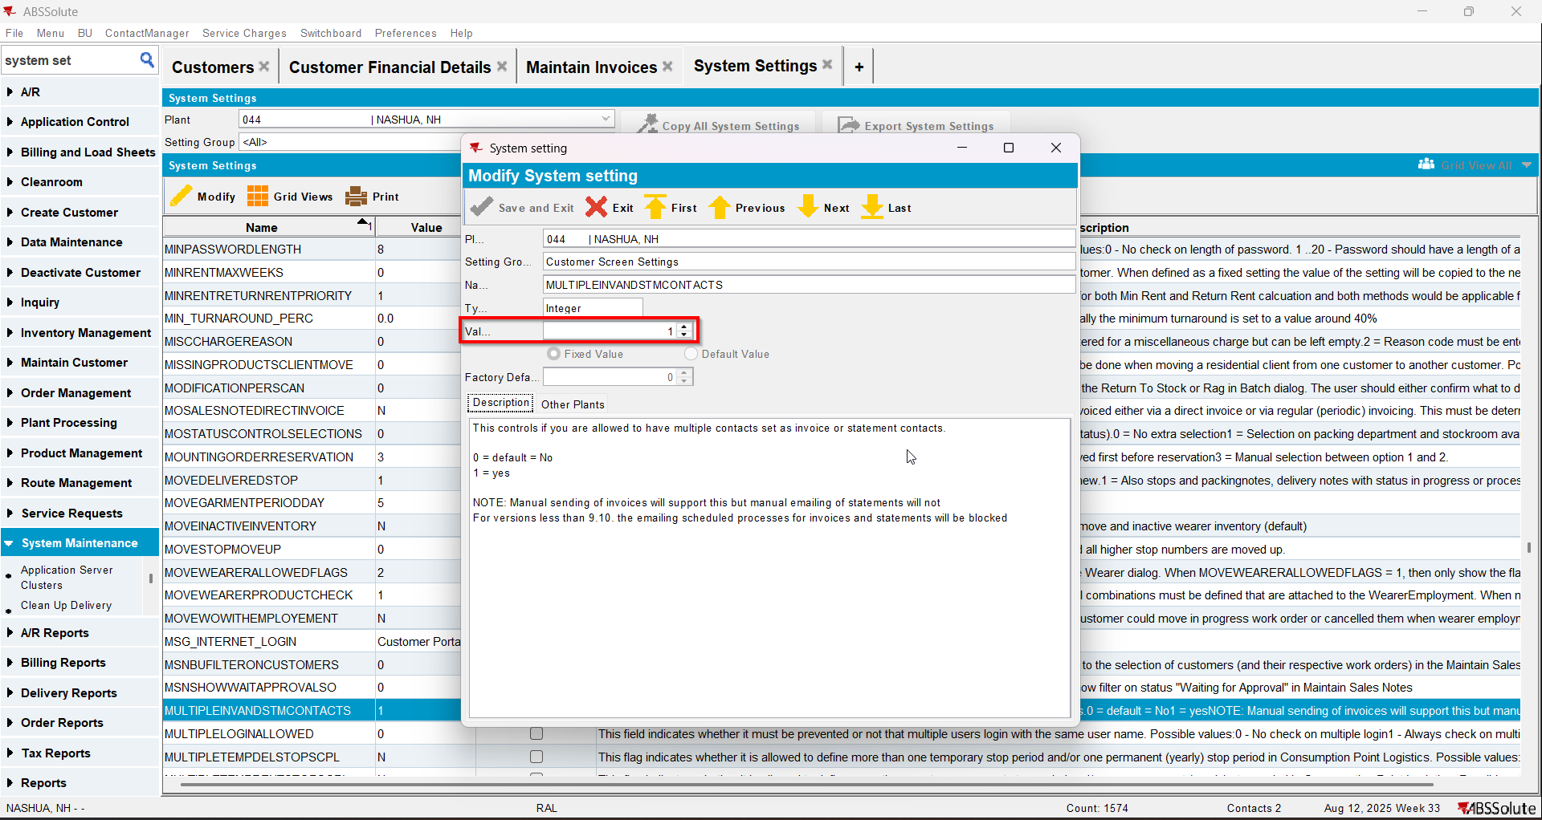
- Have a customer that is its own bill to
- Check that he has at least 2 contact persons that are invoice contact and have a valid email address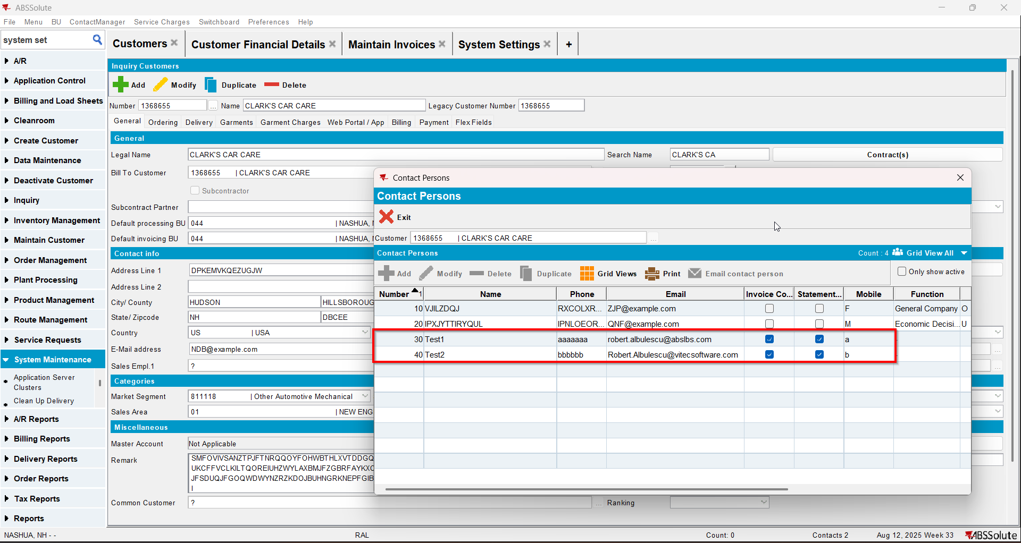
- For an invoice check what email address is on the invoice header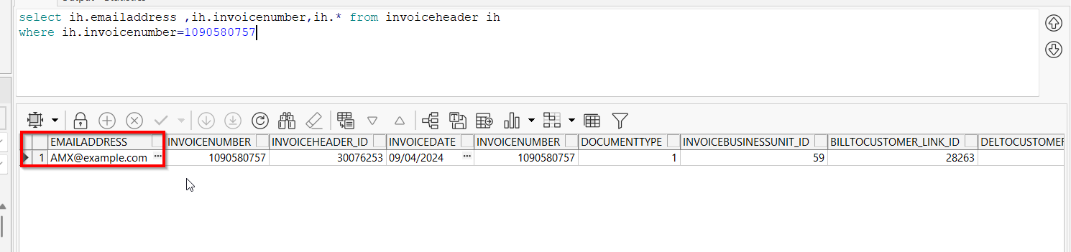
- Go to Maintain Invoices dlg and load your customer
- To Settled tab select your invoice from step 4 and press E-mail Invoice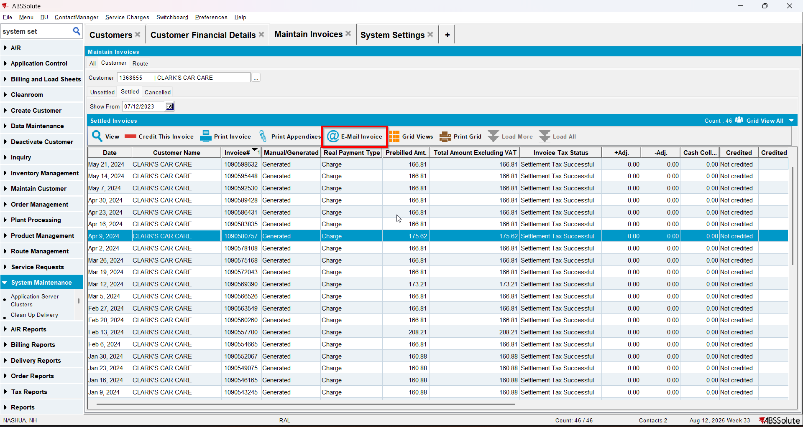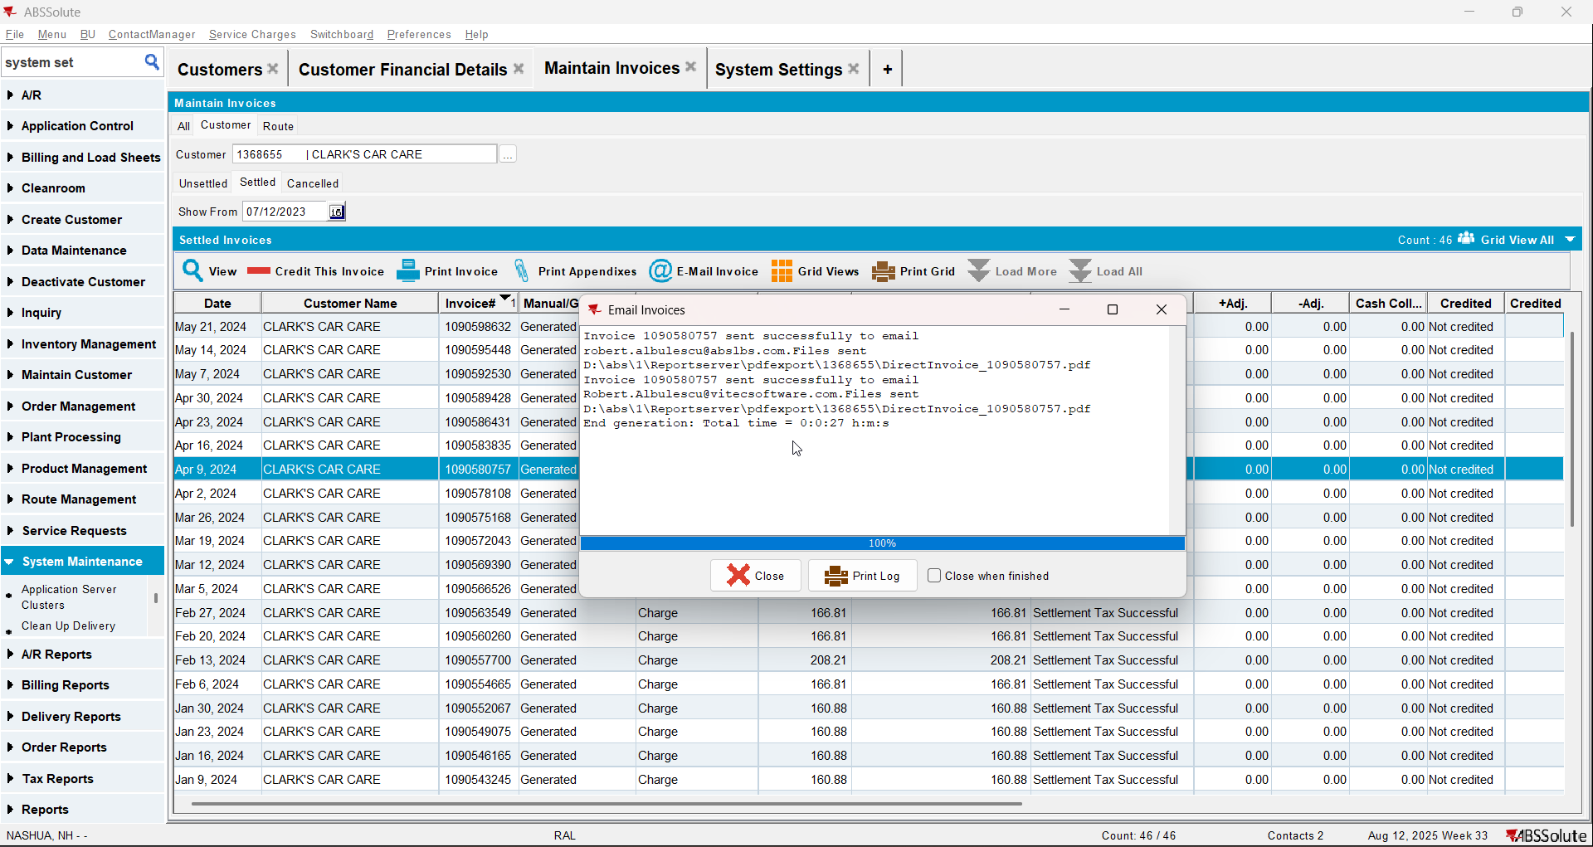
- Check if the email was sent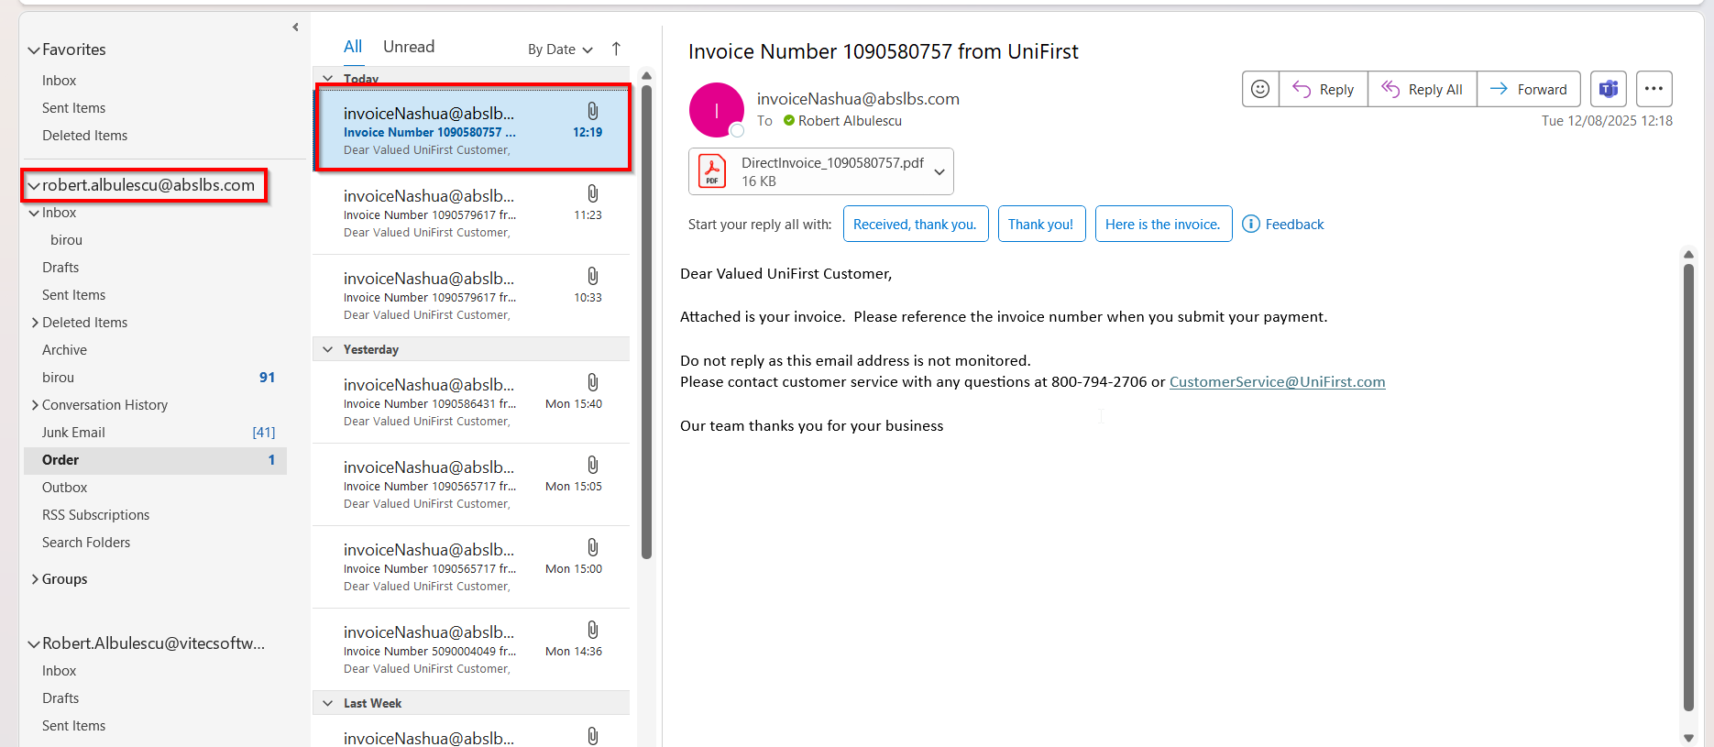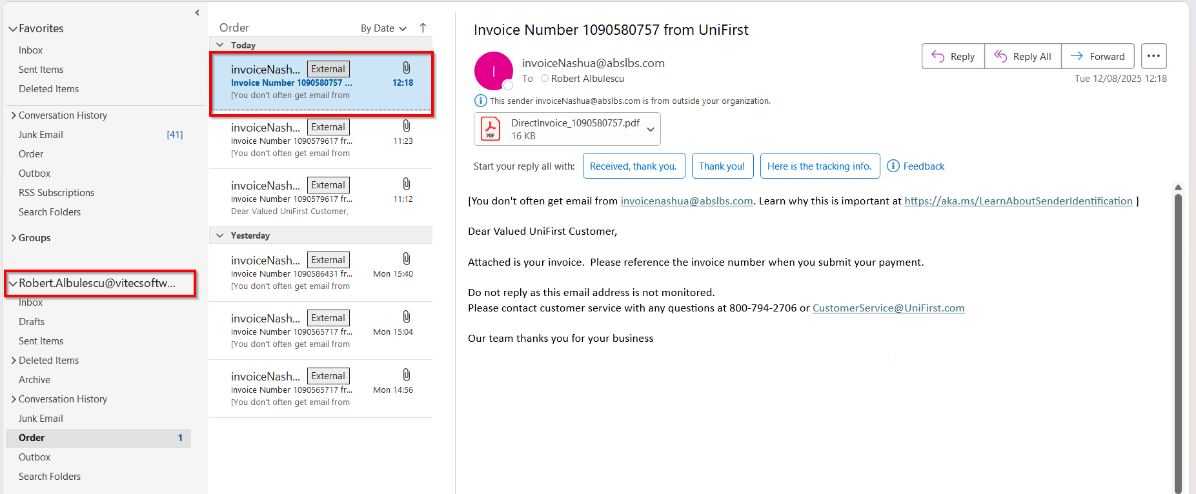

Test Case 4 – Send E-Mail when MULTIPLEINVANDSTMCONTACTS=1 and customer is not its own bill to – Tested OK
Expected behavior: The invoice should be emailed to the email address of the contact persons that is invoice contact, not on the email address that is on the invoice header
Hash: ff9c238
- Check that SS MULTIPLEINVANDSTMCONTACTS=1
- Have a customer that is not its own bill to
- Check that he has at least 2 contact persons that are invoice contacts and have a valid email address
- Go on the bill to customer and check that he has at least 2 contact persons that are invoice contacts and have a valid email address
- Also on the bill to customer check that checkbox Send by E-mail is checked and on the drop-down selection the ‘Del To Invoice Contact’ option is selected(modifying this on bill to customer will also modify on del to customer )
- For an invoice check what email address is on the invoice header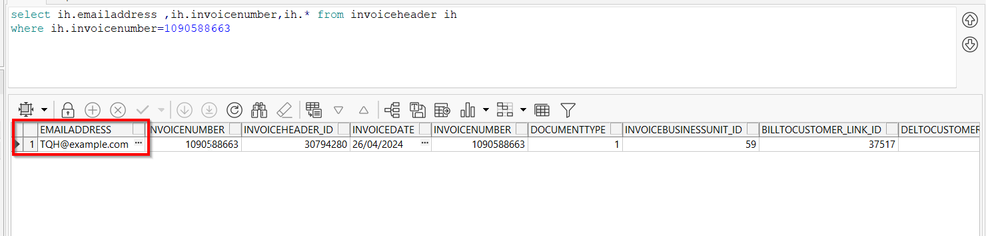
- Go to Maintain Invoices dlg and load your del to customer
- To Settled tab select your invoice from step 6 and press E-mail Invoice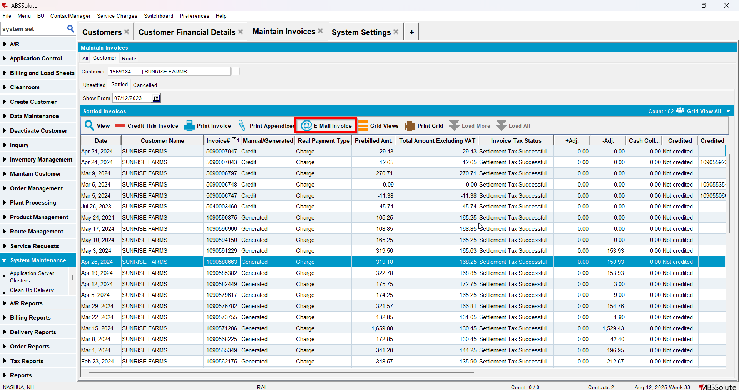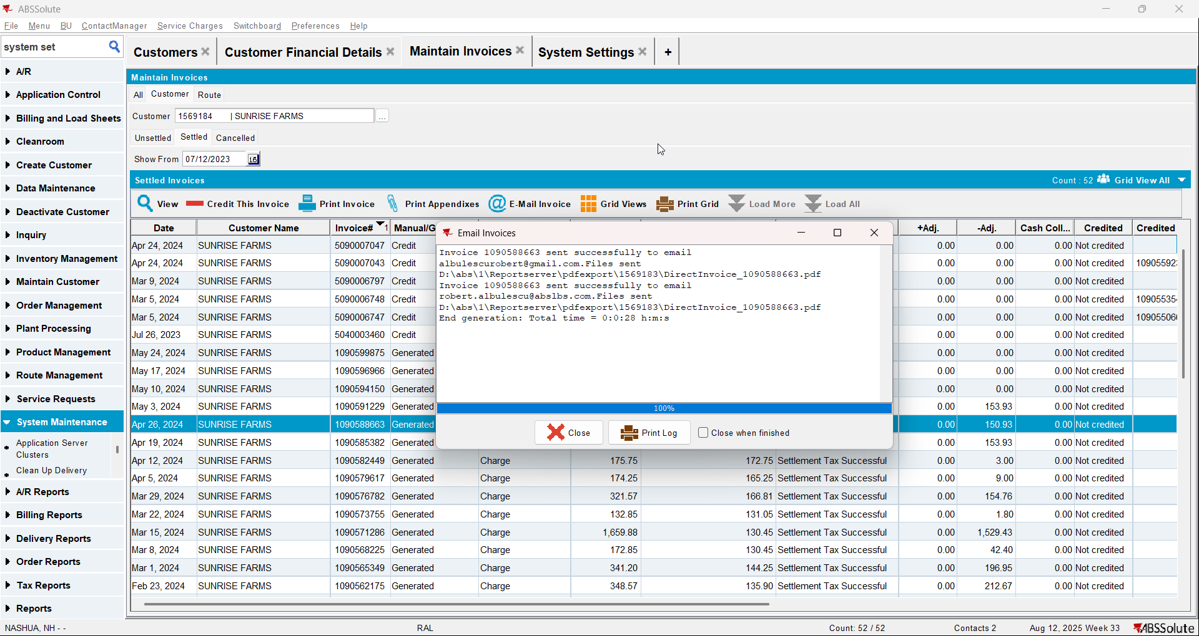
- Check if the email was sent to the contact person of the del to customer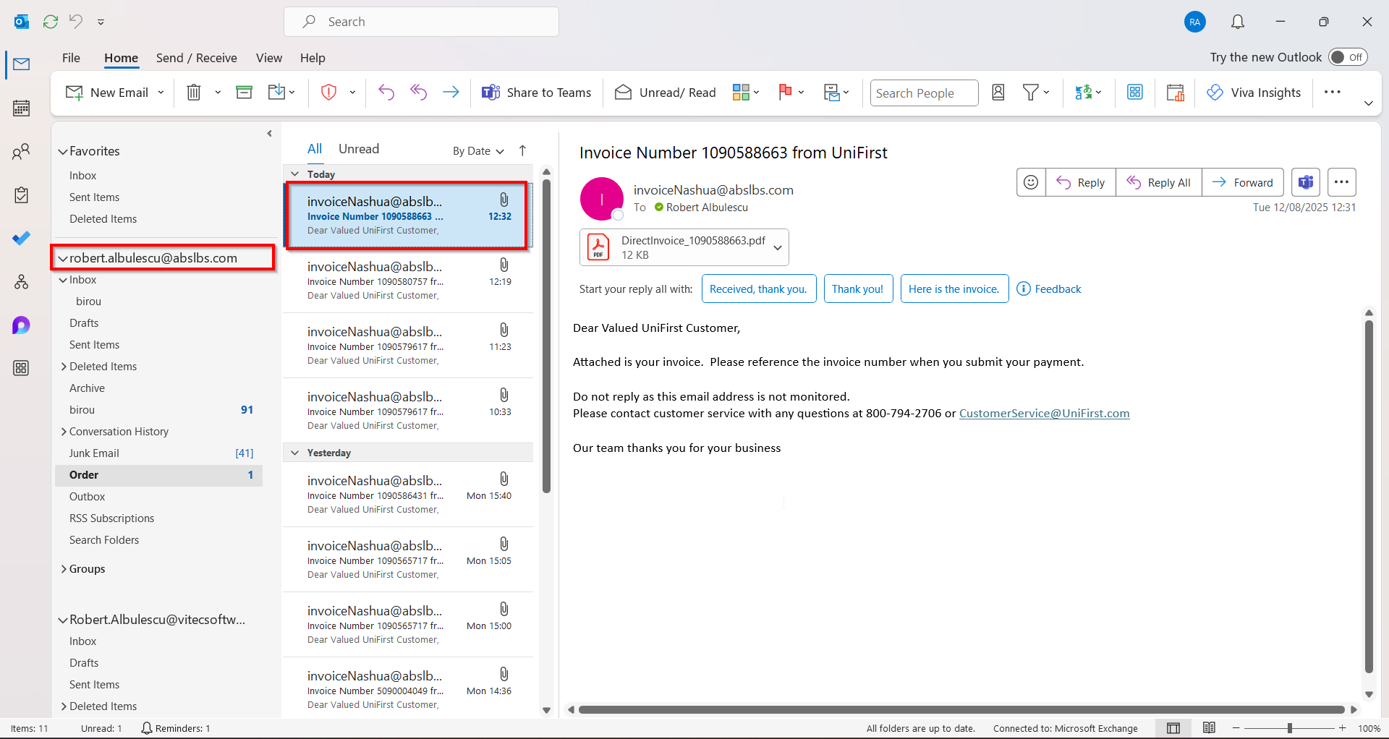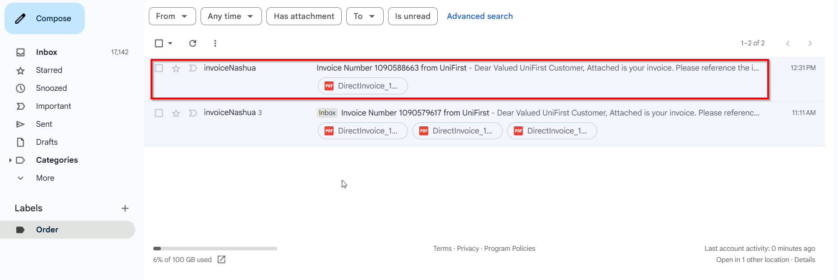
- Go on the bill to customer and on the drop-down select ‘Bill To Invoice Contact’ option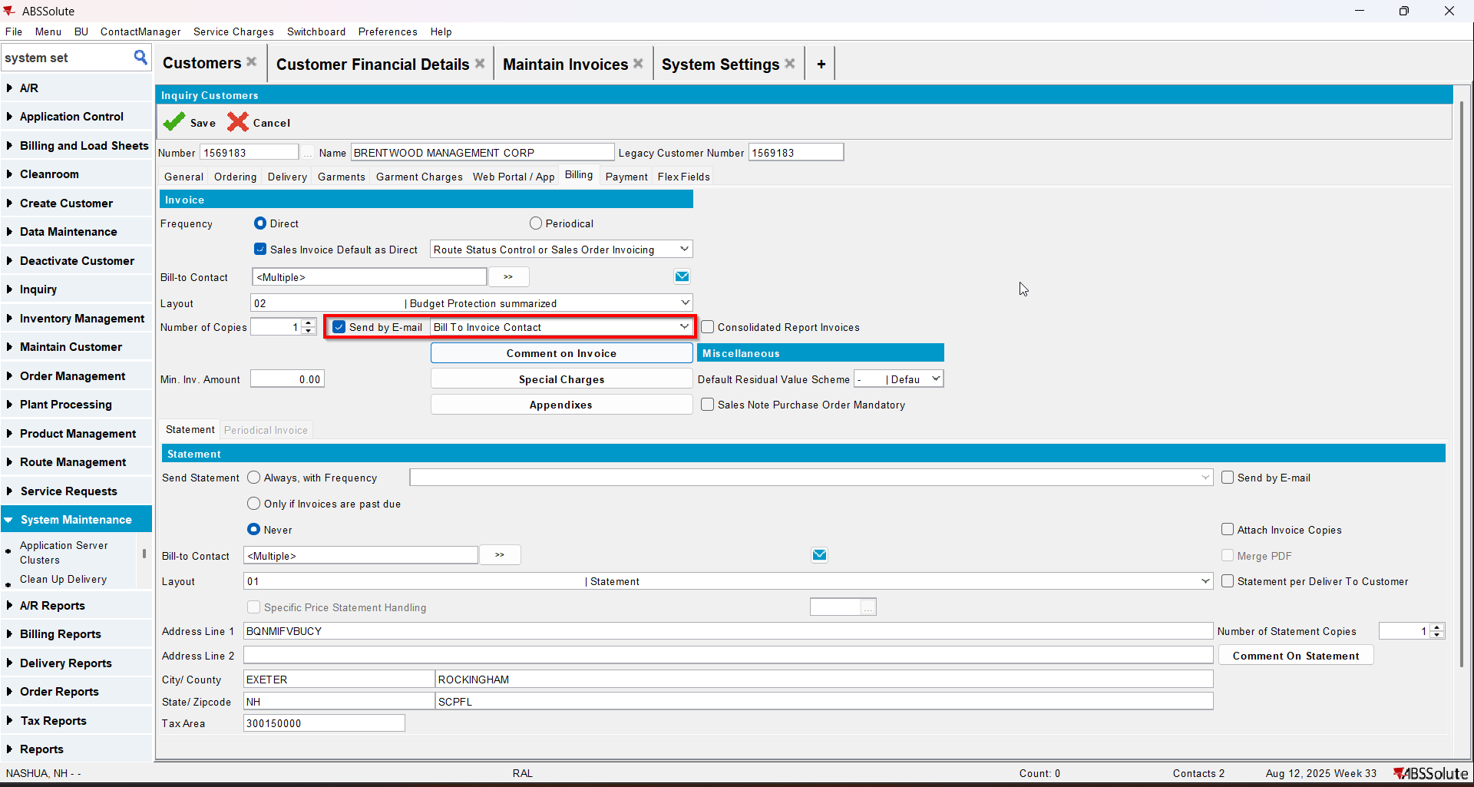
- Go to Customer Financial Details dlg and load your del to customer
- To Settled tab select your invoice from step 6 and press E-mail Invoice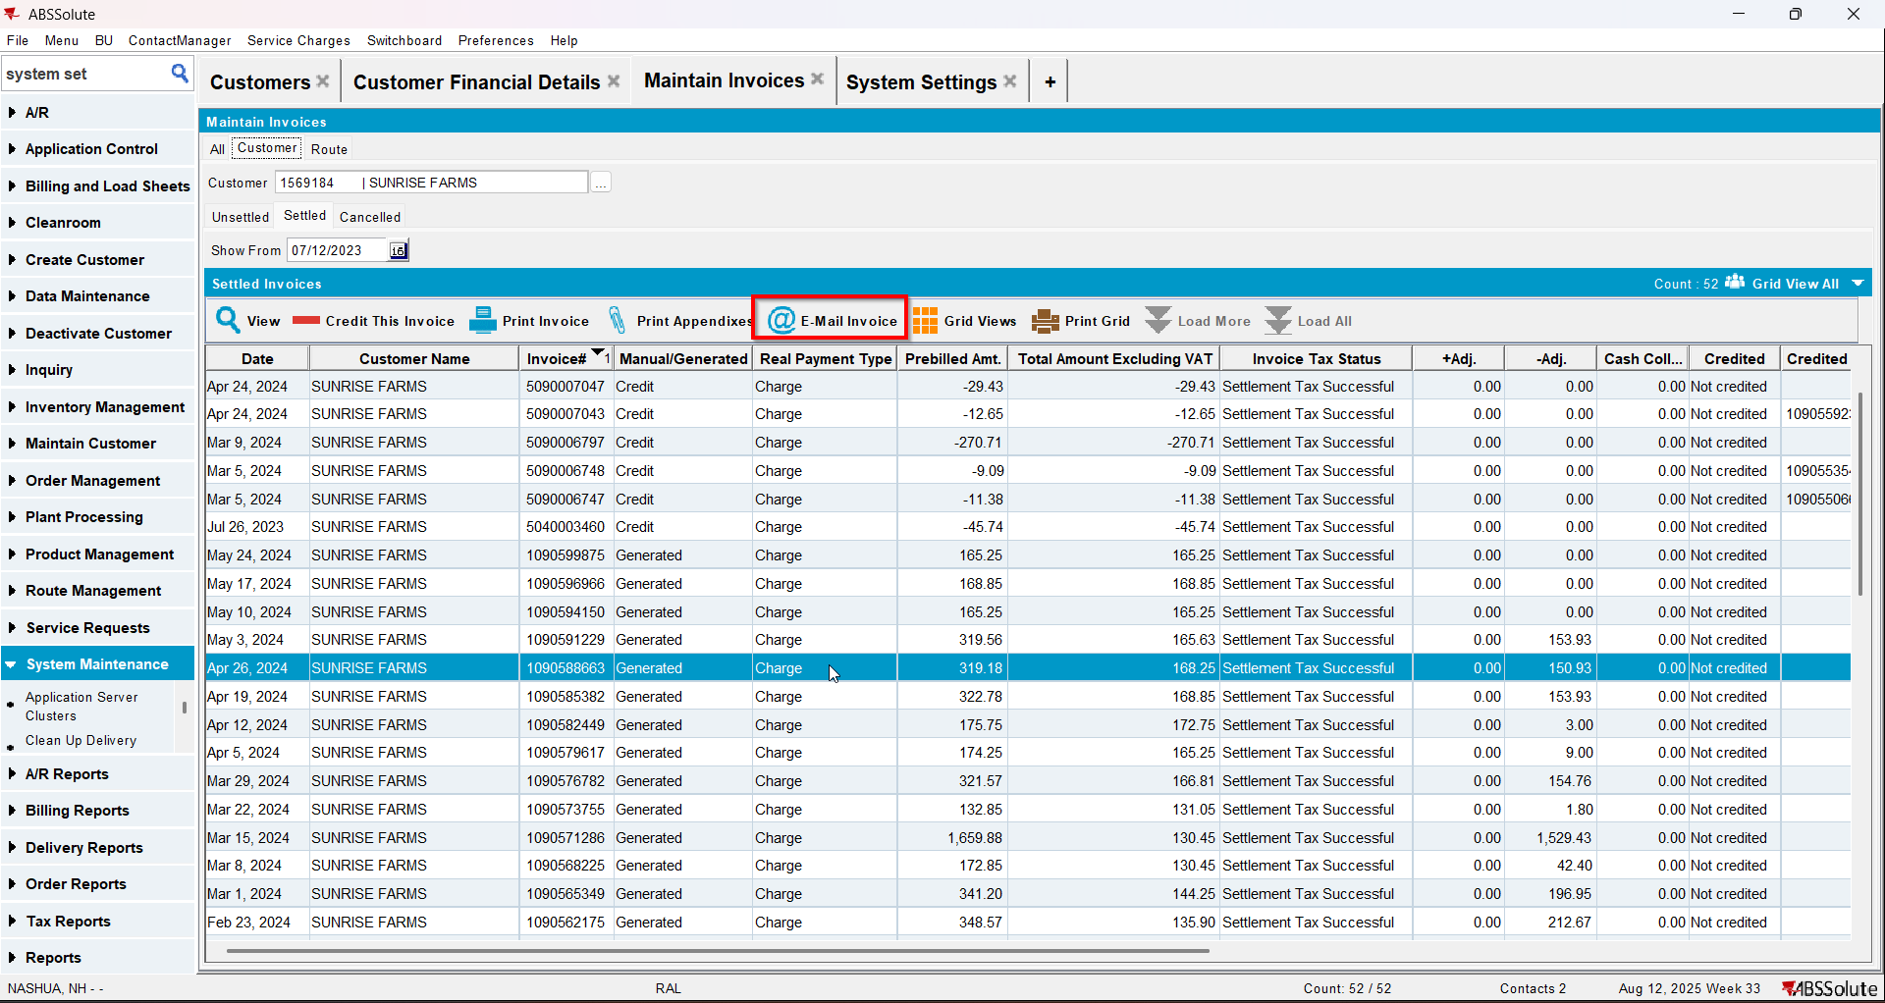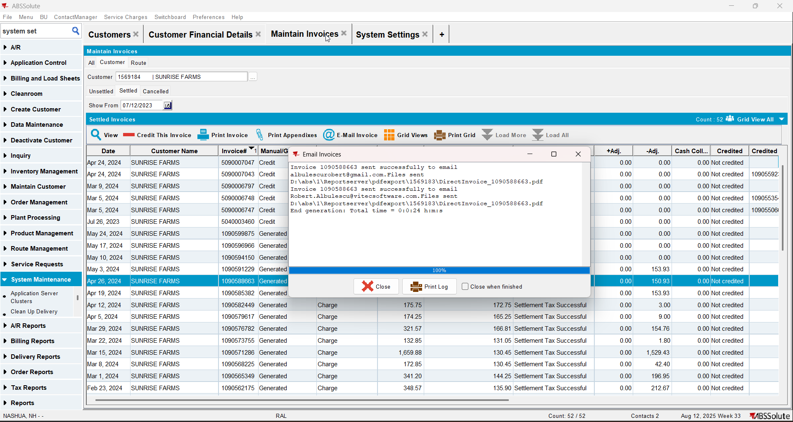
- Check if the email was sent to the contact person of the bill to customer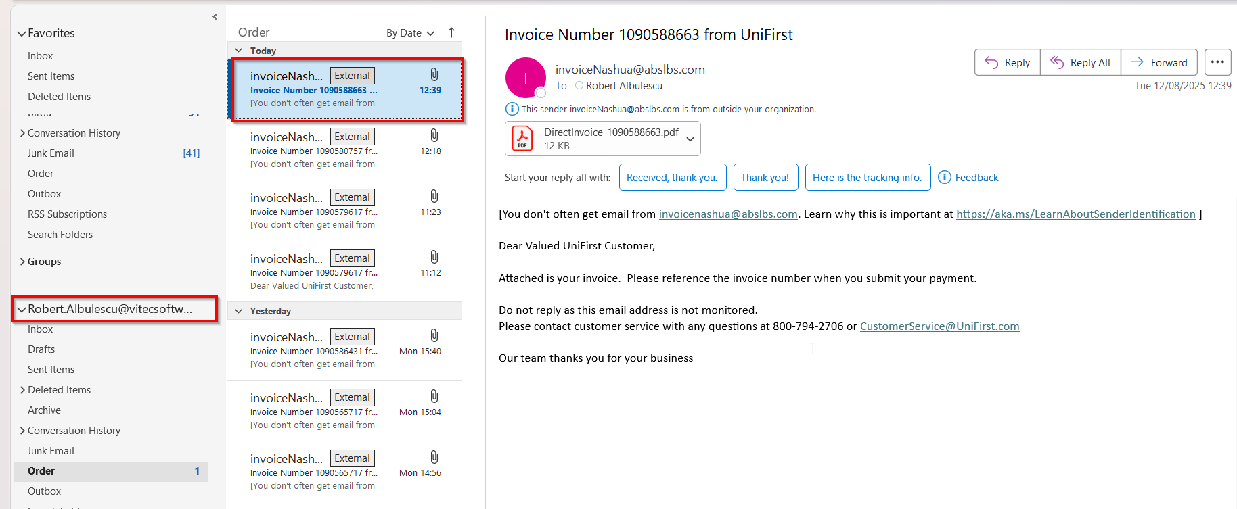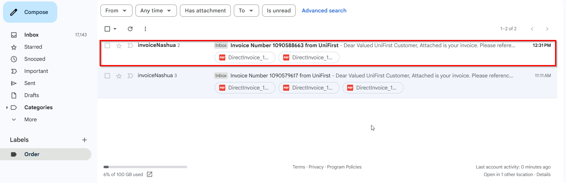
- Go on the bill to customer and on the drop-down select ‘Del To and Bill To Invoice Contacts’ option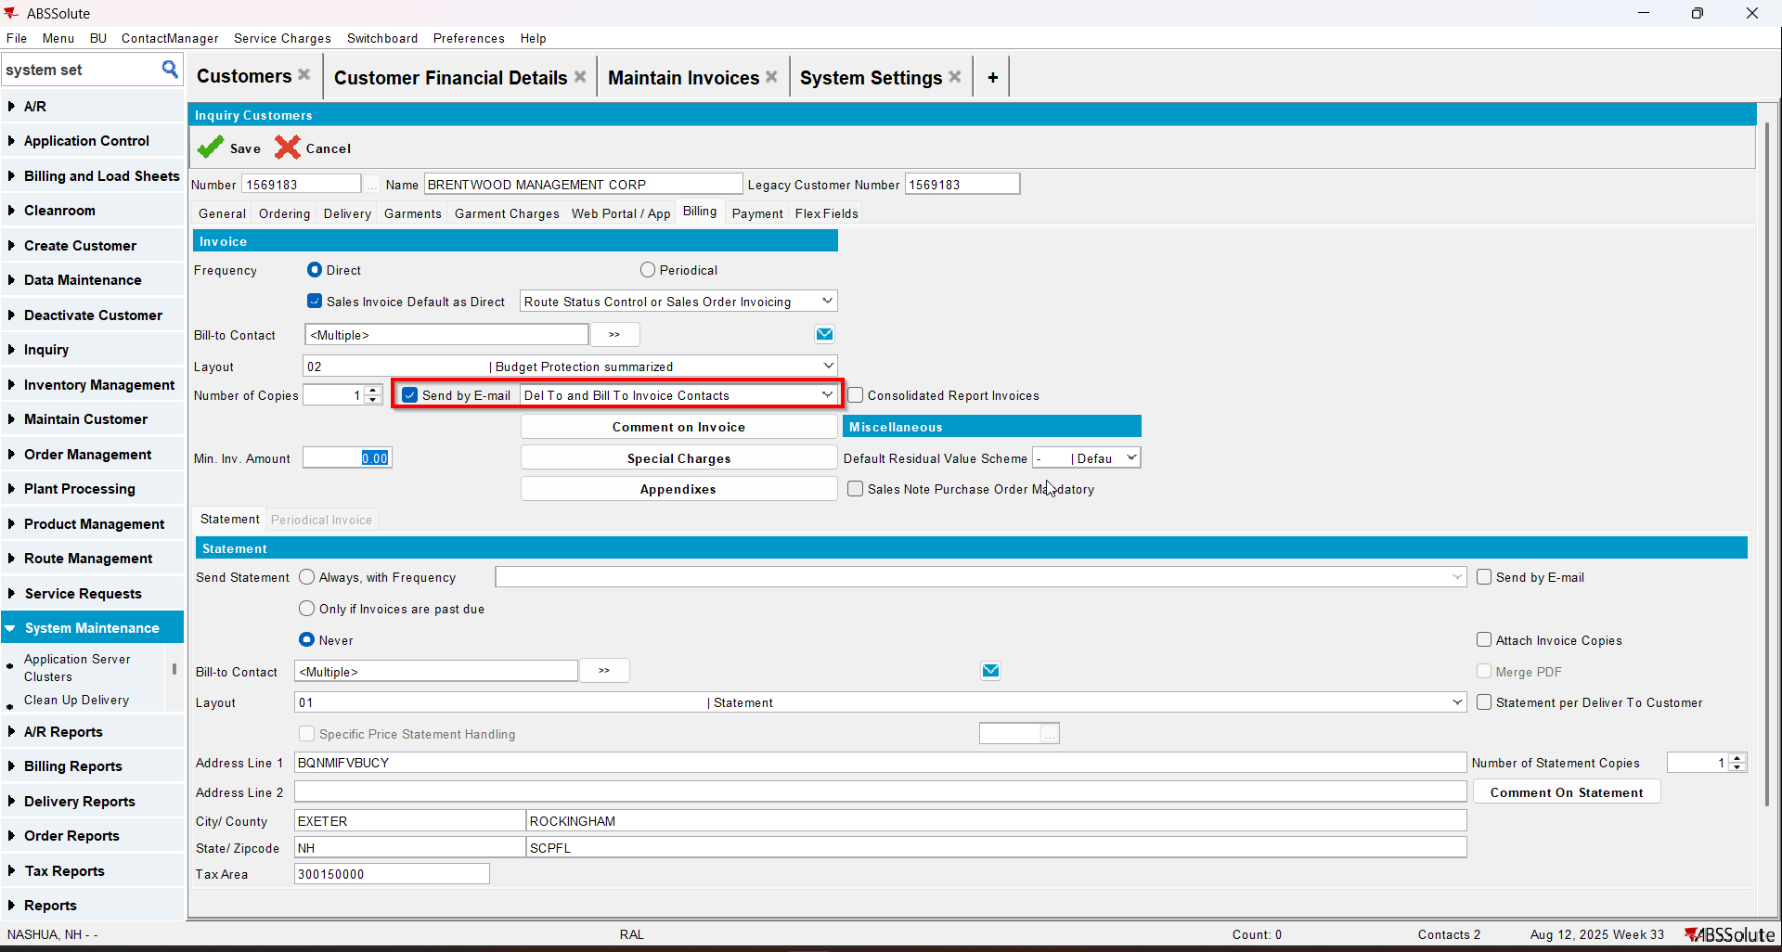
- Go to Customer Financial Details dlg and load your del to customer
- To Invoices tab select your invoice from step 6 and press E-mail Invoice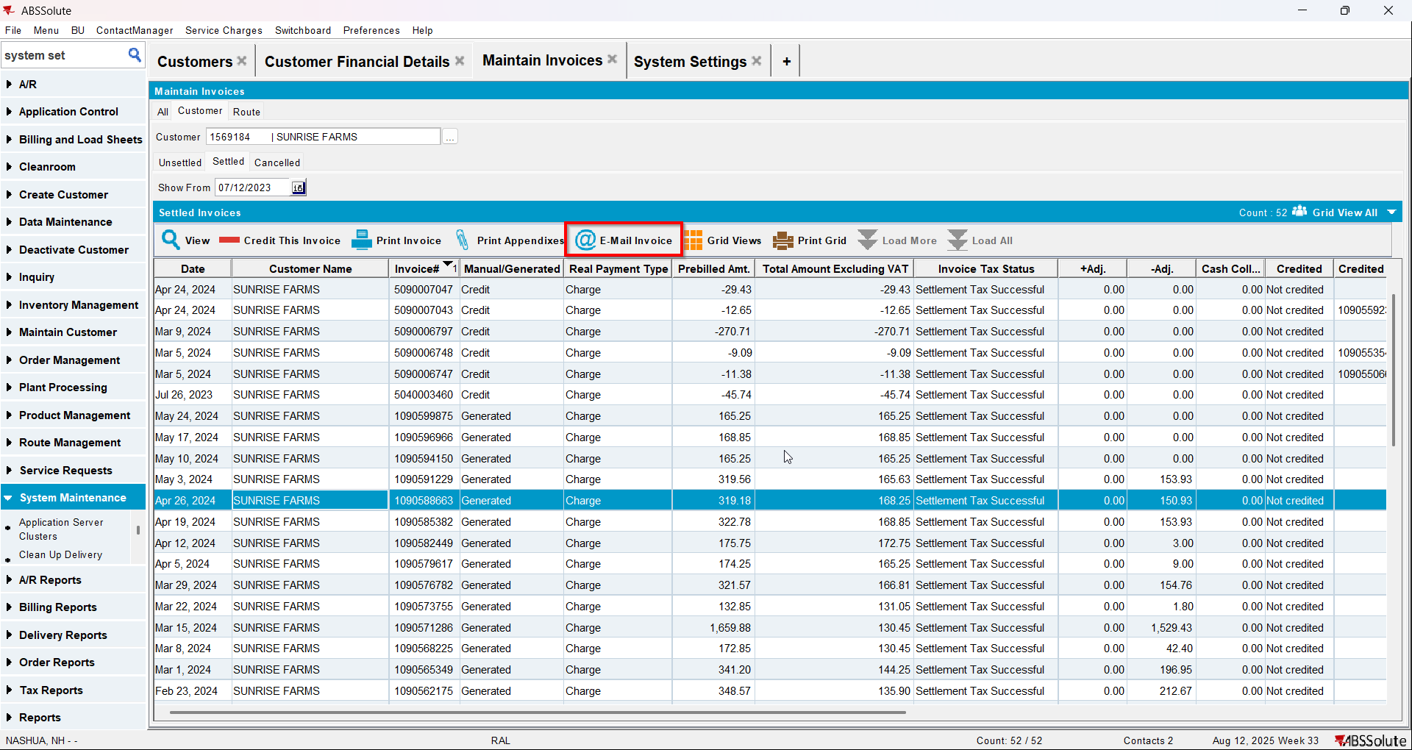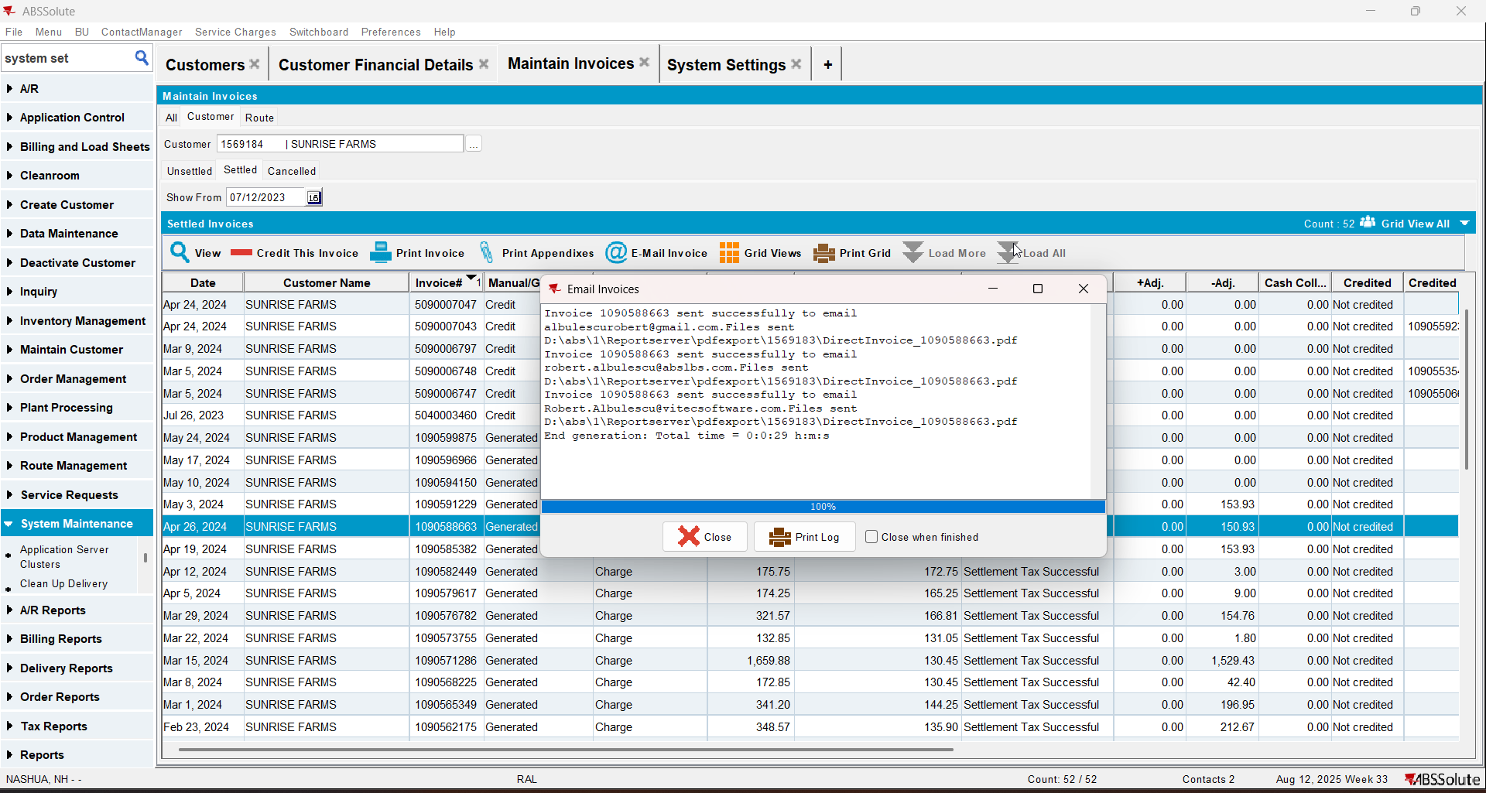
- Check if the email was sent to the contact persons of the del to customer and bill to customer. Note that if more contact persons have the same email address, it will only send 1 email 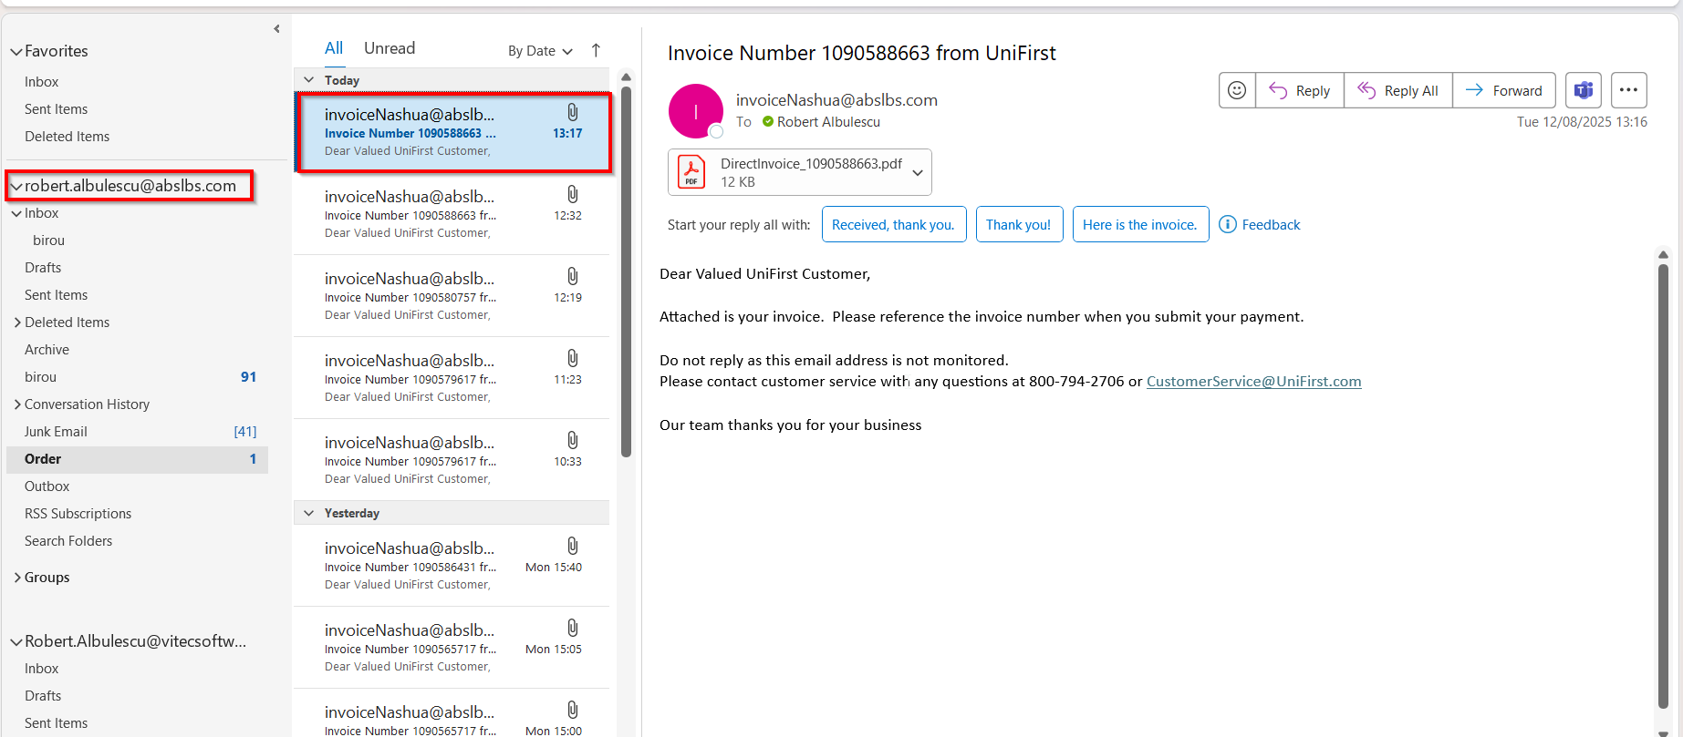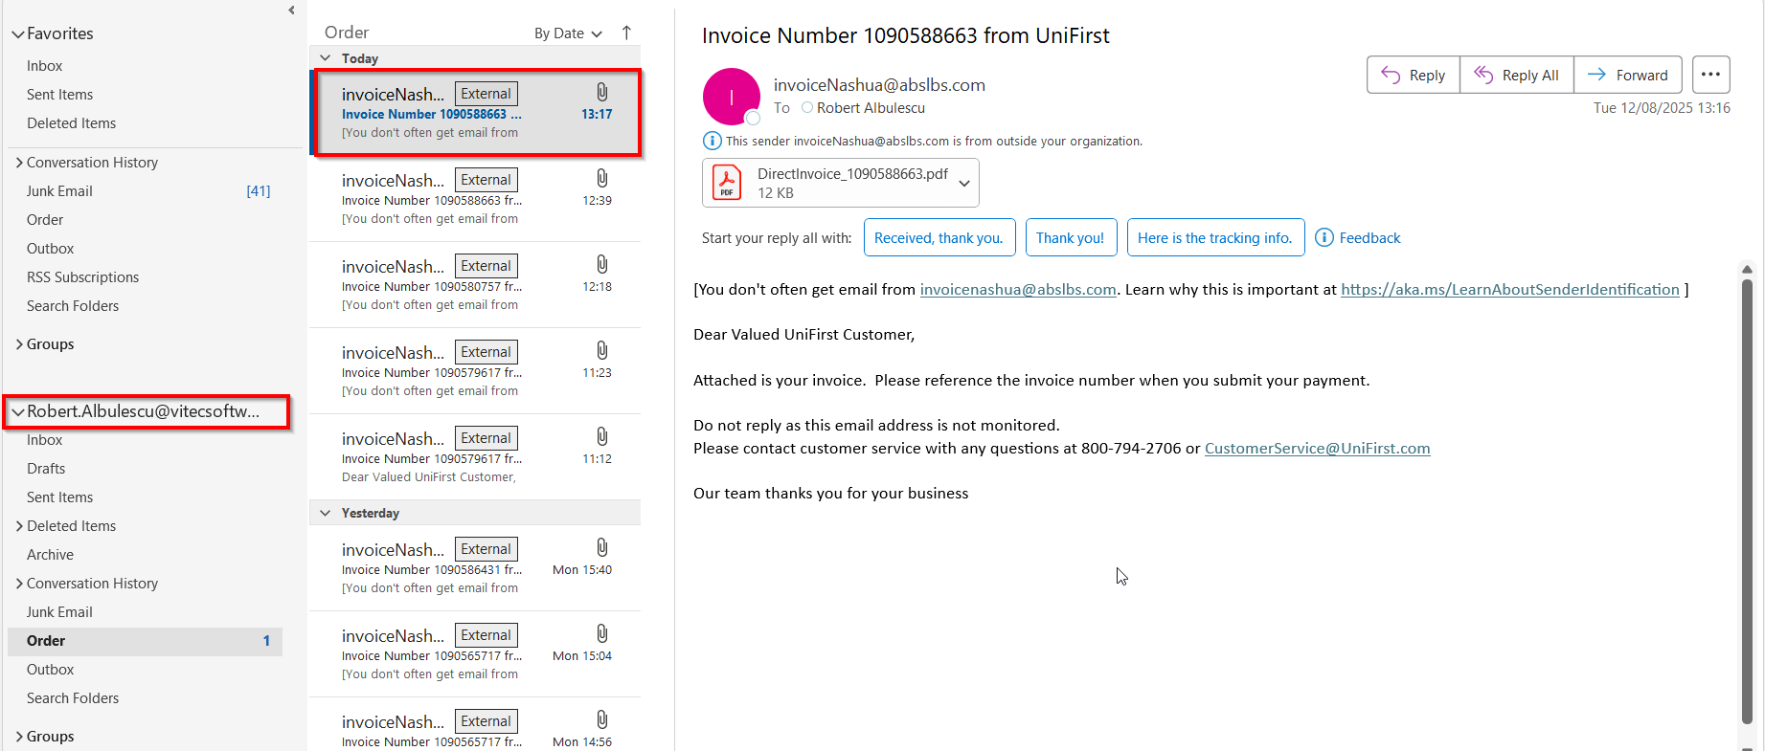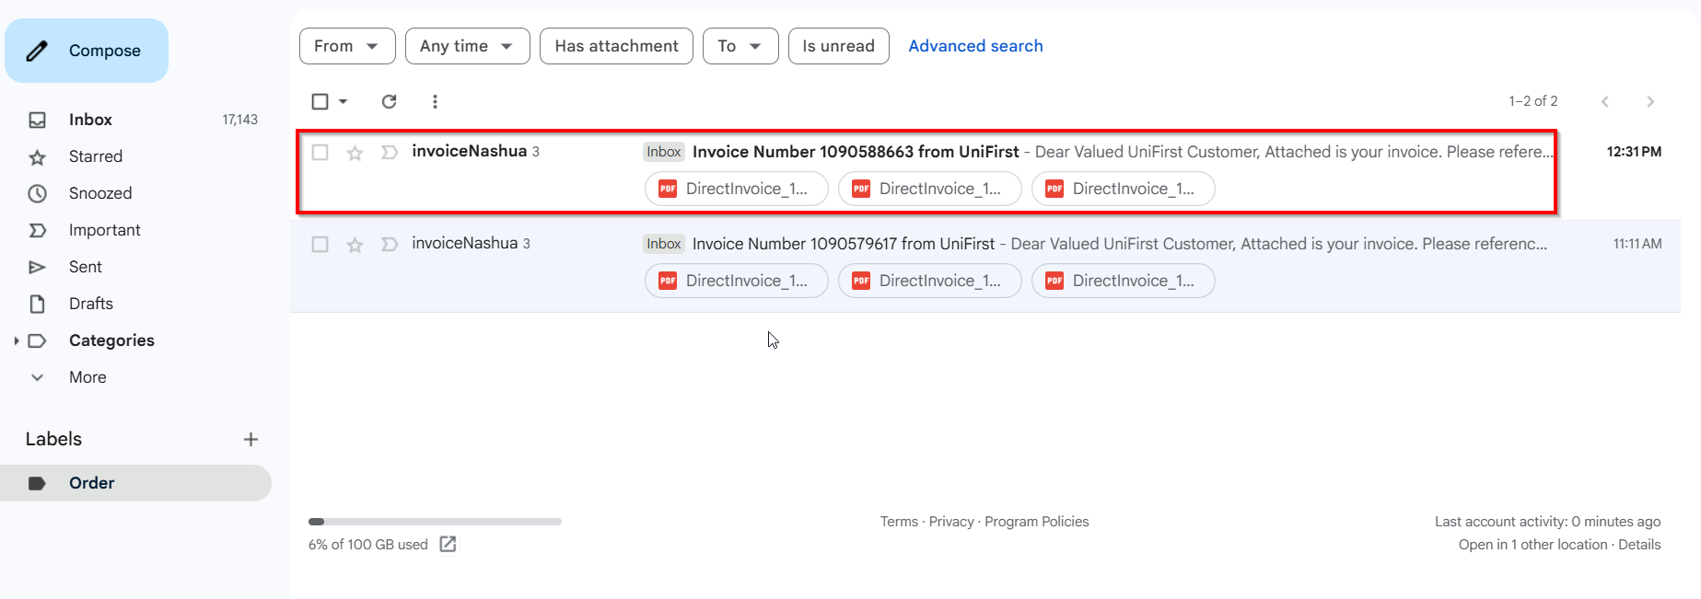

Switchboard

Test Case 1 – Send E-Mail when MULTIPLEINVANDSTMCONTACTS=0 and customer is its own bill to – Tested OK
Expected behavior: The invoice should be emailed to the email address of the contact persons that is invoice contact, not on the email address that is on the invoice header
Hash: ff9c238
- Check that SS MULTIPLEINVANDSTMCONTACTS=0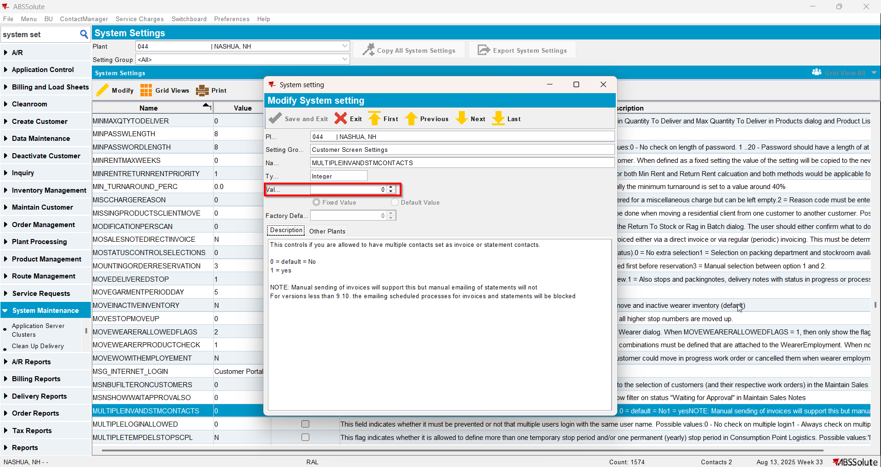
- Have a customer that is its own bill to
- Check that he has 1 contact person that is invoice contact and has a valid email address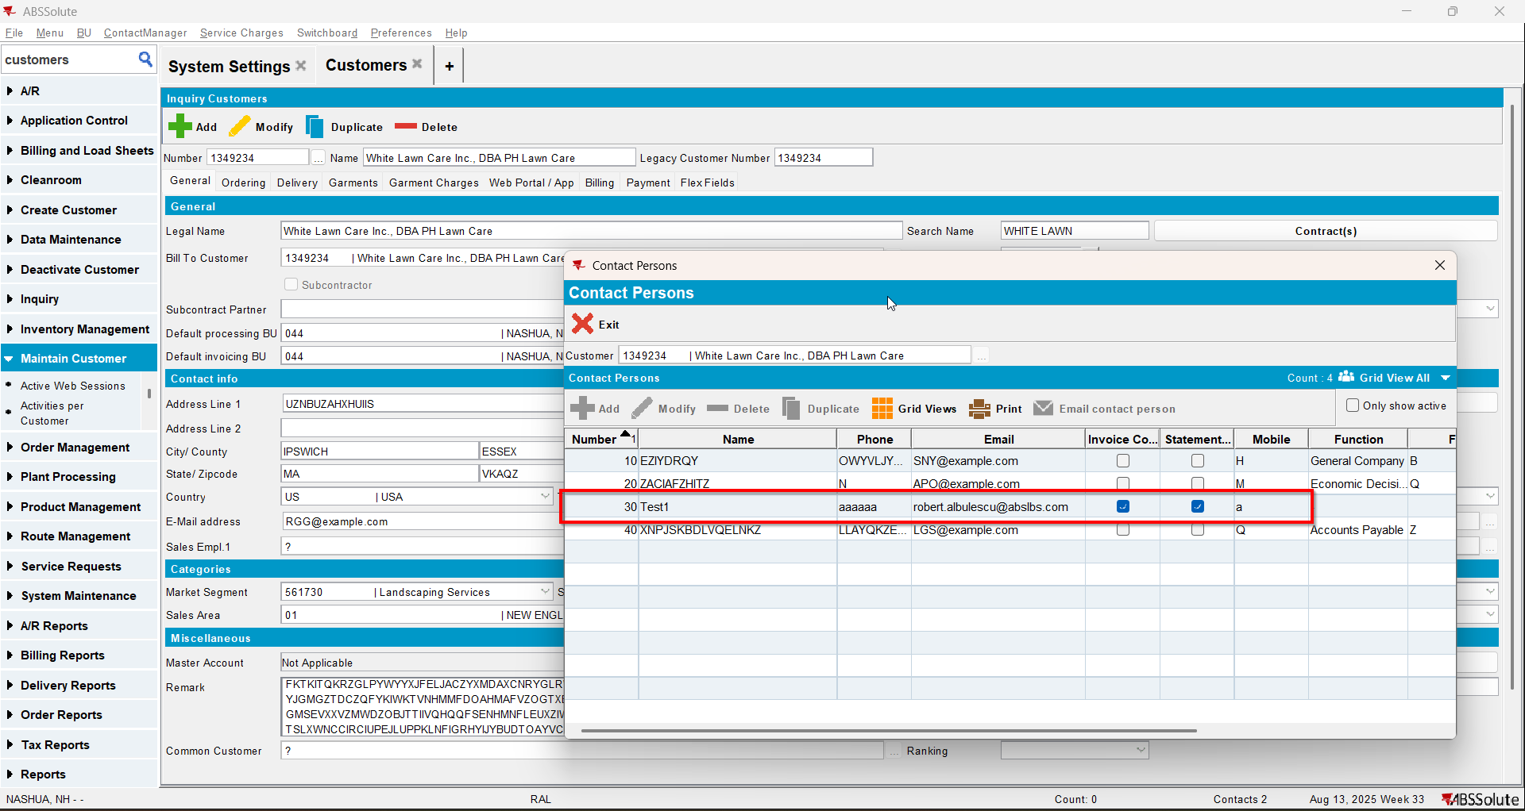
- For an invoice check what email address is on the invoice header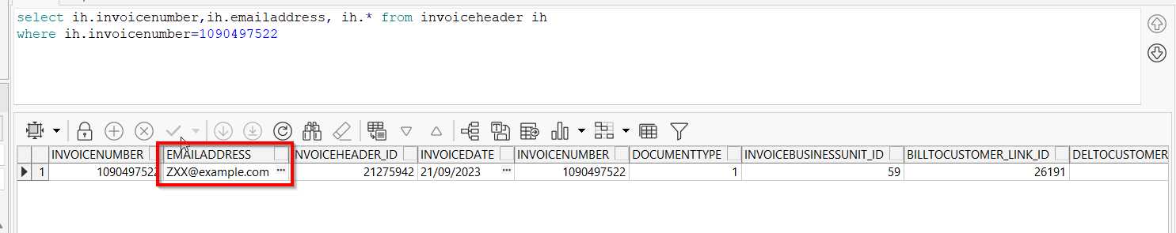
- Open Switchboard and load your customer
- Select Invoices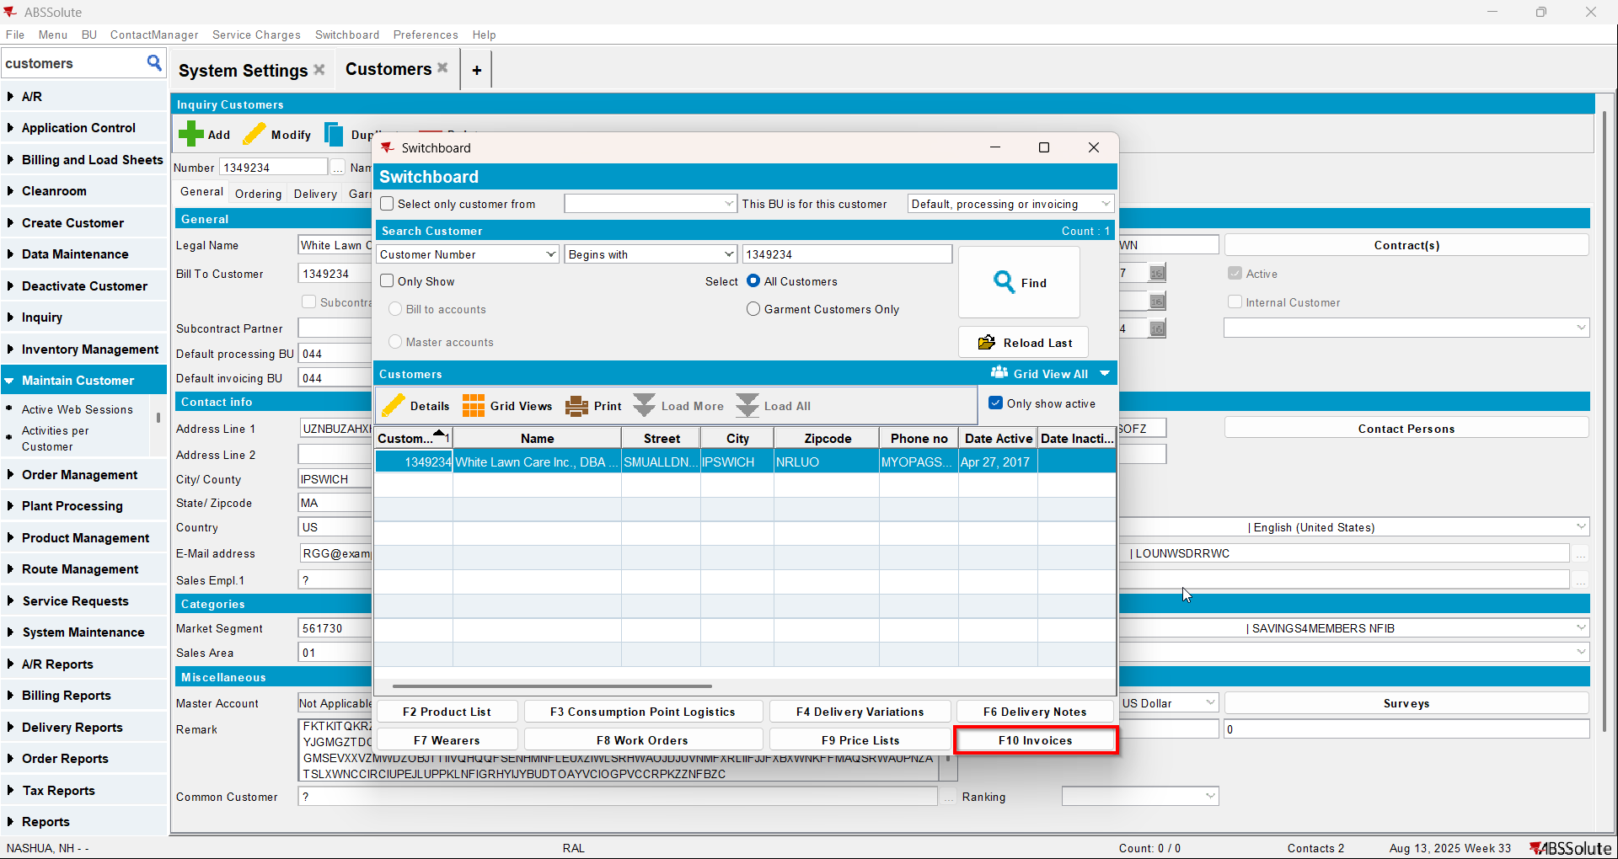
- To Settled tab select your invoice from step 4 and press E-mail Invoice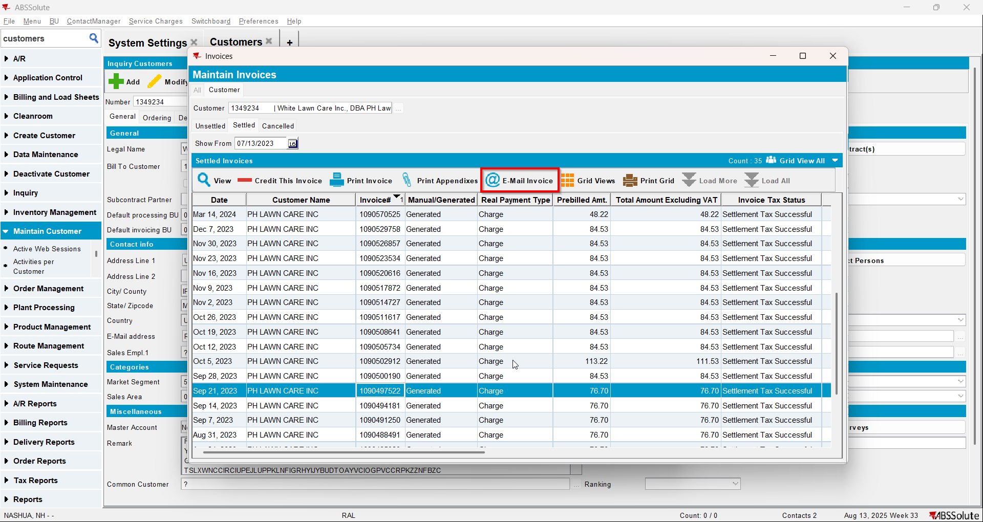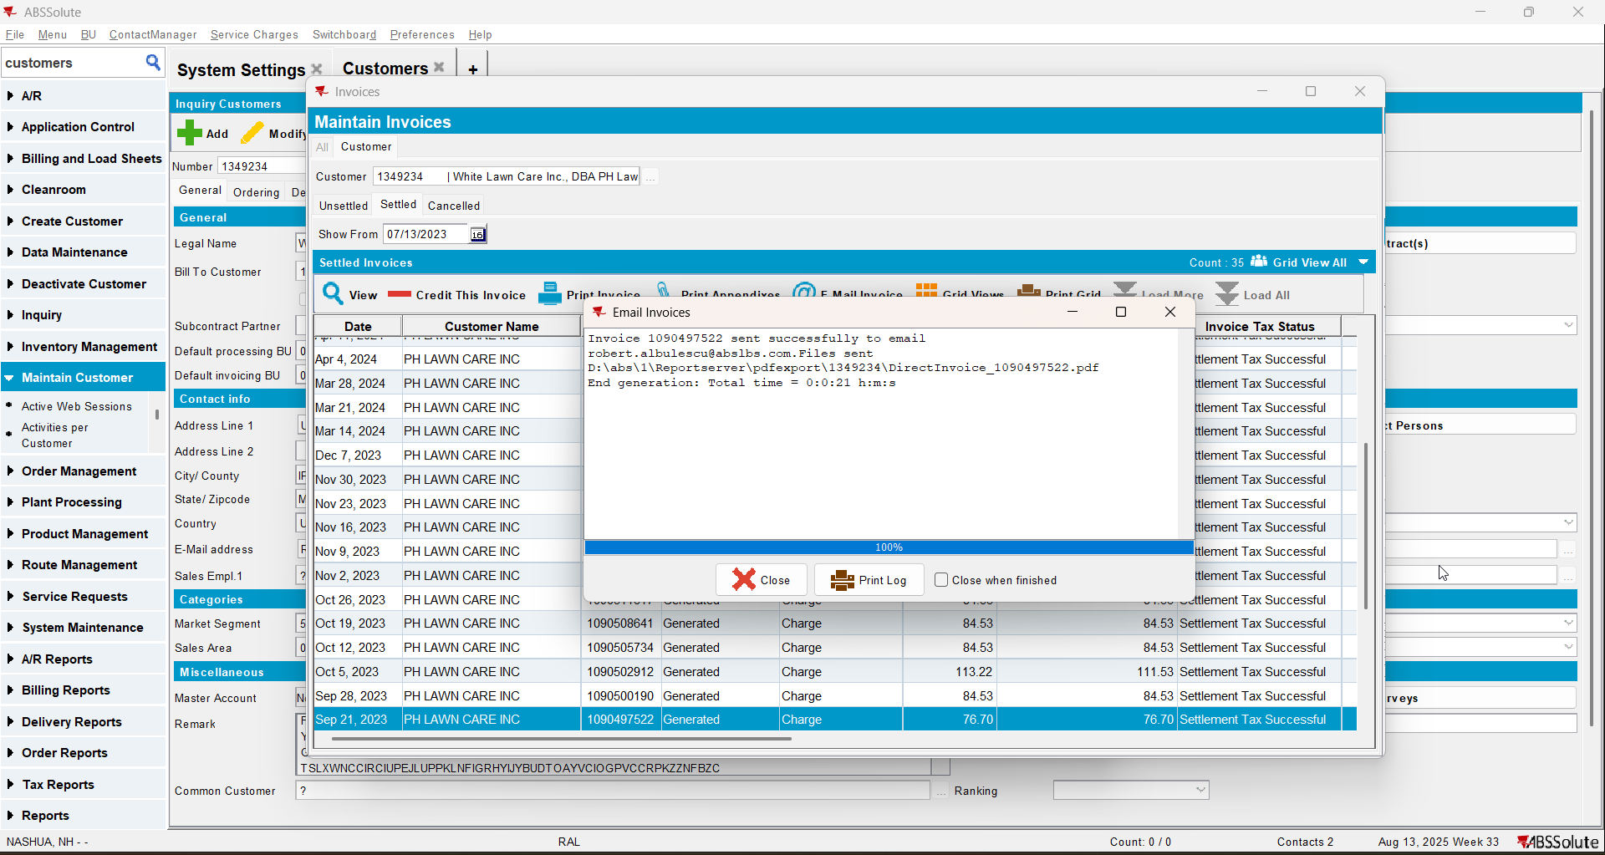
- Check if the email was sent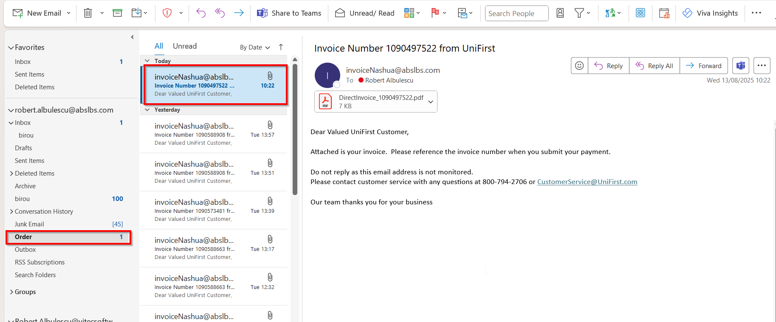

Test Case 2 – Send E-Mail when MULTIPLEINVANDSTMCONTACTS=0 and customer is not its own bill to – Tested OK
Expected behavior: The invoice should be emailed to the email address of the contact persons that is invoice contact, not on the email address that is on the invoice header
Hash: ff9c238
- Check that SS MULTIPLEINVANDSTMCONTACTS=0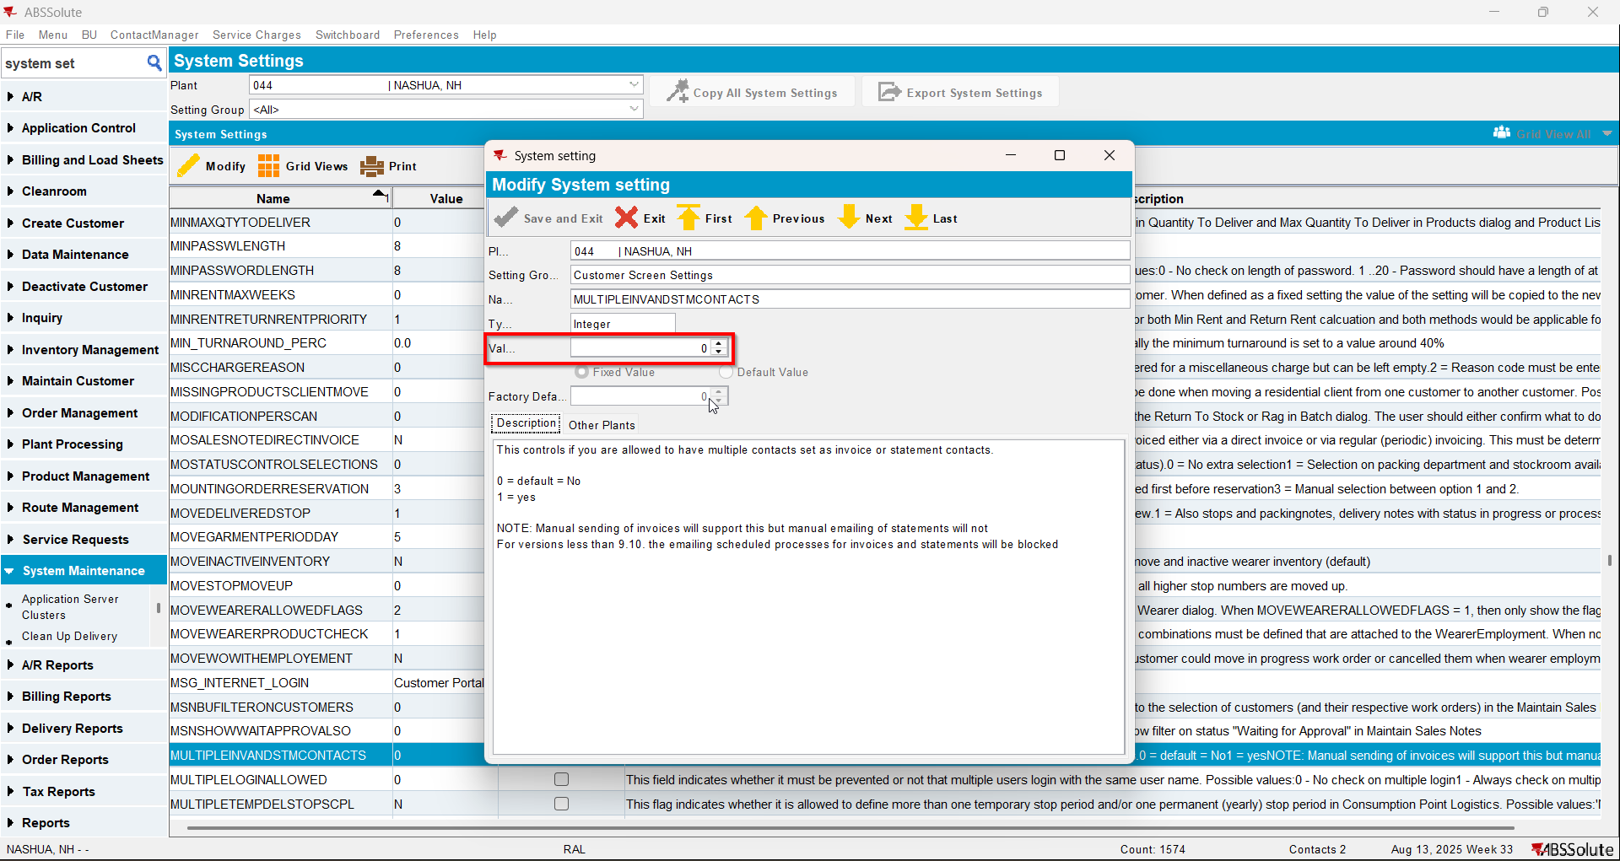
- Have a customer that is not its own bill to
- Check that he has 1 contact person that is invoice contact and has a valid email address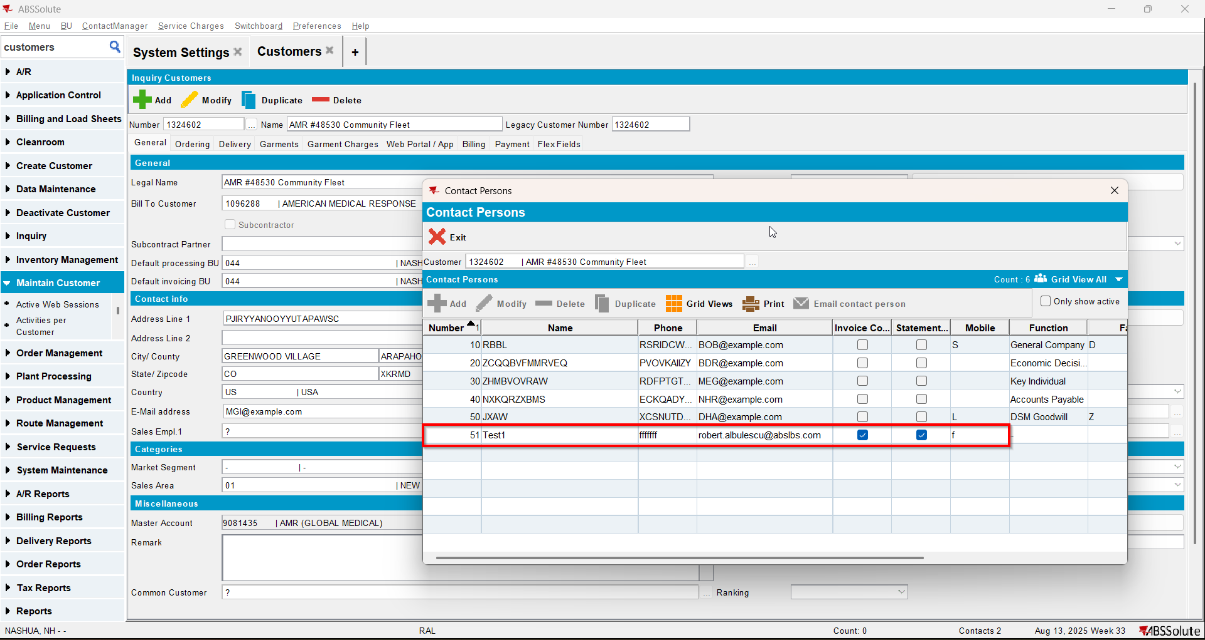
- Go on the bill to customer and also check that he has 1 contact person that is invoice contact and has a valid email address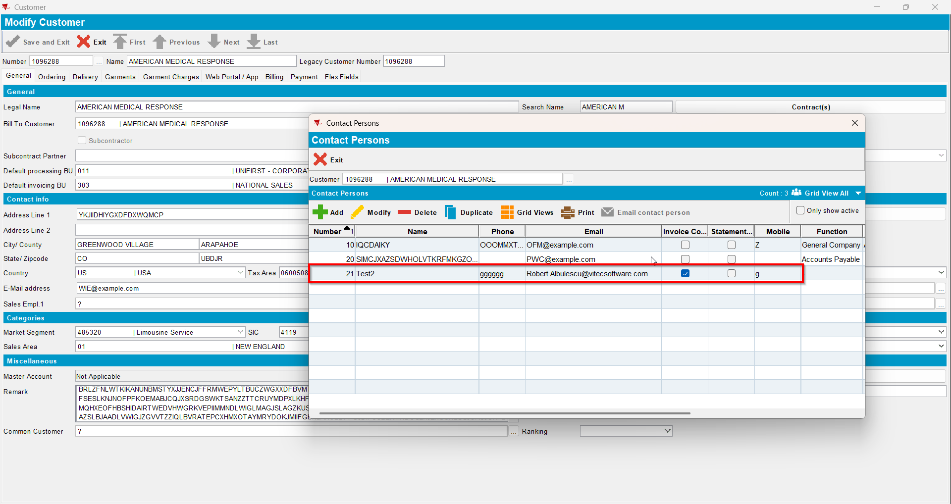
- Also on the bill to customer check that checkbox Send by E-mail is checked and on the drop-down selection the ‘Del To Invoice Contact’ option is selected(modifying this on bill to customer will also modify on del to customer )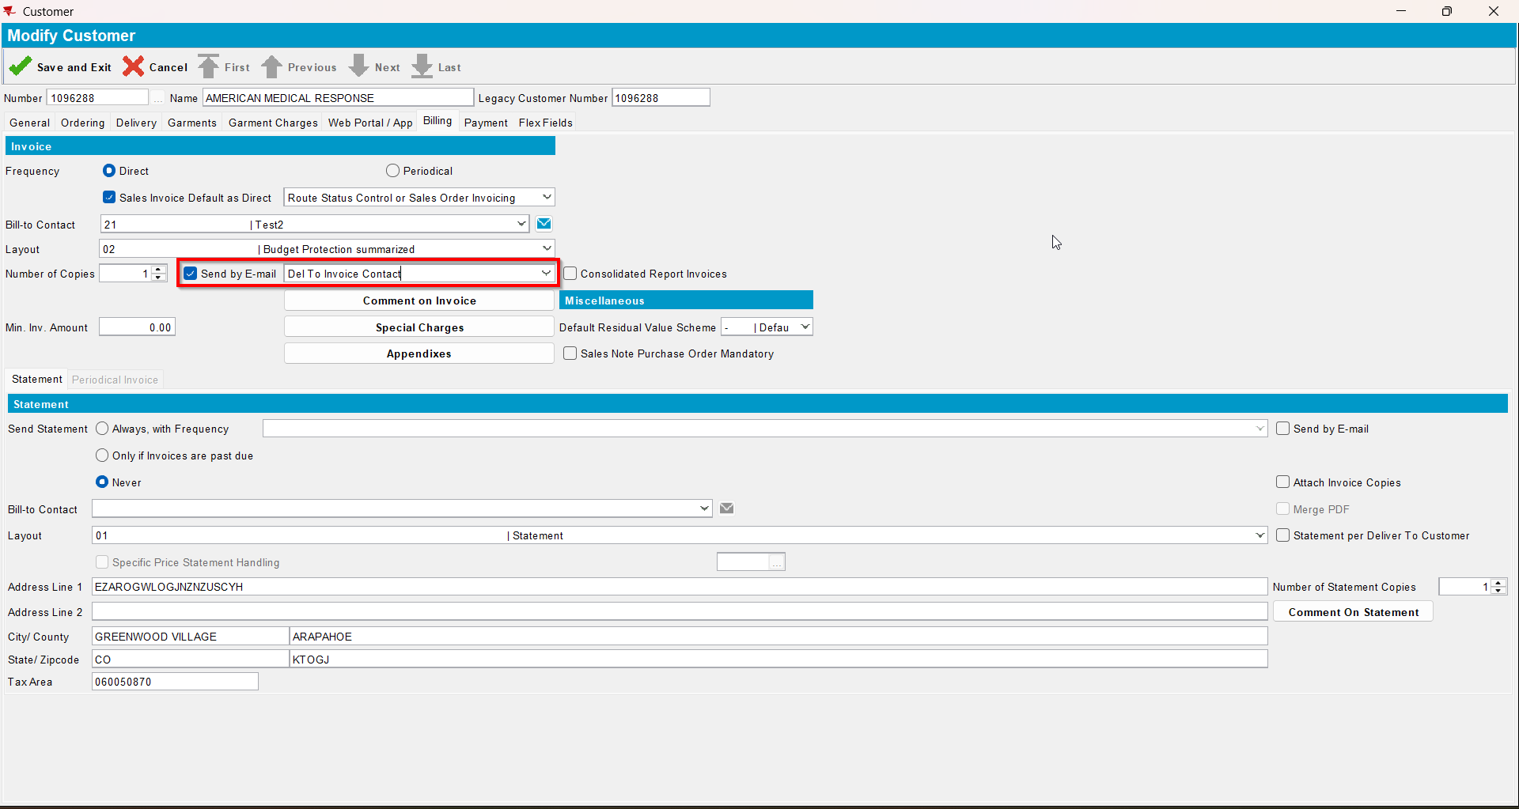
- For an invoice check what email address is on the invoice header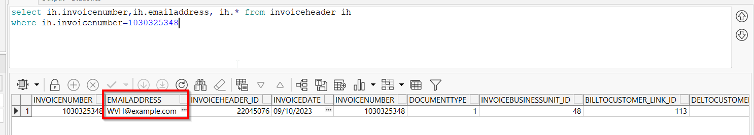
- Open Switchboard and load your del to customer
- Select Invoices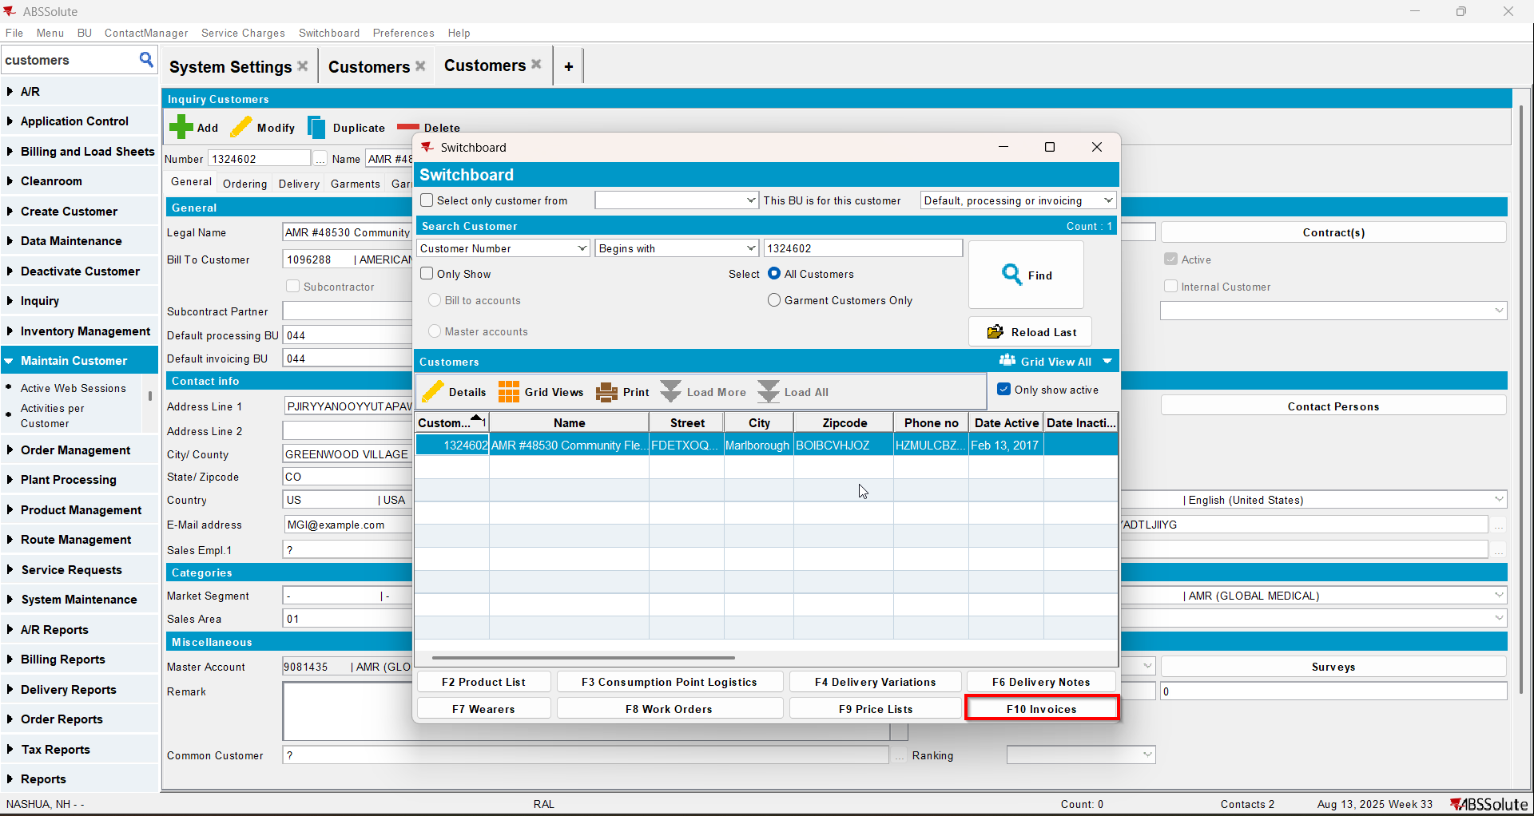
- To Settled tab select your invoice from step 6 and press E-mail Invoice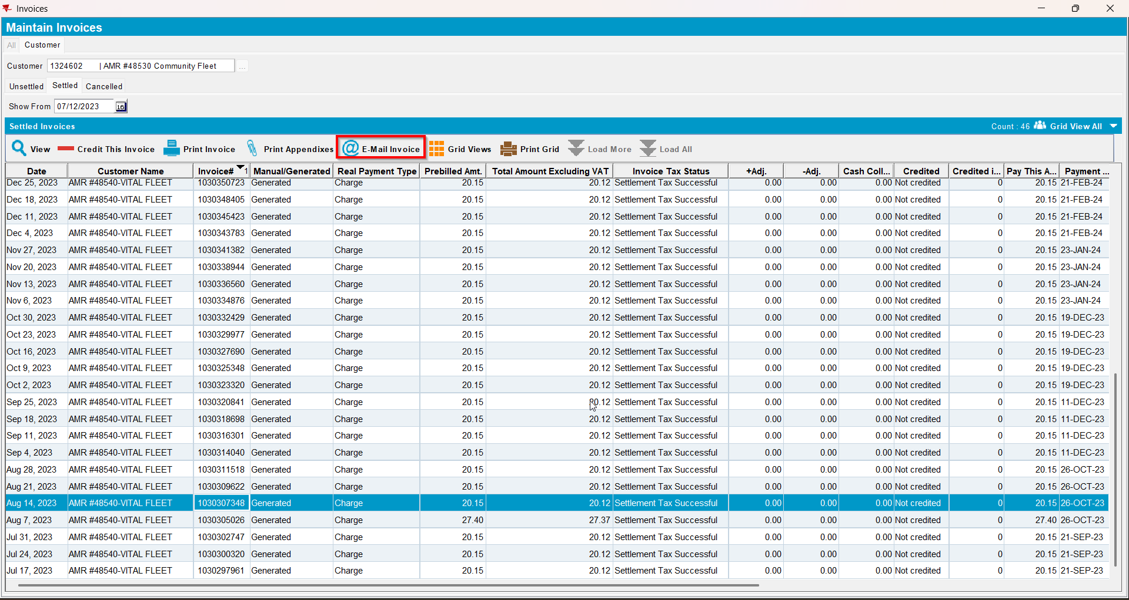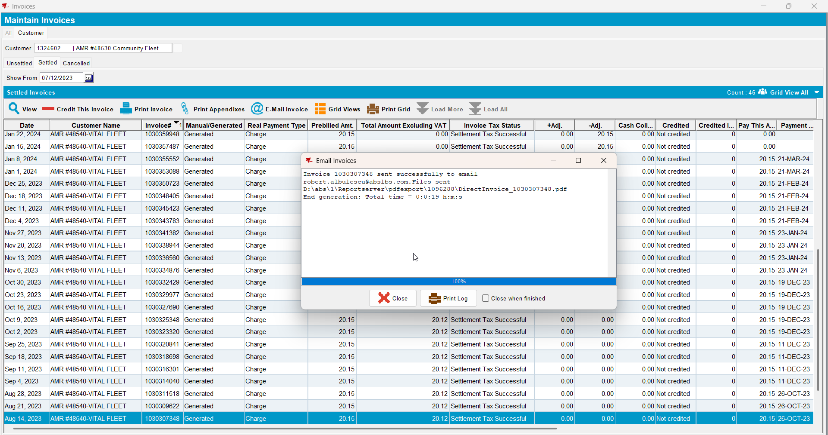
- Check if the email was sent to the contact person of the del to customer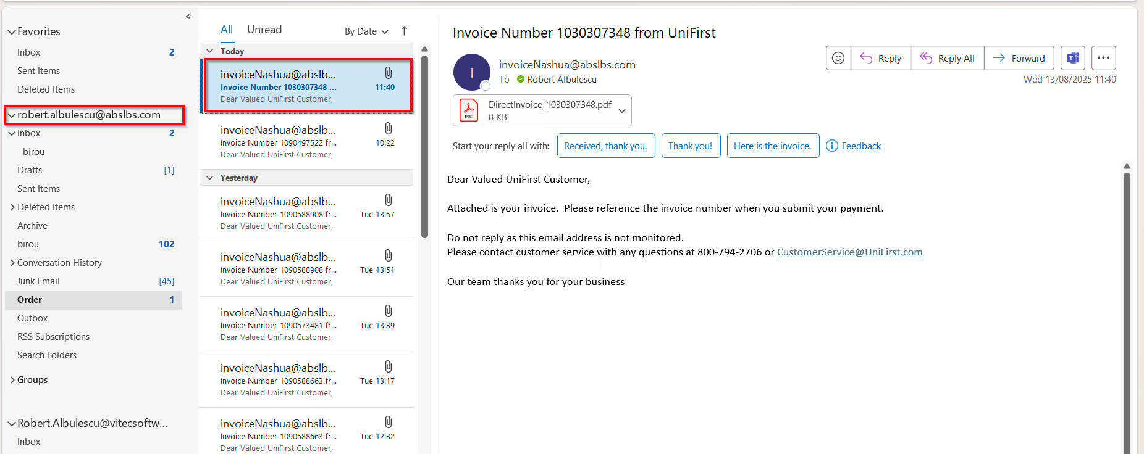
- Go on the bill to customer and on the drop-down select ‘Bill To Invoice Contact’ option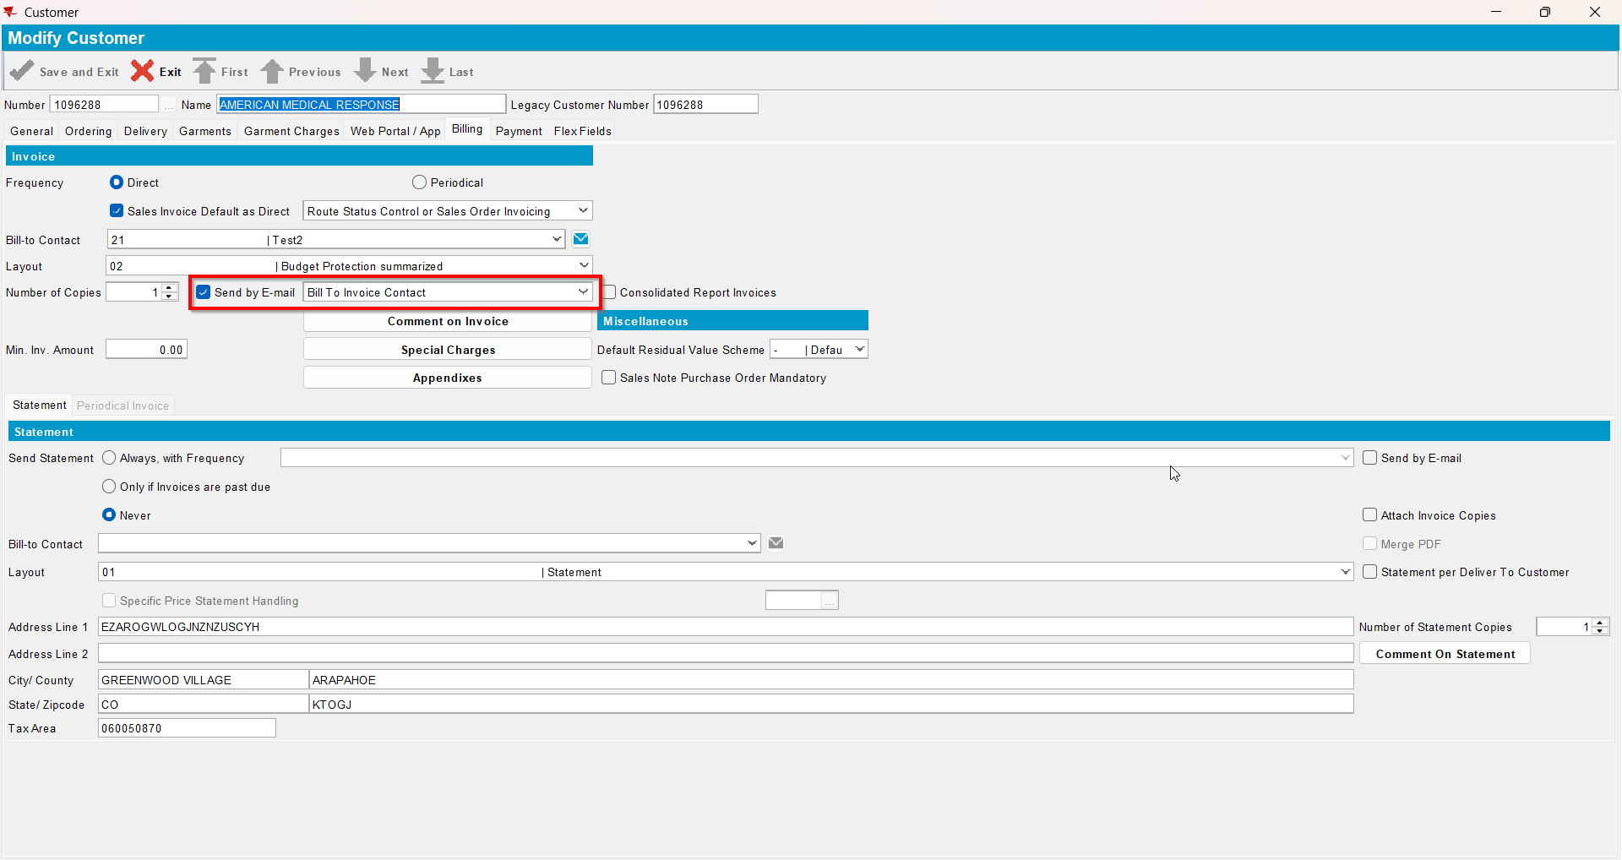
- Open switchboard and load your customer
- Select Invoices
- To Settled tab select your invoice from step 6 and press E-mail Invoice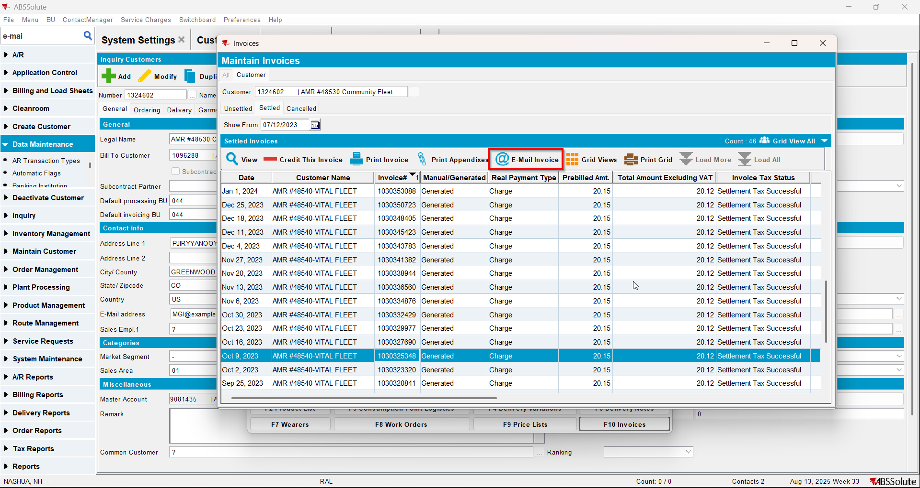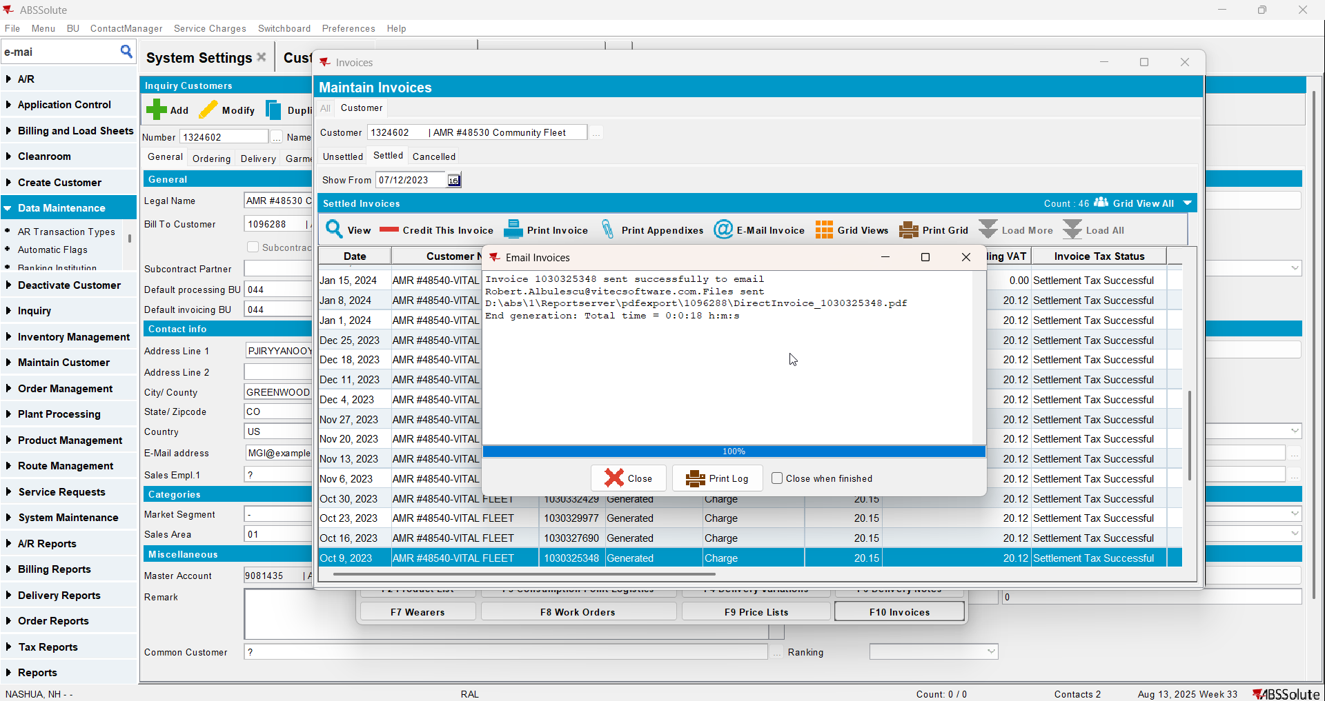
- Check if the email was sent to the contact person of the bill to customer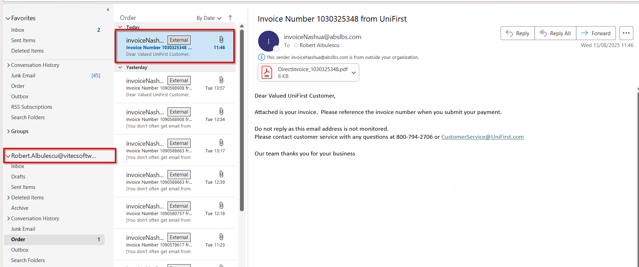
- Go on the bill to customer and on the drop-down select ‘Del To and Bill To Invoice Contacts’ option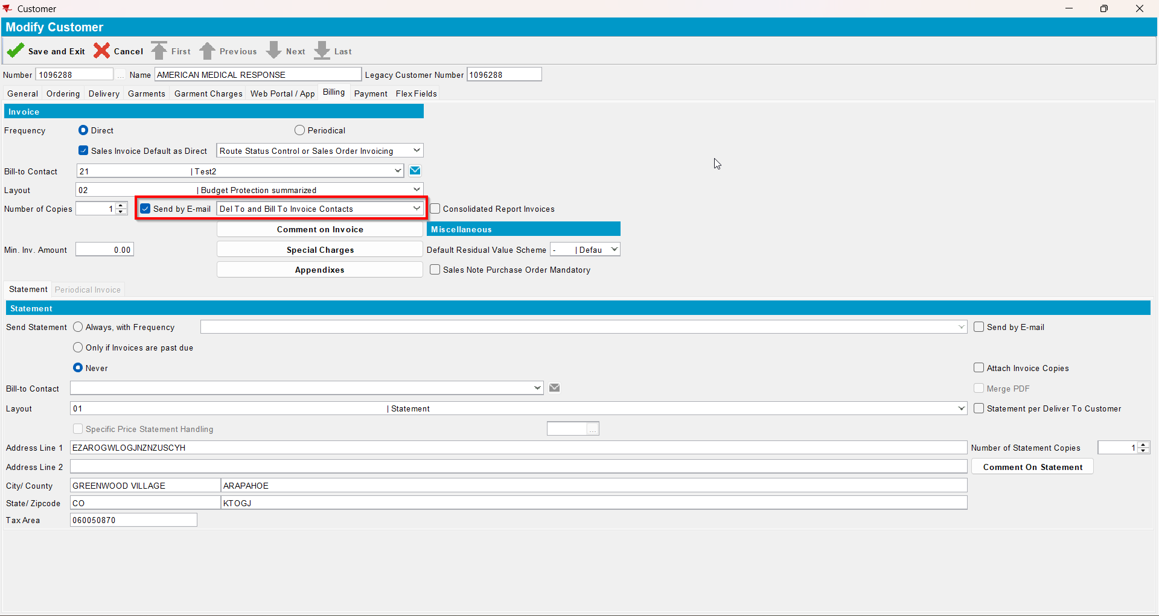
- Open Switchboard and load your customer
- Select Invoices
- To Invoices tab select your invoice from step 6 and press E-mail Invoice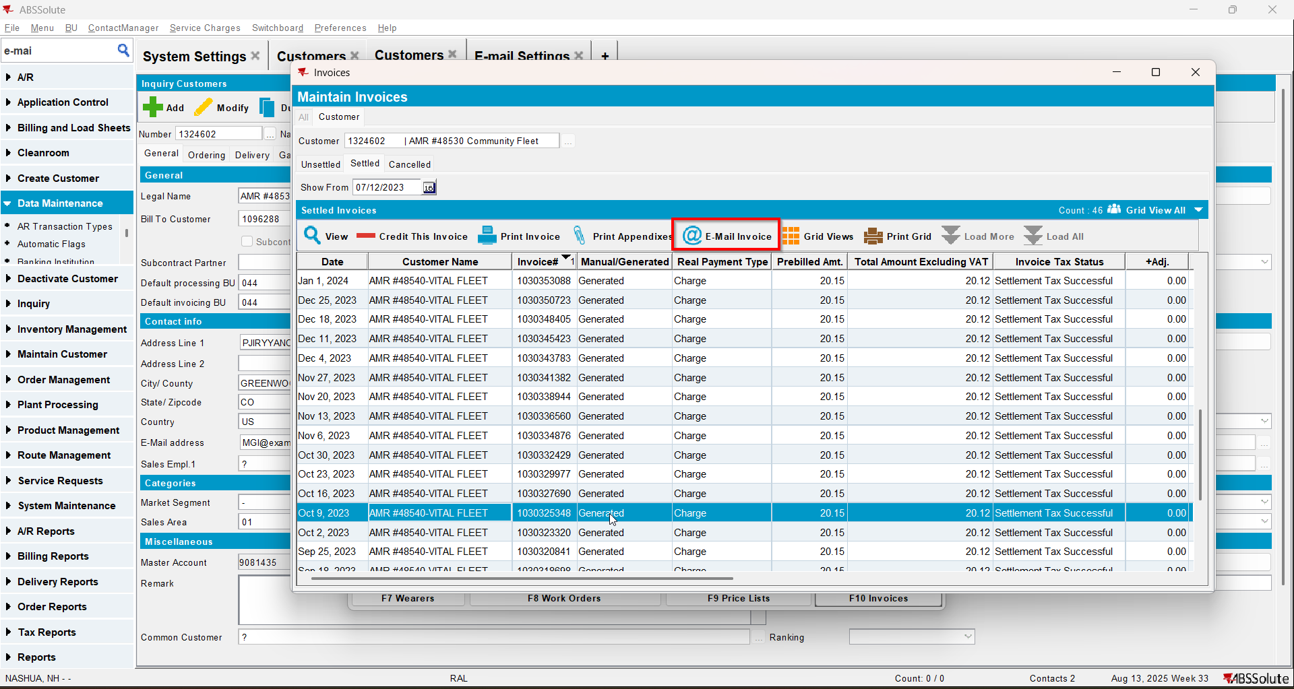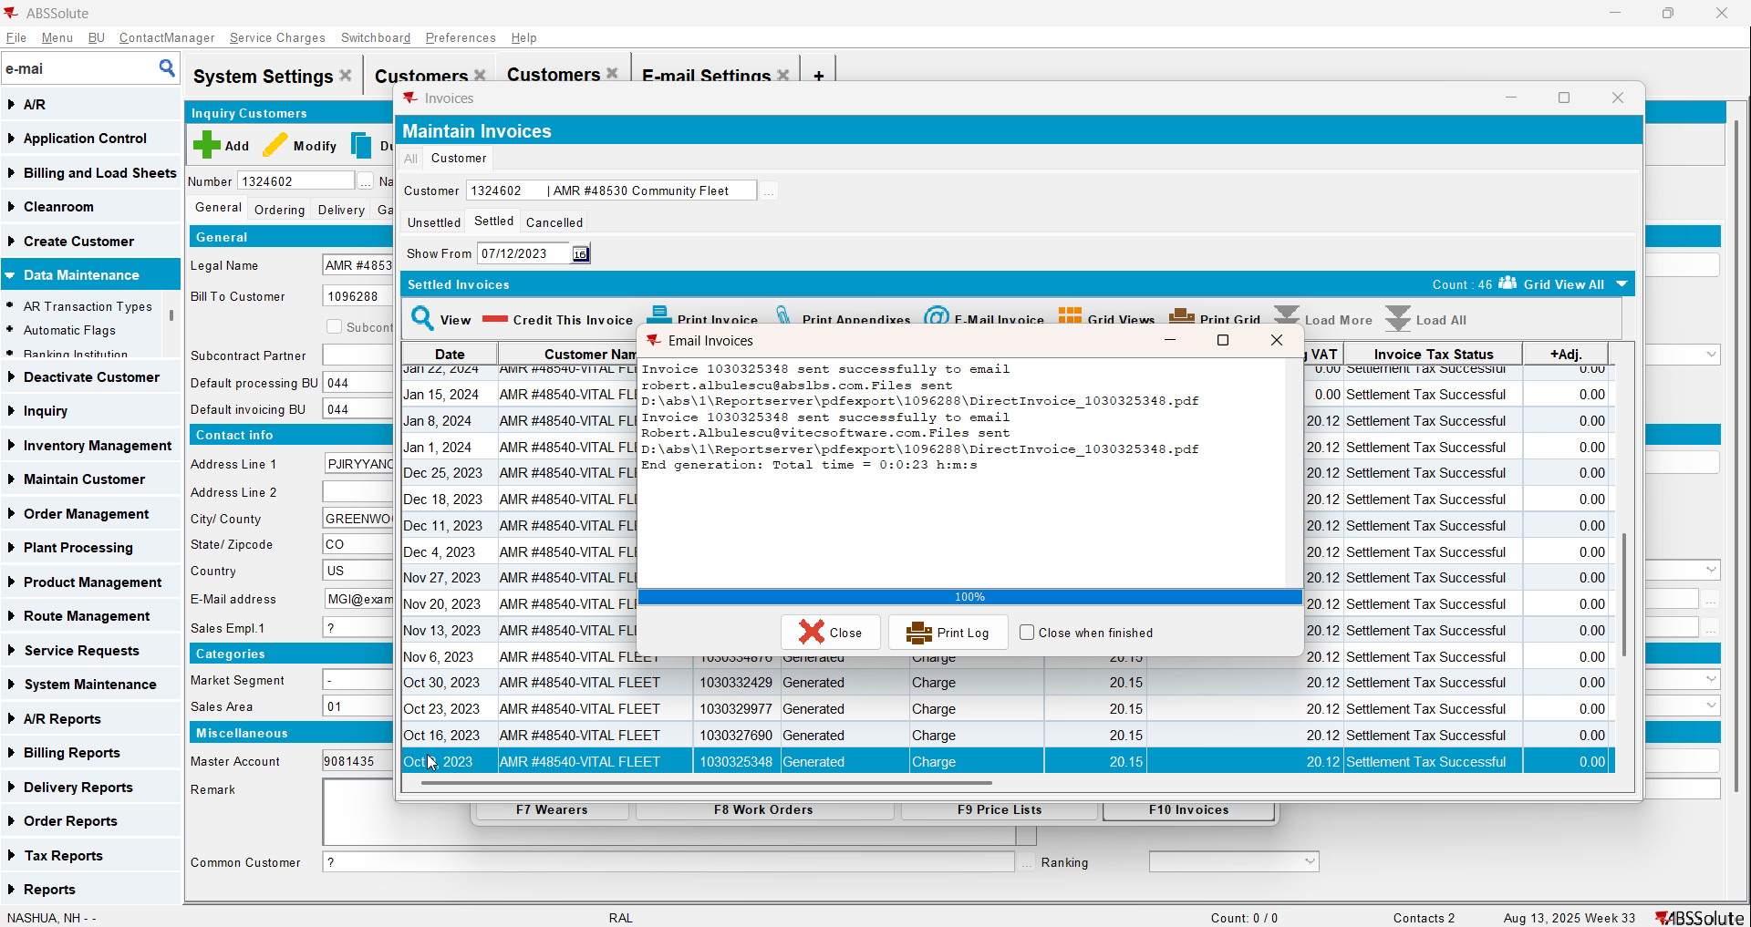
- Check if the email was sent to the contact persons of the del to customer and bill to customer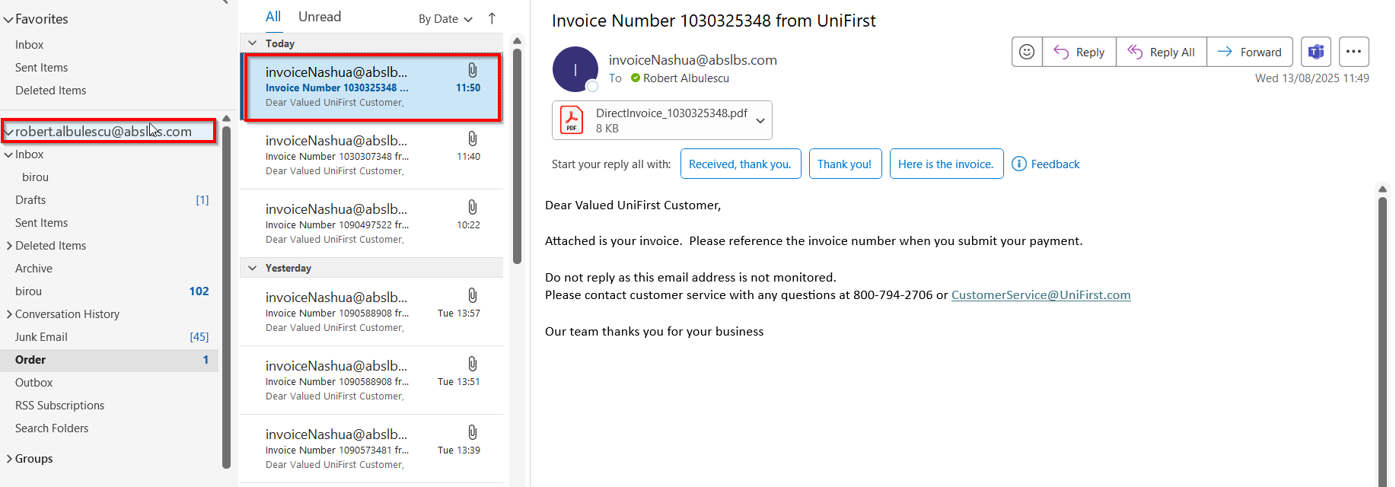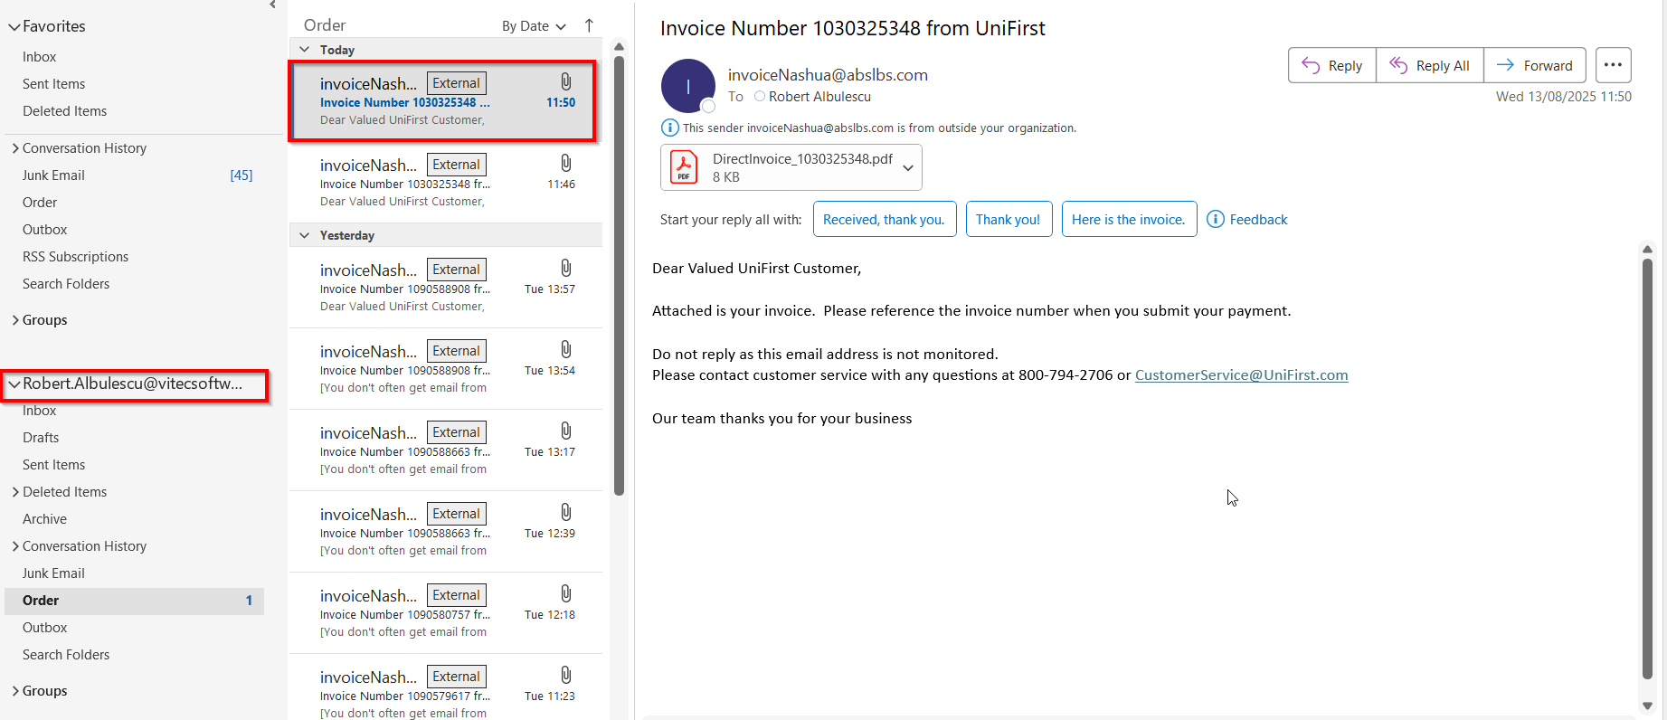

Test Case 3 – Send E-Mail when MULTIPLEINVANDSTMCONTACTS=1 and customer is its own bill to – Tested OK
Expected behavior: The invoice should be emailed to the email address of the contact persons that is invoice contact, not on the email address that is on the invoice header
Hash: ff9c238
- Check that SS MULTIPLEINVANDSTMCONTACTS=1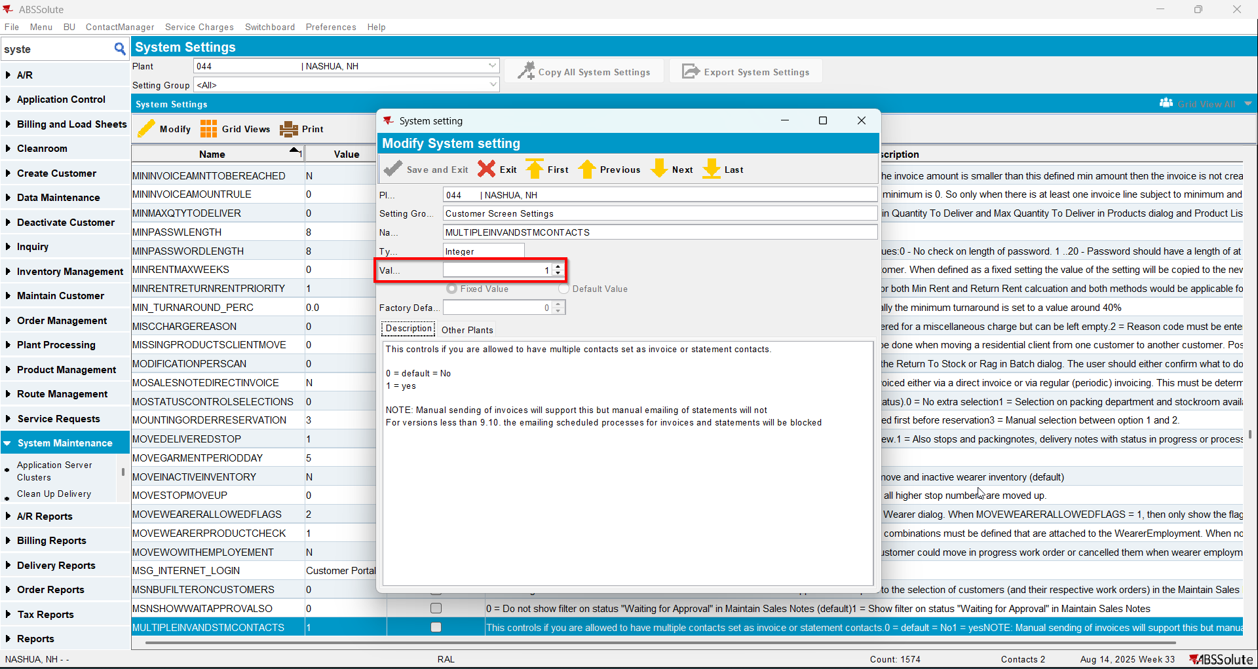
- Have a customer that is its own bill to
- Check that he has at least 2 contact persons that are invoice contact and have a valid email address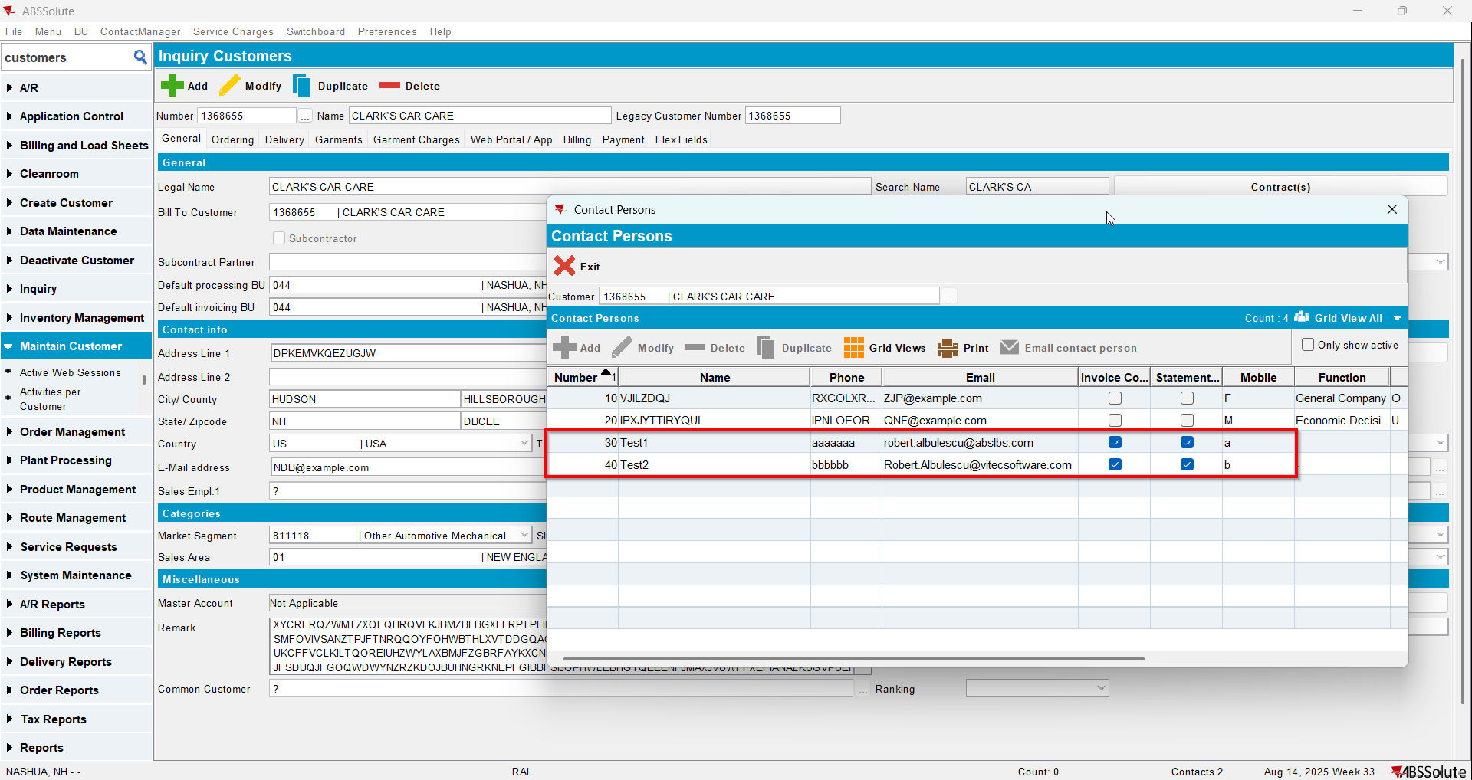
- For an invoice check what email address is on the invoice header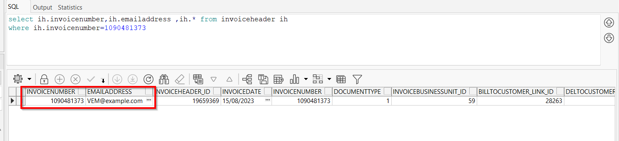
- Open Switchboard and lod your customer
- Select Invoices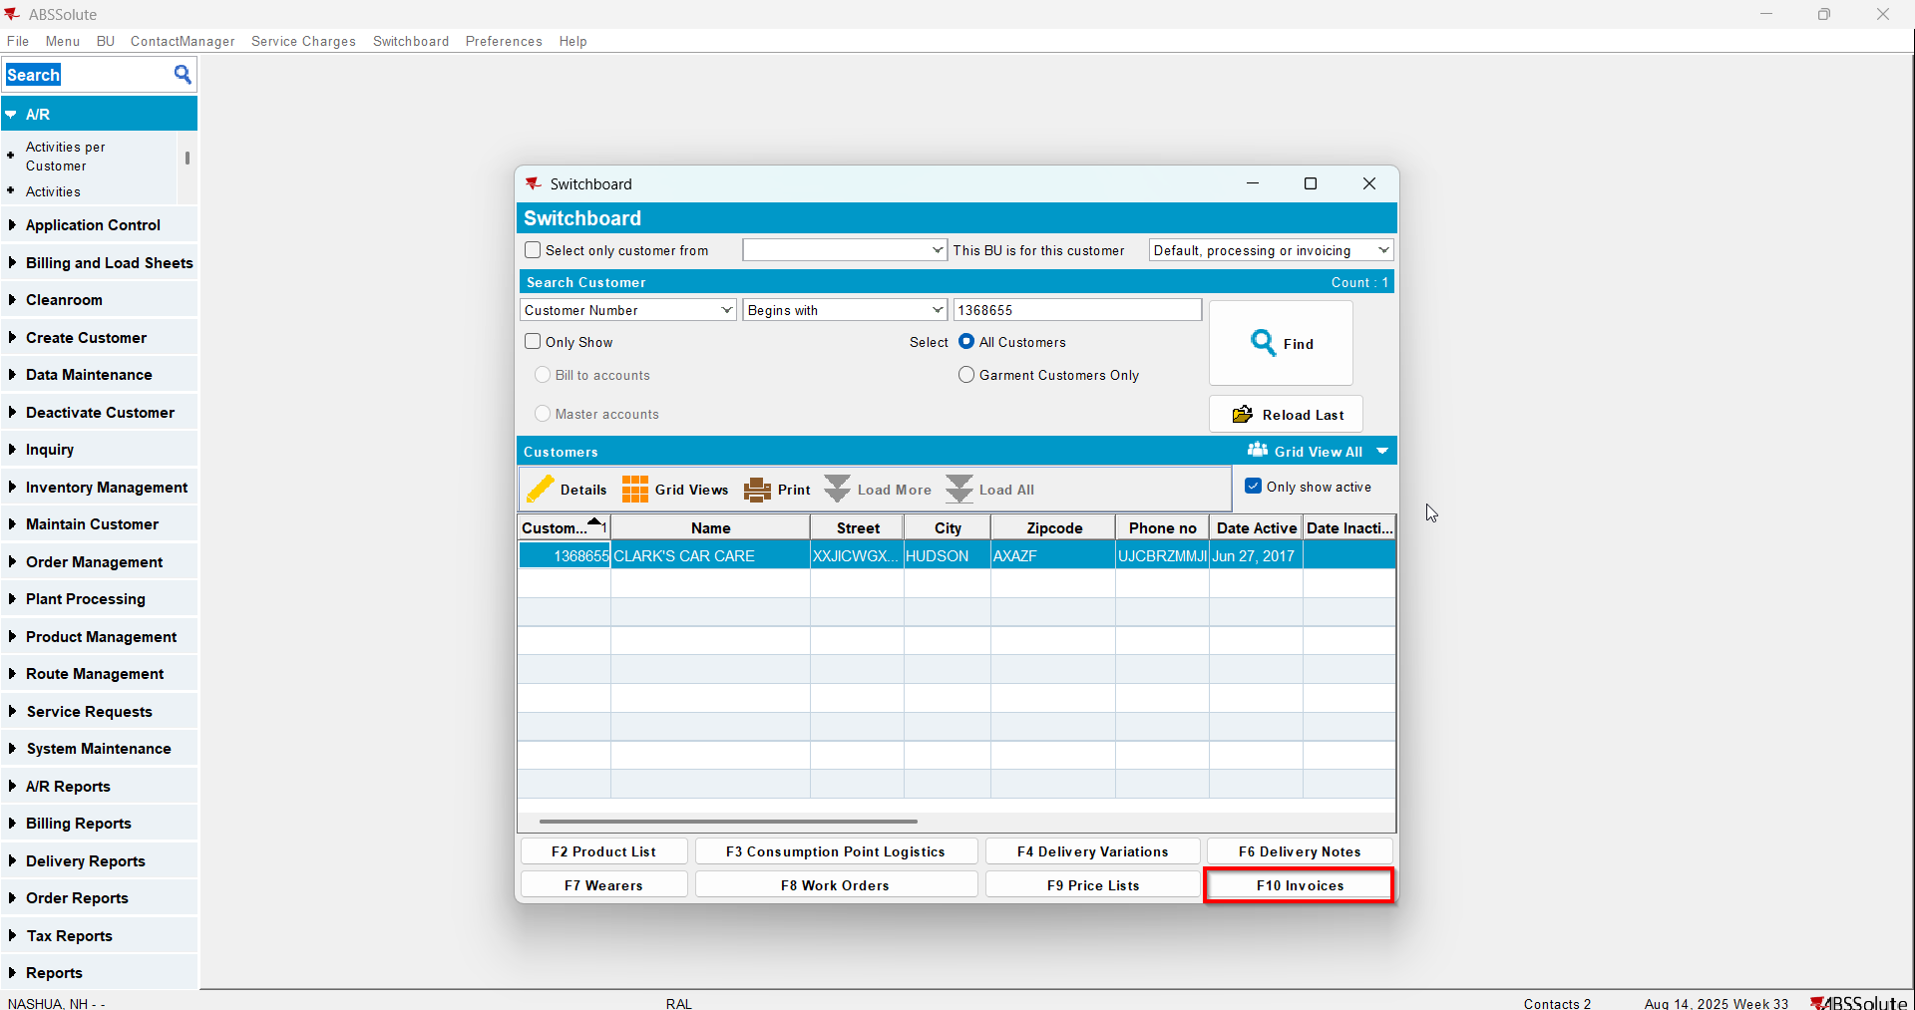
- To Settled tab select your invoice from step 4 and press E-mail Invoice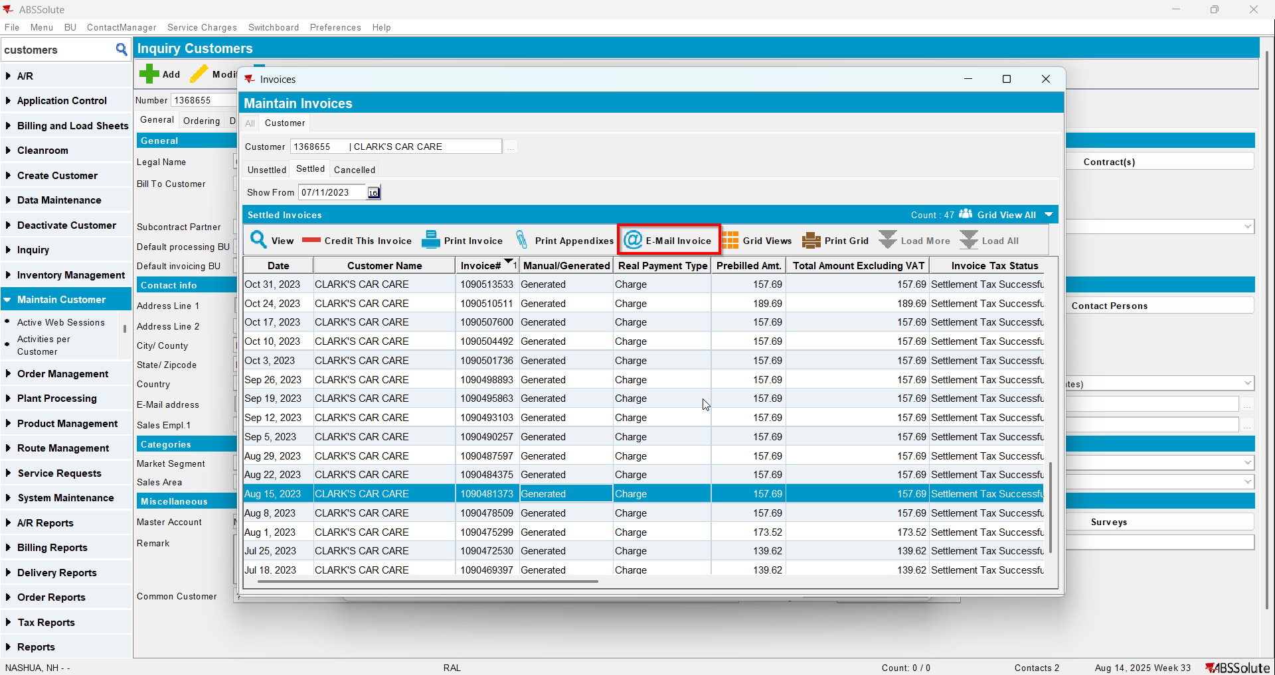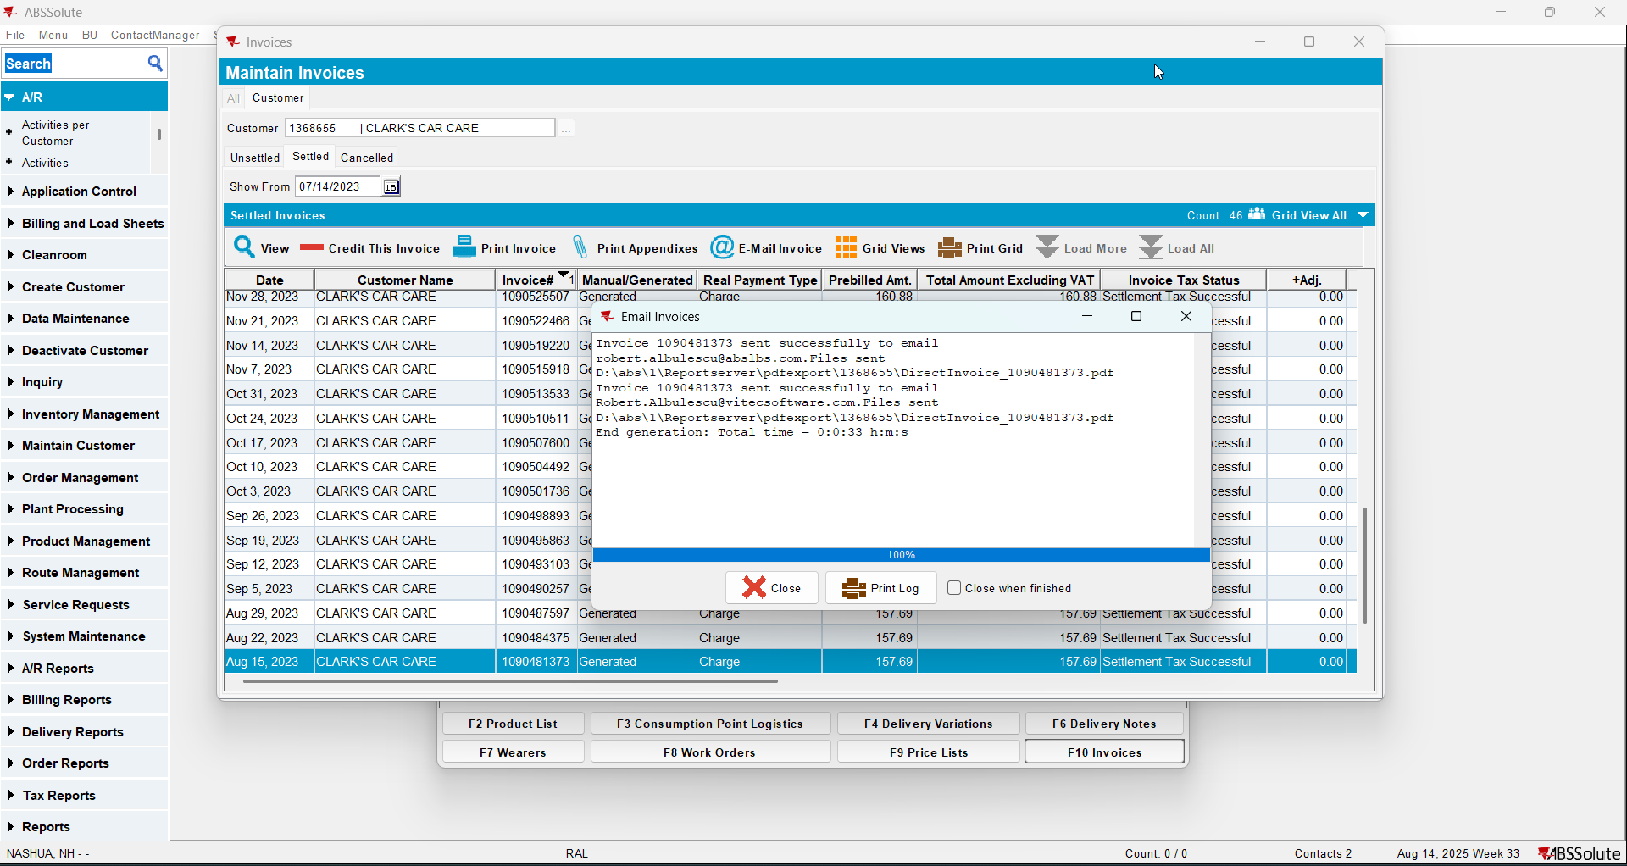
- Check if the email was sent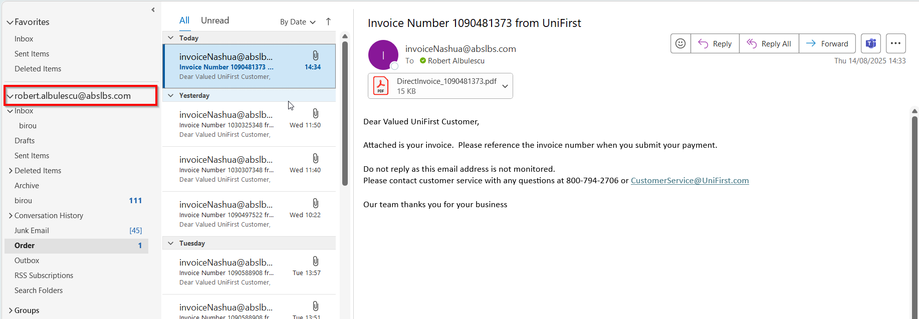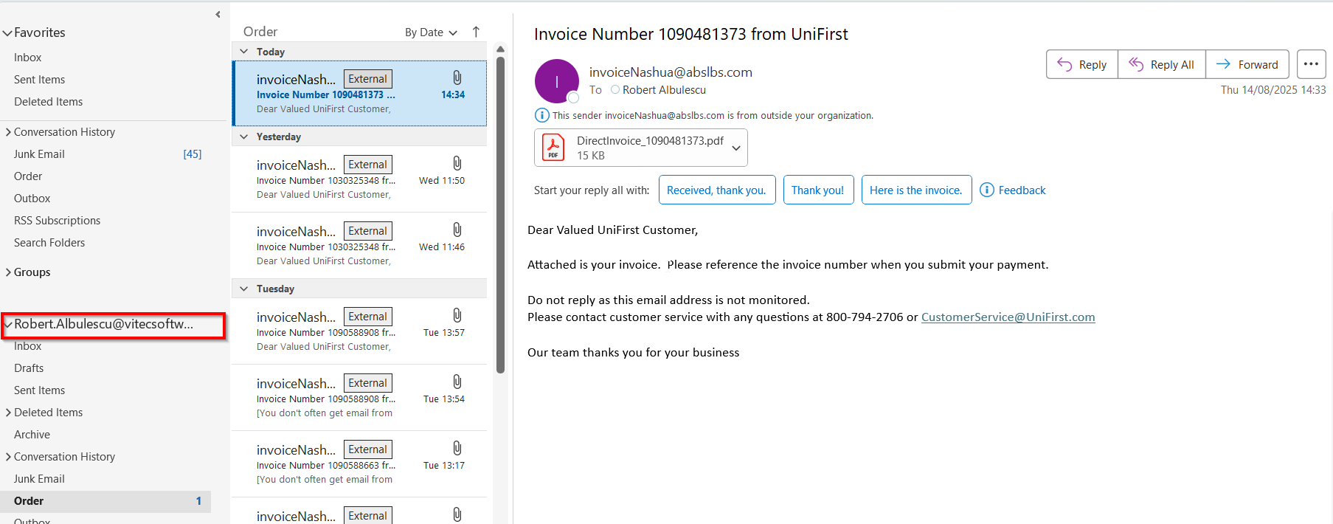

Test Case 4 – Send E-Mail when MULTIPLEINVANDSTMCONTACTS=1 and customer is not its own bill to – Tested OK
Expected behavior: The invoice should be emailed to the email address of the contact persons that is invoice contact, not on the email address that is on the invoice header
Hash: ff9c238
- Check that SS MULTIPLEINVANDSTMCONTACTS=1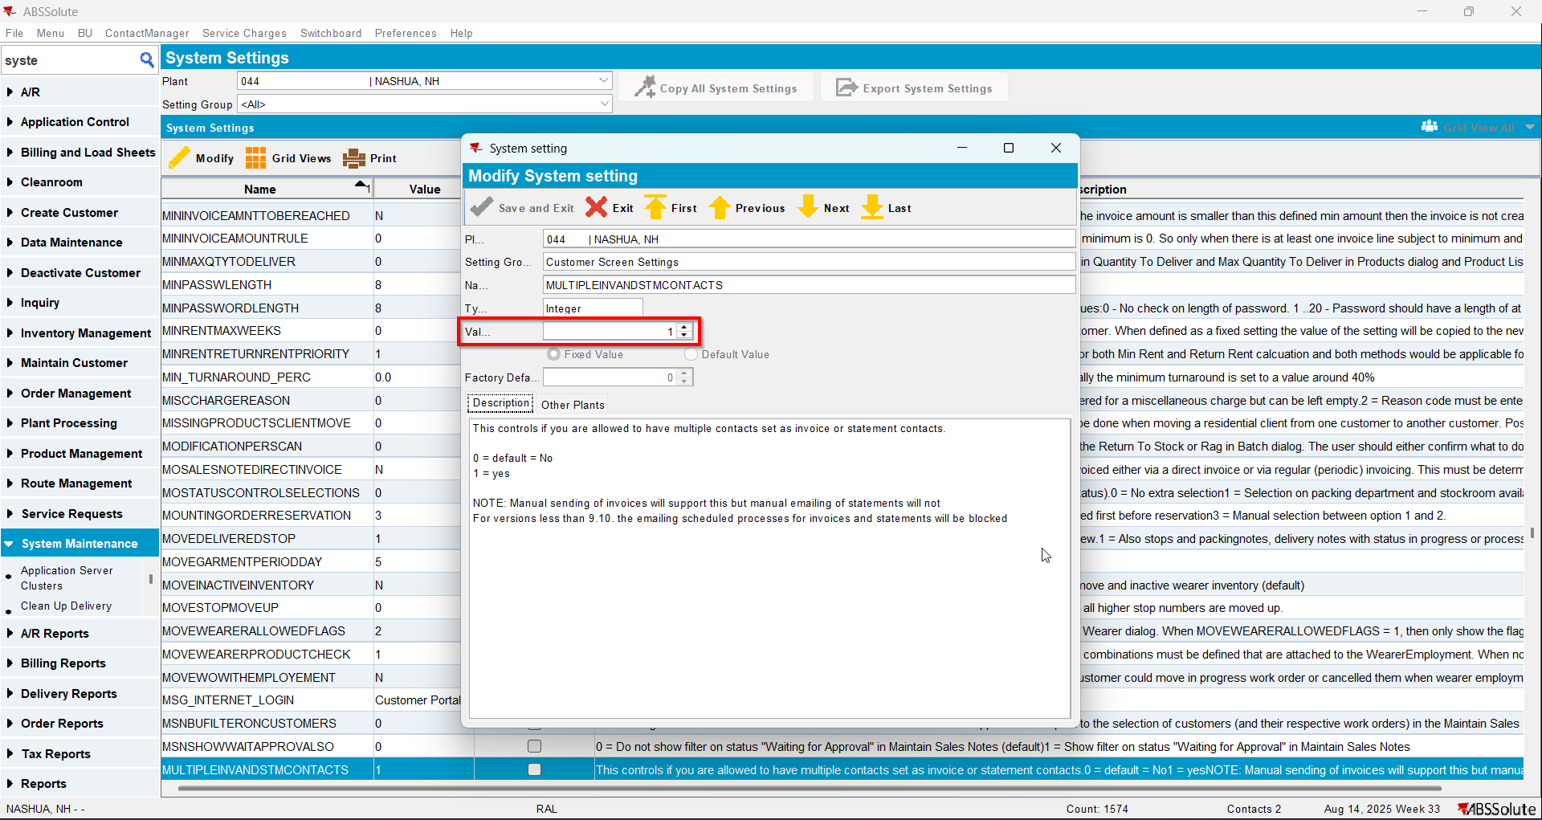
- Have a customer that is not its own bill to
- Check that he has at least 2 contact persons that are invoice contacts and have a valid email address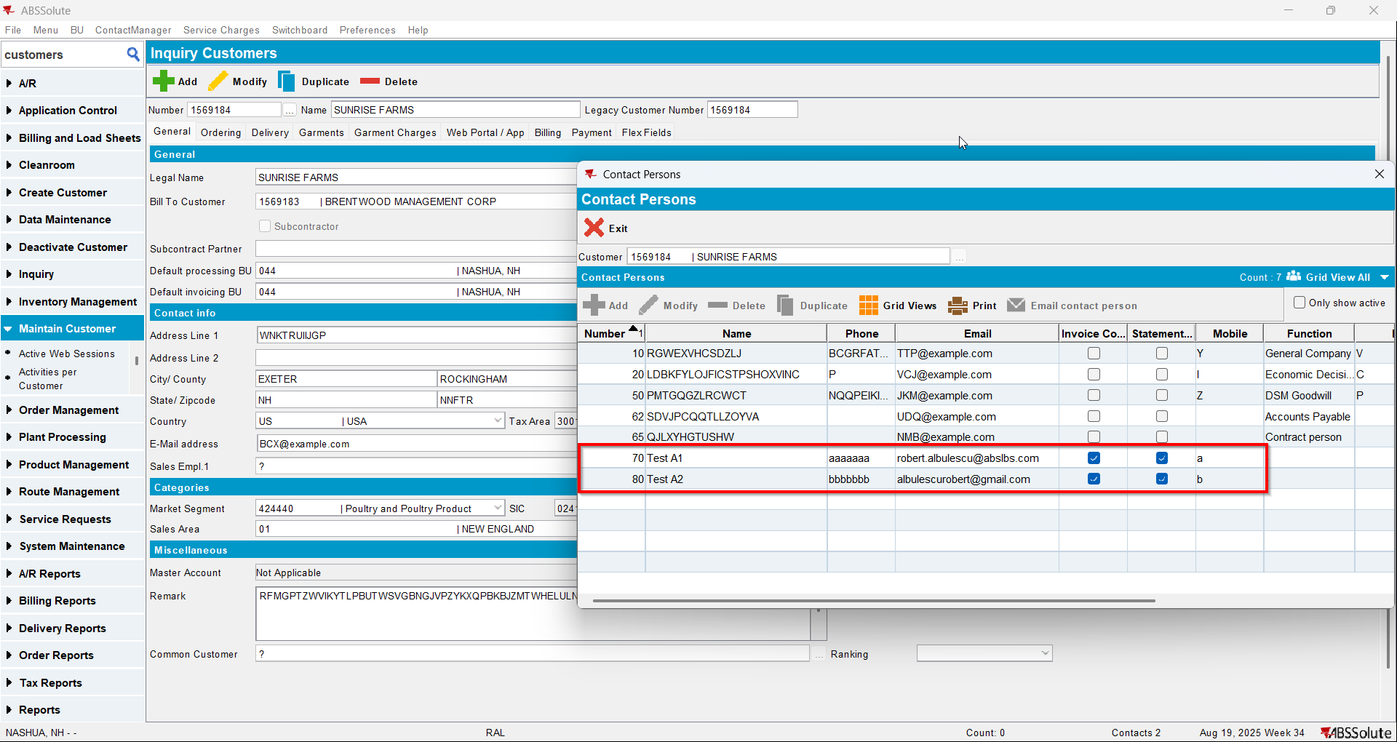
- Go on the bill to customer and check that he has at least 2 contact persons that are invoice contacts and have a valid email address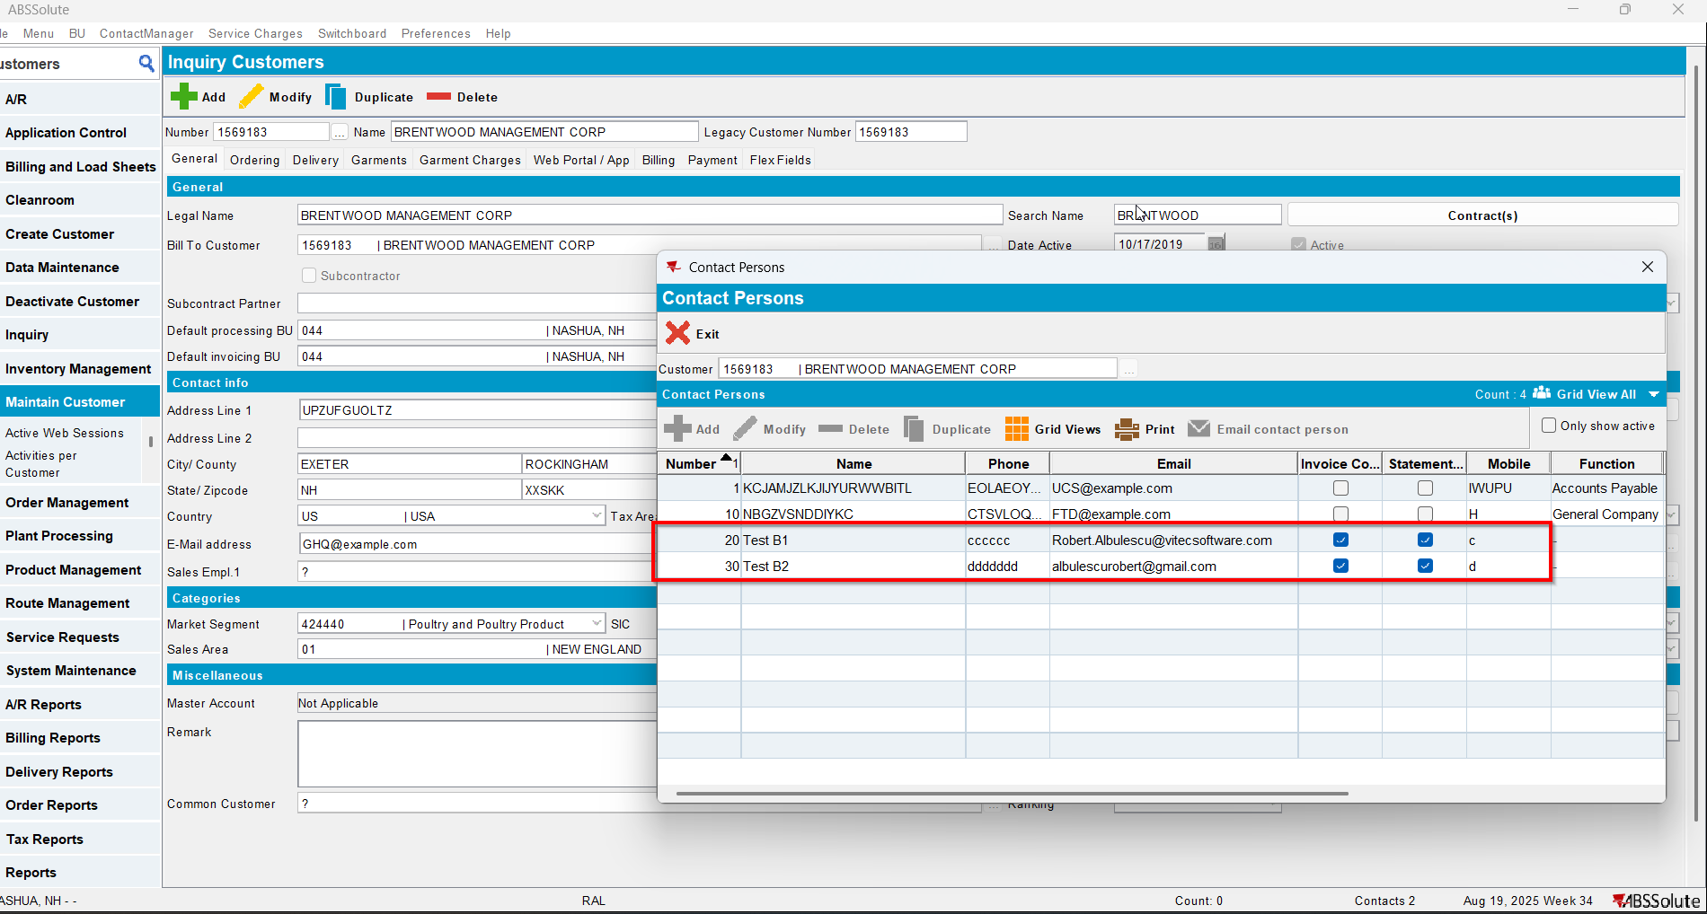
- Also on the bill to customer check that checkbox Send by E-mail is checked and on the drop-down selection the ‘Del To Invoice Contact’ option is selected(modifying this on bill to customer will also modify on del to customer )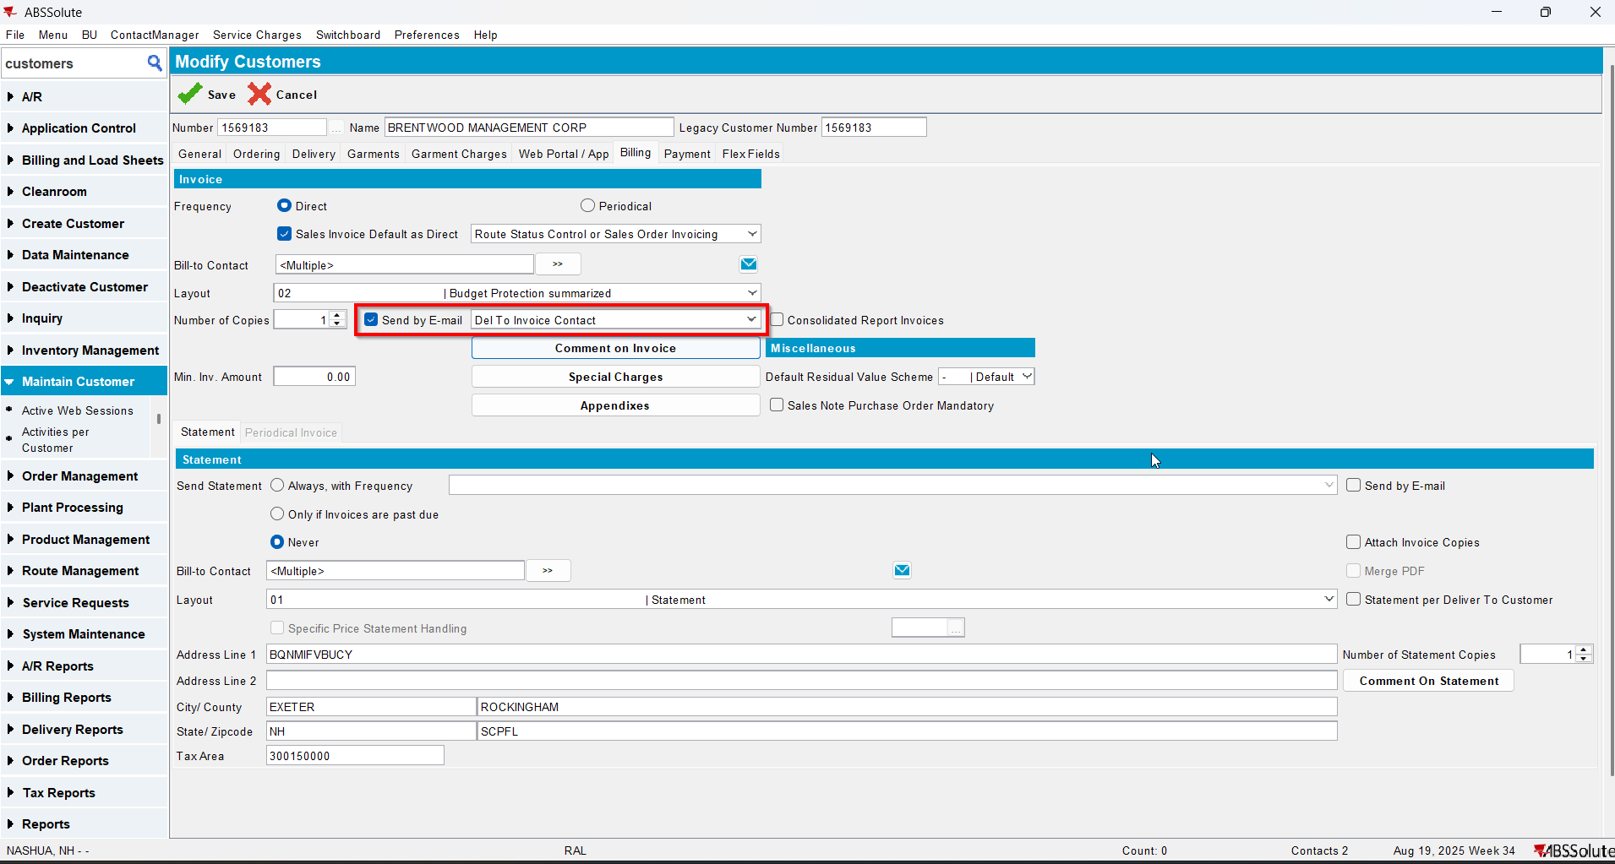
- For an invoice check what email address is on the invoice header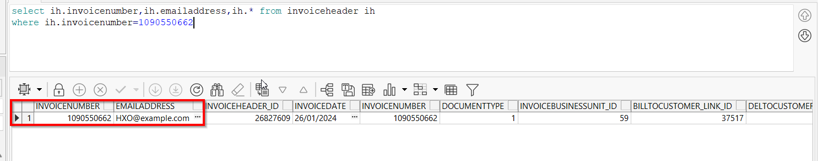
- Open switchboard and load your customer
- Select Invoices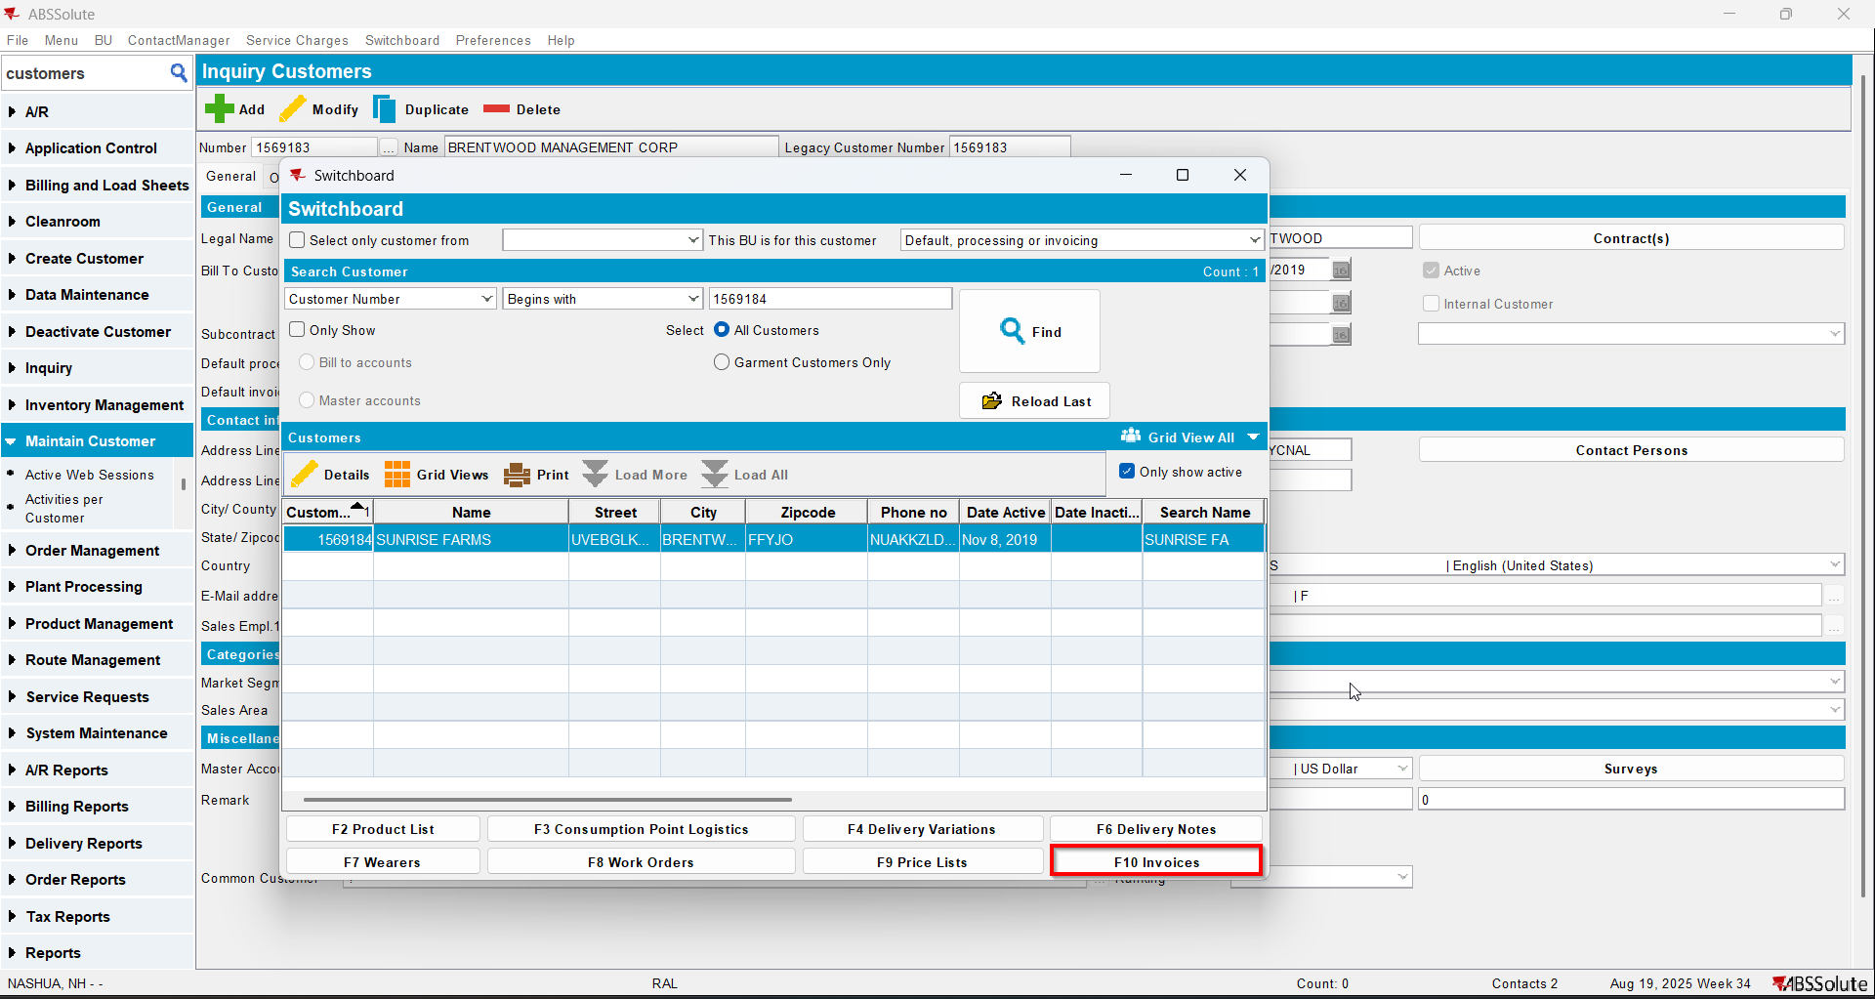
- To Invoices tab select your invoice from step 6 and press E-mail Invoice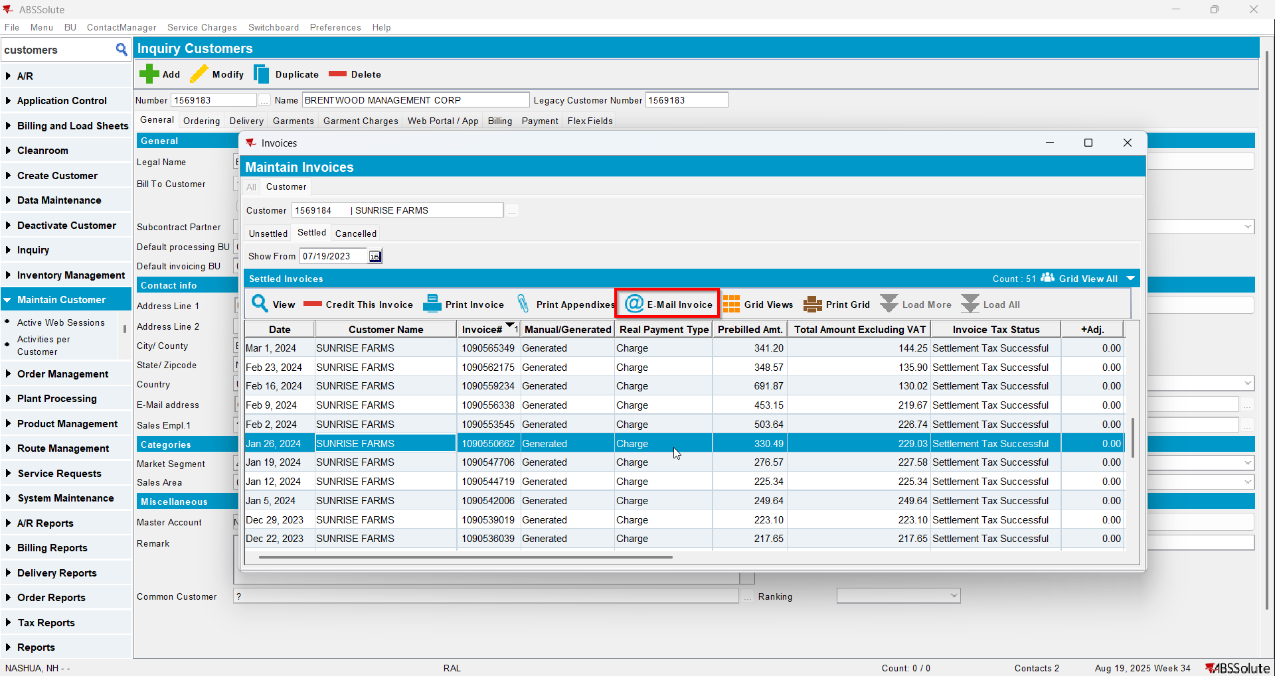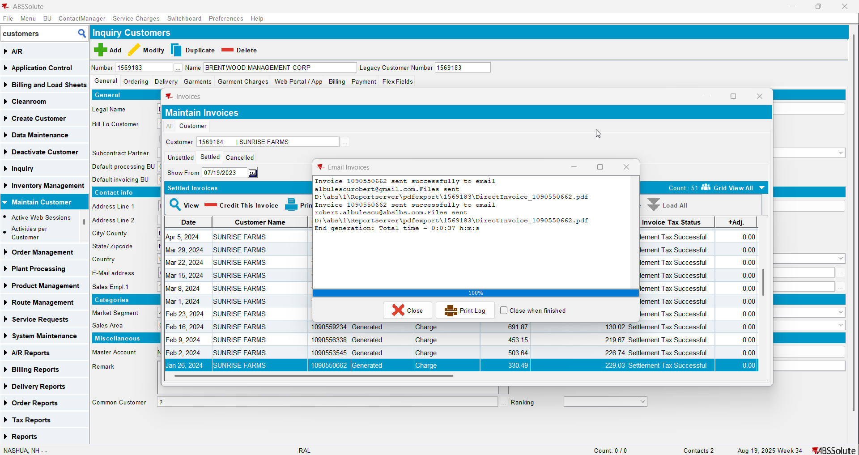
- Check if the email was sent to the contact person of the del to customer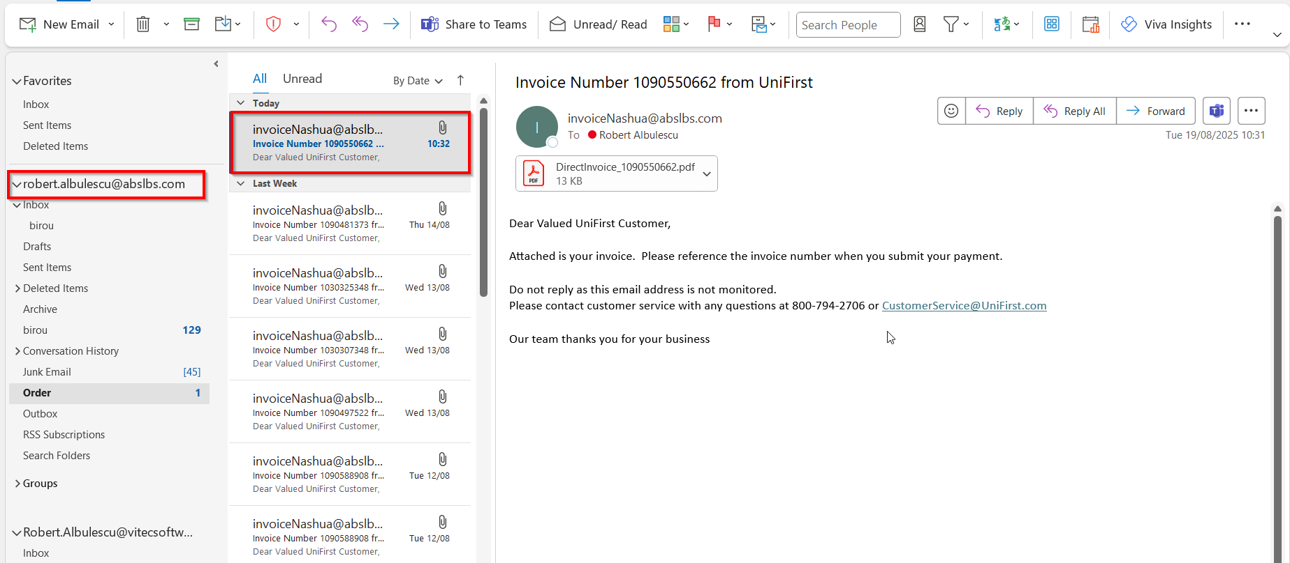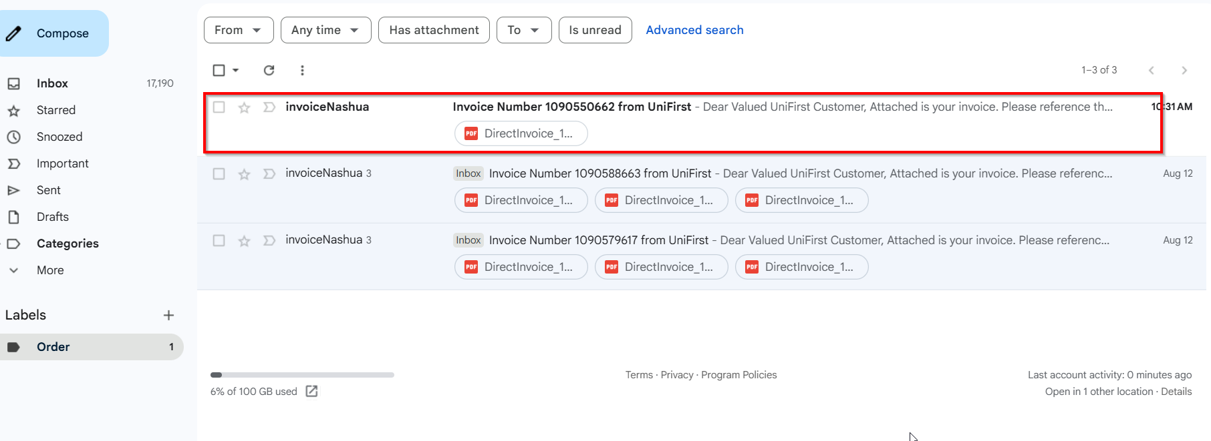
- Go on the bill to customer and on the drop-down select ‘Bill To Invoice Contact’ option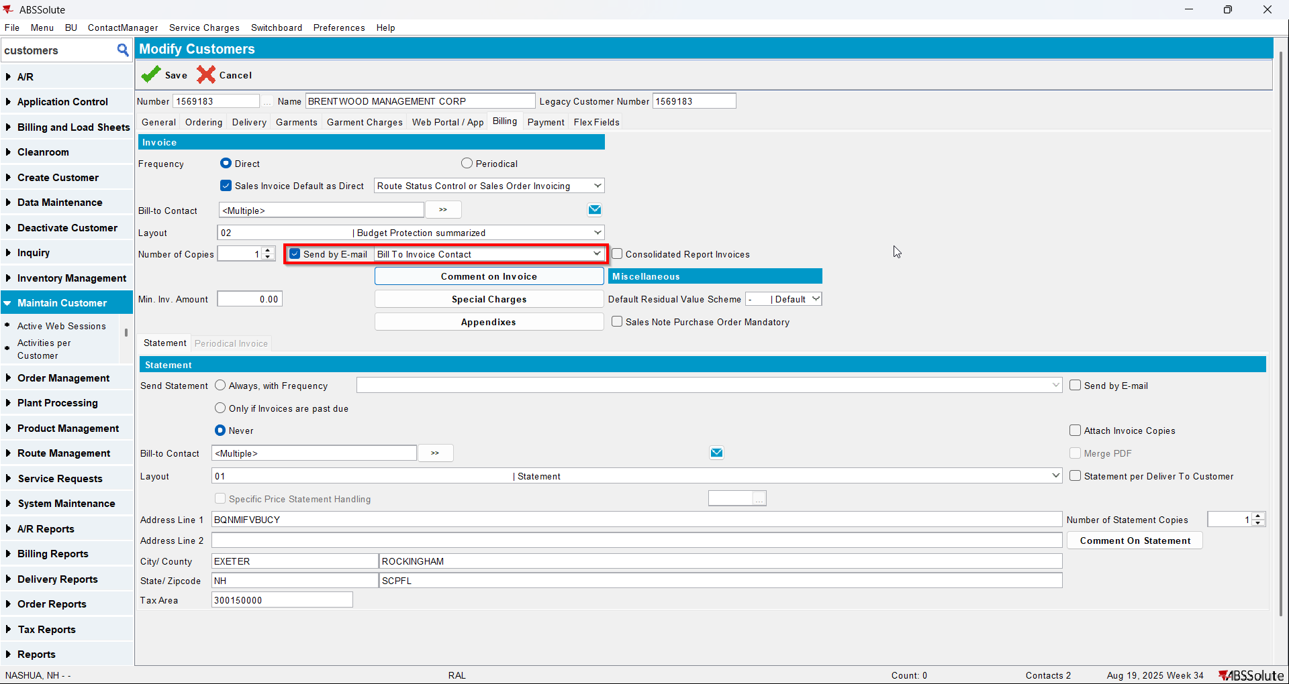
- Open Switchboard and load your customer
- Select Invoices
- To Settled tab select your invoice from step 6 and press E-mail Invoice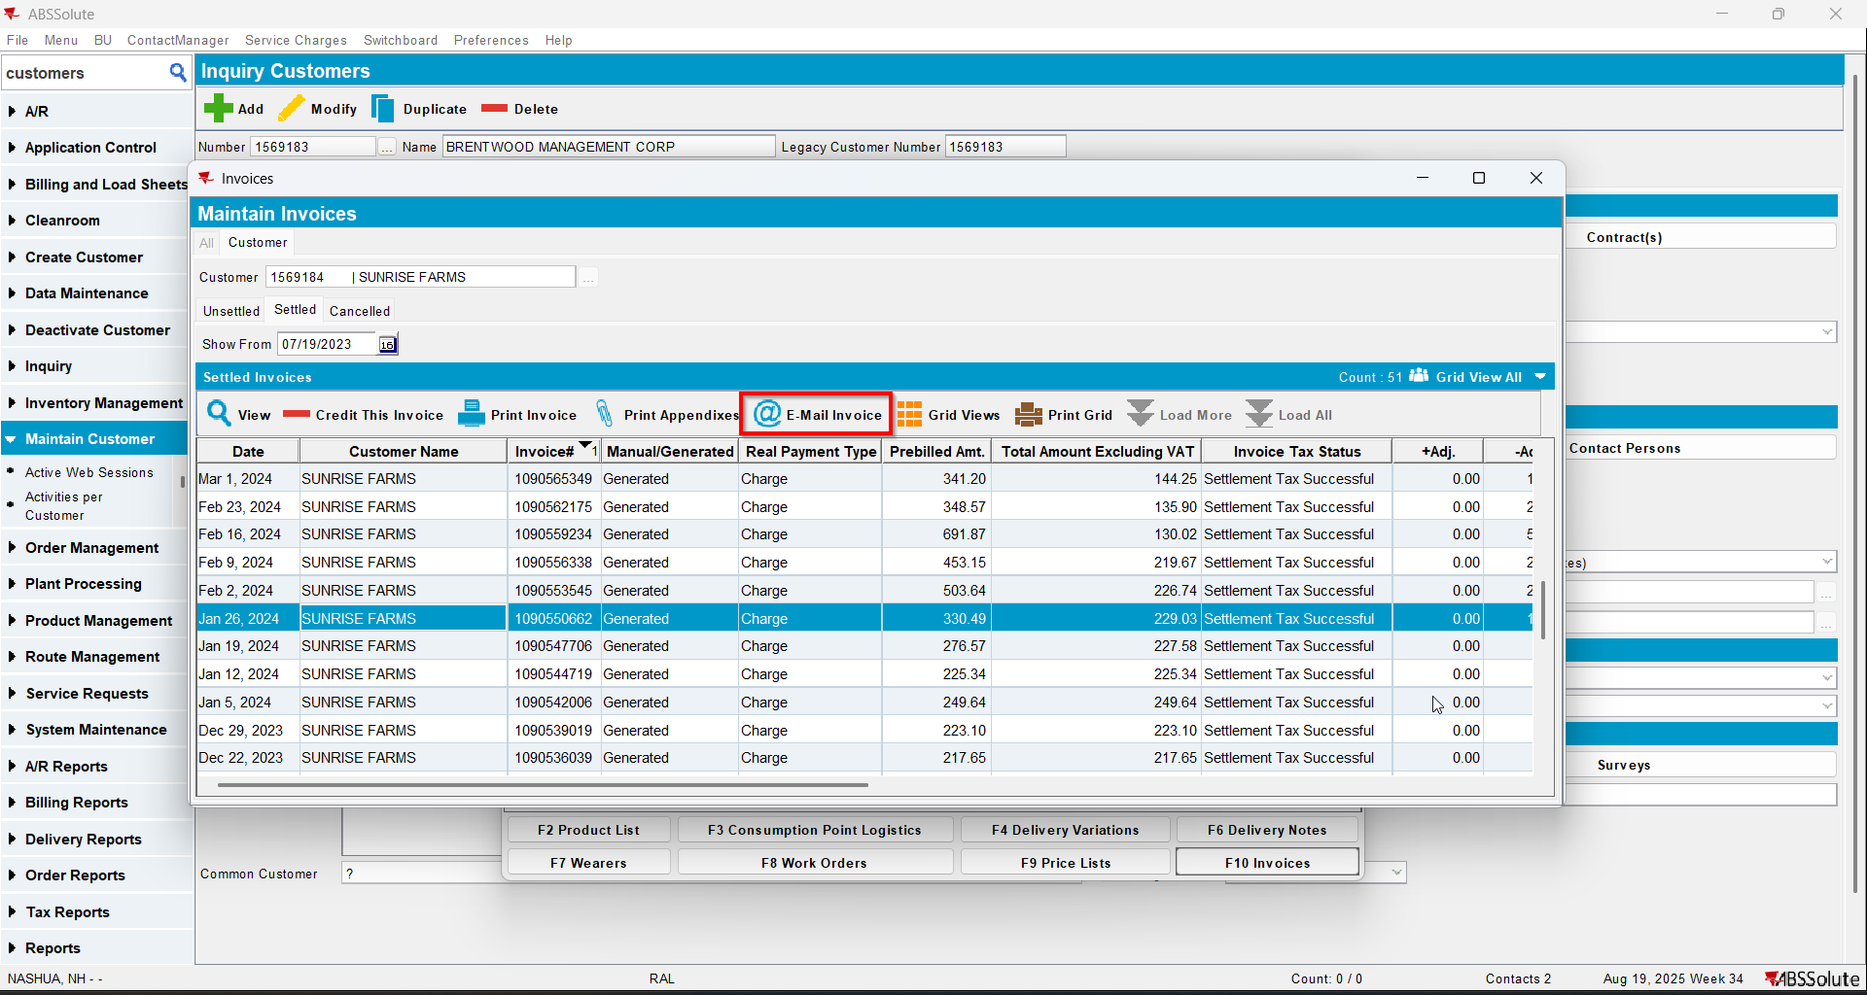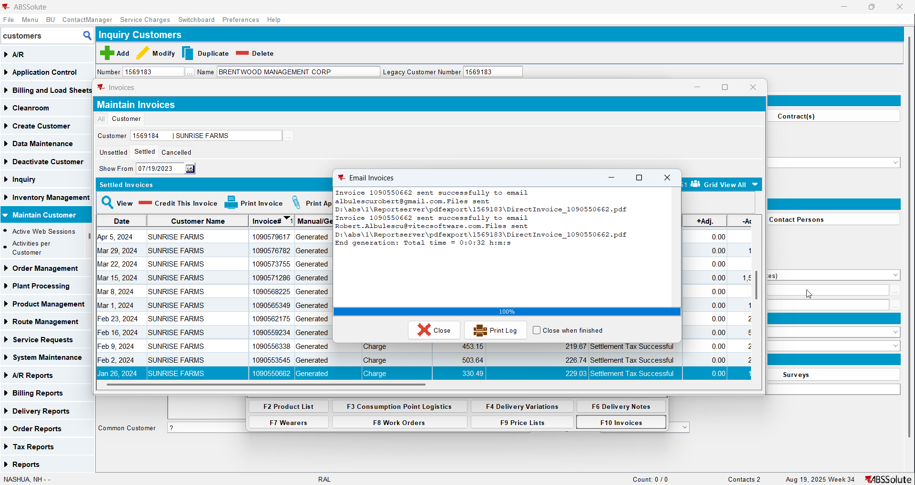
- Check if the email was sent to the contact person of the bill to customer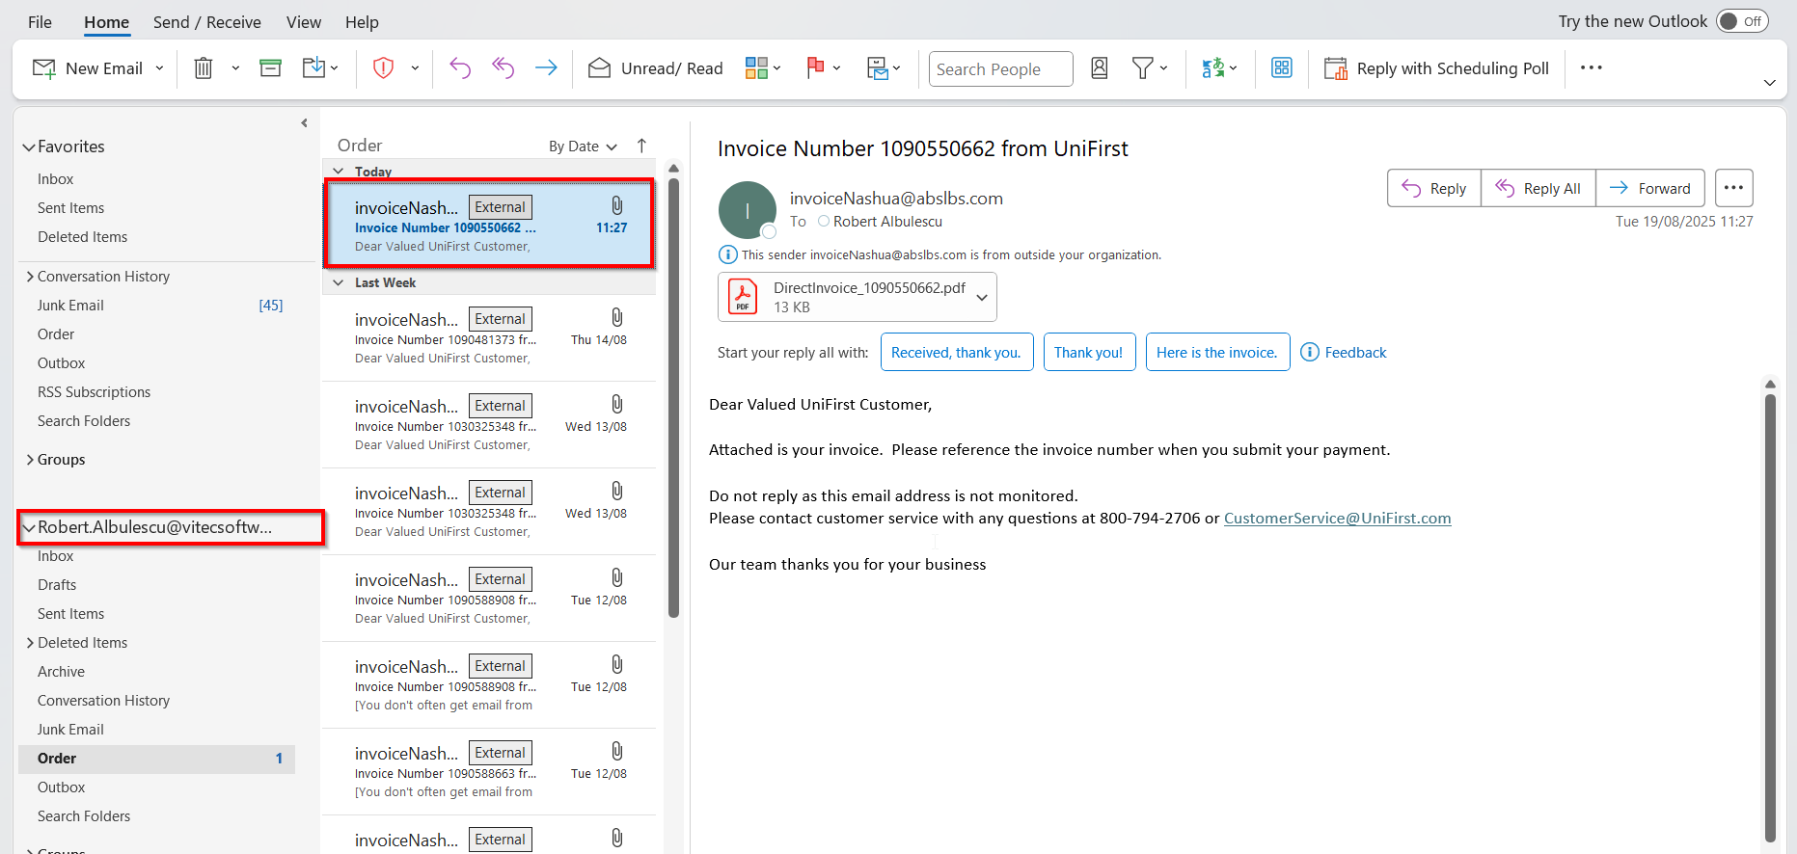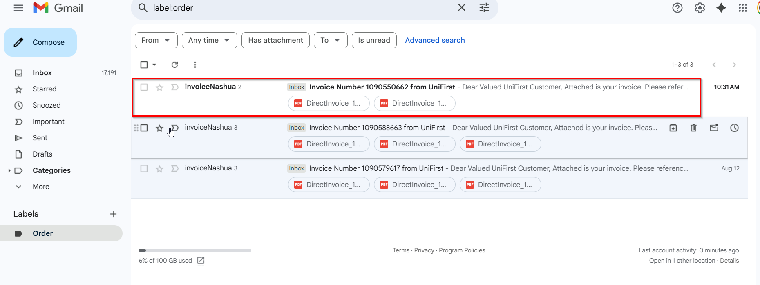
- Go on the bill to customer and on the drop-down select ‘Del To and Bill To Invoice Contacts’ option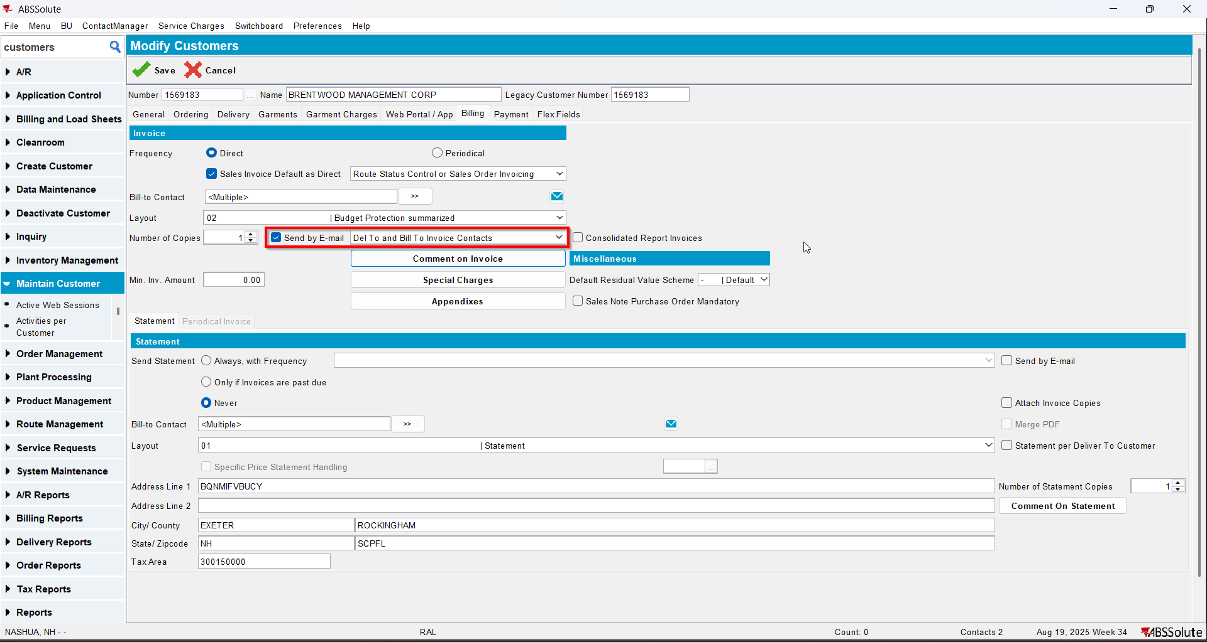
- Open Switchboard and load your customer
- Select Invoices
- To Invoices tab select your invoice from step 6 and press E-mail Invoice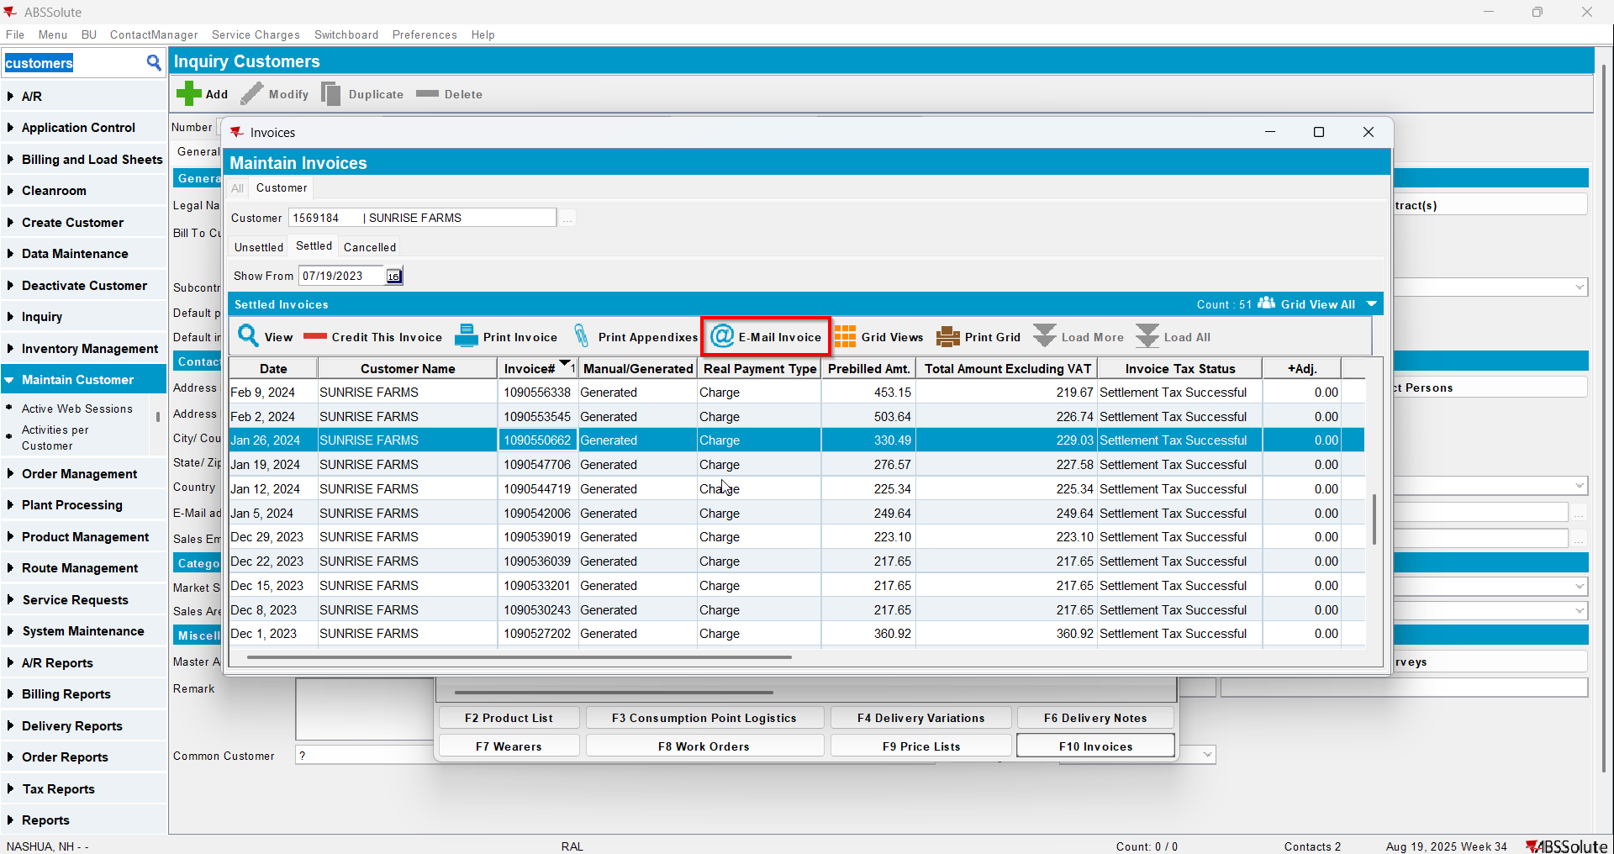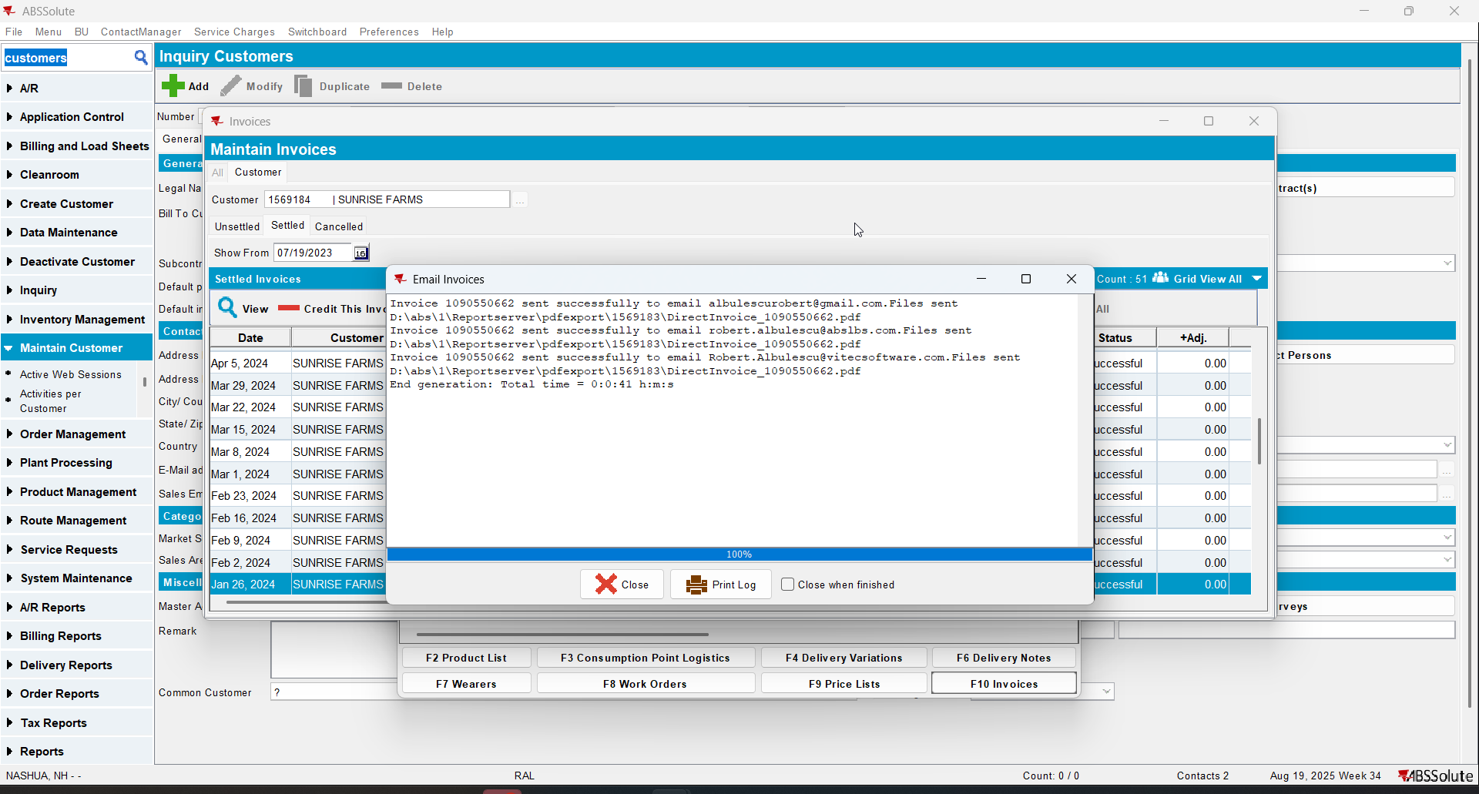
- Check if the email was sent to the contact persons of the del to customer and bill to customer. Note that if more contact persons have the same email address, it will only send 1 email 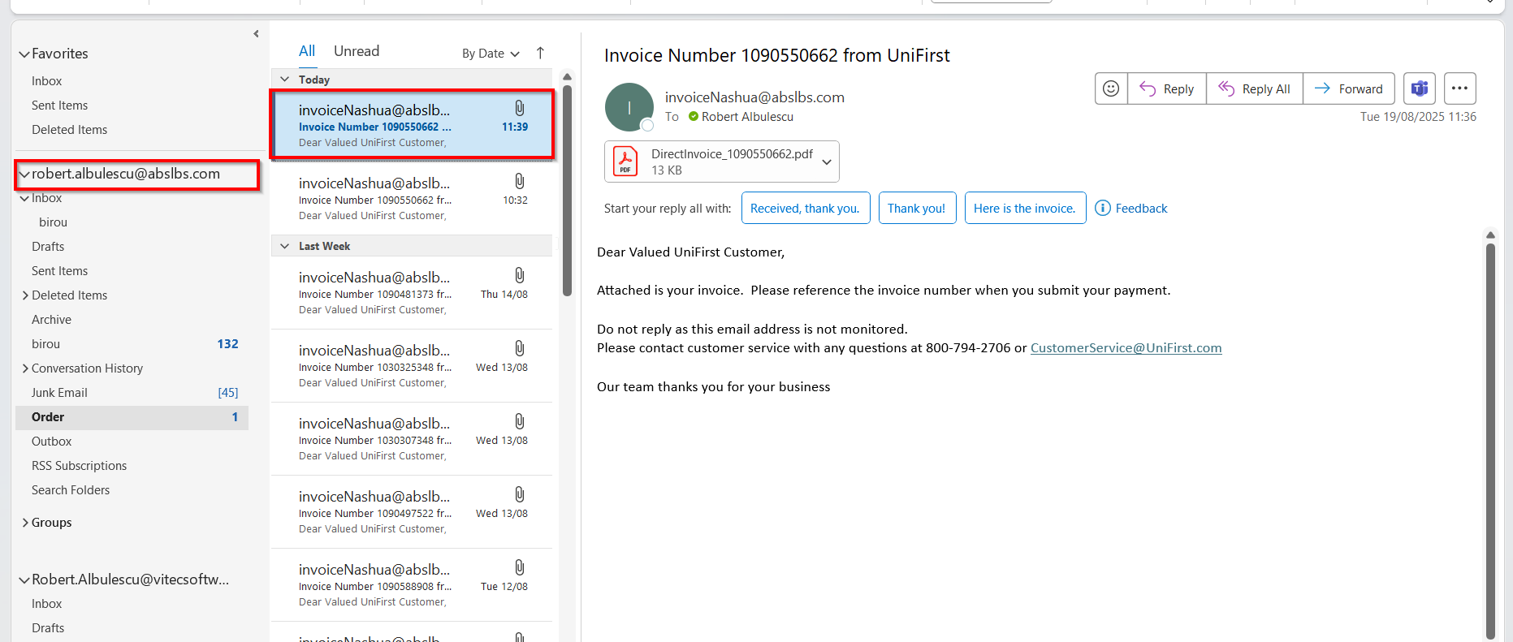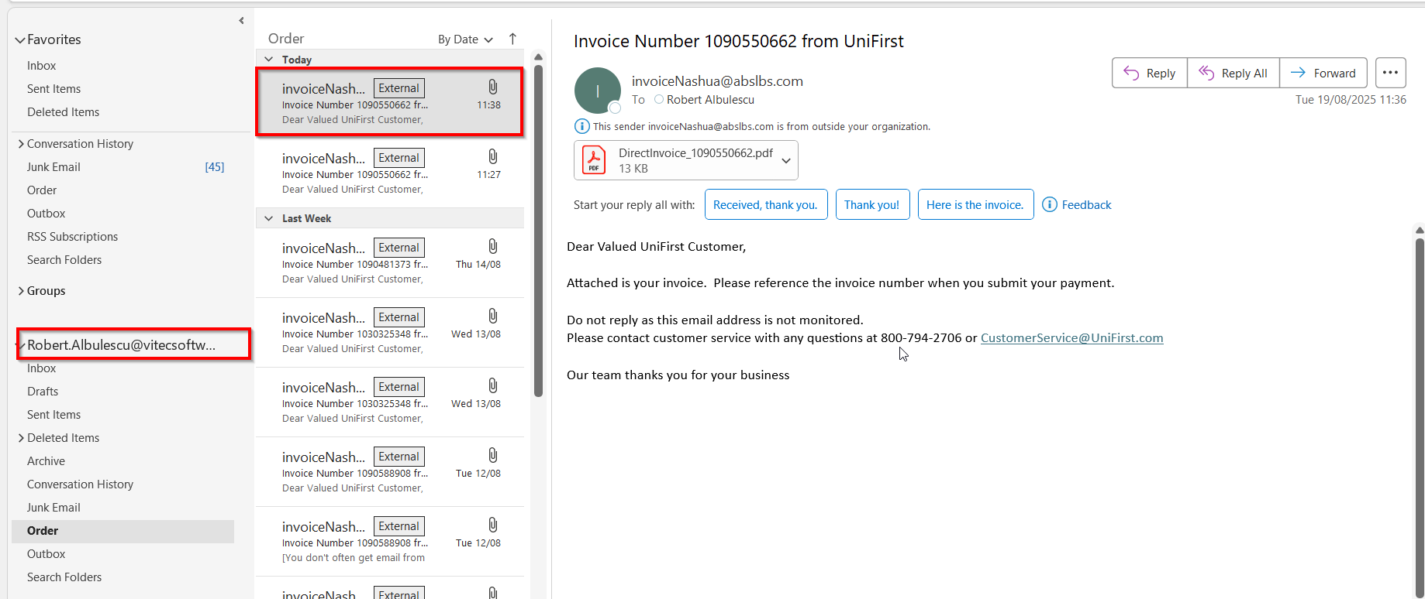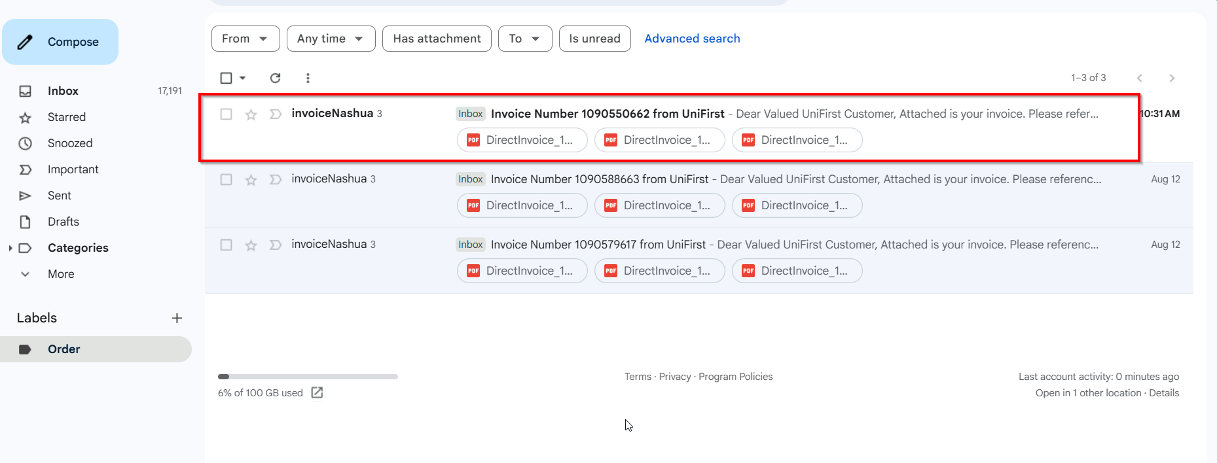

Scheduled process E-mail Direct Invoices

Test Case 1 – Send E-Mail when MULTIPLEINVANDSTMCONTACTS=1 – Tested OK
Expected behavior: The process should fail
Hash: ff9c238
- Check that SS MULTIPLEINVANDSTMCONTACTS=1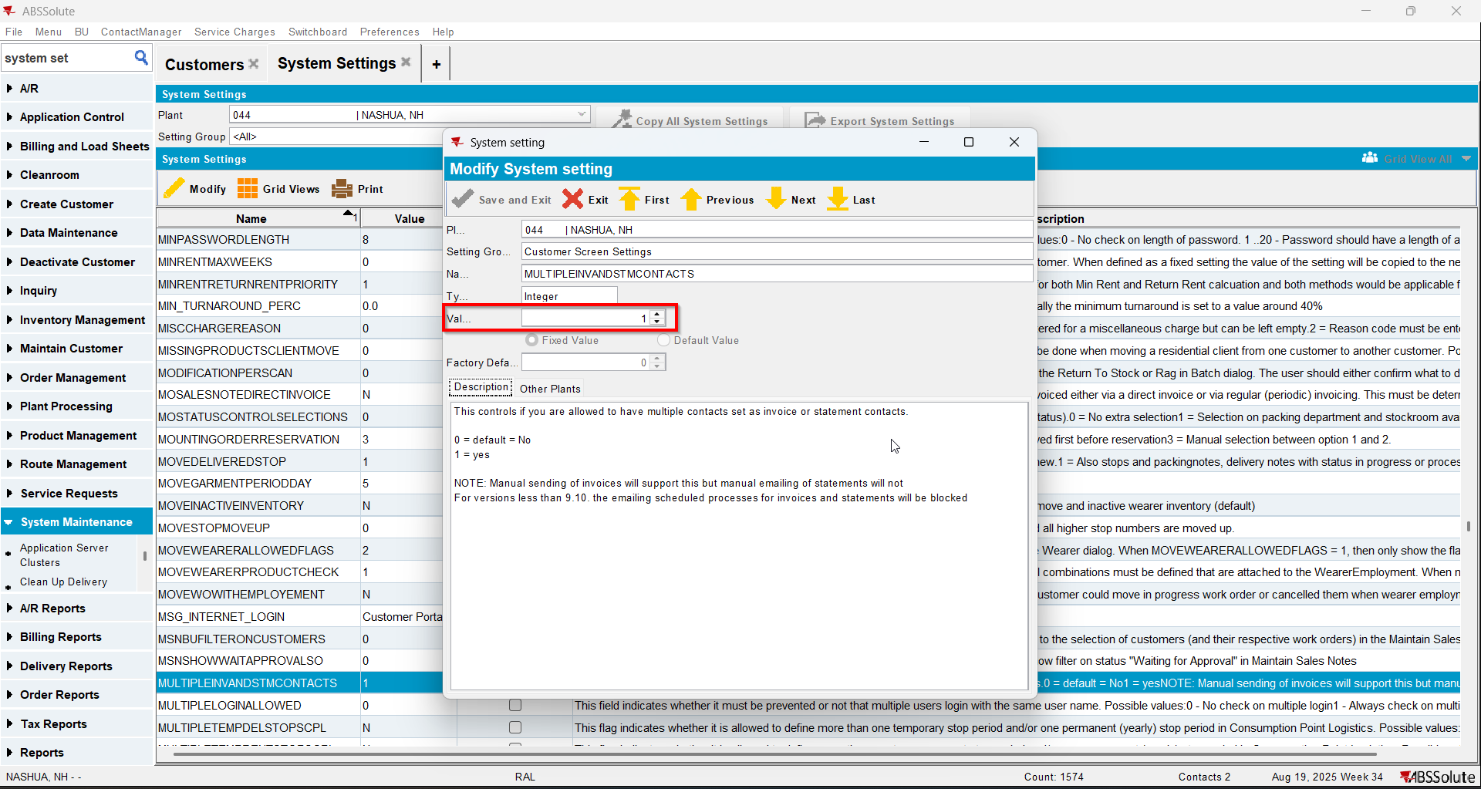
- Run process E-mail Direct Invoices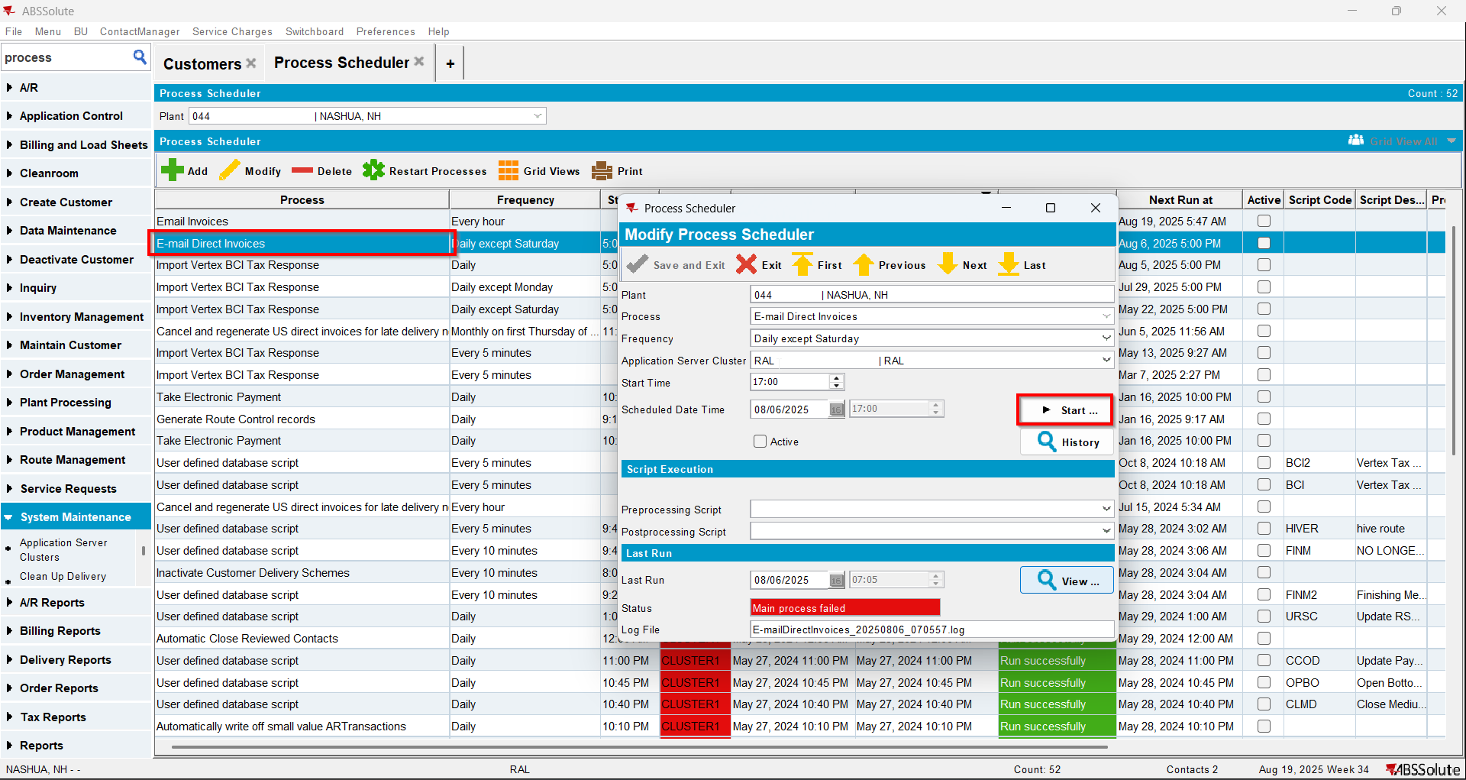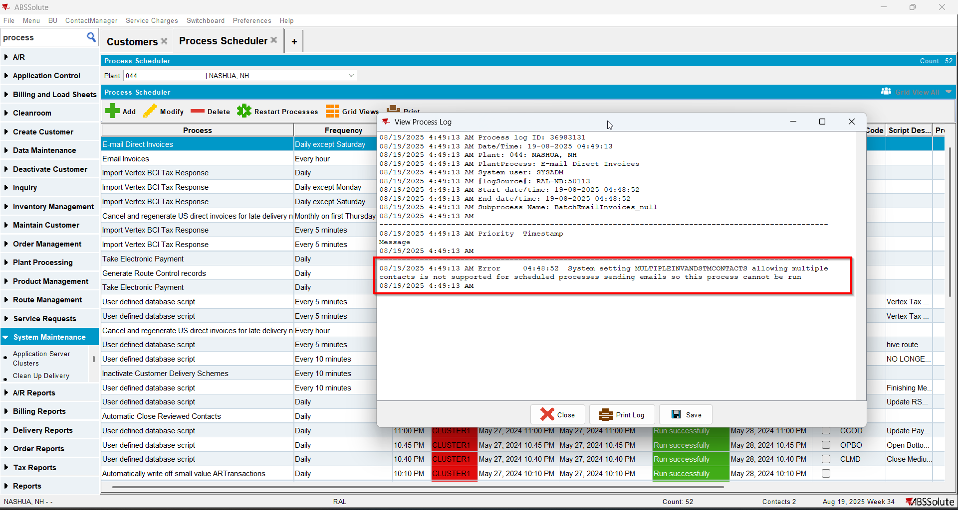

Test Case 2 – Send E-Mail when MULTIPLEINVANDSTMCONTACTS=0 and customer is its own bill to – Tested OK
Expected behavior: The process should send email to just 1 contact person if there are multiple
Hash: ff9c238
- Check that SS MULTIPLEINVANDSTMCONTACTS=0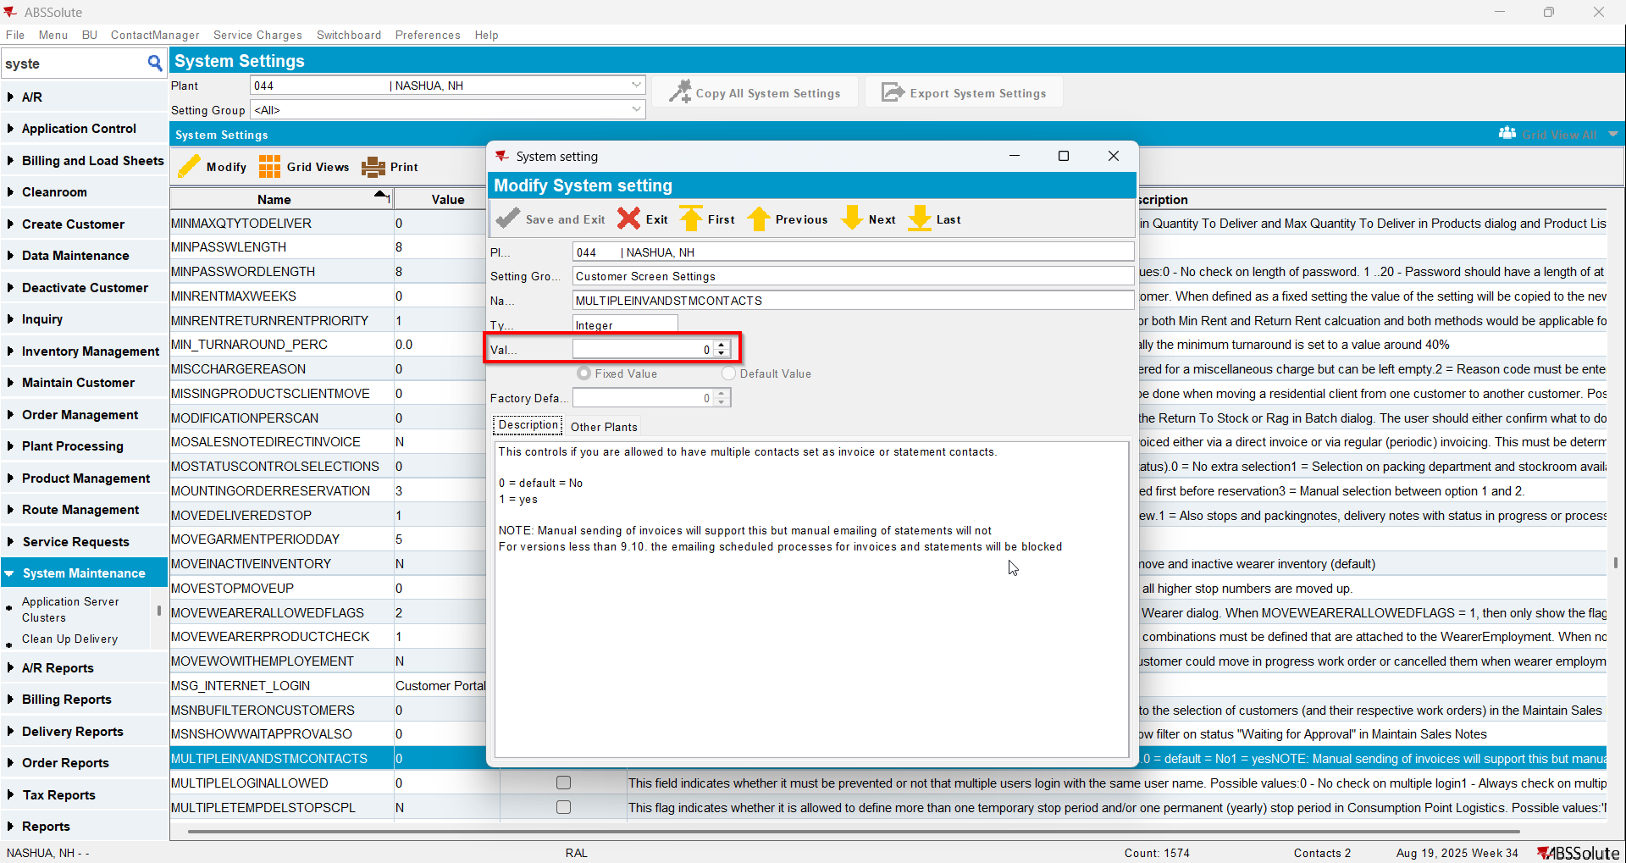
- Have a customer that has multiple contact persons set as invoice contacts. You can do this with SS on 1 and after that change it to 0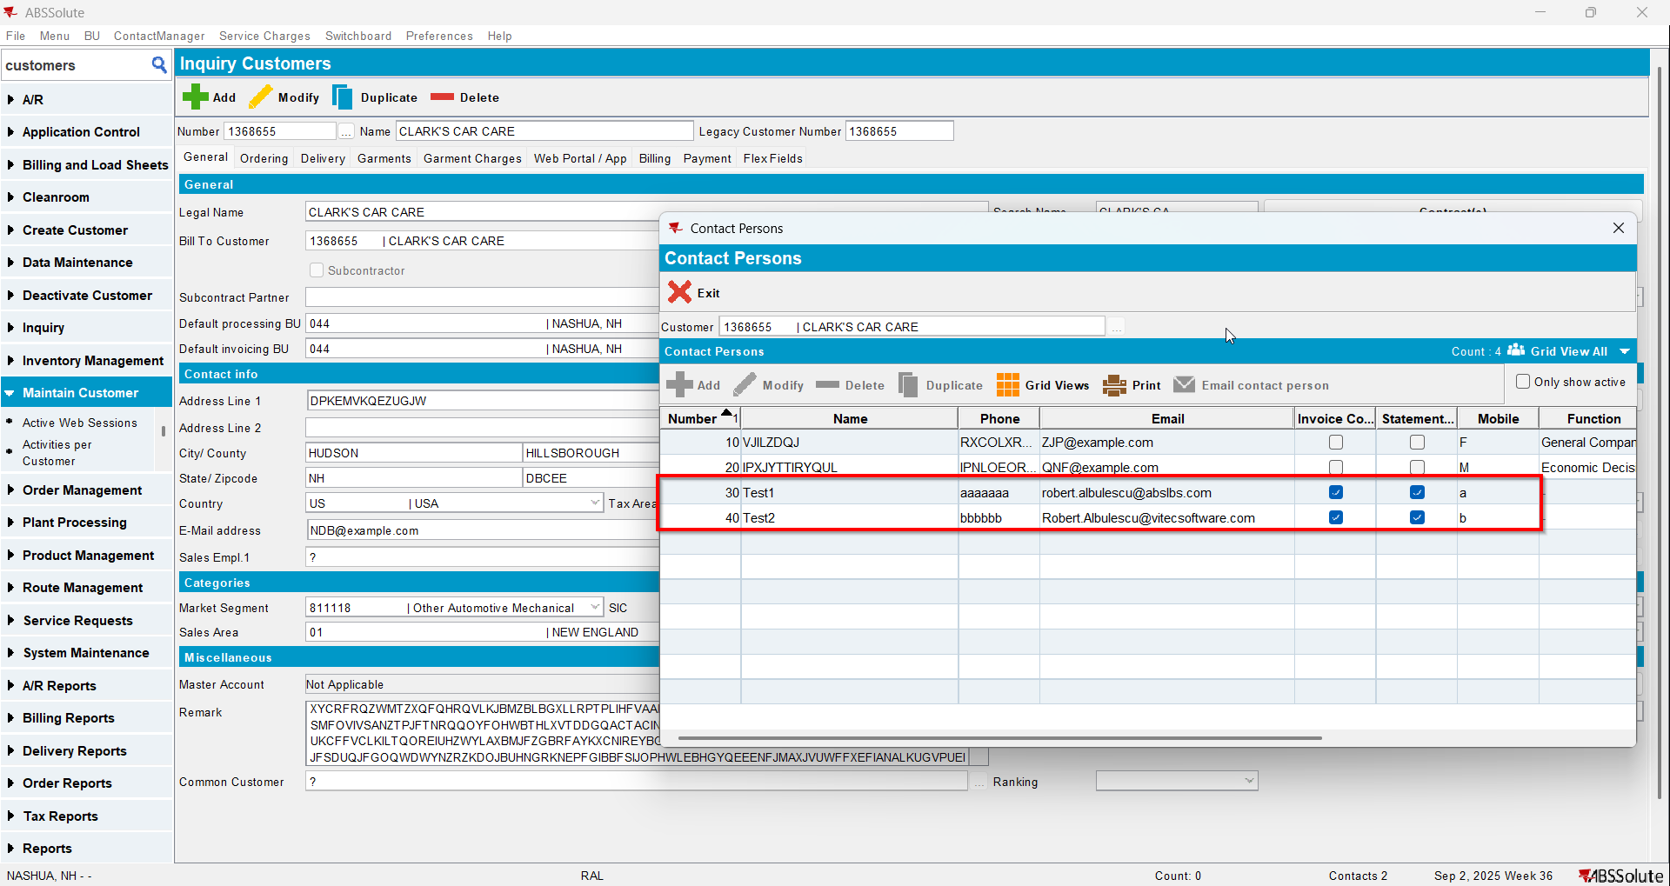
- Add a route control for your customer
- Generate invoice and settle the route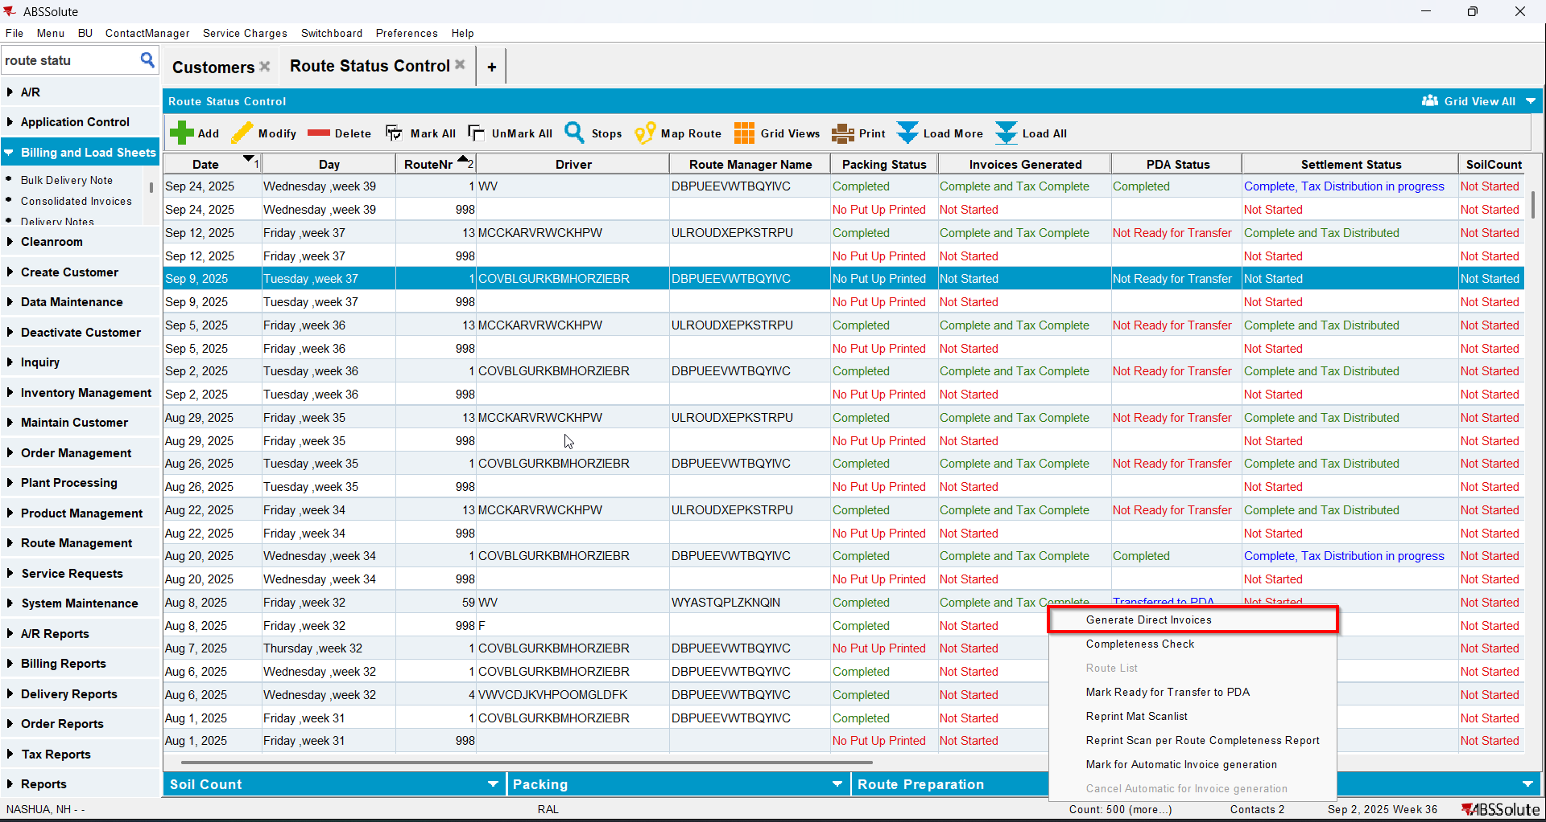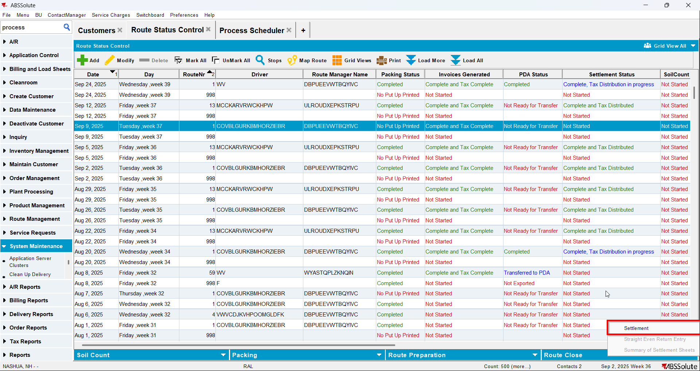
- Run the process E-mail Direct Invoices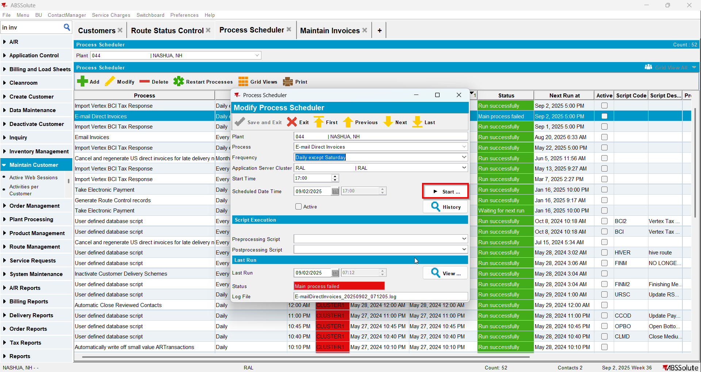
- Go to View Process Log dlg and check the log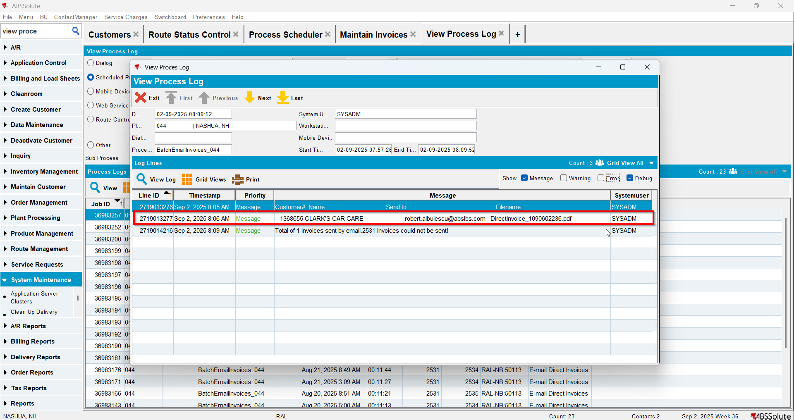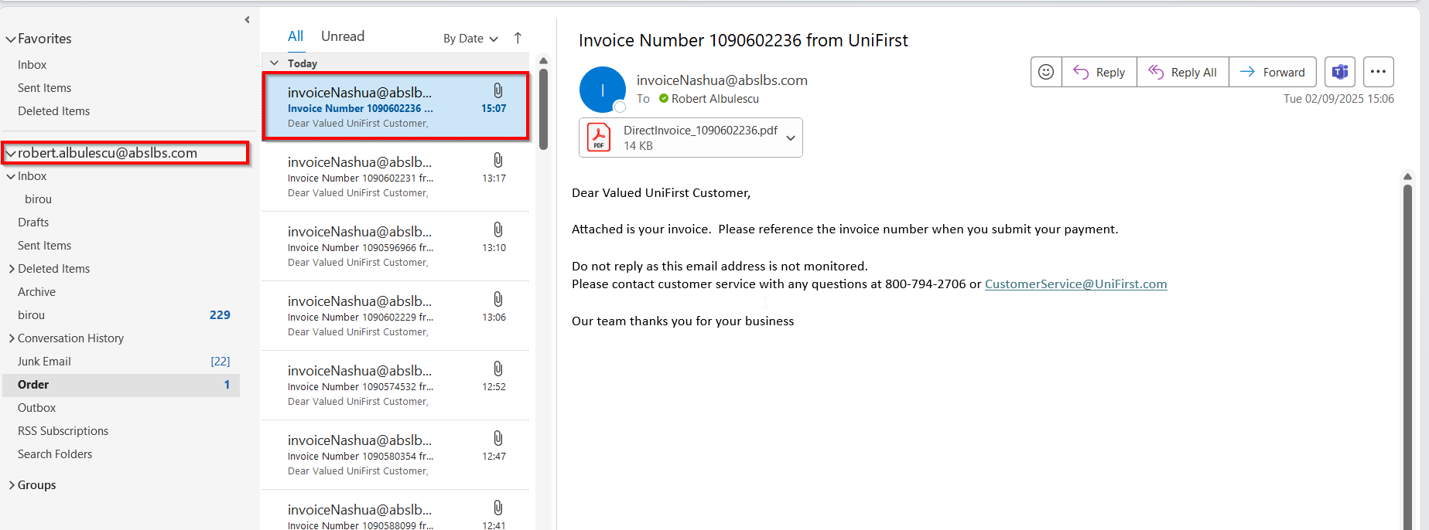

Test Case 3 – Send E-Mail when MULTIPLEINVANDSTMCONTACTS=0 and customer is not its own bill to – Tested OK
Expected behavior: The process should send email to just 1 contact person if there are multiple
Hash: ff9c238
- Check that SS MULTIPLEINVANDSTMCONTACTS=0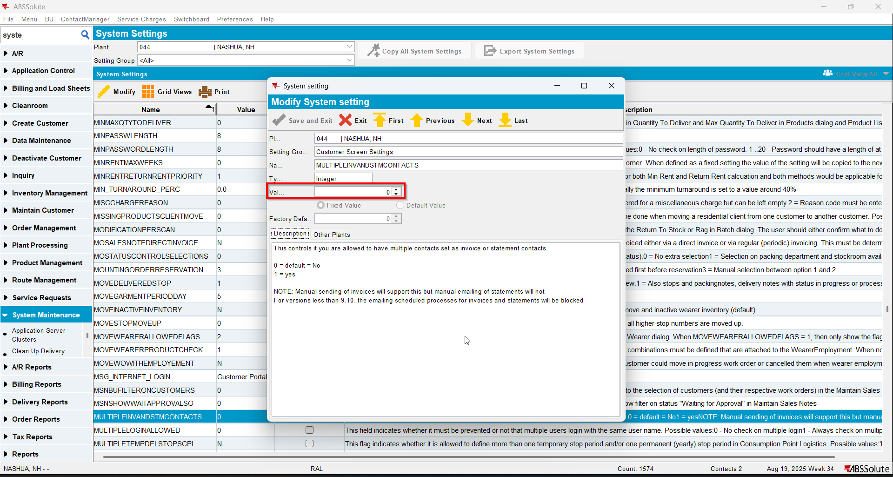
- Have a customer that has multiple contact persons set as invoice contacts. You can do this with SS on 1 and after that change it to 0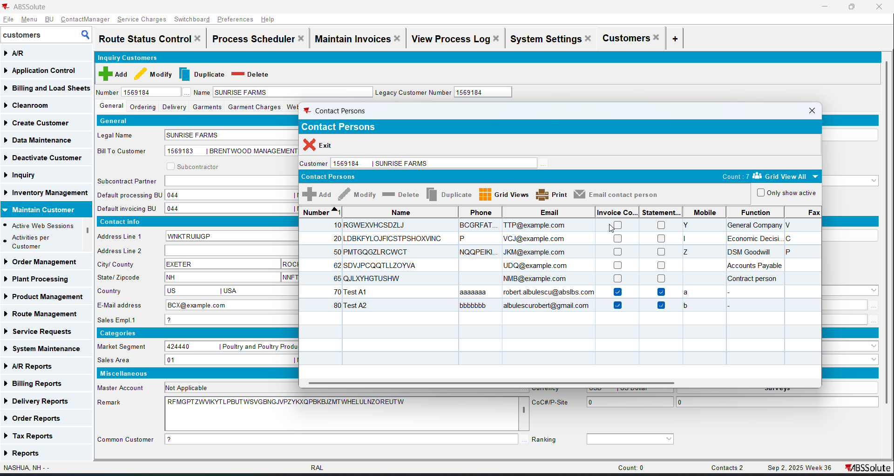
- Check that bill to customer has multiple contact persons set as invoice contacts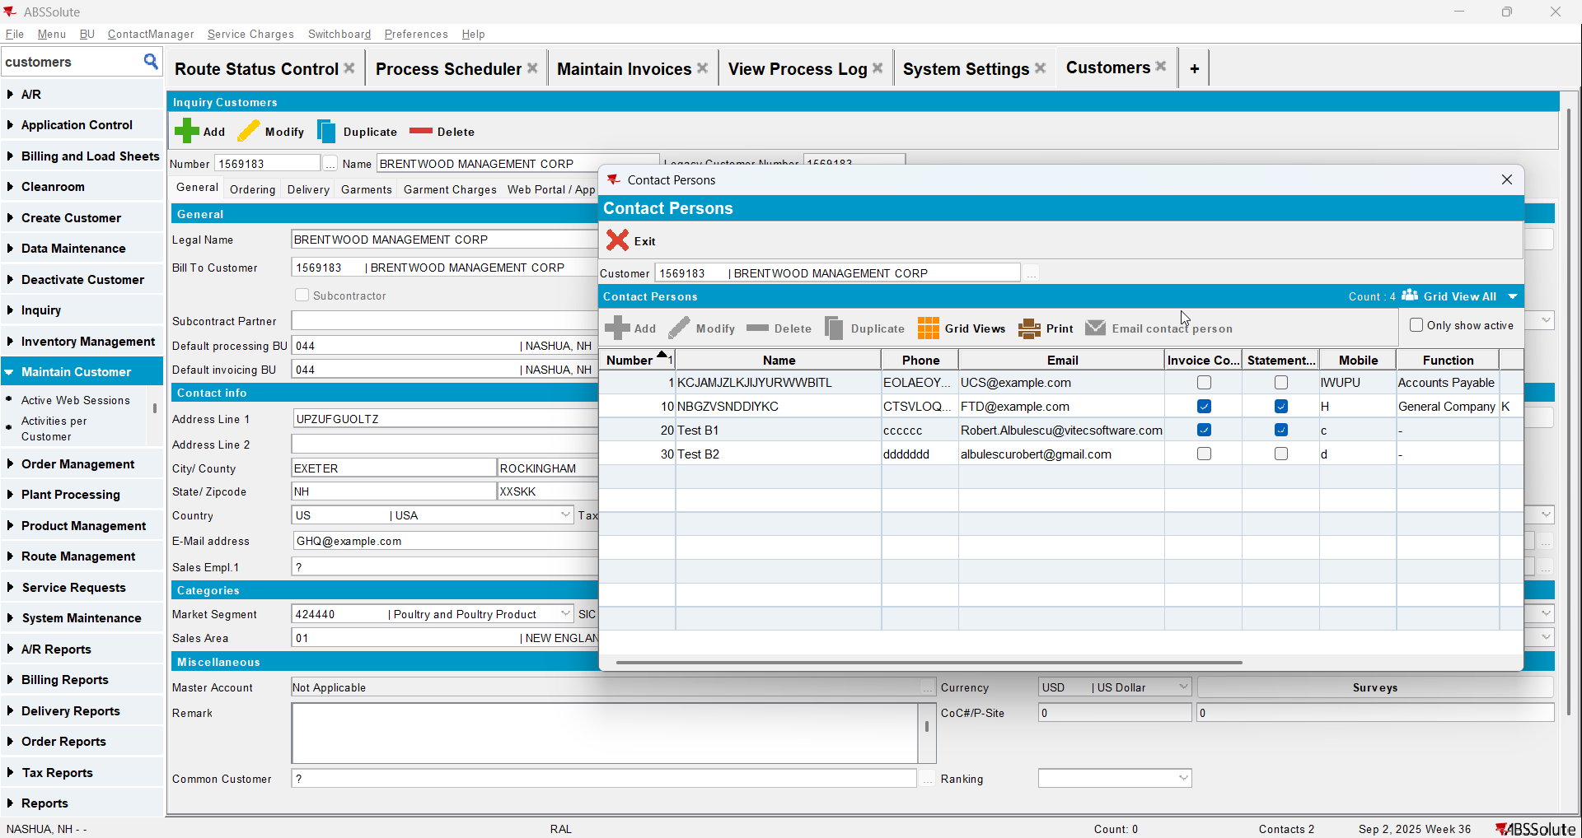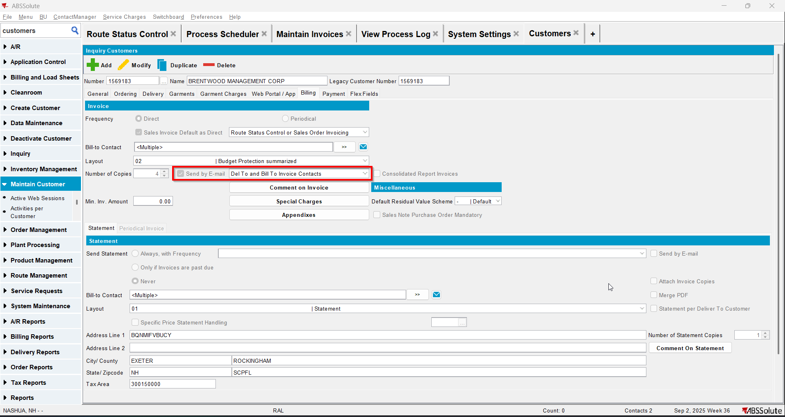
- Add a route control for your del to customer
- Generate invoice and settle the route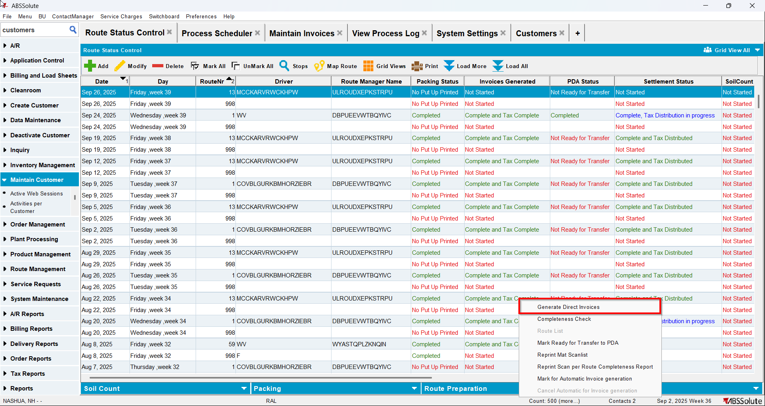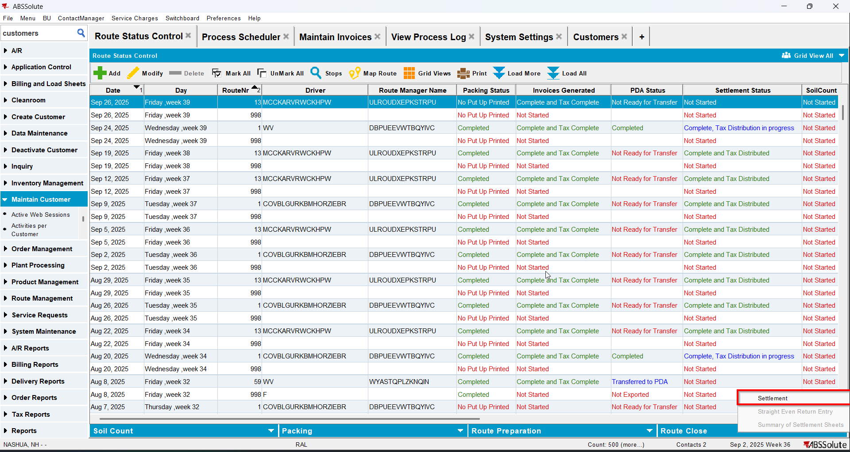
- Run the process E-mail Direct Invoices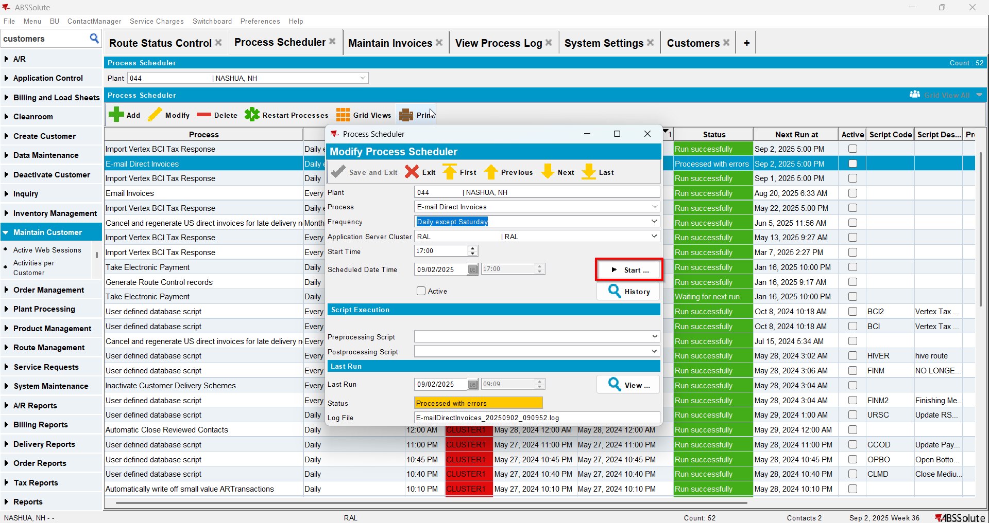
- Go to View Process Log dlg and check the log