ABSN-8325 Improve loading Credit Cards transactions dialog
Environment | Prerequisites
Version:9.07.00  DBServerName= abs-srv16.internal.abslbs.com  DBSID=CUST24  DBUser=UNFDEV  Environment=Test | - Module:  - System setting

Contents
Retest after fix 1
Steps to reproduce 1

Retest after fix
Bu: 025 PORTLAND, ME
9.07.00.UNF20 hash: 4fc6ca7

Steps to reproduce

!!! All the column grids were already saved from previous run !!! If there are not present, please add them
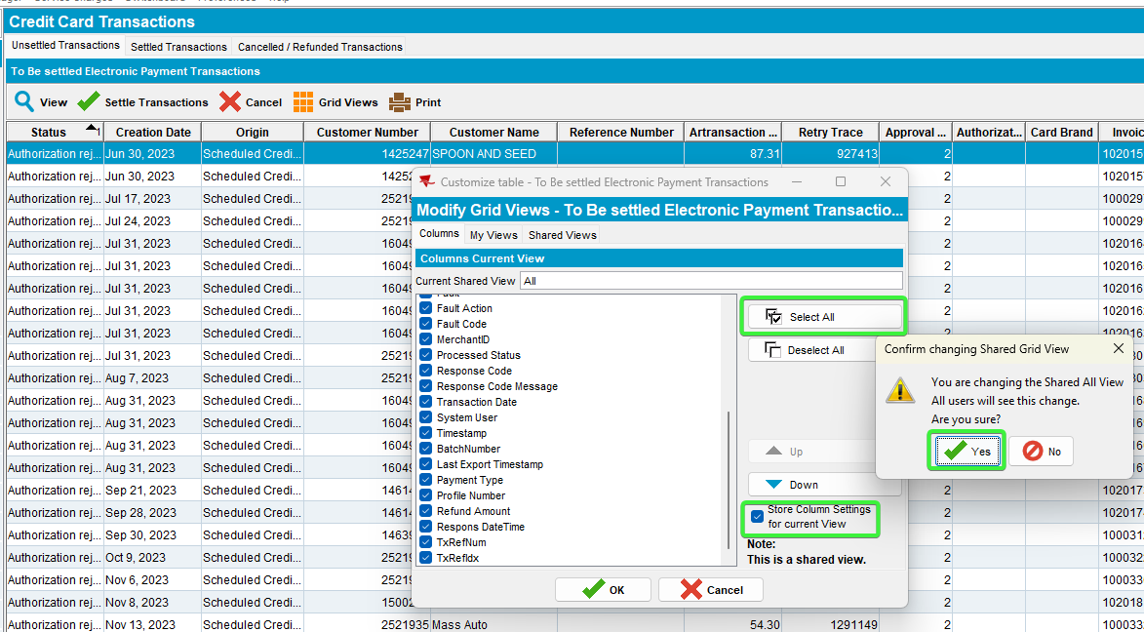
Close the server. Restart everything.
First do the steps without the fix so you can see the difference on time between before and after fix.

- Credit Card Transaction dlg: Unsettled Transactions tab, load the screen and time how much it takes to load the records.
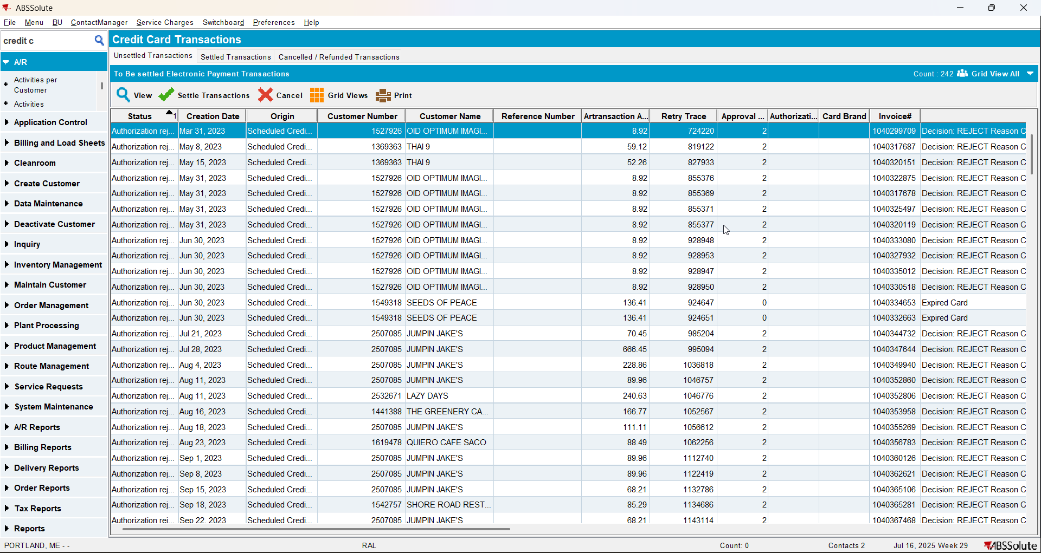

Before the improvement After the improvement
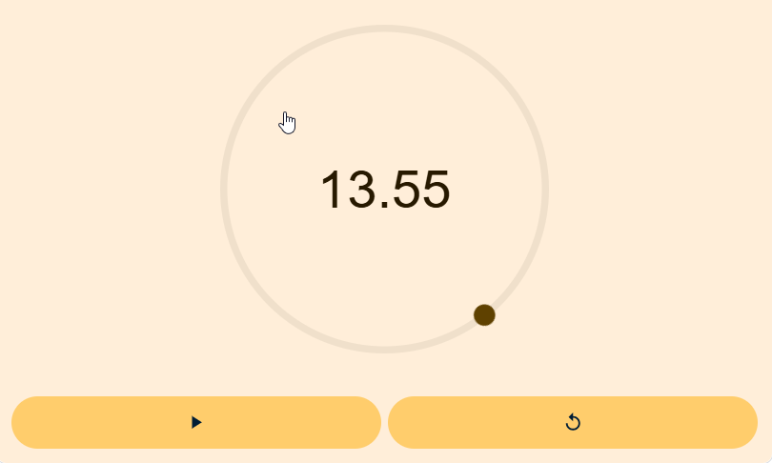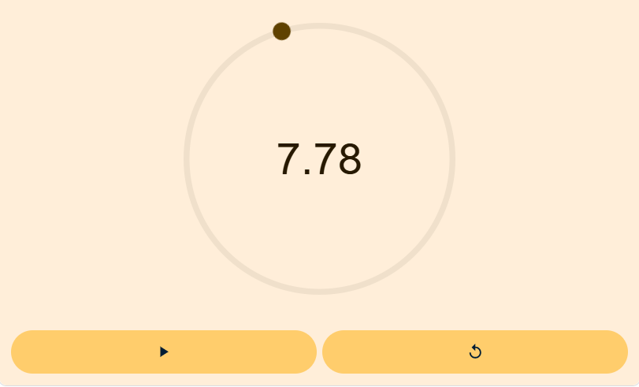

- Check the ServerError.log for any errors.
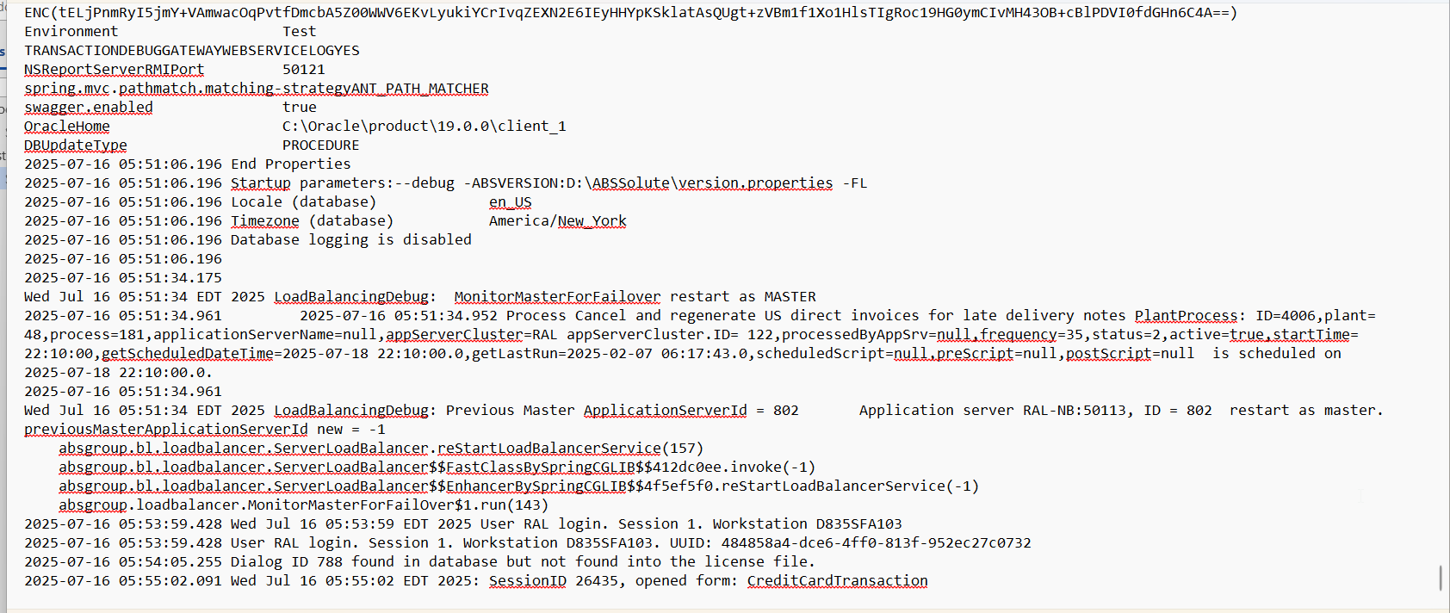
No errors were present.
- Credit Card Transactions dlg: Open Settled Transactions tab, Save all the grid columns (if were not already saved before)
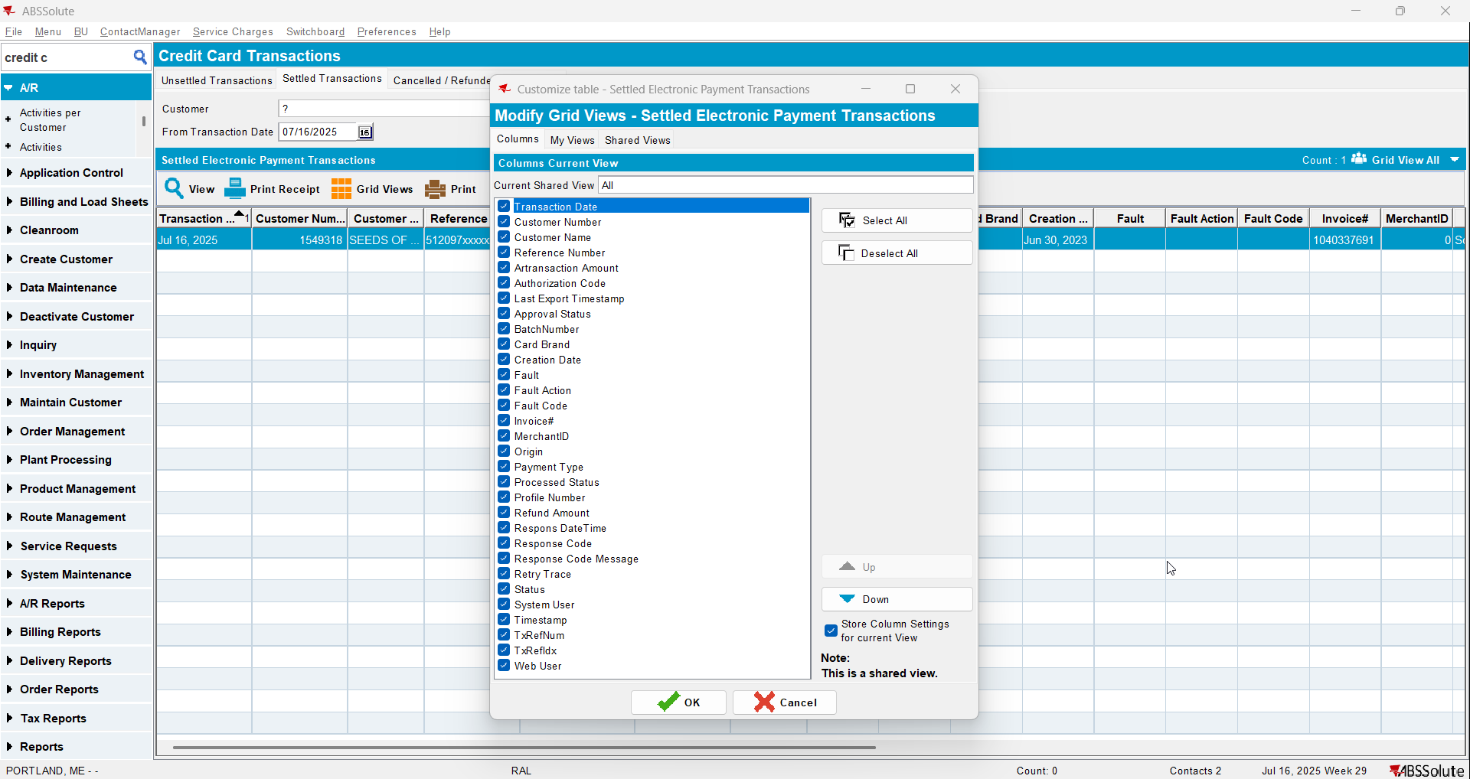
- Credit Card Transactions dlg: Load the records from settled invoices for 2+years. Wait for the data to load.
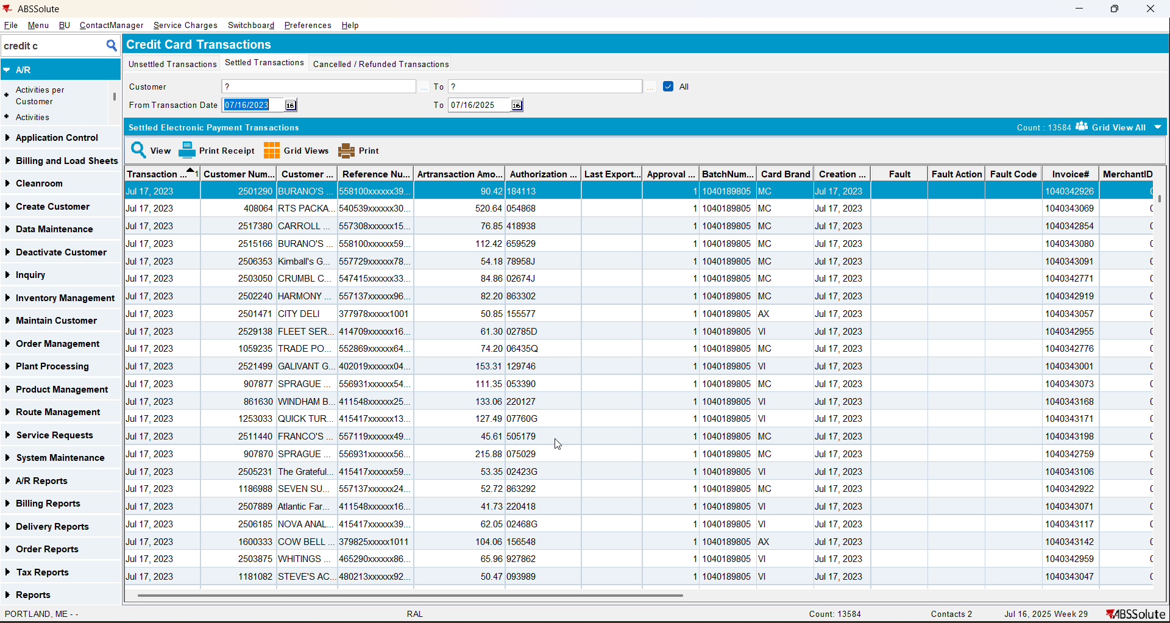
Before the improvement After the improvement
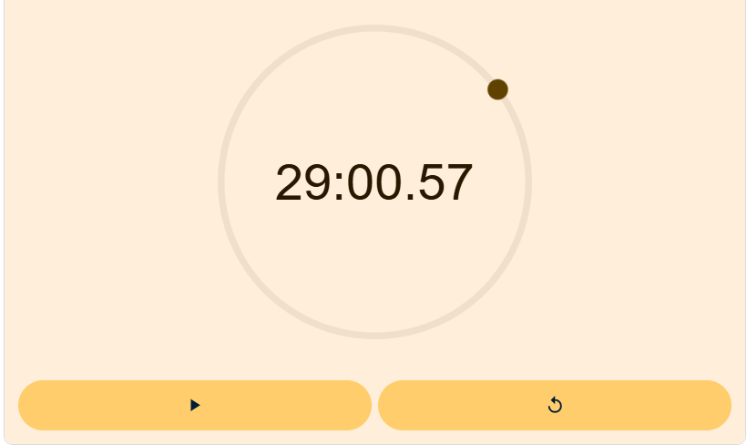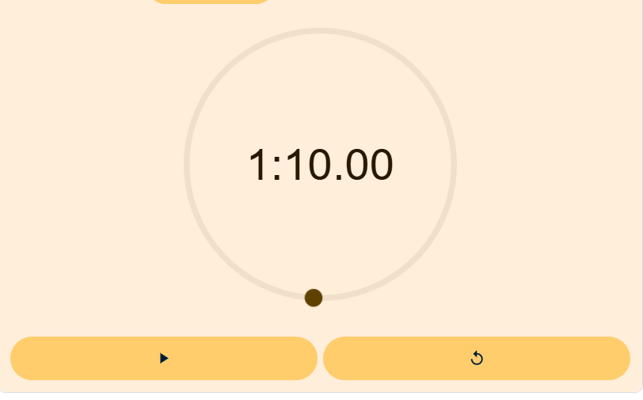
- Check the ServerError.log for any errors.
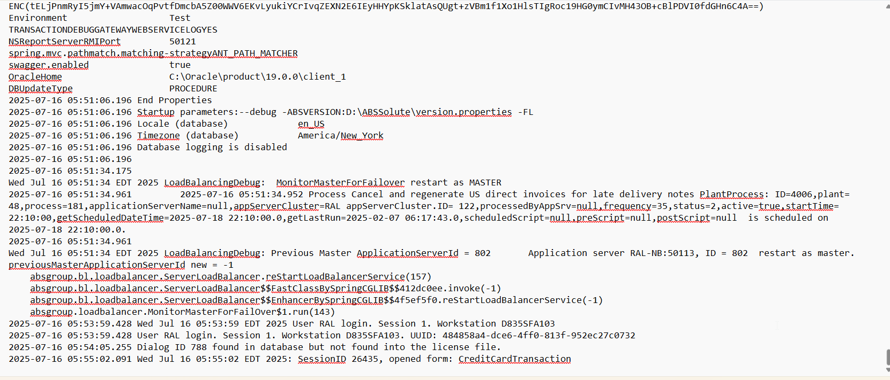
No errors were present.
- Credit Card Transactions dlg: Open Cancelled/Refunded Transactions tab, Save all the grid columns (if were not already saved before)
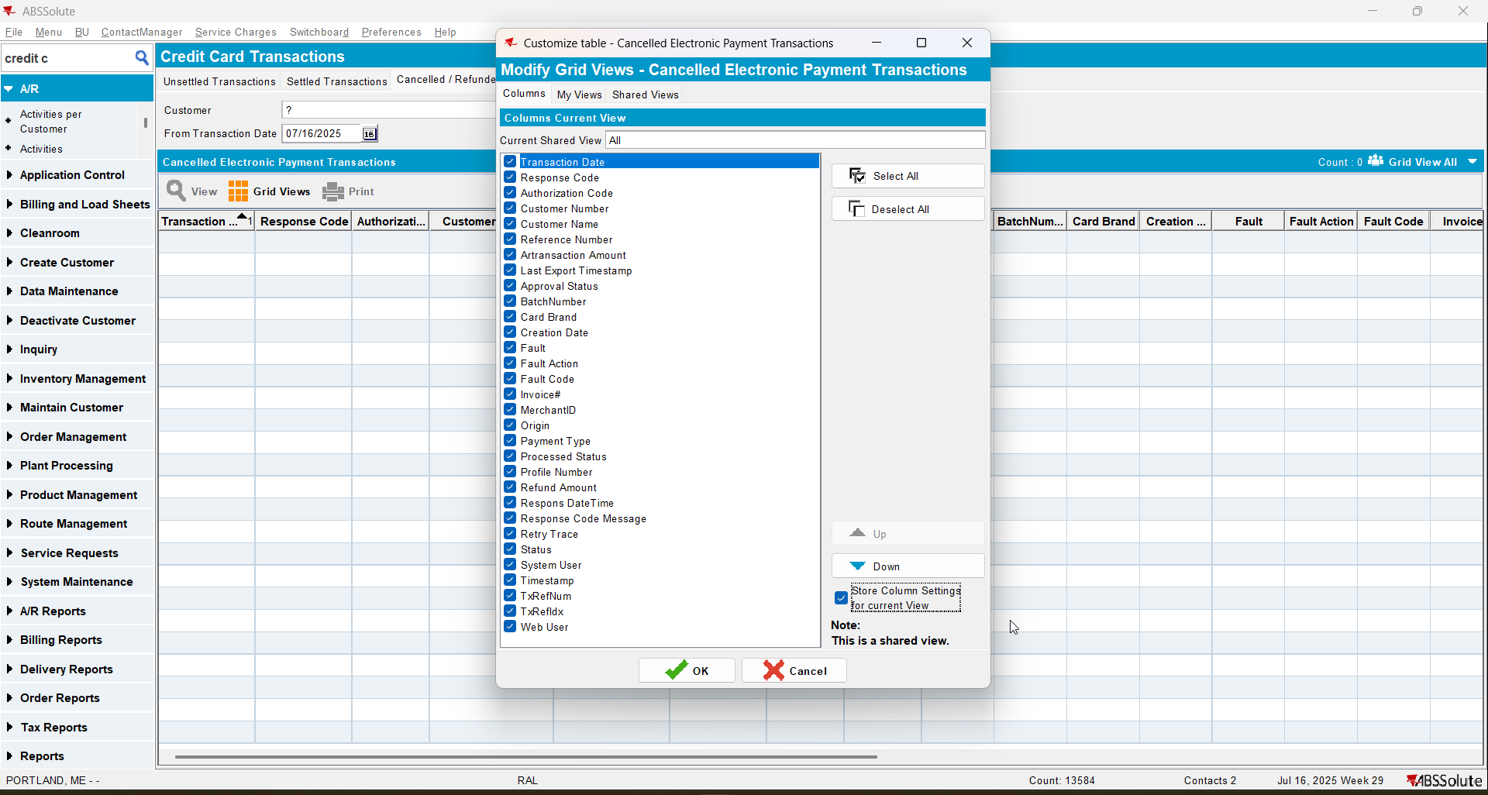
- Credit Card Transactions dlg: Load the records from settled invoices for 2+years. Wait for the data to load.
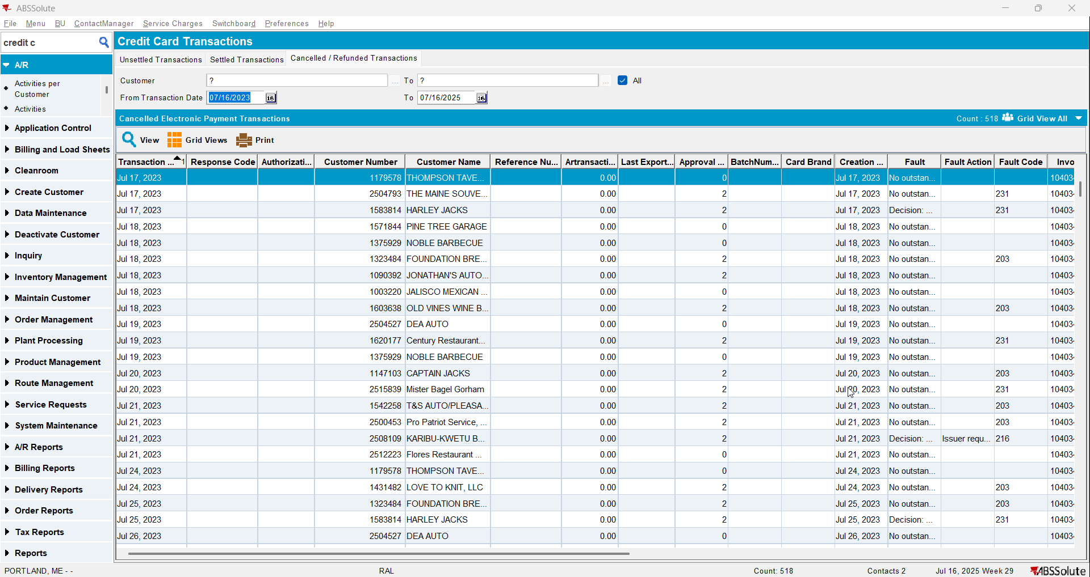

Before the improvement After the improvement
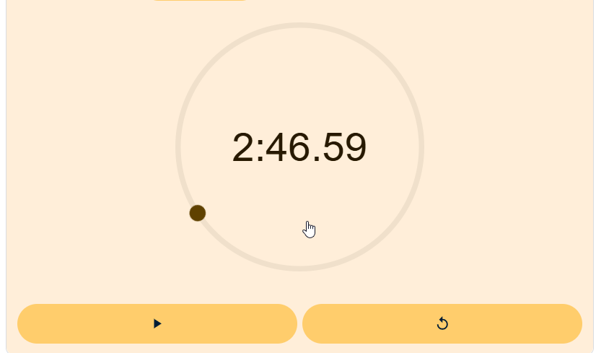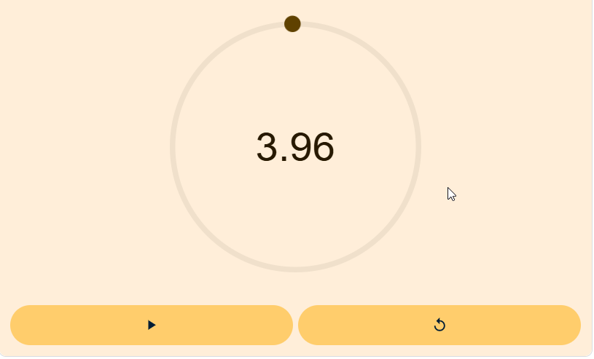

- Check the ServerError.log for any errors.
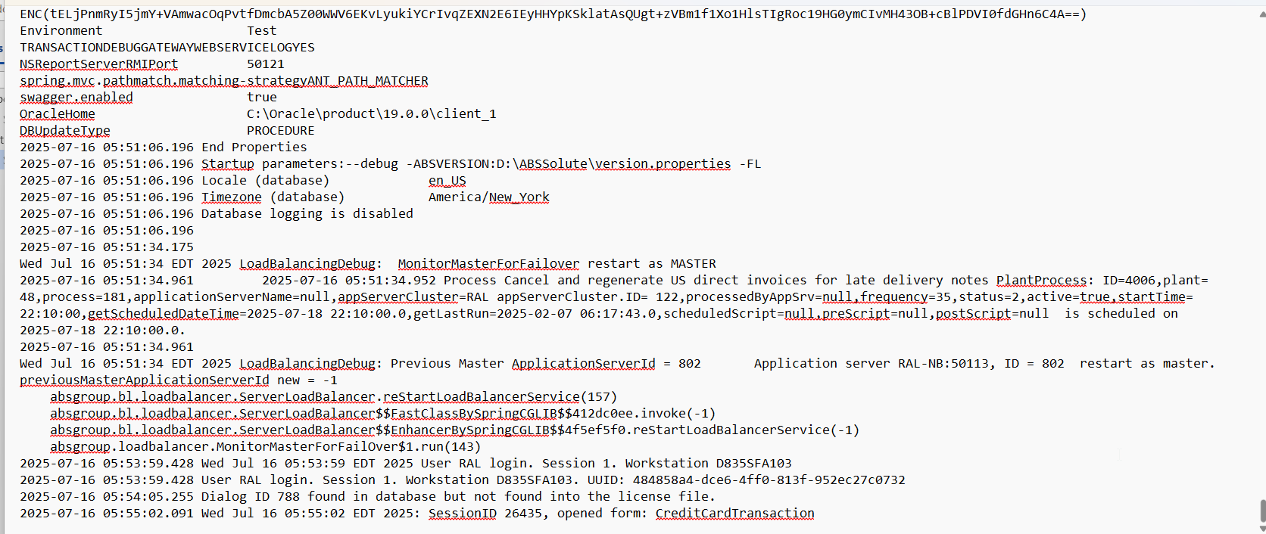
No errors were present.
- Credit Card Transaction dlg: Choose a customer from the list for which we will settle a transaction.
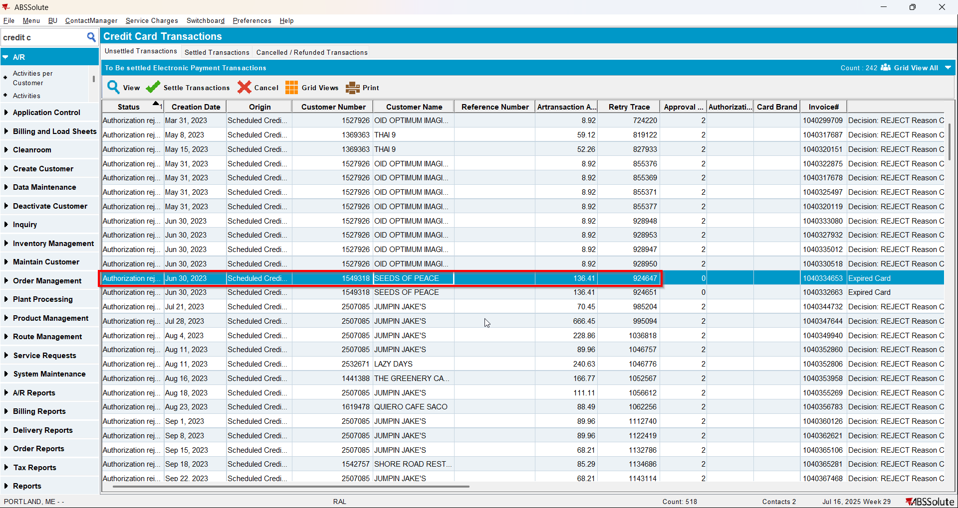

- Customers dlg: Load that customer and put a valid credit card in the Payment section.
Use a dummy valid card, eg:

02A600C0170018008292;5120********6802=2712?*CFE9CD4D4EA44DB29522CF84DF675D91FB9667069BF69F49000000000000000000000000000000000000000038333054393633393730FFFF987654001B0001411F8503
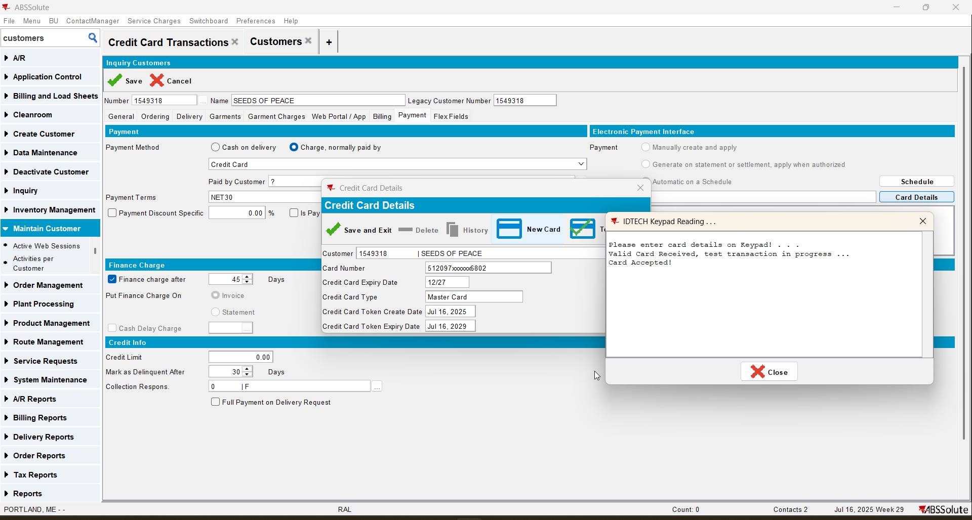

- Credit Card Transaction dlg: Settle an invoice from unsettled transaction tab, time how much it takes to get settled.
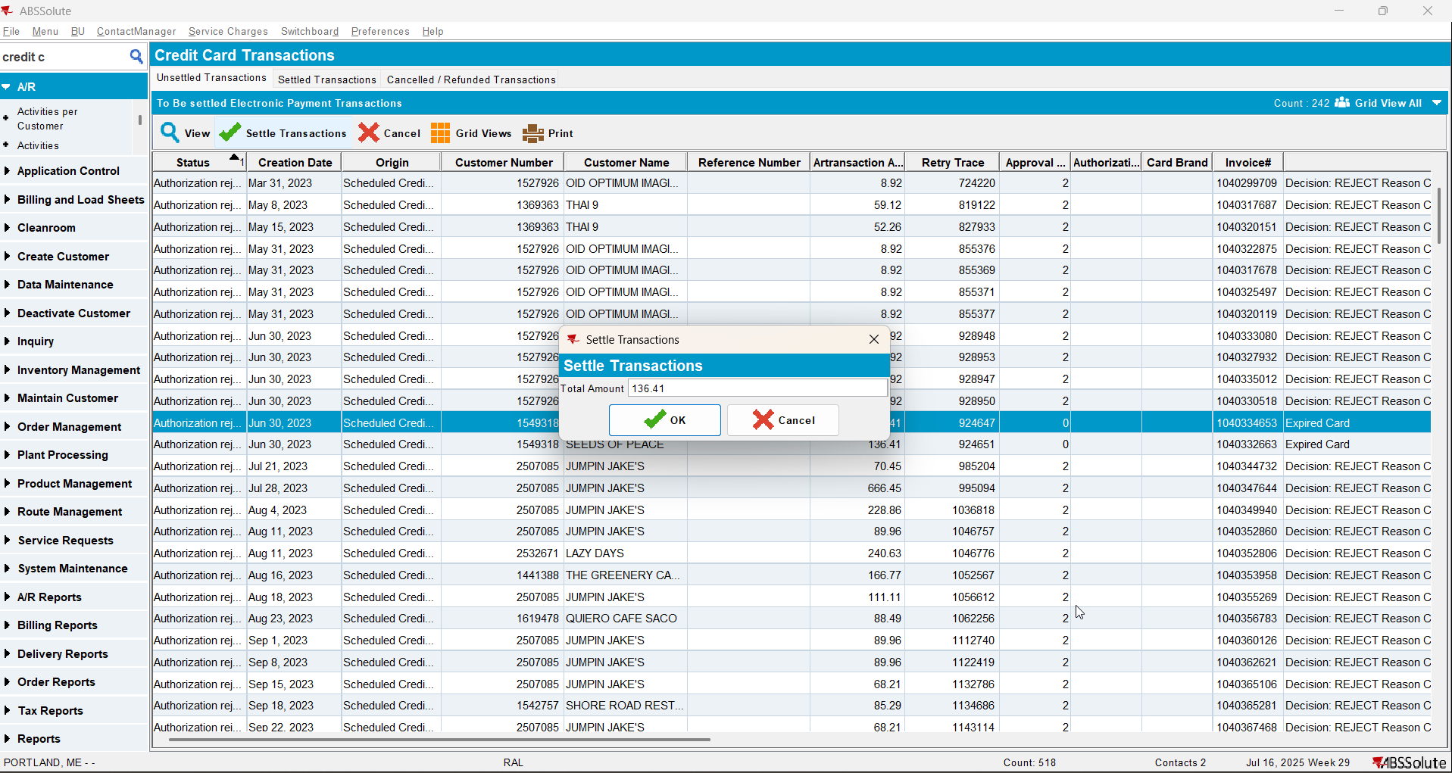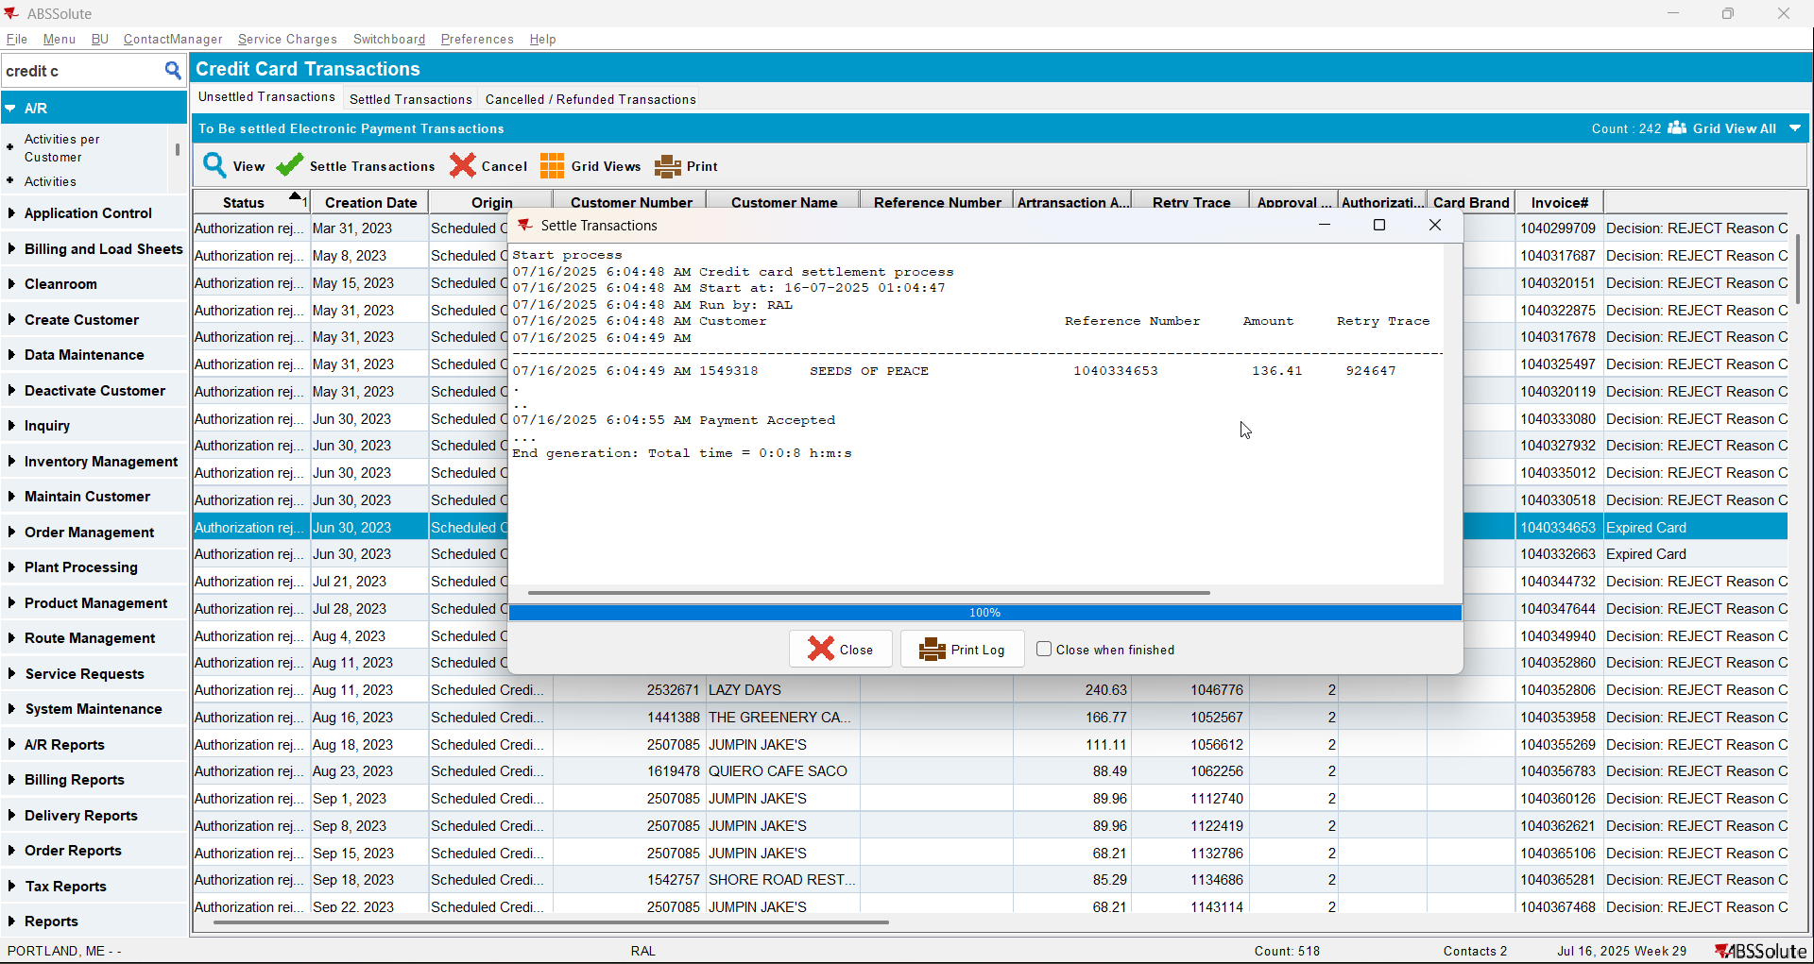

Before the improvement After the improvement
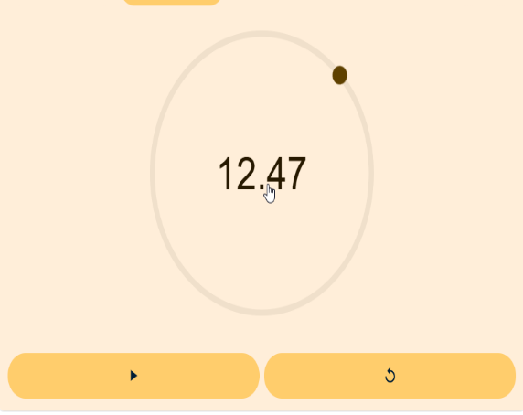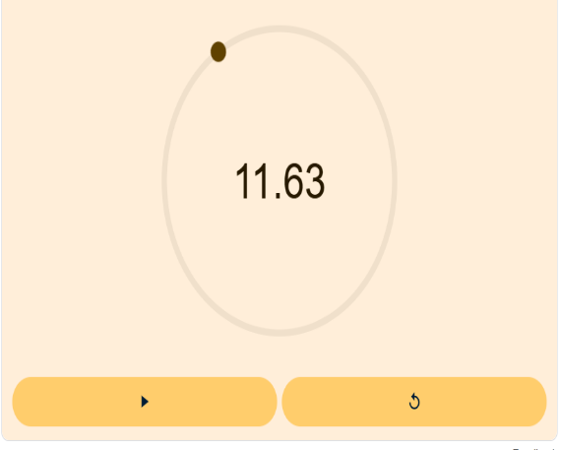
- Credit Card Transactions dlg: Go to the Settled Transactions tab and load the above customer.
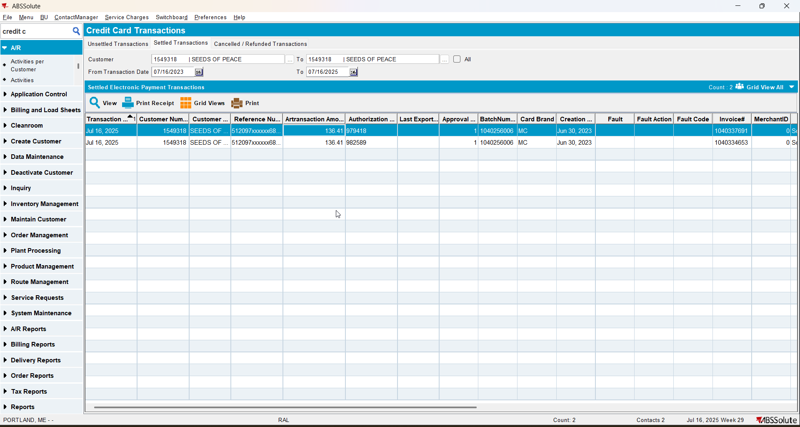
- Check the ServerError.log for any errors.
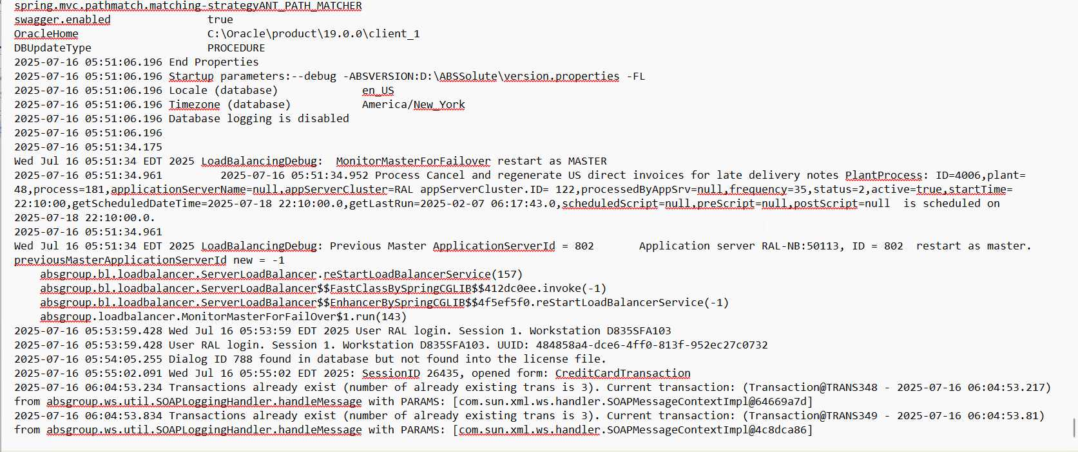
No errors were present.
- Credit Card Transactions dlg: Cancel an unsettled transaction.
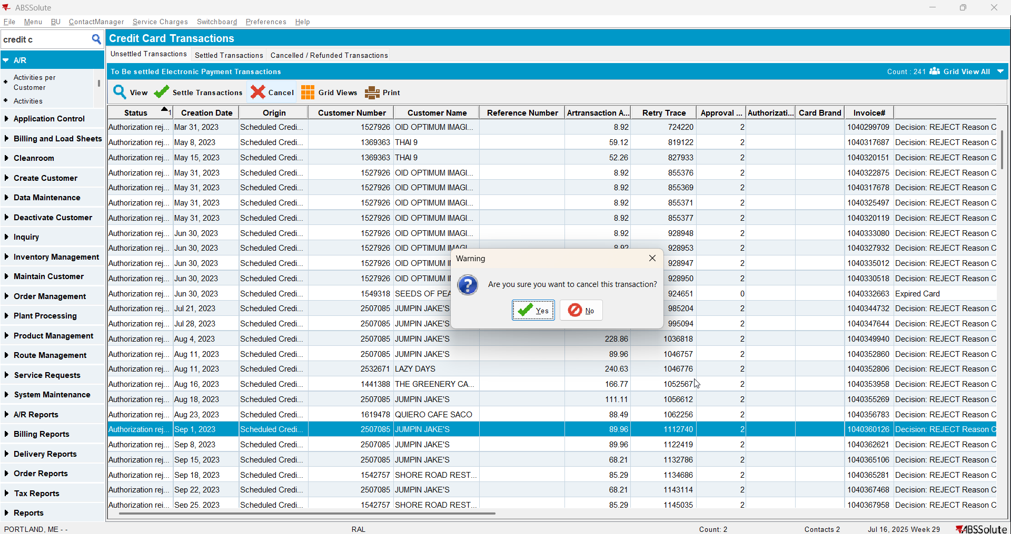

The time for this was almost the same before and after. It took like 2-3 seconds .
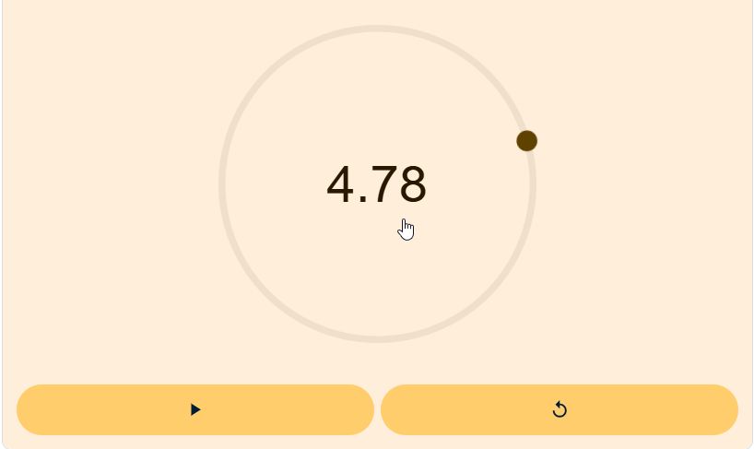

- Credit Card Transactions dlg: Go to the Cancelled / Refunded Transactions tab and check for the cancelled transaction.
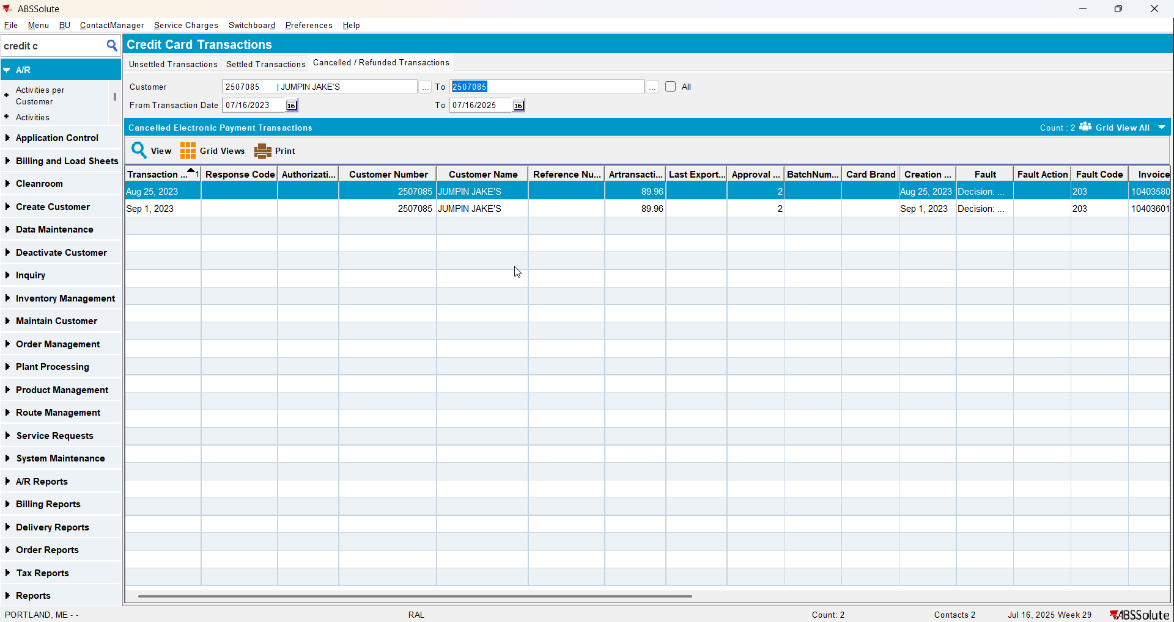
- Check the ServerError.log for any errors.
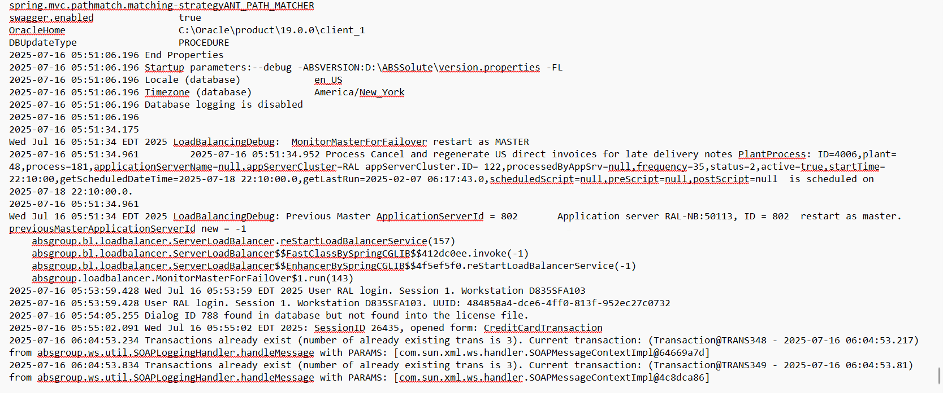
No errors were present.

