ABSN-8288 - Missing Resource for routeCheckIn.Route.failedTax in WebClientX_RouteCheckIn_Res.properties
Environment | Prerequisites
Version: 9.07.00.UNF20  DBServerName= abs-srv20.internal.abslbs.com  DBSID=CUST24  DBUser=UNFDEV  Environment=Test | - Module:  - System setting

Contents
Reproducing before fix 1
Data preparation 1
Steps to reproduce 1
Current Behavior 3
Expected behavior 3
Retest after fix 3
Test Case 1 – Check that corresponding correct error should displayed 3

Reproducing before fix

Data preparation

Steps to reproduce
- WebClientX: Find a route which was not settled yet
select bu.code, rc.drivingdate,r.routenumber, rc.settlementstatus, rc.pocketpcstatus, rc.* from routecontrol rc
join route r
on r.route_id = rc.route_id
join plant p
on p.plant_id = r.plant_id
join businessunit bu
on bu.plant_id=p.plant_id
where rc.settlementstatus <> 3 and rc.pocketpcstatus=2 and bu.code='055'
order by rc.originaldrivingdate desc

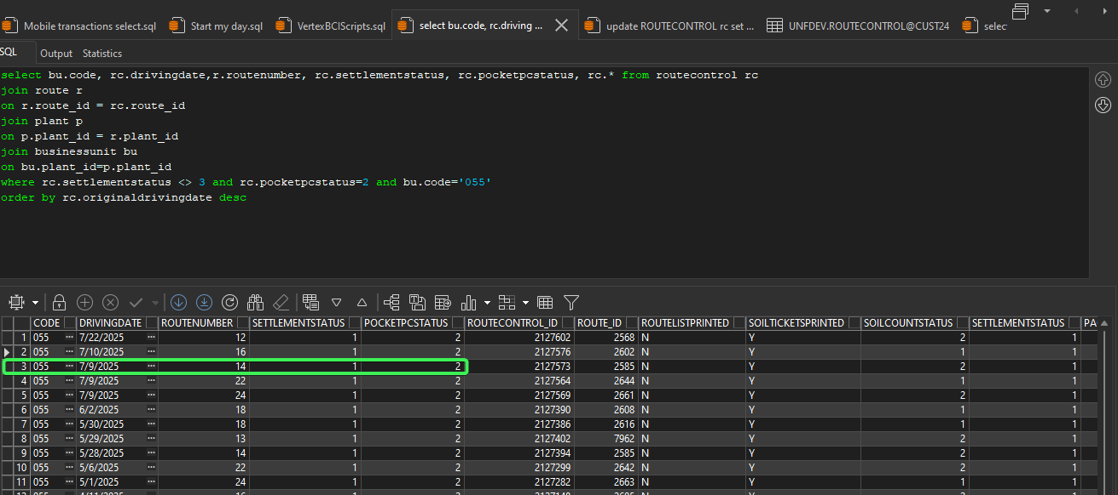
- Review all tabs of that route, so that the settlement can be done
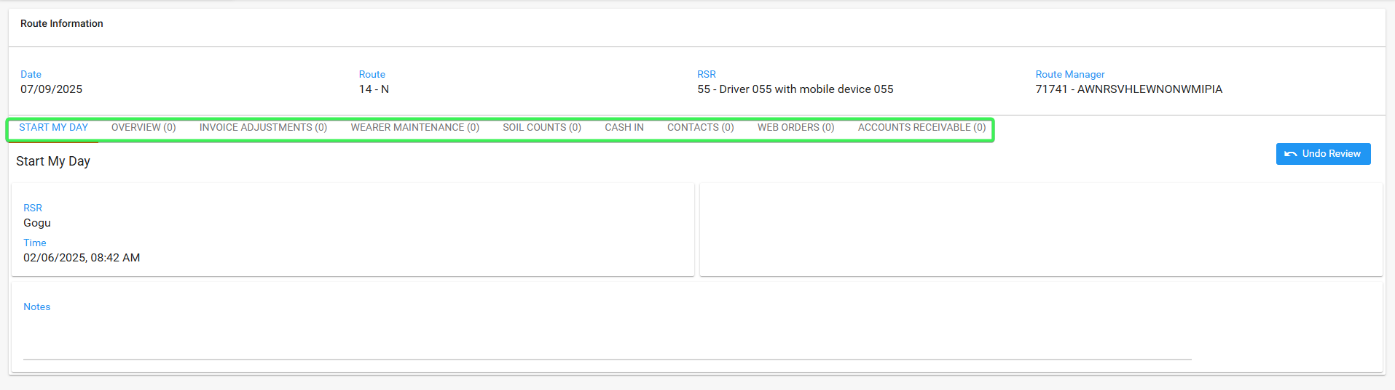
- Modify directly in database so as to invalidate one of Settle conditions
update ROUTECONTROL rc
set rc.POCKETPCSTATUS = 1
where rc.ROUTECONTROL_ID = (select rc.ROUTECONTROL_ID from ROUTECONTROL rc join ROUTE r on r.ROUTE_ID = rc.ROUTE_ID join PLANT p on p.PLANT_ID = r.PLANT_ID where rc.DRIVINGDATE = TO_DATE('30/06/2025', 'dd/mm/yyyy') and r.ROUTENUMBER = 12 and p.CODE = '055')

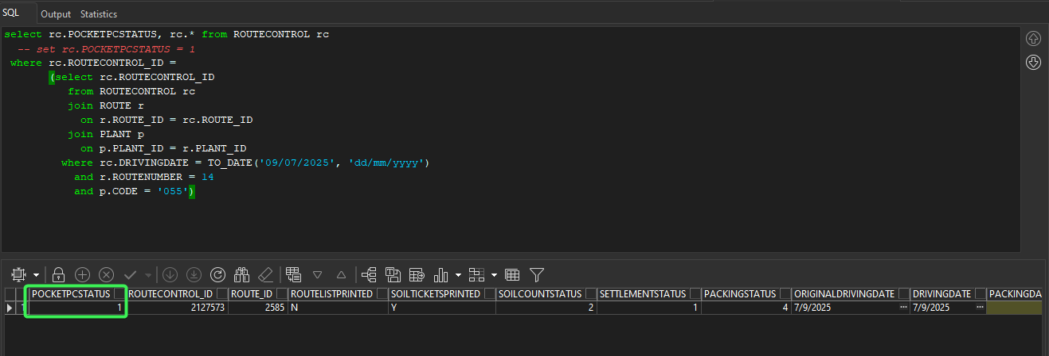
- Press 'Settle', but because Settle conditions are invalidated an error message should be displayed
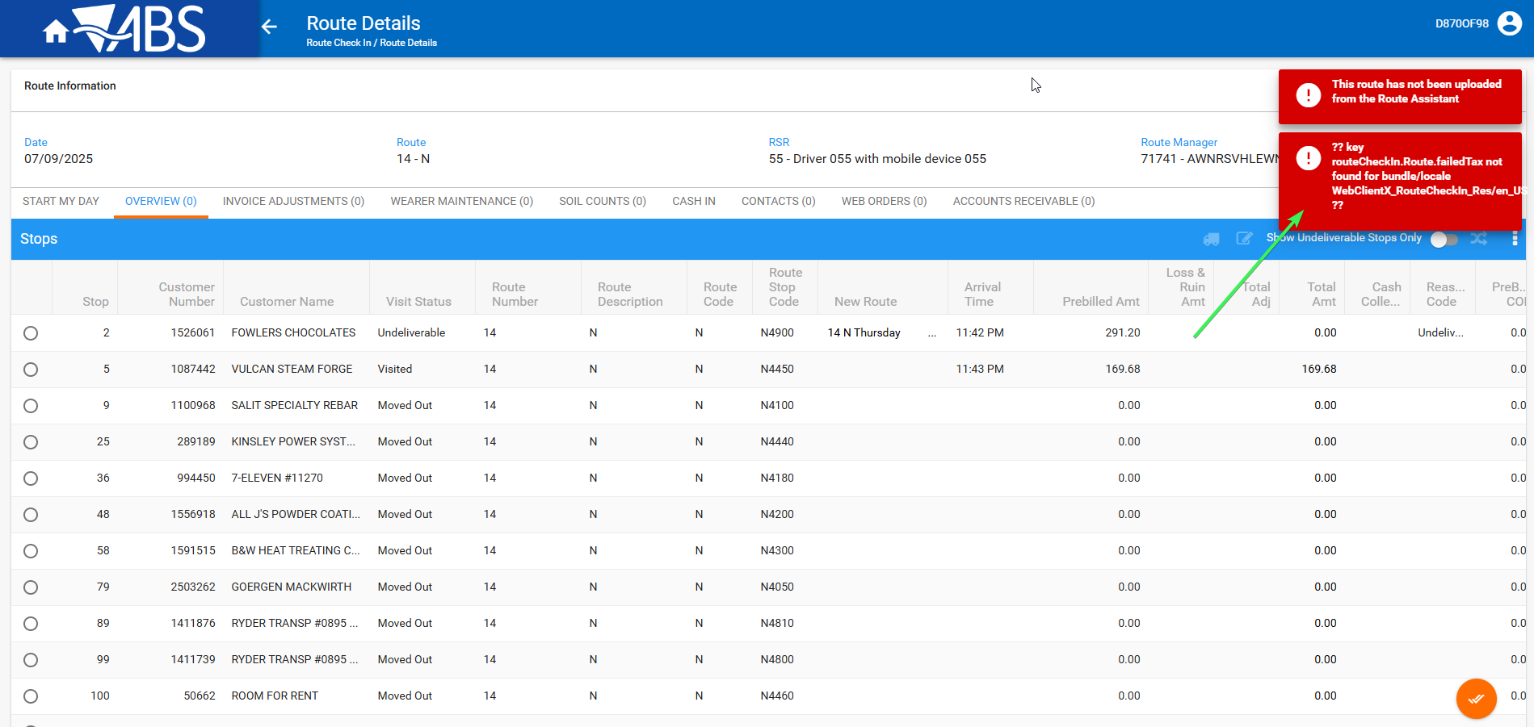

REPRODUCED OK.

Current Behavior
An error message that does not explain the problem is being displayed.

Expected behavior
An error message that mentions the source of the error should be displayed.

Retest after fix

Test Case 1 – Check that corresponding correct error should displayed
Hash: 5f87cce29a00
- WebClientX: Find a route which was not settled yet
select bu.code, rc.drivingdate,r.routenumber, rc.settlementstatus, rc.pocketpcstatus, rc.* from routecontrol rc
join route r
on r.route_id = rc.route_id
join plant p
on p.plant_id = r.plant_id
join businessunit bu
on bu.plant_id=p.plant_id
where rc.settlementstatus <> 3 and rc.pocketpcstatus=2 and bu.code='055'
order by rc.originaldrivingdate desc

- Review all tabs of that route, so that the settlement can be done
- Modify directly in database so as to invalidate one of Settle conditions
update ROUTECONTROL rc
set rc.POCKETPCSTATUS = 1
where rc.ROUTECONTROL_ID = (select rc.ROUTECONTROL_ID from ROUTECONTROL rc join ROUTE r on r.ROUTE_ID = rc.ROUTE_ID join PLANT p on p.PLANT_ID = r.PLANT_ID where rc.DRIVINGDATE = TO_DATE('30/06/2025', 'dd/mm/yyyy') and r.ROUTENUMBER = 12 and p.CODE = '055')

- Press 'Settle', but because Settle conditions are invalidated then a corresponding error should displayed
