ABSN-7926 Disable creation of manual negative invoices and other changes to manual invoices
Environment | Prerequisites
Version:9.07.00  DBServerName= abs-srv20.internal.abslbs.com  DBSID=CUST24  DBUser=UNFDEV  Environment=PRODUCTION | - Module: UNFCUSTOM  - System setting: MANUALINVOICEVALUECONTROL  MANUALINVOICEDATELIMIT  MANUALINVOICEDATECONTROL
Contents
Test Case 01 - Checkbox enabled/disabled “allow manual invoice” only for the below list – Tested Ok 2
Expected behavior: 2
Test steps: 2
Test Case 02 – The Invoice lines from previous test case are /or not visible from the dropdown on Add mode, but on Modify nothing is changed – Tested OK 5
Expected behavior: 5
Add mode 6
Test steps: 6
Modify Mode 8
Test Case 03 – In add mode check ss MANUALINVOICEVALUECONTROL = 1 – Tested OK 10
Expected behavior: 10
Test steps: 10
Test Case 04 – In modify mode with ss MANUALINVOICEVALUECONTROL = 1 –Tested OK 14
Expected behavior: 14
Test steps: 14
Test Case 05 – In add mode check ss MANUALINVOICEVALUECONTROL = 0 – Tested OK 19
Expected behavior: 19
Test steps: 19
Test Case 06 – In modify mode with ss MANUALINVOICEVALUECONTROL = 0 – Tested OK 22
Expected behavior: 22
Test steps: 22
Test Case 07 – In modify mode change a credit invoice with ss MANUALINVOICEVALUECONTROL = 1 – Tested OK 24
Expected behavior: 24
Test steps: 24
Test Case 08 – In add mode check ss MANUALINVOICEDATECONTROL = 1 + MANUALINVOICEDATELIMIT = 0 + MANUALINVOICEDATELIMIT > 4 + MANUALINVOICEDATELIMIT > 99 – Tested Ok 27
Expected behavior: 27
Test steps: 27
Test Case 09 – In modify mode check ss MANUALINVOICEDATECONTROL = 1 + MANUALINVOICEDATELIMIT = 0 + MANUALINVOICEDATELIMIT > 4 + MANUALINVOICEDATELIMIT > 99 – Tested Ok 37
Expected behavior: 37
Test steps: 38

Test Case 01 - Checkbox enabled/disabled “allow manual invoice” only for the below list – Tested Ok
BU: 288 Richmond, VA
9.07.00.UNF19 hash: bac9293fb677

Expected behavior:
Only enabled for line types that are allowed to be added in the add manual invoice dialog.
According to the MaintainInvoicesDlg analysis, this is:

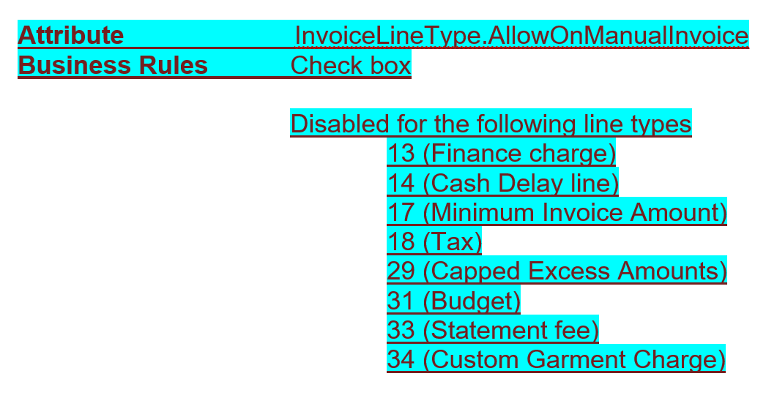

Test steps:
- PLSQL: Check in database the AllowOnManualInvoice field for all the invoicelines.
select ilt.allowonmanualinvoice, ilt.factorydescription, ilt.type, ilt.* from invoicelinetype ilt
order by ilt.type asc
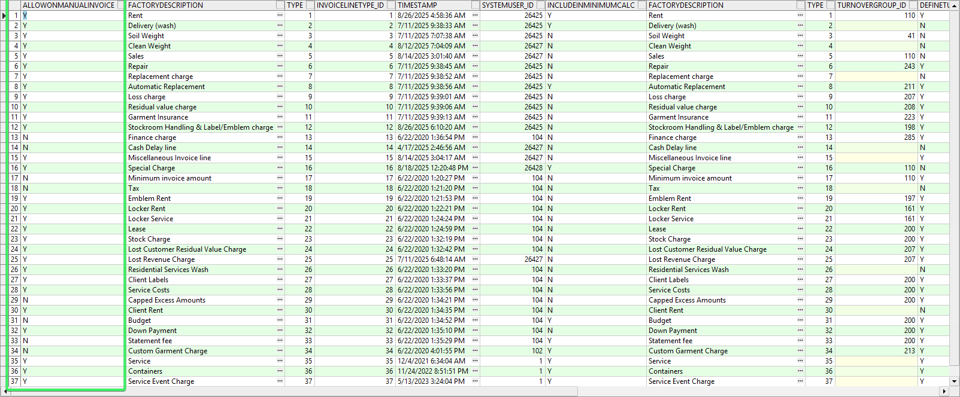

- Invoice Line Types dlg: Open the lines mentioned above and check that the AllowOnManualInvoice field it's un-checked and disabled.

13 - Finance charge
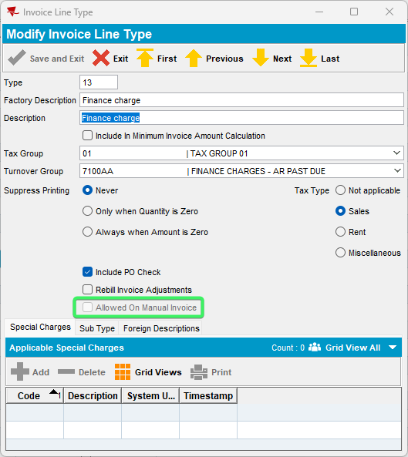
14 - Cash Delay line
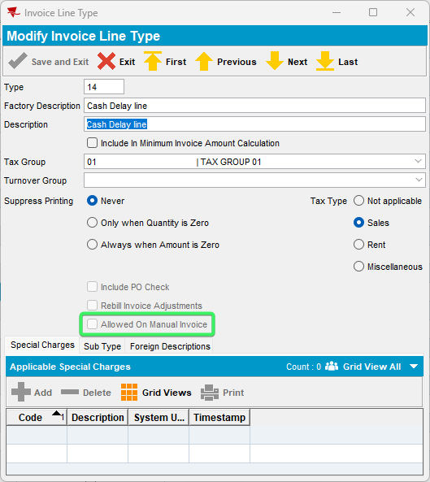

17 - Minimum invoice amount
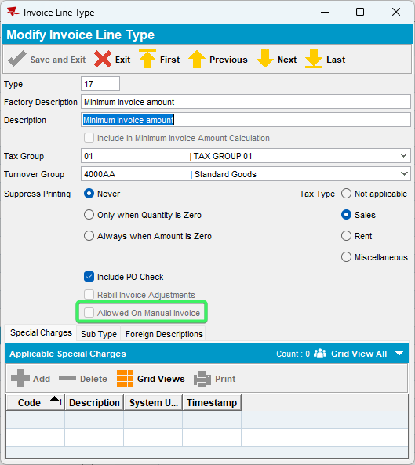

18 – Tax
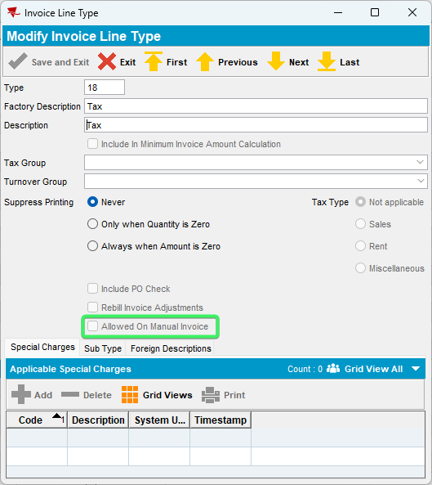
29 – Capped Excess Amounts
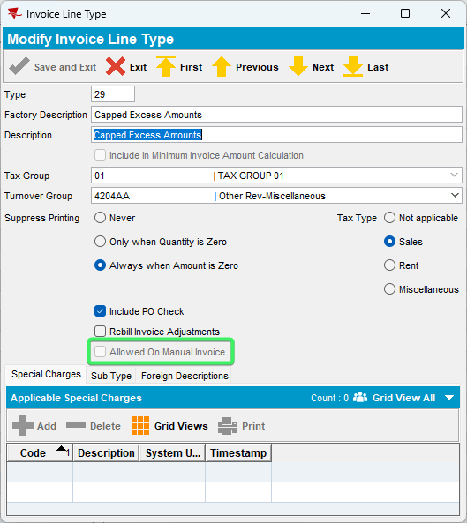
31 – Budget
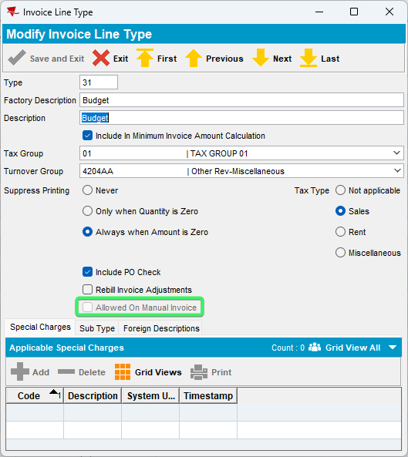
33 – Statement fee
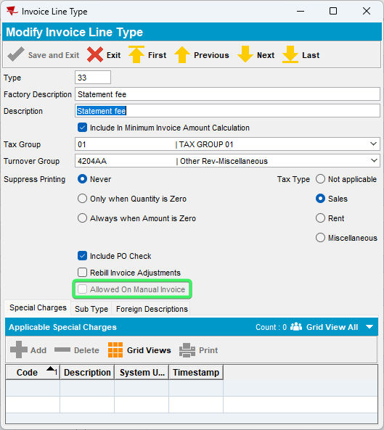

34 – Special Size Charge
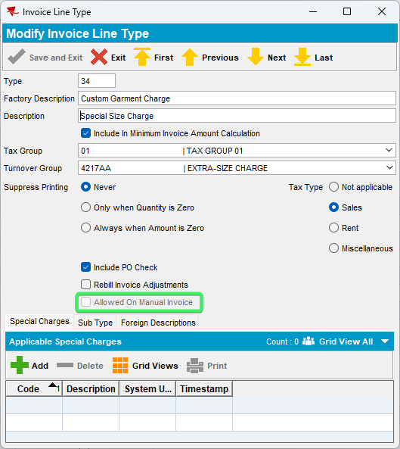
For all the others, the option is enabled
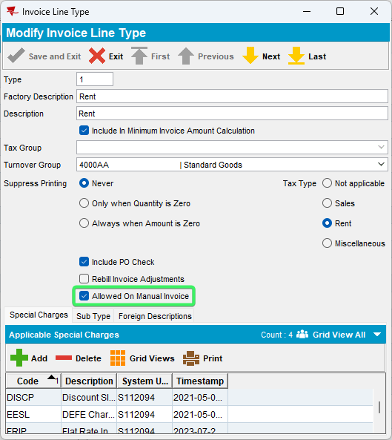

Tested OK

Test Case 02 – The Invoice lines from previous test case are /or not visible from the dropdown on Add mode, but on Modify nothing is changed – Tested OK

Expected behavior:

NOTE: In ADD mode, the list of invoice line types is also filtered by the field InvoiceLineType. AllowOnManualInvoice. Do not show the line type in the combo box when adding an invoice line if AllowOnManualInvoice = N
Invoice Line type dlg – new checkbox enabled/disabled “allow manual invoice” it is not included in the dropdown list for manual invoice line type added from Manual Invoice dlg

Check in locations with Add and modify
- Maintain Invoices dlg: Customer, All and Route tabs
- Switchboard
- Settlement screen dlg

Add mode

Test steps:
- Maintain Invoice dlg: Add a manual invoice and an invoice line, from the drop down take a screenshot of all the line types.
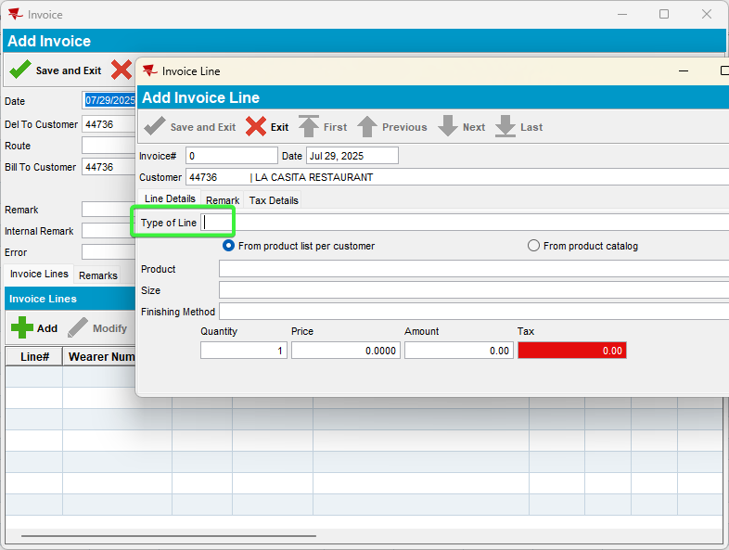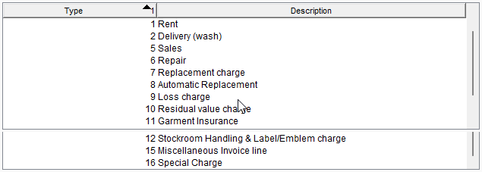
- Invoice Line Types dlg: For each invoice line type above, uncheck the Allow On Manual Invoice box.
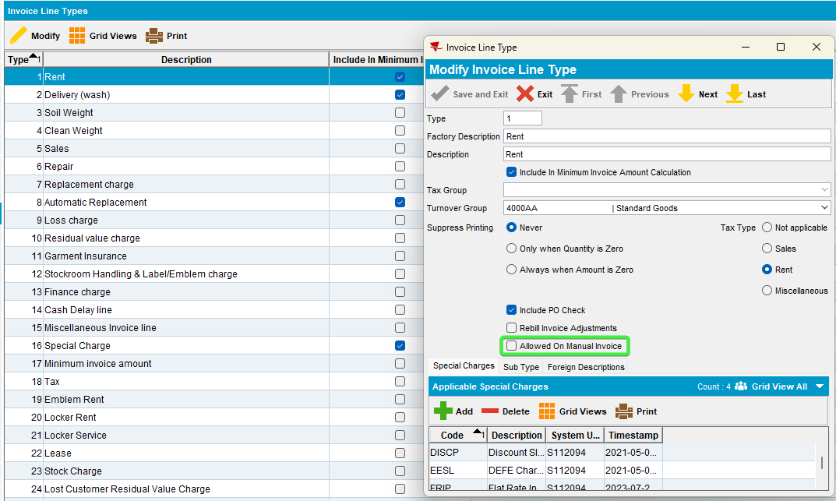
- Maintain Invoices dlg: Reload the screen, add a manual invoice and an invoice line, recheck the dropdown list of Type of line.
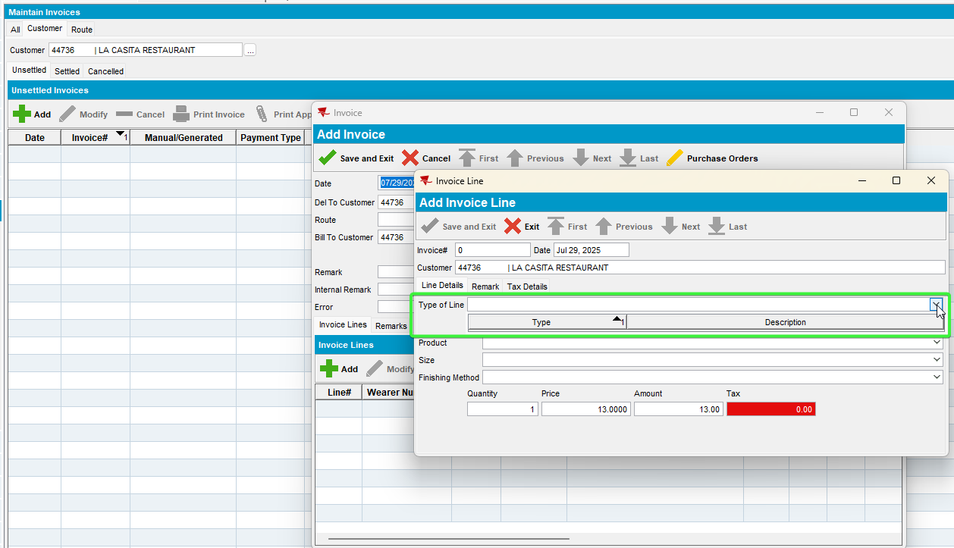
None of them are visible anymore
- Maintain Invoices dlg: All tab, check on the Manual Invoices and verify the dropdown with Type of Line
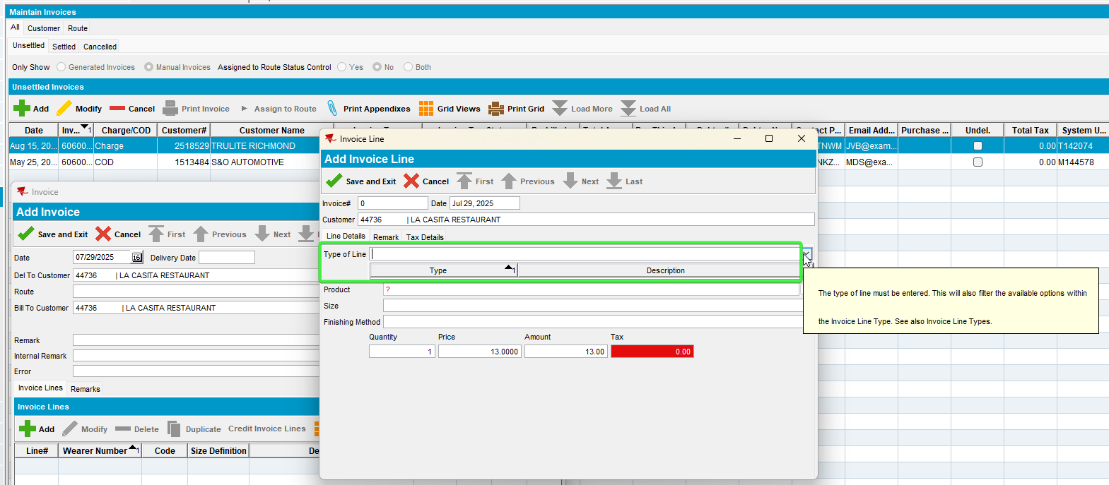
None of them are visible anymore

- RSC dlg: Use and old existing route or Add a new route in RSC (routes that have not been invoiced) , from Route tabs select that route and add a manual invoice.
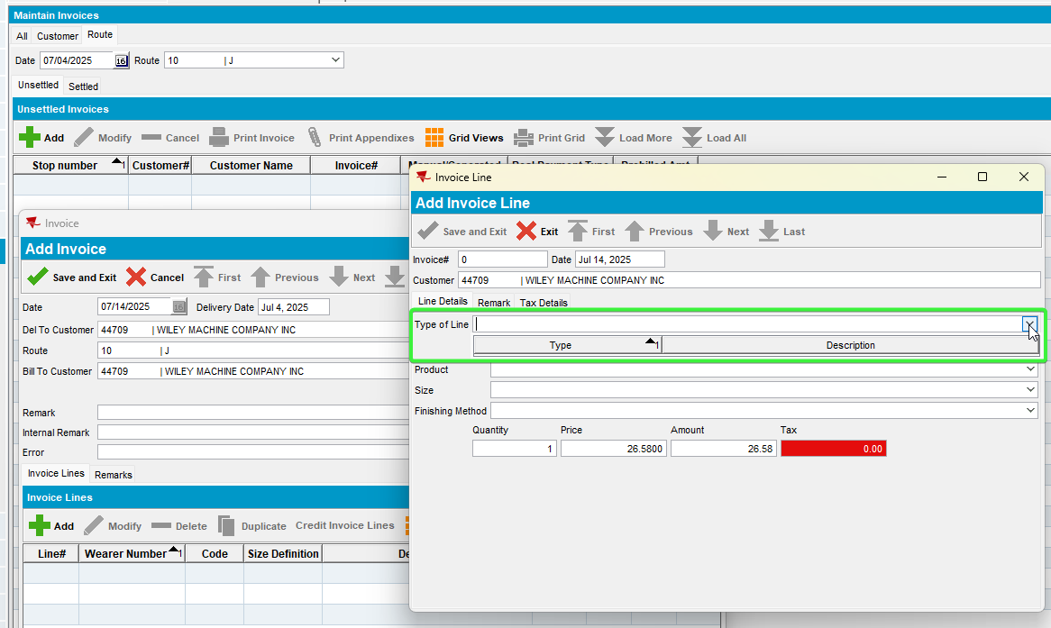
None of them are visible anymore
- Switchboard dlg: Load a customer and add Invoices.
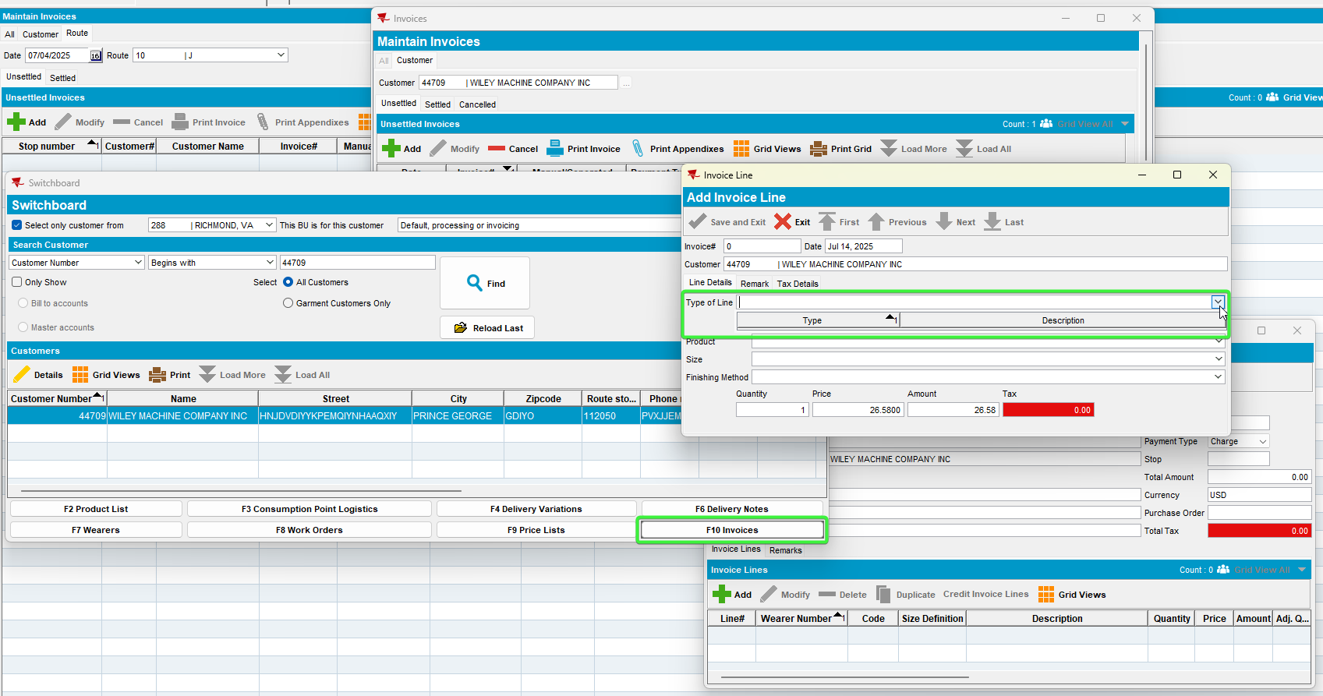
- Settlement screen dlg: Load a route that wasn’t settled and add a new invoice.
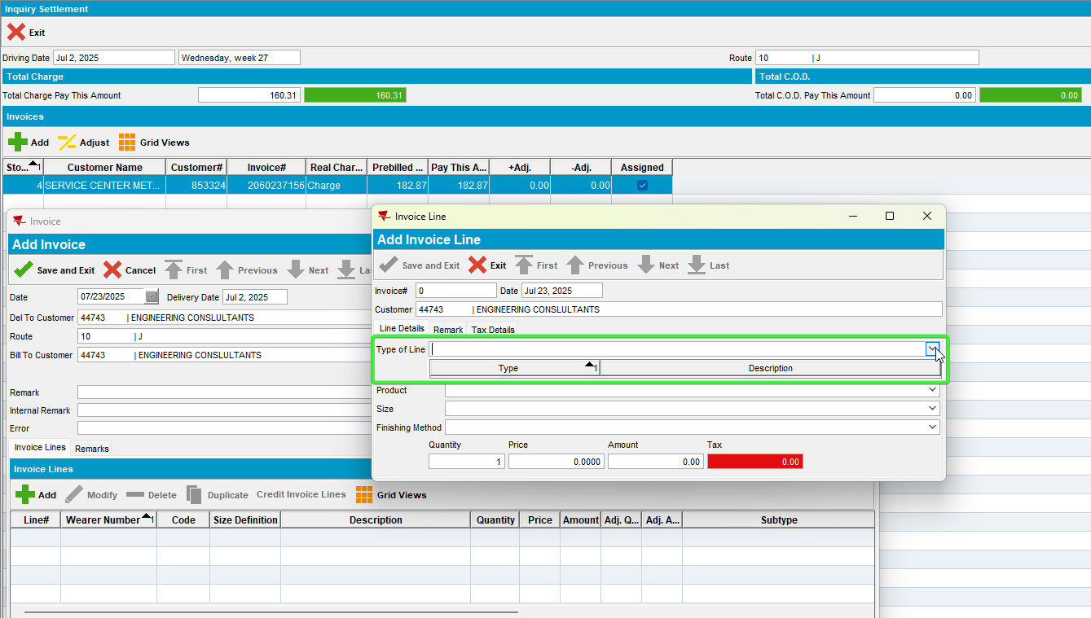
Tested OK

Modify Mode

- Invoice Line types dlg: Uncheck the Allowed on Manual Invoice for a line, eg: rent.
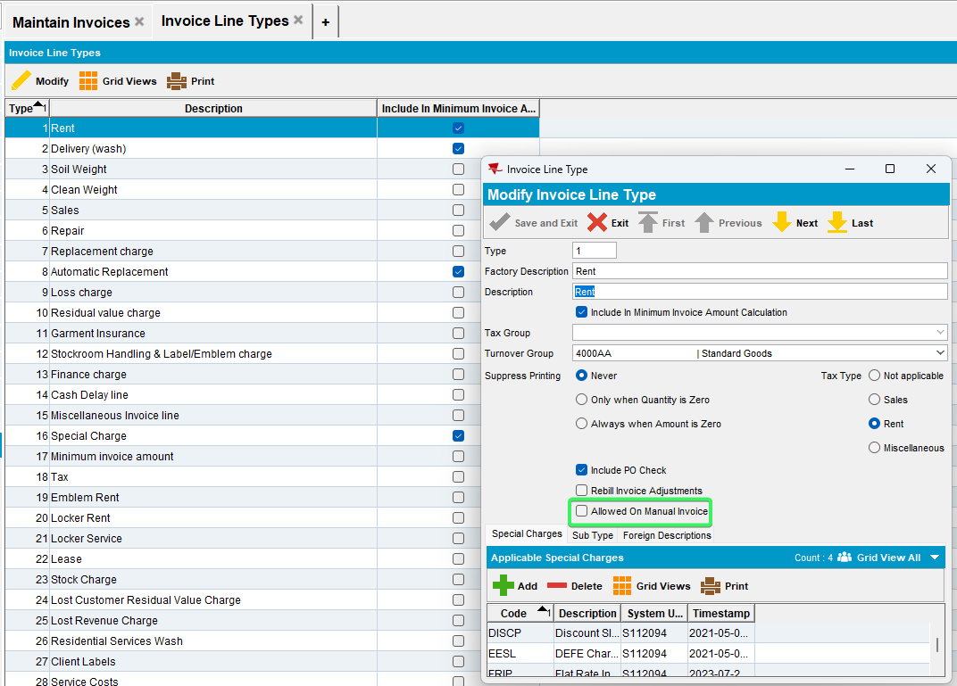
- Maintain Invoices dlg: Open a generated invoice and the invoice line type.
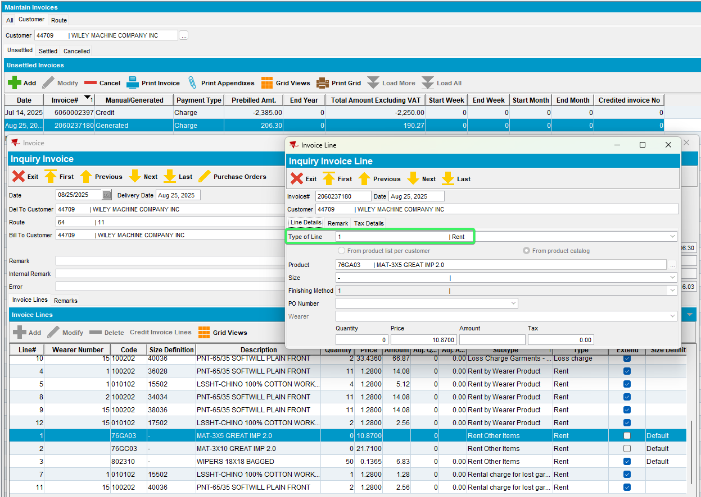
- Switchboard: Open a generated invoice and the invoice line type.
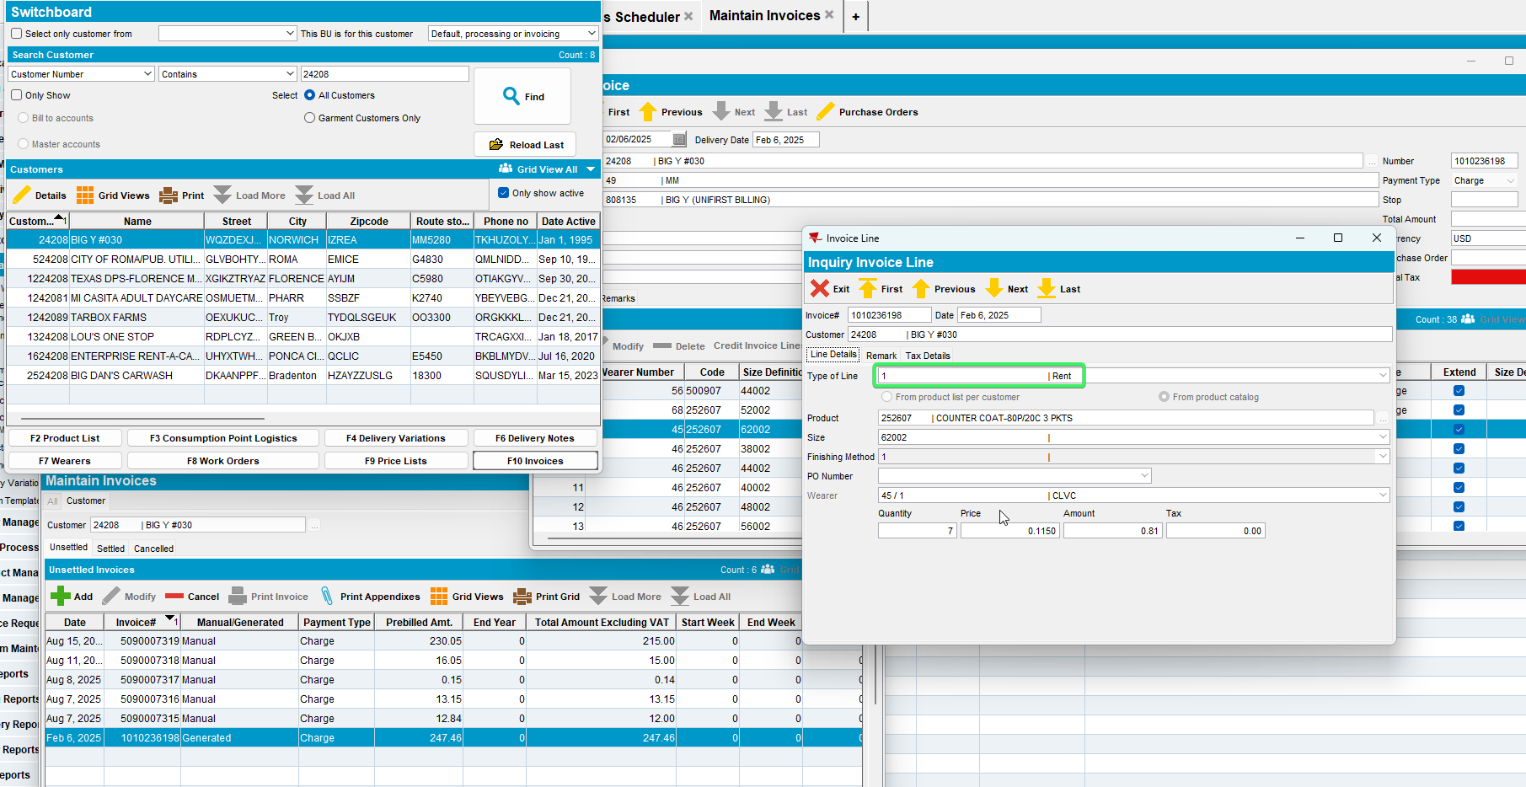
Tested OK

- Invoice Line Types dlg: Put back the Allowed On Manual Invoice option for each of the below initial invoice lines.

Test Case 03 – In add mode check ss MANUALINVOICEVALUECONTROL = 1 – Tested OK

Expected behavior:
In ADD mode, if system setting MANUALINVOICEVALUECONTROL = 1, then if the total invoice value is negative (PreBillAmount), on save show a message “Creating a Negative value invoice is not allowed” and do not allow save.

Locations:
- Maintain Invoices dlg: Customer, All and Route tabs
- Switchboard
- Settlement screen dlg

Test steps:
      - System Settings dlg: Change ss MANUALINVOICEVALUECONTROL = 1
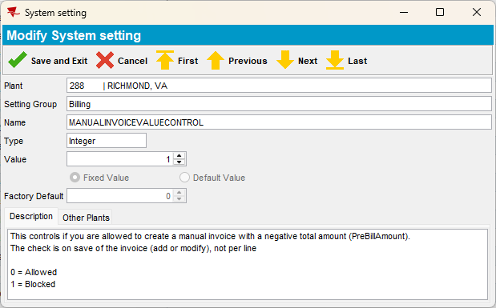
      - Maintain Invoices dlg: Add a manual negative invoice from:
- All tab, add a negative manual invoice and save it.
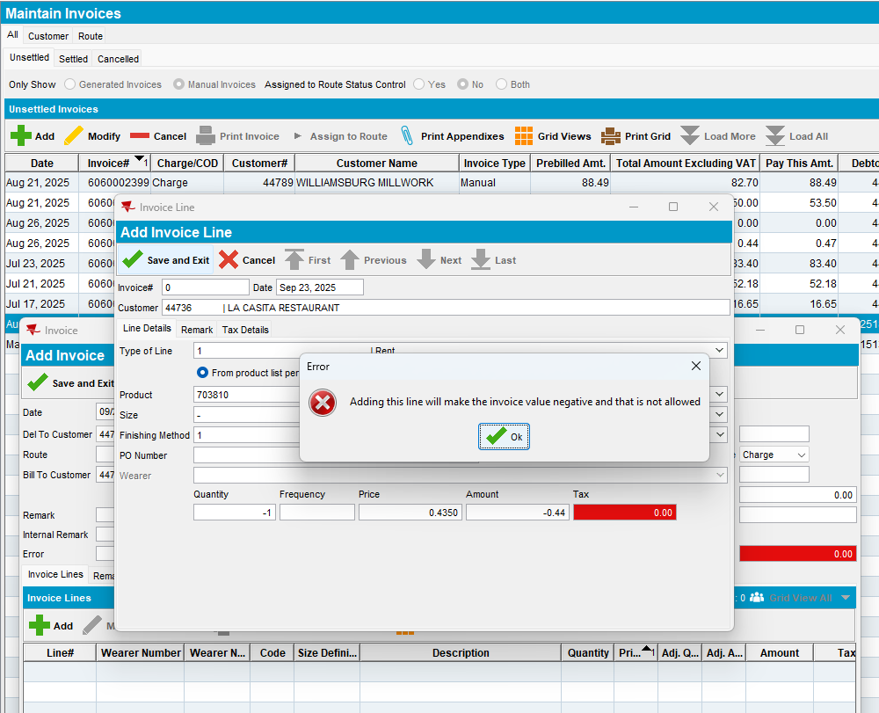
We receive the message “Adding this line will make the invoice value negative and that is not allowed” and we are not allowed to save.
- Customer tab, add a manual invoice with negative amount.
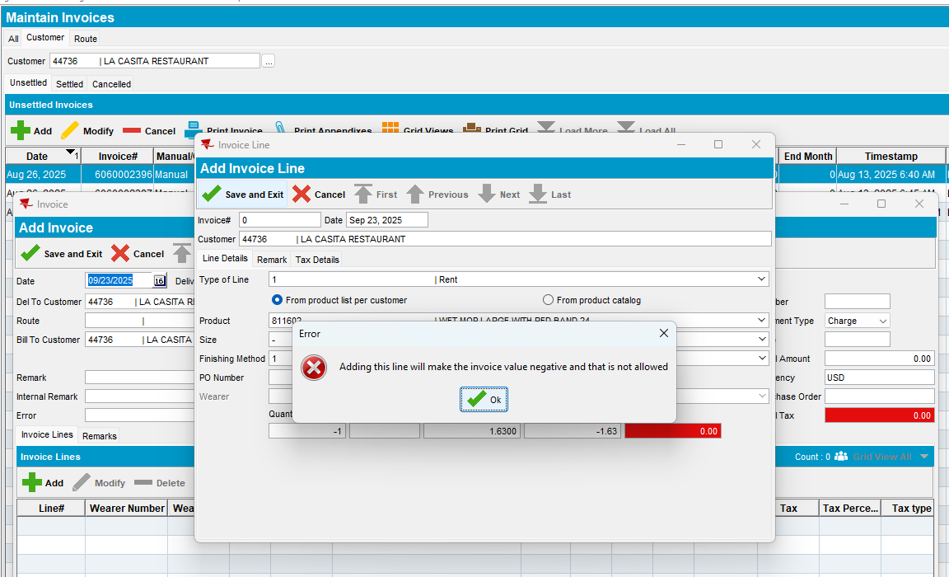
We receive the message “Adding this line will make the invoice value negative and that is not allowed” and we are not allowed to save.
- Route tab, add a manual invoice with negative amount, for a customer which is configured with a minimum invoice amount and special charges.
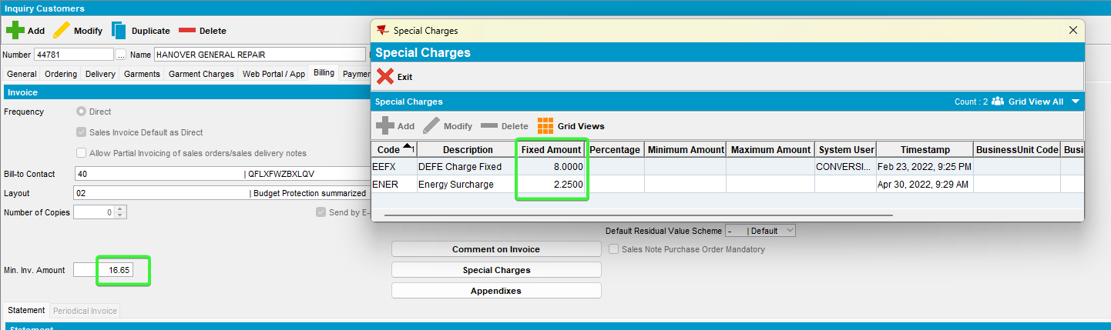
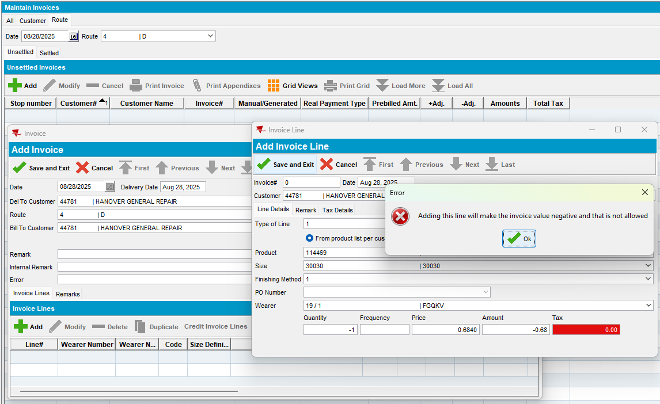
We receive the message “Adding this line will make the invoice value negative and that is not allowed” and we are not allowed to save.

- Switchboard, add a new negative manual invoice for a customer which is configured with a minimum invoice amount and special charges.
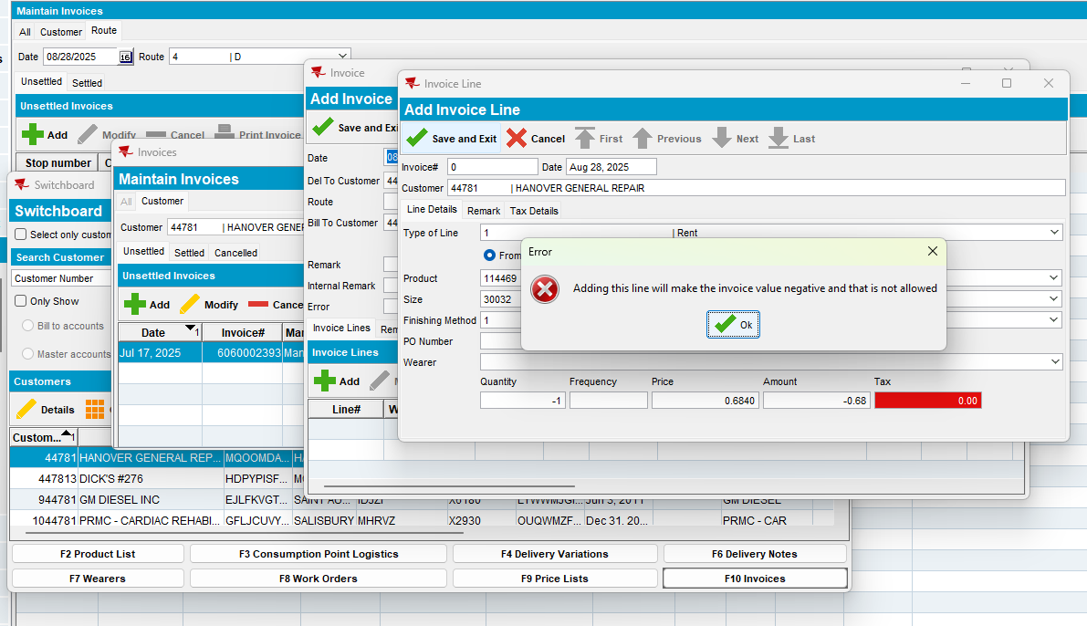
We receive the message “Adding this line will make the invoice value negative and that is not allowed” and we are not allowed to save.

Tested OK

Test Case 04 – In modify mode with ss MANUALINVOICEVALUECONTROL = 1 –Tested OK

Expected behavior:
In MODIFY mode of a manual invoice (InvoiceHeader.InvoiceType = 2, CreditedInvoiceHeader_ID is NULL), if system setting MANUALINVOICEVALUECONTROL = 1 and the total invoice value has been changed, then if the total invoice value is negative (PreBillAmount), on save show a message “Creating a Negative value invoice is not allowed” and do not allow save.

Modify the invoice lines into negative so that the total of the prebilled sum becomes negative or
Add an additional negative invoice line, so that the total of the prebilled sum becomes negative
Locations:
- Maintain Invoices dlg: Customer, All and Route tabs
- Switchboard
- Settlement screen dlg

Test steps:
      - Maintain Invoices dlg: Load a customer which is configured to have a minimum invoice amount and special charges, and credit an old invoice.
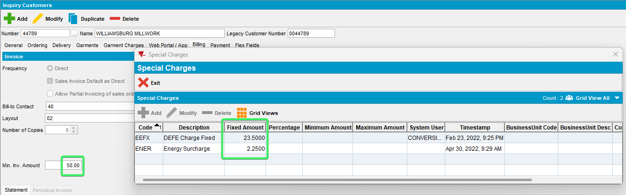
      - Maintain Invoices dlg: Add a positive manual invoice and save it.
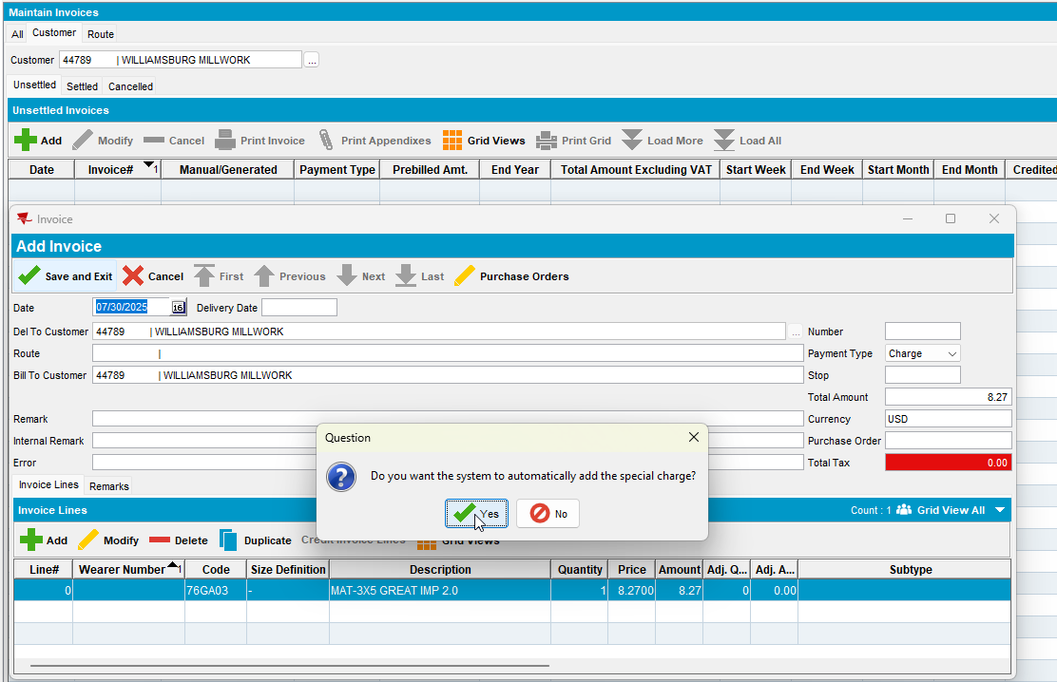

      - Maintain Invoices dlg:
- All tab, re-open the invoice and add a negative invoice line that will change the total amount, save it.
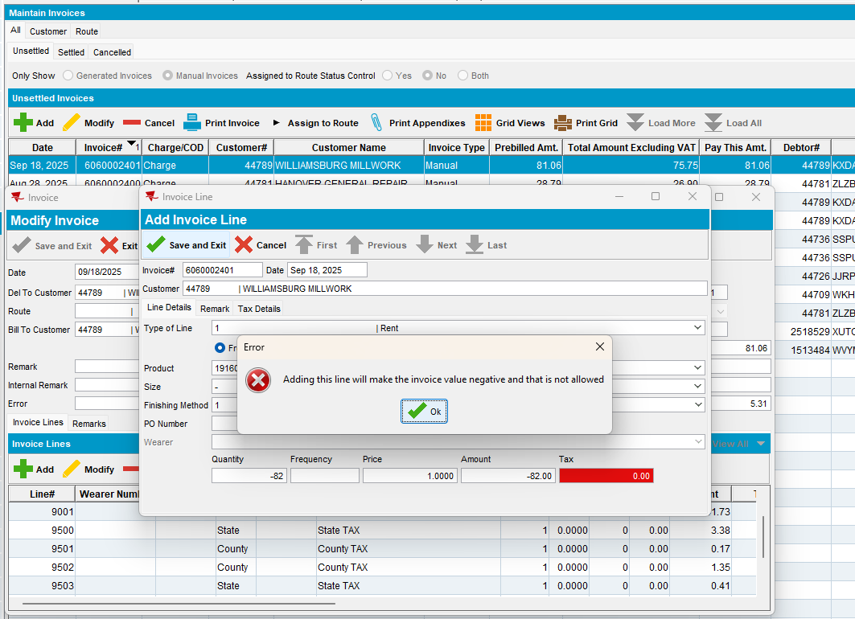
Modify the initial invoice line and turn it negative
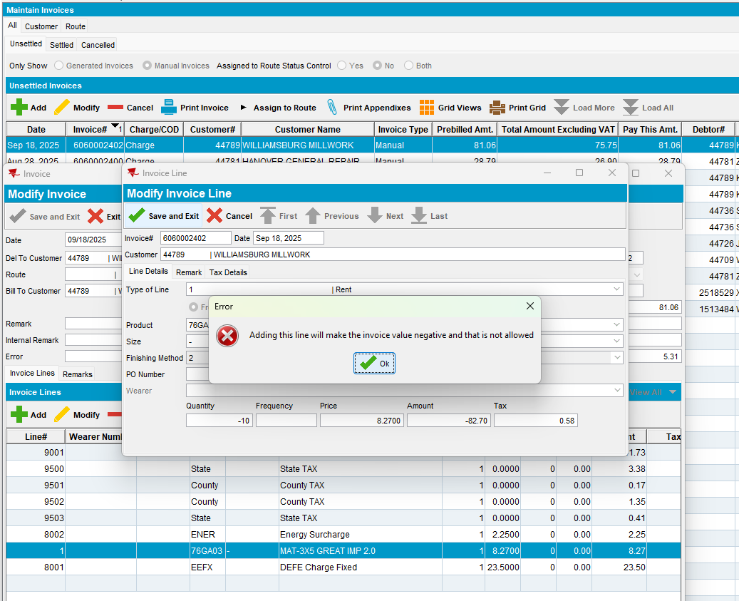
We receive the message “Adding this line will make the invoice value negative and that is not allowed” at the invoice line and we are not allowed to save.
- Customer tab, re-open the invoice and add a negative invoice line that will change the total amount, save it.
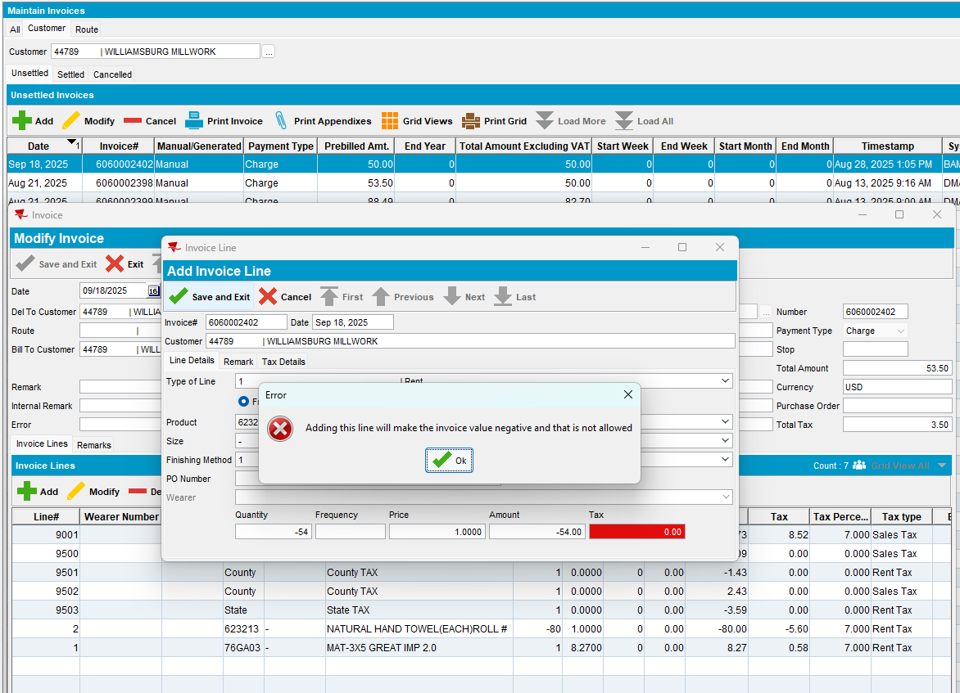
Modify the initial invoice line and make it negative
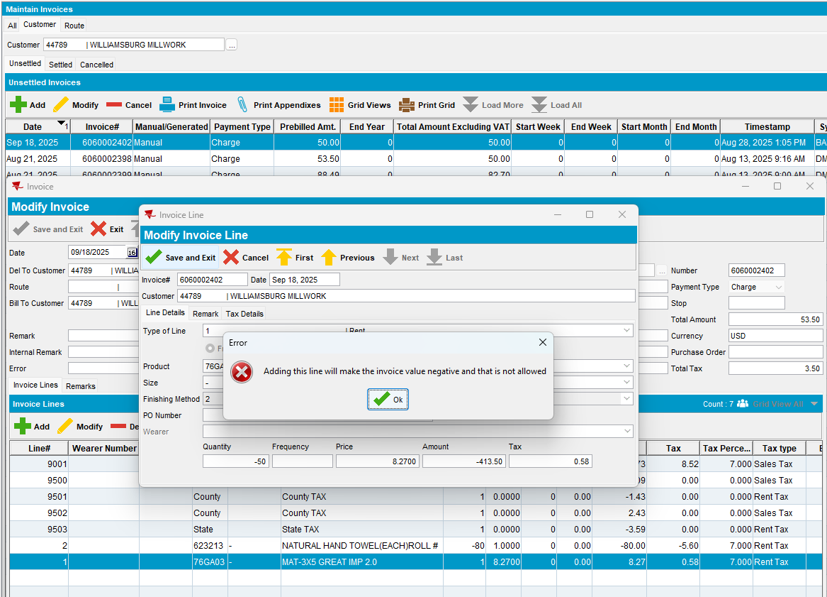
We receive the message “Adding this line will make the invoice value negative and that is not allowed” at the invoice line and we are not allowed to save.

- Route tab, re-open the invoice and add a negative invoice line that will change the total amount, save it.
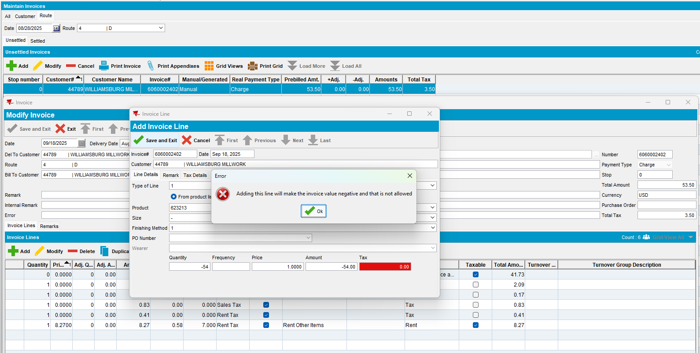
We receive the message “Adding this line will make the invoice value negative and that is not allowed” at the invoice line and we are not allowed to save.

Modify the initial invoice line and turn it negative
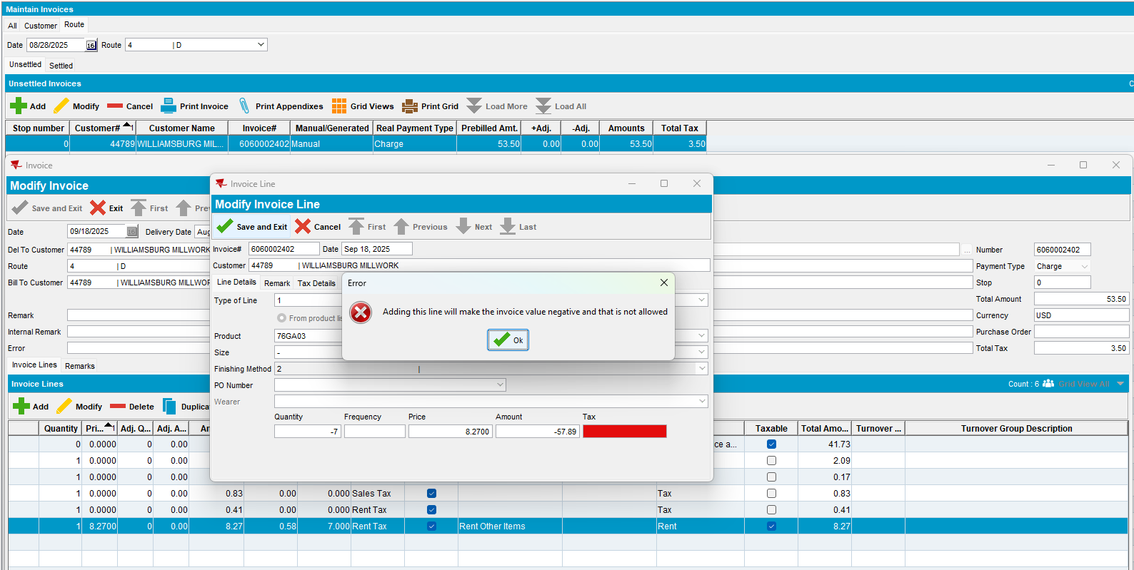
We receive the message “Adding this line will make the invoice value negative and that is not allowed” at the invoice line and we are not allowed to save.

- Switchboard, re-open the invoice and add a negative invoice line that will change the total amount, save it.
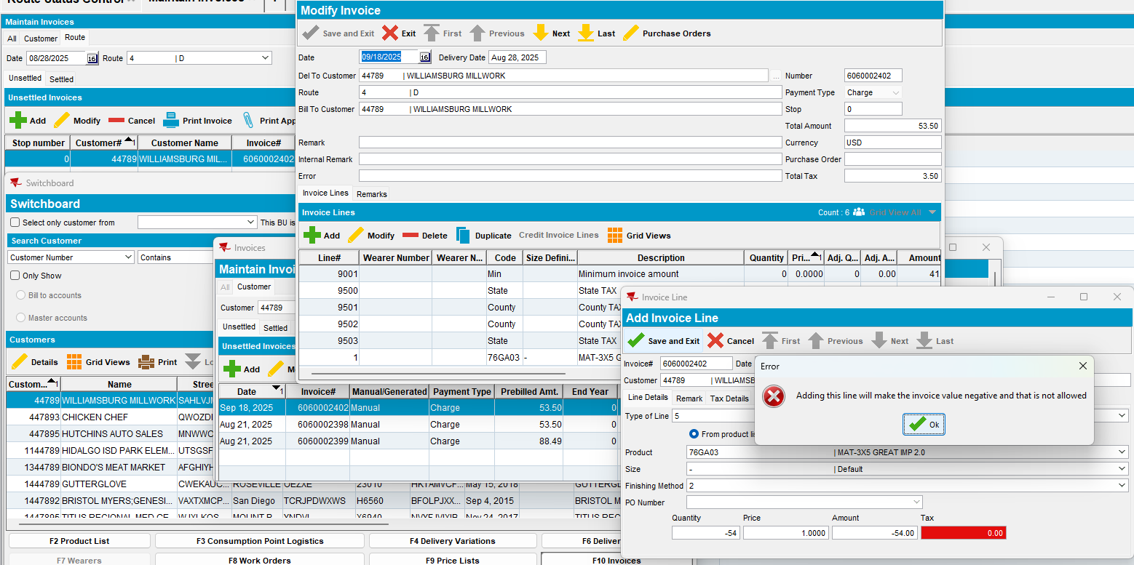
We receive the message “Adding this line will make the invoice value negative and that is not allowed” at the invoice line and we are not allowed to save.

Modify the initial invoice line and turn it negative
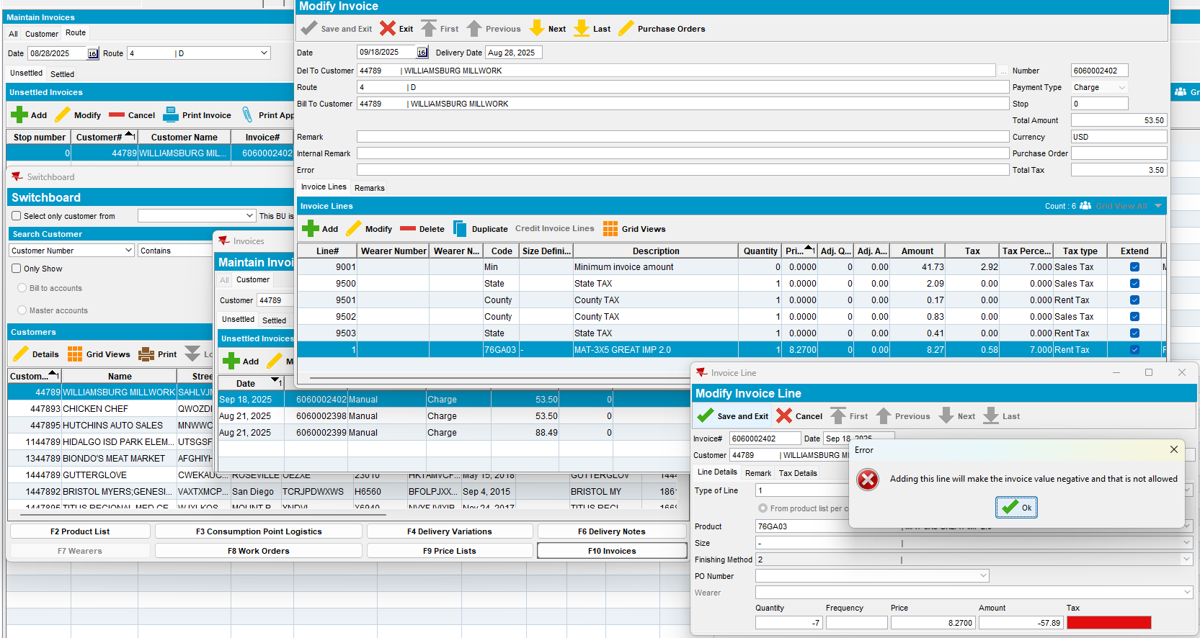
We receive the message “Adding this line will make the invoice value negative and that is not allowed” at the invoice line and we are not allowed to save.

Tested OK

Test Case 05 – In add mode check ss MANUALINVOICEVALUECONTROL = 0 – Tested OK

Expected behavior:
We don’t receive the message “Creating a Negative value invoice is not allowed” and we are allowed to save.
Locations:
- Maintain Invoices dlg: Customer, All and Route tabs
- Switchboard
- Settlement screen dlg

Test steps:
- System Settings dlg: ss MANUALINVOICEVALUECONTROL = 0
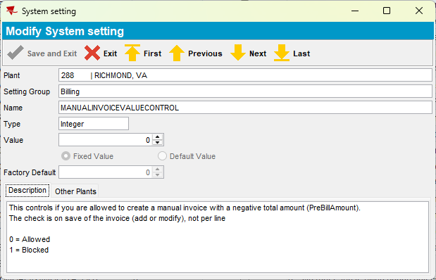
- Maintain Invoices dlg:
- All tab, add a negative manual invoice and save it.
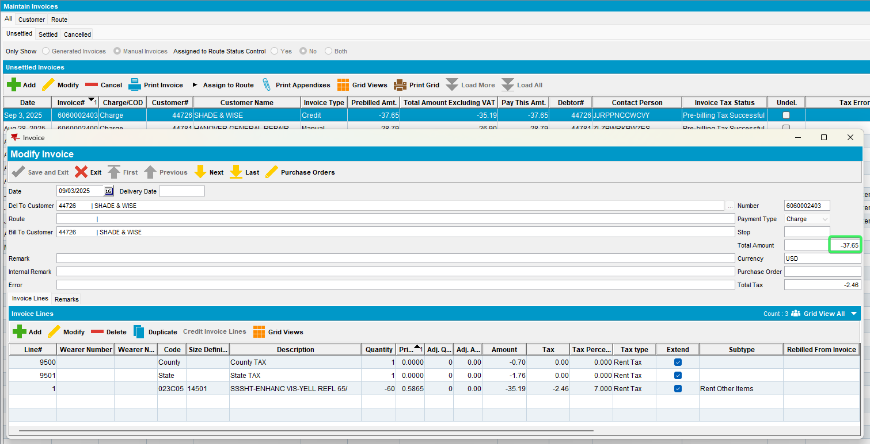
We don’t receive the message “Adding this line will make the invoice value negative and that is not allowed” and we are allowed to save.
- Customer tab, add a manual invoice with negative amount.
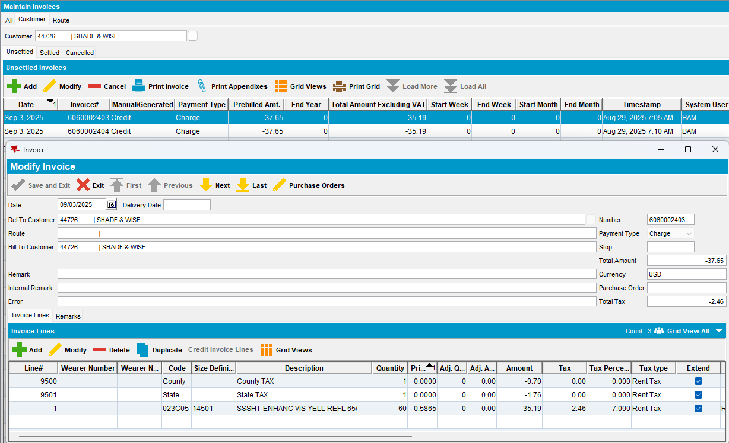
We don’t receive the message “Adding this line will make the invoice value negative and that is not allowed” and we are allowed to save.

- Route tab, add a manual invoice with negative amount.
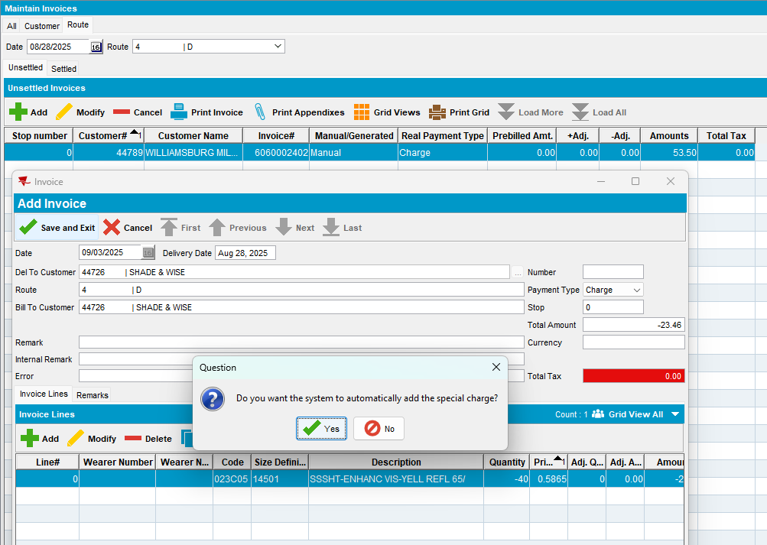
We don’t receive the message “Adding this line will make the invoice value negative and that is not allowed” and we are allowed to save.

- Switchboard, add a new negative manual invoice for a customer
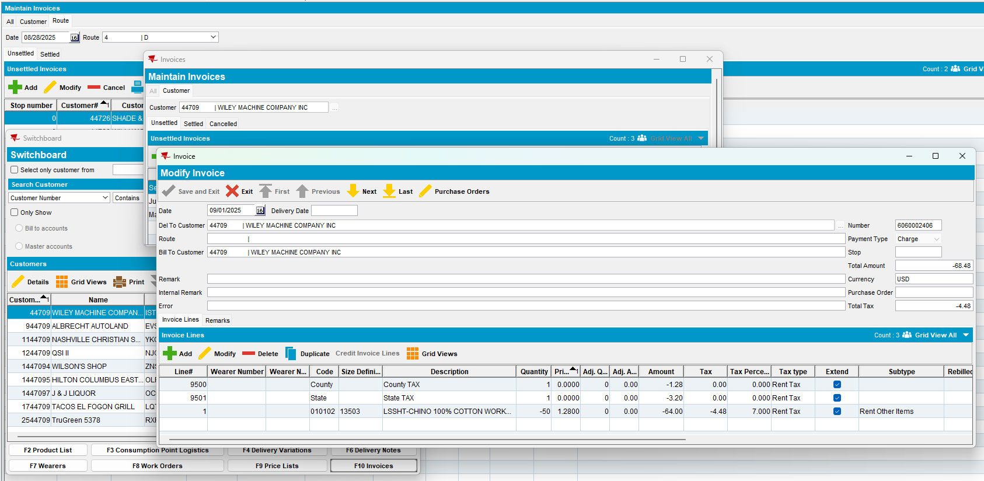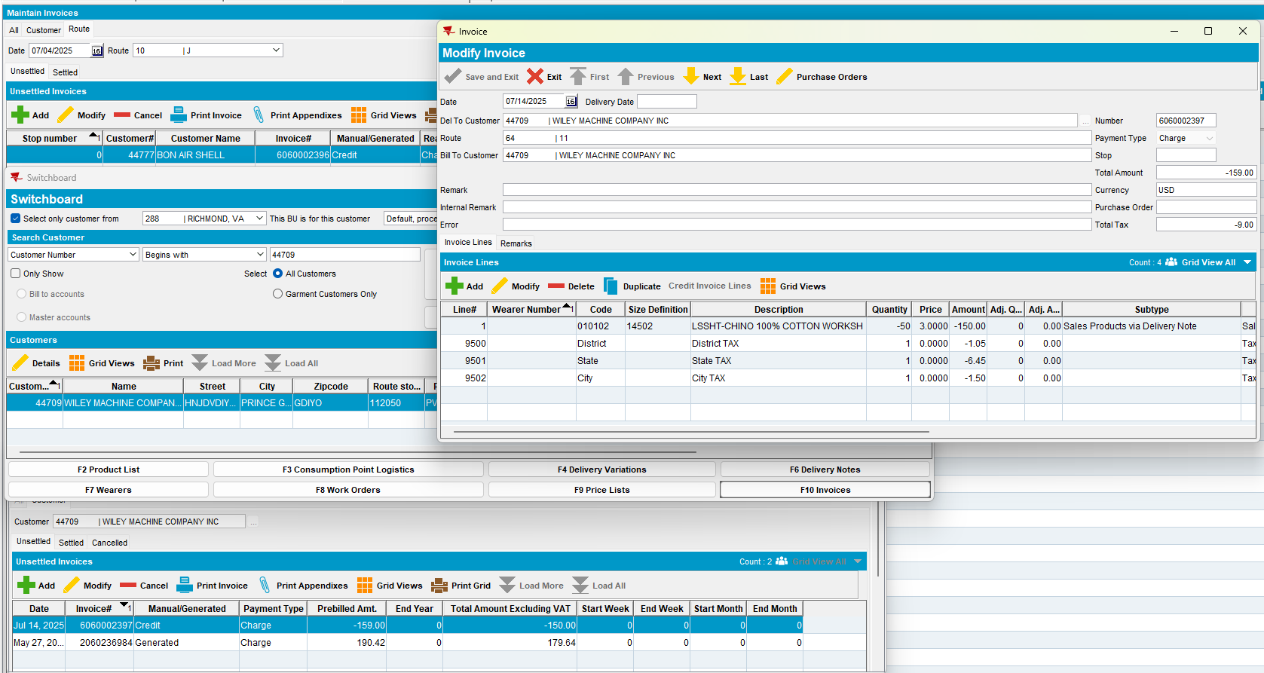
We don’t receive the message “Adding this line will make the invoice value negative and that is not allowed” and we are allowed to save.

Tested OK

Test Case 06 – In modify mode with ss MANUALINVOICEVALUECONTROL = 0 – Tested OK

Expected behavior:
We don’t receive the message “Creating a Negative value invoice is not allowed” and we are allowed to save.
Locations:
- Maintain Invoices dlg: Customer, All and Route tabs
- Switchboard
- Settlement screen dlg

Test steps:
- System Settings dlg: ss MANUALINVOICEVALUECONTROL = 0
- Maintain Invoices dlg:
- All tab, modify a negative manual invoice and add another negative invoice line and save it.
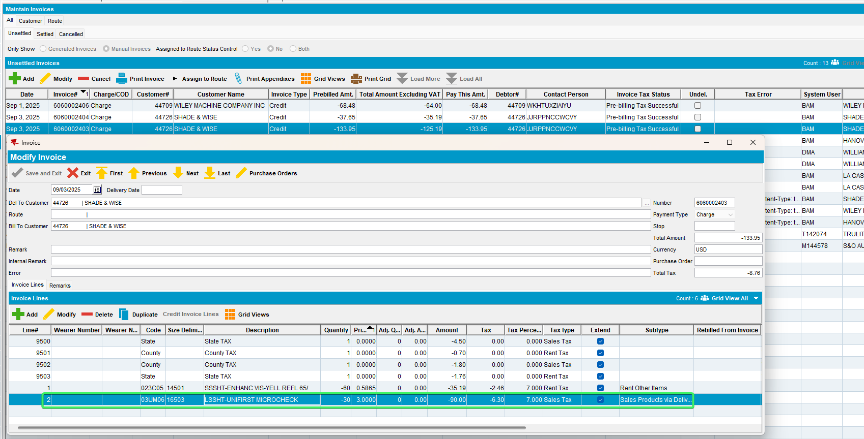
We don’t receive the message “Adding this line will make the invoice value negative and that is not allowed” and we are allowed to save.

- Customer tab, modify a negative manual invoice and increase the negative invoice line and save it.
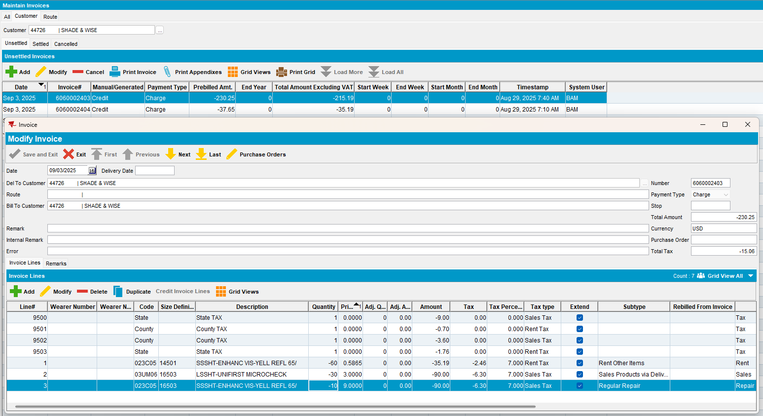

We don’t receive the message “Adding this line will make the invoice value negative and that is not allowed” and we are allowed to save.

- Route tab, modify a negative manual invoice and add another negative invoice line and save it.
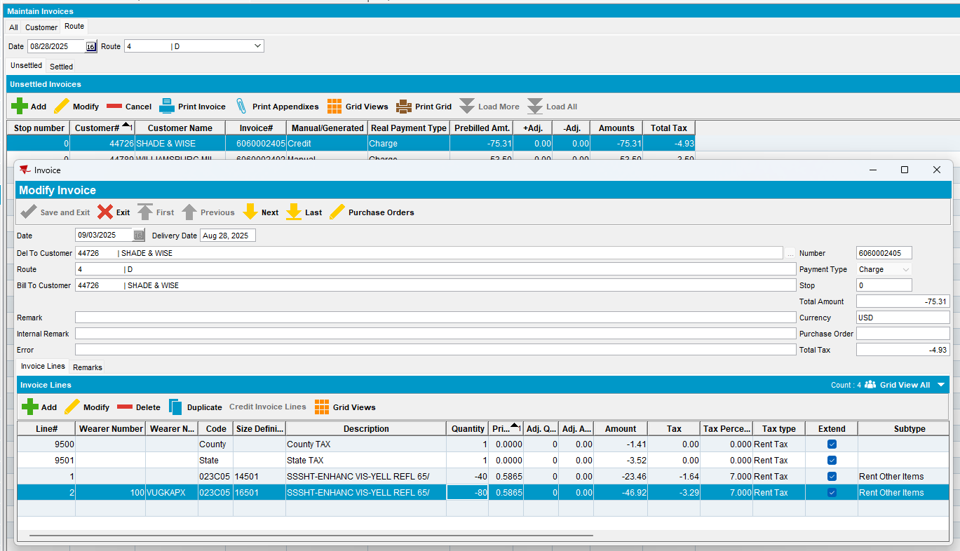
We don’t receive the message “Adding this line will make the invoice value negative and that is not allowed” and we are allowed to save.

- Switchboard, modify a positive manual invoice for a customer and add a new negative invoice line that will change the total amount to negative.
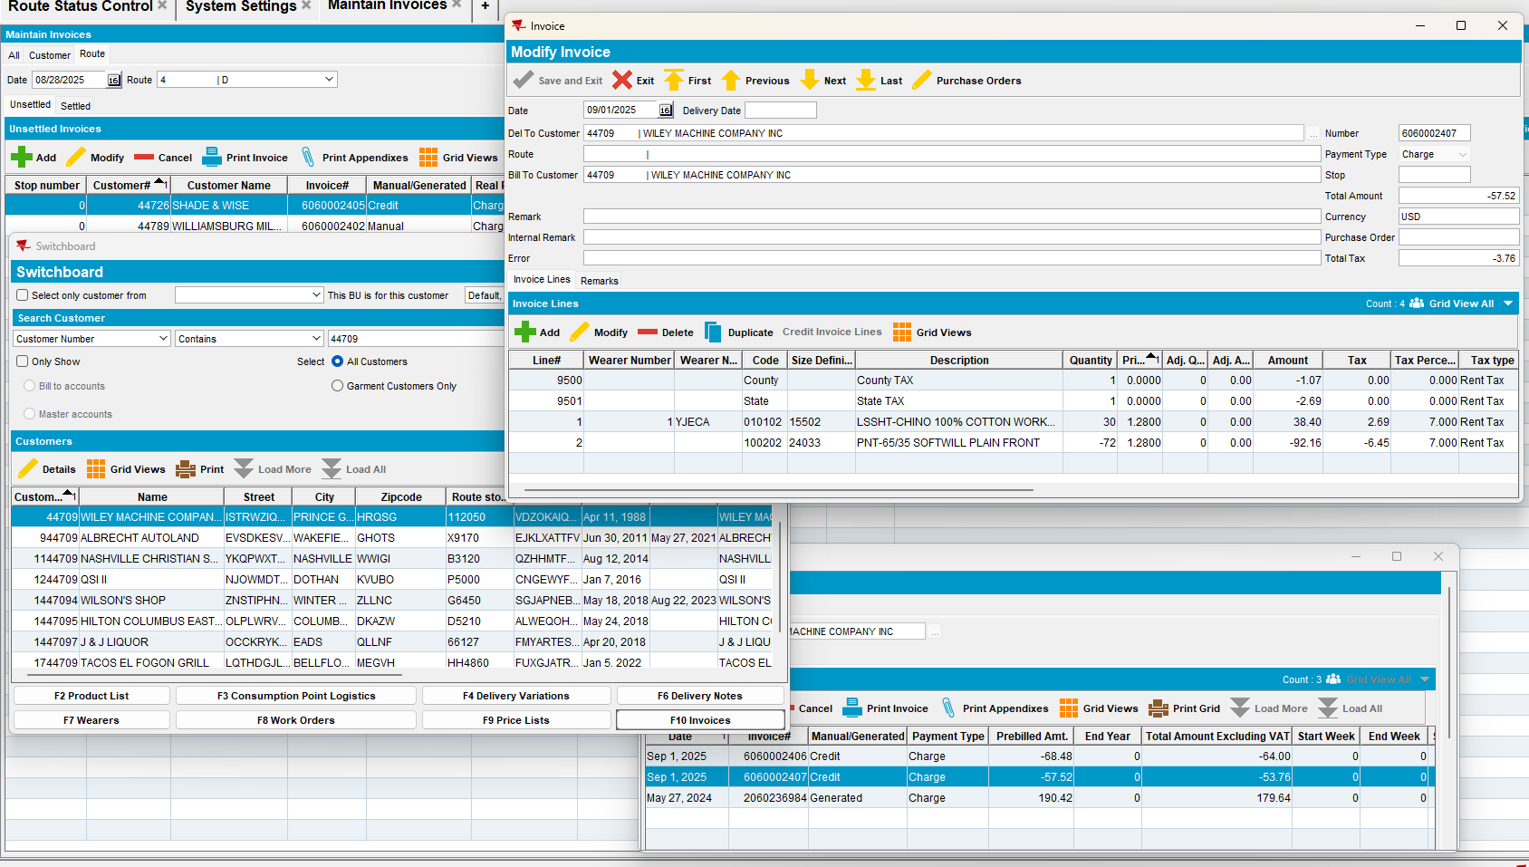

We don’t receive the message “Adding this line will make the invoice value negative and that is not allowed” and we are allowed to save.

Tested OK

Test Case 07 – In modify mode change a credit invoice with ss MANUALINVOICEVALUECONTROL = 1 – Tested OK

Expected behavior:
Take an invoice and credit from Maintain invoice dlg, an invoice settled and tax credited, the invoice becomes negative. When having the ss MANUALINVOICEVALUECONTROL = 1, modifying the credit doesn’t apply the logic of the ss to the credits.
(InvoiceHeader.InvoiceType = 2, CreditedInvoiceHeader_ID is not NULL)

Locations:
- Maintain Invoices dlg: Customer, All and Route tabs
- Switchboard
- Settlement screen dlg

Test steps:
      - System Settings dlg: Set ss MANUALINVOICEVALUECONTROL = 1
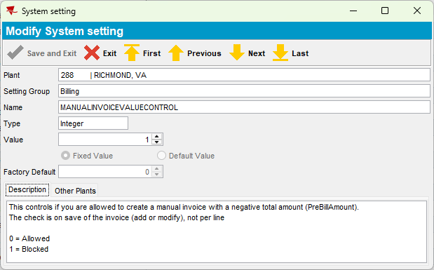
      - Maintain Invoices dlg: Load a customer which is configured to have a minimum invoice amount and special charges, and credit an old invoice.

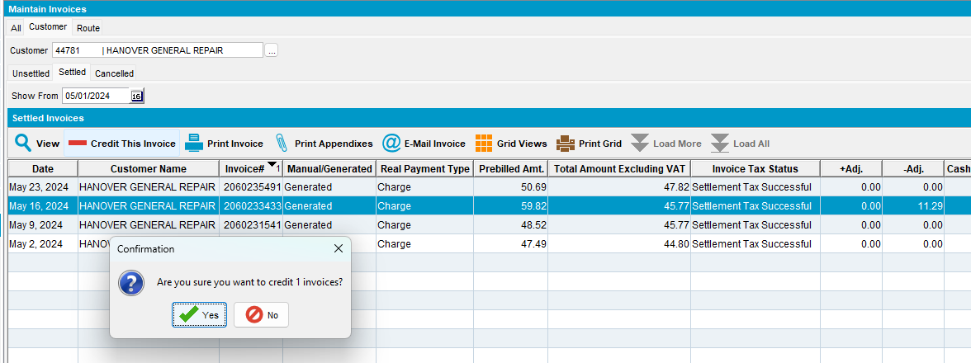

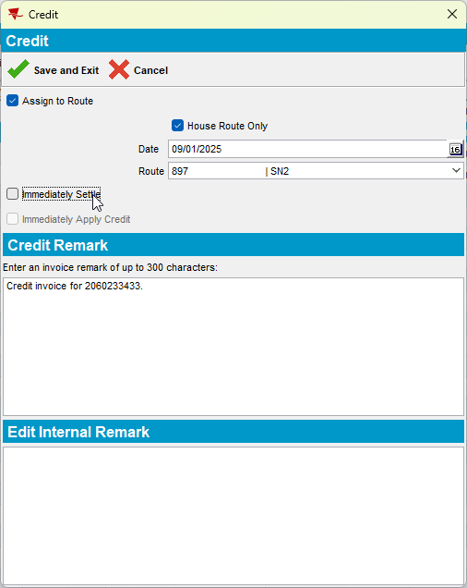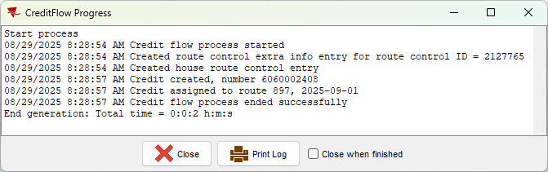
      - Maintain Invoices dlg: Go to Unsettled tab and find the credited invoice. Modify it and add negative value to one of the invoice lines.
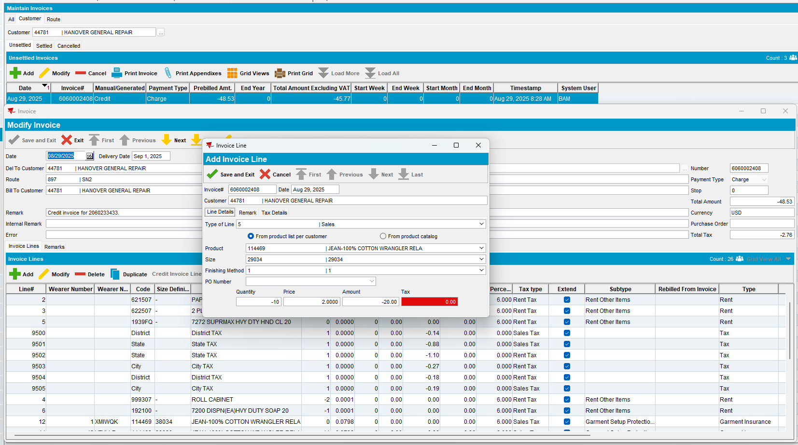
      - Maintain Invoice dlg: Save it and re-check it.
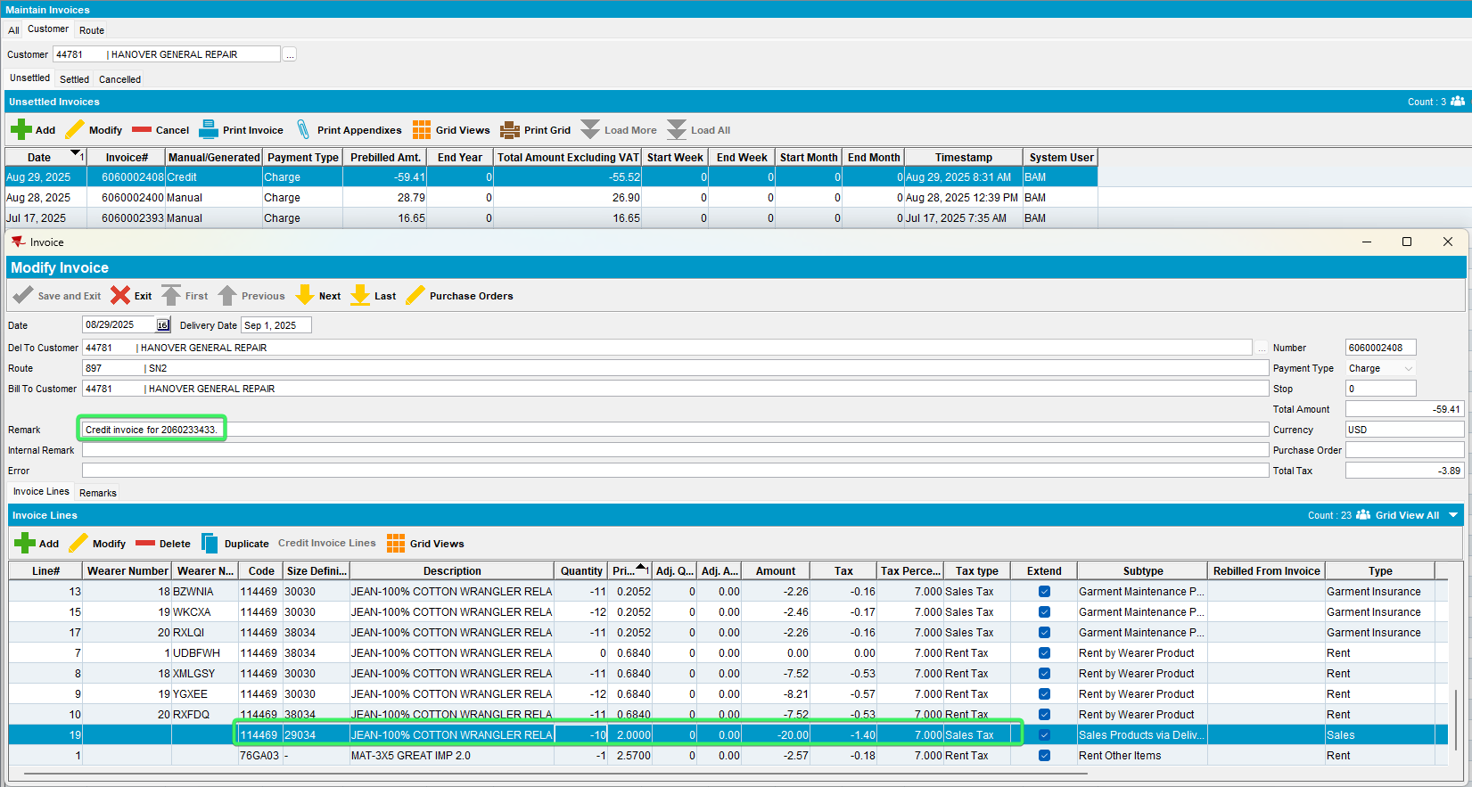
We don’t receive the message “Creating a Negative value invoice is not allowed” and we are allowed to save because it’s a credit invoice.

Tested OK

Test Case 08 – In add mode check ss MANUALINVOICEDATECONTROL = 1 + MANUALINVOICEDATELIMIT = 0 + MANUALINVOICEDATELIMIT > 4 + MANUALINVOICEDATELIMIT > 99 – Tested Ok

Expected behavior:
It doesn’t let you add an invoice date in the past <sysdate

Locations:
- Maintain Invoices dlg: Customer, All and Route tabs
- Switchboard
- Settlement screen dlg

Test steps:
- System Settings dlg: Change the ss MANUALINVOICEDATECONTROL = 1 + MANUALINVOICEDATELIMIT = 0 + MANUALINVOICEDATELIMIT > 4 + MANUALINVOICEDATELIMIT > 99
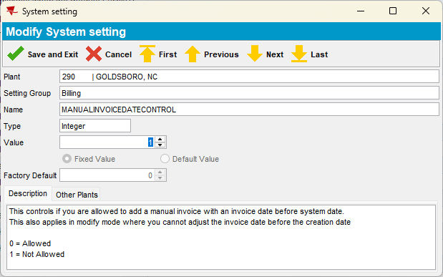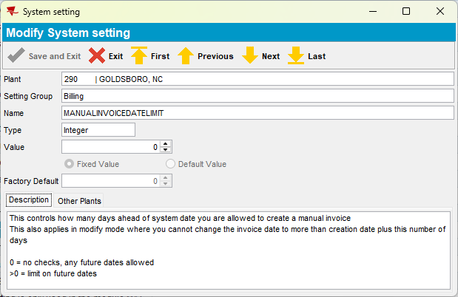
- Maintain Invoices dlg: For a customer, Add a manual invoice from:

- All tab in the past from sysdate
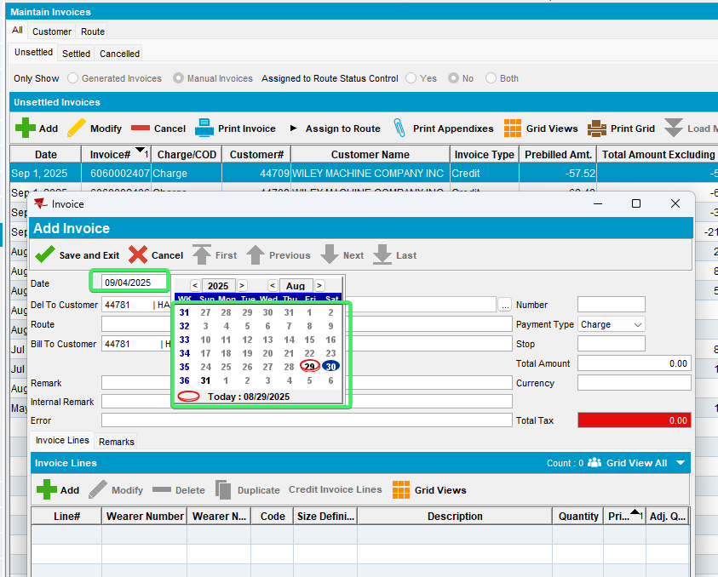
Cannot select any date from the past <sysdate while ss MANUALINVOICEDATECONTROL = 1

- All tab in the future from sysdate
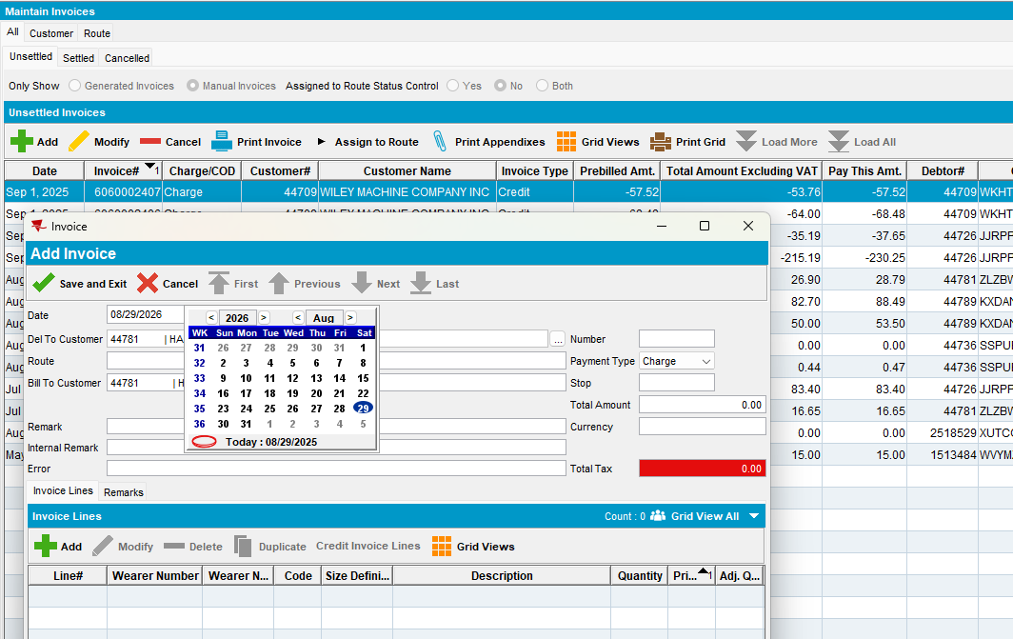
There is not limit while ss MANUALINVOICEDATELIMIT = 0

- Customer tab, in the past <sysdate
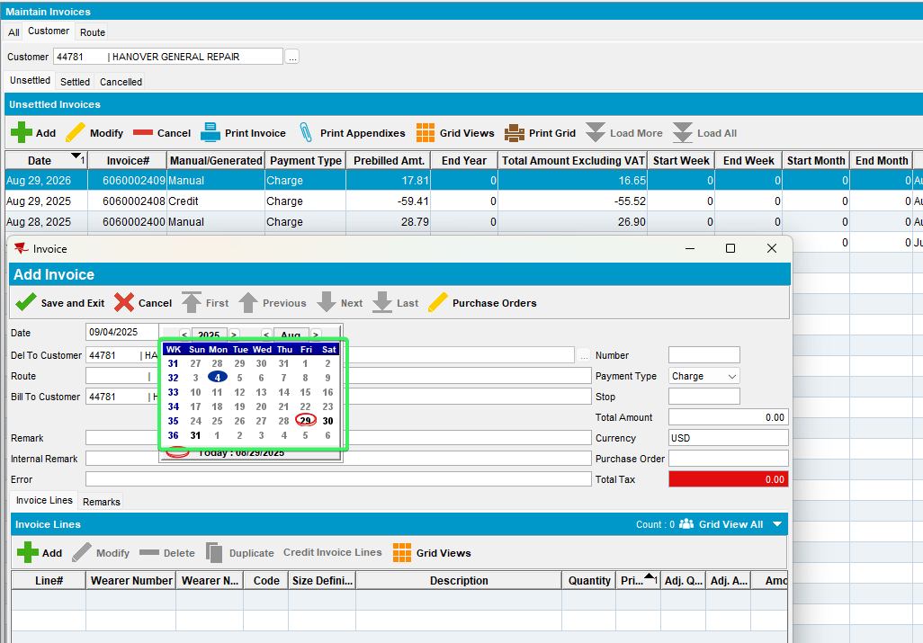
Cannot select any date from the past <sysdate while ss MANUALINVOICEDATECONTROL = 1

- Customer tab in the future from sysdate
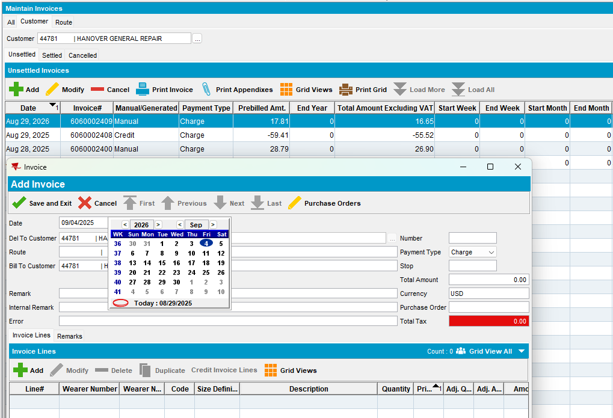
There is not limit while ss MANUALINVOICEDATELIMIT = 0
- Route tab, load a route from the past and click to add a manual invoice.
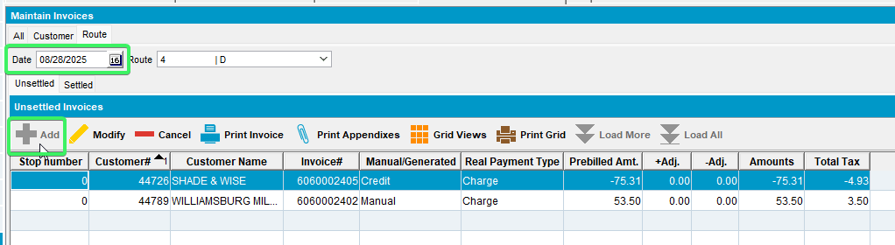
The Add button is disabled for route that are from the past <sysdate , while ss MANUALINVOICEDATECONTROL = 1

- Route tab, load a route from the future and click to add a manual invoice.
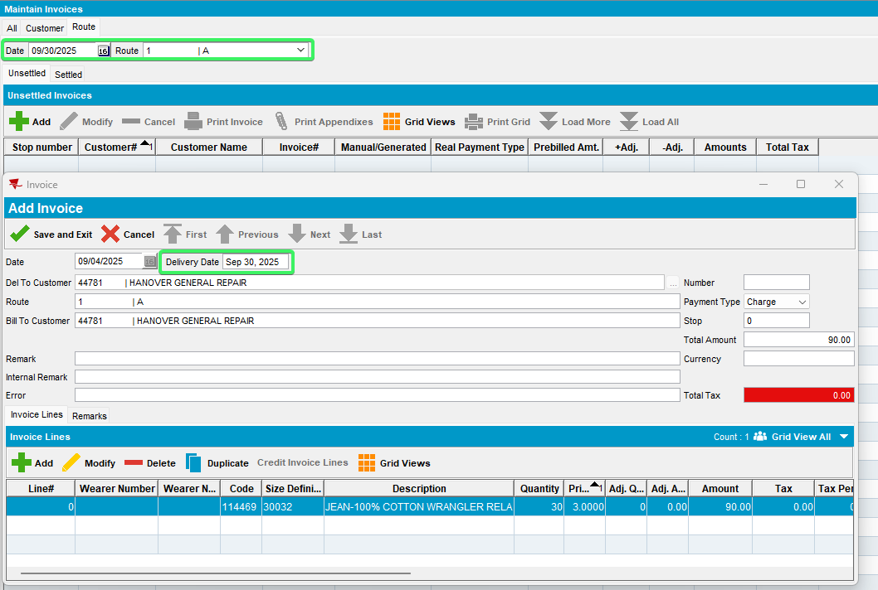
There is not limit while ss MANUALINVOICEDATELIMIT = 0

- Switchboard tab, load a customer from the same plant and add an invoice before sysdate
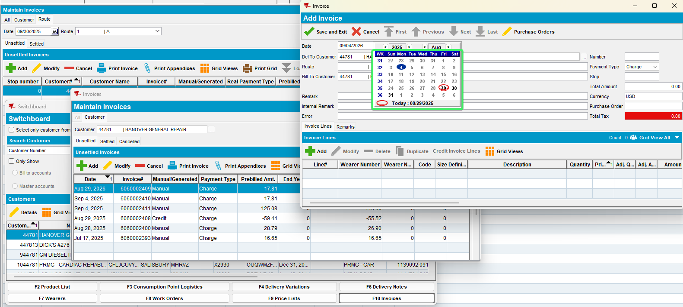
Cannot add before sysdate because ss MANUALINVOICEDATECONTROL = 1
- Switchboard tab, add an invoice in the future from sysdate
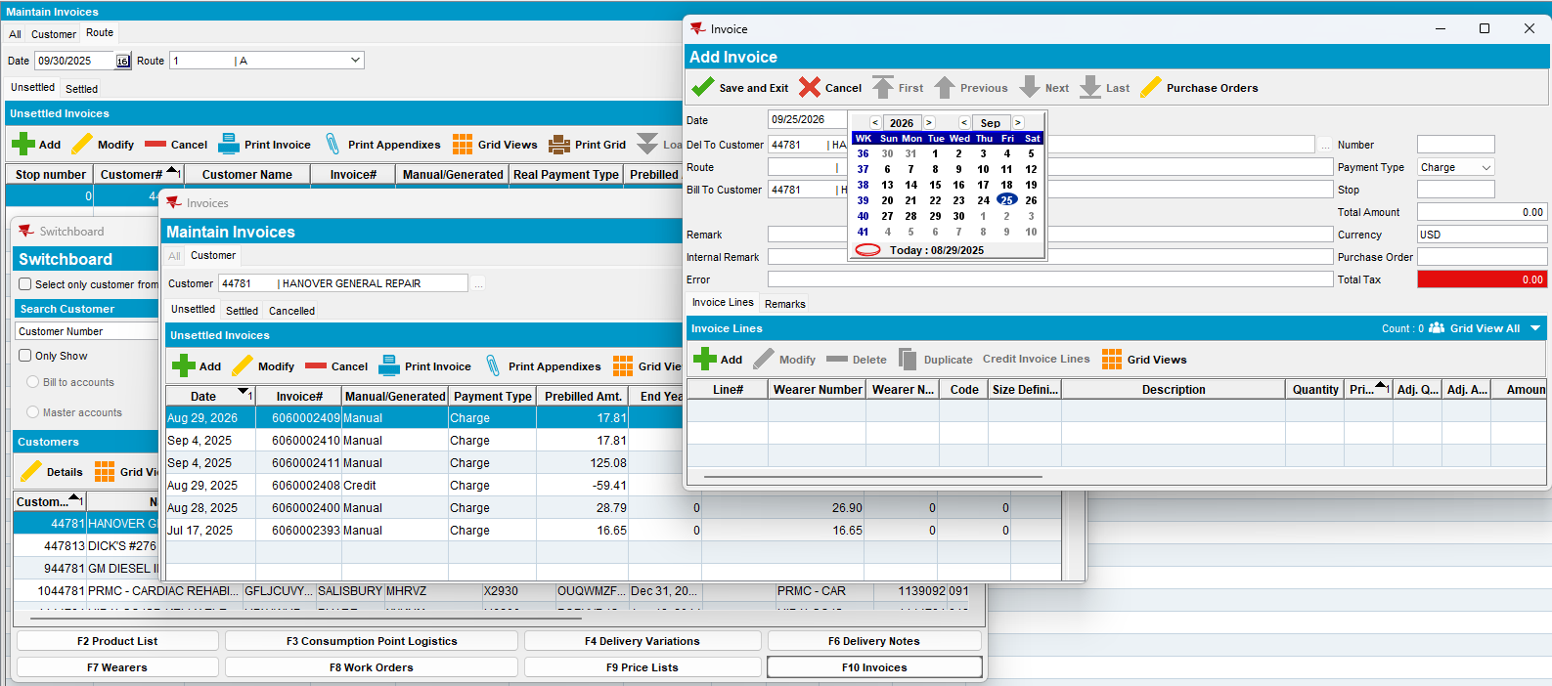

There is not limit while ss MANUALINVOICEDATELIMIT = 0

- System Settings dlg: Set MANUALINVOICEDATELIMIT > 4
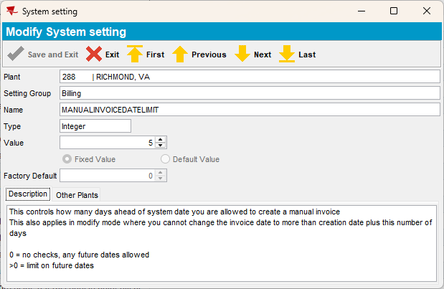
- Maintain Invoices dlg: Add a manual invoice from:

- All tab in the future from sysdate greater than ss value
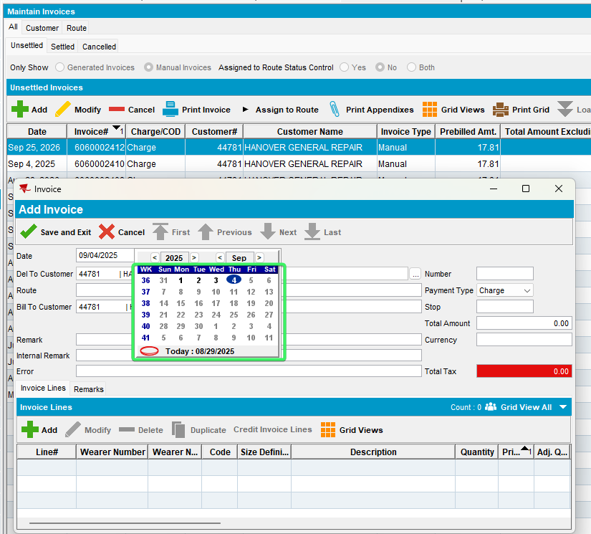
Cannot save 6 days in the future while ss MANUALINVOICEDATELIMIT = 5
- Customer tab in the future from sysdate greater than ss value
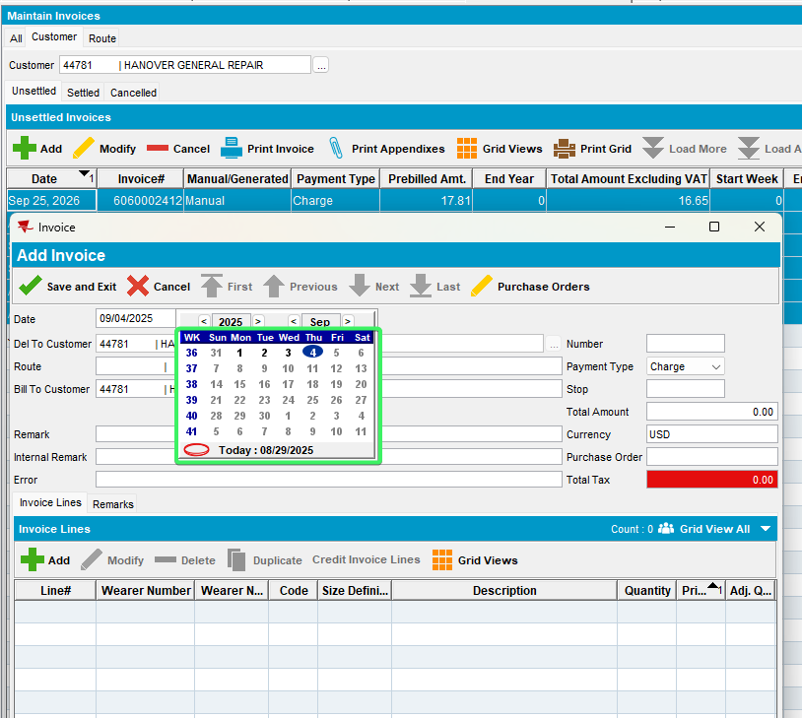
Cannot save 6 days in the future while ss MANUALINVOICEDATELIMIT = 5
- Route tab, load a route from the future and click to add a manual invoice.
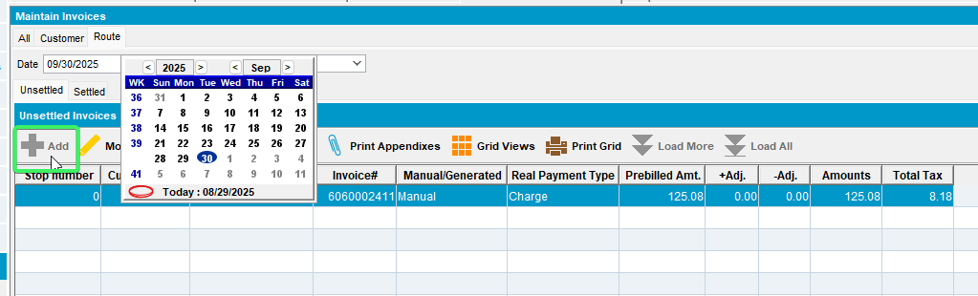
Cannot add manual invoices for route that are more than 5 days in the future while ss MANUALINVOICEDATELIMIT = 5

- Switchboard tab, add an invoice in the future from sysdate 5 days+
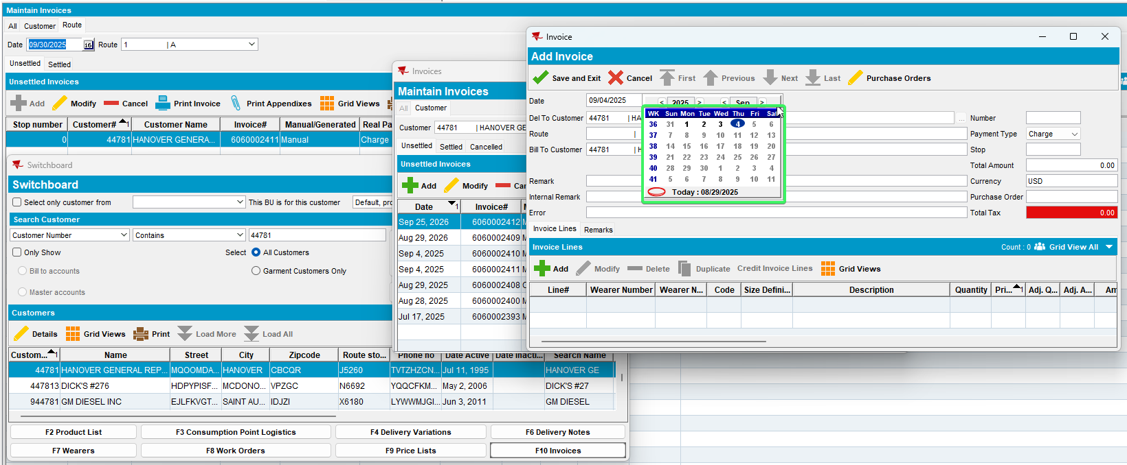

Cannot save 6 days in the future while ss MANUALINVOICEDATELIMIT = 5

- System Settings dlg: Set MANUALINVOICEDATELIMIT MANUALINVOICEDATELIMIT > 99
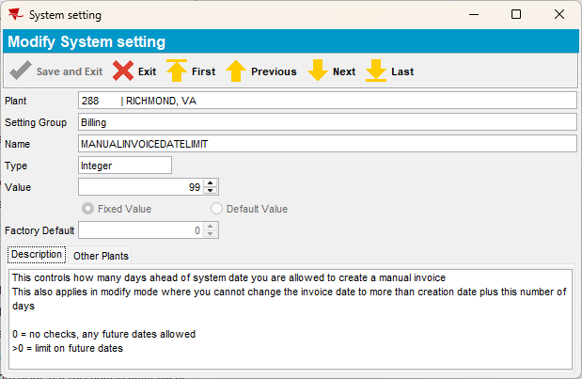

- Maintain Invoices dlg: Add a manual invoice from:

- All tab in the future from sysdate greater than ss value
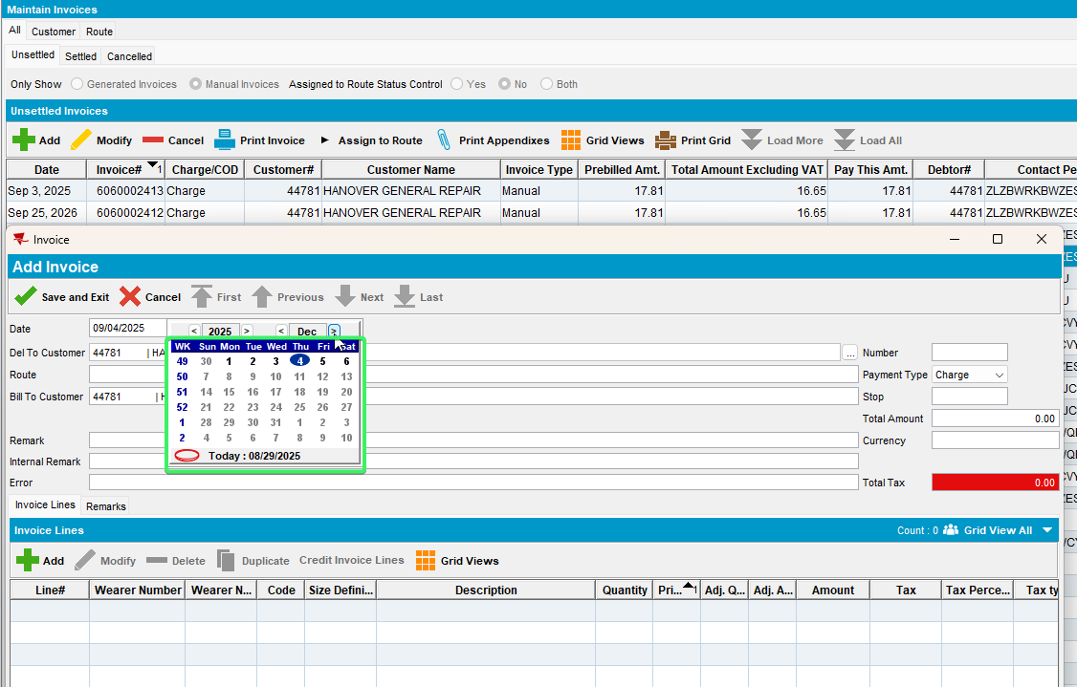
Cannot save 100 days in the future while ss MANUALINVOICEDATELIMIT = 99
- Customer tab in the future from sysdate greater than ss value
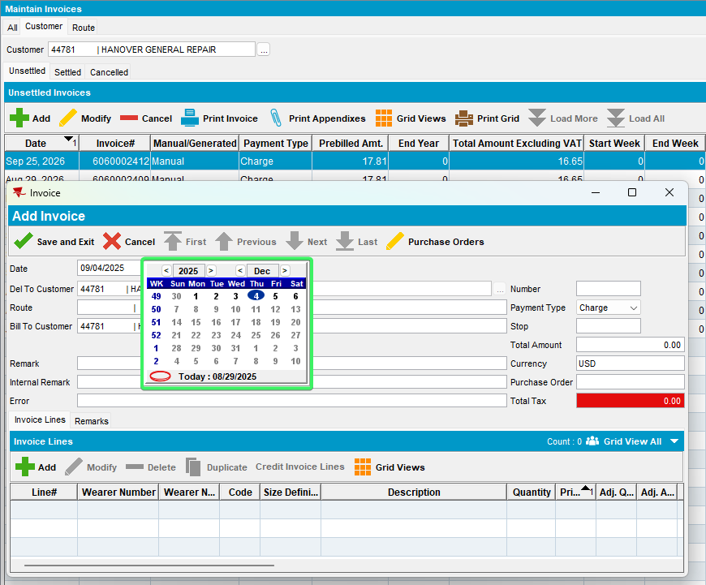
Cannot save 100 days in the future while ss MANUALINVOICEDATELIMIT = 99
- Route tab, load a route from the future and click to add a manual invoice.
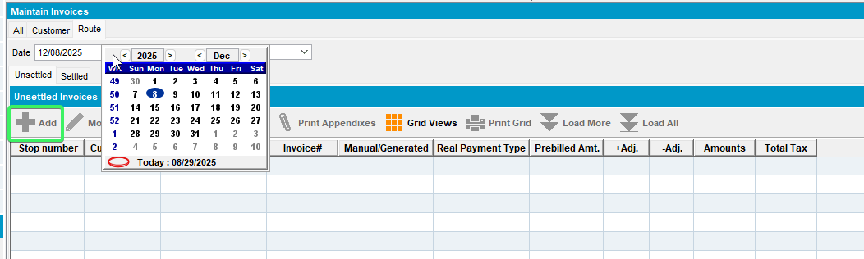
Cannot add manual invoices for routes that are more than 99 days in the future while ss MANUALINVOICEDATELIMIT = 99

- Switchboard tab, add an invoice in the future from sysdate 100 days
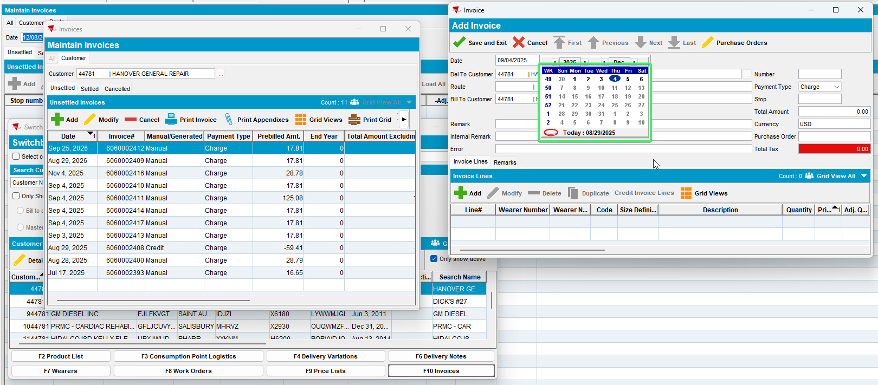

Cannot save 100 days in the future while ss MANUALINVOICEDATELIMIT = 99

Tested OK

Test Case 09 – In modify mode check ss MANUALINVOICEDATECONTROL = 1 + MANUALINVOICEDATELIMIT = 0 + MANUALINVOICEDATELIMIT > 4 + MANUALINVOICEDATELIMIT > 99 – Tested Ok

Expected behavior:
It doesn’t let you modify an invoice date in the past <sysdate – the date picker is disabled for new manual invoice, the message is displayed for older manual invoices

Locations:
- Maintain Invoices dlg: Customer, All and Route tabs
- Switchboard
- Settlement screen dlg

Test steps:
- System Settings dlg: Change the ss MANUALINVOICEDATECONTROL = 1 + MANUALINVOICEDATELIMIT = 0 + MANUALINVOICEDATELIMIT > 4 + MANUALINVOICEDATELIMIT > 99
- Maintain Invoices dlg: For a customer, Add a manual invoice in the future from sysdate
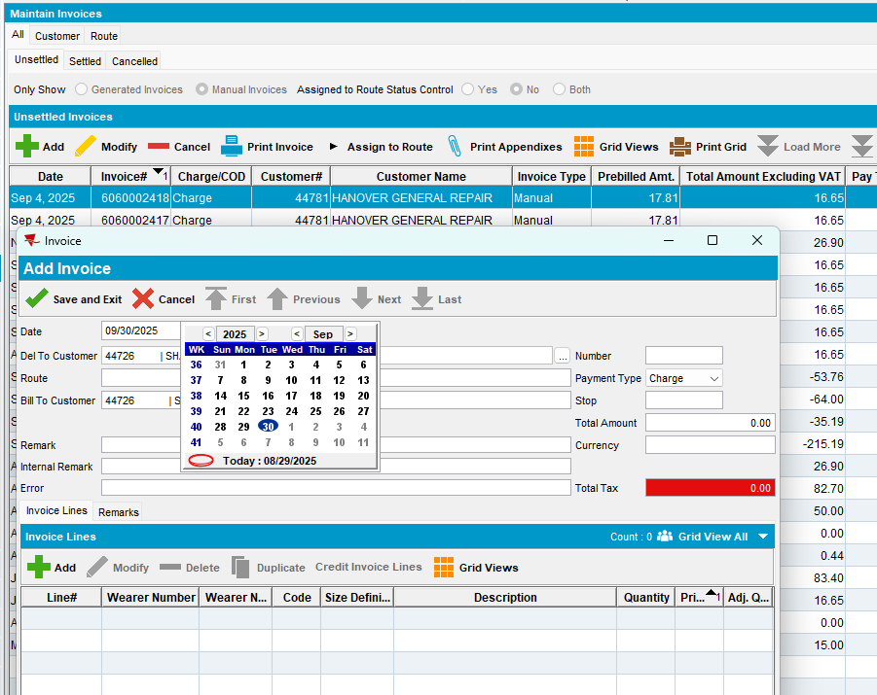
- Maintain Invoices dlg: Re-open the invoice and change the date:
- All tab
  - Try to put a date in the past <sysdate
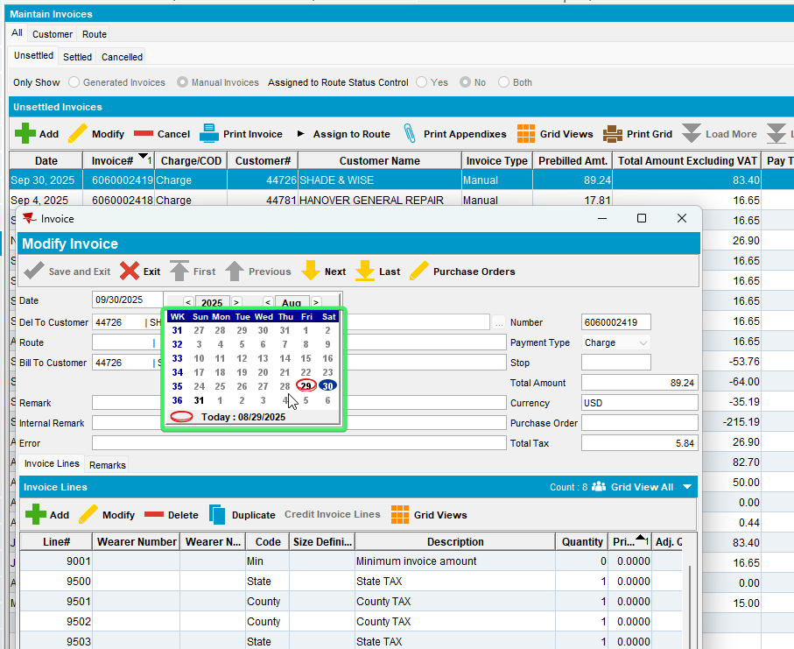
Cannot select a date in the past <sysdate
  - Try to put a date in the future less than original date of creation.
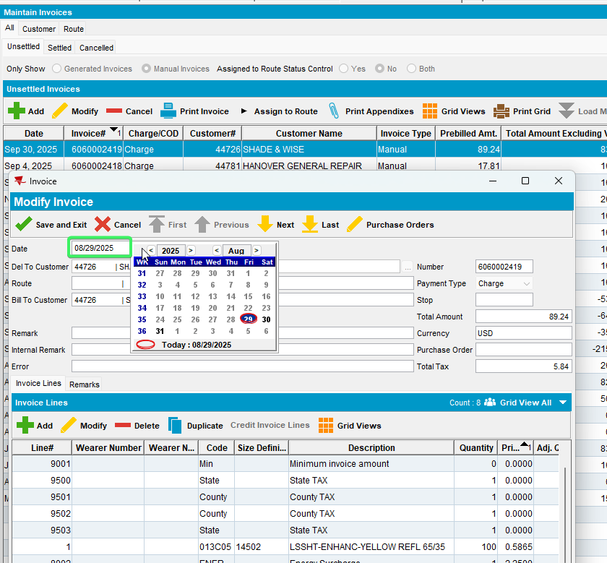
There is not limit while ss MANUALINVOICEDATELIMIT = 0

- Customer tab
- Try to put a date in the past <sysdate
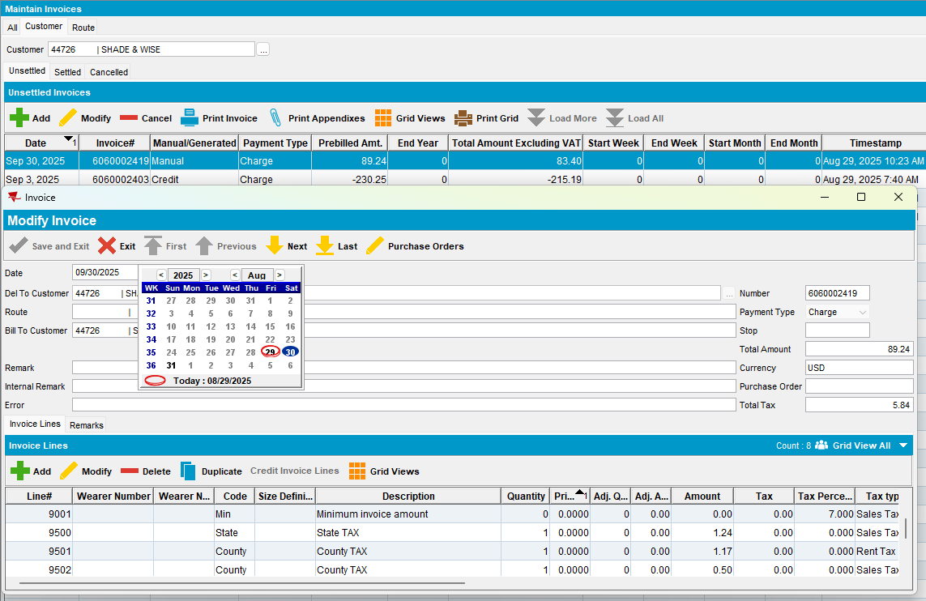
Cannot select a date in the past <sysdate
- Try to put a date in the future less than original date of creation.
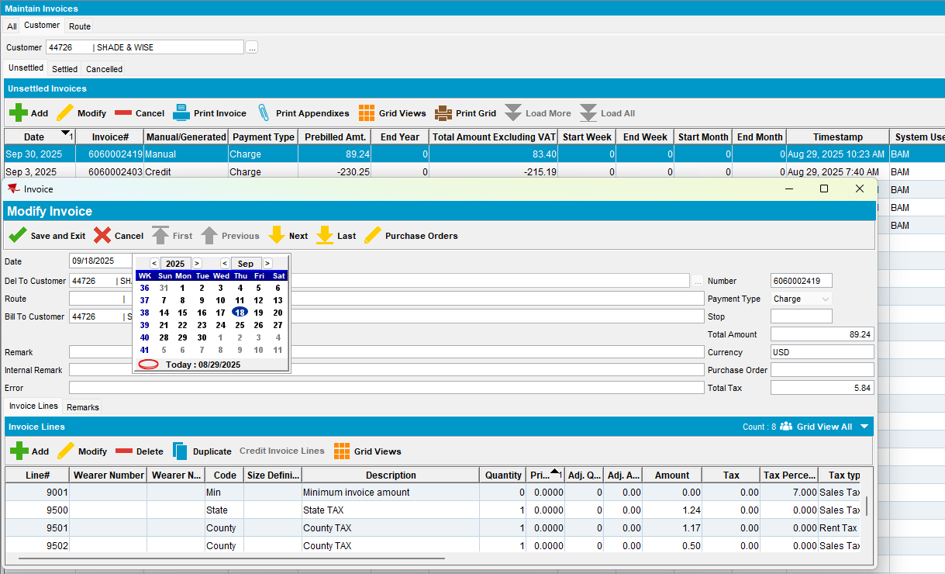
There is not limit while ss MANUALINVOICEDATELIMIT = 0

- Route tab
- Try to put a date in the past <sysdate
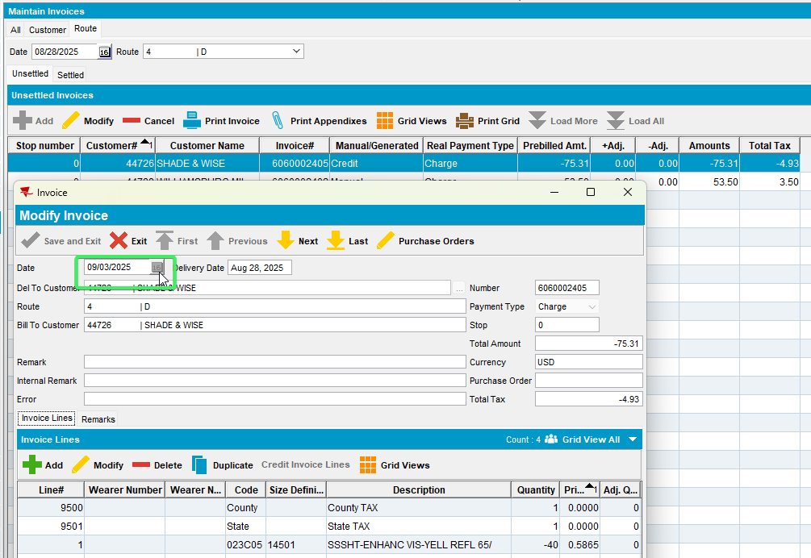
Cannot modify the date of an assigned manual invoice

- Switchboard tab
- Try to put a date in the past <sysdate
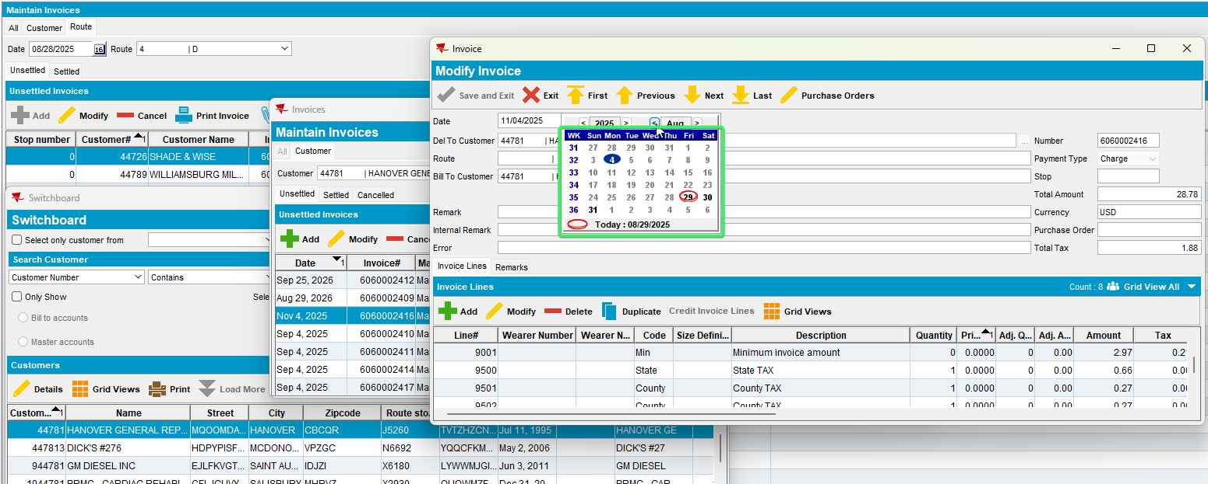
Cannot select a date in the past <sysdate
- Try to put a date in the future less than original date of creation.
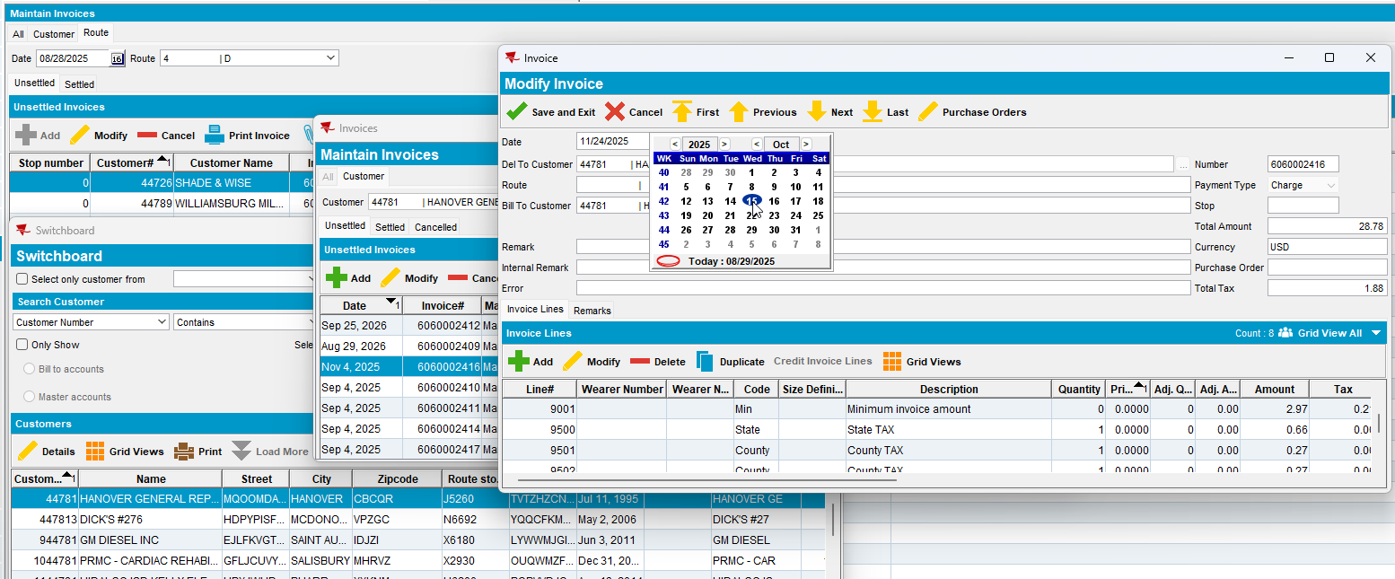
There is not limit while ss MANUALINVOICEDATELIMIT = 0
- System Settings dlg: Set ss MANUALINVOICEDATELIMIT = 4
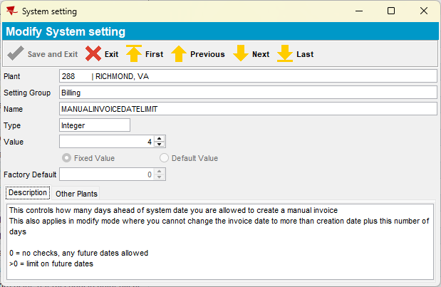

- Maintain Invoices dlg: Re-open the invoice and change the date:
- All tab
- Try to put a date in the future less than original date of creation.
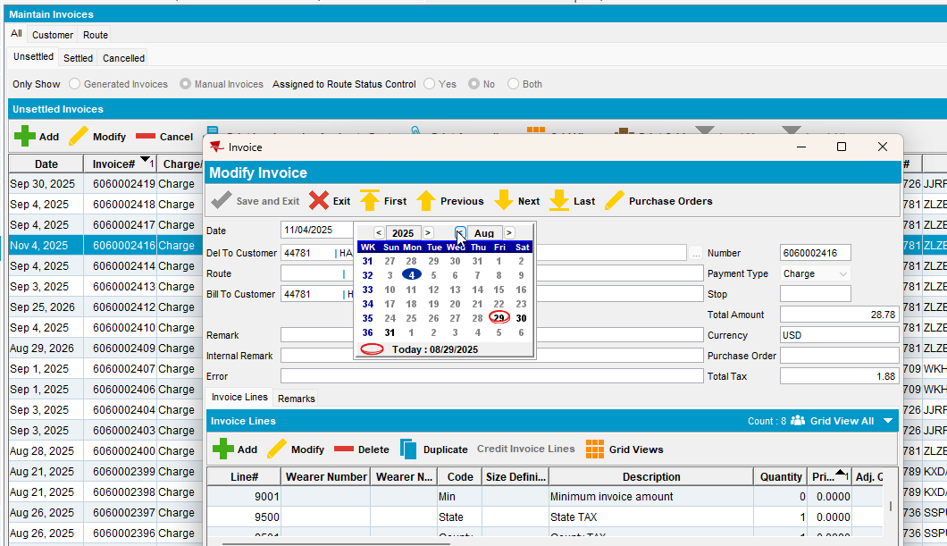
We are constrained by the ss MANUALINVOICEDATELIMIT = 4

- Customer tab
- Try to put a date in the future less than original date of creation.
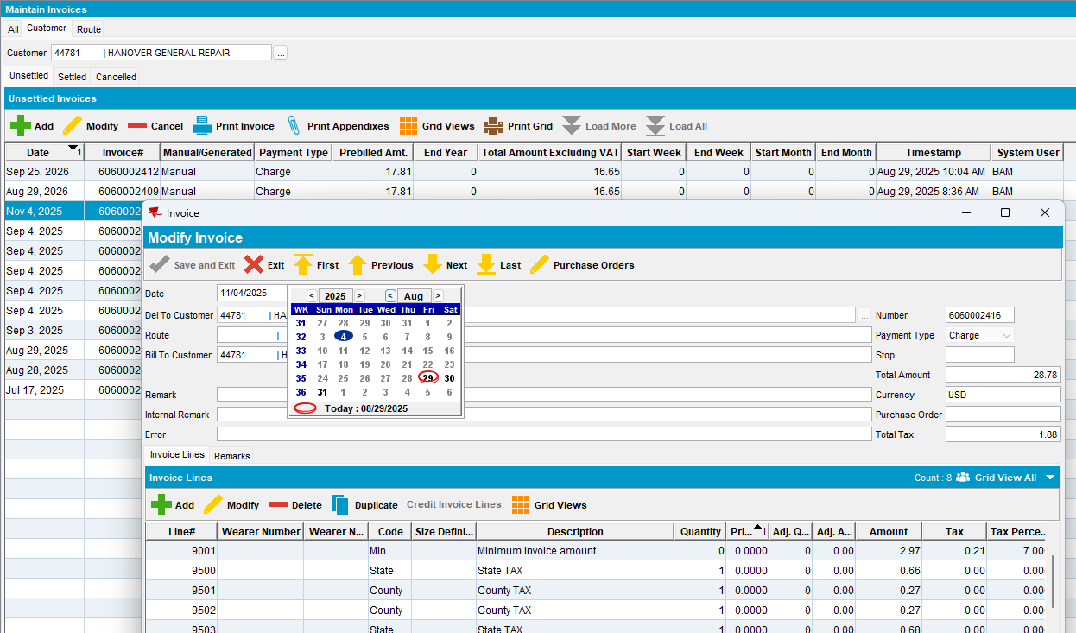
We are constrained by the ss MANUALINVOICEDATELIMIT = 4

- Route tab
- Try to put a date in the past <sysdate
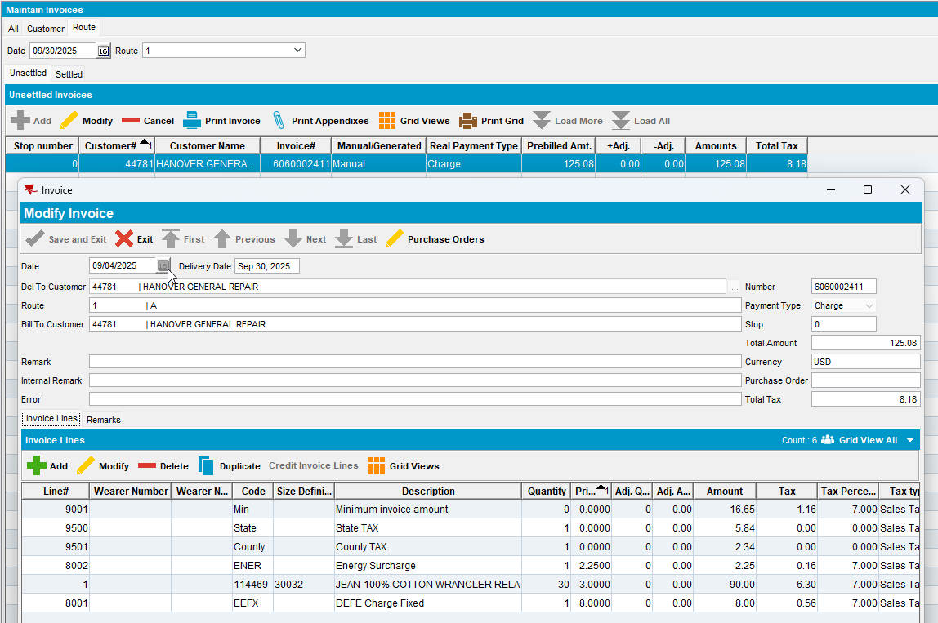
Cannot modify the date of an assigned manual invoice

- Switchboard tab
- Try to put a date in the future less than original date of creation.
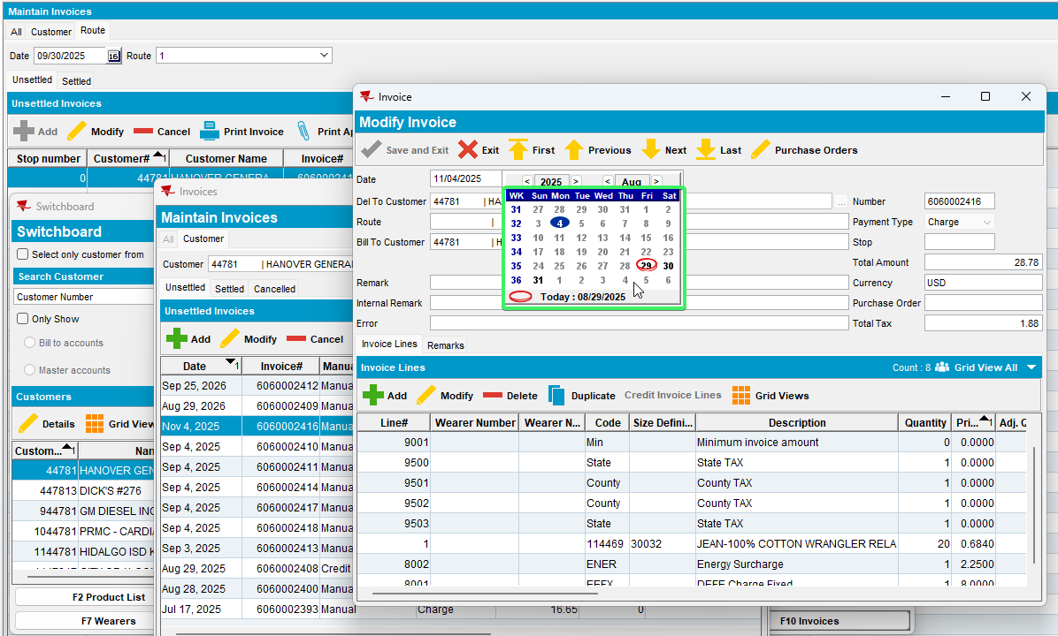
We are constrained by the ss MANUALINVOICEDATELIMIT = 4

- System Settings dlg: Set MANUALINVOICEDATELIMIT = 99
- All tab
- Try to put a date in the future more than original date of creation.
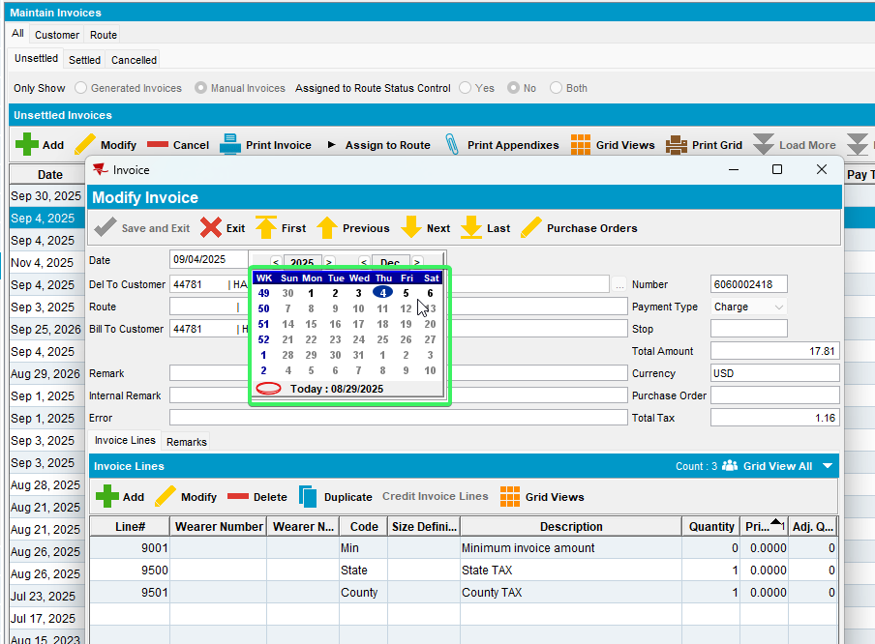
We are constrained by the ss MANUALINVOICEDATELIMIT = 99

- Customer tab
- Try to put a date in the future more than original date of creation.
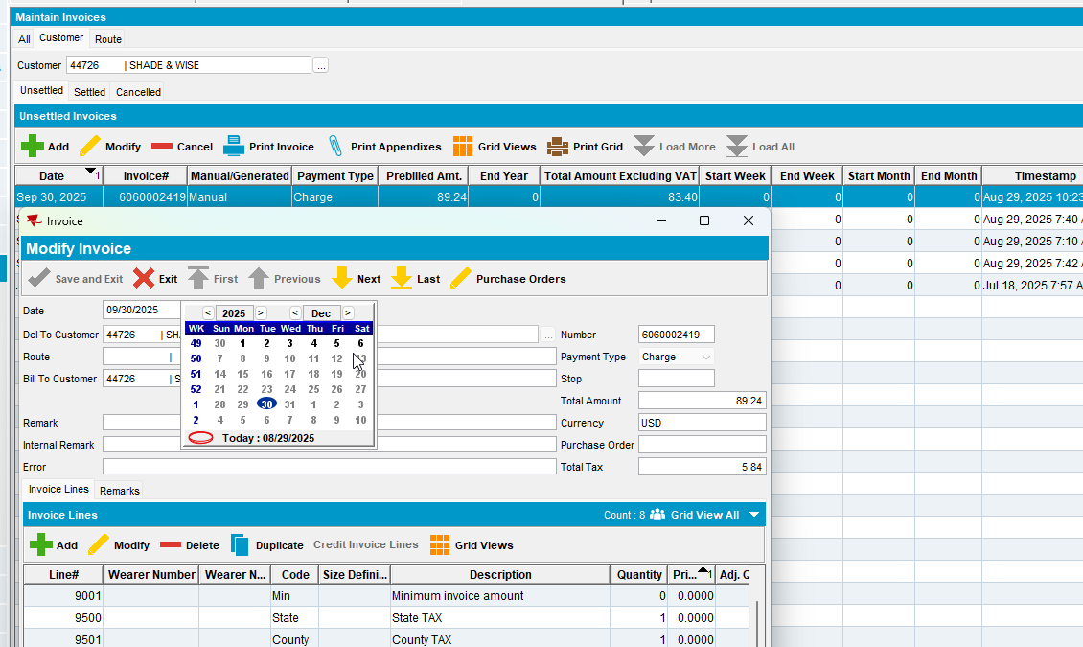
We are constrained by the ss MANUALINVOICEDATELIMIT = 99

- Route tab
- Try to put a date in the past <sysdate
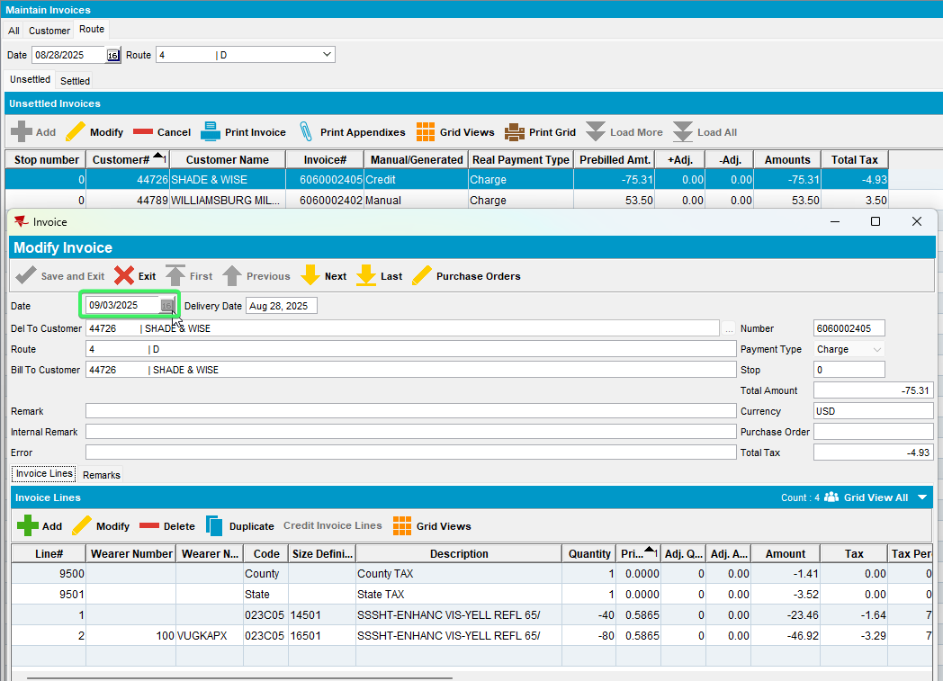
Cannot modify the date of an assigned manual invoice

- Switchboard tab
- Try to put a date in the future more than original date of creation.
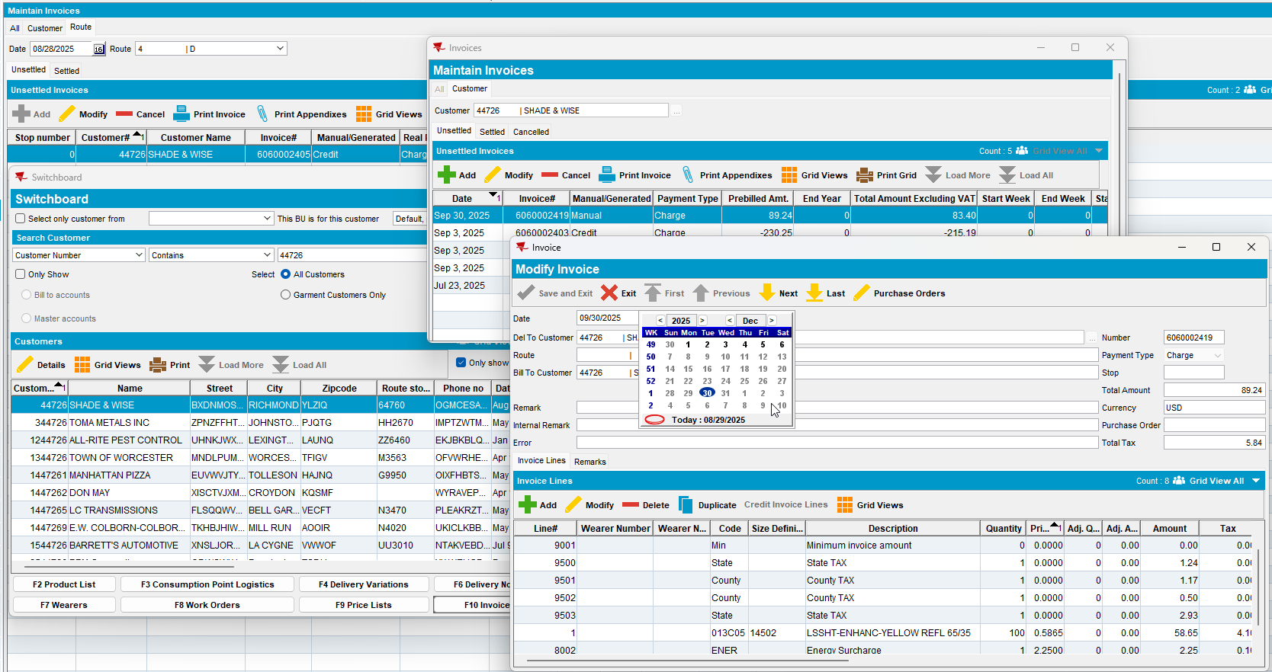
We are constrained by the ss MANUALINVOICEDATELIMIT = 99

Tested OK

