ABSN-7811 Country and currency for del to and bill to customers
Environment | Prerequisites
Version:9.07.00  DBServerName=abs-SRV20.internal.abslbs.com  DBSID=CUST24  DBUser=UNFDEV  Environment=Test | - Module:  - System setting

Contents
Test after fix 1
Test Case 1 – For a customer with a country change bill to with a customer with a different country without UNFCUSTOM – Tested OK 1
Test Case 2 – For a customer with a country change bill to with a customer with a different country with UNFCUSTOM – Tested OK 3

Test after fix

Test Case 1 – For a customer with a country change bill to with a customer with a different country without UNFCUSTOM – Tested OK
Expected behavior: You should get an error and the bill to will not be updated
Hash: 1241f7d
- Check that UNFCUSTOM is not in the license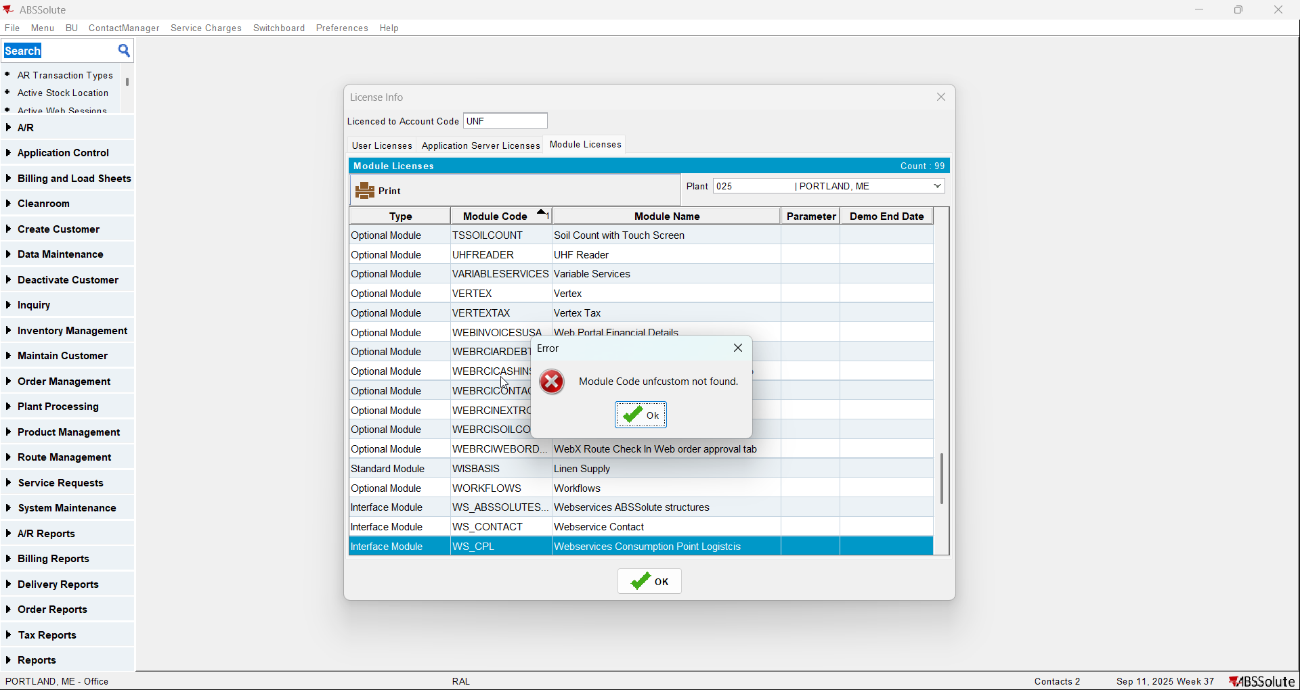
- Have a customer with country CA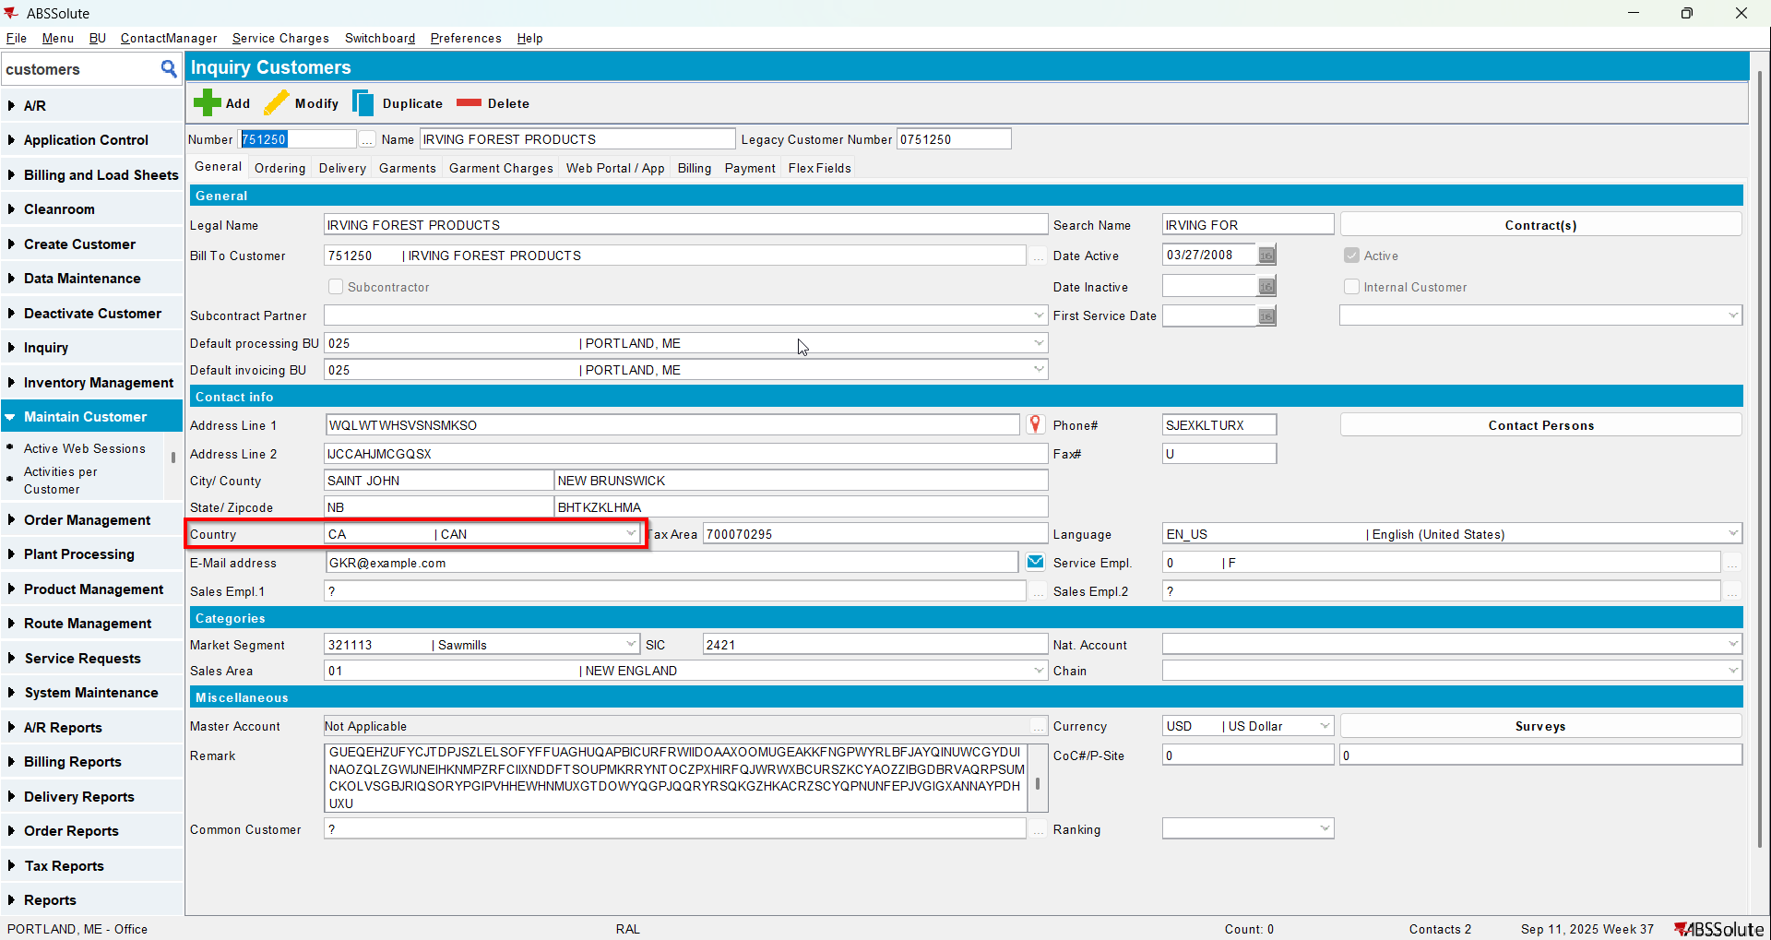
- Have another customer with country US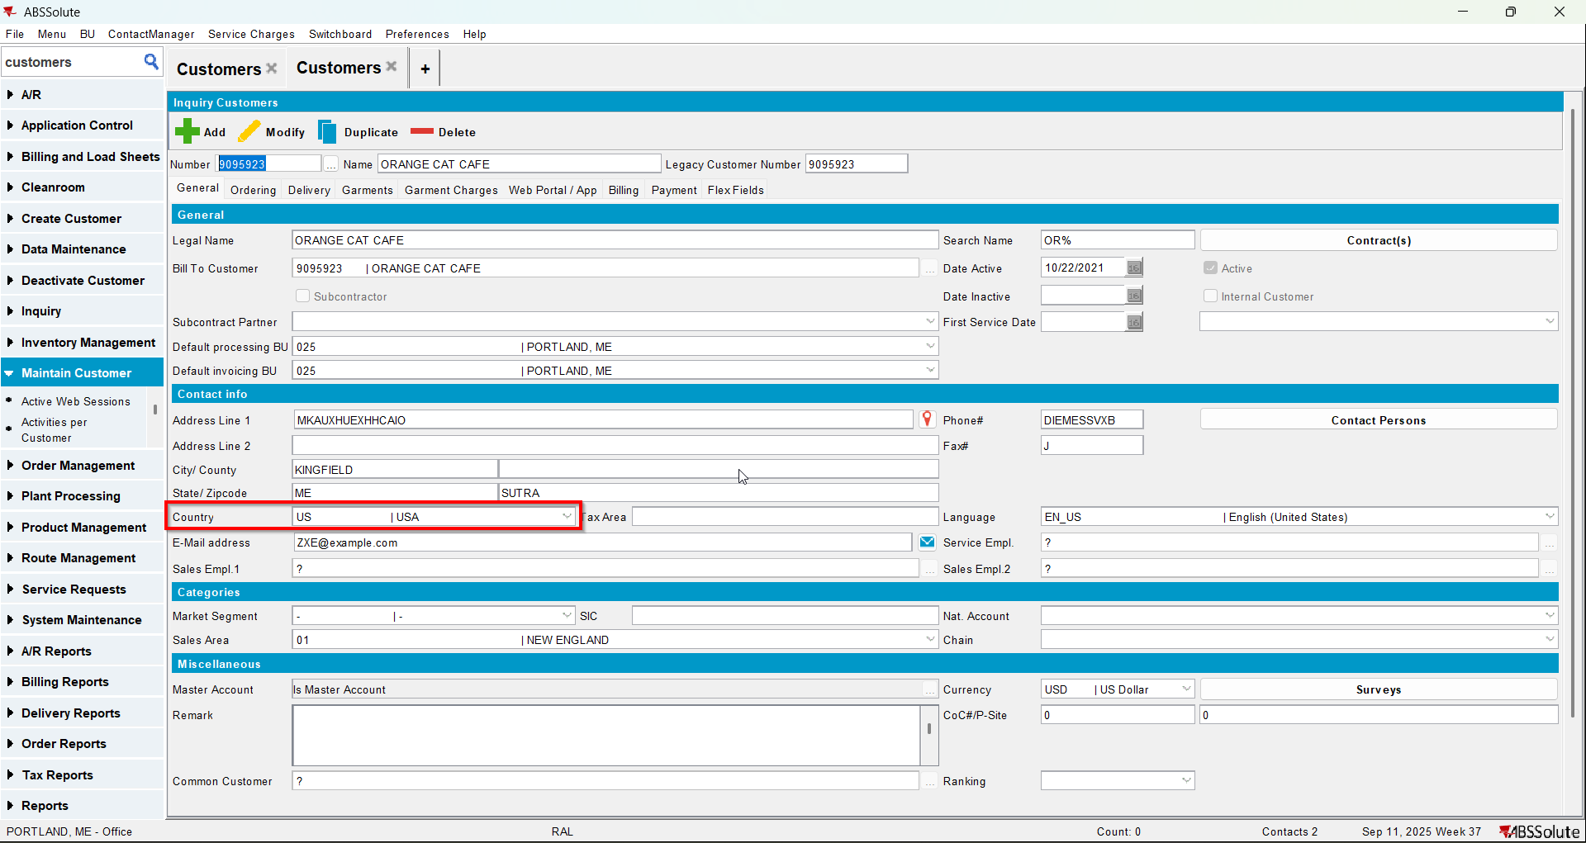
- For the customer with the country US change its bill to with the customer with country CA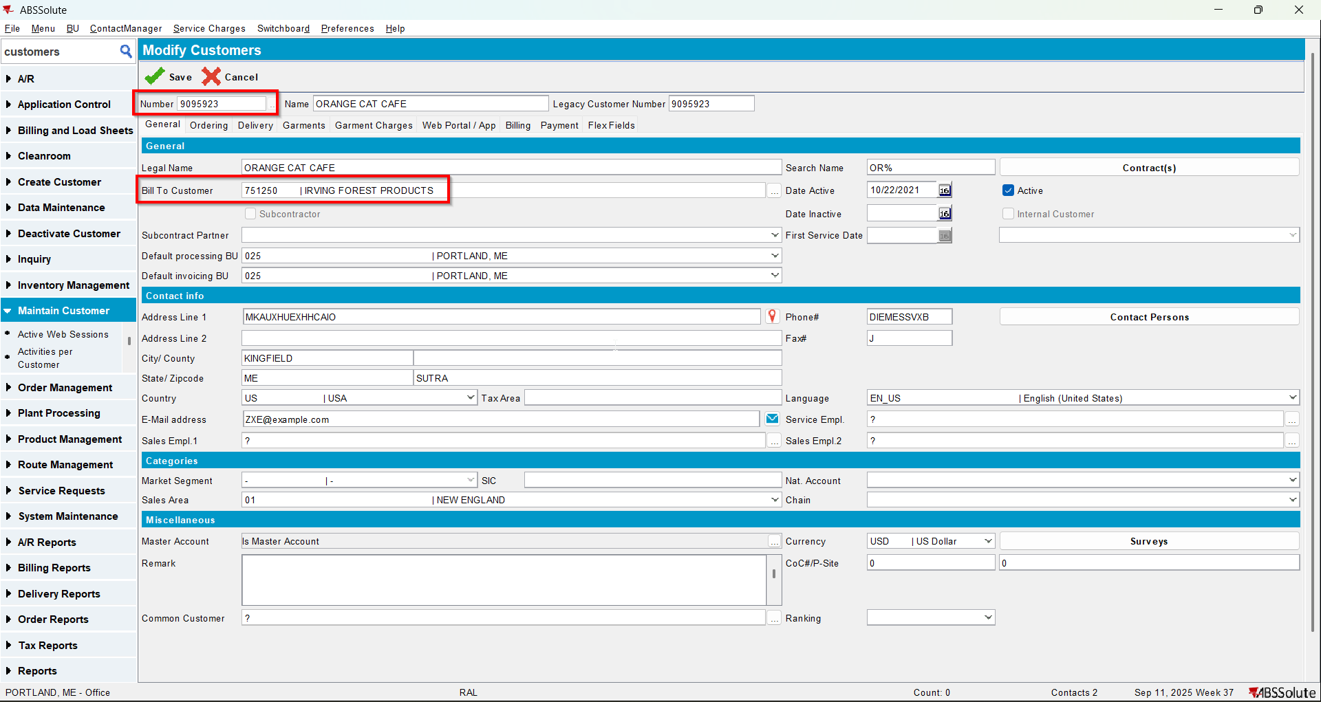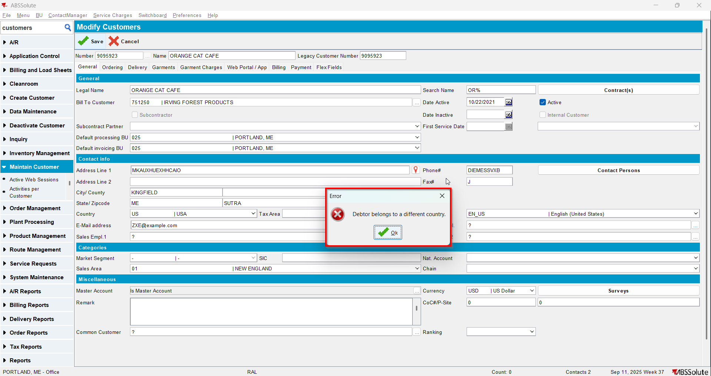

Test Case 2 – For a customer with a country change bill to with a customer with a different country with UNFCUSTOM – Tested OK
Expected behavior: The bill to should be update
Hash: 1241f7d
- Check that UNFCUSTOM is in the license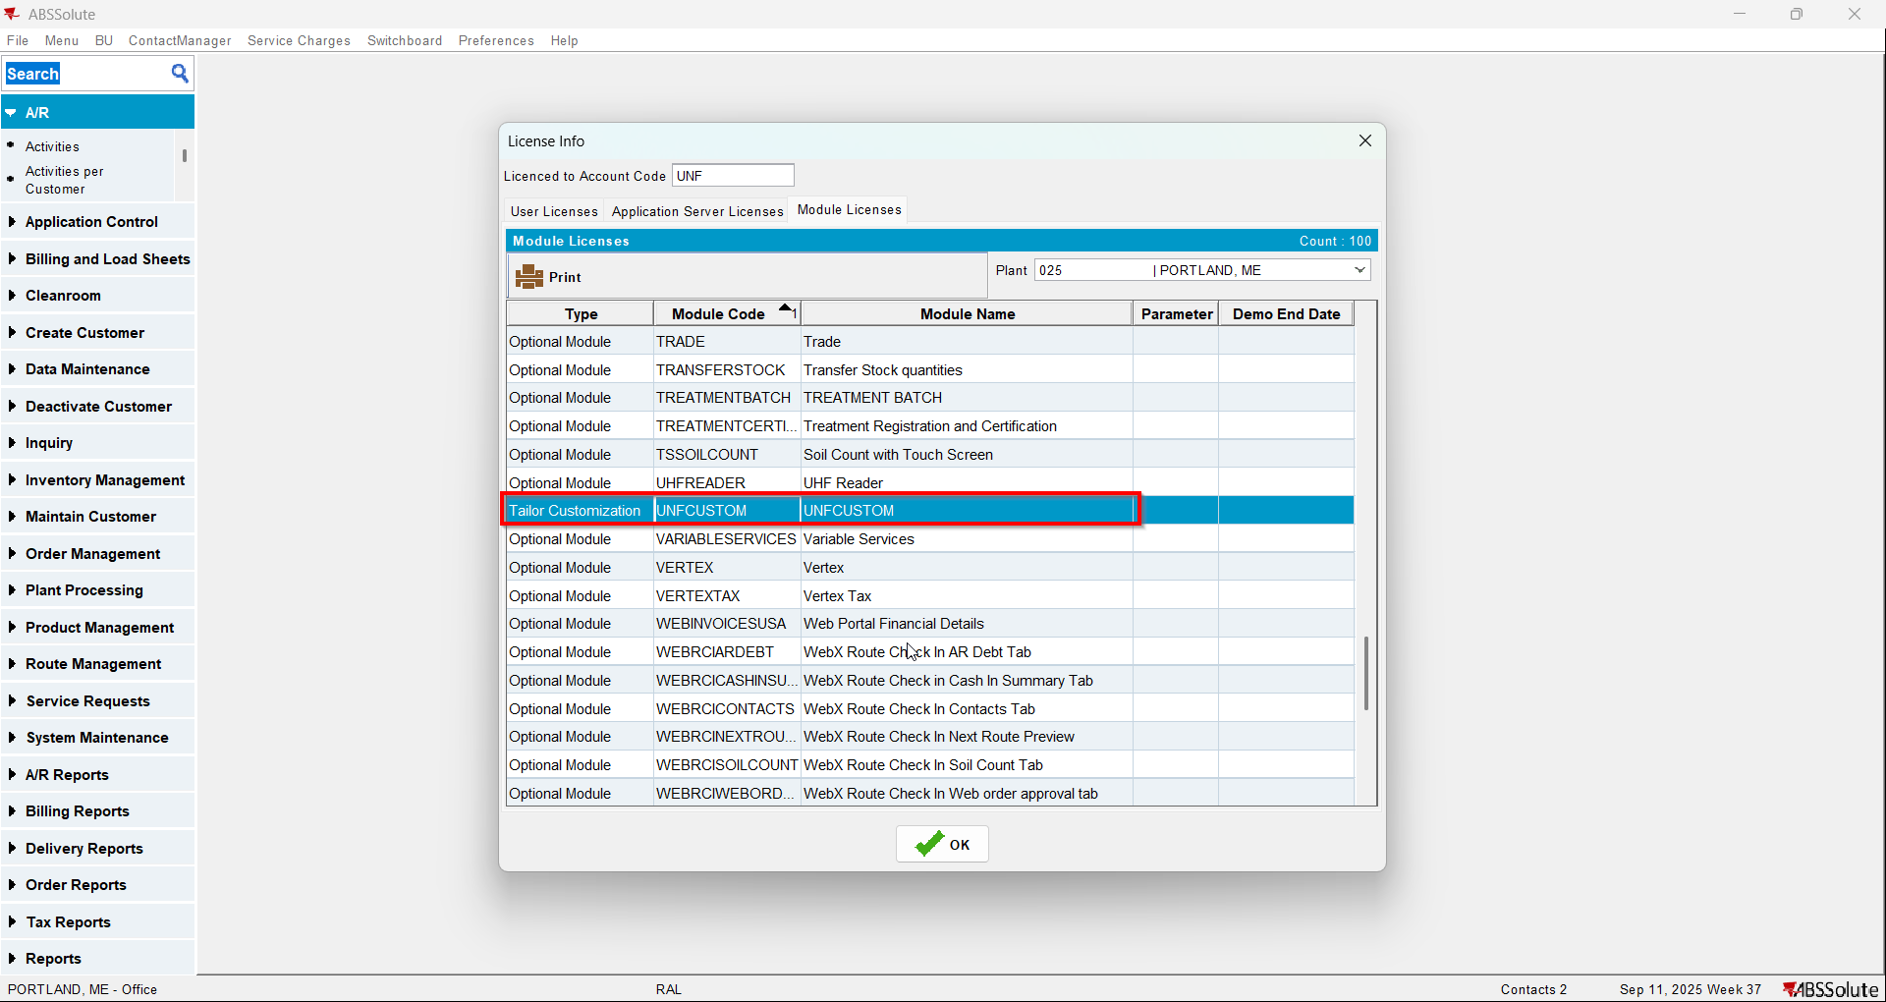
- Have a customer with country CA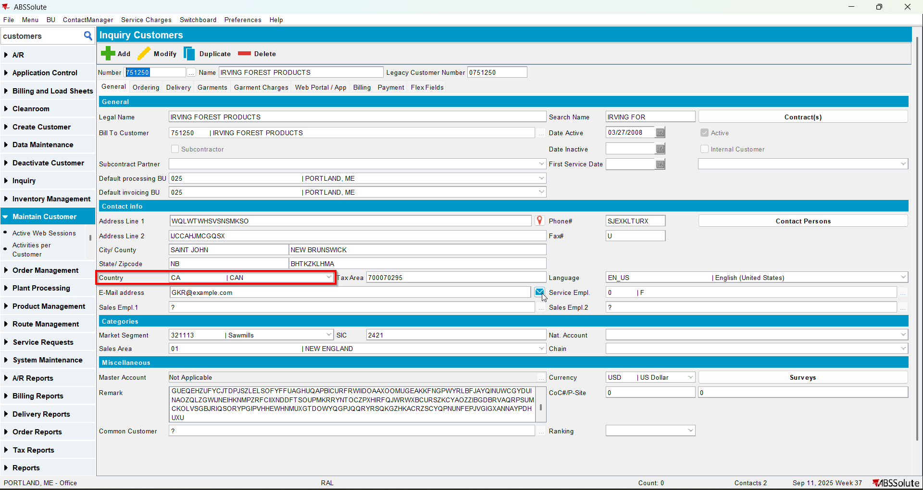
- Have another customer with country US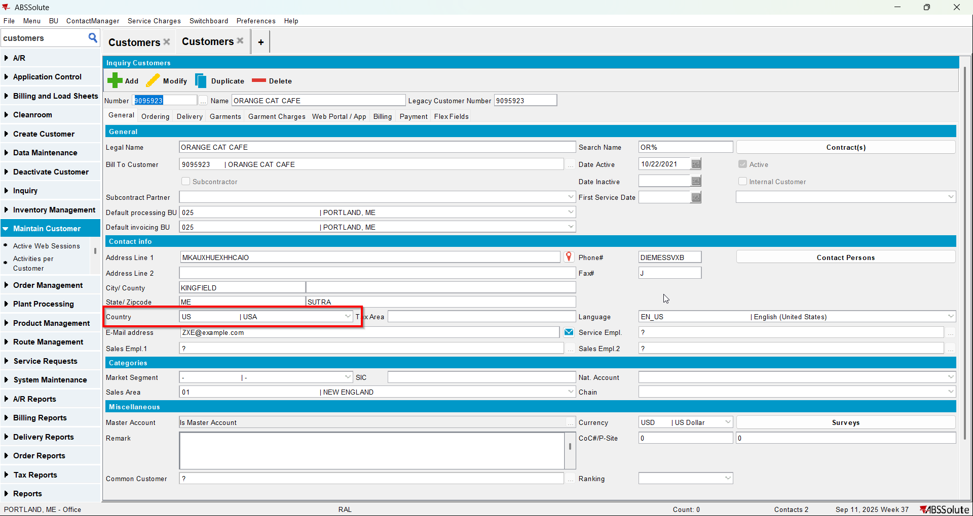
- For the customer with the country US change its bill to with the customer with country CA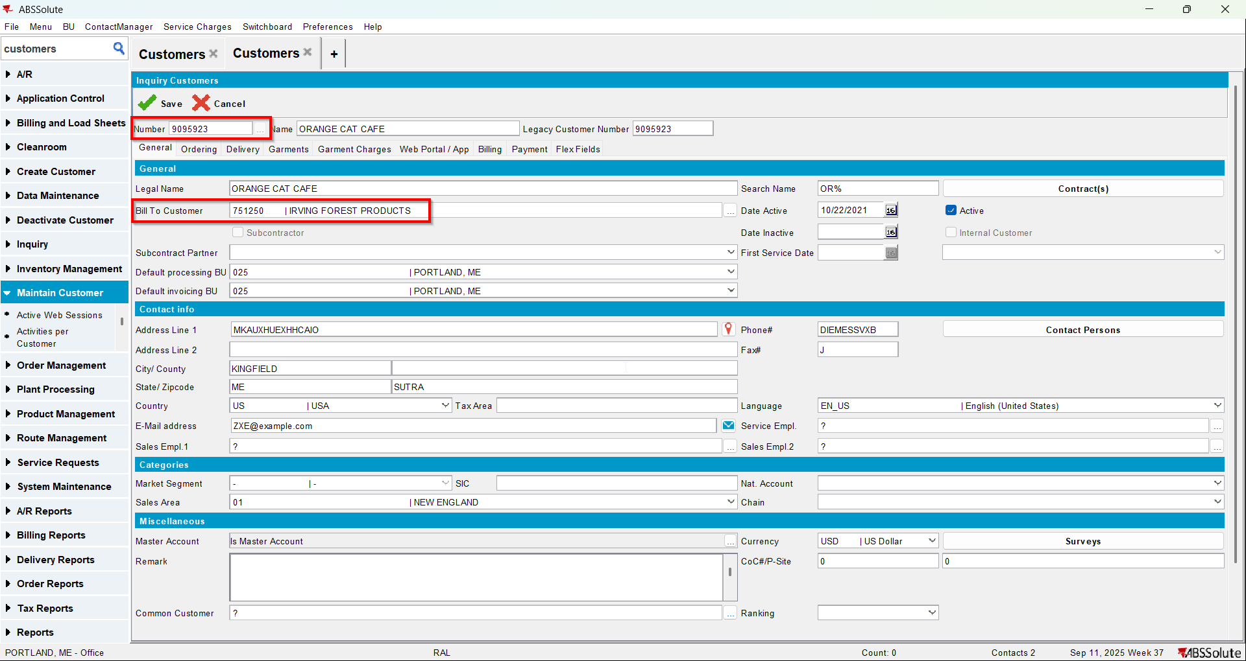
- Check that the bill to was updated