ABS-168245 D_UBS_2507 Incorrect residual value charge billing on quit wearer - adding origin to OOCH table
Environment | Prerequisites
Version: 9.07.00.UNF20  DBServerName=abs-srv20.internal.abslbs.com  DBSID= CUST24  DBUser= UNFDEV  Environment=Test | - Module:  - System setting

Contents
Test Case 01 – Checking the strings displayed in Maintain Garment Charges dlg for the origin codes – Tested Ok 1
Expected behavior 2
Steps to reproduce 2
Test Case 02 – 1 Return to stock / rag origin on OOCH table – Tested OK 6
Expected behavior 6
Steps to reproduce 6
Test Case 03 – 3 Settlement origin on OOCH table – Tested OK 9
Expected behavior 9
Steps to reproduce 9
Test Case 04 – 4 Route Returns origin on OOCH table – Tested OK 14
Expected behavior 14
Steps to reproduce 14
Test Case 05 – Cancel Loss charge from Loss Charge Monitor – Tested OK 19
Expected behavior 19
Steps to reproduce 19

Test Case 01 – Checking the strings displayed in Maintain Garment Charges dlg for the origin codes – Tested Ok
Hash: 9.07.00.UNF20 hash: bac9293fb677

Expected behavior
Columns Origin (as text), CreationTimeStamp (Column title “Created TimeStamp”) and CreationSystemUSer_ID (column title “Created By”), not displayed by default
Origin | Number | N | 0 | 0 = Not defined – default  1 = Return to stock / rag (Take items out of circ dialog)  2 = Return to stock / rag in batch  3 = Settlement  4 = Route Returns  5 = PL/SQL Return Unique Item To Stock  6 = RouteAssistant Upload  7 = PL/SQL MultiRead.RagScanInBatch  8 = Process Rag after grace period  9 = Garment dispenser  10 = Cancelled loss recharge in loss charge monitor
CreationSystemUser_ID | Number | Y |  | System user that created the record  NOTE: Not a foreign key
CreationTimeStamp | TimeStamp | Y |  | Timestamp of creation

Steps to reproduce
- Create multiple Residual Value entries for a customer
- Wearers dlg: Load a customer with wearers and unique garments, copy a unique garment.
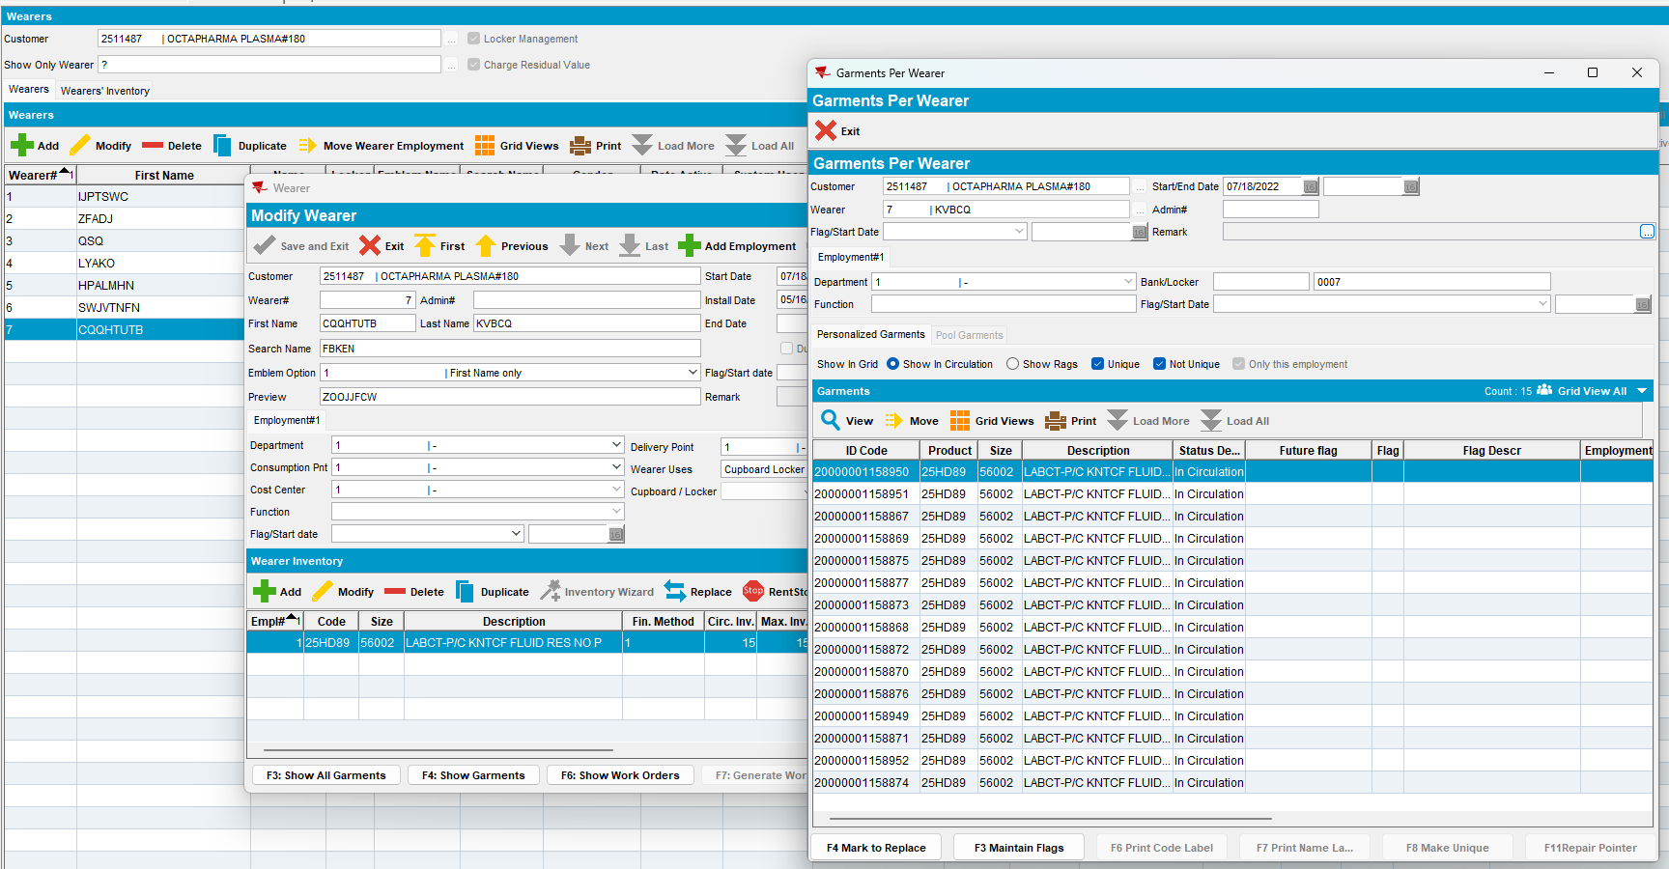
- Take items out of circ dlg: Load a garment and return it. Scan minimum 11 garments.
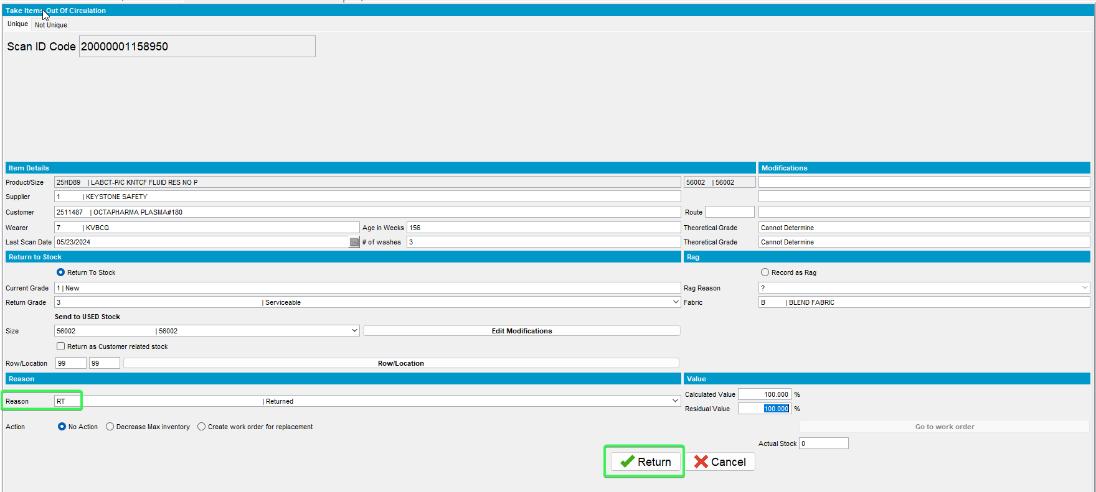
- Maintain Garment Charges dlg: Load the customer and check the Residual Values tab. Observe columns Origin, Created by and Created TimeStamp are not displayed by default
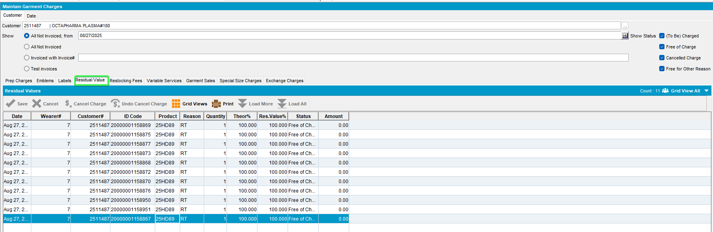
- Maintain Garment Charges dlg: Add columns Origin, Created By and Created TimeStamp
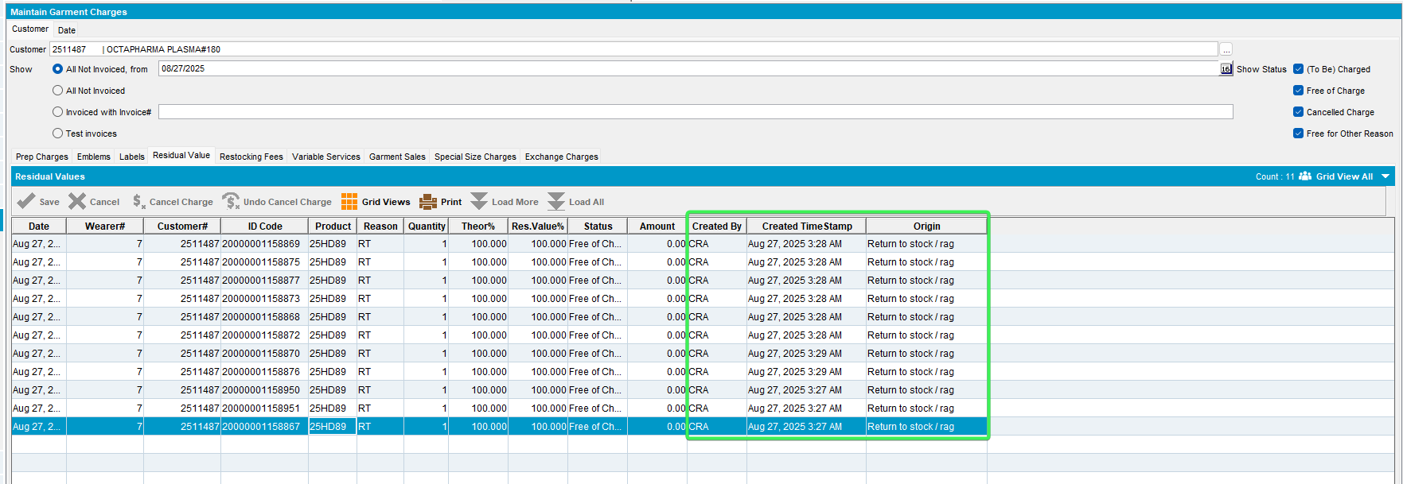
- Maintain Garment Charges dlg: Select Restocking Fees tab. Observe columns Origin, Created by and Created TimeStamp are not displayed by default
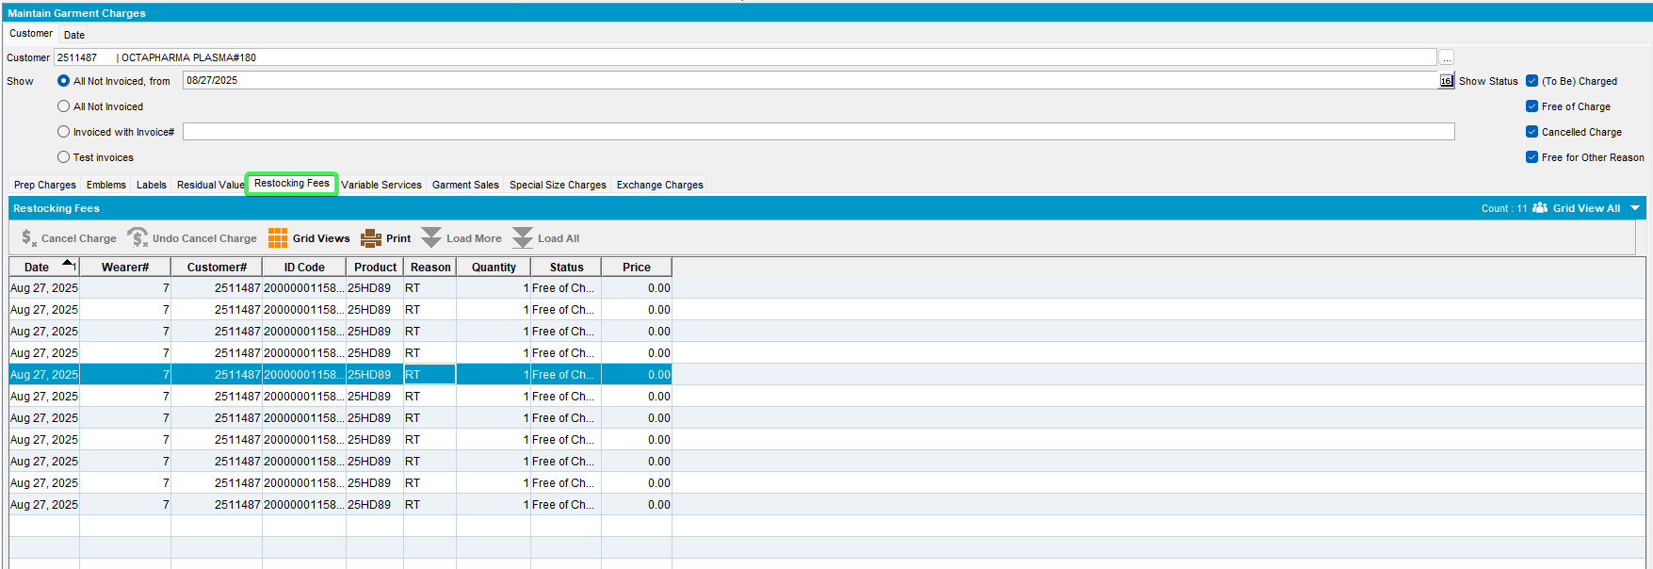
- Maintain Garment Charges dlg: Add columns Origin, Created By and Created TimeStamp
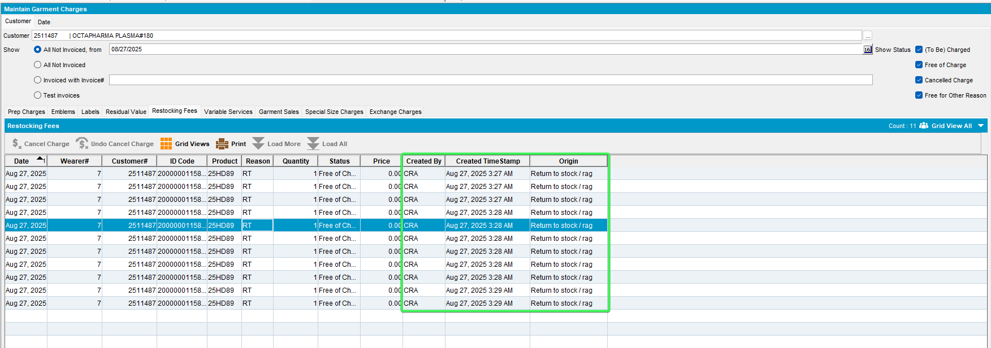
- Check the OUTOFCIRCULATIONHISTORY table
select *
from (select dynamicsql.*, rownum rnum
from (SELECT oh.outofcirculationhistory_id,
oh.outofcircdate,
cust.customernumber,
cust.name,
wearer.wearernumber,
wearer.wearername,
nvl(oh.primaryid, nvl(ui.primaryid, ri.primaryid)),
prod.code prodcode,
(select DESCRIPTION
from PRODUCT_LINK_DESC
where PRODUCT_LINK_DESC.PRODUCT_LINK_ID =
PROD.PRODUCT_LINK_ID
and LANGUAGE_ID = 1) proddesc,
reasoncode.code rccode,
(select DESCRIPTION
from REASONCODE_DESC
where REASONCODE_DESC.REASONCODE_ID =
OH.REASONCODE_ID
and LANGUAGE_ID = 1) rcdesc,
oh.quantity,
oh.theoreticalpercentage,
oh.tobechargedpercentage,
oh.enteredpercentage,
oh.status,
oh.systemuser_id,
oh.timestamp,
oh.enddatefullrent,
oh.residualvalue,
bu.code bucode,
bu.description,
oh.amount,
oh.rowcode,
oh.locationcode,
oh.chargetype,
ragreason.code rrcode,
(select DESCRIPTION
from RAGREASON_DESC
where RAGREASON_DESC.RAGREASON_ID = oh.ragreason_id
and LANGUAGE_ID = 1) rrdesc,
size2.code,
(select DESCRIPTION
from SIZEDEFINITION_LINK_DESC
where SIZEDEFINITION_LINK_DESC.SIZEDEFINITION_LINK_ID =
SIZE2.SIZEDEFINITION_LINK_ID
and LANGUAGE_ID = 1) sdesc,
distrpnt.distributionpointnumber,
oh.invoiceheader_id,
wearer.distributionpoint_link_id we_dp_id,
oh.distributionpoint_link_id oh_dp_id,
oh.customer_link_id,
oh.minimumamountcharged,
oh.origin,
oh.creationsystemuser_id,
oh.creationtimestamp
from outofcirculationhistory oh
left outer join invoiceheader
on oh.invoiceheader_id = invoiceheader.invoiceheader_id
left outer join(uniqueitem_link uil
left outer join uniqueitem ui
on uil.uniqueitem_id = ui.uniqueitem_id
left outer join raggeditem ri
on uil.raggeditem_id = ri.raggeditem_id) on oh.uniqueitem_link_id = uil.uniqueitem_link_id
left outer join weareremployment_link wearer
on oh.weareremployment_link_id =
wearer.weareremployment_link_id
left outer join businessunit bu
on oh.invoicebusinessunit_id = bu.businessunit_id
left outer join sizedefinition_link size2
on oh.sizedefinition_link_id =
size2.sizedefinition_link_id
left outer join ragreason
on oh.ragreason_id = ragreason.ragreason_id
left outer join distributionpoint_link distrpnt
on oh.distributionpoint_link_id =
distrpnt.distributionpoint_link_id, product_link prod,
customer_link cust, reasoncode
where oh.product_link_id = prod.product_link_id
and oh.customer_link_id = cust.customer_link_id
and oh.reasoncode_id = reasoncode.reasoncode_id
AND oh.customer_link_id = (select c.customer_id from customer c where c.customernumber = 2511487)
AND oh.outofcircdate >=
TO_DATE('2024-11-01 00:00:00', 'YYYY-MM-DD HH24:MI:SS')
AND oh.INVOICEHEADER_ID IS NULL
AND oh.chargetype <> 2) dynamicsql
where rownum <= 500)
where rnum >= 1
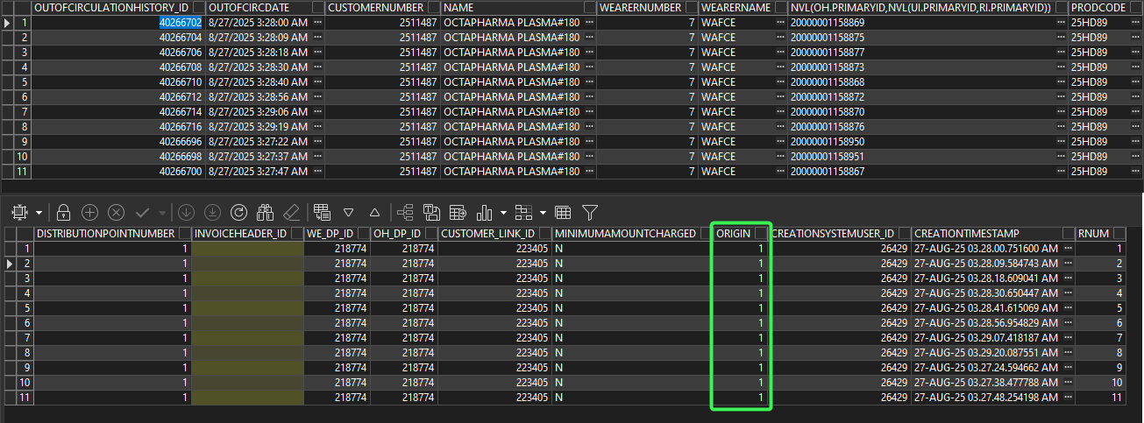
- Change the origin from database from 0 to 9.
select ooch.origin, ooch.* from outofcirculationhistory ooch
where ooch.outofcirculationhistory_id in (40265030, 40265032, 40265034, 40265036, 40265038, 40265040, 40265042, 40265044, 40265046, 40265048, 40265050) for update;

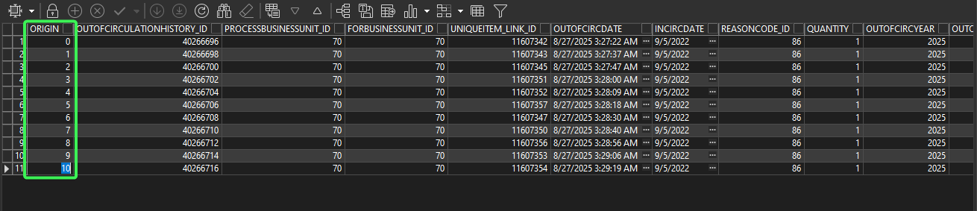
- Maintain Garment Charges dlg: Reload customer
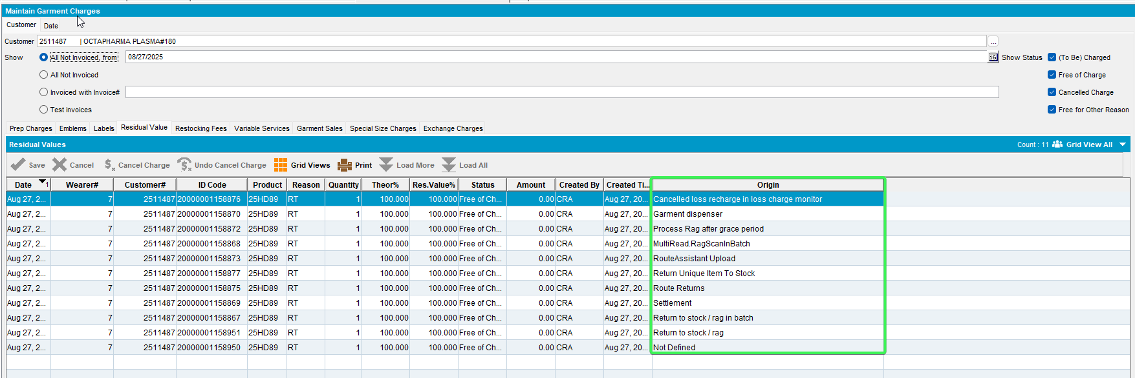
Tested OK

Test Case 02 – 1 Return to stock / rag origin on OOCH table – Tested OK
Hash: 9.07.00.UNF20 hash: bac9293fb677

Expected behavior
Table: OUTOFCIRCULATIONHISTORY the adding of entries in the below columns
CreationTimeStamp current date / time
CreationSystemUser_ID current logged in system user
Origin 1 (return to stock)

Steps to reproduce
- Wearers dlg: Load a customer with wearers and unique garments, copy a unique garment.
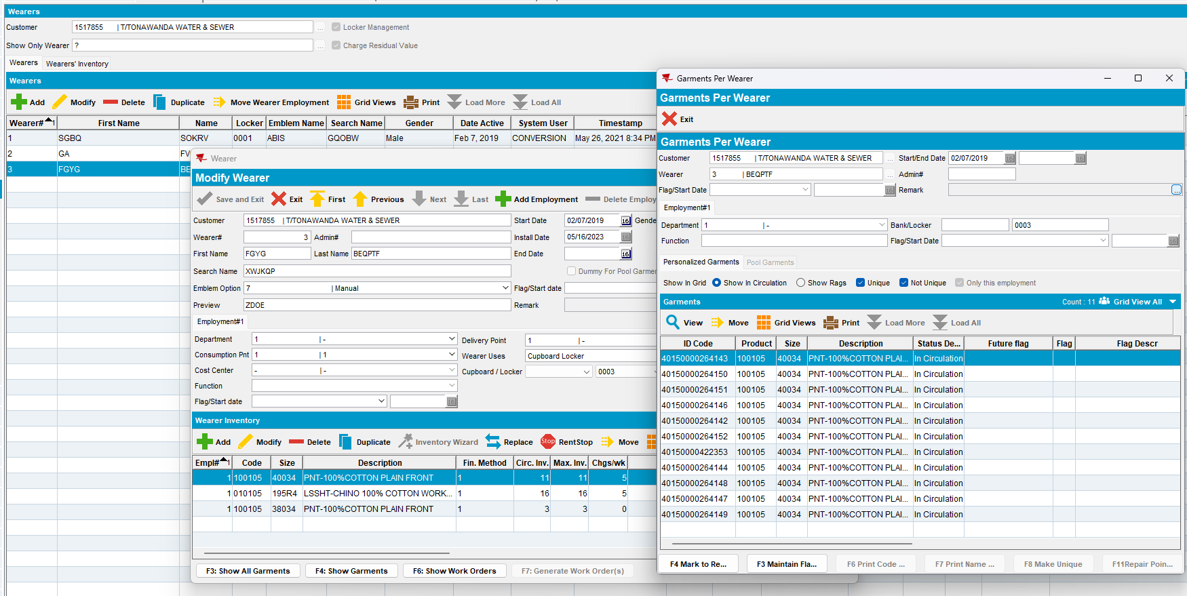
- Take items out of circ dlg: Load a garment and return it
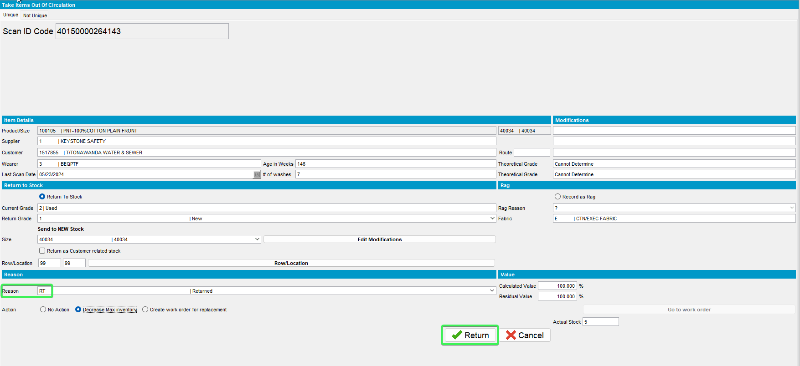
- Maintain Garment Charges dlg: Load the customer and check the Residual Value tab. We can see the Creation System User, Creation Timestamp and Origin.
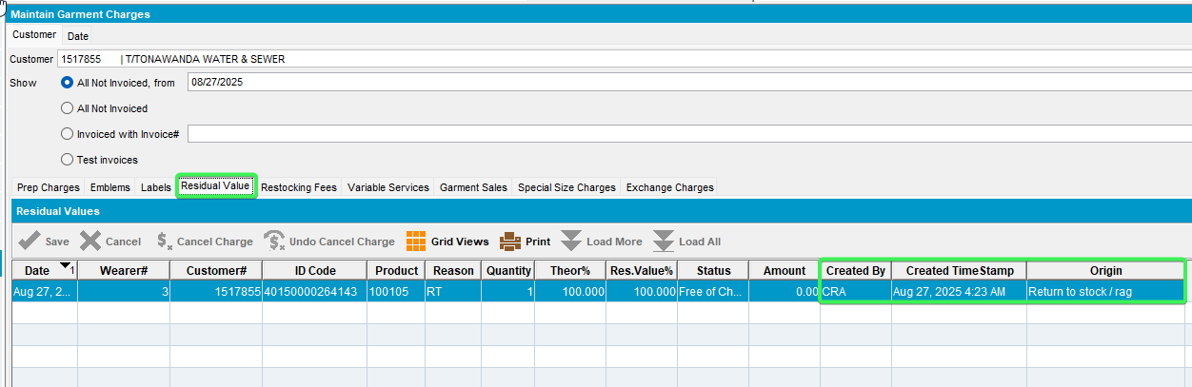
- Maintain Garment Charges dlg: Check the Restocking Fees tab. We can see the Creation System User, Creation Timestamp and Origin.
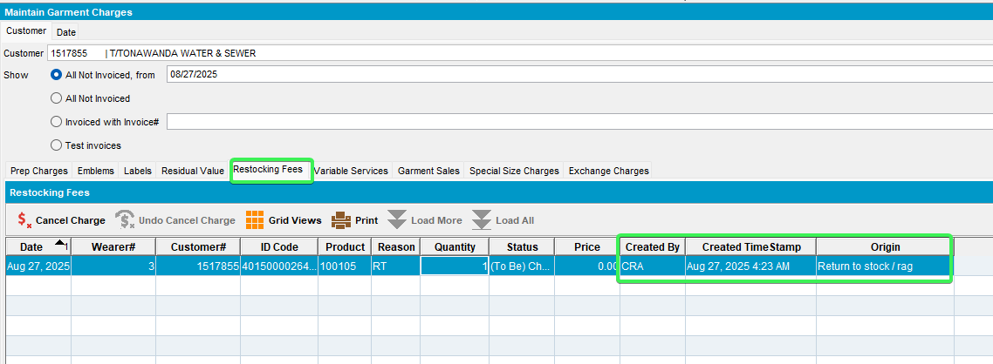
- Check also in database the columns Creation System User, Creation Timestamp and Origin.
select *
from (select dynamicsql.*, rownum rnum
from (SELECT oh.outofcirculationhistory_id,
oh.outofcircdate,
cust.customernumber,
cust.name,
wearer.wearernumber,
wearer.wearername,
nvl(oh.primaryid, nvl(ui.primaryid, ri.primaryid)),
prod.code prodcode,
(select DESCRIPTION
from PRODUCT_LINK_DESC
where PRODUCT_LINK_DESC.PRODUCT_LINK_ID =
PROD.PRODUCT_LINK_ID
and LANGUAGE_ID = 1) proddesc,
reasoncode.code rccode,
(select DESCRIPTION
from REASONCODE_DESC
where REASONCODE_DESC.REASONCODE_ID =
OH.REASONCODE_ID
and LANGUAGE_ID = 1) rcdesc,
oh.quantity,
oh.theoreticalpercentage,
oh.tobechargedpercentage,
oh.enteredpercentage,
oh.status,
oh.systemuser_id,
oh.timestamp,
oh.enddatefullrent,
oh.residualvalue,
bu.code bucode,
bu.description,
oh.amount,
oh.rowcode,
oh.locationcode,
oh.chargetype,
ragreason.code rrcode,
(select DESCRIPTION
from RAGREASON_DESC
where RAGREASON_DESC.RAGREASON_ID = oh.ragreason_id
and LANGUAGE_ID = 1) rrdesc,
size2.code,
(select DESCRIPTION
from SIZEDEFINITION_LINK_DESC
where SIZEDEFINITION_LINK_DESC.SIZEDEFINITION_LINK_ID =
SIZE2.SIZEDEFINITION_LINK_ID
and LANGUAGE_ID = 1) sdesc,
distrpnt.distributionpointnumber,
oh.invoiceheader_id,
wearer.distributionpoint_link_id we_dp_id,
oh.distributionpoint_link_id oh_dp_id,
oh.customer_link_id,
oh.minimumamountcharged,
oh.origin,
oh.creationsystemuser_id,
oh.creationtimestamp
from outofcirculationhistory oh
left outer join invoiceheader
on oh.invoiceheader_id = invoiceheader.invoiceheader_id
left outer join(uniqueitem_link uil
left outer join uniqueitem ui
on uil.uniqueitem_id = ui.uniqueitem_id
left outer join raggeditem ri
on uil.raggeditem_id = ri.raggeditem_id) on oh.uniqueitem_link_id = uil.uniqueitem_link_id
left outer join weareremployment_link wearer
on oh.weareremployment_link_id =
wearer.weareremployment_link_id
left outer join businessunit bu
on oh.invoicebusinessunit_id = bu.businessunit_id
left outer join sizedefinition_link size2
on oh.sizedefinition_link_id =
size2.sizedefinition_link_id
left outer join ragreason
on oh.ragreason_id = ragreason.ragreason_id
left outer join distributionpoint_link distrpnt
on oh.distributionpoint_link_id =
distrpnt.distributionpoint_link_id, product_link prod,
customer_link cust, reasoncode
where oh.product_link_id = prod.product_link_id
and oh.customer_link_id = cust.customer_link_id
and oh.reasoncode_id = reasoncode.reasoncode_id
AND oh.customer_link_id = 86681
AND oh.outofcircdate >=
TO_DATE('2024-11-01 00:00:00', 'YYYY-MM-DD HH24:MI:SS')
AND oh.INVOICEHEADER_ID IS NULL
AND oh.chargetype <> 2) dynamicsql
where rownum <= 500)
where rnum >= 1

Rag a garment from Take Items Out of Circulation
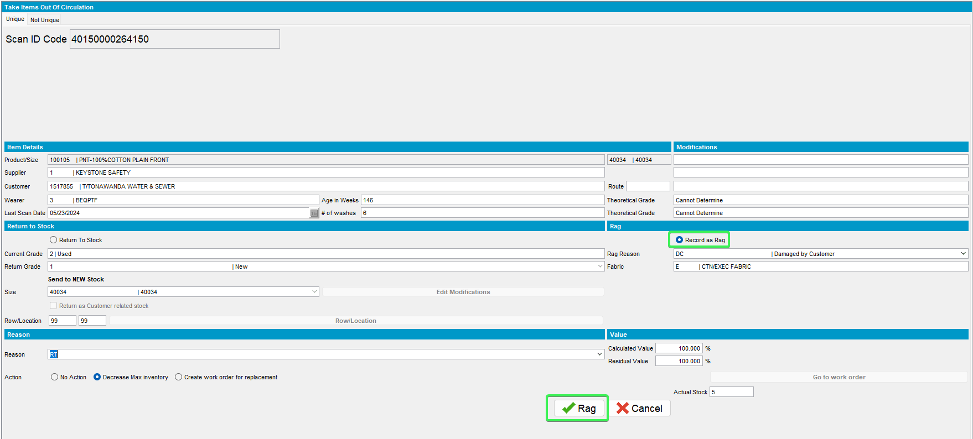
Maintain Garment Charges
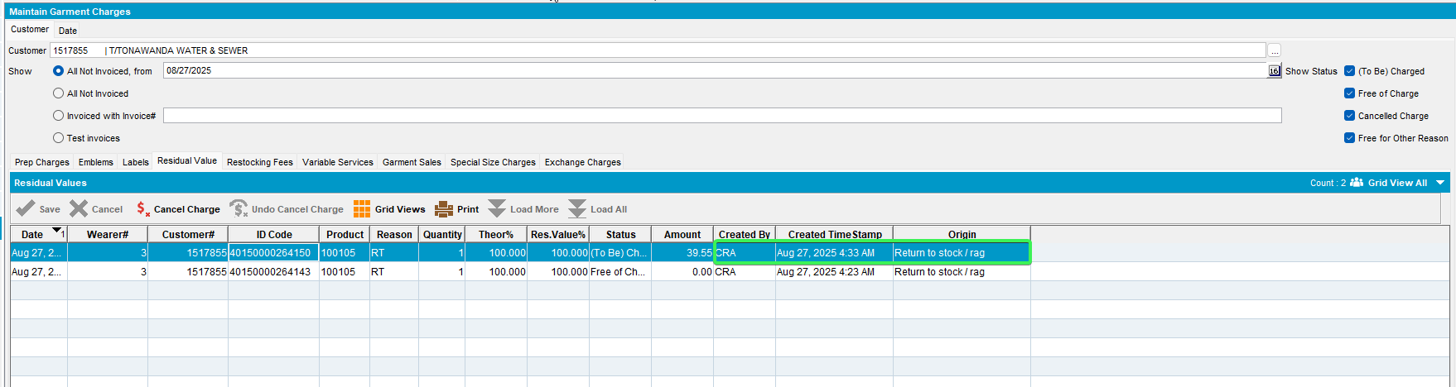

Tested OK

Test Case 03 – 3 Settlement origin on OOCH table – Tested OK
Hash: 9.07.00.UNF20 hash: bac9293fb677

Expected behavior
Table: OUTOFCIRCULATIONHISTORY the adding of entries in the below columns
CreationTimeStamp current date / time
CreationSystemUser_ID current logged in system user
Origin 3 = Settlement

Steps to reproduce
- System Settings dlg: Make sure ss PROCESSLOSSINSETTLEMENT to 1.
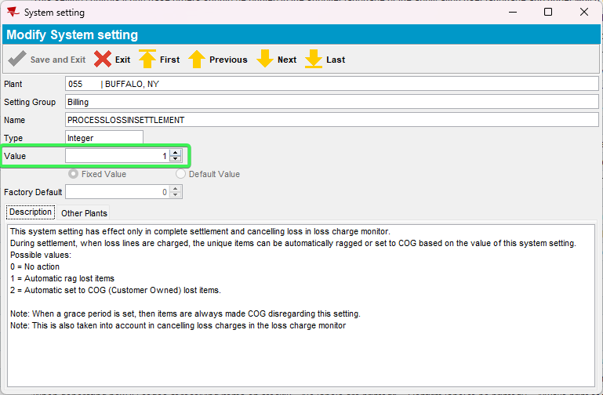
- Wearers dlg: Load a customer with wearers and unique garments.
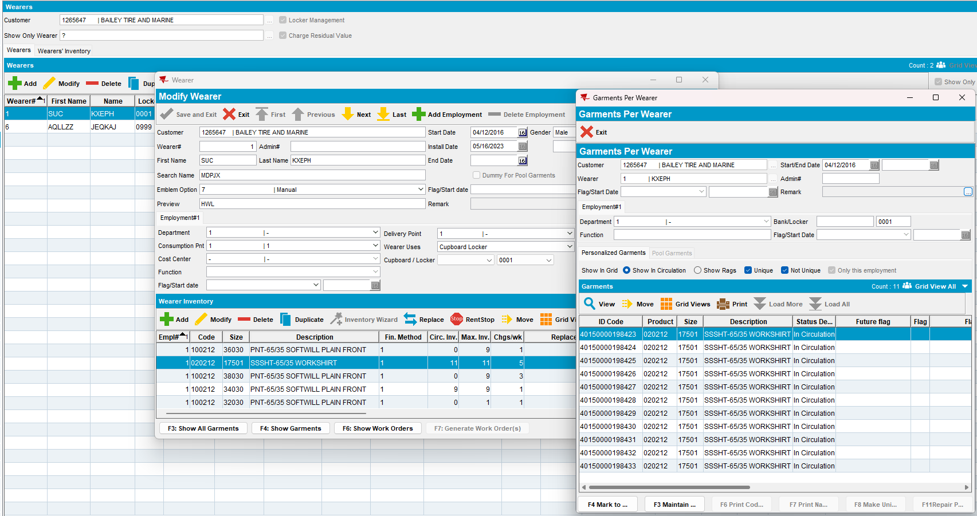
- Wearers dlg: Quit the wearer.
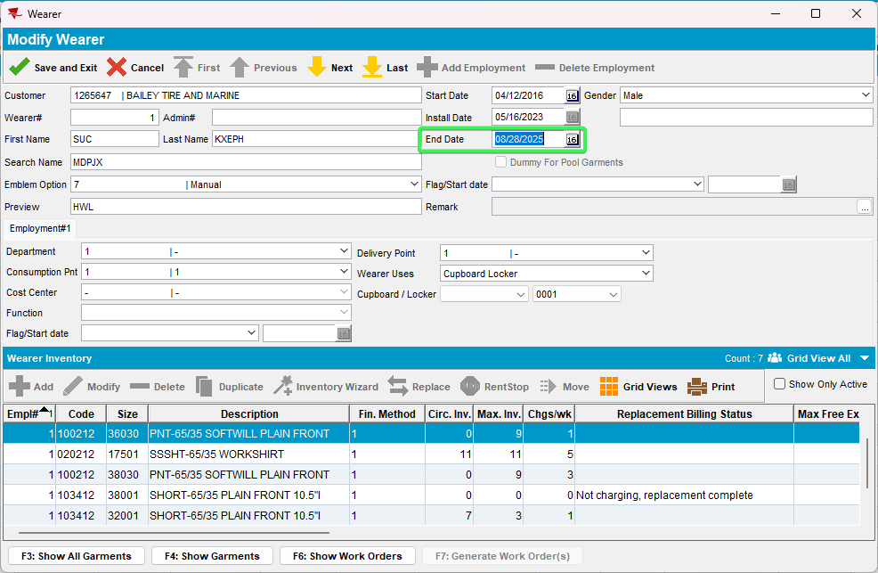
- RSC dlg: Create a new route containing the customer, 2 weeks+ in the future. Generate invoices and send the route to PDA.
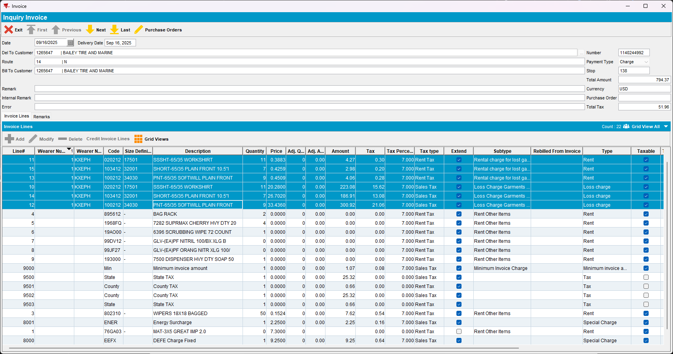
- RA: Download the route and arrive at the customer.
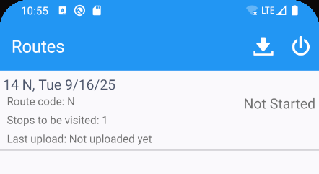
- RA: Don’t do any transactions, settle and depart.
- WebX: Review everything and settle the route.

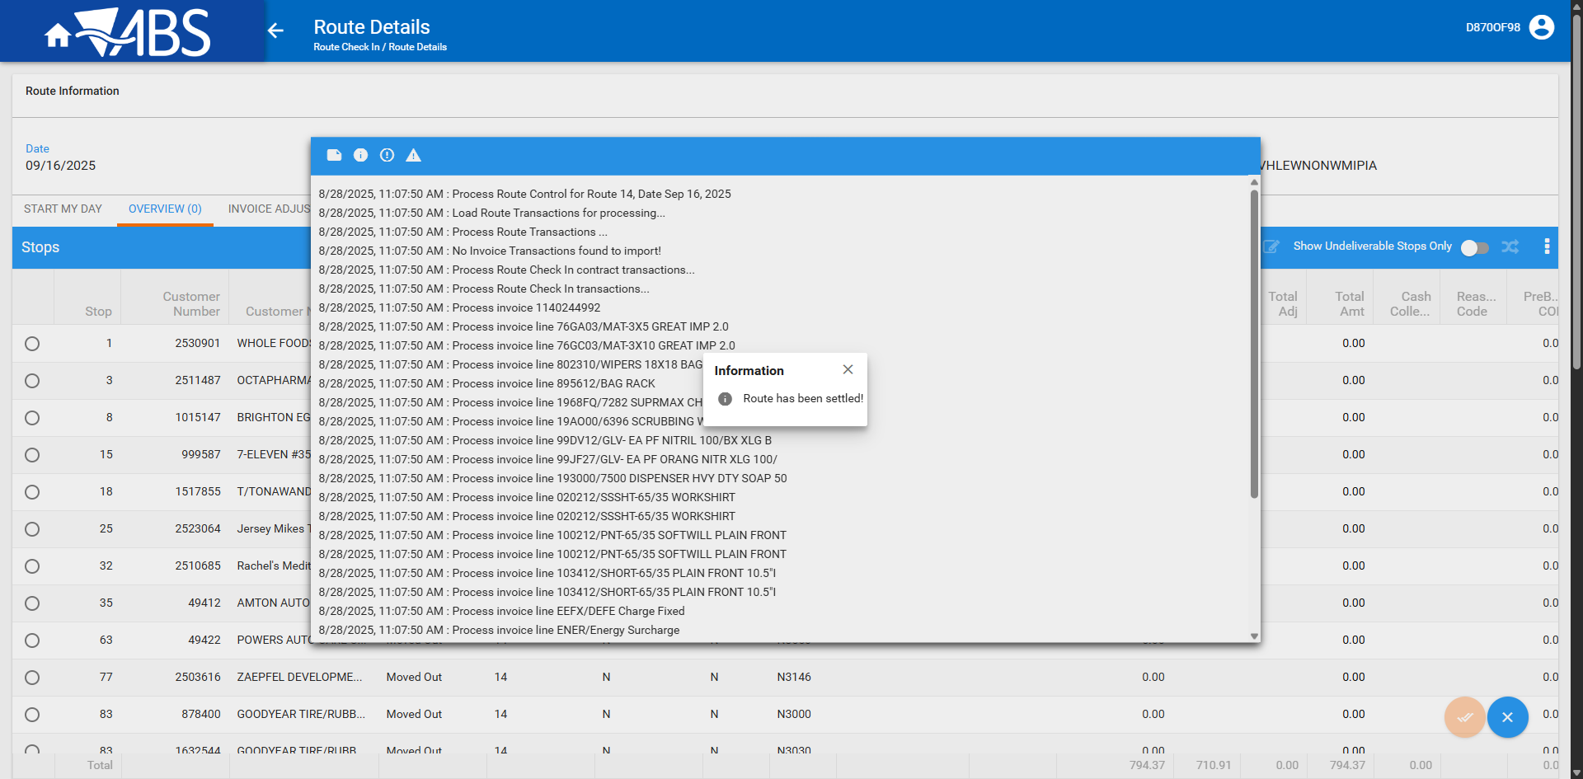
- Maintain Garments Charges dlg: Check for the garment
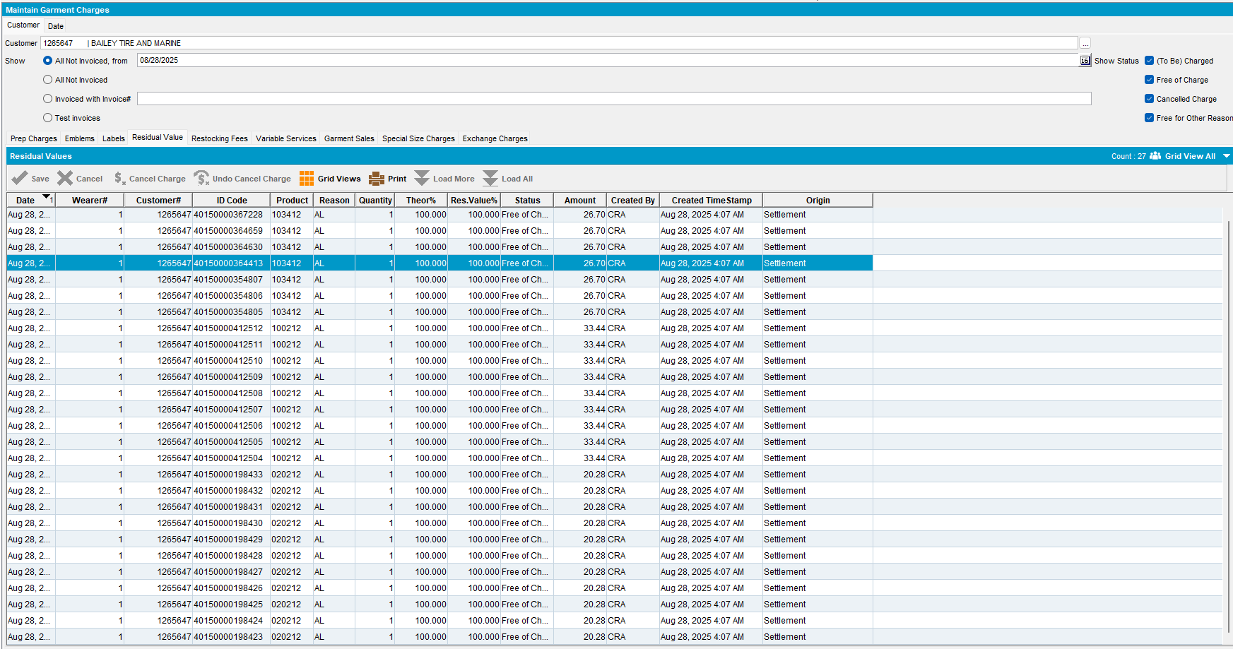
- Check in PLSQL
select *
from (select dynamicsql.*, rownum rnum
from (SELECT oh.outofcirculationhistory_id,
oh.outofcircdate,
cust.customernumber,
cust.name,
wearer.wearernumber,
wearer.wearername,
nvl(oh.primaryid, nvl(ui.primaryid, ri.primaryid)),
prod.code prodcode,
(select DESCRIPTION
from PRODUCT_LINK_DESC
where PRODUCT_LINK_DESC.PRODUCT_LINK_ID =
PROD.PRODUCT_LINK_ID
and LANGUAGE_ID = 1) proddesc,
reasoncode.code rccode,
(select DESCRIPTION
from REASONCODE_DESC
where REASONCODE_DESC.REASONCODE_ID =
OH.REASONCODE_ID
and LANGUAGE_ID = 1) rcdesc,
oh.quantity,
oh.theoreticalpercentage,
oh.tobechargedpercentage,
oh.enteredpercentage,
oh.status,
oh.systemuser_id,
oh.timestamp,
oh.enddatefullrent,
oh.residualvalue,
bu.code bucode,
bu.description,
oh.amount,
oh.rowcode,
oh.locationcode,
oh.chargetype,
ragreason.code rrcode,
(select DESCRIPTION
from RAGREASON_DESC
where RAGREASON_DESC.RAGREASON_ID = oh.ragreason_id
and LANGUAGE_ID = 1) rrdesc,
size2.code,
(select DESCRIPTION
from SIZEDEFINITION_LINK_DESC
where SIZEDEFINITION_LINK_DESC.SIZEDEFINITION_LINK_ID =
SIZE2.SIZEDEFINITION_LINK_ID
and LANGUAGE_ID = 1) sdesc,
distrpnt.distributionpointnumber,
oh.invoiceheader_id,
wearer.distributionpoint_link_id we_dp_id,
oh.distributionpoint_link_id oh_dp_id,
oh.customer_link_id,
oh.minimumamountcharged,
oh.origin,
oh.creationsystemuser_id,
oh.creationtimestamp
from outofcirculationhistory oh
left outer join invoiceheader
on oh.invoiceheader_id = invoiceheader.invoiceheader_id
left outer join(uniqueitem_link uil
left outer join uniqueitem ui
on uil.uniqueitem_id = ui.uniqueitem_id
left outer join raggeditem ri
on uil.raggeditem_id = ri.raggeditem_id) on oh.uniqueitem_link_id = uil.uniqueitem_link_id
left outer join weareremployment_link wearer
on oh.weareremployment_link_id =
wearer.weareremployment_link_id
left outer join businessunit bu
on oh.invoicebusinessunit_id = bu.businessunit_id
left outer join sizedefinition_link size2
on oh.sizedefinition_link_id =
size2.sizedefinition_link_id
left outer join ragreason
on oh.ragreason_id = ragreason.ragreason_id
left outer join distributionpoint_link distrpnt
on oh.distributionpoint_link_id =
distrpnt.distributionpoint_link_id, product_link prod,
customer_link cust, reasoncode
where oh.product_link_id = prod.product_link_id
and oh.customer_link_id = cust.customer_link_id
and oh.reasoncode_id = reasoncode.reasoncode_id
AND oh.customer_link_id = (select c.customer_id from customer c where c.customernumber = 1564845)
AND oh.outofcircdate >=
TO_DATE('2024-11-01 00:00:00', 'YYYY-MM-DD HH24:MI:SS')
AND oh.INVOICEHEADER_ID IS NULL
AND oh.chargetype <> 2) dynamicsql
where rownum <= 500)
where rnum >= 1
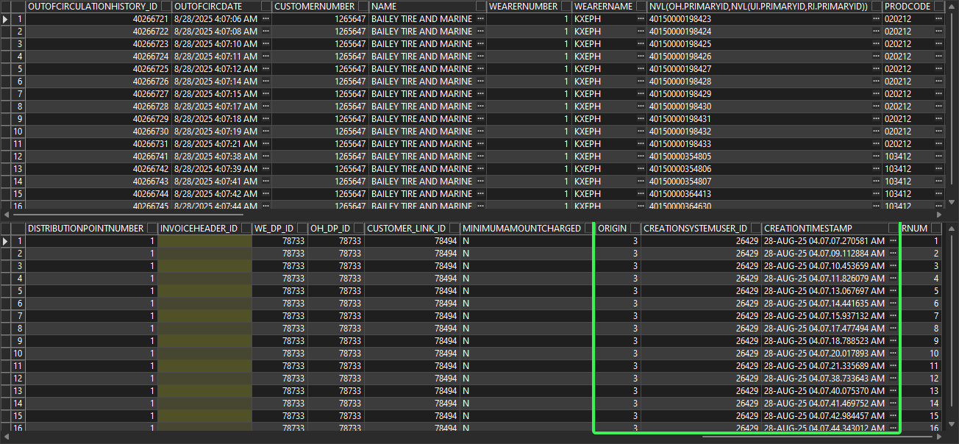
The Origin is 3 = Settlement
Tested OK

Test Case 04 – 4 Route Returns origin on OOCH table – Tested OK
Hash: 9.07.00.UNF20 hash: bac9293fb677

Expected behavior
Table: OUTOFCIRCULATIONHISTORY the adding of entries in the below columns
CreationTimeStamp current date / time
CreationSystemUser_ID current logged in system user
Origin 4 = Route Returns

Steps to reproduce
- RSC dlg: Create a route containing a customer with garment delivery. Generate invoices and send the route to PDA.
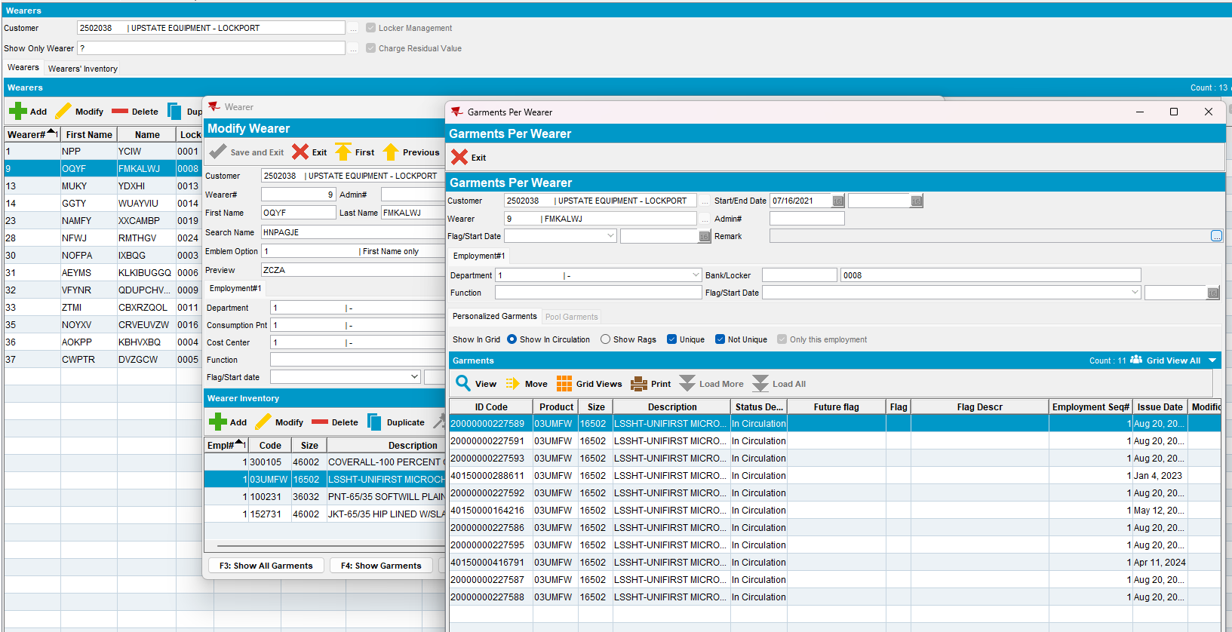
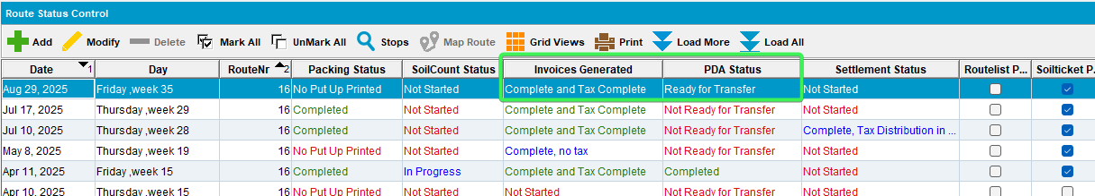
- System Settings dlg: Change ss DEFAULTROUTERETURNACTION to 2.
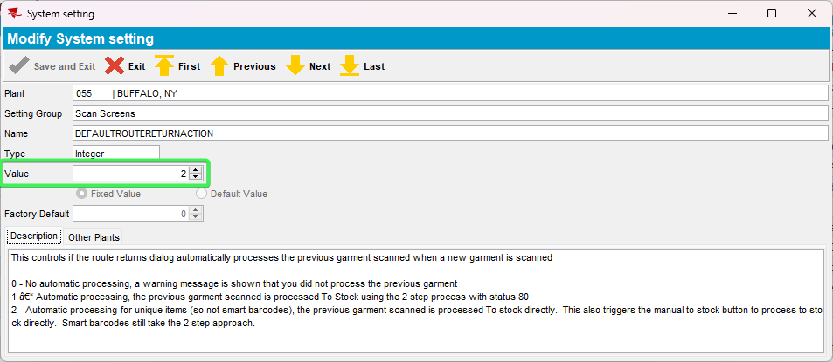
- System Settings dlg: Change ss REASONCODEFORTOSTOCK to have a real value from Reason Codes dlg
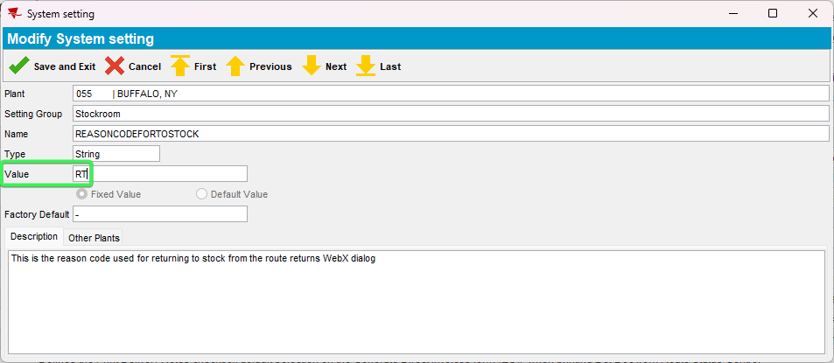
- RA: Download the route and arrive at the customer. Quit a wearer inventory and scan return some garments.

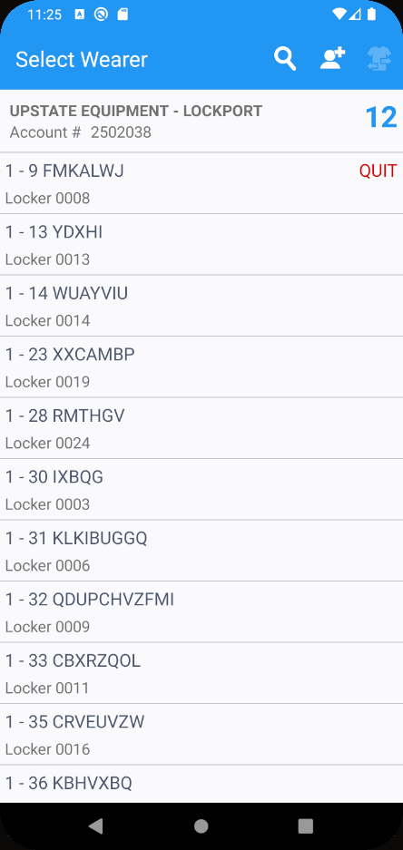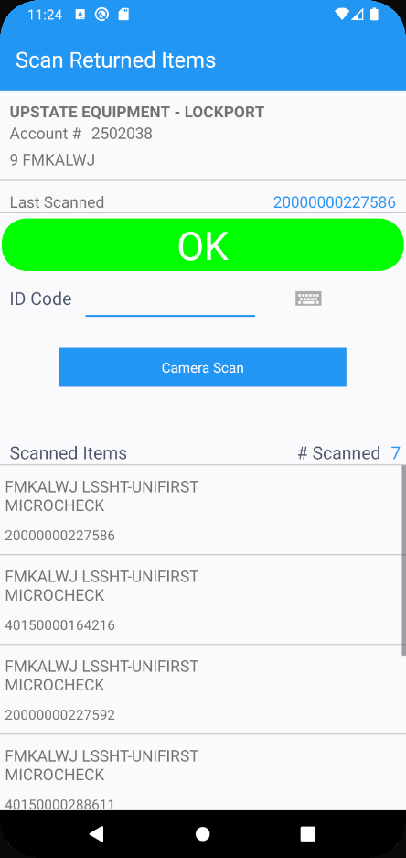
- RA: Settle and depart, finish the route and depart.
- Route Return: Scan for return to stock an unique garment.
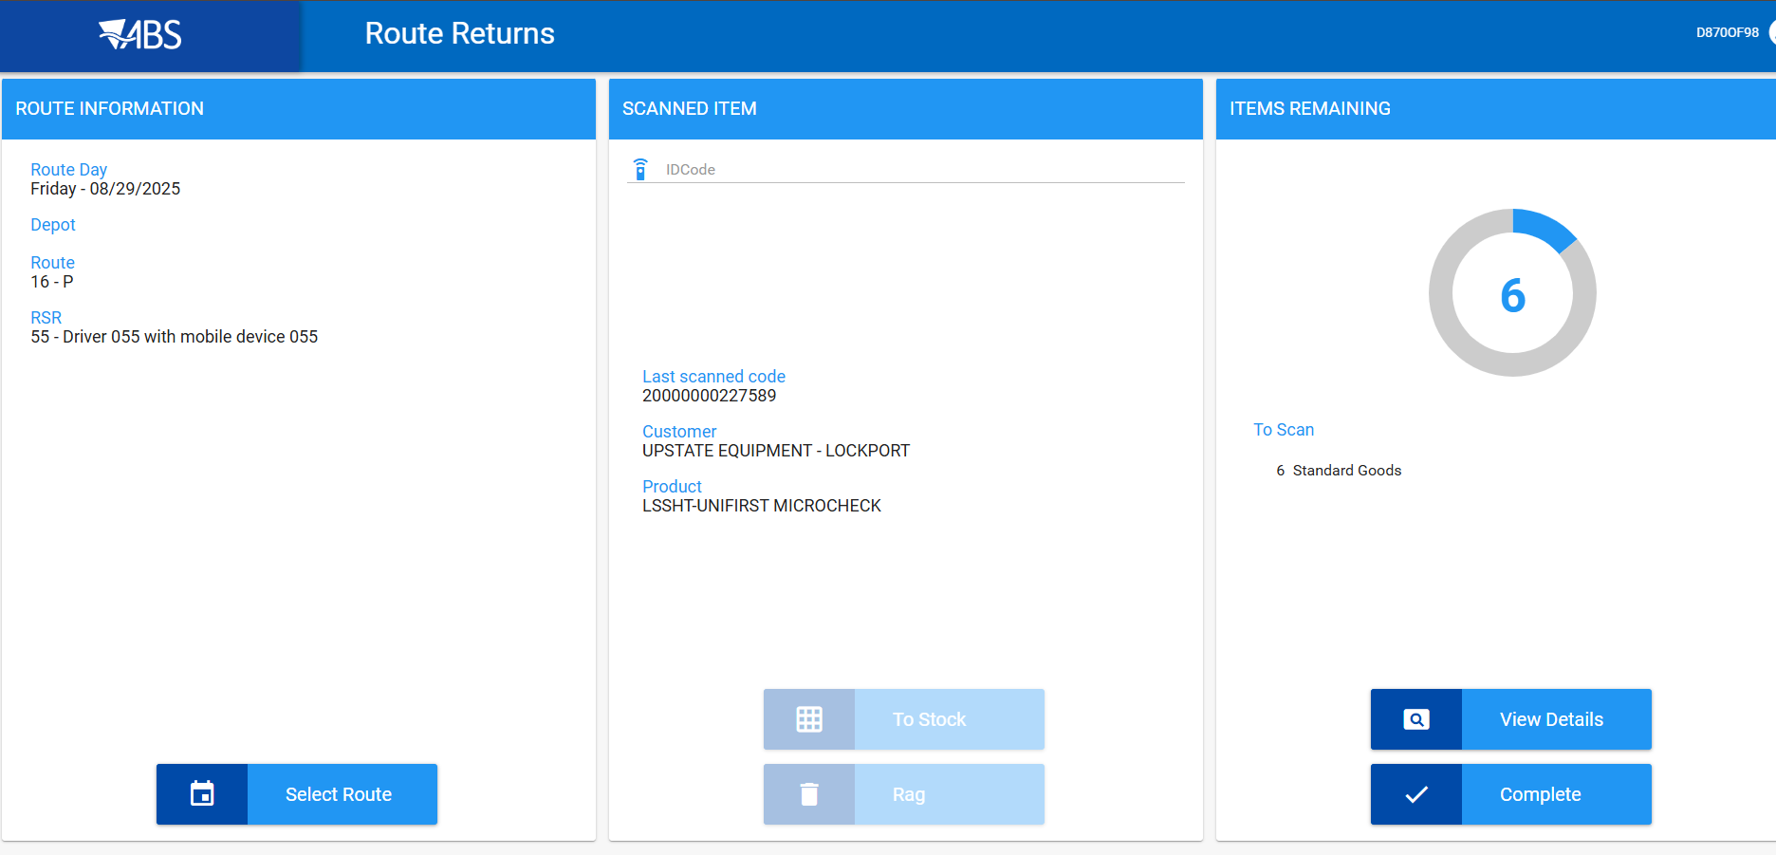
- Maintain Garment Charges dlg: Check the Residual Value and Restocking Fees tab for the garment. Check Origin, Created By and Created Timestamp columns.
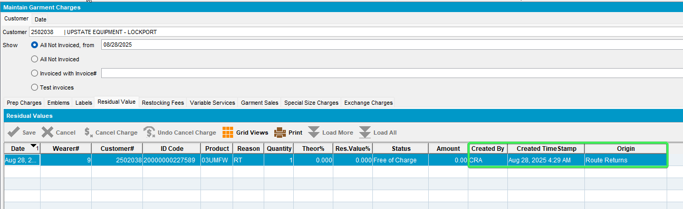
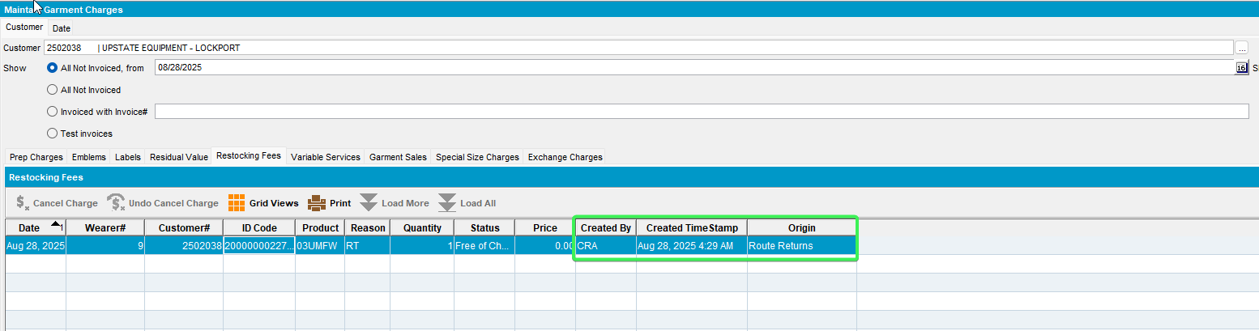
- Check the WebServer Error Log Catalina, no errors
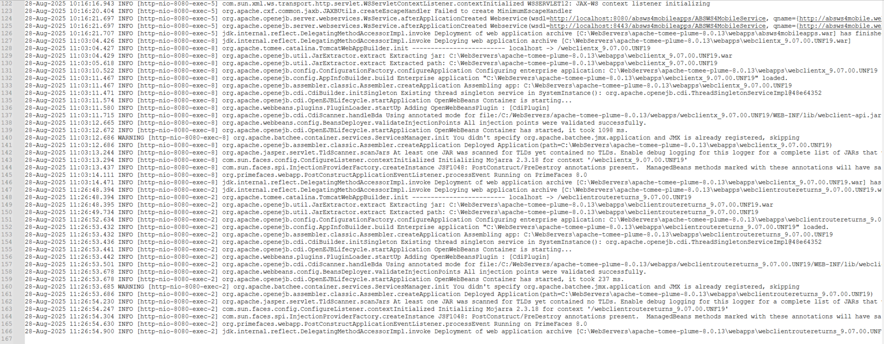
- PLSQL, check in the database
select *
from (select dynamicsql.*, rownum rnum
from (SELECT oh.outofcirculationhistory_id,
oh.outofcircdate,
cust.customernumber,
cust.name,
wearer.wearernumber,
wearer.wearername,
nvl(oh.primaryid, nvl(ui.primaryid, ri.primaryid)),
prod.code prodcode,
(select DESCRIPTION
from PRODUCT_LINK_DESC
where PRODUCT_LINK_DESC.PRODUCT_LINK_ID =
PROD.PRODUCT_LINK_ID
and LANGUAGE_ID = 1) proddesc,
reasoncode.code rccode,
(select DESCRIPTION
from REASONCODE_DESC
where REASONCODE_DESC.REASONCODE_ID =
OH.REASONCODE_ID
and LANGUAGE_ID = 1) rcdesc,
oh.quantity,
oh.theoreticalpercentage,
oh.tobechargedpercentage,
oh.enteredpercentage,
oh.status,
oh.systemuser_id,
oh.timestamp,
oh.enddatefullrent,
oh.residualvalue,
bu.code bucode,
bu.description,
oh.amount,
oh.rowcode,
oh.locationcode,
oh.chargetype,
ragreason.code rrcode,
(select DESCRIPTION
from RAGREASON_DESC
where RAGREASON_DESC.RAGREASON_ID = oh.ragreason_id
and LANGUAGE_ID = 1) rrdesc,
size2.code,
(select DESCRIPTION
from SIZEDEFINITION_LINK_DESC
where SIZEDEFINITION_LINK_DESC.SIZEDEFINITION_LINK_ID =
SIZE2.SIZEDEFINITION_LINK_ID
and LANGUAGE_ID = 1) sdesc,
distrpnt.distributionpointnumber,
oh.invoiceheader_id,
wearer.distributionpoint_link_id we_dp_id,
oh.distributionpoint_link_id oh_dp_id,
oh.customer_link_id,
oh.minimumamountcharged,
oh.origin,
oh.creationsystemuser_id,
oh.creationtimestamp
from outofcirculationhistory oh
left outer join invoiceheader
on oh.invoiceheader_id = invoiceheader.invoiceheader_id
left outer join(uniqueitem_link uil
left outer join uniqueitem ui
on uil.uniqueitem_id = ui.uniqueitem_id
left outer join raggeditem ri
on uil.raggeditem_id = ri.raggeditem_id) on oh.uniqueitem_link_id = uil.uniqueitem_link_id
left outer join weareremployment_link wearer
on oh.weareremployment_link_id =
wearer.weareremployment_link_id
left outer join businessunit bu
on oh.invoicebusinessunit_id = bu.businessunit_id
left outer join sizedefinition_link size2
on oh.sizedefinition_link_id =
size2.sizedefinition_link_id
left outer join ragreason
on oh.ragreason_id = ragreason.ragreason_id
left outer join distributionpoint_link distrpnt
on oh.distributionpoint_link_id =
distrpnt.distributionpoint_link_id, product_link prod,
customer_link cust, reasoncode
where oh.product_link_id = prod.product_link_id
and oh.customer_link_id = cust.customer_link_id
and oh.reasoncode_id = reasoncode.reasoncode_id
AND oh.customer_link_id = 104935
AND oh.outofcircdate >=
TO_DATE('2024-11-01 00:00:00', 'YYYY-MM-DD HH24:MI:SS')
AND oh.INVOICEHEADER_ID IS NULL
AND oh.chargetype <> 2) dynamicsql
where rownum <= 500)
where rnum >= 1
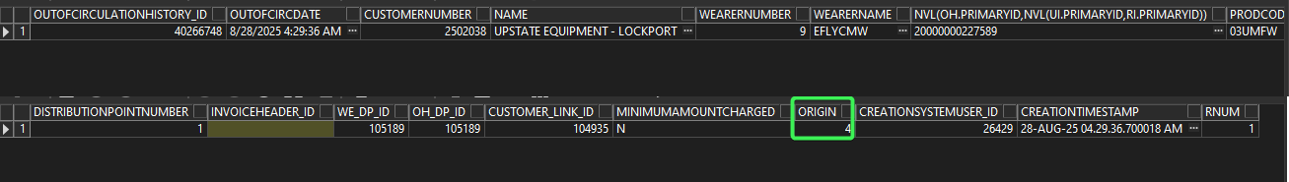
The Origin is 4 = Route Returns
- System Settings dlg: Change ss DEFAULTROUTERETURNACTION back to 0. Save and exit.
Tested OK

Test Case 05 – Cancel Loss charge from Loss Charge Monitor – Tested OK
Hash: 9.07.00.UNF20 hash: bac9293fb677

Expected behavior
Table: OUTOFCIRCULATIONHISTORY the adding of entries in the below columns
CreationTimeStamp current date / time
CreationSystemUser_ID current logged in system user
Origin 3 = Settlement

Steps to reproduce
- Wearers dlg: Find a customer with wearers and end a wearer.
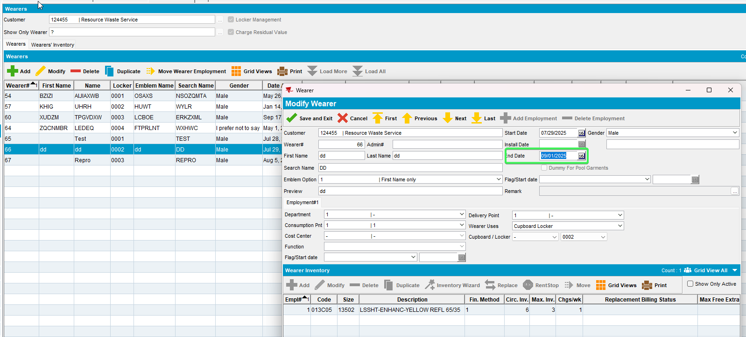
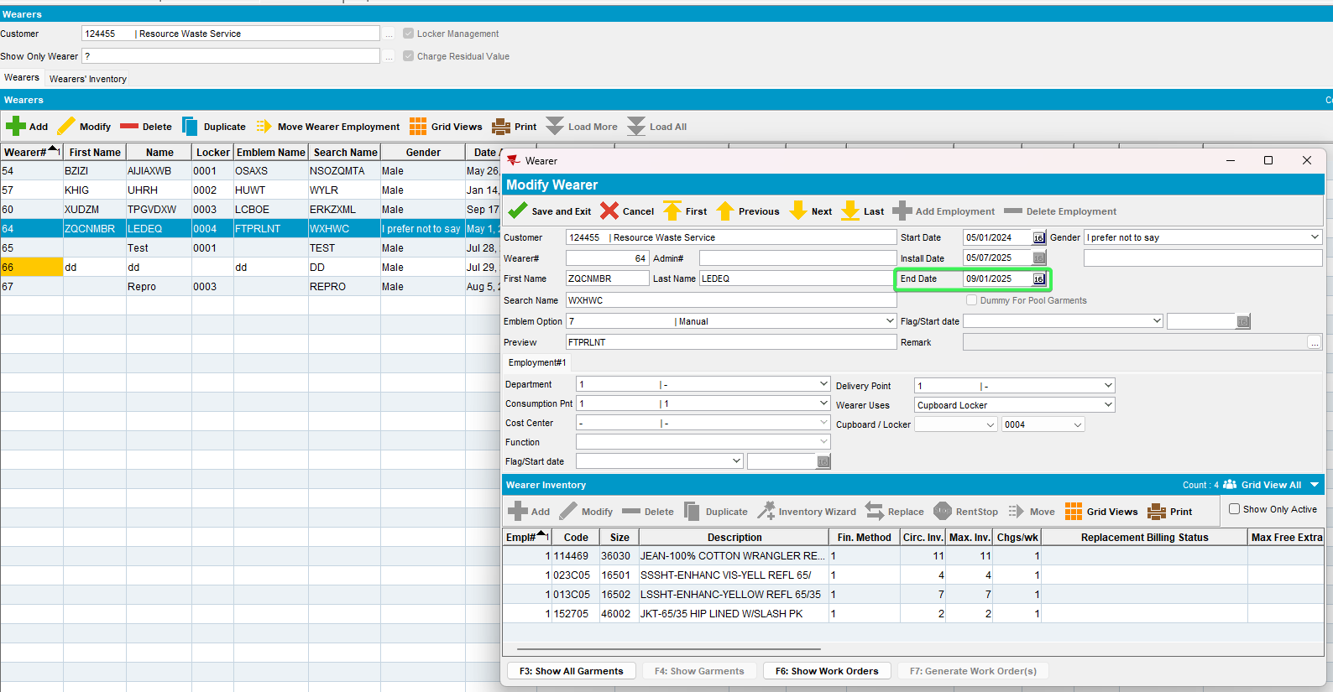
- RSC dlg: Create a route containing the customer 2weeks+ in the future.
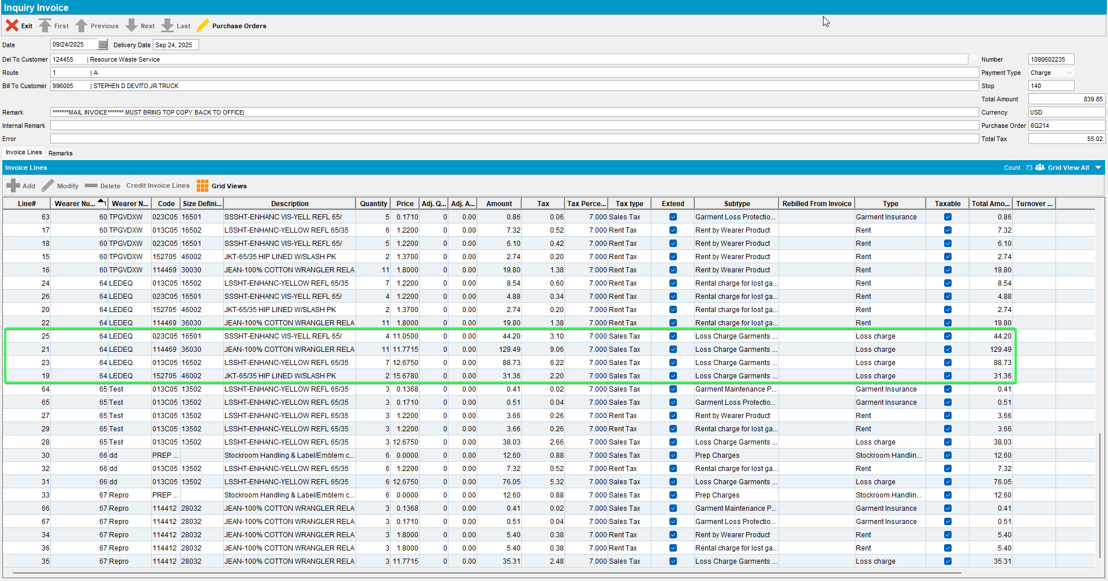
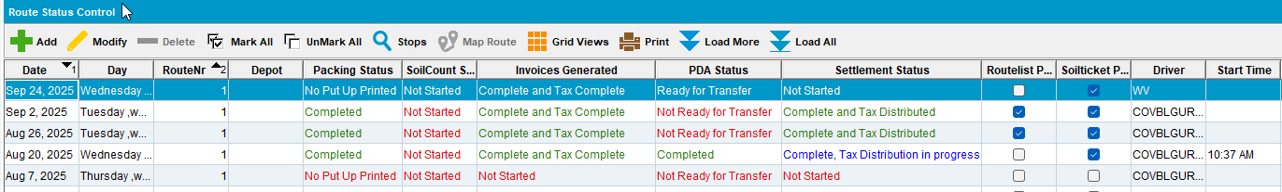
- RSC dlg: Send the route to PDA.
- RA: Download the route, arrive at the customer.
- RA: Make an adjustment on the loss charges
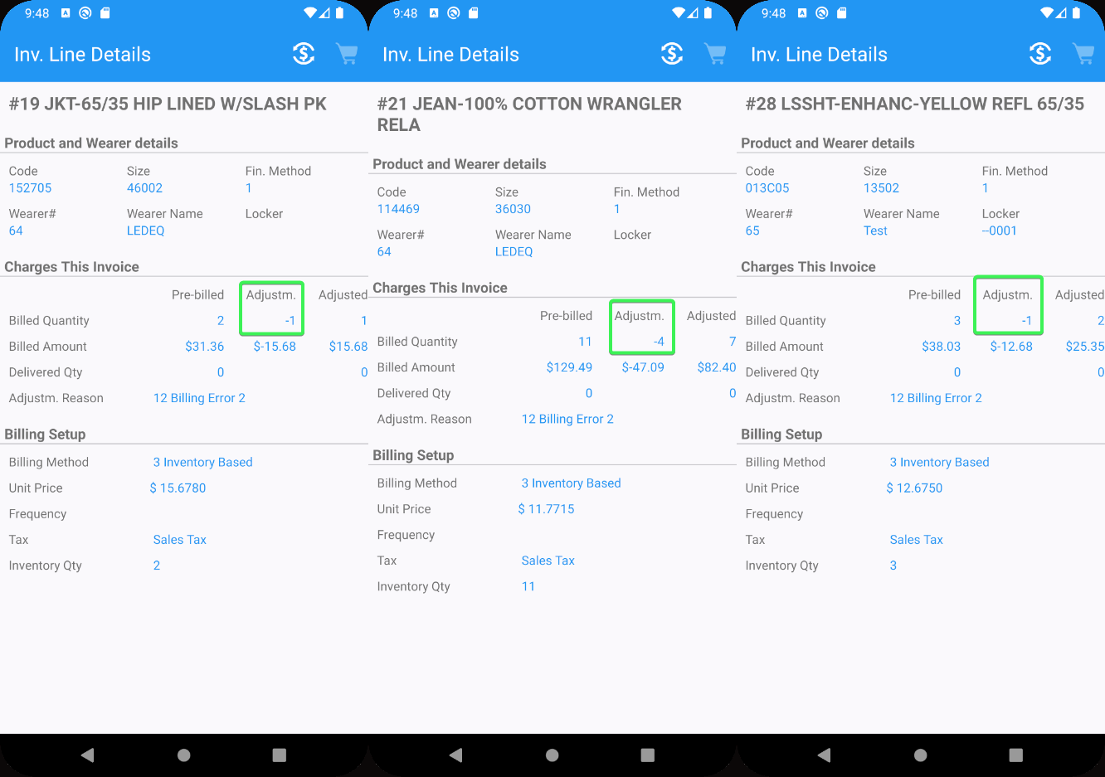
- RA: Settle and depart.
- RA: Finish and upload.
- WebX: Approve everything and settle.
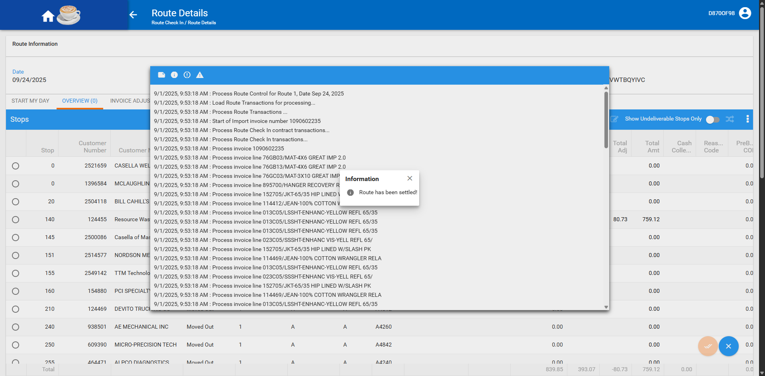
- Maintain Garment Charges dlg: Check the customer.
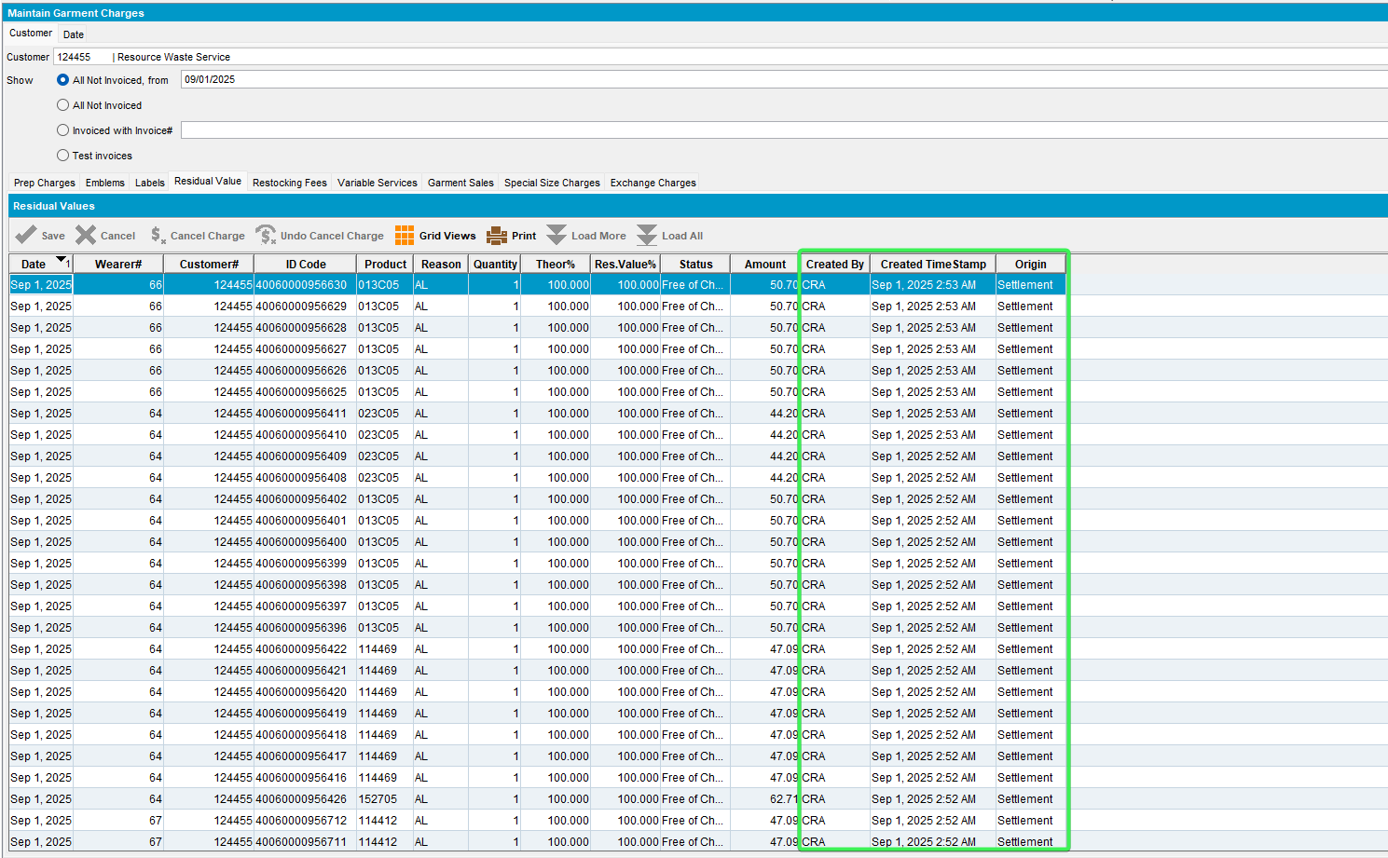
- Loss Charge Monitor dlg: Load the customer and check the loss charges.
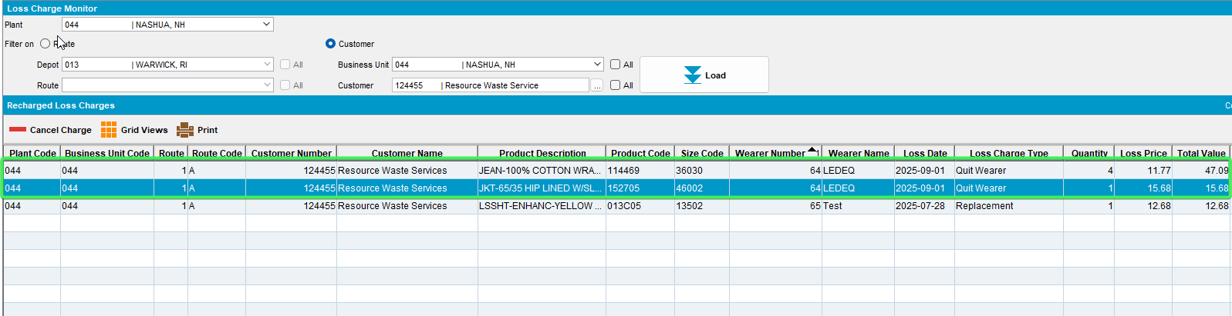
- Wearers dlg: Reload the customer and check the garments.
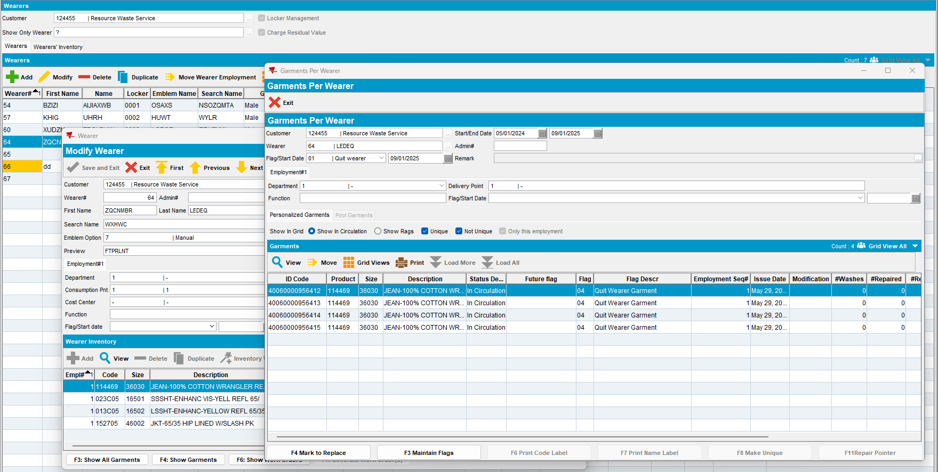

- PLSQL
select *
from (select dynamicsql.*, rownum rnum
from (SELECT oh.outofcirculationhistory_id,
oh.outofcircdate,
cust.customernumber,
cust.name,
wearer.wearernumber,
wearer.wearername,
nvl(oh.primaryid, nvl(ui.primaryid, ri.primaryid)),
prod.code prodcode,
(select DESCRIPTION
from PRODUCT_LINK_DESC
where PRODUCT_LINK_DESC.PRODUCT_LINK_ID =
PROD.PRODUCT_LINK_ID
and LANGUAGE_ID = 1) proddesc,
reasoncode.code rccode,
(select DESCRIPTION
from REASONCODE_DESC
where REASONCODE_DESC.REASONCODE_ID =
OH.REASONCODE_ID
and LANGUAGE_ID = 1) rcdesc,
oh.quantity,
oh.theoreticalpercentage,
oh.tobechargedpercentage,
oh.enteredpercentage,
oh.status,
oh.systemuser_id,
oh.timestamp,
oh.enddatefullrent,
oh.residualvalue,
bu.code bucode,
bu.description,
oh.amount,
oh.rowcode,
oh.locationcode,
oh.chargetype,
ragreason.code rrcode,
(select DESCRIPTION
from RAGREASON_DESC
where RAGREASON_DESC.RAGREASON_ID = oh.ragreason_id
and LANGUAGE_ID = 1) rrdesc,
size2.code,
(select DESCRIPTION
from SIZEDEFINITION_LINK_DESC
where SIZEDEFINITION_LINK_DESC.SIZEDEFINITION_LINK_ID =
SIZE2.SIZEDEFINITION_LINK_ID
and LANGUAGE_ID = 1) sdesc,
distrpnt.distributionpointnumber,
oh.invoiceheader_id,
wearer.distributionpoint_link_id we_dp_id,
oh.distributionpoint_link_id oh_dp_id,
oh.customer_link_id,
oh.minimumamountcharged,
oh.origin,
oh.creationsystemuser_id,
oh.creationtimestamp
from outofcirculationhistory oh
left outer join invoiceheader
on oh.invoiceheader_id = invoiceheader.invoiceheader_id
left outer join(uniqueitem_link uil
left outer join uniqueitem ui
on uil.uniqueitem_id = ui.uniqueitem_id
left outer join raggeditem ri
on uil.raggeditem_id = ri.raggeditem_id) on oh.uniqueitem_link_id = uil.uniqueitem_link_id
left outer join weareremployment_link wearer
on oh.weareremployment_link_id =
wearer.weareremployment_link_id
left outer join businessunit bu
on oh.invoicebusinessunit_id = bu.businessunit_id
left outer join sizedefinition_link size2
on oh.sizedefinition_link_id =
size2.sizedefinition_link_id
left outer join ragreason
on oh.ragreason_id = ragreason.ragreason_id
left outer join distributionpoint_link distrpnt
on oh.distributionpoint_link_id =
distrpnt.distributionpoint_link_id, product_link prod,
customer_link cust, reasoncode
where oh.product_link_id = prod.product_link_id
and oh.customer_link_id = cust.customer_link_id
and oh.reasoncode_id = reasoncode.reasoncode_id
AND oh.customer_link_id = (select c.customer_id from customer c where c.customernumber = 2524922)
AND oh.outofcircdate >=
TO_DATE('2024-11-01 00:00:00', 'YYYY-MM-DD HH24:MI:SS')
AND oh.INVOICEHEADER_ID IS NULL
AND oh.chargetype <> 2) dynamicsql
where rownum <= 500)
where rnum >= 1
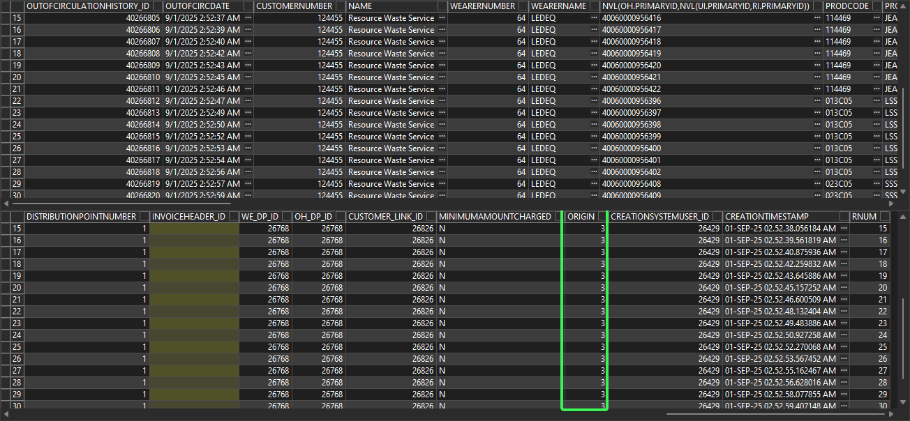
- Loss Charge Monitor dlg: Cancel a loss charge.
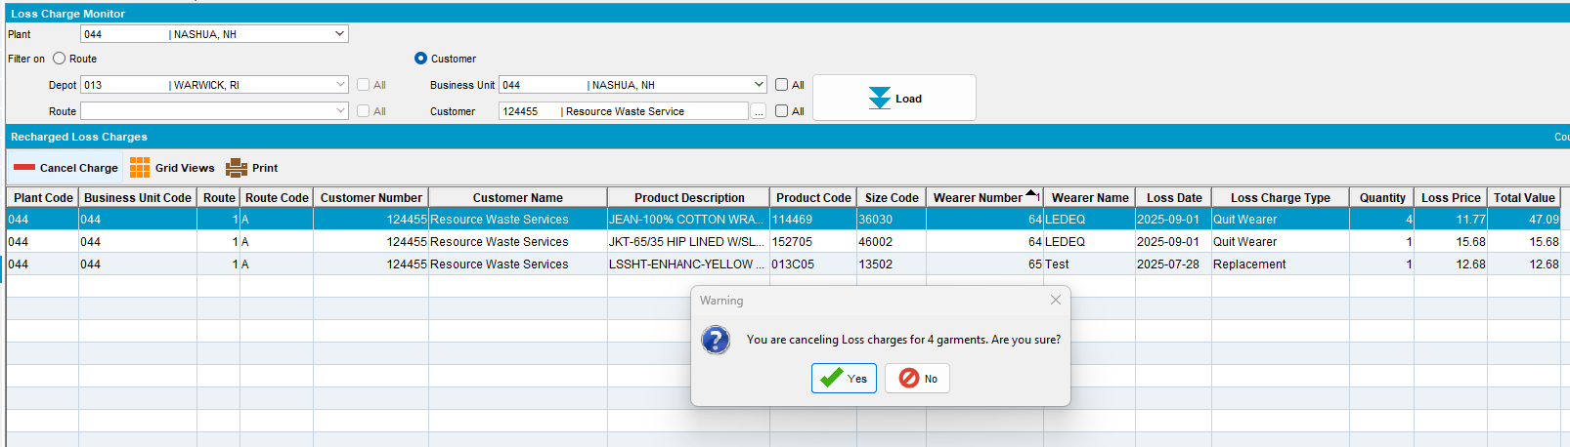
- Maintain Garment Charges dlg: Reload the table, a new entry appeared.
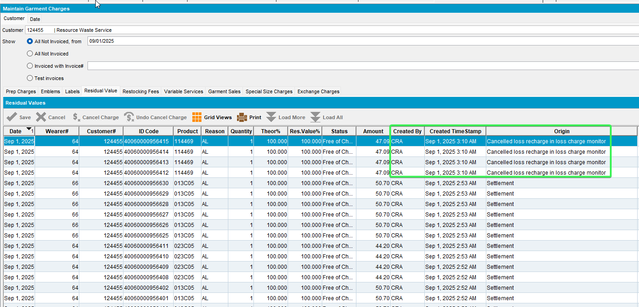
- Re-check in database.
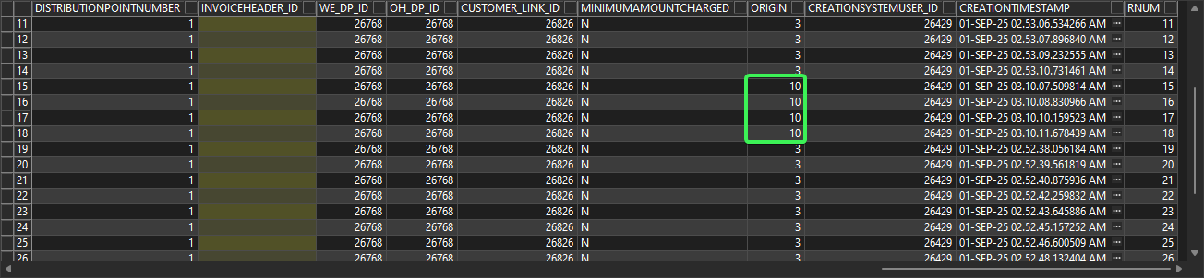
A new entry in the OUTOFCIRCULATIONHISTORY with origin 10 = Cancelled loss recharge in loss charge monitor
Tested OK

