ABSN-7687 D_UBS_2455 Unable to upload route from RA-Route Stop already exists Database error code 1
Environment | Prerequisites
Version: 9.07.00.UNF20  DBServerName= abs-srv20.internal.abslbs.com  DBSID=CUST24  DBUser=UNFDEV  Environment=Production | - Module:  - System setting

Contents
Test after fix 1

Test after fix
Hash: a4e0ff42b9fd

- RSC: Create a route with a customer with 2 stops and the same delivery point, generate the invoices and upload it to PDA.
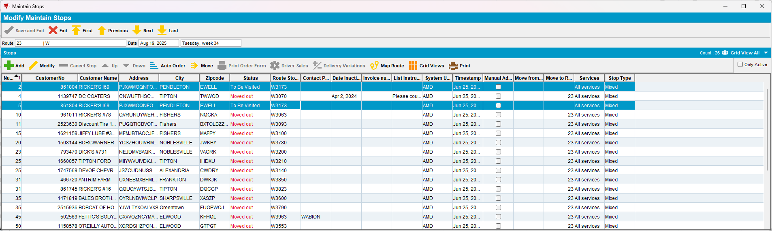

- RA: Make a permanent stop move moving the stop 125 to stop 1.
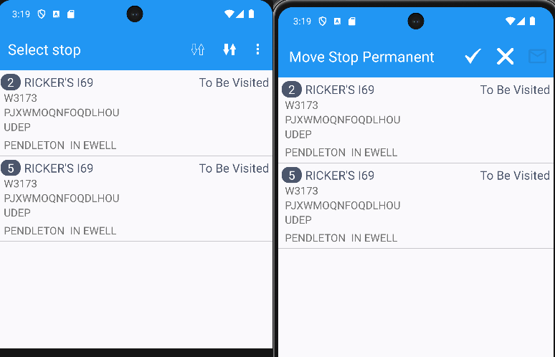

- RA: Visit the stops then upload the route.
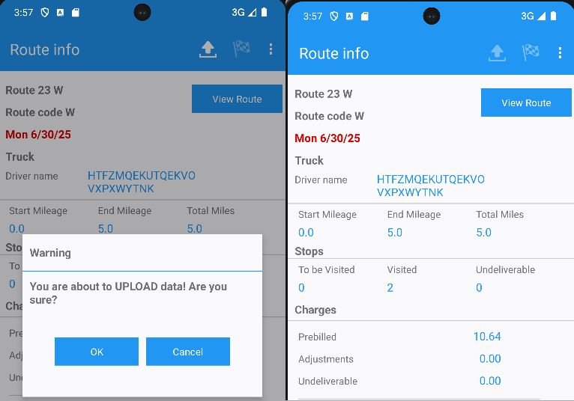
The route was uploaded successfully
TESTED OK.

