ABSN-7664 - Hide or disable field in payment tab in customer and contract dialog
Environment | Prerequisites
Version:  DBServerName= abs-srv20.internal.abslbs.com  DBSID=CUST24  DBUser=UNFDEV  Environment=Test | - Module:  - System setting

Contents
Testing Customer DLG fields visibility 2
Test Case 1 – Set SS PAYMENTTABWITHEXTERNALAR = NNHH 2
Test Case 2 – Set SS PAYMENTTABWITHEXTERNALAR = NNRR 3
Test Case 3 – Set SS PAYMENTTABWITHEXTERNALAR =NNHR 3
Test Case 4 – Set SS PAYMENTTABWITHEXTERNALAR = NNRH 4
Test Case 5 – Set SS PAYMENTTABWITHEXTERNALAR = NNNH 5
Test Case 6 – Set SS PAYMENTTABWITHEXTERNALAR = NNHN 6
Test Case 7 – Set SS PAYMENTTABWITHEXTERNALAR = NNNN 7
Test Case 8 – Set SS PAYMENTTABWITHEXTERNALAR = NNNN and have Customer in Add mode 9
Test Case 9 – Set SS PAYMENTTABWITHEXTERNALAR = NNHH and have Customer in Add mode 10
Test Case 10 – Set SS PAYMENTTABWITHEXTERNALAR = NNRR and have Customer in Add mode 12
Testing Contract DLG fields visibility 13
Test Case 1 – Set SS PAYMENTTABWITHEXTERNALAR = HHNN 13
Test Case 2 – Set SS PAYMENTTABWITHEXTERNALAR = RRNN 16
Test Case 3 – Set SS PAYMENTTABWITHEXTERNALAR = NNNN 18
Test Case 4 – Set SS PAYMENTTABWITHEXTERNALAR = NRNN 21
Test Case 5 – Set SS PAYMENTTABWITHEXTERNALAR = NHNN 22
Test Case 6 – Set SS PAYMENTTABWITHEXTERNALAR = RNNN 23
Test Case 7 – Set SS PAYMENTTABWITHEXTERNALAR = HNNN 25
Test Case 8 – Check that compliancy is based only for visible fields 26
Testing Customer fields visibility from Switchboard 30
Test Case 1 – Set SS PAYMENTTABWITHEXTERNALAR = NNNN 30
Test Case 2 – Set SS PAYMENTTABWITHEXTERNALAR = NNHH 31
Test Case 3 – Set SS PAYMENTTABWITHEXTERNALAR = NNRR 33
Testing SS BILLINGTAB set as 1 34
Test Case 1 – Set SS BILLINGTAB = 1 and SS PAYMENTTABWITHEXTERNALAR = NNNN 34
Test Case 2 – Set SS BILLINGTAB = 1 and SS PAYMENTTABWITHEXTERNALAR = HHHH 35
Test Case 3 – Set SS BILLINGTAB = 1 and SS PAYMENTTABWITHEXTERNALAR = RRRR 36

Testing Customer DLG fields visibility

Test Case 1 – Set SS PAYMENTTABWITHEXTERNALAR = NNHH
Hash: 0d7bafeb2c0a
- System Settings DLG: Set SS PAYMENTTABWITHEXTERNALAR = NNHH
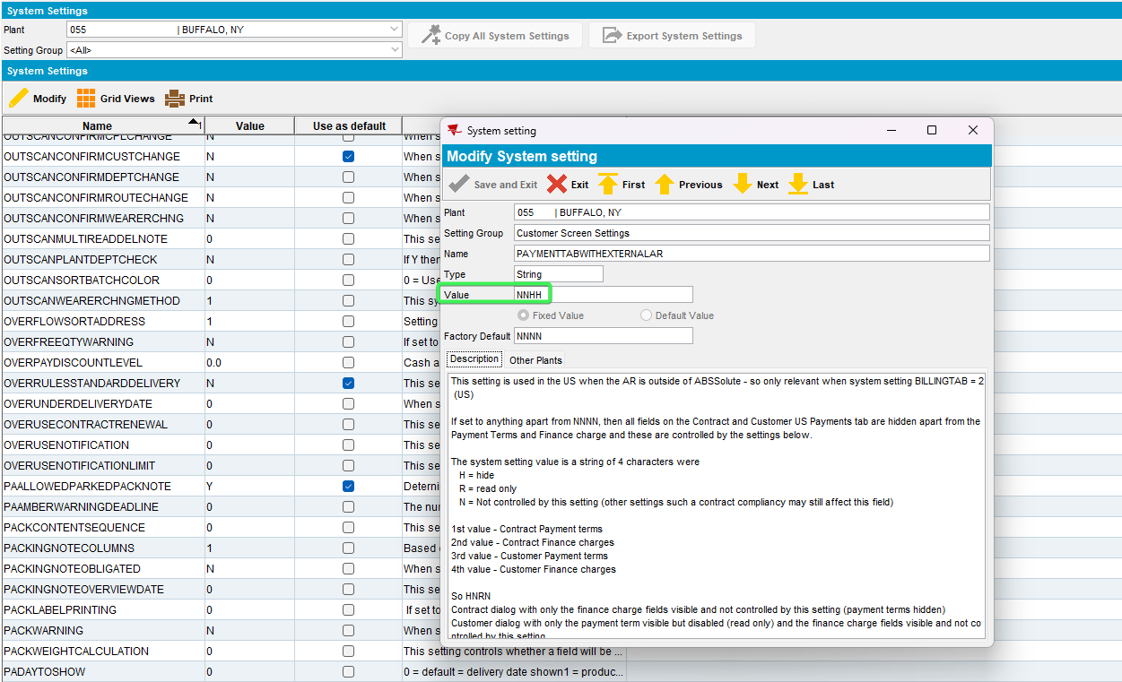
- Customers DLG: Payment tab > should be empty
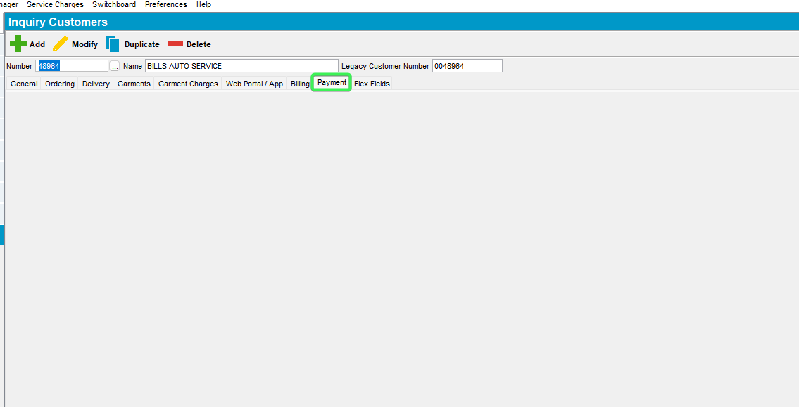
Tested OK

Test Case 2 – Set SS PAYMENTTABWITHEXTERNALAR = NNRR
Hash: 0d7bafeb2c0a
- System Settings DLG: Set SS PAYMENTTABWITHEXTERNALAR = NNRR
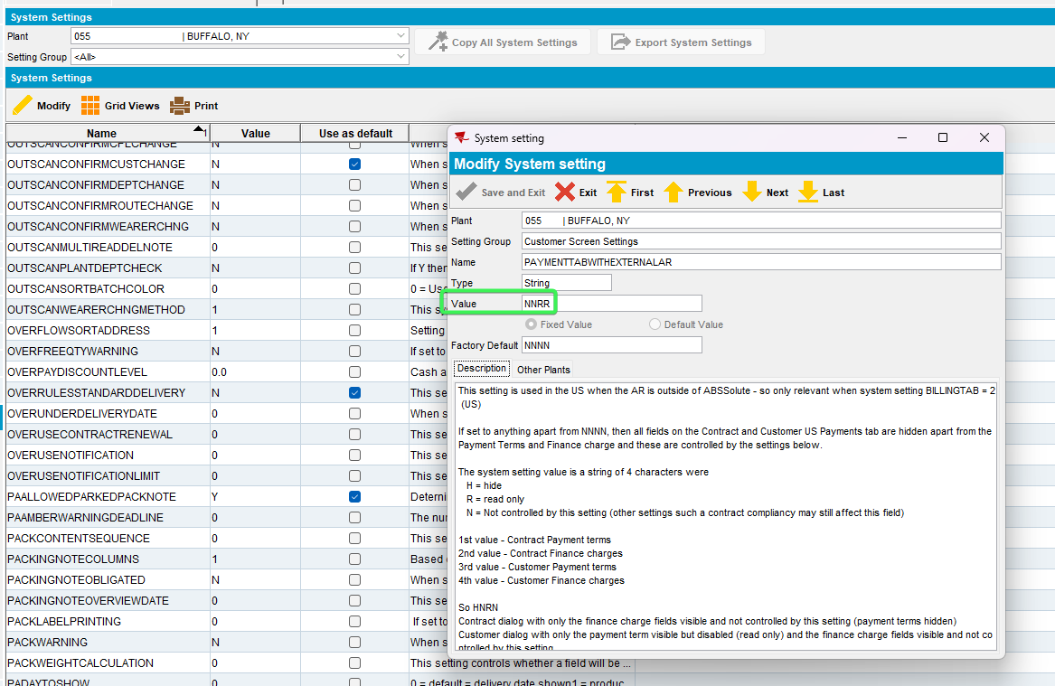
- Customers DLG: Payment tab > Payment Term and Finance charges should be visible but disabled
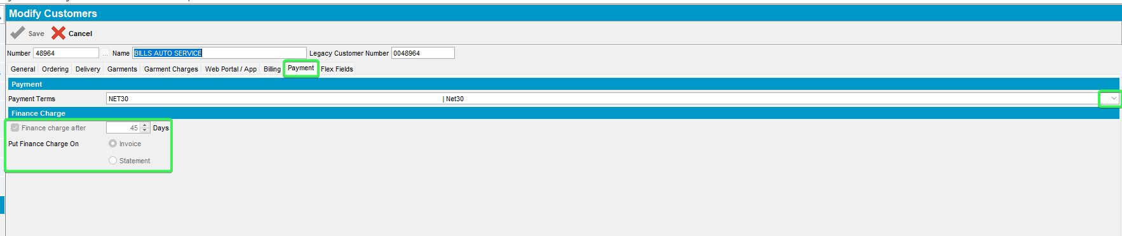
Tested OK

Test Case 3 – Set SS PAYMENTTABWITHEXTERNALAR =NNHR
Hash: 0d7bafeb2c0a
- System Settings DLG: Set SS PAYMENTTABWITHEXTERNALAR = NNHR
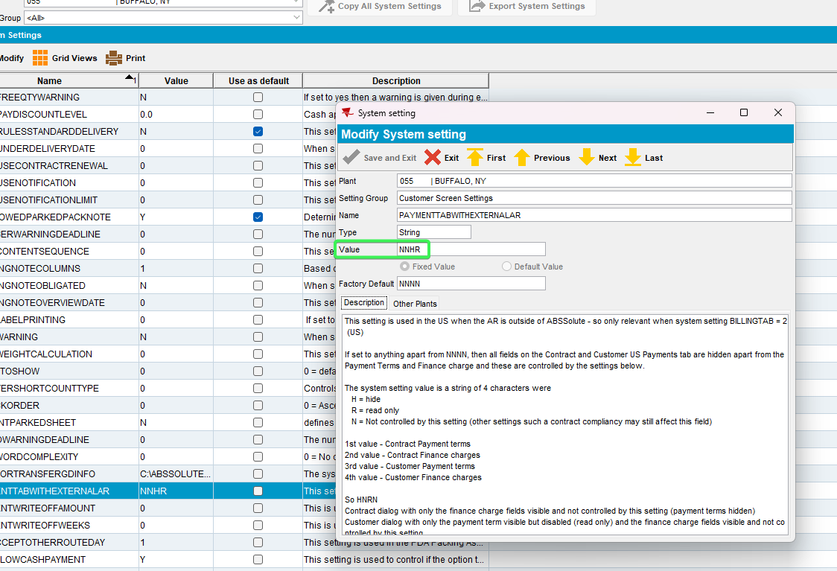
- Customers DLG: Payment tab > Payment Term should be hidden, and Finance charges should be visible but disabled
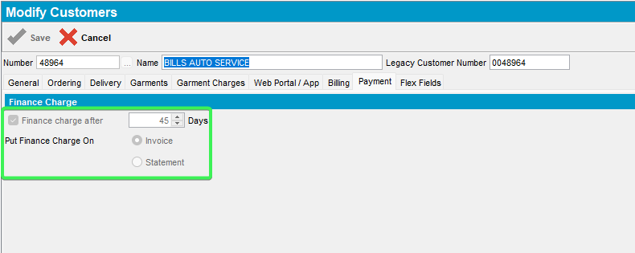
Tested OK

Test Case 4 – Set SS PAYMENTTABWITHEXTERNALAR = NNRH
Hash: 0d7bafeb2c0a
- System Settings DLG: Set SS PAYMENTTABWITHEXTERNALAR = NNRH
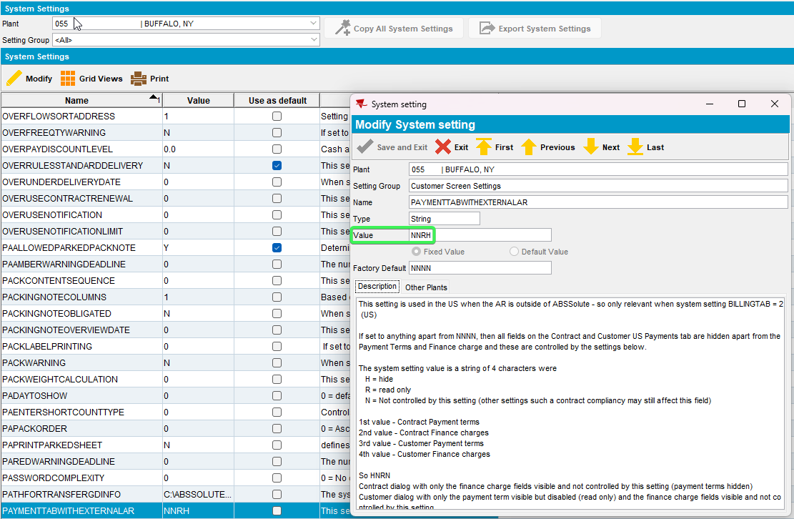
- Customers DLG: Payment tab > Payment Term should be visible but disabled, and Finance charges should not be visible
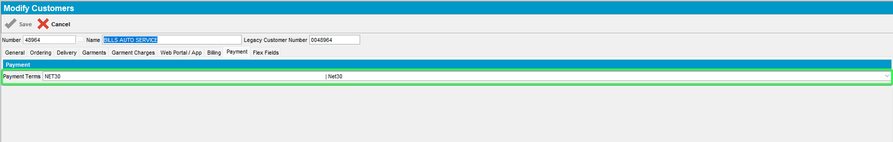
Tested OK

Test Case 5 – Set SS PAYMENTTABWITHEXTERNALAR = NNNH
Hash: c94788575274
- System Settings DLG: Set SS PAYMENTTABWITHEXTERNALAR = NNNH
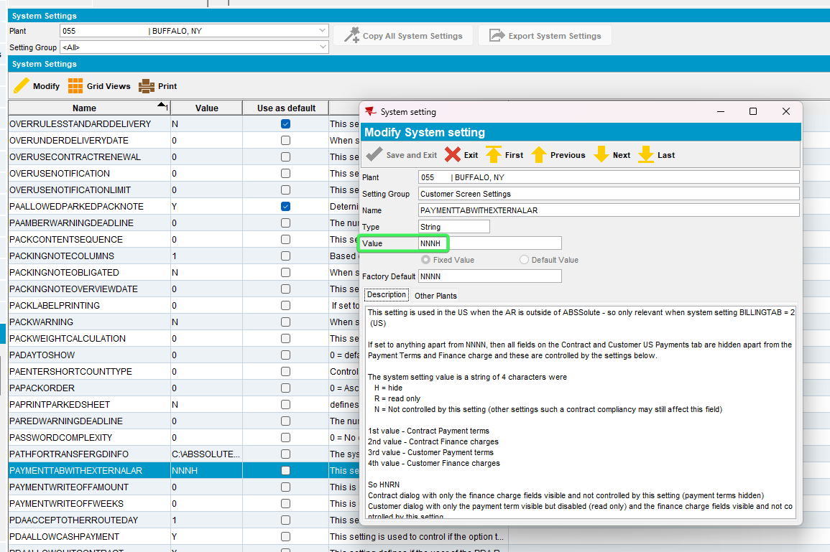
- Customers DLG: Payment tab > Payment Term should be visible and enabled, and Finance charges should not be visible
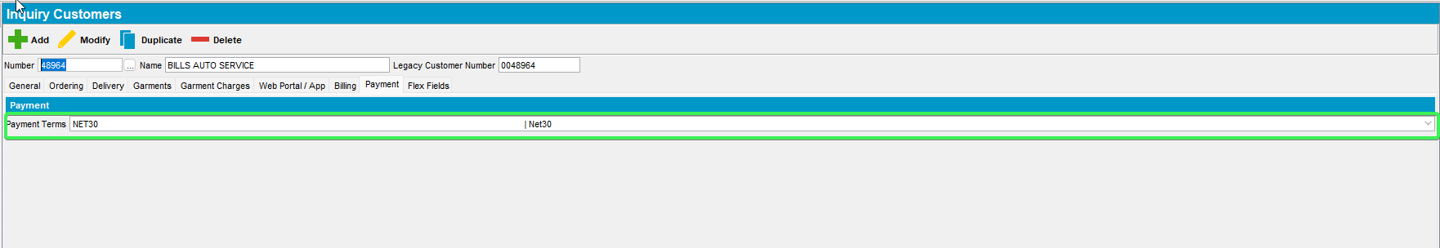
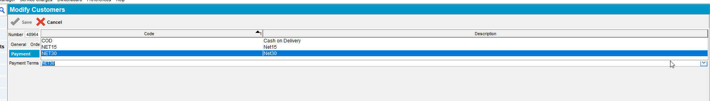
Tested OK

Test Case 6 – Set SS PAYMENTTABWITHEXTERNALAR = NNHN
Hash: 0d7bafeb2c0a
- System Settings DLG: Set SS PAYMENTTABWITHEXTERNALAR = NNHN
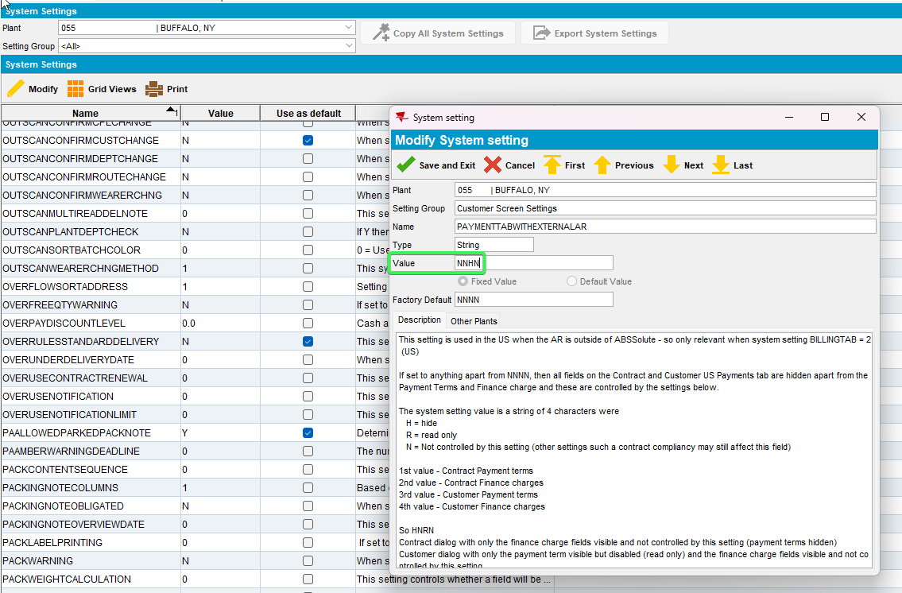
- Customers DLG: Payment tab > Payment Term should not be visible, and Finance charges should be visible and enabled
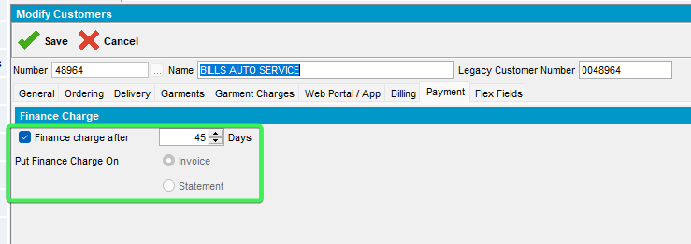

Test Case 7 – Set SS PAYMENTTABWITHEXTERNALAR = NNNN
Hash: 0d7bafeb2c0a
- System Settings DLG: Set SS PAYMENTTABWITHEXTERNALAR = NNNN
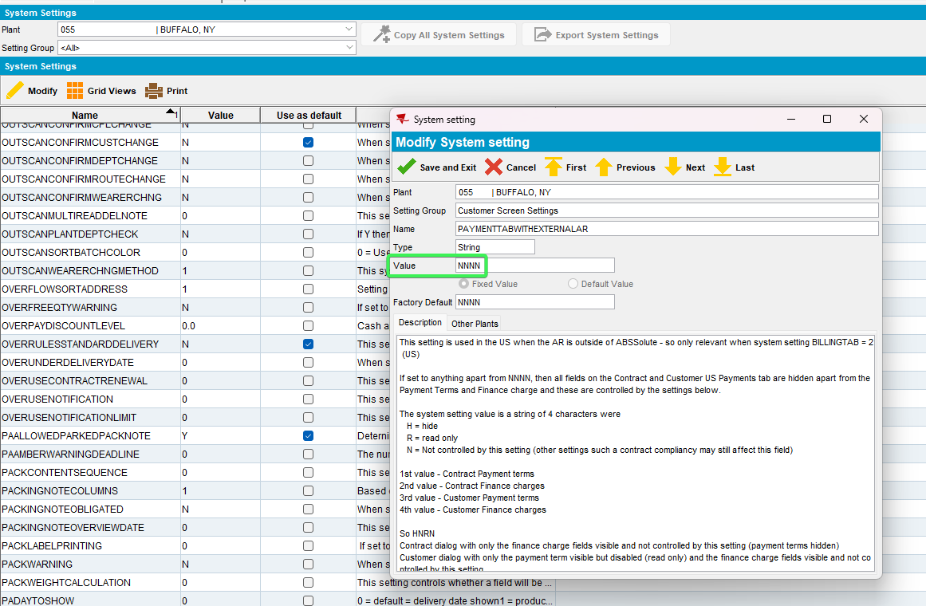
- Customers DLG: Payment tab > All fields should be visible
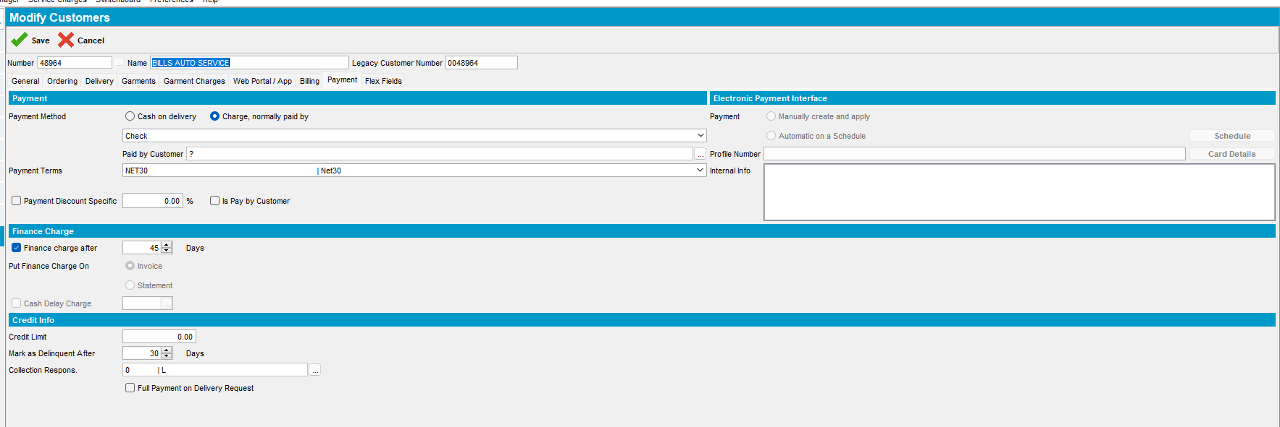
While not in modify mode all fields are disabled
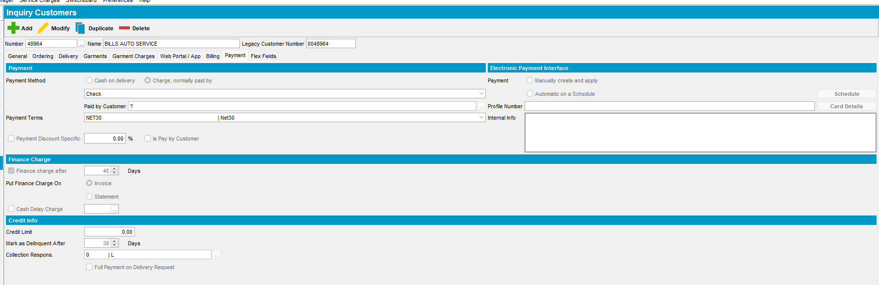
Tested OK

Test Case 8 – Set SS PAYMENTTABWITHEXTERNALAR = NNNN and have Customer in Add mode
Hash: c94788575274
- System Settings DLG: Set SS PAYMENTTABWITHEXTERNALAR = NNNN
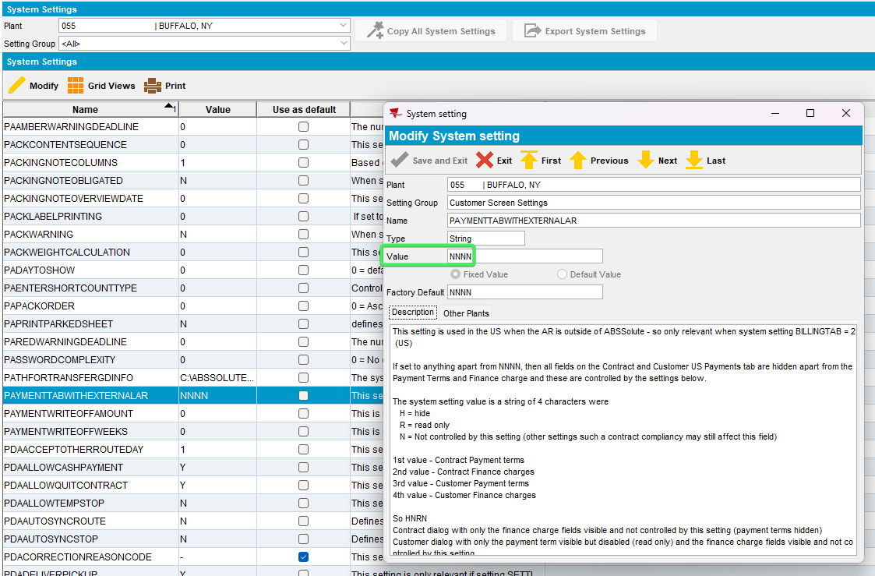
- Customer DLG: Press the add button
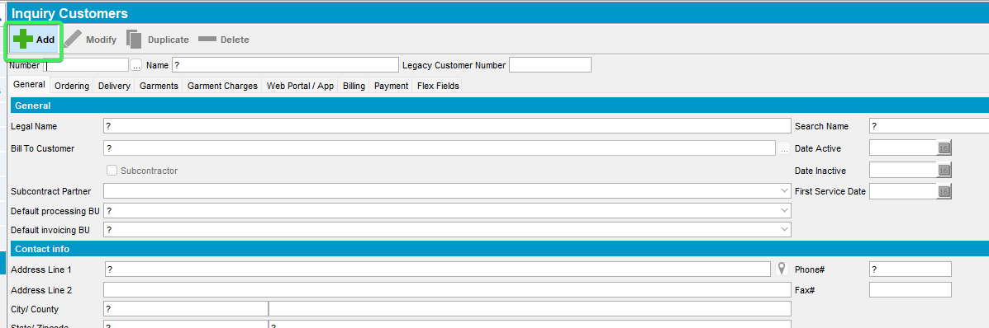
- Go to Payment tab and see that all fields are visible and functional
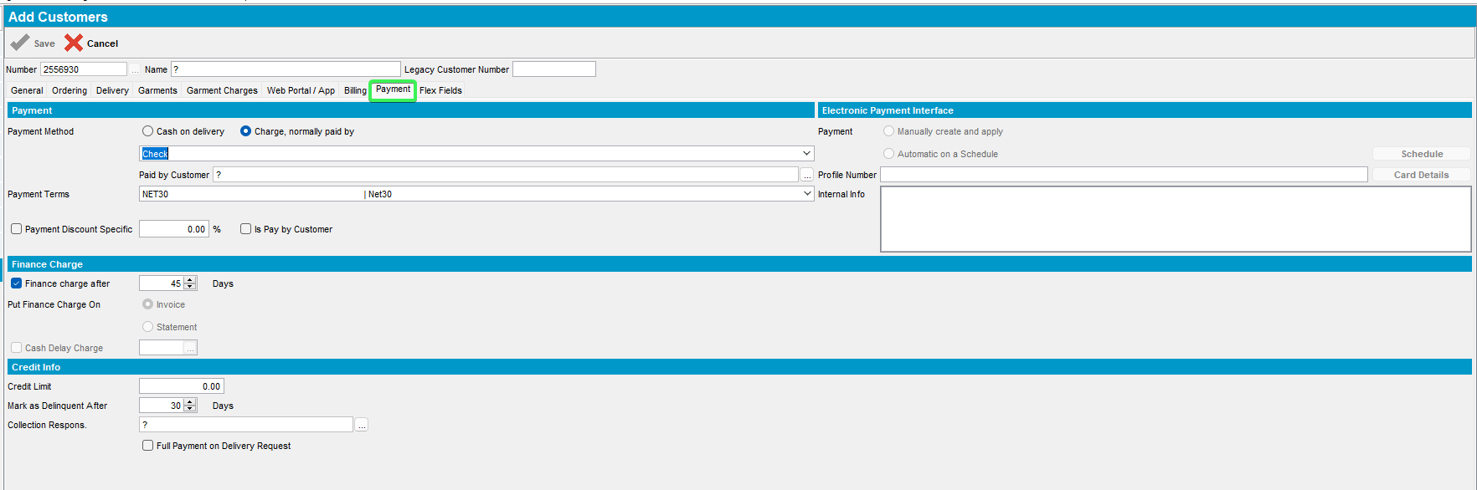
Tested OK

Test Case 9 – Set SS PAYMENTTABWITHEXTERNALAR = NNHH and have Customer in Add mode
Hash: c94788575274
- System Settings DLG: Set SS PAYMENTTABWITHEXTERNALAR = NNHH
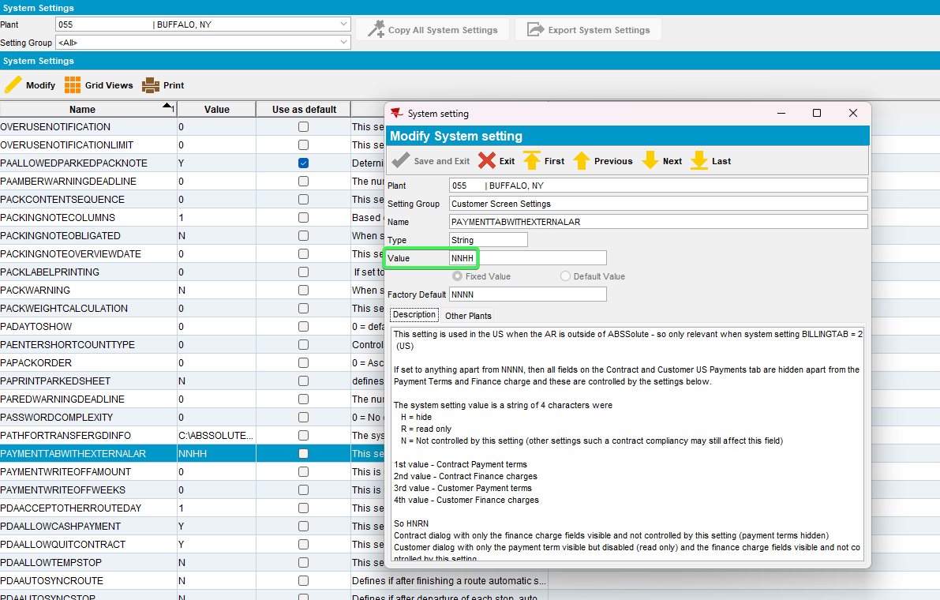
- Customer DLG: Press the Add button
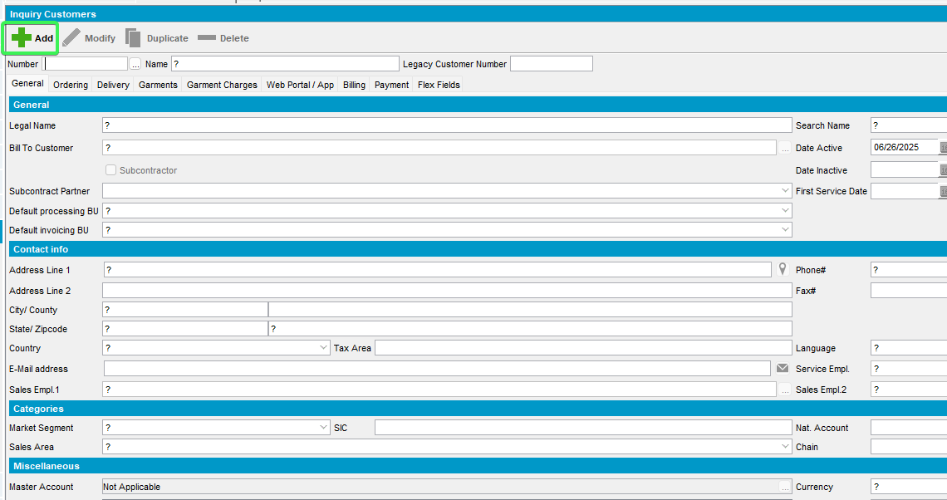
- Go to Payment tab and see that Payment terms and Finance Charges are not visible
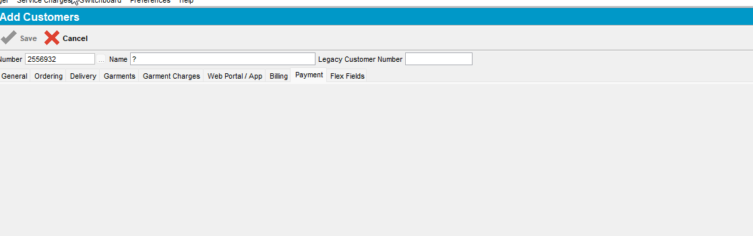
Tested OK

Test Case 10 – Set SS PAYMENTTABWITHEXTERNALAR = NNRR and have Customer in Add mode
Hash: 0f9955dbb12b
- System Settings DLG: Set SS PAYMENTTABWITHEXTERNALAR = NNRR
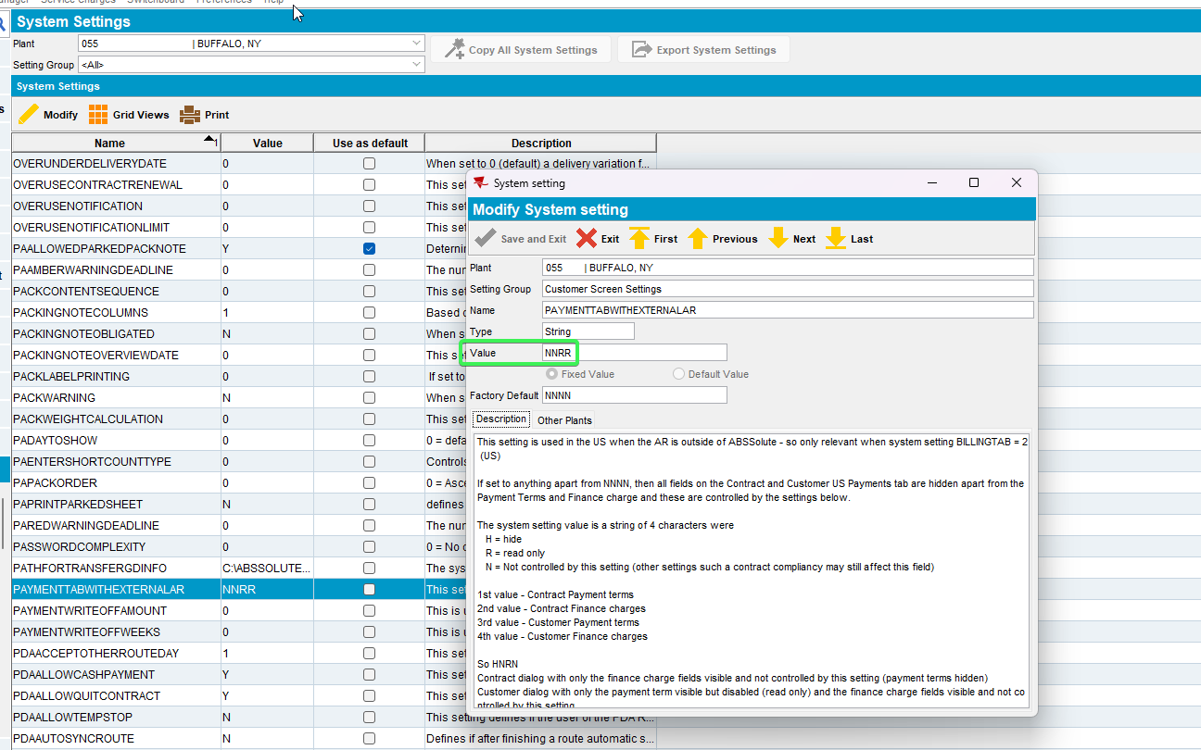
- Customer DLG: Press the Add button
- Go to Payment tab and see that Payment terms and Finance Charges are set as Read only
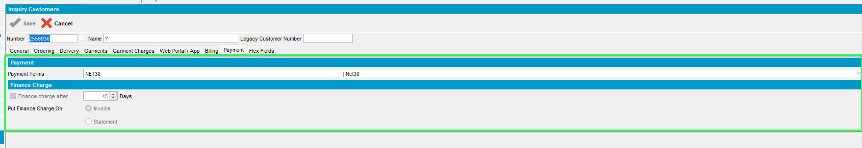
Tested OK

Testing Contract DLG fields visibility

Test Case 1 – Set SS PAYMENTTABWITHEXTERNALAR = HHNN
Hash: 0d7bafeb2c0a
- System Settings DLG: Set SS PAYMENTTABWITHEXTERNALAR = HHNN

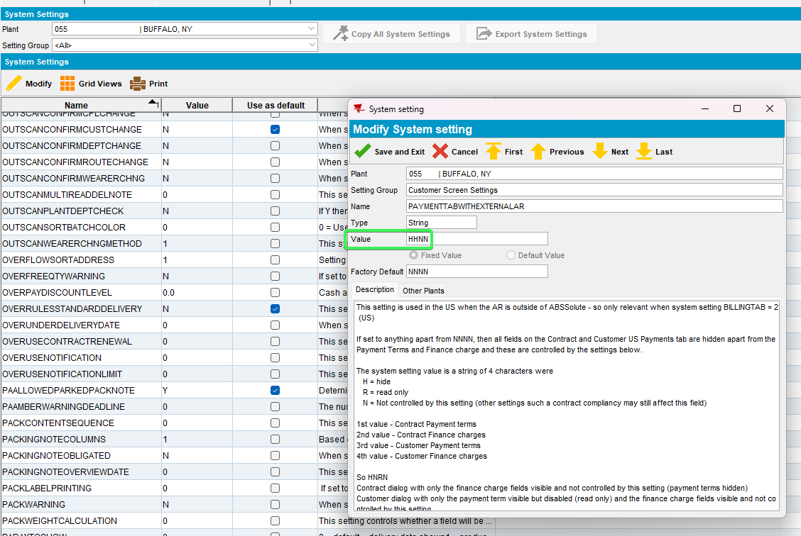
- Contract DLG: Load a contract and go to components tab
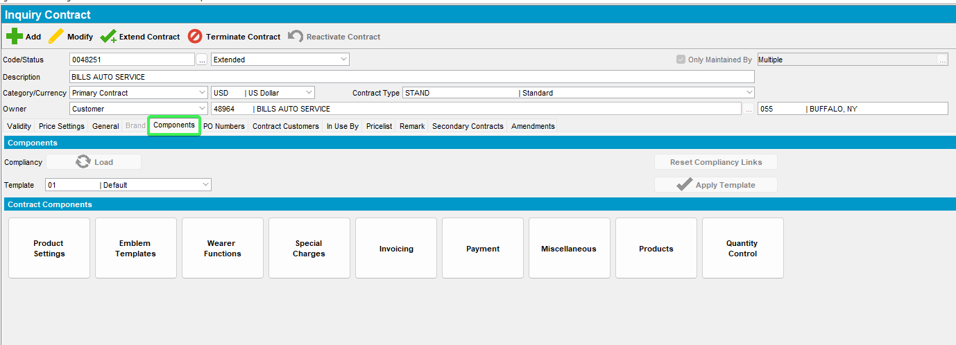
- Press Payments button and check that nothing is present in the tab
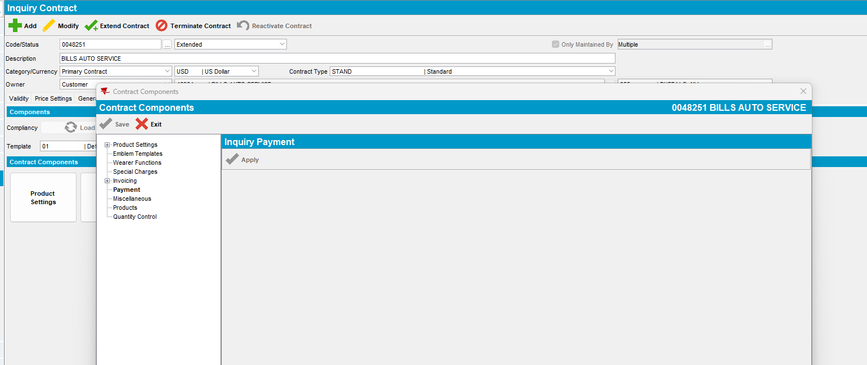
- Press Modify button and then load compliance
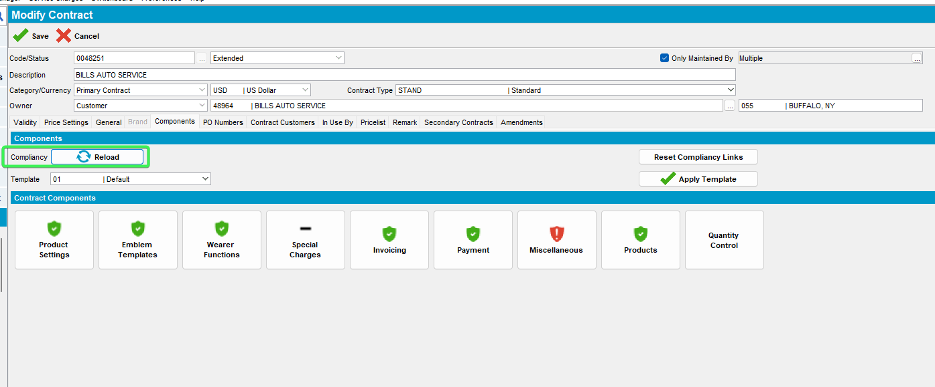
- Press Payment button again and check that nothing is present in the menu
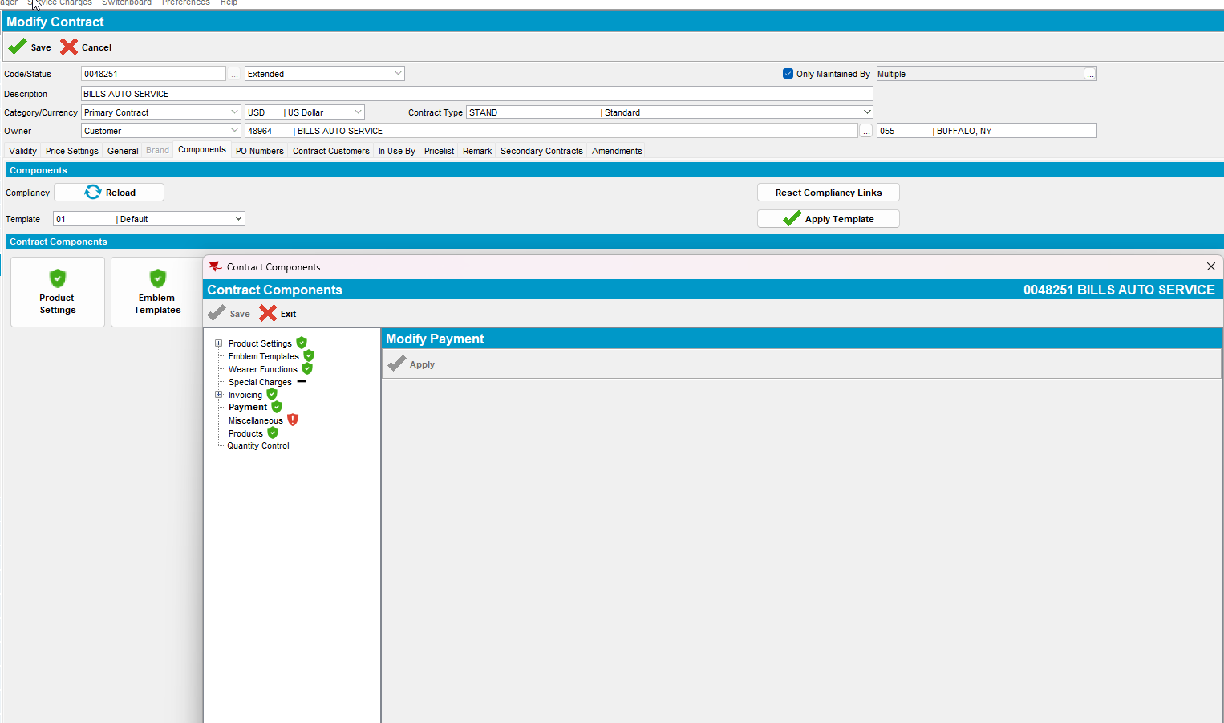
Tested OK

Test Case 2 – Set SS PAYMENTTABWITHEXTERNALAR = RRNN
Hash: 0d7bafeb2c0a
- System Settings DLG: Set SS PAYMENTTABWITHEXTERNALAR = RRNN
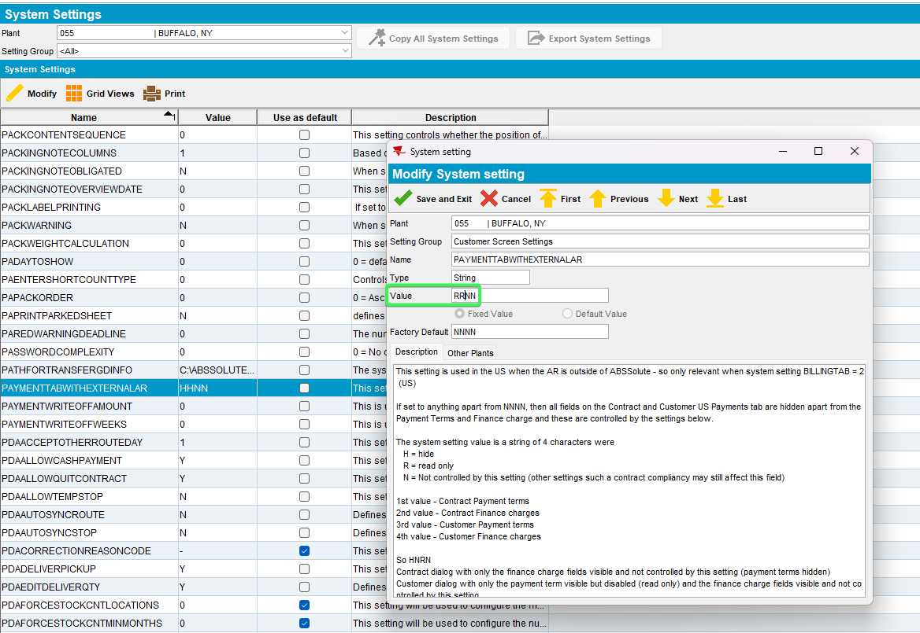
- Contract DLG: Load a contract and go to components tab
- Press Payments button and check that Payment Terms and Finance charges are present but are Read Only
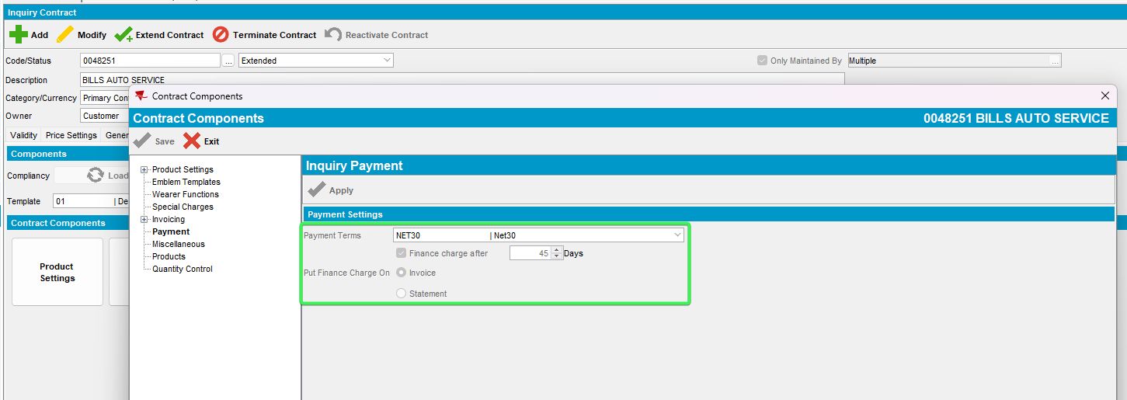
- Press Modify button and then load compliance
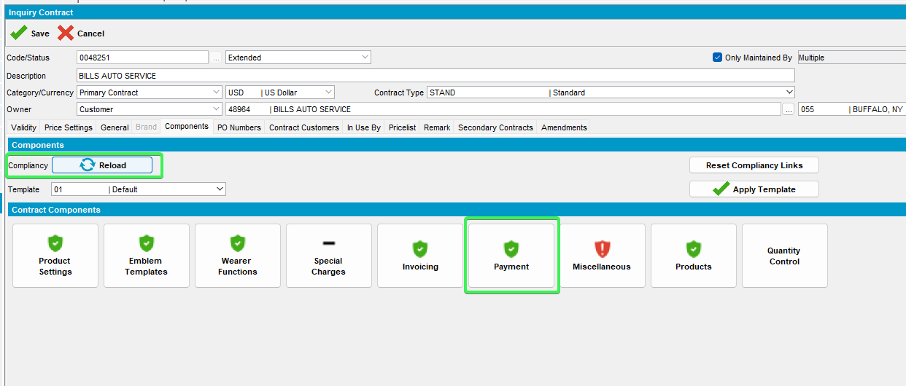
- Press Payment button again and check that Payment Terms and Finance charges are present but are Read Only
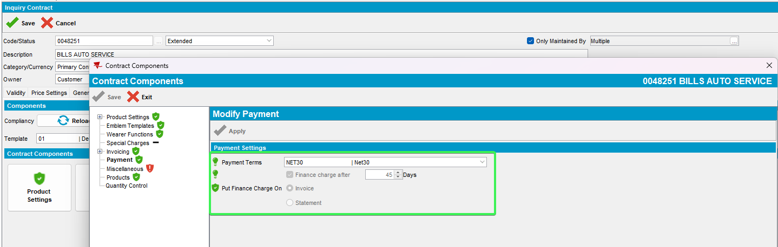
Tested OK

Test Case 3 – Set SS PAYMENTTABWITHEXTERNALAR = NNNN
Hash: 0d7bafeb2c0a
- System Settings DLG: Set SS PAYMENTTABWITHEXTERNALAR = NNNN
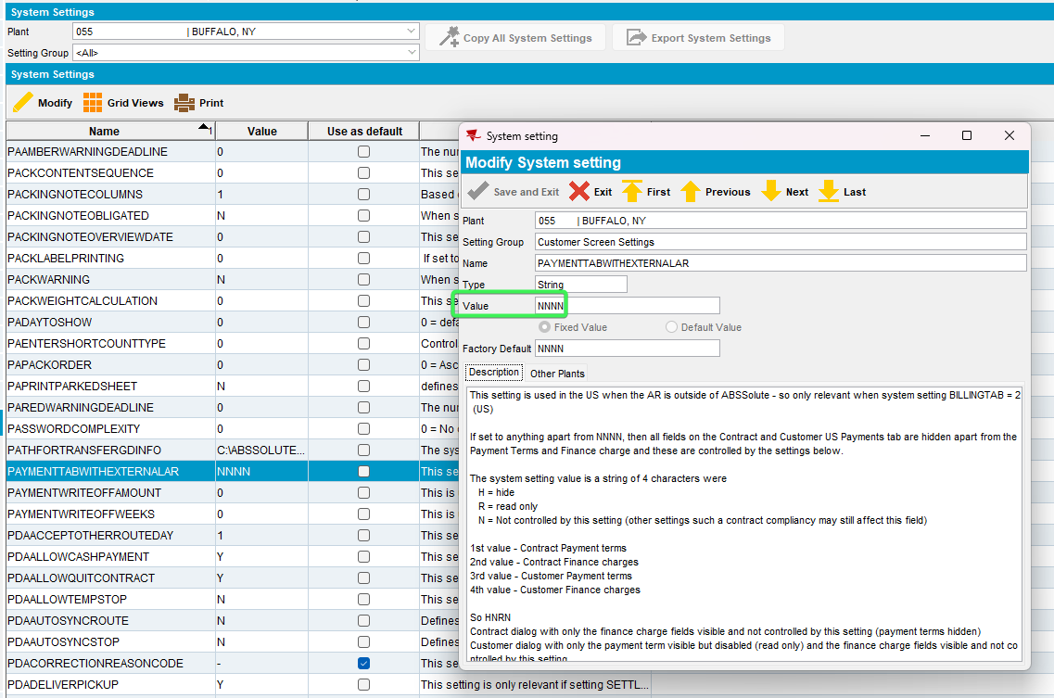
- Press Payments button and check that Payment Terms and Finance charges are present but are Read Only
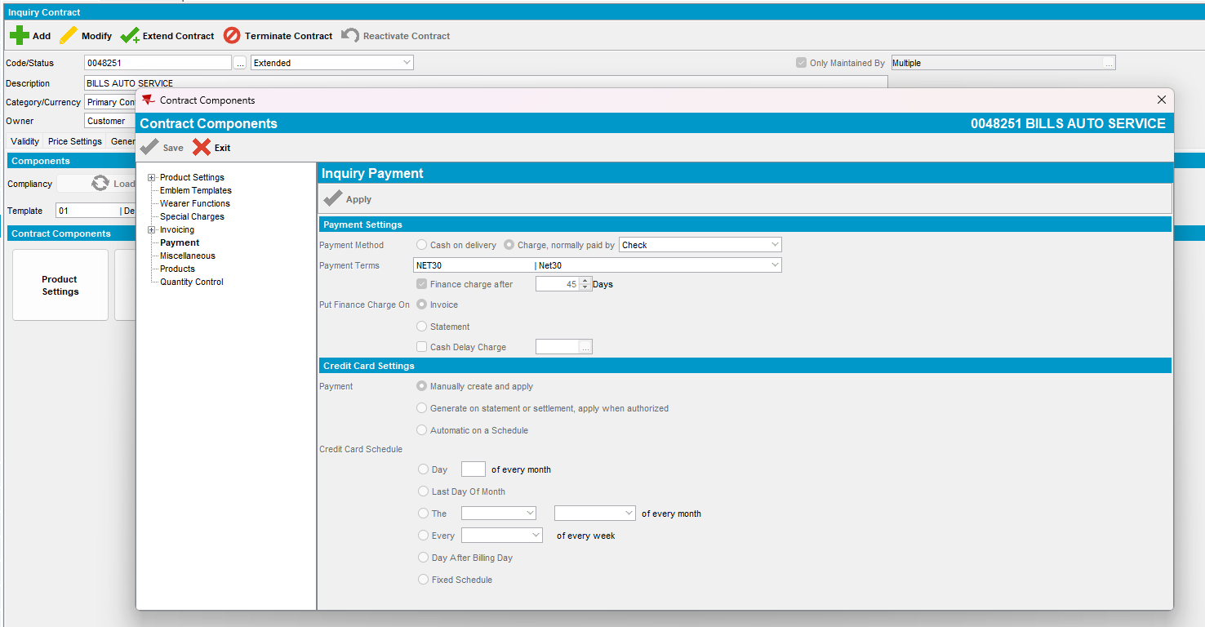
- Contract DLG: components tab > Press Modify
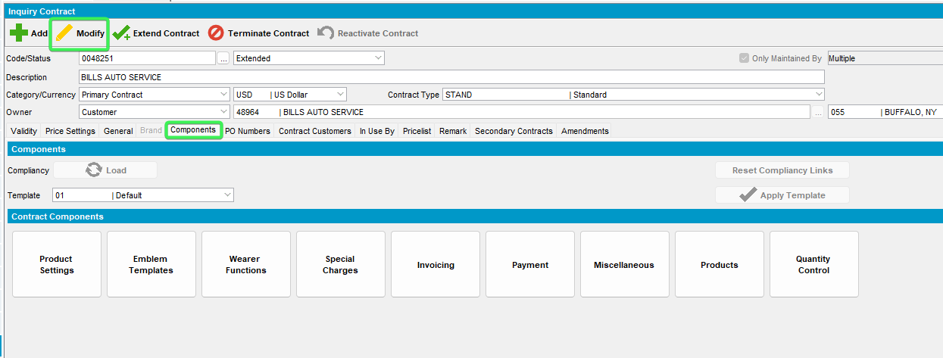
- Load Compliancy and access Payment button
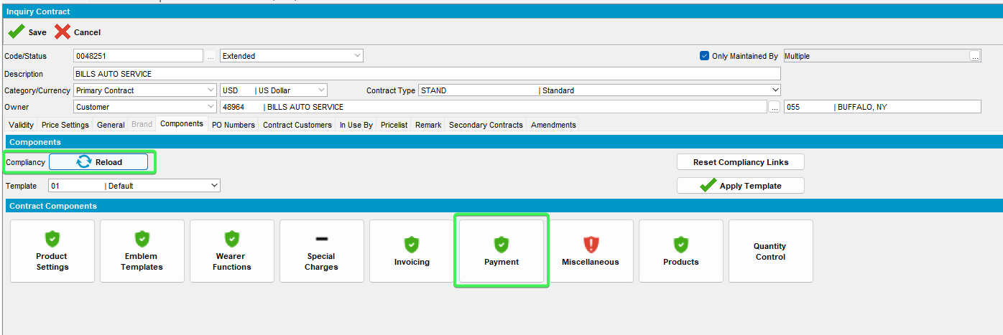
- All fields should be visible
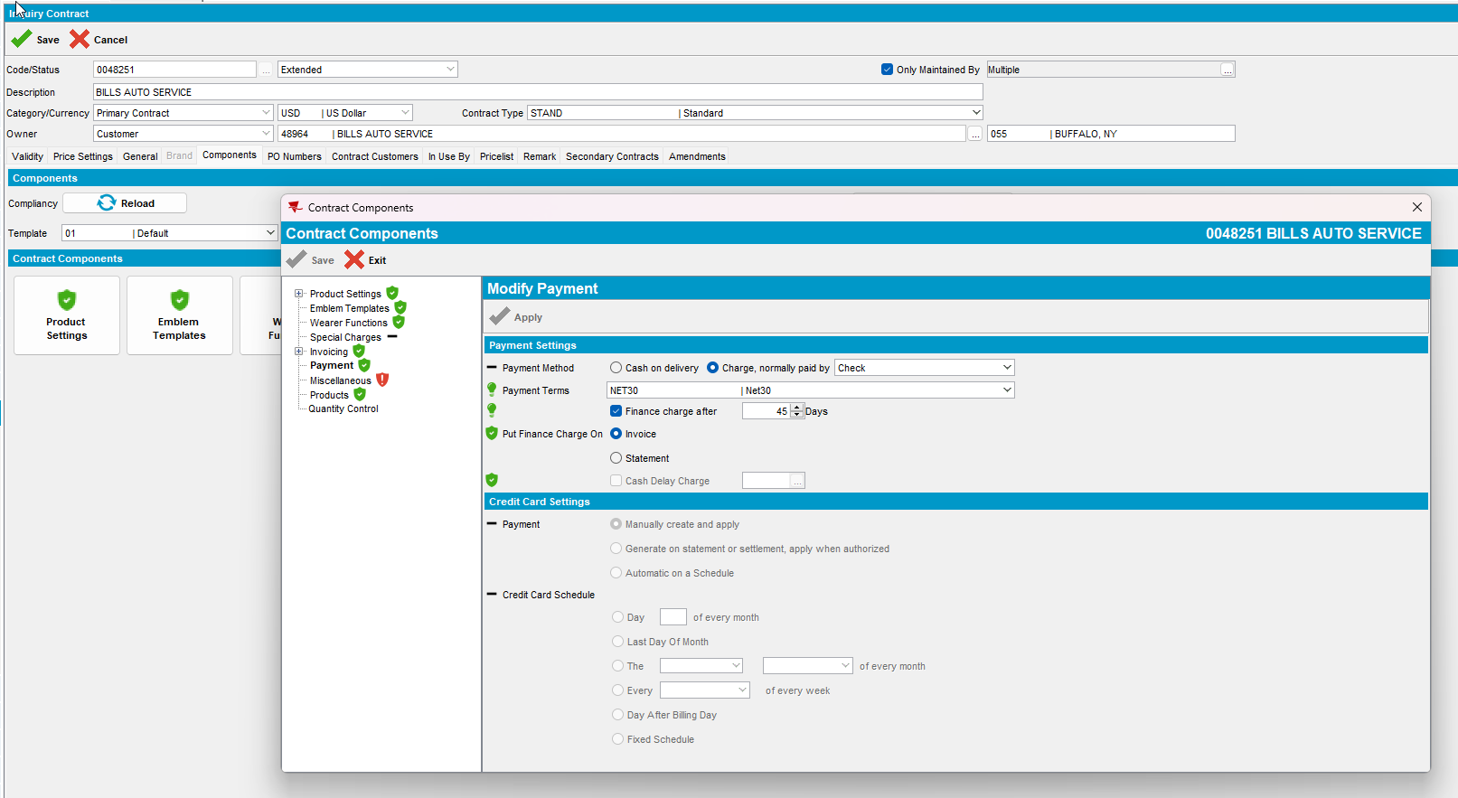
Tested OK

Test Case 4 – Set SS PAYMENTTABWITHEXTERNALAR = NRNN
Hash: c94788575274
- System Settings DLG: Set SS PAYMENTTABWITHEXTERNALAR = NRNN
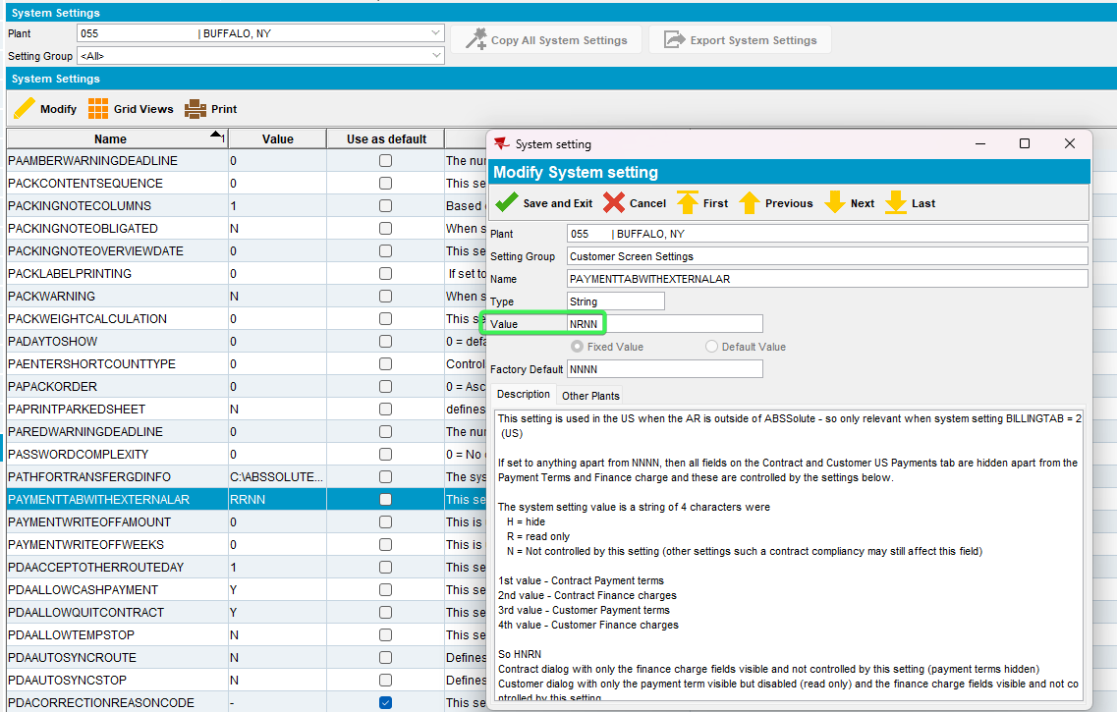
- Contract DLG: Load a contract and go to components tab
- Press Payments button and check that Payment Terms and Finance charges are present but are Read Only
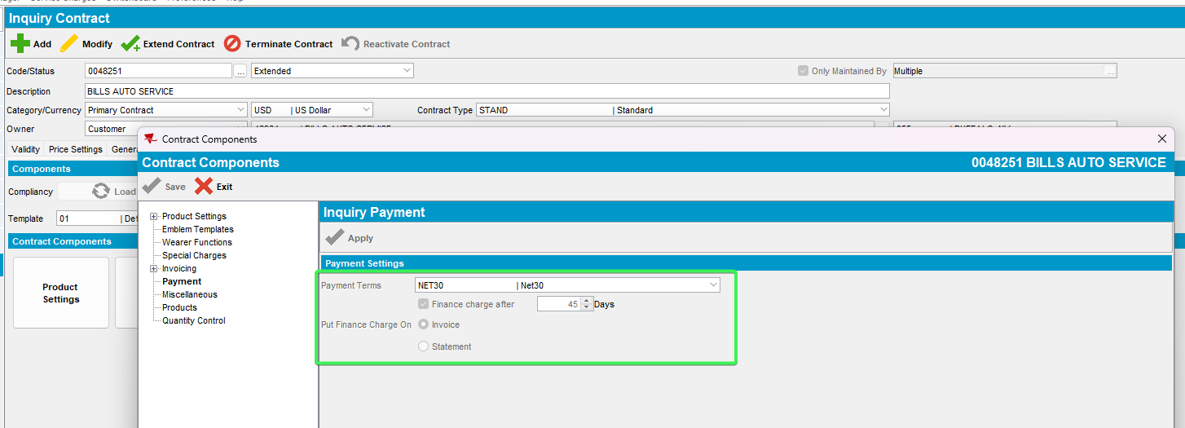
- Press Modify button and then load compliance
- Press Payment button again and check that Payment Terms is visible and enabled and Finance charges is present but is set as Read Only
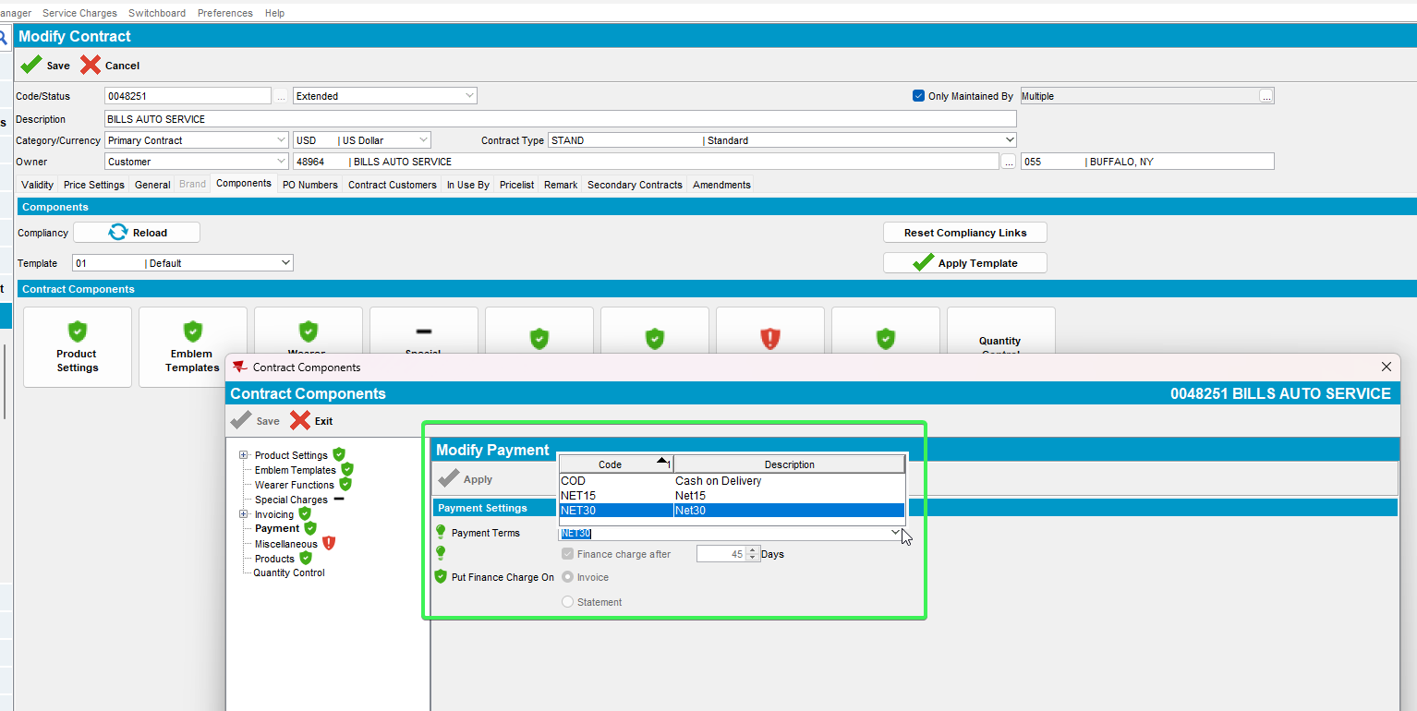
Tested OK

Test Case 5 – Set SS PAYMENTTABWITHEXTERNALAR = NHNN
Hash: c94788575274
- System Settings DLG: Set SS PAYMENTTABWITHEXTERNALAR = NHNN
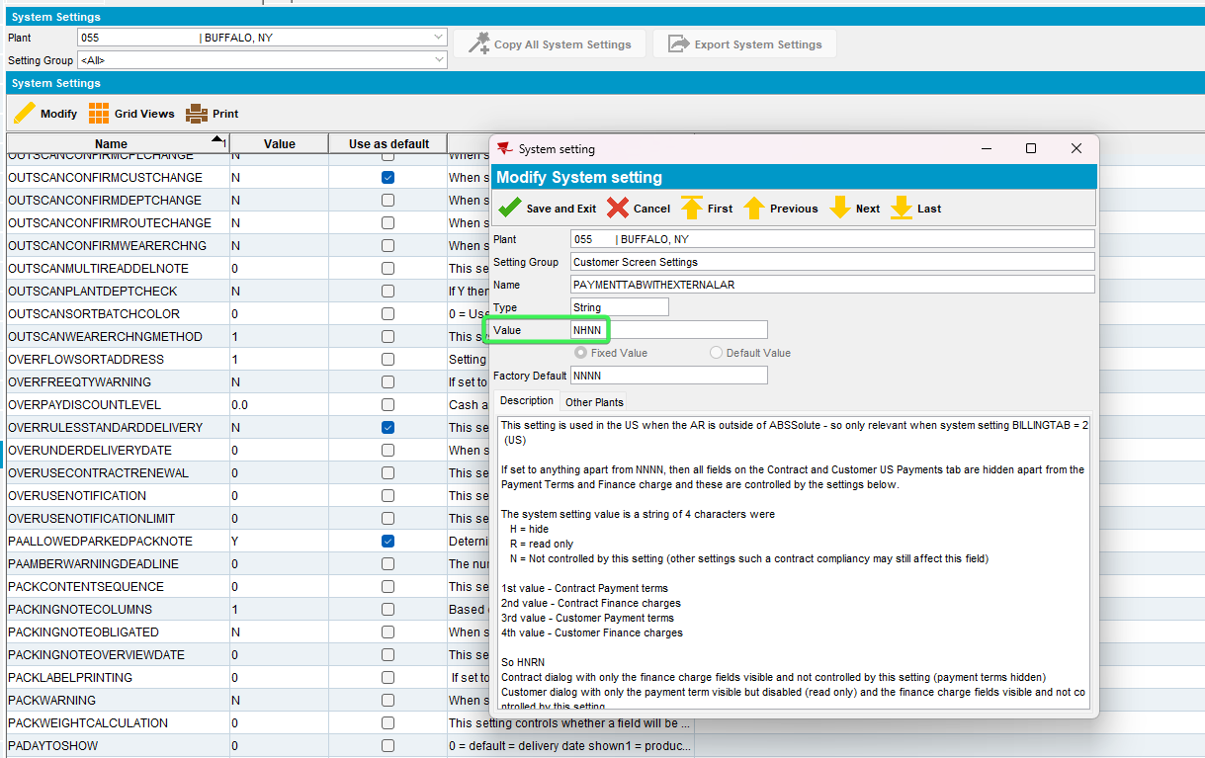
- Contract DLG: Load a contract and go to components tab
- Press Payments button and check that Payment Terms is visible but set as Read Only and Finance charges is not visible
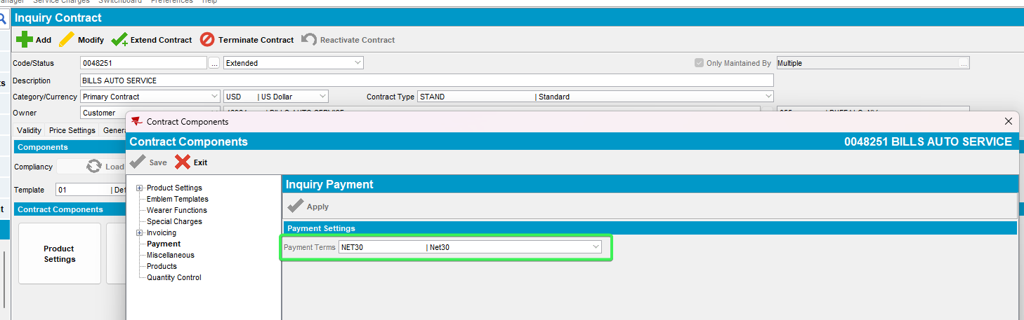
- Press Modify button and then load compliance
- Press Payment button again and check that Payment Terms is visible and enabled and Finance charges not visible
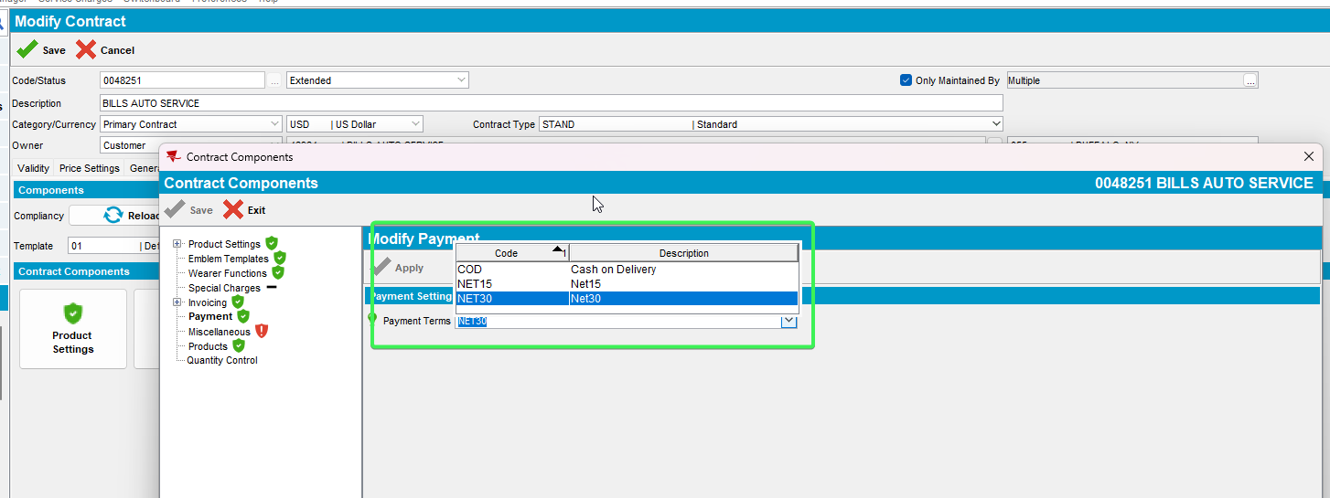
Tested OK

Test Case 6 – Set SS PAYMENTTABWITHEXTERNALAR = RNNN
Hash: 0d7bafeb2c0a
- System Settings DLG: Set SS PAYMENTTABWITHEXTERNALAR = RNNN
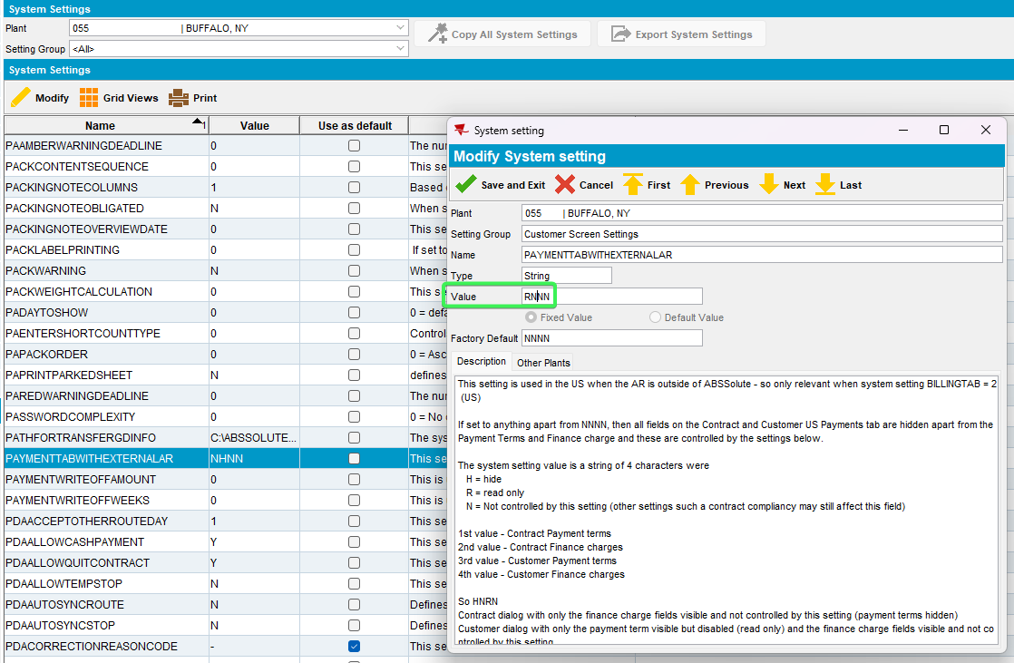
- Contract DLG: Load a contract and go to components tab
- Press Payments button and check that Payment Terms and Finance charges are visible but Read Only
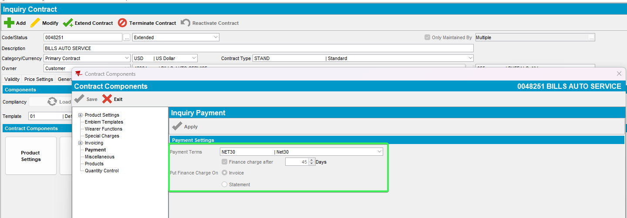
- Press Modify button and then load compliance
- Press Payment button again and check that Payment Terms is visible and set as Read Only and Finance charges is visible and enabled
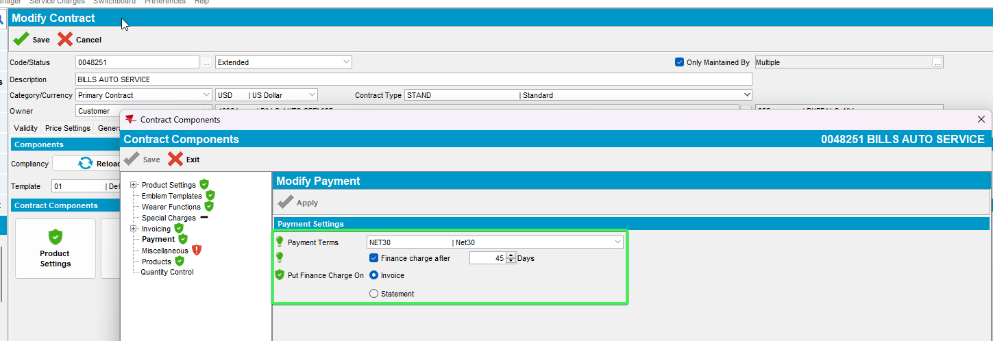
Tested OK

Test Case 7 – Set SS PAYMENTTABWITHEXTERNALAR = HNNN
Hash: 0d7bafeb2c0a
- System Settings DLG: Set SS PAYMENTTABWITHEXTERNALAR = HNNN
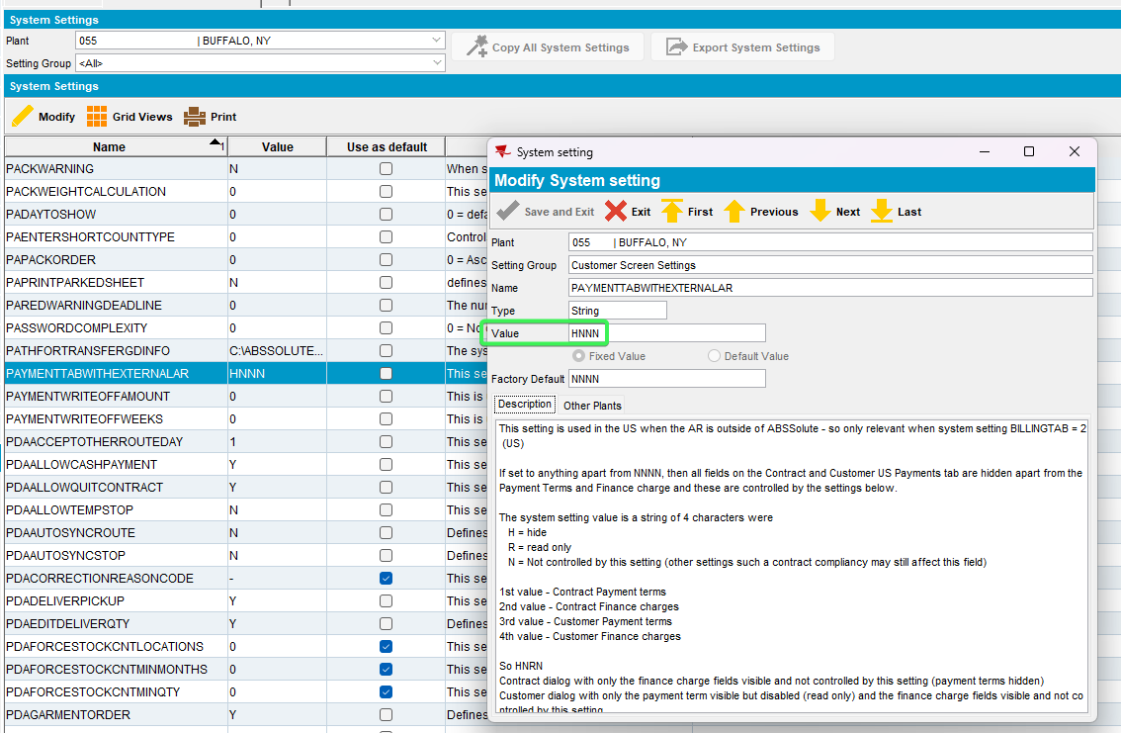
- Contract DLG: Load a contract and go to components tab
- Press Payments button and check that Payment Terms is not visible and Finance charges is visible but Read Only
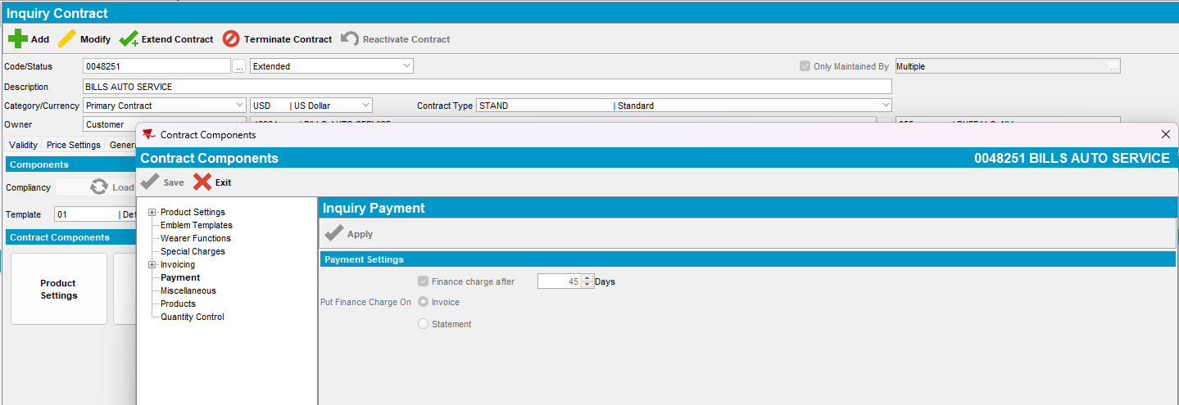
- Press Modify button and then load compliance
- Press Payment button again and check that Payment Terms not visible and Finance charges is visible and enabled
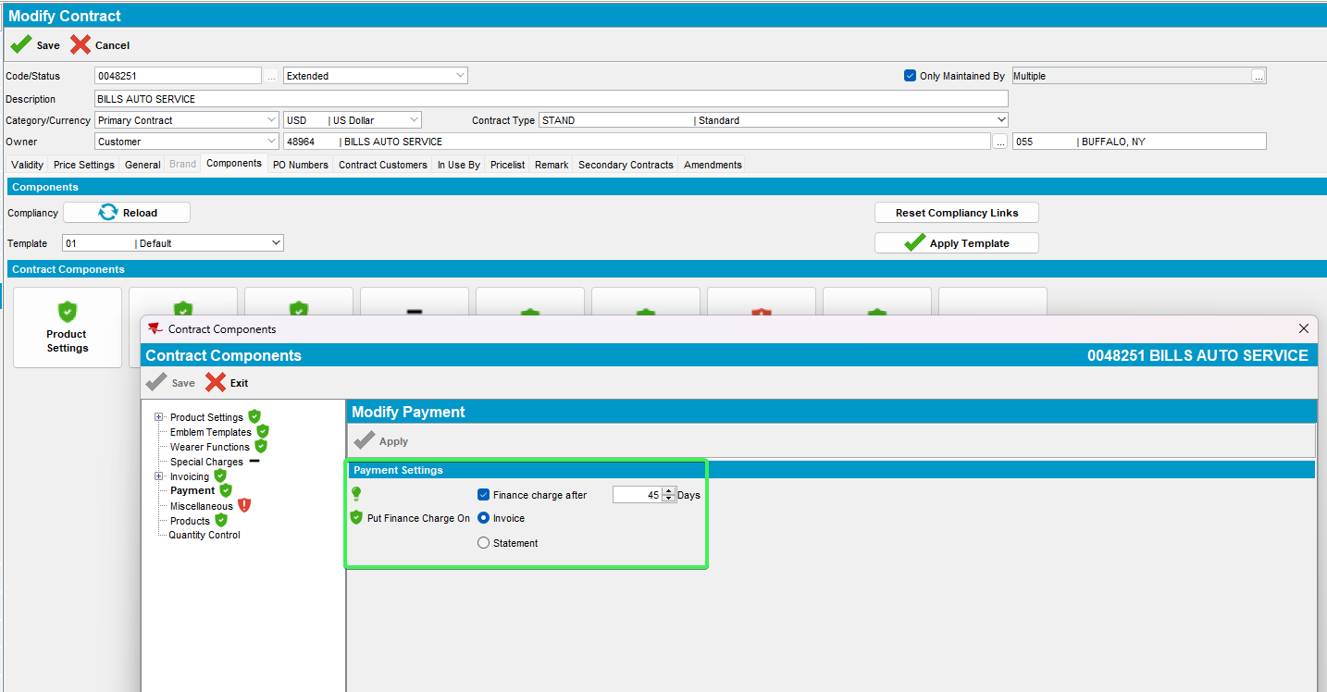
Tested OK

Test Case 8 – Check that compliancy is based only for visible fields
Hash: c94788575274

- System Settings DLG: Set SS PAYMENTTABWITHEXTERNALAR = NNNN
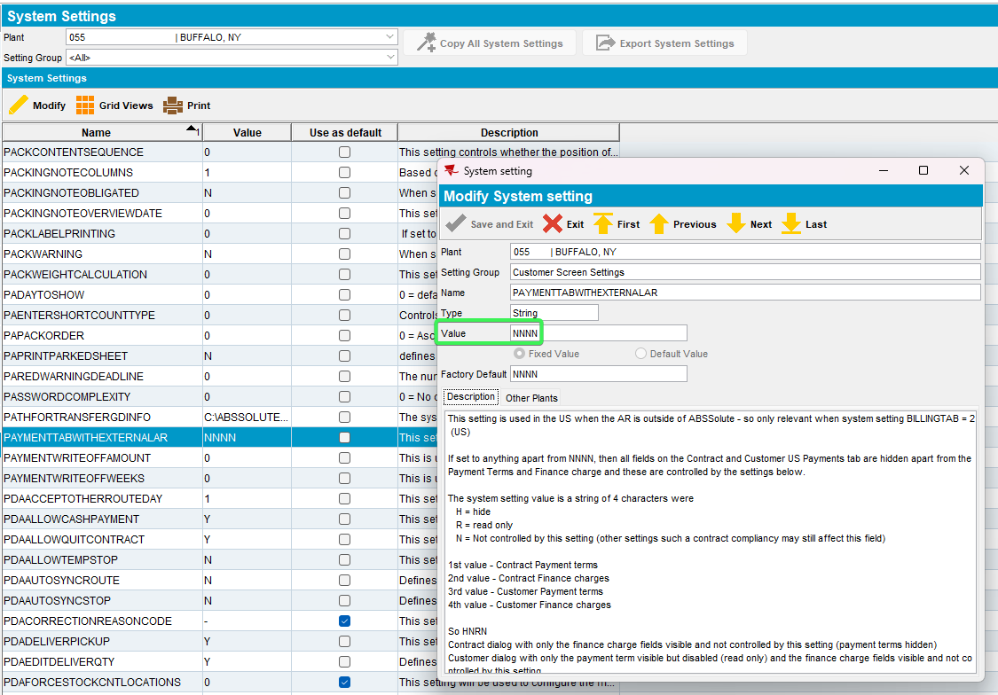
- Contract DLG: Input a contact number > Press modify > Load compliancy
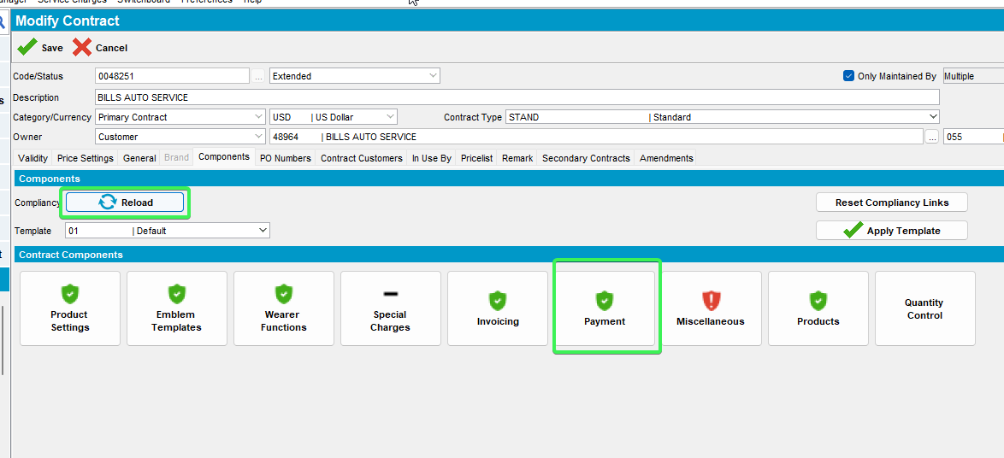
- Payment tab > change the compliancy to a field that would be hidden for example Payment Method
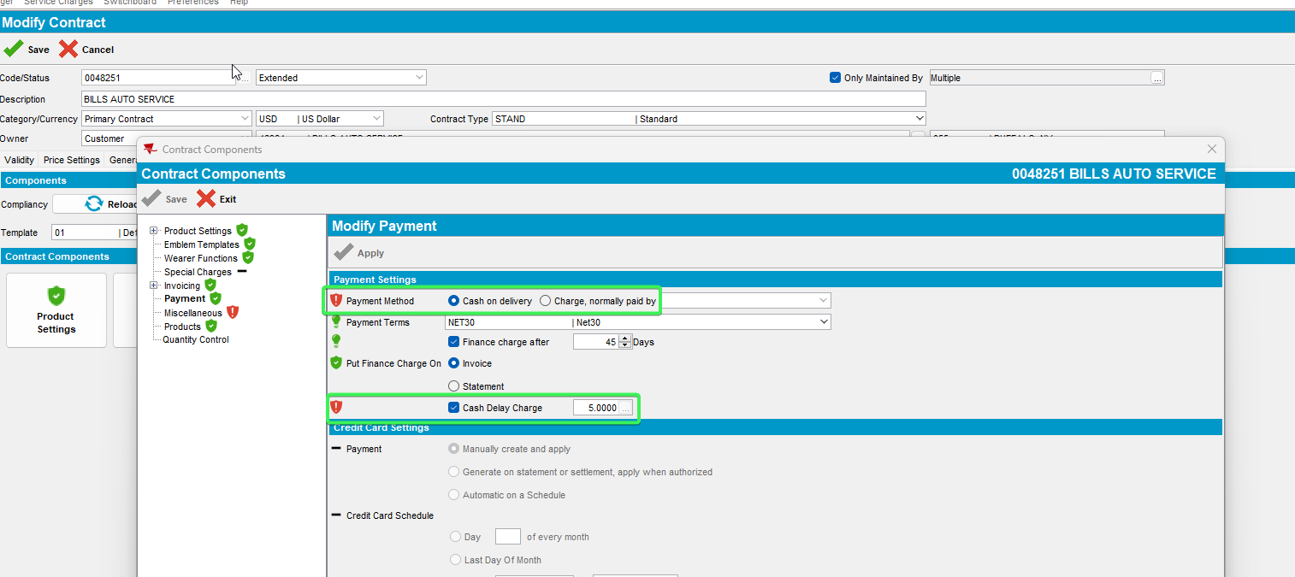
- Apply and see that the reload compliancy and see that the icon has changed for the Payment button
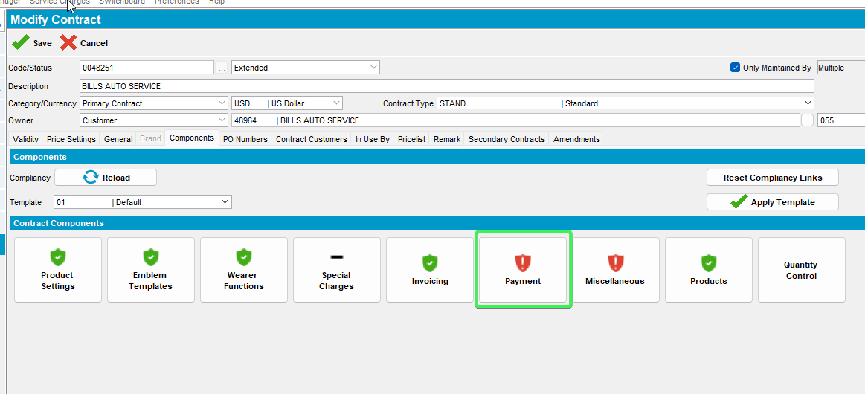
- System settings DLG: Change ss to PAYMENTTABWITHEXTERNALAR = RNNN
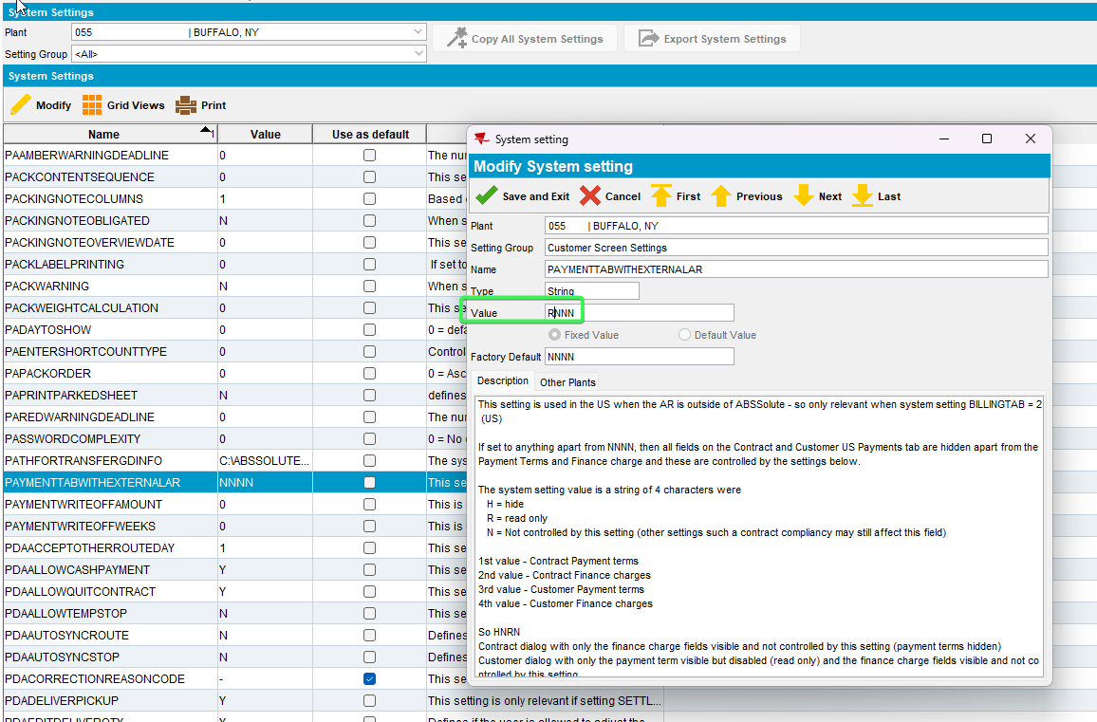
- Restart client and go back to Contract dlg > reload the contract you just modified
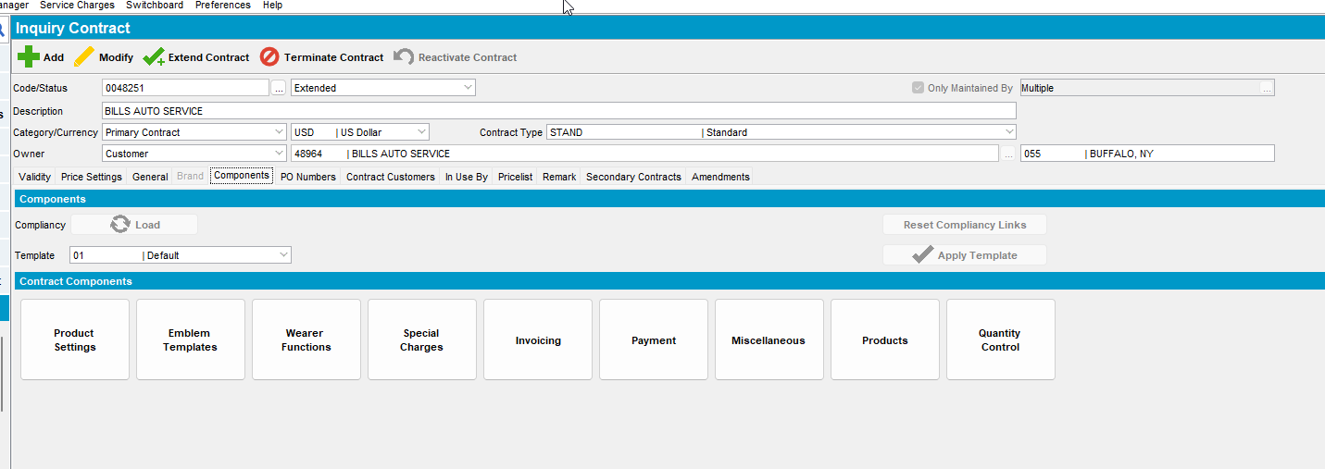
- Run the following script in order to update the compliancy rules for your contract
DELETE FROM CONTRACTCOMPLIANCY CC WHERE CC.CONTRACTATTRIBUTE_ID IN (80, 81, 255, 256, 257) and cc.contract_id=(select c.contract_id from contract c where c.code='0048251');
COMMIT;
- Press modify and load compliancy
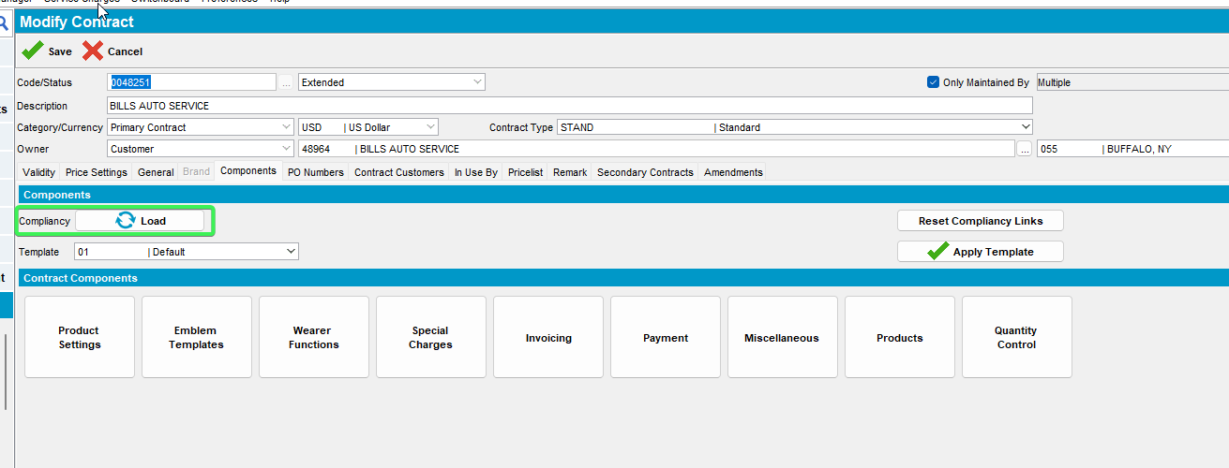
- Check that the Payment button shows as compliant
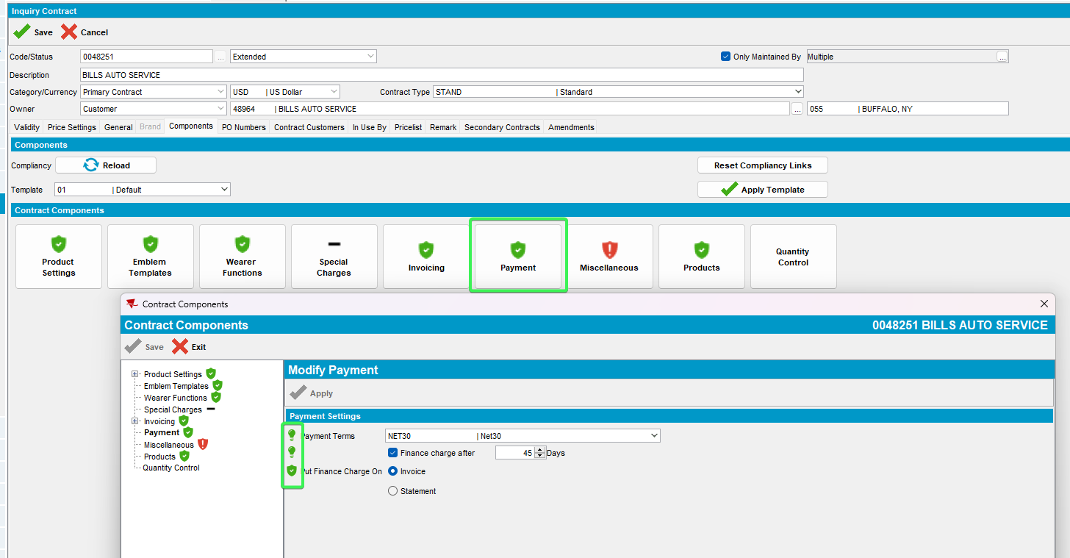
Tested OK

Testing Customer fields visibility from Switchboard

Test Case 1 – Set SS PAYMENTTABWITHEXTERNALAR = NNNN
Hash: c94788575274
- System Settings DLG: Set SS PAYMENTTABWITHEXTERNALAR = NNNN
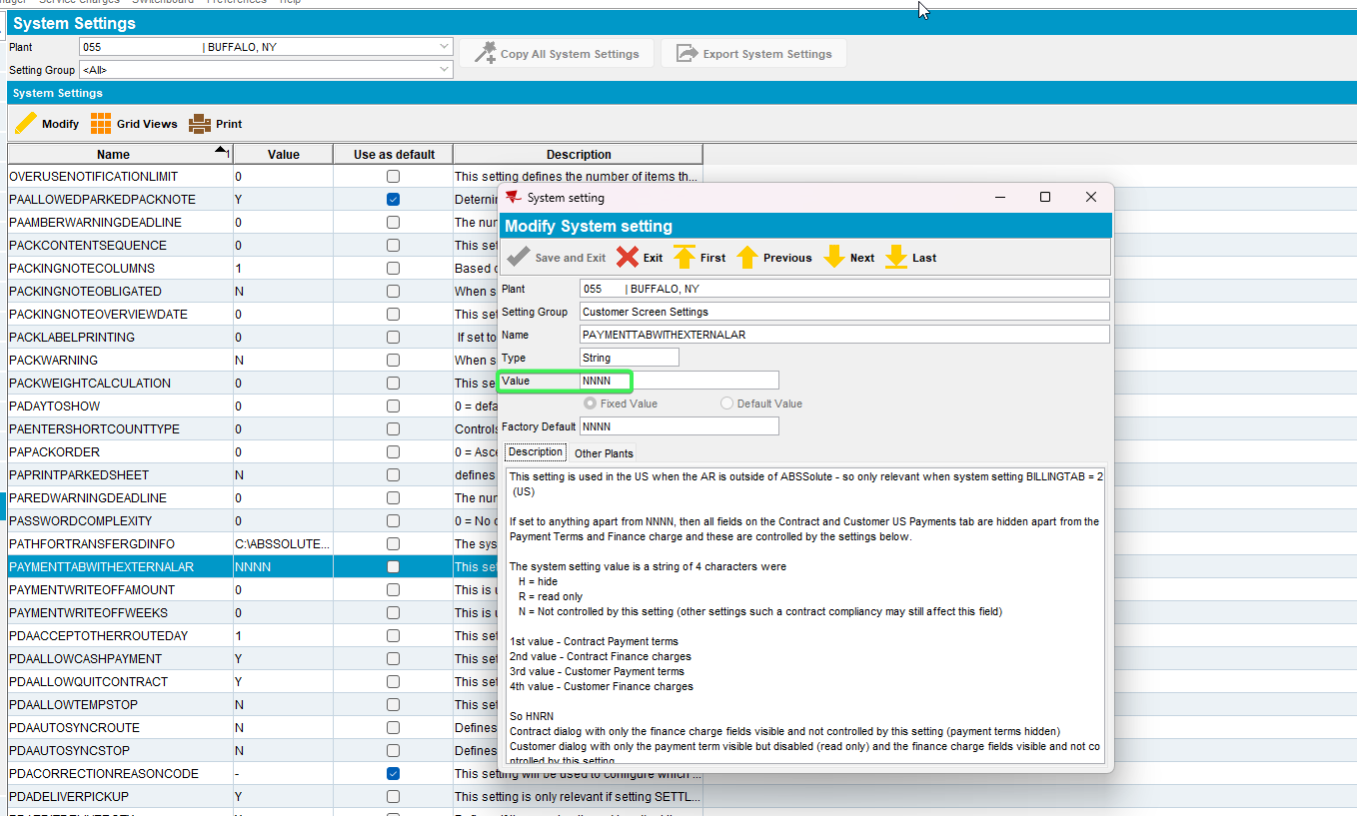
- Switchboard: Payment tab > Payment Terms and Finance charges should be active
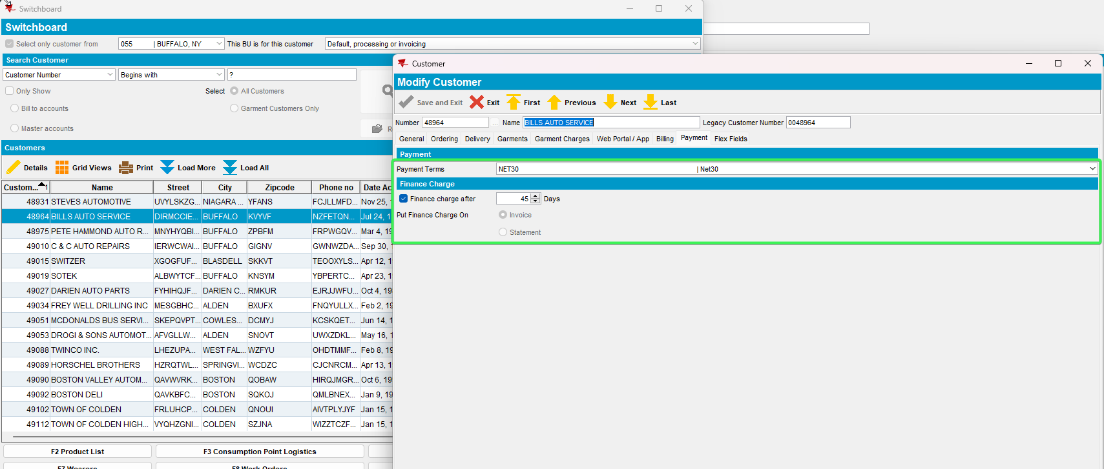
Tested OK

Test Case 2 – Set SS PAYMENTTABWITHEXTERNALAR = NNHH
Hash: 0f9955dbb12b
- System Settings DLG: Set SS PAYMENTTABWITHEXTERNALAR = NNHH
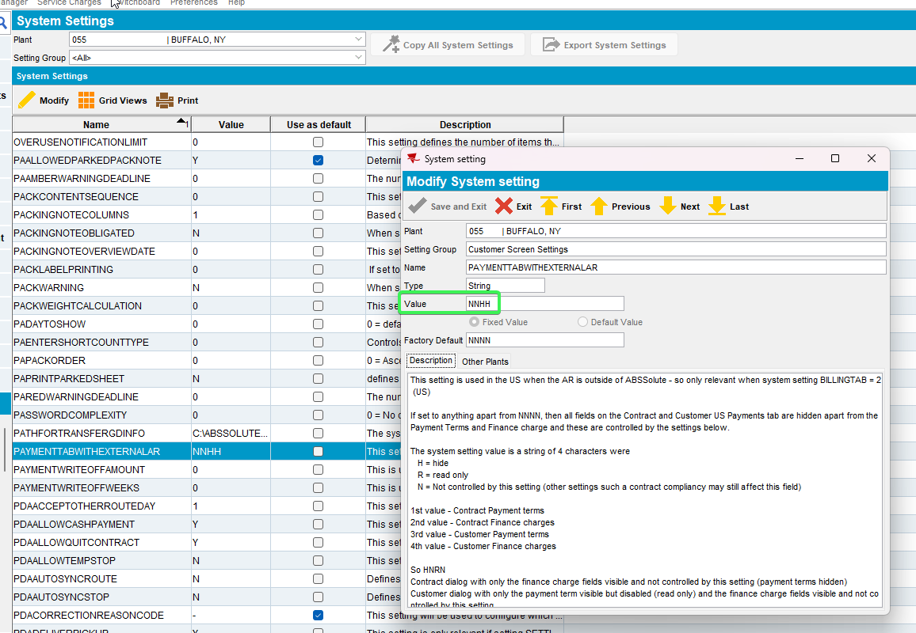
- Switchboad: Payment tab > should be empty
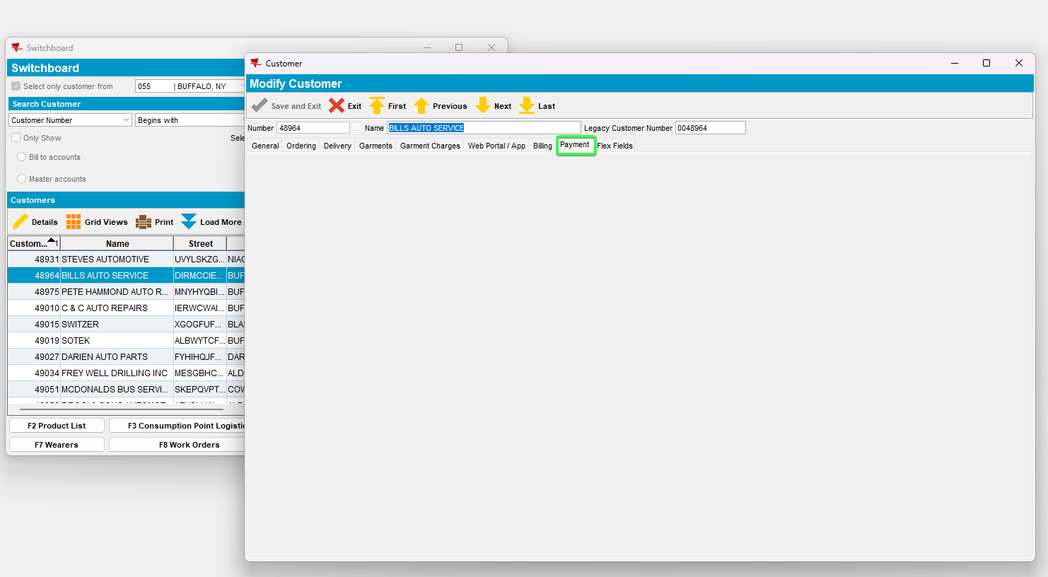
Tested OK

Test Case 3 – Set SS PAYMENTTABWITHEXTERNALAR = NNRR
Hash: c94788575274
- System Settings DLG: Set SS PAYMENTTABWITHEXTERNALAR = NNRR
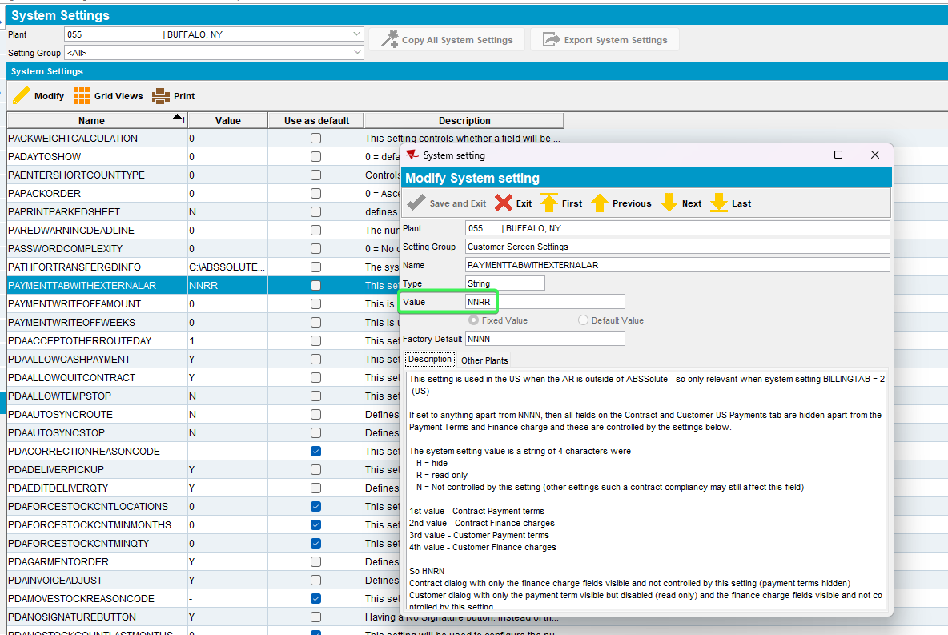
- Switchboard: Payment tab > Payment Terms and Finance charges should be set as Read Only
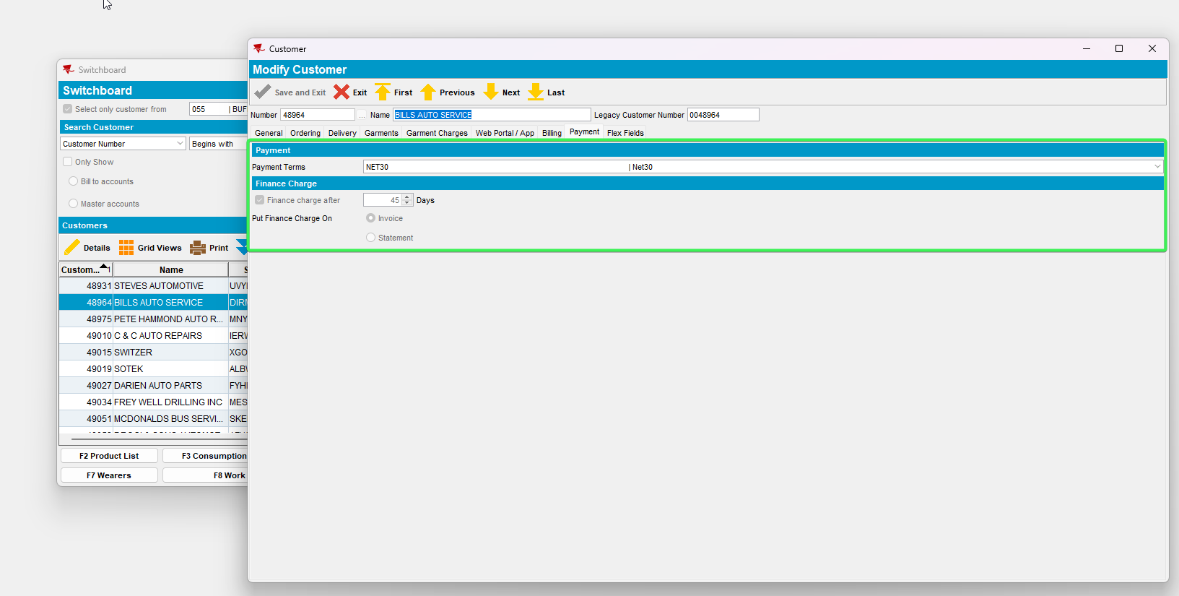
Tested OK

Testing SS BILLINGTAB set as 1

Test Case 1 – Set SS BILLINGTAB = 1 and SS PAYMENTTABWITHEXTERNALAR = NNNN
Hash: 0f9955dbb12b

- System Settings DLG: Set SS BILLINGTAB = 1 and SS PAYMENTTABWITHEXTERNALAR = NNNN
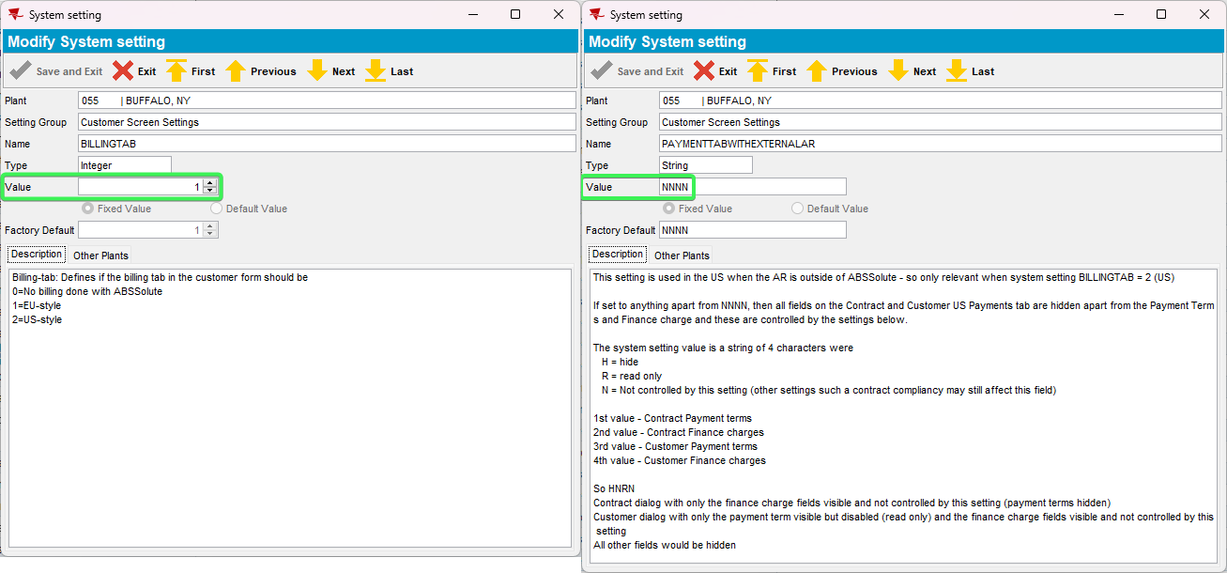
- Customer DLG: Payment tab see that the tab is set up as EU style
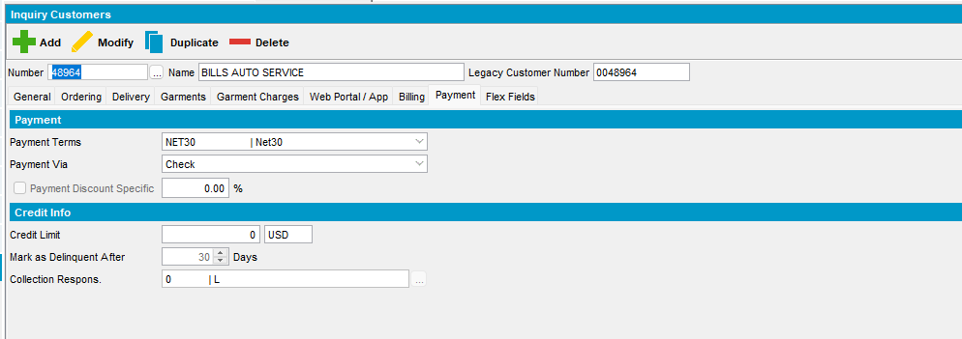
- Contract DLG: Components tab > load compliancy and press Payment button > See that the menu is set as EU style
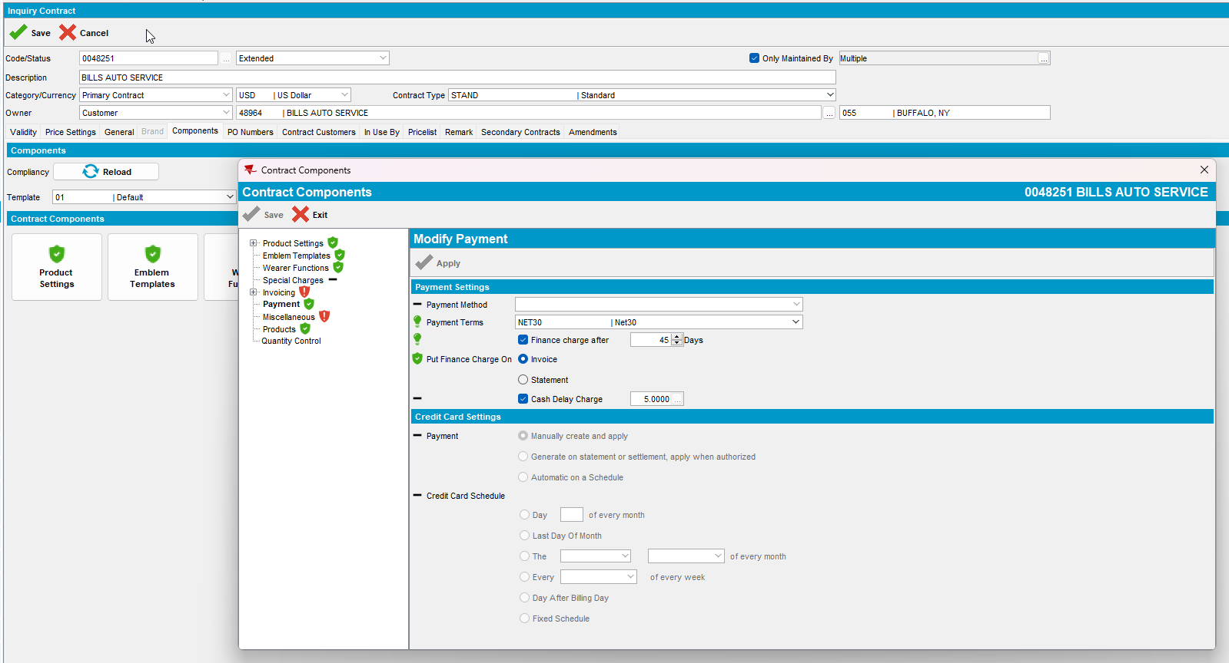
Tested OK

Test Case 2 – Set SS BILLINGTAB = 1 and SS PAYMENTTABWITHEXTERNALAR = HHHH
Hash: 0f9955dbb12b

- System Settings DLG: Set SS BILLINGTAB = 1 and SS PAYMENTTABWITHEXTERNALAR = HHHH
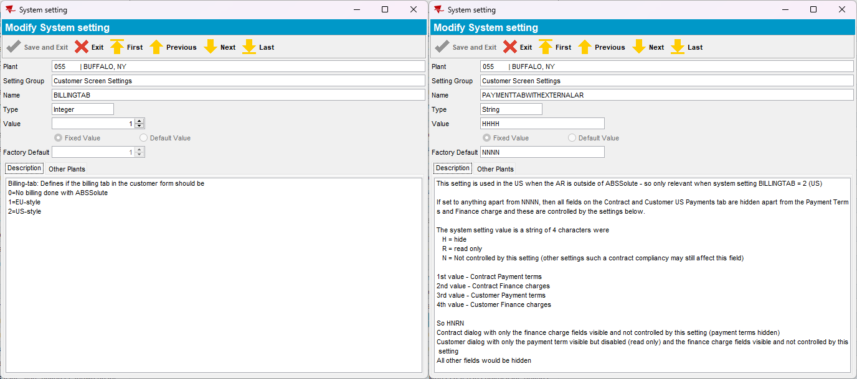
- Customer DLG: Payment tab see that the tab is set up as EU style
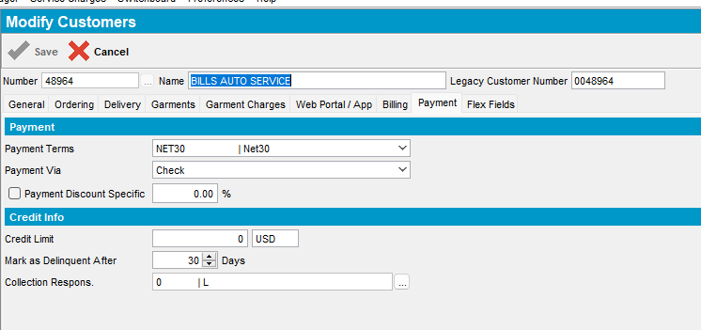
- Contract DLG: Components tab > load compliancy and press Payment button > See that the menu is set as EU style
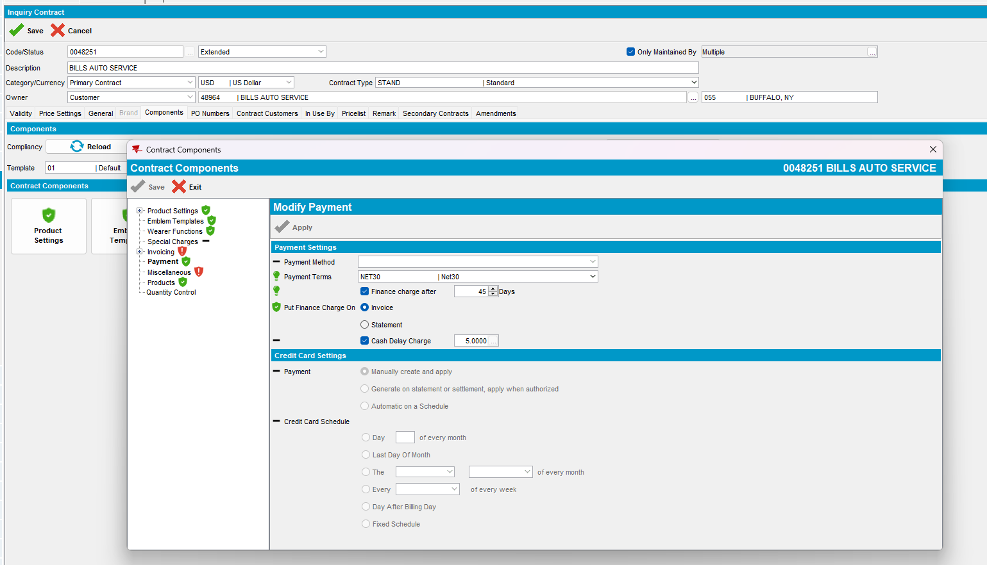
Tested OK

Test Case 3 – Set SS BILLINGTAB = 1 and SS PAYMENTTABWITHEXTERNALAR = RRRR
Hash: 0f9955dbb12b

- System Settings DLG: Set SS BILLINGTAB = 1 and SS PAYMENTTABWITHEXTERNALAR = RRRR
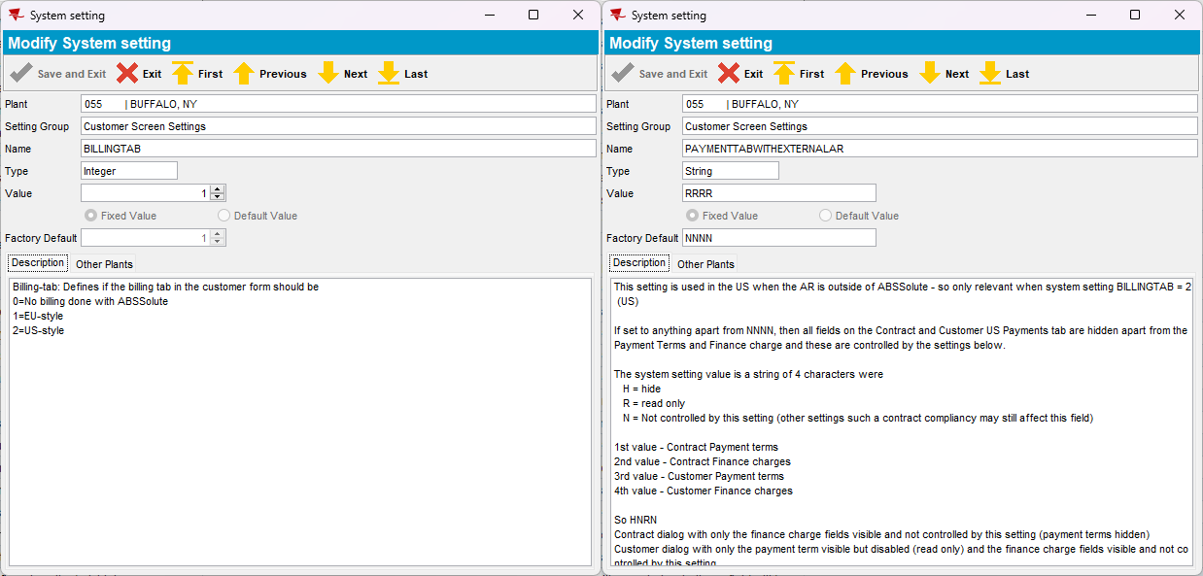
- Customer DLG: Payment tab see that the tab is set up as EU style
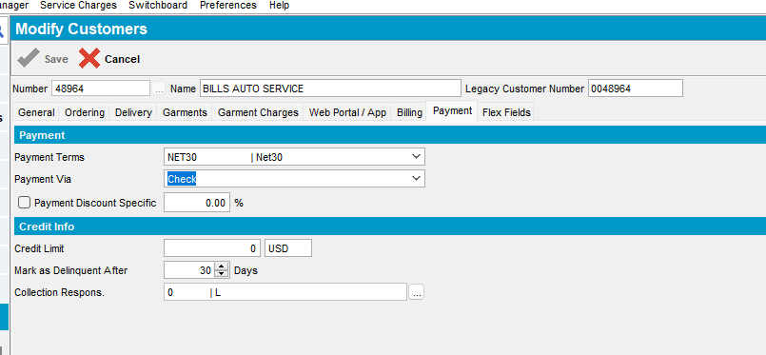
- Contract DLG: Components tab > load compliancy and press Payment button > See that the menu is set as EU style
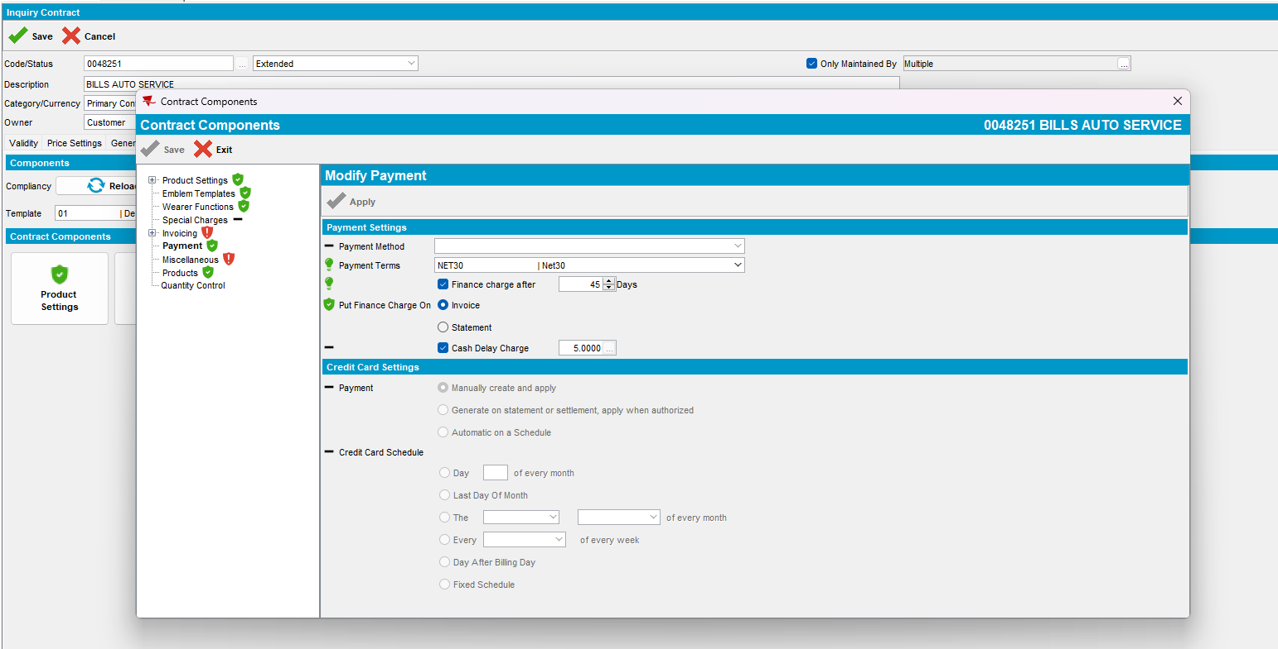
Tested OK

Read Only testing

Test Case 1 –SS PAYMENTTABWITHEXTERNALAR = NNNN and Customer and Contract DLG are set as Read Only
Hash: 0f9955dbb12b

- Menu Application: Set Customer DLG and Contract DLG as read only for your User
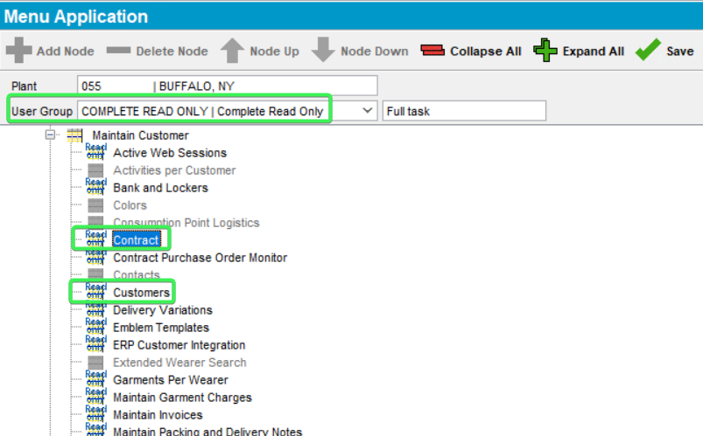
- System Settings DLG: Set SS PAYMENTTABWITHEXTERNALAR = NNNN
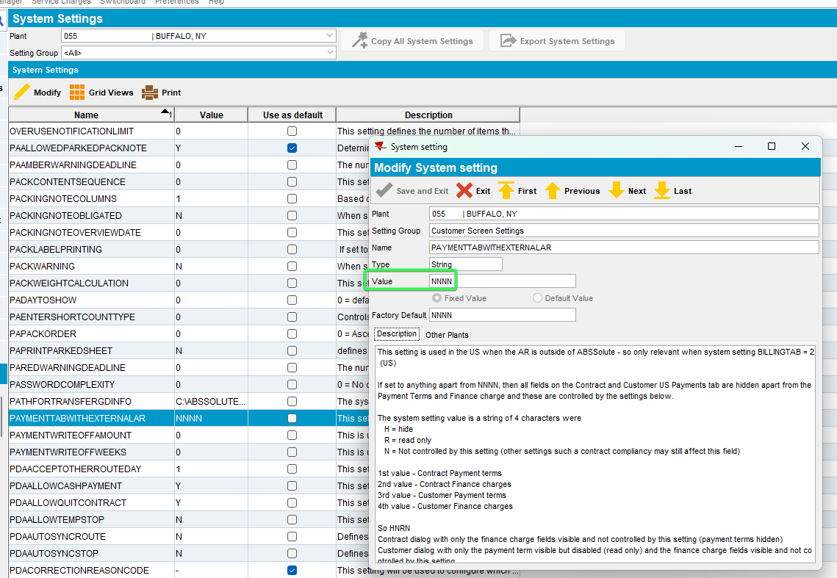
- Log in with your Read only user
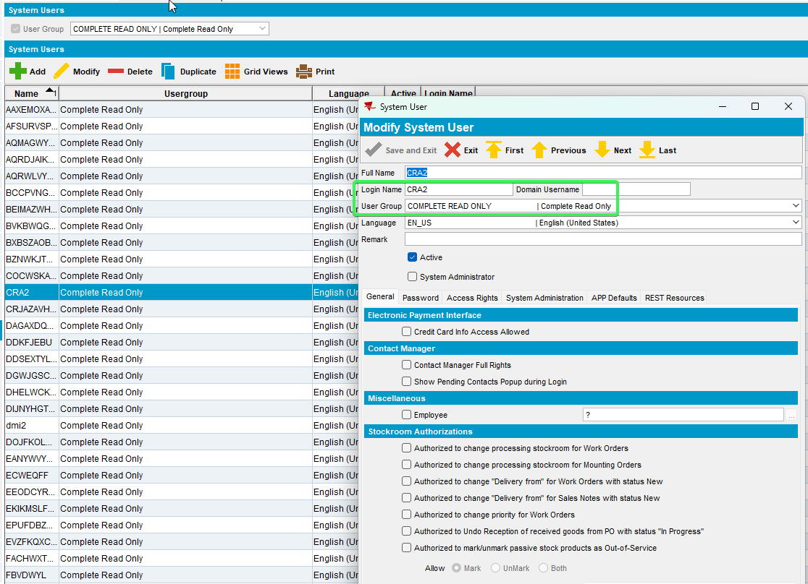
- Customers DLG: See that the tabs are present but are disabled (Read only)
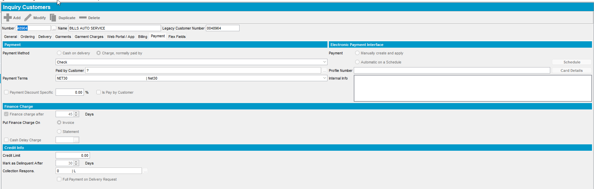
- Contract DLG: See that the tabs are present but are disabled (Read only)
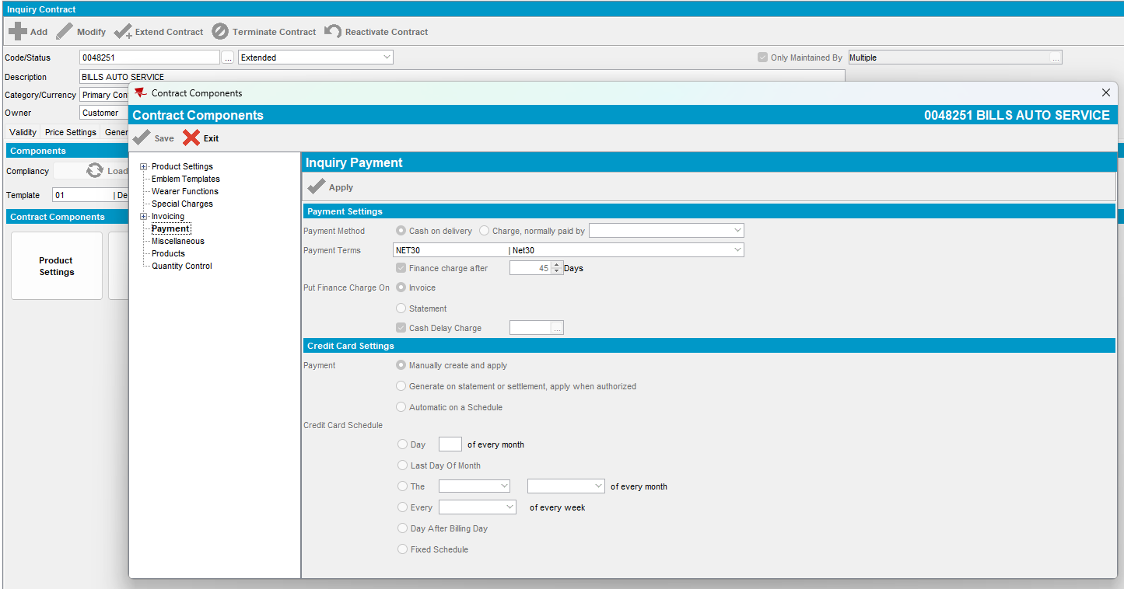
Tested OK

Test Case 2 –SS PAYMENTTABWITHEXTERNALAR = RRRR and Customer and Contract DLG are set as Read Only
Hash: 0f9955dbb12b
- Menu Application: Set Customer DLG and Contract DLG as read only for your User
- System Settings DLG: Set SS PAYMENTTABWITHEXTERNALAR = RRRR
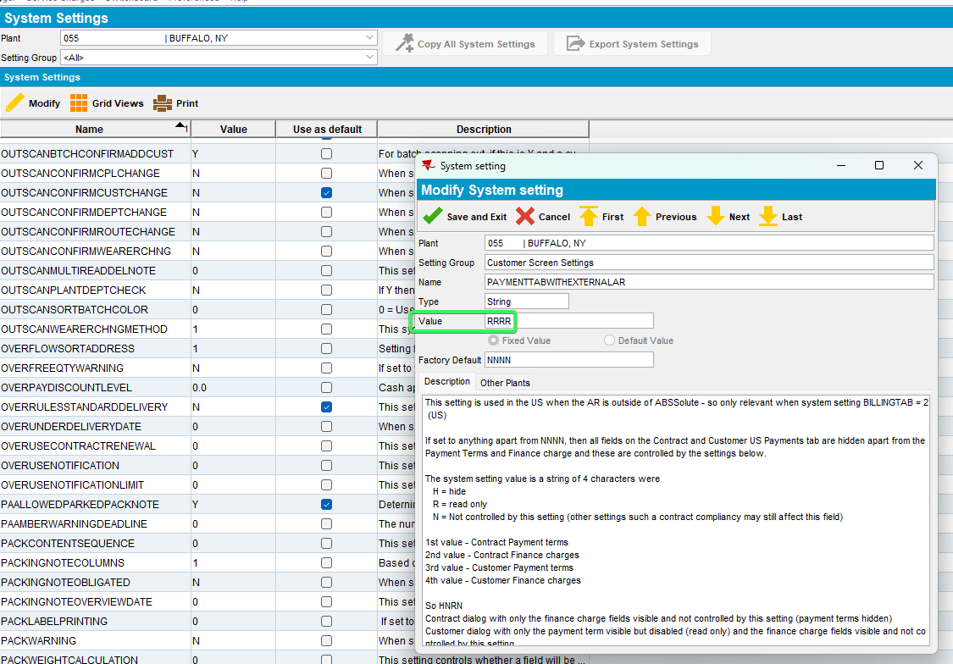
- Log in with your Read only user
- Customers DLG: See that the tabs are present but are disabled (Read only)
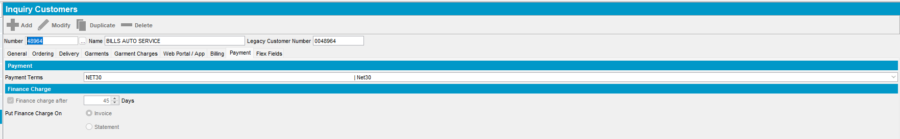
- Contract DLG: See that the tabs are present but are disabled (Read only)
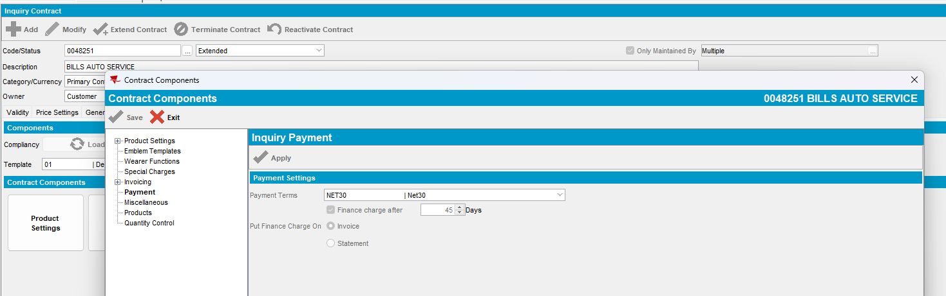
Tested OK

Test Case 3 –SS PAYMENTTABWITHEXTERNALAR = HHHH and Customer and Contract DLG are set as Read Only
Hash: 0f9955dbb12b
- Menu Application: Set Customer DLG and Contract DLG as read only for your User
- System Settings DLG: Set SS PAYMENTTABWITHEXTERNALAR = HHHH
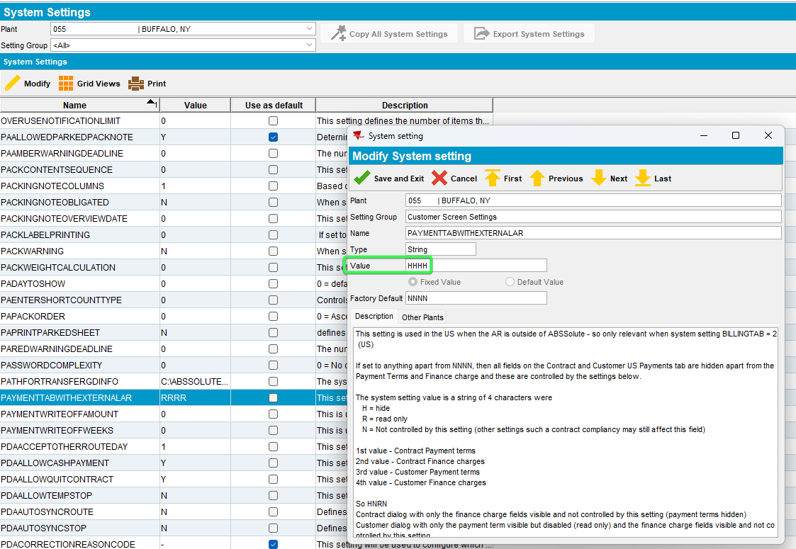
- Log in with your Read only user
- Customers DLG: See that the tabs are not present
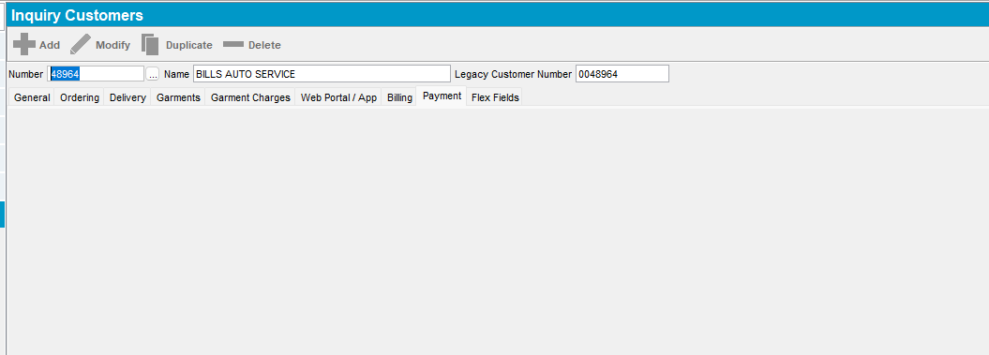
- Contract DLG: See that the tabs are not present
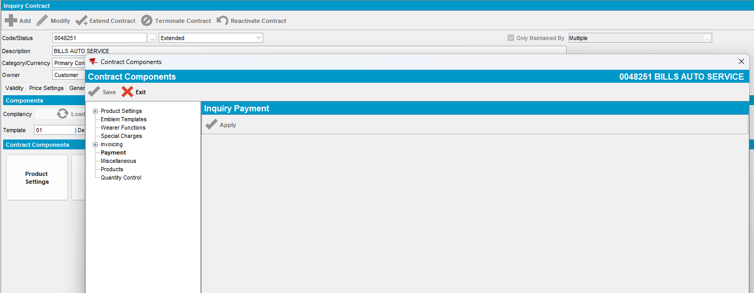
Tested OK

