ABSN-7659 - Access Rights mechanism "Read Only for Modify only/Full Access for Add" doesn't work properly
Environment | Prerequisites
Version: 9.07.00.UNF20  DBServerName= abs-srv20.internal.abslbs.com  DBSID=CUST24  DBUser=UNFDEV  Environment=Test | - Module:  - System setting

Contents
Retest after fix 1
Test Case 1 – – Access Rights List – ‘Read Only for Modify only/Full Access for Add’ 1

Retest after fix

Test Case 1 – Access Rights List – ‘Read Only for Modify only/Full Access for Add’
Hash: 23d00e060148
- System Users DLG: press modify on your system user and go to Access Rights
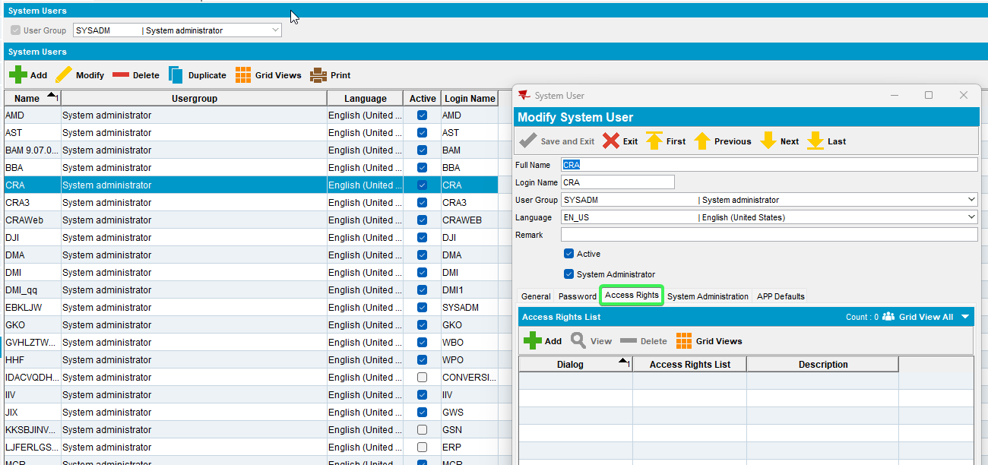
- Add Dialog Customers > All other System Users list
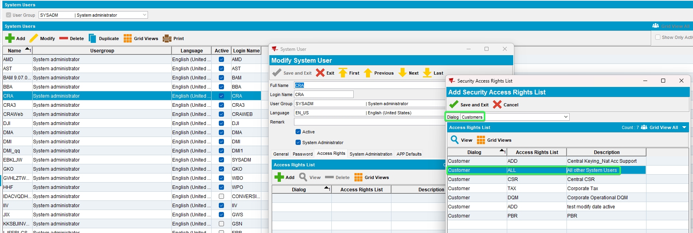
- Open ‘Maintain Access Rights List’ dlg, select the access rights list and press ‘Modify’. Set fields from ‘Tab General’ and ‘Tab Billing’ in ‘Read Only for Modify Only/Full Access for Add’
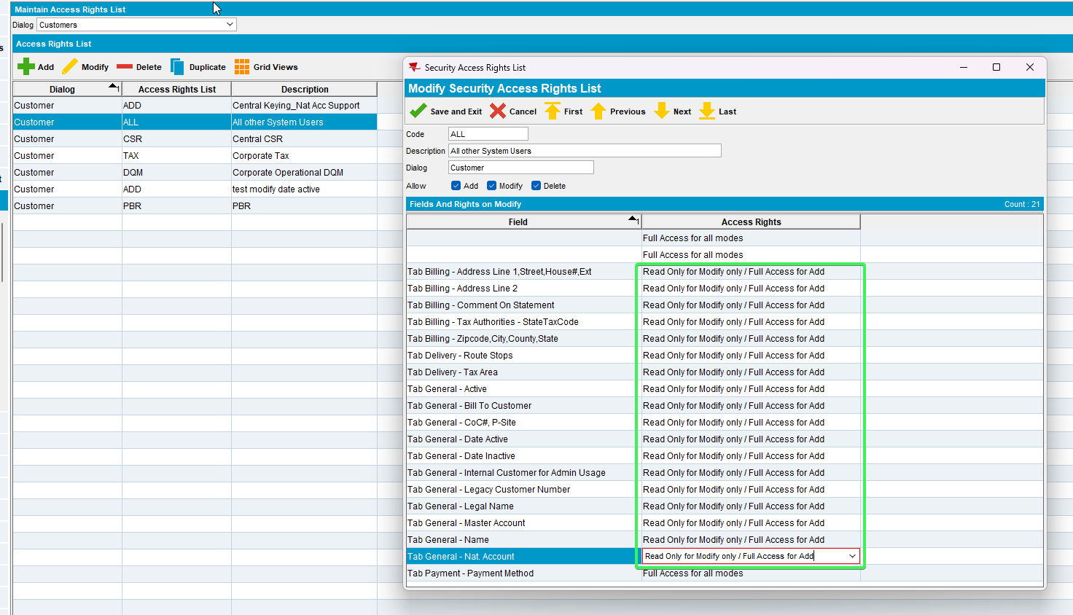

- Open ‘Customers’ dlg -> click ‘Add’ -> check the selected fields in ‘General’ tab and ‘Billing’ Tab. All fields included in the previously defined Access Rights List can be edited.
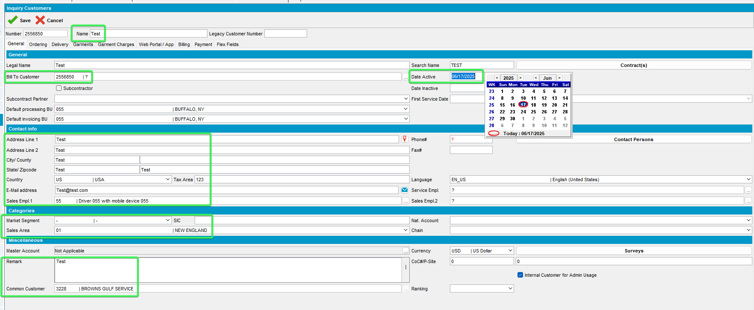
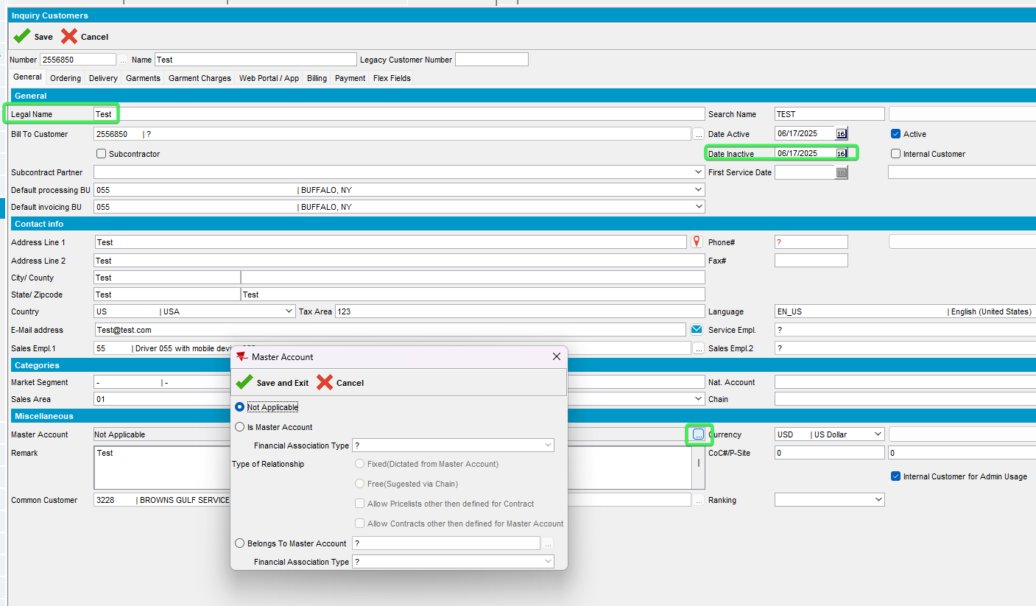
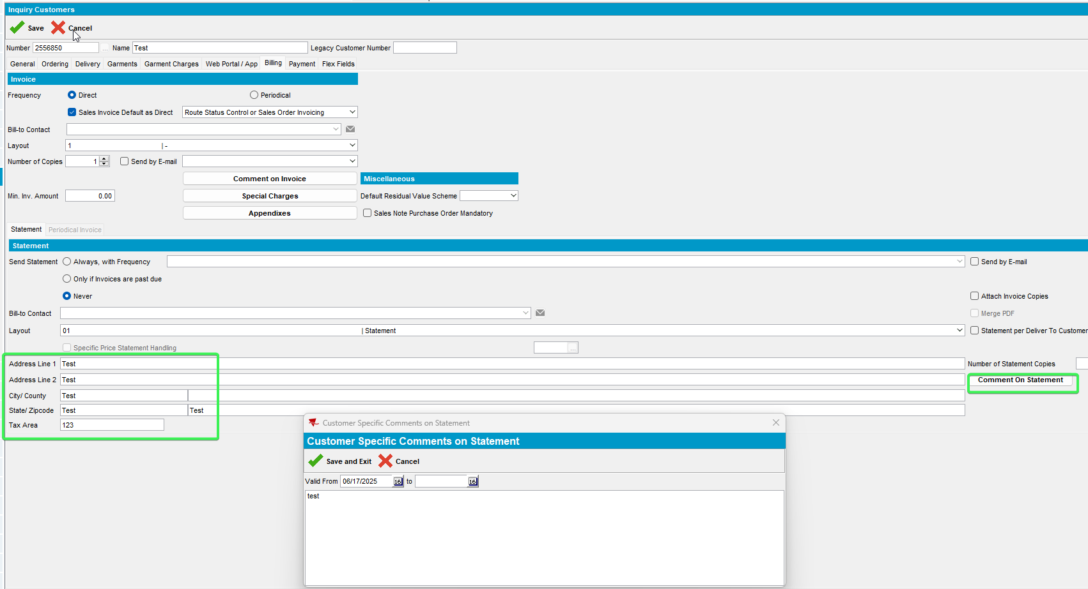
- Input a customer, press Modify and check the selected fields in ‘General’ tab and ‘Billing’ Tab. All fields included in the previously defined Access Rights List are un Read Only mode
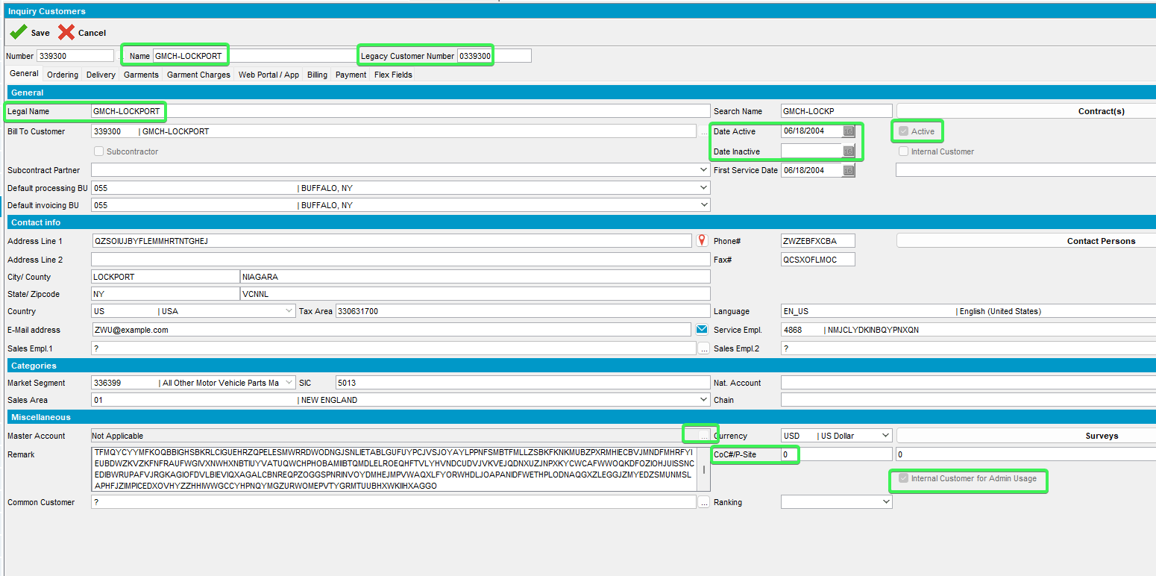
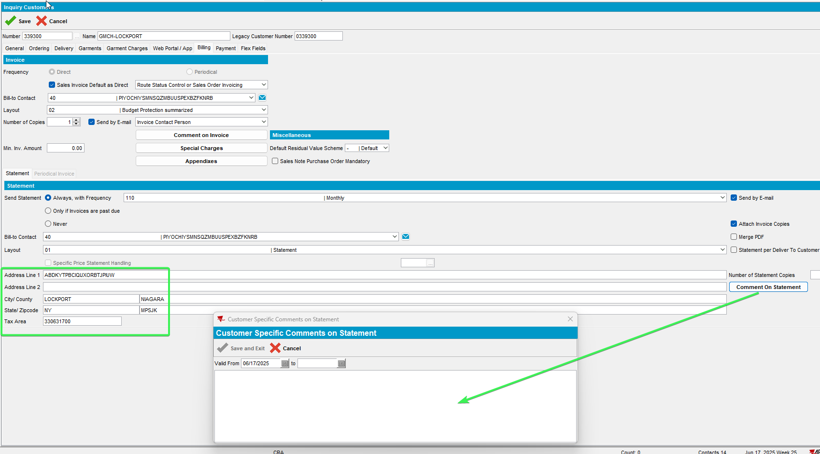
Tested OK

