ABSN-7306 D_UBS_2707 The Loss Date in the Loss Charge Monitor displays the Start Date of a wearer rather than the date the loss began billing
Environment | Prerequisites
Version:9.07.00  DBServerName= abs-srv16.internal.abslbs.com  DBSID=CUST24  DBUser=UNFDEV  Environment=PRODUCTION | - Module:  - System setting

Contents
Test before fix 2
Steps to reproduce: 2
Current behaviour: 8
Expected behaviour: 8
Retest after fix 8
Expected behavior: 8
Date loss charge started. This is the same as invoicing uses to generate and determine loss warning periods 8
For quit wearer – this is the wearer inactive date 8
For quit wearer inventory – this is the WI inactive date 8
For quit PLPC – this is the PLPC inactive date 8
For replacement – this is the replacement flag start date on the UI – if this is not the same for all the UI’s, then take the max 9
For decrease of max – take the decrease of max flag start date – same rules as per replacement for multiple UI’s 9
Test steps: 9
Non-unique garments – customer 1354800 9
From the client quit wearer – 9
this is the wearer inactive date 9
From the client quit wearer inventory – 9
this is the WI inactive date 9
From the client quit PLPC – 10
this is the PLPC inactive date 10
product code 152712 JKT 11
From the client replacement – 11
this is the replacement flag start date on the UI – if this is not the same for all the UI’s, then take the max 11
Issue work Order dlg: Issue the wo 1340157067 for the new size 13
From the client decrease of max 14
Mixed garments – customer 1230257 15
From the client quit wearer – 15
this is the wearer inactive date 15
From the client quit wearer inventory – 15
this is the WI inactive date 15
From the client quit PLPC – 16
this is the PLPC inactive date 16
From the client replacement – 17
this is the replacement flag start date on the UI – if this is not the same for all the UI’s, then take the max 17
Issue Work Order dlg: Issue workorder 1340157068 18
From the client decrease of max 19
Unique garments – customer 856759 19
From the client quit wearer – 19
this is the wearer inactive date 19
From the client quit wearer inventory – 19
this is the WI inactive date 19
From the client quit PLPC – 20
this is the PLPC inactive date 20
From the client replacement – 21
this is the replacement flag start date on the UI – if this is not the same for all the UI’s, then take the max 21
Issue the new workorder 1340157069 22
From the client decrease of max 23
On RA Non-unique garments – customer 1354800 24
On RA Mixed garments – customer 1230257 26
On RA Unique garments – customer 856759 28

Test before fix

hash: 6c8e5b86d6cd

Steps to reproduce:

- RSC dlg: Create a route with 1 customer who has wearers with garments, move out the other customers
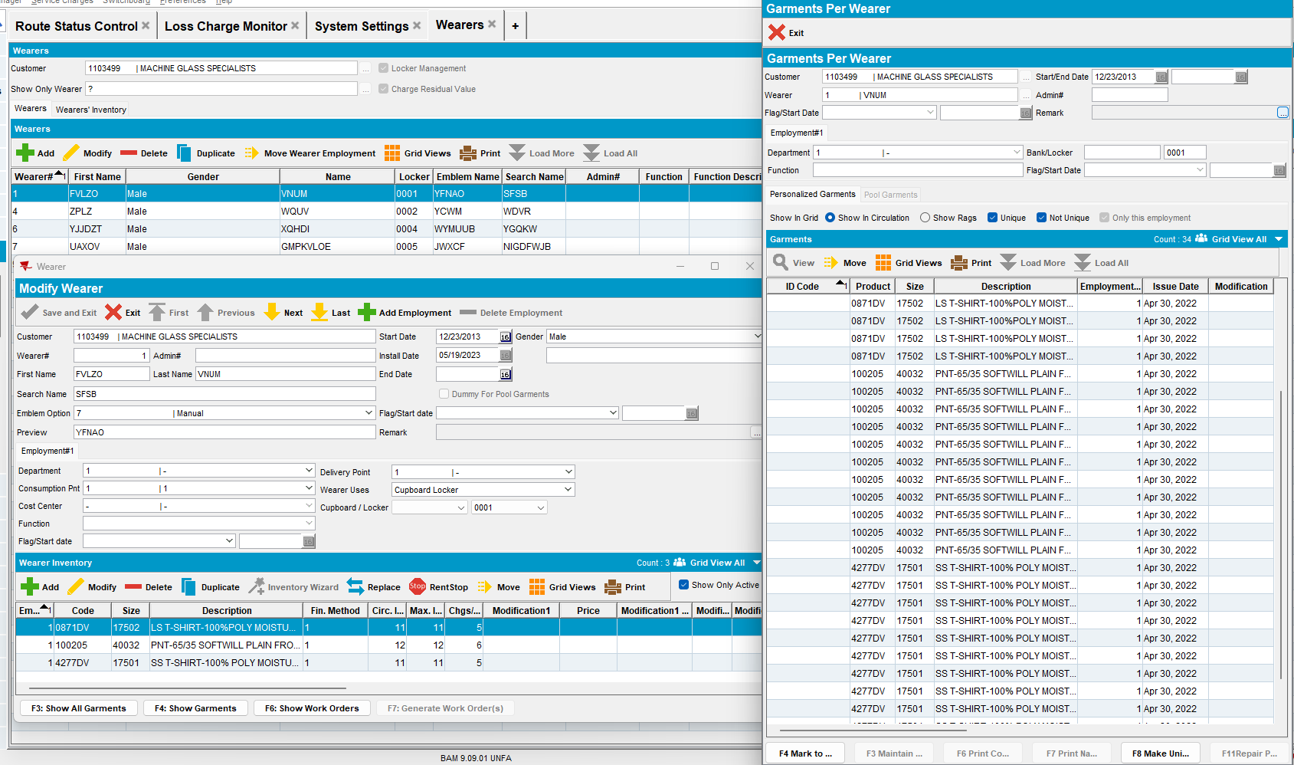
- Wearers dlg: For one wearer inventory make a replacement.
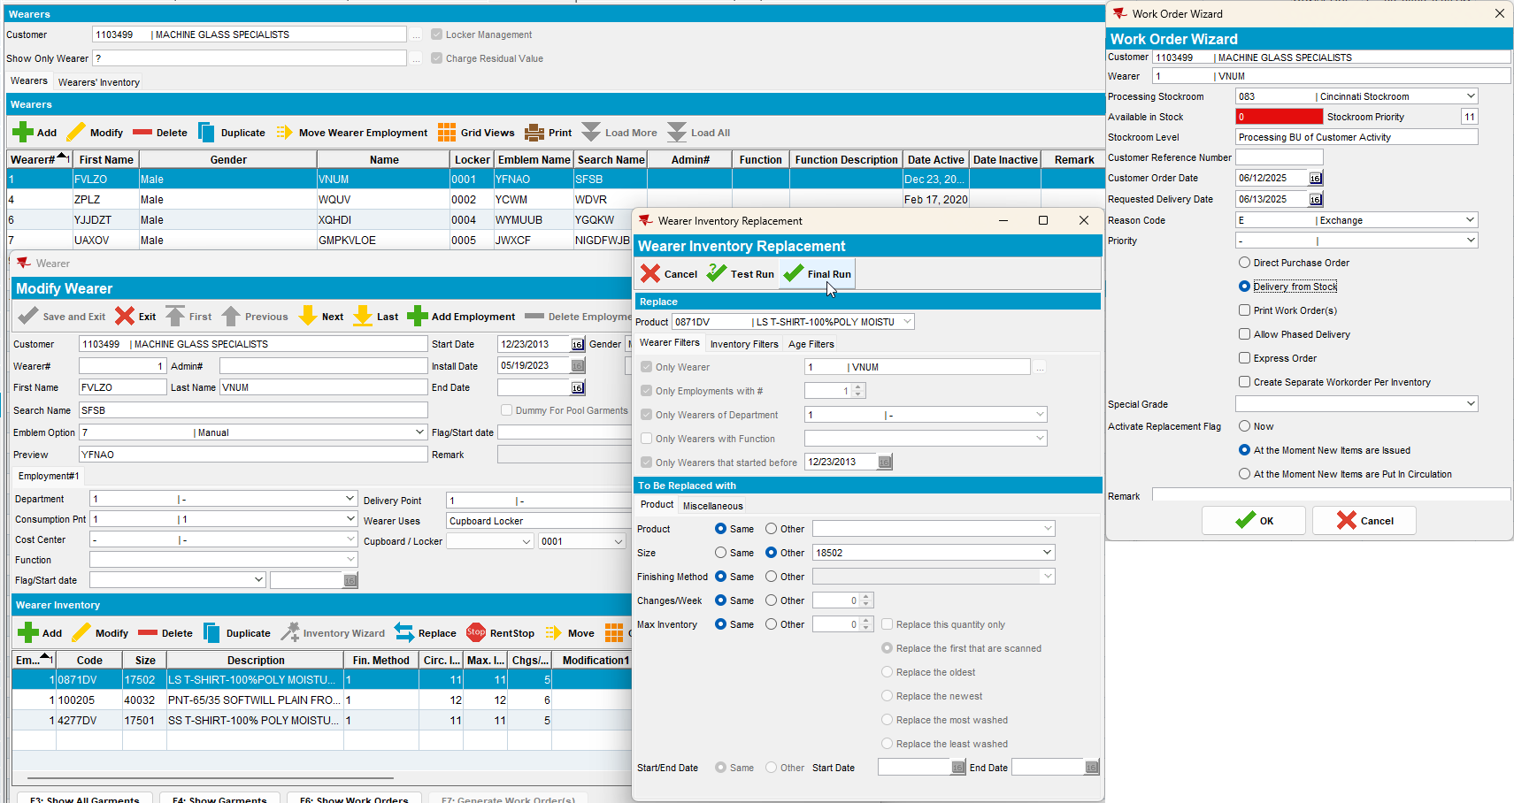
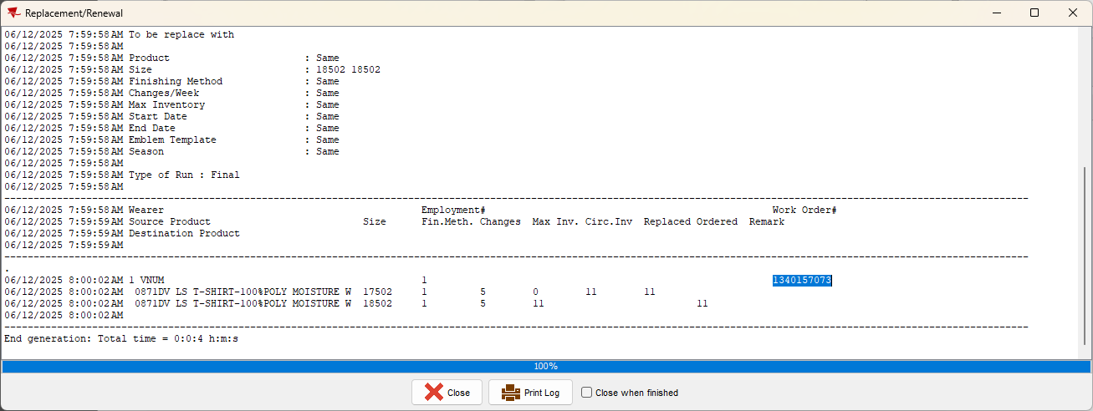

- Issue Work Order dlg: Issue the new workorder 1340157073
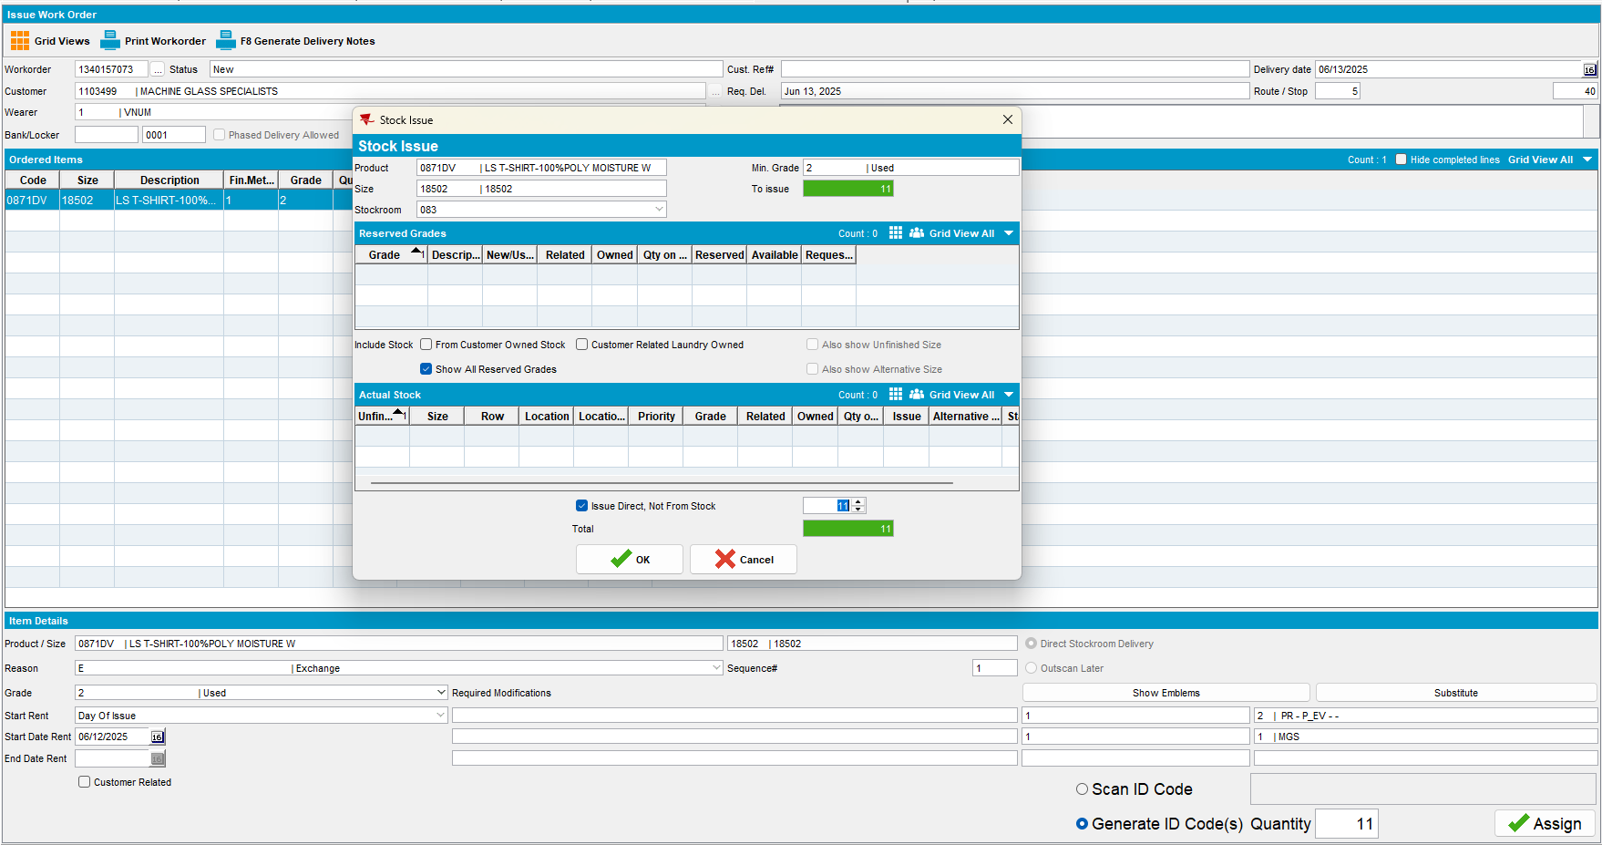
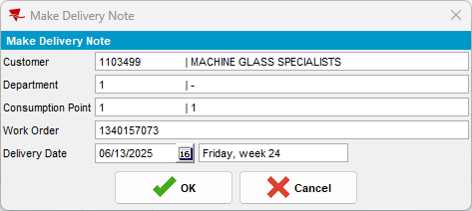

- RSC dlg: Generate packing notes, generate invoices and script the taxes. Send the route to PDA.
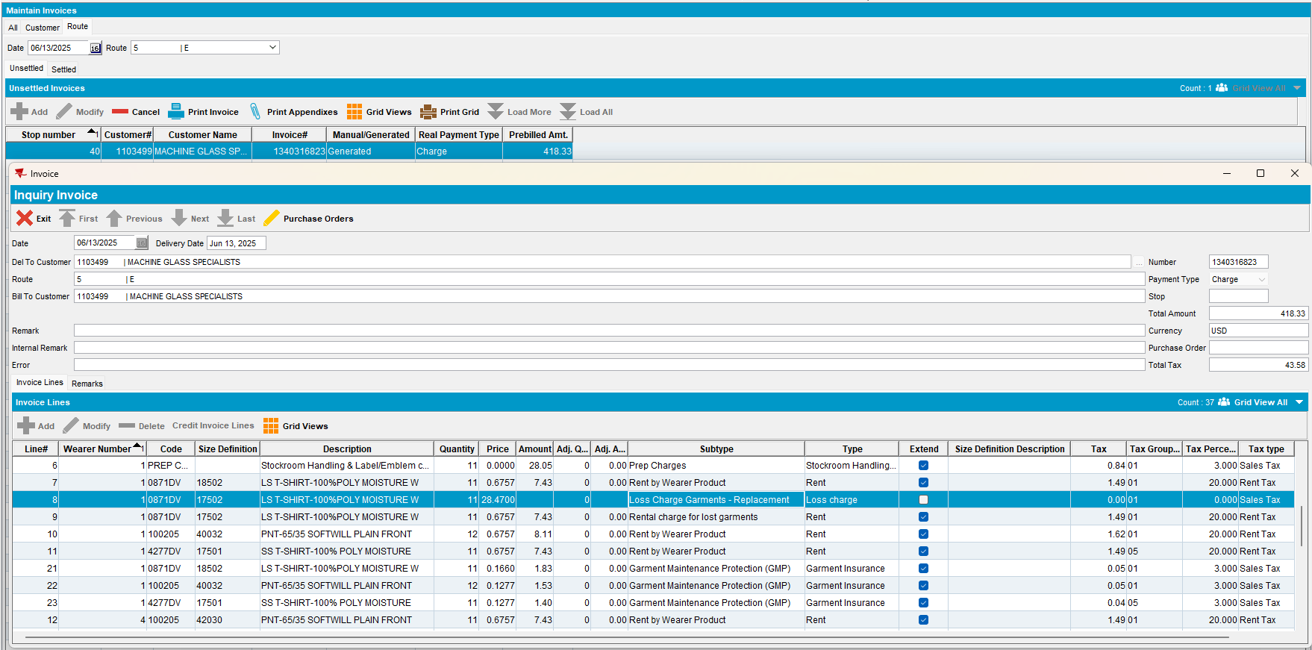
- RA: Download the route and arrive at the customer.
- RA: Settle the invoice and upload the route
- WebX: Complete the Start my day and review every tab. Settle the route.
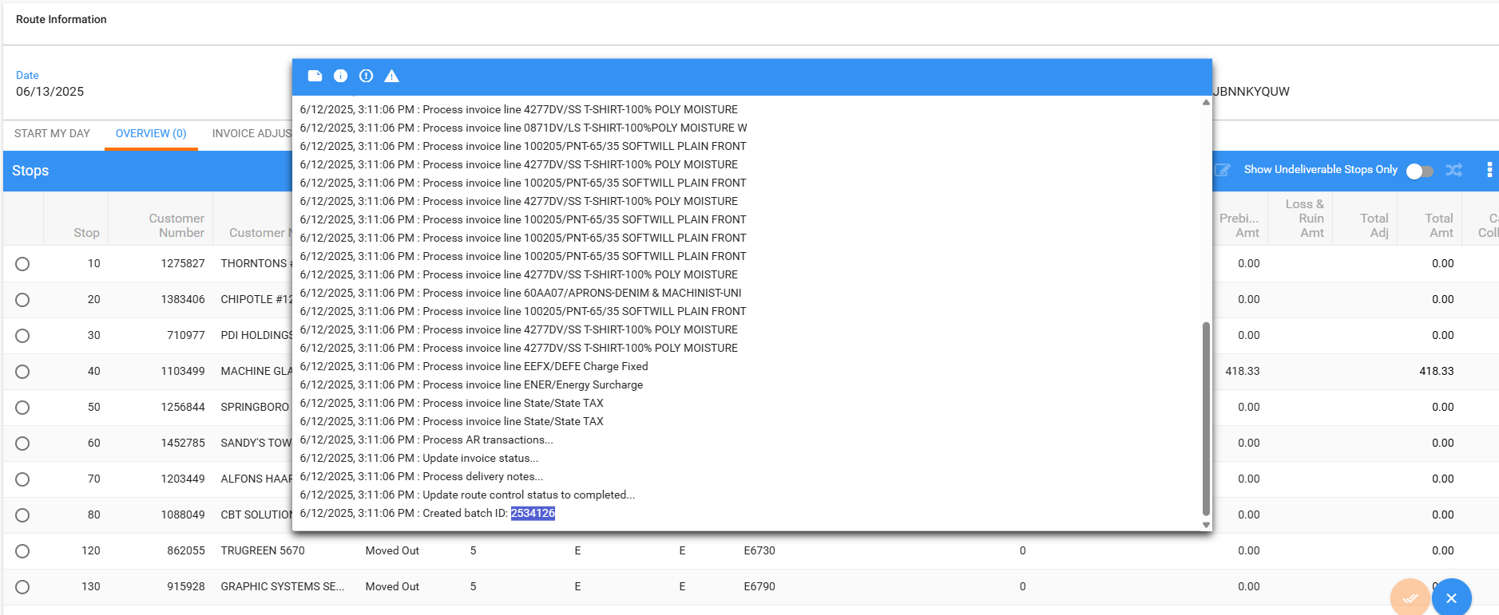
- Script the taxes for the settlement.
- RSC dlg: Create a new route containing the customer 2weeks+ in the future so that loss charges are extend = Yes.
- RSC dlg: Generate packing notes, generate invoices and script the taxes. Send the route to PDA.
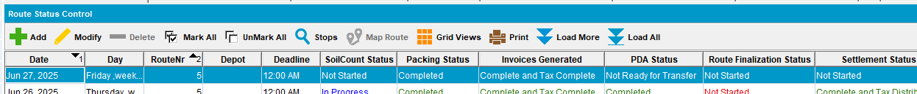

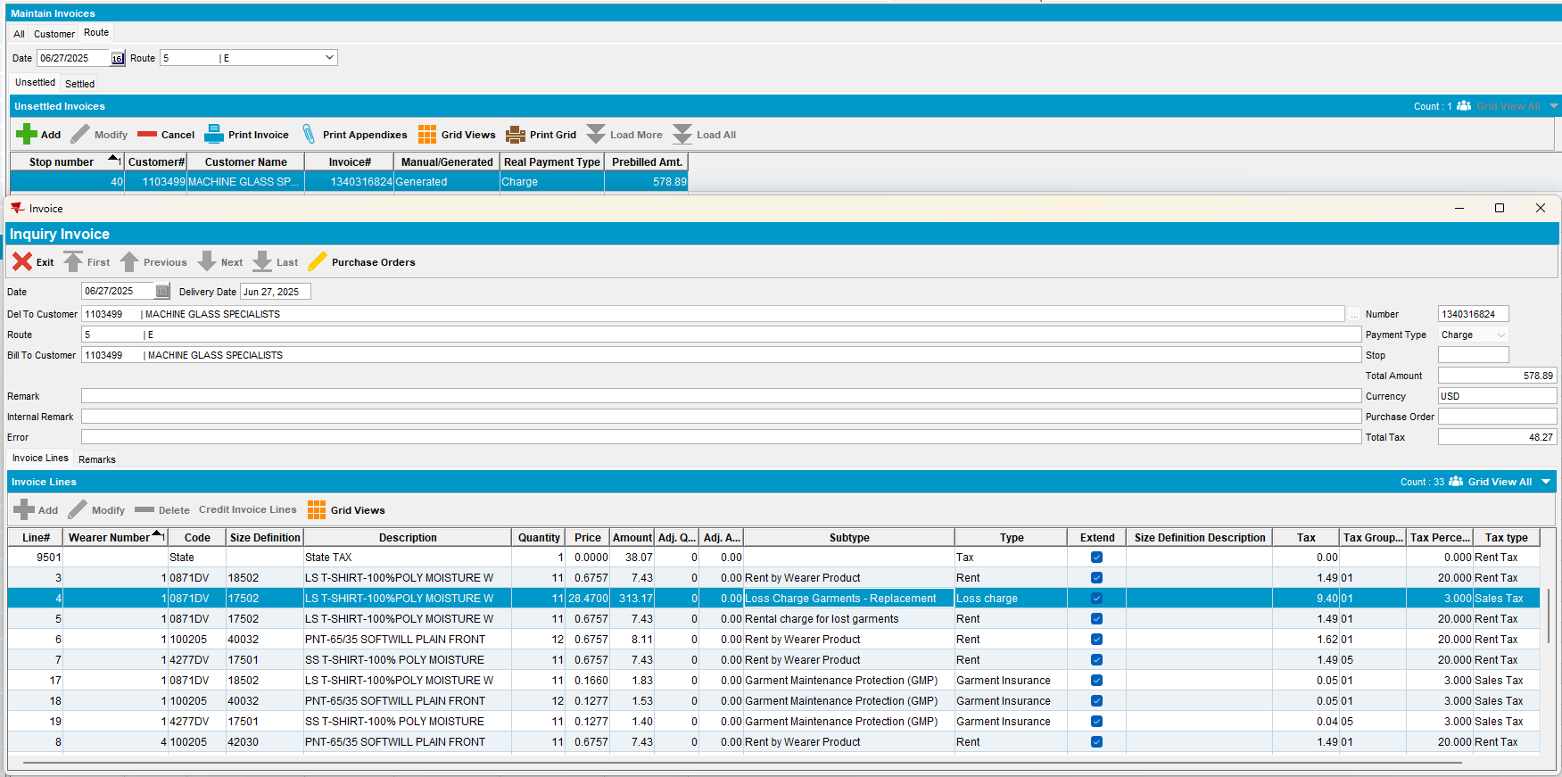

- RA: Download the route and arrive at the customer. Enter Adjust / View Lines and adjust the loss charges with the quantity you want to see in Loss Charge Monitor.
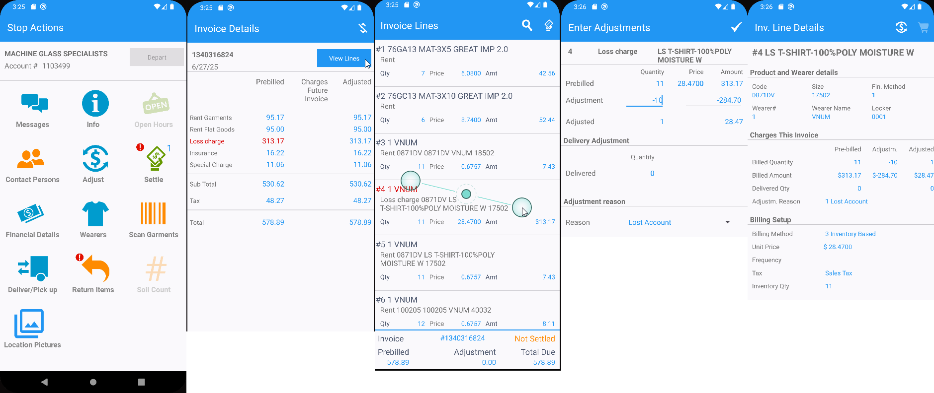
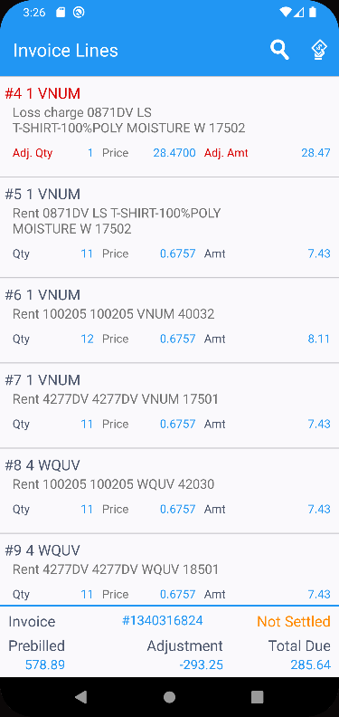
Settle and depart
- RA: Upload the route back to the client.
- WebX: Complete the start my day. Review the adjustments and any tabs that need to be reviewed.
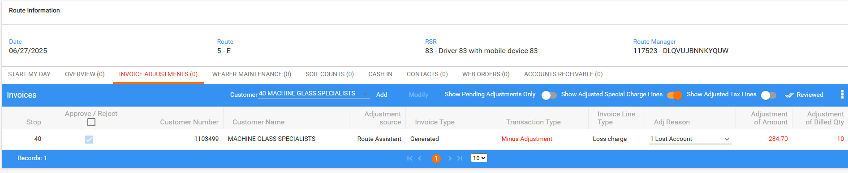

- WebX: Settle the route.
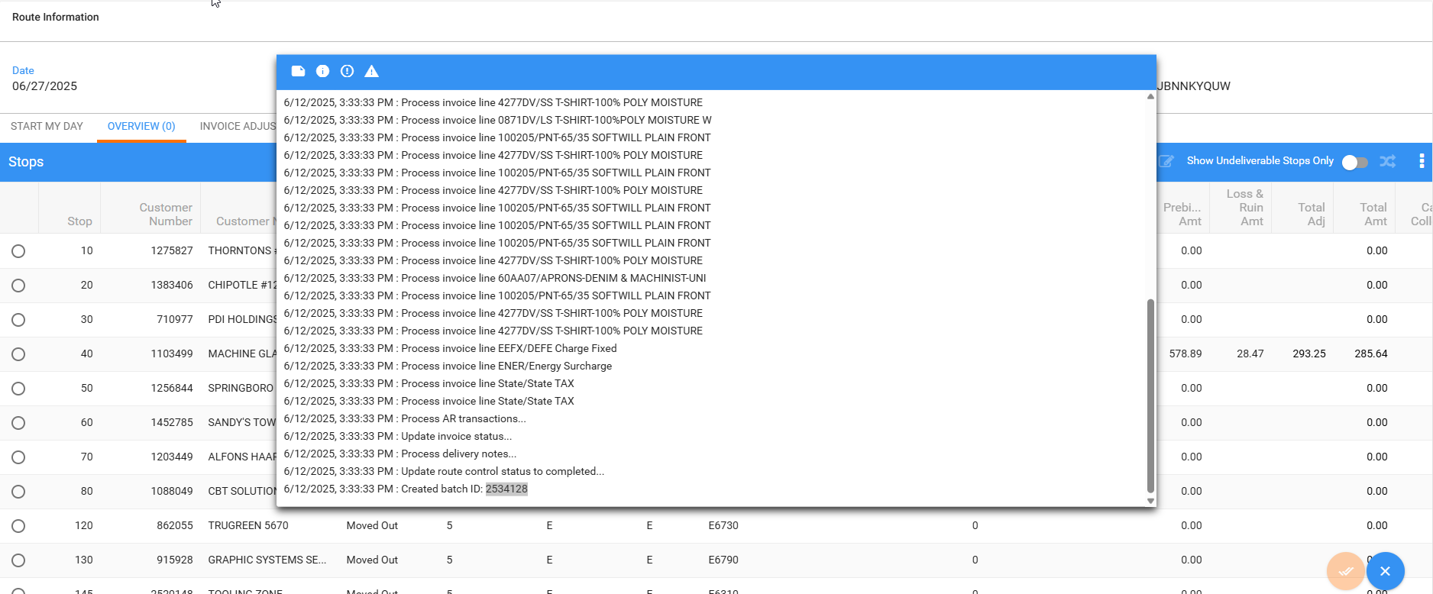
- Loss Charge Monitor: Check the loss date of the quantities that were credited in Rasa mobile app

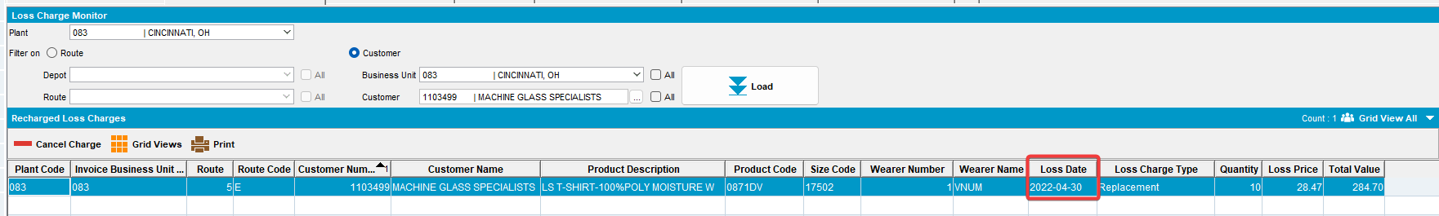

Current behaviour:
The loss date column contains the wearer inventory start date
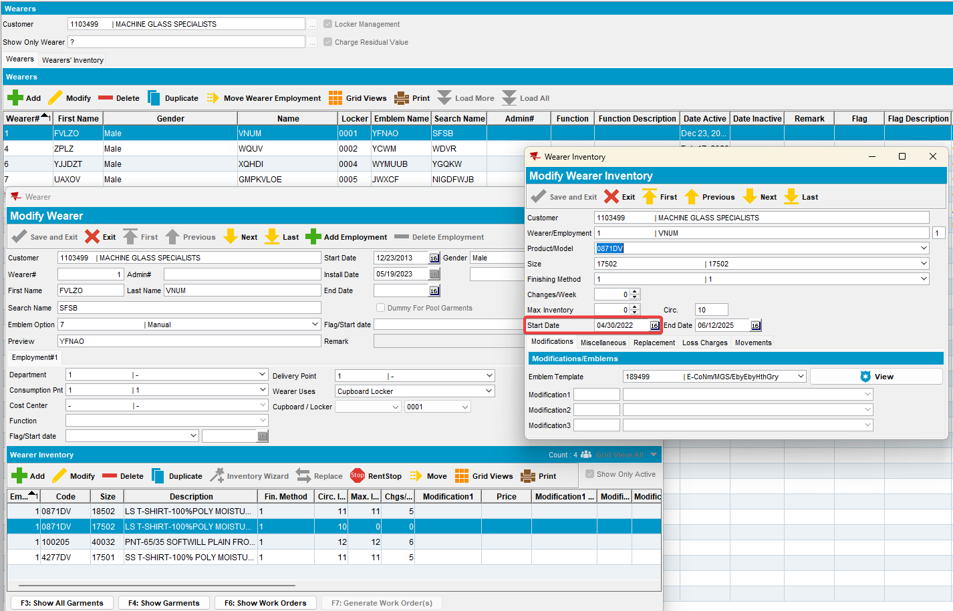

Expected behaviour:
The loss date column should contains the wearer inventory end date

Retest after fix
9.07.00.UNF20 hash: 4b81d68abc7a
Bu: 083 CINCINNATI

Expected behavior:
Date loss charge started. This is the same as invoicing uses to generate and determine loss warning periods

For quit wearer – this is the wearer inactive date

For quit wearer inventory – this is the WI inactive date

For quit PLPC – this is the PLPC inactive date

For replacement – this is the replacement flag start date on the UI – if this is not the same for all the UI’s, then take the max

For decrease of max – take the decrease of max flag start date – same rules as per replacement for multiple UI’s

Test steps:
- Create a route with customers who has:

Non-unique garments – customer 1354800

From the client quit wearer –
this is the wearer inactive date
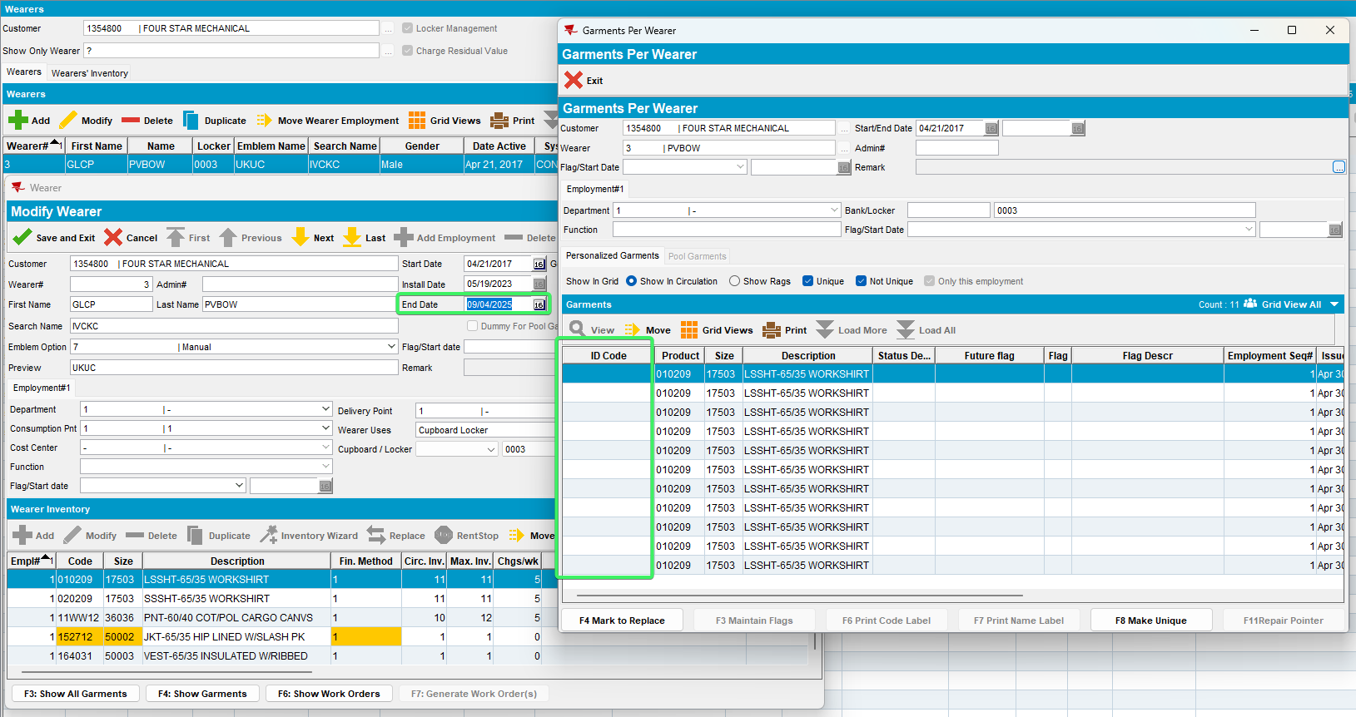

From the client quit wearer inventory –
this is the WI inactive date
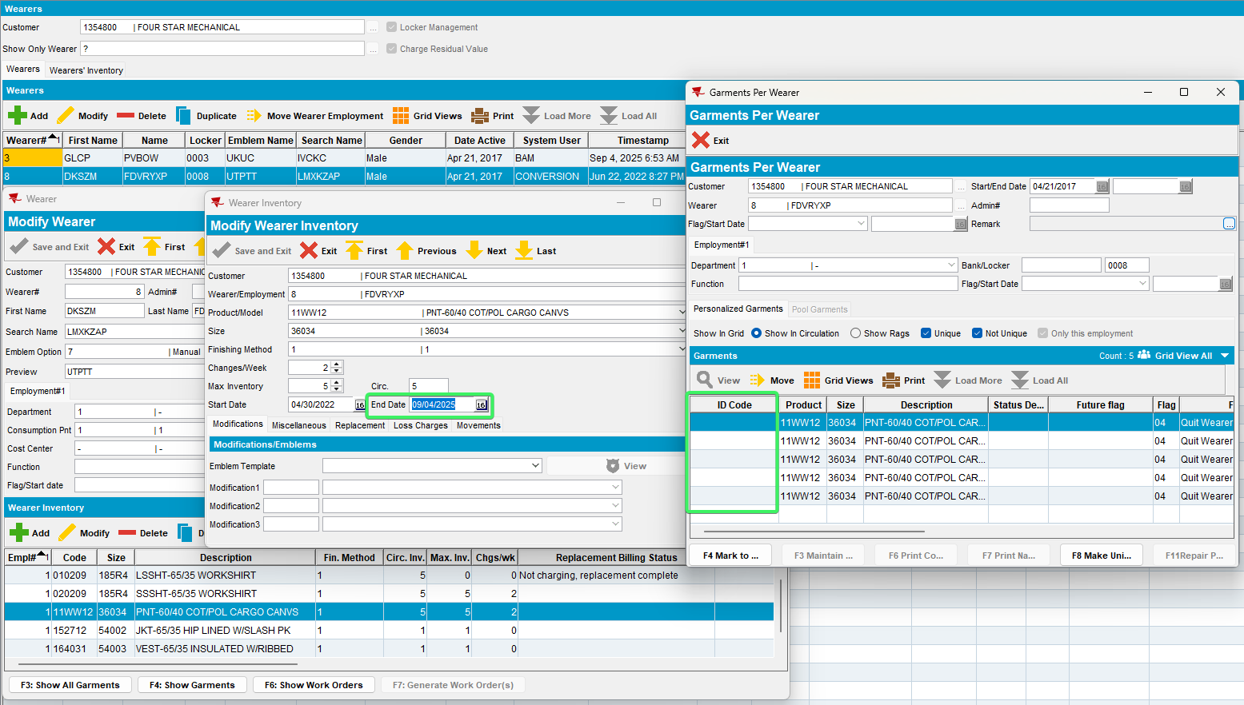

From the client quit PLPC –
this is the PLPC inactive date
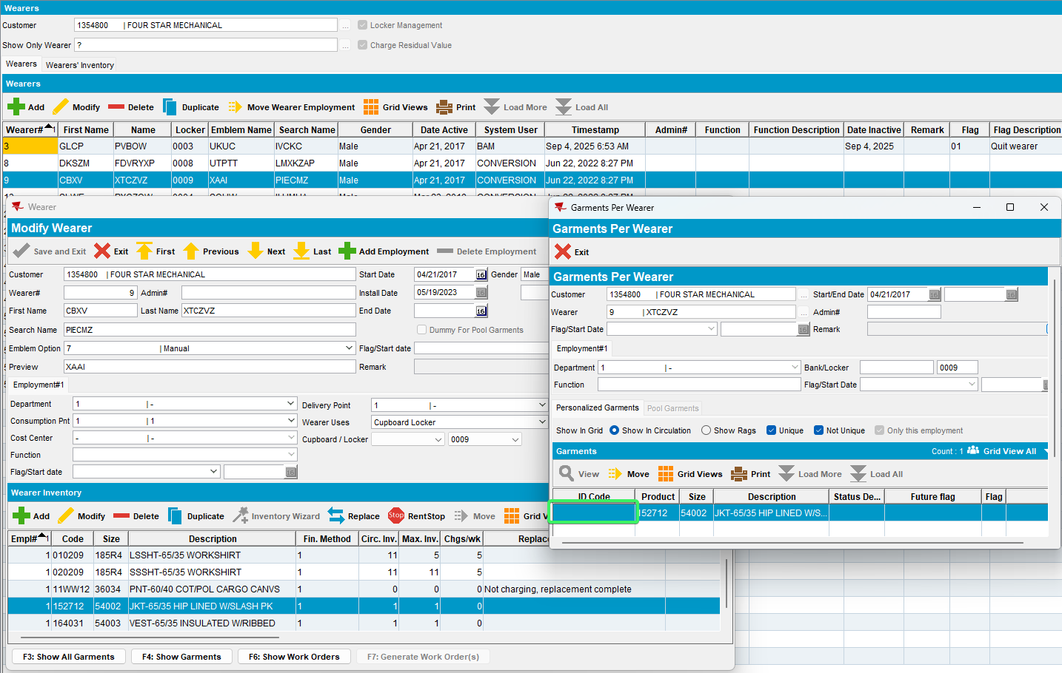
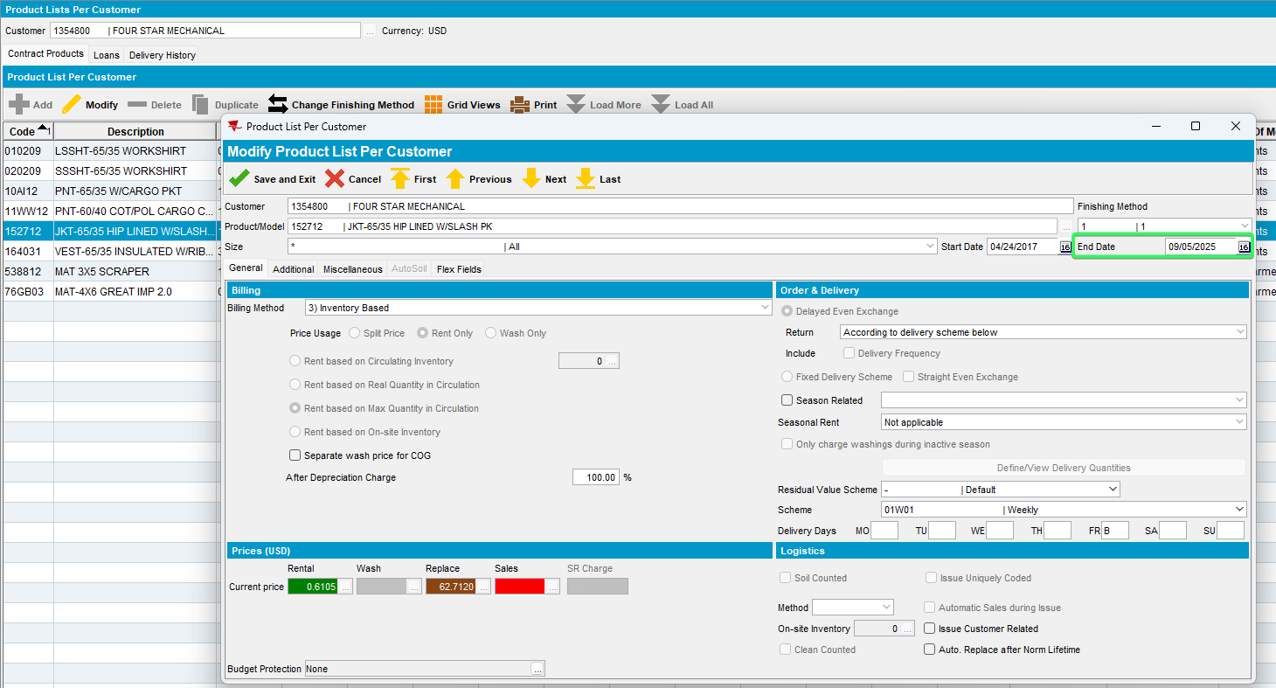
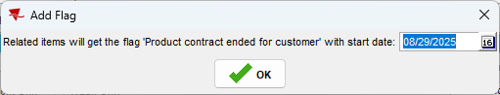
product code 152712 JKT

From the client replacement –
this is the replacement flag start date on the UI – if this is not the same for all the UI’s, then take the max
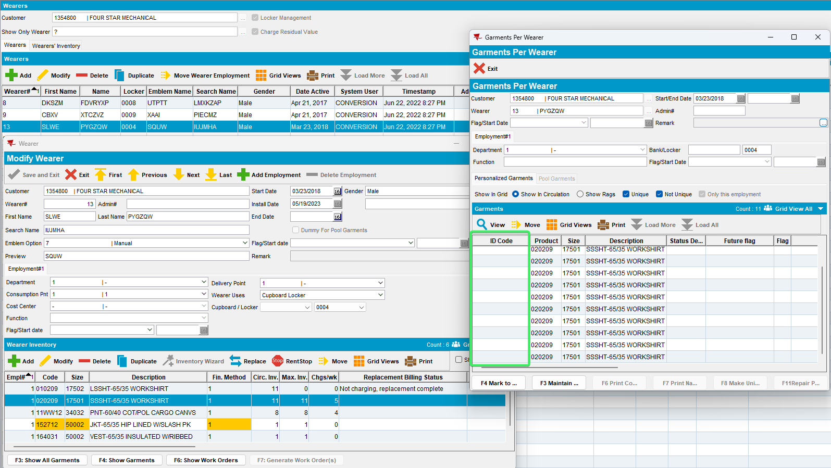

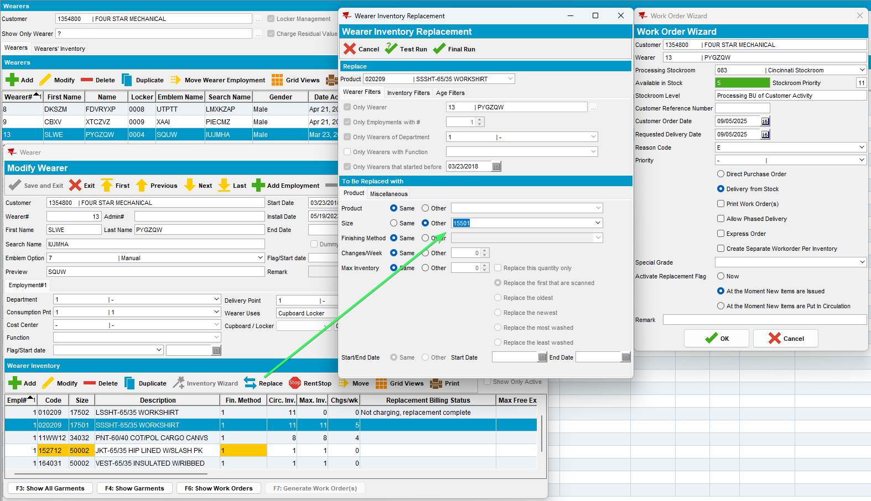
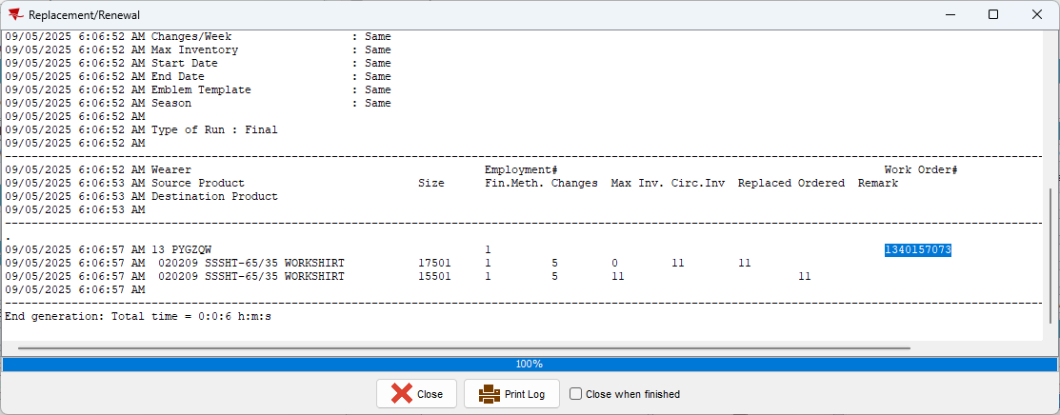
Issue work Order dlg: Issue the wo 1340157073 for the new size
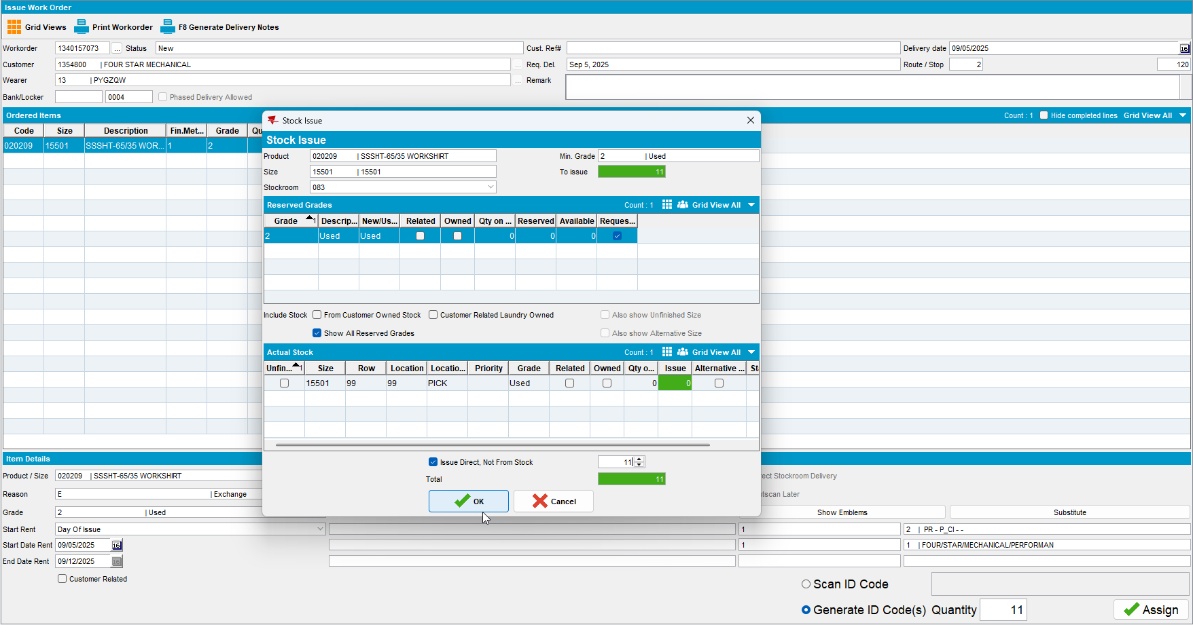

From the client decrease of max
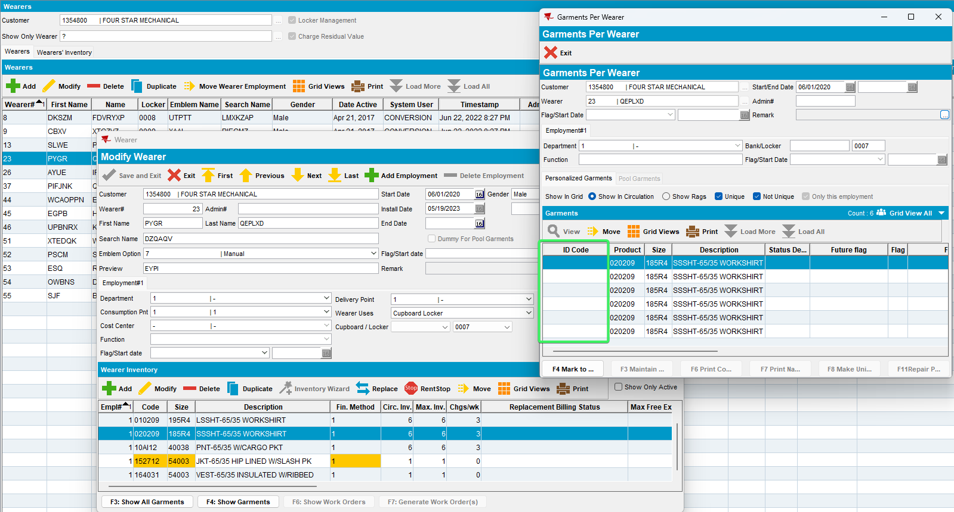

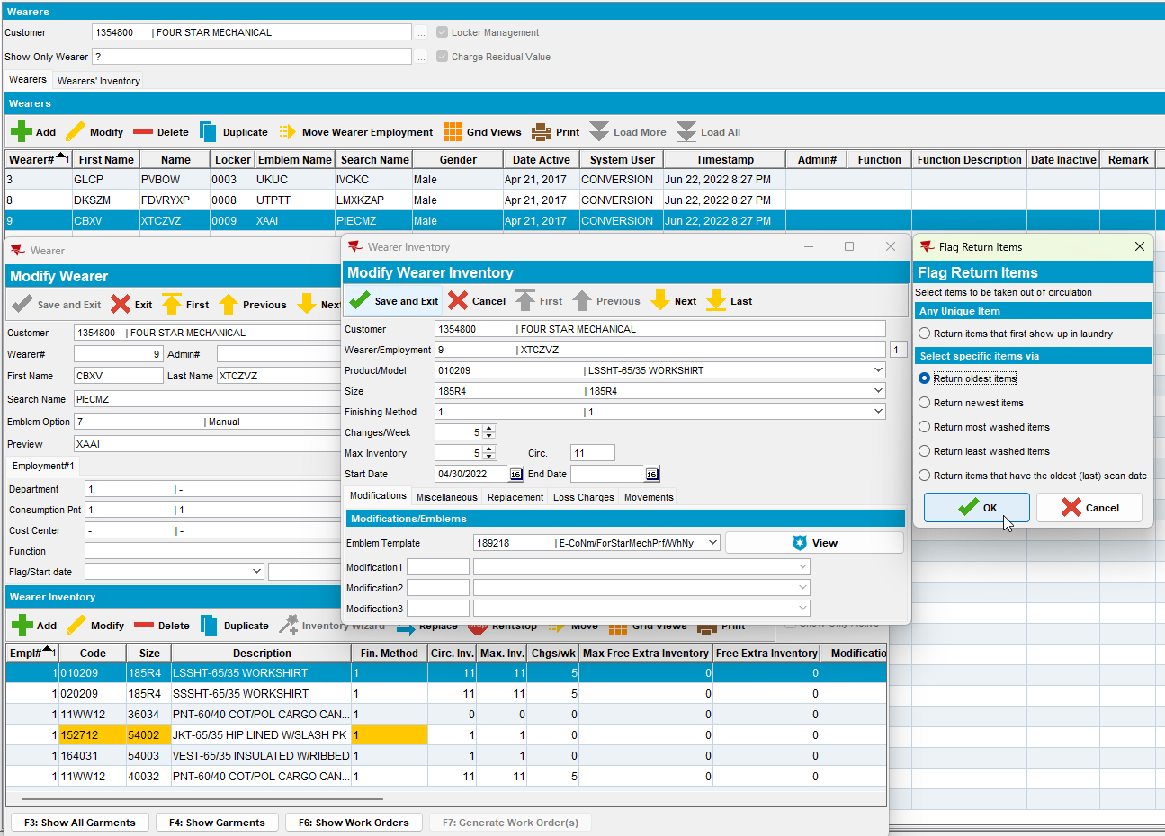

Mixed garments – customer 1230257

From the client quit wearer –
this is the wearer inactive date
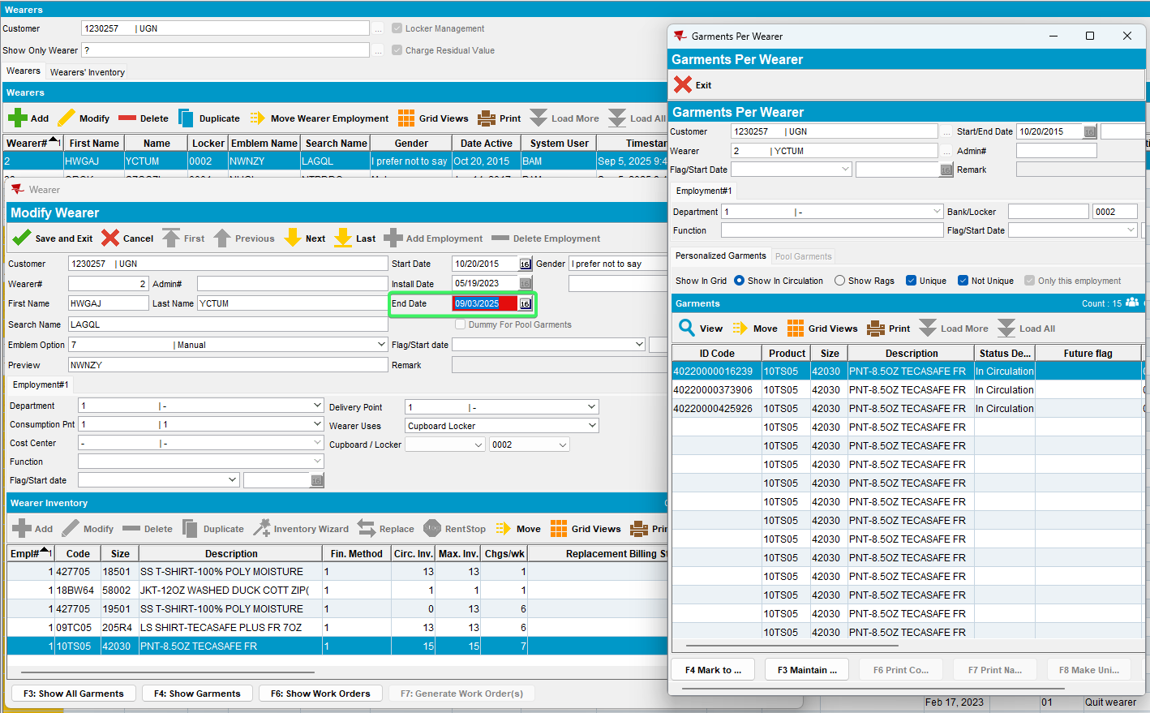

From the client quit wearer inventory –
this is the WI inactive date
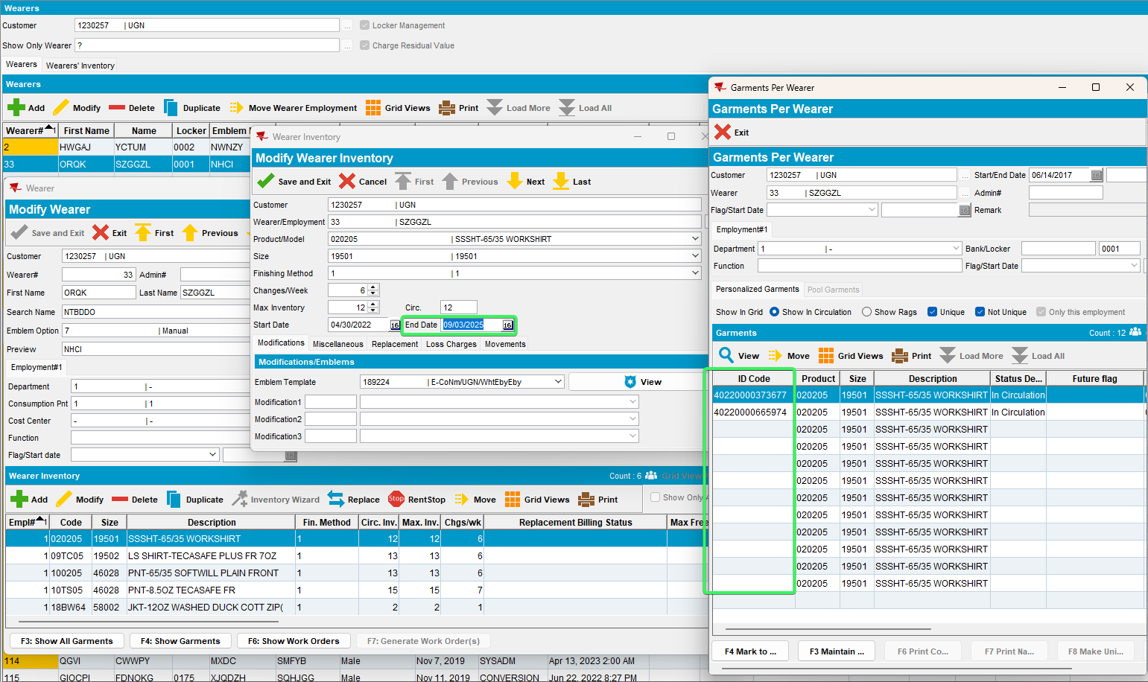

From the client quit PLPC –
this is the PLPC inactive date

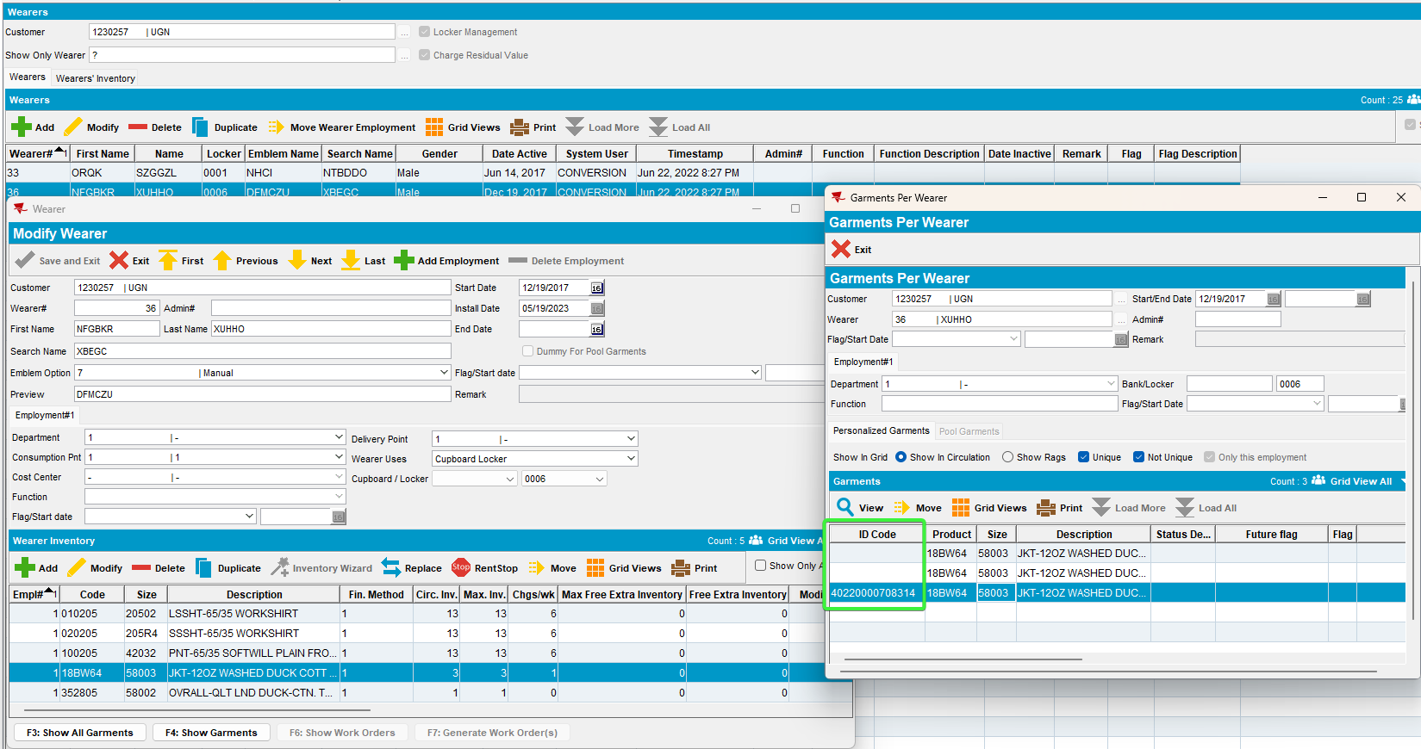
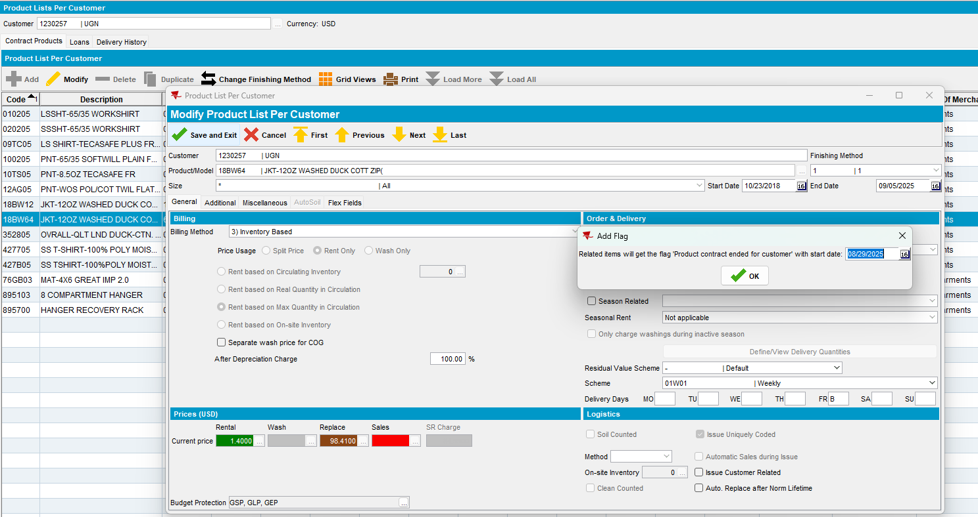

From the client replacement –
this is the replacement flag start date on the UI – if this is not the same for all the UI’s, then take the max
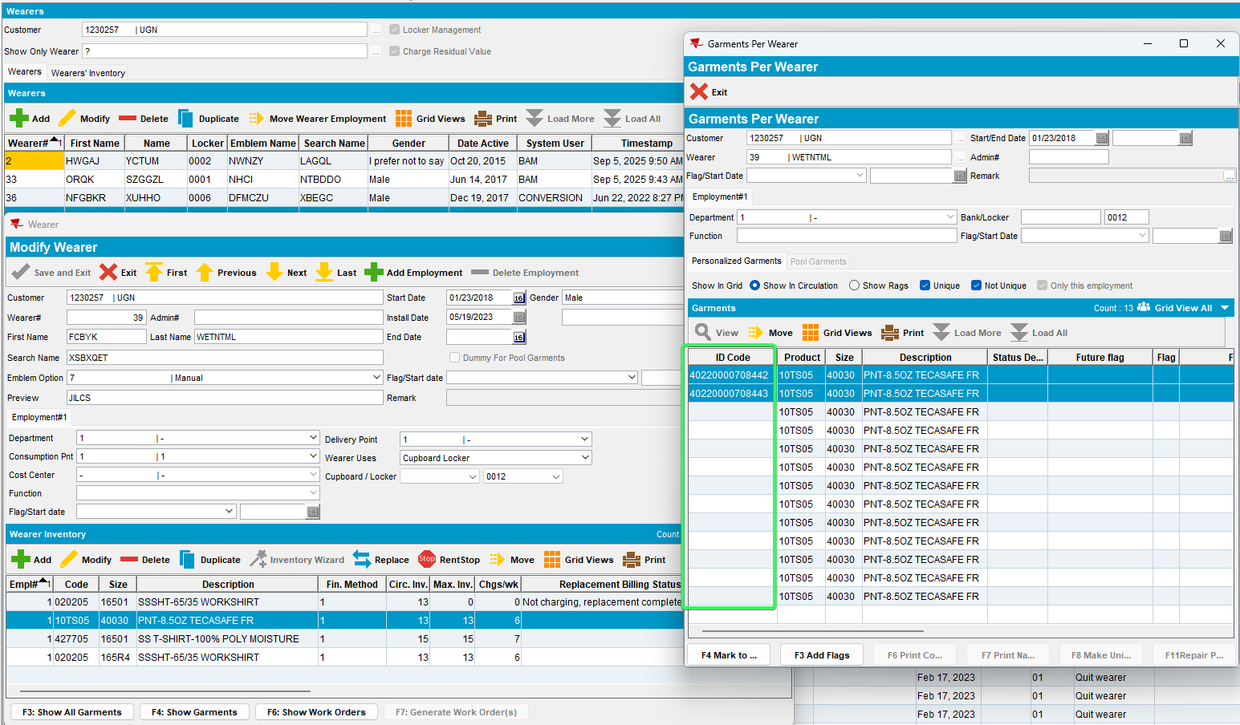
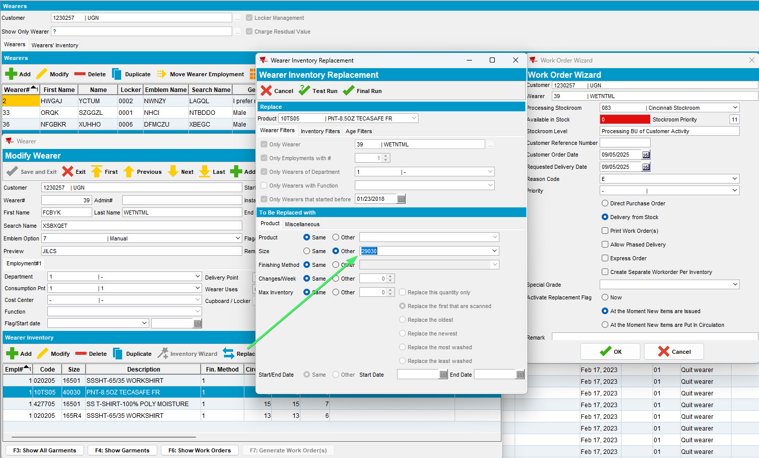

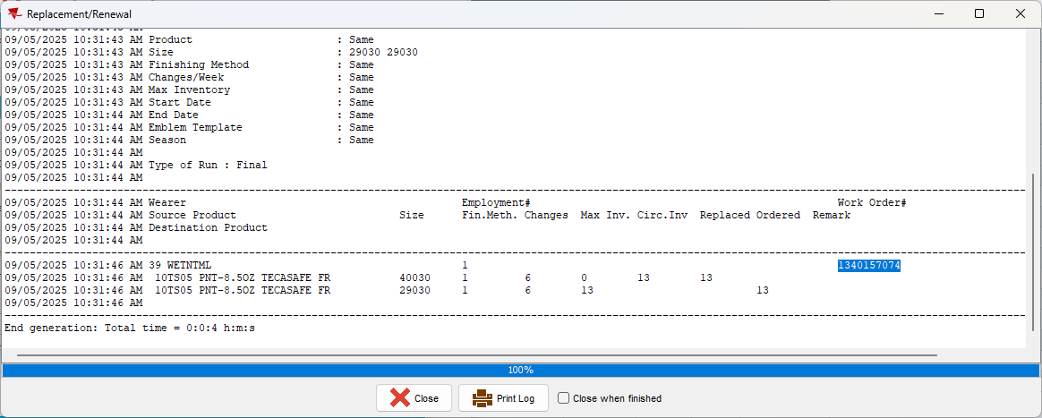

Issue Work Order dlg: Issue workorder 1340157074
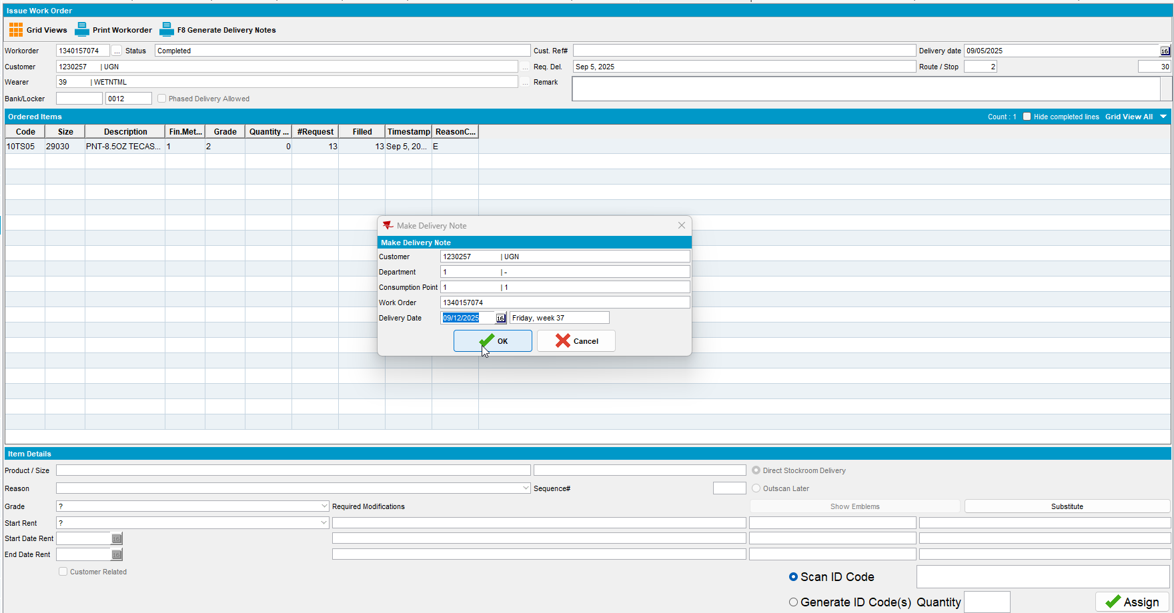

From the client decrease of max
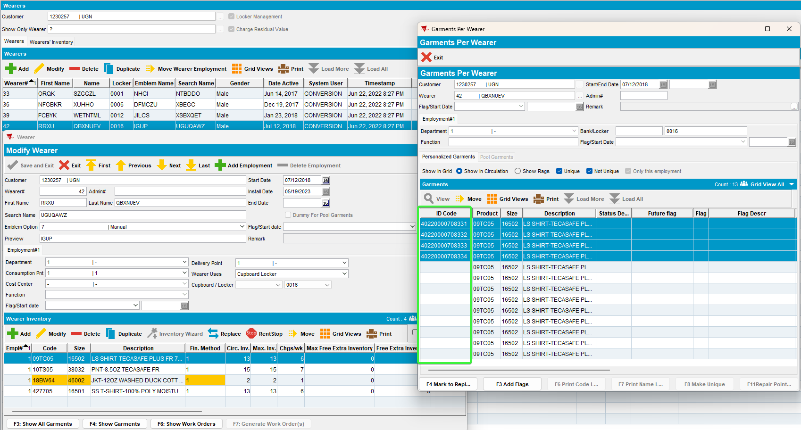
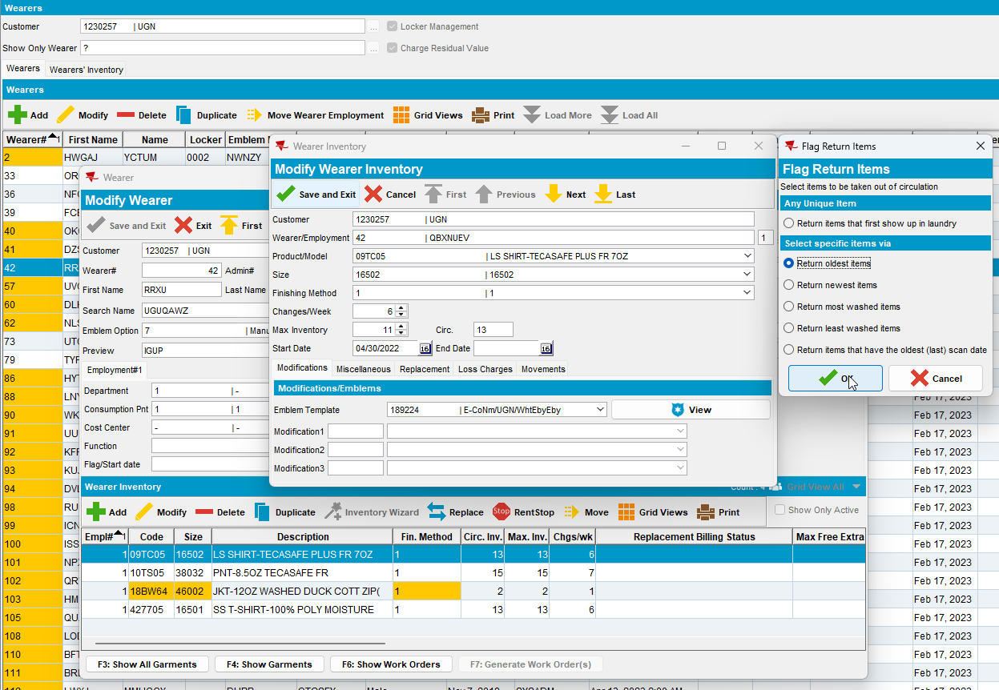

Unique garments – customer 856759

From the client quit wearer –
this is the wearer inactive date
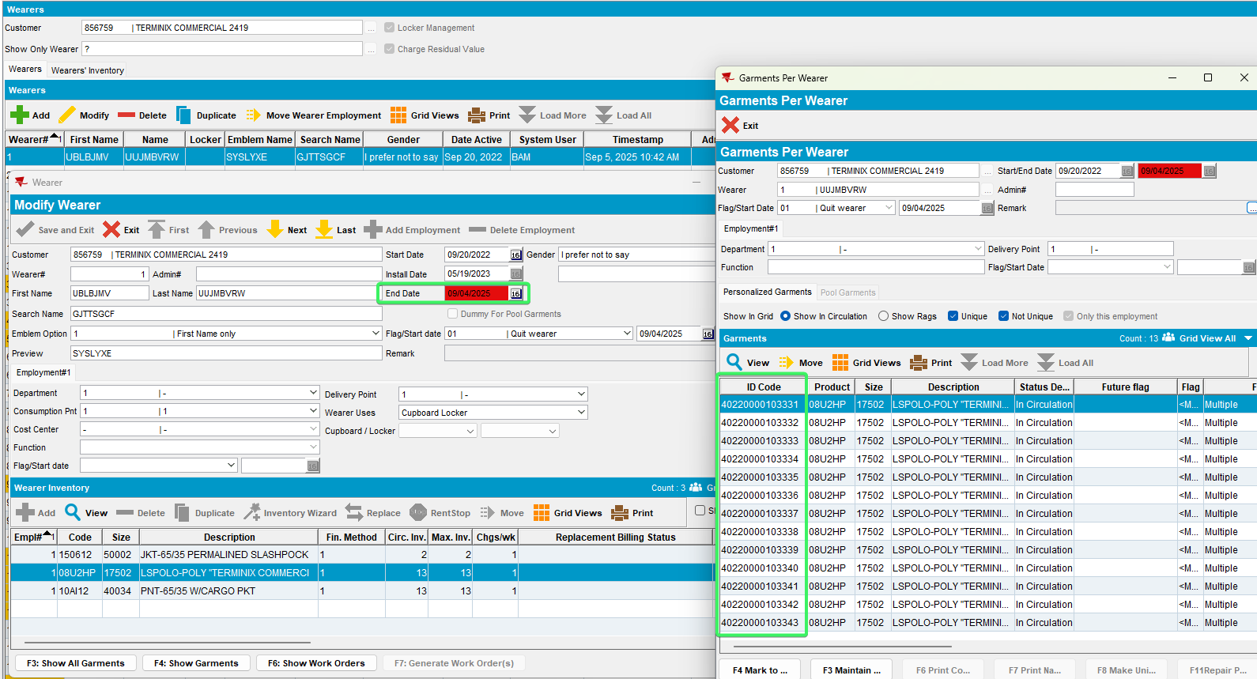

From the client quit wearer inventory –
this is the WI inactive date
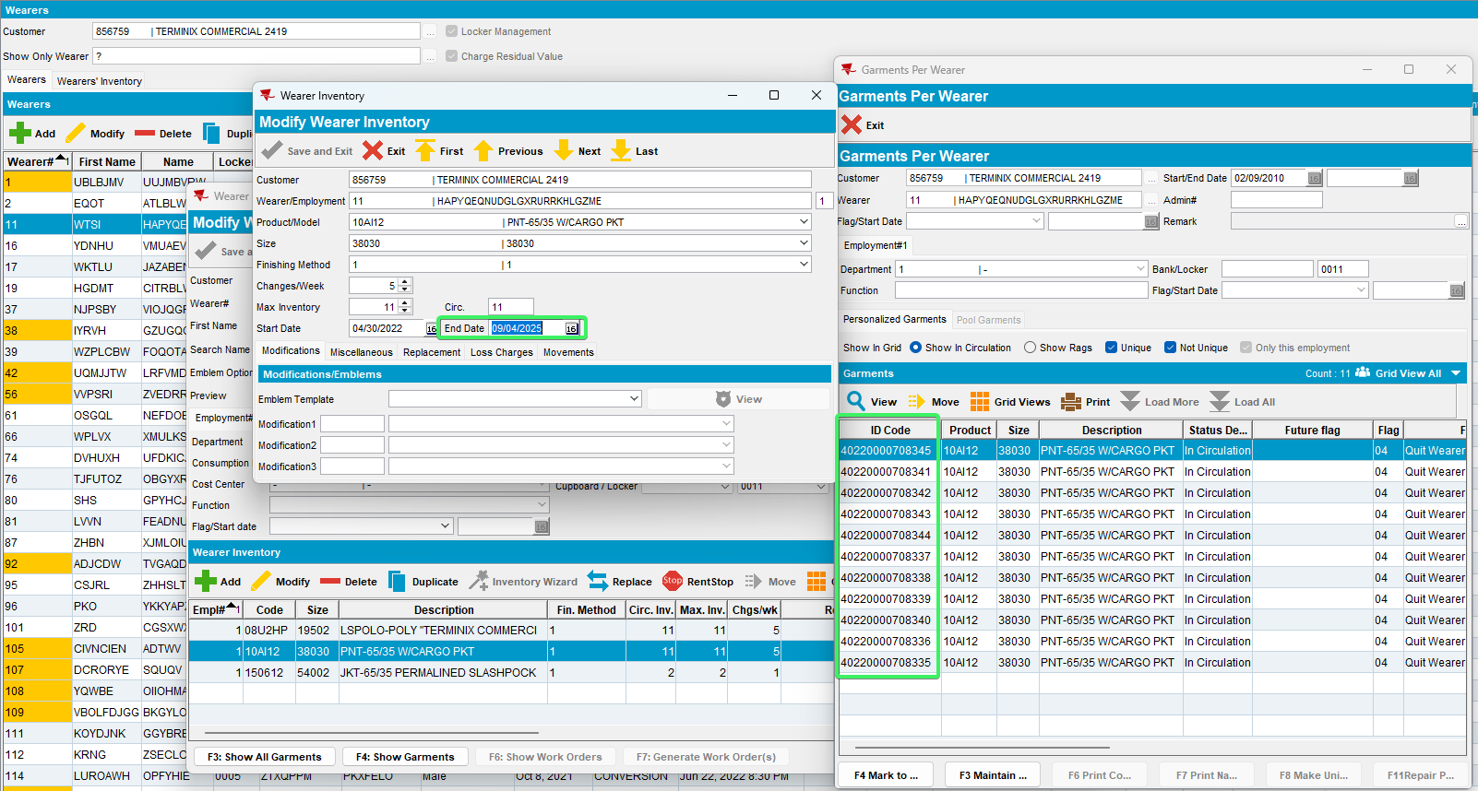

From the client quit PLPC –
this is the PLPC inactive date
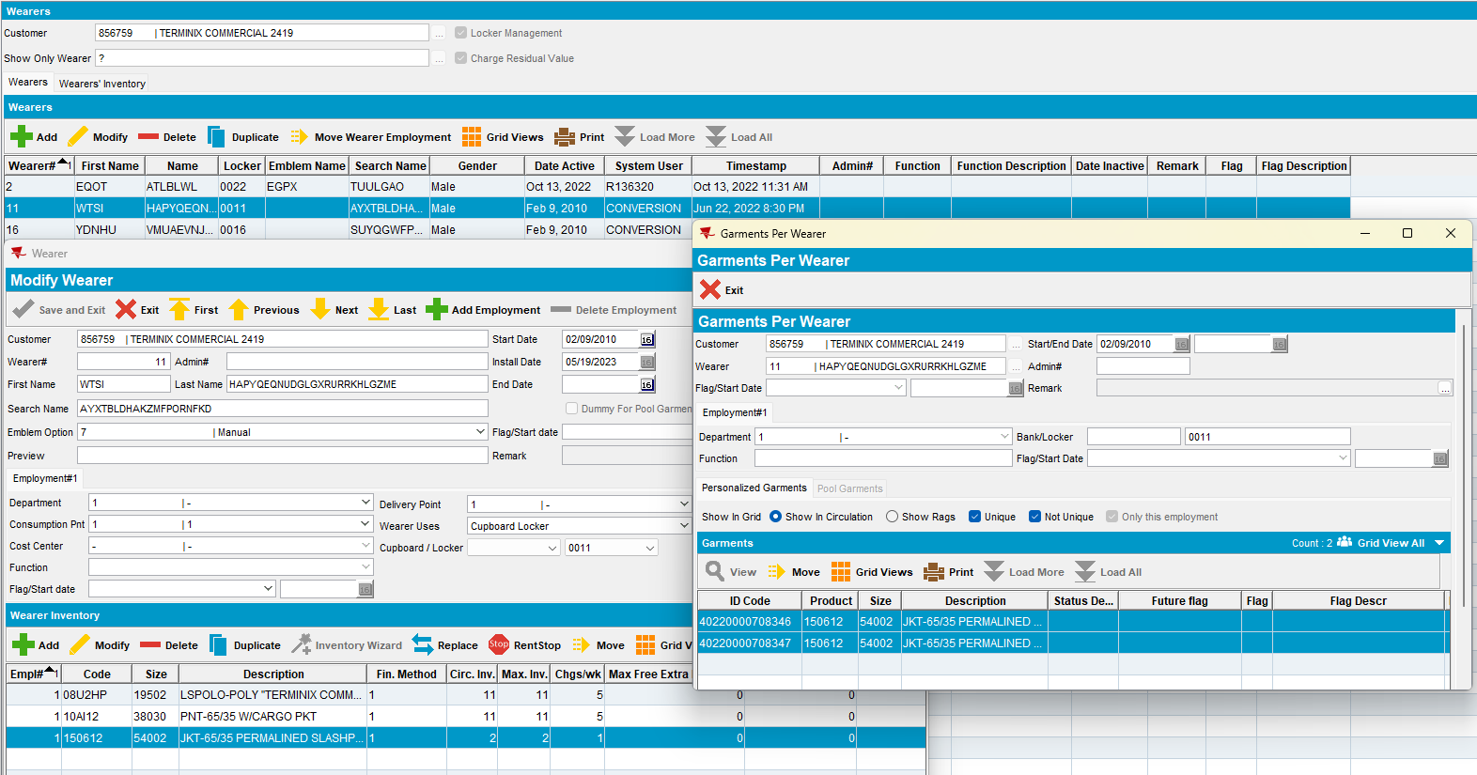
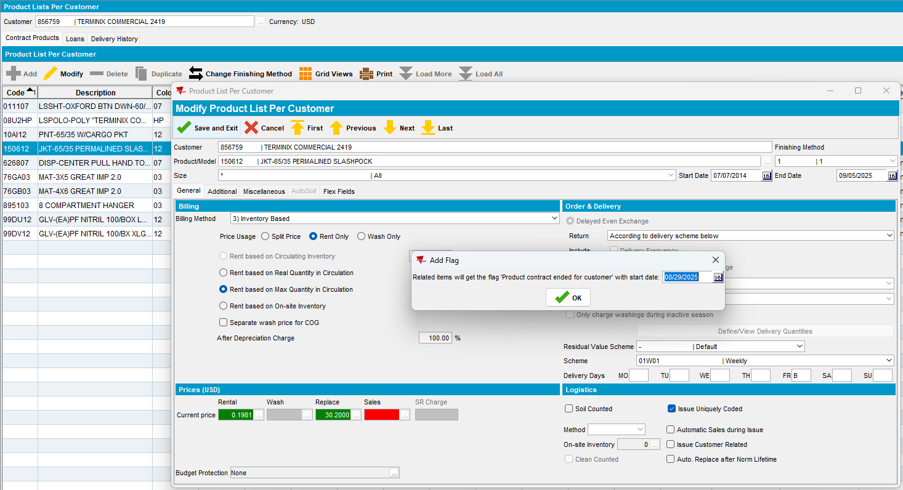

From the client replacement –
this is the replacement flag start date on the UI – if this is not the same for all the UI’s, then take the max
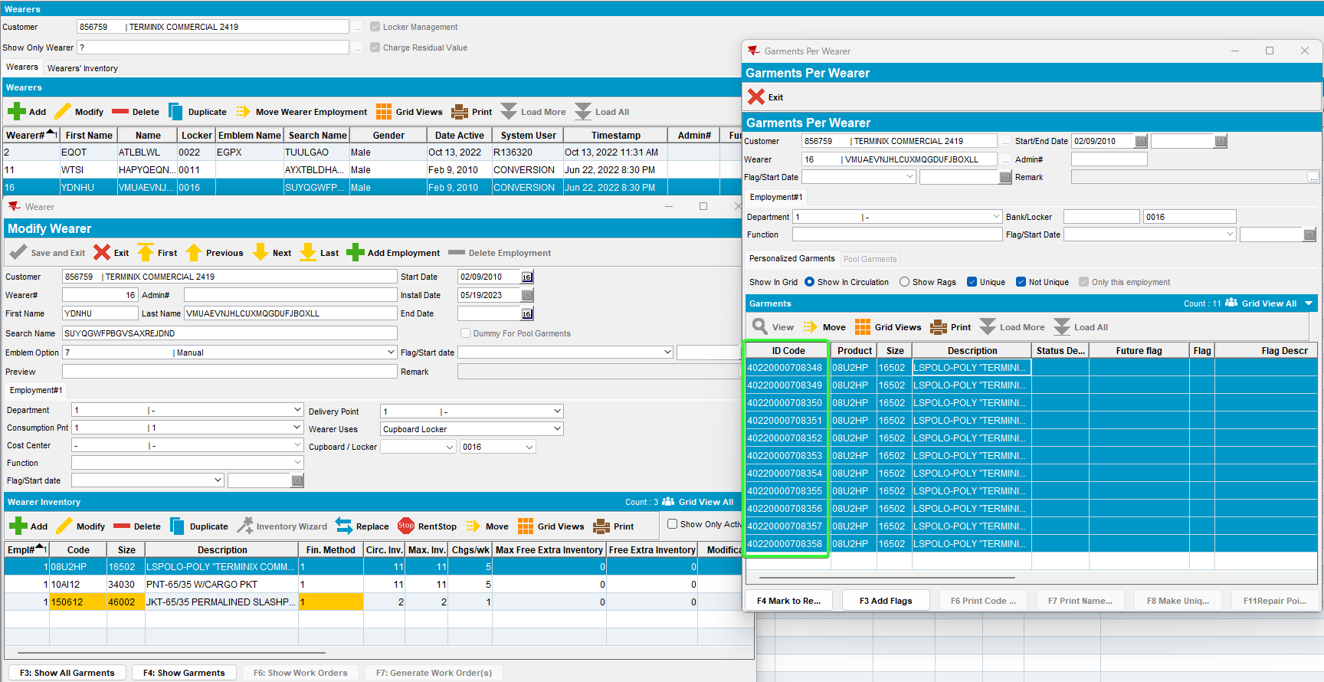
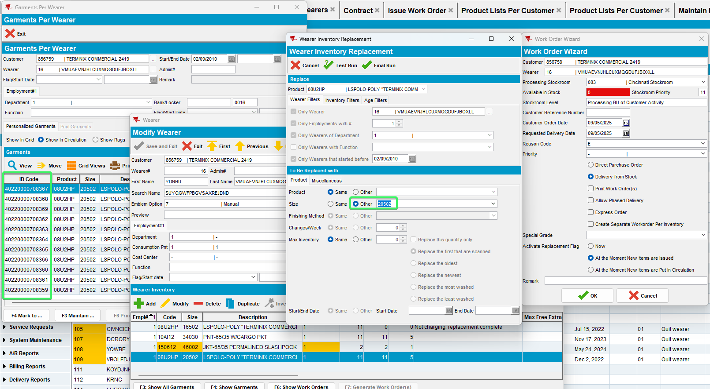

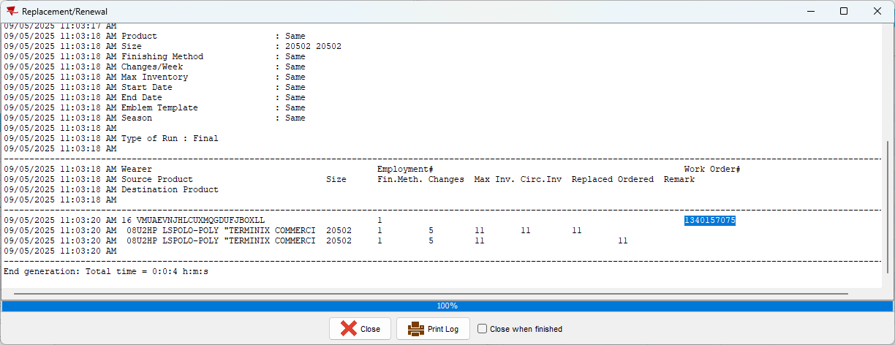
Issue the new workorder 1340157075
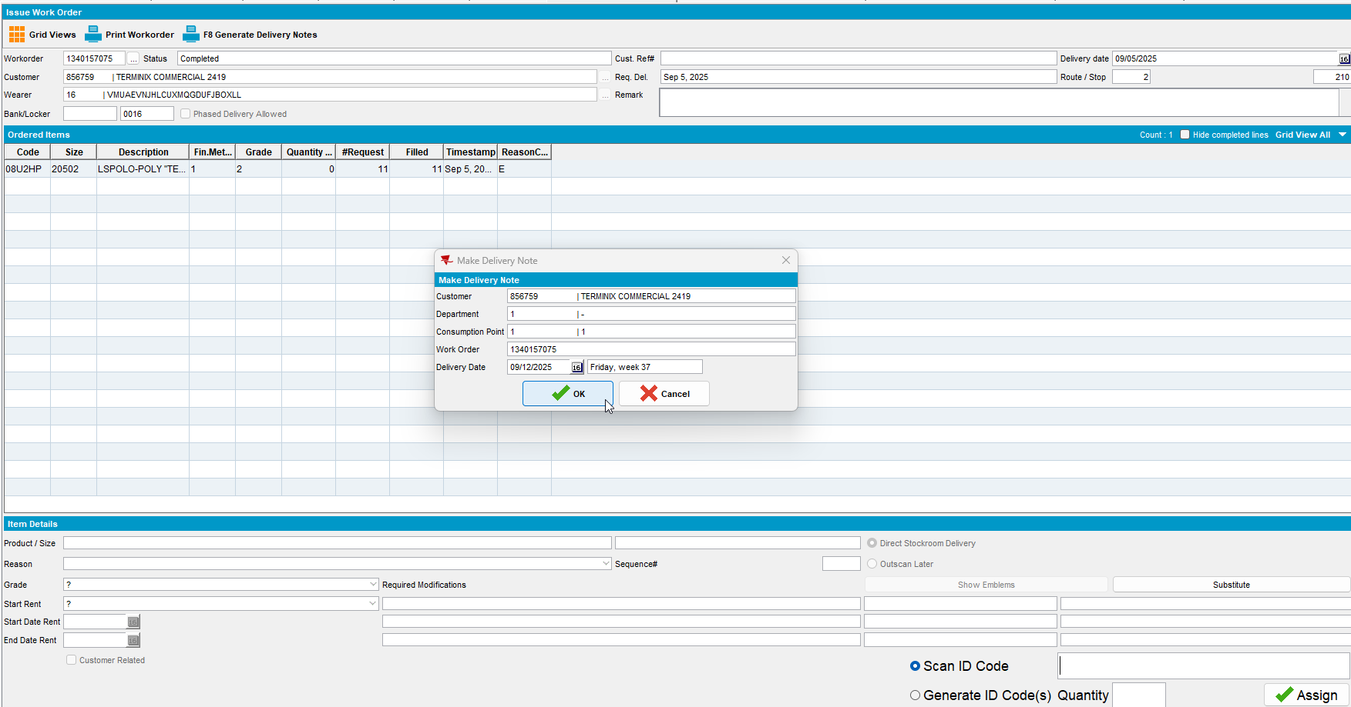

From the client decrease of max
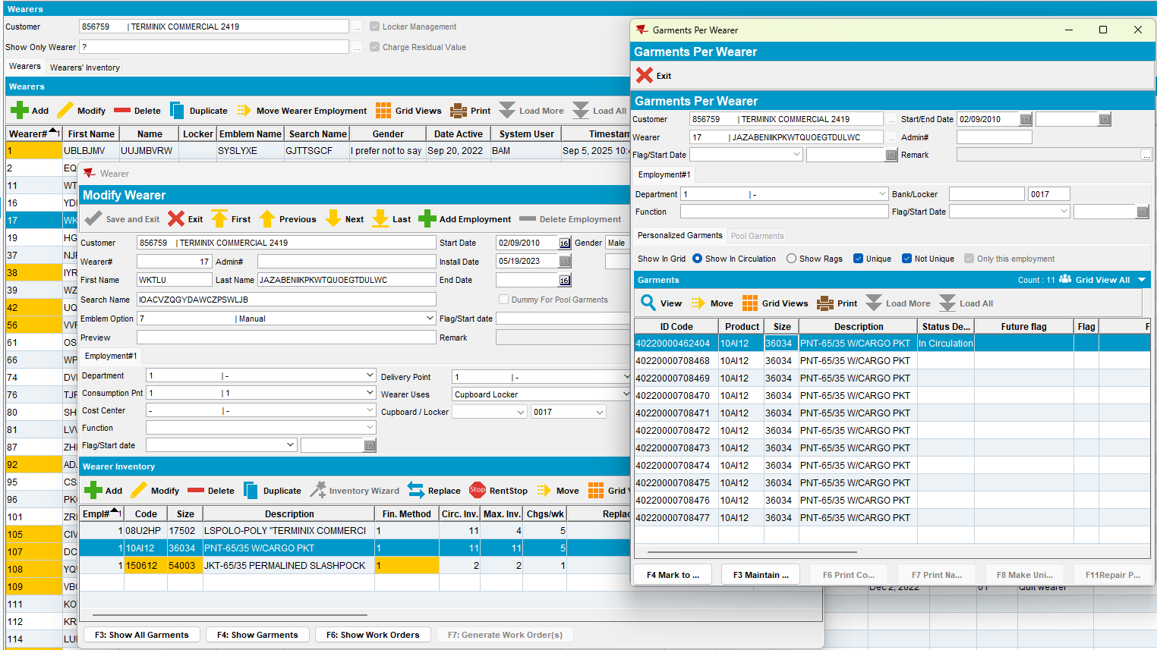
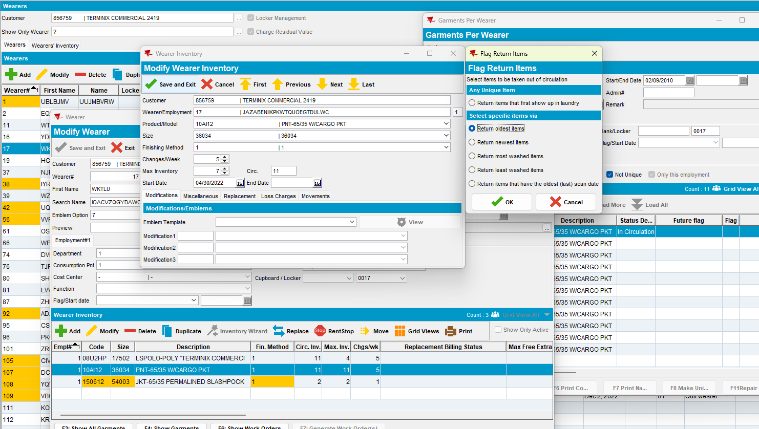

- RSC dlg: generate packing notes and invoices for the route. Send the route to PDA.
- On RA, do a scan garments, replace (Change as Needed)

On RA Non-unique garments – customer 1354800

Replacement size
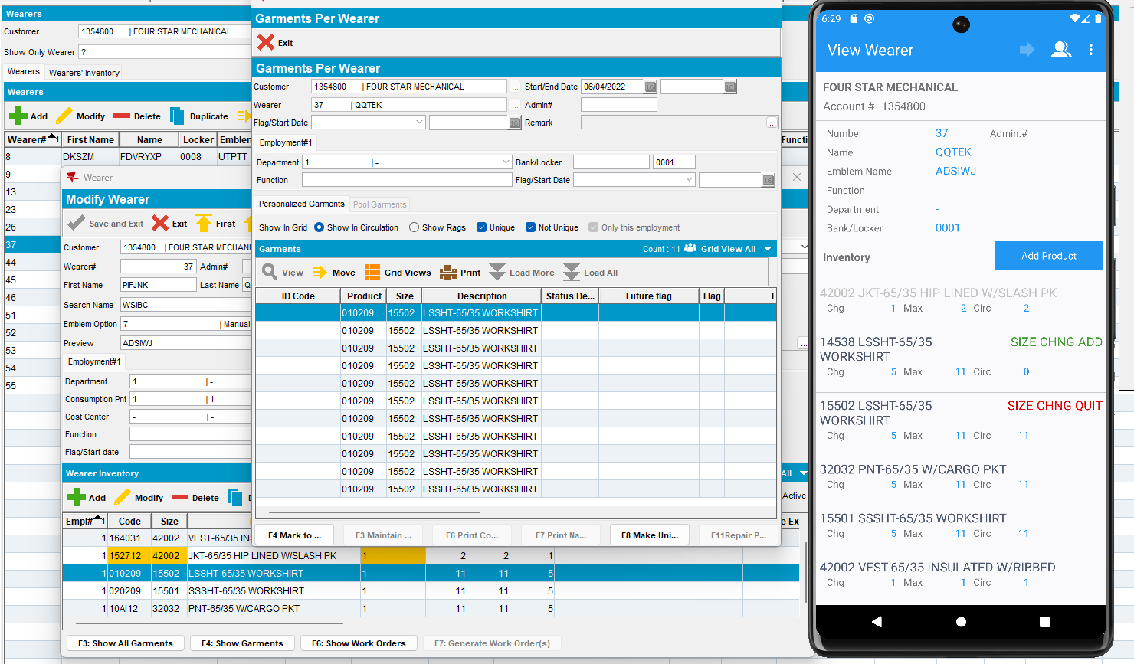

Quit wearer inventory
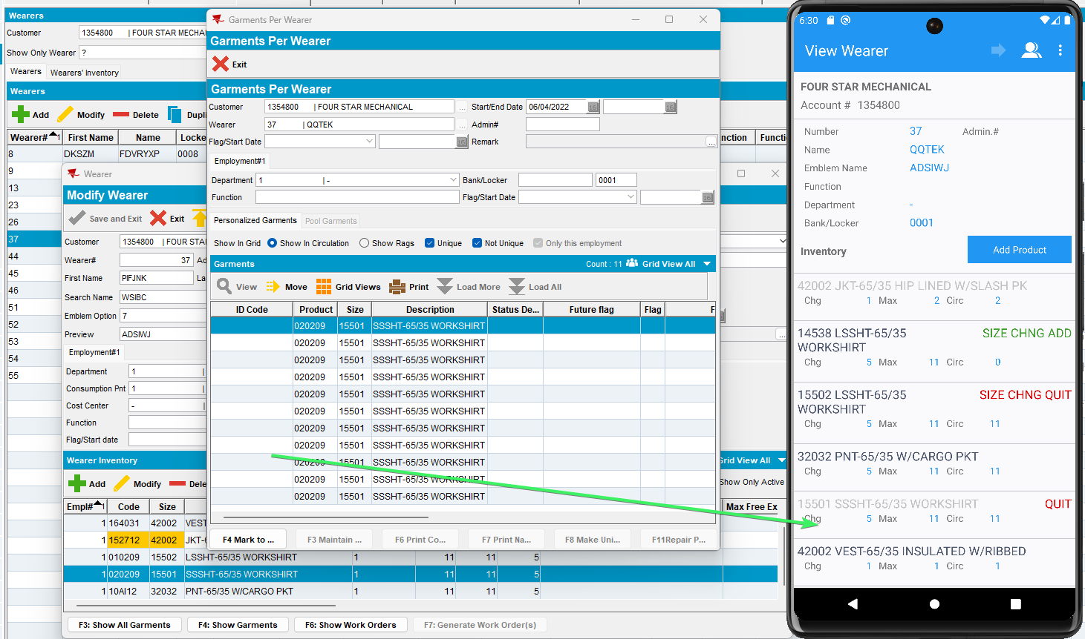

Quit wearer
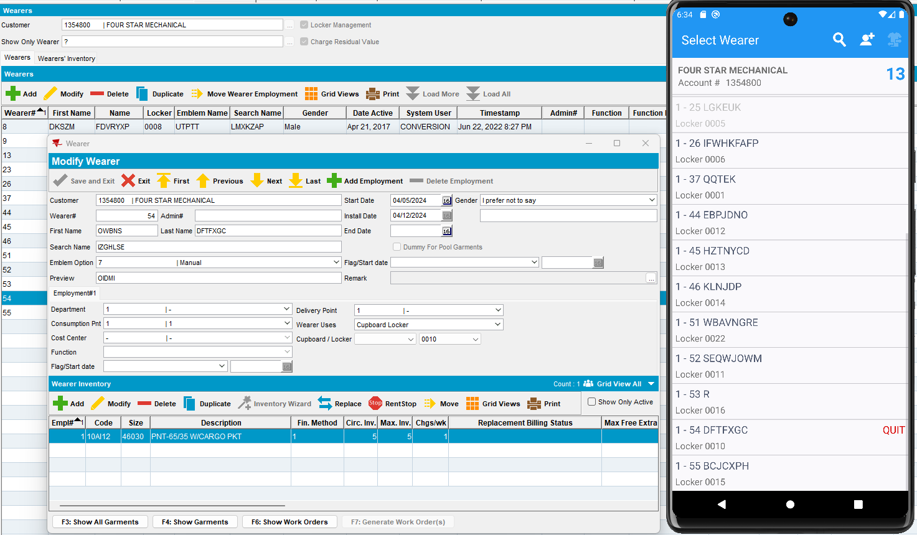

Decrease of max inventory
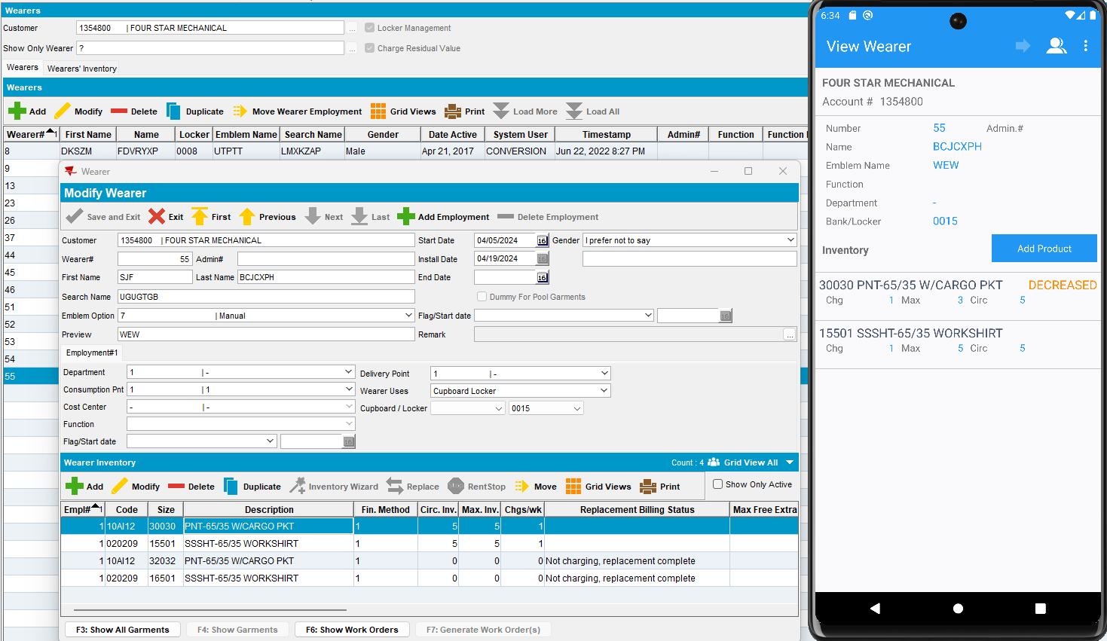
Settle and depart from customer

On RA Mixed garments – customer 1230257

Replacement size
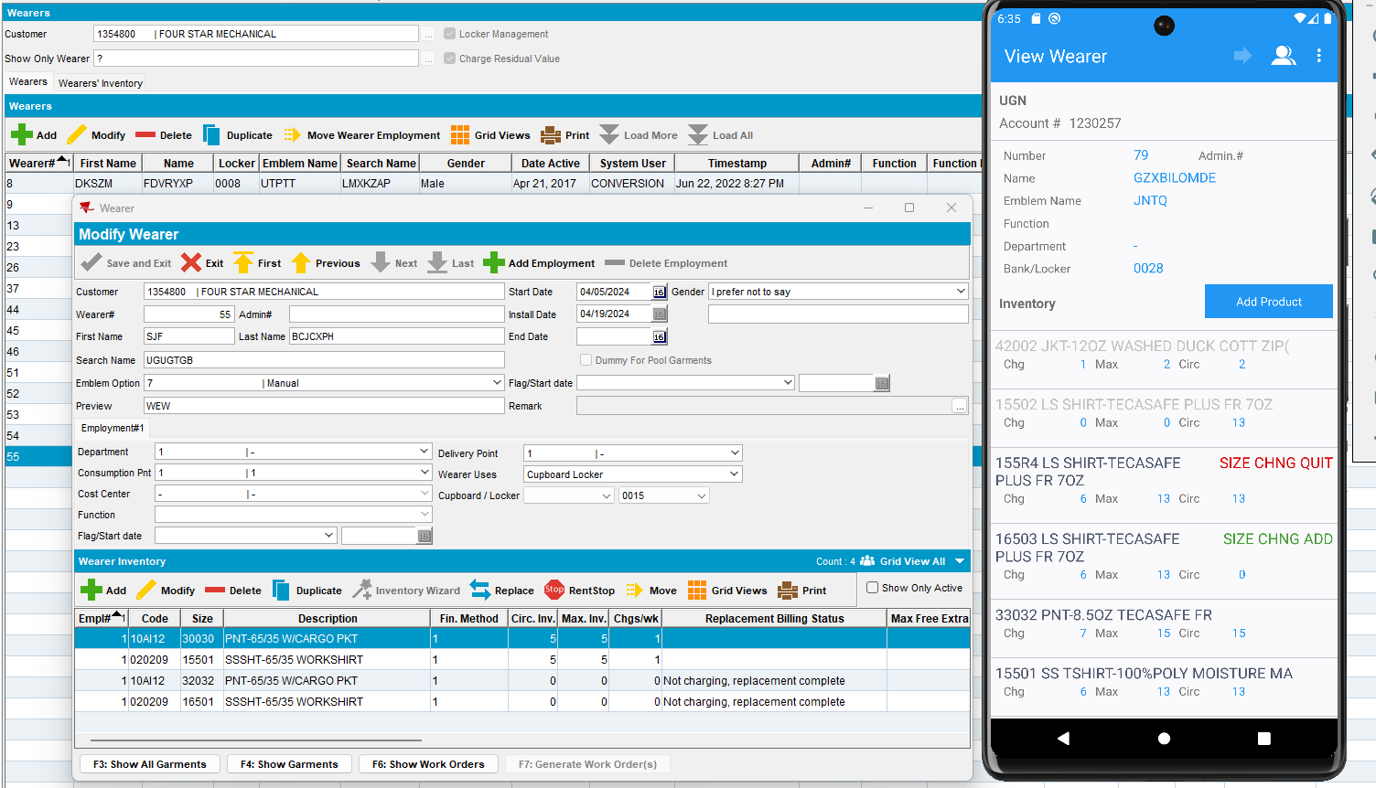

Quit wearer inventory
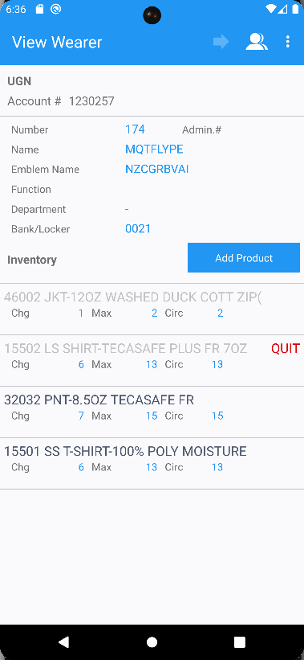

Quit wearer
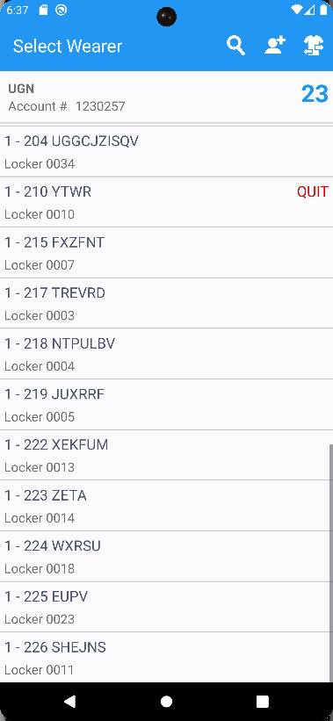

Decrease of max inventory
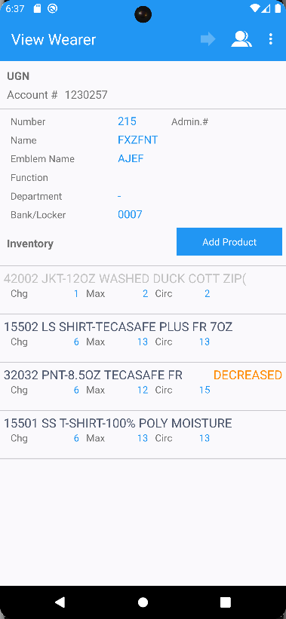
Settle and depart from customer

On RA Unique garments – customer 856759

Replacement size
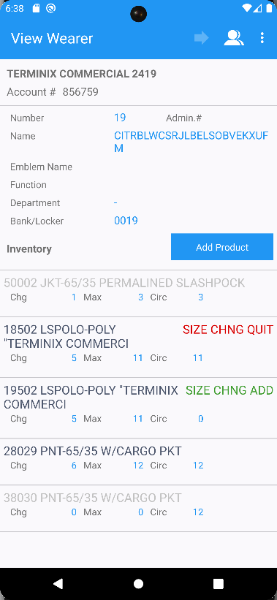

Quit wearer inventory
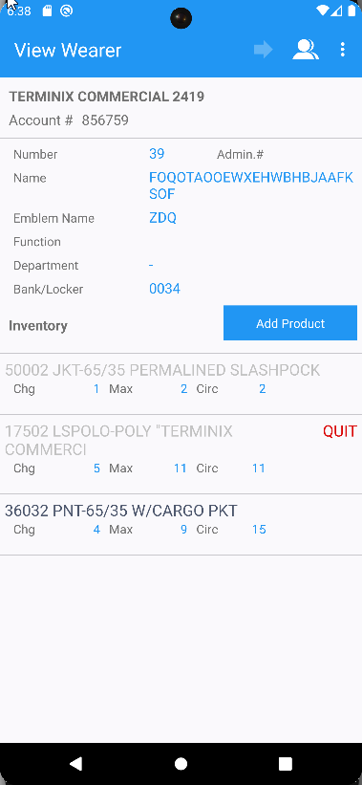

Quit wearer
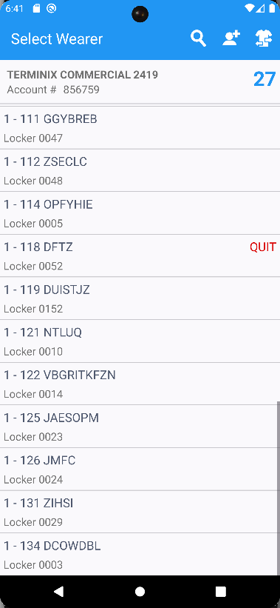

Decrease of max inventory
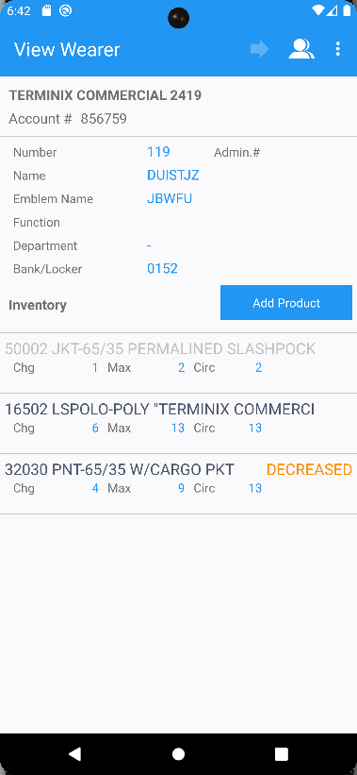

- RA: Settle and depart from all customers, upload the route back to the client.
- WebX: Complete start my day and review everything for the route.
- WebX: Settle the route. Script the taxes for the settlement.
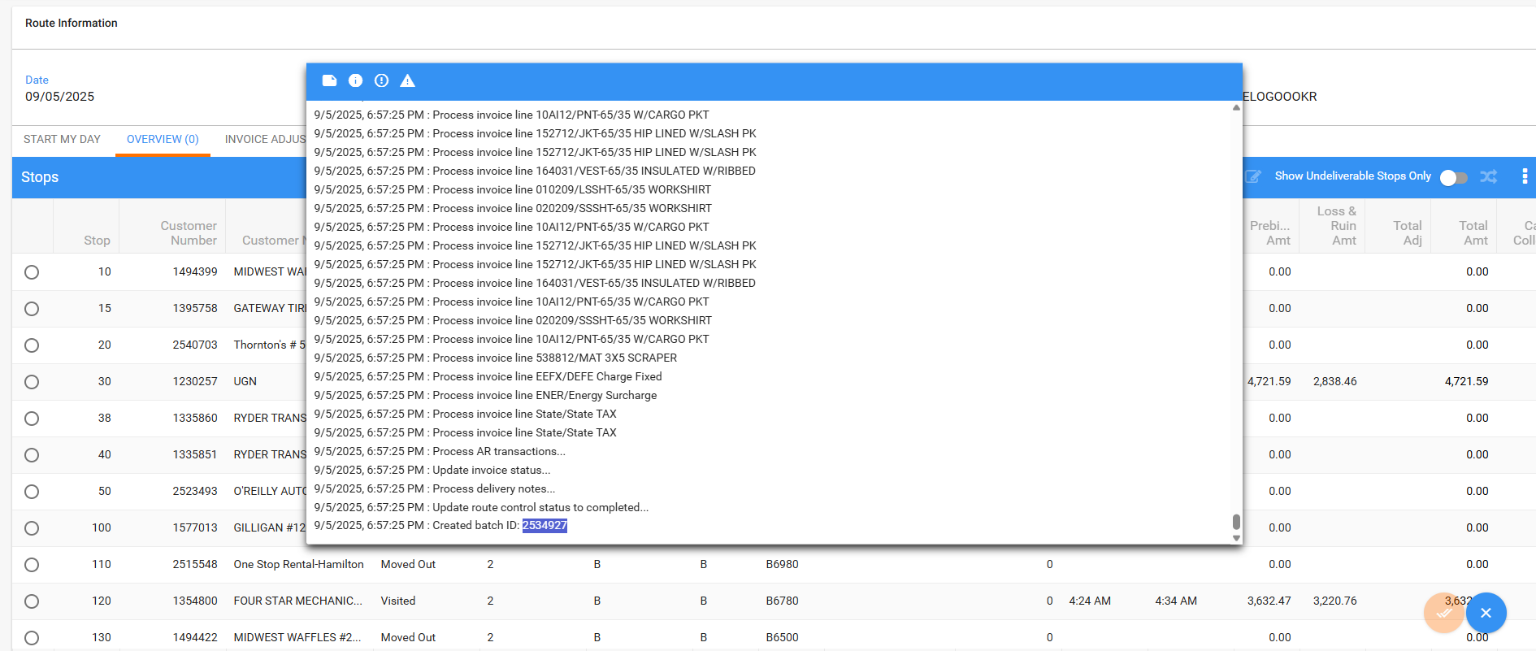
- Issue work order dlg: For each wearer from the 3 customers for which we’ve made replacement sizes, approve the new workorders that were created after RA upload.

Customer 1354800
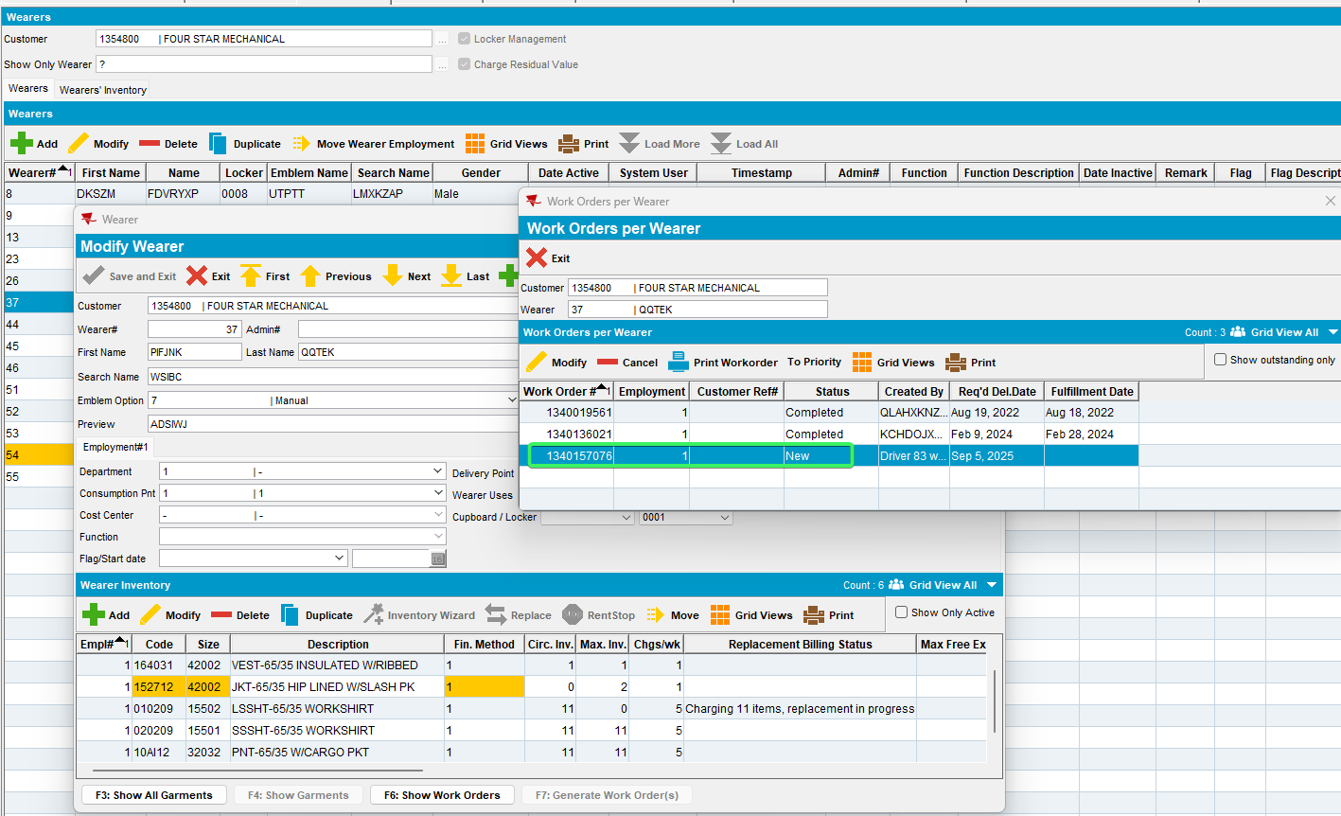
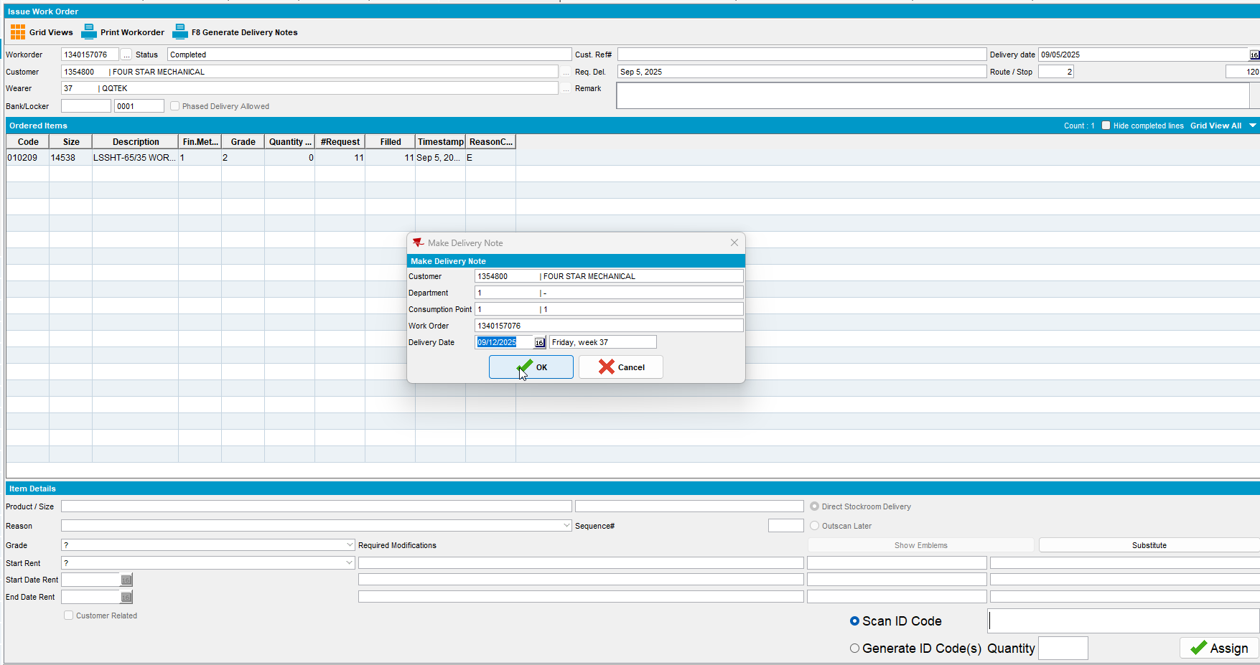

Customer 1230257
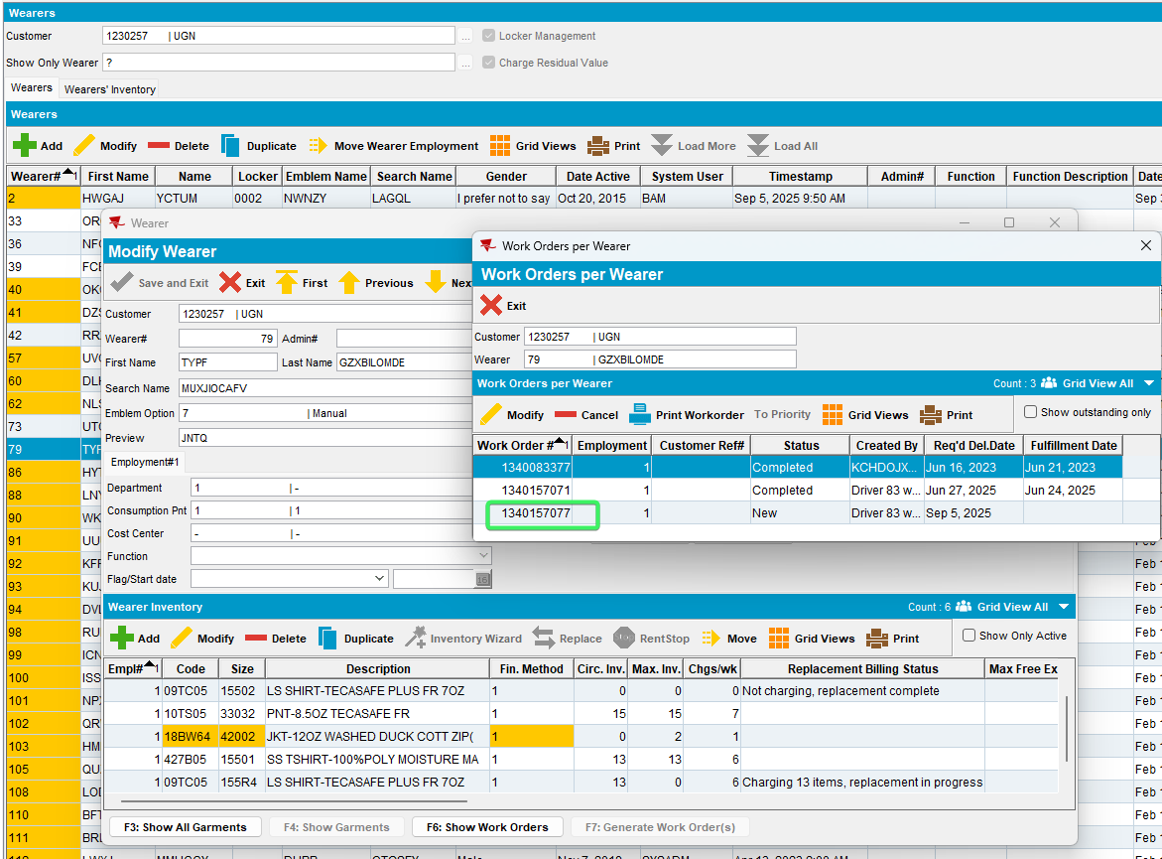

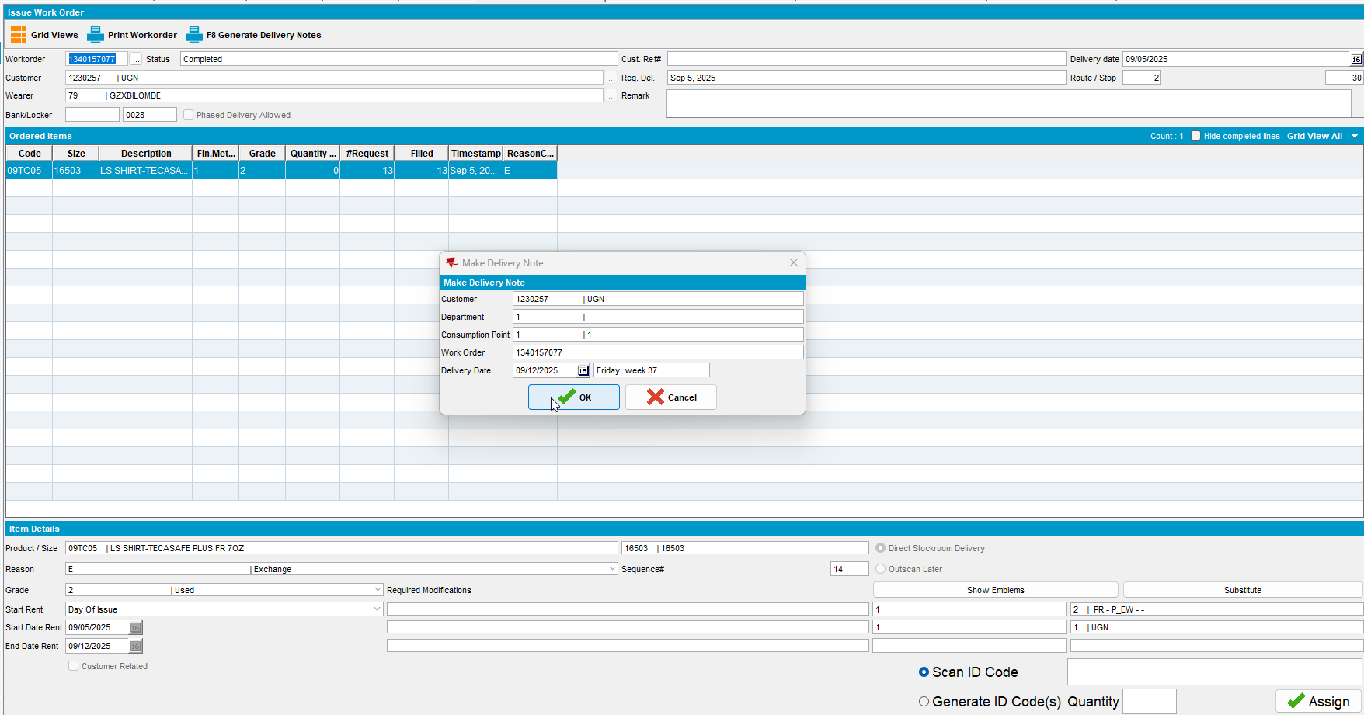

Customer 856759
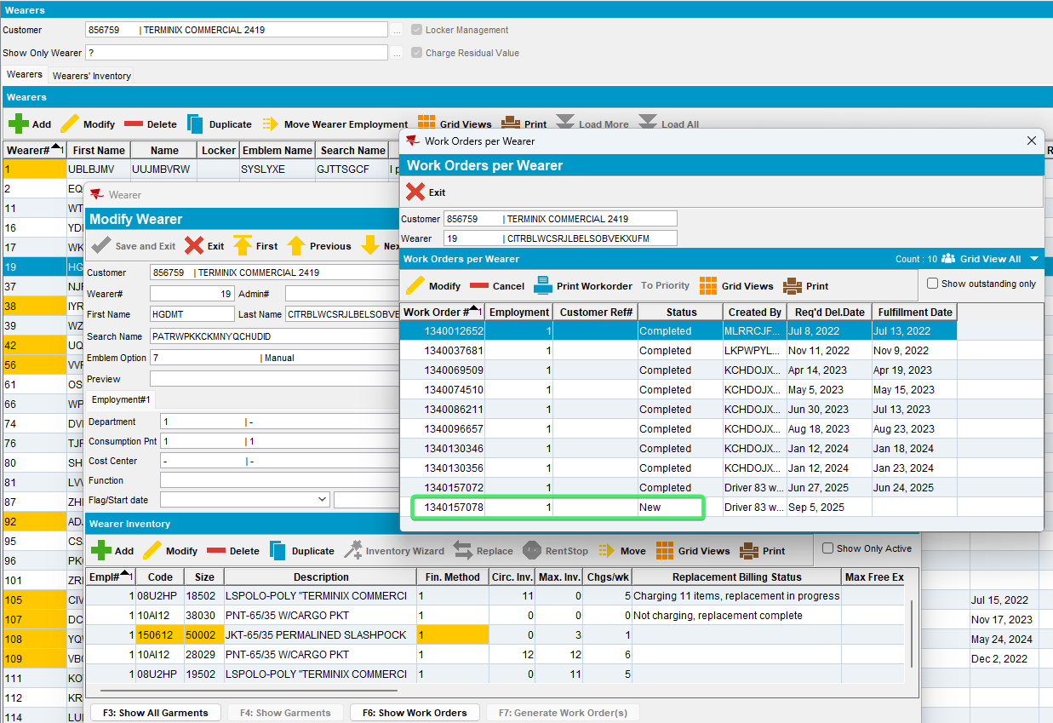
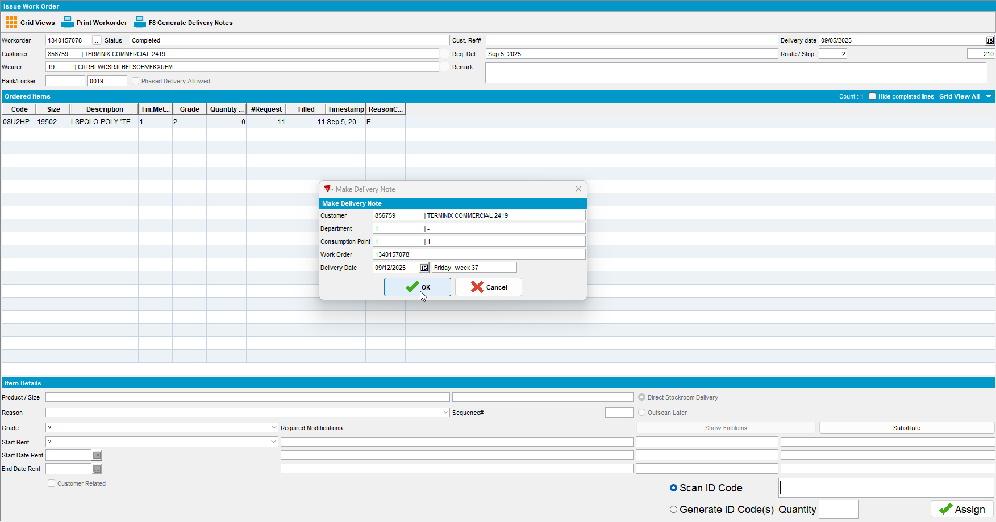
- RSC dlg: Create a new route containing the customer 2weeks+ in the future from the quitting we’ve done, so that loss charges are extend = Yes.
- RSC dlg: Generate packing notes, generate invoices and script the taxes. Send the route to PDA.
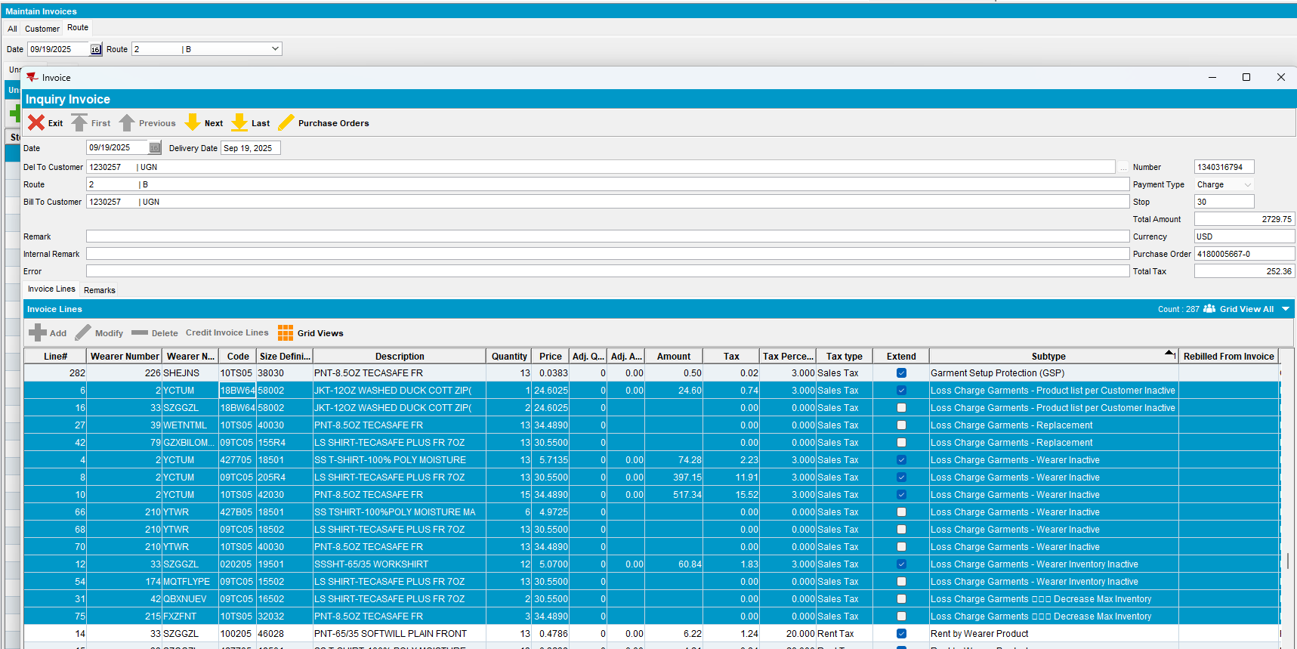
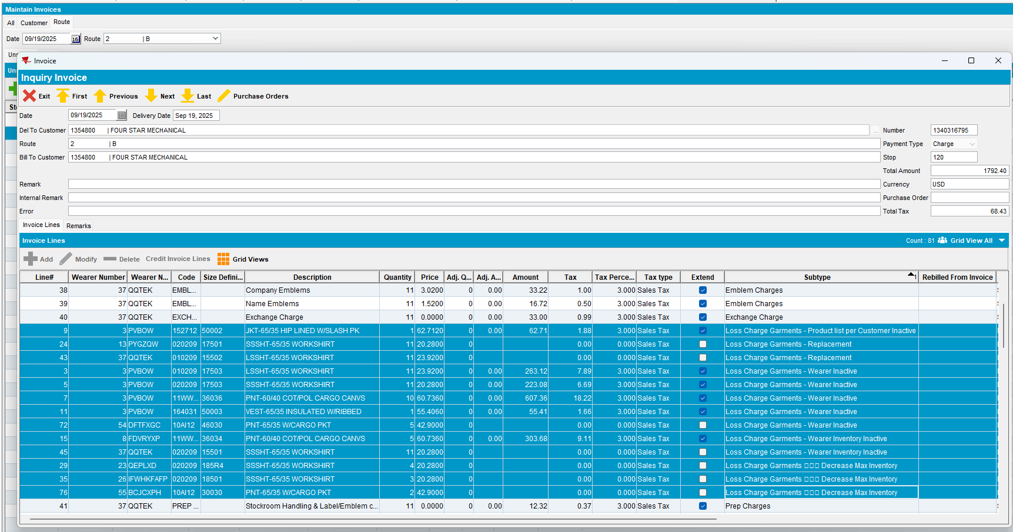
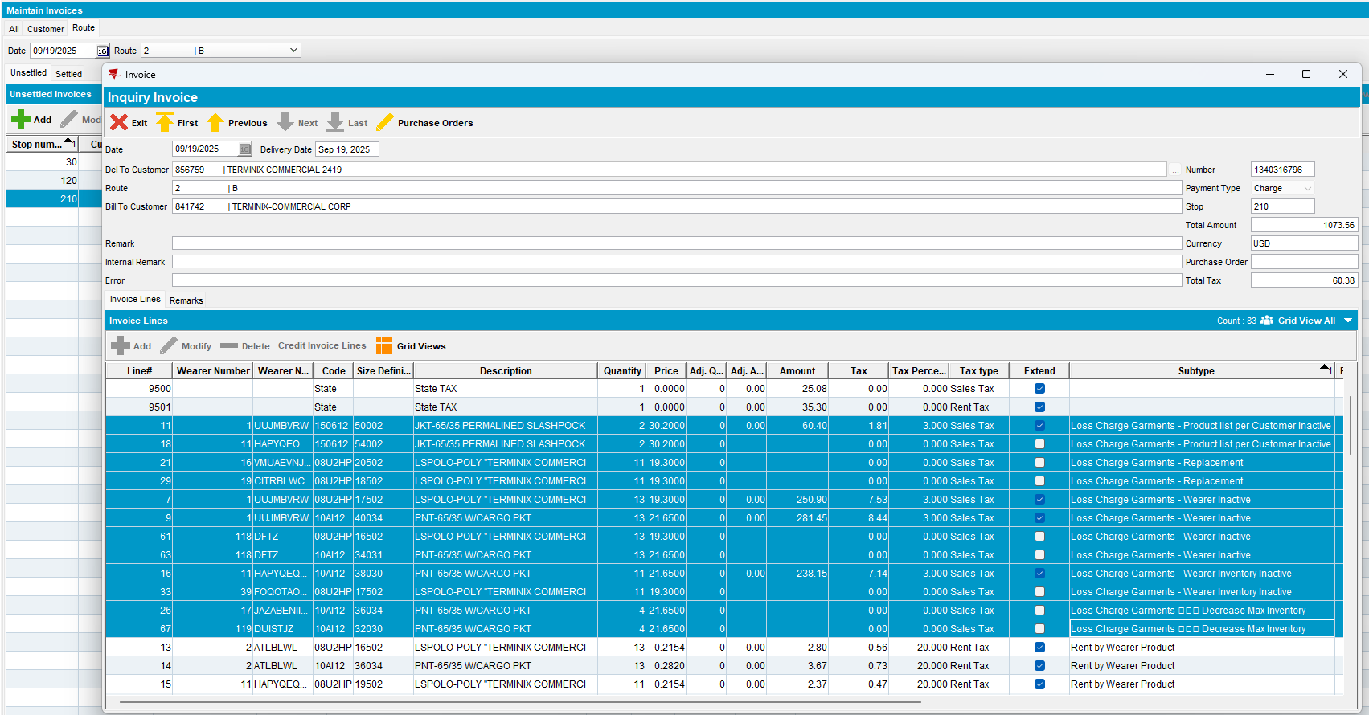

- RA: Download the route and arrive at the customers. Enter Adjust / View Lines and adjust all the loss charges with minus quantity you want to see in Loss Charge Monitor.

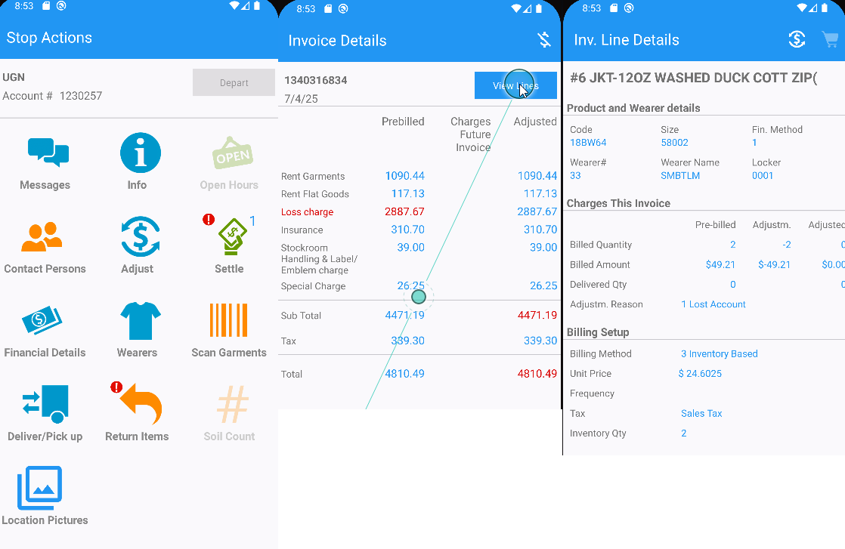
Settle and depart
- RA: Upload the route back to the client.
- WebX: Complete the start my day. Review the adjustments and any tabs that need to be reviewed.
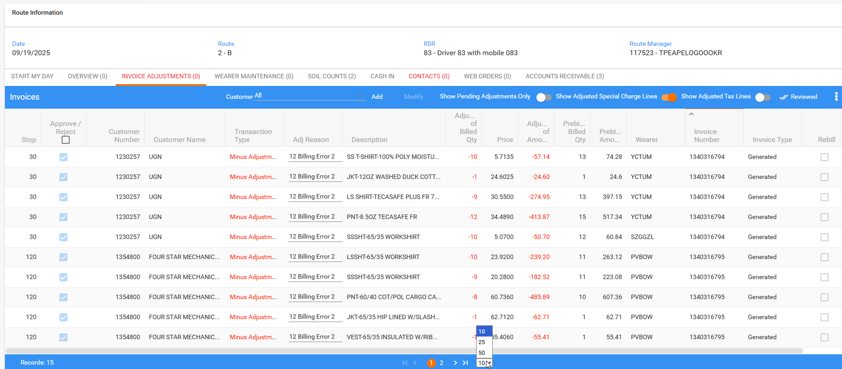
- WebX: Settle the route.
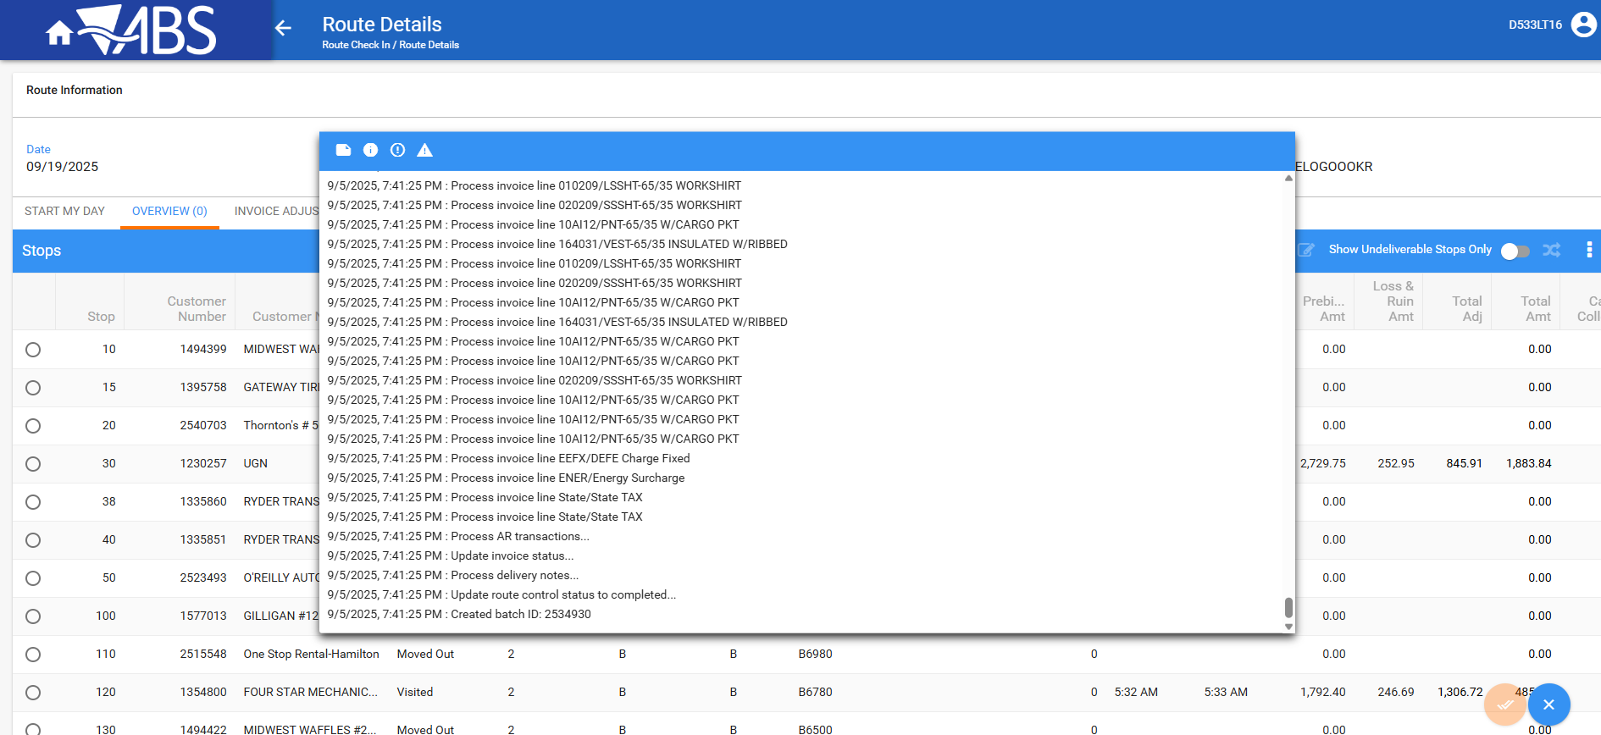
- Loss Charge Monitor: Check the loss date of the quantities that were credited in Rasa mobile app
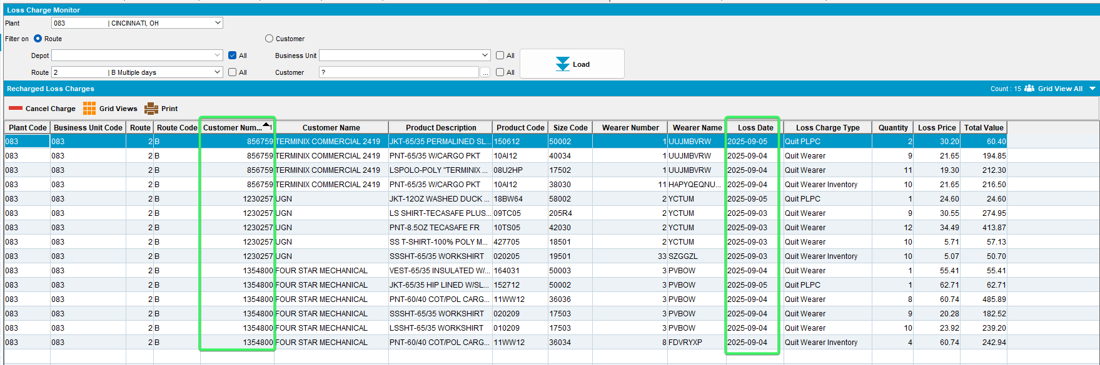
The loss date is the date when the action was made, not the wearer start date

Tested OK

