ABSN-7164 Wash line for sales off the truck
Environment | Prerequisites
Version:9.07.00  DBServerName=abs-SRV20.internal.abslbs.com  DBSID=CUST24  DBUser=UNFDEV  Environment=Test | - Module:  - System setting

Contents
Test after fix 1
Test Case 1 – With UNFCUSTOM generate packing notes and Invoices for a route where there are no DVs from the previous week for a non-garment product with BM3 - Wash Only– Tested OK 1
Test Case 2 – With NO UNFCUSTOM generate packing notes and Invoices for a route where there are no DVs from the previous week for a non-garment product with BM3 - Wash Only– Tested OK 7
Test Case 3 – With UNFCUSTOM generate packing notes and Invoices for a route where there are DVs from the previous week for a non-garment product with BM3 - Wash Only– Tested OK 11

Test after fix

Test Case 1 – With UNFCUSTOM generate packing notes and Invoices for a route where there are no DVs from the previous week for a non-garment product with BM3 - Wash Only– Tested OK
Expected behavior: The invoice contains one invoice line of type Wash with the price from PLPC for Wash and qty of 0 and amount of 0. The user is able to adjust the qty on the RA.
Hash: ab6a368
- Have UNFCUSTOM in license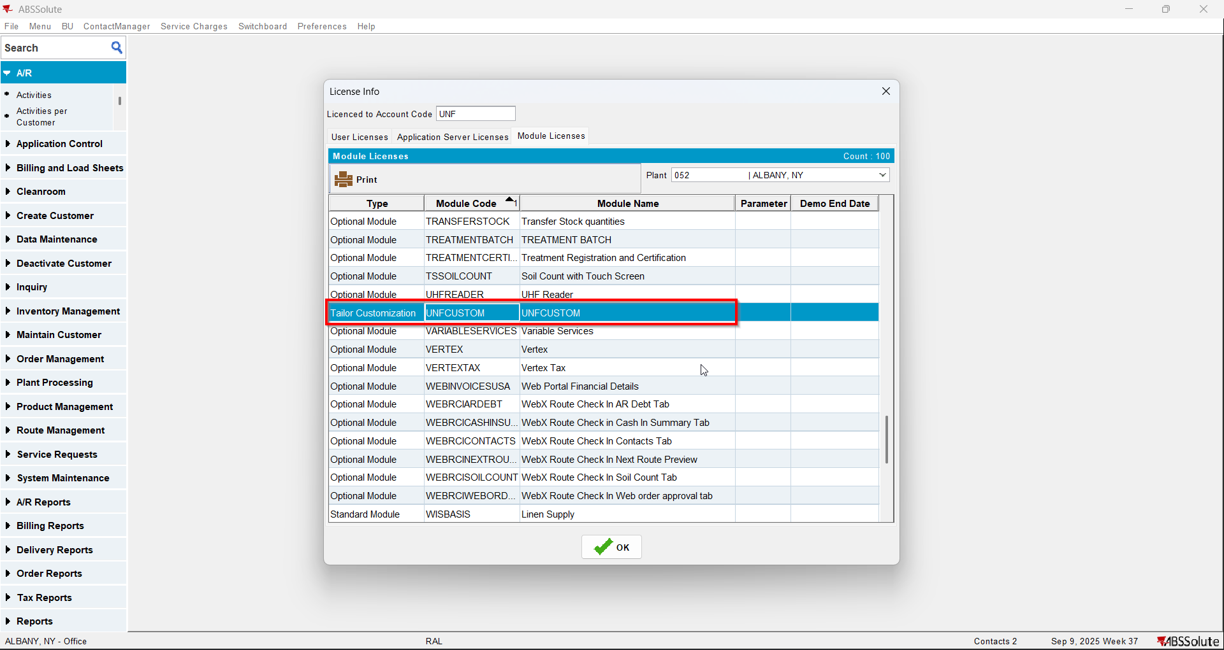
- Have a customer with a non garment with BM3 wash only and soil counted manual (you can use product 623213)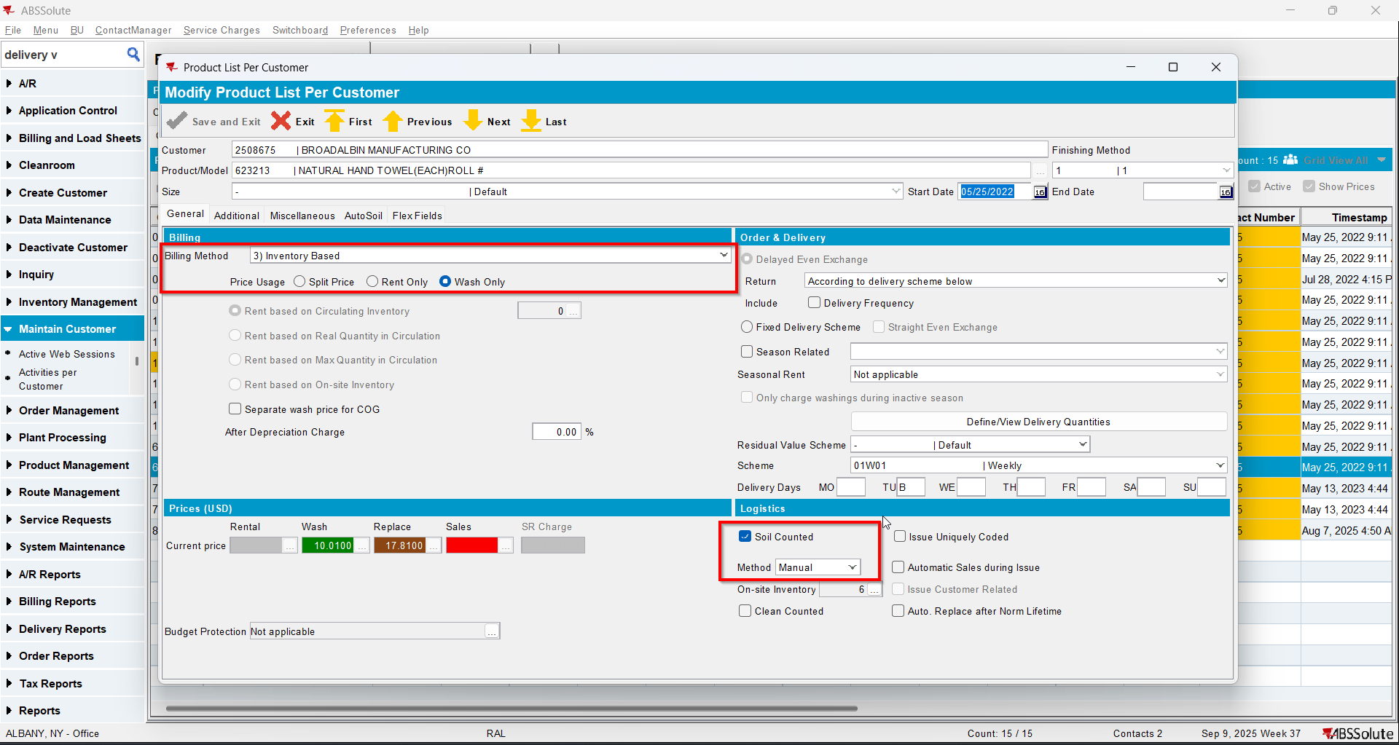
- Go to Delivery Variations dlg and check that your customer does not have DVs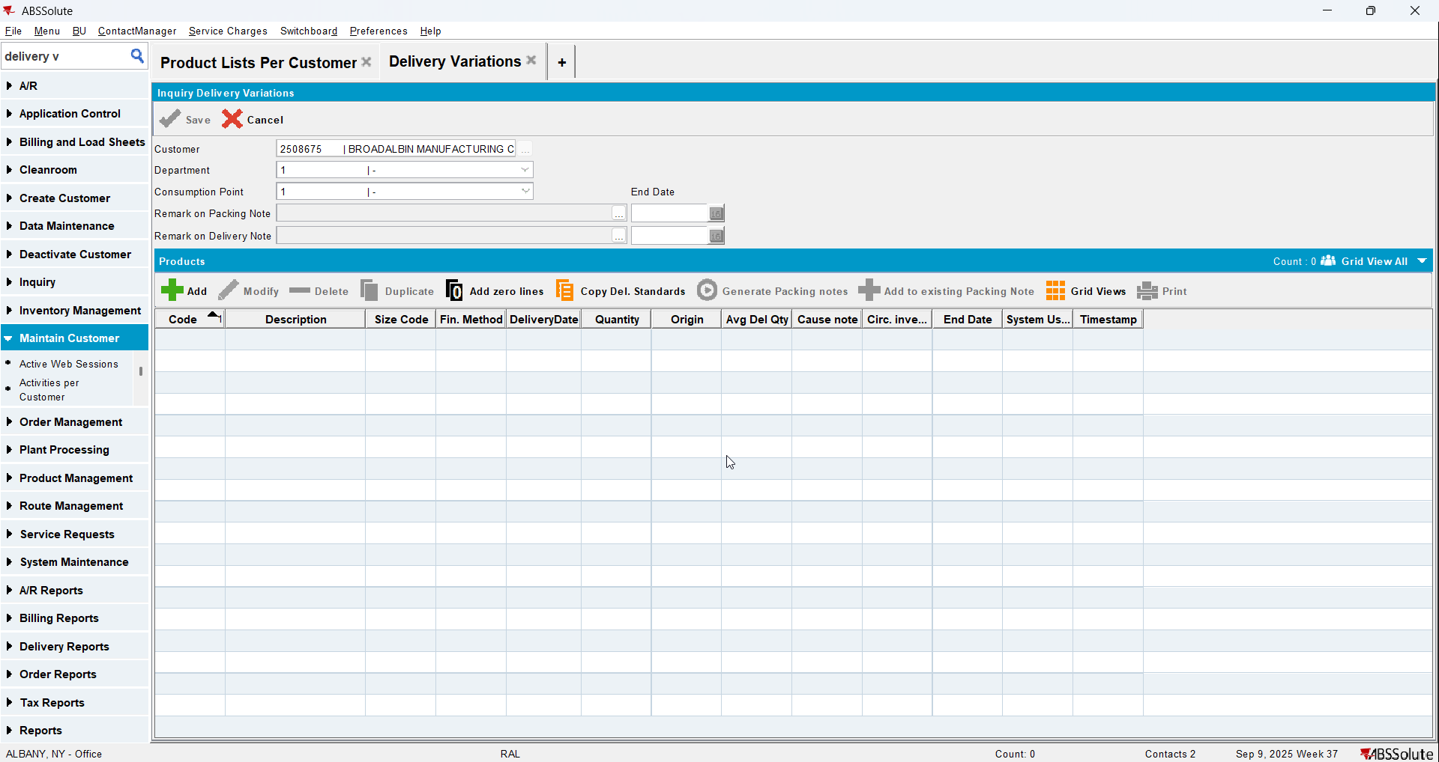
- Go to Route Status Control dlg and create a route for your customer
- Generate packing notes and invoices for it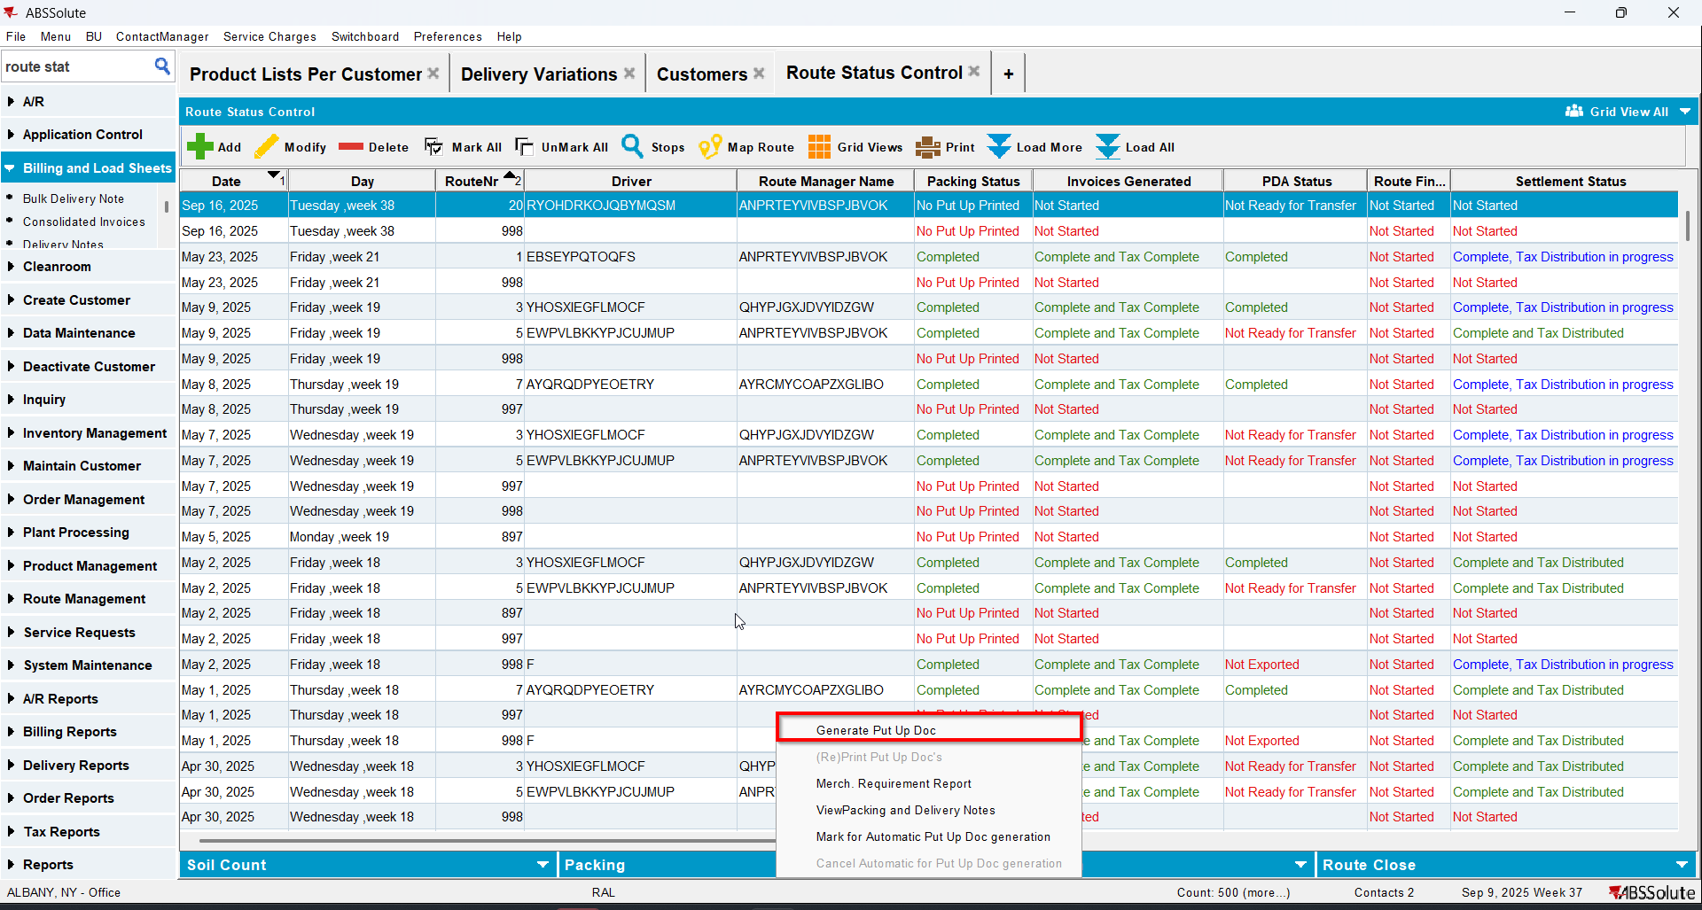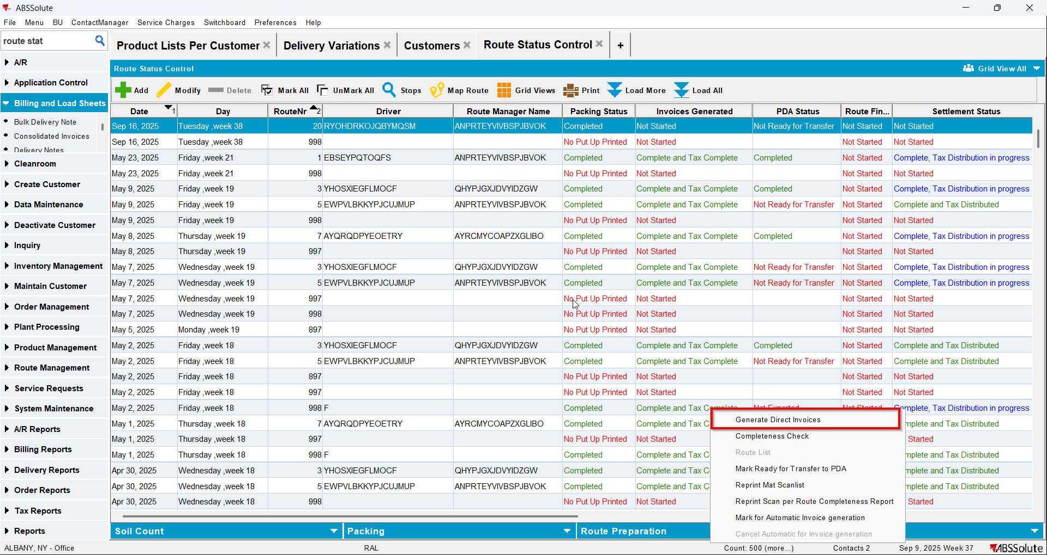
- Check on the invoices that a wash line for your non garment appears with a price but with qty and amount 0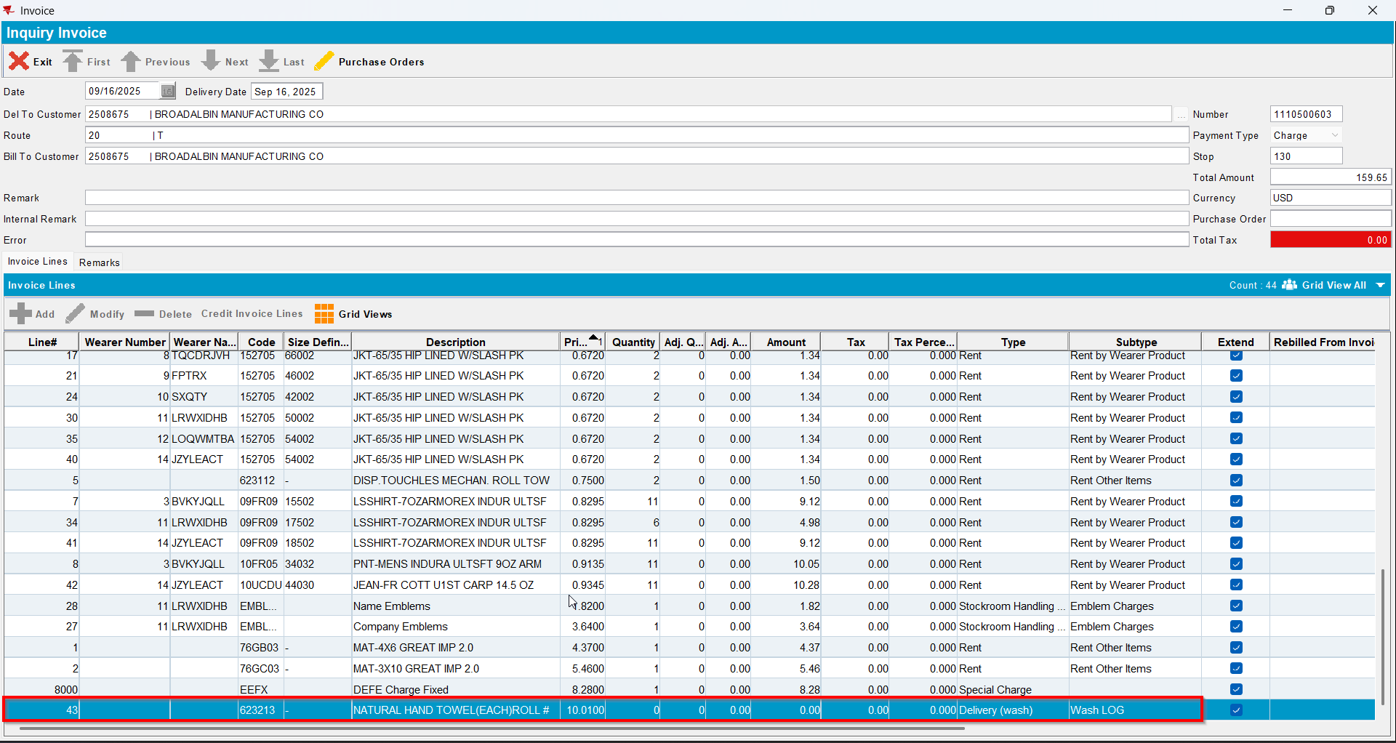
- Send the route to RA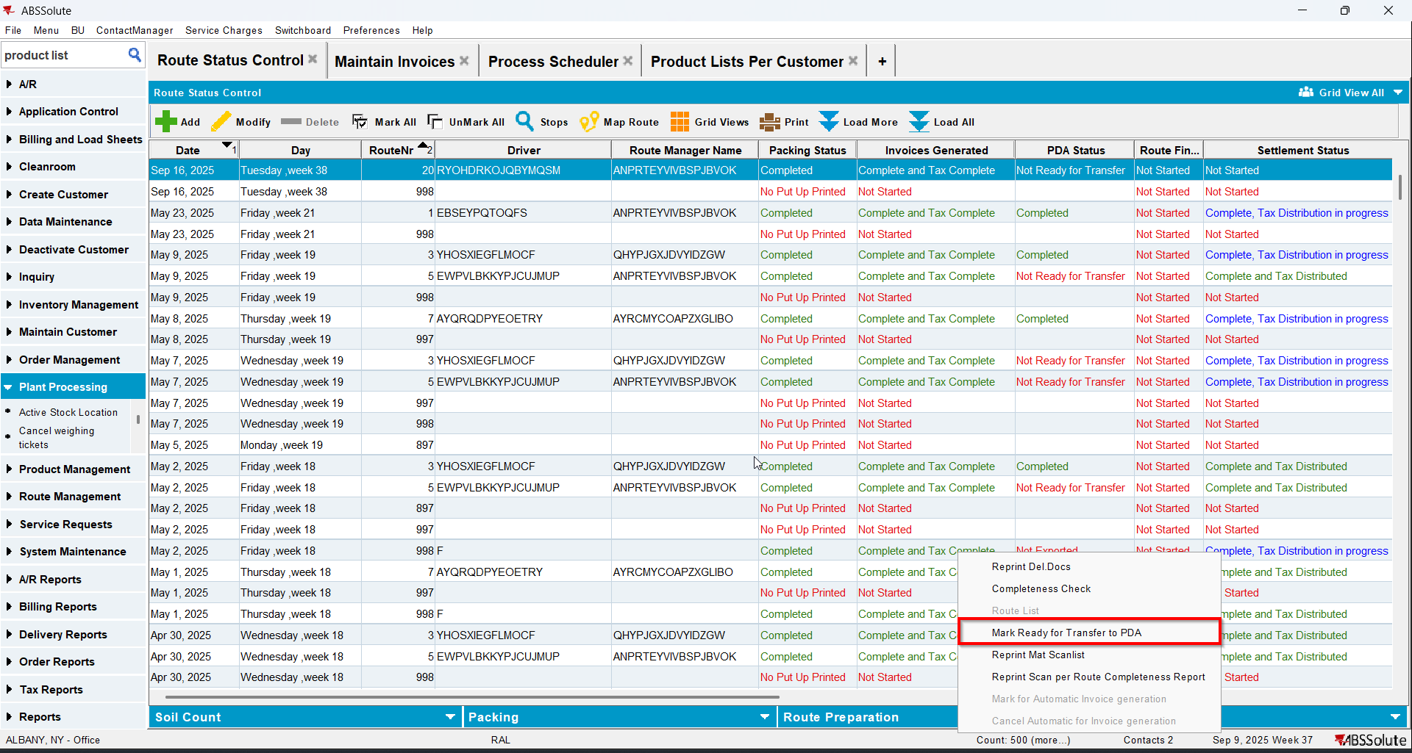
- On RA do a positive adjustment, adjusting just the qty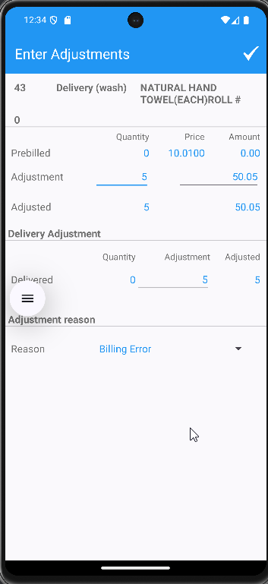
- Finish the route and upload it
- On WebX settle the route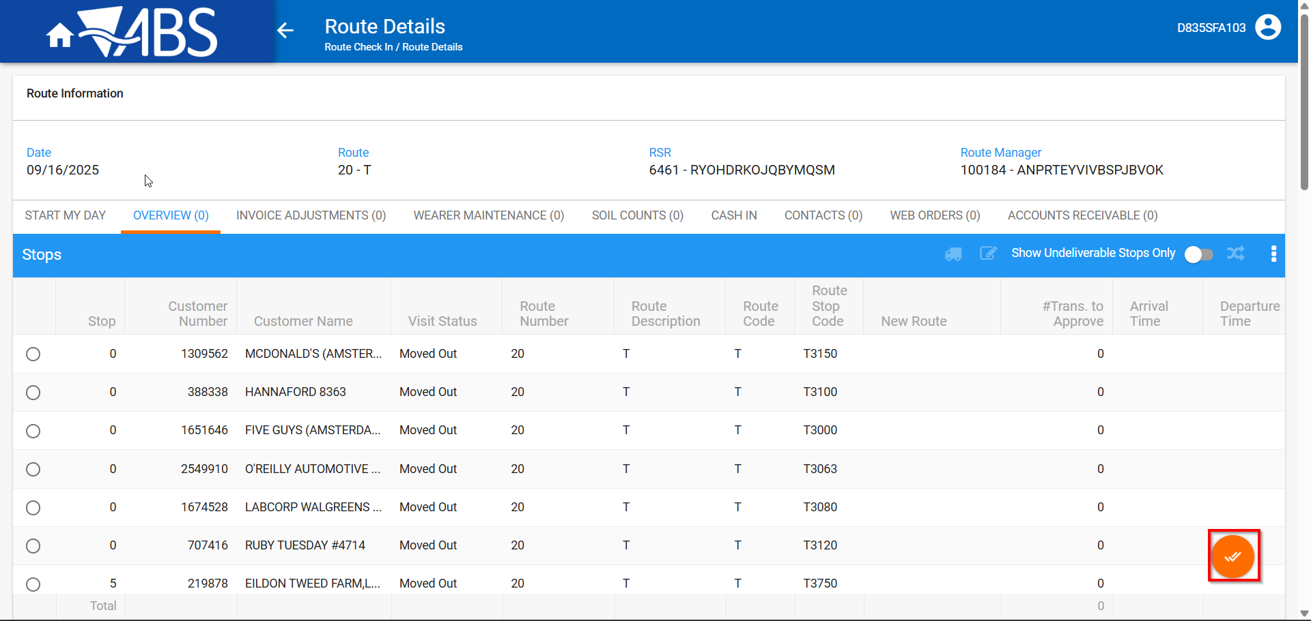
- Check now that on the invoices the adjustment appears
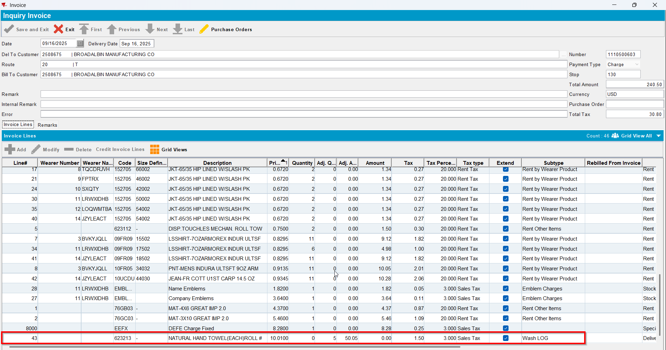

Test Case 2 – With NO UNFCUSTOM generate packing notes and Invoices for a route where there are no DVs from the previous week for a non-garment product with BM3 - Wash Only– Tested OK
Expected behavior: The invoice contains NO invoice line of type Wash with the price from PLPC for Wash and qty of 0 and amount of 0
Hash: ab6a368
- Do not have UNFCUSTOM in license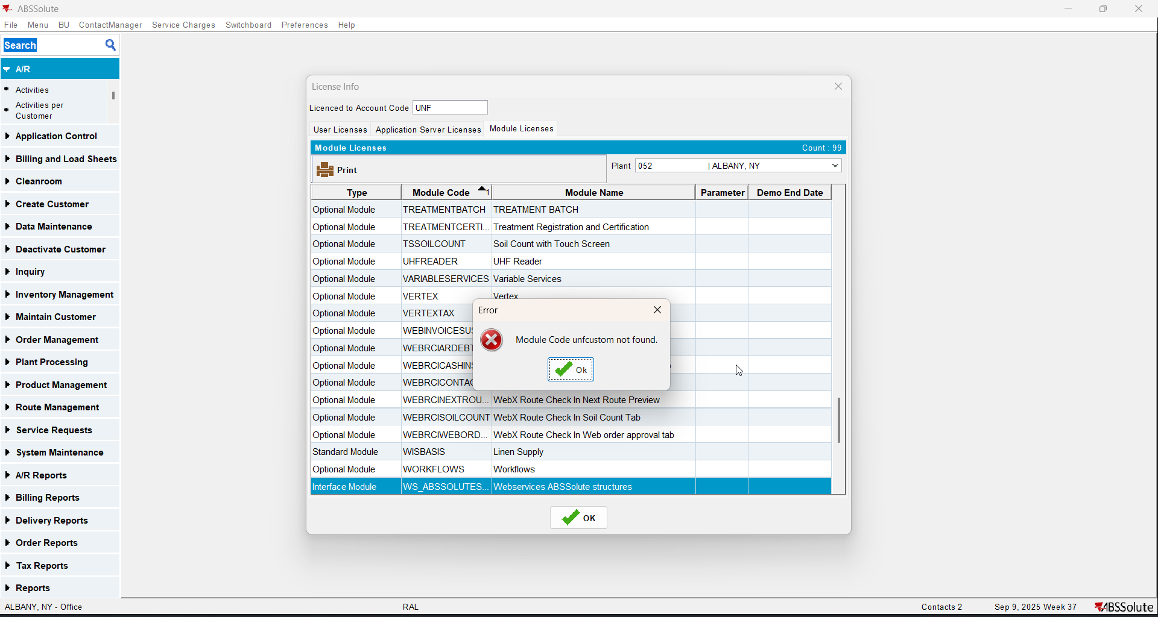
- Have a customer with a non garment with BM3 wash only and soil counted manual (you can use product 623213)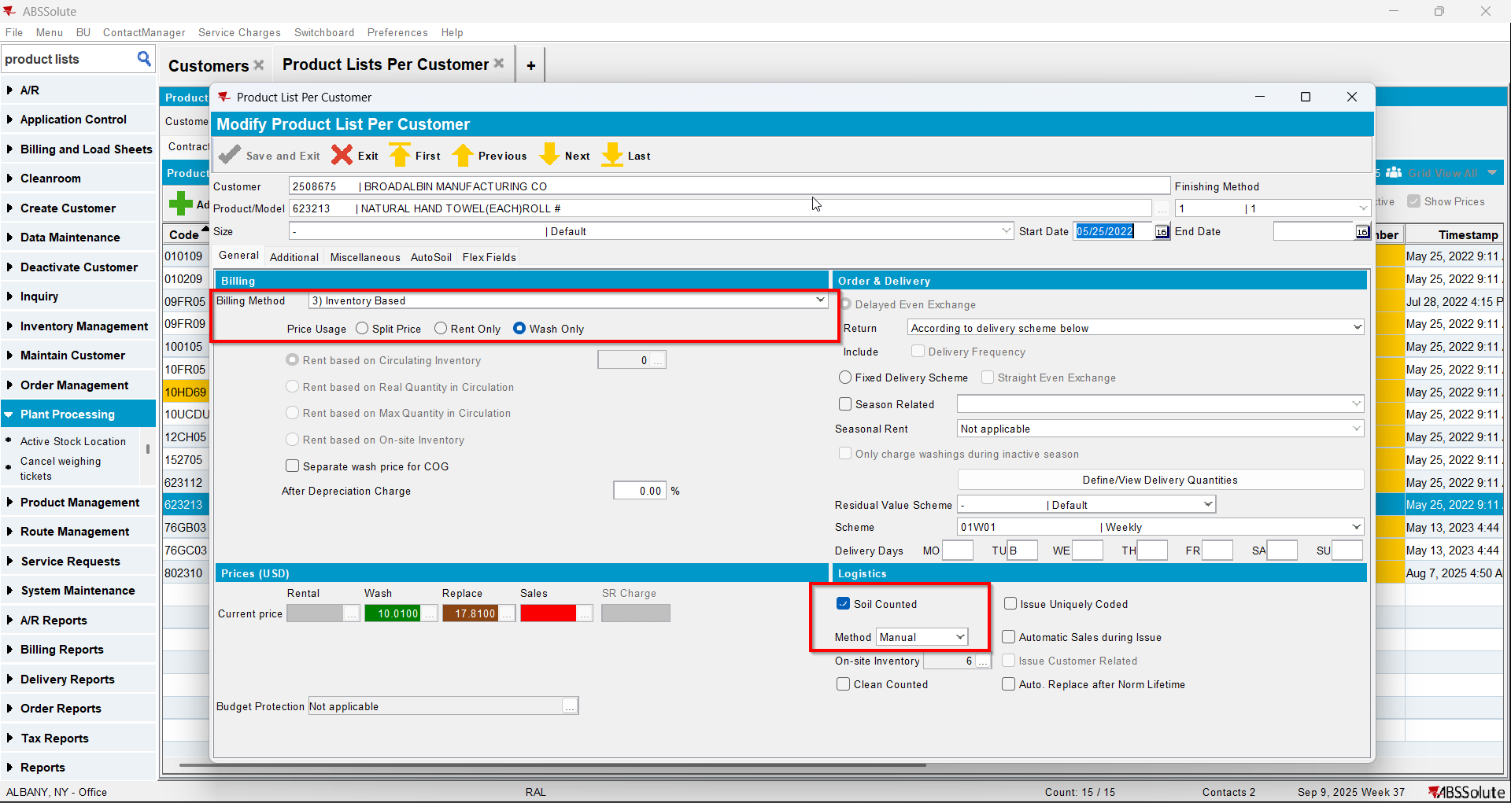
- Go to Delivery Variations dlg and check that your customer does not have DVs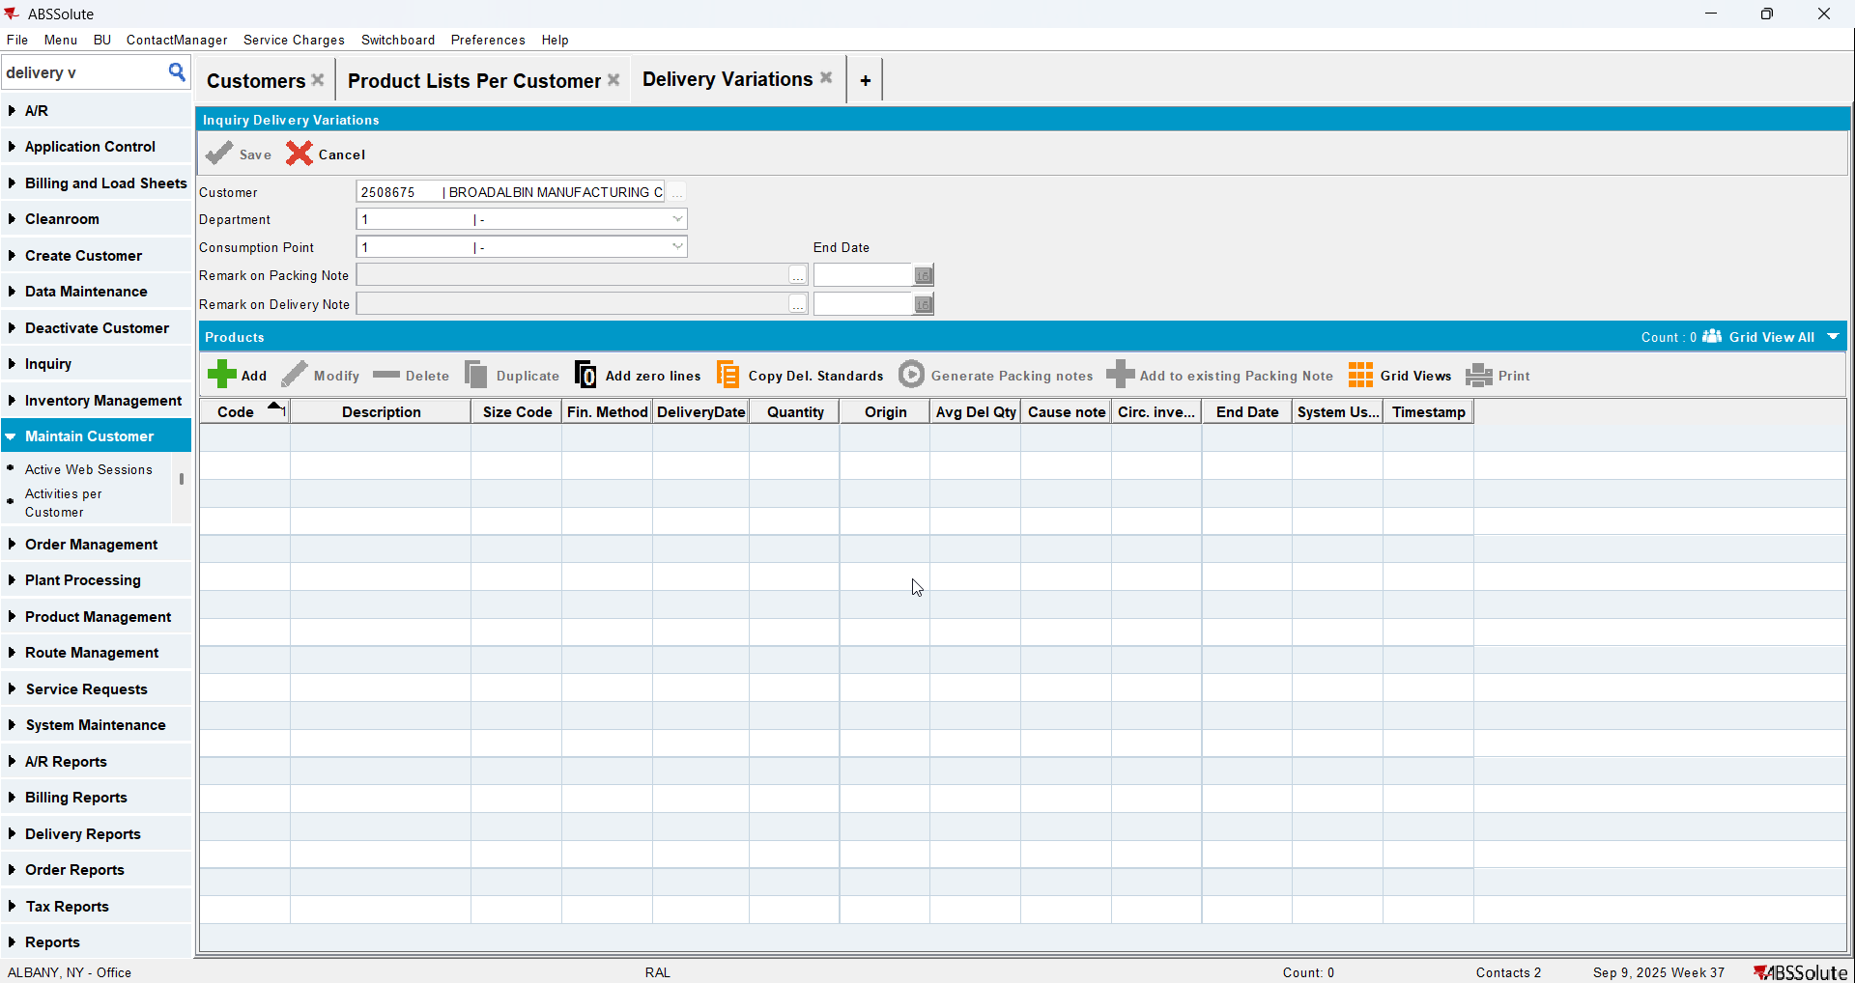
- Go to Route Status Control dlg and create a route for your customer
- Generate packing notes and invoices for it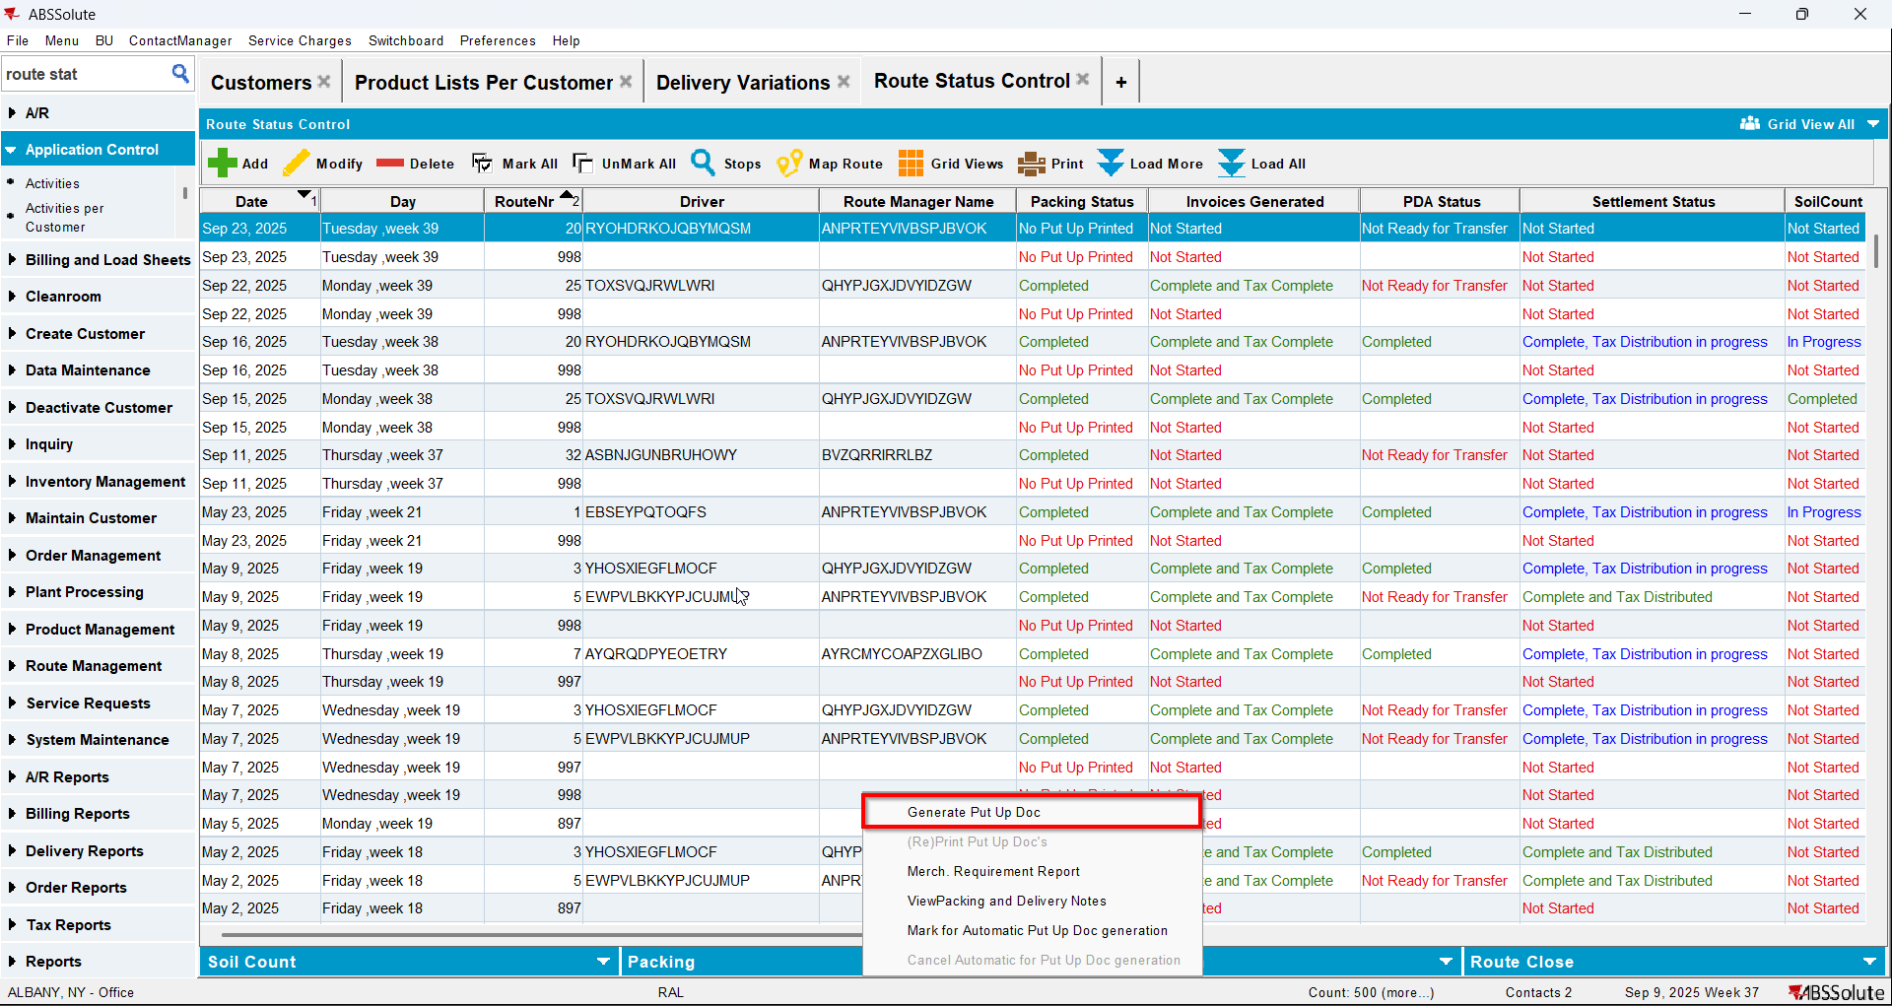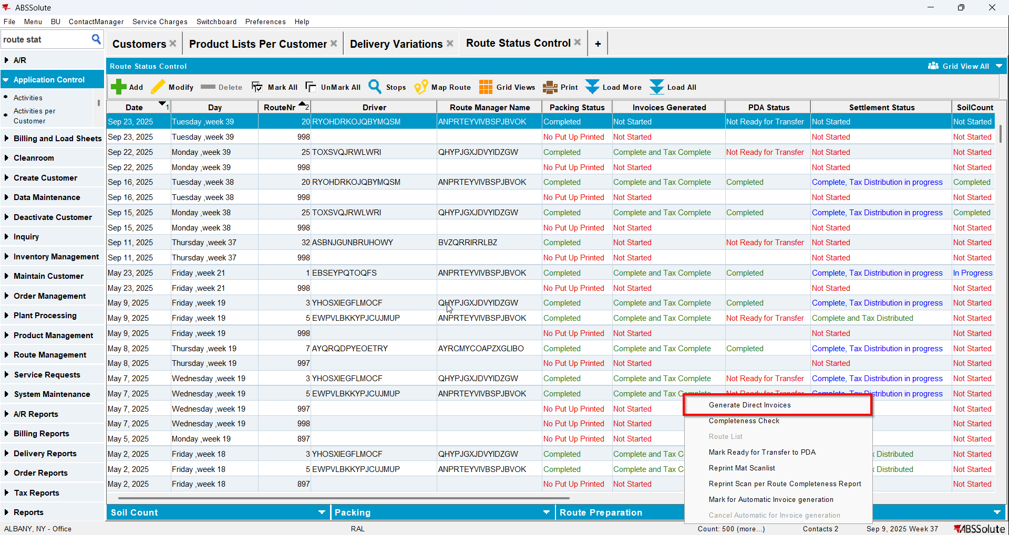
- Check that on the invoice there is no wash line for your non garment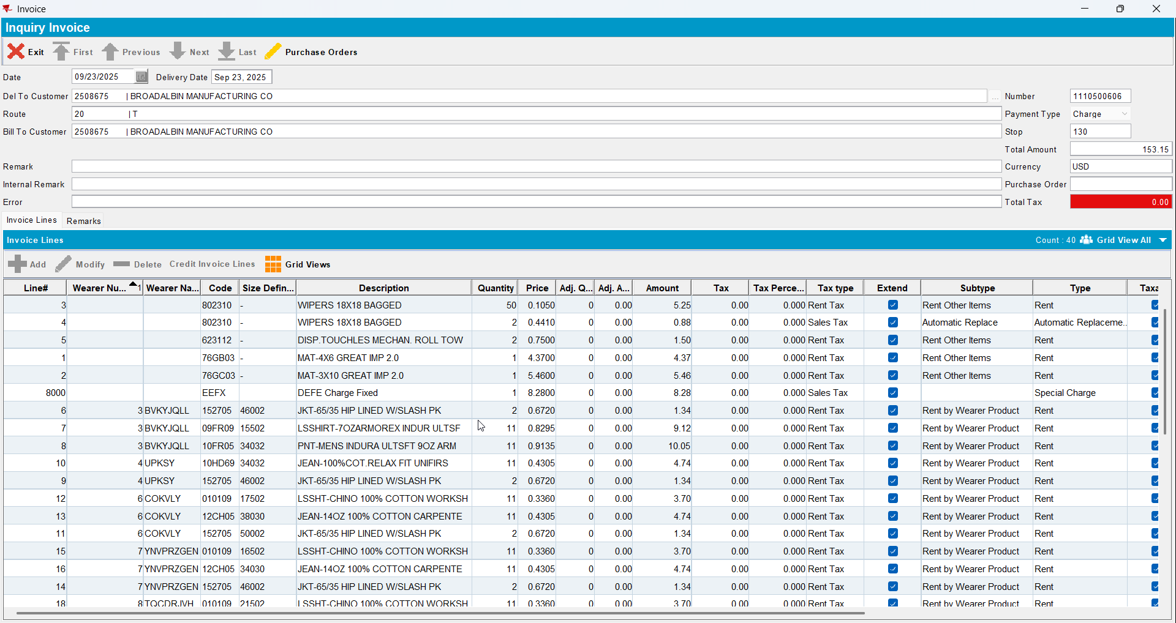

Test Case 3 – With UNFCUSTOM generate packing notes and Invoices for a route where there are DVs from the previous week for a non-garment product with BM3 - Wash Only– Tested OK
Expected behavior: The invoice contains an invoice line of type Wash with the price from the PLPC for wash and qty coming from the DV/Packing note line and a corresponding amount of price * qty
Hash: ab6a368
- Have UNFCUSTOM in license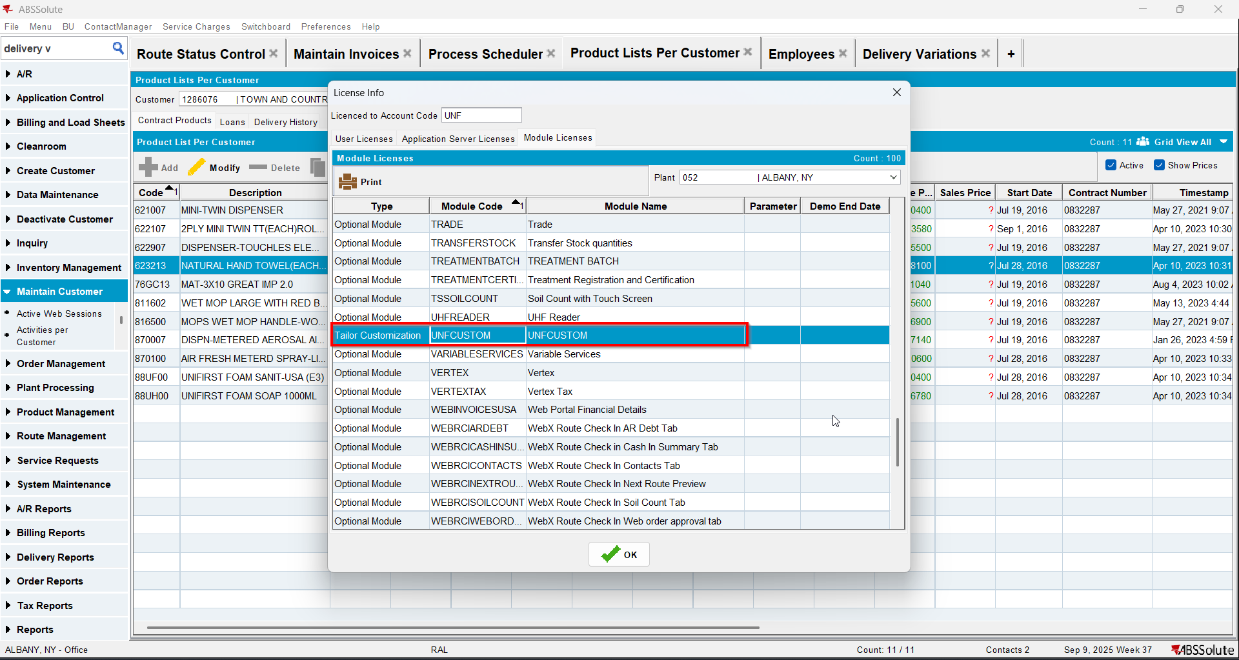
- Have a customer with a non garment with BM3 wash only and soil counted manual (you can use product 623213)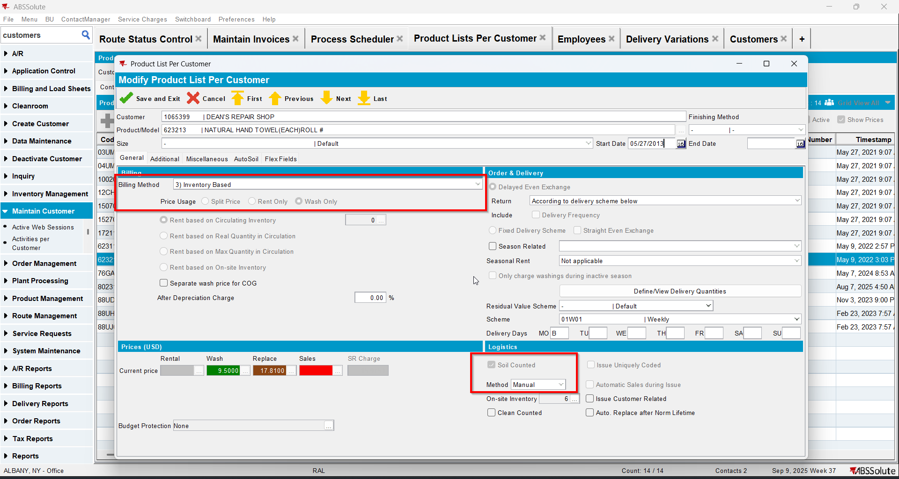
- Go to Delivery Variations dlg and check that your customer does not have DVs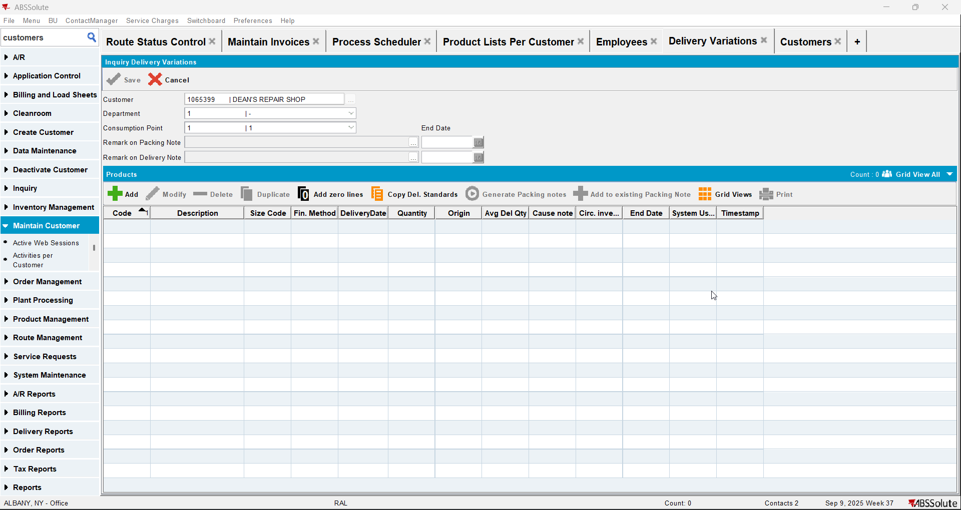
- Go to Route Status Control dlg and create a route for your customer
- Generate packing notes and invoices for it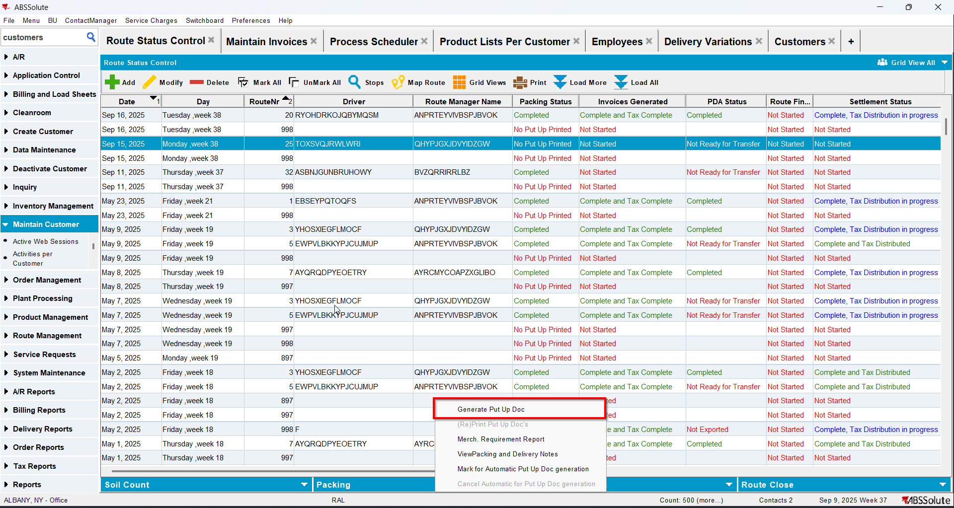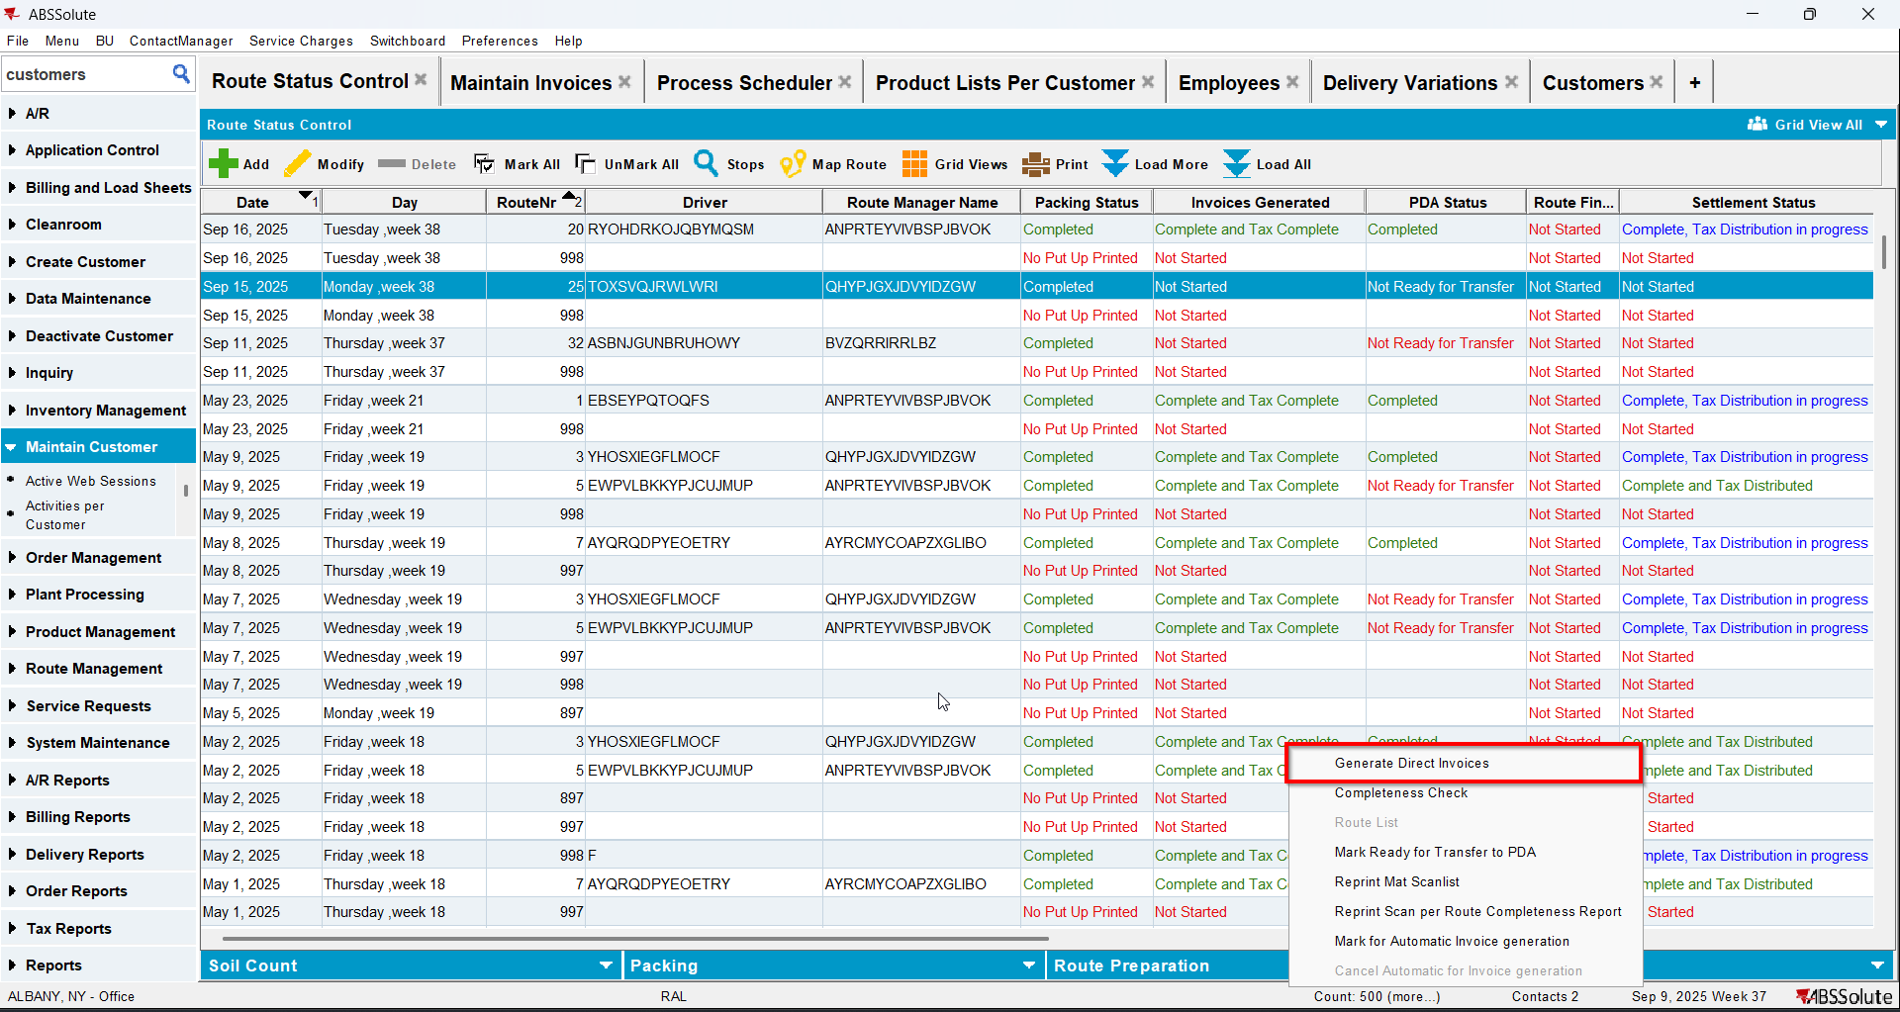
- Check on the invoices that a wash line for your non garment appears with a price but with qty and amount 0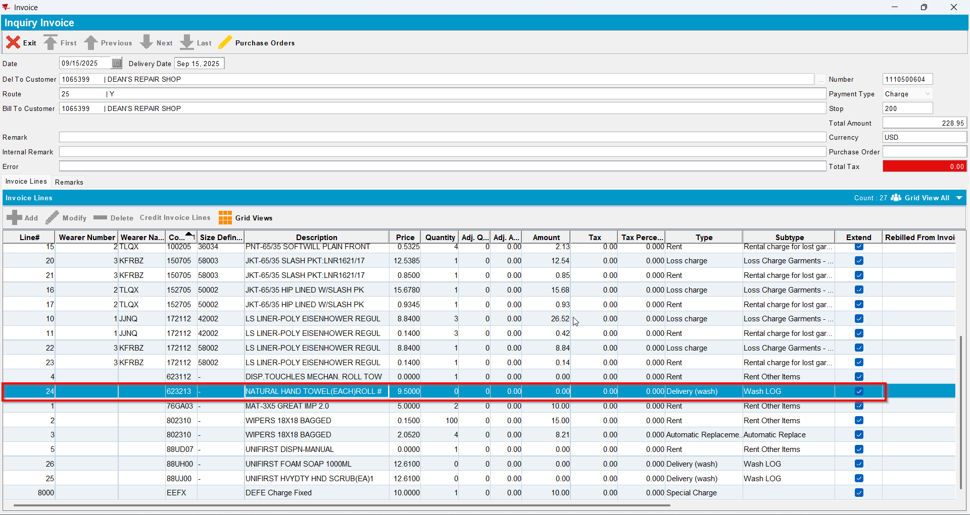
- Send the route to RA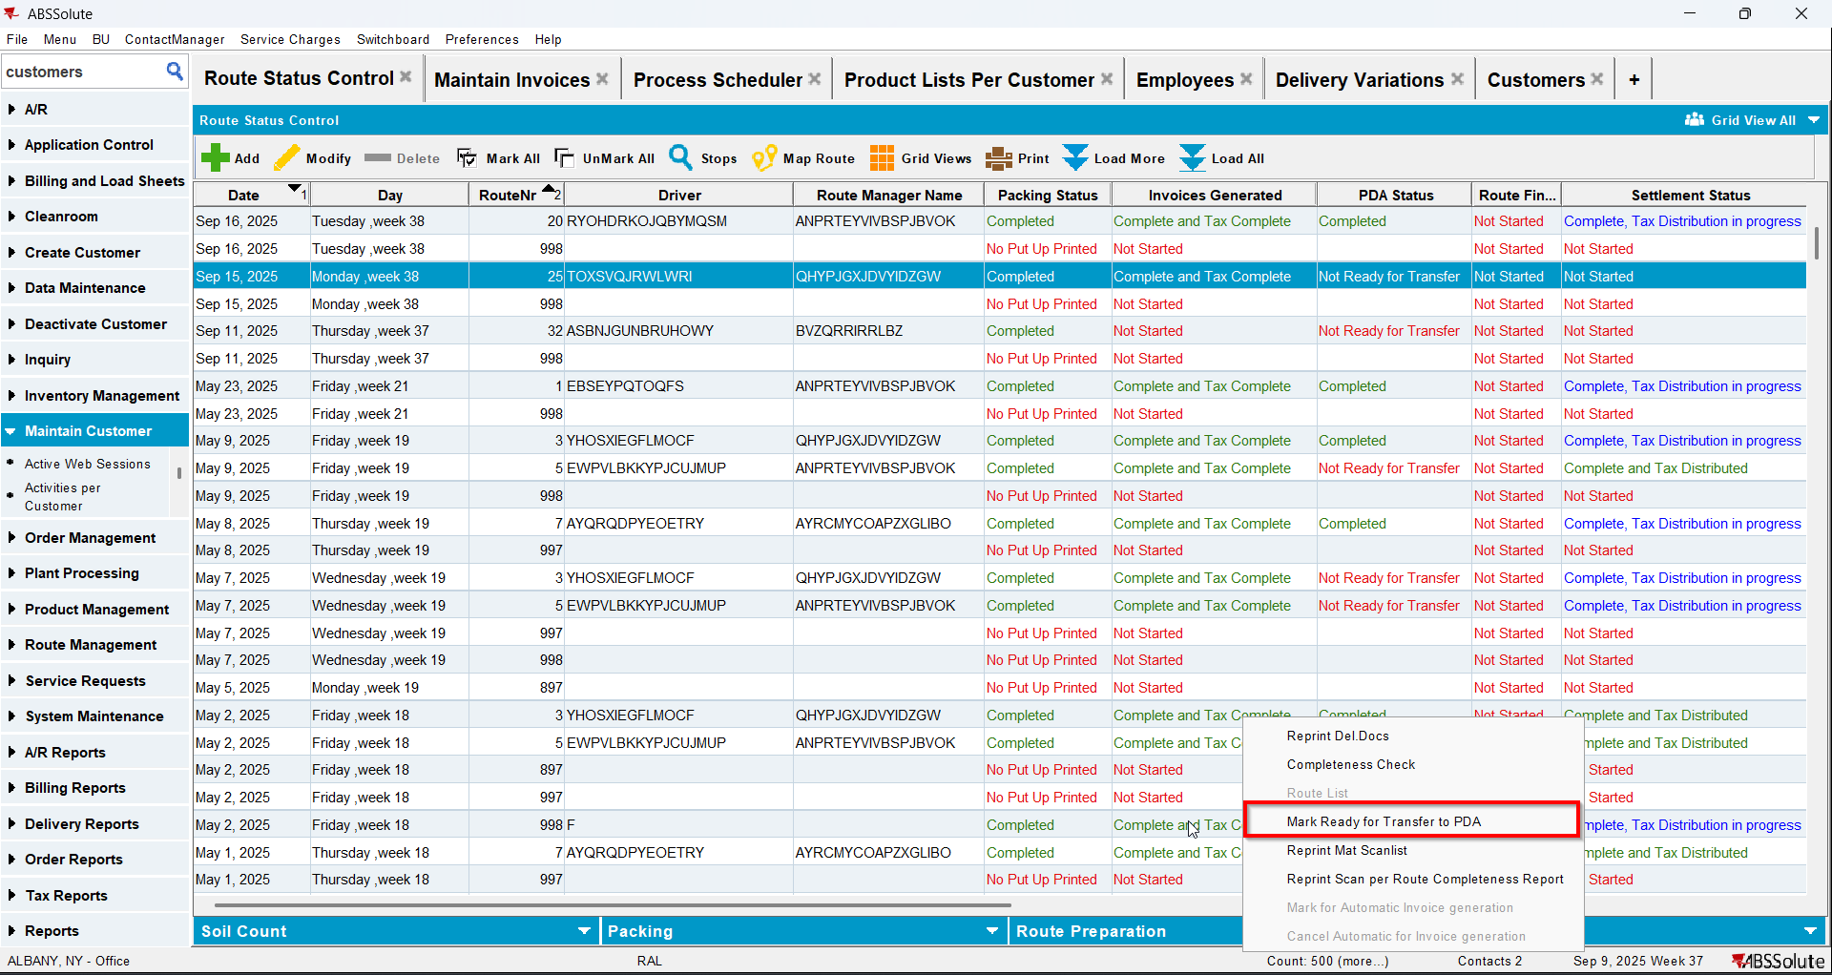
- On RA increase Soil Count for your non garment
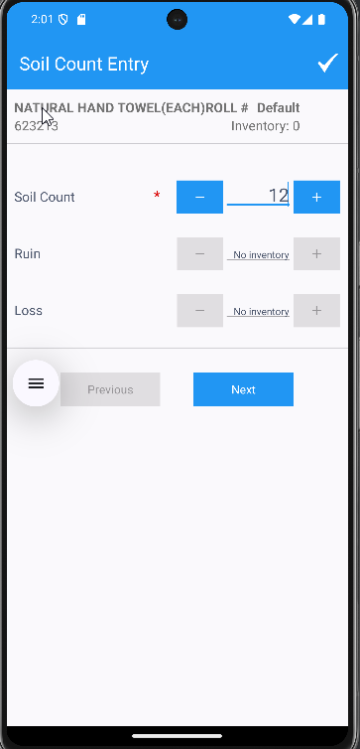
- Finish the route and upload it
- Go to Route Status Control dlg and mark the soil count completed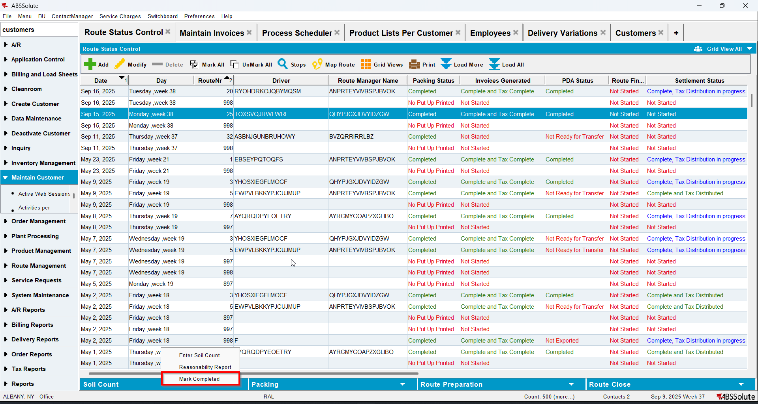
- Settle the route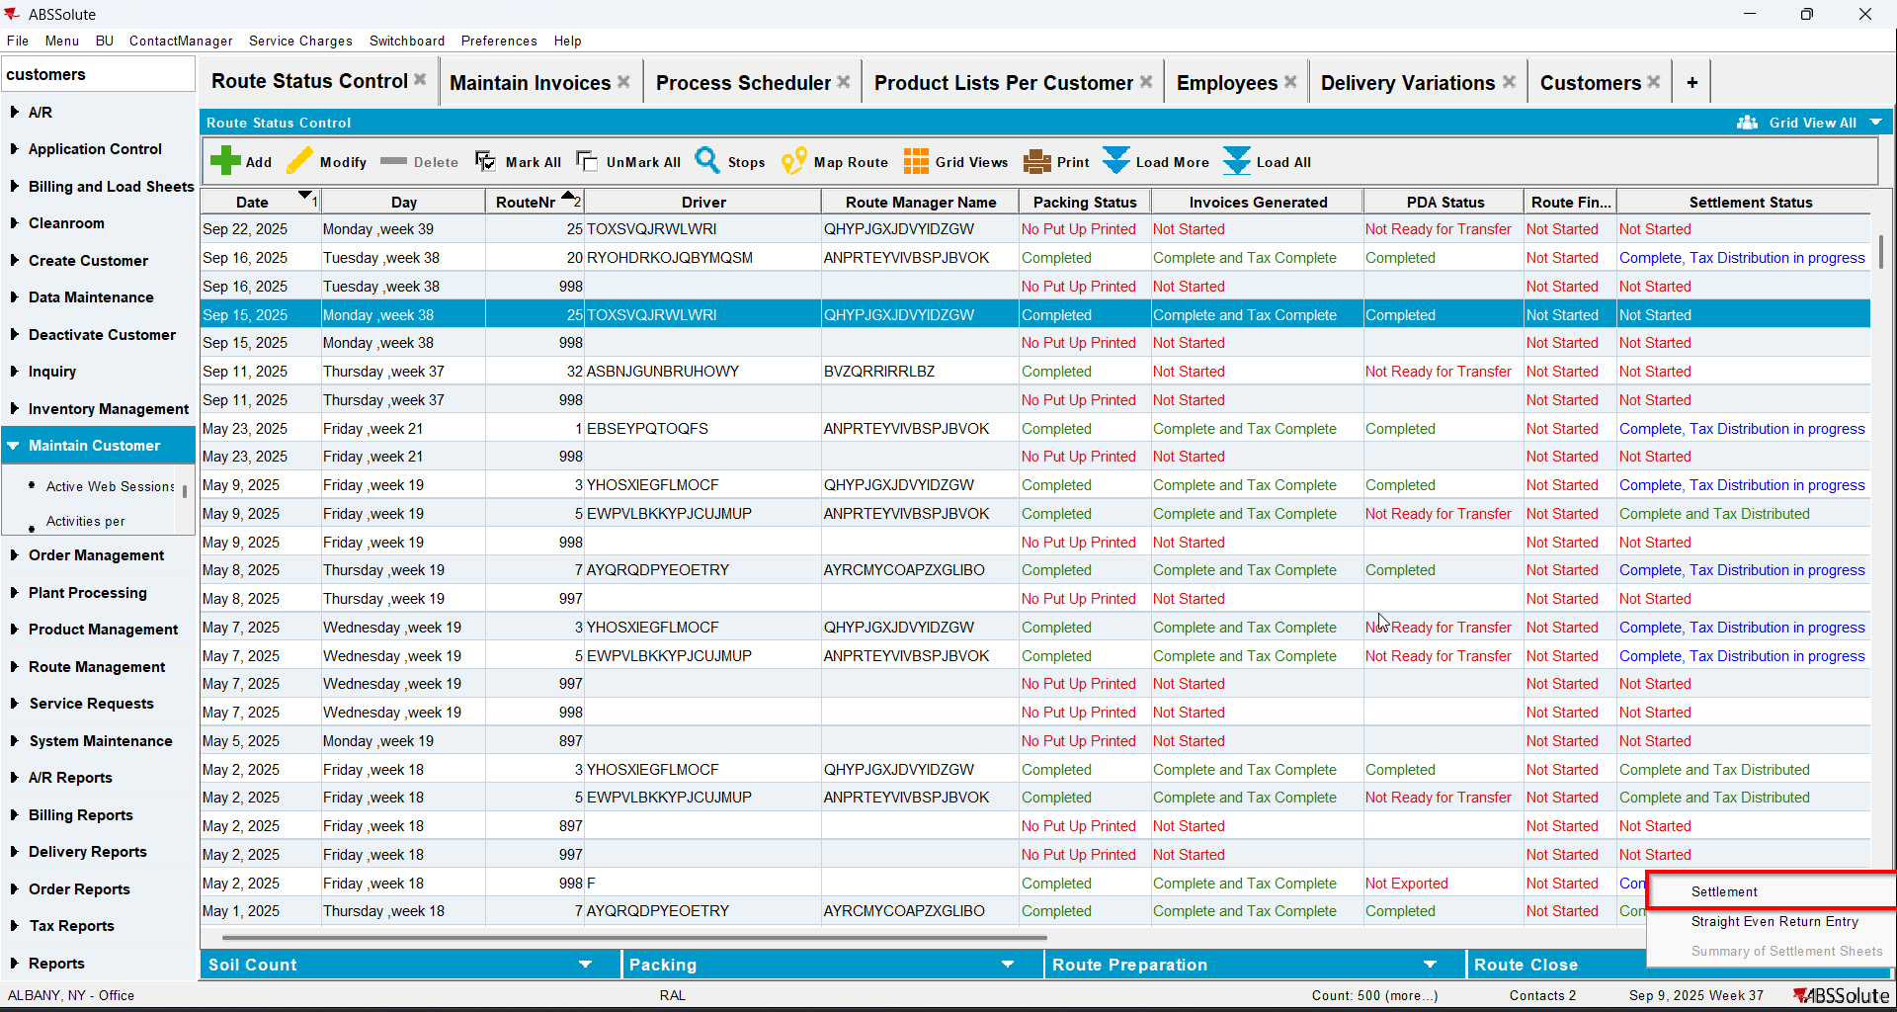
- Go to Delivery Variations dlg and check that now there is a DV for the non garment for which you increased soil count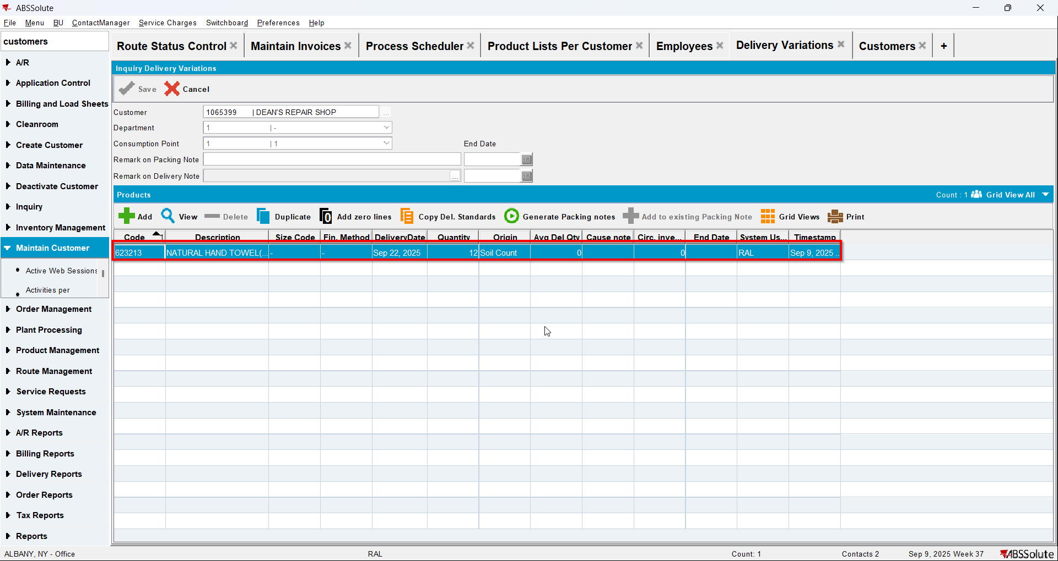
- Create next weeks route for your customer
- Generate packing notes and invoices for it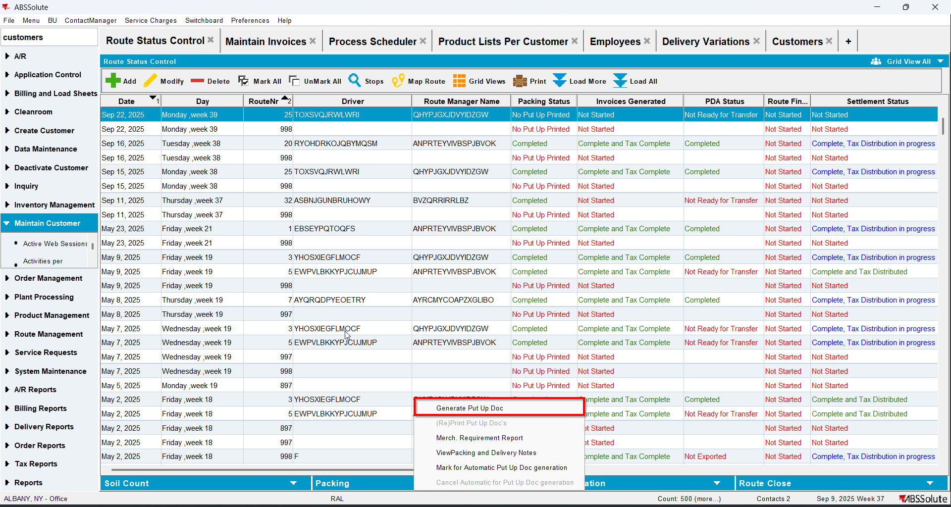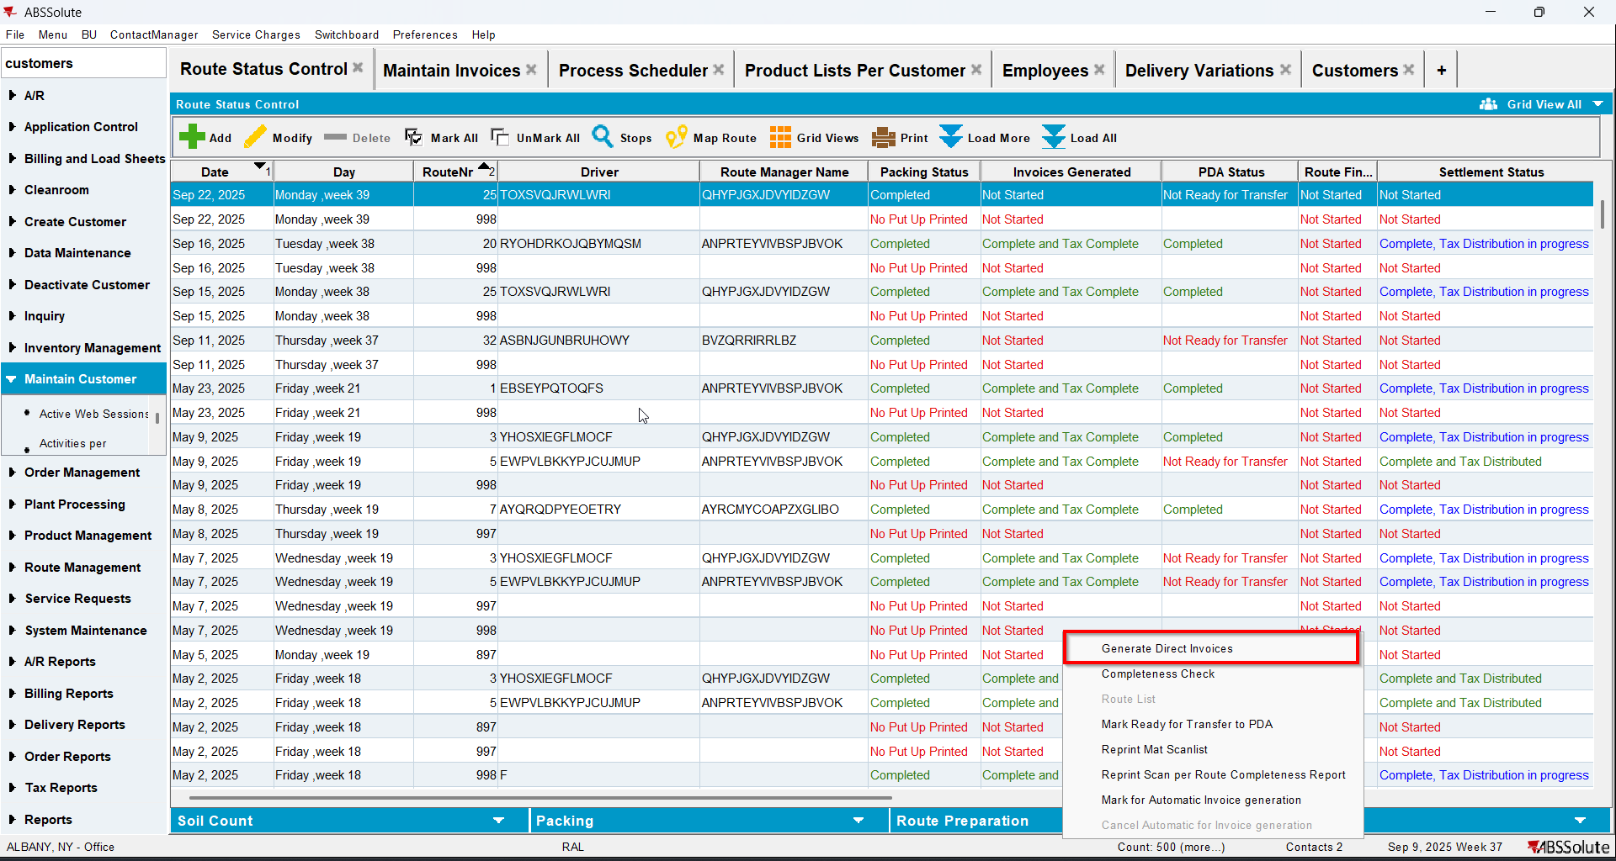
- Check on the invoice that the wash line for your non garment now has the price from the PLPC for wash and qty coming from the DV/Packing note line and a corresponding amount of price * qty