ABSN-7160 D_UBS_2545 Show Repl_StillToBeCharged in Wearer Inventory grids
Environment | Prerequisites
Version:9.07.00  DBServerName= abs-srv16.internal.abslbs.com  DBSID=CUST24  DBUser=UNFDEV  Environment=Test | - Module:  - System setting

Contents
Retest after fix 1
Expected behavior: 1
Test Steps: 1

Retest after fix
9.07.00 hash: 4e0b51c
Bu: 025 PORTLAND

Expected behavior:
Replacement Billing Status column present
NOTE: We show this field as an optional field in all wearer inventory grids described as
If NULL, then blank
If Y then “Charging <WI.old_maxinventory> items, replacement in progress”
If N then “Not charging, replacement complete”

select wi.wearerinventory_id, w.wearernumber, sd.code, wi.repl_stilltobecharged, wi.* from wearerinventory wi
join weareremployment we on we.weareremployment_id = wi.weareremployment_id
join wearer w on w.wearer_id = we.wearer_id
join customer c on c.customer_id = w.customer_id
join product p on p.product_id = wi.product_id
join sizedefinition sd on sd.sizedefinition_id = wi.sizedefinition_id
where p.code = '100202'
and c.customernumber = '1155863'
and w.wearernumber = '1'
and sd.code = '40030'

Test Steps:
- RSC dlg: Open 'Route Status Control' DLG and check the customers for wearers and wearer inventories.
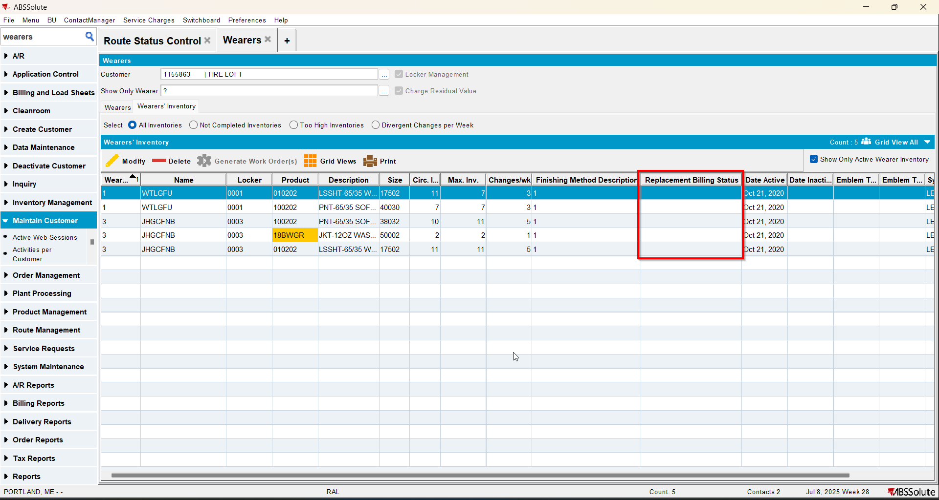
The column Replacement Billing Status is present

- Make a select to see the wearerinventory for wearer 1.
select wi.wearerinventory_id, w.wearernumber, sd.code, wi.repl_stilltobecharged, wi.* from wearerinventory wi
join weareremployment we on we.weareremployment_id = wi.weareremployment_id
join wearer w on w.wearer_id = we.wearer_id
join customer c on c.customer_id = w.customer_id
join product p on p.product_id = wi.product_id
join sizedefinition sd on sd.sizedefinition_id = wi.sizedefinition_id
where p.code = '100202'
and c.customernumber = '1155863'
and w.wearernumber = '1'
and sd.code = '40030'
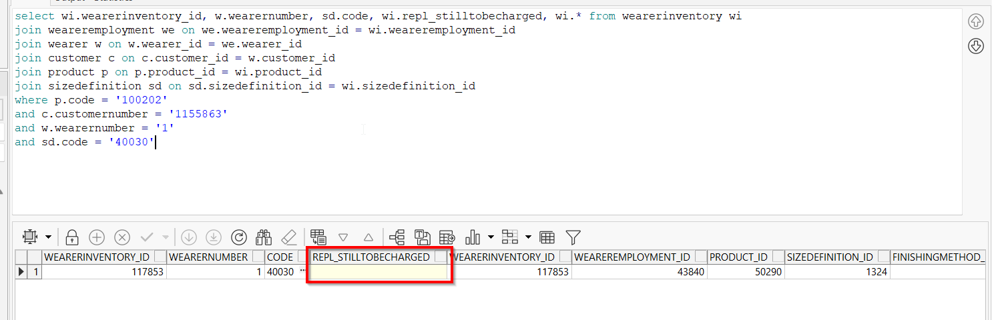

- Update the wearerinventory repl_stilltobecharged = 'Y' and wi.old_maxinventory with a random number.
update wearerinventory wi set wi.repl_stilltobecharged = 'Y', wi.old_maxinventory = '10'
where wi.wearerinventory_id =
(select wi.wearerinventory_id from wearerinventory wi
join weareremployment we on we.weareremployment_id = wi.weareremployment_id
join wearer w on w.wearer_id = we.wearer_id
join customer c on c.customer_id = w.customer_id
join product p on p.product_id = wi.product_id
join sizedefinition sd on sd.sizedefinition_id = wi.sizedefinition_id
where p.code = '100202'
and c.customernumber = '1155863'
and w.wearernumber = '1'
and sd.code = '40030');

- Wearers dlg: Re-check the column in the Wearers’ Inventory
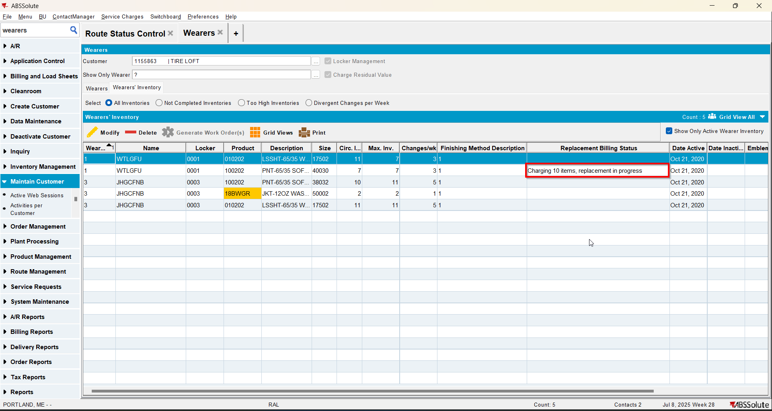
- Wearers dlg: Check the wearer 1 for column Replacement Billing Status
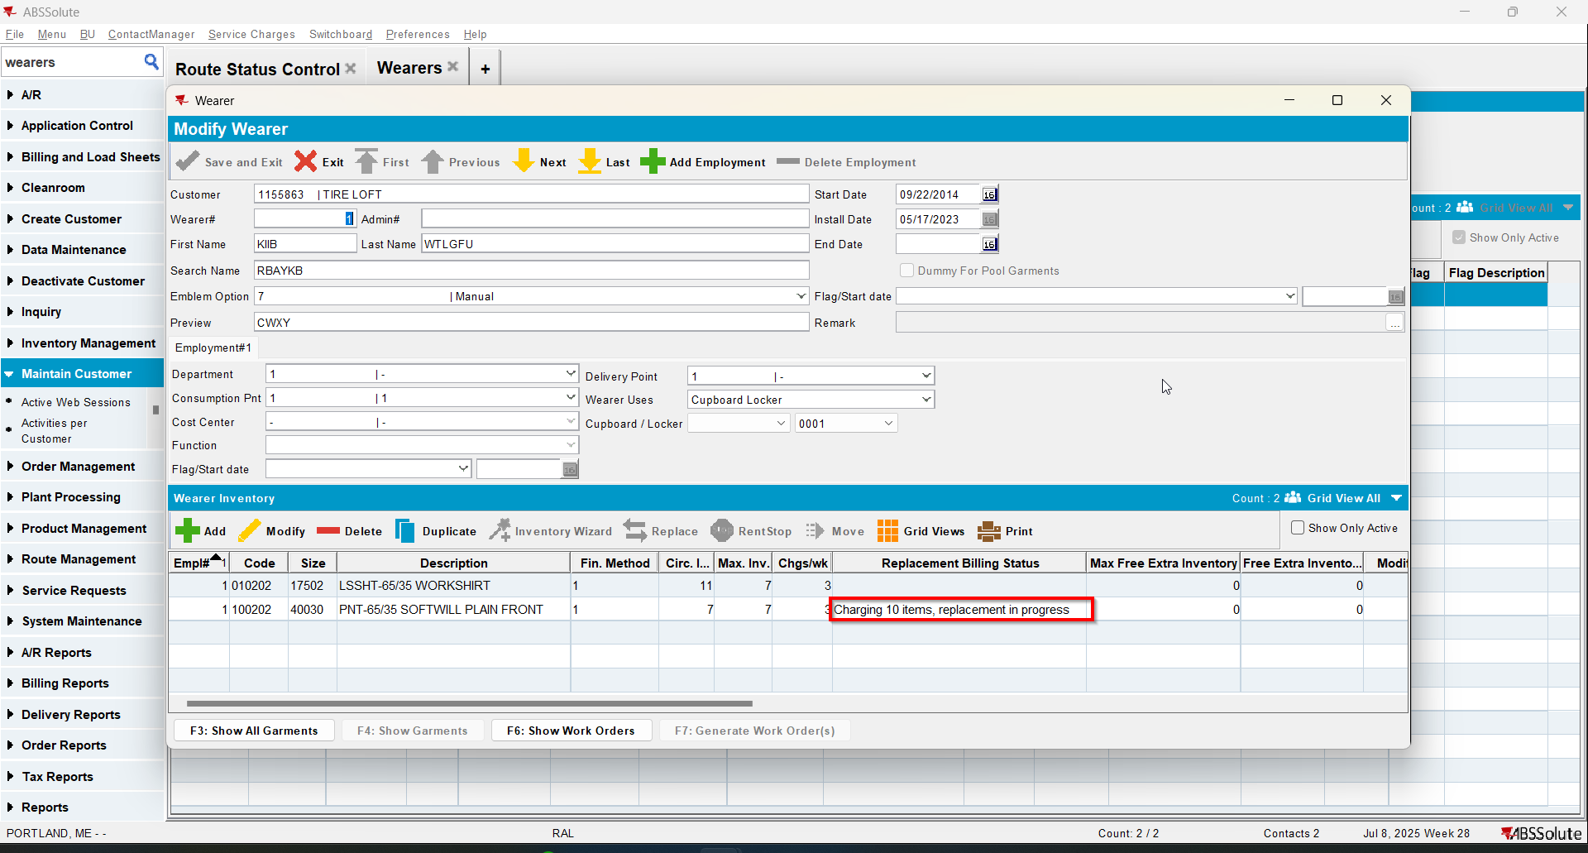
- Wearers dlg: Move the columns and navigate with next and previous through the wearers. Return to the initial wearer. The Replacement Billing Status column is still present.
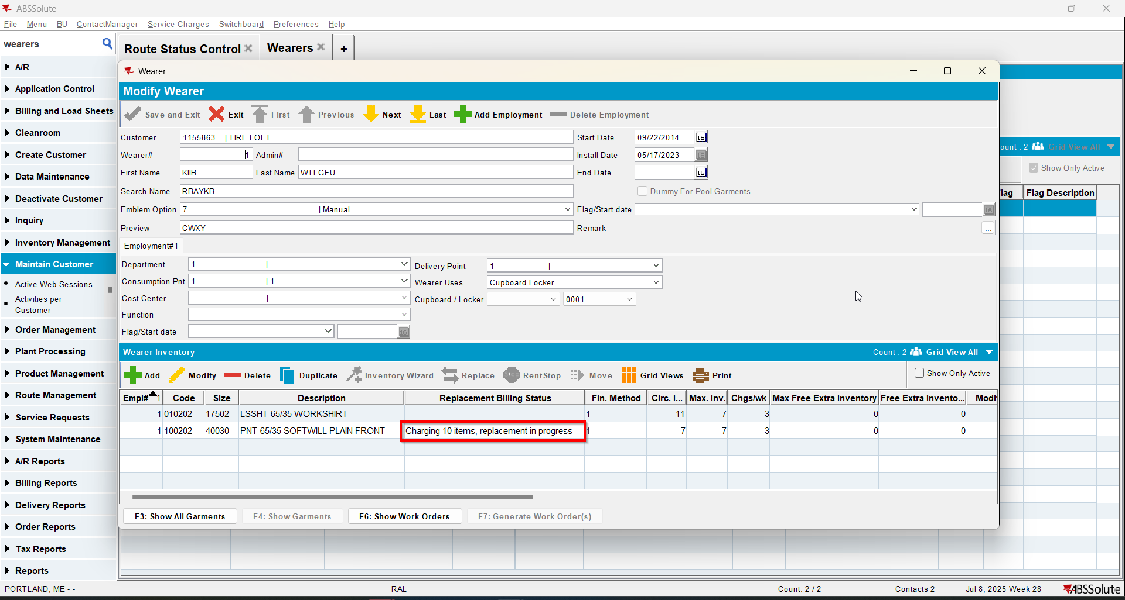
- Update the wearerinventory repl_stilltobecharged = 'N' and wi.old_maxinventory with a random number.
update wearerinventory wi set wi.repl_stilltobecharged = 'N', wi.old_maxinventory = '10'
where wi.wearerinventory_id =
(select wi.wearerinventory_id from wearerinventory wi
join weareremployment we on we.weareremployment_id = wi.weareremployment_id
join wearer w on w.wearer_id = we.wearer_id
join customer c on c.customer_id = w.customer_id
join product p on p.product_id = wi.product_id
join sizedefinition sd on sd.sizedefinition_id = wi.sizedefinition_id
where p.code = '100202'
and c.customernumber = '1155863'
and w.wearernumber = '1'
and sd.code = '40030');
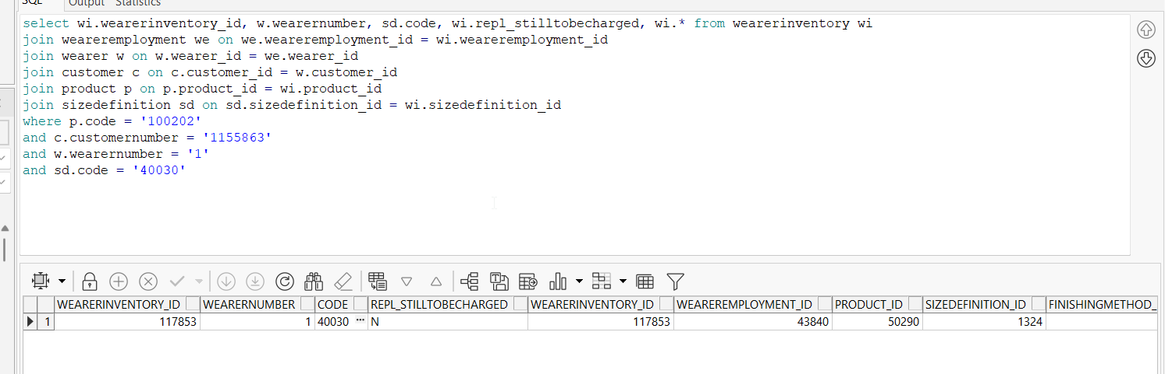

- Wearers dlg: Re-check the column in the Wearers’ Inventory
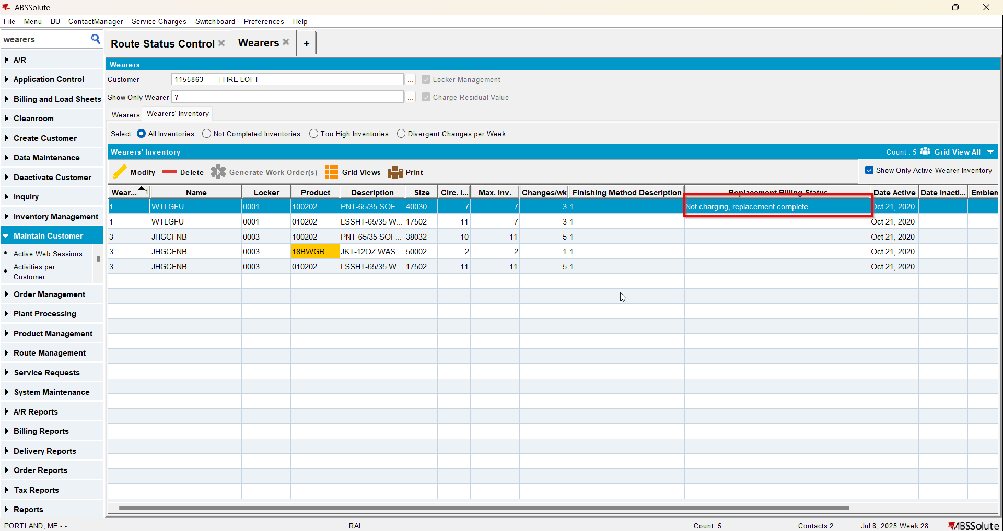
- Wearers dlg: Check the wearer 1 for column Replacement Billing Status
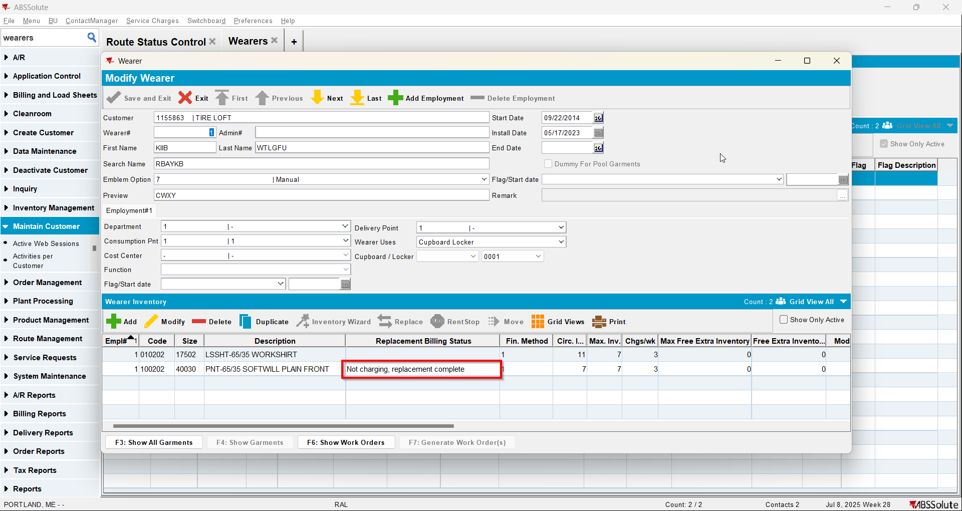
- Wearers dlg: Move the columns and navigate with next and previous through the wearers. Return to the initial wearer. The Replacement Billing Status column is still present.

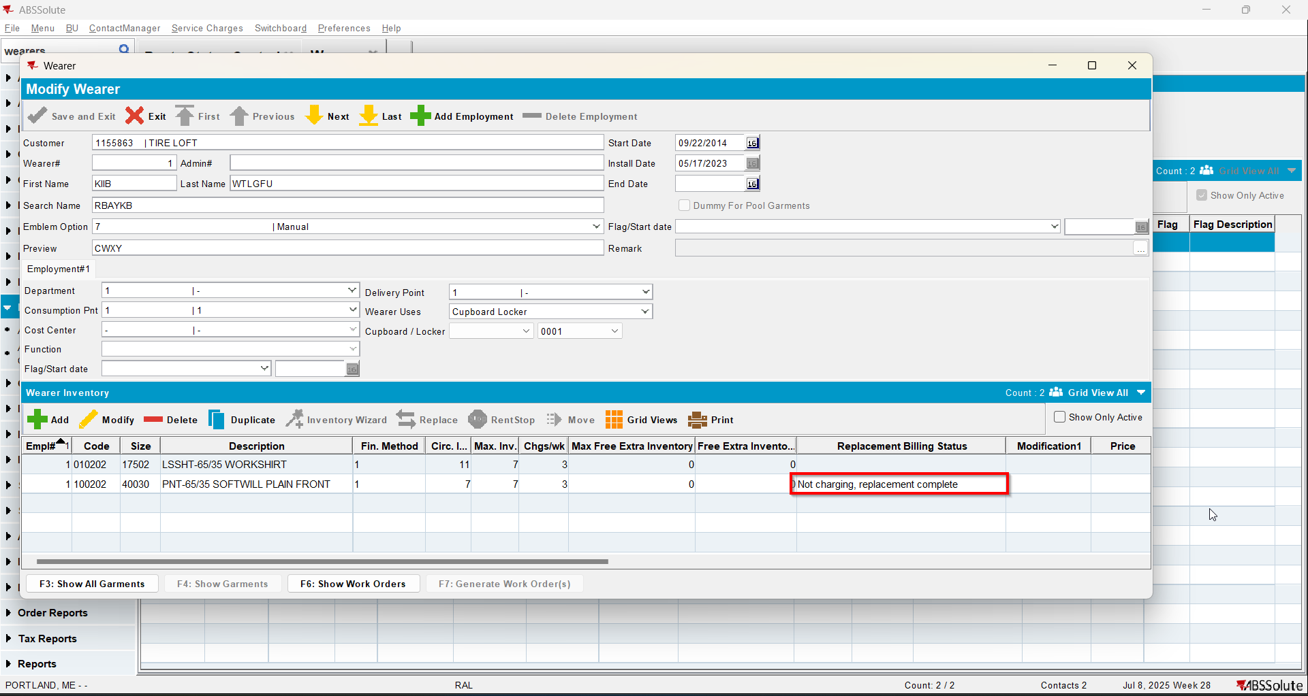
Tested OK

