ABSN-6979 - D_UBS_2702 Web Client X - Assign invoice to route should be blocked when Route Finalization is in progress
Environment | Prerequisites
Version: 9.07.00.UNF20  DBServerName= abs-srv20.internal.abslbs.com  DBSID=CUST24  DBUser=UNFDEV  DBPassword= UNFDEV  Environment=Test | - Module:  - System setting

Contents
Retest after fix 1
Test Case 1 - Endtimestamp IS NULL in ROUTECONTROLFINALIZATION for the route you plan on moving the stop to 1
Test Case 2 - RCEI.FinalizationStatus = 0 (NOT STARTED) with no entry in ROUTECONTROLFINALIZATION table 6
Test Case 3 - RCEI.FinalizationStatus = 1 (PENDING) with entry in ROUTECONTROLFINALIZATION table 10
Test Case 4 - RCEI.FinalizationStatus = 2 (Completed) with entry in ROUTECONTROLFINALIZATION table and “ENDFINALIZATIONTIMESTAMP” completed and rc.pocketpcstatus=0 17

Retest after fix

Test Case 1 - Endtimestamp IS NULL in ROUTECONTROLFINALIZATION for the route you plan on moving the stop to
Hash: 0c2910d8eef7
Expected: The route is not available in the drop down in Maintain Invoices: Assign to route or on Webx: Move Undeliverable stop
- RSC: Create a new route in the future (R1) > generate packing notes and generate invoices for a route
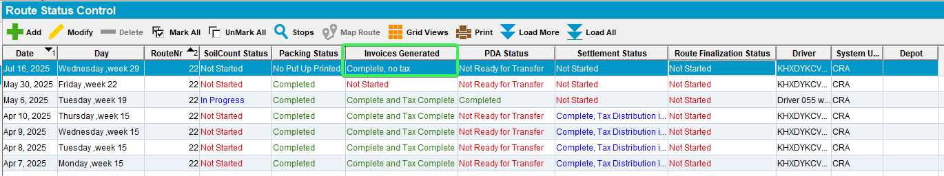

- Run the BCI taxes script and the process scheduler for Vertex tax import
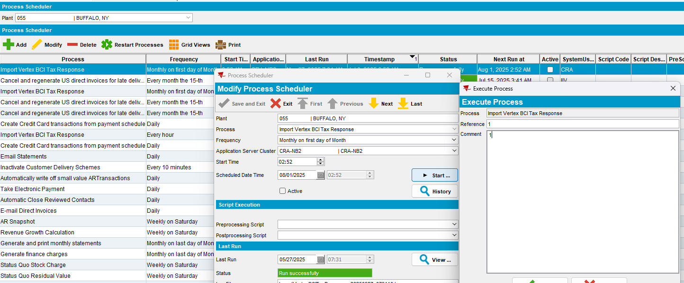

- Run the “Cancel and regenerate US direct invoices for late delivery notes”
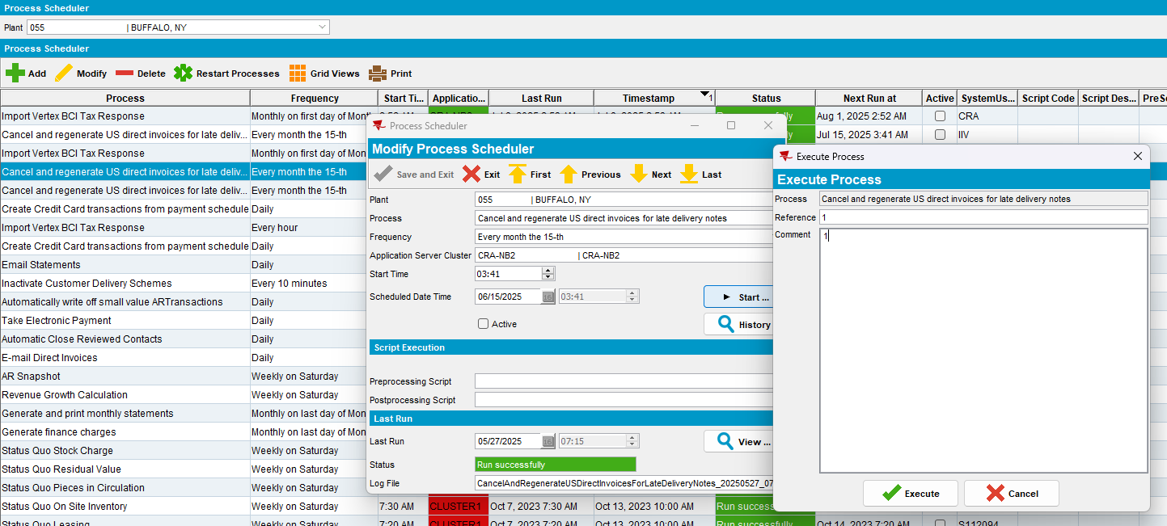
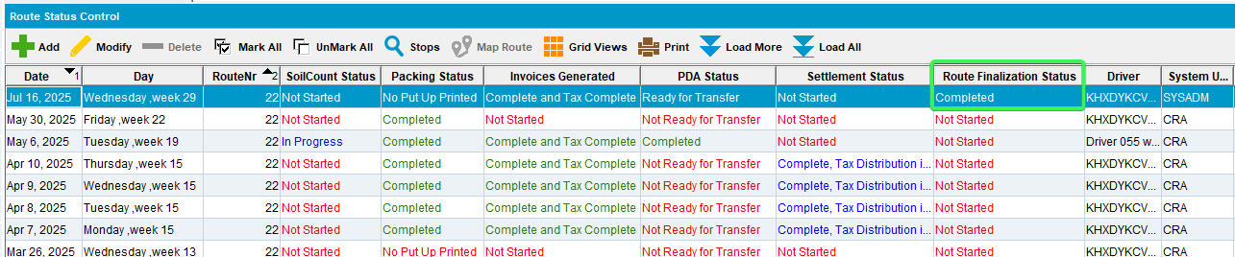
- Make “Endfinalizationtimestamp” field “null” from ROUTECONTROLFINALIZATION table
select * from ROUTECONTROLFINALIZATION RCF
where RCF.ROUTECONTROL_ID = (select rc.routecontrol_id
from routecontrol rc
join route r
on r.route_id = rc.route_id
join plant p
on p.plant_id = r.plant_id
where rc.drivingdate = to_date('16/07/2025', 'dd/mm/yyyy')
and r.routenumber = 22
and p.code = '055') for update
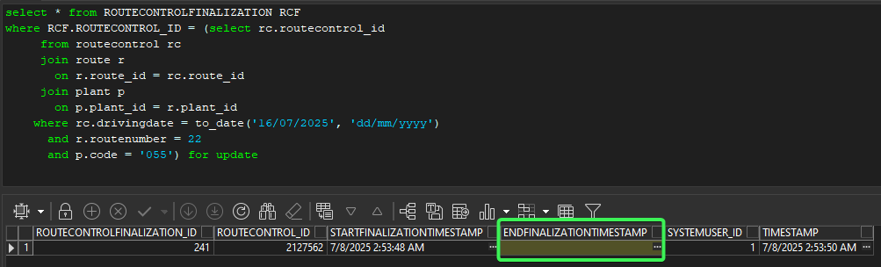
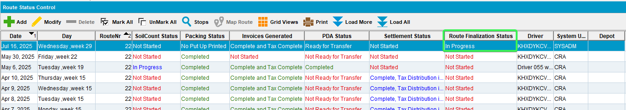
- RSC: Create a second Route (R2) which is on an earlier date than R1 > Generate put up docs and generate invoices for a route, script the taxes and run Process scheduler
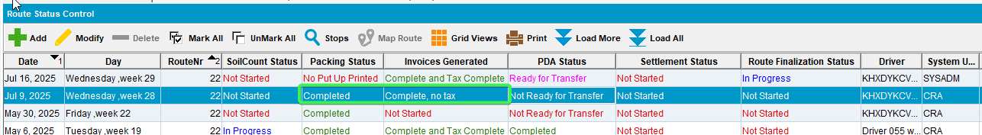

- Maintain Invoices DLG: All tab > Unsettled > Assigned to Route Status Control “Yes”
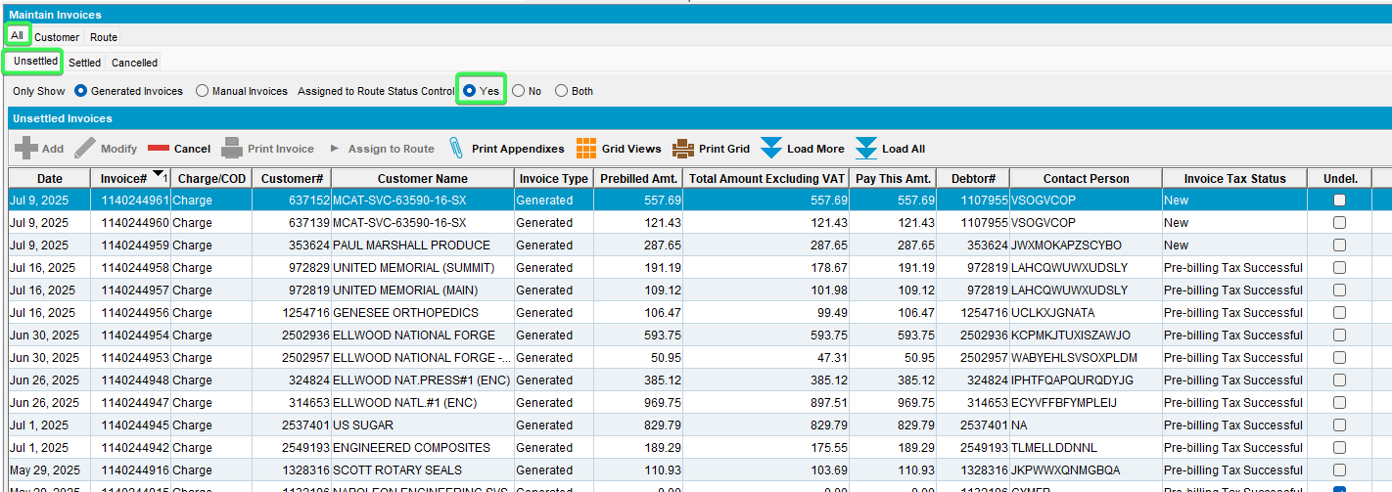
- Select a customer that was invoiced on R2 and press “Assign to Route”
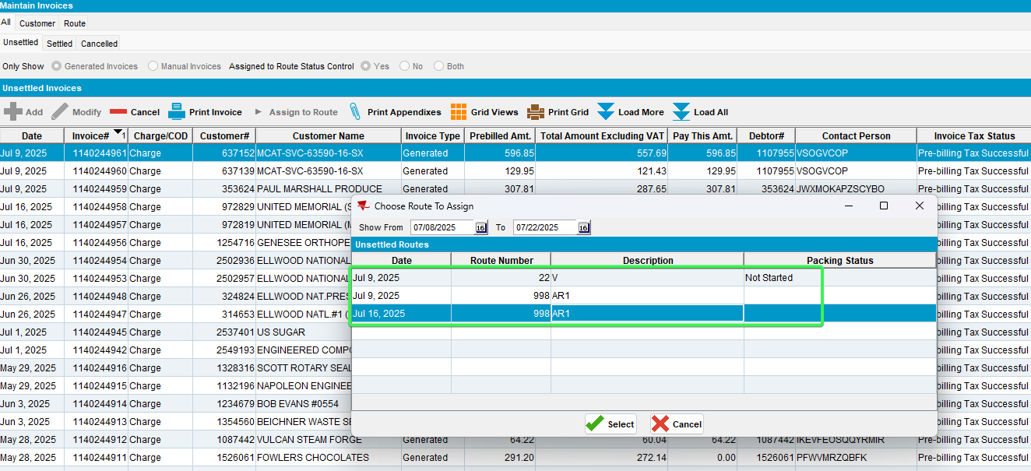
R1 16th July - is not present in the list
- RSC: Send R2 to RA
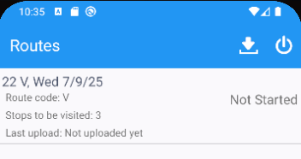
- Start the route and set 1 customer as Undeliverable
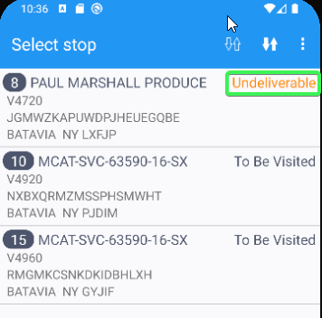
- Complete the route and upload the data
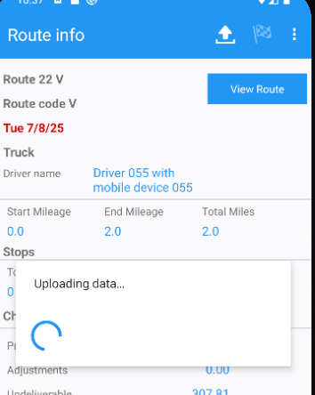
- WebX: Go to your route (R2) and complete Start my day
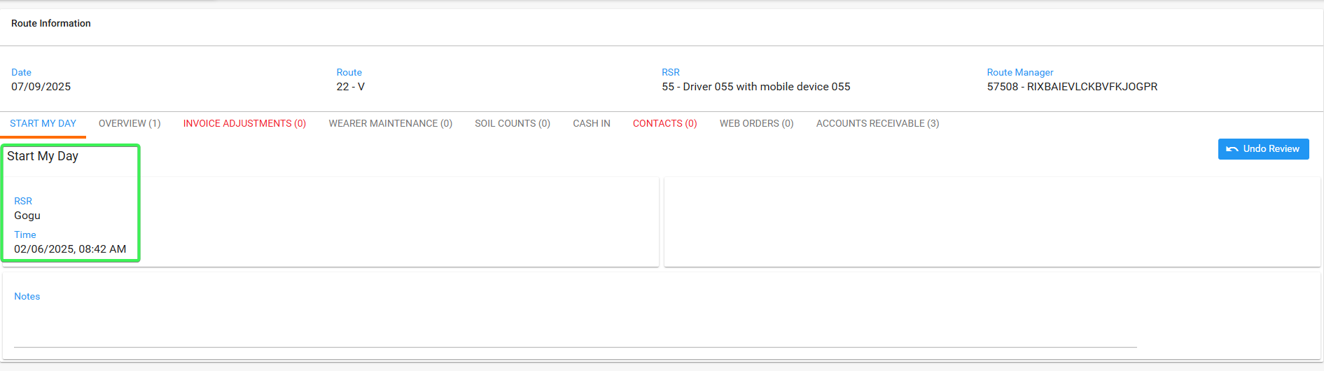
- Overview tab: Go to the Undeliverable stop and try moving it on R1
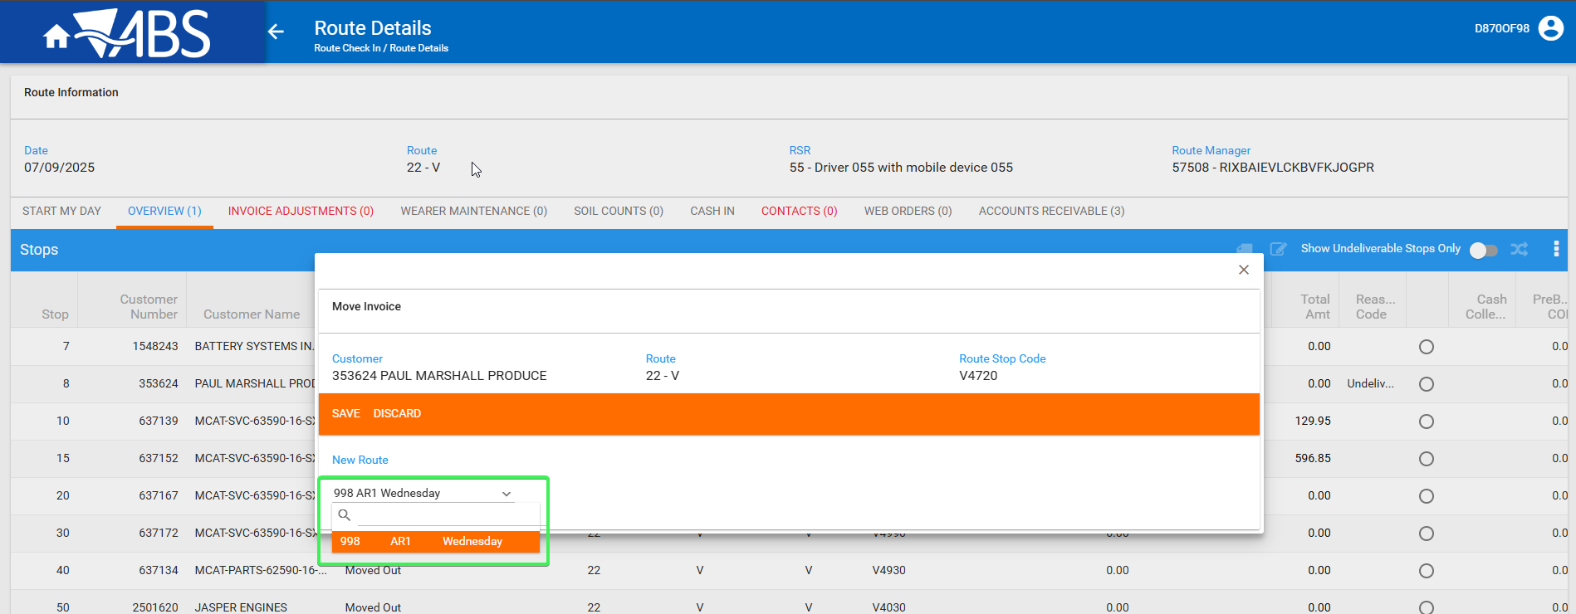
R1 – Route 22 on 16th June is not in the list
Tested OK

Test Case 2 - RCEI.FinalizationStatus = 0 (NOT STARTED) with no entry in ROUTECONTROLFINALIZATION table
Hash: 0c2910d8eef7
Expected: The route is present in the drop down in Maintain Invoices: Assign to route and is also present on Webx: Move Undeliverable stop
- RSC: Create a new route in the future (R1) > generate packing notes and generate invoices for a route
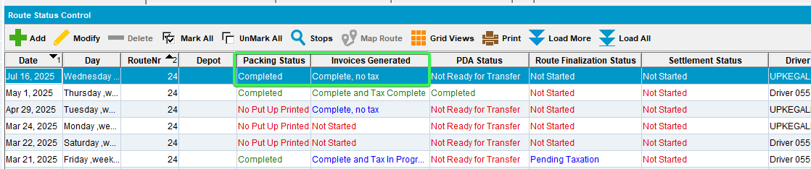
- Run the BCI taxes script and the process scheduler for Vertex tax import
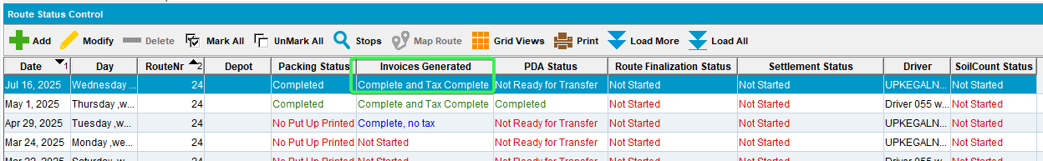

- Check that RCEI.FinalizationStatus = 0 (NOT STARTED)
select rcei.finalizationstatus From routecontrolextrainfo rcei
where rcei.routecontrol_id = (select rc.routecontrol_id
from routecontrol rc
join route r
on r.route_id = rc.route_id
join plant p
on p.plant_id = r.plant_id
where rc.drivingdate = to_date('16/07/2025', 'dd/mm/yyyy')
and r.routenumber = 24
and p.code = '055')
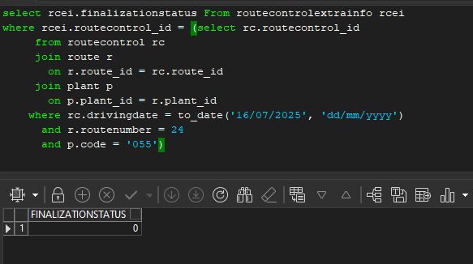
- Check that there are no entries in ROUTECONTROLFINALIZATION table for your route
select * from ROUTECONTROLFINALIZATION RCF
where RCF.ROUTECONTROL_ID = (select rc.routecontrol_id
from routecontrol rc
join route r
on r.route_id = rc.route_id
join plant p
on p.plant_id = r.plant_id
where rc.drivingdate = to_date('16/07/2025', 'dd/mm/yyyy')
and r.routenumber = 24
and p.code = '055')
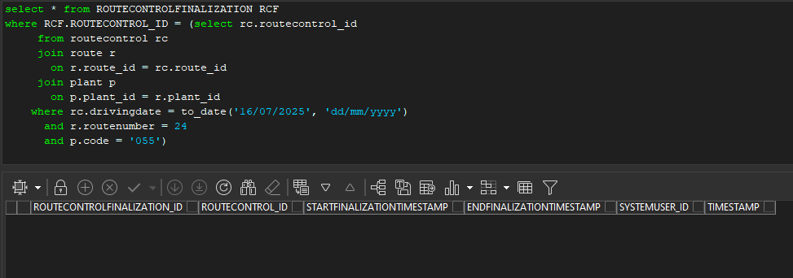
- RSC: Create a second Route (R2) which is on an earlier date than R1 > Generate put up docs and generate invoices for a route, script taxes
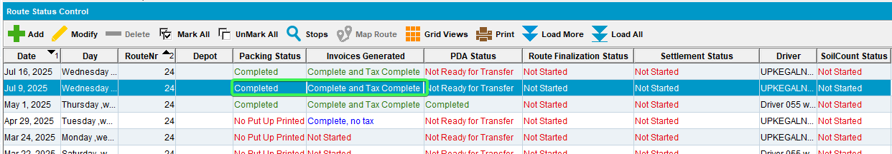
- Maintain Invoices DLG: All tab > Unsettled > Assigned to Route Status Control “Yes”
- Select a customer that was invoiced on R2 and press “Assign to Route” – Make sure the From – To dates cover R1
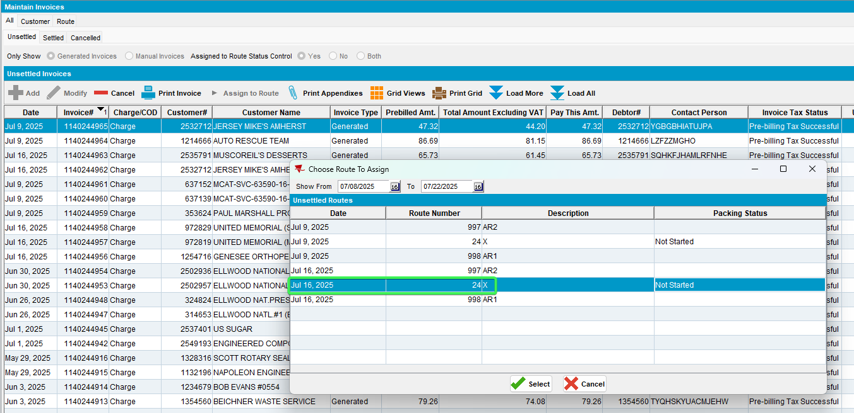
- RSC: Send R2 to RA
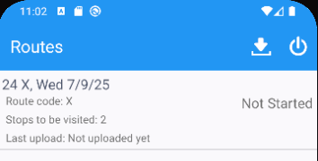
- Start the route and set 1 customer as Undeliverable
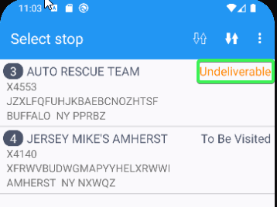
- Complete the route and upload the data
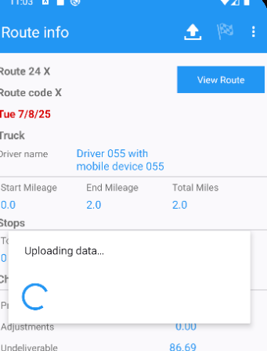
- WebX: Go to your route (R2) and complete Start my day
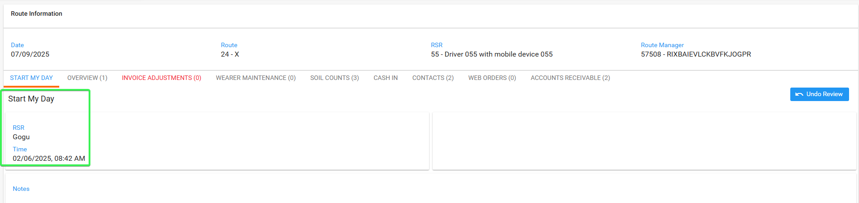
- Overview tab: Go to the Undeliverable stop and try moving it on R1
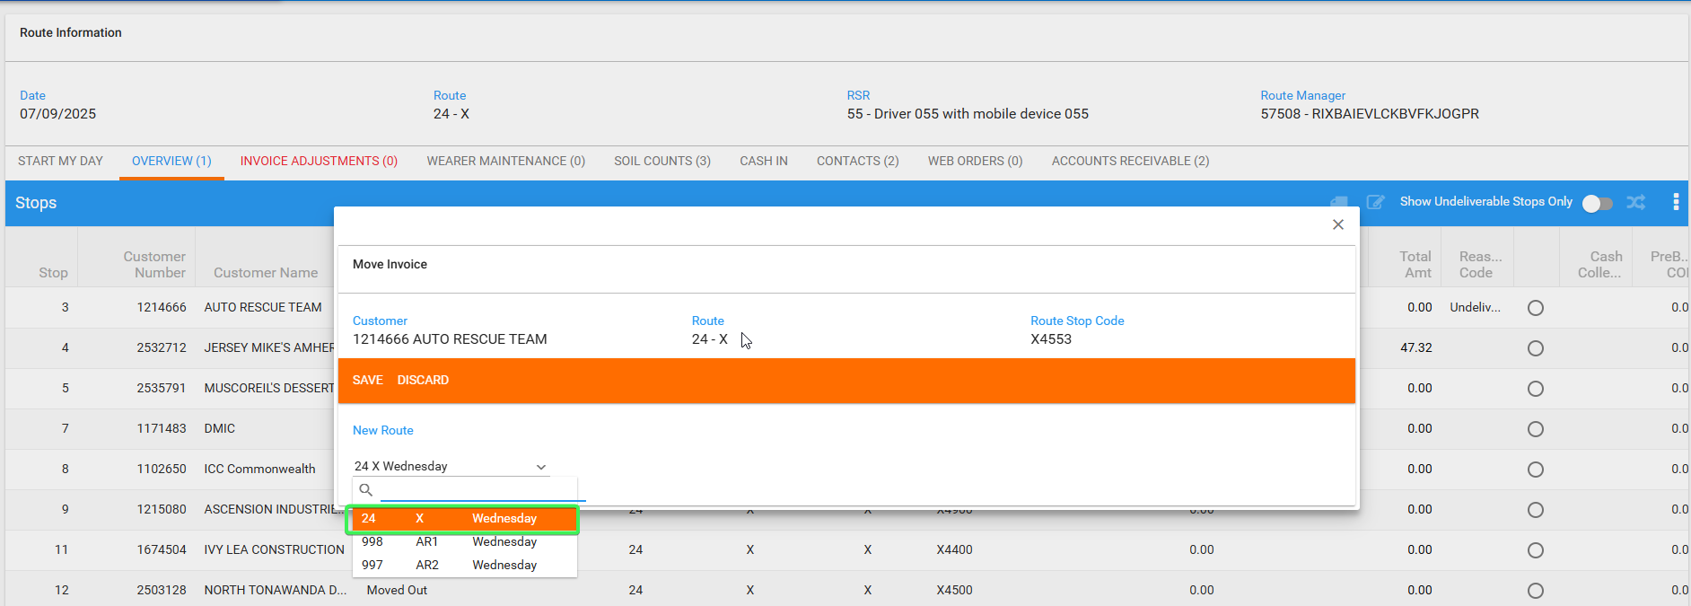
R1 is present in Dropdown
Tested OK

Test Case 3 - RCEI.FinalizationStatus = 1 (PENDING) with entry in ROUTECONTROLFINALIZATION table
Expected: The route is present in the drop down in Maintain Invoices: Assign to route and is also present on Webx: Move Undeliverable stop
Hash: 0c2910d8eef7
- RSC: Create a new route in the future Thursday, keep at least 2 customers. > generate packing notes and generate invoices for a route
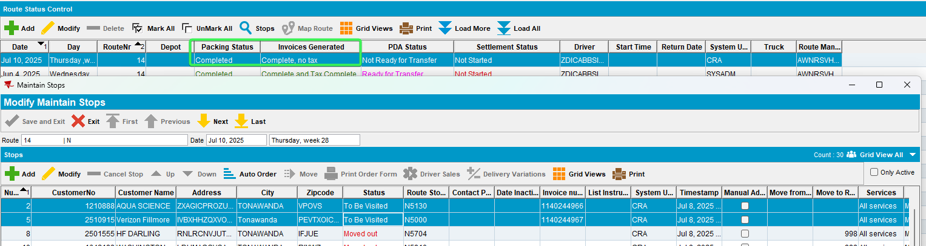
- Run the BCI taxes script and the process scheduler for Vertex tax import
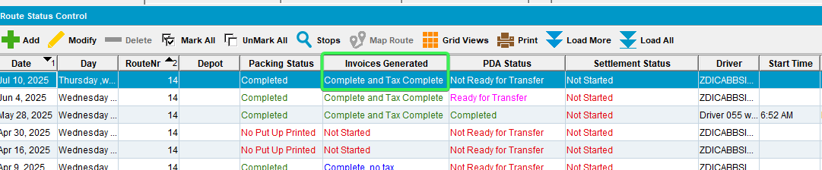
- Maintain Sales Note dlg: Add a sales note for one of the customers and assign it on Wednesday day.
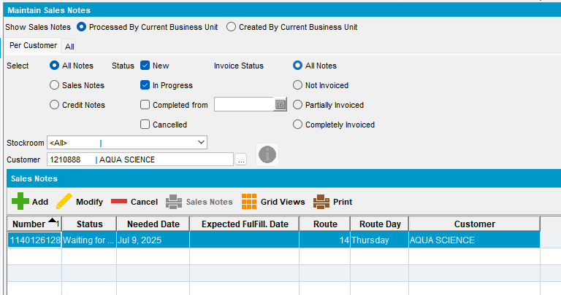
- Work Orders waiting for approval dlg: Approve the work order.
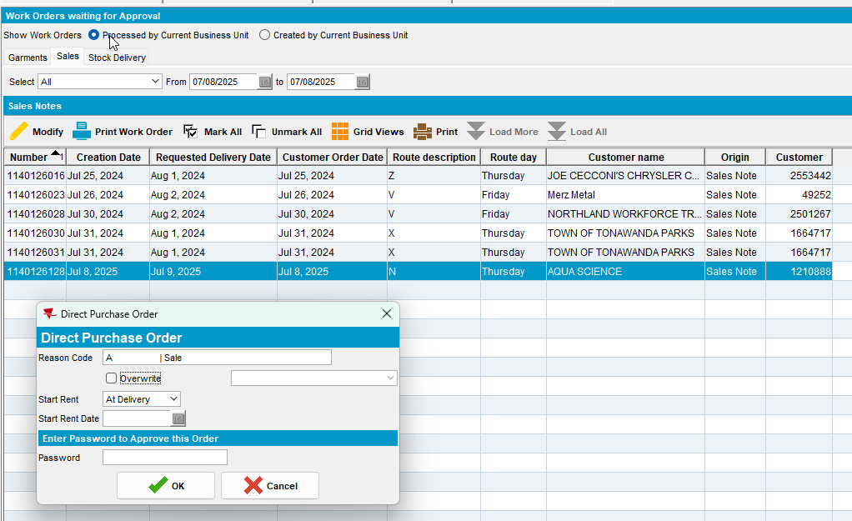
- Maintain Sales Note dlg: Issue the sales items.
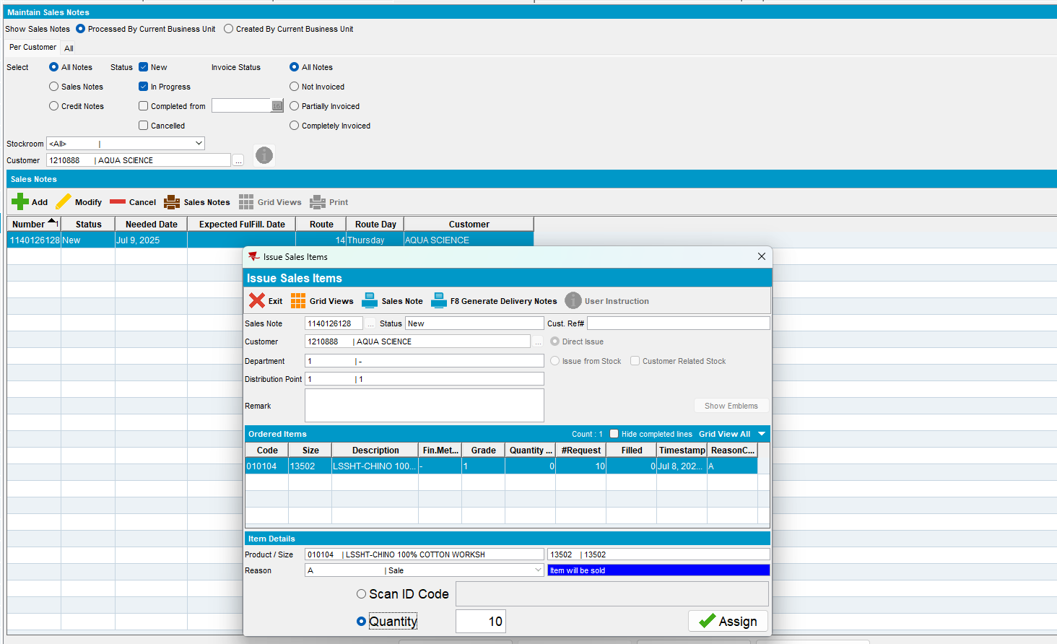
- Maintain Sales Note dlg: Generate the delivery note on Wednesday (the customer is visited on Thursday)
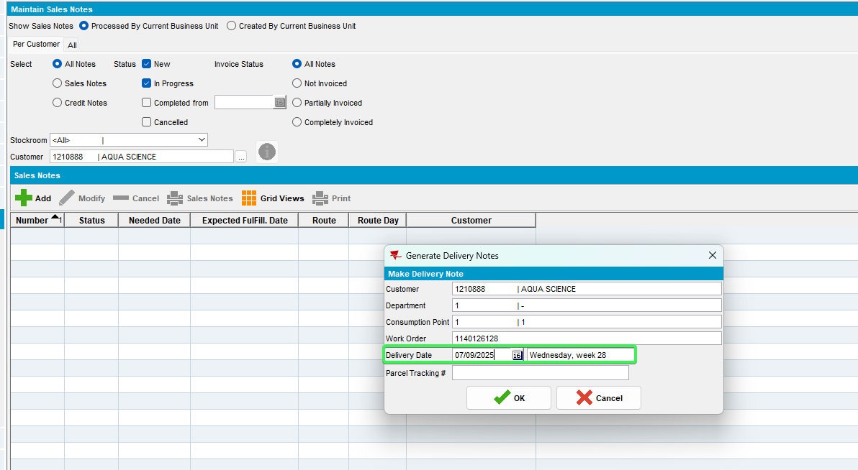
- Check that RCEI.FinalizationStatus = 0 (NOT STARTED)
select rcei.finalizationstatus From routecontrolextrainfo rcei
where rcei.routecontrol_id = (select rc.routecontrol_id
from routecontrol rc
join route r
on r.route_id = rc.route_id
join plant p
on p.plant_id = r.plant_id
where rc.drivingdate = to_date('10/07/2025', 'dd/mm/yyyy')
and r.routenumber = 14
and p.code = '055')
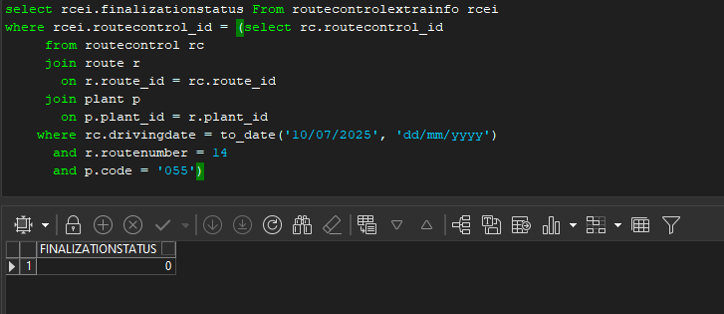
- Check that there are no entries in ROUTECONTROLFINALIZATION table for your route
select * from ROUTECONTROLFINALIZATION RCF
where RCF.ROUTECONTROL_ID = (select rc.routecontrol_id
from routecontrol rc
join route r
on r.route_id = rc.route_id
join plant p
on p.plant_id = r.plant_id
where rc.drivingdate = to_date('10/07/2025', 'dd/mm/yyyy')
and r.routenumber = 14
and p.code = '055')
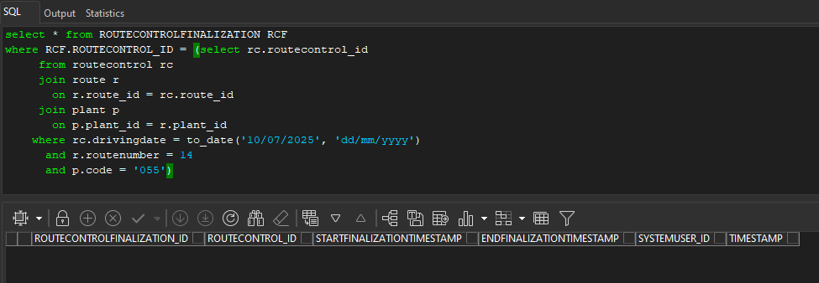
- Process Scheduler dlg: Run process Cancel and regenerate US direct invoices for late delivery notes and wait for it to finish.
- Check that RCEI.FinalizationStatus = 1 (PENDING)
select rcei.finalizationstatus From routecontrolextrainfo rcei
where rcei.routecontrol_id = (select rc.routecontrol_id
from routecontrol rc
join route r
on r.route_id = rc.route_id
join plant p
on p.plant_id = r.plant_id
where rc.drivingdate = to_date('29/05/2025', 'dd/mm/yyyy')
and r.routenumber = 4
and p.code = '012')
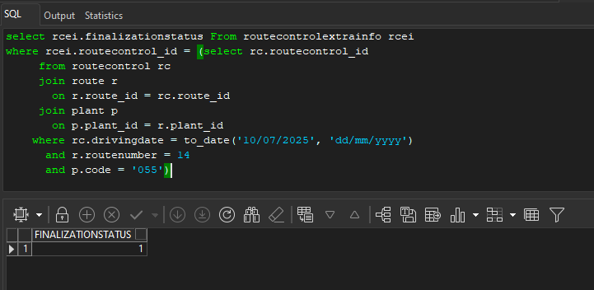
- Check that there are no entries in ROUTECONTROLFINALIZATION table for your route
select * from ROUTECONTROLFINALIZATION RCF
where RCF.ROUTECONTROL_ID = (select rc.routecontrol_id
from routecontrol rc
join route r
on r.route_id = rc.route_id
join plant p
on p.plant_id = r.plant_id
where rc.drivingdate = to_date('04/06/2025', 'dd/mm/yyyy')
and r.routenumber = 14
and p.code = '055')
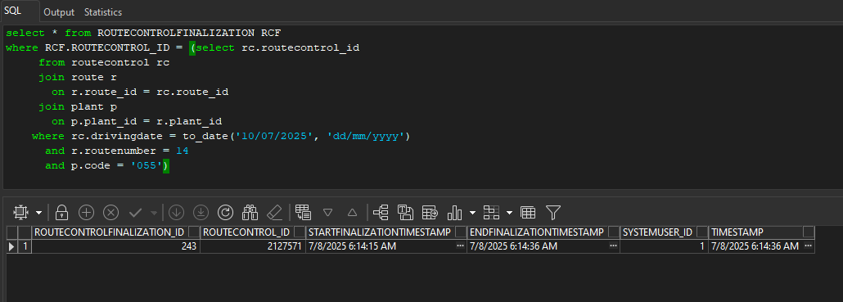
- RSC dlg: Check the statuses for the route.
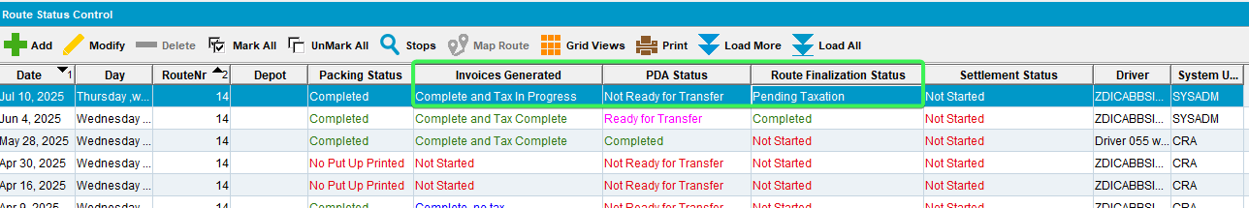
- RSC dlg: Add another route on Wednesday keep at least 2 customers, generate packing notes and generate invoices. Script the taxes.
- RSC: Send to PDA
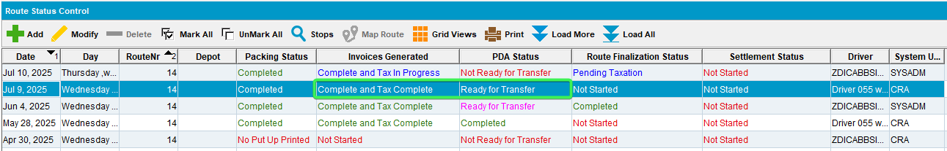
- RA: Download the route, arrive at customers, make one as undeliverable.
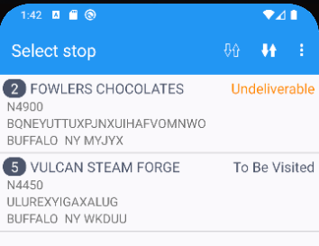
- RA: Enter the other customer, settle the route, depart, finish and upload.
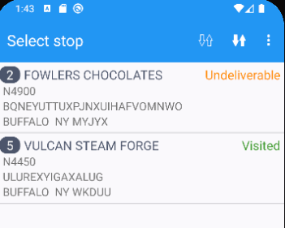
- WebX: Load the Wednesday route and complete the Start my day process.
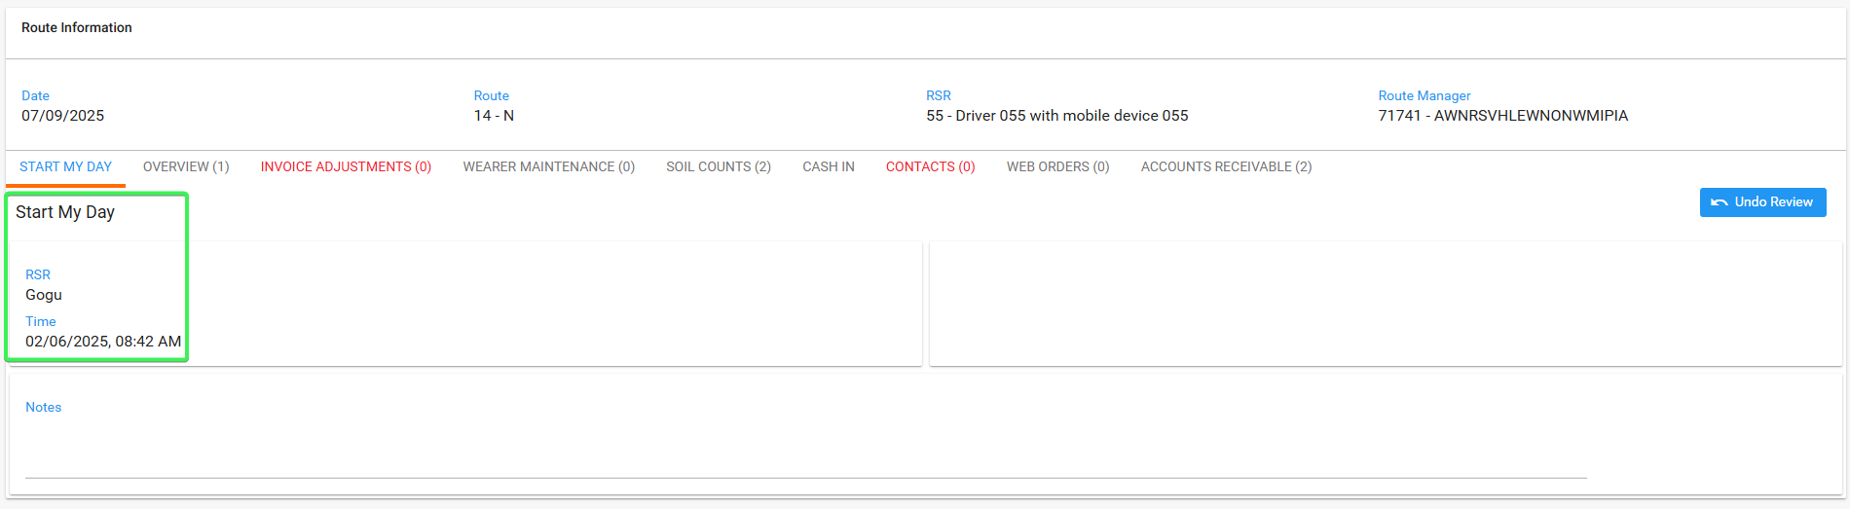
- WebX: For the undeliverable customer, try to assign it on the Thursday route(the one that had route finalization in pending)
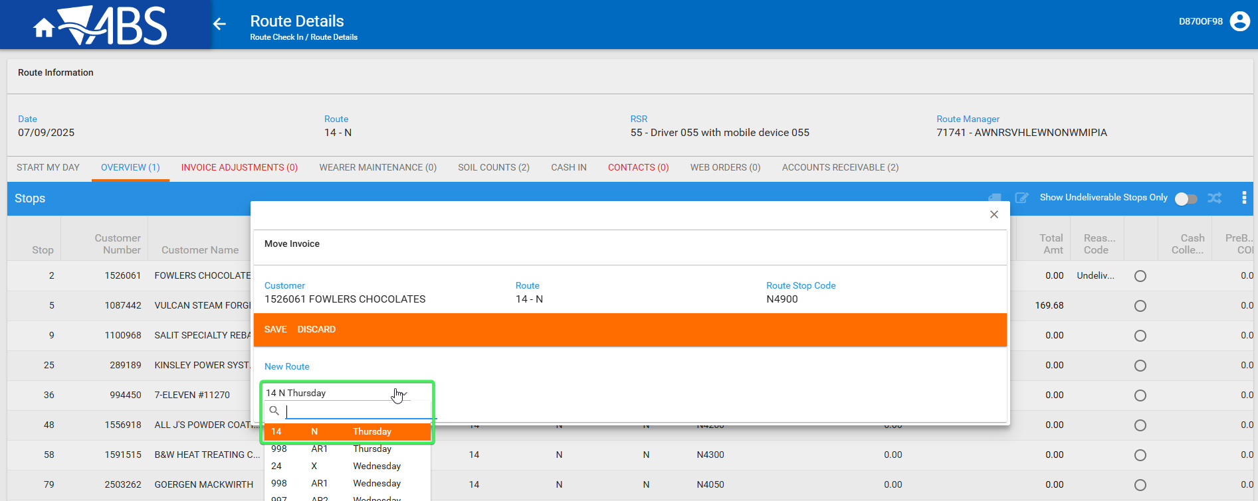
- WebX: save it.
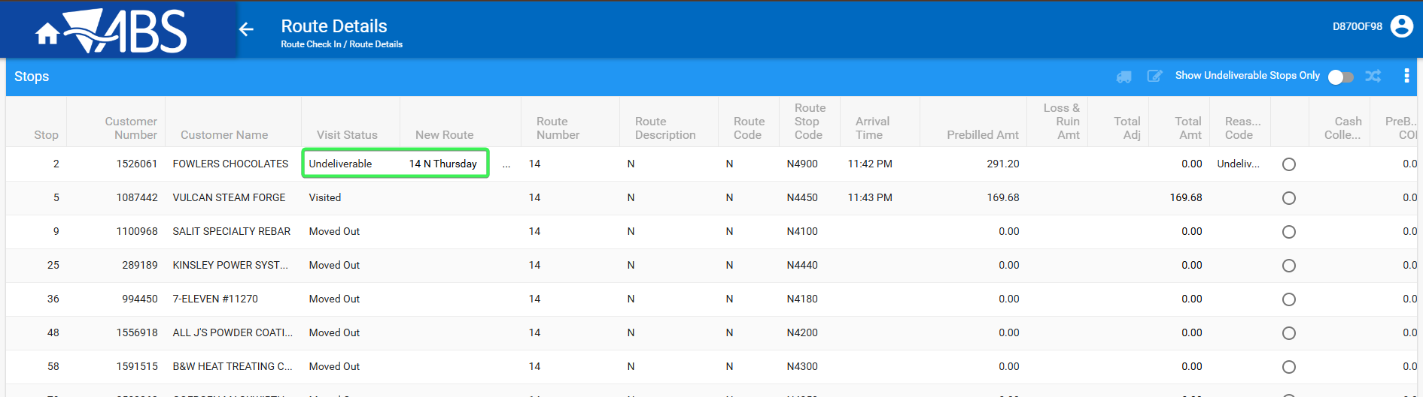
Tested OK

Test Case 4 - RCEI.FinalizationStatus = 2 (Completed) with entry in ROUTECONTROLFINALIZATION table and “ENDFINALIZATIONTIMESTAMP” completed and rc.pocketpcstatus=0
Hash: 0c2910d8eef7
Expected: The route is present in the drop down in Maintain Invoices: Assign to route and is also present on Webx: Move Undeliverable stop
- RSC: Create a new route in the future (R1) > generate packing notes and generate invoices for a route
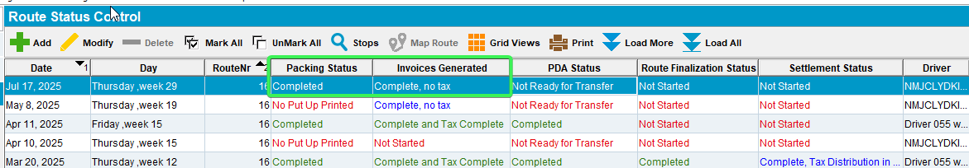
- Run the BCI taxes script and the process scheduler for Vertex tax import
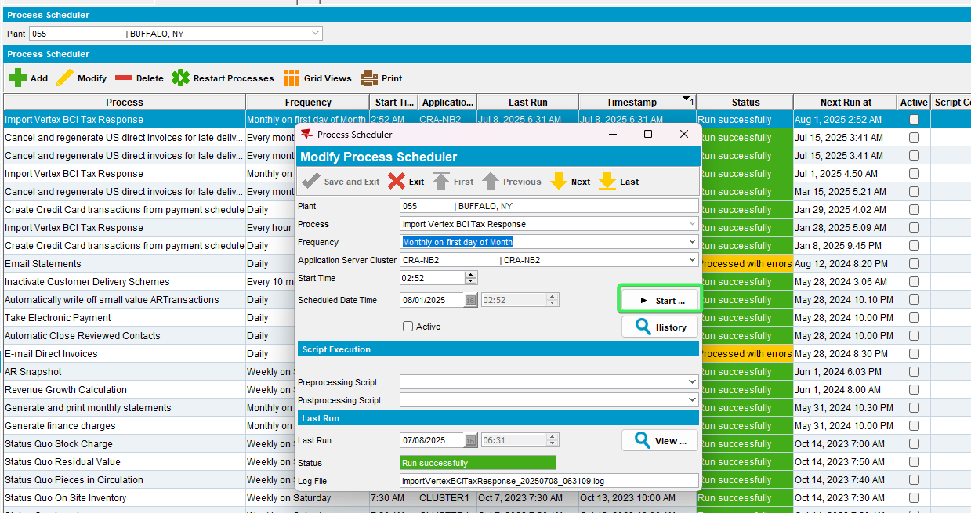
- Run the “Cancel and regenerate US direct invoices for late delivery notes”
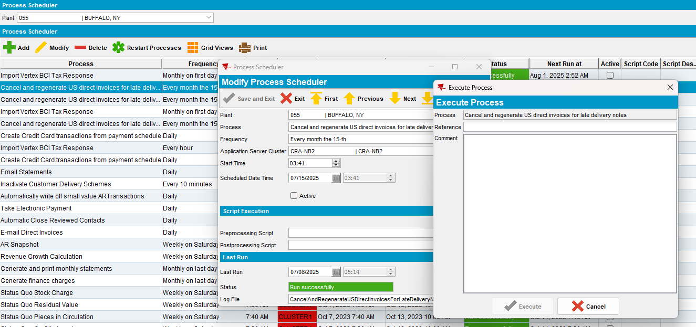
- Check that there is an entry in ROUTECONTROLFINALIZATION table for your route and “ENDFINALIZATIONTIMESTAMP” completed
select * from ROUTECONTROLFINALIZATION RCF
where RCF.ROUTECONTROL_ID = (select rc.routecontrol_id
from routecontrol rc
join route r
on r.route_id = rc.route_id
join plant p
on p.plant_id = r.plant_id
where rc.drivingdate = to_date('17/07/2025', 'dd/mm/yyyy')
and r.routenumber = 16
and p.code = '055')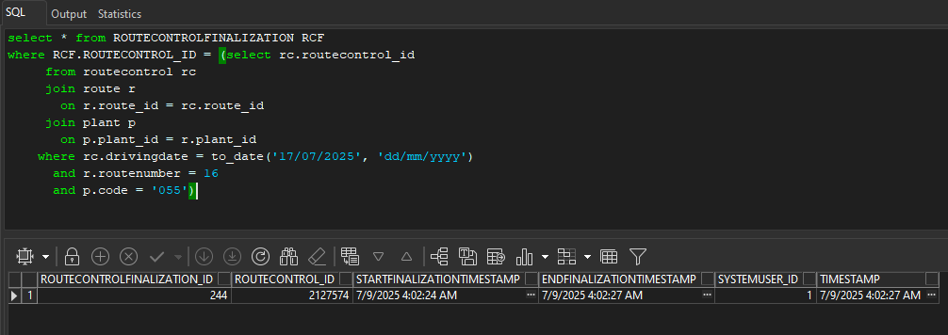
- Check that RCEI.FinalizationStatus = 2 (Completed)
select rcei.finalizationstatus From routecontrolextrainfo rcei
where rcei.routecontrol_id = (select rc.routecontrol_id
from routecontrol rc
join route r
on r.route_id = rc.route_id
join plant p
on p.plant_id = r.plant_id
where rc.drivingdate = to_date('17/07/2025', 'dd/mm/yyyy')
and r.routenumber = 16
and p.code = '055'))
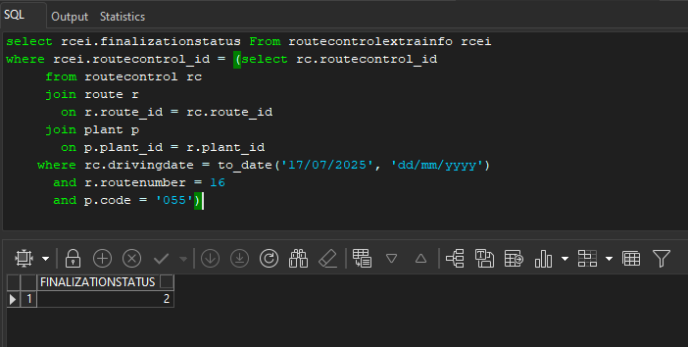
- RSC: Set PDA Status for R1 to “Not ready for transfer”
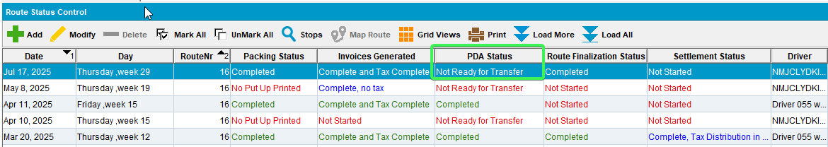
- RSC: Create a second Route (R2) which is on an earlier date than R1 > Generate put up docs and generate invoices for a route
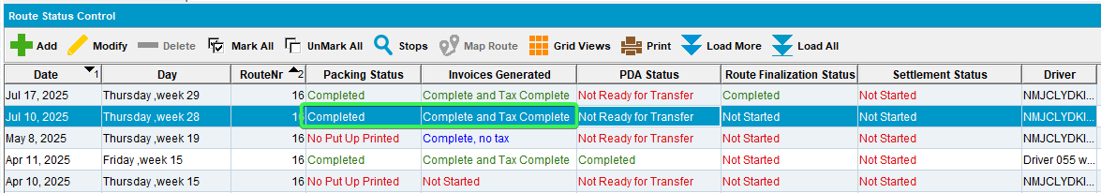
- Maintain Invoices DLG: All tab > Unsettled > Assigned to Route Status Control “Yes”
- Select a customer that was invoiced on R2 and press “Assign to Route” – Make sure the From – To dates cover R1
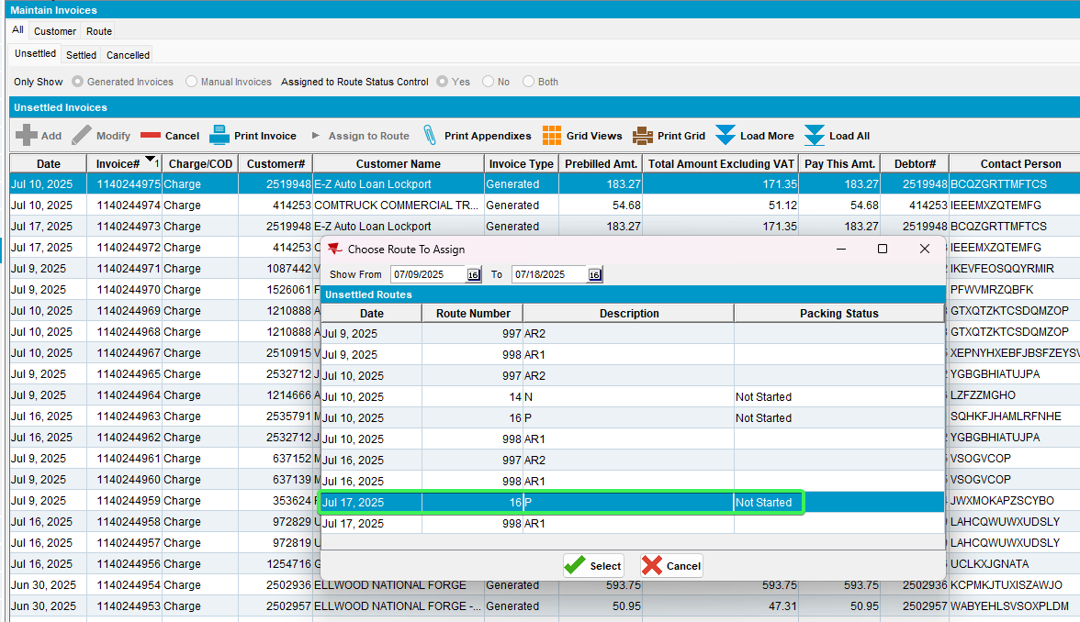
- RSC: Send R2 to RA
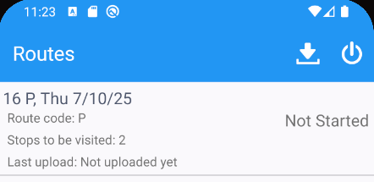
- Start the route and set 1 customer as Undeliverable
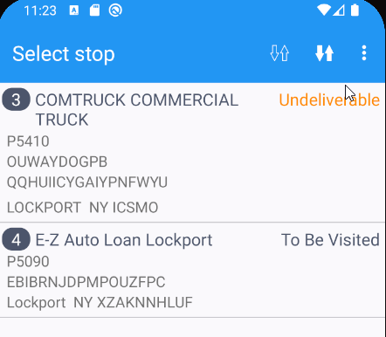
- Complete the route and upload the data
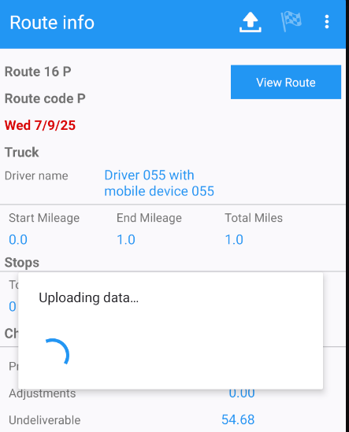
- WebX: Go to your route (R2) and complete Start my day
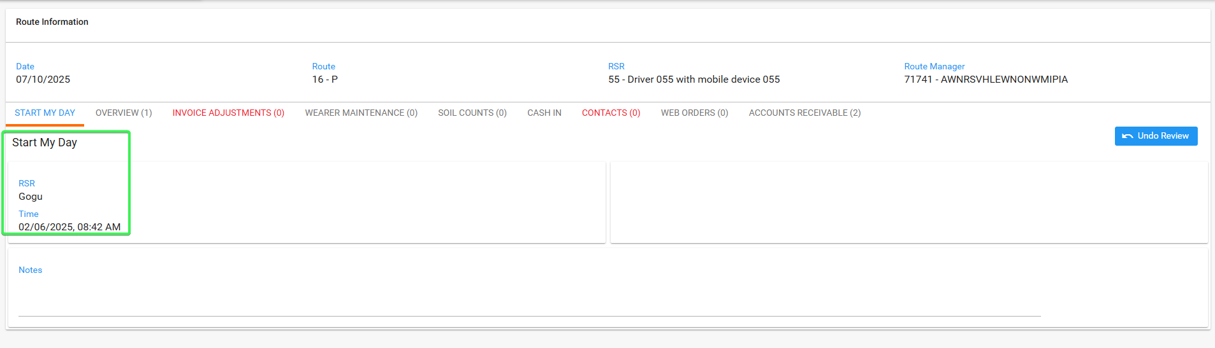
- Overview tab: Go to the Undeliverable stop and try moving it on R1
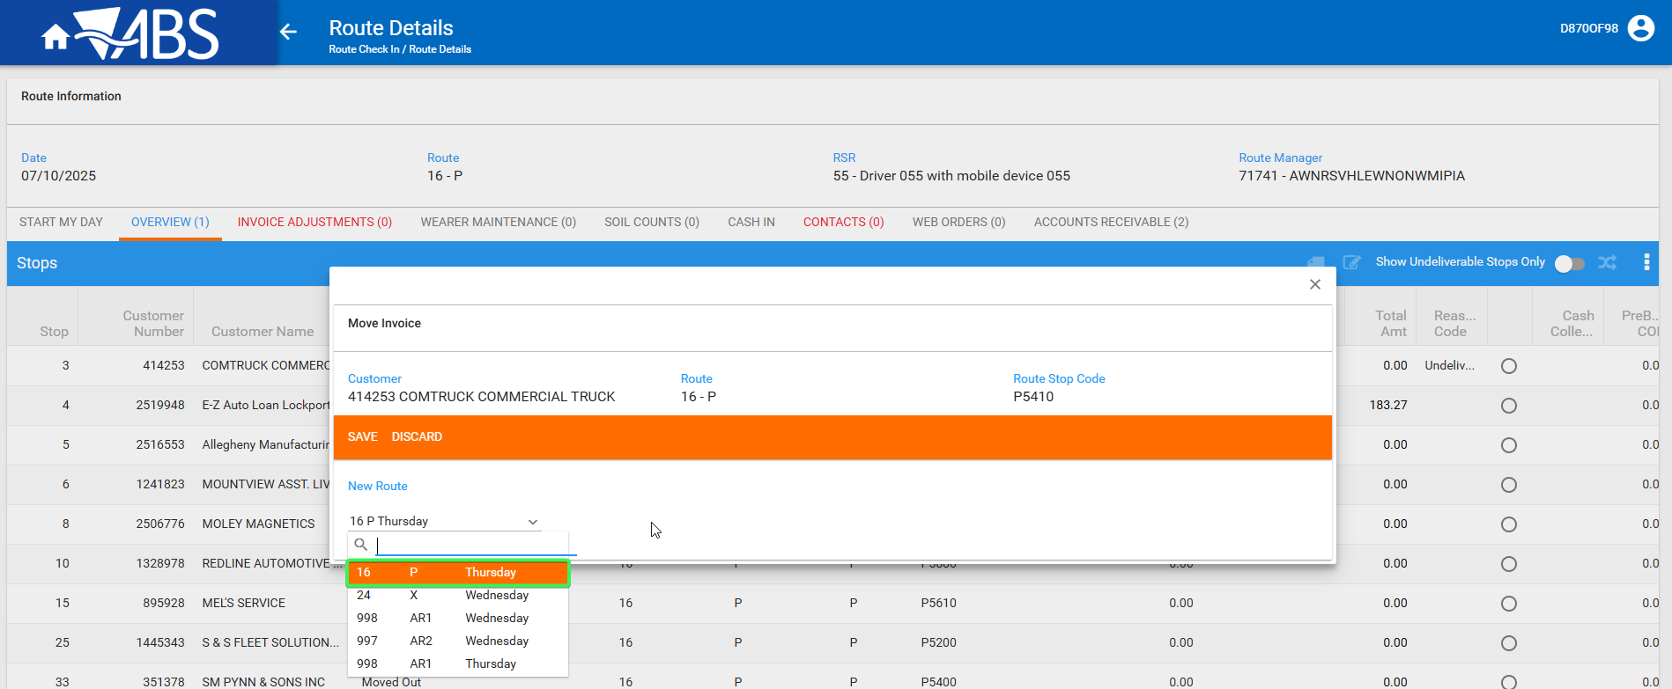
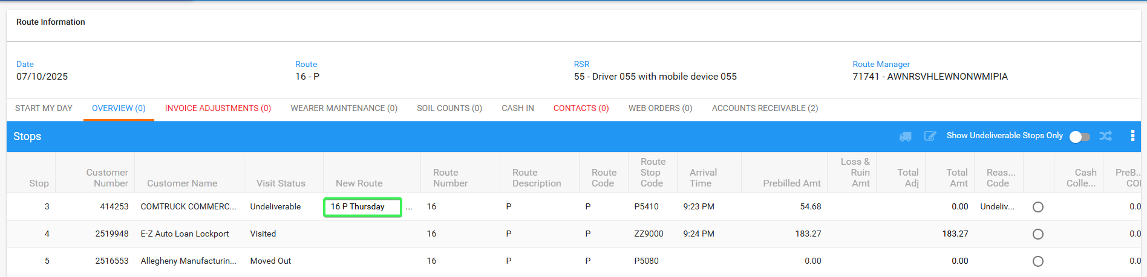
R1 is present in the dropdown
Tested OK

