ABSN-6621 D_UBS_2699 Do not transfer the contract tables to RA when module ROUTEASSISTANTCONTRACT is not in use
Environment | Prerequisites
Version: 9.07.00.UNF20  DBServerName= abs-srv20.internal.abslbs.com  DBSID=CUST24  DBUser=UNFDEV  DBPassword=UNFDEV  Environment=Test | - Module:  - System setting

Contents
Test after fix 1
Test Case 1 - Without ROUTEASSISTANTCONTRACT in the license – Tested OK 1
Expected behavior: 1
Test Steps: 2

Test after fix
After fix: 9.07.00.UNF20 hash: 2800e71e881e + RA 12.39

Test Case 1 - Without ROUTEASSISTANTCONTRACT in the license – Tested OK
Bu: 044 Nashua, NH

Expected behavior:
When module ROUTEASSISTANTCONTRACT is not in the license we do the following:

- Do not load any info in the following tables on RA:
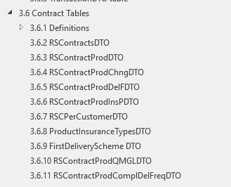
- Put 0 in the fields CustomerProductDTO
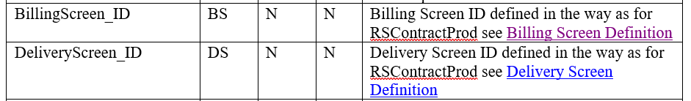
- And null in the following field on the CustomerProductDTO

Test Steps:
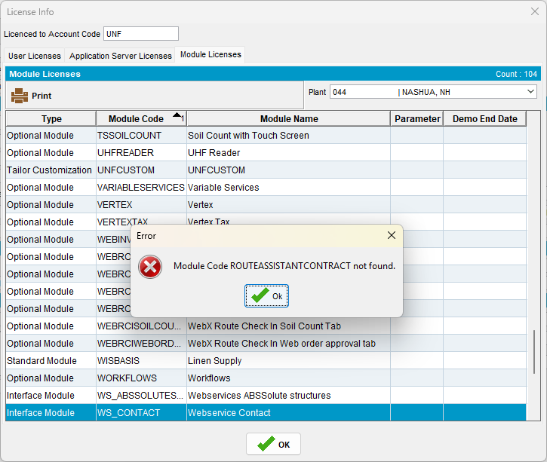
- PLSQL: find a route with a large amount of contractproducts attached to the contracts that belong to customers on the route
select count(cp.contractproduct_id), c.customernumber, rc.drivingdate, r.routenumber, p.code from routecontrol rc
join route r on r.route_id = rc.route_id
join plant p on p.plant_id = r.plant_id
join stop s on s.routecontrol_id = rc.routecontrol_id
join customer c on c.customer_id = s.customer_link_id
join contractcustomer cc on cc.customer_link_id = c.customer_id
join contract co on co.contract_id = cc.contract_id
join contractproduct cp on cp.contract_id = co.contract_id
where c.dateinactive > sysdate
and cc.enddate > sysdate
and co.enddate > sysdate
group by c.customernumber, rc.drivingdate, r.routenumber, p.code
having count(cp.contractproduct_id) > 200;
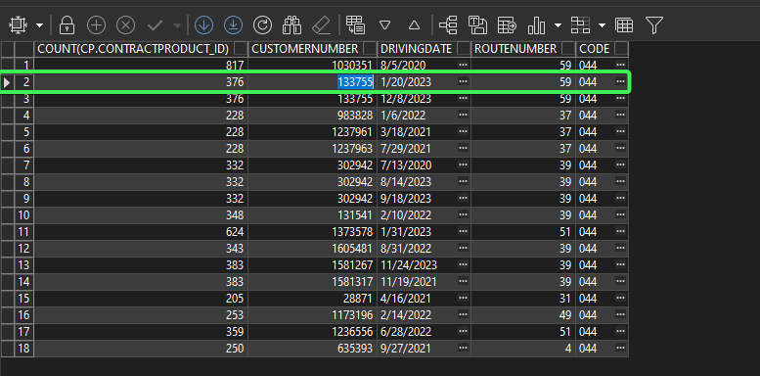
- PLPC of that customer
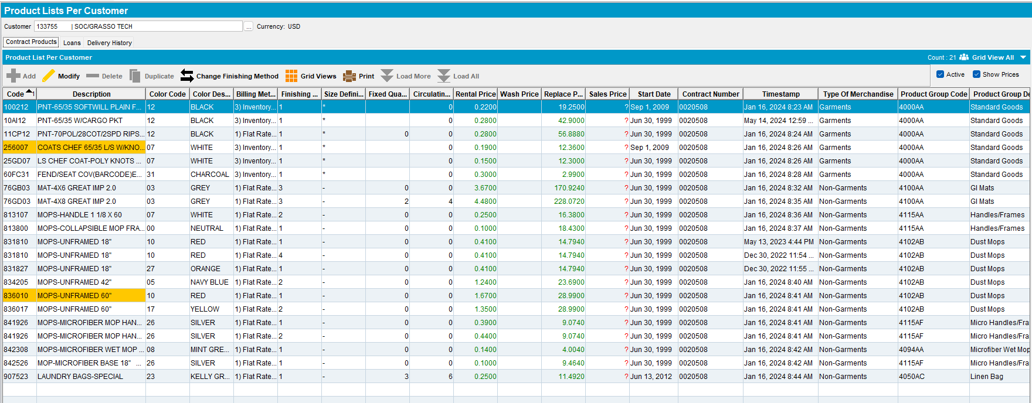
- Route Status Control DLG: Add a new route for one of your customers/route/driving date you found. Move out the rest of the customers.
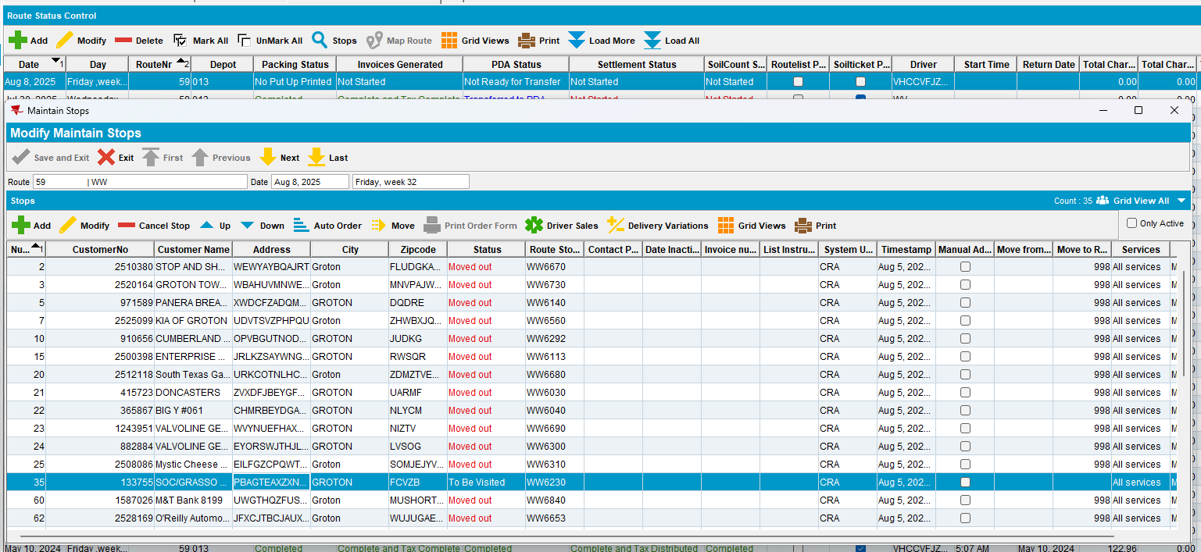
- Route Status Control DLG: Generate packing notes
- Route Status Control DLG: Generate invoices
- Route Status Control DLG: Mark ready to transfer
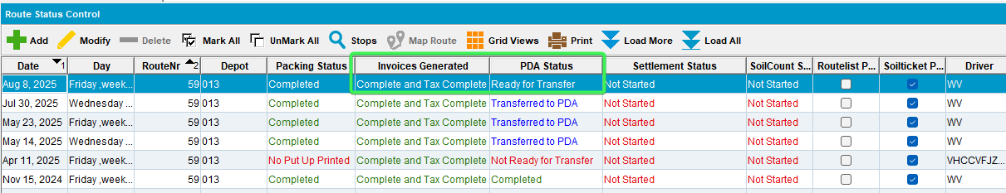
- Download the route on RA
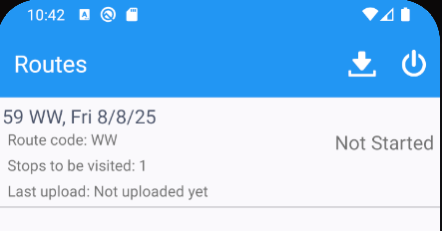
- Save the RA database for future checks
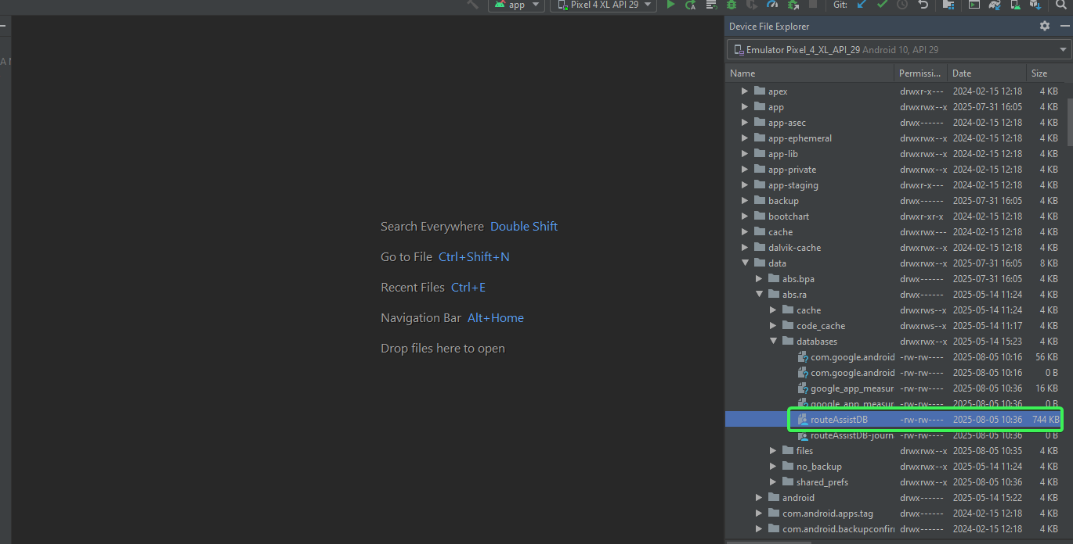
- Open the database from RA after download
- Open the database dump from RA with SQLITE and
- Check that there are no informations for the following tables.

select * from RSContractDTO;
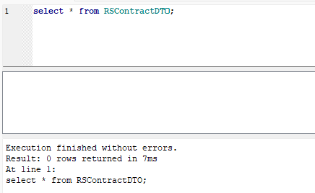
select * from RSContractProdDTO;
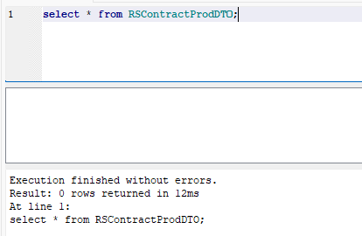
select * from RSContractProdChngDTO;
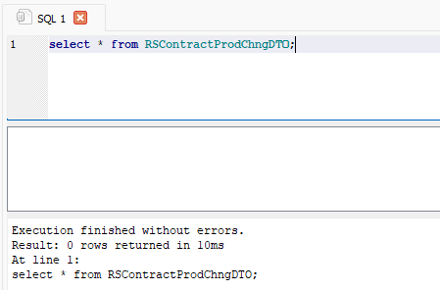
select * from RSContractProdDelFDTO;
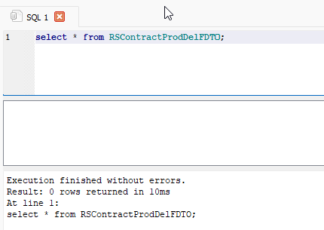
select * from RSContractProdInsPDTO;
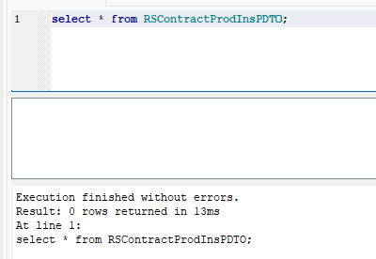
select * from RSCPerCustomerDTO;
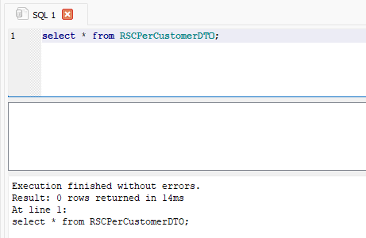
select * from FirstDeliverySchemeDTO;
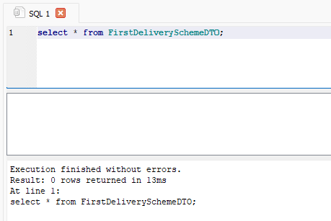
select * from RSContractProdQMGLDTO;
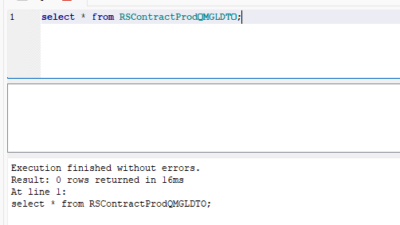
select * from RSContractProdComplDelFreqDTO;
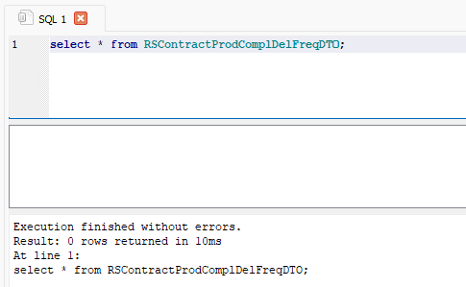
- Check that CustomerProductDTO.billingScreenId, CustomerProductDTO.deliveryScreenId have zero values and CustomerProductDTO.contractProductId have null
select CustomerProductDTO.billingScreenId, CustomerProductDTO.deliveryScreenId, CustomerProductDTO.contractProductId, CustomerProductDTO.* from CustomerProductDTO;
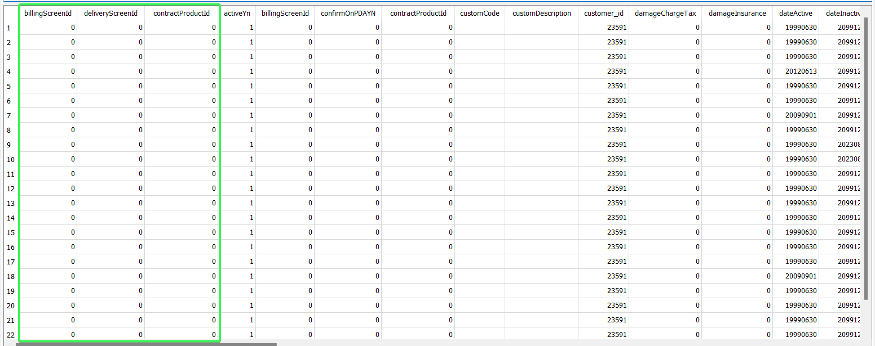
Tested OK

