ABSN-6492 D_UBS_2699 Improve SQL for loading ContractProducts at Download
Environment | Prerequisites
Version: 9.07.00.UNF20  DBServerName= abs-srv20.internal.abslbs.com  DBSID=CUST24  DBUser=UNFDEV  Environment=Test | - Module: ROUTEASSISTANTCONTRACT  - System setting

Contents
Reproduction before fix 1
Steps to reproduce 1
Retest after fix 3
Test Case 1 - Performance testing – Tested OK 3
Expected behavior: 3
Test Steps: 3
Test Case 2 - Check data integrity – Tested OK 6
Expected behavior: 6
Test Steps: 6
Test Case 3 - Download a route with multiple ContractProduct_ID's for the same product/size/fm 10
Expected behavior: 10
Test Steps: 10
Test Case 4 - Contract with multiple price lists make sure that the one with the latest startdate 13

Reproduction before fix
Bu: 847 SHREVEPORT, LA
9.07.00.UNF19 hash: e4ea4aab85bb + RA 12.37

Steps to reproduce
- Route Status Control dlg: Create a new route 25 for Monday ( 12th May 2025). Generate put up documents and invoices for all the customers present on the route.
- Process Scheduler dlg: Script the taxes and run Import Vertex BCI Tax Response process.
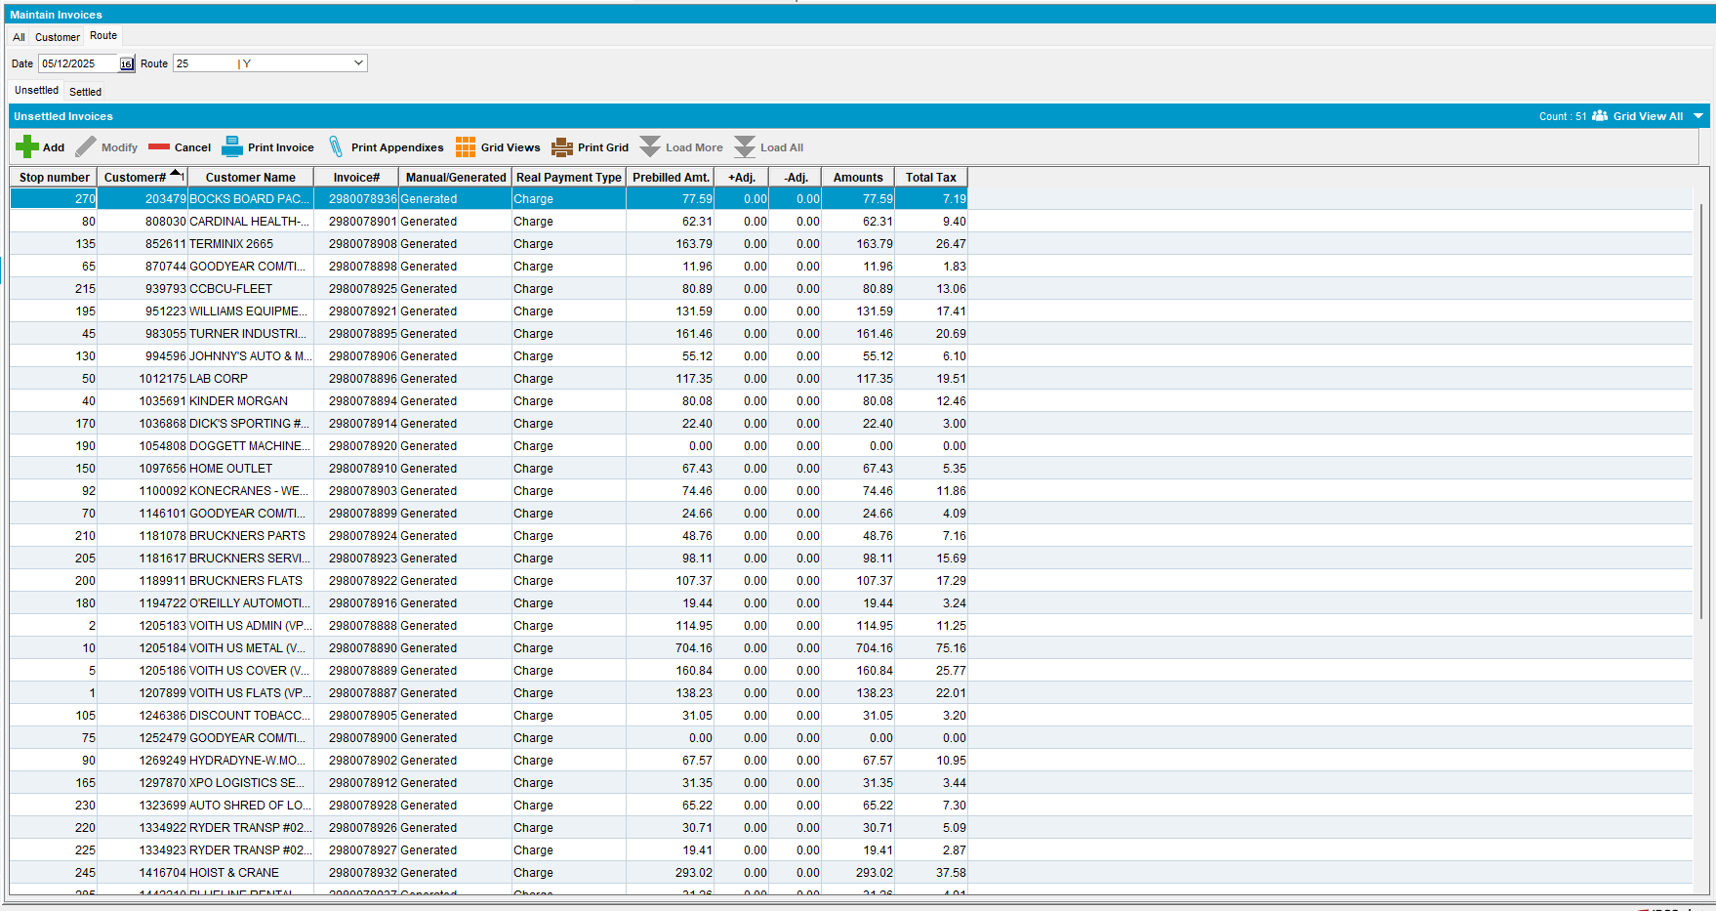
- RSC dlg: Mark the route ready for transfer.
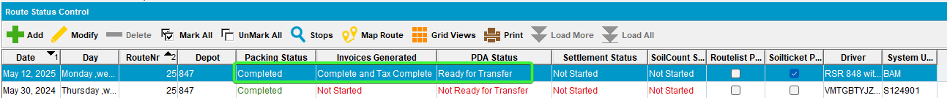
- RA: Using a timer, count how much time it takes to download the whole route.
- Download the route
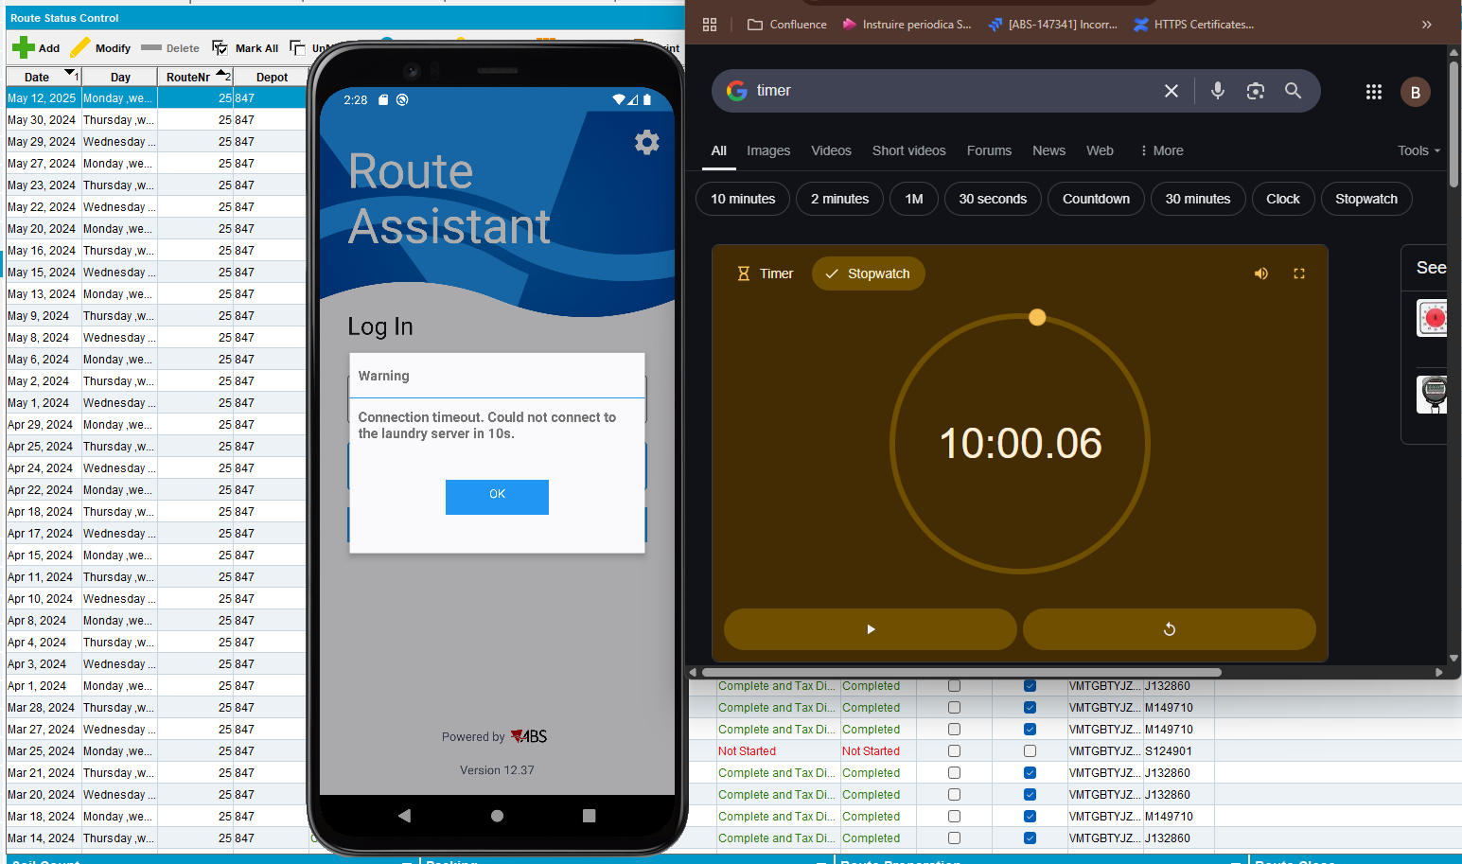
REPRODUCED OK

Retest after fix
Before Fix: 9.07.00.UNF20 hash: 23d00e060148 + RA 12.39 (version with timeout after 10 minutes)
After fix 9.07.00.UNF20 hash: 20ddac47dd41 + RA 12.39 (version with timeout after 10 minutes)

Test Case 1 - Performance testing – Tested OK
Bu: 044 NASHUA

Expected behavior:
Download speed is improved after the fix when compared to before fix for routes that have customers linked to contracts with a lot of contract products

Test Steps:
- Start the server before fix.
- PLSQL: find a route with a large amount of contractproducts attached to the contracts that belong to customers on the route

select count(cp.contractproduct_id), c.customernumber, rc.drivingdate, r.routenumber, p.code from routecontrol rc
join route r on r.route_id = rc.route_id
join plant p on p.plant_id = r.plant_id
join stop s on s.routecontrol_id = rc.routecontrol_id
join customer c on c.customer_id = s.customer_link_id
join contractcustomer cc on cc.customer_link_id = c.customer_id
join contract co on co.contract_id = cc.contract_id
join contractproduct cp on cp.contract_id = co.contract_id
where c.dateinactive > sysdate
and cc.enddate > sysdate
and co.enddate > sysdate
group by c.customernumber, rc.drivingdate, r.routenumber, p.code
having count(cp.contractproduct_id) > 200;
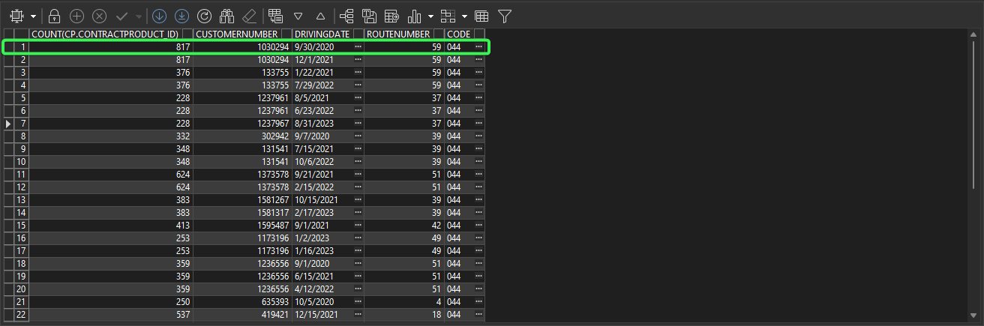
- Route Status Control DLG: Add a new route for one of your customers/route/driving date you found
- Route Status Control DLG: Generate packing notes
- Route Status Control DLG: Generate invoices
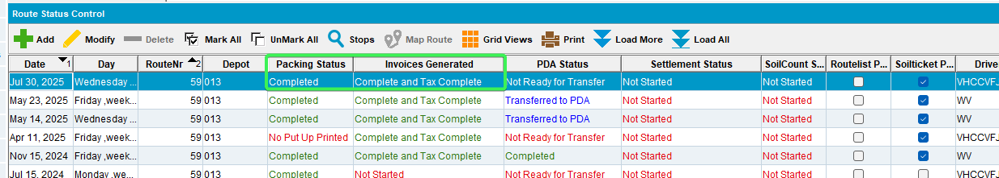
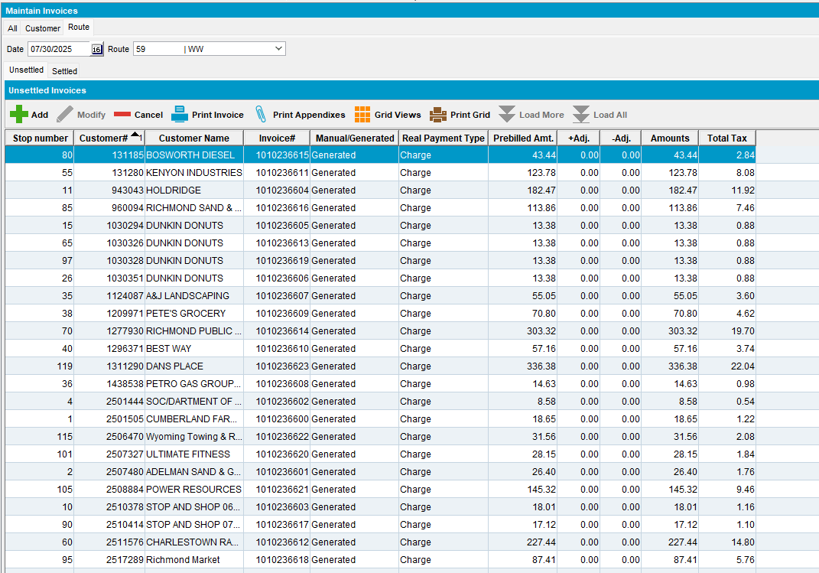
- Route Status Control DLG: Mark ready to transfer
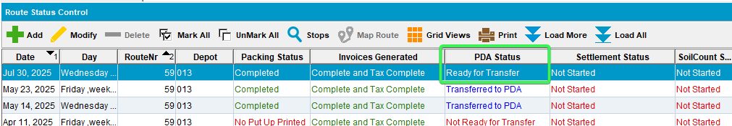
- Download route on RA with a timer on and measure the time from start of download to finish
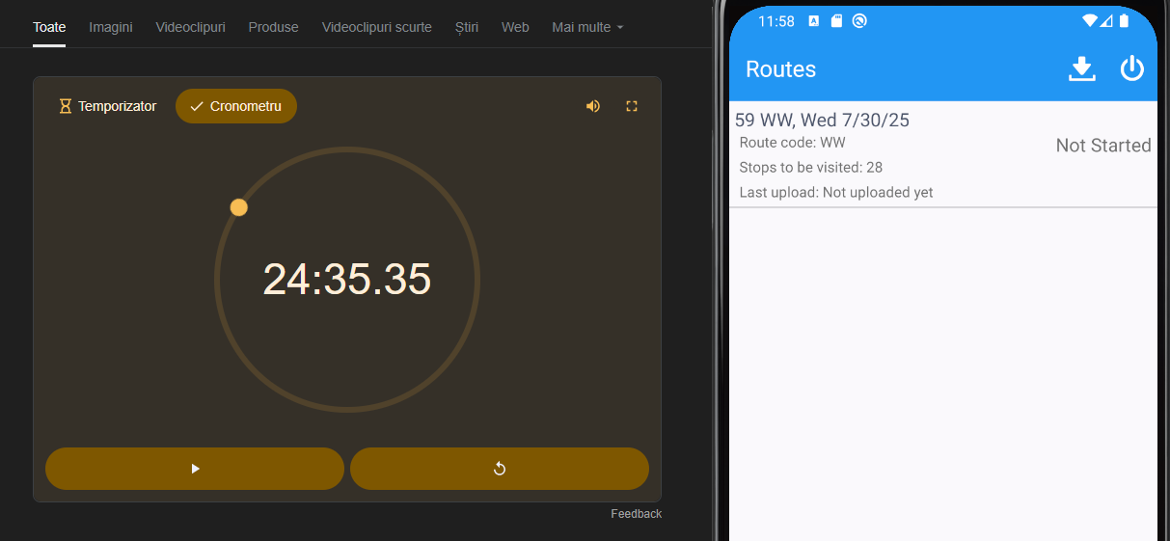
- Delete the database on RA after download finishes
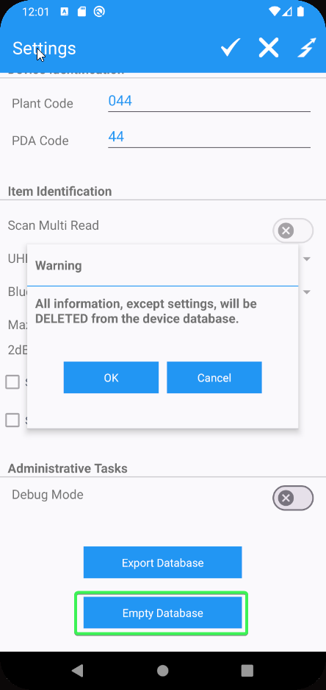
- Start the server with the fix and download again
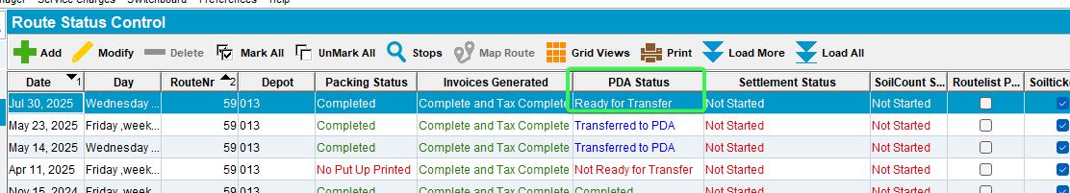

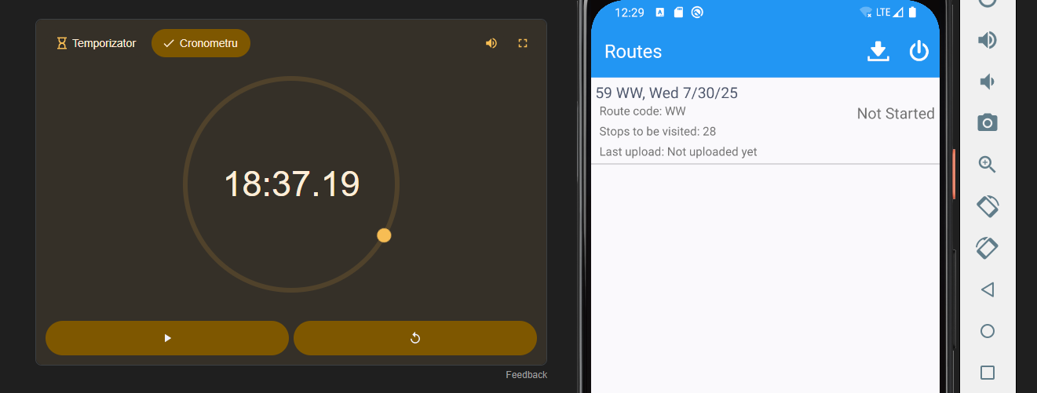

The download time was less than before fix
Tested OK

Test Case 2 - Check data integrity – Tested OK
BU: 012

Expected behavior:
When downloading a route that has customers with different types of contract products and different types of prices on the contract (rent, sales, wash, Replacement) the data on the RA is the same before and after fix

Test Steps:

- RA: Empty database.
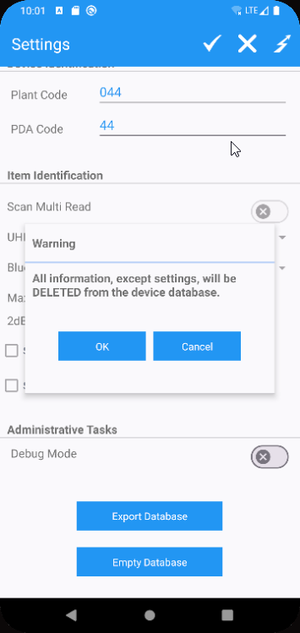
- Start the server before fix.
- PLSQL: find a route with a large amount of contractproducts attached to the contracts that belong to customers on the route that have all 4 relevant price types (rent, sales, wash, Replacement)
select c.customernumber, rc.drivingdate, r.routenumber, p.code from routecontrol rc
join route r on r.route_id = rc.route_id
join plant p on p.plant_id = r.plant_id
join stop s on s.routecontrol_id = rc.routecontrol_id
join customer c on c.customer_id = s.customer_link_id
join contractcustomer cc on cc.customer_link_id = c.customer_id
join contract co on co.contract_id = cc.contract_id
join contractproduct cp on cp.contract_id = co.contract_id
where c.dateinactive > sysdate
and cc.enddate > sysdate
and co.enddate > sysdate
and exists (select 1 from contractpricelist cpl
where cpl.contract_id = co.contract_id
and cpl.pricetype = 1) -- wash
and exists (select 1 from contractpricelist cpl
where cpl.contract_id = co.contract_id
and cpl.pricetype = 2) --Rent
and exists (select 1 from contractpricelist cpl
where cpl.contract_id = co.contract_id
and cpl.pricetype = 3) --Replacement
and exists (select 1 from contractpricelist cpl
where cpl.contract_id = co.contract_id
and cpl.pricetype = 4); --Sales
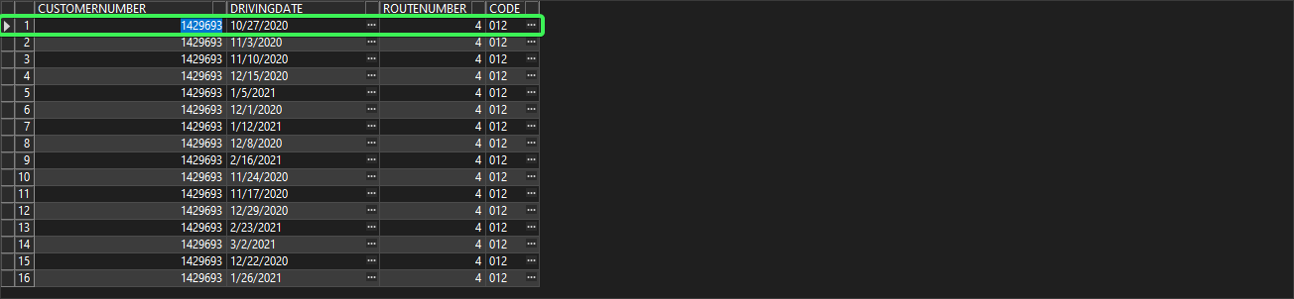
- Route Status Control DLG: Add a new route for one of your customers/route/driving date you found
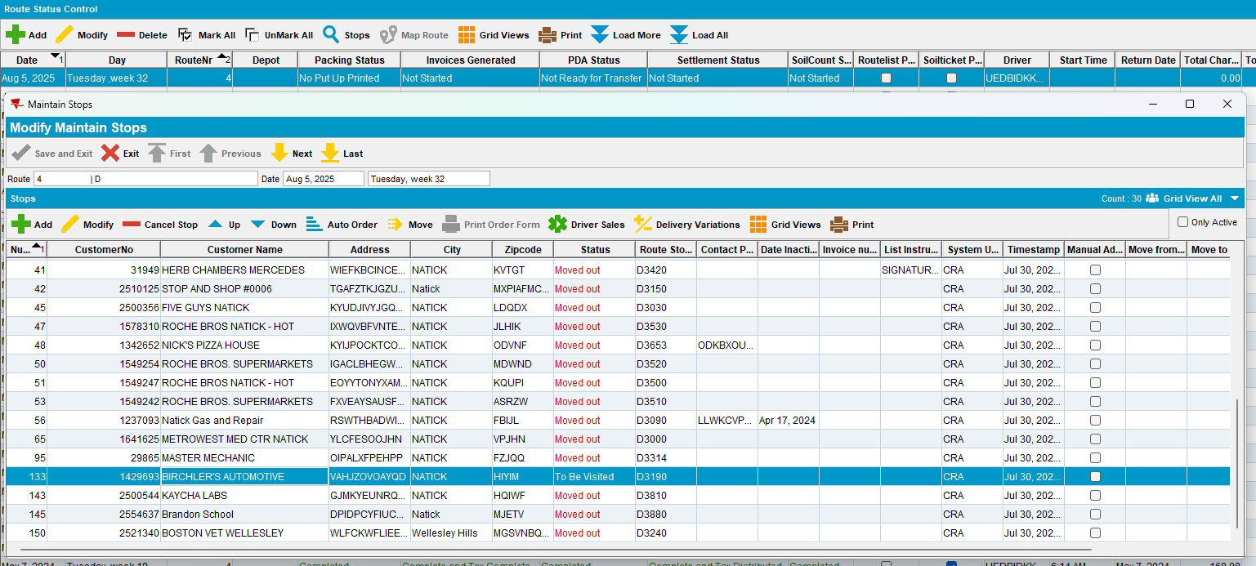
- Route Status Control DLG: Generate packing notes
- Route Status Control DLG: Generate invoices
- Route Status Control DLG: Mark ready to transfer
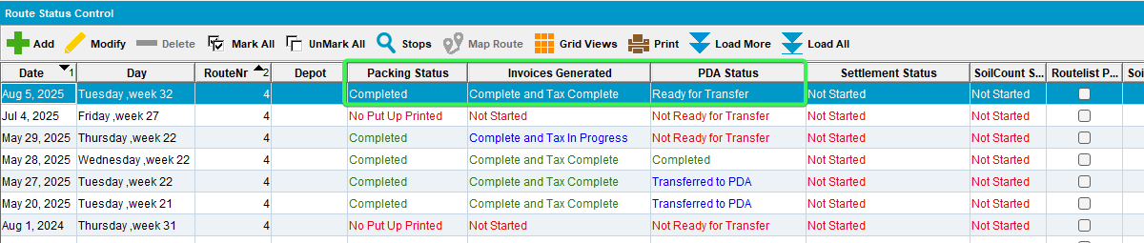
- Download the route on RA
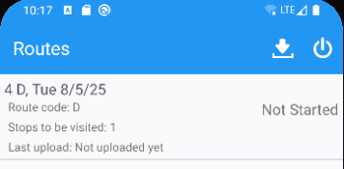
- Save the RA database for future checks
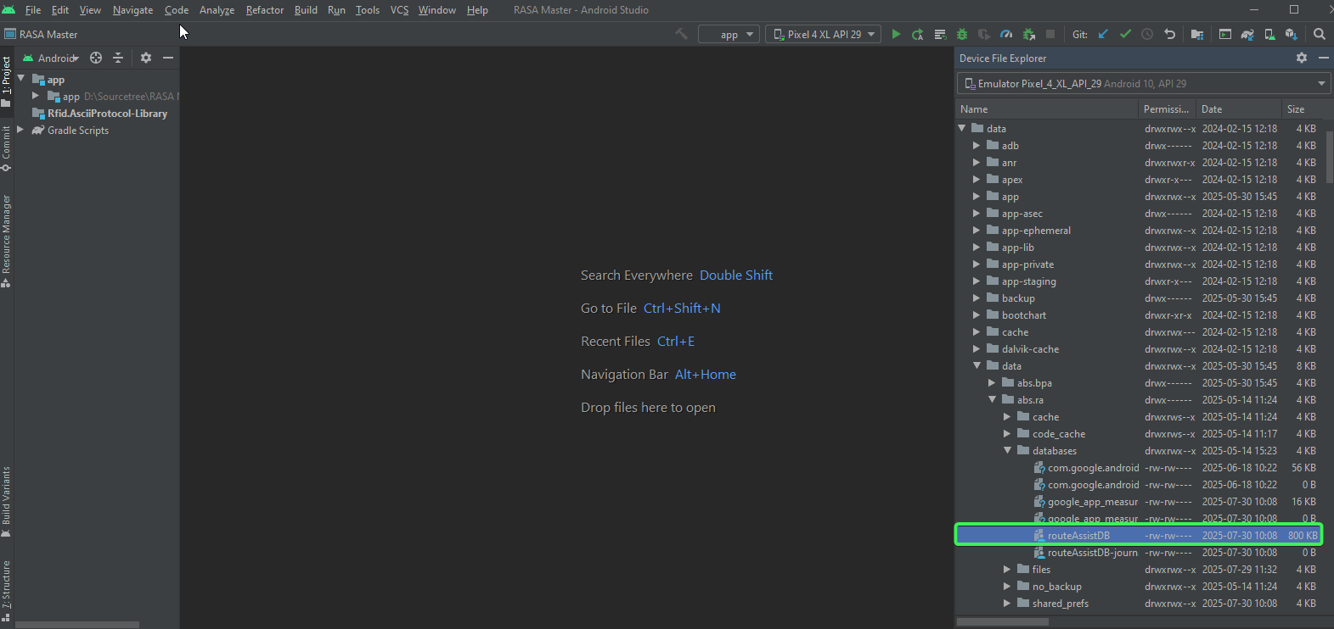
- Open the database from RA after download
- Open the database dump from RA with SQLITE and select * from RSContractProdDTO order by id;
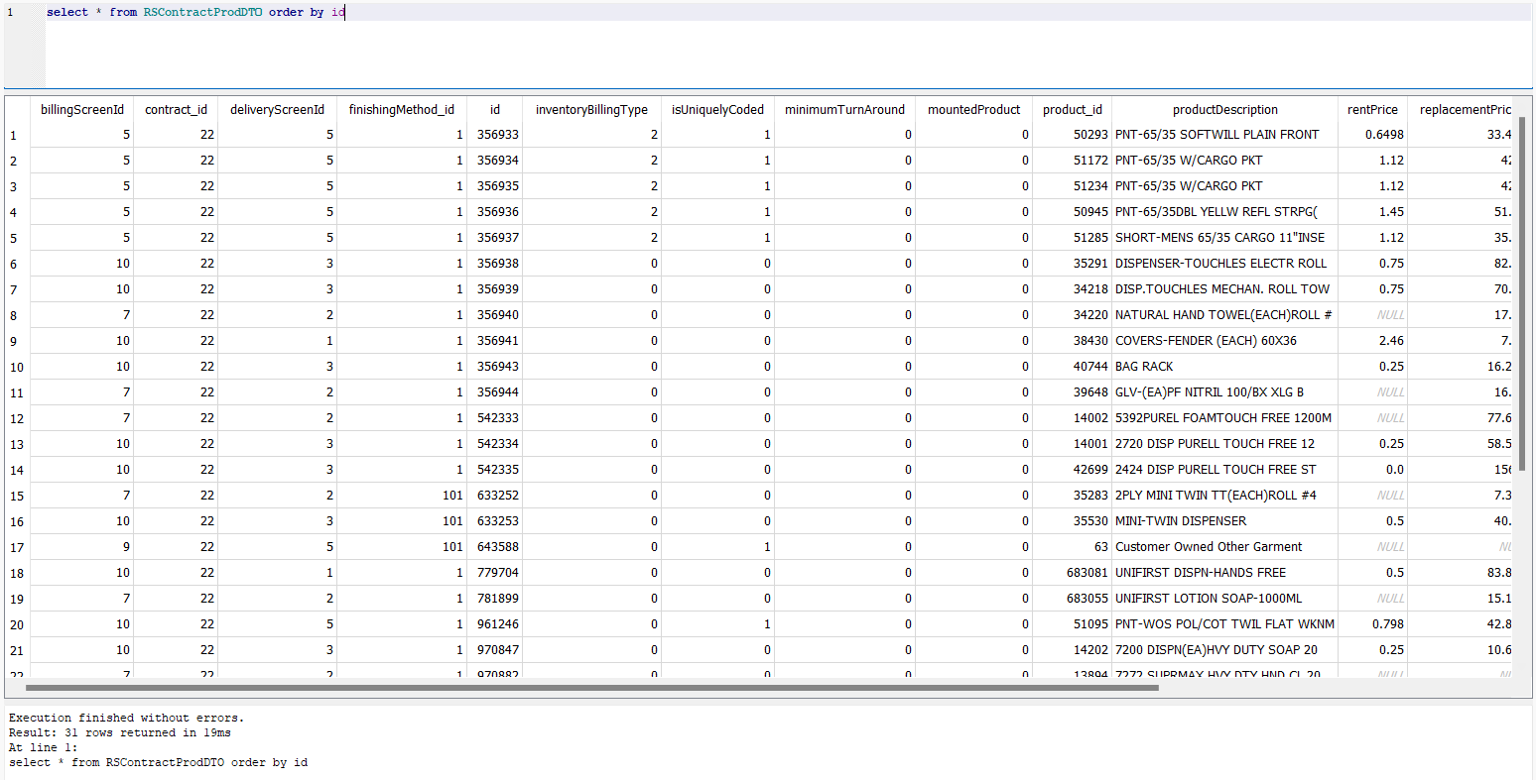
- Export the results in CSV form by clicking "Save results view" > "Export to CSV" and pressing ok
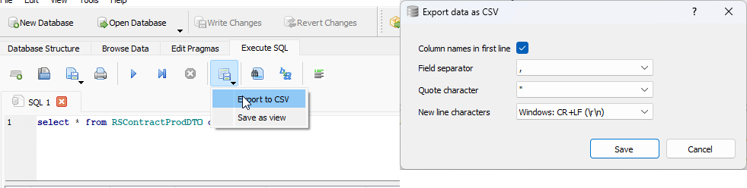
- Delete the database from the mobile device
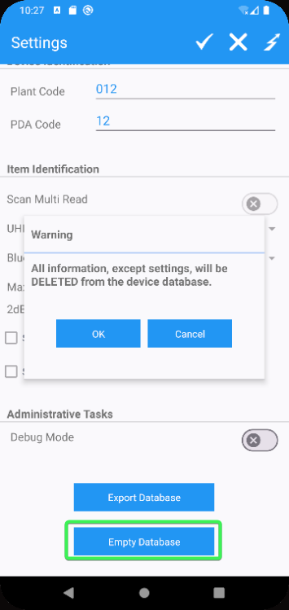
- Start the server with the fix
- Redownload the same route
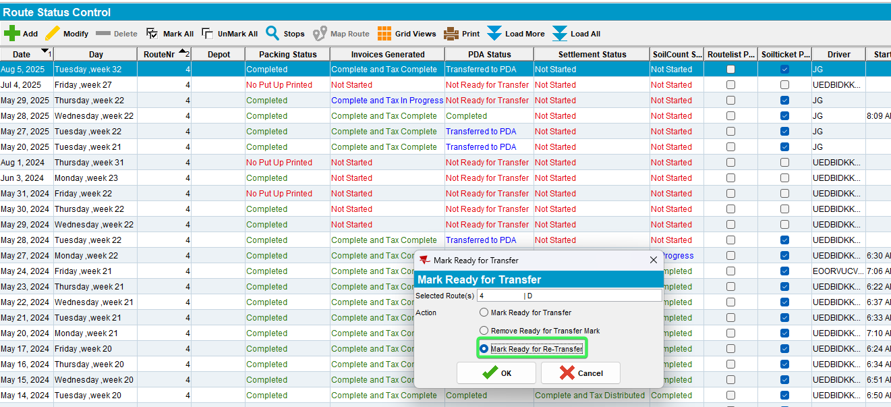
- Export the database from RA after download
- Save the RA database for future checks
- Open the database dump from RA with SQLITE and select * from RSContractProdDTO order by id;
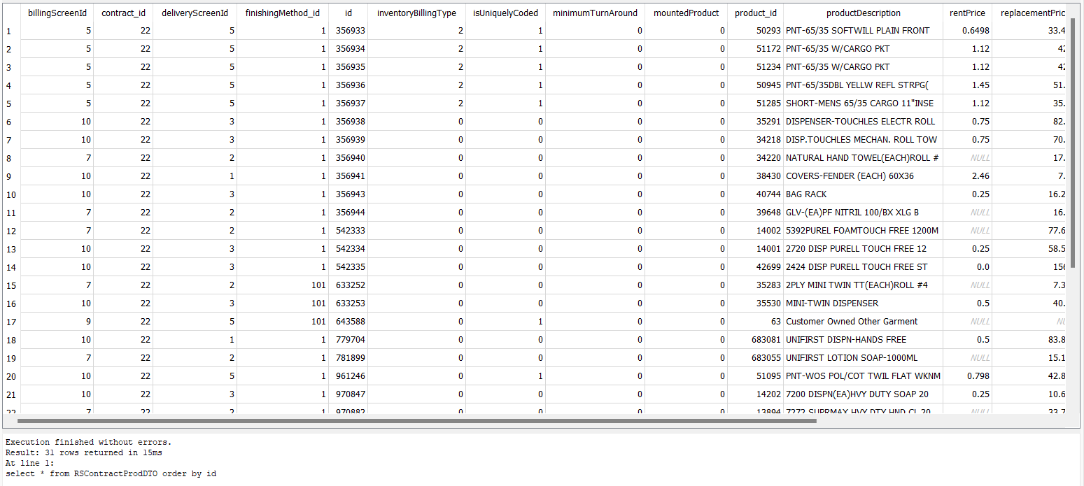
- Export the results in CSV form by clicking "Save results view" > "Export to CSV" and pressing ok
- Create a new Excel file and copy the content of the beforefix and afterfix sheets in the excel file.
- Compare the two csv contents from beforefix and afterfix using Excel in the new excel file (csv files don’t support formulas). The result of the data should be identical.

Use the following formula in excel

=IF('BeforeFix'!A1='AfterFix'!A1, 'AfterFix'!A1, "BeforeFix: " & 'BeforeFix'!A1 & " vs AfterFix: " & 'AfterFix'!A1)
Drag the formula on all the columns and rows that the previous csv file have data on.
Alt + h + o + i to expand the columns in the excel

Use conditional formatting to highlight differences using color for better spotting the difference between csv’s data =BeforeFix!A1<>AfterFix!A1
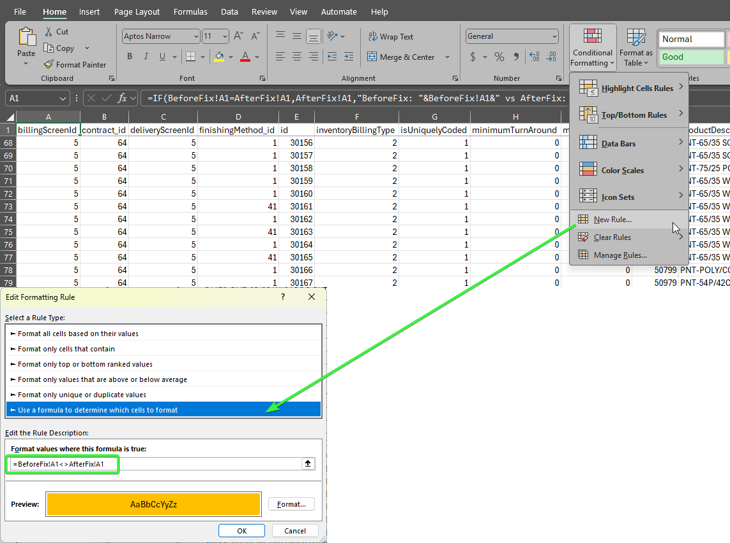

Check the results
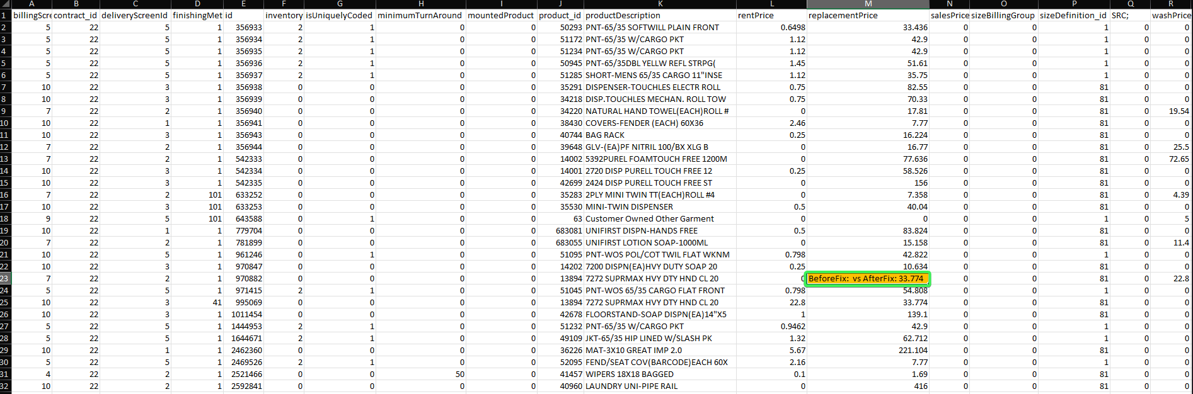
Before fix
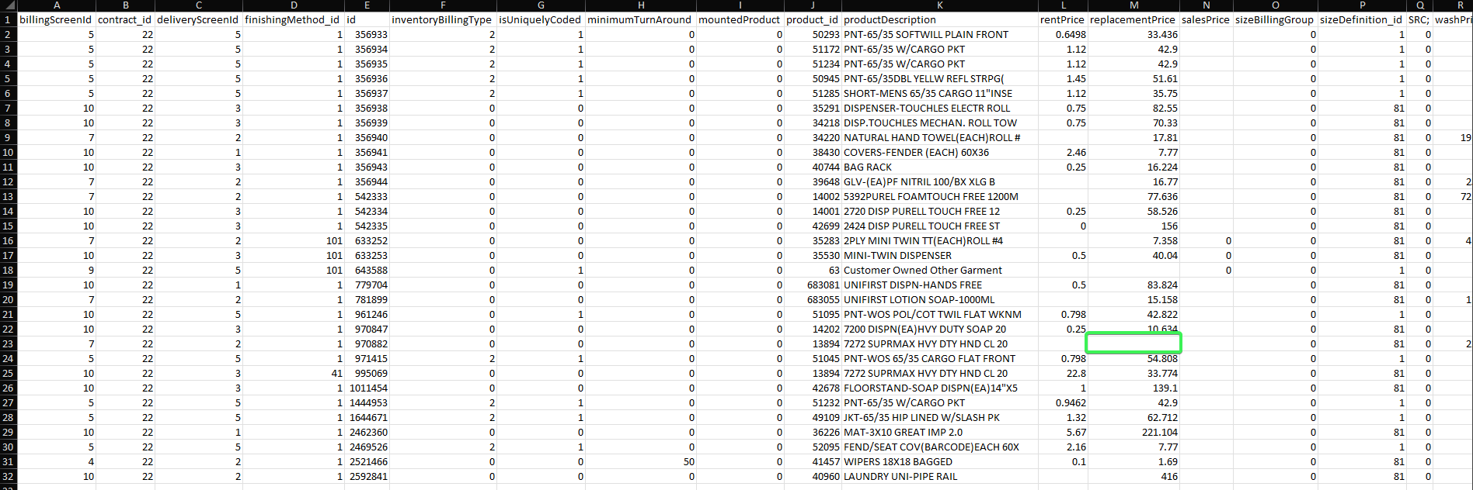
After fix
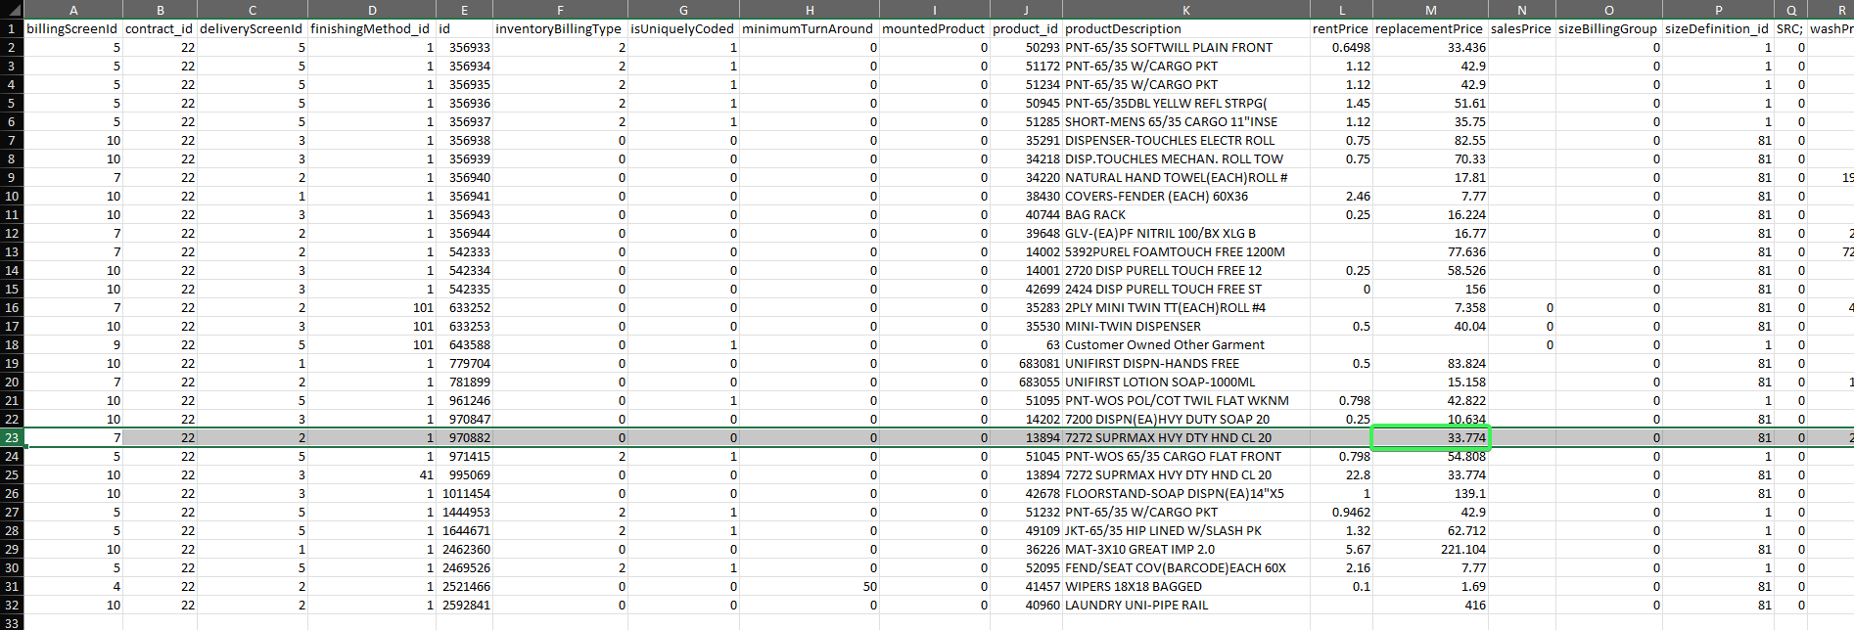
The only difference is at replacement price, because the contract had 2 contract products with the same size but different finishing methods. Before fix it didn’t find the replacement price and now it does
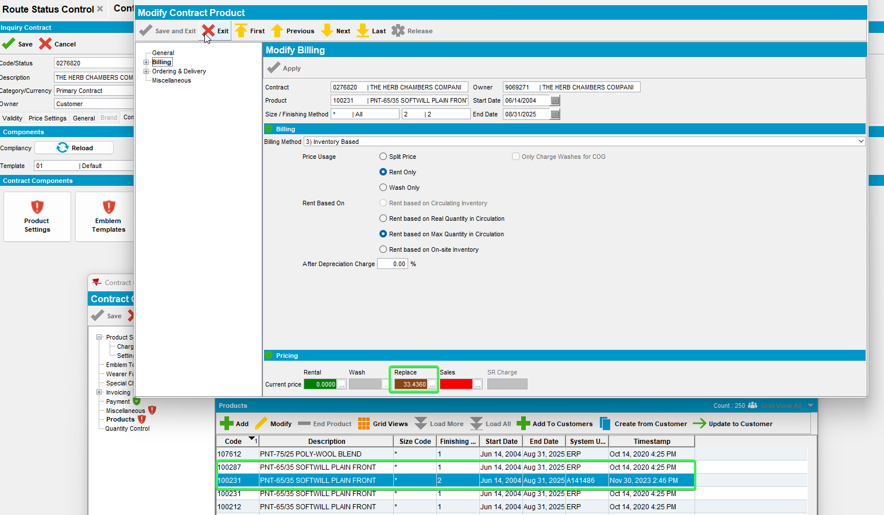

Tested OK

Test Case 3 - Download a route with multiple ContractProduct_ID's for the same product/size/fm – Tested OK

Expected behavior:
Data should be identical before and after fix except for the replacementPrice

Test Steps:
- RA: Empty database.
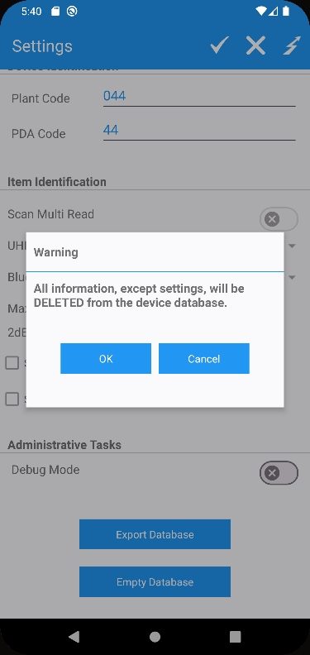
- Start the server before fix.
- PLSQL: find a customer with the following select (if you do not have any entries you cannot perform this test)
select count(cp.contractproduct_id), cp.contract_id, cp.product_id, cp.finishingmethod_id, cp.sizedefinition_id, c.customernumber
from customer c
join contractcustomer cc on cc.customer_link_id = c.customer_id
join contract co on co.contract_id = cc.contract_id
join contractproduct cp on cp.contract_id = co.contract_id
where c.dateinactive > sysdate
and cc.enddate > sysdate
and co.enddate > sysdate
group by cp.contract_id, cp.product_id, cp.finishingmethod_id, cp.sizedefinition_id, c.customernumber
having count(cp.contractproduct_id) > 1;
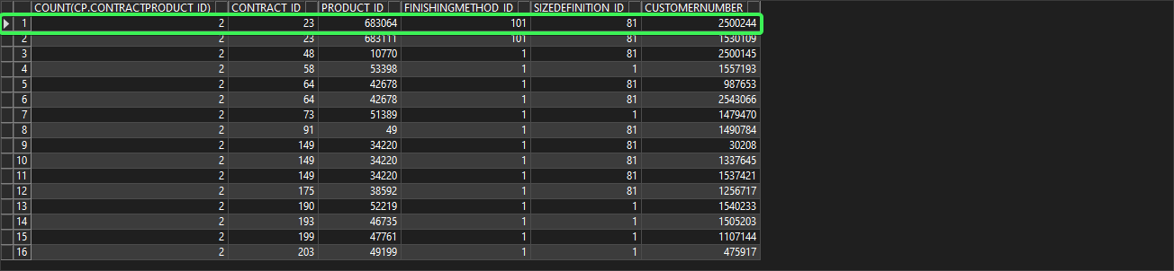
- Route Status Control DLG: Add a new route for one of your customers/route/driving date you found
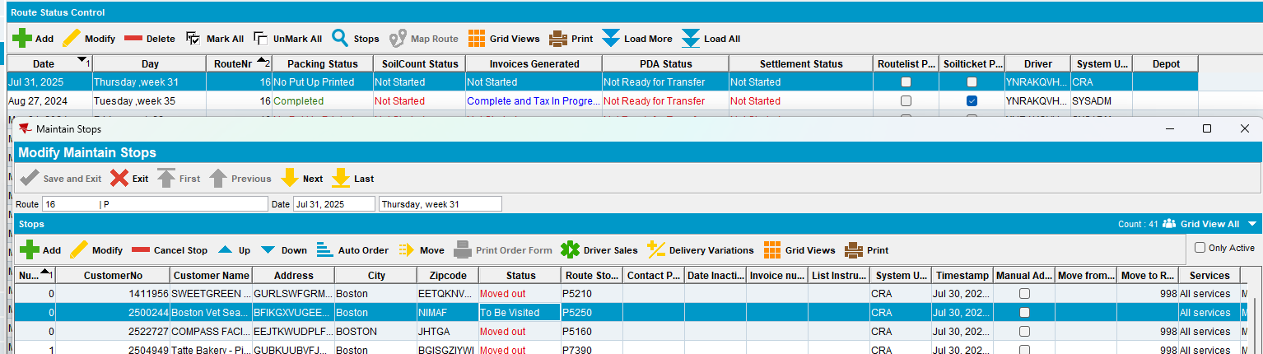
- Route Status Control DLG: Generate packing notes
- Route Status Control DLG: Generate invoices
- Route Status Control DLG: Mark ready to transfer
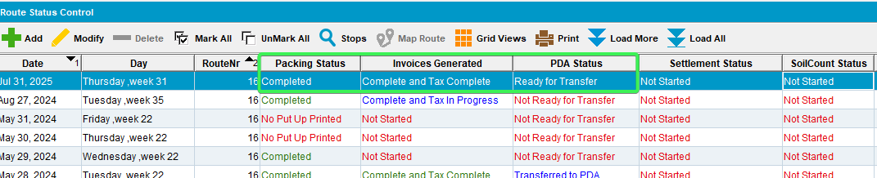
- Download the route on RA
- Save the RA database for future checks
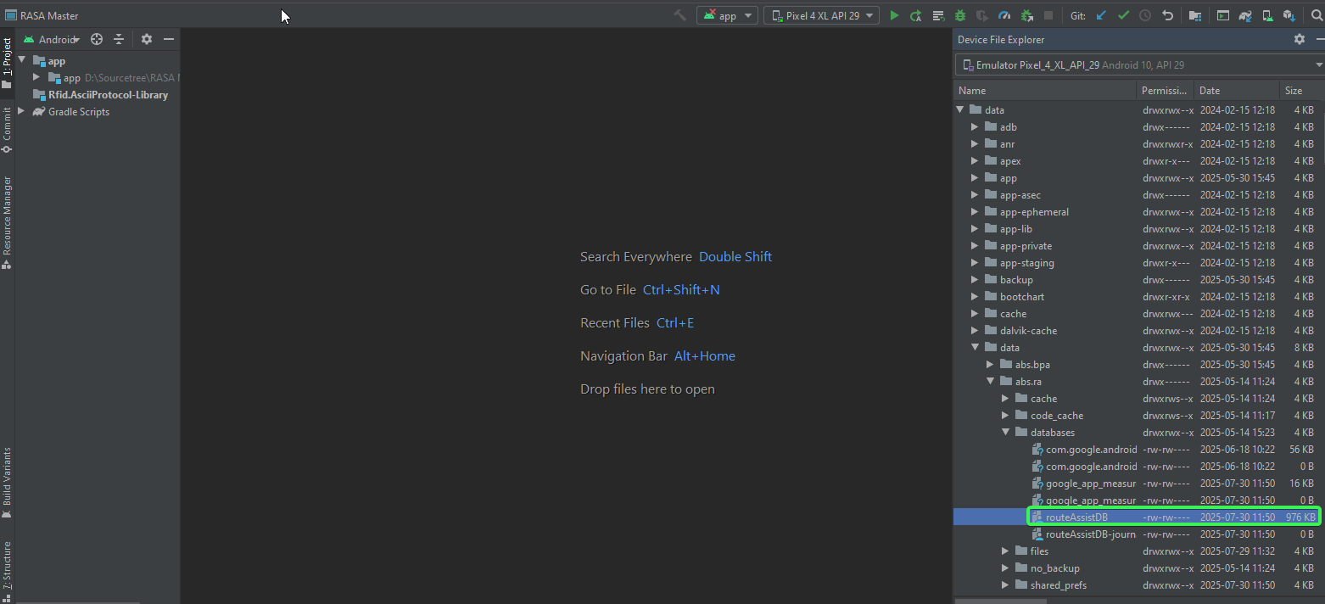
- Export the database from RA after download
- Open the database dump from RA with SQLITE and select * from RSContractProdDTO order by id;
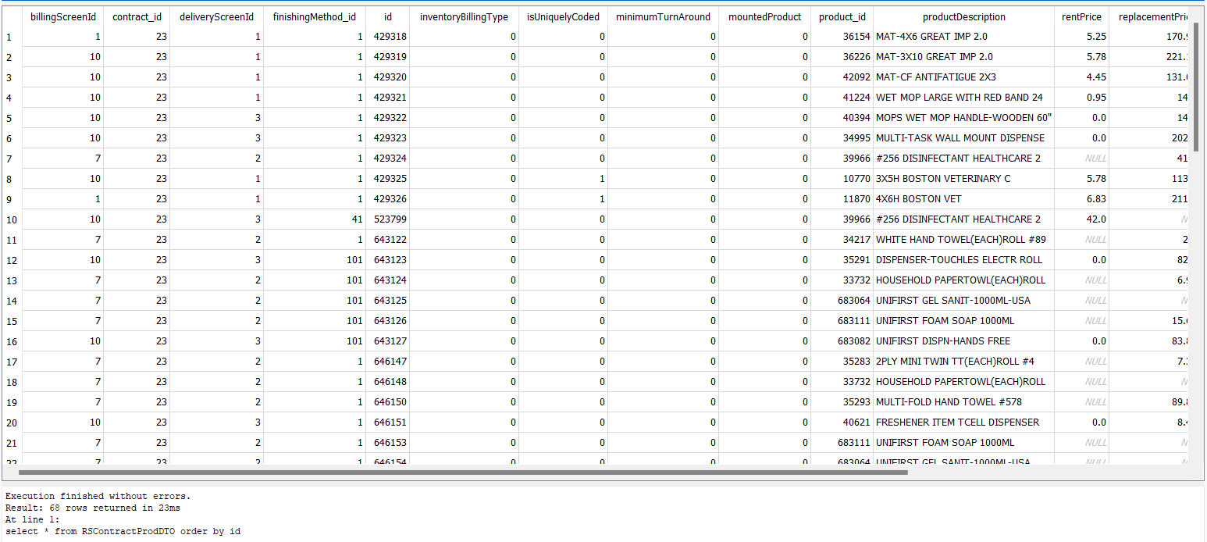
- Export the results in CSV form by clicking "Save results view" > "Export to CSV" and pressing ok
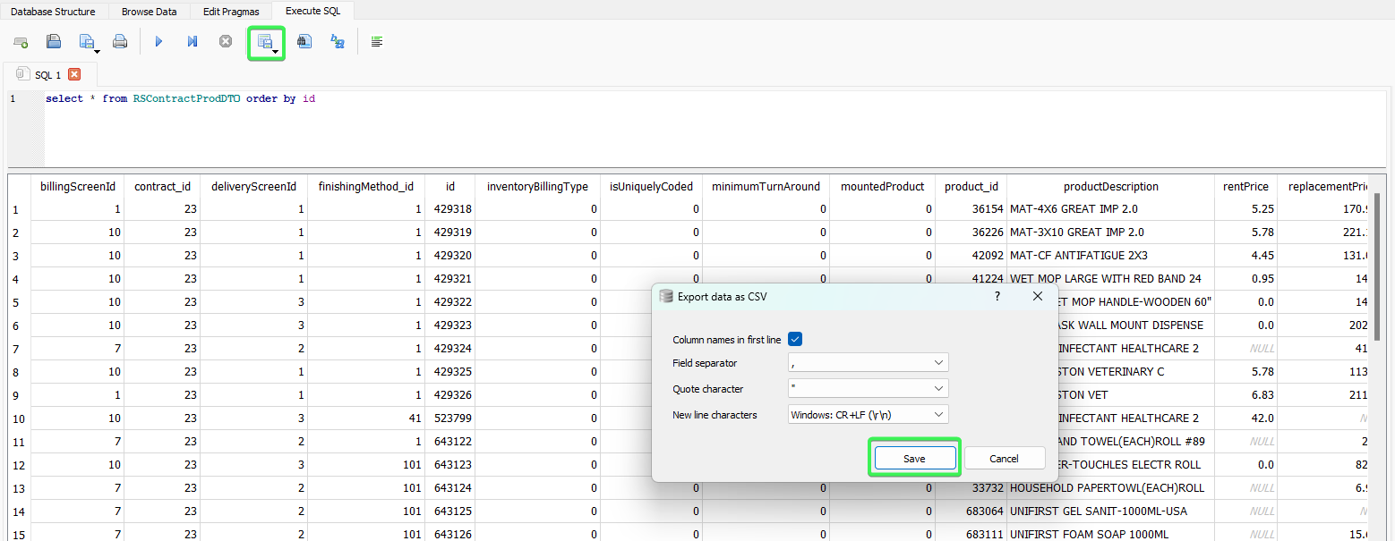
- Delete the database from the mobile device
- Start the server with the fix
- Redownload the same route
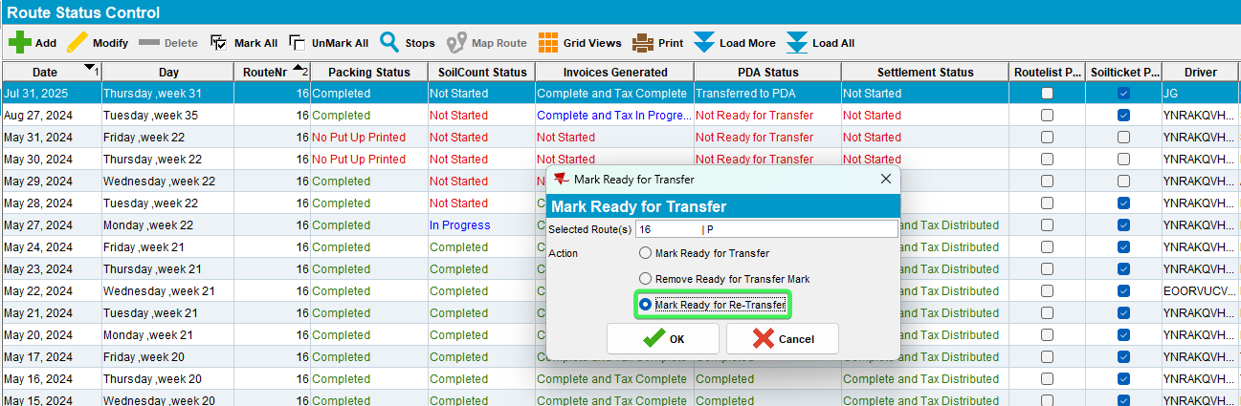
- Export the database from RA after download
- Save the RA database for future checks
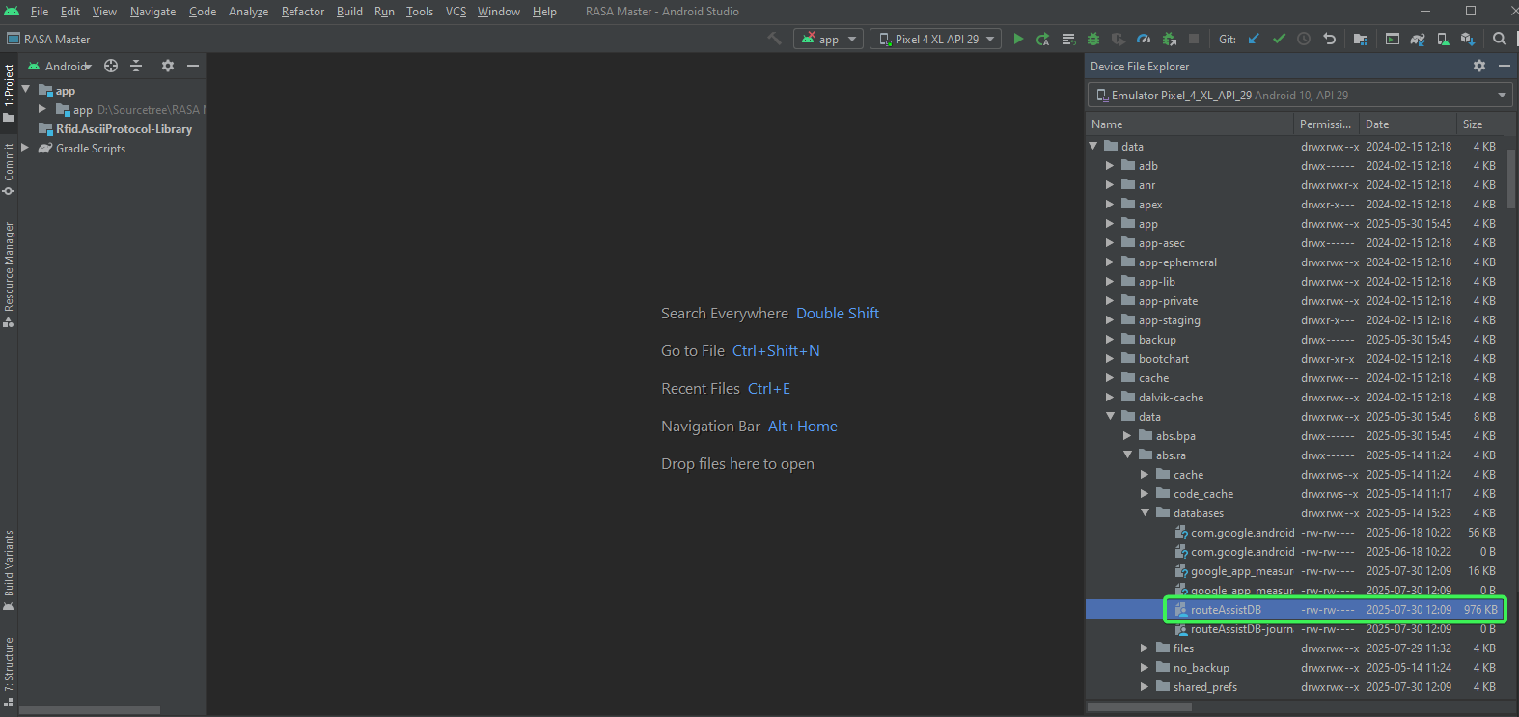
- Open the database dump from RA with SQLITE and select * from RSContractProdDTO order by id;
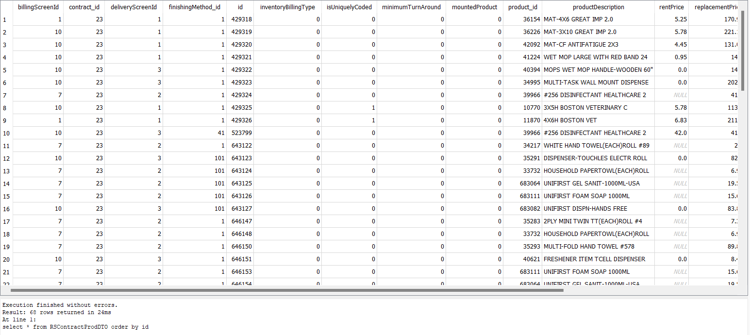
- Export the results in CSV form by clicking "Save results view" > "Export to CSV" and pressing ok
- Create a new Excel file and copy the content of the beforefix and afterfix sheets in the excel file.
- Compare the two csv contents from beforefix and afterfix using Excel in the new excel file (csv files don’t support formulas). The result of the data should be identical.

Use the following formula in excel

=IF('BeforeFix'!A1='AfterFix'!A1, 'AfterFix'!A1, "BeforeFix: " & 'BeforeFix'!A1 & " vs AfterFix: " & 'AfterFix'!A1)
Drag the formula on all the columns and rows that the previous csv file have data on.
Alt + h + o + i to expand the columns in the excel

Use conditional formatting to highlight differences using color for better spotting the difference between csv’s data = BeforeFix!A1<>AfterFix!A1

- Check the results

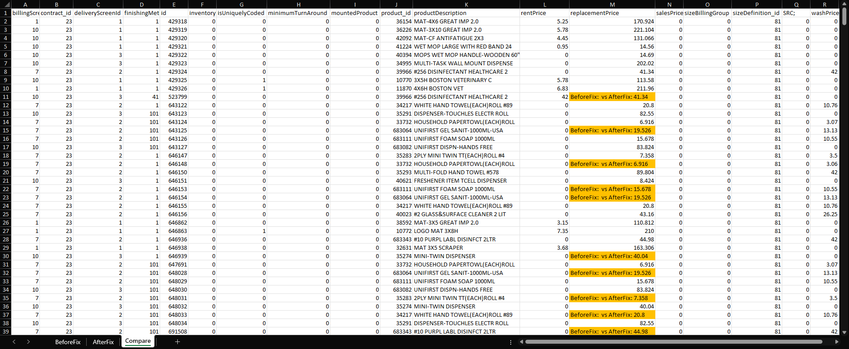

Tested OK

Test Case 4 - Contract with multiple price lists make sure that the one with the latest startdate

Expected behavior:
When a contract product has price entries for rent/wash/sales/replacement in multiple contract price lists on the same contract, the price used to populate the RSContractProdDTO table is the one that has the most recent start date.

Test Steps:
- RA: Empty database.
- Start the server before fix.
- Route Status Control DLG: Add a new route. Choose a customer, check it’s contract.
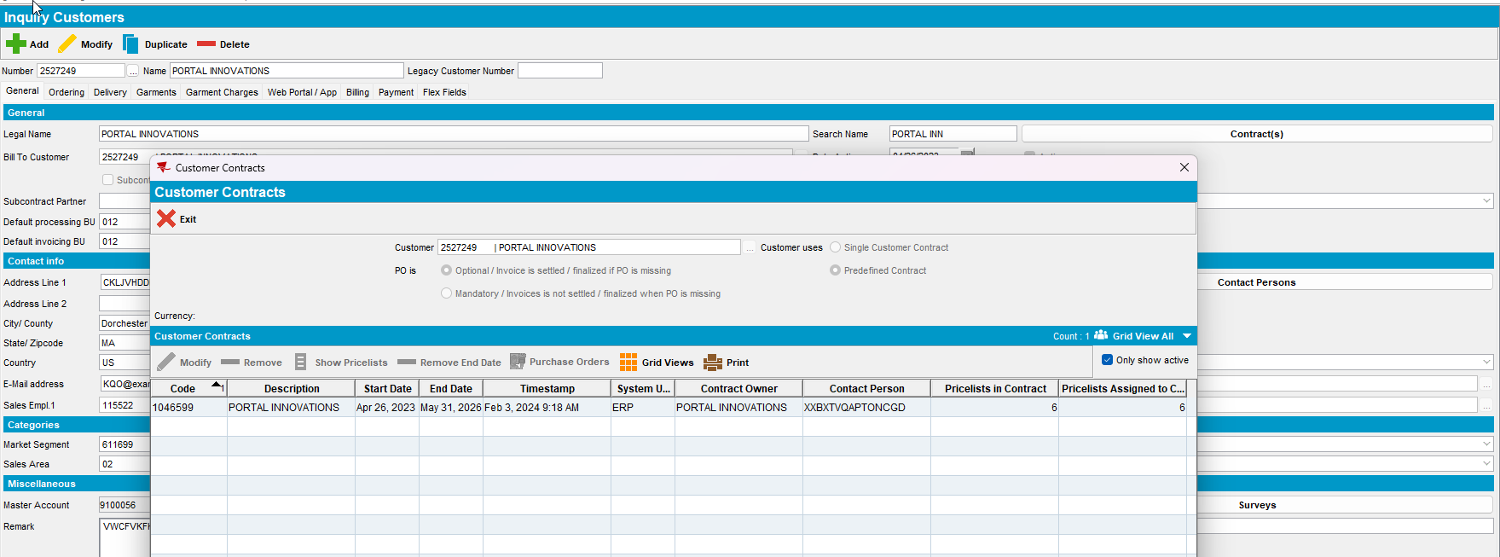
- Contract dlg: Load the contract and add a garment product or use an existing one if the contract has garment products. Check the prices
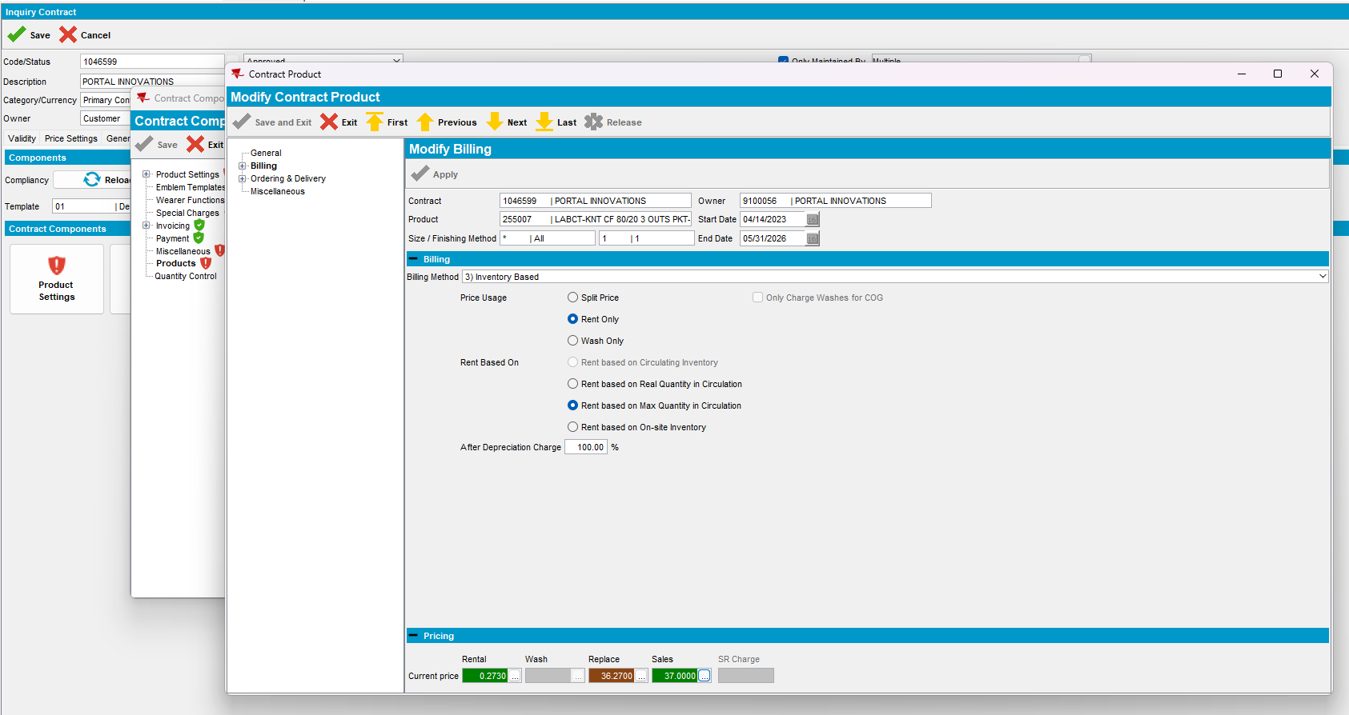
- Contract dlg: Go to Price Lists tab and add new contract price list for the same product, same size, same finishing method with different price, start date older, less older and in the future.

- Rent
- Older start date price
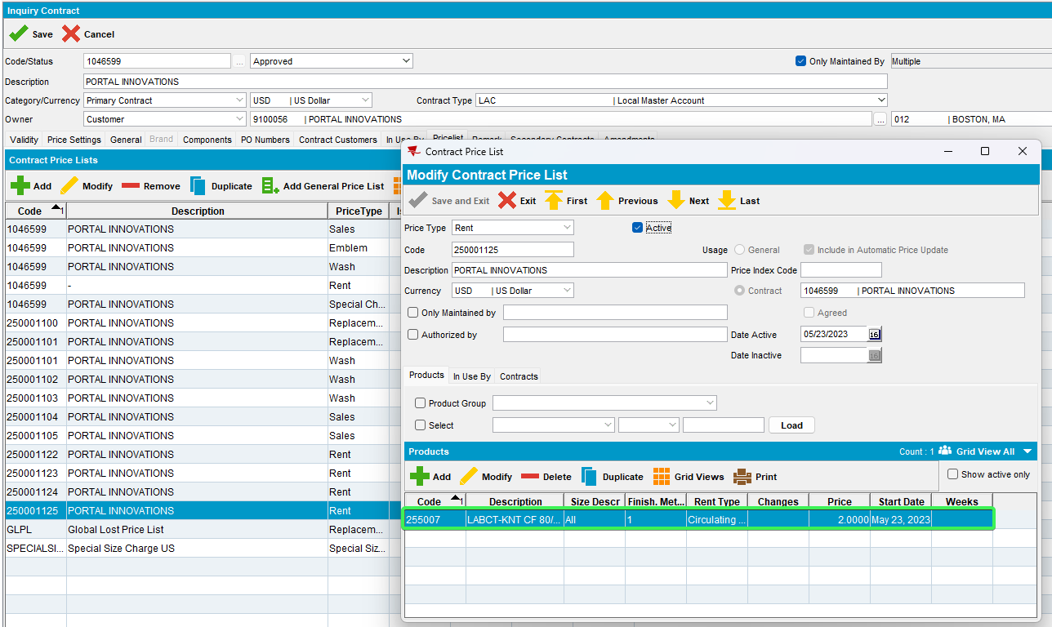
- Less older start date price put two digits price
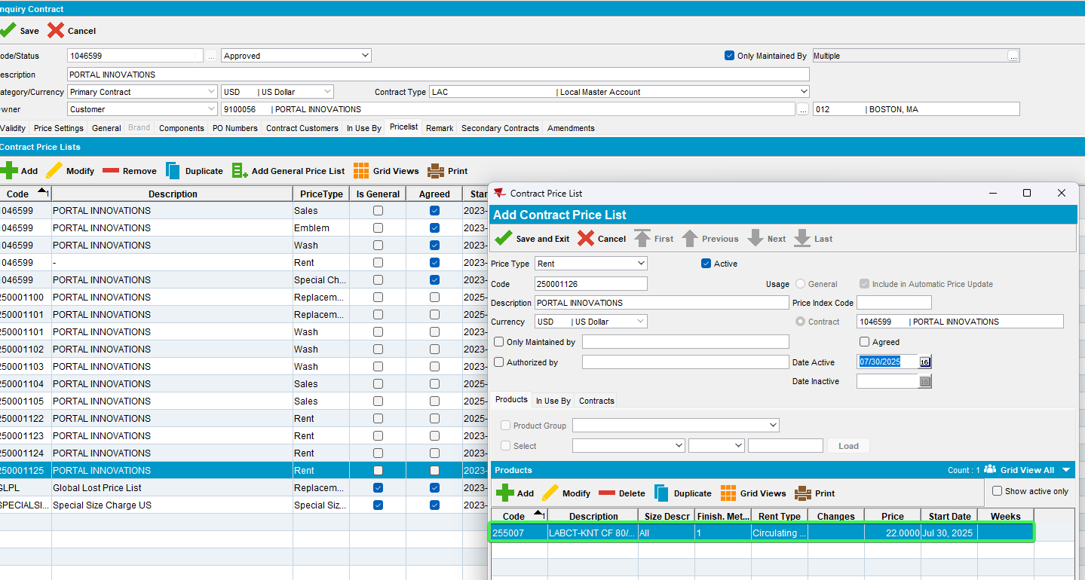
- In the future start date price
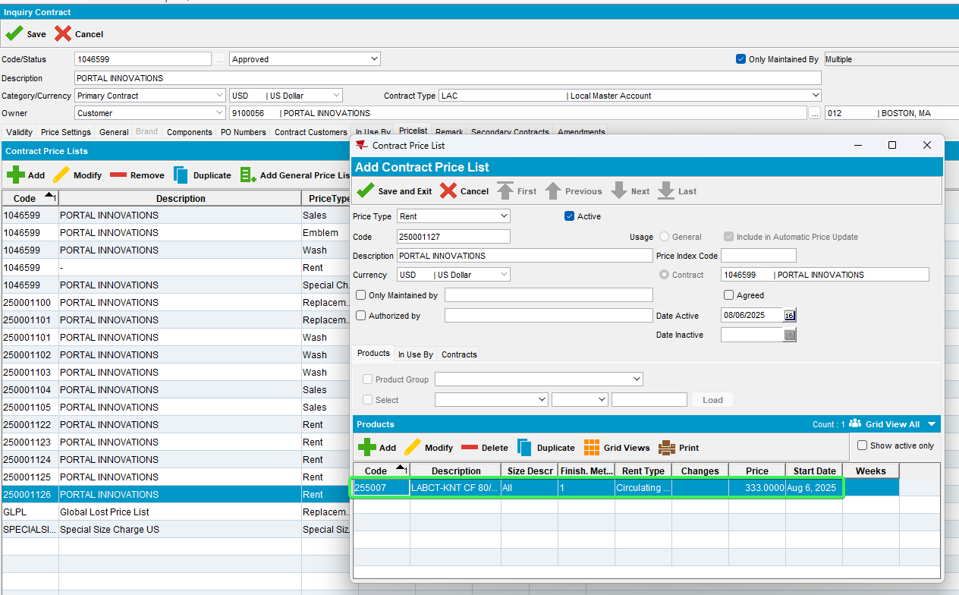

- Replace
- Older start date price
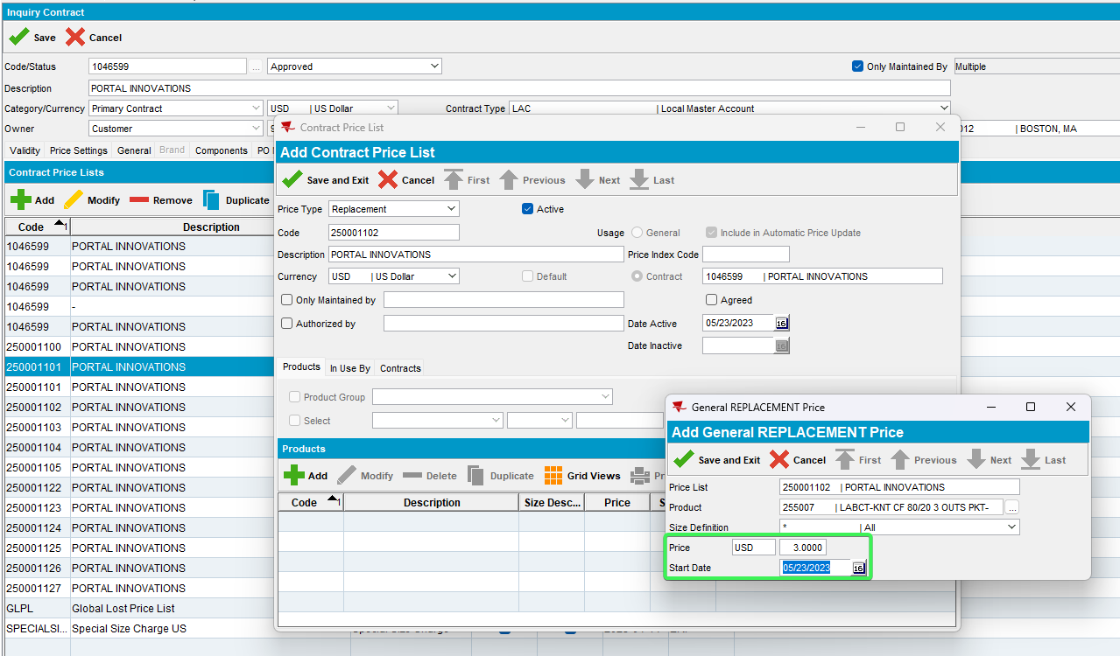
- Less older start date price put two digits price
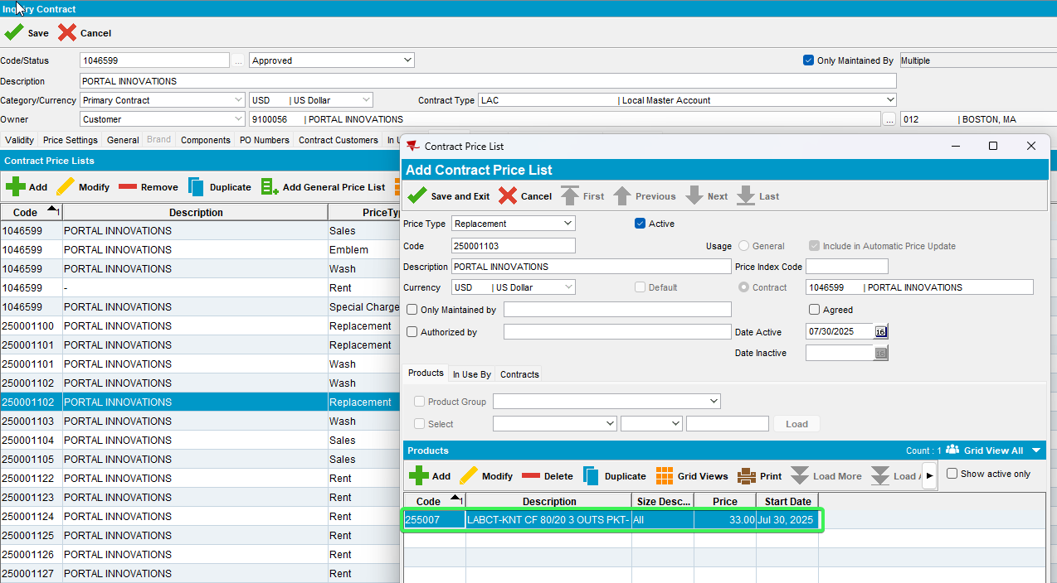
- In the future start date price
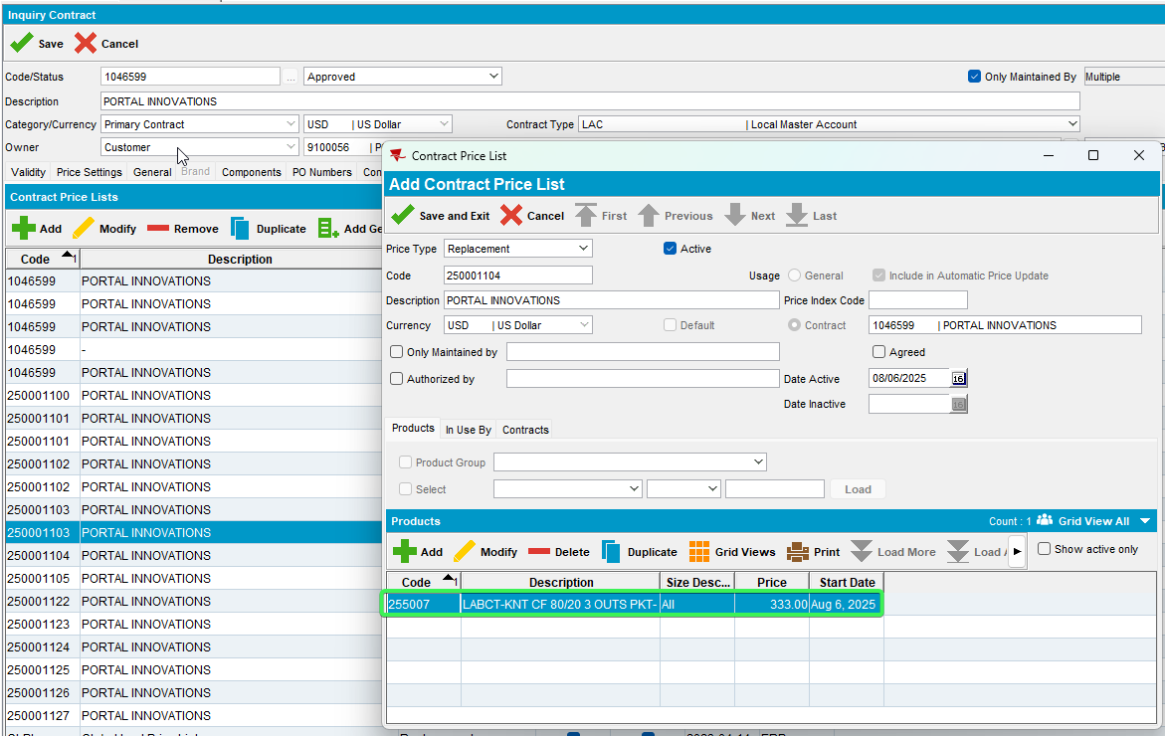
- Sales
- Older start date price
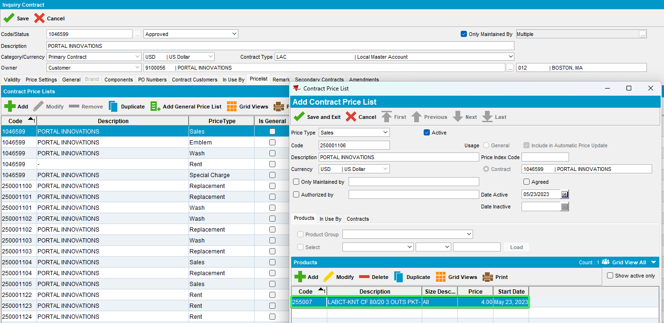
- Less older start date price put two digits price
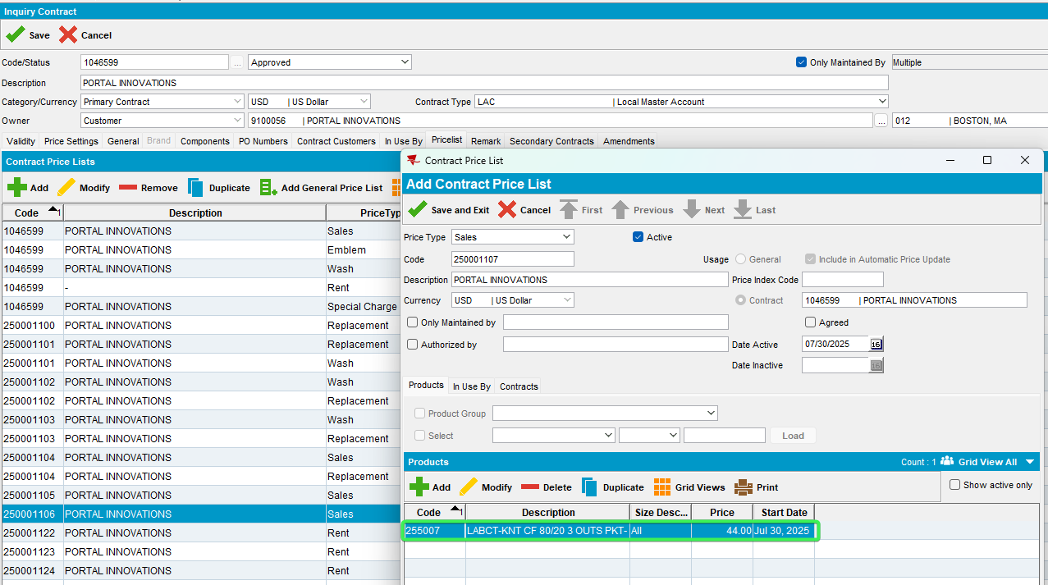
- In the future start date price
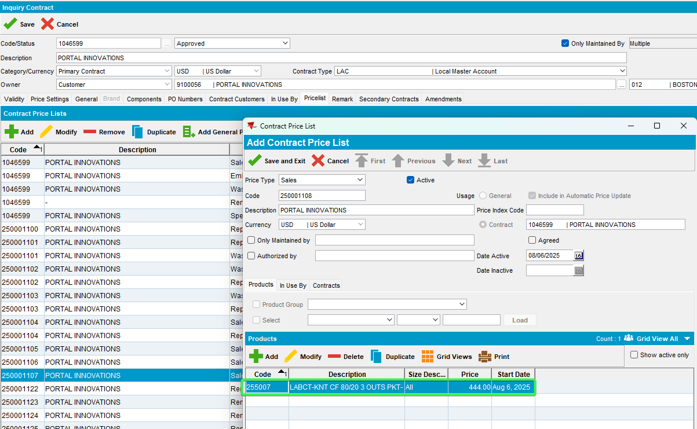
- Wash price – add the same product with different Billing Method 4 to add wash price. Release
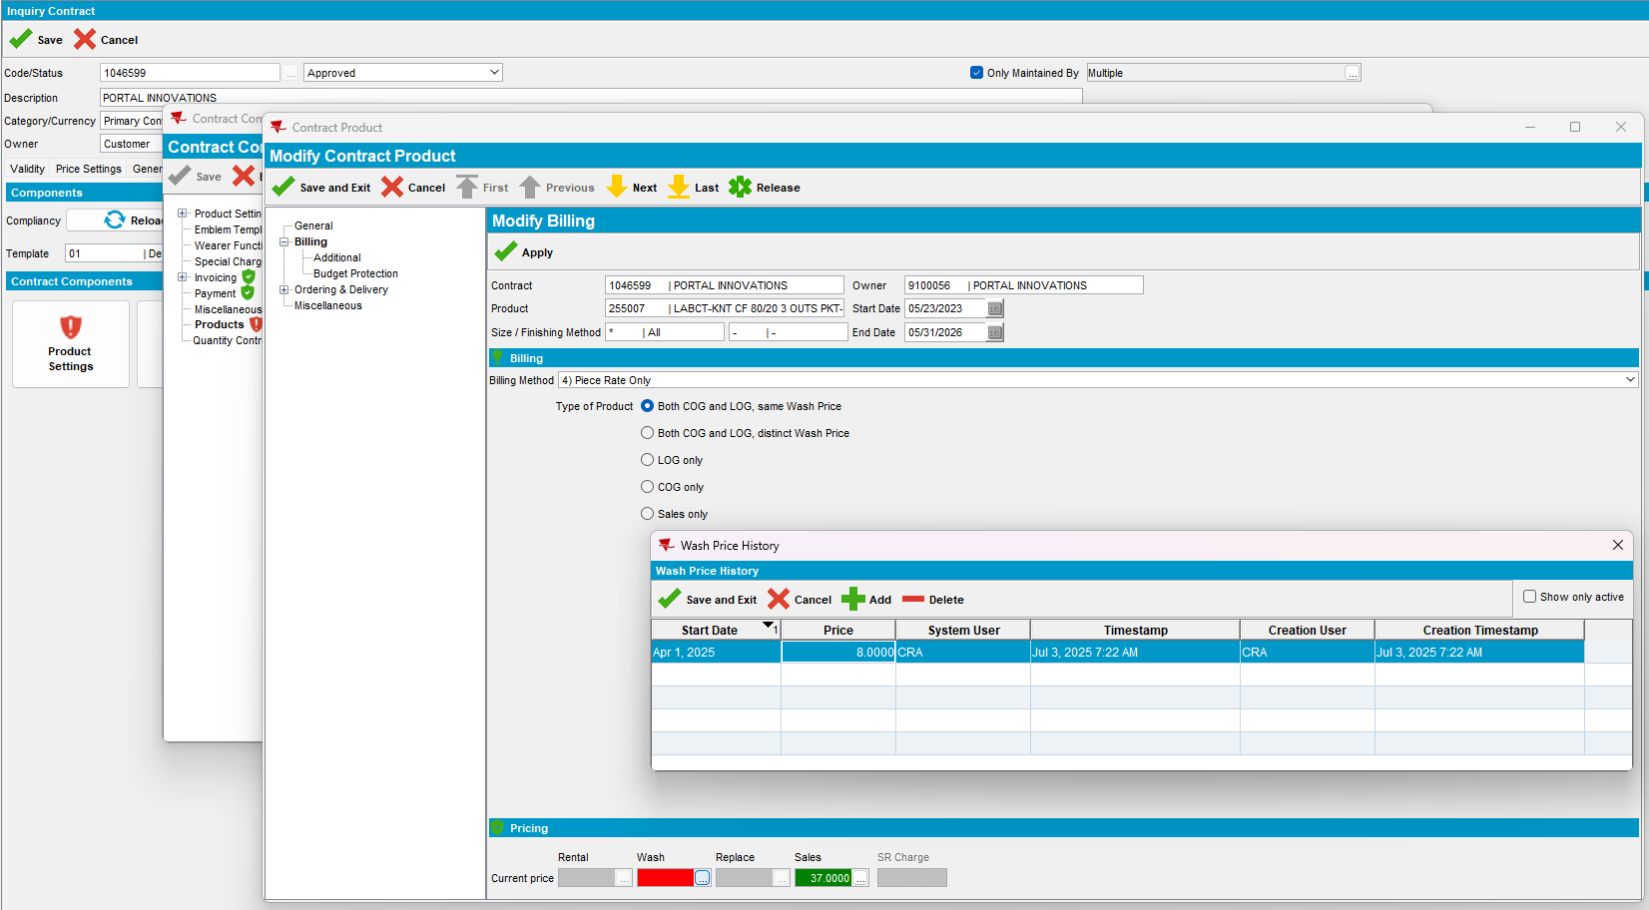

Price Lists add the wash price.

- Old start date price
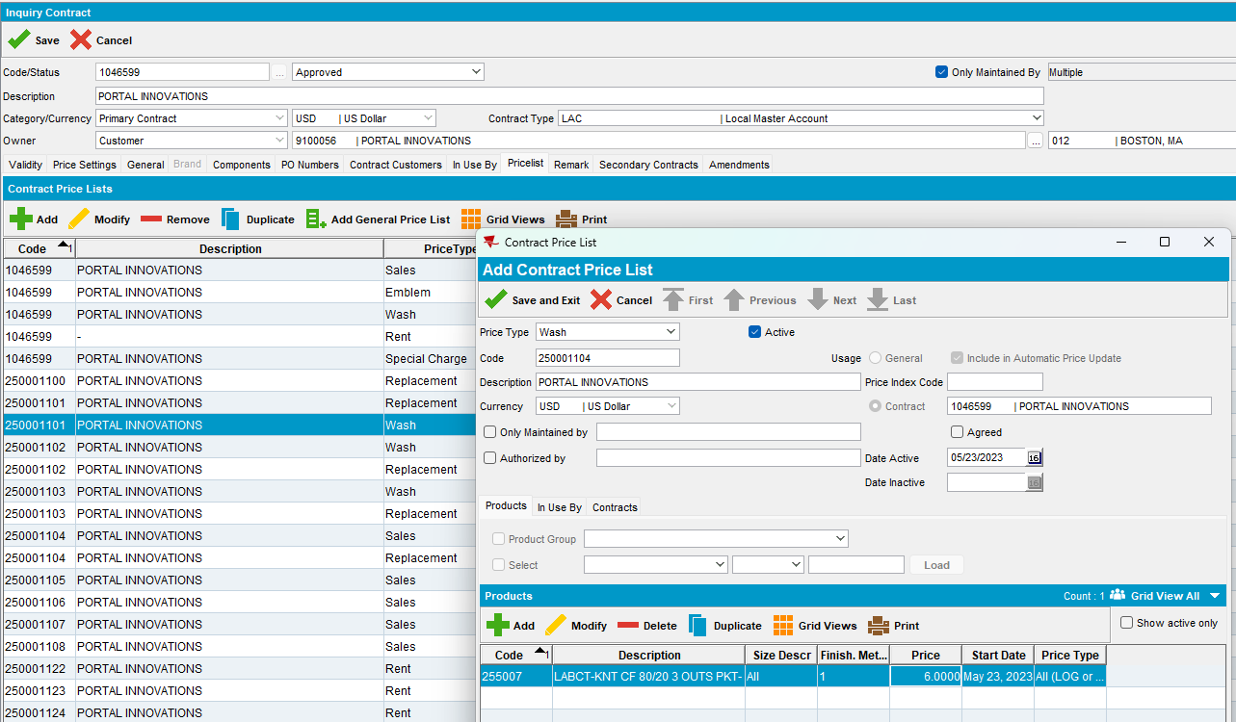
- Less older start date price put two digits price
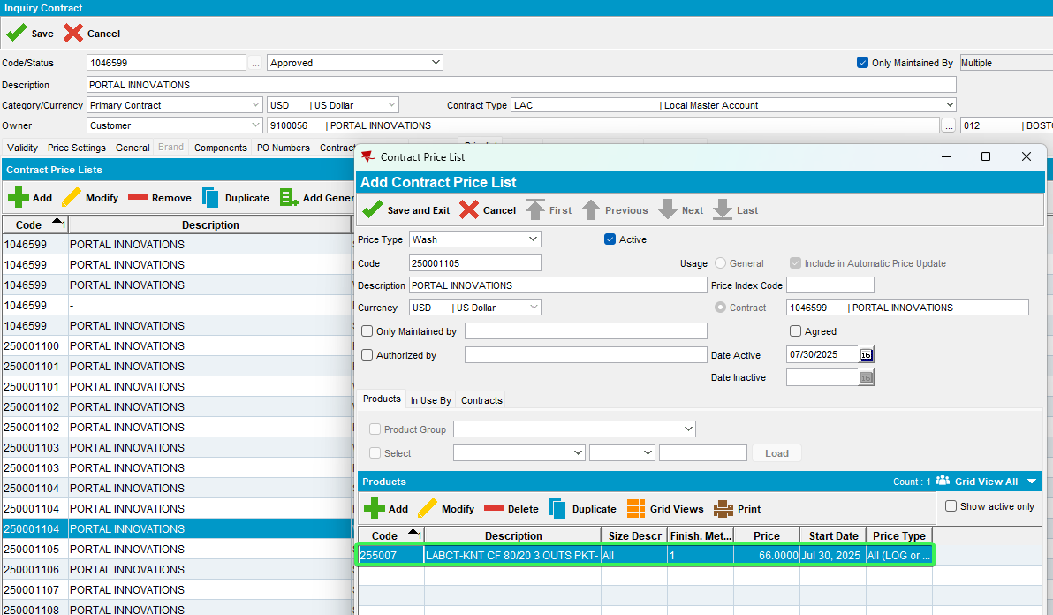
- Future start date price
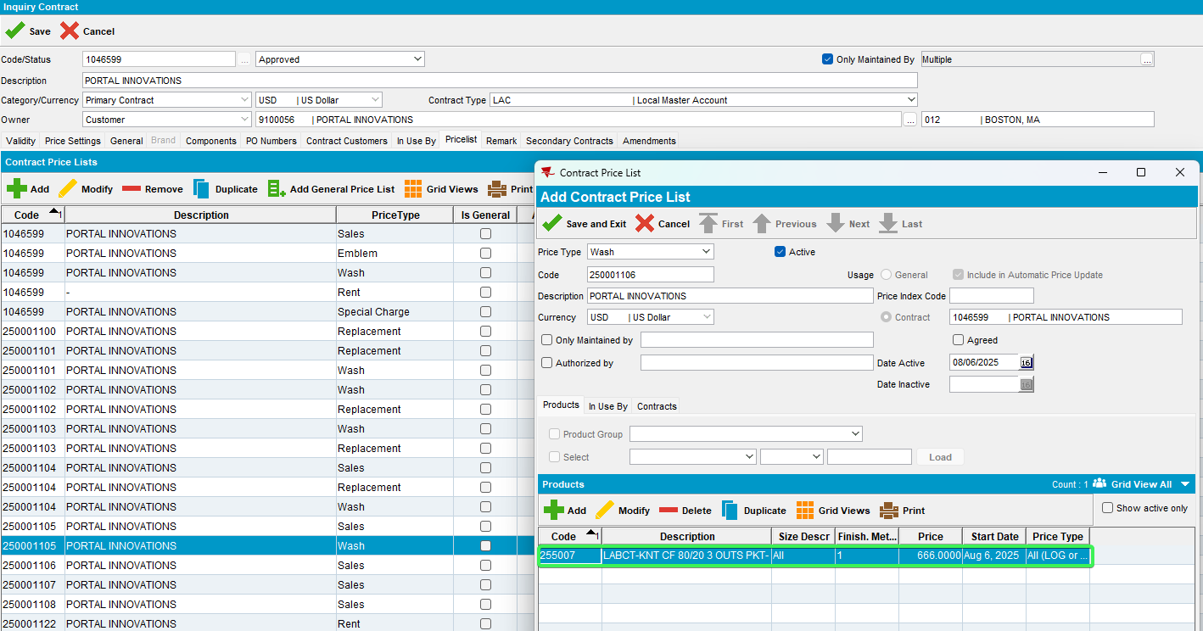

- RSC dlg: Move out all the customers except our own.
- RSC dlg: Generate packing notes and generate invoices. Script the taxes
- Route Status Control DLG: Mark ready to transfer
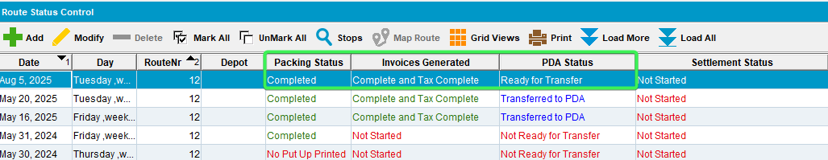
- RA: Download the route.
- Export the database from RA after download
- Save the RA database for future checks
Find the product_id of our product

select p.code, cp.finishingmethod_id, cp.contractproduct_id, p.product_id, c.* from contract c
join contractproduct cp on cp.contract_id = c.contract_id
join product p on p.product_id = cp.product_id
where c.code = '1046599'
and p.code = '255007';
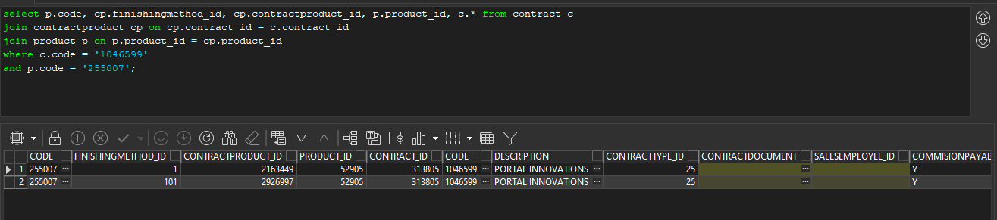

- Open the database dump from RA with SQLITE and select * from RSContractProdDTO where RSContractProdDTO.product_id = '52905';
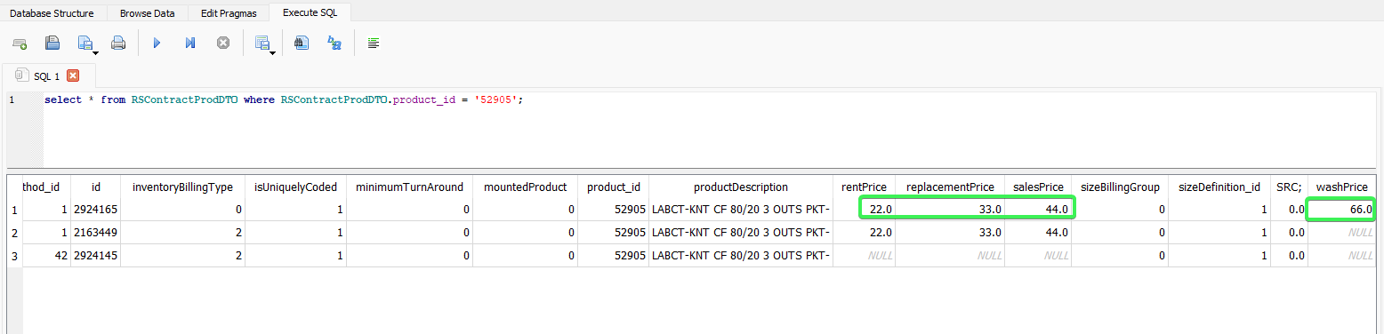

Currently the new prices with the two digits are taken into consideration which have the most recent start date.

Tested OK

