ABSN-6471 - Mark Customer for Internal Admin Usage
Environment | Prerequisites
Version: 9.09.02.RC1  DBServerName= abs-srv20.internal.abslbs.com  DBSID=CUST24  DBUser=UNFA  DBPassword= UNFA  Environment=Test | - Module:  - System setting

Contents
Test after Development 1
Test Case 1 – Check that Internal Customer for Admin Usage Check box is visible if SHOWINTERNALADMINCUSTOMER = 1 1
Test Case 2 – Check that Internal Customer for Admin Usage Check box is NOT visible if SHOWINTERNALADMINCUSTOMER = 0 3
Test Case 3 – Set “Full Access for all modes” to “Tab General - Internal Customer for Admin Usage” for your Access rights list 5
Test Case 4 – Set “Not Visible for all modes” to “Tab General - Internal Customer for Admin Usage” for your Access rights list 10
Test Case 5 – Set “Read Only for Modify only / Full access for Add” to “Tab General - Internal Customer for Admin Usage” for your Access rights list 14

Test after Development

Test Case 1 – Check that Internal Customer for Admin Usage Check box is visible if SHOWINTERNALADMINCUSTOMER = 1
Hash: 571b9d1c8c78
Expected: " Internal Customer for Admin Usage " checkbox should be present
- System Settings DLG: Have SHOWINTERNALADMINCUSTOMER = 1 (True)
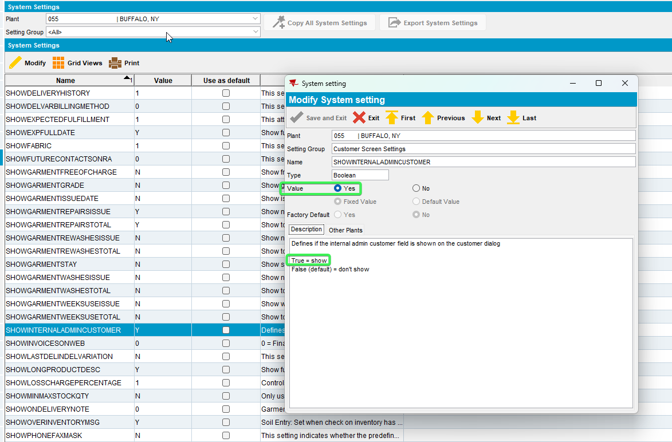
- Customer DLG: Input a customer and notice " Internal Customer for Admin Usage" checkbox is present
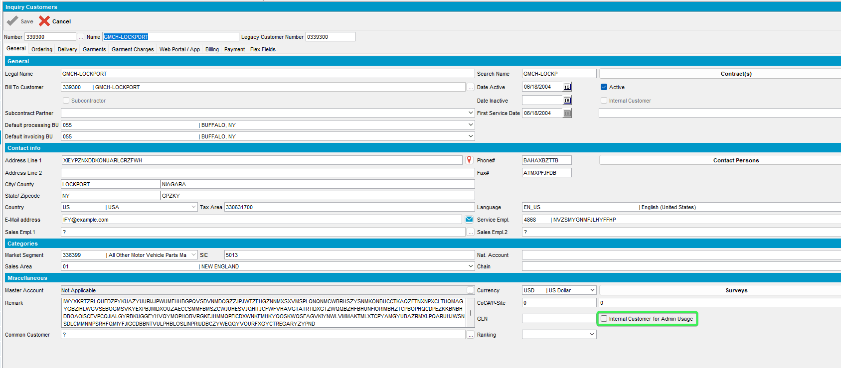
- Switchboard: Open the customer and check that " Internal Customer for Admin Usage" checkbox is present
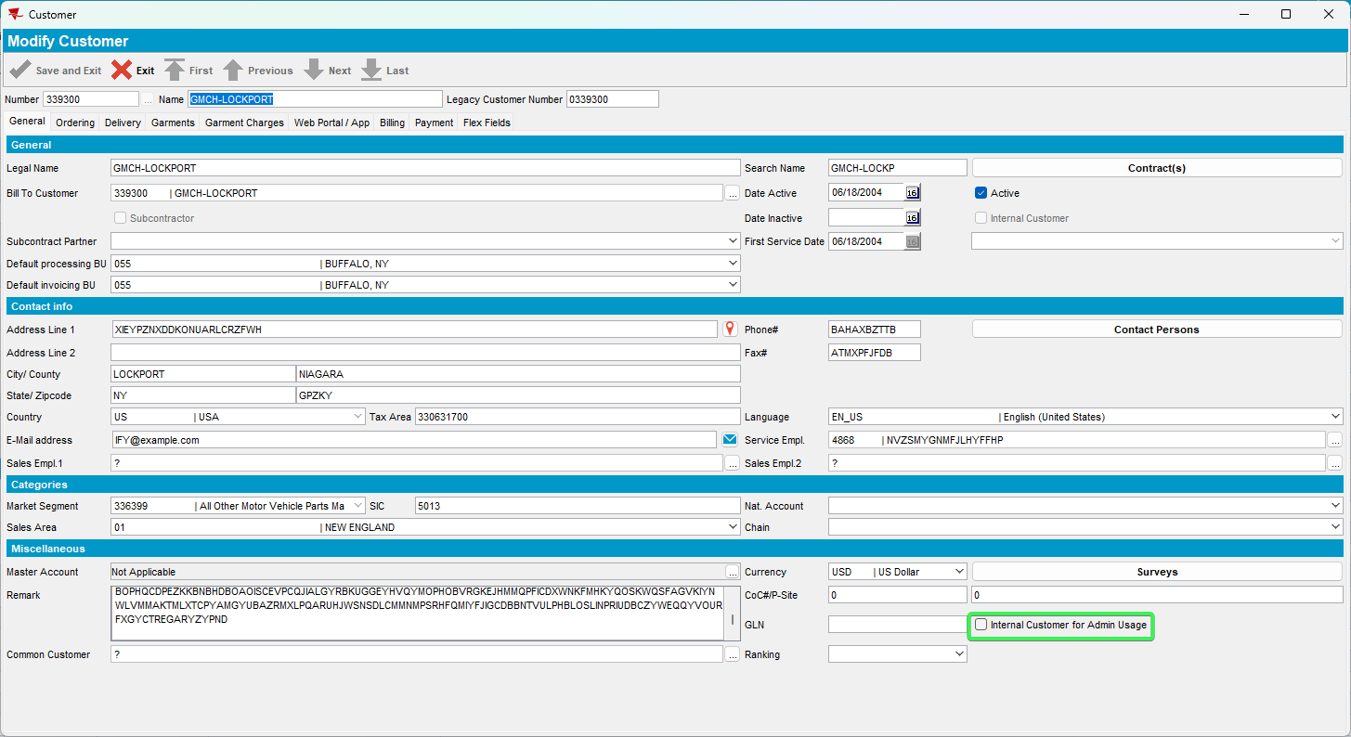
Tested OK

Test Case 2 – Check that Internal Customer for Admin Usage Check box is NOT visible if SHOWINTERNALADMINCUSTOMER = 0
Hash: 571b9d1c8c78
Expected: " Internal Customer for Admin Usage" checkbox should not be present
- System Settings DLG: Have SHOWINTERNALADMINCUSTOMER = 0 (false)
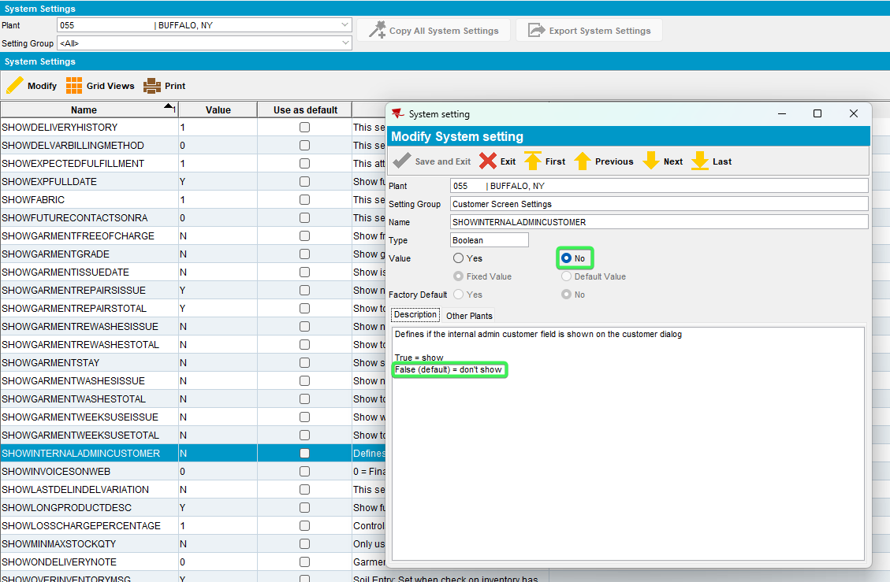
- Customer DLG: Input a customer and notice " Internal Customer for Admin Usage" checkbox is NOT present
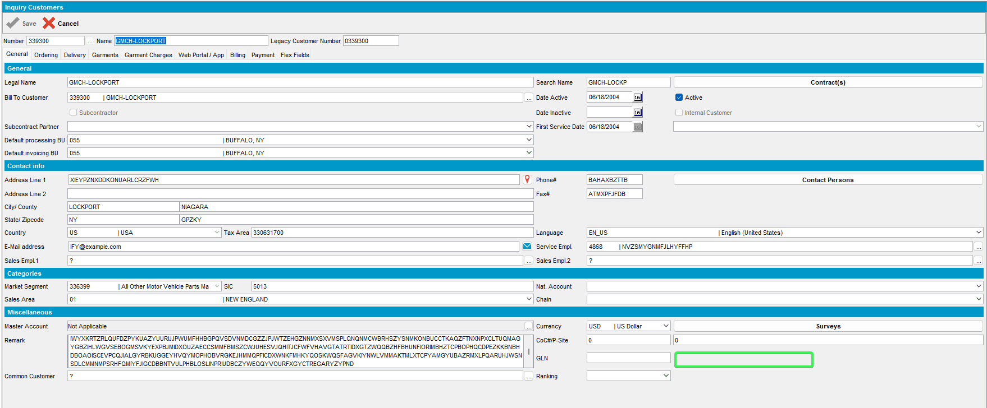
- Switchboard: Open the customer and check that " Internal Customer for Admin Usage" checkbox is NOT present
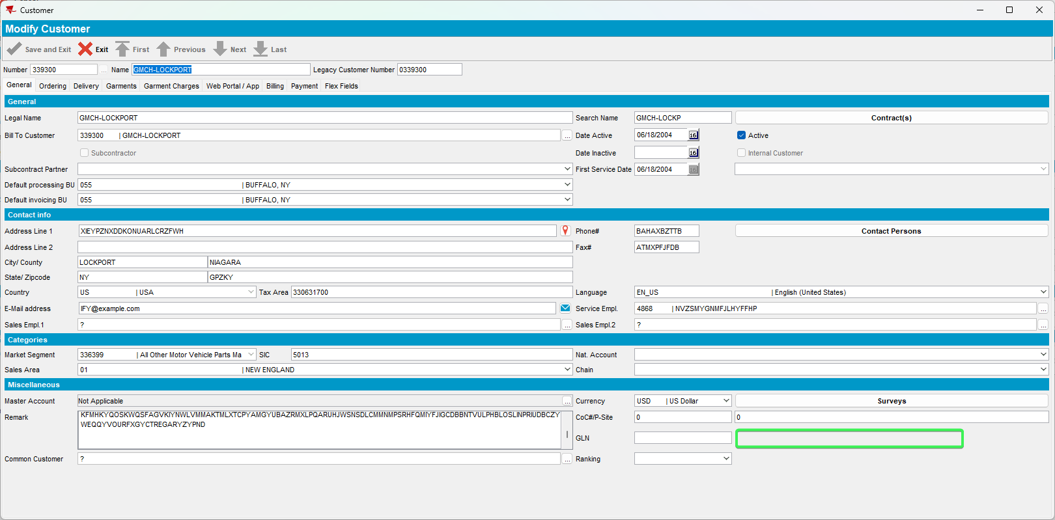
Tested OK

Test Case 3 – Set “Full Access for all modes” to “Tab General - Internal Customer for Admin Usage” for your Access rights list
Hash: 571b9d1c8c78
Expected: “Internal Customer for Admin Usage” checkbox is visible and active
- System Settings DLG: Have SHOWINTERNALADMINCUSTOMER = 1 (true)
- System Users DLG: press modify on your system user and go to Access Rights
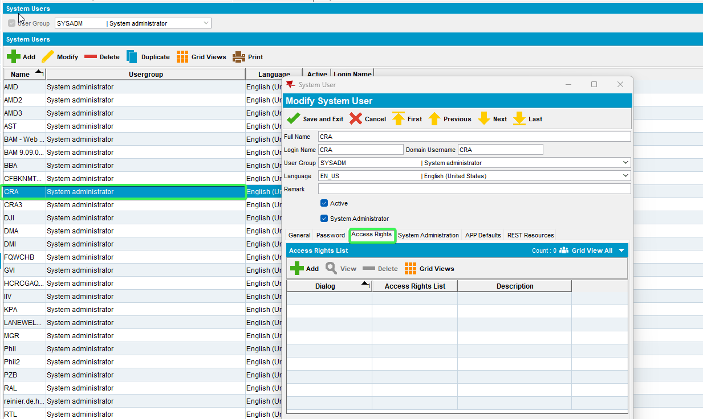
- Add Dialog Customers > All other System Users list
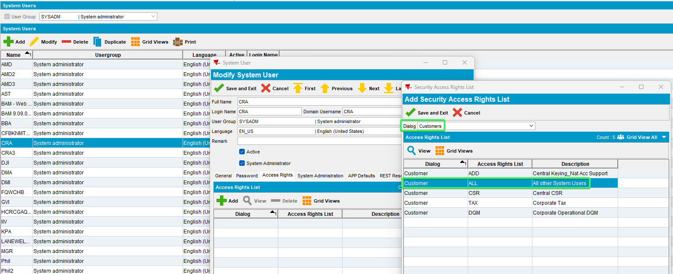
- Maintain Access Rights List DLG: press Modify for list “All Other system Users”
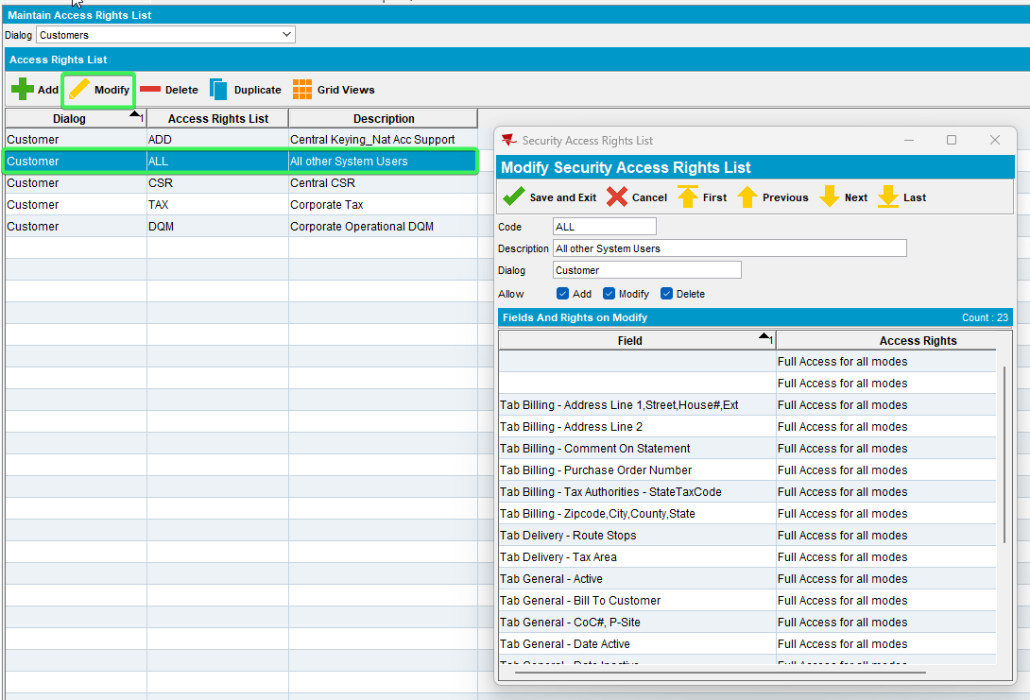
- Set “Tab General - Internal Customer for Admin Usage” as “Full Access for all modes”
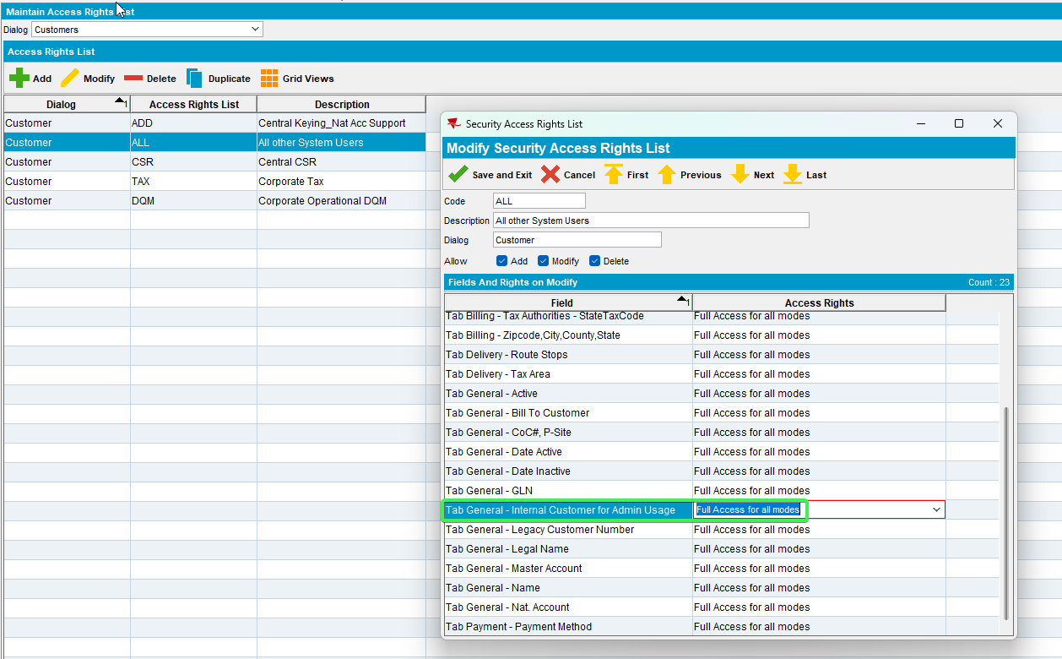
- Customers DLG: Input a customer and press modify
- See that the Internal Customer for Admin Usage Checkbox is active and functional
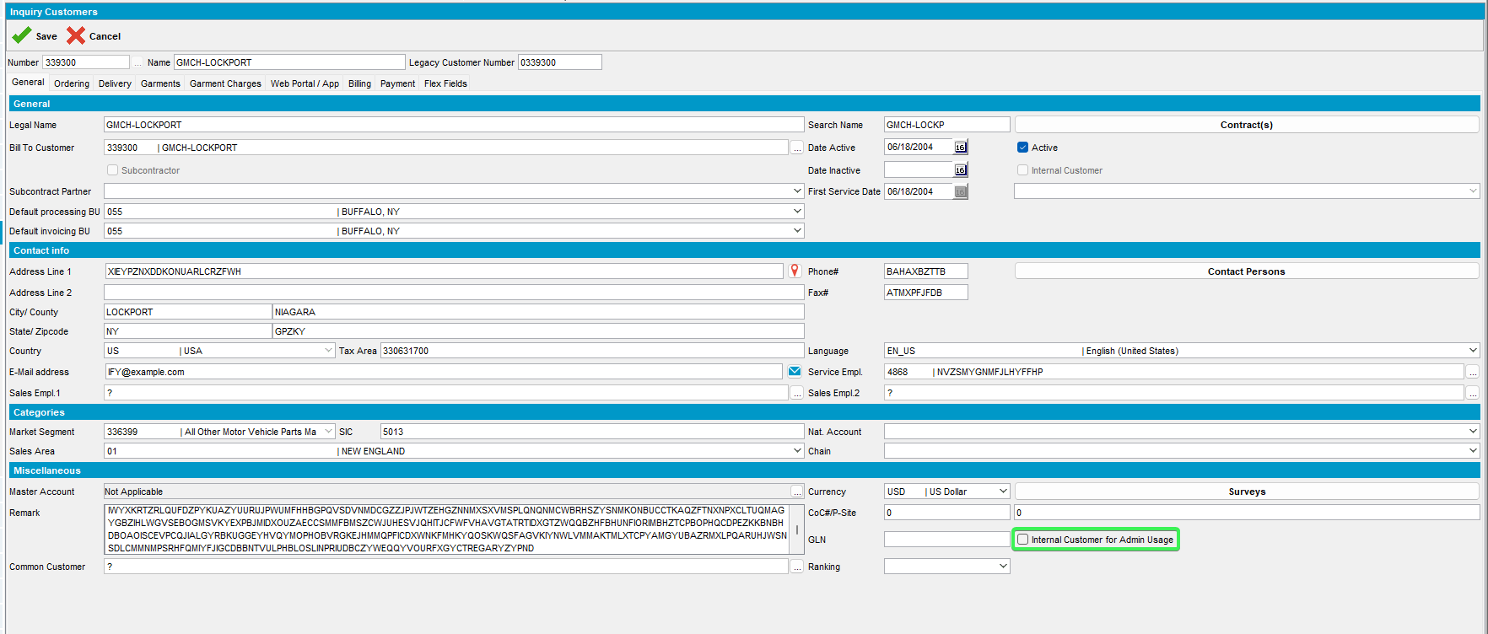
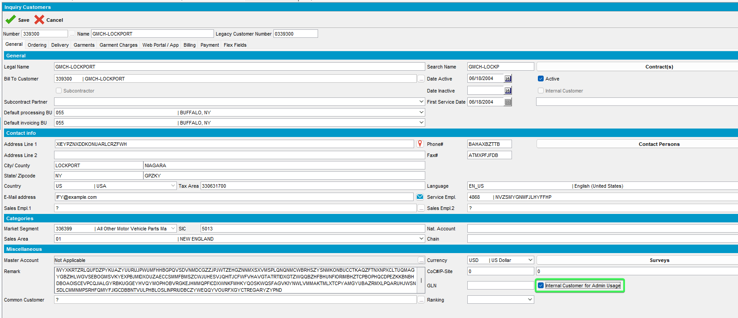
- Save the changes and see that it persists
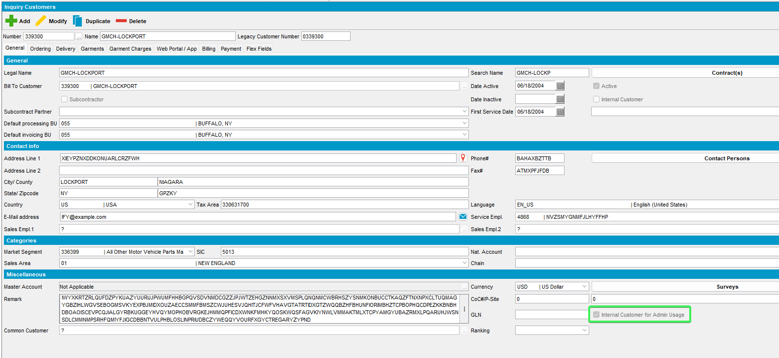
- Switchboard: See that the Internal Customer for Admin Usage Checkbox is active and functional
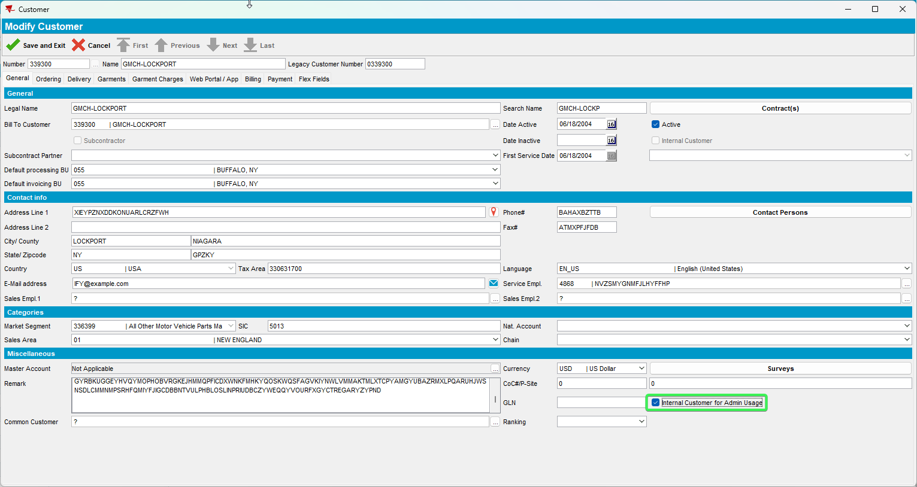
Tested OK

Test Case 4 – Set “Not Visible for all modes” to “Tab General - Internal Customer for Admin Usage” for your Access rights list
Hash: 571b9d1c8c78
Expected: “Internal Customer for Admin Usage” checkbox is NOT visible
- System Settings DLG: Have SHOWINTERNALADMINCUSTOMER = 1 (true)
- System Users DLG: press modify on your system user and go to Access Rights
- Add Dialog Customers > All other System Users list
- Maintain Access Rights List DLG: press Modify for list “All Other system Users”
- Set “Tab General - Internal Customer for Admin Usage” as “Not Visible for all modes”
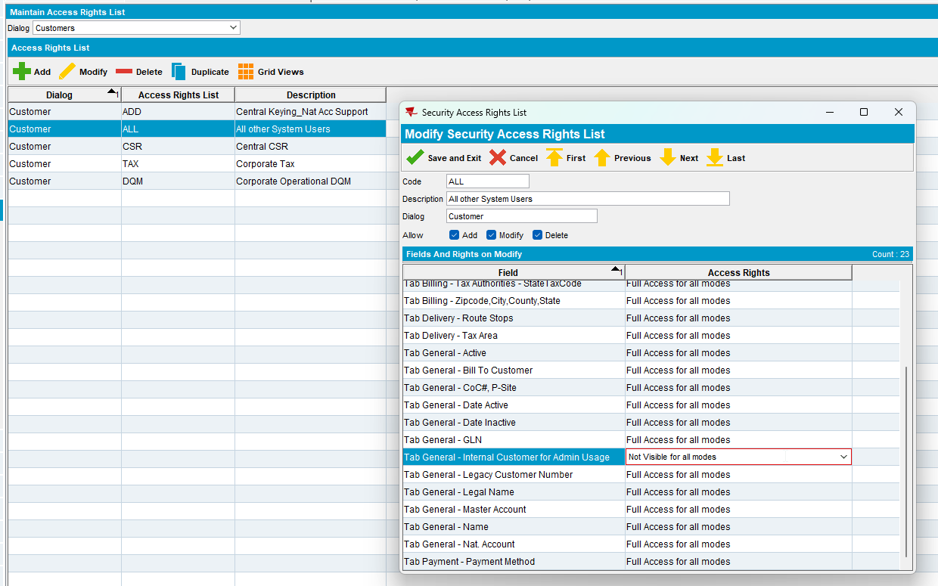
- Customers DLG: Input a customer and press modify
- See that the Internal Customer for Admin Usage Check box is not visible
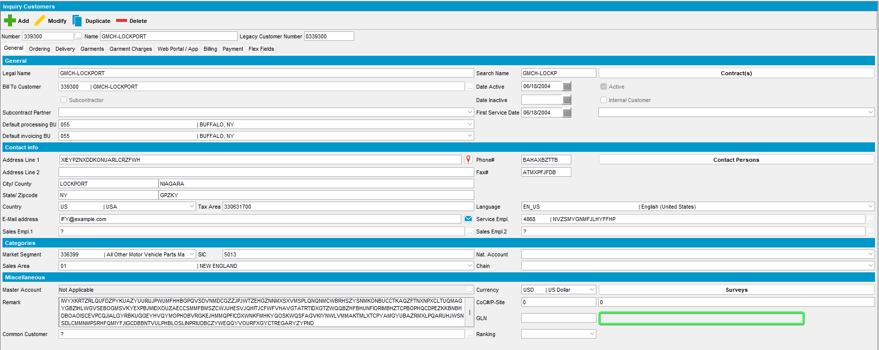
- Switchboard: Input your customer and see that the Internal Customer for Admin Usage Checkbox is not visible
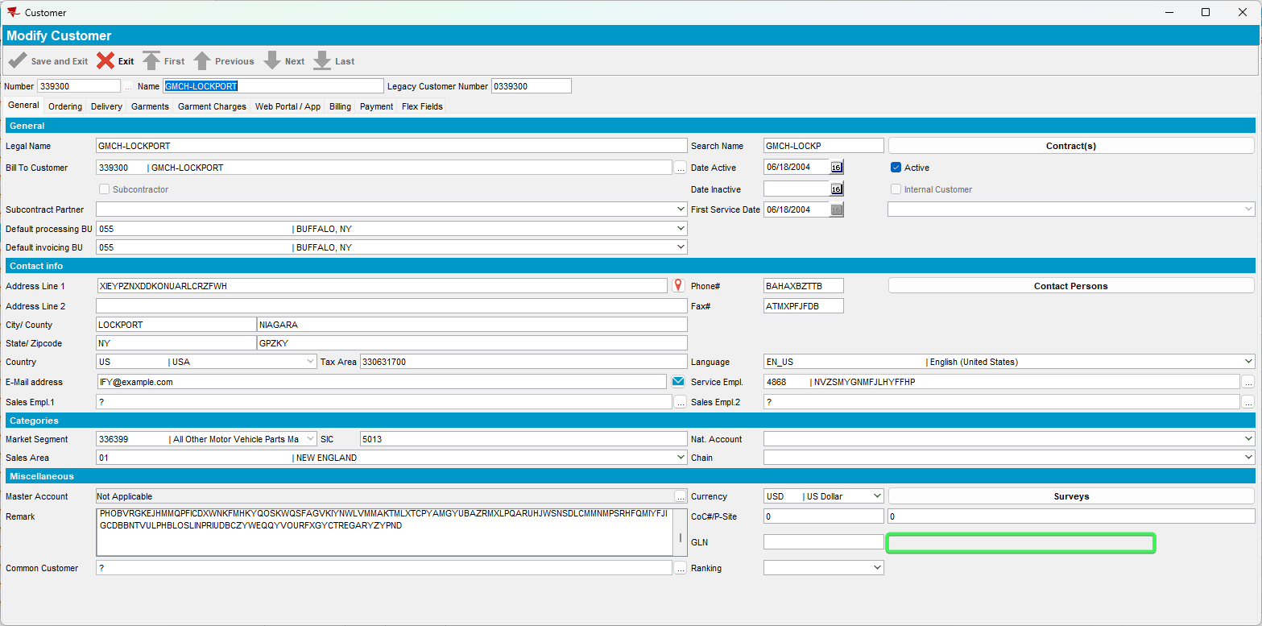

Test Case 5 – Set “Read Only for Modify only / Full access for Add” to “Tab General - Internal Customer for Admin Usage” for your Access rights list
Hash: 571b9d1c8c78
Expected: “Internal Customer for Admin Usage” checkbox is visible but not active when modifying an existing customer
And visible and active when adding a new customer.
- System Settings DLG: Have SHOWINTERNALADMINCUSTOMER = 1 (true)
- System Users DLG: press modify on your system user and go to Access Rights
- Add Dialog Customers > All other System Users list
- Maintain Access Rights List DLG: press Modify for list “All Other system Users”
- Set “Tab General - Internal Customer for Admin Usage” as “Read Only for Modify only / Full access for Add”
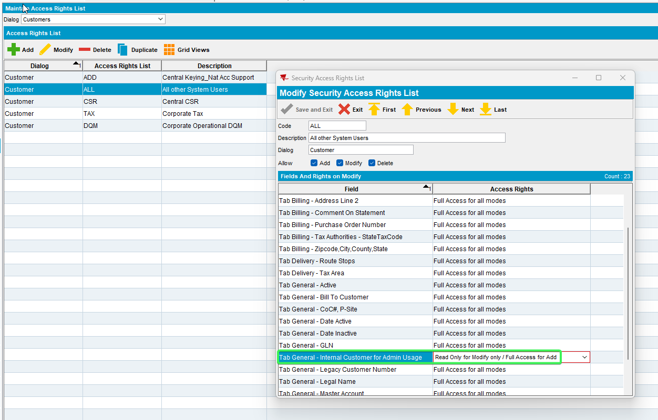
- Customers DLG: Input a customer and press modify > See that “Internal Customer for Admin Usage” checkbox is visible and disabled
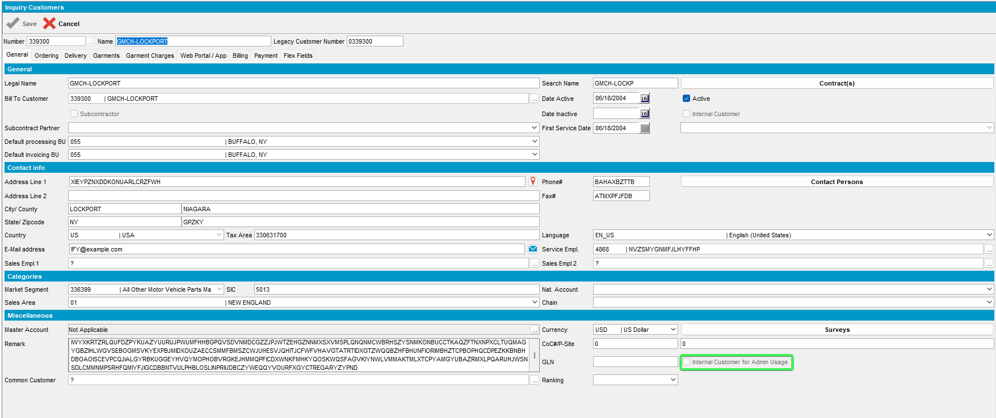
- Customers DLG: Press Add button in order to add a new customer > See that “Internal Customer for Admin Usage” checkbox is visible and enabled
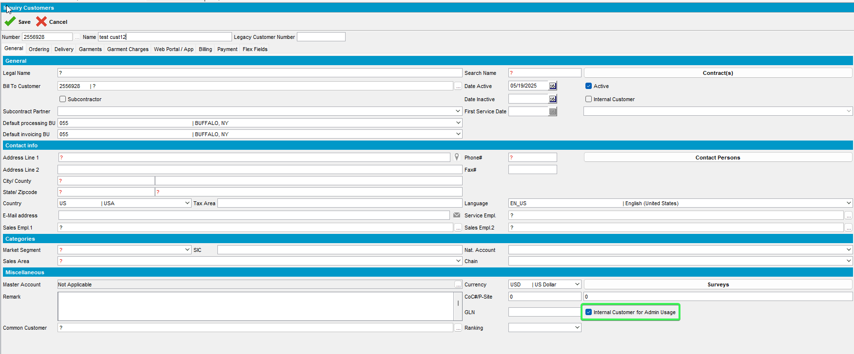
- Switchboard: Look for a customer and see that the “Internal Customer for Admin Usage” checkbox is visible and disabled
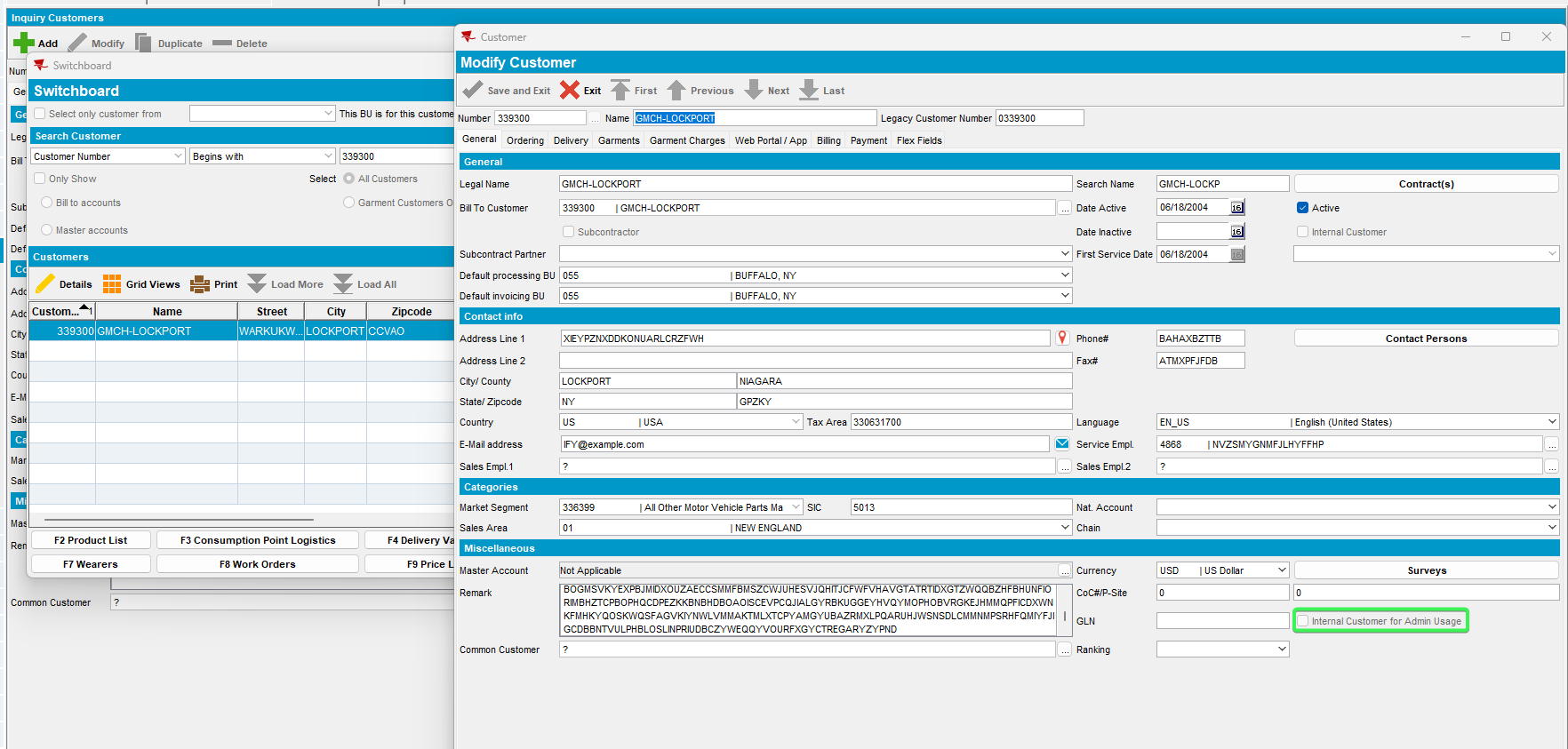
Tested OK

