ABSN-6301 D_UBS_2693 Autosoil is turned on for products that do not allow Autosoil when a contract component with Soil Counted Method checked is updated to the customer
Environment | Prerequisites
Version:9.07.00  DBServerName=abs-SRV20.internal.abslbs.com  DBSID=CUST24  DBUser=UNFDEV  Environment=Test | - Module:  - System setting

Contents
Reproducing before fix 2
Steps to reproduce 2
Current Behavior 5
Expected behavior 5
Test after fix 5
Test Case 1 – Autosoil Percentage with UNFCUSTOM – Tested OK 5
Test Case 2 – Autosoil Quantity with UNFCUSTOM – Tested OK 11
Test Case 3 – Autosoil Percentage without UNFCUSTOM – Tested OK 16
Test Case 4 – Autosoil Quantity without UNFCUSTOM – Tested OK 20

Reproducing before fix

Steps to reproduce
- Have in PLPC a product(non garment) with autosoil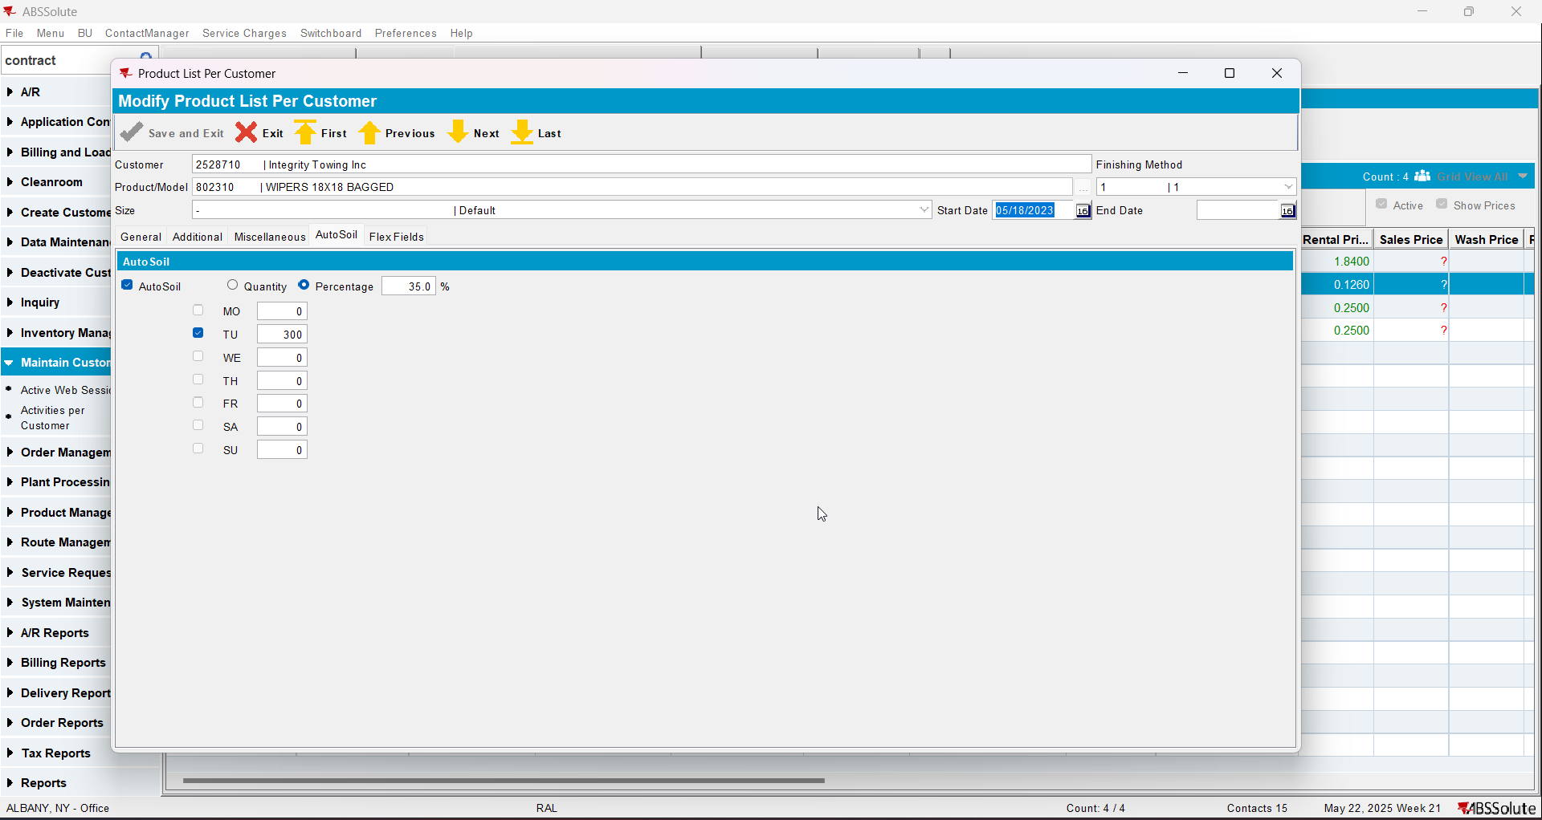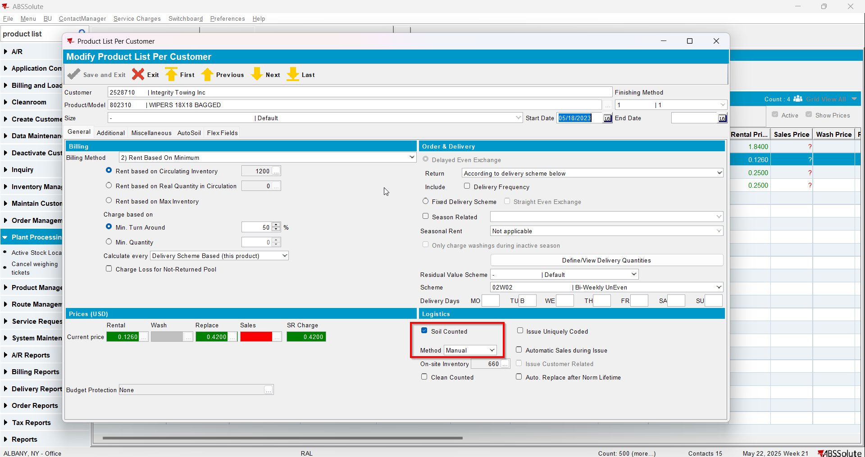
- Check that the product has autosoil checked also on contract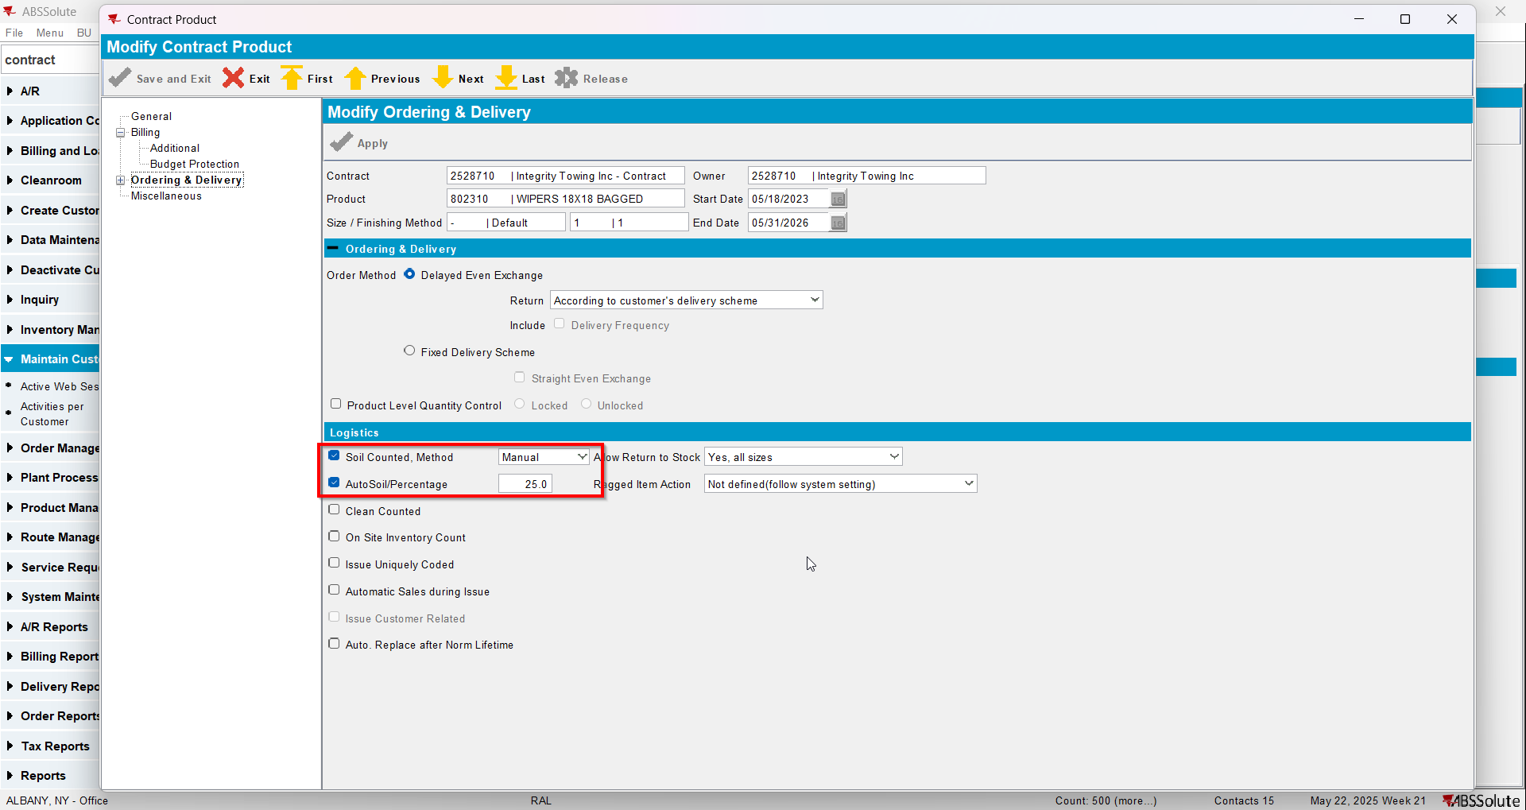
- Go to Product dlg and load your product
- Check that it has Allow Autosoil checked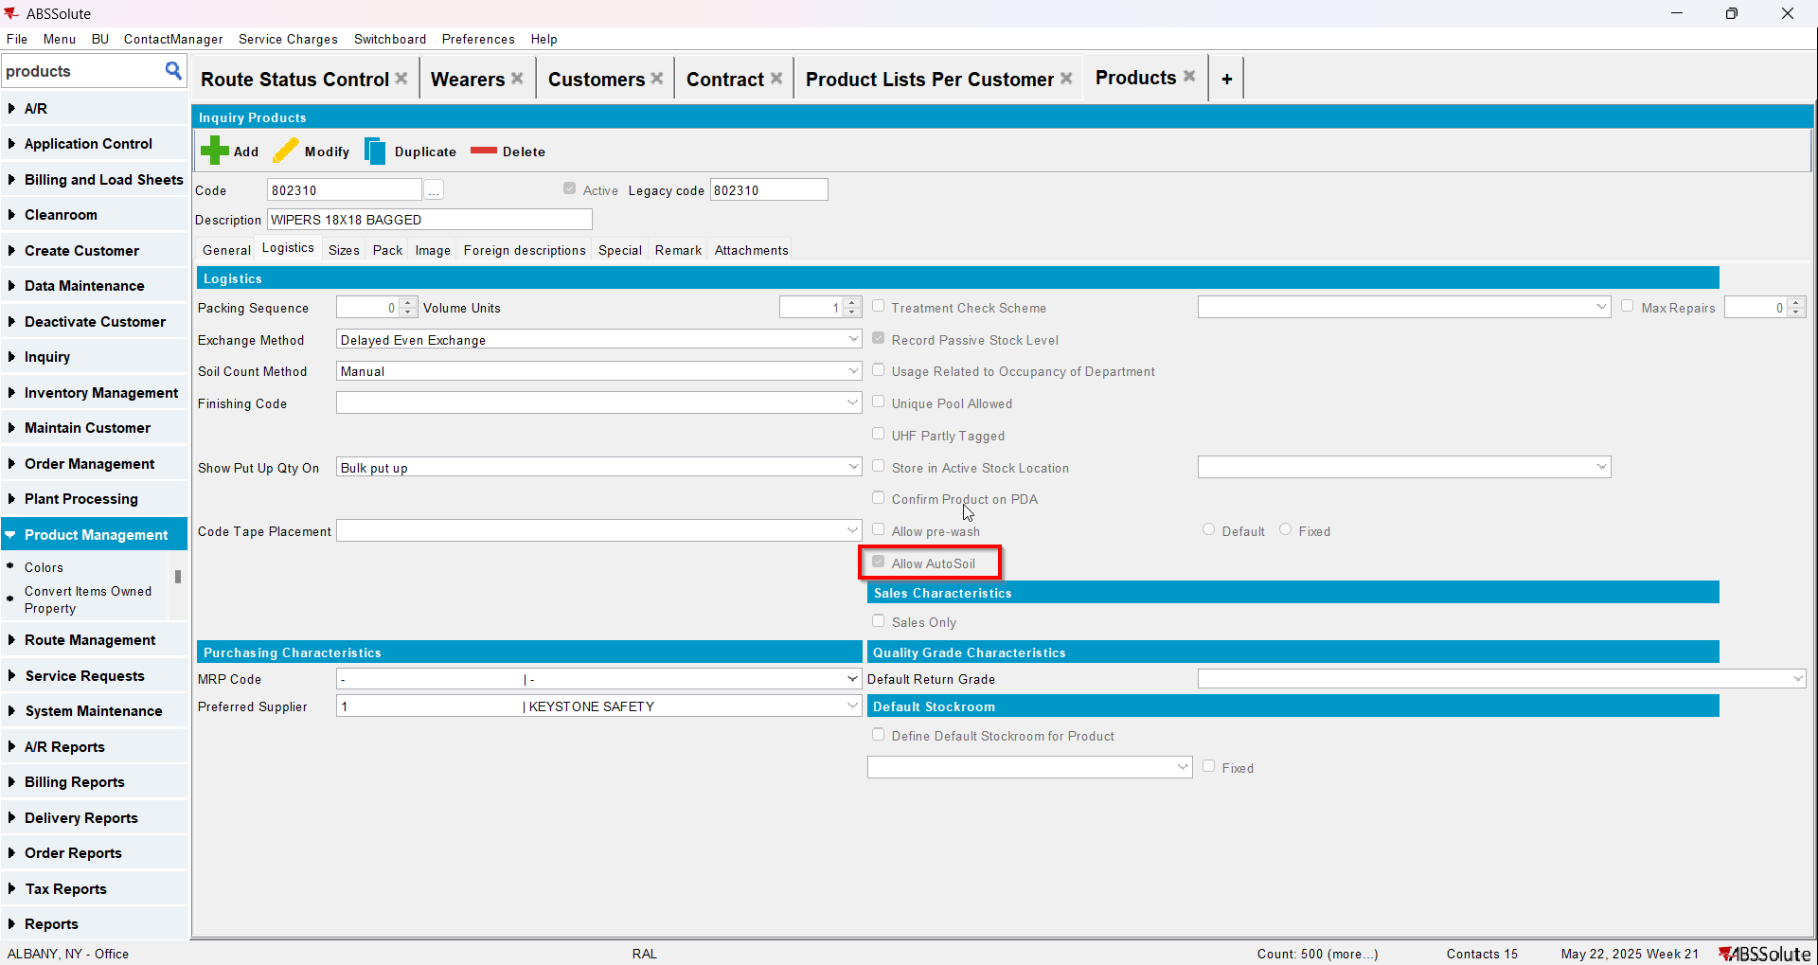
- Uncheck Allow Autosoil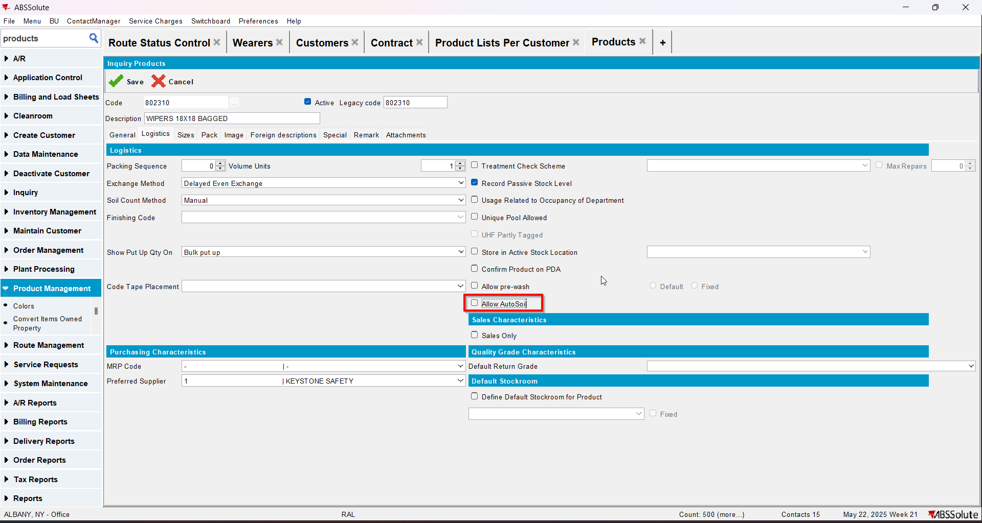
- Check in PLPC that now your product has Autosoil tab disabled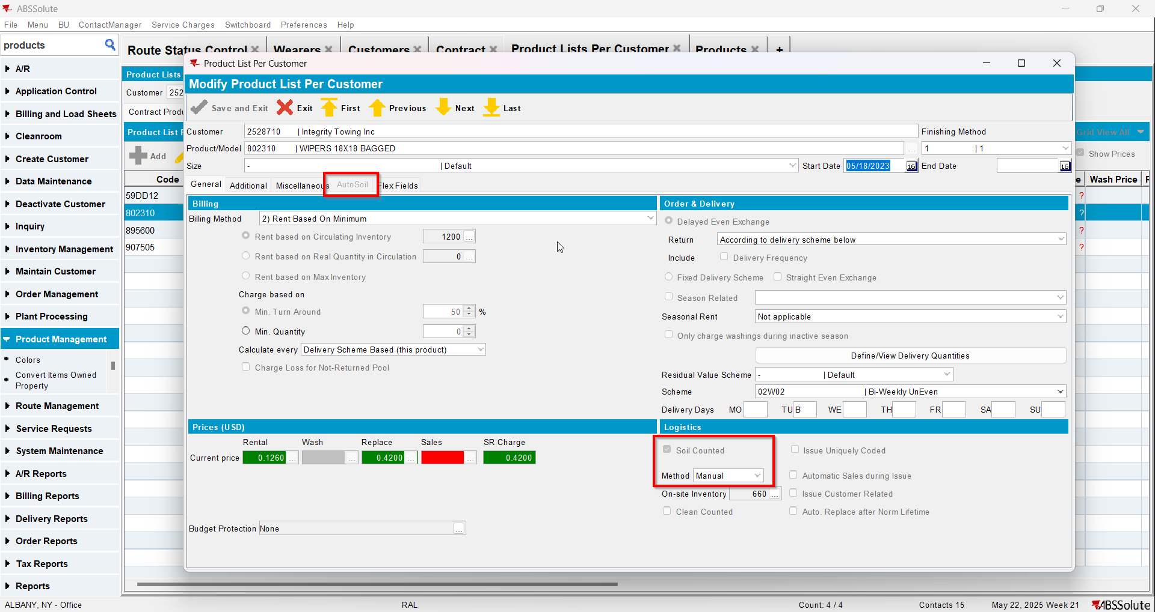
- Check in contract that your product now is missing the Autosoil checkbox field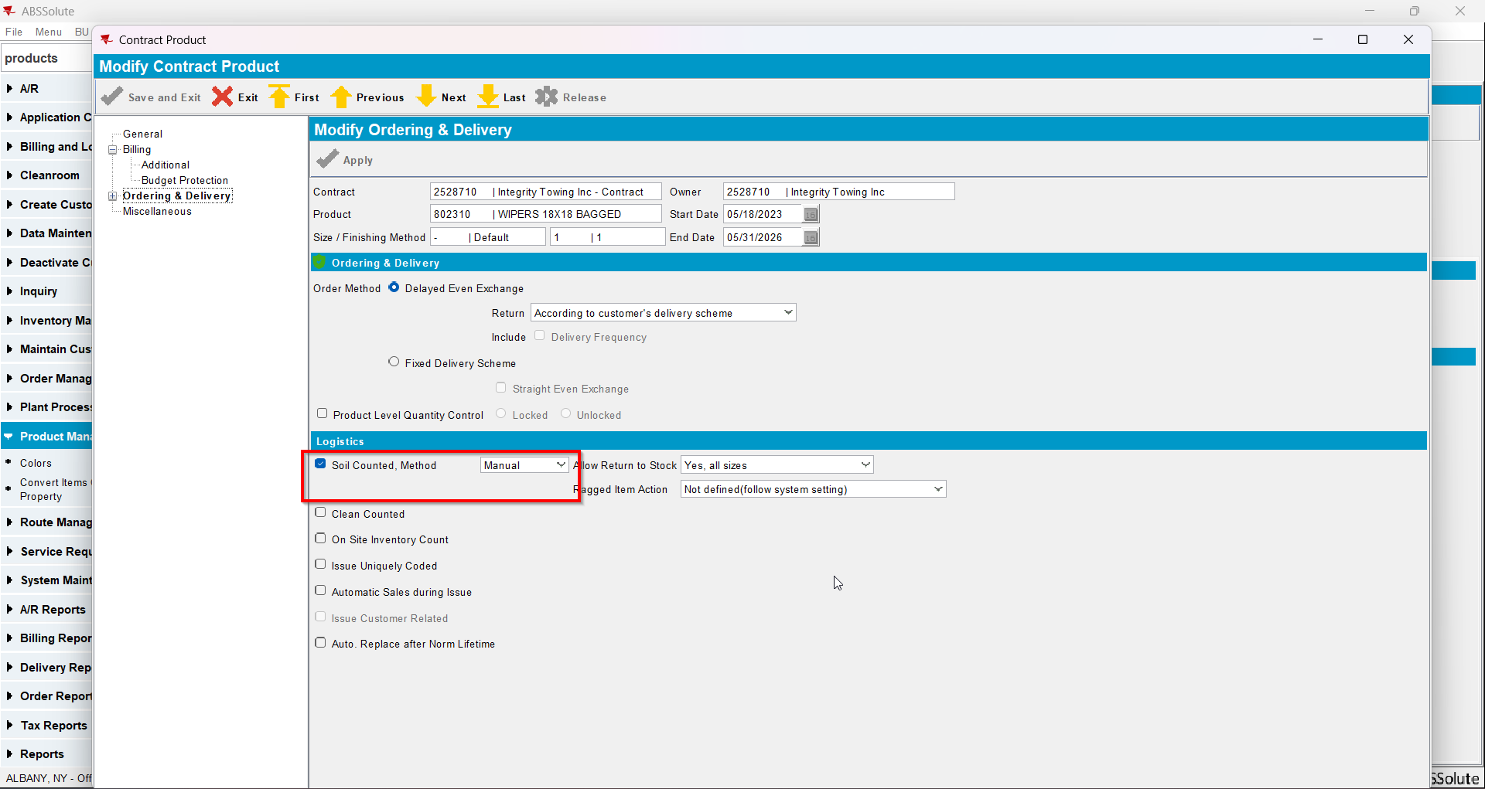
- Check in database the value of Autosoil for your product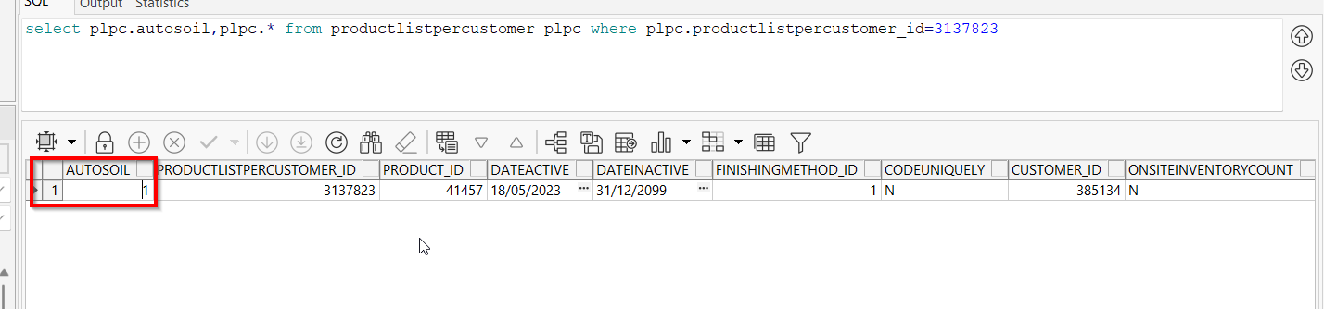
REPRODUCED OK.

Current Behavior
Autosoil is not changed in database.

Expected behavior
Autosoil should become 0.

Test after fix

Test Case 1 – Autosoil Percentage with UNFCUSTOM – Tested OK
Expected behavior: when unchecking Allow Autosoil for a product in Products dlg a message should appear saying “You disabled AutoSoil on this product, this will also remove AutoSoil for all contracts and customers using this product, are you sure you want to do this?”. Unchecking should also change autosoil to 0 for that PLPC
Hash: 6304d8e
- Check that you have UNFCUSTOM in license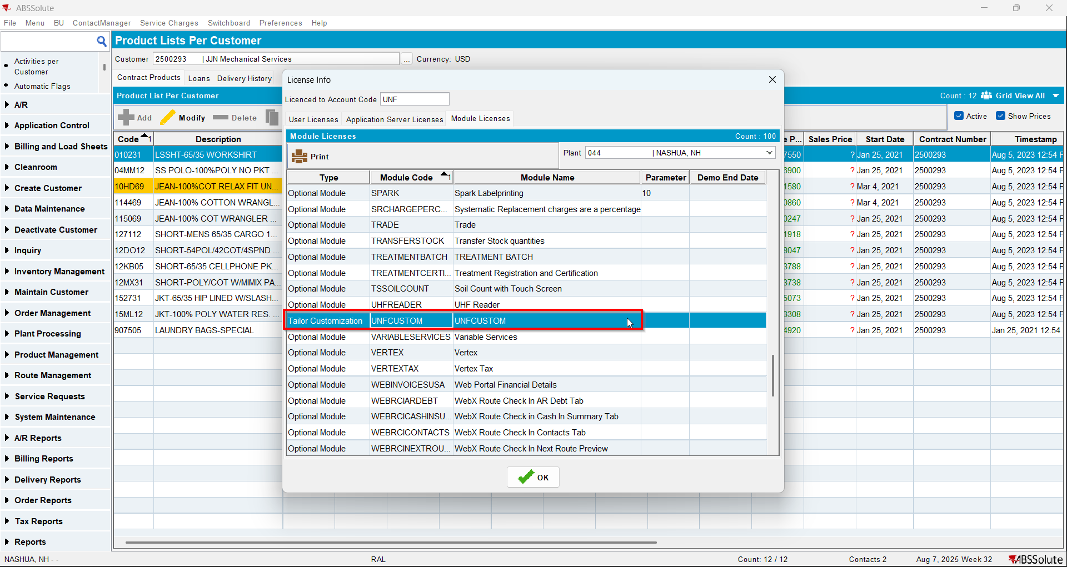
- Have in PLPC a product(non garment) with autosoil=1(percentage)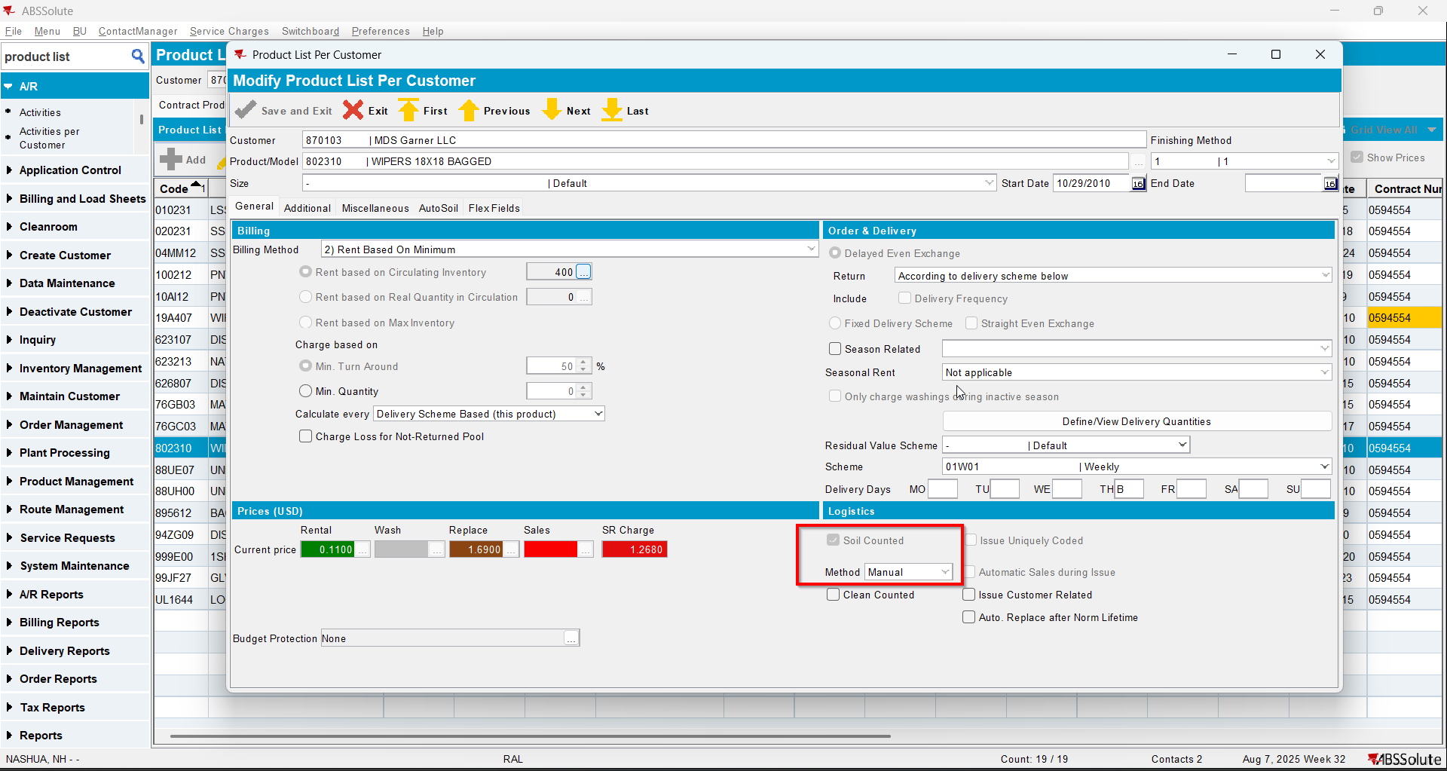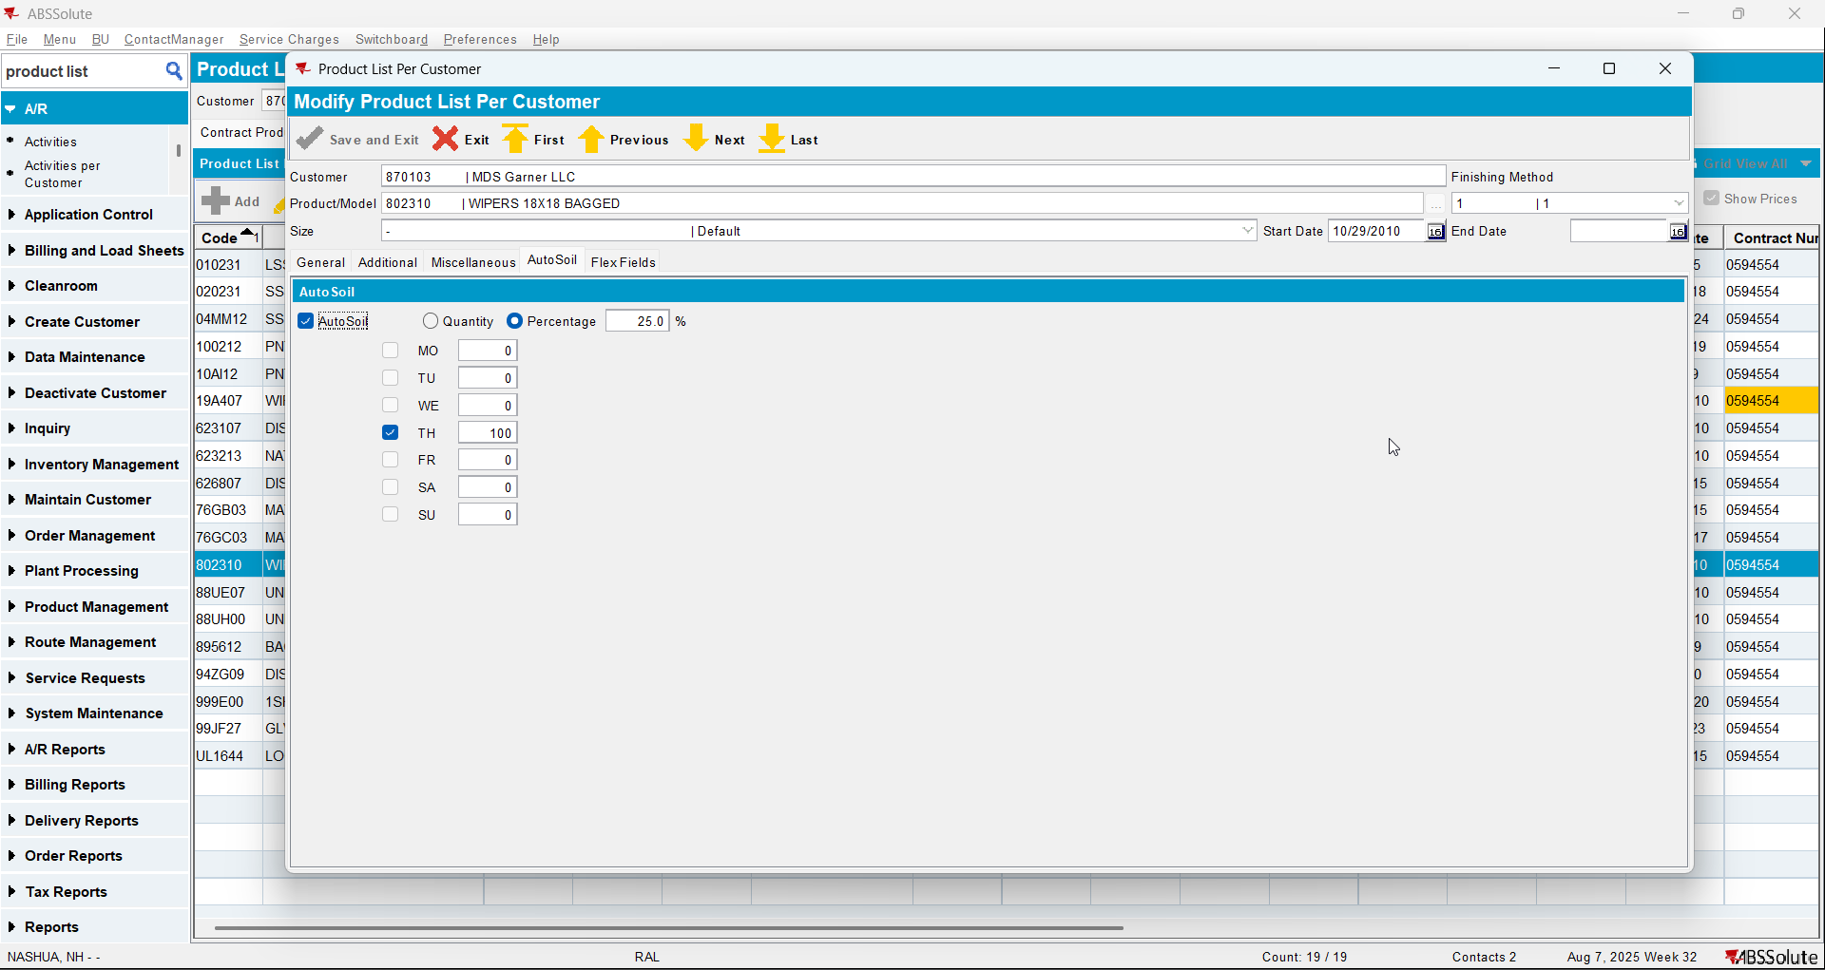
- Check that the product has autosoil checked also on contract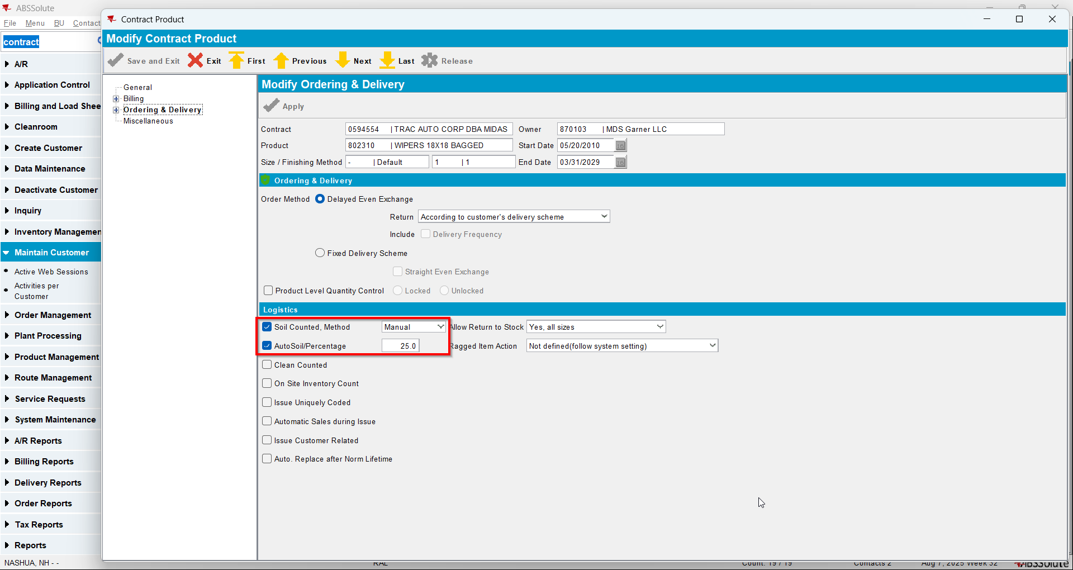
- Go to Product dlg and load your product
- Check that it has Allow Autosoil checked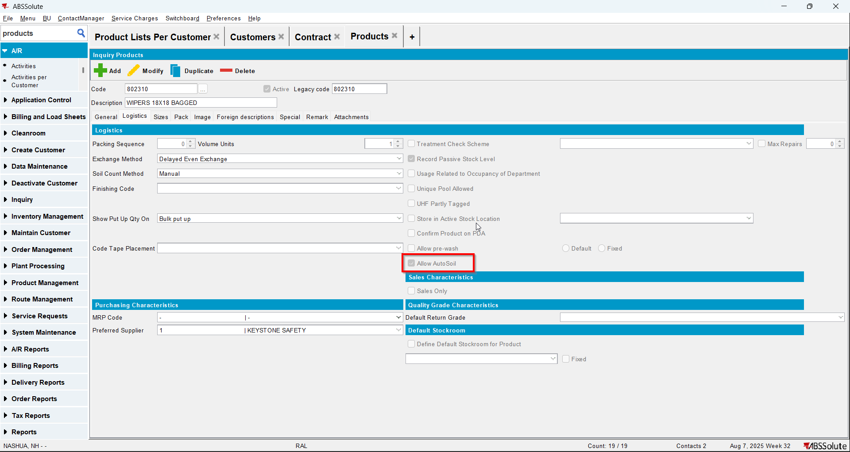
- Uncheck Allow Autosoil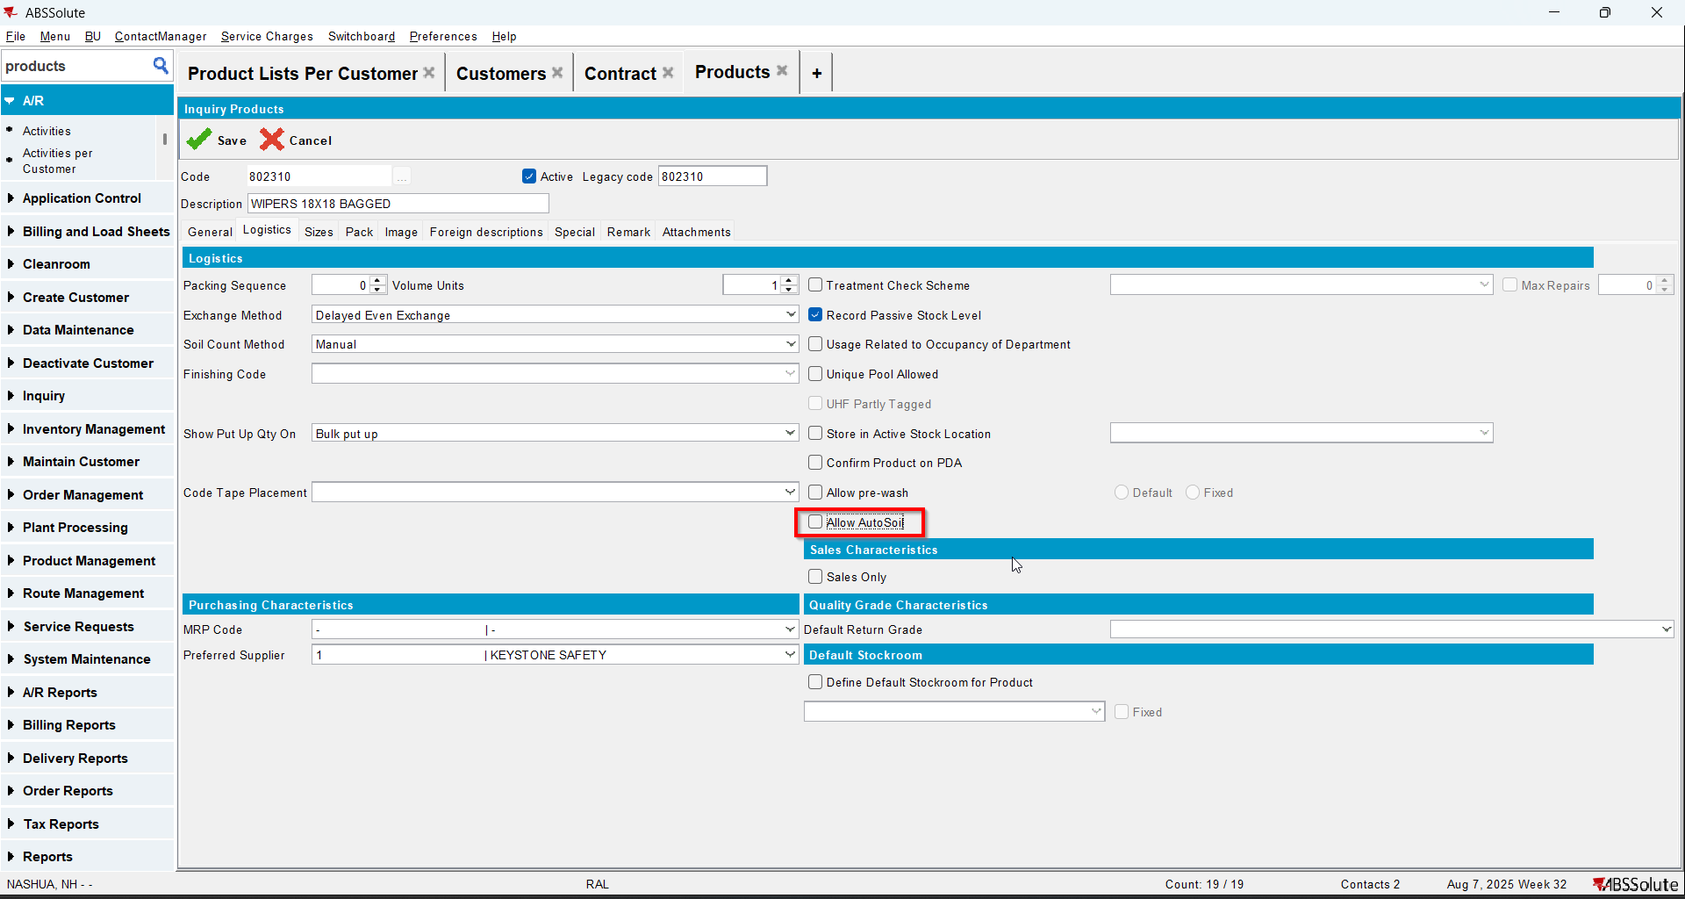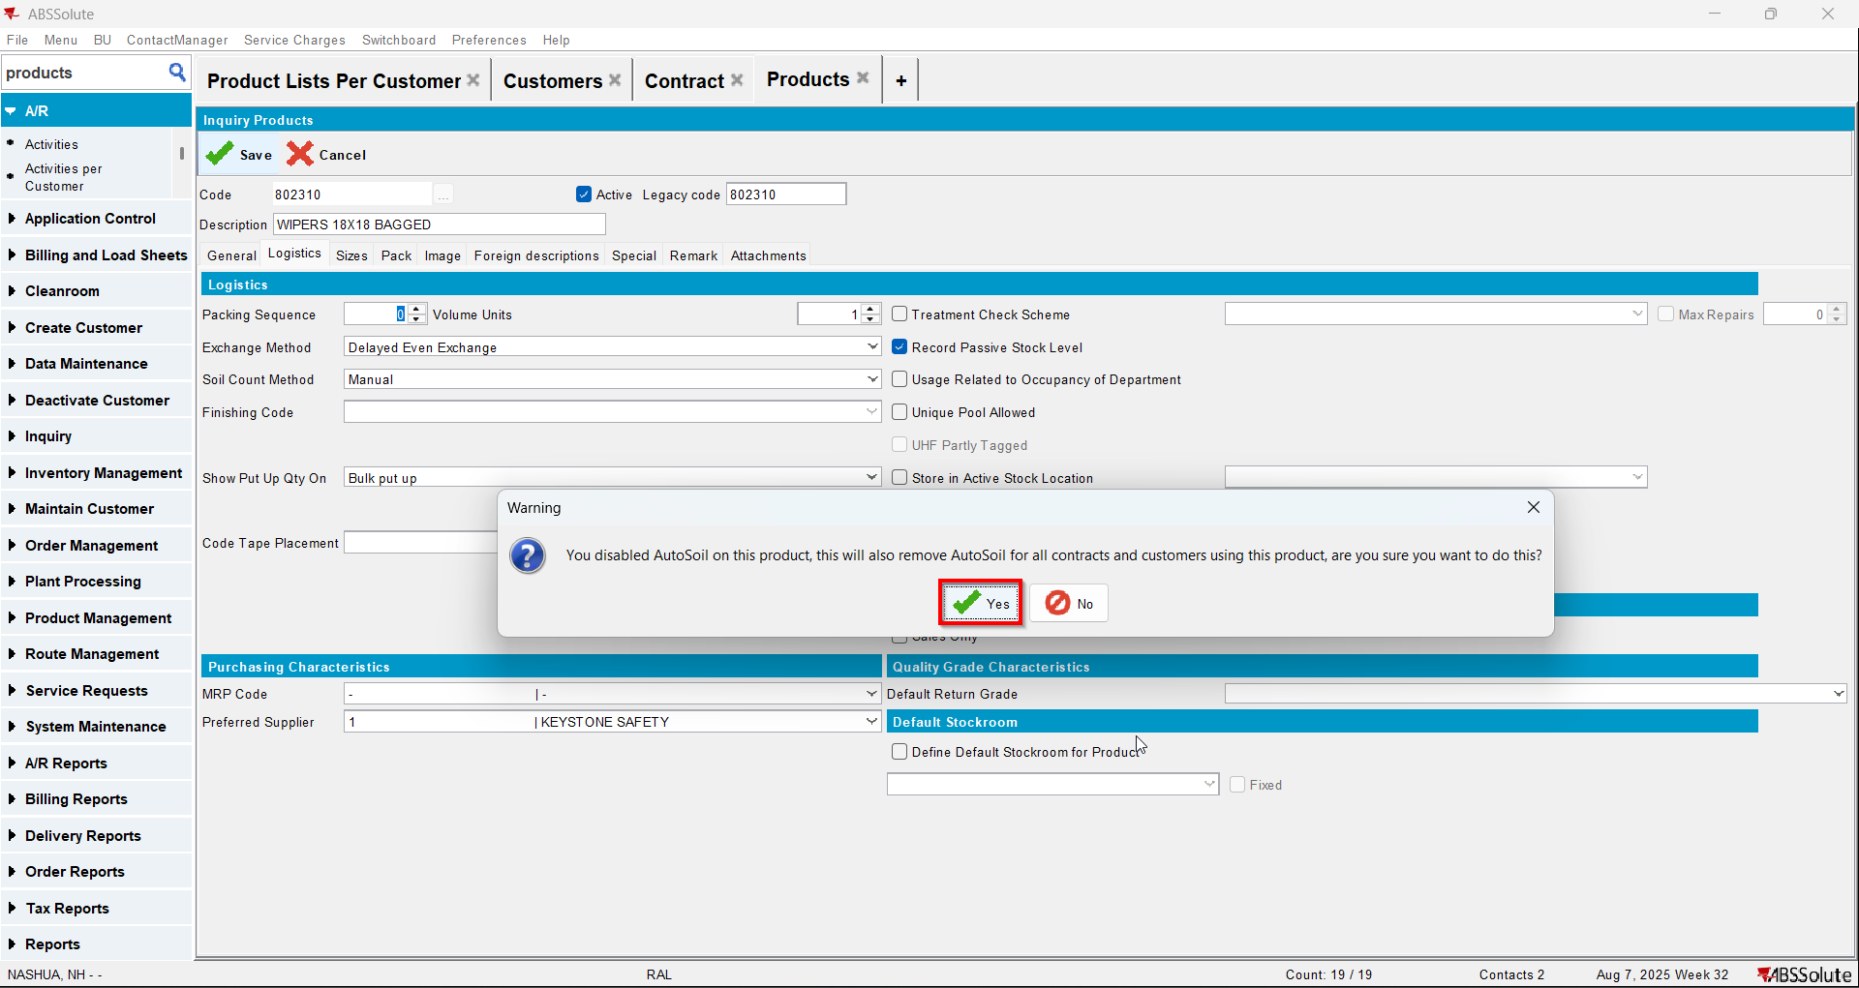
- Check in PLPC that now your product has Autosoil tab disabled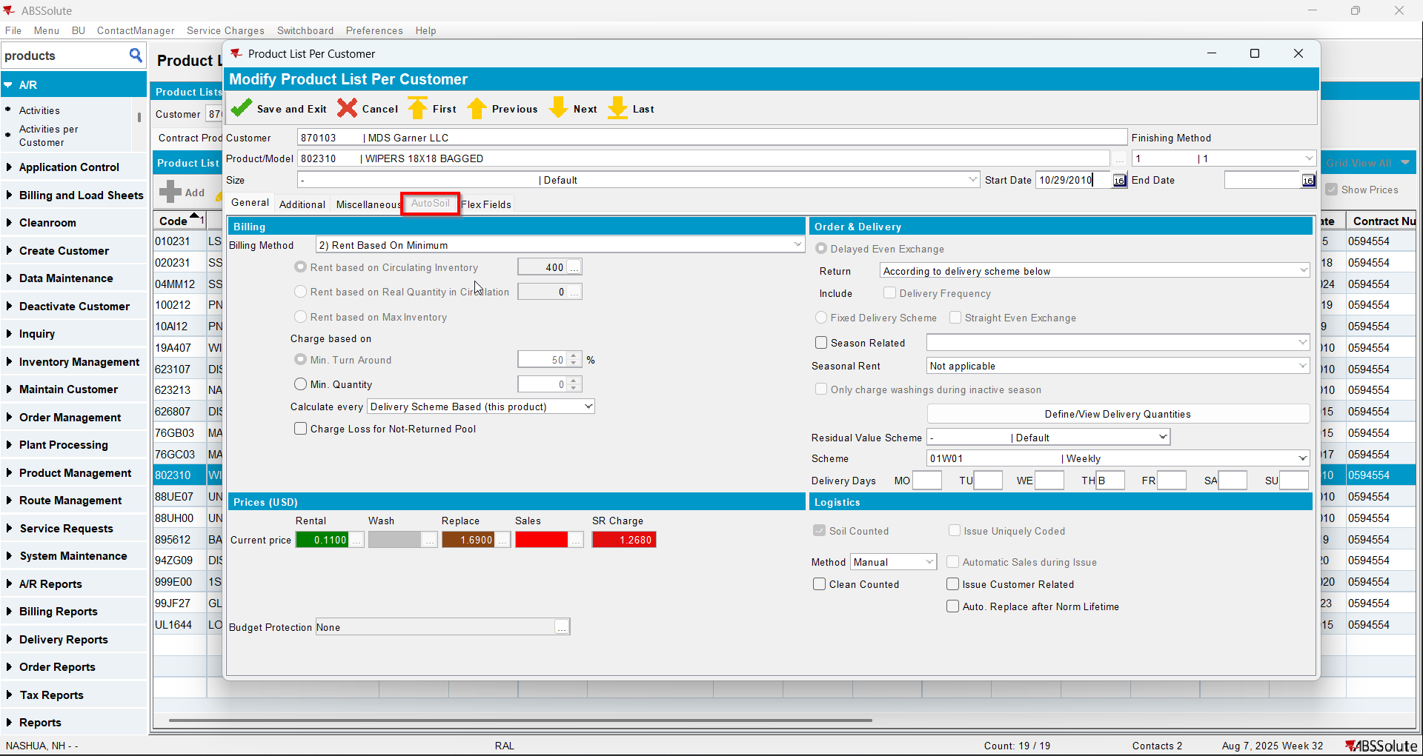
- Check in contract that your product now is missing the Autosoil checkbox field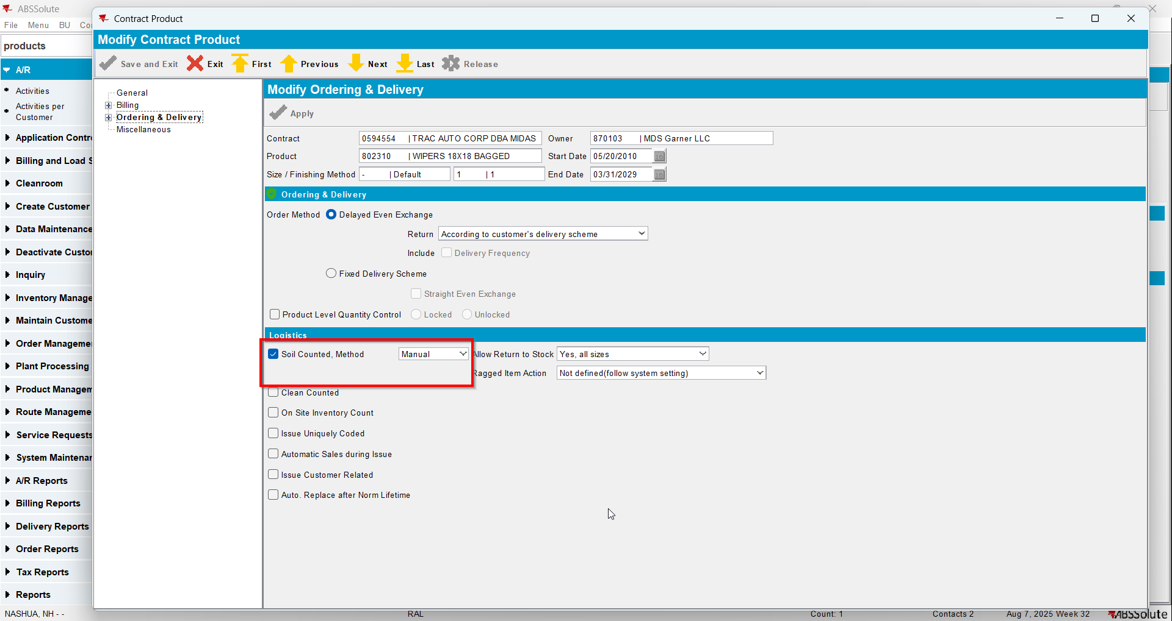
- Check in database that the value of Autosoil for your product was changed to 0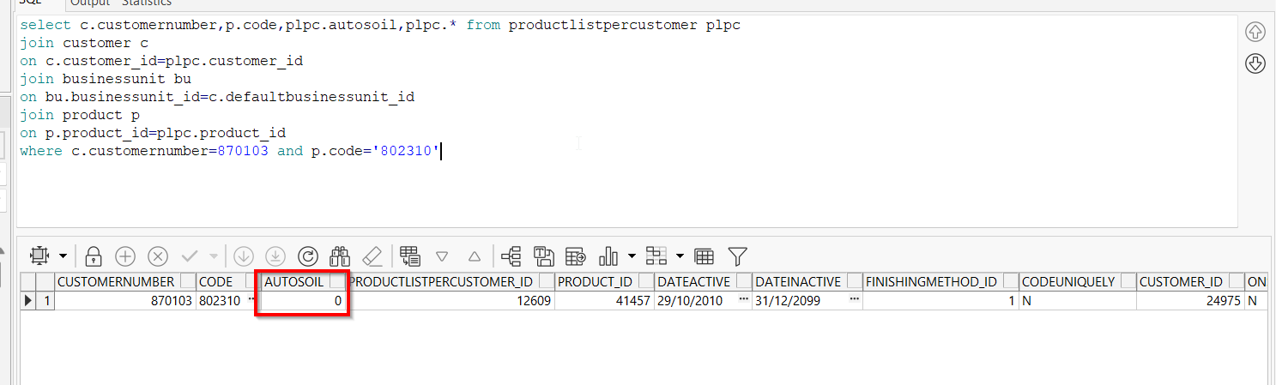

Test Case 2 – Autosoil Quantity with UNFCUSTOM – Tested OK
Expected behavior: when unchecking Allow Autosoil for a product in Products dlg a message should appear saying “You disabled AutoSoil on this product, this will also remove AutoSoil for all contracts and customers using this product, are you sure you want to do this?”. Unchecking should also change autosoil to 0 for that PLPC
Hash: 6304d8e
- Check that you have UNFCUSTOM in license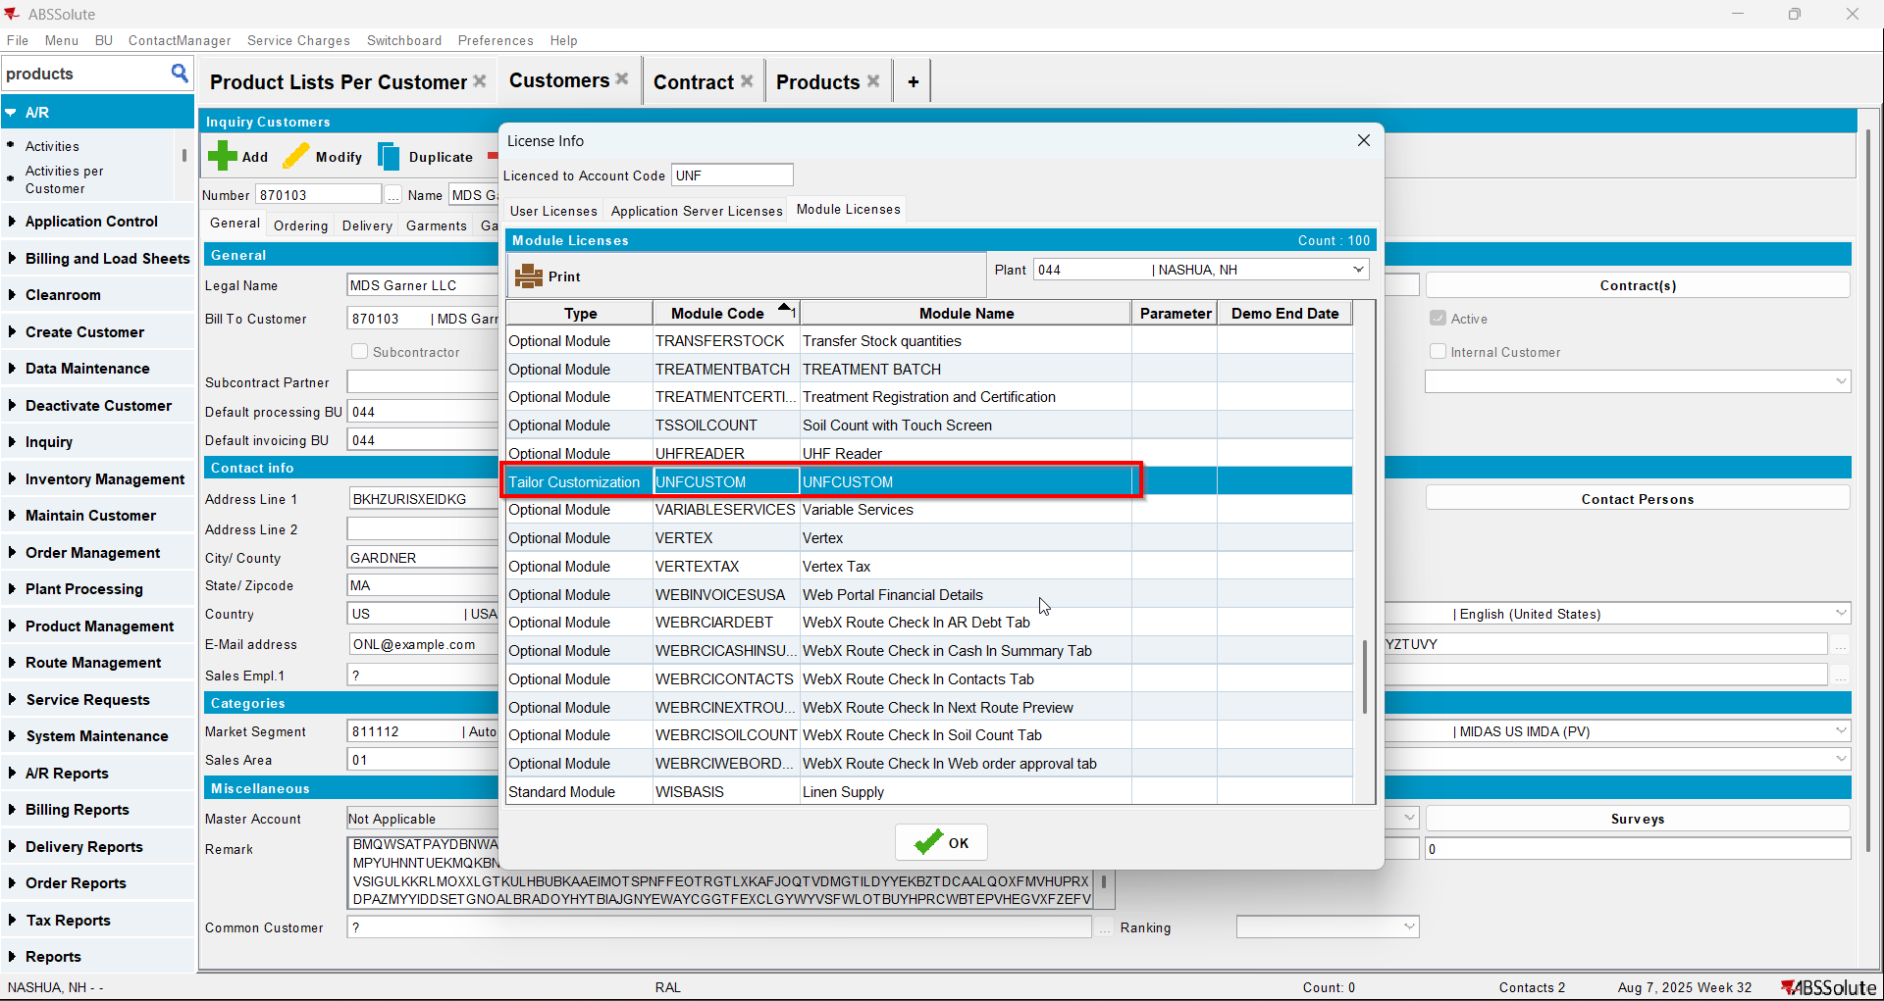
- Have in PLPC a product(non garment) with autosoil=2(quantity)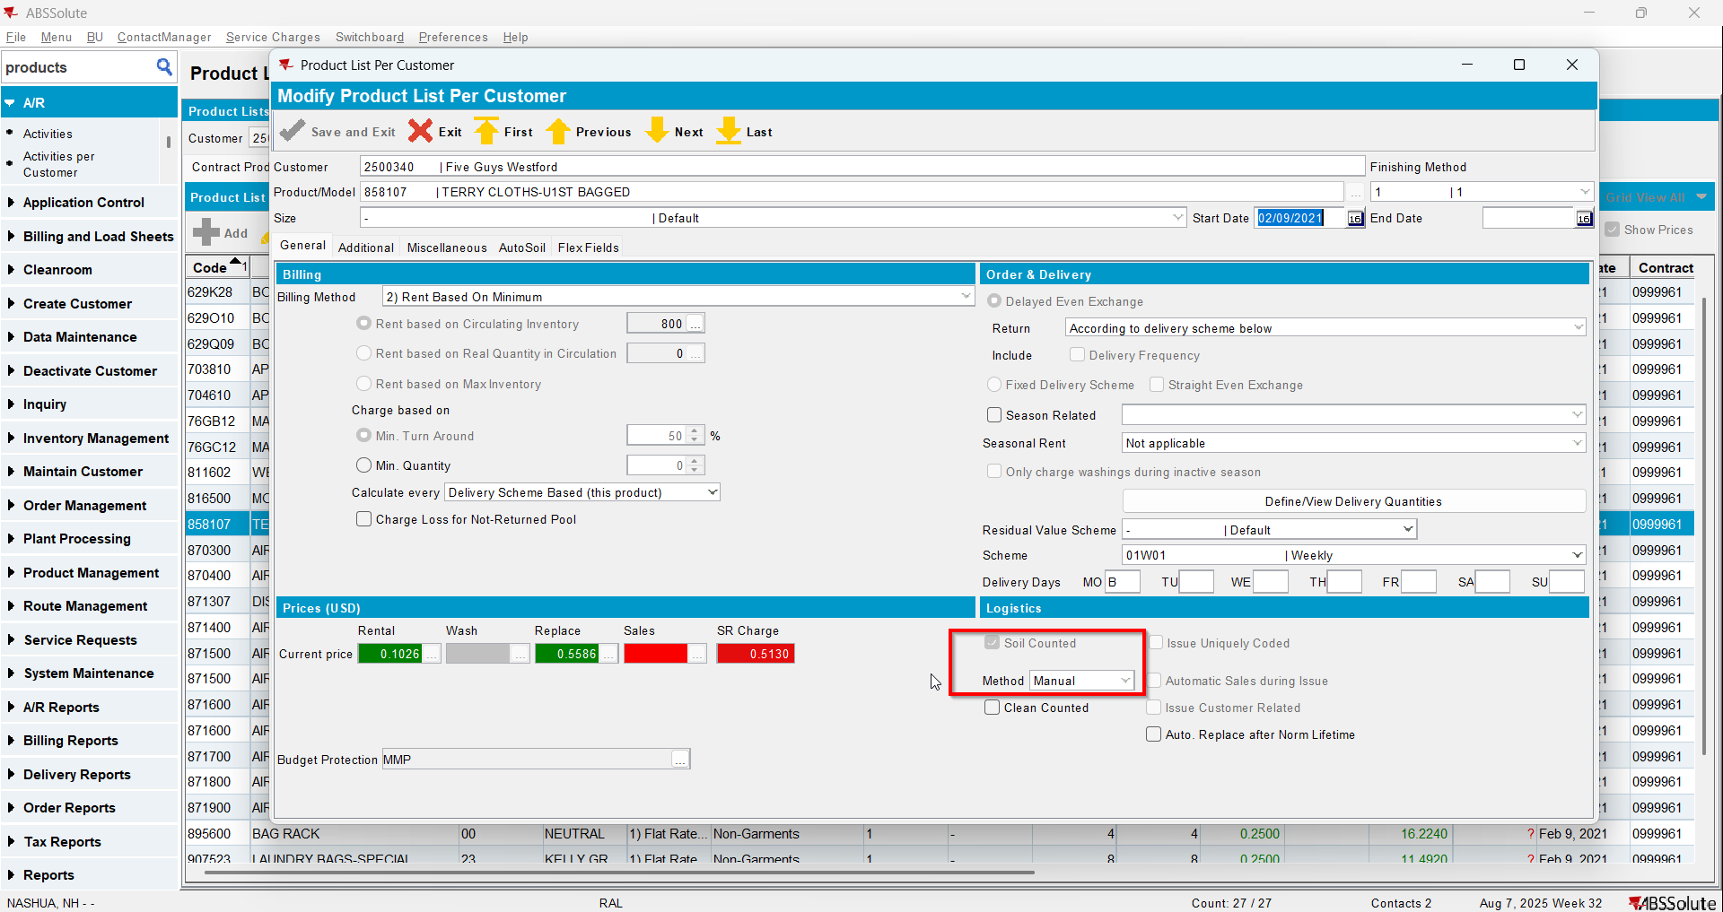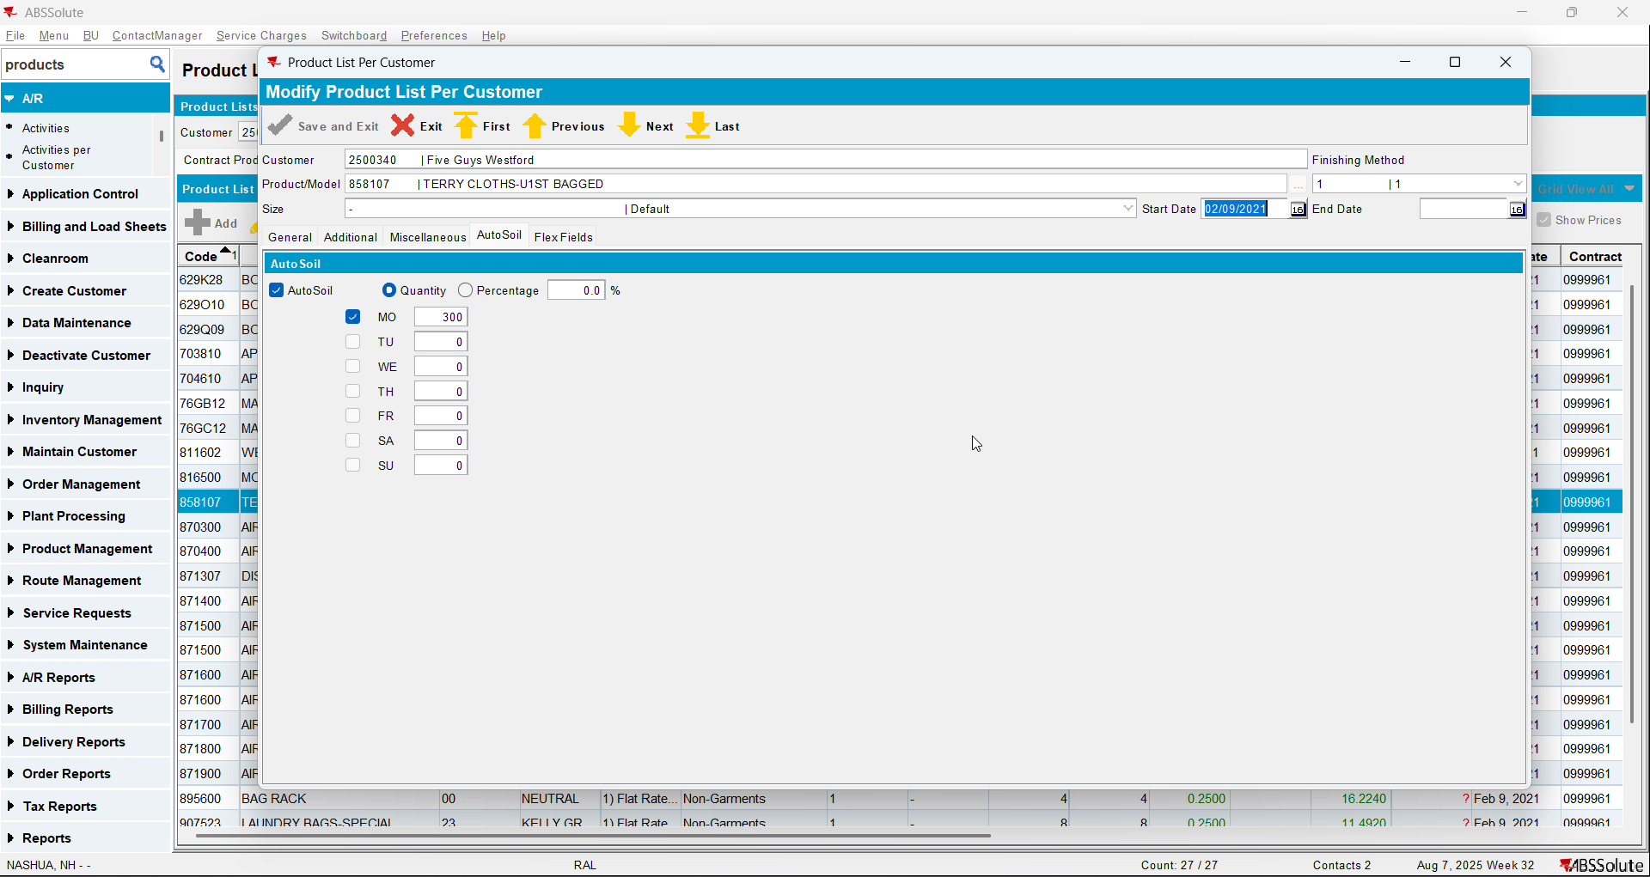
- Check that the product has autosoil checked also on contract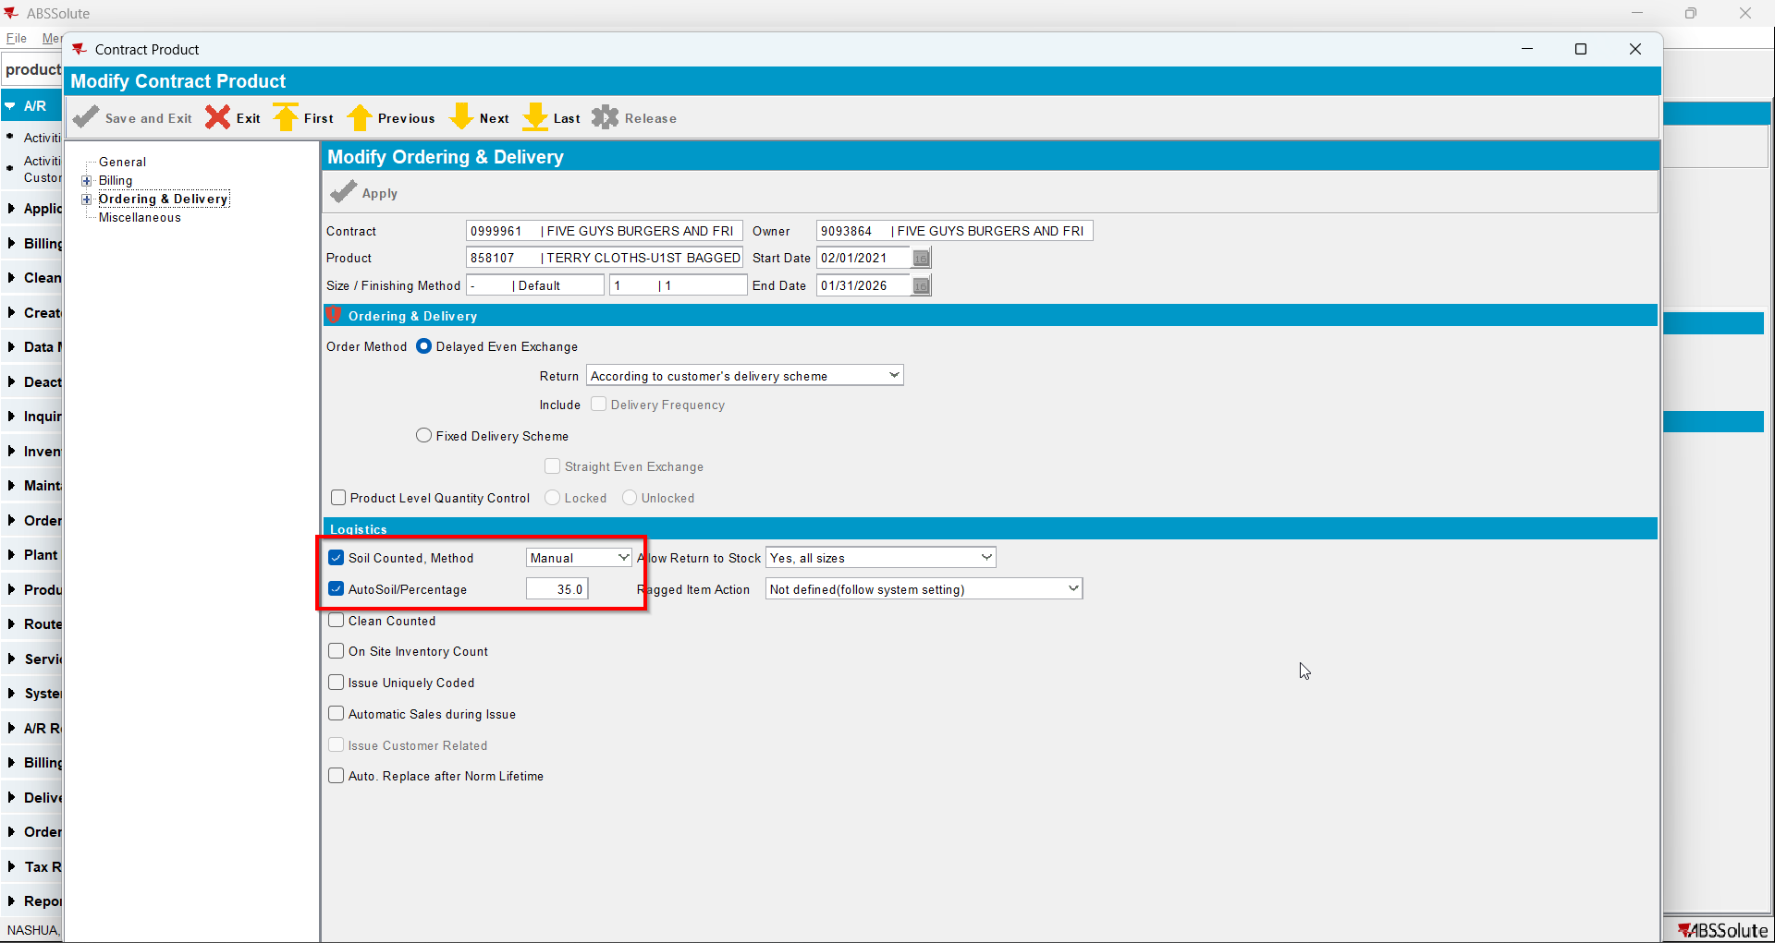
- Go to Product dlg and load your product
- Check that it has Allow Autosoil checked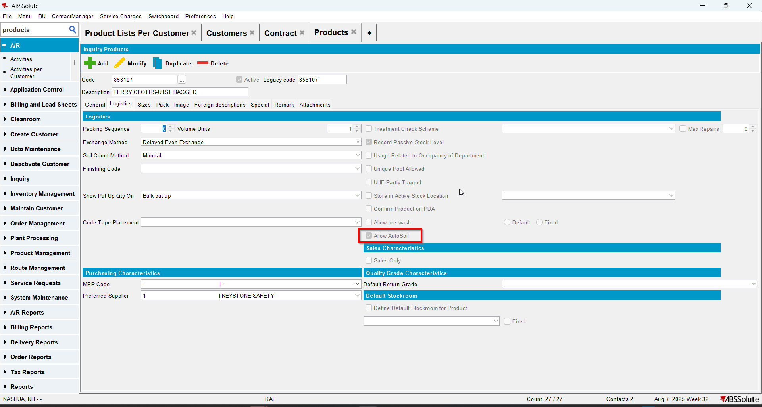
- Uncheck Allow Autosoil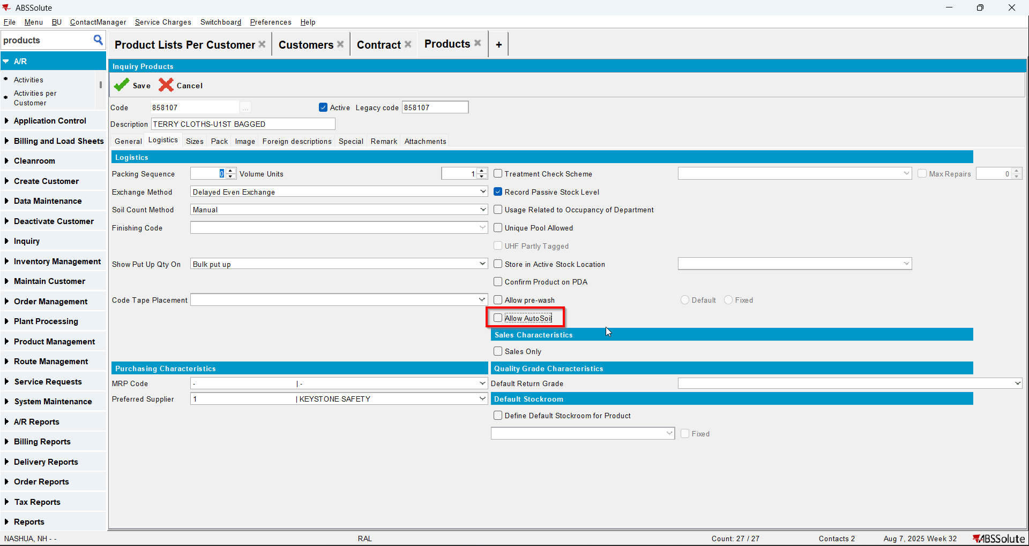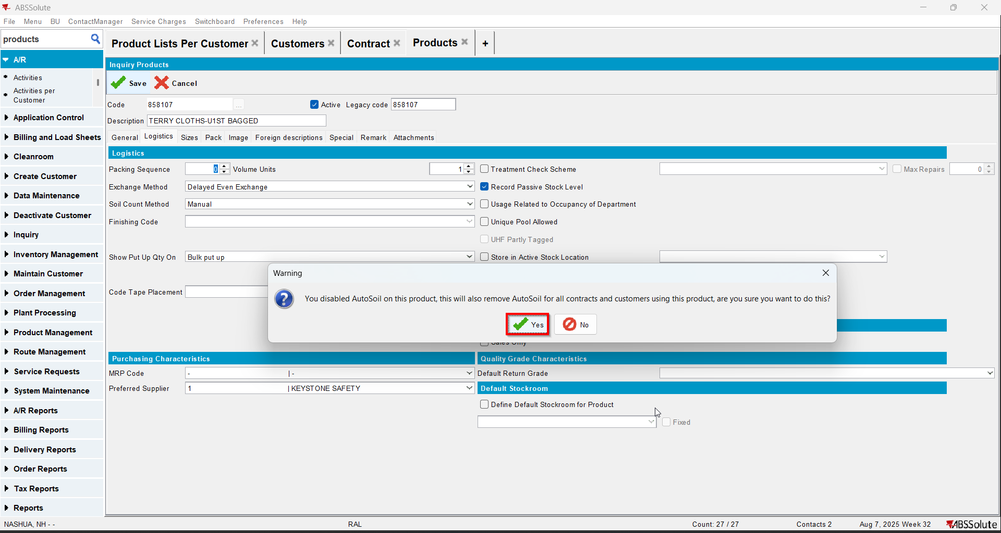
- Check in PLPC that now your product has Autosoil tab disabled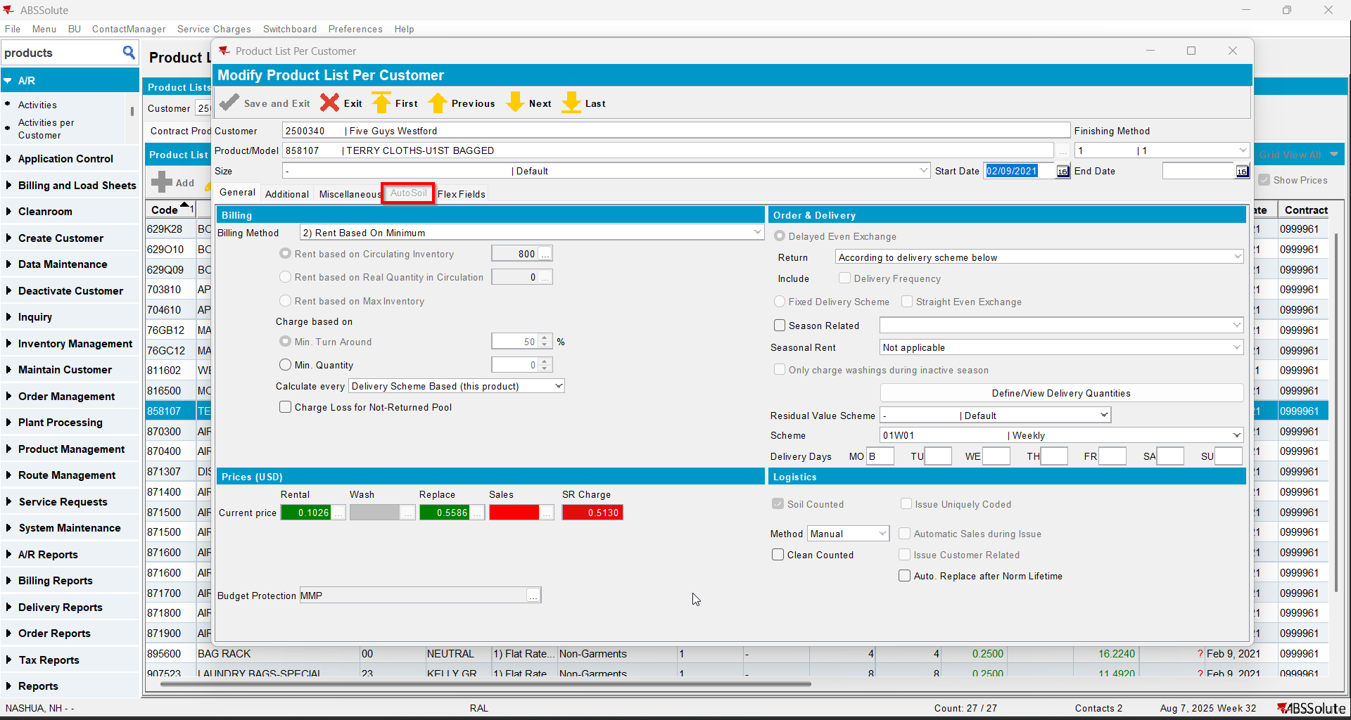
- Check in contract that your product now is missing the Autosoil checkbox field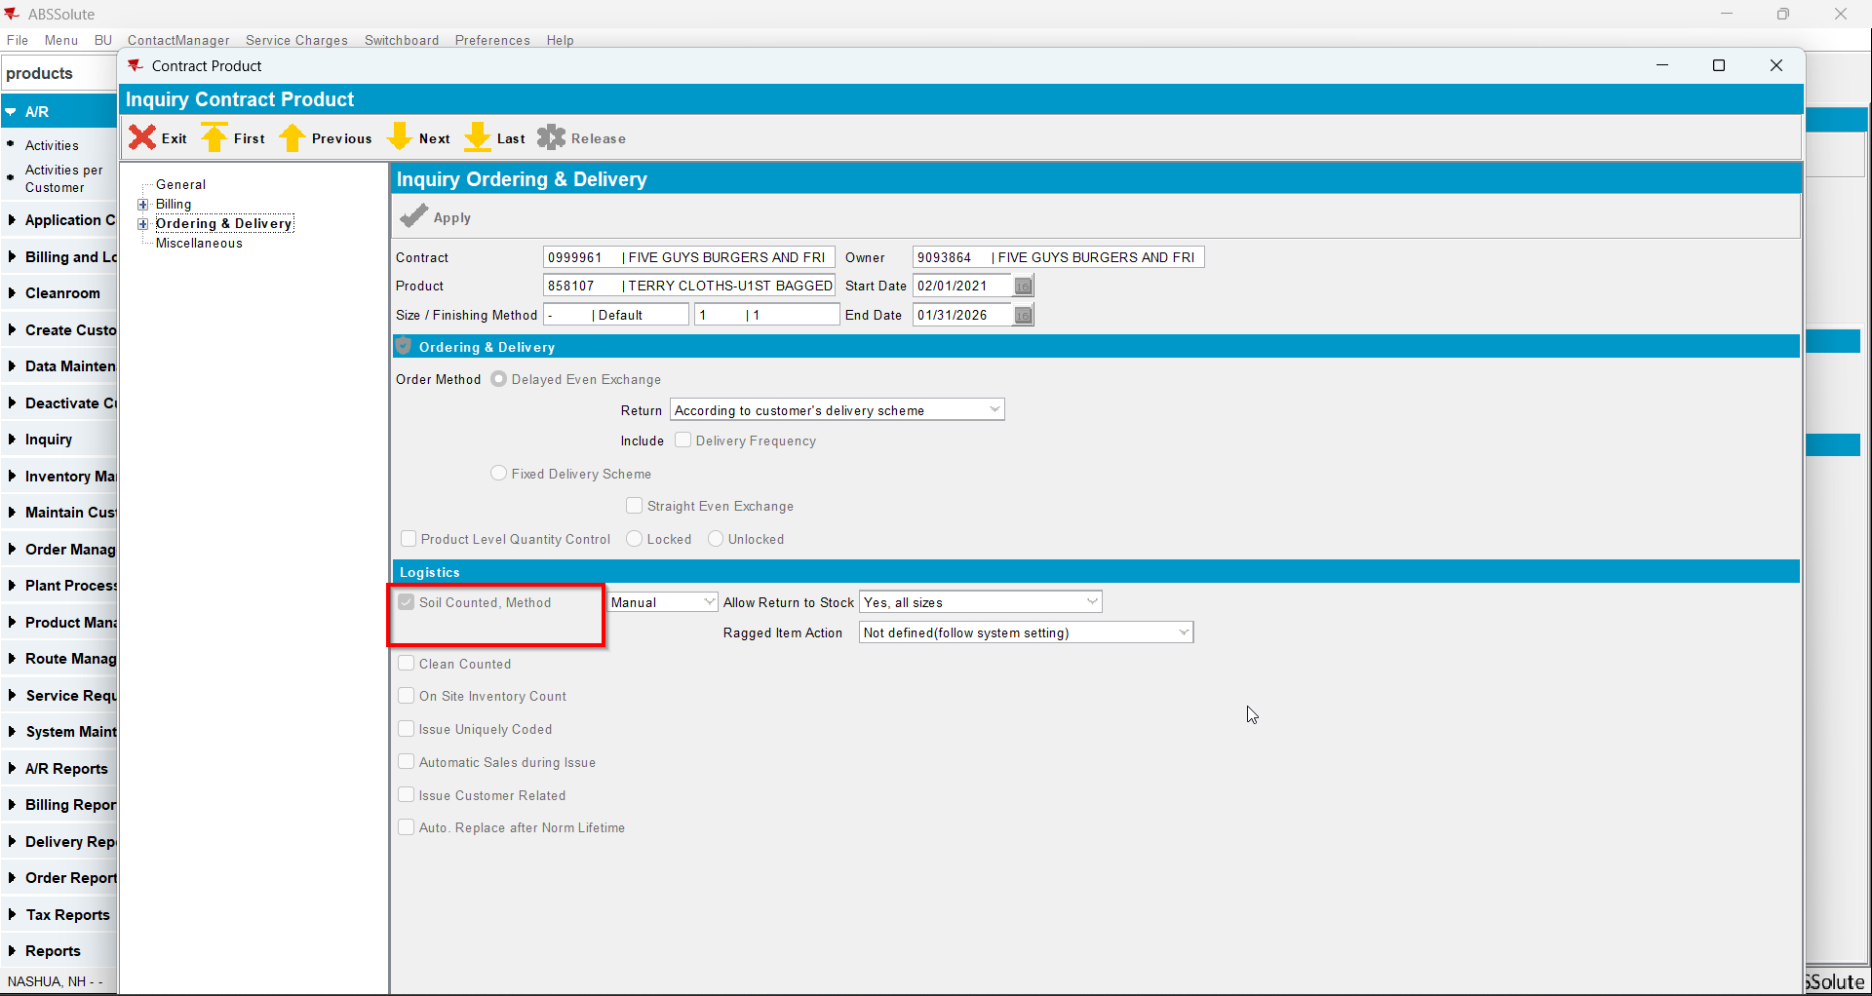
- Check in database that the value of Autosoil for your product was changed to 0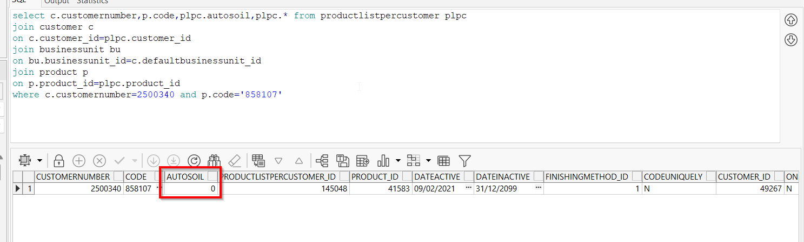

Test Case 3 – Autosoil Percentage without UNFCUSTOM – Tested OK
Expected behavior: Autosoil should not change its value for that PLPC
Hash: 6304d8e
- Check that you don’t have UNFCUSTOM in license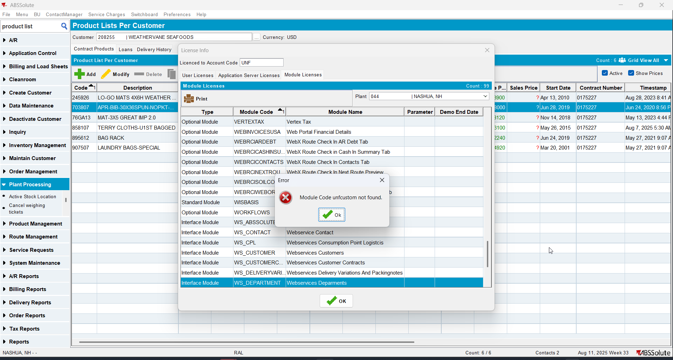
- Have in PLPC a product(non garment) with autosoil=1(percentage)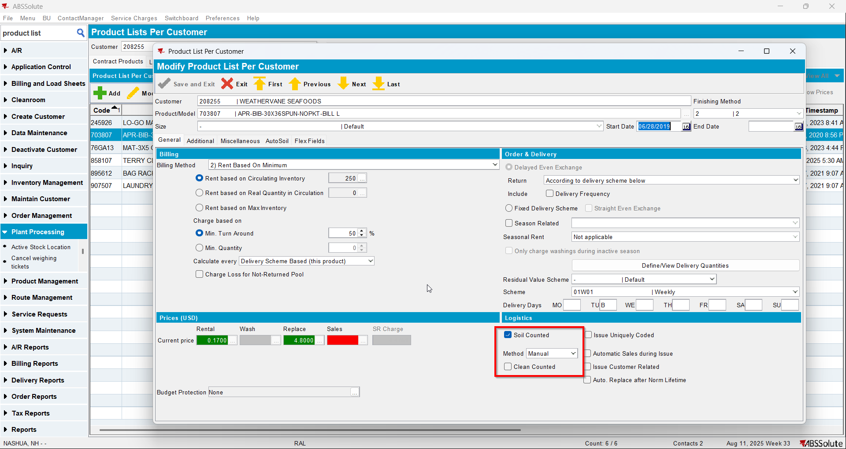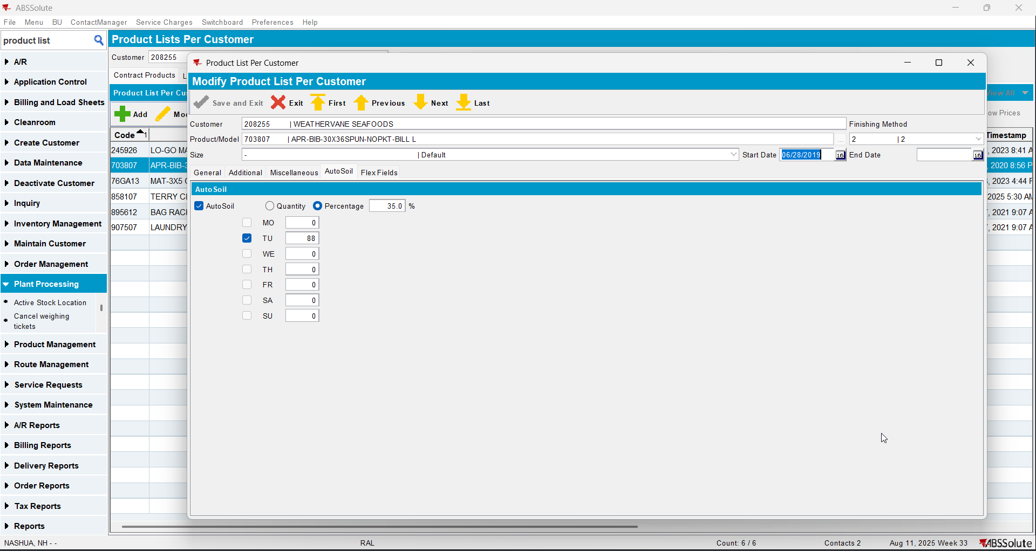
- Check that the product has autosoil checked also on contract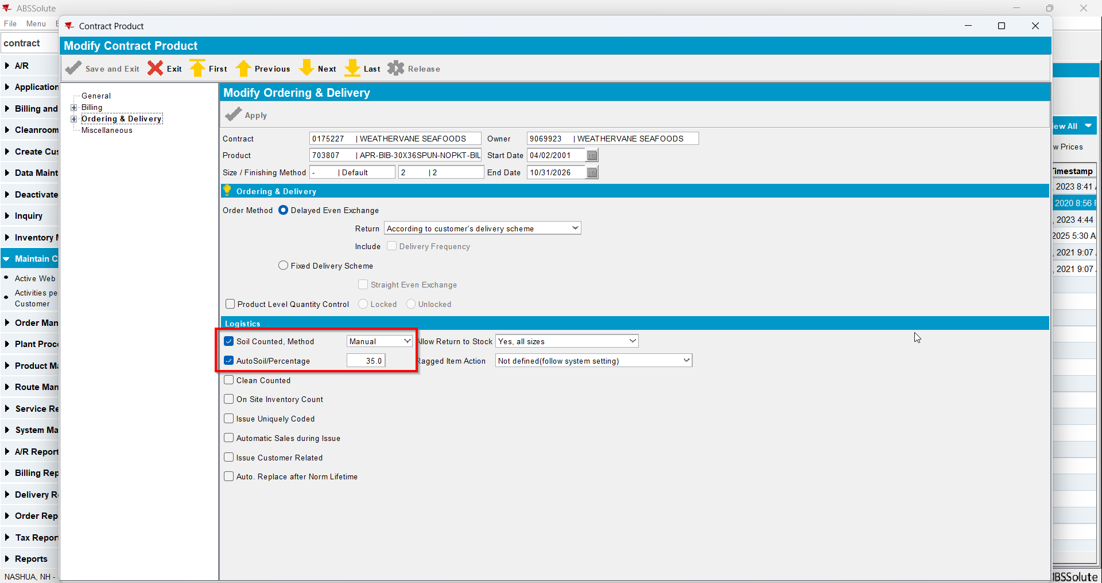
- Go to Product dlg and load your product
- Check that it has Allow Autosoil checked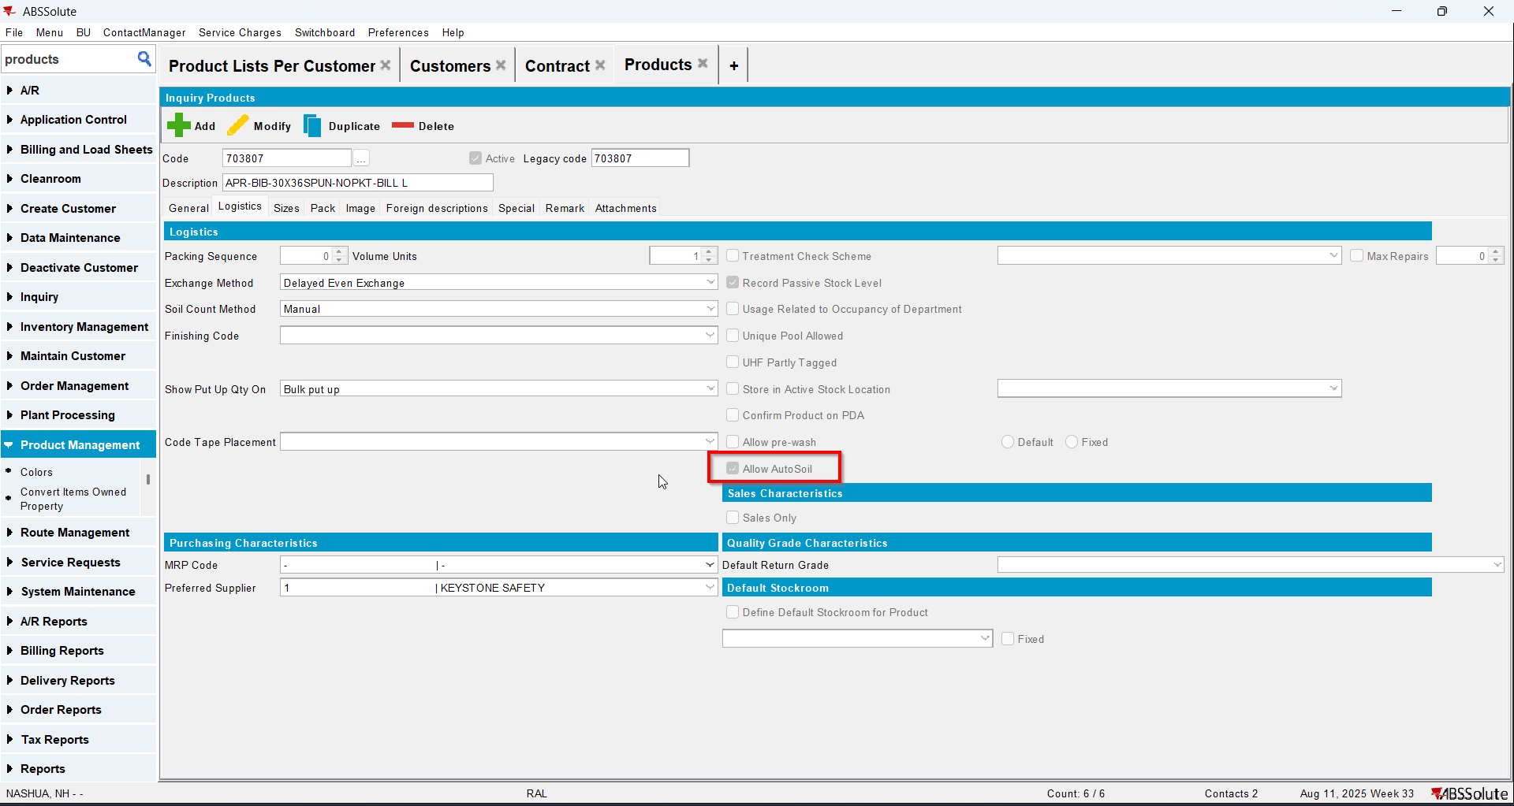
- Uncheck Allow Autosoil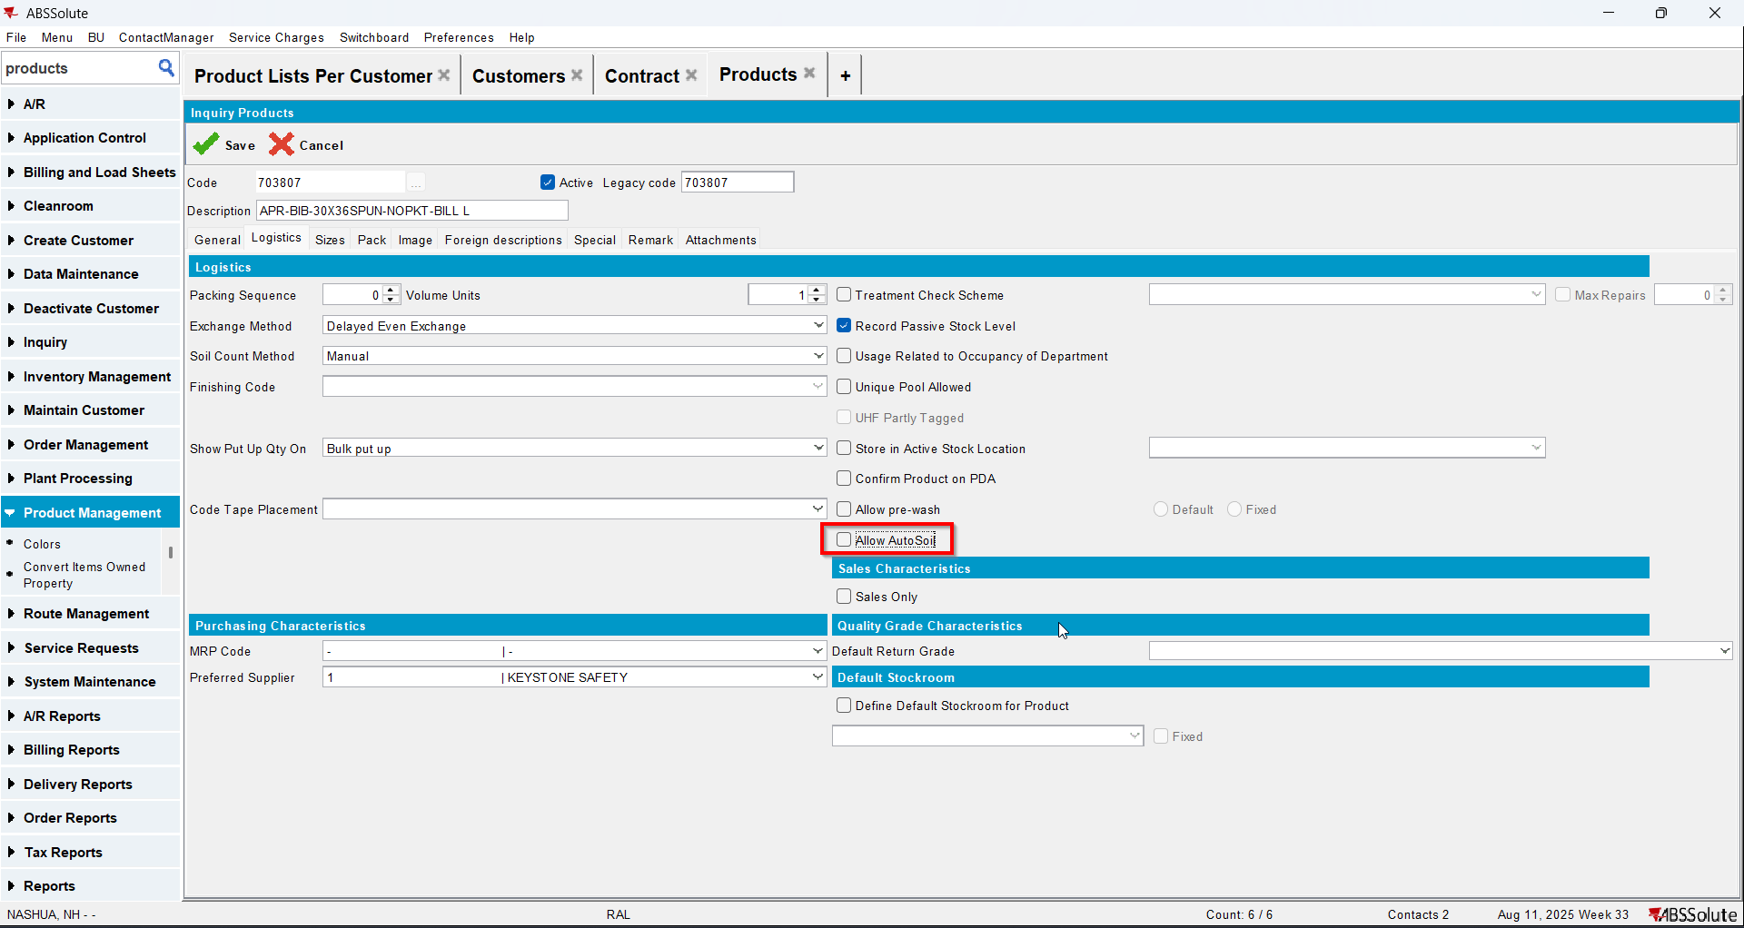
- Check in PLPC that now your product has Autosoil tab disabled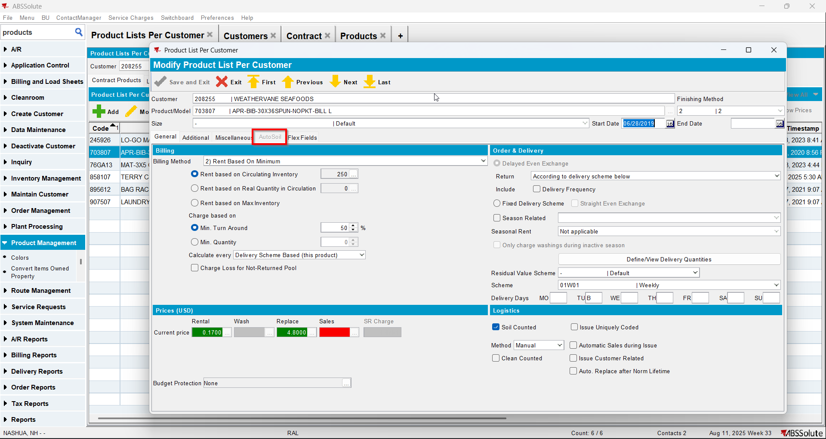
- Check in contract that your product now is missing the Autosoil checkbox field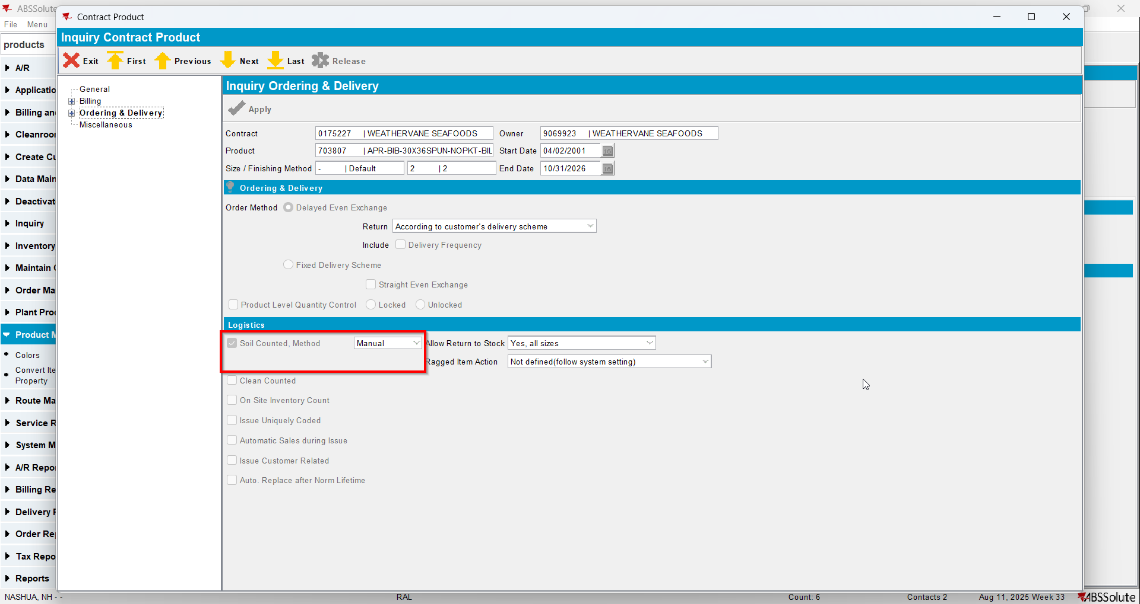
- Check in database that the value of Autosoil for your product is still 1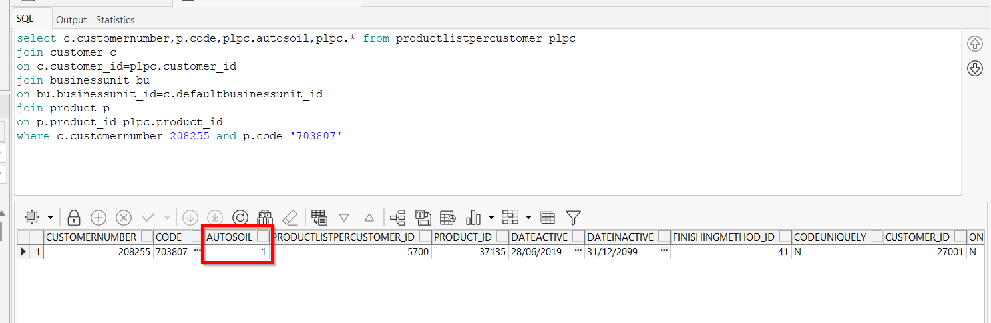

Test Case 4 – Autosoil Quantity without UNFCUSTOM – Tested OK
Expected behavior: Autosoil should not change its value for that PLPC
Hash: 6304d8e
- Check that you don’t have UNFCUSTOM in license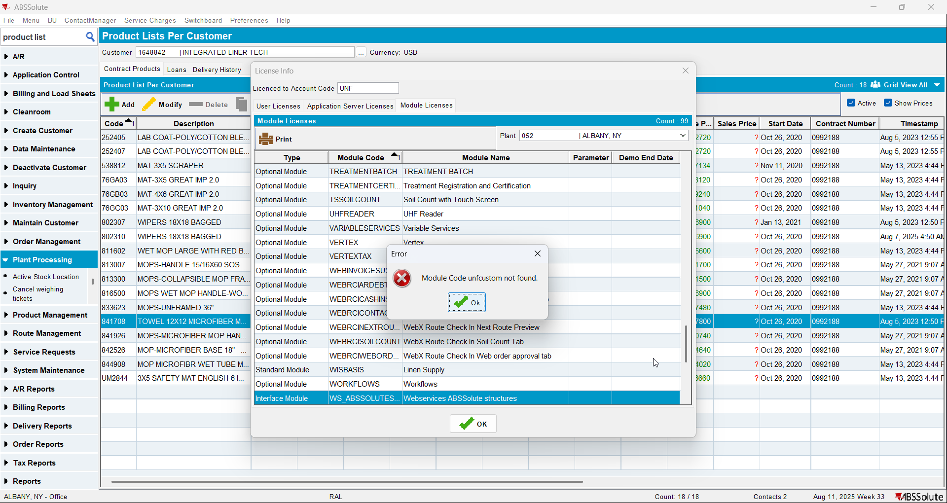
- Have in PLPC a product(non garment) with autosoil=2(quantity)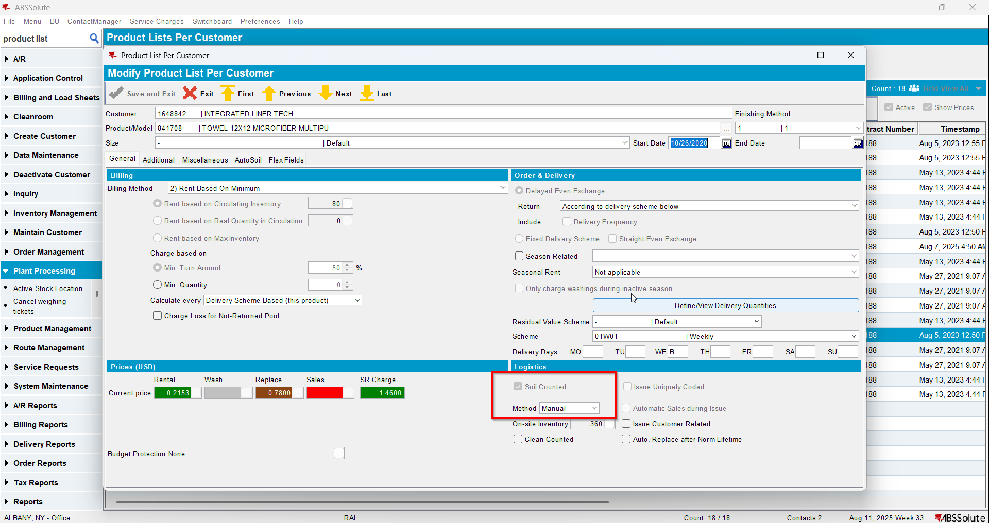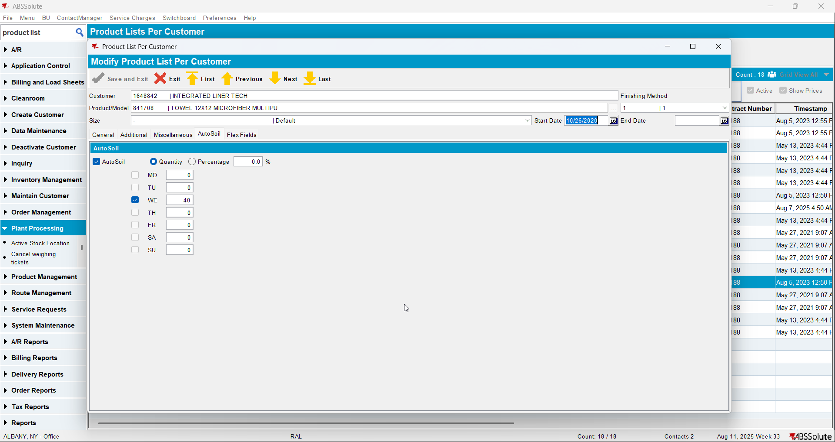
- Check that the product has autosoil checked also on contract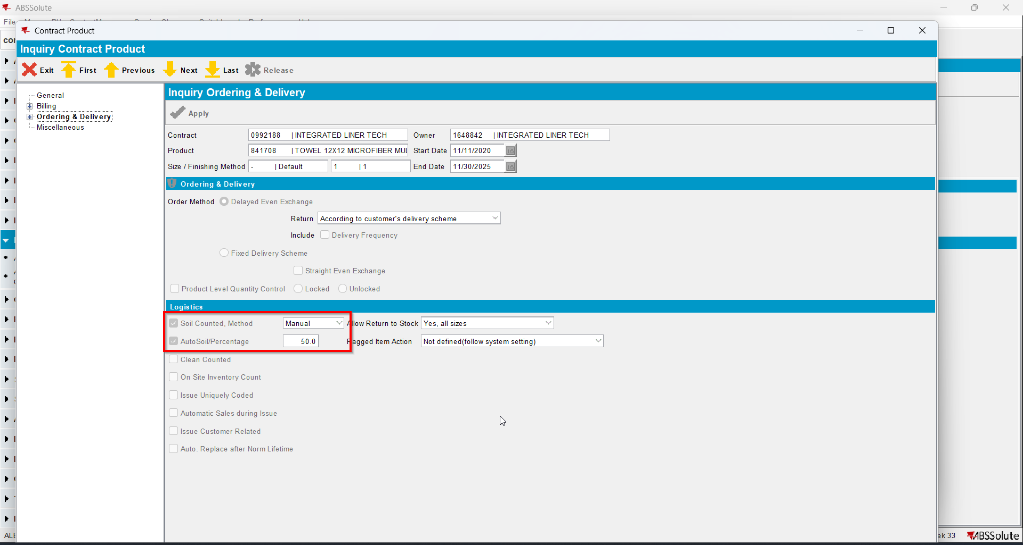
- Go to Product dlg and load your product
- Check that it has Allow Autosoil checked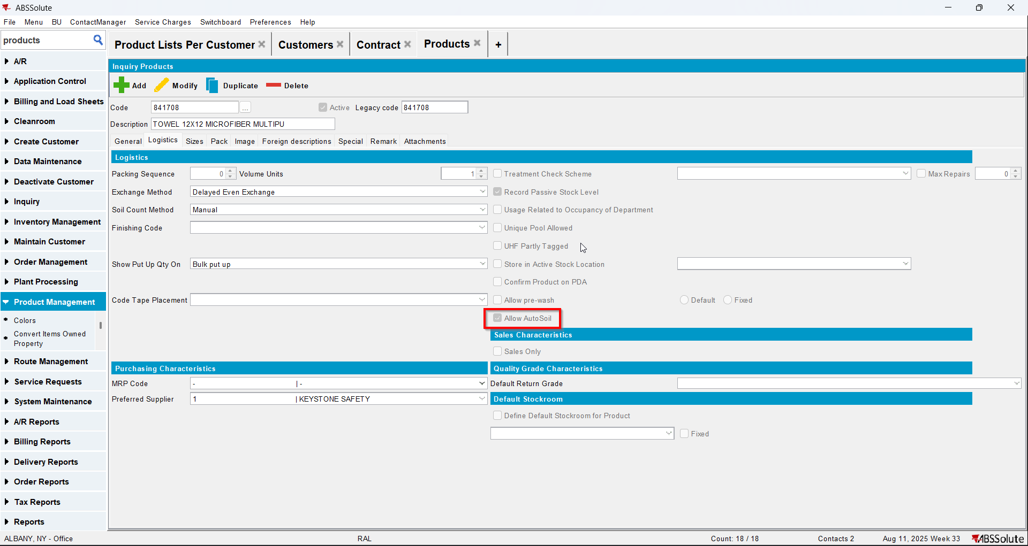
- Uncheck Allow Autosoil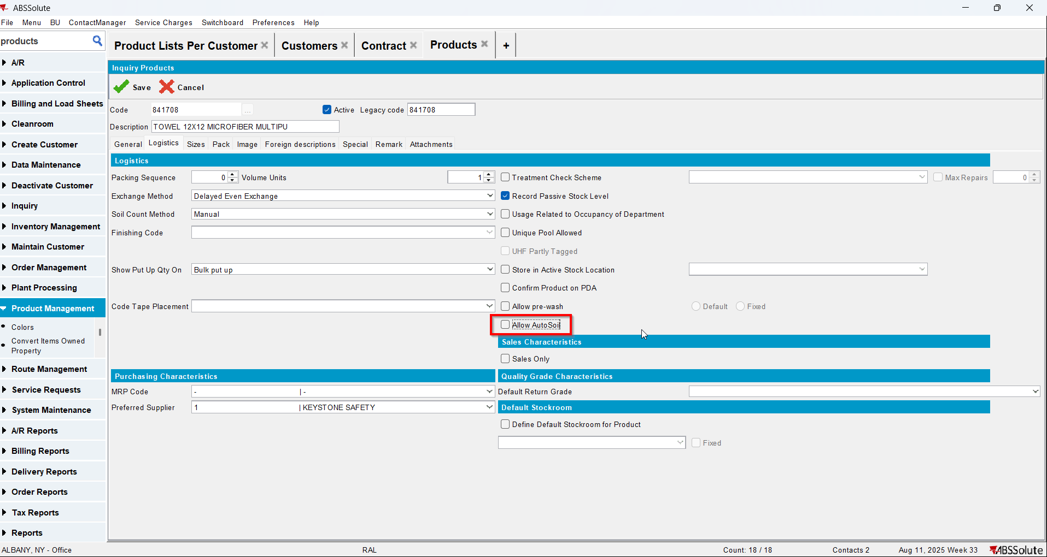
- Check in PLPC that now your product has Autosoil tab disabled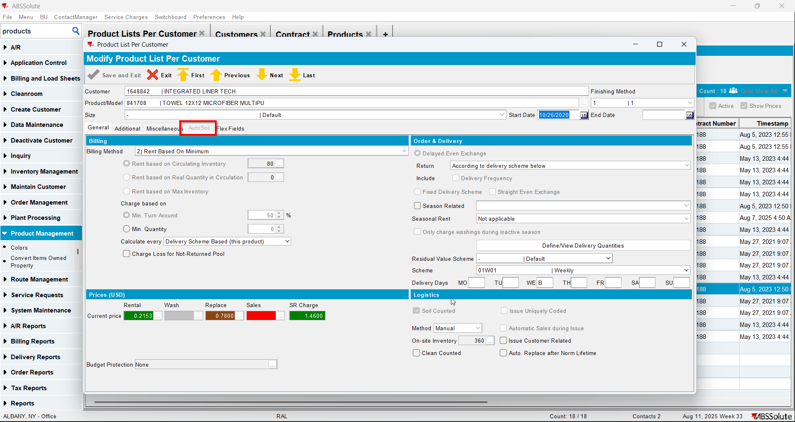
- Check in contract that your product now is missing the Autosoil checkbox field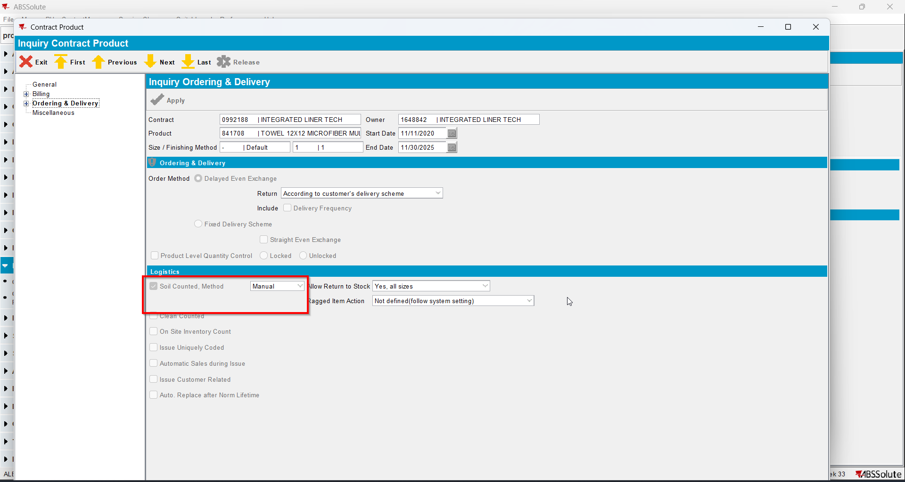
- Check in database that the value of Autosoil for your product is still 2