ABSN-5990 - D_UBS_2045 Bar codes not printing automatically when completing work orders
Environment | Prerequisites
Version: 9.07.00 UNF20  DBServerName= abs-srv20.internal.abslbs.com  DBSID=CUST24  DBUser=UNFDEV  Environment=Test | - Module:  - System setting

Contents
Reproducing before fix 1
Steps to reproduce 1
Current Behavior 4
Expected behavior 4
Retest after fix 4
Test Case 1 – Check that "Printed Code Label" field stays empty after pressing “modify” on a customer 4

Reproducing before fix

Steps to reproduce
- Find a customer with a garment delivery day set but no "Printed Code Label". I used this SQL:
select BU.CODE, C.*
from CUSTOMER C
join BUSINESSUNIT BU on BU.BUSINESSUNIT_ID = C.DEFAULTBUSINESSUNIT_ID
where exists (select 1
from CUSTOMERDELIVERYDAY CDD
where CDD.CUSTOMER_ID = C.CUSTOMER_ID
and CDD.TYPEOFMERCHADISE = 2)
and C.CODELABELLAYOUT_ID is null

- Try to modify the customer. You will notice the "Printed Code Label" is automatically populated because is the only value from combo box and, if a delivery day is set, the combo must have a value:
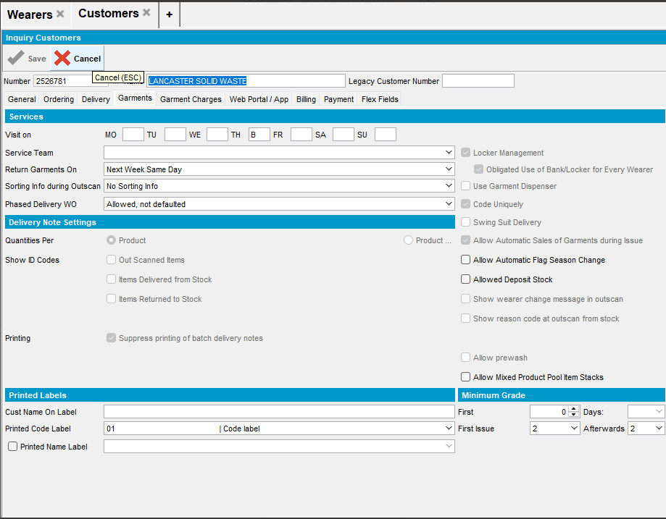
- Cancel the change. You will notice the "Printed Code Label" remains selected:
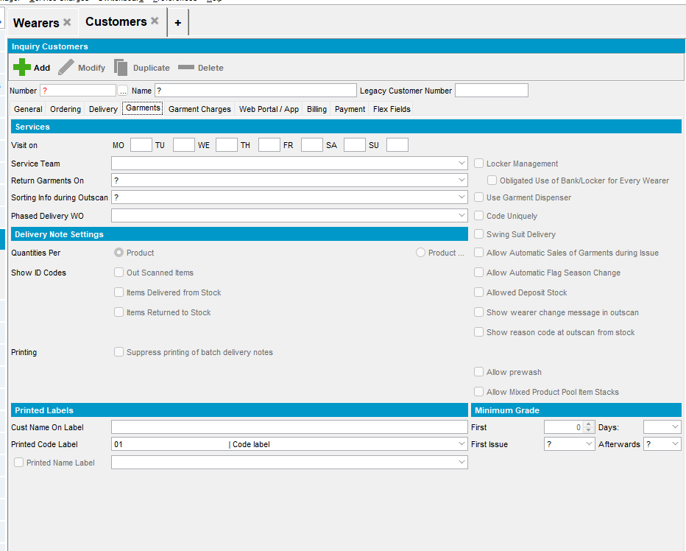
- Reload the customer. You will notice the "Printed Code Label" has a value:
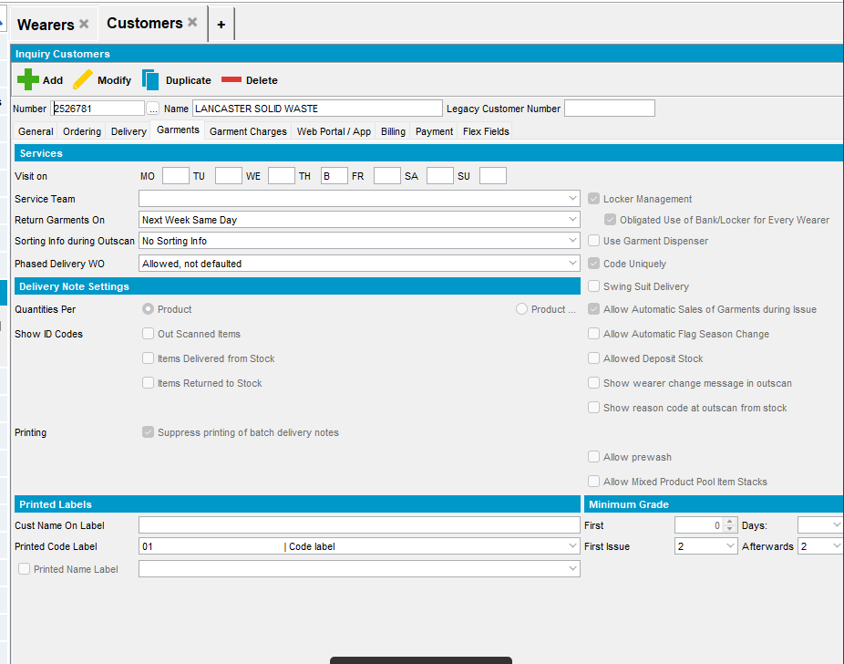

REPRODUCED OK.

Current Behavior
"Printed Code Label" is populated after pressing modify on a customer without adding the changes yourself.

Expected behavior
The field "Printed Code Label" should be empty

Retest after fix

Test Case 1 – Check that "Printed Code Label" field stays empty after pressing “modify” on a customer
Hash: 7a461ab88ffc
- Find a customer with a garment delivery day set but no "Printed Code Label" using this SQL:
select BU.CODE, C.*
from CUSTOMER C
join BUSINESSUNIT BU on BU.BUSINESSUNIT_ID = C.DEFAULTBUSINESSUNIT_ID
where exists (select 1
from CUSTOMERDELIVERYDAY CDD
where CDD.CUSTOMER_ID = C.CUSTOMER_ID
and CDD.TYPEOFMERCHADISE = 2)
and C.CODELABELLAYOUT_ID is null
- Customers DLG: Load the customer> go to Garments tab and press Modify button
- Cancel the change.
- Reload the customer
- Press Modify again and this time select a value to Printed Code Label field
- Cancel the changes
- Check that the field is still empty
- Press modify again > select a value to Printed Code Label field and save the changes
- See that the changes are saved
Tested OK

